Health Promoting Schools
Impact on Targeted Student Outcomes

Summary Report
AUGUST 23, 2017

Prepared by:
Dr Heidi Leeson
External Evaluator

HPS help schools understand the health and well-being of your children

Assessed the impact of the HPS service on student, school, and family/whānau outcomes

What is Health Promoting Schools?
Health Promoting Schools (or HPS) is a school and community focused service funded by the Ministry of Health in New Zealand that helps schools assess and address the health and wellbeing requirements of their students to advance student learning and achievement outcomes.
Health Promoting School facilitators work directly with schools to help Principals and school leadership better understand, evaluate, and activate the health and wellbeing needs of their students, and ensure they are aligned with the vision, values, goals, and priorities of their school.
Schools can then provide effective responses to the ever-changing health and wellbeing priorities of students in today’s schools.

Research has shown that when students’ health and wellbeing needs are being met, they go to school more often and they improve their learning and achievement outcomes (e.g., McKenzie & Richmond, 1998; Basch, 2010).

What did we look at?
The HPS National Leadership and Coordination Service (Cognition Education Ltd) and the Ministry of Health wanted to assess how successful the Health Promoting Schools service has been across schools in New Zealand on student outcomes.

The following areas were examined to assess how well the HPS service was helping schools, students, parents/whānau, and the community.
At a student level the research looked at:
- Attendance
- Stand-downs
- Suspensions
- Achievement
At a school community level, the following areas were measured and evaluated:
- School effectiveness
- School leader effectiveness
- Levels of parent and whānau engagement
- HPS facilitator effectiveness

HPS had a strong and positive impact on student attendance

ERO cycles were found to be a strongly correlated to the success of students

What did we find?
Results showed that on average students from schools with the same ERO cycle, where the cycles were at least 3 years apart, that were using the HPS service had more positive student outcomes in attendance, stand-downs and suspension, and reading achievement than the schools with the same ERO cycle that were not using the HPS service.

Student Outcomes
HPS had a positive impact on student rates of attendance. HPS schools were found to have had improved student attendance rates, where schools with least 3 years or more between ERO cycles and had performed well on the HPS rubric over the last two years (2015-2016). Essential to this impact was the addition of an effective HPS facilitator. The combination of these factors resulted in an average 60% of the gains seen in HPS school attendance rates¹ as being due to the impact of the HPS approach. By comparison, non HPS schools, when matched on the same variables, showed only the ERO cycle accounting for a small positive gain in attendance.
The HPS approach was shown to help schools reduce the number of students being stood-down or suspended from school. Schools that performed well on the HPS rubric and had at least 3 years between ERO cycles showed a 42% decrease in student stand downs or suspensions rates² were due to the impact of the HPS approach. In comparison, non HPS schools, when matched on the same variables, showed only the ERO cycle accounting for a small reduction in stand downs and suspensions.
Results strongly indicated that students who attended schools that had at least 3 years between ERO cycles and were receiving the HPS service, showed significant improvements in their learning and performance in reading over the previous two years (2015-2016). On average, student reading performance at HPS schools was 29% higher³, compared with students whose school had the same ERO cycle, but were not involved in the HPS service.

A “Thriving HPS School”
Student outcomes showed the successful impact that can be achieved when a school takes an HPS approach to address the health and wellbeing needs of students. Data from the HPS health and wellbeing for learning rubric, HPS School Survey and Ministry of Education were used to find the critical areas that a school needs to develop to become a Thriving HPS School.

Combined effort of school leaders, facilitators, parents, whānau, and the community is needed to have the greatest impact on student outcomes

School effectiveness
School effectiveness was measured using ERO cycle data. Results showed that school ERO cycles occurring at least 3 years apart was strongly correlated with the success of students.
Leadership effectiveness
The effectiveness of a school’s leadership was measured by the HPS health and wellbeing for learning rubric. This rubric provided a thorough evaluation of the plans, strategies, procedures, and processes developed to support students’ health and well-being.
There was a strong relationship between successful student outcomes and schools where school leaders created an environment where equity and excellence was a key focus.
Whānau engagement
Another important area was a school leader’s commitment to creating educationally powerful connections and relationships, and a culturally responsive learning environment with students, parents and whānau.
School leaders who actively engaged with students, parents and whānau had a large positive impact on improved student outcomes.
Facilitator effectiveness
Facilitator effectiveness was measured by schools’ responses to the HPS School Survey and output, activities and outcomes recorded in the HPS database. The survey results found that the degree of support and communication given to schools strongly predicted the overall successfulness of an HPS School. Facilitators had the greatest impact where they:
- collected staff, student and parent/whānau voices
- explained the findings and identified desirable outcomes
- linked schools to resources
- supported schools to action, implement, measure and monitor their progress.

What can we say about HPS?
Schools that are participating in the HPS service have seen increased positive outcomes for students.
Our findings showed that when, school effectiveness, leadership effectiveness, whānau engagement, and HPS facilitator effectiveness are combined, schools see positive student outcomes in attendance, stand-downs and suspensions, and achievement in reading (see Figure 1).

Figure 1. The conditions and factors for success as an HPS school.
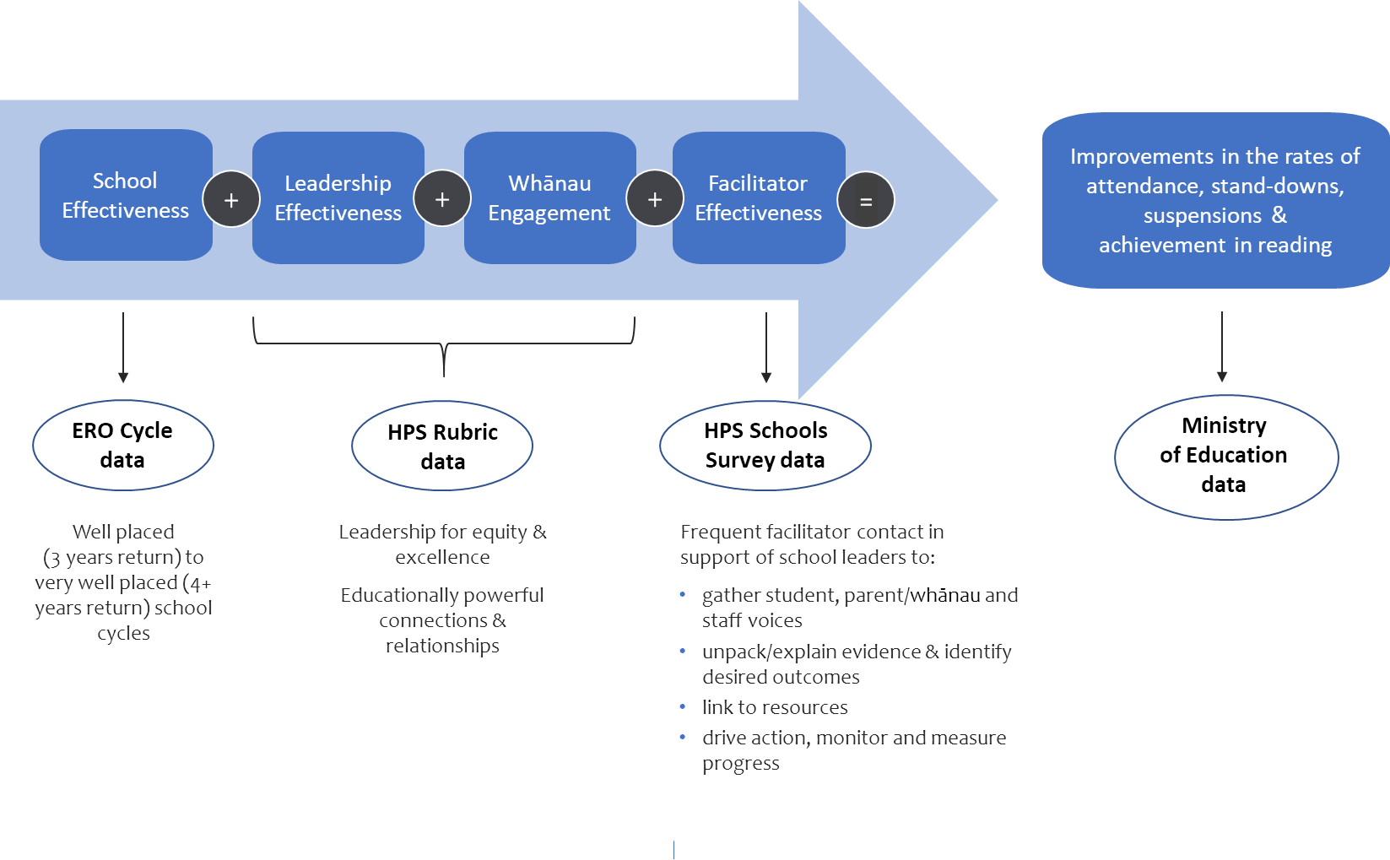

1^{, 2, 3} Significance p < .05

