Health of the Health Workforce
2013 to 2014
A report by Health Workforce New Zealand

Citation: Ministry of Health. 2014. Health of the Health Workforce 2013 to 2014. Wellington: Ministry of Health.
Published in November 2014
by the Ministry of Health
PO Box 5013, Wellington 6145, New Zealand
ISBN 978-0-478-42890-2 (print)
ISBN 978-0-478-42891-9 (online)
HP 6006
This document is available at www.health.govt.nz

This work is licensed under the Creative Commons Attribution 4.0 International licence. In essence, you are free to: share ie, copy and redistribute the material in any medium or format; adapt ie, remix, transform and build upon the material. You must give appropriate credit, provide a link to the licence and indicate if changes were made.

Foreword from
the Board Executive Chair
Health Workforce New Zealand
The Health Workforce New Zealand (HWNZ) Board is delighted by this first Health of the Health Workforce report. By itself, it signals that HWNZ has reached a level of maturity. In addition to an ongoing commitment to better regional educational infrastructure, the development of increasingly sophisticated career support and advisory systems, and the introduction of a transparent, accountable and contestable funding process, this report is only possible because HWNZ now has robust and reliable workforce intelligence.

Indeed, it is noteworthy that the New Zealand health system is much better informed about the current state of and future challenges for its workforces than any of the other members of the International Health Workforce Collaboration. The major contributor to this intelligence base has been the innovative and world-leading HWNZ health service forecasting methodology. On the basis of that intelligence, it is clear that the New Zealand health and disability workforce is in general good shape. However, there are some important shortages in the allied health workforce, and the medical workforce is not as well distributed against health need as it could be. Also, it is evident that there are other significant challenges facing the health system in regard to workforce.

However, these challenges are well understood, and corrective strategies are, or are being put, in place. The HWNZ Board believes that New Zealanders can be reassured that the health and disability workforce is largely and will increasingly be fit for purpose, affordable and sustainable.

Professor Des Gorman BSc MBChB MD (Auckland) PhD (Sydney)
Board Executive Chair, Health Workforce New Zealand

Foreword from the Director
Health Workforce New Zealand
This is HWNZ’s first report examining the health and disability workforce. It sets out what we know about the main occupational groups – doctors and dentists, nurses, midwives, allied health workers and non-regulated workers. Our goal is to ensure that the workforce is appropriately trained and configured to meet current and future needs, so New Zealanders can be confident that they will receive the very best care possible.

We are planning for an uncertain future. Changes in technology or shifts in the national or global economic outlook can turn traditional workforce planning on its head.

This report will not put exact numbers on how many nurses, GPs, sonographers or aged care workers New Zealand will need in a decade’s time. Such forecasting is an inexact science, akin to trying to predict the exchange rate 10 years hence. There are known variables that can drive the numbers up or down. What’s harder to predict is when or if these variables will come into play, and the impact of the unexpected.

Instead, we aggregate intelligence from a variety of sources to forecast future models of care. To identify and develop joined-up, mutually owned solutions to the challenges our sector faces, HWNZ has developed a taskforce and work programme for key workforces – doctors, nurses, midwives, allied health workers, non-regulated workers, and those in leadership and managerial roles. The focus will then shift to how these workforces can combine and align their efforts across new models of aged, primary and cancer care and other health priorities.

To inform our modelling, we are also seeking to improve the quality and quantity of data at our disposal.

This programme of work will enable us to develop more sophisticated responses to meeting the future health needs of New Zealanders.

Dr Graeme Benny
Director, Health Workforce New Zealand

Contents
Foreword from the Board Executive Chair Health Workforce New Zealand iii
Foreword from the Director Health Workforce New Zealand iv
The health of the health workforce 1
Data sources 1
General workforce facts and figures 1
Doctors 2
Dentists 7
Nurses 7
Midwives 11
Allied health workers 14
Non-regulated workers (kaiāwhina) 15
Future prospects for joining the workforce 18
Medical workforce 18
Nursing 19
Midwifery 19
Allied health 19
Non-regulated workforce 19
Appendices 20
Appendix 1: Numbers of medical specialists per 100,000 population 20
Appendix 2: Ratios of trainee doctors to specialists 24
Appendix 3: Numbers of nurses per 100,000 population 25
Appendix 4: List of allied health professions 26
Appendix 5: List of non-regulated/kaiāwhina roles 27

List of Tables
Table 1: Medical workforce statistics 5
Table 2: Nursing workforce statistics 9
Table 3: Midwifery workforce statistics 11
Table 4: Allied health workforce statistics 14
Table A1: Number of nurses 25

List of Figures
Figure 1: Percentage of doctors aged 55+ in 28 OECD countries, 2000 and 2011 3
Figure 2: Hard-to-staff communities for doctors and GP trainees on the 2015 Voluntary Bonding Scheme 4
Figure 3: Trends in numbers of GPs and non-GP specialists 5
Figure 4: Hard-to-staff communities for nurses on the 2015 Voluntary Bonding Scheme 8
Figure 5: Distribution of levels of experience for nurses trained overseas and in New Zealand 10
Figure 6: Hard-to-staff communities for midwives on the 2015 Voluntary Bonding Scheme 13
Figure A1: Ratios of trainee doctors to specialists 24

The health of the health workforce
The Health of the Health Workforce 2013 to 2014 is the first of what will be yearly reports on the state of the New Zealand health and disability workforce – hereafter referred to as the workforce. It is one of two reports that Health Workforce New Zealand (HWNZ) is publishing in 2014.

You can find out more about HWNZ in the companion report The Role of Health Workforce New Zealand.

Data sources
Evidence from a variety of sources contributes to HWNZ’s ability to synthesise information about the workforce and the environment it operates in, and from there to identify trends.

The data and workforce intelligence cited in these reports are drawn from multiple sources; for example, regulatory bodies such as the Medical Council of New Zealand (MCNZ) and Nursing Council of New Zealand (NCNZ), the wider Ministry of Health, district health boards (DHBs) and other employers, OECD reports, the New Zealand Census and Workforce Service Forecasts commissioned by HWNZ.

Because of this, there is some variation in the date ranges of the workforce data used.

General workforce facts and figures
The workforce is made up of a wide variety of occupational groups, ranging from highly trained health professionals to care and support workers with limited qualifications. The five main occupational groups discussed in this report are:
- doctors and dentists – the medical workforce
- nurses
- midwives
- allied health, science and technical workers
- non-regulated workers – also collectively termed kaiāwhina.

Doctors, dentists, nurses, midwives and a number of allied health professions are covered by the Health Practitioners Competence Assurance (HPCA) Act 2003, and are together referred to as the regulated workforce. Practitioners must be registered with the relevant regulatory body that issues annual practising certificates, considers complaints and takes disciplinary action when needed. The regulated workforce numbered 94,613 as of 31 March 2013, based on annual practising certificate data for all regulated professions.

District health boards are a key employer, with estimated Employed Full-Time Equivalent (FTE) workforces in March 2014 (and November 2008) of:
- 7518 (5930) doctors
- 20,719 (17,523) nurses
- 879 (801) midwives.

About one-third of New Zealand’s estimated 63,000-strong non-regulated workforce is employed by residential care providers.

Doctors
The medical workforce has grown by 15.2 percent in the past five years. There are currently 14,395 doctors with annual practising certificates registered with the MCNZ, up from 12,493 in 2009.

Some critical shortages remain in particular specialties. The following are signalled as hard-to-staff for 2015’s Voluntary Bonding Scheme (VBS): general practice, general surgery, internal medicine, pathology, psychiatry and rural hospital medicine. General practice continues to be an area of particular need, especially in certain rural and provincial areas. The VBS also records hard-to-staff regions year by year – see the map on page 3.

The Voluntary Bonding Scheme rewards medical, nursing and midwifery graduates who work in hard-to-staff specialties or communities for three to five postgraduate years. Medical physicists, sonographers and radiation therapists working in New Zealand are also eligible. More information is available at www.health.govt.nz

The medical workforce is ageing. Almost 40 percent of doctors are currently aged 50 or over, up from 34 percent in 2009. Five years ago, the largest group of doctors was aged between 45 and 49. Since 2011, the largest age group has been 50- to 54-year-olds. However, an ageing medical workforce is an international trend, and New Zealand is better placed than many other OECD countries in terms of the number of doctors in the workforce aged 55 years and over.

Figure 1: Percentage of doctors aged 55+ in 28 OECD countries, 2000 and 2011
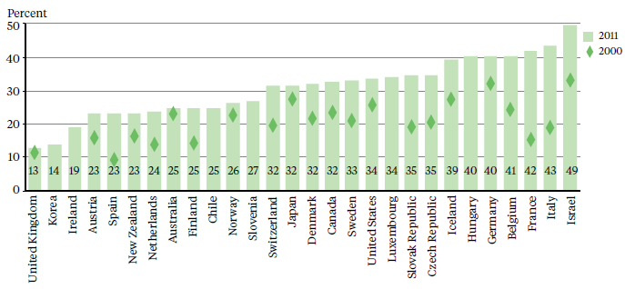

The gender gap in New Zealand’s medical workforce is closing. Women make up 41.3 percent of the workforce (39.1 percent in 2009) and outnumber men among new doctors. Further:
- 45 percent of female doctors are under 40 years of age
- 28 percent of male doctors are under 40 years of age
- 58 percent of house officers and 49 percent of registrars are women.

Māori and Pacific peoples remain under-represented in the medical workforce. However, recent
increases in the numbers of medical students from both groups indicate an emerging generation of Māori and Pacific doctors.

There are 69 GPs per 100,000 New Zealanders, up from 58 in 2009. Auckland, Capital & Coast and Nelson Marlborough DHBs have the highest numbers of GPs per head of population (100+), while West Coast, MidCentral and Counties Manukau have the lowest (37 to 51). See Appendix 1 for numbers of all specialists per 100,000 population.

Demand for GPs will only continue to rise as models of care move out of hospitals and into the community. However, the proportion of GPs in the specialist workforce continues to track slowly downwards, from 38.3 percent in 2007 to 37.5 percent in 2009 and 37.4 percent in mid-2014. Compounding this, the trend is for GPs to work shorter hours. MCNZ’s 2012 workforce survey – the latest available – showed that GPs worked on average 37.3 hours a week (0.93 FTE based on a 40-hour week), down from 40+ a decade ago. The average across all specialities was 43.1 hours a week.

Numbers of non-GP specialists continue to grow at a faster rate than GPs – see Figure 3. Between mid-2009 and mid-2014, MCNZ figures show the number of GPs with annual practising certificates went up by 24.5 percent (2509 to 3124). The number of non-GP specialists increased by 25.3 percent over the same time, up from 4176 to 5234.

Figure 2: Hard-to-staff communities for doctors and GP trainees on the 2015 Voluntary Bonding Scheme
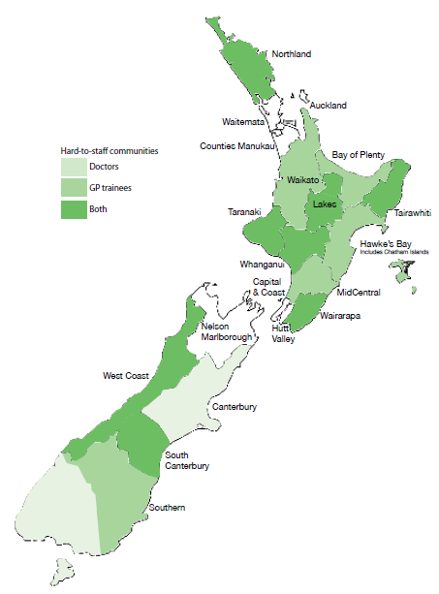

Figure 3: Trends in numbers of GPs and non-GP specialists
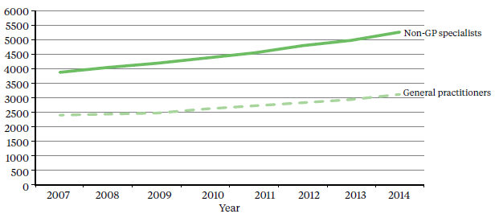

To help trainee doctors make informed decisions when choosing a specialty, HWNZ is modelling the medical workforce pipeline from graduation through to specialist training. This is a key aim of the Medical Workforce Taskforce. See our companion report, The Role of Health Workforce New Zealand, for more information.

Table 1: Medical workforce statistics
Medical workforce*
Size⁺ | Age 50+⁺ | Gender split | Ethnicity | Workplace^ | Qualified outside New Zealand
14,395  (including 3124 GPs) | 38.9% | Female 41.4%  Male 58.6% | European 95.3%  Māori 2.9%  Pacific 1.8% | Public 54.4%  Private 29%  Other 16.6% | 43.4%⁺
* Figures from MCNZ 2012 workforce survey, unless otherwise stated.
+ Annual practising certificates as of mid-2014.
^ Main place of employment.

Appendix 2 contains a graph showing each specialty’s ratio of postgraduate vocational trainees to specialists – and the average age of these senior doctors – to show which specialties are the most vulnerable to future shortages of senior staff.

Analysis so far indicates that graduate doctors who choose to train in certain specialties, including palliative medicine, rehabilitation and dermatology, are likely to have better job prospects. This is because the ratios of trainees to specialists are relatively low, and the average age of these senior doctors is 50+ years.

Job prospects are also good for doctors choosing to train as GPs. There is a high demand for GPs and a relatively low ratio of trainees to senior staff. General practice presents a doctor with the challenge of working with a wide variety of patients and being the first point of care. The hours tend to be more regular compared with other specialties, and there is greater scope for working part-time.

New Zealand continues to employ overseas-trained doctors to address staff shortages. Such doctors accounted for 43.4 percent of the medical workforce as of mid-2014, up from 42.8 percent in 2010 and 41.2 percent in 2007.

The increase in this figure is in part due to more overseas-trained doctors staying longer in New Zealand, particularly those from South Africa and Asian countries such as India, according to MCNZ analysis.

Doctors from North America and the United Kingdom are more likely to stay for a year or two, often alternating stints as a specialist locum with time off to travel. Just 35 percent of doctors from the United States and Canada are still in New Zealand one year after registration, compared with about 70 percent of those from Asia.

After two years, retention rates drop to 20 percent for North American doctors and 63 percent for those from Asian countries, and 10 percent and 45 percent respectively after eight years. For United Kingdom doctors, retention rates are 53 percent after one year, 30 percent after two years and 20 percent after eight years.

Retention rates for all overseas-trained doctors level out at about 30 percent four years after registration, with only gradual decreases thereafter – this was a consistent annual trend between 2000 and 2012, the period examined by the MCNZ in its report on its 2012 workforce survey.

The New Zealand-trained medical workforce is being boosted by an additional 200 government-funded medical student places, phased in between 2010 and 2016.

This in turn means that more postgraduate year one (PGY1) employment positions are required in DHBs. In 2013, for the first time, there were more applicants than vacancies for such positions as the first graduates of a separate expansion in student numbers joined the workforce. HWNZ and DHBs ensured that all New Zealand Government-funded students who graduated in 2013 received offers of employment. The Medical Workforce Taskforce’s priority is to ensure this will continue to be the case.

While the Taskforce initially focused on the immediate postgraduate period, a whole-of-career perspective has now been adopted. The most important issue is the impact of a prolonged period of medical labour market shortages on the workloads, wellbeing and productivity of DHB-employed senior doctors.

Other areas under consideration, some of which are directly related, include the distribution, long- term retention and retirement intentions of doctors trained in New Zealand and overseas. Leadership opportunities in systems improvement and innovation, consistent with the In Good Hands report on clinical leadership, are another focus for the Taskforce.

Dentists
In 2009, there were 1976 dentists with annual practising certificates registered with the Dental Council of New Zealand (DCNZ). This grew by 112 to 2088 by 31 March 2013; these are the latest figures available. In terms of head count, the ratio of practising dentists to the total population rose from 45.8 per 100,000 to 46.7 during this period.

In the past few years, the trend has been for roughly half of newly registered dentists to be New Zealand-trained. In 2012–13, for example, 48.2 percent of newly registered dentists gained their primary qualification overseas.

Other figures cited in this section are from the DCNZ’s 2009 workforce survey, the most recent available. In that survey, 2.8 percent of dentists identified as Māori and 1 percent as Pacific peoples.

In common with other countries – and other health professions – dentist shortages are most apparent in rural areas. This is illustrated by the ratio of FTE dentists to patients in each of the 20 DHB regions.

Just eight had more than 44 FTE dentists per 100,000 population in 2009. Five had fewer than 30 – Lakes, Tairawhiti, Whanganui, West Coast and South Canterbury. International comparisons of developed countries show ratios ranging from 44 to 94 FTE dentists per 100,000 population.

For information on other professions that provide dental care, particularly to children and young people, see the Allied health workers section of this report.

Nurses
The nursing workforce has grown steadily over the past five years. There were 51,387 nurses with annual practising certificates registered with the NCNZ as of 31 March 2014, including:
- 129 nurse practitioners
- 48,390 registered nurses
- 2868 enrolled nurses.

Figure 4: Hard-to-staff communities for nurses on the 2015 Voluntary Bonding Scheme
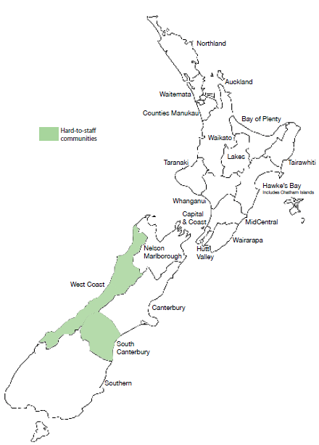

This represents an increase of 5422 since 2009, when there were 45,965 practising nurses, and 2860 since 2011 (48,527).

Figures cited in this section are from the New Zealand Nursing Register as of 31 March 2014, unless otherwise stated.

The number of practising nurses per 1000 population has increased from 10.6 in 2009 to 11.4 in 2014. The Auckland region has the highest number per head of population, while Lakes, Bay of Plenty and Whanganui DHB regions have the lowest. See Appendix 3 for numbers of nurses per 100,000 population by DHB and in New Zealand as a whole.

Nurses currently work an average of 29.7 hours a week (just under 0.75 FTE based on a 40-hour week), down slightly on 2009’s average of 30.6 hours.

The practice area with the highest percentage of nurses is surgical (10%). The lowest percentages are in youth health (0.3 %) and family planning and sexual health (0.3%).

The Voluntary Bonding Scheme signals aged care (also known as continuing care), primary care and mental health, including addiction services, as 2015’s hard-to-staff specialties for nurses. The percentages of nurses currently working in these specialties are:
- 8.9 percent in aged care
- 4.7 percent in primary care
- 7.6 percent in mental health services
- 0.4 percent in addiction services.

Almost 1500 New Zealand-trained nurses graduated in 2013/14. In recent years, not all graduates have found employment immediately, but New Zealand will need to train nurses in greater numbers by 2017, when numbers retiring from the workforce will become critical.

Nurse Entry to Practice (NETP) training programmes support nursing graduates in their first year of employment. Up to 200 extra NETP places will be funded in 2014/15, of which 40 will be in aged residential care (ARC NETP), bringing the total number of funded NETP places to 1300. Nurses can enter a NETP programme up to 24 months after graduating. An extra 25 nursing graduate scholarships are also available to work in GP practices in high-needs communities in 2015, in addition to the 48 scholarships funded in the past year.

Nursing is an ageing profession. This is a trend common across health workforces in New Zealand and overseas. The average age of nurses is 46.4 years (this is lower in main centres and higher in rural areas) – up from 45.9 in 2009. In 2014:
- 54 percent of nurses have been in practice for 15 or more years
- 46 percent are aged over 50 – up from 40 percent in 2009.

Table 2: Nursing workforce statistics
Nursing workforce*
Size | Age 50+ | Gender split | Ethnicity | Workplace^ | Qualified outside New Zealand
51,387 | 46% | Female 91.7%  Male 8.2% | European 90.7%  Māori 6.6%  Pacific 2.5% | DHB employed 52%  Primary health organisation 12%  Other 36% | 26%
* Annual practising certificate data as of 31 March 2014.
^ Main place of employment.

West Coast DHB has on average the oldest nursing workforce, followed by South Canterbury, Wairarapa, Nelson Marlborough and Hawke’s Bay.

The risk of staff shortages becomes greater as the proportion of experienced nurses approaching retirement increases. This is a particular issue in specialty areas with the highest average ages, such as palliative care (for which the average age of nurses is 53 years, up from 50 in 2009) and mental health (for which the average age is 51 years).

As the age profile suggests, the New Zealand-trained workforce is at present skewed towards experienced nurses. Nurses who trained overseas are somewhat more evenly distributed with respect to age and level of experience.

Overseas-trained nurses make up 26 percent of New Zealand’s nursing workforce. Their average age is 43.1 years, compared with 47.6 years for New Zealand-trained nurses. Just over half of overseas-trained nurses come from Australia and the United Kingdom. The remainder arrive mainly from Asia.

As Figure 5 shows, the majority of registered nurses, both New Zealand- and overseas-trained, have more than 15 years’ experience.

Figure 5: Distribution of levels of experience for nurses trained overseas and in New Zealand
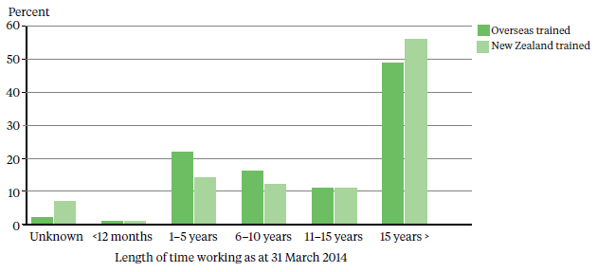

There is a demographic mismatch between the nursing workforce and the general population. The percentage of Asian registered nurses exceeds that of the Asian patient population in 16 of the 20 DHBs. In contrast, Māori and Pacific nurses are under-represented compared with the Māori and Pacific patient population across all DHB regions.

The percentage of Māori nurses is slowly rising – increasing from 3.6 percent in 2009 to 6.6 percent in 2014 – but the percentage of Pacific nurses has remained static at 2.5 percent since 2009. (The number of Pacific nurses is rising but so is the size of the overall nursing workforce.) Nursing is the second largest occupational group for Pacific peoples in the health and disability workforce, behind care and support workers (see the Non-regulated workers section). The majority of nurses who identify as Pacific peoples work in the greater Auckland area, home to seven in 10 of New Zealand’s Pacific population.

A further issue for the nursing workforce is that when economic conditions improve, the trend has been for nurses to exit the New Zealand workforce. Some leave the profession; others seek employment in countries such as Australia, where a shortage of nurses is forecast. This is expected to place further pressure on New Zealand’s future supply of nurses.

A nursing workforce programme is under way, a partnership between HWNZ, the Office of the Chief Nurse and the National Nursing Organisations. See our companion report, The Role of Health Workforce New Zealand, for more information.

Midwives
The supply of midwives has improved, but there continue to be workforce shortages, especially in rural areas. Demand for senior midwives is still very strong, with an ongoing reliance on overseas-trained practitioners.

As at 31 March 2013, there were 3072 midwives with annual practising certificates on the Midwifery Council of New Zealand’s register – up from 2823 in 2009. At that date, there were 33.6 midwives per 10,000 women of childbearing age, up from 2009’s ratio of 30.9.

Fewer babies are being born in New Zealand. Statistics New Zealand figures show 58,717 live births in 2013 and 61,568 in 2012, down from annual averages of about 64,100 between 2007 and 2010.

Table 3: Midwifery workforce statistics
Midwifery workforce*
Size | Age 50+ | Gender split | Ethnicity^ | Workplace# | Qualified outside New Zealand
3072 | 42.4% | Female 99.8%  Male 0.2% | European 88.9%  Māori 5.2% | DHB employed 54%  Self-employed LMC 32% | 34%
* Annual practising certificates, 31 March 2013, and the Midwifery Council’s September 2012 survey.
^ This figure relates to primary identified ethnicity.
# Main place of employment.

Midwifery is an almost exclusively female profession, with just six men in the workforce as at 31 March 2013. Three are self-employed lead maternity carers (LMCs), and three are hospital employees working shifts in maternity units.

Other figures in this section are from the Midwifery Council’s September 2012 workforce survey – the most recent available – unless otherwise stated.

The average age for midwives in 2012 was 46.8 years, down from 47 in 2009 and 47.2 in 2010. Almost six in 10 midwives (58%) had been in practice for more than 15 years, and about four in 10 midwives (42.4%) were aged over 50.

The age profile for midwives is slowly changing, in part due to an increase in student numbers enrolled in midwifery degrees in New Zealand. The proportions of midwives aged 20–24 and 25–29 have risen since 2010, when 126 new midwives – the first graduates of the expanded student intake – joined the workforce, compared with the previous annual average of 106. Graduate numbers have risen steadily since then, up to 147 in 2013/14. Midwifery is a profession that traditionally attracts older trainees, but midwifery schools report that the average age of students is falling.

The percentage of midwives identifying Māori as their first ethnicity in 2012 was 5.2 percent, up from 4.6 percent in 2009. Māori midwives are in demand, particularly in rural areas, where anecdotal reports suggest workloads are rising due to the increasing expectations of whānau.

About four in 10 midwives (42%) worked 32 hours a week or less in 2012 (0.75 FTE based on a 40-hour week) – a slight rise on 2009’s figure of 39.8 percent. That year LMC midwives cared for an average of 42 women a year. The recommended caseload is 40 to 60.

Midwives provide the majority of maternity services in rural areas, either as self-employed LMCs – who may travel from the nearest city – or as core midwives, who work shifts in hospitals.

About two-thirds of practising midwives work in the North Island, where a number of DHBs report staff shortages, according to the Midwifery and Maternity Provider Organisation’s (MMPO) annual workforce mapping project.

Figure 6: Hard-to-staff communities for midwives on the 2015 Voluntary Bonding Scheme
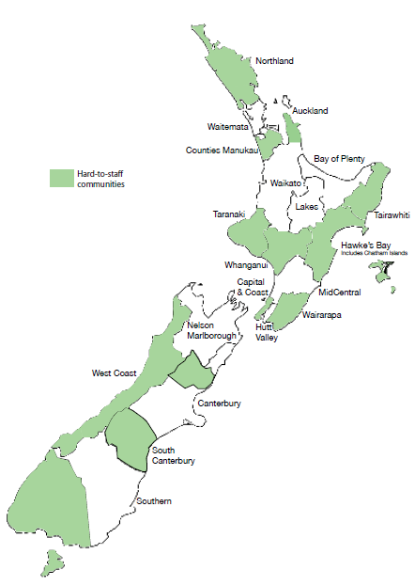

The South Island’s workforce is more stable, but rural communities across the country are vulnerable to shortages should a midwife retire or leave the area. It can take up to two years to recruit a replacement – especially if an experienced midwife with a large caseload departs. The Voluntary Bonding Scheme signals hard-to-staff communities for midwives – see Figure 6.

The MMPO’s mapping project found the number of hospital midwives dropped by 99 in the two years between 2011 and 2013, down from 1444 to 1345. This was in part due to some midwives in rural areas choosing to become self- employed LMCs.

Overseas-trained midwives made up 34 percent of the midwifery workforce in 2012 (down from 36.6 percent in 2009). The majority were from the UK, followed by Australia.

New Zealand graduates tend to stay in the workforce longer; a number of overseas-trained midwives come to New Zealand for international experience or a working holiday.

Allied health workers
There are more than 40 professions in the allied health, science and technical workforce, which includes those who provide technical and scientific expertise to support the diagnosis, monitoring, management and treatment of health conditions.

This workforce is becoming critical for addressing health targets, especially the diagnosis of chronic and non-communicable conditions such as cancer and heart disease.

About 20 allied health professions are regulated under the HPCA Act 2003. A list of these professions can be found in Appendix 4.

Table 4: Allied health workforce statistics
Allied health workforce
23,966* in professions with annual practising certificates, for example:
555 | dietitians | (527 in March 2009)
607 | dental hygienists | (403)
791 | dental therapists | (670)
1706 | medical laboratory scientists | (1621)
169 | magnetic resonance imaging (MRI) technicians |  | (77)
2296 | occupational therapists |  | (2095)
661 | optometrists |  | (675)
3351 | pharmacists |  | (3076)
4265 | physiotherapists |  | (4016)
538 | psychotherapists |  | (502)
348 | radiation therapists |  | (281)
* Annual practising certificates as of 31 March 2013 (the most recent information available), unless otherwise stated.

Workforce data tends to be scarce, particularly for the professions not regulated under the HPCA Act. (Self-regulation does not imply a lack of professional standards in comparison to professions regulated by this legislation.)

Many occupational groups in the allied health workforce are small, numbering in the tens or hundreds, and work autonomously or behind the scenes. This may contribute to a perception among allied health workers that their roles do not feature strongly when service delivery plans are developed.

These professions can quickly become vulnerable because of their small size and extended periods of training. Risk factors include:
- staff leaving the workforce
- a lack of training courses or positions
- technological advances, which may require additional training.

For example, there are about 20 perfusionists in New Zealand. During operations such as open-heart surgery, a perfusionist uses a machine that takes over from the heart and lungs to pump oxygenated blood through the body. If just one leaves the workforce, there will be a disproportionate impact on the delivery of health services.

A number of allied health professions appear on Immigration New Zealand’s long-term skill shortage list. Because there are too few home-grown professionals to fill vacancies in these professions at present, the percentage of overseas-trained practitioners tends to be high.

To address some critical shortages, sonographers, medical physicists and radiation therapists are included in 2015’s Voluntary Bonding Scheme (VBS). To be eligible for the VBS’s annual incentive payments, allied health applicants must work in New Zealand for three to five years. See www.health.govt.nz for more details.

Rapid scientific and technical advances mean new allied health careers are likely to arise in coming years, or existing roles will be transformed. Providing viable education and training programmes is likely to become a challenge.

HWNZ is developing an allied health taskforce and work programme, alongside work already under way to streamline training. See our companion report, The Role of Health Workforce New Zealand, for more information on the new multi-disciplinary framework for a number of allied health qualifications.

A particular challenge facing this workforce is that school students are typically unaware of the wide range of health careers. The majority think only of medicine or nursing, or of well-known allied health professions such as physiotherapy or dental hygiene.

More Māori and Pacific dental therapists working with children in deprived areas – in which proportions of Māori and Pacific peoples are typically higher – may help to address the inequalities in oral health and access to services identified in the 2009 New Zealand Oral Health Survey.

For information on dentists, see the Medical workforce section.

Non-regulated workers (kaiāwhina)
The wide and varied non-regulated workforce is so named because the professions it comprises are not regulated under the HPCA Act. (It should be noted that this does not imply a lack of professional standards.) The term covers professions ranging from corporate and administrative positions to carers and support workers. In this report, non-regulated allied health, science and technical professions are discussed in the Allied health workers section.

Opportunities in the non-regulated workforce are expected to rise as the population grows and ages and as care moves closer to home. Models of care increasingly focus on carers and support workers, to make more efficient use of the clinical workforce. Under such models, for example, health care assistants might undertake tasks and activities that free up doctors and nurses to concentrate on treating patients.

Workforce data is scarce, in part because no registration requirements apply and also because of the range of employers in the private and public health sectors. District health boards employ non- regulated workers, but so too do private companies and non-governmental organisations.

However, new research for Careerforce, the organisation responsible for the education and training of carers and community support workers, has cast light on the make-up of the non-regulated workforce. Careerforce and HWNZ term these workers kaiāwhina (a list of the health and disability roles covered by this term can be found in Appendix 5).

Examples of kaiāwhina roles:
- Disability support workers | - Personal care assistants | - Aged carers
- Mental health workers | - Nutritionists | - Audiologists
- Youth workers | - Rehabilitation assistants | - Whānau Ora workers

Careerforce’s analysis of 2013 Census data identified 62,910 kaiāwhina – an increase of 13.5 percent, or 7520 people, since the 2006 Census. This figure represents 3.3 percent of the total New Zealand workforce.

The demographic profile of kaiāwhina is older and female-dominated, with greater ethnic diversity and lower income and qualifications on average than the total New Zealand workforce (shown in brackets):
- 61 percent of kaiāwhina were aged 45 or older (47%)
- 84 percent were female (48%), but there was growth in male employment between 2006 and 2013
- 15 percent were Māori, 8 percent were Pacific peoples and 13 percent were Asian (11%, 5% and 11% respectively)
- 31 percent were born overseas (28%), particularly carers and support workers
- 56 percent earnt $30,000 or less a year (32%)
- 37 percent worked less than 30 hours a week (22%).

Carers account for two-thirds of kaiāwhina, particularly personal care assistants (47%) and aged or disabled carers (9%). Numbers of both have risen significantly since 2006.

The remainder of kaiāwhina is split between support workers (eg, community workers and family support officers) and occupations such as welfare workers and traditional Māori health practitioners. About 4 percent are in technical occupations and can also be considered part of the allied health workforce.

About one-third of kaiāwhina workers are employed by residential care providers, the largest employer group.

Carers and support workers are thought to make up the majority of the Pacific health and disability workforce. More than 4200 Pacific peoples work in these roles, compared with almost 1300 Pacific nurses, the next largest occupational group of Pacific health workers by a considerable margin.

A similar trend applies to the Māori workforce. There are almost 7500 Māori care and support workers, compared with about 3400 nurses, 410 doctors and 140 midwives.

HWNZ is developing a kaiāwhina taskforce and work programme with Careerforce, using the same approach that has been applied to other workforce groups. See our companion report, The Role of Health Workforce New Zealand, for more information.

Future prospects for joining the workforce
Health Workforce New Zealand’s main aim is to ensure the long-term sustainability of the health and disability workforce.

The projections in this section assess job prospects for particular areas within the workforce in the next five years, to provide information to those interested in joining the workforce, or those currently working in the health sector and thinking about future opportunities. The intention is to indicate overall trends rather than provide exact forecasts.

These projections are based on data and workforce intelligence from a range of sources. Note that workforce trends are affected by a complex range of events, some of which are very difficult to predict. Sometimes job prospects can change within a short period of time.

For information on training requirements and pay rates for a number of health careers, see the Occupation Outlook 2014 report or app on the Ministry of Business, Innovation and Employment’s website.

Medical workforce
Prospects are particularly good for GPs, especially in rural areas, and for other specialties, including:  - dermatology  - general surgery  - internal medicine  - paediatric surgery  - palliative care  - pathology  - psychiatry  - rural hospital medicine. | Prospects may be limited for specialties including:  - urgent care  - emergency medicine  - paediatrics.  The specialties with poorer job prospects are those that currently have high ratios of postgraduate trainee doctors to senior staff. If this trend continues within a given specialty, there will be greater competition for future senior vacancies. See Appendix 2 for a graph showing ratios of trainees to senior doctors for all specialties, including GPs.

Nursing
Prospects are particularly good for advanced practice om areas including:
- cancer care
- long-term condition management
- endoscopy
- aged care.

In recent years, not all nursing graduates have found employment immediately, but workforce planning indicates New Zealand will need to train more nurses by 2017, when retirement among the ageing workforce becomes a critical factor.

Midwifery
Opportunities are available particularly in rural areas.

Allied health
Prospects are good for professions including:  - sonographer  - dental hygienists  - dental therapists  - MRI technicians  - medical physicists. | Prospects are stable for professions including:  - medical laboratory scientists  - occupational therapists  - pharmacists. | Prospects may be limited for dietitians.

Non-regulated workforce
Demand for carers and support workers will only continue to rise as the population ages and the trend for care to move out of hospitals and closer to people’s homes continues. For a list of non-regulated health professions, see Appendix 5.

Appendices

Appendix 1: Numbers of medical specialists per 100,000 population
The following list is based on the number of annual practising certificates issued by the MCNZ as of mid-2014. These numbers indicate a head count, rather than numbers of FTEs.

A figure of 0 per 100,000 does not mean New Zealand lacks these specialists – rather, it indicates that numbers are too small to meaningfully record.

 | Northland | Waitemata | Auckland | Counties Manukau | Waikato | Lakes | Bay of Plenty
Anaesthesia | 12 | 7 | 43 | 1 | 15 | 16 | 11
Cardiothoracic surgery | 0 | 0 | 2 | 0 | 2 | 0 | 0
Clinical genetics | 0 | 0 | 1 | 0 | 0 | 0 | 0
Dermatology | 0 | 1 | 4 | 0 | 1 | 0 | 2
Diagnostic and interventional radiology | 6 | 3 | 27 | 2 | 6 | 5 | 7
Emergency medicine | 7 | 2 | 13 | 0 | 4 | 4 | 3
Family planning and reproductive health | 0 | 0 | 1 | 0 | 1 | 0 | 0
General practice | 71 | 43 | 125 | 37 | 62 | 67 | 67
General surgery | 6 | 2 | 15 | 0 | 7 | 6 | 5
Intensive care medicine | 0 | 1 | 5 | 0 | 1 | 0 | 0
Internal medicine | 9 | 8 | 60 | 3 | 19 | 15 | 12
Medical administration | 2 | 0 | 1 | 0 | 1 | 0 | 0
Musculoskeletal medicine | 1 | 0 | 1 | 0 | 0 | 1 | 0
Neurosurgery | 0 | 0 | 1 | 0 | 1 | 0 | 0
Obstetrics and gynaecology | 5 | 3 | 18 | 2 | 4 | 5 | 5
Occupational medicine | 0 | 1 | 1 | 1 | 0 | 1 | 1
Ophthalmology | 2 | 1 | 9 | 1 | 3 | 3 | 3
Oral and maxillofacial surgery | 0 | 0 | 1 | 0 | 1 | 0 | 0
Orthopaedic surgery | 6 | 3 | 16 | 1 | 5 | 8 | 8
Otolaryngology/  head and neck surgery | 2 | 1 | 6 | 0 | 2 | 4 | 2
Paediatric surgery | 0 | 0 | 1 | 0 | 1 | 0 | 0
Paediatrics | 7 | 3 | 28 | 1 | 5 | 8 | 7
Pain medicine | 0 | 0 | 2 | 0 | 1 | 0 | 0
Palliative medicine | 1 | 0 | 2 | 0 | 1 | 0 | 0
Pathology | 3 | 2 | 18 | 0 | 5 | 0 | 3
Plastic and reconstructive surgery | 1 | 0 | 5 | 0 | 2 | 0 | 0
Psychiatry | 9 | 6 | 29 | 4 | 11 | 4 | 7
Public health medicine | 1 | 1 | 10 | 1 | 2 | 0 | 2
Radiation oncology | 1 | 0 | 3 | 0 | 2 | 0 | 0
Rehabilitation medicine | 0 | 1 | 1 | 0 | 0 | 0 | 0
Rural hospital medicine | 10 | 0 | 0 | 1 | 3 | 3 | 0
Sexual health medicine | 0 | 0 | 1 | 0 | 1 | 0 | 0
Sports medicine | 0 | 0 | 1 | 0 | 0 | 0 | 0
Urgent care | 1 | 2 | 5 | 1 | 1 | 3 | 3
Urology | 1 | 0 | 3 | 0 | 2 | 1 | 2
Vascular surgery | 0 | 0 | 1 | 0 | 1 | 0 | 0

 | Tairawhiti | Hawke’s Bay | Taranaki | MidCentral | Whanganui | Capital & Coast | Hutt
Anaesthesia | 9 | 13 | 14 | 13 | 14 | 21 | 8
Cardiothoracic surgery | 0 | 0 | 0 | 0 | 0 | 1 | 0
Clinical genetics | 0 | 0 | 0 | 0 | 0 | 1 | 0
Dermatology | 0 | 1 | 1 | 1 | 0 | 1 | 0
Diagnostic and interventional radiology | 2 | 8 | 3 | 6 | 2 | 10 | 4
Emergency medicine | 2 | 3 | 3 | 3 | 3 | 5 | 3
Family planning and reproductive health | 2 | 0 | 0 | 0 | 0 | 1 | 0
General practice | 75 | 67 | 63 | 49 | 61 | 81 | 55
General surgery | 13 | 4 | 5 | 4 | 8 | 6 | 3
Intensive care medicine | 0 | 3 | 2 | 1 | 0 | 3 | 1
Internal medicine | 6 | 13 | 9 | 21 | 10 | 29 | 14
Medical administration | 0 | 0 | 1 | 1 | 0 | 1 | 0
Musculoskeletal medicine | 0 | 0 | 0 | 1 | 2 | 0 | 0
Neurosurgery | 0 | 0 | 0 | 0 | 0 | 2 | 0
Obstetrics and gynaecology | 6 | 4 | 4 | 5 | 3 | 5 | 3
Occupational medicine | 0 | 1 | 0 | 0 | 2 | 5 | 1
Ophthalmology | 2 | 3 | 3 | 2 | 0 | 5 | 0
Oral and maxillofacial surgery | 0 | 1 | 0 | 0 | 0 | 0 | 1
Orthopaedic surgery | 4 | 5 | 6 | 4 | 6 | 7 | 5
Otolaryngology/  Head and neck surgery | 4 | 3 | 2 | 2 | 2 | 3 | 2
Paediatric surgery | 0 | 0 | 0 | 0 | 0 | 1 | 0
Paediatrics | 11 | 6 | 6 | 4 | 3 | 6 | 5
Pain medicine | 0 | 0 | 1 | 0 | 0 | 1 | 0
Palliative medicine | 0 | 2 | 0 | 0 | 0 | 2 | 1
Pathology | 2 | 1 | 3 | 5 | 0 | 7 | 2
Plastic and reconstructive surgery | 0 | 0 | 0 | 1 | 0 | 1 | 6
Psychiatry | 2 | 6 | 10 | 6 | 10 | 18 | 12
Public health medicine | 2 | 2 | 2 | 2 | 2 | 9 | 8
Radiation oncology | 0 | 0 | 0 | 3 | 0 | 2 | 1
Rehabilitation medicine | 0 | 0 | 0 | 1 | 0 | 0 | 0
Rural hospital medicine | 2 | 1 | 1 | 1 | 0 | 0 | 1
Sexual health medicine | 0 | 0 | 0 | 0 | 0 | 1 | 0
Sports medicine | 0 | 0 | 0 | 1 | 0 | 1 | 0
Urgent care | 11 | 1 | 3 | 1 | 3 | 1 | 1
Urology | 0 | 2 | 1 | 2 | 0 | 2 | 0
Vascular surgery | 0 | 0 | 0 | 0 | 0 | 1 | 0

 | Wairarapa | Nelson Marlborough | West Coast | Canterbury | South Canterbury | Southern | New Zealand
Anaesthesia | 5 | 14 | 6 | 15 | 14 | 12 | 15
Cardiothoracic surgery | 0 | 0 | 0 | 1 | 0 | 1 | 1
Clinical genetics | 0 | 0 | 0 | 0 | 0 | 0 | 0
Dermatology | 0 | 2 | 3 | 2 | 0 | 1 | 1
Diagnostic and interventional radiology | 2 | 8 | 0 | 10 | 2 | 6 | 9
Emergency medicine | 5 | 5 | 0 | 4 | 5 | 6 | 4
Family planning and reproductive health | 0 | 0 | 0 | 1 | 0 | 1 | 1
General practice | 61 | 88 | 51 | 75 | 46 | 78 | 69
General surgery | 7 | 8 | 9 | 5 | 11 | 5 | 6
Intensive care medicine | 0 | 1 | 0 | 1 | 0 | 1 | 1
Internal medicine | 12 | 15 | 12 | 23 | 14 | 20 | 20
Medical administration | 0 | 0 | 0 | 0 | 0 | 0 | 0
Musculoskeletal medicine | 0 | 0 | 0 | 1 | 0 | 0 | 0
Neurosurgery | 0 | 0 | 0 | 1 | 0 | 1 | 0
Obstetrics and gynaecology | 2 | 6 | 9 | 6 | 7 | 5 | 6
Occupational medicine | 0 | 0 | 0 | 1 | 0 | 2 | 1
Ophthalmology | 0 | 4 | 0 | 3 | 2 | 3 | 3
Oral and maxillofacial surgery | 0 | 1 | 0 | 1 | 0 | 0 | 0
Orthopaedic surgery | 10 | 6 | 3 | 5 | 12 | 6 | 6
Otolaryngology/  Head and neck surgery | 0 | 3 | 0 | 2 | 4 | 2 | 2
Paediatric surgery | 0 | 0 | 0 | 1 | 0 | 0 | 0
Paediatrics | 2 | 6 | 0 | 6 | 2 | 5 | 7
Pain medicine | 0 | 0 | 0 | 0 | 2 | 1 | 0
Palliative medicine | 0 | 0 | 0 | 1 | 0 | 1 | 1
Pathology | 0 | 3 | 0 | 7 | 2 | 5 | 5
Plastic and reconstructive surgery | 0 | 0 | 0 | 2 | 0 | 1 | 1
Psychiatry | 7 | 8 | 12 | 14 | 5 | 15 | 12
Public health medicine | 0 | 1 | 0 | 3 | 0 | 7 | 4
Radiation oncology | 0 | 0 | 0 | 2 | 0 | 1 | 1
Rehabilitation medicine | 0 | 1 | 0 | 1 | 0 | 1 | 0
Rural hospital medicine | 0 | 4 | 12 | 1 | 2 | 5 | 2
Sexual health medicine | 0 | 0 | 0 | 1 | 0 | 0 | 0
Sports medicine | 0 | 0 | 0 | 1 | 0 | 1 | 1
Urgent care | 2 | 0 | 0 | 1 | 0 | 1 | 2
Urology | 0 | 2 | 0 | 2 | 0 | 1 | 1
Vascular surgery | 0 | 1 | 0 | 1 | 0 | 0 | 0

Appendix 2: Ratios of trainee doctors to specialists
Specialties with ratios closest to zero – and/or in which SMOs have an average age of 50+ years – are the most vulnerable to future shortages of senior staff, and therefore represent the best job prospects.

Figure A1: Ratios of trainee doctors to specialists
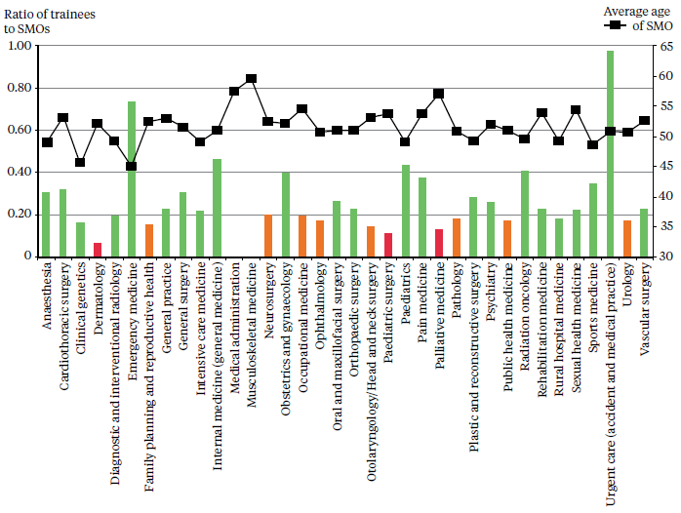
1 Number and average age of SMOs by vocational registration provided by MCNZ, March 2014.
2 Number of trainees in medical administration (0, with 22 SMOs) and musculoskeletal medicine (0, because there is no current training programme, with 22 SMOs) provided by representative colleges, December 2013.
3 Number of trainees in general practice, urgent care, occupational medicine, pain medicine, public health medicine and sports medicine provided by representative colleges, December 2013–May 2014. Note: The high number of urgent care trainees is intended to redress a shortfall in SMOs. The Royal New Zealand College of Urgent Care plans to scale back trainee numbers in future.
4 Number of trainees in family planning calculated by number undertaking Clinical Diploma in Sexual and Reproductive Health, May 2014.
5 Number of trainees in all other specialties provided by DHBs (Resident Medical Officer Workforce Collection Profile), December 2013.

Appendix 3: Numbers of nurses per 100,000 population
This table is based on the number of annual practising certificates issued by the Nursing Council as of 30 June 2014. These numbers indicate a head count, rather than numbers of FTEs.

Table A1: Number of nurses
DHB | Enrolled nurses | Nurse practitioners | Registered nurses
Northland | 79 | 4 | 1032
Waitemata | 27 | 2 | 569
Auckland | 43 | 4 | 1453
Counties Manukau | 27 | 1 | 571
Waikato | 55 | 4 | 1021
Lakes | 56 | 2 | 918
Bay of Plenty | 58 | 4 | 1007
Tairawhiti | 71 | 0 | 1048
Hawke’s Bay | 63 | 6 | 1051
Taranaki | 78 | 5 | 1029
MidCentral | 75 | 8 | 1027
Whanganui | 68 | 0 | 963
Capital & Coast | 30 | 1 | 1159
Hutt Valley | 37 | 3 | 801
Wairarapa | 108 | 2 | 981
Nelson Marlborough | 60 | 1 | 999
West Coast | 232 | 3 | 1049
Canterbury | 99 | 1 | 1106
South Canterbury | 119 | 5 | 995
Southern | 113 | 4 | 1001
Average across all DHB regions | 64 | 3 | 1073

Appendix 4: List of allied health professions
Below is a list of most of the professions generally regarded as allied health (including science and technical) professions. Some are regulated under the HPCA Act.

Anaesthetic technicians  Audiologists  Biomedical engineers and electronic technicians  Cardiac sonographers  Chiropractors  Clinical dental technicians  Clinical perfusionists  Clinical physiologists – dialysis (renal dialysis technicians)  Clinical physiologists – respiratory  Clinical physiologists and technicians – cardiac  Clinical physiologists and technicians – sleep  Clinical psychologists  Community health workers – public health  Counsellors  Cytogeneticists  Dental assistants  Dental hygienists  Dental technicians  Dental therapists  Dietitians  Dispensing opticians  Diversional therapists  Drug and addiction practitioners  Exercise physiologists  Gastroenterology scientists and technicians  Genetic associates  Hospital play specialists  Magnetic resonance imaging technologists  Massage therapists | Medical imaging (or radiation) technologists  Medical laboratory scientists  Medical laboratory technicians  Medical photographers  Medical physicists  Music therapists  Neurophysiology scientists  Neurophysiology technicians  Nuclear medicine technologists  Occupational therapists  Optometrists  Orthoptists  Orthotists and prosthestists  Osteopaths  Paramedics  Pharmacists  Pharmacy technicians  Physiotherapists  Podiatrists  Psychologists  Psychotherapists  Radiation therapists  Social workers  Sonographers  Speech and language therapists  Sterile service technicians  Traditional Chinese medicine practitioners  Vision and hearing technicians  Visiting neurodevelopmental therapists

Appendix 5: List of non-regulated/kaiāwhina roles
This list is the non-regulated professions regarded as part of the kaiāwhina workforce. The technical professions listed below are discussed in the Allied Health Workers section of this report.

Job titles are based on the Australian and New Zealand Standard Classification of Occupations 2006, also known as ANZSCO codes, used in the Census.

Non-regulated professional, support and carer roles
Aged or disabled carers  Child or youth residential care assistants  Community workers  Counsellors  Disabilities services officers  Diversional therapists  Drug and alcohol counsellors  Family and marriage counsellors  Family support workers  Health diagnostic and promotion professionals  Health promotion officers | Hospital orderlies  Kaiāwhina hauora (Māori health assistants)  Nursing support workers  Personal care assistants  Rehabilitation counsellors  Residential care officers  Social workers  Therapy aides  Traditional Māori health practitioners  Welfare workers  Youth workers

Non-regulated technical roles
Audiologists
Cardiac technicians
Dental technicians
Medical technicians
Operating theatre technicians
Orthotists or prosthetists
Phlebotomists

These figures are DHB clinical staffing numbers and are available at www.health.govt.nz The Employed FTE methodology is based on contracted hours, in which one FTE is a person working 40 hours a week or more.
Annual practising certificates to legally work in New Zealand as of mid-2014 and mid-2009.
OECD. 2013. Health at a Glance 2013: OECD indicators. OECD Publishing, p 67.
Medical graduates typically in their first or second year of work in a hospital.
Hospital positions for doctors in at least their third postgraduate year.
Pacific Perspectives. 2013. Pacific Workforce Service Forecast, for HWNZ. Wellington: Pacific Perspectives.
MCNZ registration by specialty for annual practising certificates as of mid-2014.
Annual practising certificates as of late March/early April each year, with the exception of 16 May 2014.
MCNZ. 2013. The New Zealand Medical Workforce in 2012. Wellington: Medical Council of New Zealand.
Ministerial Task Group on Clinical Leadership. 2009. In Good Hands: Transforming Clinical Governance in New Zealand. Wellington.
DCNZ. Annual Report 2013. Wellington: Dental Council of New Zealand.
Primary and secondary ethnicity combined.
DCNZ. Workforce Analysis 2009. Wellington: Dental Council of New Zealand.
The role of enrolled nurse was reintroduced in 2010, having been phased out in the early 1990s.
HWNZ forecasting and a 2013 workforce report by the NCNZ reached this conclusion.
New Zealand-trained citizens and permanent residents are eligible for Nurse Entry to Practice (NETP) places.
These scholarships are funded through the Ministry’s Very Low Cost Access scheme.
Pacific Perspectives. 2013. Pacific Workforce Service Forecast for HWNZ. Wellington: Pacific Perspectives.
Lead maternity carers provide maternity care and support throughout pregnancy, labour and the first weeks of a baby’s life. Most are midwives, but GPs with obstetrics training may also carry out this role.
Kyle and Aileone. 2013. Mapping the Rural Midwifery Workforce in New Zealand. Christchurch: Midwifery and Maternity Provider Organisation.
Midwifery Council of New Zealand. 2010. Midwifery Workforce Report 2009. Wellington: Midwifery Council of New Zealand.
Kyle and Aileone. 2013. Mapping the Rural Midwifery Workforce in New Zealand. Christchurch: Midwifery and Maternity Provider Organisation.
See Appendix 4 for a list of professions included under the allied health umbrella. This is not intended to be an exhaustive list – there is a lack of agreement about which professions should be included.
Ministry of Health. 2009. Our Oral Health. Wellington: Ministry of Health.
BERL Economics. 2014. Health and Disability Kaiāwhina Worker Workforce 2013 Profile for Careerforce. Wellington: Business and Economic Research Ltd.
Note that Census respondents are able to choose more than one ethnicity.
Pacific Perspectives. 2013. Pacific Workforce Service Forecast for HWNZ. Wellington: Pacific Perspectives.
Nursing Council registration data as of 31 March 2014.
Social workers are voluntarily regulated under the Social Workers Registration Act 2003, administered by the Ministry of Social Development.

