Appendix 4: Example of a review of an organisational document
This page comes from the Northland District Health Board’s Health Services Plan 2012–2017. The table underneath indicates a possible approach to reviewing this page.

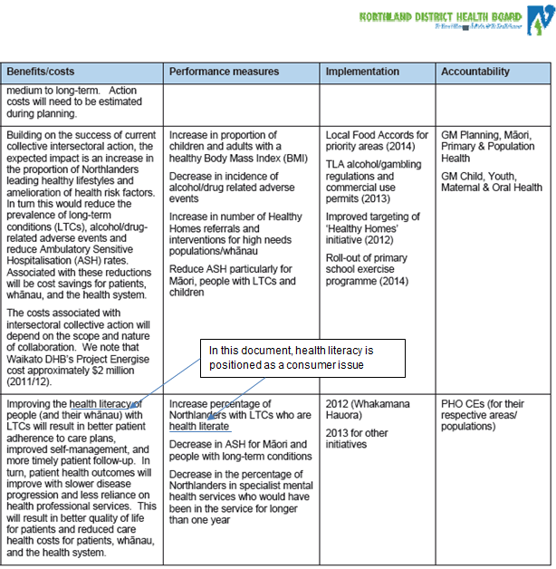
© Northland District Health Board

Document: Northland DHB Health Services Plan 2012–2017 (page 36)
References to health literacy  (link to Six Dimensions where relevant) | How it is positioned | Implications for review  (link to Six Dimensions where relevant)
Specifically refers to people with inadequate health literacy becoming more health-literate | As a consumer issue | A change of focus is needed from health literacy as a consumer issue to understanding the role of the district health board, its systems and processes, and staff in developing the health literacy of consumers and families.  (Dimensions 1 to 6)

