Health and Independence Report
2016
The Director-General of Health’s
Annual Report on the State of Public Health

Citation: Ministry of Health. 2017. Health and Independence Report 2016:
The Director-General of Health’s Annual Report on the State of Public Health.
Wellington: Ministry of Health.
Published in April 2017
by the Ministry of Health
PO Box 5013, Wellington 6140, New Zealand
ISBN 978-1-98-850231-1 (print)
ISBN 978-1-98-850232-8 (online)
HP 6580
This document is available at www.health.govt.nz
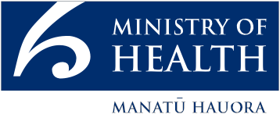
This work is licensed under the Creative Commons Attribution 4.0 International licence. In essence, you are free to: share ie, copy and redistribute the material in any medium or format; adapt ie, remix, transform and build upon the material. You must give appropriate credit, provide a link to the licence and indicate if changes were made.

Foreword
I am pleased to present the Health and Independence Report 2016.

Based on a range of information sources, such as the New Zealand Health Survey, Statistics New Zealand and other health sector reports, it provides a clear and comprehensive picture of the state of public health in New Zealand.

Overall, our health and disability system performs well for most New Zealanders, helping them live longer, healthier and more independent lives. While we have made good progress, we have more work to do, particularly for those affected by long-term conditions, disabilities or impairments.

This report recognises New Zealand’s population is growing, ageing and becoming more diverse within and across regions, meaning what was needed from our health system 20 or 30 years ago is different to what we need today, and what we will need in the future.

Like many countries, New Zealand has to deal with the challenges and opportunities presented by a changing population, shifting social trends and advances in technology. An ageing population brings greater demand for health services and support to help older people live healthy and independent lives. Obesity is becoming more common, and this has long-term health and social impacts that must be managed. And our health and disability system, while it works well for most people, has not always served every part of our society well; for example, Māori and Pacific peoples often have poorer health outcomes compared to the population as a whole.

Meeting these challenges will require different approaches to how we plan and deliver health services. The refreshed New Zealand Health Strategy has set our direction, and the health and disability system is responding. This report outlines the greater focus that has been put on primary prevention and screening in recent years to catch and treat diseases early, as well as moves under way to increase the use of technology and innovation in providing health services.

We also know that our own lifestyle choices and behaviours have a significant impact on our health and wellbeing. So finding better ways to assist New Zealanders to live well, stay well and get well must be a focus for the future.

Better integration of services is also happening. We know that many factors affect people’s health and wellbeing, and increasingly government agencies, providers, other organisations, communities and iwi are working together to achieve better health outcomes for all New Zealanders.

The 2016 Health and Independence Report highlights the challenges we face, and also shows the opportunities we have to raise the level of health and wellbeing of all New Zealanders even higher. Working together, across the health sector and wider community, we can make a difference. It is an exciting time.

Chai Chuah
Director-General of Health
Ministry of Health

Acknowledgements
This report was jointly prepared by the Strategy and Policy Business Unit and the Client Insights and Analytics Business Unit, Ministry of Health.

Inbal Salz and Mathew Powell would like to thank the peer reviewers and those who provided data for inclusion in this report.

Contents
Foreword iii
Acknowledgements iv
Executive summary ix
Our population ix
Our health ix
Our direction x
Introduction 1
Chapter 1: A growing population 2
Our life and health expectancy have increased 6
Long-term conditions are the major cause of health loss 8
More people are living with a disability 10
Chapter 2: Our health 11
Our health needs are changing 11
Diet and physical activity play a major role in our health and wellbeing 14
Key conditions impacting adults and our ageing population 28
Responding to our changing population and operating environment 44
Chapter 3: Our direction 45
The New Zealand Health Strategy 2016 45
Working together as one team across government and the sector 46
Prevention, early intervention and care closer to home 50
Smart use of data, information, technology and the workforce 53
Improving quality 59
Technical notes 61
References 62

List of Tables
Table 1: New Zealand population, 2013 and 2038 (projected) 3
Table 2: Socioeconomic indicators, Māori and non-Māori, 2013 13
Table 3: Health targets, and results, quarter 4 2015/16 48
Table 4: Access to primary health care services 51
Table 5: Outcomes for at-risk children aged 0–5 years 54

List of Figures
Figure 1: A growing and increasingly diverse population 2
Figure 2: New Zealand population (present and projected), 2013–2038, by ethnicity 3
Figure 3: Proportion of population aged 65 years and over, 2005–2056 (projected) by age group 4
Figure 4: New Zealand population, 2015, Māori and non-Māori, by age 5
Figure 5: Life expectancy and health expectancy at a glance, 1990–2015 6
Figure 6: Life expectancy and health expectancy, 1990–2015, females 6
Figure 7: Life expectancy and health expectancy, 1990–2015, males 7
Figure 8: Absolute difference of life expectancy and health expectancy, 1990–2015, by gender 7
Figure 9: Age-standardised total disability-adjusted life years rate per 1,000,
1990–2015 (projected) 8
Figure 10: Percentage of disability-adjusted life years from high-level cause groups, 1990 and 2013 9
Figure 11: Amenable mortality, age standardised rates, 0- to 74-year-olds, 2000–2013 9
Figure 12: Impairment rates for males and females by impairment type, 2013 10
Figure 13: Factors contributing to health 11
Figure 14: Neighbourhood deprivation distribution (NZDep 2013), Māori and non-Māori, 2013 12
Figure 15: Health loss as a percentage of total disability-adjusted life years 2013, by cause (risk cluster) 13
Figure 16: Age-standardised hospitalisation rates for chronic obstructive pulmonary disease, 2004–2014, by ethnicity and gender (per 100,000) 19
Figure 17: Age-specific disability-adjusted life years rates per 1,000, 2013, by age group 21
Figure 18: Percentage of mothers exclusively/full breastfeeding, 2015, by age of the baby and ethnicity 24
Figure 19: Immunisation coverage of eight-month-old babies, June 2009–December 2016, by total ethnicity, and deprivation deciles 9 and 10 25
Figure 20: Non-standardised ambulatory sensitive hospitalisation rates for 0- to 4-year-olds, 2012–2016, by total and ethnicity 26
Figure 21: Percentage of disability-adjusted life years, by condition group, 2013 28
Figure 22: Age-standardised rate per 1,000 of disability-adjusted life years attributable to coronary heart disease, 1990–2015 (projected) 29
Figure 23: Age-standardised mortality rate due to coronary heart disease, 1996–2013, males, by ethnicity 30
Figure 24: Age-standardised mortality rate due to coronary heart disease, 1996–2013, females, by ethnicity 30
Figure 25: Number and age-specific rates of cancer registration, 2013, by age group 34
Figure 26: Age adjusted cancer registration rate for Māori and non-Māori males,
2004–2013 35
Figure 27: Age adjusted cancer registration rate for Māori and non-Māori females, 2004–2013 35
Figure 28: Age-standardised mortality rate due to cancer, 2004–2013, Māori and non-Māori males 36
Figure 29: Age-standardised mortality rate due to cancer, 2004–2013, Māori and non-Māori females 36
Figure 30: Proportion of the population with diabetes, 2015, by ethnicity and age group 37
Figure 31: Proportion of the population with diabetes, 2007 and 2015, by age group 37
Figure 32: Age-standardised disability-adjusted life year rate per 1,000 attributable to diabetes, 1990–2015 (projected) 38
Figure 33: Rate of clients seen in specialist mental health services, 2007–2016, by ethnicity 41
Figure 34: A social investment approach 55
Figure 35: Compliance rates for process markers to reduce surgical site infections post knee and hip replacement, by category and quarter, July 2013–April 2016 60

Executive summary
The Health and Independence Report presents an overview of the current state of public health in New Zealand. This year’s report highlights important improvements in the health of New Zealanders in recent decades. It also identifies areas of challenge and opportunity in the context of our goal of improving, promoting and protecting the health of all New Zealanders, now and in the future.

Our population
Chapter 1 looks at our changing population. As a nation, our population is growing, ageing and becoming more ethnically and regionally diverse.

People’s life expectancy (how long we live) and health expectancy (how long we live in good health) are improving. This builds on a strong platform of health improvement in recent decades. Over the past quarter century, New Zealand achieved one of the fastest rates of decline in health loss from all causes combined among high-income countries. This is a major achievement for the health and wider social sector.

Important challenges remain, including addressing inequalities of outcomes for key populations, further reducing premature mortality, increasing years spent in good health and improving care and support for people living with long-term conditions and disability.

Our health
Chapter 2 describes how many of the major causes of ill health we are now experiencing are influenced by our wider social, economic and physical environment as well as biological and behavioural factors. Recent estimates indicate that over one-third of health loss is preventable. This means a healthy environment and healthier lifestyles have the potential to substantially reduce future ill health and premature mortality.

For example, what we eat, how active we are, and whether we smoke or have a hazardous drinking pattern all have a significant influence on our health and wellbeing. Promoting good health and preventing illness is an important focus for the health system. This report includes some examples of initiatives under way in this regard, including Healthy Families NZ, Green Prescriptions and the Childhood Obesity Plan.

This report shows there are inequalities in the distribution of risk factors that contribute to people becoming unwell (such as smoking) and associated ill health and mortality (such as lung cancer). Inequalities in health outcomes are particularly evident for Māori, Pacific people and people living in low socioeconomic communities. Reducing health inequalities is an important focus for the health system, working in partnership with other social agencies.

Chapter 2 also looks at the general health of New Zealanders. This year’s report includes a focus on ‘starting well’, and discusses key aspects of health during pregnancy, infancy and the preschool years. It acknowledges the importance of reducing risk factors such as smoking and alcohol consumption during pregnancy, and supporting breastfeeding as an important protective factor for mothers and babies. The report also highlights progress we have made in reducing infant mortality, boosting immunisation rates for infants, improving oral health outcomes and the system challenge of keeping children well and out of hospital.

A large proportion of the health loss New Zealanders experience comes from long-term conditions such as cancer and diabetes. Many long-term conditions are closely associated with exposure to the key risk factors noted above. For example, obesity is associated with a range of poor health outcomes for children and adults.

The report discusses the prevalence and impact of key long-term conditions such as cardiovascular disease (coronary heart disease and stroke), cancers, diabetes, mental illness and dementia. It also recognises prevention, early detection of disease (eg, through screening for bowel cancer) and faster access to treatment and management are important contributors to improving our health, independence and quality of life.

Long-term conditions increase markedly with age, and are on the rise as more people live into their late seventies, eighties and beyond. Dementia is one example. In addition, the need for palliative care and advanced care planning is increasing. The recently released Healthy Ageing Strategy supports the goal of improving the health and quality of life of our older population.

Our direction
Chapter 3 discusses the New Zealand Health Strategy. This strategy, released in April 2016, positions the health sector to respond to the changing nature of our population, our health and the dynamic environment we operate in. It sets a new vision for how the health system might evolve over the next 10 years. The report outlines a range of current initiatives that support the direction of the strategy and deepen our understanding of the needs of our population so that over time, more New Zealanders live well, stay well and get well.

This report provides an opportunity to reflect on the health of the nation in 2016. It shows how far we have come over the past 25 years and the sorts of challenges that lie ahead as our population ages, becomes more diverse and our health needs change. It also encourages and challenges us in our collective efforts, guided by the New Zealand Health Strategy, to improve the health and independence of all New Zealanders, now, and in the future.

Introduction
This report presents a picture of the health and independence of New Zealanders in 2016. It draws on a range of information to help increase our knowledge and understanding about how our population and health needs are changing and what that might mean for the future.

This year’s report benefits from recent information and insights from New Zealand’s Burden of Disease study, published in August 2016. Part of a global study, this provides us with important information about our health outcomes relative to other countries, the conditions that are making us unwell, and what has changed over the past 25 years. The full report can be found at health.govt.nz/publication/health-loss-new-zealand-1990-2013

The Health and Independence Report also draws on a range of other sources of information, including the Ministry of Health’s national data collections and surveys. One of these is the New Zealand Health Survey, most recently published in December 2016 for 2015/16. The Health Survey is centred on what New Zealanders tell us about their own health and wellbeing. It informs us about key health issues including obesity, smoking, alcohol consumption, mental wellbeing and access to care. The full report can be found at health.govt.nz/publication/annual-update-key- results-2015-16-new-zealand-health-survey

A report of this nature is necessarily broad in scope; it cannot cover all aspects of our health and wellbeing. It should be read in concert with other important documents about the health system, including the New Zealand Health Strategy, released in April 2016. The strategy sets the overarching direction for the health system over the coming decade. It sets out five themes (people-powered, closer to home, value and high performance, one team and smart system), and focuses on addressing the wider determinants of health, equity of access and outcomes, and early intervention and prevention of illness. Further information about the New Zealand Health Strategy can be found at health.govt.nz/publication/new-zealand-health-strategy-2016

Chapter 1:
A growing population
New Zealand’s population is growing, changing and living longer; this is creating new opportunities and challenges for the health system.

Figure 1: A growing and increasingly diverse population
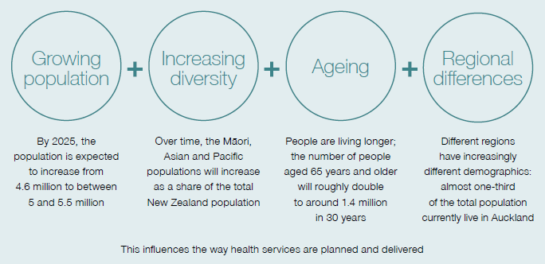

As at 30 June 2016, Statistics New Zealand estimated the total New Zealand population to be 4.6 million people. This represents an increase of 2.1 percent (an additional 97,000 people) since 30 June 2015. This means that our population has grown at its fastest rate since the 1960s. By 2025, the population is expected to grow to over 5 million (Statistics New Zealand 2016a).

Although in 2016 there was a natural increase in the population, because there were more births than there were deaths, the population also grew by over twice the natural increase through net migration (Statistics New Zealand 2016b).

Figure 2: New Zealand population (present and projected), 2013–2038, by ethnicity
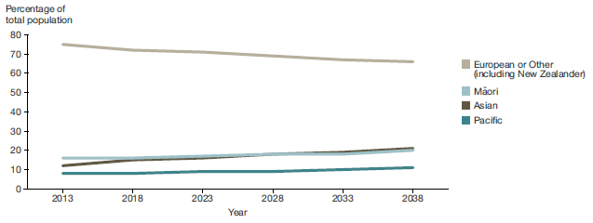
Source: Statistics New Zealand: Ethnic population projections, characteristics, 2013 (base) to 2038

… with increasing ethnic diversity
Statistics New Zealand projections indicate that the Māori, Asian and Pacific populations will continue to grow faster than European/other population overall, increasing their share of the total population (see Table 1).

Table 1: New Zealand population, 2013 and 2038 (projected)
Ethnicity | Population in millions 2013 | Projected population in millions 2038
European/other | 3.31 | 3.43–3.82
Māori | 0.69 | 1.00–1.18
Pacific | 0.34 | 0.44–0.48
Asian | 0.54 | 1.06–1.26
Source: Statistics New Zealand: National ethnic population projections, characteristics, 2016 (base) to 2038

Our population is ageing for all ethnicities
Our growing and increasingly ethnically diverse population is also living longer. Between 2006 and 2016, the percentage of New Zealanders aged 65 years and over increased from around 12 percent to around 15 percent.

Figure 3: Proportion of population aged 65 years and over, 2005–2056 (projected) by age group
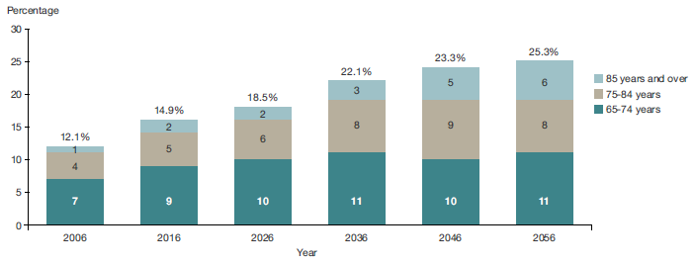
Source: Statistics NZ, National population projections, by age and sex, 2016 (base) to 2068

This trend is expected to continue. We expect that about one-quarter of our population will be 65 years and older by the middle of the century. The number of people aged 85 and older is expected to more than triple over the same period.

Projections indicate that all ethnic populations in New Zealand will gradually age over the coming decades, reflecting the combined effect of gradually reducing fertility rates (people having fewer children) and people living longer.

Māori and Pacific populations have a younger age structure
The Māori and Pacific populations will continue to have a much younger age structure than the total New Zealand population, because of their higher birth rates and lower life expectancy.

This is evident in Figure 4 comparing the current age structure of the Māori and non-Māori population. It illustrates the higher proportion of Māori children and young people (those aged 0–24 years) compared to the non-Māori population.

The proportion of Māori aged 0–4 years is around double that of non-Māori, at 11.3 percent and 5.6 percent of the total populations, respectively. This age group is of special interest in this report (see Chapter 2), which specifically acknowledges that promoting good health in the early years will improve the future health and wellbeing of the New Zealand population.

Figure 4: New Zealand population, 2015, Māori and non-Māori, by age
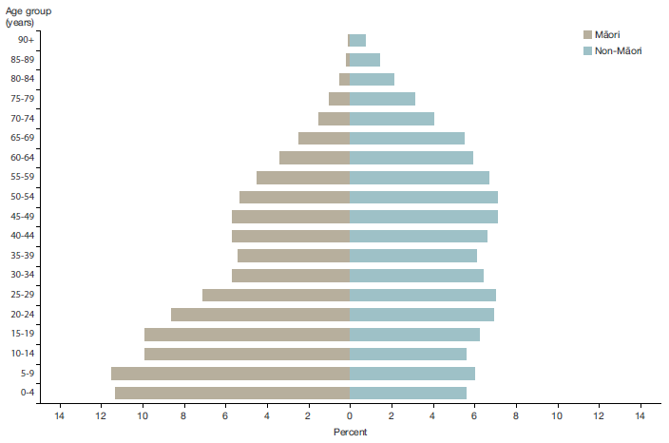
Source: Statistics New Zealand – Māori ethnic group population by age and sex at 2015

There are also regional differences
There are regional differences in the composition of our communities. In 2013, around a quarter of New Zealand’s population was born overseas, and more overseas-born people lived in the Auckland region (39.1 percent) than in any other region (18.2 percent) (Statistics New Zealand 2014a).

Pacific people in New Zealand are a young, fast growing, urbanised population. In 2013, 92.9 percent of the Pacific population lived in the North Island, and two out of three lived in the Auckland region.

The distribution of the older population also varies by region. One-fifth of all New Zealanders aged 65 years and over live in Canterbury District Health Board (DHB)’s region, and another one-fifth live in Waitemata DHB’s region. These two DHBs have the highest absolute number of people 65 years and over in their communities. By contrast, Auckland and Counties Manukau DHB regions have a comparatively low proportion of people aged 65 years and over.

The New Zealand health system must have the flexibility to respond to regional differences in the population’s composition. Each of the 20 DHBs works regionally and with its local community to plan, fund, purchase and deliver services to improve, promote and protect its population’s health.

Our life and health expectancy have increased
The average life expectancy for a male born in 2015 is 79.6 years, compared to 72.6 years for a male born in 1990. A female born in 2015 has a life expectancy of 83.3 years, compared to 78.6 years for a female born in 1990.

Figure 5: Life expectancy and health expectancy at a glance, 1990–2015
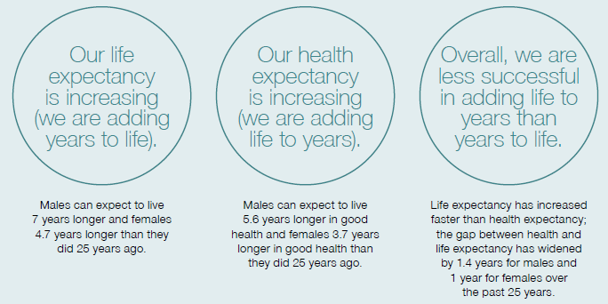

Our health expectancy – the years we live in good health – is also increasing. The average health expectancy for females increased from 68.1 years in 1990 to 71.8 years in 2015. For males, it increased from 64.3 years to 69.9 years.

Figure 6: Life expectancy and health expectancy, 1990–2015, females
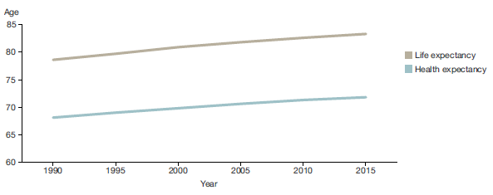
Source: GBD 2015

Figure 7: Life expectancy and health expectancy, 1990–2015, males
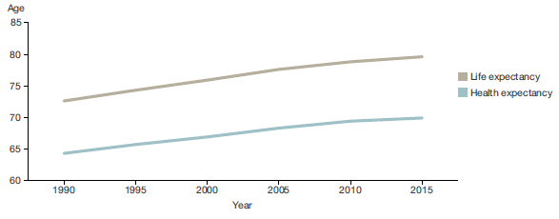
Source: GBD 2015

… but we continue to face the challenge of adding ‘life to years’
Life expectancy has increased faster than health expectancy, so the gap between life and health expectancy has also increased.

Figure 8: Absolute difference of life expectancy and health expectancy, 1990–2015, by gender
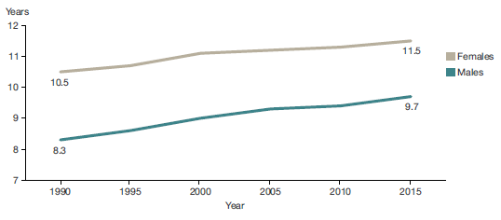
Source: GBD 2015

Between 1990 and 2015, the difference between life expectancy and health expectancy at birth increased from 8.3 to 9.7 years for males, and from 10.5 to 11.5 years for females.

This means that our health system has been more successful in adding years to life than in adding life to years. The challenge ahead is to find ways to maximise the time people spend in good health.

… and decreasing the rate of total health loss
We measure total health loss in the population in disability-adjusted life years (DALYs units). One DALY represents the loss of one year lived in full health. DALYs integrate health losses from premature mortality (years of life lost, YLL) and years lived with disability adjusted for severity (YLD). The DALY rate, adjusted to changes in population size and age structure, has been declining over time.

Figure 9: Age-standardised total disability-adjusted life years rate per 1,000, 1990–2015 (projected)
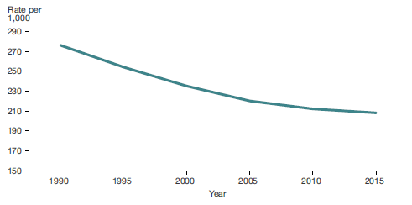
Source: Ministry of Health 2016: Health Loss in New Zealand 1990–2013

Over the past quarter century, New Zealand achieved one of the fastest rates of decline in health loss from all causes combined among high-income peer group countries. This is a major achievement for the health and wider social sector (Ministry of Health 2016a).

However, because the population is growing and ageing, the absolute number of DALYs has slowly increased, from 950,000 in 1990 to around 1.1 million in 2013.

Long-term conditions are the major cause of health loss
Looking more closely at overall health loss, it is clear that long-term conditions continue to be the most significant cause of ill health, disability and mortality in New Zealand.  Long-term conditions are ongoing or recurring conditions that have a significant impact on people’s lives. They include diabetes, cancers, cardiovascular diseases, respiratory diseases, mental illness (including depression and anxiety), chronic pain, chronic kidney disease, musculoskeletal and other conditions. Chapter 2 discusses important risk factors associated with long-term conditions, such as smoking and diet, along with the prevalence and impact of key long-term conditions. | Long-term conditions make up a large proportion of overall health loss. In 2013, long-term conditions accounted for 88 percent of health loss, compared to 83 percent in 1990.

Figure 10 shows that the burden of long-term conditions increased from 82.7 percent of total health loss in 1990 to 88.0 percent in 2013 (Ministry of Health 2016a).

Figure 10: Percentage of disability-adjusted life years from high-level cause groups, 1990 and 2013
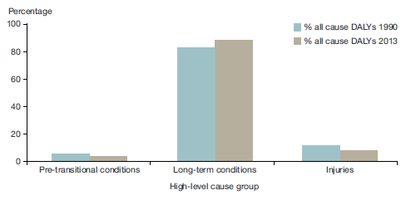
Source: Ministry of Health 2016: Health Loss in New Zealand 1990–2013

Over the 25 years to 2013, health loss from pretransitional conditions (which include maternal and neonatal disorders, nutritional deficiencies and common infectious diseases) decreased from 5.5 percent to 3.8 percent. The burden of health loss from injuries also decreased, from 11.8 percent to 8.2 percent.

While the rate of amenable mortality is decreasing, disparities remain
The amenable mortality rate measures premature deaths (deaths of people aged under 75) from causes that the health system could potentially have prevented. In New Zealand, the age-standardised amenable mortality rate declined from 144.9 deaths per 100,000 in 2000 to 92.8 deaths per 100,000 in 2013 (a 36 percent reduction). This shows that the health system has been successful in reducing amenable mortality.

Figure 11: Amenable mortality, age standardised rates, 0- to 74-year-olds, 2000–2013
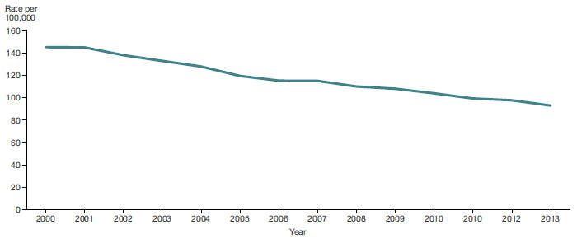
Source: Ministry of Health – Mortality Collection

Although the overall rate of amenable mortality is declining, disparities between ethnicities remain: Māori have rates 2.7 times higher and Pacific peoples rates 2.4 times higher than the non-Māori, non-Pacific population.

More people are living with a disability
The New Zealand Disability Survey defines a disability as a long-term limitation (resulting from impairment) that affects a person’s ability to carry out their daily activities.

The number of people living with a disability in New Zealand was 1,062,000 in 2013 (Statistics New Zealand 2014b). The proportion of the population living with a disability has increased from 20 percent in 2001 to 24 percent in 2013. The ageing population contributes to the higher proportion of people with disabilities, as well as other factors such as changes in public perceptions and willingness for more people to self-identify as having a disability.

Disability rates vary by gender. For example, as Figure 12 shows, a higher proportion of men experience hearing impairment, while a higher proportion of women experience physical impairments. It is common for those suffering limitation from disabilities to have multiple impairment types.

In the 2013 New Zealand Disability Survey, more than half of respondents reported experiencing more than one impairment type.

Figure 12: Impairment rates for males and females by impairment type, 2013
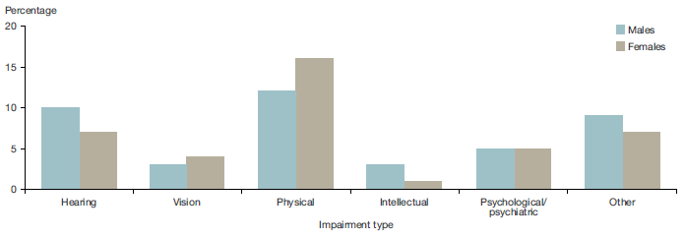
Source: Statistics New Zealand

Age-adjusted disability rates are higher among Māori than among other ethnic groups. The Māori disability rate is 1.3 times that of European and others, 1.2 times that of Pacific peoples and 1.9 times that of Asian peoples.

Chapter 2: Our health

Our health needs are changing
As our population changes, our health needs are also changing. What we needed from our health system 20 or 30 years ago is different to what we need today, and will be different again in another 20 or 30 years’ time.

Many of the major causes of health loss we are now experiencing are influenced by our social environment, as well as by lifestyle and behaviour factors, including poor nutrition, insufficient physical activity, smoking and hazardous drinking. This is an important part of the modern health story. Over one-third of current total health loss is preventable (Ministry of Health 2016a). A healthier environment and healthier lifestyles would substantially reduce future ill health.

This chapter looks at specific lifestyle factors in detail. It also looks at some of the most common causes of disease, as well as demographic differences in health outcomes, including between Māori and non-Māori and other population groups including Pacific.

Our physical and mental wellbeing is strongly influenced by the determinants of health
Our social, economic and physical environment strongly influences our health outcomes, as well as our ability to adopt and maintain a healthy lifestyle. This environment is influenced by our economy, and social organisations such as local government, central government, and our workplaces and communities.

Figure 13: Factors contributing to health
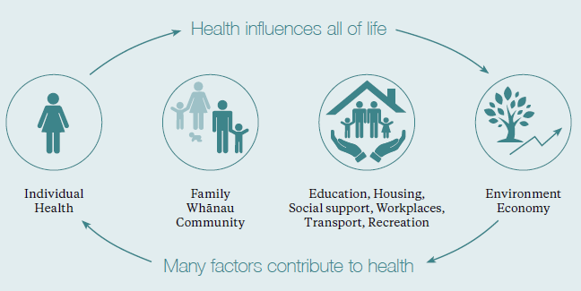

The day-to-day decisions we make (our health behaviours) also influence our health and wellbeing. We call behaviours with positive effects (such as a having a high daily intake of vegetables and fruit and undertaking regular physical activity) ‘protective factors’. We call those that increase our likelihood of experiencing ill health (such as smoking) ‘risk factors’.

Our social environment comprises our family and whānau structure, social connectedness, culture, employment status and exposure to crime and violence, as well as the level of education we achieve. This environment influences our health literacy, our social norms, our lifestyles, the value we place on health and our ability to cope with life’s adversities.

Our physical environment also affects our health. Cold, damp and overcrowded homes contribute to poor health outcomes. Six percent of our population live in homes with major damp or mould problems, and 10 percent live in crowded conditions (Ministry of Health 2014a). Household crowding is linked to a number of health conditions, including rheumatic fever, meningococcal disease, respiratory infections and skin infections.

Certain designed public spaces, including parks, playgrounds, green spaces, walking trails, cycle paths and safe transport routes, make it easier for us to be physically active and healthier.

Determinants of health affect communities in different ways
Some population groups continue to have poorer health outcomes than the population as a whole. Inequalities are found between socioeconomic groups, between ethnic groups, between people living in different geographical regions, between people living with different conditions and between males and females.

Māori feature more prominently than non-Māori in our most economically vulnerable communities, which tend to experience worse health outcomes than our least deprived communities.

Figure 14: Neighbourhood deprivation distribution (NZDep 2013), Māori and non-Māori, 2013
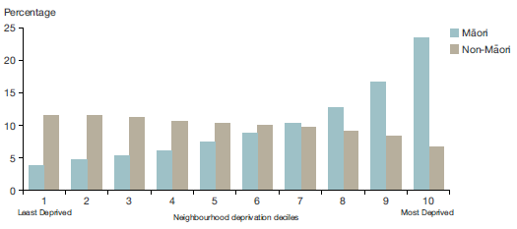
Source: Ministry of Health 2015a – Tatau Kahukura Māori health statistics

Table 2 compares a number of socioeconomic indicators between Māori and non-Māori in 2013, and shows that in each, more Māori fared worse to non-Māori (NZ Deprivation 2013).

Table 2: Socioeconomic indicators, Māori and non-Māori, 2013
Indicator | Māori (%) | Non-Māori (%)
School completion (Level 2 Certificate or higher), 15+ years, percent, 2013 | 45.1 | 64.3
Unemployed, 15+ years, percent, 2013 | 10.4 | 4.0
Total personal income less than $10,000, 15+ years, percent, 2013 | 24.1 | 18.4
Receiving income support, 15+ years, percent, 2013 | 30.4 | 13.8
Living in household without any telecommunications, all age groups, percent, 2013 | 3.0 | 0.9
Living in household without internet access, all age groups, percent, 2013 | 31.0 | 16.2
Living in household without motor vehicle access, all age groups, percent, 2013 | 8.7 | 4.4
Living in rented accommodation, all age groups, percent, 2013 | 49.5 | 27.5
Household crowding, all age groups, percent, 2013 | 18.6 | 7.7
Source: Ministry of Health 2015a – Tatau Kahukura Māori health statistics

In general, the better a person’s socioeconomic situation, the better their overall health status is likely to be. While many of these aspects of life are beyond what can be influenced directly by the health system, it shows how important it is to take a whole of system, cross-government approach to improving the health and wellbeing of New Zealanders.

Over one-third of health loss is potentially preventable
Behavioural risks (lifestyle factors) such as smoking and poor nutrition are important factors contributing to health loss, representing over one-quarter of DALYs in 2013.

Figure 15: Health loss as a percentage of total disability-adjusted life years 2013, by cause (risk cluster)
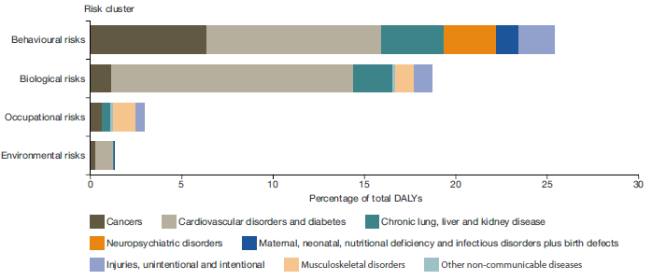
Source: Ministry of Health 2016: Health Loss in New Zealand 1990–2013

Biological risks, such as being overweight, having elevated serum cholesterol and hypertension, also contribute significantly to health loss (playing a part in common health conditions such as cardiovascular disease, diabetes and musculoskeletal conditions), and account for almost one-fifth of total health loss.

Occupational risks (such as workplace exposure to noise and carcinogens) and environmental risks (such as lead exposure and air pollution) account for 3 percent and 1 percent of health loss respectively.

After adjusting for ‘overlaps’ between clusters of risk, we can attribute approximately 38 percent of all health loss in the New Zealand population to known modifiable risk factors in 2013 (Ministry of Health 2016a). This means that we could potentially reduce over one-third of the health loss our population experiences through positive lifestyle, occupational and environmental changes.

The following sections look at diet, physical activity and obesity; smoking; and hazardous drinking in more detail.

Diet and physical activity play a major role in our health and wellbeing
Healthy eating is important for living well, staying well and getting well. It helps by reducing the risk of avoidable illness and other health problems, such as obesity, tooth decay, high blood pressure, high cholesterol, heart diseases, type 2 diabetes, osteoporosis, some cancers and depression. | The food and drink we consume, and the physical activity we undertake, play a major role in our health and wellbeing. Healthy eating includes plenty of vegetables and fruit (five plus a day), whole grains (breads and cereal), some (mostly low-fat) milk products, and some proteins (eg, legumes, nuts, seeds, seafood, poultry and red meat). These foods provide us with all the essential nutrients.  Dietary risk factors are a leading cause of health loss in New Zealand, being responsible for an estimated 9.4 percent of all health loss. These factors include having low vegetable and fruit intake; low wholegrain intake; and high salt, sugar and red meat consumption. Among these factors, low vegetable and fruit intake contributes the most to health loss, accounting for one-quarter of the total impact of diet and 2.5 percent of total DALY loss (Ministry of Health 2016a). A high body mass index (BMI) is another important risk factor that can contribute to a range of poor health outcomes.

Healthy Families NZ
Healthy Families NZ is a large-scale initiative that brings community leadership together in a united effort for better health. It has the potential to impact the lives of over 1 million New Zealanders.
Healthy Families NZ aims to improve people’s health where they live, learn, work and play, to prevent obesity and chronic disease. The initiative has a focus on improving nutrition, increasing physical activity, helping people to be smoke-free and reducing alcohol-related harm.
Taking a whole-of-community approach to prevention, Healthy Families NZ is engaging local leadership at all levels to create healthy change in our schools, early childhood centres, workplaces, sports clubs, marae, places of worship and community spaces and more, to create healthier environments for all. The initiative is currently being implemented in 10 locations across the country.
The most recent New Zealand Health Survey found that percent of adults in New Zealand met the Ministry of Health’s guidelines for vegetable and fruit intake. The proportion of adults meeting these guidelines has dropped since 2011/12. In 2015/16 Māori, Pacific and Asian adults were less likely than non-Māori, non-Pacific and non-Asian adults respectively to eat enough vegetables and fruit, after adjusting for age and sex differences (Ministry of Health 2016b).

Nearly half of New Zealand adults are regularly physically active
Regular physical activity (defined as a minimum of 30 minutes a day of moderate to vigorous physical activity, on five or more days each week) is an important protective factor against the risk of developing a number of non-communicable diseases, including cardiovascular disease; stroke; type 2 diabetes; certain cancers; unhealthy weight; and mental health issues such as anxiety, depression and stress (Ministry of Health 2015b). | In 2015/16, almost half of all adults (47.7 percent) were active for at least 30 minutes on five days or more.

The 2015/16 Health Survey found that nearly half of all adults (47.7 percent) were active for at least 30 minutes on five or more days in the past week. This represents a slight decrease from the previous year (when the figure was 50.7 percent) and from 2011/12 (when it was 54.4 percent).

Māori and Pacific peoples reported the same level of physical activity as the non-Māori and non-Pacific population. However, Māori and Pacific peoples had higher rates of physical inactivity (defined as being physically active for less than 30 minutes in the past week) compared to the non-Māori and non-Pacific population. In 2015/16, Māori males were more physically active than Māori females (the figures were 53 percent and 46 percent respectively); this pattern was also evident for Pacific peoples (the figures were 52 percent and 37 percent respectively).

Eating and Activity Guidelines for New Zealand Adults
The Eating and Activity Guidelines for New Zealand Adults (Ministry of Health 2015b) provide advice on healthy eating and being physically active for adult New Zealanders, based on international evidence. They are designed to be used by health practitioners and others who provide advice on nutrition and physical activity. They cover recommended types and quantities of food and physical activities and the reason for these recommendations, and include practical suggestions on how to put the recommendations into practice.

The Asian population had higher rates of physical inactivity compared to the non-Asian population. Asian women in particular reported very low rates of physical activity (35.9 percent) and high rates of physical inactivity (23.5 percent).

Inadequate physical activity is estimated to have accounted for about 3 percent of health loss in 2013 (Ministry of Health 2016a).

Obesity is increasing
Obesity in adults is defined as a measured BMI of 30 or more. In 2015/16, 32 percent of adults in New Zealand were obese, up from 27 percent in 2006/07 (Ministry of Health 2016b).

The proportion of obese people is highest in Pacific and Māori adults (67 percent and 47 percent respectively); it is lower in European/other adults (30 percent) and lowest in Asian adults (15 percent). Pacific adults are almost five times as likely to be extremely obese (defined as having a measured BMI of 40 or more) as non-Pacific adults, and 2.6 times as likely to be obese; Māori adults are almost 2.5 times as likely to be extremely obese as non-Māori and 1.7 times as likely to be obese.

Although the obesity rate among European/other adults is lower than that of Māori and Pacific adults, the total number of obese adults is highest in the European/other population. Around 850,000 of the 1.2 million obese adults in the population are European/other. Among the European/other population, there is a social gradient in the obesity prevalence rate. People living in the most deprived areas (ie, the most deprived 20 percent of neighbourhoods) have a significantly higher obesity rate (38 percent) compared to those in the least deprived areas (24 percent).

Obesity is associated with a range of health conditions
Obesity is linked to lower life expectancy, and to a range of health conditions including coronary heart disease, high blood pressure, some cancers (eg, breast and bowel), stroke and arthritis/ musculoskeletal conditions. It also raises a person’s risk of type 2 diabetes.

Obesity is associated with a low-level chronically inflamed state in many parts of the body. This accounts, in part, for the emergence of some of the chronic conditions noted above (Merkur et al 2013). Reducing obesity will contribute to lowering the burden of avoidable disease.

One in nine children aged 2–14 years is obese
Obesity has an important impact on the health of our young people. One in nine children aged 2–14 (11 percent) is obese. While this rate has not changed significantly since 2011/12, it has increased since 2006/07 (when the rate was 8.4 percent). Rates of childhood obesity are higher in the Pacific and Māori populations than in the non-Pacific, non-Māori population.

Obesity is linked to neighbourhood deprivation in both adults and children. This connection is far stronger for children than it is for adults. In 2015/16, the childhood obesity rate was three times higher for children living in the most deprived areas than it was for children living in the least deprived areas, after adjusting for age, sex and ethnic differences (Ministry of Health 2016b).

Overweight and obese children are more likely to be obese when they are adults, have a higher risk of illness, and are more likely to have abnormal cholesterol and blood pressure levels at a younger age than children who are within a normal weight range. Being overweight or obese in childhood is also associated with social and mental health issues, including low self-esteem.

Clinical Guidelines for Weight Management in New Zealand Children and Young People
Clinical Guidelines for Weight Management in New Zealand Children and Young People (Ministry of Health 2016c) provides updated clinical guidance for primary health care practitioners and others who provide advice on weight management for New Zealand children and young people aged 2–18 years. The guidelines support the ‘raising healthy kids’ health target.
The key components of weight management in children and young people are represented in the acronym FAB: food and drink, activity (including reducing sedentary time, and ensuring sufficient sleep) and behavioural strategies. The guidelines are supported by a series of eating, activity and sleep tips for parents of 2–5 year-olds,
5–12 year-olds and teenagers, along with tips specifically for teenagers.

Tackling childhood obesity
The Childhood Obesity Plan is a package of initiatives for government agencies, the private sector, communities, schools, families and whānau that aim to prevent and manage obesity in children and young people up to 18 years of age. The plan focuses on:
- broad approaches to make healthier choices easier for all New Zealanders
- increased support for those at risk of becoming obese
- targeted interventions for those who are obese.

The Ministry of Health’s key approach to childhood obesity is through prevention and early intervention, alongside treatment of those who are already obese. The emphasis is on improved nutrition, positive behaviour change, and being physically active at each life stage, starting during pregnancy and early childhood (Ministry of Health 2015c).

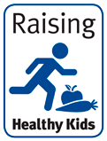 | Raising Healthy Kids health target  By December 2017, 95% of obese children identified in the B4 School Check programme will be offered a referral to a health professional for clinical assessment and family-based nutrition, activity and lifestyle interventions.  The raising healthy kids health target is one of the initiatives within the Childhood Obesity Plan. The target reflects a renewed focus on intervening in the early stages of life to ensure positive, sustained effects on health. It aims to ensure that most four-year-olds identified as obese at their B4 School Check are offered a referral to health services providing support for improved nutrition and increased physical activity.

Smoking rates are decreasing, but smoking is still more common in Māori and people living in lower socioeconomic communities
Smoking rates in New Zealand have been on the decline since the mid-1970s and have further decreased over the past decade. The proportion of adults who smoke at least monthly fell from 20 percent in 2006/07 (including 18 percent who were daily smokers) to 16 percent in 2015/16 (including 14 percent who were daily smokers). There was a substantial decline in rates of smoking for 15–17-year-olds over this time, from 16 percent in 2006/07 to 6 percent in 2015/16 (Ministry of Health 2016b).  Daily smoking is strongly influenced by social factors. The 2015/16 New Zealand Health Survey data shows that adults living in the most socioeconomically deprived areas were 3.1 times as likely to be current smokers and 3.7 times as likely to be daily smokers, compared with adults living in the least deprived areas (after adjusting for age, gender and ethnic differences). | In 2015/16, adults living in the most socioeconomically deprived areas were 3.7 times as likely to be daily smokers compared with adults living in the least deprived areas.

Although the difference in the proportion of smokers who are Māori compared to non-Māori is decreasing, disparities remain. Māori males are 2.3 times more likely to be current smokers than non-Māori, while Māori females are 3.5 times more likely to be current smokers than non-Māori females (after adjusting for age).

Impact of smoking on health
Tobacco use and breathing in other people’s smoke (second-hand smoke) contribute to approximately 5,000 deaths every year (through chronic lung disease, cancer, stroke, heart disease and others), killing more people than road crashes, alcohol, other drugs, suicide, murder and drowning combined.

Smoking causes 40 percent of all strokes and heart disease in people aged under 65 years. Smokers have two to three times the risk of having a sudden cardiac death than non-smokers. Smoking is also a major cause of disability through blindness: about 1,300 people in New Zealand have untreatable blindness due to current and past smoking. In total, tobacco consumption accounts for about 9 percent of health loss in New Zealand (Ministry of Health 2016a).

Figure 16: Age-standardised hospitalisation rates for chronic obstructive pulmonary disease, 2004–2014, by ethnicity and gender (per 100,000)
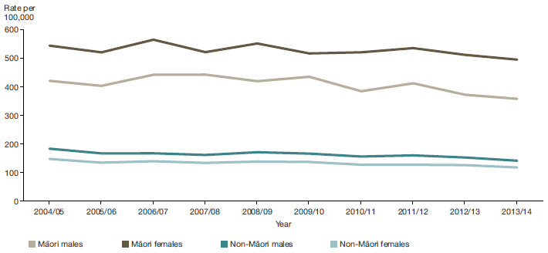
Source: Ministry of Health: New Zealand National Minimum Dataset

Smoking habits acquired in adolescence or early adulthood greatly increase the risk of chronic obstructive pulmonary disease (a form of lung damage that causes coughing and breathlessness and includes emphysema and chronic bronchitis) in adulthood and old age, along with many other diseases, including lung cancer – which is about 20 times more common in smokers than non-smokers (Peto et al 2000).

Smoking can also explain the higher rates of hospitalisation for chronic obstructive pulmonary disease later in life in Māori (particularly for female Māori) in comparison to non-Māori (as Figure 16 shows). This difference is mirrored in the mortality rates from chronic obstructive pulmonary disease.

Similarly, lung cancer incidence, as well as mortality from lung cancer, is higher in the Māori population, and especially the Māori female population, compared to the non-Māori population. Again, this can be explained in part by higher rates of smoking among Māori.

Alcohol use and hazardous drinking
Alcohol continues to be New Zealand’s most popular recreational drug; approximately 80 percent of adult New Zealanders used it in 2015/16 (Ministry of Health 2016b). Not all alcohol consumption is harmful to health, but alcohol use is a behavioural risk factor, accounting for about 4 percent of total health loss in New Zealand. Half of this health loss is due to disease (especially mental illness and cirrhosis), and the other half due to injury. Hazardous drinking can cause serious and long-term health issues, personal and social problems, and death.

Risks of harm increase with levels of consumption, and different patterns of drinking expose the drinker to different risks. Binge drinkers (those who consume more than six drinks in a sitting) are at greater risk of immediate harms such as accident and injury. Heavy, long-term drinkers are at increased risk of long-term harm, such as liver disease and cancer. Young people who start drinking early in life are more likely to develop alcohol use disorder (addiction and withdrawal syndrome).

The health impacts of alcohol use are often experienced by people other than the drinker. Alcohol use is a significant contributor to New Zealand’s rates of violent and sexual offences, traffic accidents, drowning, fires and child maltreatment. Exposure to alcohol during pregnancy can be harmful to the development of the fetus (see the ‘Starting well’ section below).

In 2015/16, around 1 in 5 adults had a hazardous drinking pattern. | In 2015/16, adults in the most socioeconomically deprived areas were less likely to have drunk alcohol in the past year than adults in the least deprived areas (the rates were 70 percent and 86 percent respectively). However, among drinkers, those living in the most socioeconomically deprived areas were more likely to be binge drinkers than those living in the least deprived areas.

According to the latest New Zealand Health Survey, the percentage of adults with hazardous drinking patterns is increasing. In 2015/16, about one in five adults (21 percent) had a hazardous drinking pattern. This rate was higher in young adults aged 18–24 years, at 37.1 percent.

The 2015/16 survey indicated that Māori adults were more likely to be hazardous drinkers than non-Māori adults. It found that relatively few Pacific adults had drunk alcohol in the previous year (58 percent), but that Pacific adults who did drink were 1.5 times more likely to have a hazardous drinking pattern than non-Pacific drinkers, after adjusting for age and gender differences.

A combination of risk factors increases the risk of poor health outcomes
Risk factors are cumulative: in general, the more risk factors present in a person’s life, the poorer that person’s health outcomes are likely to be. Multiple risk factors are associated with earlier and more rapid development of a condition, more complications and recurrence, a greater health loss and disease burden, and a greater need for management of a condition.  Analysis of key risk factors from the New Zealand Health Survey found that 18 percent of adult respondents (those aged 15 years and over) had no behavioural risk factors (ie, a ‘healthy lifestyle’). The proportion of people with a healthy lifestyle was significantly lower in the Māori, Pacific and Asian populations (10.9 percent, 11.2 percent and 12.5 percent respectively) compared to European/ other (19.9 percent). | Analysis of key risk factors from the New Zealand Health Survey found that 18 percent of adult respondents had no behavioural risk factors (ie, a ‘healthy lifestyle’).

The survey found that 45 percent of adult respondents had two or more risk factors.

Populations and key conditions
Figure 17 illustrates that, after a peak in infancy, the rate of health loss increases with age; there is a second peak in old age. With this in mind, this year’s Health and Independence Report looks in detail at children in the early years of life, as well as older adults, and has a special emphasis on people aged 65 and over.

Figure 17: Age-specific disability-adjusted life years rates per 1,000, 2013, by age group
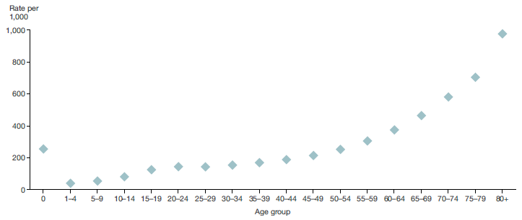
Source: Ministry of Health 2016: Health Loss in New Zealand 1990–2013

Starting well – a focus on preschool children
Starting life well is important for good health, education and social outcomes over people’s lives. This year’s report focuses on a number of health indicators for pregnant women, infants and preschool children (those aged 0–5 years).

While infant mortality is declining, inequalities remain
The infant mortality rate (which measures deaths of live-born children under the age of one year) is an indicator of population health and the effectiveness of the health system. Overall, the New Zealand infant mortality rate fell 33 percent, from 7.3 to 4.9 deaths per 1,000 live births, between 1996 and 2013.

Although infant mortality is declining, we face ongoing challenges. In 2013 New Zealand was ranked below the average of OECD countries in this respect (OECD 2015). The infant mortality rate in 2013 for those living in the most deprived areas was around 2.5 times the rate for those living in the least deprived areas. Pacific peoples and Māori experienced higher rates of infant mortality (7.6 per 1,000 live births and 5.3 per 1000 live births respectively) than the European/other and Asian populations (4.4 per 1000 live births and 4.1 per 1000 live births respectively).

Improving outcomes across population groups is an ongoing focus for the health sector. Examples of specific initiatives include the maternity and quality safety programme operating in each DHB; initiatives encouraging women to register with a lead maternity carer, such as a midwife, early in pregnancy; promotion of safe sleeping and smoke-free environments for infants; and prompt enrolment of infants into primary care organisations and Well Child/ Tamariki Ora services following birth, to support timely immunisation and ongoing advice, care and support.

Maternal risk factors
Good health leading up to and during pregnancy is important for both mother and baby. Each year, around 60,000 babies are born in New Zealand. Most pregnant women experience positive outcomes for themselves and their babies. For too many however, a range of risk factors including smoking, alcohol consumption, high blood pressure, obesity, diabetes, family violence and mental health conditions continue to contribute to poor outcomes. Addressing key maternal risk factors is an important focus for the health sector.

Reducing smoking during pregnancy
Smoking during pregnancy can cause miscarriage; stillbirth; low birth weight; and an increased risk of pneumonia, asthma and glue ear in the infant. It also increases the risk of sudden unexpected death in infancy (SUDI).

In 2014, approximately 13 percent of women giving birth identified themselves as smokers two weeks after birth. This measure is important, because it may identify women who smoked during pregnancy, as well as those who re-commenced smoking following birth (Ministry of Health 2016d). This rate varies between DHBs. Younger women (those aged 25 years and under), Māori and women in high-deprivation communities had higher rates of smoking following the birth of their baby. | Smoking during pregnancy increases the risks of serious health problems for both mother and baby.

One of the Government’s health targets is ‘better help for smokers to quit’. The target specifies that, 90 percent of pregnant women who identify as smokers upon registration with a DHB-employed midwife or Lead Maternity Carer are offered brief advice and support to quit smoking.

Reducing exposure to second-hand smoke is important to help protect the health of newborns and infants. The Ministry of Health, working with DHBs, has agreed on a system-level measure to increase the proportion of babies who live in a smoke-free household at six weeks after birth, for implementation from 1 July 2017.

Reducing alcohol exposure during pregnancy
Drinking alcohol during pregnancy can compromise the health of both a mother and her unborn baby. It increases the risk of a number of pregnancy complications, including injuries, miscarriage, stillbirth, growth restriction and premature birth. It also increases the likelihood of SUDI, and can cause permanent damage to the brain and body of the developing fetus. There is no known safe amount of alcohol in pregnancy. | Exposure to alcohol during pregnancy can lead to babies being born with  a fetal alcohol spectrum disorder.

Evidence suggests that about one in two pregnancies in New Zealand is exposed to alcohol, and that approximately 10 percent of pregnancies are exposed to alcohol at high levels of risk (a single binge, or more than seven standard drinks in a week). These figures are likely to be an underestimate, as they are based on self-reporting (FASD Working Group 2016).

Fetal exposure to alcohol during pregnancy can lead to babies being born with a fetal alcohol spectrum disorder (FASD) – an umbrella term used to describe the range of different effects from in-utero alcohol exposure. There is no New Zealand data on the prevalence of FASD, but studies from the United States suggest that approximately 1 percent of the population there is affected. This figure would be a conservative estimate for New Zealand. This estimate suggests that there are likely to be approximately 570 FASD-affected births per year (FASD Working Group 2016).

Those people born with a FASD are at heightened risk of poor outcomes over their lifetime. Their bodies will be less robust and resilient, and their brains are less likely to work the same way as other people’s. They are likely to have a harder time learning things, controlling themselves and navigating society.

In 2016, the Ministry of Health published the Taking Action on Fetal Alcohol Spectrum Disorder: 2016–2019: An action plan, which aims to create a more effective, equitable and collaborative approach to FASD. The plan represents a cross-agency commitment, designed to build on work that is already under way by providing coordinated support to those on the front line (FASD Working Group 2016).

Breastfeeding is an important protective factor
Breastfeeding is important for the health of mothers and infants. It provides babies with optimal nutrition, and gives them the best start in life. Breastfeeding strengthens babies’ immunity, and protects them against colds, tummy bugs, infections and allergies. It also helps protect babies from SUDI. Breastfeeding can also protect against diabetes and obesity in adulthood. Breastfeeding not only improves physical health but also contributes to the social and emotional wellbeing of infants, mothers and families and whānau.

The Ministry of Health recommends that infants are breastfed exclusively to around six months of age, and continue to be breastfed, alongside the introduction of appropriate complementary foods, up to one year of age or beyond.

Overall, New Zealand has a high rate of exclusive breastfeeding at the start of life: 82.2 percent of babies discharged from a Baby-Friendly Hospital Initiative-accredited maternity facility are exclusively breastfed.

Figure 18: Percentage of mothers exclusively/full breastfeeding, 2015, by age of the baby and ethnicity
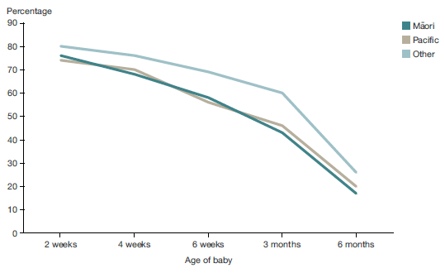
Source: Rates of exclusive or fully breastfed infants reported by Lead Maternity Carers (at 2 weeks and at LMC discharge at around 4-6 weeks). Rates at 6 weeks, 3 months, and 6 months reported by Plunket.

However, there has been little change in breastfeeding rates over the last 10 years, and there is a steady decrease in exclusive/full breastfeeding rates after three months of age.

There are also significant ethnic and socioeconomic differences in breastfeeding rates: fewer Māori and Pacific babies are breastfed, and those ethnicities experience a faster decline in breastfeeding in the first few months of life.

DHBs are incorporating breastfeeding measures and targets into their annual planning processes for 2017/18. All DHBs will commit to local actions to improve the uptake and duration of breastfeeding in New Zealand.

Immunisation coverage at eight months has increased
Immunisation protects individuals and communities against a range of preventable infectious diseases. The National Immunisation Schedule provides a series of free vaccinations to pregnant women, babies, children and adults.

Timely immunisations provide the best protection; missing or delaying a vaccination can put health at risk. The Ministry of Health has placed a concerted focus on improving the timeliness of immunisations for infants. The ‘increased immunisation’ health target aims to ensure that 95 percent of children are fully immunised at eight months (ie, that they have received all immunisations scheduled for 6 weeks, 3 months and 5 months of age). This reflects the Government’s focus on delivering Better Public Services for vulnerable children.

Figure 19: Immunisation coverage of eight-month-old babies, June 2009–December 2016, by total ethnicity, and deprivation deciles 9 and 10
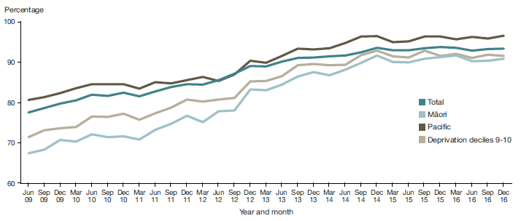
Source: National Immunisation Register

As of December 2016, full immunisation rates had increased to 93.3 percent of eight-month-olds (this represents an increase of 8 percentage points since introduction of the target in June 2012). European/other rates were 93.8 percent and Māori rates were 90.8 percent. Pacific and Asian rates were above the target, at 96.5 percent and 97.5 percent respectively. The rate among those living in deprivation deciles 9 and 10 (ie, the areas of the highest deprivation) was 91.5 percent.

The Ministry attributes progress against this target to a range of factors, including promotion of enrolling babies at birth with a general practice team, which supports timely access to services; general practice teams tailoring their approaches to reach families with higher needs; and improvement of the recall and reminders processes.

Keeping children well and out of hospital
The term ‘ambulatory sensitive hospitalisations’ (ASH) refers to mostly acute hospital admissions for conditions that are preventable, or that could have been treated earlier in primary care.

ASH rates are often used as proxy markers for primary care access; high admission rates may suggest difficulty in accessing care in a timely fashion, poor care coordination or failures in continuity of care.

Comparisons of this indicator between population groups and geographic areas provide useful information to inform initiatives that aim to improve prevention or treatment rates. However, determining the reasons for high or low ASH rates is complex, as it is in part a whole-of-system measure (Ministry of Health 2016e).

Figure 20 shows the trend over time from 2012 to 2016 in ASH rates for the 0–4 age group. It illustrates that the rates are the highest for Pacific preschoolers, followed by Māori, and that the lowest are in the ‘other’ group.

Figure 20: Non-standardised ambulatory sensitive hospitalisation rates for 0- to 4-year-olds, 2012–2016, by total and ethnicity
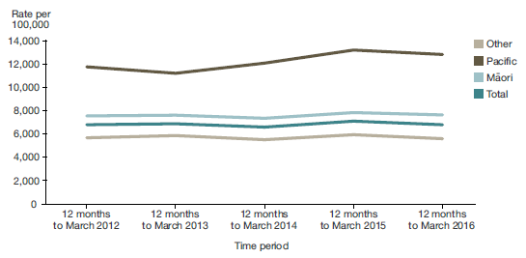
Source: National Minimum Dataset

The figure also illustrates that rates have been relatively constant over the past four years. The most common conditions children are hospitalised for include respiratory conditions, skin-related disorders and dental conditions.

Reducing ASH rates for 0- to 4-year-olds
Reducing ASH rates for young children is the focus of a new system-level initiative. The Ministry of Health now requires DHBs and primary health organisations (PHOs) to develop and submit plans to reduce ASH rates for 0–4 year-olds, which include strategies to address inequalities. These plans are based on the DHB baseline trends of local ASH rates over time and the needs of the local population. To achieve their planned milestones, DHBs and PHOs will work together, making better use of health data and integration. Reducing ASH rates will improve health outcomes for local populations, and reduce demand on hospitals (Ministry of Health 2016e).

Oral health outcomes for children
Although poor oral health is largely preventable, it is a common chronic health problem experienced by New Zealanders of all ages.

Dental decay is one of the leading causes of hospital admissions for children. | Poor oral health affects general health, and is related to risk factors and determinants common to other chronic diseases, particularly cardiovascular diseases, cancer, chronic respiratory diseases and diabetes.  Children with poorer oral health status are more likely to experience dental pain, miss school and perform poorly in school. Dental caries (dental decay) is one of the most prevalent childhood diseases, and one of the leading causes of hospital admissions of New Zealand children.

Between 2007 and 2015, the percentage of preschool children enrolled in the Community Oral Health Service increased from 43 percent to 80 percent. | Children and adolescents have access to free basic oral health services until their 18th birthday. Between 2007 and 2015, the percentage of preschool children enrolled in the Community Oral Health Service increased from 43 percent to 80 percent. There are encouraging signs of improvement in child oral health outcomes over time, although disparities in outcomes between population groups remain.  In 2015 around 60 percent of all children at age five were caries free, an increase from 52 percent in 2005. In 2015, the proportion of Māori and Pacific children caries free at age five was 39 and 33 percent, respectively, compared to 69 percent of European/other.

The Community Oral Health Service – a health- promoting model
Since 2008, the Ministry of Health has allocated $116 million in additional capital funding for DHBs to build new fixed and mobile dental facilities for the Community Oral Health Service. It has provided DHBs an additional $32 million each year in operating funding, to support the improved model of care.
The new Community Oral Health Service operates from 176 fixed clinics and 169 mobile units, at 1263 sites around New Zealand. A key aim of the reinvestment is to change the model of care, from a reactive model to a health-promoting model with a focus on family/ whānau involvement, education for self-care, prevention of ill health, and early intervention. Increasing parental engagement from an early age is critical to improving oral health for children.

Significant evidence from the past 60 years confirms that water fluoridation at recommended levels prevents dental decay. New Zealand’s most recent national oral health survey showed that, on average, children accessing fluoridated drinking water experienced 40 percent less tooth decay than those living in areas without it (Ministry of Health 2010). The Australian National Survey of Adult Oral Health has shown that adults accessing fluoridated drinking water experience 20–30 percent less tooth decay.

In 2016, the Government announced proposed legislative changes to allow DHBs, rather than local authorities, to decide which community water supplies in their areas are fluoridated. This recognises that water fluoridation is a health-related issue. The Health (Fluoridation of Drinking Water) Amendment Bill passed its first reading on 6 December 2016. Public submissions on the Bill closed on 2 February 2017.

Key conditions impacting adults and our ageing population
Figure 21 illustrates key conditions impacting the population, and the percentage of DALY by condition group.

Figure 21: Percentage of disability-adjusted life years, by condition group, 2013
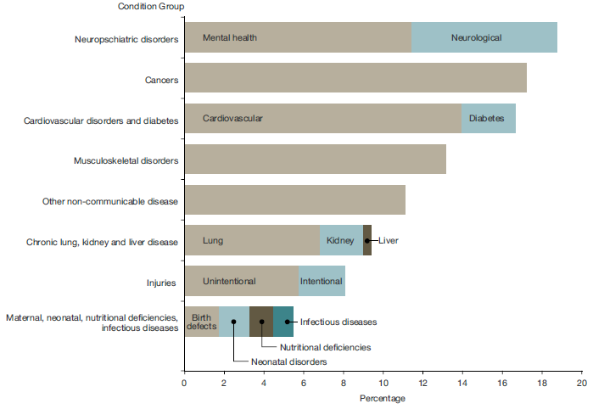
Source: Ministry of Health based on GBD 2013

Due to the extent of their respective impacts on health loss, the following conditions are a focus of this report:
- cardiovascular disease (with a focus on coronary heart disease and stroke)
- cancer
- diabetes
- mental health
- dementia.

The report also highlights some initiatives that are already in place to help prevent and better manage these long-term conditions. The important role of palliative care is also discussed.

Cardiovascular disease
Cardiovascular diseases are a group of disorders of the heart and blood vessels. Collectively, they are the leading causes of death worldwide, and the second leading cause of death in New Zealand, after cancers.

Two main disorders in this condition group include coronary heart disease (disease of the blood vessels supplying the heart muscle) and cerebrovascular disease (disease of the blood vessels supplying the brain, including stroke). One of the main underlying pathological processes that leads to these two disorders is known as atherosclerosis. This is when the arteries become narrowed by a gradual build-up of fatty material within their wall.

The early changes of atherosclerosis develop in childhood and adolescence due to the overall effect of risk factors such as smoking, high blood pressure, poor diet, diabetes and obesity. The changes to atherosclerosis are cumulative, becoming more evident as people get older.

Mortality from cardiovascular disease in New Zealand has generally been falling since the 1970s. The reduction is mainly due to heightened awareness of preventable factors (particularly blood pressure and smoking), alongside advances in emergency services and medical procedures (Woodward and Blakely 2014; Tobias et al 2005).

Coronary heart disease outcomes have improved over time
Coronary heart disease (also called ischaemic heart disease) impacts thousands of New Zealanders each year, accounting for 10 percent of all health loss (measured in DALYs) in males, and 6 percent in females.

Figure 22: Age-standardised rate per 1,000 of disability-adjusted life years attributable to coronary heart disease, 1990–2015 (projected)
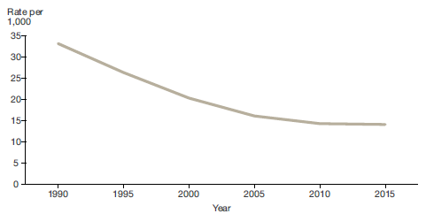
Source: Ministry of Health 2016: Health Loss in New Zealand 1990–2013

There have been reductions in age-adjusted health loss rates attributed to coronary heart disease over time. It is estimated that between 1990 and 2015 (projected from 2013 data – Ministry of Health 2016a) the rate of health loss due to this cause more than halved.

In 2013 New Zealand, the mortality rate (age and gender adjusted) within 30 days of admission for acute myocardial infarction (heart attack) in the population aged 45 and over was 8.2 percent; this was less than the OECD average at 9.5 percent. New Zealand’s rate has decreased substantially since 2003 when it was 11.5 percent (OECD 2015).
While medical advances (including statins, revascularisation surgery, defibrillator access and dedicated coronary care units) and population health status improvements (including interventions to reduce smoking and improve diet and physical activity levels) have contributed to reductions in mortality rates, coronary heart disease remains a significant cause of health loss for older people, accounting for 12 percent of health loss in people aged 65–74 and 15 percent of health loss in people aged 75 years and over.

Heart disease rates differ between population groups. Māori and Pacific people have elevated rates of risk factors associated with heart disease (such as smoking, poor diet, physical inactivity and hazardous use of alcohol), and experience higher rates of coronary heart disease than the general population. Overall, age-adjusted mortality rates from coronary heart disease in 2013 were two times higher for Māori compared to non-Māori in males and females.

Figure 23: Age-standardised mortality rate due to coronary heart disease, 1996–2013, males, by ethnicity
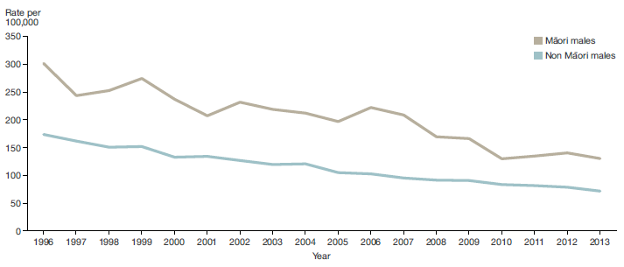
Source: New Zealand Health Information Service. Note: Age standardised to WHO world population.

Figure 24: Age-standardised mortality rate due to coronary heart disease, 1996–2013, females, by ethnicity
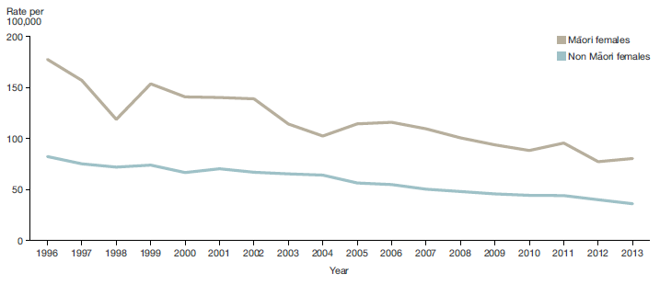
Source: New Zealand Health Information Service. Note: Age standardised to WHO world population.

Such disparities are linked to a complex interplay of factors including socioeconomic determinants, genetic and physiological factors, health behaviours, health literacy levels and barriers to accessing care.

Reducing the risk from cardiovascular disease
A range of initiatives aim to reduce the risk of cardiovascular disease. They focus on smoking cessation, improving nutrition and increasing physical activity, and are delivered through community and school-based initiatives such as Healthy Families NZ, Healthy Christchurch and Healthy Auckland Together, Health Promoting Schools, and a range of social marketing initiatives.

Early detection helps us deliver better heart health outcomes. The development of cardiovascular disease risk assessment guidelines help medical professionals estimate individual patient risk, predict future cardiovascular events and the need for early treatment, and devise strategies to improve heart health. They are based on New Zealand population and medical data.  The Ministry of Health is currently updating these guidelines. The update will build on the Ministry’s significant investment in achieving the ‘more heart and diabetes checks’ health target, which enabled 1.2 million New Zealanders (91 percent of the eligible population) to be risk assessed. | 1.2 million New Zealanders (91 percent of the eligible population) have had a heart and diabetes check as part of the national health target.

Stroke is a significant cause of premature mortality and disability
Stroke is a cerebrovascular condition which increases in incidence as people age. It can cause significant disability and premature death. It occurs when the blood supply to the brain is cut off, often as a result of a blood clot or a bleed.

Stroke accounts for 4 percent of health loss for people aged 65–74, and 7.3 percent of health loss for those aged 75 years and over. It is a leading cause of adult disability in New Zealand. New Zealand’s age-standardised rate of health loss from stroke in 2013, like the rate of health loss from coronary heart disease, was comparable to the rates of selected peer group countries.

We are making progress on reducing overall rates of stroke
There has been a significant reduction in age-adjusted health loss rates attributed to stroke over time. Between 1990 and 2015 (projected from 2013 data – Ministry of Health 2016a), health loss from stroke is estimated to have reduced from 4.7 percent to 3.6 percent of total health loss.

Population-based data from the four Auckland Regional Community Stroke (ARCOS I–IV) Studies between 1981 and 2012 demonstrated that stroke incidence (number of strokes) and one-year mortality (number of deaths occurring within one year of a stroke) decreased by 23 and 62 percent respectively between 1981 and 2012 (Feigin et al 2015). The fact that the pace of decline in stroke mortality rates is faster than the pace of decline in stroke incidence rates suggests a further rise of stroke prevalence and related disability over the next decade, likely to be exacerbated by population growth and ageing.

Māori and Pacific stroke rates are declining more slowly than those of the general population
The Auckland regional studies mentioned above found that Māori and Pacific people had the slowest rates of decline in stroke incidence and mortality, and that they continue to experience stroke at a significantly younger age (a mean age of 60 and 62 years respectively) compared with New Zealand Europeans (among whom the mean age was 75 years).

Our preventative measures to reduce the key risk factors for stroke need to focus on addressing health inequalities across population groups.

Reducing risk factors and improving early detection of stroke
High blood pressure is a main risk factor for stroke; this in turn is influenced by factors such as high levels of salt and alcohol consumption, as well as lack of physical activity. Measures to reduce blood pressure across the population can contribute to a reduction in stroke mortality.

Recognising the signs of stroke is important; the sooner a person receives treatment, the less damage a stroke will cause. In particular, quick thrombolysis (dissolution of a blood clot) can reduce the risk of post-stroke disability; however, this requires rapid complex decision-making by experienced clinicians.

In 2016, the Ministry of Health, the Stroke Foundation and the Health Promotion Agency launched the FAST campaign, to raise awareness of stroke, its symptoms and the importance of reacting quickly (Health Promotion Agency 2016).

Improving stroke management – the Telestroke trial
One recent innovation in stroke management is the Ministry of Health-funded Telestroke pilot. Telestroke provides a solution to the current difficulty in several central region DHBs in providing 24/7 access to specialist skills for managing stroke. It is a new service model in which neurologists (usually from a DHB) provide expert decision support remotely via videoconferencing equipment to less experienced clinicians at other DHBs. Over the 10-week Telestroke trial there was an increase in the treatment rate of out-of-hours thrombolysis, from 7 percent to 19.8 percent, and the average time from presentation to hospital and treatment reduced considerably.

Cancers
Cancers of all types accounted for 17 percent of total health loss in 2013. Cancer is the leading cause of health loss in middle-aged adults (those aged 45–64), contributing to around 23 percent of health loss within that age group (Ministry of Health 2016a).

The total number of new cancer registrations increased from 19,353 in 2004 to 22,166 in 2013. However, after adjusting for age and population structure, the registration rate actually decreased slightly, from 359.1 per 100,000 people in 2004 to 335.5 per 100,000 in 2013 (Ministry of Health 2016f).

In 2013 the most commonly registered cancers for the male population were prostate cancer, colorectal (bowel) cancer, melanoma, lung cancer and non-Hodgkin’s lymphoma. For the female population, the most commonly registered cancers were breast cancer, colorectal cancer, melanoma, lung cancer and uterine cancer.

Primary prevention, early detection and faster access to treatment
We need to address key lifestyle risk factors to prevent cancers, and focus on detecting and treating cancer early. The text boxes below present two separate initiatives with these aims in mind.

Screening for bowel cancer
Screening enables early detection of and intervention for disease; it is the process of testing for diseases in people before they exhibit any symptoms.
Often, there are no warning signs that bowel cancer is developing. Bowel screening can save lives by detecting bowel cancer at an early stage, when it can be more easily treated, and often cured.
Around 3,000 New Zealanders are diagnosed with bowel cancer each year, and more than 1,200 die from it. Māori are 30 percent less likely than non-Māori to get bowel cancer. Once Māori are diagnosed, they are 30 percent more likely to die from bowel cancer than non-Māori.
The National Bowel Screening Programme (NBSP) builds on the success of a bowel screening pilot in Waitemata DHB. Once it is fully implemented, the NBSP will invite more than 700,000 people for screening every two years. It will be rolled out progressively across the country, beginning in the 2017/18 financial year. Hutt Valley and Wairarapa DHBs will be the first DHBs to begin screening the eligible 60–74-year age group; other DHBs will follow in stages. Bowel screening will continue to be offered at Waitemata DHB.

Faster access to cancer treatment
Faster access to cancer treatment (or other support for cancer patients) is a national health target. In quarter four of 2015/16, 74 percent of patients received their first cancer treatment (or other management) within 62 days of being referred with a high suspicion of cancer and a need to be seen within two weeks. This is important progress towards more patients being seen and receiving treatment sooner which is associated with better outcomes for patients.

People aged 65 years and over accounted for approximately 6 out of 10 new cancer cases in 2013
There is an association between age and cancer registration. Cancer is relatively uncommon in those aged 0–24 years; this group accounted for only 1.5 percent of all new cancers in 2013. People aged 25–44 years accounted for 6.8 percent of all cancer registrations in 2013. The most common cancer registered in this age group was melanoma for males and breast cancer for females.

About one-third of all cancers in 2013 were registered to people aged 45–64-years. Prostate cancer was the most common cancer registered in males in this age group, and breast cancer the most common in females.

Figure 25: Number and age-specific rates of cancer registration, 2013, by age group
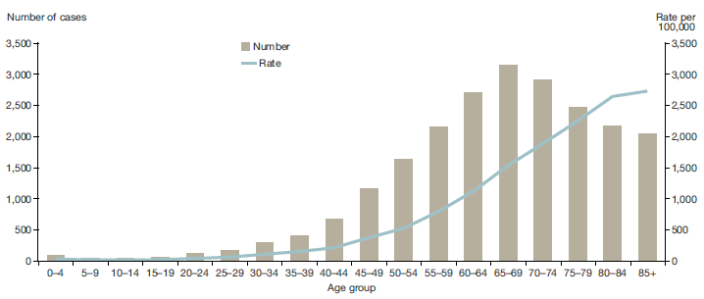
Source: New Zealand Cancer Registry

People aged 65 years and over accounted for approximately 60 percent of new cancer cases in 2013. Approximately 27.3 percent of new cancer cases were registered in the 65–74 years age group, and 30.0 percent in the 75 years and older age group. The most common cancers registered in this age group were prostate cancer for males and colorectal cancer for females.

Like cancer registration rates, age-specific cancer mortality rates increase steadily with age. In 2013, more than 70 percent of cancer deaths were in people aged 65 years and older. The highest mortality rate by age was in people aged 85 years and older at 2338.7 per 100,000 people.

Cancer incidence and mortality rates differ between populations
Cancer incidence and mortality is not evenly distributed and certain cancers impact more on some populations than others (Teng et al 2016). For example, lung cancer rates are higher in Māori and Pacific populations than they are in the general population, reflecting higher smoking rates in these populations in the past. Rates of endometrial cancers is another example. Key risk factors include type 2 diabetes, physical inactivity and obesity, and rates of endometrial cancers for Pacific females compared with non-Pacific females.

In 2013, Māori had an all-cancer registration rate of 418.9 per 100,000 people; this rate was 27.6 percent higher than the equivalent rate for non-Māori (328.2 per 100,000). This disparity is especially high for Māori females compared to non-Māori females.

Figure 26: Age adjusted cancer registration rate for Māori and non-Māori males,
2004–2013
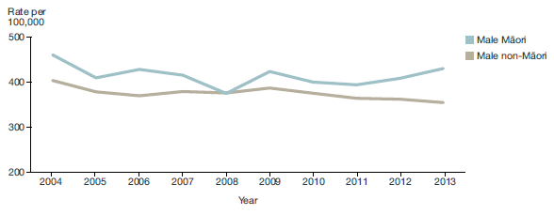
Source: Cancer: new registrations and death series

Figure 27: Age adjusted cancer registration rate for Māori and non-Māori females,
2004–2013
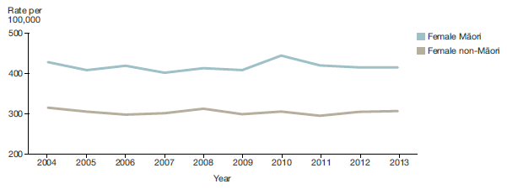
Source: Cancer: new registrations and death series

In the same year, there were large disparities in the rates of stomach cancer and lung cancer registrations. The rate of stomach cancer in Māori females was 4.5 times higher than the rate in non-Māori females, while the rate of lung cancer was 3.8 times higher in Māori females than non-Māori females. The rate of uterine cancer in Māori females was 1.5 times higher than the rate in non-Māori females.

In 2013, lung cancer was the leading cause of cancer death, accounting for nearly one in every five deaths from cancer (1656 deaths). Colorectal cancer was the second most common, accounting for 1252 deaths. Together lung and colorectal cancers accounted for nearly one-third of all cancer deaths across the whole population.

Māori had a higher all-cancer mortality rate than non-Māori in 2013, with a rate of 197.9 per 100,000 Māori population; 1.7 times the rate for non-Māori (116.0 per 100,000).

Figures 28 and 29 illustrate the all-cancer age standardised mortality rates by gender and ethnicity between 2004–2013. It is shown that each year the rates were significantly higher for Māori males and females compared to non-Māori.

Figure 28: Age-standardised mortality rate due to cancer, 2004–2013, Māori and non-Māori males
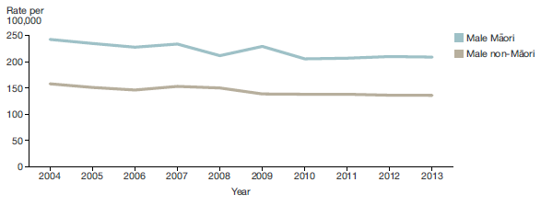
Source: Cancer: new registrations and death series

Figure 29: Age-standardised mortality rate due to cancer, 2004–2013, Māori and non-Māori females
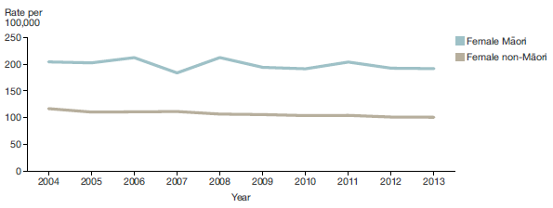
Source: Cancer: new registrations and death series

Between 2004 and 2013, the mortality rates for Māori males and females were significantly higher than the rates for non-Māori males and females each year.

Diabetes is a fast-growing condition that is largely preventable
Diabetes is New Zealand’s fastest growing long-term condition. It poses a significant health and economic burden at individual and societal levels. In 2015, an estimated 260,000 New Zealanders had been diagnosed with diabetes representing a significant increase from the 2008 estimation of 160,000. If this trend continues, the number will double over the next 20 years.

Approximately 90 percent of people with diabetes have type 2 diabetes, which is largely preventable. The Ministry of Health estimates that approximately one-quarter of adult New Zealanders have pre-diabetes. Without preventive action, these people are likely to develop type 2 diabetes. Poor diet and lack of exercise can contribute to a high BMI, which is a key factor for developing type 2 diabetes.

Diabetes affects population groups at different rates
The prevalence of diabetes is increasing for all ethnicities and ages. However, diabetes affects different population groups at different rates. Māori, Pacific, and Indo-Asian people are disproportionately affected, and develop diabetes at an earlier age. One in three Pacific adults aged 45 years or over has diabetes and experience more complications than non-Pacific people with the condition.

Figure 30: Proportion of the population with diabetes, 2015, by ethnicity and age group
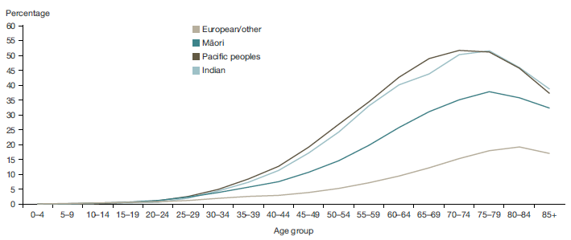
Source: Virtual Diabetes Register

Adults living in the most socioeconomically deprived areas are over three times more likely to report being diagnosed with diabetes than adults living in the least deprived areas. Those adults are also more likely to be Māori or Pacific adults than non-Māori, non-Pacific adults.

Obese children and young people have a higher risk of developing type 2 diabetes and early signs of cardiovascular disease.

Figure 31: Proportion of the population with diabetes, 2007 and 2015, by age group
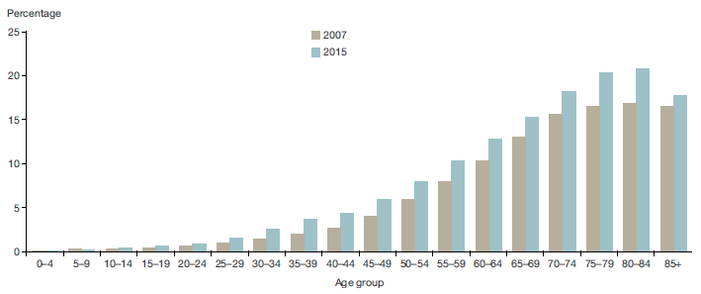
Source: Virtual Diabetes Register

Early onset type 2 diabetes is increasing among Pacific and Māori children and youth under the age of 25 years. It is also increasingly common in people aged 65 and older, which has important implications for the health of our ageing population.

The impact of diabetes
Diabetes is a major cause of serious but largely preventable conditions including renal failure, working-age adult blindness and lower limb amputations, and is a substantial contributor to premature stroke and cardiovascular disease.

A focus on addressing diabetes over the last ten years has begun to yield signs of improvement. Figure 32 shows that on a per capita, age-adjusted basis, health loss from diabetes declined between 2005 and 2015, even though the prevalence of diabetes increased over that time. This reflects earlier diagnosis and better management of this condition.

Figure 32: Age-standardised disability-adjusted life year rate per 1,000 attributable to diabetes, 1990–2015 (projected)
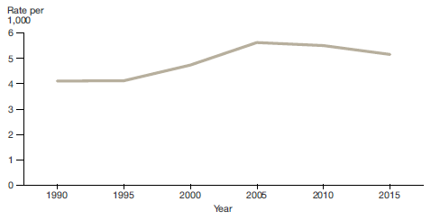
Source: Ministry of Health 2016: Health Loss in New Zealand 1990–2013

The Ministry of Health has developed a five-year plan to further respond to the challenge of type 2 and type 1 diabetes (see text box).

Living Well with Diabetes
The Minister of Health launched Living Well with Diabetes: A plan for people at high risk of or living with diabetes 2015–2020 in 2015 (Ministry of Health 2015d).
The plan builds on work already under way, and aims to ensure that all New Zealanders with, or at high risk of developing, type 2 diabetes live well and have access to high-quality people-centred services, with a focus on supporting people to manage their condition themselves.
The priority areas of action are to: prevent people at high risk from developing type 2 diabetes; enable effective self-management; improve the quality of services; detect diabetes early and reduce the risk of complications; provide integrated care; and meet the needs of children and adults with type 1 diabetes.

Once diabetes (type 1 or type 2) is diagnosed, it is important to manage the condition well to prevent complications. Good management includes, for example, self-management and timely access to primary care. Data from the Health Quality & Safety Commission shows that the number of patients with diabetes admitted for hypoglycaemia (low blood sugar level) decreased from 4.9 to 3.8 admissions per 1000 patients with diabetes between 2011 and 2014. This may reflect improved care at the community level, and an improvement in people’s ability to self-manage their condition.

Mental health and wellbeing
Good mental health and wellbeing enables people to participate in education, employment, family/whānau and social life, and to engage with the communities in which they live.

Mental illness is a major cause of health loss
Mental illness is one of the major causes of health loss in New Zealand. One in five people experiences mental illness each year (Oakley Brown et al 2006). The most commonly diagnosed disorders are anxiety, depression and substance use disorders.

Serious mental health issues often co-exist with other issues (such as alcohol and drug use), and can contribute to relationship breakdown, poor educational outcomes and unemployment. People with a mental health condition recorded as the primary condition that impacts on their ability to work, make up about one-third of all clients in receipt of a health or disability related benefit ie, Jobseeker Support – Health and Disability or Supported Living Payment.

Māori and Pacific peoples are more likely to report experiencing psychological distress
Approximately 7 percent of adult respondents to the 2015/16 New Zealand Health Survey reported that they had experienced psychological distress in the previous four weeks, indicating that they may have had, or been at risk of developing, an anxiety or depressive disorder.

Pacific and Māori adults were 1.5 times as likely to report having experienced psychological distress in the previous four weeks as non-Pacific and non-Māori adults. However, Pacific adults have some of the lowest rates of diagnosed mood and/or anxiety disorders.

Mental health problems are significant health issues for children and young people
Mental illness (including conduct disorder, depressive and anxiety disorders, addictions and self-harm) feature strongly in the leading health conditions affecting children and young people.

Addressing mental health concerns in childhood is an important focus for the health system. One strategy for doing so is the Well Child/Tamariki Ora programme, available for all preschool children and their families/whānau. The programme provides timely and regular assessments of child health and development, and facilitates referrals to appropriate follow-up services. It includes the B4 School Check, which reaches around 80 percent of all four-year-olds, and assesses a child’s behavioural and emotional needs prior to starting school.

Early intervention is important
Young people with poor mental health and addiction are more at risk of poor social outcomes later in life. The health sector works with other government agencies to improve prevention and early intervention in the context of mental health. The Prime Minister’s Youth Mental Health Project is one example.

The Prime Minister’s Youth Mental Health Project – a cross-agency initiative
The Prime Minister’s Youth Mental Health Project, which is a cross-agency initiative led by the Ministry of Health, has been a forerunner in shifting the focus of the mental health sector to prevention and early intervention. The project complements specialist care with initiatives to identify, support and treat youth with, or at risk of developing, mild to moderate mental health issues.
The project has reached more than 180,000 youth so far. The Ministry estimates that 1,764 youth have become free of illness after accessing services through the project. For example, 43.7 percent of the 400 youth who completed four modules of SPARX e-therapy (a free online tool) went into remission (Superu 2016).

Mental illness can affect physical health
It is well established that mental illness impacts on people’s physical health. Compared to the general population, people with serious mental illness have higher medical needs and hospitalisation rates, and are at greater risk of developing cardiovascular disease and other long-term conditions. They are also two to three times more likely to die prematurely than the general population. Two-thirds of this premature mortality is due to cardiovascular disease, cancer and other physical illnesses (Te Pou o Te Whakaaro Nui 2014).

Given the strong relationship between mental illness, physical health and premature mortality, it is clear that preventing mental health problems and illness, and improving timely access to mental health services, is important to improving the overall health of New Zealanders.

Over 600,000 New Zealanders accessed mental health services in 2015
In 2015, a record number of people – over 600,000 – accessed mental health services, including phone and online help, primary mental health services and specialist mental health services (which reached 162,000 people; 3.5 percent of the population – Ministry of Health 2016g). Fewer New Zealanders are now accessing specialist mental health services as their first interaction with mental health services.

Māori experience the highest levels of mental illness overall, and are more likely to be diagnosed with serious illness and more likely to experience co-morbidities than non-Māori. Māori make up approximately 16 percent of New Zealand’s population, but account for 26 percent of specialist/secondary mental health service users (Ministry of Health 2016g).

Figure 33: Rate of clients seen in specialist mental health services, 2007–2016, by ethnicity
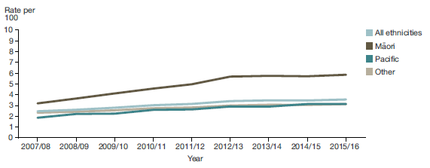
Source: Ministry of Health

Rising to the Challenge
The health sector’s work to improve mental health and addiction outcomes, including for Māori and Pacific peoples, is guided by Rising to the Challenge: The Mental Health and Addiction Service Development Plan 2012–2017 (Ministry of Health 2012a). This plan provides a strong vision to guide service development within the mental health and addiction sector.
The plan focuses on four key areas: making better use of resources; improving integration between primary and secondary services; cementing and building on gains in resilience and recovery for people with high needs; and delivering increased access for infants, children and youth, older people, and adults with common mental health and addiction disorders such as anxiety and depression.

Suicide impacts the lives of many families/whānau and communities
Suicide is a serious concern for New Zealand. All suicidal behaviour is a sign of great distress. Suicide affects the lives of families/whānau, friends, colleagues and communities. In 2013, 508 people died by suicide in New Zealand, accounting for 1.7 percent of all deaths.

In 2013, approximately 2.5 times as many males died by suicide as females. The highest rate of suicide in New Zealand by life stage is evident among young people. Males and Māori are both overrepresented in suicide rates across all age groups. Suicide is a leading cause of death among Pacific young people; the suicide rate among Pacific people aged 15–24 years and 25–44 years is higher than the overall suicide rate for all ethnicities for those age groups (Ministry of Health 2012b).

The New Zealand Suicide Prevention Strategy
The New Zealand Suicide Prevention Strategy 2006–2016 and the New Zealand Suicide Prevention Action Plan 2013–2016 are well regarded nationally and internationally. They guide the health system in its work with other agencies to prevent suicide. The action plan seeks to strengthen support for family, whānau and communities; build the evidence base (specifically in terms of what works for Māori and Pacific peoples); extend existing services, specifically addressing geographical gaps in the coverage of services; and strengthen suicide prevention targeted to high-risk populations who are in contact with agencies. In 2017, the Ministry of Health will be developing a new suicide prevention strategy with input from the sector and public.

Dementia is a growing health concern
As more people live into their late 70s, 80s and beyond, we can expect the prevalence of dementia to increase.

In New Zealand, health loss from dementia rises sharply from 2.6 percent of total DALYs among 65–74-year-olds to 12 percent among people aged 75 years and over.

Health loss due to dementia rises sharply with age, from 2.6 percent of total DALYs among 65–74-year-olds to 12 percent among people aged 75 years and older. | Dementia affects people’s health and independence. In 2016, approximately 26 percent of older people assessed for home care and 52 percent of people entering long-term residential care had Alzheimer’s disease or dementia.  An estimated 50,000 people have dementia in New Zealand; this number is projected to rise to 78,000 people by 2026. Dementia currently costs our health system around $1 billion each year; this cost will rise as the number of people with dementia increases.

As yet, no single factor has been identified as the cause of dementia, and there is no cure. However, people can reduce their risk of developing dementia by making a few simple lifestyle changes, including looking after their heart, being physically active, following a healthy diet, challenging their brain and enjoying social activities.

The health sector is focused on preventing dementia, and improving the quality of life of people with dementia and their carers, families and whānau. The Ministry of Health is progressively implementing its action plan Improving the Lives of People with Dementia (Ministry of Health 2014b).

Aged residential care
While the overall number of people entering aged residential care is increasing as the population grows and ages, the proportion of people aged 75 years and over who require aged residential care has actually decreased over the last five years, from 11.1 percent to 9.6 percent.

This reflects the health system’s recent focus on supporting people to remain at home for longer, as well as overall improvement in the health of older people (as discussed earlier in this report), despite the increasing prevalence of dementia and diabetes.

Palliative and end-of-life care
Palliative care is care for people of any age with a life-limiting or life-threatening condition. It aims to optimise a person’s quality of life until death by addressing their physical, psychosocial, spiritual and cultural needs. Palliative care also supports the person’s family, whānau and other caregivers through their illness and after their death.

Palliative care is a priority for the Government. The Healthy Ageing Strategy (Associate Minister of Health 2016) aims to strengthen palliative care. It has a strong focus on providing palliative care ‘closer to home’, and supporting people to live and die within their community (whether at home or in aged residential care). Chapter three provides further information about the strategy.

Health professionals provide palliative care according to an individual’s needs and wishes; it may be suitable whether death is days, weeks, months or occasionally even years away. The preferred approach is that palliative care is available wherever the person wishes to receive it, and that all health care professionals provide it, supported where necessary by specialist palliative care services.

As medical treatments become more advanced, people often experience ‘prolonged dwindling’ as opposed to a rapid decline following the onset of a life-limiting condition. For this reason, there is a growing need for primary palliative care and advanced care planning (see below).

Advance care planning
Advance care planning is the process of thinking about, talking about and planning for future health care and end-of-life care. Both the New Zealand Health Strategy and the Healthy Ageing Strategy identify advance care planning as a priority area; both emphasise the need for people to plan for their future care needs early.
Advance care planning gives everyone a chance to define what is important to them. It helps people understand what the future might hold, and to say what treatment they would and would not want. Advance care plans enable carers and health care professionals to target care effectively, and in line with a person’s wishes.

Investing in community palliative care services
Through Budget 2015, the Government invested $76.1 million into hospice services. That comprised $52 million to address hospice funding pressures, and $24.1 million to support the delivery of new palliative care services in aged residential care, primary care and other community settings.

In 2016, the Ministry of Health led a review of adult palliative care services in New Zealand. An action plan to implement the recommendations is being developed with the Palliative Care Advisory Panel and will be announced in 2017.

Responding to our changing population and operating environment
To improve the health and wellbeing of New Zealanders the health system must keep pace with changing demographics, population health needs, technological and medical advances, workforce development, and customer expectations of modern health services.

Responding to these challenges is a key focus for the health system operating within financial constraints. The New Zealand Health Strategy sets out an overarching approach to meeting the particular set of challenges we face; Chapter 3 discusses it in more detail.

Chapter 3: Our direction

The New Zealand Health Strategy 2016
The New Zealand Health Strategy (Minister of Health 2016) recognises and responds to the key health challenges facing the nation.

The Ministry of Health developed the strategy with input from health professionals, academics, planners and funders, policy-makers and the public. It was released in April 2016, and sets out a new vision for how the health system might evolve over the next 10 years, so that New Zealanders live well, stay well, get well.  The strategy acknowledges that in order to respond to the challenges we currently face, we need to transition to a system that is people- powered, provides services closer to home, is designed for value and high performance, and works as one team in a smart system.  Alongside the strategy, the Ministry of Health published a roadmap of actions, to help guide progress towards improving the health and independence of New Zealanders. Implementation of the strategy is under way. | All New Zealanders live well, stay well, get well, in a system that is people- powered, provides services closer to home, is designed for value and high performance, and works as one team in a smart system.

Find more information about the strategy at: health.govt.nz/publication/new-zealand-health-strategy-2016

Supporting strategies
A number of other strategies and priorities designed to improve the health of all New Zealanders support the New Zealand Health Strategy. They include the New Zealand Disability Strategy, He Korowai Oranga: Māori Health Strategy and ’Ala Mo’ui: Pathways to Pacific Health and Wellbeing 2014–2018.

Healthy Ageing Strategy 2016
During 2015 and 2016, the Ministry of Health consulted widely on the health of older people in order to develop the Healthy Ageing Strategy (Associate Minister of Health 2016), which refreshes and replaces the Health of Older People Strategy 2002. The strategy’s vision is that ‘older people live well, age well, and have a respectful end of life in age-friendly communities’. It takes a life-course approach that seeks to maximise health and wellbeing for all older people.

The strategy’s key outcome areas are:
- a greater focus on prevention, healthy ageing and resilience throughout people’s older years
- ensuring older people can live well with long-term health conditions
- improved rehabilitation and recovery from acute episodes
- better support for older people with high and complex needs
- ensuring respectful end of life care.
The strategy heavily promotes a cross-government approach. This will enable innovations that seek to link personal health and wellbeing initiatives with initiatives from the wider social sector. To ensure the health and wellbeing of older people, all parts of the sector need to align their efforts, focus on government priorities and be able to adapt to new technologies and opportunities.

Working together as one team across government and the sector

Working across the social sector
The health and social sectors need to work together to address the drivers of poor health and social outcomes. The Social Sector Board, made up of social sector chief executives, has a collective responsibility to address the complex social problems facing New Zealanders.

The health sector regularly partners with other Social Sector Board agencies to help achieve shared objectives. Examples of cross-agency work includes actions to reduce household crowding, improve mental health, tackle methamphetamine issues, and reduce family violence and the influence of gangs in our communities.

Supporting vulnerable children
The Ministry of Health and DHBs are also working with other social sector agencies to support our most vulnerable pregnant women and children, through programmes such as Children’s Teams and gateway assessments for children entering the care and protection system.

During 2016, the Ministry of Health supported work led by the Ministry of Social Development to establish a new child-centred, stand-alone ministry to focus on the care and protection of vulnerable children and young people. The new department, named the Ministry for Vulnerable Children, Oranga Tamariki, will begin operating by April 2017.

Delivering better public services
The government’s Better Public Services (BPS) programme aims to achieve results that make a real difference for New Zealanders. The BPS programme sets challenging targets for government agencies in 10 result areas. Specific targets for the health system relate to increasing immunisation rates (discussed in Chapter 2) and preventing rheumatic fever (discussed below). Three other result areas in which the health system has a part to play are reducing welfare dependency, reducing assaults on children and improving people’s interaction with government (State Services Commission 2016).

A closer look at reducing rheumatic fever
Since the Government introduced the Better Public Services target in 2012, the Ministry of Health has made progress towards reducing rheumatic fever by two-thirds. By the end of the 2015/16 financial year there had been a 37 percent decrease in hospitalisations for first-episode rheumatic fever: the rate had reduced to 2.4 cases per 100,000, down from 4.0 per 100,000 in 2012. Rheumatic fever remains an area of focus.

Rheumatic fever starts with a sore throat that is known as ‘strep throat’ – a throat infection caused by a bacteria called group A streptococcus. Rheumatic fever makes the heart, joints (elbows and knees), brain and skin swollen and painful. It is more common among Māori and Pacific children and young people than among children and young people in the non-Māori, non-Pacific population.

We can prevent rheumatic fever by more effectively treating strep throat infections. District health boards with a high incidence of rheumatic fever are currently implementing a range of actions, including raising awareness, treating strep throats quickly and effectively in high-risk populations, and developing healthy homes initiatives to reduce household crowding (to reduce the spread of strep throat). | There has been a 37 percent decrease in first-episode rheumatic fever hospitalisations since 2012.

More than half of all rheumatic fever cases occur in the Auckland region. The Ministry’s focus in 2017 will be working with the three Auckland DHBs to reduce numbers of cases, particularly among Pacific people, who have experienced less of a decrease in incidence than Māori. In particular, there will be a focus on boosting awareness activities and targeting them towards Pacific communities.

Progress towards national health targets
All DHBs are working towards supporting New Zealanders to live well, stay well and get well through prevention (such as increased immunisation), early intervention (such as faster cancer treatment) and improving quality of life and independence (such as improved access to elective surgery).

The national health targets (set out in Table 3) are challenging, and present DHBs with stretch goals to achieve over time. Table 3 sets out DHBs’ progress towards the targets as at Quarter 4 of the 2015/16 financial year. Details can be found on the Ministry of Health’s website (Ministry of Health 2016h).

Table 3: Health targets, and results, quarter 4 2015/16
Target | Measures | Target rate | 2015/16  Quarter 4 result
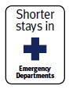 | 95% of patients will be admitted, discharged, or transferred from an emergency department within six hours. | 95% | 94%
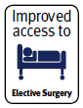 | The volume of elective surgery will be increased by an average of 4,000 discharges per year. | 100% | 108%
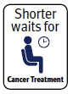 | 85% of patients receive their first cancer treatment (or other management) within 62 days of being referred with a high suspicion of cancer and a need to be seen within 2 weeks. | 85% | 74%
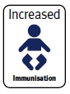 | 95% of 8-months-olds will have their primary course of immunisation (6 weeks, 3 months and 5 months immunisation events) on time. | 95% | 93%
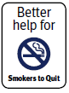 | - 90% of PHO enrolled patients who smoke have been offered help to quit smoking by a health care practitioner in the last 15 months.  - 90% of pregnant women who identify as smokers upon registration with a DHB-employed midwife or Lead Maternity Carer are offered brief advice and support to quit smoking. | 90% | 88%
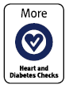 | 90% of the eligible population will have had their cardiovascular risk assessed in the last 5 years. | 90% | 91%

The targets are reviewed annually to ensure they continue to align with government health priorities. In 2016, noting that the ‘more heart and diabetes checks’ target had been achieved, the Ministry incorporated it into ongoing DHB accountability measures, and announced a new target, ‘raising healthy kids’ (see Chapter 2).

Whānau Ora
c
e
Whānau Ora is an innovative whānau-centred approach to empowering whānau to achieve better health, education, housing, skill development and economic outcomes. It supports progress towards health equity for Māori and Pacific peoples.
g

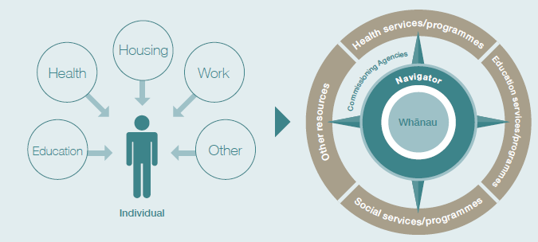

The Ministry of Health works with Te Puni Kōkiri on all aspects of the Whānau Ora work programme, including commissioning for results and the Whānau Ora Outcomes Framework. As part of Whānau Ora, DHBs collaborate with three NGO commissioning agencies to achieve accelerated progress towards health equity for Māori and Pacific.
s

In the context of Whānau Ora, priority areas for the Ministry of Health and DHBs over the next four years will be:
- tobacco use (in particular, support for Māori pregnant women to quit smoking)
- asthma (in particular, reducing hospitalisation rates among 0–4 year-olds)
- mental health (in particular, reducing the rate of Māori committed to compulsory treatment)
- obesity (in particular, increasing referral rates for Māori and Pacific 4 year-olds)
- oral health (in particular, ensuring that more children are caries-free at age five).

The Ministry of Health leads the information system workstream for Whānau Ora, called Mahere. This gives people the ability to develop and have control over their own whānau plans, alongside the Whānau Ora collectives they work with (Te Puni Kōkiri 2016).

Enabling Good Lives for people living with disabilities
The Enabling Good Lives programme offers New Zealanders with disabilities greater choice over the support they receive and the lives that they lead. The aim is to give people with disabilities more choice and control over where they live, who they live with and what they do during the day, as well as more employment opportunities.

The Ministry of Health set up a three-year Enabling Good Lives demonstration project in Christchurch in 2013, and recently extended it to 2018. In July 2015, it established another Enabling Good Lives demonstration project in the Waikato for two years, to further develop the model.

Prevention, early intervention and care closer to home
In order to deliver on the New Zealand Health Strategy and improve outcomes for New Zealanders, we need to be able to provide effective prevention, early intervention and care closer to home. Work discussed in this section supports the health sector’s recent focus on addressing health and social concerns early, to prevent poor outcomes and higher costs in the long run.

Pharmacy Action Plan 2016 to 2020
The recently released Pharmacy Action Plan 2016 to 2020 (Ministry of Health 2016i) supports the implementation of the New Zealand Health Strategy and the delivery of care closer to home. The Action Plan recognises pharmacist services as an essential part of a people-powered integrated model of care, where services are delivered in innovative ways, across a broad range of settings, so that all New Zealanders have equitable access to medicines and health care services. The Action Plan identifies four focus areas for changing models of care over the next three to five years: population and personal health; medicines management services; minor ailments and referral; dispensing and supply services. Further information can be found at: http://www.health.govt.nz/ publication/pharmacy-action-plan-2016-2020

It is estimated that nearly 40 percent of health loss can be prevented. Some of the most effective and cost-effective approaches to prevention involve multi-sectorial programmes that make it easier to reduce risk factors such as poor nutrition, lack of physical activity, hazardous alcohol consumption and tobacco smoking. These programmes are most effective when they target communities and populations before risk factors develop.

The health sector is investing in a range of programmes that promote healthy lifestyles in our communities and schools. Some examples are Healthy Families New Zealand, Health Promoting Schools, Healthy Christchurch and Healthy Auckland Together. The Green Prescription initiative is another example of supporting individuals and families/whānau to improve their own health and wellbeing; Green Prescriptions encourage people to adopt healthy lifestyles by getting active and improving their diet. In 2015/16 almost 50,000 Green Prescriptions were issues to patients to support people to make healthy lifestyle changes.

Two important parts of the focus on prevention and early intervention are primary care screening and early intervention services that aim to delay the development of long-term conditions and reduce health loss and premature mortality. Early diagnosis and treatment offer people the best opportunity to halt or reverse the progress of a disease, and are more effective than treatment after waiting for symptoms to develop or become serious. To offer the best early diagnosis and treatment, it is vital that we improve access to primary care services, improve health literacy and increase the uptake of screening services.

Improving access to services
Knowing where to go to get help, being able to get there and afford the service all matter for those accessing services. Table 4 presents information from the 2015/16 New Zealand Health Survey on access to primary health services, under four headings; accommodating, accessible, available, and affordable.

Table 4: Access to primary health care services
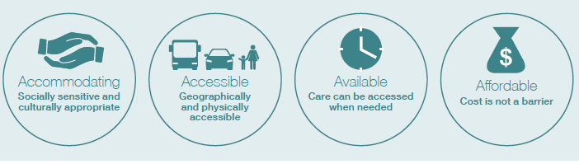
Accommodating | Accessible | Available | Affordable
79.2% of adults reported definite confidence and trust in their GP, and 79.9% of parents had confidence in their child’s GP. | 3.2% of adults and 1.3% of children experienced an unmet need for a GP due to lack of transport. | 17.8% of adults and 17.6% of children were unable to get an appointment at their usual medical centre within 24 hours. | 14.3% of adults and 4.5% of children reported an unmet need for a GP due to cost.
Some groups are more affected than others
As age increases, confidence and trust in GPs increases: from around 73% in younger adults (those aged 15–34 years) to around 86% for those aged 65 years and over. | Māori and Pacific adults were more likely (3.3 and 2.9 times respectively) to experience an unmet need for a GP due to a lack of transport compared with their non-Māori and non-Pacific counterparts. | Adults living in the most deprived areas were 1.3 times less likely to be able to get an appointment at their usual medical centre within 24 hours, compared with adults in the least deprived areas. | Cost prevented 1 in 5 adults living in the most deprived areas from visiting a GP, compared with 1 in 11 adults in the least deprived areas.
Source: New Zealand Health Survey 2015/6

The health sector is working to reduce barriers and improve access to primary care services through a range of current initiatives, including:
- enrolling babies into multiple services (a GP, an immunisation service, a Well Child/Tamariki Ora provider and a community oral health service) soon after birth
- reducing cost barriers through offering free doctors’ visits and prescriptions for children under the age of 13, and through the Very Low Cost Access Scheme, the Community Services Card, the High Use Health Card and the Prescription Subsidy Scheme for adults and families
- offering services in a range of settings (eg, in schools, youth one stop shops, marae and churches) to reach key population groups
- offering free advice and support via Healthline, PlunketLine and other telehealth services.

Further improving access to primary care and other health services is an ongoing focus for
policy-makers, planners, funders, service providers and health professionals working with patients and their families/whānau.

Increasing health literacy
Increasing health literacy is fundamental in enabling people to look after their health and access services. We use the term ‘health literacy’ to describe people’s ability to receive and understand basic health information and services, so that they can make informed decisions about their health.

A health literate system provides high-quality services that are easy to access and navigate, and produces health messages that are clear and relevant.

In 2015, the Ministry of Health launched A Framework for Health Literacy (Ministry of Health 2015e), to help the health and disability system respond to the health literacy needs of all New Zealanders. The framework guides action to build the health literacy skills of the workforce and the individuals who use health services.

The marae-based health literacy project
Between 2014 and 2016, the Ministry of Health, in association with Ngā Kaitiaki o Te Puna Rongoā o Aotearoa, the Māori Pharmacists’ Association, trialled a series of marae-based programmes to improve health literacy and the management of chronic conditions, particularly gout. The aims of the project were to educate people about serious long-term conditions, provide them with the skills necessary to manage them and give whānau the knowledge base and health literacy skills to support family members living with these conditions.
Review findings from the programme showed that by the end of the trial participants had greater understanding of the causes, prevention, treatment and management of long-term conditions; had greater confidence to seek support from doctors; were more encouraging and supportive of whānau living with long-term conditions; and had greater control of their existing conditions. The programme won the Te Hapai Hauora Award in the 2016 New Zealand Pharmacy Awards, in recognition of an intervention/team that illustrated excellence in the provision of pharmacy services to Māori and whānau. It also won the Supreme Award.

Screening
Screening programmes can detect some conditions with the aim to reduce the chance of developing or dying from that condition. In some cases, such as newborn metabolic screening, screening may find conditions which can be treated before the baby develops a preventable illness or disability. In other cases, such as breast screening, screening detects cancer at an early stage to increase the likelihood of survival.

Breast cancer screening
Breast cancer is New Zealand’s third most common cancer; it accounts for more than 600 deaths every year. Regular screening for breast cancer can find breast cancer early, meaning that an affected patient can receive less intensive treatment. A recent study carried out jointly by the Ministry of Health and University of New South Wales found that for women screened at least once by New Zealand’s national breast screening programme, the death rate from breast cancer was reduced by one-third compared to women who had never been screened by the programme. For women who undergo regular screening, there is an even greater reduction in the mortality rate (Ministry of Health 2015f).

BreastScreen Aotearoa (BSA) is New Zealand’s free national breast screening programme for women aged 45–69 years. It aims to screen 70 percent of eligible women aged 50–69 every two years. In the two years ending 31 December 2016, BSA had screened over 70 percent of Other (ie, non-Māori, non-Pacific, and Asian women) and Pacific women in this age group, and 64.7 percent of Māori women.

Māori women have a higher incidence of breast cancer, and the mortality rate for breast cancer in Māori and Pacific women is significantly higher (30.9 per 100,000, compared to 16.6 per 100,000) (Ministry of Health 2016f). The latest BSA monitoring reports show that while BSA is making a difference to breast cancer outcomes for Māori and Pacific women, lower coverage and lower rescreening rates are preventing BSA from achieving greater reductions in breast cancer mortality and morbidity for Māori and Pacific women. The National Screening Unit is continuing to work with providers to improve access to the service.

Smart use of data, information, technology and the workforce
The health system, like other parts of government, collects a range of information to help it understand the needs of individuals, communities and populations. Analysis and smart use of this information generates deeper insights into the health of New Zealanders and reveals ways we can improve services to meet current and future needs.

An investment approach to the needs of preschool children
Government agencies are increasingly using an investment approach to service provision, which takes into account the long-term impact of government spending on people’s lives. The Government wishes to make investment in the health sector that results in people having a greater ability to participate in education and employment and a reduced experience of, for instance, alcohol and drug dependency, family violence or mental health conditions. Such investment will have a positive long-term economic and social impact.

During 2015, the Ministry of Health, with support from other social sector agencies, started work on taking an investment approach on improving outcomes for 0- to 5-year-olds. The work incorporated work previously undertaken by The Treasury on children aged 0–14 years.

This project used an outcomes framework to determine the outcomes the social sector hoped to achieve for all children, and used integrated data from a range of sources to develop an understanding of the particular preschool children who were at risk of not reaching these outcomes. Using a set of key risk factors already shown to be linked to poor outcomes later in life, the review found that 53,127 (14.6 percent) of 0- to 5-year-olds were at risk of experiencing poor outcomes later in life. Just over 65 percent of the at-risk population (34,413 children) were Māori (The Treasury 2015).

Analysis found that children in this at-risk population were less safe, in poorer health, missing out on learning opportunities and less likely to belong to a community than other children. Table 5 gives further details of the review.

Table 5: Outcomes for at-risk children aged 0–5 years
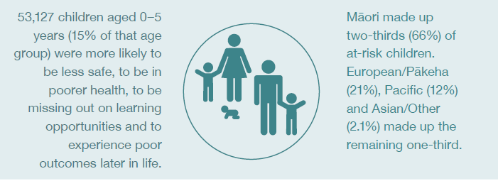

Outcomes
Safety | Health | Learning | Belonging
At-risk children were:  - 13.8 times more likely to have had a police family violence referral to Child, Youth & Family (CYF)  - 1.7 times more likely to have had a hospitalisation for an injury  - 5.6 times more likely to have a mother who smokes  - 8.9 times more likely to have had a CYF notification (as expected given the risk factor of a CYF finding). | At-risk children were:  - 1.6 times more likely to have had a low birth weight  - 1.7 times more likely to have been hospitalised for a condition that could have been mitigated in primary care  - 2.5 times more likely to have needed a dental referral  - 1.6 times more likely to be receiving disability services. | At-risk children were:  - 3.4 times less likely to have participated in early childhood education (ECE) before starting school  - 2.3 times more likely to have been assessed as having emotional or behavioural issues during their B4 School Check at age four. | At-risk children were 6.0 times more likely to move house at least once a year
By age (in years)
18 | 19 | 21 | 22
At-risk children were:  - 4.7 times more likely to have had further contact with CYF  - 1.6 times more likely to have used mental health services. | At-risk children were 2.5 times less likely to have any NCEA qualifications. | At-risk children were:  - 6.9 times more likely to have received a custodial sentence  - 4.6 times more likely to have received a main benefit for two years  - 4.1 times more likely to have received a benefit with a dependent child. | At-risk children were 13.5 times more likely to be a current gang member.
Within their lifetime, at-risk children were likely to require support services (through Child, Youth and Family, corrections, welfare and youth justice services) costing 5.6 times more than those required by the general population.

The analysis suggested that by the time at-risk children enter their late teens and early twenties, many will have encountered poor outcomes that could have been avoided (The Treasury 2016). This means it is particularly important that we ensure that children start well, develop well and stay well. The health system has a key role to play, through improving access to core health services for all pregnant women, children and families and by identifying and referring people with additional health and social needs to other services and support.

Social investment can help us with some of our key health challenges
The Ministry of Health has developed a work programme to trial a social investment approach to the high-priority issues of child health and mental health. It selected these areas based on high levels of pressure on the services involved, possible service gaps and the large difference to people’s lives maximising investment in these areas could bring about.

Figure 34: A social investment approach
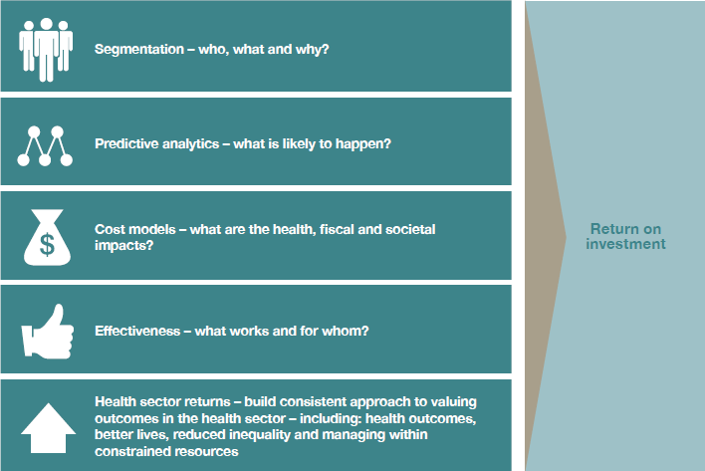

As Figure 34 illustrates, a social investment approach in these areas will provide us with a better understanding of the population’s needs, the current models and service packages and their impact on improving outcomes, and service gaps. It will help us make decisions that optimise the effectiveness of our services and the return on our investment.

Digital technologies
The New Zealand Health Strategy has set an ambitious goal of a people-powered, smart health system by 2025. New health and digital technologies can help us make progress towards achieving such a system.

Digital Health 2020
The Ministry of Health developed Digital Health 2020 in response to the New Zealand Health Strategy, to address the core digital technology requirements the strategy outlines.

Digital Health 2020 sets out a path towards a uniform information platform and a consistent data approach across the sector. It has five core components, set out in ‘Digital Health 2020 – overview’ (Ministry of Health 2016j):
- a single electronic health record for New Zealanders – a single longitudinal view of health information accessible to consumers, carers and decision-makers
- a health and wellness dataset – access to health data to support government, health organisations and individuals to make evidence-based decisions aligned to the Government’s social investment approach
- a preventative health IT capability – information and enabling information and communications technology (ICT) capability to support and improve the targeting of screening, immunisation and other public health initiatives
- digital hospital – to lift the digital capability within hospitals and the integration with the wider sector
- regional IT foundations – eHealth foundations supporting regional access to health information, delivery of the single electronic health record and lifting digital capability within hospitals.

The five core components are supported by architecture and standards, a health information governance framework (supporting data sharing, privacy, security and information management) and core ICT infrastructure and ICT enablers common to the Digital Health 2020 focus areas.

Progress towards a single electronic health record
The single electronic health record is an important element of Digital Health 2020. A single electronic health record will enable patients to access their own personal data more easily; save clinicians time through improved productivity and faster handover; and enable individuals, local decision-makers in DHBs, national decision-makers in the Ministry of Health and wider social sector decision-makers to use data and information appropriately to support broader health and social investments and outcomes.
In November 2016, the Ministry of Health entered into a strategic partnership to support the development of a two-stage business case for the single electronic health record (EHR). An indicative business case will be developed to establish options for a single EHR during 2017. The preferred option will then be further developed into a detailed business case by the end of 2018 for consideration by decision-makers.

Patient portals
New technologies are one way that the health system can respond to the challenges of a changing population. Patient portals are one example of the way ICT can help people to manage their own health. Patient portals are secure online sites, provided by general practice teams, where patients can access their health information and interact with their general practice team. As of December 2016, over 297,000 New Zealanders were using patient portals, and over 445 practices were offering them.

Patient portals give people convenient and secure electronic access to their health information, and increase their ability to manage their own health care. The portals allow patients to book appointments, see laboratory results, check their immunisation history and send secure messages to their GP or practice nurse.

Telehealth
The National Telehealth Service provides an integrated platform on which people can access health information, advice and support from trained health professionals. The service brings together seven helplines: Healthline, Quitline, the Gambling Helpline, the Alcohol Drug Helpline, the Depression Helpline (and National Depression Initiative services), the Poison Information Service and immunisation advice for the public.

Telehealth allows people to receive the right care at the right time and in the right place, using a range of communication channels. People contacting the service are able to talk to a range of professional staff, including registered nurses, mental health and addiction specialists and poisons specialists, who provide 24/7 advice, support, assessment of symptoms, triage and treatment advice.

The Ministry of Health will add more services and channels to the National Telehealth Service over the coming months, including new mental health services, as part of the $12 million boost Budget 2016 allocated to increase mental health support for people at an earlier stage. Homecare Medical runs the Telehealth service, in partnership with the Ministry of Health, with support from ACC and the Health Promotion Agency.

Devices and applications (apps)
Recent advances in medical devices and smartphone applications are helping people to manage long-term conditions such as type 2 diabetes. Predictive tools available through advances to patient management systems (such as cardiovascular risk assessment tools) are helping doctors and other health professionals intervene sooner.

This is an exciting area of development and more work will need to be done to understand the contribution of health-related smartphone applications in the marketplace for clinicians and health care consumers. The Ministry of Health is working with a range of people to develop guidance about the key considerations app developers should take into account, particularly in the New Zealand context. The aim is to have guidance in place by the end of 2017.

The health workforce
The New Zealand health workforce comprises a range of professions, including doctors (approximately 15,100), nurses (approximately 53,900), midwives (approximately 3,100), kaiā whina (approximately 63,000) and other allied health workers (approximately 24,800). To respond effectively to the challenges facing the health system, the workforce will need to transform and adapt.

Health Workforce New Zealand provides national leadership as it works with stakeholders involved in the development of the health workforce. It works with key organisations to ensure the New Zealand public has a health workforce fit to meet its needs. It collaborates with educational bodies and employers to ensure that workforce planning and postgraduate training aligns with current and future needs.

Through the development of its Workforce Forecasting Model, Health Workforce New Zealand is in an increasingly better position to more accurately project, and regularly review, supply of the majority of regulated health professionals, and is starting to develop a demand model to help determine investment decisions, including in terms of trainee numbers and training priorities. Health Workforce New Zealand anticipates that New Zealand’s demand for health practitioners will continue to rise as the general population, and the health workforce itself, ages.

Increases in the medical workforce 2008–2016
Between 30 November 2008 and 30 September 2016, the medical employed full-time equivalent (FTE) workforce increased by 1,974. Senior medical officers accounted for the majority of the increase (57.9 percent), and junior doctors (registrars and house officers) the second-largest component (44.0 percent). The majority of the increase of 4,961 in the nursing employed FTE workforce (including health assistants) over the same period was comprised of registered nurses (66.4 percent). There was a 23.7 percent increase in senior nurses.
Source: Ministry of Health 2016k

Ongoing training and development of a highly skilled health workforce is vital to delivering health services effectively and efficiently. Health Workforce New Zealand funds and supports:
- postgraduate clinical training to develop the skills of the clinical workforce, including technical and allied health professions
- the Voluntary Bonding Scheme – an incentive-based payment scheme to reward medical, midwifery and nursing graduates who agree to work in hard-to-staff communities and/or specialties, and medical physicist and radiation therapist graduates who remain in New Zealand after their studies
- GP training – which has changed after a review by Health Workforce New Zealand, the Royal New Zealand College of General Practitioners and the Medical Council of New Zealand that investigated how training (including clinical placements) could better accommodate the need for more GPs and match emerging models of care
- other training – such as regional training hubs, and health science and technical workforce reviews.

Nurse prescribing
We can improve timely and convenient access to health care services by making sure our health practitioners are working to their full capacity. An example of this is the enactment of new regulations allowing registered nurses, in certain situations, to prescribe medicines. Since September 2016, the Nursing Council has authorised registered nurses as prescribers. This reduces the number of steps patients need to take to access medicines, and assists in managing professional workloads in some settings (such as rural areas).

Regulations now allow registered nurse prescribers practising in primary health and specialty teams, to work with patients with long term and common conditions and prescribe from a limited list of commonly used medicines. Conditions treated may include high blood pressure, diabetes, respiratory diseases, common skin conditions and infections. Nurse prescribers work in team settings alongside authorised prescribers including doctors or nurse practitioners.

Internationally, nurse prescribing has been found to improve patient access to treatment, enhance patient care, allow for more effective use of medical staff time, and strengthen both professional satisfaction for nurses and inter-professional working practices.

Improving quality
Improving quality brings financial benefits, as well as individual health benefits. ‘Quality’ covers a number of important dimensions, such as safety, patient experience, effectiveness, equity, timeliness and efficiency. As a health system we are working to make improvements in all these dimensions, through a programme of work across services and settings.

Quality initiatives include, for example, the Maternity Quality and Safety Programme, the Well Child/Tamariki Ora Quality Improvement Framework, Cornerstone Accreditation for General Practice, Choosing Wisely (for patients and clinicians) and a quality framework and suite of quality measures for the emergency department phase of acute patient care. These initiatives and others like them contribute to system-wide and service level improvements.

The Health Quality & Safety Commission has established baseline measures and indicators to assess the quality of the health and disability system. One focus in this year’s report is a programme to reduce surgical site infections following hip and knee replacement operations. The Commission’s work programme also involves medication safety, reducing harm from falls, increasing consumer engagement, reporting on adverse events and findings of the mortality reviews committees. For more information, see www.hqsc.govt.nz

A good practice programme for reducing surgical site infections
Since the implementation of a good practice programme, the surgical site infection median rate following knee and hip replacement operations decreased from 1.3 percent in 2012 to 0.8 percent in August 2015. | Patients may acquire surgical site infections after an operation which can have serious implications in terms of illness, high costs, long hospital stays, emotional stress and mortality. A significant number of such infections are preventable.  In 2012, the Health Quality & Safety Commission launched a national programme to reduce surgical site infection rates following hip and knee replacement (arthroplasty) operations, by improving processes that contribute to lowering surgical site infections, including administration of antibiotics prior to surgery (prophylaxis), appropriate skin preparation, and clipping rather than shaving hair at the surgical site.  Figure 35 shows the improvement in process indicators for preventing surgical site infections following the programme’s implementation – including significant increases in selecting the right antibiotic dosage and giving it on time, and best practice preparation of the skin (HQSC 2016).

This programme has resulted in reducing the surgical site infection rates.

Figure 35: Compliance rates for process markers to reduce surgical site infections post knee and hip replacement, by category and quarter, July 2013–April 2016
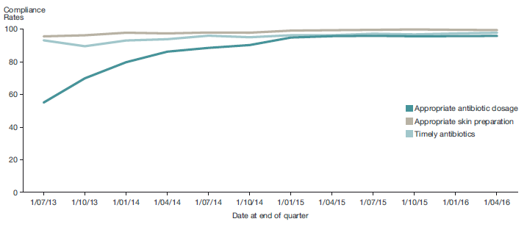

Technical notes
This report includes data from a wide range of sources, many of which are produced outside of the Ministry of Health. We have tried to ensure we only report on data where the data collection and analytical processes are robust. Notes are included where methodological information impacts on the interpretation of the data. We encourage you to refer to the original data source for further methodological information.

Where possible, the most recent validated data was used, although the time lag between the most recent data and the present can be substantial. For example, the most recent complete mortality data and health loss are for 2013. For some analyses, estimates of disability-adjusted life years (DALYs) were projected from 1990–2013 to 2015, by fitting a mathematical model to the trend data.

Where possible, we have reported on statistically significant time trends and differences between population groups, for example, by sex, age group and ethnic groups.

In many comparisons, the results are adjusted or standardised for factors that may be influencing (confounding) the comparison, such as age, sex and ethnicity. Age standardisation is often used in this report to account for differences in age structure between population groups, using the WHO world population.

Ethnic comparisons, where possible, were conducted using prioritised ethnic groups with mutually exclusive groups, such as Māori with non-Māori for data derived from national collection and mortality data. When it was not possible, such as data derived from the New Zealand Health Survey, total response ethnicity has been used. Total response ethnicity classifies a person in all the ethnic groups they identify with. This means that people can appear in more than one ethnic group.

Selected results are presented by neighbourhood deprivation, as measured by the New Zealand Index of Deprivation 2013 (NZDep2013). This index measures the level of socioeconomic deprivation for each neighbourhood (Primary Sampling Unit, PSU) according to a combination of the following 2013 Census variables: income, benefit receipt, transport (access to car), household crowding, home ownership, employment status, qualifications, support (sole-parent families) and access to a telephone (Atkinson et al 2014). In this report, ‘most deprived areas’ refers to quintile 5 (deciles 9 and 10); that is, the people living in the most socioeconomically deprived 20 percent of small areas in New Zealand.

References
Associate Minister of Health. 2016. Healthy Ageing Strategy. Wellington: Ministry of Health.
FASD Working Group. 2016. Taking Action on Fetal Alcohol Spectrum Disorder: 2016–2019: An action plan. Wellington: Ministry of Health.
Feigin VL, Krishnamurthi RV, Barker-Collo S, et al. 2015. 30-Year Trends in Stroke Rates and Outcome in Auckland, New Zealand (1981–2012): A Multi-Ethnic Population-Based Series of Studies. URL: http://dx.doi.org/10.1371/journal.pone.0134609
Health Promotion Agency. Don’t Know? Don’t Drink. URL: www.hpa.org.nz/node/11192 Health Promotion Agency. 2016. Stroke FAST Campaign. URL: www.hpa.org.nz/stroke-fast-campaign
HQSC. 2016. Surgical Site Infection Improvement Programme. URL: www.hqsc.govt.nz/our-programmes/infection-prevention-and-control/projects/surgical-site-infection-improvement
Institute for Health Metrics and Evaluation. 2015. GBD Compare. Seattle, WA: IHME, University of Washington.
Merkur S, Sassi F, McDaid D. 2013. Promoting health, preventing disease: is there an economic case? Copenhagen: World Health Organization, OECD, European Observatory.
Minister of Health. 2016. New Zealand Health Strategy: Future direction. Wellington: Ministry of Health.
Ministry of Health. 2010. Our Oral Health: Key findings of the 2009 New Zealand Oral Health Survey. Wellington: Ministry of Health.
Ministry of Health. 2012a. Rising to the Challenge: The Mental Health and Addiction Service Development Plan 2012–2017. Wellington: Ministry of Health.
Ministry of Health. 2012b. Tupu Ola Moui: Pacific Health Chart Book 2012. Wellington: Ministry of Health.
Ministry of Health. 2013. Hazardous Drinking in 2011/12: Findings from the New Zealand Health Survey. URL: www.health.govt.nz/publication/hazardous-drinking-2011-12-findings-new-zealand-health- survey
Ministry of Health. 2014a. Analysis of Household Crowding based on Census 2013 data. Wellington: Ministry of Health.
Ministry of Health. 2014b. Improving the Lives of People with Dementia. Wellington: Ministry of Health.
Ministry of Health. 2015a. Socioeconomic indicators. URL: www.health.govt.nz/our-work/ populations/Māori-health/tatau-kahukura-Māori-health-statistics/nga-awe-o-te-hauora-socioeconomic-determinants-health/socioeconomic-indicators#1
Ministry of Health. 2015b. Eating and Activity Guidelines for New Zealand Adults. Wellington: Ministry of Health.
Ministry of Health. 2015c. Childhood Obesity Plan. Wellington: Ministry of Health.
Ministry of Health. 2015d. Living Well with Diabetes: A plan for people at high risk of or living with diabetes 2015–2020. Wellington: Ministry of Health.
Ministry of Health. 2015e. A Framework for Health Literacy. Wellington: Ministry of Health.
Ministry of Health. 2015f. Summary of the BreastScreen Aotearoa Mortality Evaluation 1999–2011. Wellington: Ministry of Health.
Ministry of Health. 2016a. Health Loss in New Zealand 1990–2013: A report from the New Zealand Burden of Diseases, Injuries and Risk Factors Study. Wellington: Ministry of Health.
Ministry of Health. 2016b. Annual Update of Key Results 2015/16: New Zealand Health Survey. Wellington: Ministry of Health.
Ministry of Health. 2016c. Clinical Guidelines for Weight Management in New Zealand Children and Young People. Wellington: Ministry of Health.
Ministry of Health. 2016d. New Zealand Maternity Clinical Indicators 2014. Wellington: Ministry of Health.
Ministry of Health. 2016e. System Level Measures Framework questions and answers. URL: www.health.govt.nz/new-zealand-health-system/system-level-measures-framework/ system-level-measures-framework-questions-and-answers
Ministry of Health. 2016f. Cancer: New registrations and deaths 2013. Wellington: Ministry of Health.
Ministry of Health. 2016g. Office of the Director of Mental Health Annual Report 2015. Wellington: Ministry of Health.
Ministry of Health. 2016h. Health targets – 2015/16 quarter 4 – results summary. URL: www.health. govt.nz/new-zealand-health-system/health-targets/how-my-dhb-performing/how-my-dhb-performing-2015-16/health-targets-2015-16-quarter-4-results-summary Ministry of Health. 2016i. Pharmacy Action Plan 2016 to 2020. Wellington: Ministry of Health.
Ministry of Health. 2016j. Digital Health 2020 – overview. URL: http://healthitboard.health.govt.nz/system/files/documents/pages/digital_health_2020_overview.pdf
Ministry of Health. 2016k. DHB clinical staffing numbers: As at September 2016. URL: www.health. govt.nz/our-work/health-workforce/dhb-clinical-staffing-numbers
Oakley Browne MA, Wells JE, Scott KM (eds). 2006. Te Rau Hinengaro: The New Zealand Mental Health Survey. Wellington: Ministry of Health.
OECD. 2015. Health at a Glance 2015: OECD Indicators. Paris: Organisation for Economic Co-operation and Development.
Peto R, Darby S, Deo H, et al. 2000. Smoking, smoking cessation, and lung cancer in the UK since 1950: combination of national statistics with two case control studies. British Medical Journal 321: 323–9.
Superu. 2016. Prime Minister’s Youth Mental Health Project. URL: www.superu.govt.nz/ymh
State Services Commission. 2016. Better Public Services: Supporting vulnerable children – result 3: infant immunisation. URL: www.ssc.govt.nz/bps-supporting-vulnerable-children#result3
Statistics New Zealand. 2014a. Half a million Aucklanders born overseas. URL: www.stats.govt.nz/ census/2013-census/profile-and-summary-reports/qstats-culture-identity-auck-mr.aspx
Statistics New Zealand. 2014b. The New Zealand Disability Survey 2013. Wellington: Statistics New Zealand.
Statistics New Zealand. 2015a. National Ethnic Population Projections: 2013(base)–2038. Wellington. Statistics New Zealand.
Statistics New Zealand. 2016a. Population heads for 5 million. National Population Projections: 2016 (base)–2068 – media release. Wellington: Statistics New Zealand.
Statistics New Zealand. 2016b. National Population Estimates: At 30 June 2016. Wellington. Statistics New Zealand.
Te Pou o Te Whakaaro Nui. 2014. The Physical Health of People with a Serious Mental Illness and/or Addiction: An evidence review. Auckland: National Centre of Mental Health Research, Information and Workforce Development.
Te Puni Kōkiri. 2016. Whānau Ora at a Glance. URL: www.tpk.govt.nz/en/whakamahia/whanau-ora
Teng AM, Atkinson J, Disney G, et al. 2016. Ethnic inequalities in cancer incidence and mortality: census-linked cohort studies with 87 million years of person-time follow-up. BMC Cancer 16: 755.
Tobias M, Turley M, Paul S, et al. 2005. Debunking the ‘only 50%’ myth: prevalence of established risk factors in New Zealanders with self-reported ischaemic heart disease. Australian and New Zealand Journal of Public Health 29(5): 405–11.
The Treasury. 2015. Using Integrated Administrative Data to Understand Children at Risk of Poor Outcomes as Young Adults. Analytical Paper 15/01. Wellington: The Treasury.
The Treasury. 2016. Characteristics of Children at Greater Risk of Poor Outcomes as Adults. Analytical Paper 16/01. Wellington: The Treasury.
Woodward A, Blakely T. 2014. The Healthy Country? A History of Life and Death in New Zealand. Auckland: Auckland University Press.

The Global Burden of Disease estimates for life expectancy shown above differ slightly from those produced by Statistics New Zealand because of small differences in data and methods (Institute for Health Metrics and Evaluation 2015).
‘Hazardous drinking, refers to an established drinking pattern that carries a risk of harming physical or mental health, or having harmful social effects to the drinker or others. It is defined as a score of 8 or more on the 10-question Alcohol Use Disorders Identification Test (AUDIT)’. Ministry of Health 2013. See also health.govt.nz/publication/ annual-update-key-results-2015-16-new-zealand-health-survey
Based on analysis of data from the 2013/14 and 2015/16 surveys. Risk factors were hazardous drinking, current smoker, no physical activity and not eating enough fruit and vegetables.
Progress on these measures is reported at www.tpk.govt.nz

