Office of the Director of Mental Health Annual Report
2014

Disclaimer
The purpose of this publication is to inform discussion about mental health services and outcomes in New Zealand, and to assist in policy development.
This publication reports information provided to the Programme for the Integration of Mental Health Data (PRIMHD) (see Appendix 2) by district health boards and non-governmental organisations. It is important to note that, because PRIMHD is a dynamic collection, it was necessary to wait a certain period before publishing a record of the information in it, so that it is less likely that the information will need to be amended after publication.
Although every care has been taken in the preparation of the information in this document, the Ministry of Health cannot accept any legal liability for any errors or omissions or damages resulting from reliance on the information it contains.

A note on the cover
‘Mountain Tops’ by Rhonda Swenson
Rhonda Swenson has been an artist at Vincents Art Workshop for more than 20 years. Through her paintings and poetry, Rhonda gives artistic expression to living with multiple disabilities, including cerebral palsy and a specific learning disability. Rhonda says ‘Attending Vincents Art Workshop on most days gives me social inclusion where I meet other people. I talk and work in an environment without pressure to have to meet any performance standard but my own’.
Vincents Art Workshop is a community art space in Wellington established in 1985. A number of people who attend have had experience of mental health services or have a disability, and all people are welcome. Vincents Art Workshop models the philosophy of inclusion and celebrates the development of creative potential and growth.
Website: www.vincents.co.nz

Citation: Ministry of Health. 2015. Office of the Director of Mental Health
Annual Report 2014. Wellington: Ministry of Health.
Published in December 2015
by the Ministry of Health
PO Box 5013, Wellington 6145, New Zealand
ISBN 978-0-947491-37-6 (print)
ISBN 978-0-947491-38-3 (online)
HP 6300
This document is available at www.health.govt.nz

This work is licensed under the Creative Commons Attribution 4.0 International licence. In essence, you are free to: share ie, copy and redistribute the material in any medium or format; adapt ie, remix, transform and build upon the material. You must give appropriate credit, provide a link to the licence and indicate if changes were made.

Foreword
Tēnā koutou.
Nau mai ki tēnei te tuangahuru o ngā Rīpoata ā Tau a te Āpiha Kaitohu Tari Hauora Hinengaro mō te Manatū Hauora. Kei tēnei tūnga te mana whakaruruhau kia tika ai te tiaki i te hunga e whai nei i te oranga hinengaro. Ia tau ka pānuitia tēnei ripoata kia mārama ai te kaitiakitanga me te takohanga o te apiha nei ki te katoa.
Welcome to the tenth Annual Report of the Office of the Director of Mental Health. The main purpose of the report is to present information and statistics that serve as barometers of quality for our mental health services. Active monitoring of services is vital to ensuring New Zealanders are receiving quality mental health care.
In this year’s report there is a focus on child and youth mental health. Although children and youth rarely receive mental health care under the Mental Health (Compulsory Assessment and Treatment) Act 1992 (the Mental Health Act), initiatives that pursue positive outcomes for children, young people and their families provide important context to the Office of the Director of Mental Health’s work.
The child and youth focus of this year’s report is consistent with my vision for mental health in 2030: an integrated system that promotes early intervention and a holistic, family/whānau-focused model of service delivery; a system that gives due consideration to the social determinants of health by working across sectors, and that endorses the World Health Organization principle ‘there is no health without mental health’.
The ‘voices’ of individuals from different vantage points within the sector are again included in this report. We feature several individuals involved in innovative work within child and youth mental health.
Last year, we published statistics on Māori and the use of section 29 of the Mental Health Act for the first time. This year, we have expanded this section to include further information on gender and length of time spent under community treatment orders. It is my hope that this information is used to support the ongoing improvements in service provision to Māori in Aotearoa.
In addition, we have published statistics on the use of section 7A of the Mental Health Act for the first time. Section 7A requires consultation with family/whānau during the compulsory assessment and treatment process (except in certain circumstances). I regard the publishing of section 7A statistics as a welcome inclusion that underscores the importance of family/whānau in a person’s journey of recovery.
Looking to the future, the Office of the Director of Mental Health will continue to improve processes related to the administration of the Mental Health Act, always with the aim of making a meaningful contribution to the mental health conversation in New Zealand.
Noho ora mai
Dr John Crawshaw
Director of Mental Health
Chief Advisor, Mental Health

He moana pukepuke e ekengia e te waka.
A choppy sea can always be navigated.
Could we change our attitude, we should not only see life differently, but life itself would come to be different.
Katherine Mansfield

Contents
Foreword iii
Executive summary ix
Introduction 1
Objectives 1
Structure of this report 1
Context 2
The Ministry of Health 2
Rising to the Challenge 2
Specialist mental health services 3
The Mental Health Act 5
A holistic approach to mental health service delivery 7
Activities for 2014 13
Mental health sector relationships 13
Cross-government relationships 13
Special patients and restricted patients 16
The Mental Health Review Tribunal 18
Ensuring service quality 20
Consumer satisfaction surveys 20
Waiting times 21
Relapse prevention plans 22
Use of the Mental Health Act 24
Māori and the Mental Health Act 31
Family/whānau consultation and the Mental Health Act 36
Seclusion 40
Electroconvulsive therapy 49
Serious adverse events 56
Death by suicide 58
The Alcoholism and Drug Addiction Act 1996 64
Opioid substitution treatment 65
References 70
Appendices
Appendix 1: Additional statistics 72
Appendix 2: Caveats relating to PRIMHD 76

List of Tables
Table 1: Number of long-leave, revocation and reclassification applications for special patients and restricted patients, 1 January to 31 December 2014 17
Table 2: Number of people transferred to hospital from prison under sections 45 and 46 of the Mental Health Act, 2001 to 2014 17
Table 3: Average number of people per 100,000 per month required to undergo assessment under sections 11, 13 and 14(4) of the Mental Health Act, by district health board, 1 January to 31 December 2014 27
Table 4: Average number of people per 100,000 on a given day subject to sections 29, 30 and 31 of the Mental Health Act, by district health board, 1 January to 31 December 2014 28
Table 5: Age-standardised rates of Māori and non-Māori subject to a community treatment order (section 29) under the Mental Health Act, by gender, 1 January to 31 December 2014 33
Table 6: Seclusion indicators for forensic and ID services, by district health board, 1 January to 31 December 2014 48
Table 7: Electroconvulsive therapy indicators by district health board of domicile, 1 January to 31 December 2014 51
Table 8: Indicators for situations in which electroconvulsive therapy was not consented to, by district health board of service, 1 January to 31 December 2014 53
Table 9: Number of people treated with electroconvulsive therapy, by age group and gender, 1 January to 31 December 2014 54
Table 10: Number of people treated with electroconvulsive therapy, by ethnicity, 1 January to 31 December 2014 55
Table 11: Number of serious adverse events reported to the Health Quality & Safety Commission, 1 January to 31 December 2014 56
Table 12: Number of serious adverse events reported to the Health Quality & Safety Commission, by district health board, 1 January to 31 December 2014 57
Table 13: Outcomes of reportable death notifications under section 132 of the Mental Health Act, 1 January to 31 December 2014 57
Table 14: Number and age-standardised rate of suicide, by service use, people aged
10–64 years, 1 January to 31 December 2012ª 59
Table 15: Number and age-standardised rate of suicide, by service use and sex, people aged 10–64 years, 1 January to 31 December 2012ª 60
Table 16: Number and age-specific rate of suicide, by age group, sex and service use, people aged 10–64 years, 1 January to 31 December 2012 61
Table 17: Number and age-standardised rate of suicide and deaths of undetermined intent, by ethnicity and service use, people aged 10–64 years, 1 January to 31 December 2012 62
Table 18: Number of applications for detention and committal, by application outcome, 2004–2014 64
Table 19: Number of granted orders for detention and committal, 2004–2014 65
Table A1: Outcome of Mental Health Act applications received by the Mental Health Review Tribunal, 1 July 2013 to 30 June 2014 72
Table A2: Results of inquiries under section 79 of the Mental Health Act held by the Mental Health Review Tribunal, 1 July 2013 to 30 June 2014 72
Table A3: Ethnicity of people who identified their ethnicity in Mental Health Review Tribunal applications, 1 July 2013 to 30 June 2014 73
Table A4: Gender of people making Mental Health Review Tribunal applications, 1 July 2013 to 30 June 2014 73
Table A5: Applications for compulsory treatment orders (or extensions), 2004–2014 74
Table A6: Types of compulsory treatment orders made on granted applications,
2004–2014 75

List of Figures
Figure 1: Number of people engaging with specialist services each year, 2011–2014 3
Figure 2: Percentage of service users accessing only community services, 1 January to 31 December 2014 4
Figure 3: Responses to the statement ‘overall I am satisfied with the services I received’, 2013/14 21
Figure 4: Percentage of people seen by mental health services within three weeks (left) and within eight weeks (right), 2013/14 22
Figure 5: Percentage of people seen by addiction services within three weeks (left) and within eight weeks (right), 2013/14 22
Figure 6: Percentage of long-term service users with a relapse prevention plan,
2007–2014 23
Figure 7: Percentage of service users with a relapse prevention plan, by district health board, 1 January to 31 December 2014 23
Figure 8: Average number of people per 100,000 on a given day subject to a community treatment order (section 29 of the Mental Health Act), by district health board, 1 January to 31 December 2014 28
Figure 9: Average number of people per 100,000 on a given day subject to an inpatient treatment order (section 30 of the Mental Health Act), by district health board, 1 January to 31 December 2014 29
Figure 10: Rate of people per 100,000 subject to compulsory treatment order applications (including extensions), by age group, 2004–2014 29
Figure 11: Rate of people per 100,000 subject to compulsory treatment order applications (including extensions), by gender, 2004–2014 30
Figure 12: Rate ratio of Māori to non-Māori subject to a community treatment order (section 29) under the Mental Health Act, by district health board, 1 January to 31 December 2014 33
Figure 13: Age-standardised rates of Māori and non-Māori subject to a community treatment order (section 29) under the Mental Health Act, by gender, 1 January to 31 December 2014 34
Figure 14: Length of time spent subject to a community treatment order (section 29) under the Mental Health Act for Māori and non-Māori 34
Figure 15: Average national percentage of family/whānau consultation for particular assessment/treatment events, 1 January to 31 December 2014 38
Figure 16: Average percentage of family/whānau consultation across all assessment/ treatment events by DHB, 1 January to 31 December 2014 38
Figure 17: Reasons for not consulting family/whānau, 1 January to 31 December 2014 39
Figure 18: Number of people secluded in adult inpatient services nationally, 2007–2014 41
Figure 19: Total number of seclusion hours in adult inpatient services nationally,
2007–2014 42
Figure 20: Number of people secluded in all mental health inpatient services (adult, forensic, ID and youth) by age group, 1 January to 31 December 2014 43
Figure 21: Distribution of seclusion events in all mental health inpatient services (adult, forensic, ID and youth), by duration of event, 1 January to 31 December 2014 43
Figure 22: Number of people secluded in adult inpatient services per 100,000, by DHB, 1 January to 31 December 2014 44
Figure 23: Number of seclusion events in adult inpatient services per 100,000, by district health board, 1 January to 31 December 2014 45
Figure 24: Seclusion indicators for adult inpatient services, Māori and non-Māori, 1 January to 31 December 2014 46
Figure 25: Percentage of people secluded in adult inpatient services, for Māori and non-Māori males and females, 1 January to 31 December 2014 46
Figure 26: Number of Māori and non-Māori secluded in adult inpatient services,
2007–2014 47
Figure 27: Number of people treated with electroconvulsive therapy, 2005–2014 50
Figure 28: Rate of people treated with electroconvulsive therapy, by district health board of domicile, 1 January to 31 December 2014 52
Figure 29: Number of people treated with electroconvulsive therapy, by age group and gender, 1 January to 31 December 2014 55
Figure 30: Age-standardised rate of suicide, by service use, people aged 10–64 years, 2001–2012 60
Figure 31: Age-specific rate of suicide, by age group, sex and service use, people aged 10–64 years, 1 January to 31 December 2012 61
Figure 32: Number of opioid substitution treatment clients, by age group, 2008–2014 66
Figure 33: Number of people receiving treatment from a specialist service, general practice or prison service, 2008–2014 67
Figure 34: Percentage of people receiving OST treatment from specialist services and general practice, by district health board, 1 January to 31 December 2014 67
Figure 35: Percentage of withdrawals from opioid substitution treatment programmes, by reason (voluntary, involuntary or death), 2008–2014 68
Figure 36: Number of people prescribed Suboxone, 2008–2014 69

Executive summary
- In 2014, a record number of people accessed specialist mental health and addiction services. Most accessed services in the community.
- In 2014, consumer satisfaction with mental health and addiction services was rated around 81 percent.
- In 2014, approximately 93 percent of long-term service users had a relapse prevention plan.
- In 2014, a small proportion of all service users received compulsory assessment and/or treatment under the Mental Health (Compulsory Assessment and Treatment) Act 1992 (the Mental Health Act).
- Māori are over-represented under the Mental Health Act. Reducing the disparity in mental health outcomes for Māori is a priority action for the Ministry of Health and district health boards (DHBs).
- In 2014, the use of seclusion in adult inpatient units continued to decline. However, Māori are still over-represented in the seclusion figures.
- In 2014, 247 people received electroconvulsive therapy (ECT) in mental health services. Women were more likely to receive ECT than men, and older people were more likely to receive ECT than younger people.
- In 2012, a total of 551 people died by suicide. Mental disorders are a significant risk factor for suicidal behaviour.

Introduction

Objectives
The objectives of this report are to:
- provide information about specific clinical activities that must be reported to the Director of Mental Health under the Mental Health Act
- report on the activities of statutory officers under the Mental Health Act (such as district inspectors and the Mental Health Review Tribunal)
- contribute to the improvement of standards of care and treatment for people with a mental illness through active monitoring of services against targets and performance indicators led by the Ministry of Health
- inform mental health service users, their families/whānau, service providers and members of the public about the role, function and activities of the Office of the Director of Mental Health and the Chief Advisor, Mental Health.

Structure of this report
This report is divided into three main sections. The first section (‘Context’) provides an overview of the legislative and service delivery contexts in which the Office operates. The second section (‘Activities for 2014’) describes the work carried out by the Office in 2014. The final section (‘Ensuring service quality’) provides statistical information, which covers the use of compulsion, seclusion, reportable deaths and ECT during the reporting period.

Context

The Ministry of Health
The Ministry of Health improves, promotes and protects the mental health and independence of New Zealanders by:
- providing whole-of-sector leadership of the New Zealand health and disability system
- advising the Minister of Health and the Government on mental health issues
- directly purchasing a range of important national mental health services
- providing health sector information and payment services.

Ministry groups play a number of roles in leading and supporting mental health services. The Clinical Leadership, Protection and Regulation business unit monitors the quality of mental health and addiction services and the safety of compulsory mental health treatment, through the Office of the Director of Mental Health and provider regulation groups.
The Ministry of Health improves, promotes and protects the mental health and independence of New Zealanders

The Sector, Capability and Implementation business unit supports the implementation of mental health policy through the Mental Health Service Improvement and Māori Health Service Improvement groups. Clinical and policy leaders from these groups collaborate with the Policy business unit to advise the Government on mental health policy and to implement policy.

The National Health Board is responsible for the funding, monitoring and planning of DHBs, including the annual funding and planning rounds. The Office of the Chief Nurse works to optimise the contribution of nursing to Government objectives and to the health and wellbeing of New Zealanders.

All of these Ministry teams have representation in the Mental Health Governance Group. The Director of Mental Health established the Governance Group in 2012. The Governance Group allows the Director to collaborate closely with colleagues from across the Ministry, enabling different business units to work effectively together to reach mental health objectives.

Rising to the Challenge
Rising to the Challenge targets disparities in mental health outcomes for certain groups, including Māori, Pacific peoples, refugees and people with disabilities
Over the last 50 years, New Zealand mental health services have moved from an institutional model to a recovery model that emphasises community treatment. Compulsory inpatient treatment has largely given way to voluntary engagement with mental health services in a community setting.

In December 2012 Cabinet approved Rising to the Challenge: The Mental Health and Addiction Service Development Plan 2012–2017 (Ministry of Health 2012e). This document builds on improvements to this model of mental health care by providing a strategic direction for mental health service improvement over the five years 2012–2017.

Rising to the Challenge outlines key actions to build on and enhance mental health service delivery, with the aim of improving wellbeing and resilience, expanding access and decreasing waiting times.

Rising to the Challenge also targets disparities in mental health outcomes for certain groups, including Māori, Pacific peoples, refugees and people with disabilities. Implementation of Rising to the Challenge is the responsibility of the Ministry, DHBs, other government agencies, and non-governmental organisations (NGOs) contracted to provide mental health and addiction services.

The Ministry of Health restricts funding for mental health and addiction services within the overall health funding that it provides to DHBs. Funding for mental health services increased from $1.1 billion in 2008/2009 to around $1.3 billion in 2013/14.

Specialist mental health services
General practitioners (GPs) and other primary health care providers support many people experiencing mental illness. Specialist mental health services provide support to people whose needs cannot be met by a primary care provider. In 2014, 158,313 people (3.5 percent of the New Zealand population) engaged with a specialist mental health or addiction service.

Figure 1 shows that the number of people engaging with specialist services gradually increased from 142,936 people in 2011 to 158,313 people in 2014. The rise could be due to a range of factors, including better data capture, a growing New Zealand population, improved visibility of and access to services, and stronger referral relationships between providers.
In 2014, 158,313 people engaged with a specialist mental health or addiction service

Figure 1: Number of people engaging with specialist services each year, 2011–2014
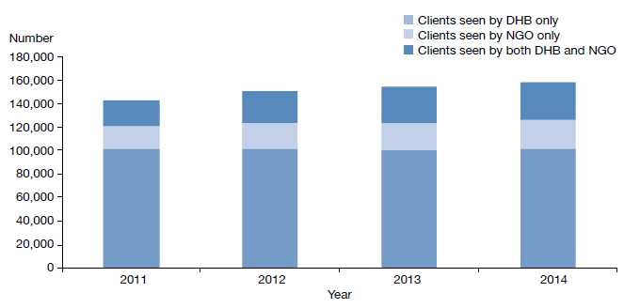
Source: PRIMHD data, extracted on 26 June 2015

District health boards are responsible for funding, planning and providing specialist mental health services for their respective populations. Mental health services are provided directly by DHBs, or indirectly by contracting between DHBs and NGOs. In most DHB areas, directly provided specialist mental health services include hospital mental health care and community mental health services. Non-governmental organisations provide a range of significant mental health services in each area, which can include alcohol and other drug (AOD) treatment, kaupapa Māori services, family/whānau support, supported accommodation and home-based support.
Non-governmental organisations provide a range of mental health services such as AOD treatment, kaupapa Māori services, family/whānau support, supported accommodation and home-based support
Most people access mental health services in the community. In 2014, 90.7 percent of specialist service users accessed only community mental health services, 0.5 percent accessed only inpatient services, and the remaining 8.7 percent accessed a mixture of inpatient and community services (Figure 2). The proportion of people who receive treatment in the community has increased by 5 percent from 86 percent in 2002.

Figure 2: Percentage of service users accessing only community services, 1 January to 31 December 2014
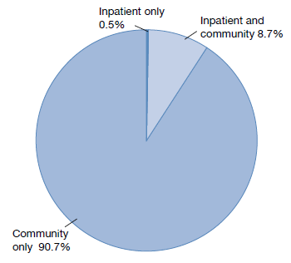
Note: Includes NGOs.
Source: PRIMHD data, extracted on 2 September 2015

The Mental Health Act
The Mental Health Act defines the circumstances under which people may be subject to compulsory mental health assessment and treatment.

The Mental Health Act provides a framework for balancing personal rights and the public interest when a person poses a serious danger to themselves or others due to mental illness.

The purpose of the Mental Health Act is to:
redefine the circumstances in which and the conditions under which persons may be subjected to compulsory psychiatric assessment and treatment, to define the rights of such persons and to provide better protection for those rights, and generally to reform and consolidate the law relating to the assessment and treatment of persons suffering from mental disorder.

The ‘Ensuring service quality’ section provides data on the use of the Mental Health Act.

Administration of the Mental Health Act
The chief statutory officer under the Mental Health Act is the Director of Mental Health, appointed under section 91. The Director is responsible for the general administration of the Mental Health Act under the direction of the Minister of Health and Director-General of Health. The Director is also the Chief Advisor, Mental Health, and is responsible for advising the Minister of Health on mental health issues.
One of the purposes of the Mental Health Act is to define the rights of persons subject to compulsory mental health assessment and treatment, and to provide better protection for those rights

The Mental Health Act also allows for the appointment of a Deputy Director of Mental Health.

The Director’s functions and powers under the Mental Health Act allow the Ministry to provide guidance to mental health services, supporting the strategic direction of Rising to the Challenge and a recovery-based approach to mental health.

In each DHB, the Director-General of Health appoints a director of area mental health services (DAMHS) under section 92 of the Mental Health Act. The DAMHS is a senior mental health clinician, responsible for administering the Mental Health Act within their DHB area. They must report to the Director of Mental Health every three months regarding the exercise of their powers, duties and functions under the Mental Health Act (Ministry of Health 2012b).

In each area, the DAMHS appoints responsible clinicians and assigns them to lead the treatment of every person subject to compulsory assessment or treatment (Ministry of Health 2012a). The DAMHS also appoints competent health practitioners as duly authorised officers to respond to people experiencing mental illness in the community who are in need of intervention. Duly authorised officers are required to provide general advice and assistance in response to requests from members of the public and the New Zealand Police. If a duly authorised officer believes that a person may be mentally disordered and may benefit from a compulsory assessment, the Mental Health Act grants them powers to arrange for a medical examination (Ministry of Health 2012c).

Protecting the rights of people subject to compulsory treatment
Although the Ministry of Health expects each DAMHS to protect the rights of people under the Mental Health Act in their area, the Mental Health Act also provides for independent monitoring mechanisms. The Minister of Health appoints qualified lawyers as district inspectors under section 94 of the Mental Health Act to protect the rights of people under the Mental Health Act, investigate alleged breaches of those rights and monitor service compliance with the Mental Health Act process.

The Mental Health Act requires district inspectors to inspect services regularly and report on their activities monthly to the Director of Mental Health. From time to time the Director can initiate an investigation under section 95 of the Mental Health Act, in which case the Act grants a district inspector powers to conduct an inquiry into a suspected failing in a person’s treatment under the Mental Health Act or in the management of services (Ministry of Health 2012b).

The Mental Health Act also provides for the appointment of the Mental Health Review Tribunal, a specialist independent tribunal comprising a lawyer, a psychiatrist and a community member. If a person disagrees with their treatment under the Mental Health Act, they can apply to the Tribunal for an examination of their condition and of whether it is necessary to continue compulsory treatment. Where the Tribunal considers it appropriate, it may release the person from compulsory status.

Sector voices

Dr Sue Nightingale – Director of area mental health services
Kia ora. My name is Sue Nightingale. I am the director of area mental health services (DAMHS) for Canterbury DHB and a deputy psychiatrist member of the Mental Health Review Tribunal.

As DAMHS, my primary role is to oversee the administration of the Mental Health Act in Canterbury. This means ensuring that every person who is assessed under the Mental Health Act is treated fairly, that the proper processes are followed and that everyone receives a high standard of care.

This also includes making sure that duly authorised officers and responsible clinicians appointed under the Act receive appropriate training, and that all concerns bought to my attention by consumers, family/whānau, staff and district inspectors are addressed.

I am fortunate to work in an environment where we have a great team of mental health clinicians. We have been working very hard to make our acute admission wards less restrictive, and increase the delivery of services to people in their homes. We have dramatically reduced our seclusion use and continue to work towards eliminating it. We are working hard to engage our consumers and family/whānau to provide the best possible care.

A holistic approach to mental health service delivery
While compulsory mental health assessment and treatment is an important intervention for a small number of people, it is only one strategy within a wide range of strategies we employ to achieve positive mental health outcomes for New Zealanders. Effective mental health care recognises the social, cultural, physical and economic determinants of health, such as housing, education, safe environments and social connectedness. It starts early, with our children and young people.
Effective mental health care recognises the social, cultural, physical and economic determinants of health. It starts early, with our children and young people
The focus of this section aligns with the Director of Mental Health’s vision for mental health in 2030: an integrated system that promotes early intervention and a family/whānau focused model of service delivery; a system that gives due consideration to the wider determinants of health and that endorses the World Health Organization (WHO) principle ‘there is no health without mental health’.

There is now compelling evidence that a holistic approach to mental health reduces the burden of mental illness and addiction for future generations (Beardslee et al 2011). Children and young people have been an area of priority for the current government, and initiatives increasingly involve cross- agency collaboration. The following subsections canvass a range of recent initiatives that pursue positive outcomes for children, young people and their families in New Zealand.

Perinatal and infant mental health service development
During the perinatal period, women are at higher risk for the onset or recurrence of mental illnesses than at other times in their lives (Thio et al 2006). Maternal mental illness can affect mother-infant bonding, which can lead to delayed social, emotional and cognitive development in the growing child (Ministry of Health 2011).
Mental health services are moving from an individualised approach to service delivery to a holistic, family/whānau focused approach
Budget 2013 appropriated new funding of $18.2 million over four years to extend acute perinatal and infant mental health services across the North Island, as part of the continuum of services available to mothers (and/or primary caregivers) and their babies. The new service provision varies based on existing services and local need. The range of new and enhanced services are now available in all of the North Island DHBs.

Supporting Parents, Healthy Children
A child who has a parent with mental health and/or addiction issues is more vulnerable to a range of adverse outcomes (Ministry of Health 2015b). Further, a mental health issue is likely to be just one of the challenges that the child’s family/whānau is experiencing (Ministry of Health 2015b).

The Ministry of Health has recently published the guideline Supporting Parents, Healthy Children (Ministry of Health 2015b) to guide the mental health and addiction sector in relation to the children of parents with mental illness and/or addiction issues. The guideline supports adult mental health services to move from an individualised approach to service delivery to a holistic, family/whānau focused approach.

Vulnerable Children’s Action Plan
Most children grow up happy and healthy, with nurturing caregivers, family/whānau, hapū, iwi and communities. But a minority of children in New Zealand are at significant risk of abuse, neglect and harm to their wellbeing. Such children often have complex needs (New Zealand Government 2012).

The Vulnerable Children’s Action Plan (New Zealand Government 2012) is a seven-year plan that translates the objectives of the White Paper for Vulnerable Children into initiatives aimed to identify, support and protect vulnerable children. The Ministry of Health’s role in implementing the plan includes leading the community responsibility work programme, leading health sector implementation of the Vulnerable Children Act 2014 requirements and supporting the implementation of ten children’s teams across New Zealand.

Sector voices

Dr Tania Pinfold – Youth health GP
My name is Tania Pinfold. I am a youth health GP. I have worked in Rotorua since 1987, initially as a hospital doctor and then in general practice. From the early 1990s I moved progressively into youth health.

During the 1990s, we developed ‘wellness centres’ in all of the high schools in Rotorua. The schools employ nurses, and we provide GP services to students. It became clear that most of these consultations were quite different to what is usually
seen in general practices.

In 2003, we opened up a youth ‘one stop shop’ in town called Rotovegas Youth Health. The service currently has around 850 consults per month, seeing young people aged 15 to 24 years for any problems. Accessible, appropriate and non-judgmental services are essential for young people, as are nurses, doctors and social workers with specific skills and training.

Since 2010, Rotovegas Youth Health has held the contract to provide health care at the Rotorua Youth Justice residence Te Maioha o Parekarangi. This site houses up to 30 young men with diverse criminal charges and complicated histories.

These overlapping pieces of work give us a broad perspective on the issues that can affect the health of our local young people. Relationships, friends, families, school, work and the economy all determine health outcomes. Such big picture issues may seem out of the scope of medical/ nursing practice, but they are central to our work. Rather than just helping individuals, we must participate in social justice and equity conversations, and use our influence to bring about positive and creative change.

Prime Minister’s Youth Mental Health Project
The Prime Minister’s Youth Mental Health Project is a four-year, cross-government project that aims to improve mental health outcomes for young people with, or at risk of developing, mild to moderate mental health issues. The project is delivering 26 initiatives in schools, via health and community services and online. These include:
- the expansion of decile 3 school-based health services. Now 19,000 decile 3 students have access to services, compared to 5000 in 2012
- the introduction of 19 specially trained youth workers in low-decile schools, reaching 300 young people
- the expansion of youth primary mental health services to all DHBs. Over 14,300 young people accessed these services in the year to June 2015
- the provision of free online access to the SPARX e-therapy tool. Since its launch in April 2014, 2477 people have registered to use SPARX, including 2026 young people
- the rolling out of the Positive Behaviour for Learning School-Wide programme in 72 secondary schools. The programme is now in place in 180 schools, compared to 108 in 2012
- the launch of the Common Ground website offering mental health information to parents, families and friends in July 2015. Since the launch there have been 25,000 unique visits to the website.

Youth AOD Exemplar
In 2014 the Ministry of Health commissioned a report on substance use by secondary school students based on Youth ’12: The national health and wellbeing survey of 8500 New Zealand secondary school students (Fleming et al 2014). The report found that approximately 11 percent of secondary students are using substances at levels likely to cause them significant harm in the short- and long-term.

The Youth AOD Exemplar is a model of care that is part of the Prime Minister’s Youth Mental Health Project. A number of DHBs have implemented the Exemplar, which aims to reduce barriers to youth access to AOD services, and to provide culturally and developmentally appropriate, evidence-based interventions to young people experiencing AOD issues.
A 2014 report found that approximately 11 percent of secondary students are using substances at levels likely to cause them significant harm

Sector voices

Dr Grant Christie – Youth addiction psychiatrist/senior lecturer
Hi, I’m Grant. I am a youth addiction psychiatrist by trade, although I hold a number of roles in the mental health sector. I feel very privileged to work with so many dedicated and wonderful people.

Half of my time is spent as lead clinician of the Waitemata DHB Altered High Youth Service (www.alteredhigh.com), an amazing multidisciplinary team of around 20 AOD clinicians who provide addiction treatment to the wider Auckland region. Every year, we see more than 1200 young people and their families in their homes, schools and communities.

As lead clinician, my job is to ensure that the team provides a safe, effective and holistic service. My role involves:
- supervising Altered High’s clinical supervisors (who oversee the clinical work of our staff)
- contributing to staff practice, pathways, training and professional development
- conducting psychiatric assessments and treatment planning for young people with more serious co-existing mental health problems (CEP), such as depression or early psychosis
- providing treatment to young people with severe addiction problems, such as IV opiate use or alcohol dependence.

The other half of my time is spent as a senior lecturer at the University of Auckland Department of Psychological Medicine. My role there involves:
- teaching undergraduate and postgraduate students about infant, child and adolescent mental health
- providing advice to staff in team meetings
- supporting mental health workforce development via the Werry Centre (www.werrycentre.org.nz), particularly in relation to youth mental health and CEP
- research as part of Professor Sally Merry’s world-renowned team, who are currently developing mental health and addiction online and app-based interventions for young people (see www.sparx.org.nz).

Suicide Prevention Action Plan 2013–2016
Suicide and suicidal behaviours continue to be a major public health issue in New Zealand. In 2012, the highest rate of suicide in New Zealand was in the 15–24-year age group (23.4 per 100,000 young people) (Ministry of Health 2015a).

The Ministry of Health’s Suicide Prevention Strategy 2006–2016 recognises that suicide is preventable. Its second action plan, the Suicide Prevention Action Plan 2013–2016, contains a range of actions that aim to reduce suicide risk and promote wellbeing in young people, including:
- the creation of opportunities for young people to be involved in community development projects
The prevention of youth suicide requires a range of approaches, from those that specifically target youth to those that build community resilience
- the dissemination of a resource kit that supports adults to respond to students at risk of suicide or self-harm
- the delivery of specialist suicide prevention training to frontline staff including Child, Youth and Family (CYF) caregivers, Work and Income staff, youth justice residential staff and social workers
- the delivery of specialist suicide prevention training to frontline police officers
- the development of resources on good cyber citizenship aiming to reduce cyber-bullying
- the delivery of youth-focused suicide prevention initiatives in Māori and Pasifika communities through Waka Hourua, the national Māori and Pasifika suicide prevention programme.

Sector voices

Morgan Butler and Aych McArdle – RainbowYOUTH
Kia ora koutou. We are Morgan Butler (left) and Aych McArdle (right), and we work at RainbowYOUTH, an Auckland-based charity that supports queer and gender diverse young people.

Morgan Butler
As the support coordinator at RainbowYOUTH, my role is to provide one-on-one support to young people. I look after our groups, facilitators and interns. And I support the mahi of young people who want to diversify their school or community in any way.

My role is important because the young people who need support often have difficulty finding people familiar with these issues in mainstream support services. I love that I have one-on-one connections with young people, and that I’m able to walk with them through things in their lives that they find challenging.

Aych McArdle
Education plays a vital role in supporting communities to have conversations about the diversity of sex, gender and sexuality.

As the education director at RainbowYOUTH, I look after our team of educators who deliver workshops in schools that explore sexual orientation and gender identity issues, the impacts of homophobia and transphobia, and how to create safer school and work environments for everyone. Our young people are pretty awesome, and we want to help create a world that is safer and brighter for them.

At RainbowYOUTH this year, we are really excited to have launched our national education programme Inside Out (www.insideout.ry.org.nz), a set of video-based teaching resources that aim to decrease homophobic and transphobic bullying.

Cross-government response for children and young people with conduct problems
Conduct problems in childhood and youth are a significant predictor of antisocial behaviour later in life, including youth offending, family/whānau violence and other serious crimes (Ministry of Social Development 2007).

In collaboration with the Ministry of Education, the Ministry of Social Development and the New Zealand Police, the Ministry of Health is leading an evidence-based cross-government initiative for children and young people with conduct problems, building on existing policies, services and systems. The project will enable vulnerable children and youth to achieve in education, take advantage of economic opportunities and enjoy good relationships and good health.

Youth Crime Action Plan
The Youth Crime Action Plan (Ministry of Justice 2013) is a 10-year plan to reduce crime by children and young people, and to help those who offend turn their lives around. The Ministry of Health has been working alongside the Ministries of Social Development, Education and Justice (including the Department of Corrections), the New Zealand Police and Te Puni Kōkiri to implement the Plan.
The Youth Crime Action Plan is a 10-year plan that helps children and young people who offend turn their lives around
The Ministry of Health’s contribution has involved the establishment of new youth forensic services across the country. These provide court liaison screening and assessments in youth courts and on-site assessment and treatment in the four CYF youth justice residences for up to 750 youth per annum, and assist services to support young people when they move from the youth justice system into the community. In addition, the first national youth forensic inpatient unit in New Zealand is currently being built in Kenepuru.

Sector voices

Andrew Becroft – Principal Youth Court Judge
If you are planning for a year, sow rice; if you are planning for a decade, plant trees; if you are planning for a lifetime, nurture youth.
– Chinese proverb

My name is Andrew Becroft and I am the Principal Youth Court Judge.

Youth offending in New Zealand is dropping. Youth Court numbers are at a historic low, and there is reason for cautious optimism. That said, the small group that now appear in the Youth Court (1982 last year) are some of the most disadvantaged in the country. They commit very serious offences and capture media headlines, and about half will continue to commit crimes for most of their lives.

This group of young people have a number of common characteristics. Eighty-one percent are male. Sixty-one percent are Māori. Around 70 percent are not engaged with (or even enrolled at) school. Most experience family dysfunction and disadvantage. Many have some form of psychological disorder or neuro-developmental disability. Up to 80 percent have alcohol or drug issues. About 10–15 percent are already parents of children themselves.

As these young people have complex needs, the work of the Youth Court is extremely challenging. Youth justice legislation requires the underlying causes of offending to be addressed, which is where mental health services come in. Representatives from the Ministry of Health are vital members of the youth justice team, as are youth forensic nurses, psychologists, psychiatrists and drug and alcohol clinicians.

The Ministry of Health has recently committed significant resources to youth forensic services and youth drug and alcohol services. It could be said that excellent youth mental health services, at least indirectly, are a crime-fighting force. From where I sit, the judges of the Youth Court would emphasise: long may this commitment to youth crime fighting continue!

Activities for 2014

Mental health sector relationships
The Director of Mental Health visited each DHB mental health service at least once during the reporting year. These visits give the Director an opportunity to engage with the services and get an understanding of the particular constellation of challenges that the local mental health service is facing, while offering Ministry support and oversight.

The Office of the Director of Mental Health also maintains collaborative relationships with many parts of the mental health sector, attending and presenting at a large number of mental health sector meetings each year.

Cross-government relationships
The Office of the Director of Mental Health maintains strong relationships with other government agencies, to support good clinical practice and client-centred services for people with mental health and addiction problems.

In 2014, the Office of the Director of Mental Health worked with a number of agencies on a wide range of projects, including:
The Office of the Director of Mental Health attends and presents at a large number of mental health sector meetings each year
- the Youth Crime Action Plan
- the Vulnerable Children’s Action Plan
- the Gateway Assessments programme
- implementation of the Autism Spectrum Guidelines
- the Prime Minister’s Youth Mental Health Project
- the Suicide Prevention Action Plan 2013–2016
- the cross-agency response for children and young people with conduct problems
- Equally Well, a collaborative initiative that involves improving physical health outcomes for people with experience of mental health and/or addiction issues
- facilitating the transfer of responsibilities for psychosocial welfare in emergencies from the Ministry of Social Development to the Ministry of Health and DHBs
- implementing new youth forensic mental health and AOD services
- improving the interface between the youth justice system and mental health and addiction services.

Relationship with the Department of Corrections
The Ministry works closely with the Department of Corrections to improve the health services provided to people detained in prisons. People detained in prison often have complex mental health needs, which may require more intensive support than Corrections health services can give as a provider of primary health care.

Regional forensic psychiatry services support Corrections to access and treat prisoners with complex mental health needs. Prisoners may be transferred to a secure forensic mental health facility for treatment in a therapeutic environment where necessary.

Relationship with New Zealand Police
People detained in police custody often have complex mental health needs. In addition, although DHB mental health services operate emergency intervention teams, police are often required to be the initial response to people whose mental illness appears to contribute to them being a danger to themselves or to others. It is therefore important for police and DHB mental health services to maintain collaborative relationships.

Safer opioid substitution treatment services
In 2014, the Director of Mental Health and the Mental Health and Addiction Services team reviewed all specialist addiction services providing opioid substitution treatment (OST) in New Zealand. After the review, the Ministry of Health approved 19 specialist OST services, and the New Zealand Gazette thereafter published their names and locations. The Ministry appointed a specialist lead clinician for each approved service.

A lead clinician is expected to provide expert leadership, oversight and guidance to the OST service, and to the other prescribers (GPs) in the area. The Ministry established the role to provide more localised leadership and supervision for OST prescribing, with the aim to create safer, better OST services, minimise drug diversion, and encourage more connectedness between specialist services and primary care providers.

District inspectors
The Minister of Health appoints lawyers as district inspectors under section 94 of the Mental Health Act to ensure people’s rights are upheld during the compulsory assessment and treatment process. District inspectors work to protect specific rights provided to people under the Mental Health Act, address concerns of family/whānau, and investigate alleged breaches of rights, as set out in the Act.

The Office of the Director of Mental Health’s responsibilities in relation to district inspectors include:
The Minister of Health appoints lawyers as district inspectors to ensure people’s rights are upheld during the compulsory assessment and treatment process
- coordinating the appointment and reappointment of district inspectors
- managing district inspector remuneration
- receiving and responding to monthly reports from district inspectors
- organising twice-yearly national meetings of district inspectors
- facilitating inquiries under section 95 of the Mental Health Act
- implementing the findings of section 95 inquiries by district inspectors.

The role of district inspectors
The Act requires district inspectors to report to the DAMHS in their area within 14 days of inspecting mental health services. It also requires them to report monthly to the Director of Mental Health on the exercise of their powers, duties and functions. These reports provide the Director with an overview of mental health services and any problems arising from them.

Number of district inspectors
As at 31 December 2014, there were 37 district inspectors throughout New Zealand. This number includes one senior advisory district inspector, to provide leadership and advice to the other inspectors. A list of current district inspectors is available on the Ministry of Health website (www.health.govt.nz).

Sector voices

Murray Cochrane – District inspector
For 17 years I have been the district inspector for mental health for the Taranaki region, based in New Plymouth.

Important aspects of my work are:
- maintaining the rights of people placed under the Mental Health Act
- helping them to understand the compulsory assessment and treatment process and the options they have
- engaging with the entire community of people involved in the provision of mental health services, both in hospitals and in the community
- ensuring that there are clear processes, policies and procedures in place so that all those who provide or receive services know how and when to access information.

In provincial areas it is not possible to provide the full range of services that larger centres have. In Taranaki, the acute ward cares for the full range of mental health patients, from the very young to the very old. There is no residential forensic service. This creates certain difficulties that have to be carefully managed until specialist services can be accessed, such as Starship Children’s Hospital in Auckland and the Henry Rongomau Bennett Centre in Hamilton.

The acute ward in New Plymouth is scheduled for a significant upgrade, which will materially improve its ability to care for young and elderly patients in the future.

The Ministry of Health requires district inspectors to keep it well informed about young persons who are in adult wards in provincial centres. The Director of Mental Health is keen to ensure the best possible treatment options are found for young persons, and will assist where necessary to ensure that happens.

Work as a district inspector always presents challenges, but there is satisfaction in seeing the incremental improvements in treatment options and service delivery that are occurring.

Special patients and restricted patients
Special patients and restricted patients are covered by Part 4 of the Mental Health Act. Their treatment is provided in accordance with either the Mental Health Act or the Criminal Procedure (Mentally Impaired Persons) Act 2003.

Special patients include:
- people charged with, or convicted of, a criminal offence and remanded to a secure hospital for a psychiatric report
- remanded or sentenced prisoners transferred from prison to a secure hospital
- defendants found not guilty by reason of insanity
- defendants unfit to stand trial
- people who have been convicted of a criminal offence and both sentenced to a term of imprisonment and placed under a compulsory treatment order.

Restricted patients are people detained by a court order because they pose a danger to others.
Regional forensic psychiatric services throughout New Zealand develop management plans to progressively reintegrate special and restricted patients into the community
Special and restricted patients are detained in the care of one of five regional forensic psychiatry services throughout New Zealand. These services develop management plans to progressively reintegrate people into the community as treatment improves their mental health.

The Director of Mental Health has a central role in the management of special patients and restricted patients. The Director may direct the transfer of such patients under section 49 of the Mental Health Act, or grant leave for any period not exceeding seven days for certain special and restricted patients (section 52).

The Minister of Health grants longer periods of leave (section 50), which are available to certain categories of special patients. The Director briefs the Minister of Health when requests for leave are made.

The Director must also be notified of the admission, discharge or transfer of special and restricted patients, and certain incidents involving these people (section 43). The process for reclassifying special and restricted patients differs according to the person’s particular status, but always requires ministerial involvement.

Special patients found not guilty by reason of insanity may be considered for a change of legal status if it is determined that their detention is no longer necessary to safeguard the interests of the person or the public. Applications for changes of legal status are sent to the Director of Mental Health. After careful consideration, the Director will make a recommendation to the Minister about a person’s legal status.

Table 1 shows the numbers of section 50 long-leave applications, revocations and change of status applications processed by the Office of the Director of Mental Health during 2014.

Table 1: Number of long-leave, revocation and reclassification applications for special patients and restricted patients, 1 January to 31 December 2014
Type of request | Number
Initial ministerial section 50 leave applications | 5
Initial ministerial section 50 leave applications not approved | 0
Ministerial section 50 leave revocations | 6
Further ministerial section 50 leave applications | 22
Change of legal status applications approved | 8
Change of legal status applications not approved | 0
Total | 41
Note: No applications were received in 2014 for restricted patients, or defendants unfit to stand trial.
Source: Office of the Director of Mental Health records

Prisoner transfers to hospital
Once a person has been sentenced to a term of imprisonment, any compulsory treatment order relating to the prisoner ceases to have effect. Remand prisoners may remain on a pre-existing compulsory treatment order, but it is unlawful to enforce compulsory treatment in the prison environment. If compulsory assessment and/or treatment is required, section 45 of the Mental Health Act provides for the transfer to a hospital of mentally disordered prisoners. Section 46 allows for voluntary admission to hospital with the approval of the prison superintendent. Services must notify the Director of Mental Health of all such admissions.

Table 2 shows the number of people who have been transferred from prison to hospital under either section 45 or section 46 from 2001 to 2014.

Table 2: Number of people transferred to hospital from prison under sections 45 and 46 of the Mental Health Act, 2001 to 2014
Year | Number transferred compulsorily (s 45) | Number transferred to voluntarily (s 46) | Total
2001 | 134 | 4 | 138
2002 | 96 | 0 | 96
2003 | 113 | 2 | 115
2004 | 121 | 1 | 122
2005 | 117 | 8 | 125
2006 | 128 | 16 | 144
2007 | 98 | 2 | 100
2008 | 80 | 2 | 82
2009 | 120 | 12 | 132
2010 | 105 | 11 | 116
2011 | 85 | 4 | 89
2012 | 84 | 3 | 87
2013 | 132 | 5 | 137
2014 | 80 | 6 | 86
Source: Manual data provided by DHBs

Sector voices

Anne Le’aupepe – Executive assistant
19 March 1991 was a day of enlightenment for me. This was the first day of my career in mental health. When I started at Porirua Hospital I had never heard of the Mental Health Act, nor known anyone in my family or in the community who had experienced mental illness. However, my knowledge was going to grow in the following years, and I am still learning.

My first role in mental health was working alongside the Superintendent of Porirua Hospital. The job varied from typing case notes and investigations to shorthand for the team that established the Clozapine protocol for the hospital. I was also the roster administrator for the doctors. This was prior to the new Mental Health Act, which came into force in 1992.

When I moved into forensic mental health at the end of 1991, I worked at the Purehurehu unit. As well as typing reports for the criminal court and mental health court, I was in daily contact with the clients. To the present day, I have supported six-monthly client reviews, leaves from hospital, revocation of leaves, changes of legal status and so on. It has been gratifying to see the improvement in clients who come into hospital very unwell and, with the support of dedicated clinicians, move into the community to lead normal lives.

I now work for Nigel Fairley, the Director of Area Mental Health for Wairarapa, Hutt Valley and Capital & Coast DHBs. My other role is victim notification coordinator.

The Mental Health Review Tribunal
The Mental Health Review Tribunal is an independent tribunal empowered by law to review compulsory treatment orders, special patient orders and restricted patient orders. If a person disagrees with their legal status or treatment under the Mental Health Act, they can apply to the Tribunal for an independent review of their condition.

The Tribunal comprises three members, one of whom must be a lawyer, one a psychiatrist and the third a community member.
The Mental Health Review Tribunal is empowered by law to review compulsory treatment orders, special patient orders and restricted patient orders
A selection of the Tribunal’s published cases is available to the public online (www.nzlii.org/nz/cases/NZMHRT).

These cases have been carefully anonymised to respect the privacy of the individuals and family/whānau involved. The intention of publishing such cases is to improve public understanding of the Tribunal’s work and of mental health law and practice.

The main function of the Tribunal is to review the condition of people in accordance with sections 79 and 80 of the Mental Health Act. Section 79 relates to people who are subject to ordinary compulsory treatment orders, and section 80 relates to the status of special patients. During the year ending 30 June 2014, the Tribunal heard 80 cases of contested treatment orders. In eight cases (10 percent), a person was deemed fit to be released from compulsory status.

The Tribunal has a number of other functions under the Mental Health Act, including reviewing the condition of restricted patients (section 81), considering complaints (section 75) and appointing psychiatrists authorised to carry out second opinions under the Mental Health Act (sections 59–61).
A selection of the Tribunal’s published cases are available online to improve public understanding of mental health law and practice
Under section 80 of the Mental Health Act, the Tribunal makes recommendations relating to special patients to the Minister of Health or the Attorney-General, who determine whether there should be a change to the patients’ legal status.

The Tribunal may also investigate a complaint if the complainant is dissatisfied with a district inspector’s investigation. If the Tribunal decides a complaint has substance, it must report the matter to the relevant DAMHS, with appropriate recommendations. The DAMHS must then take all necessary steps to remedy the matter.

For more information about the Tribunal’s activities for the year ending 30 June 2014, see Appendix 1.

Ensuring service quality
As a sector we are all working together to get better mental health care to more people sooner. Central government, DHBs, NGOs, international bodies (such as the United Nations and WHO) and independent watchdogs (such the Office of the Ombudsman and district inspectors) all work in collaboration to achieve this goal.
Actively monitoring the performance of DHBs and NGOs is vital to ensuring service quality and safety
Actively monitoring the performance of DHBs and NGOs is vital to ensuring service quality and safety. The Ministry and wider government set goals and targets for the sector aimed at improving outcomes for the people who use mental health services. Reporting from the sector is integral to this process, as it allows the Ministry to measure progress against these goals.

This section presents statistics on a number of mental health indicators concerned with general mental health service use, as well as compulsory care under the Mental Health Act.

Statistics include consumer satisfaction surveys, waiting times, relapse prevention plans, the Mental Health Act, Māori and section 29 of the Mental Health Act, family/whānau consultation and the Mental Health Act, seclusion in inpatient units, ECT, serious adverse events and OST.

Consumer satisfaction surveys
Since 2006, the Ministry has conducted national mental health consumer satisfaction surveys as one measurement of DHB service quality and consumer outcomes. Survey participants are people who have received treatment from specialist mental health community services in DHBs around New Zealand.

In 2006, half of the DHBs in New Zealand participated in the survey, gathering a total of 596 respondents. Since then, participation has grown; in 2014, all 20 DHBs participated, attracting a total of 2807 respondents.

Survey results
In the 2013/14 fiscal year, 81 percent of respondents either agreed or strongly agreed with the statement ‘overall I am satisfied with the services I received’ (Figure 3). Another 10 percent gave an in-between rating, 4 percent disagreed and 5 percent strongly disagreed.

Figure 3: Responses to the statement ‘overall I am satisfied with the services I received’, 2013/14
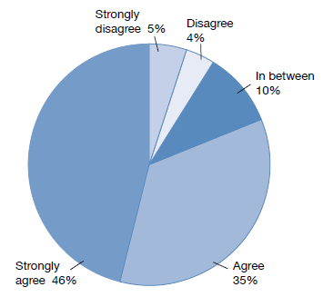
Source: National Mental Health Consumer Satisfaction Survey 2013/14

Other results from the survey included the following.
- Sixty-two percent of respondents agreed or strongly agreed with the statement ‘as a result of the services I have received, I feel that I do better in my personal relationships’.
- Eighty-two percent agreed or strongly agreed that ‘I feel comfortable asking questions about my medication and treatment’.
- Eighty-two percent agreed or strongly agreed that ‘staff have helped me to remain living in the community’.
- Eighty-four percent agreed or strongly agreed that ‘there is at least one member of staff who believes in me’.

Waiting times
Waiting times are a measure of how long new clients wait to been seen by mental health and addiction services. New clients are defined as people who have not accessed mental health or addiction services in the past year.

Waiting times reflect the length of time between the day when a person is referred to a mental health or addiction service and the day when the person is first seen by the service.

By 30 June 2015, DHBs were required to meet a sector-wide target whereby 80 percent of people referred for non-urgent mental health or addiction services are seen within three weeks, and 95 percent of people are seen within eight weeks.

In the 2013/14 fiscal year, 78 percent of all clients of mental health services were seen within three weeks, and 93 percent were seen within eight weeks (Figure 4). In addiction services (both DHB services and NGOs), 81 percent of clients were seen within three weeks and 94 percent were seen within eight weeks (Figure 5).

Figure 4: Percentage of people seen by mental health services within three weeks (left) and within eight weeks (right), 2013/14
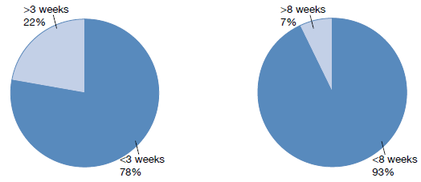
Source: PRIMHD data, extracted on 26 June 2015

Figure 5: Percentage of people seen by addiction services within three weeks (left) and within eight weeks (right), 2013/14
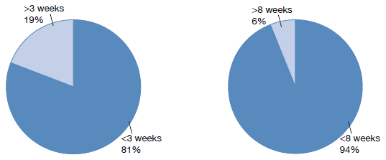
Source: PRIMHD data, extracted on 26 June 2015

Relapse prevention plans
In 2007, the Director-General of Health introduced a health target requiring that at least 95 percent of people who have used mental health and addiction services for over two years (‘long-term service users’) must have a relapse prevention plan.

In summary, in 2014:
- 93 percent of long-term service users across the country had a relapse prevention plan, up from 59 percent in 2007 (Figure 6)
- four of the 20 DHBs achieved the 95 percent target.
In 2014, 93 percent of service users across the country had a relapse prevention plan
A relapse prevention plan identifies a person’s early warning signs of a relapse of their condition. It identifies what the person can do for themselves and what their service will do to support them. Ideally, the person will develop their own plan with support from their clinician and their family/whānau.

District health boards reported on relapse prevention plans twice during 2014. The first reporting period covered 1 January to 30 June, and the second 1 July to 31 December. Figure 7 shows the results of DHBs’ reporting for the 2014 calendar year.

Figure 6: Percentage of long-term service users with a relapse prevention plan, 2007–2014
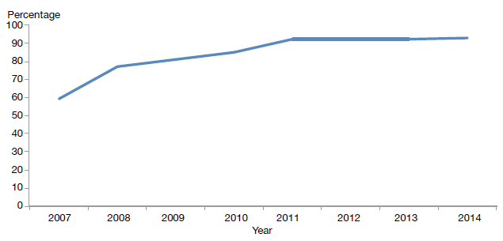
Source: DHB quarterly reporting data

Figure 7: Percentage of service users with a relapse prevention plan, by district health board, 1 January to 31 December 2014
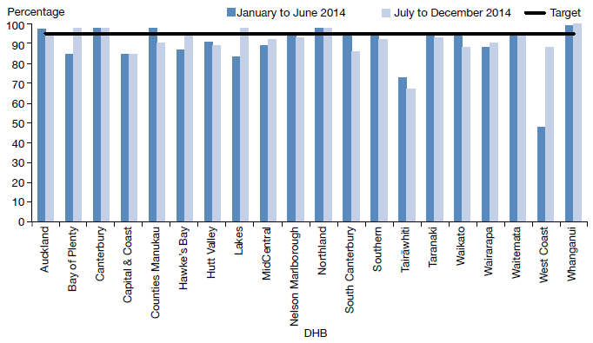
Source: DHB quarterly reporting data

Sector voices

Dr Barry Welsh – Principal advisor, Mental Health and Addiction Services, Ministry of Health
Hi my name is Barry Welsh. Improving mental health and addiction services based on objective information is my passion.

I am driven by my own considerable experience of mental health services. I have received the very worst to the very best mental health care. When I was a young man recently graduated from Lincoln University I was institutionalised in Lake Alice for a psychotic disorder. I went on to be a successful dairy farmer for 15 years, albeit struggling on and off with serious mental illness. For over 35 years now I have taken anti-psychotic medication.

The key tool that keeps me well is a personal plan on how my illness is managed. I have the responsibility for managing my condition with support from my GP, mental health services and family. Until I had a plan I thought I had no control over my illness, and that is simply not so.

In 1999, I made the decision to leave farming so I could use my skills and experience to make a difference for others with mental illness. My first project in health was the co-development of the tool ‘Knowing the People Planning’ (KPP). The tool is aimed at improving outcomes for people with serious mental health conditions. In 2009 the Government advised that all DHBs should adopt KPP or an equivalent process.

In 2010 I completed a PhD based on KPP. One significant finding of this research was that when people had a personal plan their health was markedly improved; there were fewer acute admissions and increased employment. The early findings of this research underpinned the introduction of the DHB relapse prevention plan target.

Here at the Ministry of Health I manage the PRIMHD national mental health and addiction services data set. Much of the data used in this report is drawn from PRIMHD. I also manage DHB annual planning and performance measurement processes, and assist to ensure the $1.3 billion of designated annual funding is actually spent on mental health and addiction services.

It is a privilege to be actively involved in the improvement of our mental health services. Significant effort is still required, but there is no doubt we have come a long way since I was locked up in Lake Alice in the 1970s.

Use of the Mental Health Act
The Mental Health Act defines the circumstances under which people may be subject to compulsory mental health assessment and treatment. It provides a framework for balancing personal rights and the public interest when a person has a diminished capacity to care for themselves or poses a serious danger to themselves or others due to mental illness.

In summary, in 2014:
- 9280 people (approximately 7.4 percent of specialist mental health and addiction service users) came into contact with the Mental Health Act.
- On the last day of 2014, approximately 5012 people were subject to either compulsory assessment or compulsory treatment under the Mental Health Act.
In 2014, 9280 people were subject to the Mental Health Act
- Use of the Mental Health Act varied across DHBs.
- Males were more likely to be subject to the Mental Health Act than females.
- People aged 25–34 years were the most likely to be subject to compulsory treatment, and people over 65 years of age were the least likely.
- Māori were more likely to be assessed or treated under the Mental Health Act than non-Māori.

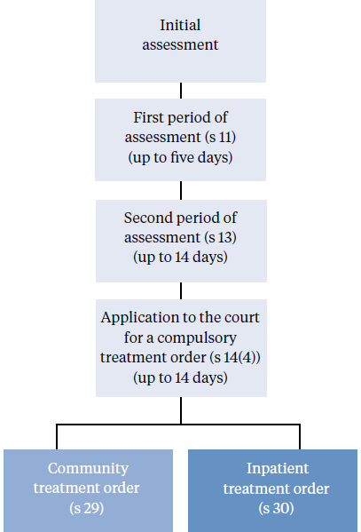
The Mental Health Act process
The compulsory assessment and treatment process begins with a referral and an initial assessment by a psychiatrist. If the psychiatrist believes a person fits the statutory criteria, the person will become subject to the Act, and will receive further assessment accordingly.

Compulsory assessment
Compulsory assessment can take place in either a community or a hospital setting. There are two periods of compulsory assessment, during which a person’s clinician may release them from assessment at any time.

During the assessment period, a person is obliged to receive treatment as prescribed by their responsible clinician.

The first period (section 11 of the Mental Health Act) is for up to five days. The second period (section 13) can last up to 14 days.

Following the first two assessment periods, a clinician can make an application to the Family or District Court (section 14(4)) to place the person on a compulsory treatment order.

At any time during the compulsory assessment process, the person (or someone acting on their behalf) can request a judicial review to review their condition and determine whether it is appropriate that they continue to receive assessment under the Mental Health Act.
At any time during the compulsory assessment process, the person (or someone acting on their behalf) can request a judicial review
A judicial review consists of a hearing in the District Court. Based on information provided by clinicians, a judge will decide whether the person should continue to be compulsorily assessed.

During 2014, approximately 1152 applications for compulsory treatment orders were considered under section 16 of the Mental Health Act. Of this total, an order for release of the person from compulsory status was issued in 32 cases (5 percent of the applications that proceeded to hearings).

Compulsory treatment
Most people subject to compulsory treatment access it in the community (approximately 87 percent in 2014)
There are two types of compulsory treatment orders. One is for treatment in the community (a section 29 order) and the other is for treatment in an inpatient unit (a section 30 order). A person’s responsible clinician can convert an inpatient treatment order into a community treatment order at any time. A responsible clinician may also grant a person leave from the inpatient unit for treatment in the community for up to three months (section 31).

Most people subject to compulsory treatment access it in the community (approximately 87 percent in 2014) (sections 29 and 31).

Statistics
On the last day of 2014, 5012 people were subject to either compulsory assessment or compulsory treatment.

In New Zealand in each month of 2014, on average, the provisions of the Mental Health Act were applied as follows.

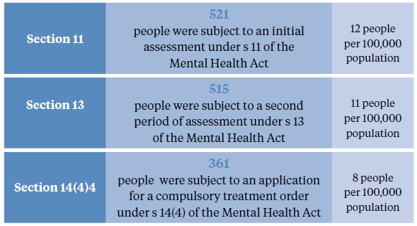

In New Zealand on a given day in 2014, on average, the provisions of the Mental Health Act were applied as follows.

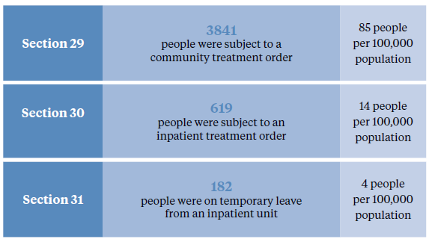

Compulsory assessment and treatment by DHB
Table 3 shows the average number of people per month in 2014 required to undergo assessment and treatment under the Mental Health Act, by DHB. Table 4 shows the average number of people subject to a compulsory treatment order on a given day in 2014, again by DHB. The figures that follow also present the average number of people subject to a compulsory treatment order on a given day, but focus specifically on community treatment orders (Figure 8) and inpatient treatment orders (Figure 9) respectively.

Table 3: Average number of people per 100,000 per month required to undergo assessment under sections 11, 13 and 14(4) of the Mental Health Act, by district health board, 1 January to 31 December 2014
DHB | s 11 | s 13 | s 14(4) |  | DHB | s 11 | s 13 | s 14(4)
Auckland | 14 | 17 | 12 |  | Northland | 15 | 20 | 14
Bay of Plenty | 14 | 10 | 11 |  | South Canterbury | 7 | 6 | 8
Canterbury | 11 | 11 | 8 |  | Southern | 11 | 11 | 7
Capital & Coast | 10 | 12 | 10 |  | Tairāwhiti | 13 | 14 | 11
Counties Manukau | 11 | 9 | 6 |  | Taranaki | 10 | 10 | 6
Hawke’s Bay | 13 | 11 | 7 |  | Waikato | 14 | 11 | 4
Hutt Valley | 13 | 12 | 10 |  | Wairarapa | 4 | 1 | 0
Lakes | 9 | 9 | 5 |  | Waitemata | 10 | 12 | 9
MidCentral | 11 | 10 | 9 |  | West Coast | 13 | 10 | 7
Nelson Marlborough | 8 | 5 | 3 |  | Whanganui | 11 | 10 | 6
 |  |  |  |  | National | 12 | 11 | 8
Note: The national average rates per 100,000 are slightly higher than the 2013 rates, which were 10, 9 and 6 for sections 11, 13 and 14(4) respectively. The rise in the national rate may have been influenced by better data capture; more DHBs reported via PRIMHD for 2014.
Source: PRIMHD data, extracted on 2 September 2015, except for Capital & Coast, Counties Manukau, Hutt Valley, Nelson Marlborough and Wairarapa DHBs, and Auckland DHB (section 14(4) only), who supplied manual data.
Table 4: Average number of people per 100,000 on a given day subject to sections 29, 30 and 31 of the Mental Health Act, by district health board, 1 January to 31 December 2014
DHB | s 11 | s 13 | s 14(4) |  | DHB | s 11 | s 13 | s 14(4)
Auckland | 100 | 8 | – |  | Northland | 177 | 10 | 6
Bay of Plenty | 28 | 11 | 7 |  | South Canterbury | 108 | 61 | 43
Canterbury | 58 | 11 | 6 |  | Southern | 72 | 12 | 3
Capital & Coast | 111 | 30 | 3 |  | Tairāwhiti | 119 | 11 | 6
Counties Manukau | 98 | 14 | 3 |  | Taranaki | 65 | 2 | 1
Hawke’s Bay | 62 | 4 | 4 |  | Waikato | 96 | 9 | 4
Hutt Valley | 69 | 6 | 1 |  | Wairarapa | 90 | – | –
Lakes | 110 | 15 | 9 |  | Waitemata | 86 | 13 | 1
MidCentral | 61 | 25 | 13 |  | West Coast | 74 | 4 | 3
Nelson Marlborough | 63 | 8 | – |  | Whanganui | 85 | 22 | 2
 |  |  |  |  | National average | 85 | 14 | 4
Note: The national average rates per 100,000 are slightly higher than the 2013 rates, which were 80, 12 and 3 for sections 29, 30 and 31 respectively. The rise in the national rate may have been influenced by better data capture; more DHBs reported via PRIMHD for 2014.
Source: PRIMHD data, extracted on 2 September 2015, except for Bay of Plenty, Capital & Coast, Hutt Valley, MidCentral, Tairāwhiti, Wairarapa, and Counties Manukau (section 29) who supplied manual data.

Figure 8: Average number of people per 100,000 on a given day subject to a community treatment order (section 29 of the Mental Health Act), by district health board, 1 January to 31 December 2014
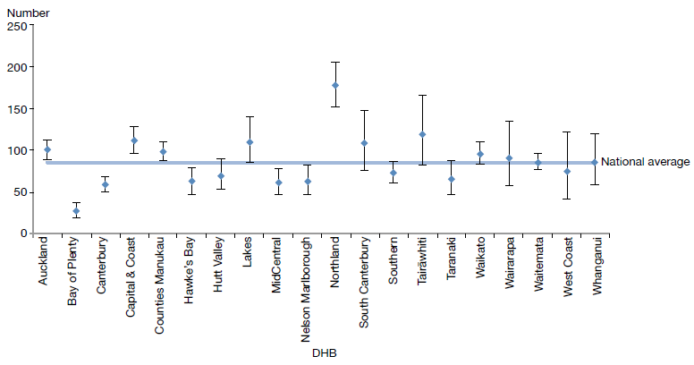
Note: Confidence intervals (for 99 percent confidence) have been used to aid interpretation. Where a DHB region’s confidence interval crosses the national average, this means the DHB’s rate was not statistically significantly different to the national average.
Source: PRIMHD data, extracted on 2 September 2015, except for data from Bay of Plenty, Capital & Coast, Hutt Valley, MidCentral, Tairāwhiti, Wairarapa and Counties Manukau DHBs, which was provided manually.

Figure 9: Average number of people per 100,000 on a given day subject to an inpatient treatment order (section 30 of the Mental Health Act), by district health board, 1 January to 31 December 2014
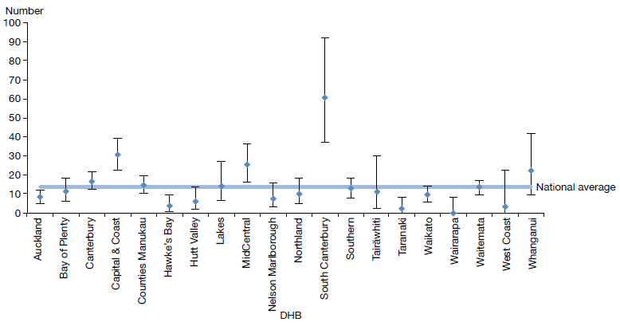
Note: Confidence intervals (for 99 percent confidence) have been used to aid interpretation. Where a DHB region’s confidence interval crosses the national average, this means the DHB’s rate was not statistically significantly different to the national average.
Source: PRIMHD data, extracted on 2 September 2015, except for data from Bay of Plenty, Capital & Coast, Hutt Valley, MidCentral, Tairāwhiti, and Wairarapa DHBs, which was provided manually.

Compulsory treatment by age and gender
During 2014:
- people aged 25–34 years were the most likely to be subject to a compulsory treatment order (196 per 100,000) and people over 65 years of age were the least likely (53 per 100,000) (Figure 10)
- males were 1.5 times more likely to be subject to a compulsory treatment order (111 per 100,000) than females (72 per 100,000) (Figure 11).

Figure 10: Rate of people per 100,000 subject to compulsory treatment order applications (including extensions), by age group, 2004–2014
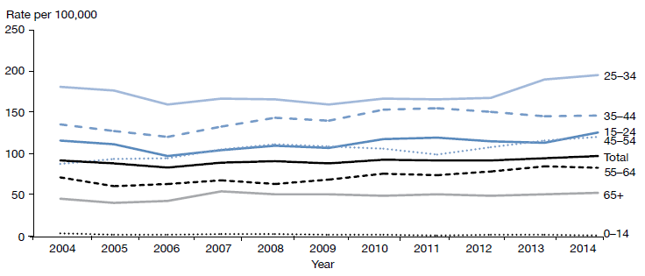
Source: Ministry of Justice’s Integrated Sector Intelligence System, which uses data entered into the Case Management System (CMS). The CMS is a live operational database, and figures are subject to minor changes at any time.

Figure 11: Rate of people per 100,000 subject to compulsory treatment order applications (including extensions), by gender, 2004–2014
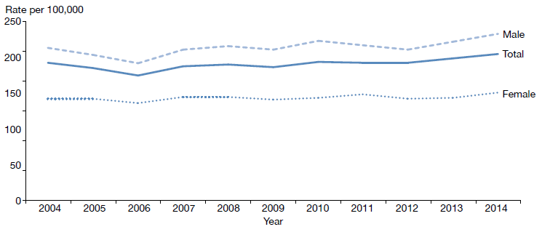
Source: Ministry of Justice’s Integrated Sector Intelligence System

Sector voices

Martine Shaw – Duly authorised officer
Hello, I’m Martine Shaw. I’m a registered nurse and duly authorised officer (DAO) for Southern DHB.

I have been a DAO since the Mental Health Act came into force in 1992. In fact, I had the honour of being the DAO at the first Mental Health Act assessment in Otago. (The proposed patient told me that he had written the Mental Health Act, which was indicative of his mania!)

As stated in sections 37–39 of the Mental Health Act, my role is to give advice and assistance to people in need of mental health assessment, assistance to outpatients and inpatients on leave, and assistance in taking or returning a proposed patient or compulsory patient to places of assessment or treatment. Yes, I do all of this – and much more.

The role of DAO is both interesting and complex. As a mental health nurse, I want the best therapeutic outcome for the patient and the patient’s family/whānau. As a DAO, I must ensure that my decisions comply with the requirements of the Mental Health Act and other legislation. I am mindful of the importance of family/whānau in the mental health assessment and treatment of people.

It is seldom that I have to act in my role as DAO for a child under 16 years. Usually the child consents to mental health treatment and/or the parent/guardian enables the child to receive treatment. As a nurse and DAO I need to ensure that the rights of the child are upheld, and in most cases, the support of their family/whānau is integral to their wellbeing.

The position of DAO allows me to have a varied and interesting role in peoples’ lives.

Māori and the Mental Health Act
This section presents data on Māori subject to community treatment orders (section 29 of the Mental Health Act) in 2014. This is the second year this information has been published in the Annual Report. The section has been expanded this year to include information on gender, and length of time spent under a community treatment order.

These statistics further underline the need for the mental health sector to engage in meaningful action to address the disparity of mental health outcomes for Māori in New Zealand.

In summary, in 2014:
- Māori were 3.5 times more likely to be subject to a community treatment order (section 29) than non-Māori
Meaningful action is needed to address the disparity of mental health outcomes for Māori in New Zealand
- Māori males were the population group most likely to be subject to a section 29 order (compared to non-Māori males, and Māori and non-Māori females)
- the ratio of Māori to non-Māori subject to section 29 varied by DHB
- on average, Māori and non-Māori remained on a section 29 order for a similar period of time.

The high rate of Māori under compulsory treatment orders is a complex issue. Māori make up approximately 16 percent of New Zealand’s population, yet they account for 25 percent of all mental health service users.

The national mental health prevalence study, Te Rau Hinengaro (Oakley Browne et al 2006), showed that Māori experience the highest levels of mental health disorder overall. They are also more likely to experience serious disorders and co-morbidities than other population groups.
Māori make up approximately 16 percent of the population, yet they account for 25 percent of all mental health service users
Other demographic features relevant to the high rate of Māori service users include the youthfulness of the Māori population (approximately half of the population is under 25 years of age) and the disproportionate representation of Māori in low socioeconomic groups (two-thirds live in deprivation deciles 7–10).

Analysis has shown that these demographic factors do not completely account for the high rate of Māori with serious mental illness (ie, if Māori had the same age structure and level of socioeconomic privilege as people in other groups, their rates of mental disorder would still be higher) (Oakley Browne et al 2006).

What other factors are involved in the disparity?
Elder and Tapsell (2013) emphasise that we need more research to better understand the Māori experience of the Mental Health Act and why Māori are over-represented in compulsory treatment.

They suggest that the following are important questions for the sector to consider.
- Are Māori receiving differential treatment in the mental health system?
- How can we build a more culturally competent workforce and reduce cultural bias from formulations of mental illness?
- Are whānau of tāngata whaiora (people seeking wellness) being sufficiently engaged by mental health services?
A major improvement in the service provision to Māori has involved the establishment of dedicated kaupapa Māori services around New Zealand
It is clear that the sector needs to actively address these questions in order to bring about better outcomes for Māori. However, it is important to keep in mind the significant improvements in the service provision to Māori that have been achieved over the last few decades.

One such improvement is the establishment of dedicated kaupapa Māori services in certain areas around New Zealand. In 2014, Māori access rates to services exceeded the access rates of other groups (5.7 percent of Māori accessed mental health services in 2014, compared with 3.1 percent of non-Māori). These higher access rates are likely to be a contributing factor to higher rates of Māori under compulsory treatment orders.

Māori and section 29 of the Mental Health Act by DHB
Figure 12 shows variation around the country in regard to the disparity between Māori and non-Māori subject to community treatment orders. The Māori to non-Māori rate ratio ranges from 0.5:1 (in West Coast DHB) to 4.8:1 (in Bay of Plenty DHB). District health boards in which the Māori age-standardised rate is significantly higher than the New Zealand rate include Auckland, Bay of Plenty, and Waikato. These numbers are difficult to interpret, as it is hard to indicate what an ideal rate ratio would be for a given population or DHB (however, for comparative purposes a line of no difference has been included in Figure 12). The numbers emphasise that in-depth, area-specific knowledge would be useful for understanding the particular disparities around the country and what could be done at a local level to address them.

Figure 12: Rate ratio of Māori to non-Māori subject to a community treatment order (section 29) under the Mental Health Act, by district health board, 1 January to 31 December 2014
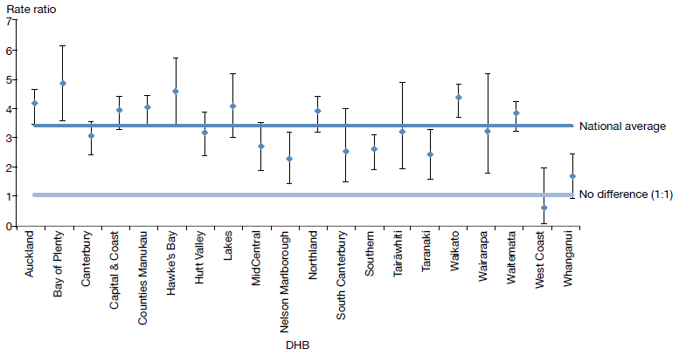
Notes:
Rates per 100,000 are age-standardised to account for differences in the population structures of the DHBs.
Some data quality concerns have been identified relating to 2014 PRIMHD data on section 29; these do not affect the ethnicity rate ratio of the data set.
Confidence intervals (for 99 percent confidence) have been used to aid interpretation. Where a DHB region’s confidence interval crosses the national average, this means the DHB’s rate was not statistically significantly different to the national average.
Source: PRIMHD data, extracted on 2 September 2015

Gender, ethnicity and compulsory treatment
Māori males are more likely to be subject to compulsory treatment under section 29 of the Mental Health Act compared to Māori females and non-Māori. In particular, in 2014, Māori males were almost four times more likely to be subject to a community treatment order (section 29) than non-Māori males. Table 5 and Figure 13 present information on age-standardised rates of community treatment orders by gender and ethnicity.

Table 5: Age-standardised rates of Māori and non-Māori subject to a community treatment order (section 29) under the Mental Health Act, by gender, 1 January to 31 December 2014
 | Male | Female
Māori | 438 | 195
Non-Māori | 116 | 62
Rate ratio Māori: non-Māori | 3.8:1 | 3.1:1
Notes:
Some data quality concerns have been identified relating to 2014 PRIMHD data for section 29; these do not affect the ethnicity rate ratio of the data set.
Rates per 100,000 are age-standardised to account for differences in the population structures of the DHBs.
Source: PRIMHD data, extracted 2 September 2015

Figure 13: Age-standardised rates of Māori and non-Māori subject to a community treatment order (section 29) under the Mental Health Act, by gender, 1 January to 31 December 2014
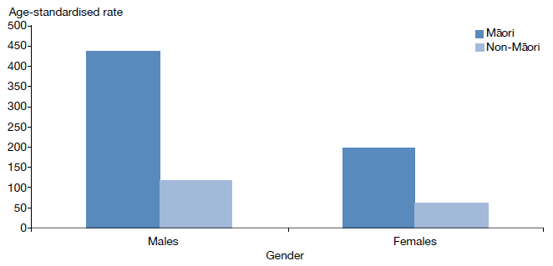
Notes:
Some data quality concerns have been identified relating to 2014 PRIMHD data for section 29; these do not affect the ethnicity rate ratio of the data set.
Rates per 100,000 are age-standardised to account for differences in the population structures of the DHBs.
Source: PRIMHD data, extracted 2 September 2015

Length of time spent subject to community treatment
On average, Māori and non-Māori remain on community treatment orders for a similar amount of time.

For orders commenced between 2009 and 2012, 71 percent of Māori and 73 percent of non-Māori under a community treatment order were subject to the order for less than a year. Seven percent of Māori and 6 percent of non-Māori remained under the order for between one and two years, and 22 percent of both Māori and non-Māori remained under the order for more than two years.

Figure 14: Length of time spent subject to a community treatment order (section 29) under the Mental Health Act for Māori and non-Māori
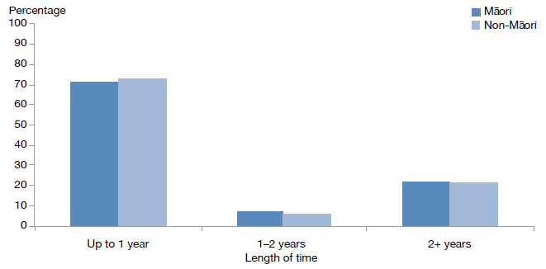
Note: The data refer to treatment orders which were started between 2009 and 2012. 2012 is the most recent year referred to in this figure, as this analysis requires at least two years to have elapsed to determine the number of people who have remained on a treatment order for two or more years.
Source: PRIMHD data, extracted on 2 September 2015

Future focus
The Office of the Director of Mental Health will continue to ensure that the best possible mental health outcomes are being sought for Māori in New Zealand
Reducing the disparity of Māori mental health outcomes is a priority for the Ministry of Health (Ministry of Health 2012e). Publishing data on the rate of Māori subject to compulsory treatment is just one part of what needs to be a wider conversation around Māori over-representation in compulsory assessment and treatment under the Mental Health Act.

The Office of the Director of Mental Health will continue to work alongside DHBs and other Ministry and government groups to ensure that the best possible mental health outcomes are being sought for Māori in New Zealand.

Sector voices

Tracey Wright-Tawha – Chief executive
Kia ora, my name is Tracey Wright-Tawha. I am the chief executive of Ngā Kete Mātauranga Pounamu, a kaupapa Māori health and social service provider based in Murihiku (Invercargill).

We offer AOD counselling, problem gambling counselling and Te Piringa, our Māori public health team, who deliver a suicide prevention service for all ages called Kia Piki Te Ora. As of February this year, we also offer a low cost access GP practice called He Puna Waiora Wellness Centre. Over the last six months, we have gained 1781 enrolled patients, of whom 1259 are high-needs. Each year, we have more than 33,500 engagements with community members, supported by 45 staff.

The greatest resource an agency has it its human resource. Every year we have a staff wellbeing theme. Wellbeing is about balance, so we support staff who want to see their child’s kapa haka performance or school race day. We celebrate culture by supporting cultural leave, which helps staff to maintain whakapapa or ancestral practices relevant to their whānau, hapū and iwi.

Ngā Kete Mātauranga Pounamu views wellbeing as ki uta ki tai – an appreciation that from the mountains, to the sea, and everywhere in between there is a mauri; a life essence that must be nurtured and protected. There must be balance in all things strived for.

Family/whānau consultation and the Mental Health Act
Family/whānau involvement can be a vital component in a person’s journey of recovery from mental illness. Section 7A of the Mental Health Act requires a mental health service to consult with a person’s family/whānau during the compulsory assessment and treatment process (unless consultation is deemed not reasonably practicable, or not in the interests of the tangata whaiora).

In summary, in 2014:
- the average percentage of family/whānau consultation nationally was 62 percent of all Mental Health Act assessment/treatment events
- families/whānau were most likely to be consulted during a person’s initial assessment (section 10) under the Mental Health Act
- family/whānau consultation varied by DHB
- the most common reason families/whānau were not consulted was that service providers deemed consultation not reasonably practicable in the given circumstance.

History and purpose
Family/whānau involvement can be a vital component in a person’s journey of recovery
In 1999 Parliament made an amendment to the Mental Health Act that required clinicians to consult family/whānau at particular junctures of a person’s compulsory assessment and treatment under the Mental Health Act. The purpose of consultation with family/whānau is to:
- strengthen family/whānau involvement in the compulsory assessment and treatment process
- enhance family/whānau contribution to the person’s care
- address family/whānau concerns about information sharing and treatment options
- facilitate ongoing family/whānau involvement in Mental Health Act processes, such as clinical reviews of treatment or court hearings (Ministry of Health 2012d).

In 2006, the Ministry of Health published a review of the application of section 7A of the Mental Health Act, following concerns that mental health services were not adequately carrying out the required consultation (Ministry of Health 2006). The review made a number of recommendations, including revision of the relevant section in the Mental Health Act Guidelines (Ministry of Health 2012d), better training and resources for clinicians, development of more information and opportunities for involvement in the compulsory assessment and treatment process for family/whānau, and the establishment of nationwide reporting on section 7A consultation.

This is the first year that national data on the application of section 7A has been included in this report. It has been included in the hope that its publication will further emphasise the importance of family/whānau consultation, bring greater transparency and accountability to DHB efforts to involve family/ whānau, and further encourage a culture of family/whānau involvement in mental health treatment.

Definition of family/whānau
Family/whānau is not limited to blood ties, but may include partners, friends, and others in the person’s wider support network
Definitions and understandings of family/whānau vary, and are informed by different cultural backgrounds and practices. Almost always, the most important perspective for defining family/whānau is that of the tangata whaiora. Therefore, family/whānau is not limited to blood ties, but may include partners, friends, and others in the person’s wider support network (Ministry of Health 2012d).

District health board reporting of family/whānau consultation
The Ministry requires DHBs to report on family/whānau consultation across five different assessment/treatment events in the Mental Health Act process, as follows.
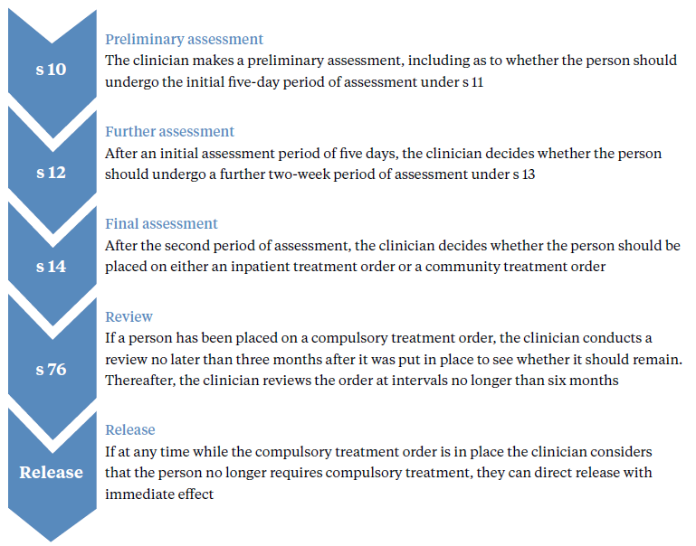

Across all DHBs in 2014, the point in this process at which the highest rate of family/whānau consultation occurred was the clinician’s initial assessment (72 percent). Figure 15 shows the percentage of cases in which family/whānau consultation occurred at other points in the process (labelled according to the relevant governing section) in 2014.

Figure 15: Average national percentage of family/whānau consultation for particular assessment/treatment events, 1 January to 31 December 2014
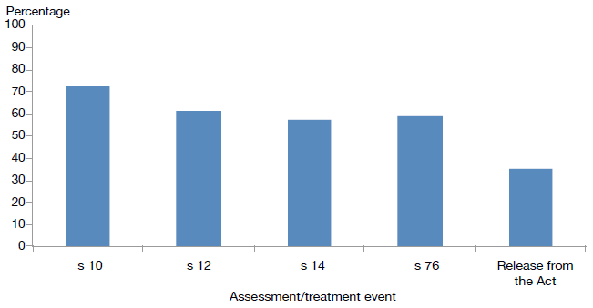
Note: Waitemata DHB does not record section 7A family/whānau consultation data.
Source: Office of the Director of Mental Health records

Nationally during 2014, the average percentage of cases in which family/whānau consultation occurred across all assessment/treatment events was 60 percent. West Coast DHB had the highest rate of consultation at 100 percent, and Capital & Coast had the lowest, at 25 percent.

Figure 16: Average percentage of family/whānau consultation across all assessment/ treatment events by DHB, 1 January to 31 December 2014
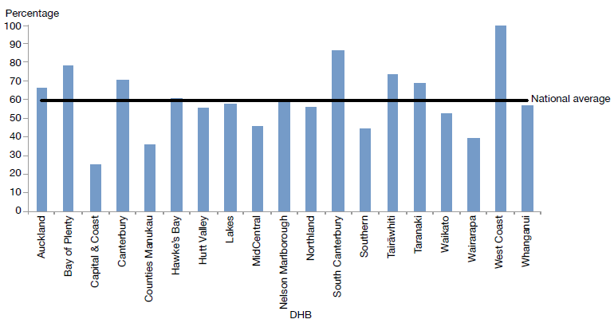
Note: Waitemata DHB does not record section 7A family/whānau consultation data.
Source: Office of the Director of Mental Health records

Reasons for not consulting family/whānau
During 2014, the most common reason DHBs gave for family/whānau consultation not being arranged was that it was not reasonably practicable (57 percent). This was followed by ‘don’t’ know’ (28 percent), ‘not in the best interests of the person’ (8 percent) and ‘no for another reason’ (7 percent) (Figure 17).

Figure 17: Reasons for not consulting family/whānau, 1 January to 31 December 2014
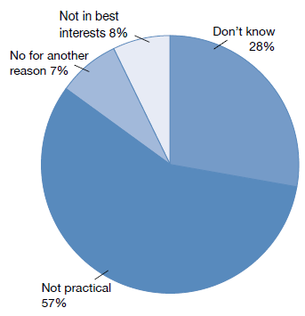
Note: Waitemata DHB does not record section 7A family/whānau consultation data.
Source: Office of the Director of Mental Health records

Sector voices

Heather E Pantin Lewis – Mental health consumer
I’m Heather – I was born in 1957, Wellington. It’s taken me a long time to be able to understand what I’m going to say next. I have a lifelong major depressive disorder resulting from complex post-traumatic stress disorder, caused by childhood trauma – abuse and neglect.

It’s been a long hard road.

My first real breakthrough came when a Salvation Army counsellor suggested I save up to see a specialist psychiatrist. He worked with me to find the right combination of medication to help me cope with everyday life.

My second breakthrough was finding a psychologist who had patience and the right skill-set. He validated my negative feelings that were a result of being abused and neglected throughout my childhood/teenage years. It was a relief to finally find someone who believed me! Who accepted what I said without debate, blame or belittling me (like others had done). Regular sessions over six months were a major turning point. I suddenly felt free of this huge burden I had carried around my whole life.

I needed both of these interventions to achieve the results I have. Everyone is different. The talking therapy has been life-changing for me; now I truly feel that I am finally on my personal road to recovery.

As many mental illness sufferers know – when we ask for help, it’s because we are often in immense, unbearable emotional pain. Unlike a broken leg, it’s harder to explain how bad the pain is – this can lead to misunderstandings with family/friends/health professionals alike. Please just be there for us.

My message to sufferers is: it’s never too late to seek answers to your questions; to seek help to ease your pain, or therapy to face your fears (even if the events happened decades ago). You might have to fight to access the services you know instinctively you need – but keep fighting. I am so glad I did and continue to do so.

Seclusion
Seclusion is ‘where a consumer is placed alone in a room or area, at any time and for any duration, from which they cannot freely exit’ (Standards New Zealand 2008a). Seclusion should be an uncommon event, and should be used only when there is an imminent risk of danger to the individual or others and no other safe and effective alternative is possible.
Seclusion should be an uncommon event, used only when there is an imminent risk of danger to the individual or others
In summary, in adult inpatient services in 2014:
- The total number of people who experienced seclusion while receiving mental health treatment in an inpatient service had decreased by 32 percent since 2009.
- The total number of hours spent in seclusion had decreased by 55 percent since 2009.
- Men were more than twice as likely to have been secluded as women.
- People aged 20–29 years were more likely to have been secluded than those in any other age group.
- Māori were more likely to have been secluded than non-Māori.

The Health and Disability Services (Restraint Minimisation and Safe Practices) Standards came into effect on 1 June 2009 (Standards New Zealand 2008b). Their intent is to ‘reduce the use of restraint in all its forms and to encourage the use of least restrictive practices’.

In addition, reducing (and eventually eliminating) seclusion is one of the goals of the Ministry’s service development plan Rising to the Challenge (Ministry of Health 2012e).

Section 71 of the Mental Health Act covers seclusion. It states that seclusion can only occur where, and for as long as, it is necessary for the care or treatment of the person, or for the protection of other people.

Seclusion rooms must be designated by the relevant DAMHS, and can be used only with the authority of a person’s responsible clinician. Clinicians must record the duration and circumstances of each episode of seclusion in a register, which must be available for review by district inspectors.

Seclusion should never be used for the purposes of discipline, coercion or staff convenience, or as a substitute for adequate levels of staff or active treatment.

The Ministry of Health revised guidelines on seclusion (Ministry of Health 2010) identify best practice methods for using seclusion in mental health inpatient units. Their intent is to progressively decrease and limit the use of seclusion for mental health service users.
The intent of the revised Ministry of Health guidelines is to progressively decrease and limit the use of seclusion and restraint

Te Pou o Te Whakaaro Nui (National Workforce Centre for Mental Health, Addiction and Disability) supports the national direction set by the Ministry of Health for seclusion reduction by using evidence-based information, such as the ‘Six Core Strategies’ of the National Technical Assistance Centre (Huckshorn 2005). Te Pou works with DHBs to support their local initiatives. Further information and stories of emerging good practice can be found on its website (www.tepou.co.nz).

Changes in the use of seclusion over time
Since 2009, when the seclusion reduction policy was introduced, the total number of people secluded in adult inpatient services nationally has decreased by 32 percent. The number fell by 4 percent between 2013 and 2014.
Since 2009, the total number of seclusion hours for people in adult services has decreased by 55 percent

Between 2009 and 2014, the total number of seclusion hours for people in adult inpatient services nationally decreased by 55 percent. Between 2013 and 2014 the decrease was 9 percent.

Figures 18 and 19 show a decrease in the number of people secluded in adult inpatient services (for those aged 20–64 years) and in the total number of seclusion hours since 2007.

The declining trend for both the number of people and the total number of hours spent in seclusion aligns with one of the goals of Rising to the Challenge (Ministry of Health 2012e), which is to reduce and eventually eliminate the use of seclusion in New Zealand.

Figure 18: Number of people secluded in adult inpatient services nationally, 2007–2014
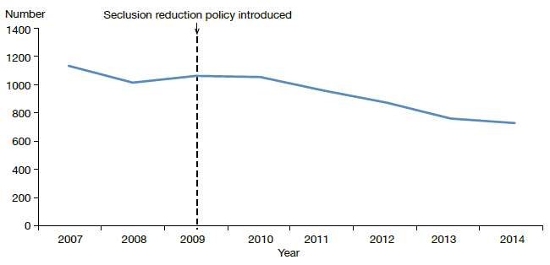
Source: Office of the Director of Mental Health Annual Reports, 2007–2013 and (for 2014) PRIMHD data extracted on 2 September 2015. Manual data was obtained from Lakes, South Canterbury, Capital & Coast and Hutt Valley DHBs

Figure 19: Total number of seclusion hours in adult inpatient services nationally,
2007–2014
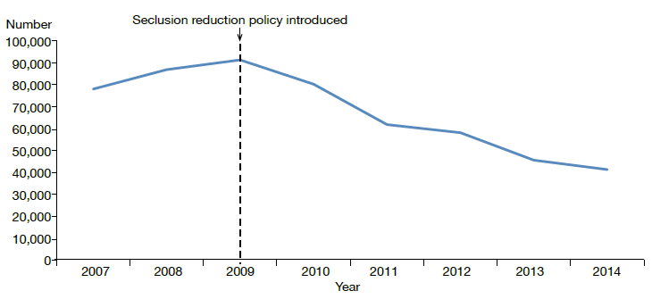
Source: Office of the Director of Mental Health Annual Reports, 2007–2013 and (for 2014) PRIMHD data extracted on 2 September 2015. Manual data was obtained from Lakes, South Canterbury, Capital & Coast and Hutt Valley DHBs.

Seclusion in New Zealand mental health services
Between 1 January and 31 December 2014, 7091 people spent time in New Zealand adult mental health services (excluding forensic and other regional rehabilitation services) for a total of 182,382 bed nights. Of these people, 736 (10.4 percent) were secluded at some time during the reporting period.

People who were secluded were often secluded more than once (on average 2.4 times). Therefore, the number of seclusion events in adult inpatient services (1804) was higher than the number of people secluded.
During 2014, 736 people were subject to seclusion in adult mental health services in New Zealand
Across all services, including forensic, intellectual disability (ID) and youth services, 959 people across all age groups experienced at least one seclusion event. Of those secluded, 68 percent were male and 32 percent were female. The most common age group for those secluded was 20–24 years (Figure 20). A total of 111 young people (under 19 years) were secluded during the 2014 year, in 339 seclusion events.

Figure 20: Number of people secluded in all mental health inpatient services (adult, forensic, ID and youth) by age group, 1 January to 31 December 2014
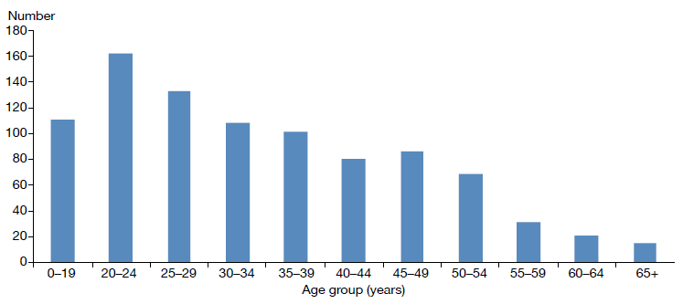
Source: PRIMHD data, extracted on 2 September 2015. Manual data was obtained from Lakes and South Canterbury DHBs.

The length of time spent in seclusion varied considerably. Most seclusion events (74 percent) lasted for less than 24 hours. Some (14 percent) lasted for longer than 48 hours. Figure 21 shows the number of seclusion events by duration of the event.

Figure 21: Distribution of seclusion events in all mental health inpatient services (adult, forensic, ID and youth), by duration of event, 1 January to 31 December 2014
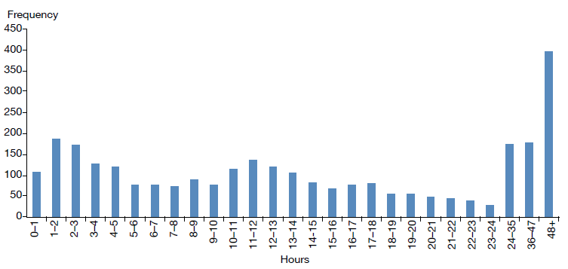
Source: PRIMHD data, extracted on 2 September 2015. Manual data was obtained from Lakes and South Canterbury DHBs.

Seclusion by district health board
All DHBs except for Wairarapa (which has no mental health inpatient service) use seclusion. In 2014, the national average number of people secluded in adult inpatient services per 100,000 population was 28.3, and the average number of events per 100,000 population was 68.5.

As Figures 22 and 23 show, seclusion data varied widely across DHBs. Such variation is likely to be due to a number of factors, including:
- differences in seclusion practice
- geographical variations in the prevalence and acuity of mental illness
- ward design factors, such as the availability of intensive care and low-stimulus facilities
- staff numbers, experience and training
- use of sedating psychotropic medication
- the frequent or prolonged seclusion of one person, distorting seclusion figures over the 12-month period.

Because it is difficult to measure and adjust for these factors, it can be useful to compare an individual DHB’s performance over time in addition to considering the adjusted comparisons between DHBs made in this Annual Report.

Figure 22: Number of people secluded in adult inpatient services per 100,000, by DHB, 1 January to 31 December 2014
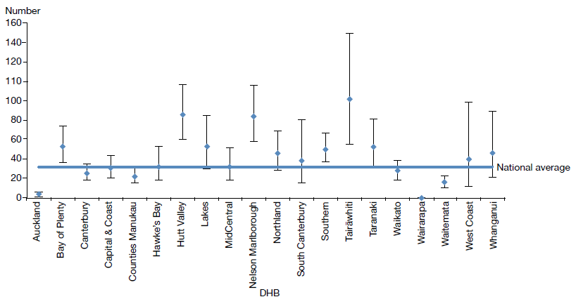

Note: Confidence intervals (for 99 percent confidence) have been used to aid interpretation. Where a DHB region’s confidence interval crosses the national average, this means the DHB’s rate was not statistically significantly different to the national average.
Source: PRIMHD data, extracted on 2 September 2015. Manual data was obtained from Lakes, South Canterbury, Capital & Coast and Hutt Valley DHBs.

Figure 23: Number of seclusion events in adult inpatient services per 100,000, by district health board, 1 January to 31 December 2014
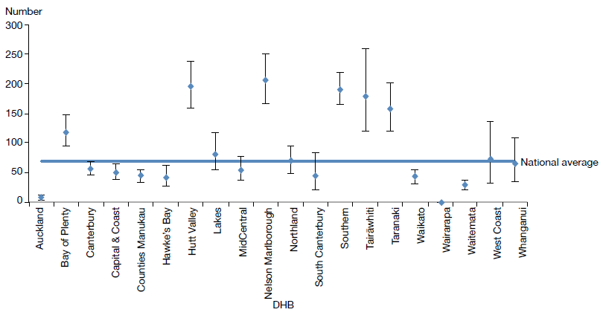
Note: Confidence intervals (for 99 percent confidence) have been used to aid interpretation. Where a DHB region’s confidence interval crosses the national average, this means the DHB’s rate was not statistically significantly different to the national average.
Source: PRIMHD data, extracted on 2 September 2015. Manual data was obtained from Lakes, South Canterbury, Capital & Coast and Hutt Valley DHBs.

Seclusion and ethnicity
As a population group, Māori experience the greatest burden due to mental health issues in New Zealand.
In 2014, Māori were almost four times more likely to be secluded than people from other ethnic groups

In 2014, Māori were almost four times more likely to be secluded in adult inpatient services than people from other ethnic groups (per 100,000 population). Of the 736 people secluded in adult inpatient services during 2014, 38 percent were Māori.

Figure 24 shows seclusion indicators for Māori and non-Māori during 2014. Māori were secluded at a rate of 67.9 people per 100,000, and non-Māori at a rate of 18 people per 100,000 population.

Reducing and eventually eliminating the use of seclusion for Māori is a priority action in Rising to the Challenge (Ministry of Health 2012e) supported by Te Pou. Information on initiatives and strategies for reducing the use of seclusion with Māori can be accessed on Te Pou’s website (www.tepou.co.nz).

Figure 24: Seclusion indicators for adult inpatient services, Māori and non-Māori, 1 January to 31 December 2014
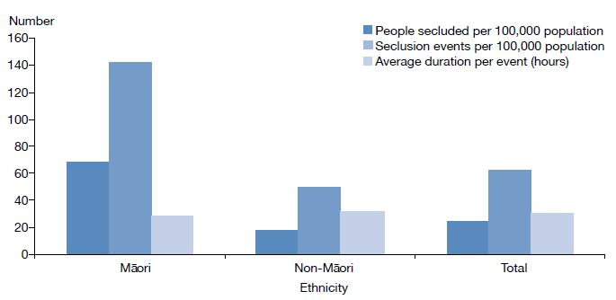
Source: PRIMHD data, extracted on 2 September 2015. Manual data was obtained from Lakes and South Canterbury DHBs.

Figure 25 shows the percentage of inpatients secluded in adult services for Māori and non-Māori males and females in 2014. This figure indicates that a greater proportion of Māori were secluded than non-Māori, and that across ethnicities males were more likely to be secluded (12 percent) than females (7 percent).

Figure 25: Percentage of people secluded in adult inpatient services, for Māori and non-Māori males and females, 1 January to 31 December 2014
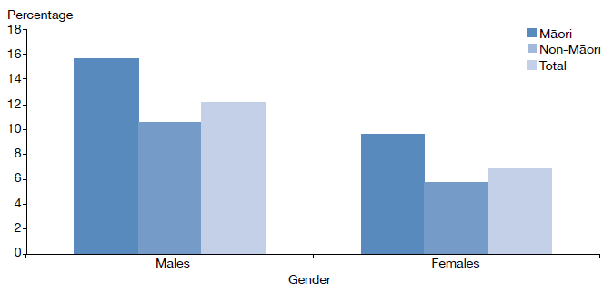
Source: PRIMHD data, extracted on 2 September 2015. Manual data was obtained from Lakes and South Canterbury DHBs.

Figure 26 shows the proportion of Māori secluded in adult inpatient services (for those aged 20–64 years) from 2007 to 2014. Nationally between 2007 and 2014 the number of people secluded decreased by 40 percent. Consistent with the declining national rate, the number of people secluded who identify as Māori decreased by 32 percent over the same time.

Figure 26: Number of Māori and non-Māori secluded in adult inpatient services,
2007–2014
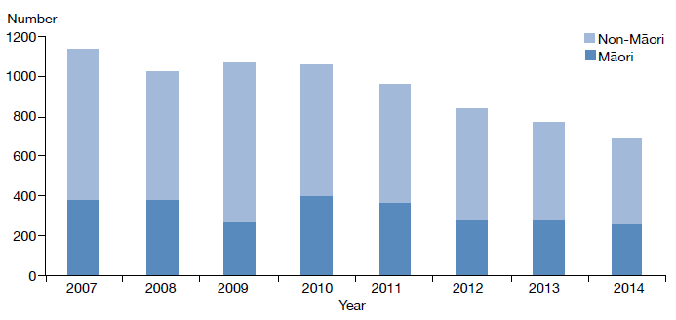
Source: PRIMHD data, extracted on 2 September 2015. Manual data was obtained from Lakes and South Canterbury DHBs.

Seclusion in forensic units and intellectual disability units
Specialist inpatient forensic services are provided in five DHBs: Canterbury, Capital & Coast, Southern, Waikato and Waitemata. There is a smaller inpatient forensic service in Whanganui. Forensic services provide mental health treatment in a secure environment for prisoners with a mental disorder, and for people defined as special or restricted patients under the Mental Health Act.

Forensic services also provide care for people defined as care recipients or special care recipients under the Intellectual Disability (Compulsory Care and Rehabilitation) Act 2003 (IDCC&R Act). These services are delivered in specialised intellectual disability units for people with an intellectual disability and who are subject to a compulsory care order under the IDCC&R Act.

In 2014, 125 people were secluded in forensic services (including specialised ID units) (up from 98 in 2013), contributing to a total of 801 seclusion events. The average duration of a seclusion event in a forensic service decreased from 34.4 hours in 2013 to 31.7 hours in 2014.

Table 6 presents the seclusion indicators for the 2014 calendar year. These indicators cannot be compared with adult service indicators, because they do not reflect the same client base. The rates of seclusion for the relatively small group of people in the care of forensic and ID services can be affected by individuals who were secluded significantly more often than others. In particular, one person accounted for 354 (44 percent) of the 801 seclusion events over the reporting period.

Table 6: Seclusion indicators for forensic and ID services, by district health board, 1 January to 31 December 2014
DHB | Number of clients secluded | Number of events | Average duration per event (hours)
Canterbury | 20 | 479 | 16
Capital & Coast | 9 | 11 | 50
Southern | 7 | 33 | 83
Waikato | 27 | 67 | 32
Waitemata | 62 | 211 | 59
Total | 125 | 801 | 32
Source: PRIMHD data, extracted on 2 September 2015

Sector voices

Chloe Fergusson-Tibble – Consumer leader
Kia ora, I’m Chloe and I come from Ngāti Kahungunu ki Wairoa and Ngāpuhi. My husband is Kahurangi Tibble from Ngāti Porou, Te Aitanga ā Mahaki and Ngāti Uenukukopako, and we have two school-aged children. I’m 27 years old and I’ve been working as a consumer leader at Te Kupenga Net Trust in the Tairāwhiti (Gisborne) mental health and addictions sector for almost four years.

I’m actively engaged with mental health issues at the local, regional and national levels.

I’m interested in advancing issues facing young Māori, and supporting a culturally relevant approach to mental health service delivery. I believe that young people who access services have a pretty solid understanding of the direction services need to head in, and I’m especially interested in projects that support the development of these visions and of young people as leaders.

I’m a staunch believer that restrictive practices in mental health should be eliminated. I find it hard to write the term ‘seclusion’ because I don’t think it adequately describes the practice. I prefer to use ‘solitary confinement’. I believe that if we don’t keep a close eye on restrictive practices they could become the norm, and inhibit our ability to consider alternatives. I look forward to a time when the wider community consistently feels included and able to contribute to mental health in Aotearoa as we do.

Two pieces of work that I’m currently involved in locally are championing the option of marae-based Mental Health Act hearings (rather than hearings only taking place at hospitals and courts) and the elimination of solitary confinement by February 2020. I’m super excited about where we are heading!

Electroconvulsive therapy
Electroconvulsive therapy is a therapeutic procedure in which a brief pulse of electricity is delivered to a person’s brain in order to produce a seizure. It can be an effective treatment for various types of mental illness, including depressive illness, mania, catatonia and other serious neuropsychiatric conditions. It is often effective as a last resort in cases where medication is contraindicated or is not relieving symptoms sufficiently. It can only be given with the consent of the person receiving it, other than in certain carefully defined circumstances.
Although ECT remains controversial, a 2005 independent review concluded that banning its use would deprive a small group of seriously ill people of a sometimes life-saving treatment
In summary, in 2014:
- 247 people received ECT (5.5 people per 100,000)
- a total of 2463 treatments of ECT were administered
- those treated received an average of 10 administrations of ECT over the year
- women were more likely to receive ECT than men
- older people were more likely to receive ECT than younger people.

Medical staff administer ECT under anaesthesia in an operating theatre, making use of muscle relaxants. The person wakes unable to recall the details of the procedure. The most common side effects of ECT are confusion, disorientation and memory loss. Confusion and disorientation typically clear within an hour, but memory loss can be persistent and in some cases even permanent (American Psychiatric Association 2001; Ministry of Health 2004).

Significant advances have been made in improving ECT techniques and reducing side effects over the last 20 years. Despite these improvements it remains a controversial treatment. In 2003, in response to petition 1999/30 of Anna de Jonge and others regarding ECT, the Health Select Committee recommended that a review be undertaken, independently of the Ministry of Health, on the safety and efficacy of ECT and the adequacy of regulatory controls on its use in New Zealand. The review concluded that ECT continues to have a place as a treatment option for consumers of mental health services in New Zealand, and that banning its use would deprive some seriously ill people of a potentially effective and sometimes life-saving means of treatment (Ministry of Health 2004).

In 2009, the Ministry of Health created a consumer resource on ECT as part of the 2003 Government response to the review (Ministry of Health 2009).

Number of patients treated with ECT
The number of people treated with ECT in New Zealand has remained relatively stable since 2006: around 200 to 300 people receive the treatment each year (Figure 27).

Figure 27: Number of people treated with electroconvulsive therapy, 2005–2014
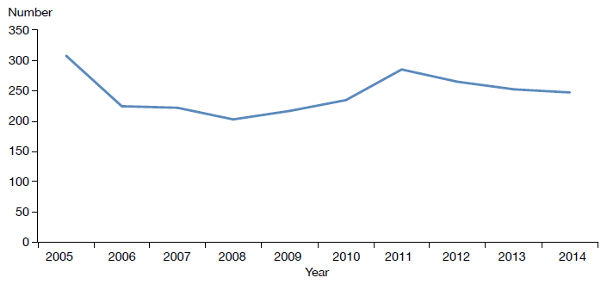
Source: Office of the Director of Mental Health Annual Reports, 2005–2013 and (for 2014) PRIMHD data extracted on 2 September 2015.

A total of 247 people received ECT during the year ending 31 December 2014. Table 7 shows the total number of people who received ECT in 2014 by DHB of domicile. The total number of treatments administered over this period was 2463, representing a mean of 10 treatments per person.

Table 7: Electroconvulsive therapy indicators by district health board of domicile, 1 January to 31 December 2014
DHB of domicile | Number of people treated with ECT | Number of treatments | Mean number of treatments per person (range)
Auckland | 17 | 159 | 9.4 (1–27)
Bay of Plenty | 18 | 128 | 7.1 (1–16)
Canterbury | 42 | 402 | 9.6 (2–23)
Capital & Coast | 23 | 160 | 6.1 (1–19)
Counties Manukau | 20 | 175 | 8.8 (1–31)
Hawke’s Bay | 11 | 58 | 5.3 (1–11)
Hutt Valley | 9 | 85 | 9.4 (1–20)
Lakes | 12 | 93 | 7.8 (1–23)
MidCentral | 10 | 149 | 14.9 (1–34)
Nelson Marlborough | 3 | 41 | 13.7 (3–23)
Northland | 3 | 37 | 12.3 (10–14)
South Canterbury | 2 | 15 | 7.5 (3–12)
Southern | 21 | 197 | 9.4 (1–36)
Tairāwhiti | 1 | 1 | 1 (1–1)
Taranaki | 0 | 0 | 0
Waikato | 31 | 327 | 10.5 (1–35)
Wairarapa | 5 | 66 | 13.2 (7–23)
Waitemata | 23 | 344 | 15 (4–27)
West Coast | 1 | 4 | 4 (4–4)
Whanganui | 1 | 10 | 10 (10–10)
Unknown | 2 | 12 | 6 (1–11)
New Zealand | 247 | 2463 | 10.0 (1–36)
Notes:
In 2014, 23 people were treated out of area:
- Auckland DHB saw one person from an unknown area
- Canterbury DHB saw one person from each of South Canterbury, Southern, Waitemata, West Coast and an unknown area.
- Capital & Coast DHB saw two people from Hutt Valley and one person from MidCentral
- Counties Manukau DHB saw one person from Auckland
- Hawke’s Bay DHB saw one person from MidCentral
- Hutt Valley DHB saw one person from Bay of Plenty, one person from Capital & Coast and five people from Wairarapa
- MidCentral DHB saw one person from Whanganui
- Southern DHB saw one person from South Canterbury
- Waikato DHB saw one person from Bay of Plenty
- Waitemata DHB saw one person from Auckland and one person from Waikato.
If a person was seen while living in two DHB areas, they were counted twice. The New Zealand total of 247 is a unique count and not a sum of this column in the table, as the New Zealand total excludes individuals who were counted by more than one DHB.
Source: PRIMHD data, extracted on 2 September 2015

Figure 28 presents the rate of people treated with ECT by DHB of domicile. The national rate of people receiving ECT treatment in 2014 was 5.5 per 100,000. As Figure 28 shows, the rate of ECT treatments given varies regionally. Several factors contribute to this. First, regions with smaller populations are more vulnerable to annual variations (according to the needs of the population at any given time).

In addition, people receiving continuous or maintenance treatment will typically receive more treatments in a year than those treated with an acute course. Electroconvulsive therapy is indicated in older people more often than in younger adults because older people are more likely to have associated medical problems contraindicating medication. Finally, populations in some DHBs have better access to ECT services than others, which is likely to influence the rates of use.

Figure 28: Rate of people treated with electroconvulsive therapy, by district health board of domicile, 1 January to 31 December 2014
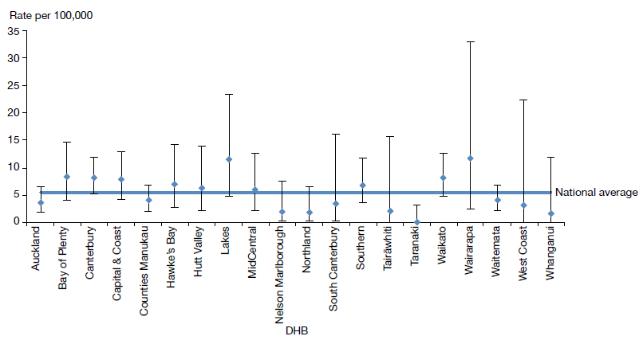
Notes:
As the numbers of people receiving ECT by DHB are so small, it is difficult to make meaningful comparisons between DHBs as rates per 100,000 population.
Confidence intervals (for 99 percent confidence) have been used to aid interpretation. Where a DHB region’s confidence interval crosses the national average, this means the DHB’s rate was not statistically significantly different to the national average.
Source: PRIMHD data, extracted on 2 September 2015

Consent to treatment
Section 60 of the Mental Health Act describes the process required for obtaining consent for ECT. Either the consent of the person themselves or a second opinion from a psychiatrist appointed by the Mental Health Review Tribunal is required. In the latter case, the psychiatrist must consider the treatment to be in the interests of the person.

This process allows for the treatment of people too unwell to consent to treatment. Clinicians are advised to make the decision about whether ECT is in the interests of the person after discussing the options with family/whānau and considering any relevant advance directives the person has made.

During 2014, two people were treated with ECT who retained decision-making capacity and refused consent. Table 8 shows the number of treatments administered without consent during 2014.

Table 8: Indicators for situations in which electroconvulsive therapy was not consented to, by district health board of service, 1 January to 31 December 2014
DHB of service | Number of people given ECT who did not have the capacity to consent | Number of administrations not able to be consented to | Number of people given ECT who had capacity and refused consent
Auckland | 0 | 0 | 0
Bay of Plenty | 0 | 0 | 0
Canterbury | 6 | 32 | 0
Capital & Coast | 0 | 0 | 0
Counties Manukau | 8 | 44 | 0
Hawke’s Bay | 2 | 2 | 0
Hutt Valley | 1 | 7 | 0
Lakes | 0 | 0 | 0
MidCentral | 2 | 23 | 0
Nelson Marlborough | 0 | 0 | 0
Northland | 2 | 2 | 0
South Canterbury | 0 | 0 | 0
Southern | 0 | 0 | 0
Tairāwhiti | 1 | 5 | 1
Taranaki | 0 | 0 | 0
Waikato | 19 | 144 | 1
Wairarapa | – | – | –
Waitemata | 0 | 0 | 0
West Coast | – | – | –
Whanganui | – | – | –
New Zealand | 41 | 259 | 2
Notes:
The data in this table cannot be reliably compared with the data in Table 7 above, as it relates to DHB of service rather than DHB of domicile.
The total number of ECT treatments not able to be consented to decreased from 631 treatments in 2013 to 259 treatments in 2014.
A dash (–) indicates the DHB does not perform ECT. In this case, the DHB sends people to other DHBs for treatment.
Source: Manual data from DHBs (the Ministry of Health is currently unable to provide this data from PRIMHD)

Age and gender of patients treated with electroconvulsive therapy
Table 9 and Figure 29 present information on the age and gender of people who were treated with ECT in 2014. For this data, age group was determined by the individual’s age at the beginning of their treatment. The majority of people (63 percent) treated with ECT were aged over 50 years in 2014.

Of the 247 people who received ECT treatment in 2014, 156 (63 percent) were women and 91 (37 percent) were men. The main reason for the gender difference is that more women present to mental health services with depressive disorders. This ratio is similar to that reported in other countries.

Table 9: Number of people treated with electroconvulsive therapy, by age group and gender, 1 January to 31 December 2014
Age group (years) | Female | Male | Total
15–19 | 5 | 1 | 6
20–24 | 7 | 4 | 11
25–29 | 8 | 4 | 12
30–34 | 5 | 5 | 10
35–39 | 11 | 3 | 14
40–44 | 8 | 11 | 19
45–49 | 10 | 9 | 19
50–54 | 13 | 8 | 21
55–59 | 16 | 12 | 28
60–64 | 14 | 7 | 21
65–69 | 18 | 9 | 27
70–74 | 16 | 9 | 25
75–79 | 5 | 6 | 11
80–84 | 14 | 3 | 17
85–89 | 5 | 0 | 5
90–95 | 1 | 0 | 1
Total | 156 | 91 | 247
Source: PRIMHD data, extracted on 2 September 2015

Figure 29: Number of people treated with electroconvulsive therapy, by age group and gender, 1 January to 31 December 2014
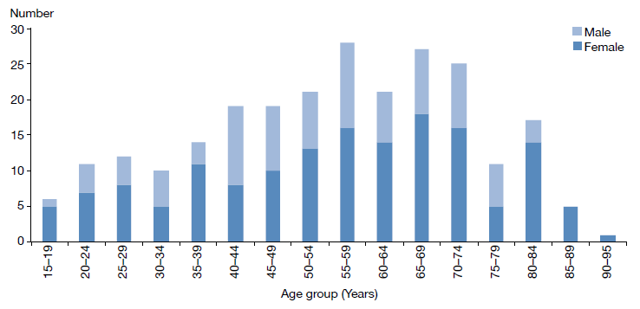
Source: PRIMHD data, extracted on 2 September 2015

Ethnicity of people treated with electroconvulsive therapy
Table 10 suggests that Asian, Māori and Pacific peoples are less likely to receive ECT than those of Other ethnicity. However, the numbers involved are so small that it is not statistically appropriate to compare the percentages of people receiving ECT in each ethnic group with the proportion of each ethnic group in the total population of New Zealand.

Table 10: Number of people treated with electroconvulsive therapy, by ethnicity, 1 January to 31 December 2014
Ethnicity | Number
Asian | 13
Māori | 25
Pacific | 3
Other | 206
Total | 247
Source: PRIMHD data, extracted on 2 September 2015

Serious adverse events
District health boards report serious adverse events (SAEs) relating to clients of their mental health services to the HQSC in accordance with the requirements of the national reportable events policy. The Office of the Director of Mental Health collects information on SAEs involving people under the Mental Health Act, including deaths.

In summary, in 2013/14:
- Mental health and addiction services reported 185 SAEs to the HQSC.
- 139 SAEs involved suspected suicide, 27 involved serious self-harm and 19 involved serious adverse behaviour.
- Mental health and addiction services reported 56 deaths of people under the Mental Health Act to the Director of Mental Health. Of these, 13 people were reported to have died by suicide or suspected suicide, and 43 were reported to have died by other means, including natural causes.
Since 2006/07 the number of serious adverse events reported to the HQSC has increased considerably, as DHBs have improved their reporting systems and cultures to ensure better and safer mental health care
The purpose of reporting of SAEs is to encourage DHBs to identify and review incidents with the aim of preventing similar events in the future. Ultimately the reporting requirements exist to promote a reflexive process around serious events, helping to ensure safer and better mental health care for New Zealanders into the future.

In the time since the HQSC took over the public reporting of SAEs, the number reported to the HQSC has grown considerably: from the first report in 2006/07, when 182 such events were reported, to that in 2013/14, when almost 454 were reported. This growth is not because the frequency of SAEs has increased, but rather because DHBs have improved their reporting systems and cultures, with the result that they are reviewing a greater number of incidents.

Table 11 shows a breakdown of the SAEs reported to the HQSC during 2014, and Table 12 shows the number of SAEs reported by each DHB. It is important to note that comparisons between individual DHBs are problematic, as high numbers may indicate that a DHB has a good reporting culture (rather than a significantly high number of serious events). In addition, DHBs that manage larger and more complex mental health services are likely to report a higher number of SAEs.

Table 11: Number of serious adverse events reported to the Health Quality & Safety Commission, 1 January to 31 December 2014
Type of event | Community | Inpatient unit | On approved leave | Total
Suspected suicide | 131 | 6 | 2 | 139
Serious self-harm | 18 | 9 | 0 | 27
Serious adverse behaviour | 12 | 7 | 0 | 19
Total | 161 | 22 | 2 | 185
Source: Data reported to the HQSC by DHBs

Table 12: Number of serious adverse events reported to the Health Quality & Safety Commission, by district health board, 1 January to 31 December 2014
DHB | Number |  | DHB | Number
Auckland | 13 |  | Northland | 1
Bay of Plenty | 7 |  | South Canterbury | 1
Canterbury | 23 |  | Southern | 23
Capital & Coast | 6 |  | Tairāwhiti | 2
Counties Manukau | 25 |  | Taranaki | 3
Hawke’s Bay | 5 |  | Waikato | 17
Hutt Valley | 2 |  | Wairarapa | 1
Lakes | 1 |  | Waitemata | 29
MidCentral | 17 |  | West Coast | 6
Nelson Marlborough | 1 |  | Whanganui | 2
 |  |  | Total | 185
Source: Data reported to the HQSC by DHBs

Reportable deaths under the Mental Health Act
Section 132 of the Mental Health Act requires that the Director of Mental Health be notified within 14 days of the death of any person or special patient under the Mental Health Act, and that such notification identifies the apparent cause of death.

If the circumstances surrounding a death cause concern, the relevant DHB may initiate an inquiry. The Director of Mental Health can also initiate an investigation under section 95 of the Mental Health Act, and in rare cases the Minister or Director-General of Health can initiate an inquiry under section 72 of the New Zealand Public Health and Disability Act 2000. The Director of Mental Health has a role in ensuring that recommendations are followed up by DHBs.

In 2014, the Director of Mental Health received notification of 56 deaths of people who were under the Mental Health Act at the time of death (Table 13). Thirteen people were reported to have died by suicide or suspected suicide, and one of these deaths has been confirmed as a suicide by the coroner at the time of writing this report. The Ministry is yet to receive coroners’ reports for the other 12 people who are suspected to have died by suicide.

In 2014, 43 people were reported to have died by other means, including by natural causes and illness unrelated to their mental health status, while receiving treatment under the Mental Health Act.

Table 13: Outcomes of reportable death notifications under section 132 of the Mental Health Act, 1 January to 31 December 2014
Reportable death outcome | Number
Suicide | 1
Suspected suicide | 12
Other deaths | 43
Total | 56
Note: A person is recorded as having died by suicide when the coroner has made a finding of suicide.
Source: Office of the Director of Mental Health records

Death by suicide
This section provides a brief overview of suicide deaths and deaths of undetermined intent among people who used specialist mental health services for 2012. Data from 2012 is used because it can take over two years for a coroner’s investigation into a suicide to be completed.

In summary, in 2012:
- 551 people died by suicide. A further 20 deaths of undetermined intent were recorded in the mortality database.
New Zealand is one of 28 countries with a national strategy to address suicide
- Approximately 40 percent of those who died by suicide or undetermined intent (among those aged 10–64) were mental health service users.
- Mental disorders were a significant risk factor for suicidal behaviour.
- Males were more likely to commit suicide than females.

Suicide is a serious concern for New Zealand. Around 500 New Zealanders die by suicide every year. Suicide affects the lives of many others – families/whānau, friends, colleagues and communities.

New Zealand’s national strategy to address suicide is the New Zealand Suicide Prevention Strategy 2006–2016 (Associate Minister of Health 2006). The New Zealand Suicide Prevention Action Plan 2013–2016 (Ministry of Health 2013a) implements this strategy, and reflects the Government’s commitment to addressing New Zealand’s unacceptably high suicide rates.

The Suicide Prevention Action Plan makes use of funding of $25 million over four years to implement 30 actions, including expanding existing services to make them more accessible and to support communities to prevent suicide.

The focus of this section is on people who died by suicide with a history of contact with specialist mental health (including AOD) services in the year prior to their death. People with no history of mental health service use in the year prior to death are referred to as ‘non-service users’ here, although it is acknowledged that some non-service users may have used mental health or AOD services at some earlier time in their lives.
The Suicide Prevention Action Plan 2013–2016 makes use of funding of $25 million over four years, aiming to support communities to prevent suicide

Prevalence of suicide in the population
At the time the data was extracted, there were 551 suicides recorded in the mortality database for 2012. A further 22 deaths of undetermined intent were recorded, and are included in this report. Of this initial total of 573 deaths, 60 involved people aged 65 years and over and one involved a child younger than 10 years. These deaths are excluded from the following discussion.

Table 14 shows the remaining 512 deaths by suicide or deaths of undetermined intent. Of these people who died, 204 (40 percent) had contact with specialist mental health services in the year prior to death. Mental disorders (in particular, mood disorders, substance use disorders and antisocial behaviours) are a significant risk factor for suicidal behaviour (Beautrais et al 2005).

Table 14: Number and age-standardised rate of suicide, by service use, people aged 10–64 years, 1 January to 31 December 2012ª
 | Number | Age-standardised rate^{b}
Deaths due to intentional self-harm
Service users | 194 | 129.8
Non-service users | 298 | 7.9
Total | 492 | 12.8
Deaths of undetermined intent
Service users | 10 | 7.3
Non-service users | 10 | 0.3
Total | 20 | 0.5
Total deaths
Service users | 204 | 137.1
Non-service users | 308 | 12.9
Total | 512 | 12.9
Notes:
a Service user denominator excludes service users with unknown age.
b Age-standardised rate is per 100,000, standardised to the WHO standard population aged 0–64 years.
Source: Ministry of Health mortality database data, extracted on 26 June 2015

Changes in number of suicides over time
Figure 30 shows the changes in the rates of suicide by service users and non-service users between 2001 and 2012.

Figure 30: Age-standardised rate of suicide, by service use, people aged 10–64 years,
2001–2012
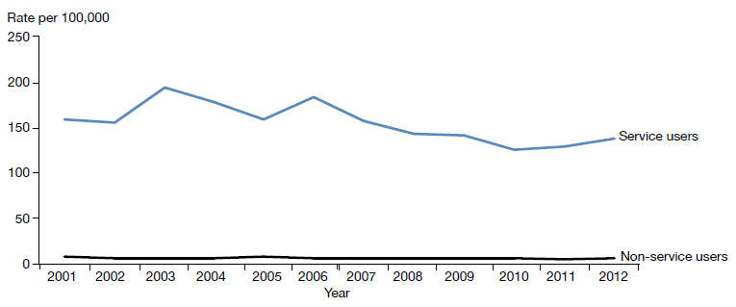
Notes:
Age-standardised rate is per 100,000, standardised to the WHO standard population aged 0–64 years.
The service user population is much smaller than the non-service user population, and will therefore produce rates more prone to fluctuation from year to year.
Source: Ministry of Health mortality database data, extracted on 26 June 2015

Sex and age in relation to suicide
As Table 15 and Figure 31 show, 2.7 times as many males as females died by suicide in 2012. Forty percent of people who died by suicide in 2012 were service users. Of those service users who died by suicide in 2012, 30 percent were female and 70 percent were male.

Table 15: Number and age-standardised rate of suicide, by service use and sex, people aged 10–64 years, 1 January to 31 December 2012ª
Sex | Service users^{b} |  | Non-service users |  | Total
 | Number | ASR | Number | ASR | Number | ASR
Male | 142 | 175.8 | 232 | 12.4 | 374 | 19.0
Female | 62 | 92.6 | 76 | 4.1 | 138 | 7.0
Total | 204 | 137.1 | 308 | 8.2 | 512 | 12.9
Notes:
ASR = age-standardised rate.
a Suicide includes deaths of undetermined intent. Age-standardised rate is per 100,000, standardised to the WHO standard population 0–64 years.
b Service user denominator excludes service users of unknown age.
Source: Ministry of Health mortality database data, extracted on 26 June 2015

Figure 31: Age-specific rate of suicide, by age group, sex and service use, people aged 10–64 years, 1 January to 31 December 2012
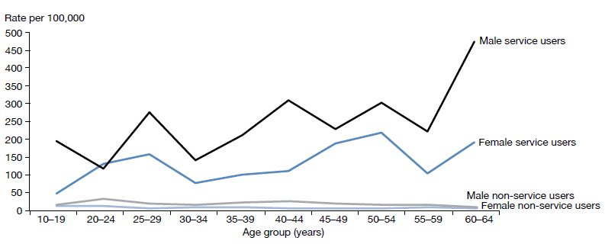
Note: Age-standardised rate is per 100,000, standardised to the WHO standard population 0–64 years.
Source: Ministry of Health mortality database data, extracted on 26 June 2015

As Table 16 shows, the rate of suicide among female service users was highest for those aged 50–54 years, at 216.8 per 100,000. The rate of suicide among male service users was highest for those aged 60–64 years, at 470.1 per 100,000.

When considering these numbers it is important to note that because these age-specific rates are derived from a small service-user population, they are highly variable over time.

For female and male non-service users, the rate of suicide was highest in those aged 20–24 years, at 7.9 per 100,000 ASR and 27.6 per 100,000 ASR respectively.

Table 16: Number and age-specific rate of suicide, by age group, sex and service use, people aged 10–64 years, 1 January to 31 December 2012
Age band (years) | Service users |  |  |  | Non-service users
 | Female |  | Male |  | Female |  | Male
 | Number | ASR | Number | ASR | Number | ASR | Number | ASR
10–19 | 6 | 49.4 | 27 | 193.6 | 21 | 7.4 | 32 | 10.7
20–24 | 8 | 133.1 | 10 | 118.1 | 12 | 7.9 | 44 | 27.6
25–29 | 8 | 157.8 | 19 | 273.4 | 4 | 2.8 | 22 | 15.7
30–34 | 4 | 79.4 | 9 | 141.4 | 8 | 5.9 | 14 | 11.2
35–39 | 5 | 101.9 | 13 | 210.5 | 6 | 4.1 | 23 | 17.4
40–44 | 6 | 112.5 | 20 | 306.7 | 6 | 3.8 | 33 | 23.1
45–49 | 9 | 189.0 | 13 | 227.4 | 4 | 2.5 | 24 | 16.2
50–54 | 9 | 216.8 | 14 | 300.2 | 6 | 4.0 | 18 | 12.8
55–59 | 3 | 104.1 | 7 | 221.9 | 7 | 5.5 | 17 | 13.8
60–64 | 4 | 192.0 | 10 | 470.1 | 2 | 1.7 | 5 | 4.4
Notes:
Includes deaths of undetermined intent. ASR = age-standardised rate.
Source: Ministry of Health mortality database data, extracted on 26 June 2015

Ethnicity and suicide
As Table 17 indicates, among people using mental health services in 2012, the age-standardised rate of suicide was higher for Pacific peoples (103.1 per 100,000 service users) than for Māori peoples (86.0 per 100,000 service users). The age-standardised rate of suicide for those in the category of other ethnicities was 153.4 per 100,000 service users.

It should be noted that the suicide rate for Pacific peoples is highly variable over time.

Table 17: Number and age-standardised rate of suicide and deaths of undetermined intent, by ethnicity and service use, people aged 10–64 years, 1 January to 31 December 2012
Ethnicity | Service users |  | Non-service users |  | Total
 | Number of deaths | ASR | Number of deaths | ASR | Number of deaths | ASR
Māori | 39 | 86.0 | 82 | 14.4 | 121 | 22.6
Pacific | 11 | 103.1 | 19 | 7.3 | 30 | 12.6
Other | 154 | 153.4 | 207 | 6.7 | 361 | 11.3
Total | 204 | 137.1 | 308 | 8.2 | 512 | 12.9
Note: ASR = age-standardised rate.
Source: Ministry of Health mortality database data, extracted on 26 June 2015.

Service users who died by suicide during 2012
During 2012, 204 service users died by suicide. Of this total, eight service users died while an inpatient, nine died within a week of being discharged and 48 died within 12 months of discharge.

An overview of service users dying by suicide, 2001–2012
Over the 11-year period from 2001 to 2012, 1993 service users died by suicide. Of this total, 30 service users (1.5 percent) died while an inpatient, 121 (6 percent) died within a week of being discharged and 632 (32 percent) died within 12 months of discharge.

Of the 1993 service user suicides from 2001 to 2012, 1695 service users were receiving treatment from a specialist service community team in the 12 months before death, and 447 patients were receiving treatment from a specialist AOD team in the 12 months before death.

Sector voices

Marama Parore and Dr Monique Faleafa – Suicide prevention leaders
Rarangahia te taurawhiri tangata kia hūa āi te marama.
Weaving people together so enlightenment comes to fruition.

As chief executive of Te Rau Matatini (Marama Parore) and chief executive of Le Va (Dr Monique Faleafa), it is our humble privilege to lead Waka Hourua, New Zealand’s national Māori and Pasifika suicide prevention programme. We know that Māori and Pasifika youth have some of the highest rates of suicide deaths and attempted suicides across the OECD, and Waka Hourua is a direct response to this.

Marama Parore
Waka Hourua ensures that suicide and suicide prevention is addressed from within our Māori and Pasifika communities. It enables communities to enhance resilience, build capacity to prevent suicide, and respond safely and effectively when suicide occurs.

Through the Community Fund, Waka Hourua supported a community organisation to deliver ‘Rangatira to Rangatira’, a programme that involved five activity-based wānanga. More than 200 Māori and Pasifika people learnt about rangatiratanga (leadership and empowerment), kaitiakitanga (guardianship) and wairuatanga (spiritual wellbeing) through a process of manaakitanga (caring and kindness).

Dr Monique Faleafa
‘FLO: Pasifika For Life’ is New Zealand’s national Pasifika suicide prevention programme. We are prioritising a space for the youth voice to be heard through an evidence-based approach, supporting seven youth-focused community initiatives and educating parents and other adults about suicide prevention. FLO’s online knowledge bank and ‘FLO Talanoa’ education programme are enabling families and communities to take ownership and leadership of suicide prevention.

As a clinical psychologist who has served Pasifika communities for the past 17 years, I know that a strengths-based approach will ensure that our Pasifika families are given the opportunities to unleash their full potential.

The Alcoholism and Drug Addiction Act 1996
The Alcoholism and Drug Addiction Act 1966 (ADA Act) provides for the compulsory detention and treatment of people with severe substance dependence for up to two years at certified institutions.

In summary, in 2014:
- the Family Court granted 64 orders for either detention or committal under the ADA Act
- 50 of the granted orders were for voluntary detention (under section 8) and 14 were for involuntary committal (under section 9).

In October 2009 the Prime Minister announced a review of the ADA Act as part of a range of initiatives to reduce harm from methamphetamine. The Law Commission released its report Compulsory Treatment for Substance Dependence: A review of the Alcoholism and Drug Addiction Act 1966 in October 2012 (New Zealand Law Commission 2012). In 2012 Parliament introduced a bill to repeal and replace the ADA Act.

Section 8 of the ADA Act allows a person who is dependent on alcohol or another drug to voluntarily apply to the Family Court for detention in a specified institution certified under the ADA Act (detention). Section 9 of the ADA Act applies when another person (such as a relative or the police) makes an application to the Family Court for the person to be committed to a specified institution certified under the ADA Act (committal). Section 9 applications must be accompanied by two medical certificates.

Table 18 details the outcomes of applications under the ADA Act to the Family Court since 2004, when the Ministry of Justice began to publish statistics on the use of the ADA Act. Table 19 shows the number of orders granted for detention under section 8 and for committal under section 9 of the ADA Act.

Table 18: Number of applications for detention and committal, by application outcome, 2004–2014
Application outcome | 2004 | 2005 | 2006 | 2007 | 2008 | 2009 | 2010 | 2011 | 2012 | 2013 | 2014
Granted or granted with consent | 72 | 79 | 77 | 71 | 75 | 71 | 69 | 74 | 72 | 74 | 64
Dismissed or struck out | 5 | 3 | 4 | 1 | 2 | 3 | 3 | 1 | 2 | 3 | 4
Withdrawn, lapsed or discontinued | 3 | 9 | 2 | 6 | 1 | 4 | 9 | 5 | 9 | 9 | 7
Total | 80 | 91 | 83 | 78 | 78 | 78 | 81 | 80 | 83 | 86 | 75
Note: The table presents applications that were disposed at the time of data extraction at 7 July 2014.
Source: Ministry of Justice’s CMS. The CMS is a live operational database. Figures are subject to minor changes at any time.

Table 19: Number of granted orders for detention and committal, 2004–2014
Year | Number (percentage) of orders  granted for detention | Number (percentage) of orders  granted for committal | Total
2004 | 44 (92%) | 28 (85%) | 72
2005 | 49 (96%) | 30 (79%) | 79
2006 | 60 (98%) | 17 (77%) | 77
2007 | 52 (100%) | 19 (76%) | 71
2008 | 63 (98%) | 12 (86%) | 75
2009 | 49 (98%) | 22 (81%) | 71
2010 | 55 (96%) | 14 (58%) | 69
2011 | 59 (97%) | 15 (75%) | 74
2012 | 61 (97%) | 11 (58%) | 72
2013 | 58 (94%) | 16 (64%) | 74
2014 | 50 (94%) | 14 (64%) | 64
Note: The table presents applications that were disposed at the time of data extraction on 7 July 2015.
Source: Ministry of Justice’s CMS. The CMS is a live operational database. Figures are subject to minor changes at any time.

Opioid substitution treatment
Opioid substitution treatment involves prescribing opioids such as methadone and buprenorphine with naloxone (Suboxone) as a substitute for illicit opioids. It is a well-established treatment that ensures that people with opioid dependence have access to comprehensive services that support them in their recovery. One of the key objectives of OST is to improve the physical and psychological health and wellbeing of the people who use opioids.

In summary, in 2014:
- the total number of people receiving OST at the end of 2014 was 5230
- of people receiving OST, 79 percent were New Zealand European, 14 percent were Māori, 1.3 percent were Pacific peoples and 5.6 percent were of another ethnicity
- approximately 27 percent of people receiving OST were being treated by a GP in a shared care arrangement.

The Director of Mental Health is responsible for approving qualified practitioners to prescribe controlled drugs for the treatment of drug dependence under section 24 of the Misuse of Drugs Act 1975. For this purpose, the Director undertakes regular site visits, with an emphasis on building relationships and service quality improvement.

Achievements/service improvements

Safer opioid substitution treatment services
The Ministry of Health has developed a framework to ensure a lead medical practitioner in OST in each region is gazetted, to ensure effective oversight of OST prescribing. Gazetted lead practitioners have the power to authorise other suitably qualified practitioners in their region (either within a specialist service or a primary care setting) to prescribe controlled drugs for addiction treatment. Gazetting is expected to contribute to the quality of service delivery while ensuring regulatory compliance.

Specialist Opioid Substitution Treatment Service Audit and Review Tool
The Specialist Opioid Substitution Treatment Service Audit and Review Tool sets out clinical audit requirements to ensure best treatment and services for clients and their family/whānau. The indicators against which the Ministry of Health audits services are primarily drawn from two key documents:
- New Zealand Practice Guidelines for Opioid Substitution Treatment (Ministry of Health 2014)
- National Guidelines: Interim methadone prescribing (Ministry of Health 2007).
Opioid substitution treatment ensures people with opioid dependence have access to services that support them in their recovery
The Ministry of Health has initiated a rolling programme of audits of all OST services. During the 2014 reporting period it audited three services supported by the audit tool. It will audit all other OST services over the next few years.

A greater emphasis on managing co-existing medical and mental health problems and a continued focus on integration between primary and specialist services will be required (Ministry of Health 2012e) to ensure the best possible health outcomes for those receiving the service.

The aging population of OST clients
Opioid substitution treatment clients are an aging population; by age group, people between the ages of 45–59 and 60+ are the most likely to be receiving treatment.

Figure 32: Number of opioid substitution treatment clients, by age group, 2008–2014
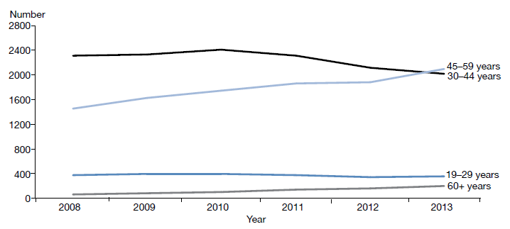
Source: Data provided by OST services in six-monthly reports

Shared care with general practice
Opioid substitution treatment in New Zealand is provided by specialist addiction services and primary health care teams. Transferring care to a shared care arrangement with primary care offers a lot of benefits, including allowing specialist services to focus on those with the highest need and normalising the treatment process. Ensuring services are delivered seamlessly across providers will be an important focus going forward.

Corrections opioid substitution treatment shared care model
Opioid substitution treatment services continue to be delivered in prison for those people who were receiving treatment prior to entering prison. While in prison, these people continue to receive psychosocial support and treatment from specialist services.

Figure 33: Number of people receiving treatment from a specialist service, general practice or prison service, 2008–2014
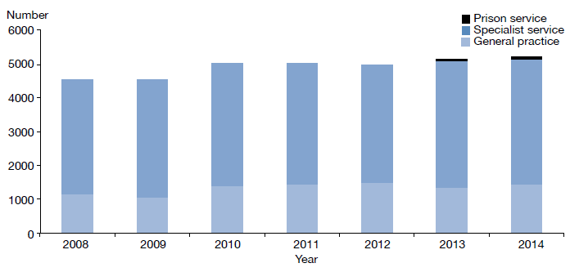
Source: Data provided by OST services in six-monthly reports

Between 2013 and 2014 the number of clients accessing OST services increased by approximately 150. This growth is consistent with the previous year, when the increase was approximately the same level.

In 2014, 18 DHBs and one primary health organisation delivered OST services, thereby providing national coverage. The Ministry’s target for service provision is 50:50 between primary and specialist care. Currently, across the country, approximately 27 percent of OST treatment is delivered by general practice and approximately 71 percent by specialist services. Auckland and Canterbury DHBs are working close to the target, and other DHBs are also showing improvement over time, including Capital & Coast, Northland, Waikato and Whanganui.

Figure 34: Percentage of people receiving OST treatment from specialist services and general practice, by district health board, 1 January to 31 December 2014
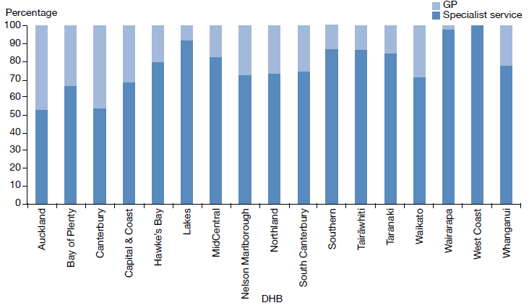
Source: Data provided by OST services in six-monthly reports

Entry to and exit from opioid substitution treatment
Opioid substitution treatment is built on a model of recovery; it aims to assist people to stay well through building support structures that help them to define and achieve their goals. Entering, staying in and exiting OST are indicators by which we can track an individual’s recovery.

At the end of 2014, there were 365 (83 percent) planned voluntary withdrawals from OST. This is consistent with the previous year’s figures, with small incremental differences. During this period there was 3 percent of involuntary withdrawals. Involuntary withdrawals are generally a result of behaviour that may have jeopardised the safety of the individual or others. The number of involuntary withdrawals continues to decrease from year to year.

During 2014, 57 people receiving OST from specialist treatment services died, from a range of causes. This is an increase from previous years. Of this number, six deaths were likely a result of overdose related to the use of other substances. When a client dies of a suspected overdose, the Ministry of Health requires services to conduct an incident review and report on it to the Director of Mental Health.

Figure 35: Percentage of withdrawals from opioid substitution treatment programmes, by reason (voluntary, involuntary or death), 2008–2014
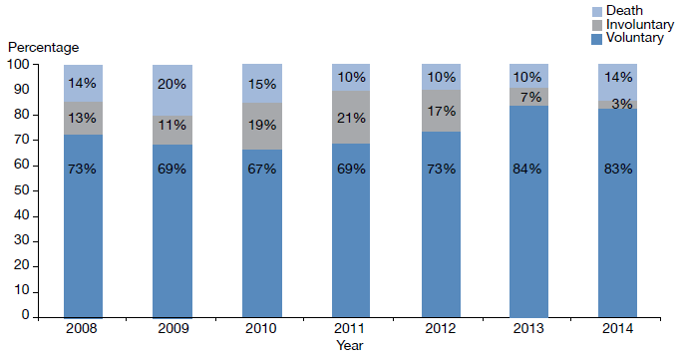
Note: 2013 data has been updated, and differs from data presented in the 2013 Annual Report.
Source: Data provided by OST services in six-monthly reports

Methadone and Suboxone prescribing
Since July 2012 PHARMAC has funded Suboxone for OST. Since then, there has been a steady increase in the number of people prescribed it. Suboxone lowers the risk of diversion, and its misuse is lower than that associated with methadone. In addition, Suboxone can be given in cumulative doses lasting several days, rather than the daily dosing regimen that is required with methadone.

Figure 36: Number of people prescribed Suboxone, 2008–2014
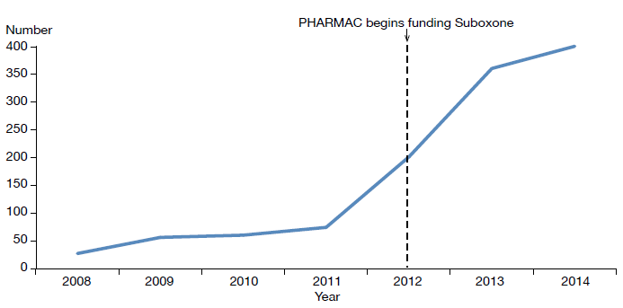
Source: Data provided by OST services in six-monthly reports

Sector voices

Matua Raki Consumer Leadership Group
Kia ora. We are the Matua Raki Consumer Leadership Group. It is our role to support Matua Raki, the national addiction workforce development group, to respond to consumers/tāngata whaiora and their families to reduce addiction-related harm. We also provide support to the Matua Raki Consumer Project Lead to achieve the goals of the addiction consumer and peer workforce.

An example of consumer leadership in action is the review of the Ministry of Health’s New Zealand Practice Guidelines for Opioid Substitution Treatment (Ministry of Health 2014). Through our networks and personal experiences we were aware that many consumers did not have access to the guidelines, and many were not receiving the information they needed to make informed decisions on engaging in OST.

Matua Raki supported our request, and Sheridan Pooley, the leadership group chair, was contracted to develop a client-friendly version of the guidelines called OST and You. As part of the process, she regularly consulted with us and with other OST consumers from around New Zealand.

Consumer Jo Hall says that OST and You is her first-aid handbook to wellness and recovery. ‘It’s a great way to start the conversation. I can take the book along with me to my appointments and look at what I need to do to get where I want. It’s about having input into decisions made about your life.’

References
American Psychiatric Association. 2001. The Practice of ECT: A task force report (2nd ed). Washington, DC: American Psychiatric Association.
Associate Minister of Health. 2006. New Zealand Suicide Prevention Strategy 2006–2016. Wellington: Ministry of Health.
Beardslee WR, Chien PL, Bell CC. 2011. Prevention of mental disorders, substance abuse, and problem behaviors: a developmental perspective. Psychiatric Services 62: 247–54.
Beautrais AL, Collings SCD, Ehrhardt P, et al. 2005. Suicide Prevention: A review of evidence of risk and protective factors, and points of effective intervention. Wellington: Ministry of Health.
Department of Corrections. 2007. Over-representation of Māori in the Criminal Justice System: An exploratory report. Wellington: Department of Corrections.
Elder H, Tapsell R. 2013. Māori and the Mental Health Act. In J Dawson and K Gledhill (eds). New Zealand’s Mental Health Act in Practice. Wellington: Victoria University Press.
Fleming T, Lee AC, Moselen E, et al. 2014. Problem substance use among New Zealand secondary school students: Findings from the Youth’12 National Youth Healing and Wellbeing Survey. Auckland: the University of Auckland.
Huckshorn KA. 2005. Six Core Strategies to Reduce the Use of Seclusion and Restraint Planning Tool. Alexandria, VA: National Association of State Mental Health Program Directors.
Ministry of Health. 1996. Inquiry under Section 47 of the Health and Disability Services Act 1993 in Respect of Certain Mental Health Services. Wellington: Ministry of Health.
Ministry of Health. 2004. Use of Electroconvulsive Therapy (ECT) in New Zealand: A review of efficacy, safety, and regulatory controls. Wellington: Ministry of Health.
Ministry of Health. 2006. Review of the Application of Section 7A of the Mental Health (Compulsory Assessment and Treatment) Act 1992. Wellington: Ministry of Health.
Ministry of Health. 2007. National Guidelines: Interim methadone prescribing. Wellington: Ministry of Health.
Ministry of Health. 2009. Electroconvulsive Therapy (ECT) in New Zealand: What you and your family and whānau need to know. Wellington: Ministry of Health.
Ministry of Health. 2010. Seclusion under the Mental Health (Compulsory Assessment and Treatment) Act 1992. Wellington: Ministry of Health.
Ministry of Health. 2011. Healthy Beginnings: Developing perinatal and infant mental health services in New Zealand. Wellington: Ministry of Health.
Ministry of Health. 2012a. Guidelines for the Role and Function of Directors of Area Mental Health Services. Wellington: Ministry of Health.
Ministry of Health. 2012b. Guidelines for the Role and Function of District Inspectors Appointed under the Mental Health (Compulsory Assessment and Treatment) Act 1992. Wellington: Ministry of Health.
Ministry of Health. 2012c. Guidelines for the Role and Function of Duly Authorised Officers under the Mental Health Act 1992. Wellington: Ministry of Health.
Ministry of Health. 2012d. Guidelines to the Mental Health (Compulsory Assessment and Treatment) Act 1992. Wellington: Ministry of Health.
Ministry of Health. 2012e. Rising to the Challenge: The Mental Health and Addiction Service Development Plan 2012–2017. Wellington: Ministry of Health.
Ministry of Health. 2013a. New Zealand Suicide Prevention Action Plan 2013–2016. Wellington: Ministry of Health.
Ministry of Health. 2013b. PRIMHD: Mental health data. URL: www.health.govt.nz/nz-health-statistics/national-collections-and-surveys/collections/primhd-mental-health-data (accessed 2 November 2015).
Ministry of Health. 2014. New Zealand Practice Guidelines for Opioid Substitution Treatment. Wellington: Ministry of Health.
Ministry of Health. 2015a. Suicide Facts: Deaths and intentional self-harm hospitalisations 2012. Wellington: Ministry of Health.
Ministry of Health. 2015b. Supporting Parents, Healthy Children. Wellington: Ministry of Health.
Ministry of Justice. 2013. Youth Crime Action Plan 2013–2023. Wellington: Ministry of Justice.
Ministry of Social Development. 2007. Inter-agency Plan for Conduct Disorder/Severe Antisocial Behaviour 2007–2012. Wellington: Ministry of Social Development.
New Zealand Government. 2012. Children’s Action Plan. Wellington: New Zealand Government.
New Zealand Law Commission. 2012. Compulsory Treatment for Substance Dependence: A review of the Alcoholism and Drug Addiction Act 1966. Wellington: New Zealand Law Commission.
Oakley Browne MA, Wells JE, Scott KM (eds). 2006. Te Rau Hinengaro: The New Zealand Mental Health Survey. Wellington: Ministry of Health.
Office of the Prime Minister’s Science Advisory Committee, Gluckman PD. 2011. Improving the Transition: Reducing social and psychological morbidity during adolescence. Office of the Prime Minister’s Science Advisory Committee.
Standards New Zealand. 2008a. Health and Disability Services (General) Standard. Wellington: Standards Council.
Standards New Zealand. 2008b. Health and Disability Services (Restraint Minimisation and Safe Practices) Standards. Wellington: Standards Council.
Thio IM, Oakley Browne MA, Coverdale JH, et al. 2006. Postnatal depressive symptoms go largely untreated: A probability study in urban New Zealand. Social psychiatry and psychiatric epidemiology 41(10): 915–818.

Appendix 1: Additional statistics

The Mental Health Review Tribunal
During the year ended 30 June 2014, the Tribunal received 157 applications under the Mental Health Act. Table A1 presents the types of applications received (by governing section) and the outcomes of these applications.

Table A1: Outcome of Mental Health Act applications received by the Mental Health Review Tribunal, 1 July 2013 to 30 June 2014
Outcome | Section 79 | Section 80 | Section 81 | Section 75 | Total
Deemed ineligible | 20 | 0 | 0 | 3 | 23
Withdrawn | 48 | 2 | 1 | 0 | 51
Held over to the next report year | 5 | 0 | 0 | 0 | 5
Heard in the report year | 70 | 7 | 0 | 1 | 78
Total | 143 | 9 | 1 | 4 | 157
Source: Annual Report of Mental Health Review Tribunal, 1 July 2013 to 30 June 2014

During the year ended 30 June 2014, the Tribunal heard 80 applications under section 79 of the Mental Health Act. Table A2 presents the results of those cases.

Table A2: Results of inquiries under section 79 of the Mental Health Act held by the Mental Health Review Tribunal, 1 July 2013 to 30 June 2014
Result | Number
Not fit to be released from compulsory status | 72
Fit to be released from compulsory status | 8
Total | 80
Source: Annual Report of Mental Health Review Tribunal, 1 July 2013 to 30 June 2014

Table A3 shows the ethnicity of the 128 people for whom ethnicity was identified in an application to the Tribunal in the year ended 30 June 2014.

Table A3: Ethnicity of people who identified their ethnicity in Mental Health Review Tribunal applications, 1 July 2013 to 30 June 2014
Ethnicity | Number | Percentage
NZ European | 74 | 58
Māori | 31 | 24
Pacific | 9 | 7
Asian | 7 | 5.5
Other | 7 | 5.5
Total | 128 | 100
Source: Annual Report of Mental Health Review Tribunal, 1 July 2013 to 30 June 2014

Of the 157 Mental Health Act applications received by the Tribunal during the year ended 30 June 2014, 97 (62%) were from males and 60 (38%) from females. Table A4 presents these figures.

Table A4: Gender of people making Mental Health Review Tribunal applications, 1 July 2013 to 30 June 2014
Subject of application | Total number (percentage) | Gender | Number
Community treatment order | 111 (71%) | Female  Male | 50  61
Inpatient treatment order | 36 (23%) | Female  Male | 10  26
Special patient order | 9 (6%) | Female  Male | 0  9
Restricted person order | 1 (0%) | Female  Male | 0  1
Source: Annual Report of Mental Health Review Tribunal, 1 July 2013 to 30 June 2014

Ministry of Justice statistics
Table A5 presents data on applications for a compulsory treatment order from 2004 to 2014. Table A6 shows the types of orders granted over the same period.

Table A5: Applications for compulsory treatment orders (or extensions), 2004–2014
Year | CTO or extension to a CTO | Granted, or granted with consent | Dismissed or struck out | Withdrawn, lapsed or discontinued | Transferred to the High Court
2004 | 4423 | 3863 | 100 | 460 | 0
2005 | 4302 | 3682 | 100 | 520 | 0
2006 | 4268 | 3643 | 109 | 515 | 1
2007 | 4557 | 3916 | 99 | 542 | 0
2008 | 4557 | 3969 | 103 | 485 | 0
2009 | 4586 | 4038 | 54 | 494 | 0
2010 | 4754 | 4156 | 74 | 523 | 1
2011 | 4801 | 4215 | 70 | 516 | 0
2012 | 4858 | 4343 | 71 | 444 | 0
2013 | 5057 | 4580 | 68 | 409 | 0
2014 | 5236 | 4616 | 47 | 573 | 0
Notes:
The table presents applications that had been processed at the time of data extraction on 7 July 2015. The year is determined by the final outcome date.
CTO = compulsory treatment order
Source: Ministry of Justice’s Integrated Sector Intelligence System, which uses data entered into the CMS. The CMS is a live operational database, and figures are subject to minor changes at any time.

Table A6: Types of compulsory treatment orders made on granted applications,
2004–2014
Year | Number of granted applications for orders | Compulsory community treatment orders (or extension) | Compulsory inpatient treatment orders (or extension) | Both compulsory community and inpatient treatment orders (or extension) | Type of order not recorded
2004 | 3863 | 1832 | 1534 | 117 | 380
2005 | 3682 | 1576 | 1439 | 92 | 575
2006 | 3643 | 1614 | 1384 | 91 | 554
2007 | 3916 | 1716 | 1336 | 116 | 748
2008 | 3969 | 1841 | 1429 | 120 | 579
2009 | 4038 | 2085 | 1564 | 106 | 283
2010 | 4156 | 2238 | 1614 | 107 | 197
2011 | 4215 | 2255 | 1677 | 90 | 193
2012 | 4343 | 2428 | 1680 | 76 | 159
2013 | 4580 | 2630 | 1749 | 69 | 132
2014 | 4616 | 2651 | 1781 | 78 | 106
Notes:
The table presents applications that had been processed at the time of data extraction on 7 July 2015. The year is determined by the final outcome date.
Where more than one order type is shown, it is likely to be because new orders are being linked to a previous application in the CMS.
Source: Ministry of Justice’s Integrated Sector Intelligence System, which uses data entered into the CMS. The CMS is a live operational database, and figures are subject to minor changes at any time.

Appendix 2: Caveats relating to PRIMHD
The Programme for the Integration of Mental Health Data, or PRIMHD (pronounced ‘primed’), is the Ministry of Health’s national collection for mental health and addiction service activity and outcome data for mental health consumers. PRIMHD data is used to report on what services are being provided, who is providing the services, and what outcomes are being achieved for health consumers across New Zealand’s mental health sector. These reports enable mental health and addiction service providers to undertake better quality service planning and decision-making, at the local, regional and national levels (Ministry of Health 2013b). PRIMHD reports are invaluable for facilitating important conversations and debates about mental health issues in New Zealand.

In 2008, DHB reporting to PRIMHD became mandatory. In addition, from this date an increasing number of NGOs began reporting to the PRIMHD database. As of December 2014, 209 NGOs were reporting to PRIMHD.

Because of both its recent introduction and the enormous complexities of creating and maintaining a national data collection, the following caveats need to be kept in mind when reviewing statistics generated using PRIMHD data.
- Shifts or patterns in the data after 2008 may reflect the gradual adaptation of service providers to the PRIMHD system, in addition to, or instead of, any trend in mental health service use or consumer outcomes.
- PRIMHD is a living data collection, which continues to be revised and updated as data reporting processes are improved. For this reason, previously published data may be liable to amendments.
- Statistical variance between services may reflect different models of practice and different consumer populations. However, inter-service variance may also result from differences in data entry processes and information management.
- To function as a national collection, PRIMHD requires integration with a wide range of person management systems across hundreds of unique service providers. As the services adjust to PRIMHD, it is expected that the quality of the data will improve.
- The quality and accuracy of statistical reporting relies on consistent, correct and timely data entry by the services that report to PRIMHD.
- The Ministry of Health is actively engaged in a continuing project to review and improve the data quality of PRIMHD. This project is considered a priority given the importance of mental health data in providing information about mental health consumption and outcomes, and in generating conversations and public debate about how to improve mental health care for New Zealanders.

Data from 2012 is used because it can take over two years for a coroner’s investigation into a suicide to be completed.
If people seen by addiction services only are excluded, the total number of people who engaged with a specialist mental health service was 125,780. Source: PRIMHD, data extracted 28 September 2015.
Between 2011 and 2014 the total New Zealand population increased by approximately 2.4 percent.
Excludes those who accessed a mixture of inpatient and community services.
Mental Health Act, long title.
See the section on relapse prevention plans above.
Mental Health Act sections 11, 13, 14(4), 15(1), 15(2), 29, 30 and 31.
Data extracted from the Ministry of Justice’s Case Management System as at 7 July 2015.
PRIMHD data, extracted on 2 September 2015.
PRIMHD data, extracted on 2 September 2015, except for data from Capital & Coast, Counties Manukau, Hutt Valley, Nelson Marlborough, Wairarapa and Auckland DHBs (in the case of section 14(4) only), which was supplied manually.
Source: PRIMHD data, extracted on 2 September 2015, except for data from Bay of Plenty, Capital & Coast, Hutt Valley, MidCentral, Tairāwhiti, Wairarapa and Counties Manukau DHBs (in the case of section 29 only), which was supplied manually.
This action is outlined in Rising to the Challenge (Ministry of Health 2012e). In addition, the number of Māori subject to section 29 of the Mental Health Act is now an indicator for reporting in the Māori Health Plans the Ministry of Health requires every DHB to produce.
This ratio is based on the age-standardised rates of the Māori and non-Māori populations. When using a crude rate, the ratio is 2.9 (the same as the crude rate ratio published in the 2013 Annual Report). The age-standardised rate is considered to be a more appropriate method for comparing Māori and non-Māori populations, given the different age structures.
PRIMHD data, extracted on 17 March 2014. This applies to both voluntary service users and those under the Mental Health Act.
PRIMHD data, extracted 17 March 2015.
Statistical difference was calculated with a 99 percent confidence interval. Rates per 100,000 have been age-standardised to account for differences in the population structures between DHBs.
Adult mental health services generally care for people aged 20–64 years. Adult inpatient services are distinct from forensic, youth, intellectual disability services and services for older people.
Of the 111 young people secluded, 39 were secluded in the country’s specialist facilities for children and young people (in Christchurch, Auckland and Wellington). Of the 339 seclusion events, 112 seclusion events occurred in those specialist facilities.
If a person in Wairarapa requires admission to mental health inpatient services, they are transported to Hutt Valley or MidCentral DHB; seclusion statistics in relation to these patients appear on the corresponding DHB’s database.
The Whanganui inpatient unit comes under the Central region’s forensic services.
Table 7 presents data by DHB of domicile; that is, the area where a person lives. This takes account of the fact that some DHBs do not perform ECT; people who live in such areas are referred to other DHBs for ECT treatment. Other ECT statistics are presented by DHB of service.
The psychiatrist must be independent of the person’s clinical team.
Refer to the Guidelines to the Mental Health (Compulsory Assessment and Treatment) Act 1992 (Ministry of Health 2012d).
For more information on reporting, see the HQSC’s website (www.hqsc.govt.nz).
Any suicides or suspected suicides of people under the Mental Health Act also come under the SAE reporting requirements of the HQSC.
These numbers are subject to change. The mortality database is a dynamic collection, and changes can be made even after the data is considered nominally final.
The statistics discussed here cover only people under 65 years of age because in the Central and Southern regions older people’s mental health treatment was provided by health services for older people rather than mental health services and is not necessarily recorded in PRIMHD. Deaths of children under 10 years have also been excluded because undetermined intent deaths in this age group are unlikely to be caused by suicide. The data was drawn from information provided to the Ministry’s national mortality database and PRIMHD.
The term ‘gender’ has been used for all other reporting measures in this report. However, the mortality database uses ‘sex’ in relation to suicide statistics, and this section follows that convention.
This figure is determined from the number of people who died on the same day as they had an inpatient activity. This approach to classification has been taken to mean here that they were still in the context of an inpatient unit on the day of death.
Excluding those who received treatment on the day of death.
Excluding those who received treatment on the day of death and those who died within a week of being discharged from an inpatient service.
Includes deaths of undetermined intent.

