line_170mmx2mm

line_170mmx2mm

|  |
| --- |
|  |
|  |
| Disability Information and Advisory Services and Needs Assessment and Service Coordination Review  A Proposed Design and Framework |
|  |

14 October 2016

About Sapere Research Group Limited

Sapere Research Group is one of the largest expert consulting firms in Australasia and a leader in provision of independent economic, forensic accounting and public policy services. Sapere provides independent expert testimony, strategic advisory services, data analytics and other advice to Australasia’s private sector corporate clients, major law firms, government agencies, and regulatory bodies.

|  |  |  |
| --- | --- | --- |
| Wellington  Level 9, 1 Willeston St  PO Box 587  Wellington 6140  Ph: +64 4 915 7590  Fax: +64 4 915 7596 | Auckland  Level 8, 203 Queen St  PO Box 2475  Auckland 1140  Ph: +64 9 909 5810  Fax: +64 9 909 5828 |  |
| Sydney  Level 14, 68 Pitt St  GPO Box 220  NSW 2001  Ph: +61 2 9234 0200  Fax: +61 2 9234 0201 | Canberra  Unit 3, 97 Northbourne Ave  Turner ACT 2612  GPO Box 252  Canberra City, ACT 2601  Ph: +61 2 6267 2700  Fax: +61 2 6267 2710 | Melbourne  Level 2, 65 Southbank Boulevard  GPO Box 3179  Melbourne, VIC 3001  Ph: +61 3 9626 4333  Fax: +61 3 9626 4231 |

For information on this report please contact:

Name: Jo Esplin

Telephone: +64 9 360 1773

Mobile: +64 27 233 4010

Email: jesplin@srgexpert.com

Contents

[Executive summary vii](#_Toc464210315)

[1. Introduction 1](#_Toc464210316)

[1.1 By way of background 1](#_Toc464210317)

[1.2 NASC and DIAS described 2](#_Toc464210318)

[1.2.1 Methodology: Independent review with a mixed methods approach 2](#_Toc464210319)

[1.3 Scope 2](#_Toc464210320)

[2. Strategic context and a changed environment 3](#_Toc464210321)

[2.1 Strategic context converges on client orientation 3](#_Toc464210322)

[2.1.1 Disability specific context 4](#_Toc464210323)

[2.1.2 Wider Government sector 6](#_Toc464210324)

[2.2 Māori and Pacific people with disabilities 7](#_Toc464210325)

[3. Summary of current state 8](#_Toc464210326)

[3.1 What is driving people’s feelings/experiences 8](#_Toc464210327)

[3.1.1 DIAS functions are wide and varied and local presence is highly valuable 8](#_Toc464210328)

[3.1.2 Access framework was most criticised 10](#_Toc464210329)

[3.1.3 Budget allocation 12](#_Toc464210330)

[3.1.4 The purchase framework also needs modernising 13](#_Toc464210331)

[4. What is the DSS of the future? 14](#_Toc464210332)

[4.1.1 A paradigm and culture shift is needed 14](#_Toc464210333)

[5. NASC quantitative analysis 16](#_Toc464210334)

[5.1 Methods for NASCs analysis 16](#_Toc464210335)

[5.2 NASC financial data 16](#_Toc464210336)

[5.3 Service coordination data 16](#_Toc464210337)

[5.4 Context – population, active clients and funding 17](#_Toc464210338)

[5.5 To what extent does the number of NASCs matter? 20](#_Toc464210339)

[5.5.1 The current number of NASCs 21](#_Toc464210340)

[5.5.2 Consideration of scale economies 22](#_Toc464210341)

[5.6 Is there evidence of some NASC activity being unnecessary? 24](#_Toc464210342)

[5.6.1 Testing the claim that some assessments are low value 24](#_Toc464210343)

[5.6.2 Findings – a majority of clients had ‘no change’ at their most recent service review 24](#_Toc464210344)

[5.6.3 Implications for resourcing 28](#_Toc464210345)

[5.7 What might be obtained with freed-up resources? 30](#_Toc464210346)

[6. Analysis of Disability Information and Advisory Services (DIAS) 32](#_Toc464210347)

[6.1 DIAS groupings 33](#_Toc464210348)

[6.1.1 Disability Resource Centres 33](#_Toc464210349)

[6.1.2 Disability information organisations 35](#_Toc464210350)

[6.1.3 The national website – WEKA, is not widely known 36](#_Toc464210351)

[6.2 Culturally specific services 37](#_Toc464210352)

[6.2.1 Māori DIAS contracts 37](#_Toc464210353)

[6.2.2 Other ethnic based contracts 38](#_Toc464210354)

[6.3 The key issues 39](#_Toc464210355)

[6.4 The impact and the key changes 40](#_Toc464210356)

[6.4.1 Proposed key changes include a national disability brand across disability services 40](#_Toc464210357)

[6.4.2 National Disability Service – vertical integration 41](#_Toc464210358)

[6.4.3 National Disability Service – horizontal integration 43](#_Toc464210359)

[6.4.4 Contract implications 45](#_Toc464210360)

[7. The proposed changes/framework design 46](#_Toc464210361)

[7.1 Overview 46](#_Toc464210362)

[7.1.1 The challenge of achieving this change and managing risks is large 47](#_Toc464210363)

[7.1.2 Workforce implications are significant for NASC 47](#_Toc464210364)

[7.1.3 Workforce implications are also present for DIAS 49](#_Toc464210365)

[7.2 The disability information component 49](#_Toc464210366)

[7.2.1 Summary recommendation - grow and develop what is in place; make some national change for both DIAS and NASC 49](#_Toc464210367)

[7.2.2 Current issues 50](#_Toc464210368)

[7.2.3 Our conclusion - DIAS services and supports are cost effective for the Ministry, yet opportunities for improvement 50](#_Toc464210369)

[7.3 For NASC: The independent planning and assessment components 50](#_Toc464210370)

[7.3.1 Summary recommendation – a paradigm shift is needed, and link LAC function with DIAS (information) and NASC 51](#_Toc464210371)

[7.3.2 Current issues 51](#_Toc464210372)

[7.3.3 Our conclusion – independent planning needs to be evolved and implemented widely along with LAC type functions 51](#_Toc464210373)

[7.4 Independent facilitation, navigation: “getting things done” and/or “connecting up” 52](#_Toc464210374)

[7.4.1 Summary recommendation – this is an important function for many and links to LAC functions 52](#_Toc464210375)

[7.4.2 Current issues 52](#_Toc464210376)

[7.4.3 Our conclusion 52](#_Toc464210377)

[7.5 Budget allocation 52](#_Toc464210378)

[7.5.1 Summary recommendation – budget allocation needs to be separate to planning and assessment, yet linked 52](#_Toc464210379)

[7.5.2 Current issues 53](#_Toc464210380)

[7.5.3 Our conclusion 53](#_Toc464210381)

[8. Change approach 54](#_Toc464210382)

[8.1 DIAS contracts minimal change 54](#_Toc464210383)

[8.2 Two levels of options considered for NASC and LAC type functions; plus, is devolution of funds an option? 54](#_Toc464210384)

[8.3 The preferred option of paradigm and culture change with option of devolution of funds in the future 56](#_Toc464210385)

[8.3.1 Implications 56](#_Toc464210386)

[8.3.2 Summary of key recommended key changes 58](#_Toc464210387)

[8.3.3 Implications of preferred option 63](#_Toc464210388)

[8.3.4 Impact analysis 64](#_Toc464210389)

[8.4 Implementation considerations 64](#_Toc464210390)

[9. Works cited for this report 73](#_Toc464210391)

Appendices

[Appendix 1 EGL Principles 65](#_Toc464210392)

[Appendix 2 Stakeholder list 66](#_Toc464210393)

[Appendix 3 Interview questions 68](#_Toc464210394)

[Appendix 4 Timeline of disability reviews and key milestones 69](#_Toc464210395)

[Appendix 5 DIAS Providers 70](#_Toc464210396)

Tables

[Table 1 Disability strategic context and relevance 4](#_Toc464210397)

[Table 2 Wider Government sector considerations 6](#_Toc464210398)

[Table 3 Comparison between reports of ethnicity of disabled people 7](#_Toc464210399)

[Table 4 The number of NASCs – dimensions to consider 21](#_Toc464210400)

[Table 5 Estimated number of clients with no service change after an annual review 29](#_Toc464210401)

[Table 6 Estimated number of FTEs for annual reviews resulting in no service change 30](#_Toc464210402)

[Table 7 Disability Resource Centre overview of contract funding 34](#_Toc464210403)

[Table 8 Māori DIAS providers 37](#_Toc464210404)

[Table 9 Review of advantages and disadvantages for revising DIAS contracts 44](#_Toc464210405)

[Table 10 Examples of outcome measures as suggested through survey 45](#_Toc464210406)

[Table 11 Three broad framework options for NASC type functions 55](#_Toc464210407)

[Table 12 Disability Framework Components 56](#_Toc464210408)

[Table 13 Preferred options in detail 59](#_Toc464210409)

Figures

[Figure 1 Pictorial view of the future DSS framework x](#_Toc464210410)

[Figure 2 Pictorial view of the future DSS framework 15](#_Toc464210411)

[Figure 3 NASCs by size of catchment population 18](#_Toc464210412)

[Figure 4 NASCs by size of active client base, 2016 18](#_Toc464210413)

[Figure 5 Client share and population share for each NASC, 2016 19](#_Toc464210414)

[Figure 6 NASC management funding per client compared with number of active clients, 2016 20](#_Toc464210415)

[Figure 7 NASC cost structures – a stylised example 23](#_Toc464210416)

[Figure 8 Proportion of clients with ‘no change’ in service number or type 25](#_Toc464210417)

[Figure 9 Proportion of clients with ‘no change’ in service number, mix, or volume 26](#_Toc464210418)

[Figure 10 Proportion of clients by service coordination events 27](#_Toc464210419)

[Figure 11 Proportion of clients with ‘no change’ in service, by coordination event type 28](#_Toc464210420)

[Figure 12 Proportion of DHB population that is Māori, 2013 38](#_Toc464210421)

[Figure 13 Information model 42](#_Toc464210422)

[Figure 14 DIAS providers 70](#_Toc464210423)

[Figure 15 Hub and spoke DIAS contract providers 71](#_Toc464210424)

Executive summary

##### Purpose and scope

This is the third and final conclusion and recommendation paper in the independent review of the framework for Disability Information and Advisory Services (DIAS) and Needs Assessment and Service Coordination (NASC) for Disability Support Services (DSS) of the Ministry of Health (the Ministry). The purpose of the first paper was to highlight the current state (i.e. what is happening now) and reflect key messages from the stakeholder engagement (a sample of disabled people, families, DIAS and NASC providers, as well as the Ministry and other linked stakeholders). The second paper drew conclusions and proposed options for discussion with the Ministry. This final paper contains our (Sapere’s) options and analysis of the potential impacts for a revision of the framework.

**Methodology**

We met with a targeted number of stakeholders including NASC and DIAS providers, either face to face or by phone. Some we met with more than once. In addition we met with Disabled Persons Organisations (DPOs) and a mix of additional disabled people and organisations. We also met regularly with the DSS Steering Group at the Ministry.

We undertook a desk review and analysis of contracts and data that was supplied by both a sample of NASCs and DSS. We used the data for modelling options for the future. In addition we ran an e-survey for DIAS providers and carried out a rapid literature scan.

##### Impetus for change

There are several factors that lead to the need for change for the DSS framework; therefore, status quo is not an option. We summarise the key point for impetus for change (i.e. what needs to be addressed by future developments) as:

* The **primary** concern is to make the system more person focused, with choice and control by the person, a system that is permissive and localised, and from that other benefits should follow.
* The **secondary** need is to streamline and release resources to do things differently, moving from input controls to an outcome focus, as well as connecting services and supports up across the system more.
* The **tertiary** consideration is who carries the financial risk of full budget management.

**DIAS contracts and delivery is varied**

There are over 100 DIAS contracts with significant variances in financial amounts per annum. The Ministry funds these on a contributory model and the rest is made up by the providers from a mix of other contracts, grants, donations and volunteer time. Anyone can access these services (i.e. they don’t need DSS eligibility) and these people are not recorded on the Ministry’s data system.

In general the various services can be summarised in to five types:

* Disability resource centres (DRCs);
* Disability generic information;
* Disability (or impairment) specific information;
* Disability therapy; and
* Culturally specific.

DIAS providers undertake a range of work, including traditional gathering, development and dissemination of information and newsletters, web access through to community connections and “getting things done for people”. They are not a homogenous type of provider but adjust to meet the needs of their local communities. Generally they are “high touch” (as in people can call in or talk to a person on the phone, albeit for some they are seeing an increase in email queries) type agencies providing a local service.

**Quantitative analysis of NASCs shows room for change**

There are 33,257 active DSS clients on the Ministry’s database as at 27 September 2016. Note: not all disability support funding goes via the database, e.g. DIAS clients and child development. We analysed in total circa 10 per cent of client data entry. There are 12 NASCs covering 15 areas. Of these 12, five agencies cover 13 of the 20 District Health Board areas.

Three key evaluation questions were addressed by the NASC data analysis:

* To what extent does the number of NASCs matter?
* Is there evidence of some needs assessment activity being unnecessary?
* If resources could be freed up, what other activities might be obtained with that resource?

In summary the analysis showed that there is some evidence of unnecessary activity. Conservative estimates show that this could be in the vicinity of 7 to 14 FTE nationally as 84 per cent of clients had no change in their DSS funded needs as a result of the review or assessment activity (note there may have been other non DSS needs that were addressed). The key activities modelled were the annual reviews and three yearly re-assessments which many stakeholders told us were unnecessary and not needs based. This frequency is a requirement of the Ministry on NASCs.

Considering the number of NASCs (i.e. do we need more or less than current) showed that there are minimal administrative efficiencies to be gained by changing to less, as there is still a local presence required. If in the future there was to be full budget devolution to NASCs then fewer would be better for scale efficiency of DSS spend.

##### Recommendations

##### Key features of a changed framework are mostly about how work is done, not the structure

This review considers the need for change and proposes a framework that can progress a significant culture (how things are done) and paradigm (what things are done) change. For example:

* The need for change:
  + To transform the NASC experience for those who find it difficult, a culture and paradigm shift needs to occur of some DIAS and all NASC functions to make them simplified and streamlined. Focus on getting people’s needs met early (investment approach) and, where possible, prevent them needing long-term disability supports, in line with the current local area coordination (LAC) and enabling good lives (EGL) principles and functions.
  + We are recommending change for both NASC and DIAS, but not wholesale disruption. We are recommending significant paradigm (system) and culture (the way things are done) change.
  + We also recommend that the wider system, i.e. the purchase framework and services, need modernisation (as it is 20 years old) as well, however this was outside the scope of this review. We believe that the paradigm shift for NASCs will not be fully realised without this parallel system change.

A key recommendation is to develop a national high profile, high quality “branded” disability system. As part of this, there is a need to have a national disability “go to/peak” disability resource. A key function is to take a leadership role in developing evidence-based resources to share with local disability providers and to assist them to grow their quality.[[1]](#footnote-2)

We also recommend that future system developments have a strong requirement for representative Governance with disabled people at the table.

##### The functions of NASC

The following are the key changes recommended for NASC:

* Freeing up some of the redundant activity of NASC, i.e. stop unnecessary reviews and reassessments
* Take an investment approach and invest early to reduce need or prevent escalation of need where possible.
* Change the prescriptive input model NASC processes (by the Ministry), to be based on the person’s and/or family’s actual needs, e.g. length of assessment and planning forms, frequency of review, and reassessments being needs based and not process led.
* Change Ministry requirements to allow NASC to be more flexible and in line with EGL principles, and not limit response options by being prescriptive about what can and cannot be done. Therefore, being able to use DSS funds for a wider variety of responses (within available budget).
* Consider how the services in the purchase framework (i.e. the services the Ministry buys, that NASC can refer to and people can use, like respite and home and community supports) can be more flexible and visible, act like a suite or menu so people who need them can use them more flexibly and at their own discretion.
* A change for some of the workforce to build on and promote an enhanced professional approach.[[2]](#footnote-3) We note that many of the challenges for NASC are often due to a combination of how parts of the system interact with each other and what the Ministry requires of NASC, i.e. NASCs do the best they can within the constraints and resources they have.
* Building and developing community connections.

##### The functions of DIAS; linked to LAC and NASC functions

* Grand scale change is not recommended for DIAS but, rather, building on what is working well now and growing the quality where required.
* Geographical inequities are acknowledged and should be addressed over time.

We recommend linking the functions of information (DIAS), LAC, and NASC, as can be seen in the pictorial below.

Figure 1 Pictorial view of the future DSS framework



##### In summary, a paradigm change is recommended with an ongoing evaluation function

Although there are some functional paradigm shifts that are vital, especially in the way people work, we are not recommending large-scale contractual change. All the current functions are still required, albeit working in a different way.

As part of this change we recommend a national branding of disability in New Zealand and in particular across information and NASC agencies (i.e. access, front line).

Over time it would be advantageous to have this across Government, not just DSS. Based on stakeholder input we suggest that consideration be given to having one branded name so that access is easily identifiable and raises the profile of disability in New Zealand. Harness the synergies of creating information nationally, share widely, high quality info (e.g. refer to Like Minds, Like Mine Model). [[3]](#footnote-4)

##### Other summary recommendations or conclusions

* Grow and develop what is in place for information (DIAS) services, but change to an outcome focus and outcome reporting.
* A paradigm and culture shift is needed in how the Ministry works with and fosters NASC type functions, especially to work towards a streamlined and early, quick planning process, and links to LAC type functions and information for as many people as possible (low touch).
* Independent facilitation/brokerage is an important function for many, but not all – both in a LAC type function and in longer-term brokerage or key worker type functions (high touch).
* Budget allocation for long-term disability supports should, for most people, not be the default in the system, and continue to be separate from independent planning and independent assessment.
* Retain current NASCs, but completely change the paradigm and culture by inverting the model including an approach that fosters:
  + Early investment;
  + Considers lifetime costs (where possible);
  + Removes the Ministry input model and makes the NASC approach more permissive and flexible in line with EGL principles, current and future strategic contexts, and
  + Frees up some resources to do things differently up front (early) to prevent default to long-term disability supports, and maybe have to invest some more for greater gains.
* DIAS overall appears to be providing good value for money, as it is a contributory funding model and is supported by other revenue streams and in many instances, volunteers. Over time more investment in these type of services, when linked with LAC and NASC functions may well be needed.

# Introduction

This is the last and final paper in the independent review of the framework for Disability Information and Advisory Services (DIAS) and Needs Assessment and Service Coordination (NASC) for Disability Support Services (DSS) of the Ministry of Health (the Ministry). The purpose of the first paper was to highlight the current state (i.e. what is happening now) and reflect key messages from the stakeholder engagement, a “think piece”[[4]](#footnote-5). The purpose of the second paper was to draw conclusions and propose options for discussion with the Ministry. This final paper contains our recommendations with accompanying analysis of the potential impacts and implementation factors for consideration.

## By way of background

Sapere Research Group (Sapere) responded to and was awarded a Request for Proposal (RFP) from the Ministry of Health for:

1. *“…. Review the functions of all Ministry of Health funded disability information and needs assessment, service coordination and budget management arrangements, (currently within DIAS / NASC contracted services)….”.* Source: Cover page, RFP.

The review was to consider all functions in both Disability Information and Advisory Services (DIAS) and Needs Assessment and Service Coordination (NASC) services, and to:

1. *“….propose a disability information framework which ensures effectiveness of delivery, […and] a framework for effective delivery of these [NASC] functions reduced duplication, value for money and best outcomes for disabled people, family and whanau.”* Source: Page 2, Request for Proposal.

There are three distinct parts to the current disability framework:

* 1. The information and access framework of the functions of DIAS and NASC;
  2. The service purchase framework (i.e. services contracted by the Ministry of Health to deliver long term disability supports, e.g. home and community supports, residential care, behavioural support, supported living, etc.), and
  3. Mechanisms for delivery of the services (e.g. individualised funding, direct payments, funded family care, etc.).

This review is primarily about number one: The information and access framework of the functions of DIAS and NASC. However, due to the inextricable nature of all three parts of the framework to take a system approach, this review also comments on the other two parts.

This review is guided by the principles of Enabling Good Lives (EGL). These principles can be found in Appendix 1.

## NASC and DIAS described

### Methodology: Independent review with a mixed methods approach

This review took a mixed methods approach. Levels of engagement with stakeholders were budget dependent. Key stakeholders to engage with were identified from a range of sources, including the Ministry, key informants, and our own networks. Engagement included:

* Interviews and focus groups with disabled people, families and carers;[[5]](#footnote-6)
* Attending the DSS Consumer Consortium;
* Attending meetings of groups of DIAS and NASC providers;
* Individual NASC interviews;
* Meetings with the NASC Association Executive;
* Meetings with Disabled People Organisations (DPOs);
* Interviews with targeted key stakeholders, internal and external to the Ministry of Health, and
* Received written papers and emails from groups.

In addition, we undertook:

* A workshop with Ministry of Health stakeholders;
* Met with the Review Steering Group several times;
* Desk review of previous key papers, and
* A rapid literature scan.

A list of stakeholders can be found in Appendix 2.

## Scope

In scope was review of the functions of DIAS and NASC.

Out of scope of this review was:

* Purchasing of support services.
* Intellectual disability compulsory care and rehabilitation (IDCCR).
* Residential disability services and other support services.

# Strategic context and a changed environment

This review is about the modernisation of an aging framework of 20 years or so of age (i.e. implemented in the early 1990s). There is impetus from a number of directions for a change in approach and in services. This strategic context is not so much changing now, as it already has changed. Since the Select Committee Review into the quality of care and service provision for people with disabilities (2008), there has been a drive to shift from a service delivery framework to a person centred approach, to achieve a citizenship-based model for disability supports.[[6]](#footnote-7) This resulted in the development of the “new model” by DSS in the Ministry and a number of demonstrations are running in certain locations in New Zealand such as choice in community living (Auckland, Waikato, Hutt and Otago/Southland), enhanced individualised funding (Bay of Plenty), local area coordination (Bay of Plenty including the Lakes Region, Hutt Valley and Otago/Southland regions) and supported self-assessment. See Appendix 4 for an overview timeline of reviews and the changes.

However, despite these changes to the mechanisms of the disability support services, the access framework has remained largely the same. This review seeks to align the principles of EGL and the New Model with the front end (access) to the system.

## Strategic context converges on client orientation

There are various strategies and work underway across the sector and cross Government that need to be considered for this review. The key ones are noted in the table 1.

Note they all focus on client centric approaches and considerations. In addition, there is considerable governmental pressure to be more client focused, more efficient, and more responsive across a range of services and supports, not just DSS. We find those directions in a number of areas including the State Services Commission’s Performance Improvement Framework, in the Better Public Service directions, and in public sector expressions of a social Return on Investment.

### Disability specific context

The following table lists the key documents that strategically guide and influence disability supports.

Table 1 Disability strategic context and relevance

|  |  |
| --- | --- |
| Strategic consideration | Relevance |
| United Nations Convention on the Rights of Persons with Disabilities[[7]](#footnote-8) | Overall guide relating to people with disabilities. |
| New Zealand Disability Strategy[[8]](#footnote-9) | The 2001 strategy is currently being revised. A draft version is being consulted on during 2016. Focuses 15 objectives from the 2001 strategy into eight outcomes: education, employment, health and wellbeing, justice, accessibility, attitudes, choice and control, and leadership. Under a vision of “New Zealand is an enabling society – A place where disabled people have the same opportunities as everyone else to achieve outcomes, their aspirations become a reality, and all of New Zealand works together to achieve this”. |
| New Zealand Carers Strategy and Action Plan[[9]](#footnote-10) | Sets out priorities for cross-government work relating to family carers. |
| Enabling Good Lives[[10]](#footnote-11) | Cross-government principles for how disability supports should be planned and delivered at an individual level. |
| Disability Support Services Strategic Plan[[11]](#footnote-12) | Sets out the vision for DSS – that disabled people and their families are supported to live the lives they choose – along with some guiding principles that informed the development of the plan. |
| New Zealand Health Strategy | New Zealand Health Strategy for all New Zealanders for the next 10 years; 2016 – 2026. Five strategic themes guided by eight refreshed principles. |
| Whāia Te Ao Mārama: The Māori Disability Action Plan 2012–2017[[12]](#footnote-13) | Outlines a pathway towards supporting Māori with disabilities to achieve overall wellbeing, and bringing both them and our communities into a place of shared understanding and action. The four priorities of the action plan include:   * 1. Improving outcomes for disabled Māori.   2. Better support for whānau.   3. Good partnerships with Māori.   4. Responsive disability services for Māori. |
| Faiva Ora – National Pasifika Disability Plan[[13]](#footnote-14) | Faiva Ora 2014–2016 sets out priority outcomes and actions that will contribute to achieving its vision – Pasifika disabled people and their families can live in their home and take part in the community in the same way other New Zealanders do.   * 1. Ensuring Pasifika people are aware of, understand and know how to access disability services.   2. Improving the cultural responsiveness of disability support services used by Pasifika people.   3. Ensuring family members and carers of Pasifika disabled people are supported to provide effective care. |

### Wider Government sector

In addition to the disability specific and related documents there are wider Government sector considerations.

Table 2 Wider Government sector considerations

|  |  |
| --- | --- |
| Strategic consideration | Relevance |
| State Services Commission’s Performance Improvement Framework[[14]](#footnote-15) | The Performance Improvement Framework (PIF) helps senior leaders in the State Services lead performance improvement in their agencies and across the system. Users of the framework start with the question: “what is the contribution New Zealand needs from this agency (or sector or system) in the medium term?” They then use the framework to identify the critical gaps and opportunities between the current and desirable future capability and performance.  Key areas of:   * Leadership and direction * Delivery for customers and New Zealanders * Relationships * People development * Financial and resource management |
| Better Public Service | There are 10 challenging results under five areas for the public sector to achieve over the next five years. Those of most relevance for this report are:   * Supporting vulnerable children * Boosting skills and employment * Improving interaction with government - 10. New Zealanders can complete their transactions with the Government easily in a digital environment. |
| Government ICT Strategy[[15]](#footnote-16) | ICT enabled transformation of public services to New Zealanders.  Focus area on   * Digital services * Information * Technology * Investment * Leadership |

## Māori and Pacific people with disabilities

The two strategies focusing on disabled Māori and Pacific populations; (1) Whāia Te Ao Mārama and (2) Faiva Ora have priorities focused on equity, and in both plans there is a vision around “taking part in their community the way other New Zealanders do” which is a vision for all disabled people.

According to the 2013 Disability Survey, one in four Māori identify as disabled, which is slightly higher than the rate for the European population, yet Māori only make up 16 per cent of the population. Māori also make up nearly 17 per cent of the disabled population that are allocated disability support services. Most Māori disabled live in Auckland, Waikato, and Northland, which is different to the total population spread. (see Figure 12).

Table 3 Comparison between reports of ethnicity of disabled people

|  |  |  |
| --- | --- | --- |
|  | Disability Survey 2013 | Demographic Report 2014 |
| Māori | 26% | 17% |
| Pacific | 19% | 6% |
| Asian | 13% | 5% |
| European | 25% | 69% |

The majority of DSS clients live in the urban centres of Auckland (30 per cent), Christchurch (13 per cent), and Hamilton (ten per cent). Nearly three quarters of all Pacific clients live in the Auckland region, and 67 per cent of all Asian clients. Forty-three per cent of all DSS clients are aged under 25, with only ten per cent over 65 due to the transition of some of this cohort into older people’s services.

# Summary of current state

A summary of NASC and DIAS and what we found in our earlier stakeholder engagement work can be found in our first report. In this section, we focus on the key drivers for the current state (i.e. what is happening now).

## What is driving people’s feelings/experiences

Stakeholders had congruent and some negative experiences of their interactions with the functions under review, especially of NASC. During interviews, the question “what is working well” was asked explicitly, but repeatedly people felt the need to express what is not working well for them. Perhaps they saw this as a prime opportunity to have their views heard. A full list of the interview questions is included in Appendix 2. The Ministry asked us to list what was driving people’s views which we do as follows.

### DIAS functions are wide and varied and local presence is highly valuable

DIAS in general is not a term people know, but once explained, most people knew of a “*DIAS type provider*”. There is little understanding in the wider sector of the fact that DIAS funding is usually only a contributory part of the total funds of a provider, with other funds or resources coming from other government contracts, fundraising, grants, and the use of volunteers. Contract prices per annum range from many below $10,000 to over $1 million (some being local and some national contracts). This mix of resource needs be taken in to account when considering DIAS contracts in to the future. We undertook an e-survey of the providers, as well as asking consumers of their experiences with DIAS providers.

What we have heard is that the function of disability information is wide and varied, particularly in profile, availability, and quality of the information. People find it hard to find the right information they need even though (or because of) there are over 100 DIAS providers. Disability information via DIAS is for all ages, most disability types (including outside the “traditional DSS definition”[[16]](#footnote-17)) and is highly varied in how it is delivered. Some of that variability is quite appropriate while other variation is less useful.

What we also heard is that the quality and delivery modes of information are varied. Conversely, and most importantly, we also were given examples of some very good supports in place, particularly the local presence of DIAS people (e.g. field officers) to assist people to:

* Access information.
* Interpret information in their own context (this was seen as very valuable).
* Assist people to “get things done”.
* Assist people to access supports.
* Provide practical (physical) supports.

We heard strongly that the function of “*walking alongside*” someone, or “*just getting things sorted*” with the presence of a local “*face to face*” person, is of enormous value and in fact may make the most difference in assisting resilience of a person or family. This is particularly when the information service knows the disability or impairment specific information. We heard that people or families often need information “*interpreted*… ”, e.g. “*what does this really mean for me or my situation*”, “*how do I access other supports I might need*”, and “*what is available*” for them.

The ability of a local person being able to connect people up and interpret information should not be overlooked.

1. *“What we do is just help people get things done. There is a lot of support and hand holding needed at times of stress.”*
2. *“It is good to be able to talk to someone locally, who knows what is out there, so they can tell me what I can do, where I need to go. Sometimes they even go with me which is great. They have taught me what I need to do for myself.”*
3. *“A lot, well most, of the people we support don’t use the web. So it is important there is a person to talk to.”*

Conversely, we also heard:

1. *“What I like to do is google things, then take what I have found to someone who knows more about it than me and they can talk me through it. That is good.”*
2. *“A lot of people do use the web. Even if they can’t there is usually someone at their house or in their life who can assist. But you, know, not everybody is the same.”*

However, the following are the themes we heard about and why people want change to disability information provision:

* Hard to find the right information, especially in a timely manner.
* No strong disability information branding; do not know where to go.
* Not perceived to be value for money or high quality information.
* Information is not connected up and people have to go to several places.
* Disability resource centres are seen as mainly for older people; there is an opportunity to shift to being broader and more inclusive of younger people.

The providers themselves struggle with the limited annual contract process (we note that it has returned to annual from longer periods as this review is undertaken), out of date service specifications and reporting, all which take valuable resource from the service delivery to contract management. We note that on presentation of the report there are already contract changes planned for the future for a three plus two year contract term. Many providers saw the value in a national branding and infrastructure support that would enable a better quality and seamlessness of information development and provision.

However, this feedback is mainly in relation to the disability and impairment specific organisations. The Disability Resource Centres (DRCs) and WEKA[[17]](#footnote-18) are commonly perceived, from the stakeholders we spoke to, as more for older people and in need of modernisation. We understand some work is underway by the Federation of DRCs and Enable New Zealand on this topic. The DRCs have the potential to support access to information in that client-facing forum; however, there needs to be an overarching identity or brand for disability of which DRCs are one part.

We noted that many of the DIAS providers are very mobile and travel, e.g. to homes or to support people at other services, e.g. education, Work and Income, rural and coastal places, to try to enable people to access their services.

What was reported by the majority of stakeholders was:

* High use of volunteers.
* Some working strictly to the current contract with the Ministry and others acting more liberally.
* The current service specification and reporting requirements are out of date and need updating to reflect what the communities need and to an outcomes based reporting framework.
* Resource challenges.

### Access framework was most criticised

NASC consists of 12 contracted providers, covering 15 regions. The access framework, which is essentially the functions of NASC currently, received the most negative feedback. The sample of people we spoke with felt the NASCs were not as responsive to individuals or families as they should be and that in general, the staff of the NASCs did not listen to what people had to say about their personal lives and needs.

We have heard that when assessment processes are not inclusive, people feel emotive, that their wellbeing has been harmed, it lowers “*self-esteem*” and that they feel they have to “*fight*” for what should be in place for them or their whānau.

The current state is a result of a system that has been ‘tinkered’ with over its long lifetime (i.e. 20 years), but with no cohesive approach which aligns all parts of the systems and processes. This also affects how linkages interact between DIAS and NASC.

In addition, NASC staff also felt that the system (meaning the rules and constraints required of them) was too rigid, and they could see room for savings if they could be more innovative and flexible with how they met people’s needs. A more connected system working in collaboration between the Ministry, NASCs and the person, as well as a more permissive and flexible system, is what is needed.

The majority of interviewees see that the implementation of the LAC demonstrations is trying to test how to address this gap; however, separating this function from NASC type functions has fragmented and siloed the system even further for individuals and families. The LAC in NASC demonstrations are reporting that this is somewhat changing NASC behaviours and client outcomes already, resulting in an efficient and effective model. Already, there is some (anecdotal) evidence of less reliance on long-term DSS funded supports where a LAC function is involved and some change in NASC staff approaches.

A key function within this is “brokerage”.[[18]](#footnote-19) Identifying, brokering and coordinating whatever people need, in and outside of DSS, to build their overall resilience and improve life outcomes. Common examples given were links with Work and Income, housing, education (both Ministry and local schools), transport, health, relationship (psychosocial) issues in the family, and various other avenues like support groups. This in totality reflects the wider whole of life view that is needed.

What was reported by the majority of stakeholders was:

* There is a lot of “disguising” and “work arounds” occurring to try and get the system to work for people, i.e. grouping up service hours to make a package that works when it might not be the script as per the service line, e.g. using hours of carer support in an innovative way.
* Too much distance from the person as to where decisions are made, especially for high cost community packages, i.e. via other people and/or the Ministry, not at local level (and a lack of transparency in the process).
* NASC not empowered to do the job they are asked or feel they need to do.
* Lack of transparency. There is much rhetoric about what should happen, e.g. principles and ideals of EGL and the UN Convention, but this is not the reality of what is occurring. This mismatch is difficult for people and we had many reports of how this makes people feel “*disempowered*”.
* Some felt that due to the requirements of the Ministry, e.g. the prescriptive manual, the NASC agencies are now just “*processing centres and not really about people*” (this was heard from clients and the NASCs themselves).
* People not getting what they need in a timely manner.
* Not taking an early investment approach[[19]](#footnote-20), being able to do trade-offs, and getting supports and what they need early enough.
* Several people (despite the process including a requirement for disabled people to sign off on and agree to their plan,) commented they did not feel included or central to the NASC process and felt “*done to*”.
* The current system is seen to be a monopoly within regions and a lack of transparency about the process has left many feeling that they have no recourse for complaints.
* “*Invasive or intrusive*” nature of assessments, that should not have to repeat background information that does not change, and should only be updated when needs change. Also that some planners and assessors didn’t understand the specific disability so a lot of background explanation had to be given.

*“I have to repeat my story again and again to the NASC. And every time I tell it I feel traumatised again. It makes me feel sick and fearful every time a reassessment comes around.”*

*“I don’t feel as if they consult with us as a family. We are the ones who know what it is like to live this life and what sort of things would help it be better. We’d like to work together as a team.”*

The 12 NASCs cover 15 NASC regions which semi-correlate with the 16 council regions and 20 district health board areas. There has been debate as to whether the size or type of NASC entity has an impact on its service performance, such as private provider, Trust, or DHB run. A Ministry of Health demographic report[[20]](#footnote-21) states that half of all DSS clients reside in the three most populated regions, which include the major cities of Auckland, Christchurch, and Hamilton.

What we also note is that the huge variety of organisational names for the NASCs is confusing for the stakeholders, as they told us it made it difficult to know where to go, especially if they are in a new geographic location.

### Budget allocation

Budget management is given as a responsibility to NASC agencies from DSS in the Ministry of Health. However, it is not a fully devolved budget management/responsibility and the NASCs are required to adhere to the Ministry of Health’s NASC Manual, purchasing guidelines, rules and requirements, and purchase framework. Often these things can change abruptly or are added to ad hoc over time, without a seemingly strategic view of how these levers and incentives can interact or work alongside each other. Some NASCs enact these rules to the letter, while others are more lenient or try to do work arounds. However, there are no consequences of either way, e.g. incentives, rewards, or disciplines.

In addition, there are two additional stepped processes for when allocations are over certain amounts per disabled person. The Ministry requires independent scrutiny of NASC applications for packages over $85,000 to $159,000. Then there is a national Independent Review Panel (a further stage) for packages over $159,000. We would suggest keeping these types of stepped processes, at least in the interim, but look to streamline them. Importantly, in addition, the NASC functions and the people themselves should be more fully in charge of how these processes are run with full transparency, in conjunction with the individuals and families these processes affect. Some individuals and families we spoke to report they are unaware of how these processes work and have expressed frustration.

The key current issue is the demand and expectations of NASCs concerning budget allocation. Examples were:

1. *“The paediatricians send parents and families here and have already told them we will be giving them x, y and z. Their expectations are raised and this can be a problem.”*
2. *“It seems like NASCs are so busy all they can see and do is what they can allocate from their DSS budget. So they only default to that. Innovative solutions aren’t found or tried.”*
3. *“In honesty, we don’t have enough resource to do the job we want to do – we just run, run, run. We therefore can’t be innovative so we just use the DSS long term supports as allocations, as that is quicker.”*

### The purchase framework also needs modernising

Although technically out of scope for this review, the purchase framework of DSS services was commented on a lot, and it affects the way NASCs can respond and constrains the way people can use the services and supports. A summary of what we heard is:

* Services are siloed and trade-offs cannot be made.
* The way the services are contracted for (e.g. some for hours, some for days, some bulk funded) does not allow disabled people and families to flex between them or flex up and down easily as needs change, or as clients want to make their own decisions about what is delivered and when (e.g. changes due to work requirements, holidays, illness ).
* Many people commented on the contract approaches not being inclusive of disabled people, families, or NASCs to really contract for what is required and how it can be delivered.

There was acknowledgement by some that some of the impacts are external to the Ministry, such as pressure on prices including the minimum wage requirements, unions, health and safety, etc.

# What is the DSS of the future?

DSS was designed 20 years ago at the time of the DSS transfers from Vote: Social Development to Vote: Health. Since that time, societal, individual, and family expectations of what is possible and what is needed have changed. This change is compounded by other external or environmental developments such as deinstitutionalisation, housing options, technology, and other support options. Rights of disabled people such as their rights to live a full life in the wider community have been highlighted. Together, changed expectations and the combination of external/ environmental developments mean that the historic description of what disability supports via DSS can do and is delivered is outdated. It appears over time ad hoc changes have “crept in”, but there is a need for a clearer strategic statement of the future.

Whāia Te Ao Mārama and Faiva Ora, the Māori and Pacific disability strategies have put it in the simplest terms. They wish for their disabled populations to:

1. *“…take part in their communities as other New Zealanders do”.*

This requires a flexible approach, which is cognisant of disabled people’s abilities, desires and cultures. It needs to be individual and where appropriate, family inclusive. We have heard clearly from stakeholders the framework and system needs to be more permissive and flexible, not just in rhetoric, but also in practical real terms. This means the functions of DIAS and NASC and the service delivery framework need to really be more client centred and respond to needs, compared with today’s system that people need to “*fit in to*”. This change reflects the principles of EGL that have not yet been practically embraced by the wider DSS system (although are implied in the current language of DSS).[[21]](#footnote-22)

In addition, stakeholders were very clear that this framework review needs to take in to account that the population of disabled people and their families is not homogenous. That is, levels and types of need vary, as this is about whole of life and the resilience of individuals and/or families. This need is not linear based on level of disability need, but more holistic, and many factors can influence this need which may change or fluctuate over time (more or less need).

### A paradigm and culture shift is needed

Attractive though it sounds, likely evolution will be in a number of small steps, in at least two phases, rather than in a single transformative step. The question then is how do we know we are heading in the right direction? The principles we suggest changes are measured against are as follows (in priority order):

* 1. Does the change improve outcomes and/or the experience of clients?
  2. Does the change make the system more efficient (in terms of allocating benefits to needs)?
  3. Does the change make the system more effective (by reducing administrative and co-ordination costs)?
  4. Does the change make the system more sustainable in terms of managing current budget issues and long-term, whole of life, costs?

Figure 2 Pictorial view of the future DSS framework



# NASC quantitative analysis

## Methods for NASCs analysis

The quantitative research and analysis was largely based on data from two sources: (1) data on NASC cost structures provided by a sample of NASCs, and (2) data on NASC needs assessment and service coordination activities provided by the Ministry of Health from the national “Socrates” database. The data was obtained and analysed with the aim of addressing three key research questions:

* To what extent does the number of NASCs matter?
* Is there evidence of some needs assessment activity being unnecessary?
* If resources could be freed up, what other activities might be obtained with that resource?

## NASC financial data

A sample of five NASCs provided summary data on their financial performance, workforce size, cost structures, and active client base – in response to a request disseminated by NASCA (the Association for NASCs), on behalf of Sapere, to all NASCs. The purpose of collating and analysing this data was to understand NASC cost structures to help address the research question related to the future number of NASCs.

Of the five NASCs that volunteered their data, three were small-to-medium in size (i.e. 1,200 to 1,700 active clients) and two were medium-to-large in size (i.e. 2,500 to 5,000 active clients). The data was shared on the basis that the individual NASCs would not be identified in any subsequent analysis.

A summary of the analysis of this data was reflected back to representatives of the five contributing NASCs at a workshop in Wellington on 2 September 2016. The resulting feedback from those NASC representatives led to additional refinements in the interpretation of the data.

## Service coordination data

Two datasets on needs assessment and service coordination activities were extracted from the “Socrates” database by the Ministry of Health, on 30 August and 27 September 2016. Socrates is a national database that contains information on Disability Support Services clients and service providers, as entered by the NASCs during their assessment and coordination activities.

The first extract covered needs assessment and service coordination activity for 3,475 clients – equivalent to ten per cent of the population of 33,257 active clients with a service allocation (as at 27 September 2016). This anonymised data comprised two samples – of 1,493 and 1,982 clients (four per cent and six per cent of client base, respectively). The data was analysed to determine the extent to which their latest service coordination event did not result in a change in their service allocation.

The second extract summarises the number of active clients with a service allocation, as at 27 September 2016. This summary dataset, comprising 33,257 clients, informed some comparative analysis about the number of clients and funding for each of the NASCs.

## Context – population, active clients and funding

The 12 NASCs that work with Disability Support Services may be responsible for the population of one or more district health boards (DHBs). Accordingly, they vary in terms of the size of their catchment population. Focus, which covers the Wairarapa district, has the smallest catchment of 44,000 people, or one per cent of the national population.[[22]](#footnote-23) Taikura Trust has the largest catchment of 1.589 million people across the Auckland region – accounting for 35 per cent of the national population. Figure 3 shows that five NASCs have a catchment population of approximately 150,000 to 200,000, with a further five NASCs having a population of between 300,000 and 560,000.

Five NASCs cover catchment populations that comprise multiple – and not always adjoining – DHBs. Those five NASCs cover 13 of the 20 DHBs, which together represent 70 per cent of the national population:

* Taikura Trust – Auckland, Counties Manukau and Waitemata;
* Life Links – South Canterbury, Canterbury and West Coast;
* AccessAbility –Southern, Taranaki and Whanganui;
* Support Net – Bay of Plenty and Lakes, and
* Life Unlimited – Hutt and Tairawhiti.

Figure 3 NASCs by size of catchment population

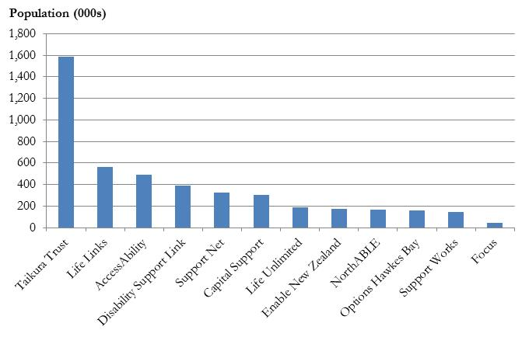

**Source**: Statistics NZ – DHB population estimate, 2015/16

There were 33,257 active clients with a service allocation being managed by NASCs, as at 27 September 2016. The number of clients managed by an individual NASC ranges from 345 (Focus) to 10,121 (Taikura Trust). Figure 4 shows that six NASCs – half of all NASCs – are managing between 1,200 and 1,600 clients. A further four NASCs have an active client base of between 2,500 and 5,000 clients.

Figure 4 NASCs by size of active client base, 2016

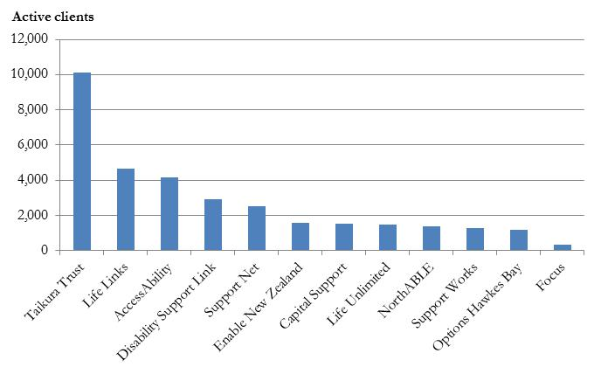

**Source**: Ministry of Health – Socrates database, August 2016; author calculations

For most NASCs, the number of clients is commensurate with the size of their catchment population. Figure 5 compares each NASC’s share of the national population and its share of active clients with a service allocation. The diagonal line marks where a share of clients matches a share of the population. Some NASCs have a client share that is slightly higher than their population share (i.e. above the diagonal). Conversely, a couple of NASCs have a client share that is lower than their population share. Reasons for this variation may be due to a mix of factors including differences in population age structure; historic reasons, such as where clients ended up living after deinstitutionalisation; and the availability of services.[[23]](#footnote-24)

Figure 5 Client share and population share for each NASC, 2016

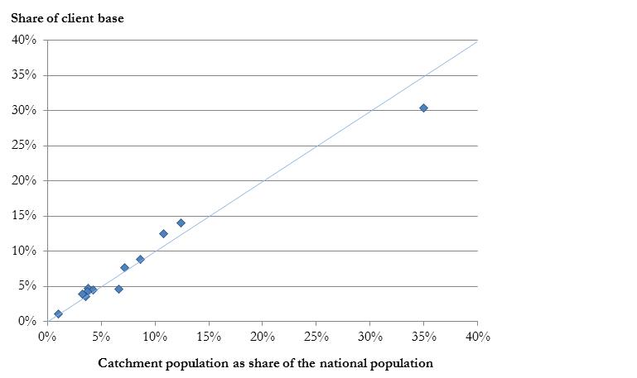

**Source**: Statistics NZ; Ministry of Health; author calculations

NASCs are funded to undertake their core needs assessment and service allocation activities under a management contract. Although most NASCs hold one management contract, a small number of NASCs hold contracts for separate districts. Figure 6 plots the number of active clients (with a service allocation) for each NASC with the management funding received by each NASC, converted to a per-client basis. Smaller NASCs receive a higher amount of management funding on a per-client basis, in the range of $725 to $894 per client, whereas larger NASCs receive $466 to $563 per client. There is variation in management funding per client within these two groupings, although this does not appear to be closely linked to client numbers. This suggests that other factors may inform funding levels, for example, the number of frontline offices, staff travel times and, potentially, other historic reasons.

Figure 6 NASC management funding per client compared with number of active clients, 2016

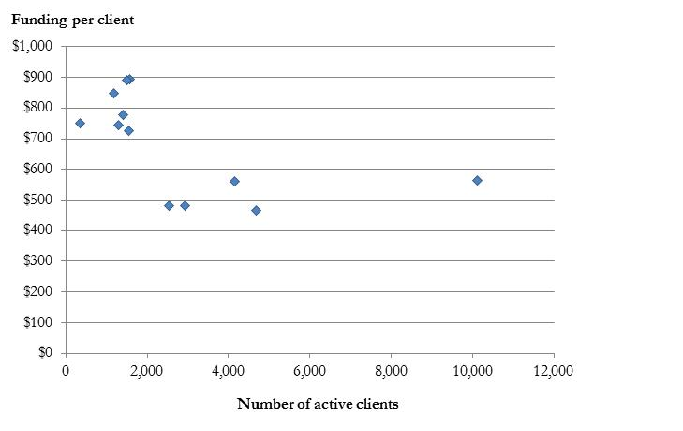

**Source**: Ministry of Health – NASC management contract data and client data; author calculations

## To what extent does the number of NASCs matter?

This section addresses the question of the number of NASCs for the sector. We focus on the same number or less for the purposes of our analysis. We were asked to also comment on there being more NASCs in the future, for example, to correspond to all 20 DHBs. However, we have discounted this for the following key reasons:

* Economies of scale – this would suggest that having a larger number of smaller NASCs would add costs in the form of additional management overheads (notwithstanding that some smaller NASCs gain some scale by holding other needs assessment and service coordination contracts);
* Management of financial risk – if in the future the Ministry of Health wishes to devolve funding to the NASCs for full budget management, then there needs to be a critical mass in size;
* National branding will be simpler with same (or fewer) number of NASCs, and
* Avoiding confusion for clients in urban areas where there is more than one DHB, e.g. Auckland.

### The current number of NASCs

There are currently 12 NASCs that work with Disability Support Services. There has been some consolidation in the past, with the number of NASCs reducing via tender processes for district contracts. Five NASCs now cover 13 of the 20 DHBs, which together represent 70 per cent of the national population. In some cases, their catchment population does not comprise adjoining DHBs and a frontline presence is maintained in each district, for example, Life Unlimited (Hutt and Tairawhiti) and AccessAbility (Southern, Taranaki and Whanganui).

The question is whether there would be material gains from having fewer NASCs. The following table offers some possible advantages to there being fewer NASCs along with some plausible counter arguments. These are grouped into four dimensions that are worthy of consideration: (a) outcomes for clients; (b) administrative efficiency; (c) cost savings; and (d) financial risk management.

Table 4 The number of NASCs – dimensions to consider

|  |  |  |
| --- | --- | --- |
| Dimension | Possible advantage from fewer NASCs | Counter arguments and possible disadvantages |
| **Outcomes for clients** | Greater standardising of the client experience, e.g. waiting times, quality of engagement.  Improved potential for quality control of the client experience.  Easier for a national branding exercise and therefore for potential clients to find NASCs. | No routine outcome measures at this stage, so no evidence whether size makes a material difference to client experience or outcomes.  There is anecdotal evidence of performance variation and, if there are smaller NASCs would they be more likely to struggle to meet expected standards?  Fewer NASCs could mean reduced chances for innovations that improve client outcomes. |
| **Administrative efficiency** | The centre deals with fewer agents when rolling out policy change and monitoring performance.  The dissemination of innovation may become easier among fewer, larger organisations. | Does the centre face unreasonably high transaction costs or coordination issues in dealing with the current number of NASCs?  What barriers currently exist to prevent the sharing of innovation among NASCs? |
| **Cost savings** | Economies of scale are achievable, in theory, if the overheads of running a separate organisation can be spread over more activity. Therefore, fewer NASCs could see savings from within the NASC management contracts. | Is there evidence of scale economies among larger NASCs or is there evidence that suggests there is potential for such gains?  A local presence would likely be required in each district, which may mute any savings in administrative costs (e.g. office accommodation). |
| **Management of financial risk** | Having fewer NASCs of larger scale matters if NASCs are holding and managing devolved service budgets in future. | Not as relevant, there are no immediate plans to devolve service budgets. Could be looked at in future. |

In terms of cost savings, it is reasonable to expect that smaller NASCs – i.e. those with a relatively small catchment population and a small client base – would face higher operating expenses, on a per client basis, than larger NASCs. This is because a larger organisation has an opportunity to spread its fixed costs over a greater number of clients (and the NASC management funding that those clients attract). Conversely, a smaller organisation faces a relative diseconomy of small scale with its fixed costs forming a higher share of total expenses. To investigate this issue, summary data was obtained from five NASCs – with respect to their financial performance, workforce size, cost per FTE, and active client base. The sample included three medium-to-small NASCs and two medium-to-large NASCs.

### Consideration of scale economies

Analysis of the data shows that these five NASCs spend a fairly similar proportion of their expenses on frontline personnel – in the range of 47 per cent to 55 per cent of operating expenses. However, no consistent pattern is visible, in terms of this share and the size of each NASC’s client base. Furthermore, there is no visible relationship in the data between a NASC’s fixed costs as a proportion of expenses and the size of its client base. Figure 7 presents a stylised picture of cost structures, based on the average of cost data from across the five NASC. Three high-level categories are readily apparent.

* Frontline personnel – 51 per cent of operating expenses. This category comprises frontline workers in salaried and contracted roles. The job titles vary across NASCs and include needs assessor, service coordinator; service facilitator, customer service coordinator, support facilitator, outcome planners and outcome coordinators.
* Other personnel – 23 per cent of operating expenses. This category covers management and support roles, and includes job titles such as manager, service leader, team leader, practice leader as well as ‘back office’, IT support, admin, PA, and finance.
* ‘Other’ expenses – 26 per cent of operating expenses. These expenses include accommodation and associated costs (e.g. power, cleaning), office equipment, vehicles, staff travel, as well as outsourced business services such as finance, IT, and legal services.

Figure 7 NASC cost structures – a stylised example

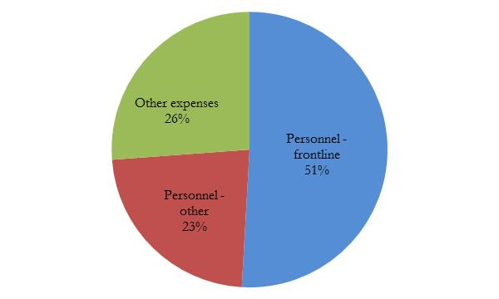

**Source**: Sample of cost data from five NASCs; author analysis

Further analysis – along with feedback from participating NASCs – points to several issues that may be masking the visibility of economies of scale.

* Some NASCs have a frontline presence in several districts, in the form of a local office and staff, and so may incur higher costs relative to peers with a similar catchment population that operate out of a single centralised office. Operating out of multiple frontline offices will increase the fixed costs that a NASC faces.
* NASCs may arrange themselves differently to address their local needs and issues, including dispersion of client base, travel times for staff, and local labour market conditions. Some NASCs make greater use of contracted needs assessment staff, relative to salaried roles, and these staff may be largely based in the community. This kind of model may increase the balance of a NASC’s variable costs relative to its fixed costs.
* In general, NASCs are living within their means – that is, they arrange themselves to manage within the funding allocated under the NASC management contract. Therefore, to the extent that the level of funding in a contract for a district reflects local or historic issues, the funds available will determine how a NASC arranges and manages itself.

Although economies of scale are not readily visible in the data, they are apparent in other parts of the wider health and disability sector and it seems reasonable that they are being obtained – or are obtainable – for NASCs. If further economies of scale among NASCs are obtainable, this may be revealed through a competitive tender process. If larger providers can obtain economies of scale and offer a sustainably lower price for a contract for a district – while achieving performance and quality standards and client outcomes – then this would likely be revealed over time. However, alongside this scenario is the possibility that smaller providers can remain competitive by offering value in other ways, for example, an organisational culture of innovation and high performance that contributes to a positive experience for clients, or strong networks and connections with local communities.

Through our qualitative interviews, and in discussions with the Ministry of Health, we have concluded that changing the number of NASCs at this time is less of a priority than changing the paradigm and culture (i.e. embedding a new NASC service model) – with the aim of improving the client experience.

## Is there evidence of some NASC activity being unnecessary?

This section looks at whether some NASC activity may be unnecessary. It also considers how much time could be freed up for frontline personnel to focus on other activities that may be considered higher value, from a client perspective.

### Testing the claim that some assessments are low value

NASCs are required by the Ministry to undertake an annual review of each client, with a full re-assessment of need being required every three years. The resulting service allocation is then recorded in a national database (“Socrates”). Feedback from some stakeholders pointed to some of this activity, particularly annual reviews, as being unnecessary or even being seen as invasive for some clients. To test this point, an extract of data on needs assessment and service coordination activities from the national database was provided for analysis by the Ministry of Health.

The objective was to identify the extent to which these assessment and service coordination events do not lead to a change in the service allocation to clients. A sample of 1,493 clients, or four per cent of active clients with a service allocation, was analysed to identify the services allocated to each client at their most recent service coordination event. The services were analysed on three dimensions: (a) the number of services; (b) the type of services, and (c) the volume of units allocated.

The results for each client were compared with the number, type, and volume of services allocated prior to their most recent service allocation event. As a check on the results, this method was repeated for a second sample – comprising 1,982 clients or six per cent of active clients with a service allocation. The method was then replicated for the combined sample of 3,475 clients, representing ten per cent of active clients.

### Findings – a majority of clients had ‘no change’ at their most recent service review

The initial analysis focused on clients that had a change in the number and/or type of services at their most recent service allocation event. Figure 8 shows the results for sample 1. A majority (84 per cent) of clients had no change in the number or type of the services allocated. The similarity of results obtained from sample 2 – i.e. 83 per cent had no change in the number or the type of services – gives some confidence in the representativeness of these sample-based results.

Figure 8 Proportion of clients with ‘no change’ in service number or type

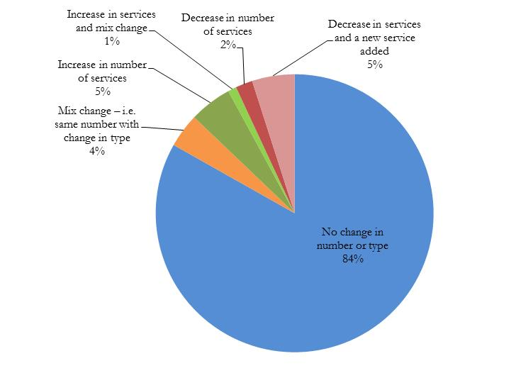

**Source**: Ministry of Health – Socrates database, sample 1; author calculations

Figure 9 goes further and shows the results for the combined sample with the added dimension of the volume of service units being allocated. A majority (63 per cent) of clients had no change in the number, type, or the volume of services allocated at their most recent service coordination event.

* A further 20 per cent of clients had a change in the volume of service units allocated, while three per cent had a change in the mix of services only.
* One per cent had a change in the mix and a change in the volume of services.
* Six per cent of clients had an increase in the number of services allocated (includes one per cent that also had a change in the mix of services).
* Seven per cent had a decrease in the number of services allocated (including five per cent that also had a change in mix of services).

Figure 9 Proportion of clients with ‘no change’ in service number, mix, or volume

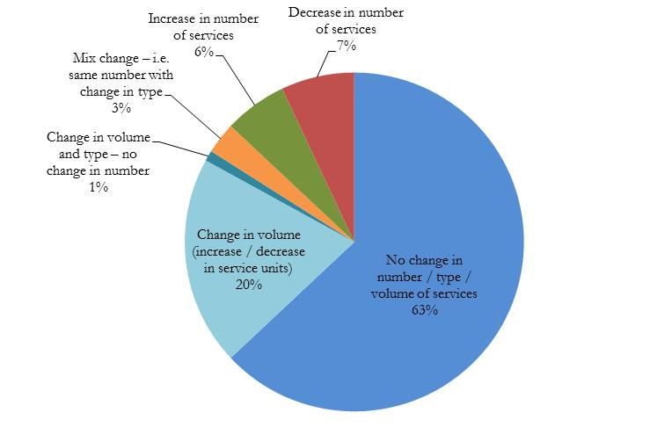 **Source**: Ministry of Health – Socrates database, combined sample; author calculations

Figure 10 focuses on the latest service coordination event and shows the proportion of clients receiving each type of event. ‘Scheduled Review’ (62 per cent of clients) was the most common type of coordination event, followed by ‘Following Reassessment’ (30 per cent of clients). These events appear to represent the annual reviews and the three-yearly full reassessments, respectively. As might be expected, the ‘Scheduled Review’ events are roughly twice as frequent as ‘Following Reassessment’ events – reflecting the fact that a rolling one-third of clients can be expected to undergo a reassessment in a year, while two-thirds otherwise receive an annual review. The other types of service coordination events represented are ‘Early Review’ (five per cent of clients), ‘Reconsideration Request’ (three per cent of clients), and ‘Crisis’ (0.4 per cent of clients).

Figure 10 Proportion of clients by service coordination events

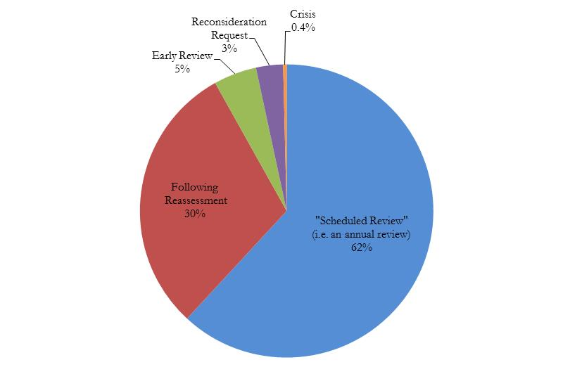**Source**: Ministry of Health – Socrates database, combined sample; author calculations

The tendency for an assessment and service coordination event to result in ‘no change’ in the number, type, or volume of services allocated to a client differs by the type of coordination event. Figure 11 looks at the latest service coordination event for each client and shows the proportion of clients with an outcome of ‘no change’ versus ‘some service change’ (i.e. a change in the number, type or volume of services) – for each type of coordination event.

‘Scheduled Review’ events have the highest proportion of ‘no change’, with 68 per cent of clients having an outcome of ‘no change’ in the number, type, or volume of services. The comparable figure for ‘Following Assessment’ events is similar at 63 per cent of clients – the same figure as the average for all types of service coordination event. In contrast, ‘Reconsideration Request’ and ‘Early Review’ events have a relatively low proportion of clients with ‘no change’ – 18 per cent and 15 per cent, respectively. Conversely, these types of service coordination events have a relatively high proportion of clients experiencing an outcome of some change – of 82 per cent and 85 per cent, respectively.

Figure 11 Proportion of clients with ‘no change’ in service, by coordination event type

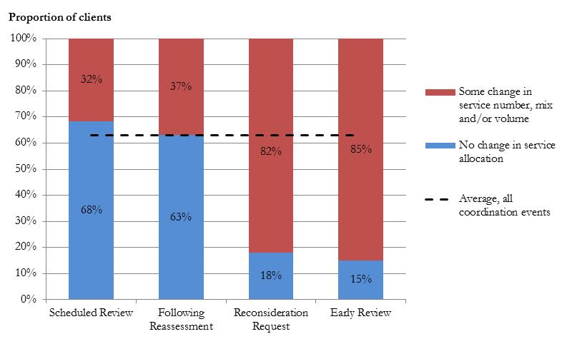**Source**: Ministry of Health – Socrates database, combined sample; author calculations

### Implications for resourcing

The results of this analysis should be treated with some caution. Firstly, the absence of service change does not automatically mean an assessment or that, particularly, a service coordination event is unnecessary or redundant. Feedback from NASC representatives noted that an annual review might still offer value for the client that is not visible in the national database, for example, service coordinators may resolve issues with a client’s existing service, arrange access to a non-DSS funded service, attend a Family Group Conference, or provide a welcome touch point. Secondly, this analysis is based on data captured for administrative rather than analytical purposes. It does not capture the variation in effort and time associated with these coordination events or the extent to which some NASCs have been exploring a ‘low touch’ process for some clients.

Therefore, a follow-up stream of work could explore the method used here to validate the results. Further, work to examine coordination events for clients through time could also be useful – to build up a fuller picture of when, and how often, different types of clients receive a change in service allocation.

Nevertheless, the results point to some NASC time that could be reallocated, if there are other activities that offer higher value for clients. Given this, it is useful to consider the scale of resources that could be freed up if the requirement for an annual review were to be relaxed so that, for example, clients (or their caregivers) could drive their engagement with NASCs outside of the three-yearly full reassessments. In this scenario, a rolling one-third of clients would undergo a full reassessment within a given year, with the remaining two-thirds of clients no longer receiving a mandatory review in that year.

Table 5 draws on the findings from above to estimate the maximum number of clients that might plausibly no longer receive a mandatory annual review in a given year. The starting point is the current base of 33,257 clients, of which one-third (33 per cent) receive a reassessment in a given year and up to two-thirds (67 per cent) would otherwise have a scheduled annual review. This proportion of 67 per cent is reduced by five percentage points – in light of Figure 10, which shows that five per cent of clients received an early review instead of a scheduled annual review. This gives a figure of 62 per cent of clients who might otherwise receive their scheduled annual review in a given year.

Of the 62 per cent of clients that would otherwise receive a scheduled annual review, the finding above is that 68 per cent would have an outcome of ‘no change’ in the number, type, or volume of services. This equates to 14,021 clients or 42 per cent of client base (i.e. 0.62 \* 0.68). This figure represents an upper bound of clients that may not require a scheduled annual review under a more client-driven approach to NASC engagement. The figure is an upper bound because some clients may prefer to retain a scheduled annual review.

Table 5 Estimated number of clients with no service change after an annual review

|  |  |
| --- | --- |
| Measure | Value |
| Number of active clients [A] | 33,257 |
| Proportion of clients that would otherwise receive an annual review in a year [B] | 62% |
| Proportion of clients with ‘no change’ following an annual review [C] | 68% |
| Estimated number of clients with ‘no change’ following a review [D] = [A x B x C] | 14,021 |

**Source**: Ministry of Health – Socrates database, August 2016; author calculations

Table 5 estimates the NASC FTEs that could be freed up from delivering annual reviews in a given year. The starting point is the estimated number of clients per annum who would otherwise receive an annual review that results in no change to their service allocation (14,021 clients).

* Feedback from NASC representatives suggested that, at a minimum, it would take an hour for a coordinator to undertake an annual review, which typically involves reading the client file, calling the client, liaising with providers, and recording information into the database. In some cases, these steps could take considerably more time. Therefore, two values are used to address this uncertainty – 1.0 hour and 2.0 hours per review avoided.
* Multiplying these time estimates by the number of clients gives the range of hours that are plausibly associated with this activity –of 14,021 to 28,042 hours.
* The results are then divided by the annual number of hours per FTE (2,080) to give a range of 6.7 to 13.5 FTEs. This range is an estimate of the upper bound of staff time that could be freed up across the system, from forgoing scheduled annual reviews for clients.

Table 6 Estimated number of FTEs for annual reviews resulting in no service change

|  |  |  |
| --- | --- | --- |
| Measure | Low case | High case |
| Estimated number of clients with ‘no change’ following a review [D] | 14,021 | |
| Average frontline staff hours per annual review (assumption) [E] | 1.0 | 2.0 |
| Estimated frontline staff hours associated with ‘no change’ reviews [F] | 14,021 | 28,042 |
| Annual hours per FTE [G] | 2,080 | |
| Estimated FTE associated with ‘no change’ reviews [H] = [D x E/G] | 6.7 | 13.5 |

**Source**: author calculations

## What might be obtained with freed-up resources?

The analysis above estimates that between 6.7 and 13.5 frontline FTEs could be freed up if scheduled annual reviews were waived in favour of a client-driven, needs-based approach to NASC engagement outside of the three-yearly reassessments. This range is based on the finding that in a given year, 42 per cent of clients receive a scheduled annual review that does not result in a change in their service allocation. This may be an upper bound, as some clients may still prefer to receive an annual review even within a client-driven engagement regime. The use of the range reflects some uncertainty about the amount of time, on average, that a service review takes.

If these FTEs were able to be freed up and allocated to another client-focused purpose, for example a ‘service navigator’ function, then it is interesting to consider what this reallocated resource might cover.

On a national basis – the range of 6.7 to 13.5 ‘freed-up’ FTEs being spread across 33,257 active clients would equate to range of 4,900 to 2,500 clients for each of these FTEs.

At the NASC level – based on the relative size of each NASC’s client base, a range of 6.7 to 13.5 ‘freed-up’ FTEs would equate to between 0.3 and 0.6 FTE for most small-to-medium NASCs and between 0.5 and 1.9 FTEs for most medium-to-large NASCs.

On a financial basis – the range of 6.7 to 13.5 ‘freed-up’ FTEs could reasonably be costed at between $460k to $930k. This estimate is based on an assumption of an average direct salary cost for a frontline NASC worker of $52,000 per annum. This figure is based on average frontline worker costs within the sample of five NASCs. A further 33 per cent was then included to allow for associated overheads (i.e. management and support personnel, other expenses).

# Analysis of Disability Information and Advisory Services (DIAS)

The DIAS contracts state the intention is for the service to implement two of the New Zealand Disability Strategy (2001) objectives:

* ‘To improve the quality of information available, including where to go for more information, the services available, and how to access them’ and
* ‘Provide education and information for families with disabled family members’.

This very specific intention has broadened over time and now, for some, its “*let’s just get things done*”, “*let’s just sort things out*” for people. It can also include provision of rehabilitation services or therapy, as well as a wide range of disability support services. However, the contracts for DIAS have largely remained the same since they transferred from Vote: Social Welfare to Vote: Health, during the early 1990s. Most of the providers in existence today are from that transition and shortly after.[[24]](#footnote-25) There are six main contract variations, which vary from regional based to national contracts, as well as FTE based contracts for Māori DIAS providers, which are essentially Māori disability “fieldworkers”.[[25]](#footnote-26) All of the contracts apart from Māori DIAS contracts include the following service deliverables:

Box 1 Service deliverables

Trusts or “hub and spoke” model contracts can also include some discretionary funding around the management and training of the providers and quality assurance. There is a historical arrangement still present in the Central region whereby a number of Trusts providing disability information still collectively identify as an APEPSI trust (Advocacy, Promotion, Education, Prevention, Support, and Information) which was established at the same time as the NASCs over 20 years ago.

|  |
| --- |
| This will be achieved by the service responding to:   * Requests for information (telephone) * Requests for information (face to face visits) * Requests for information (fax) * Requests for information (e-mail)   and/or the provision of:   * Newsletters} Must be in an easy-to-read format * Pamphlets} Must be in an easy-to-read format * Seminars} Must be in an easy-to-understand format   or whatever is appropriate for the service. |

For the purposes of this review, it is useful to group the contracts in terms of the service types they provide:

* 1. **Disability Resource Centres** – physical spaces and providers of generic disability information (commonly also providing equipment);
  2. **Disability Generic** – providers of generic disability information in a variety of contexts;
  3. **Disability Specific** – providers of specialist information and support on individual disability categories, e.g. hearing impaired, autism, brain injury;
  4. **Disability therapy** – there are a small group of providers who provide horse riding for the disabled, a mix of national and local contracts, and
  5. **Culturally specific** – e.g. Māori and Pacific[[26]](#footnote-27).

It has already been suggested that the fourth group (therapy – which includes only four contracts) be transferred to a more appropriate portfolio of DSS, e.g. rehabilitation. The other categories are considered in the following sections. There are cross-cutting themes of the way in which the services are contracted – that is to say nationally or regionally, direct or through hub and spoke models.

## DIAS groupings

### Disability Resource Centres

There are 25 disability resource centres[[27]](#footnote-28) (DRCs) across New Zealand: one in Northland, six in Auckland, six in Thames-Waikato and Bay of Plenty region, seven in the lower North Island, and five in the South Island.

The DRCs generally provide local touch points for the general public and disabled people. All of the ones listed here are affiliated under the Federation of Disability Information Centres, which supports national standards to achieve consistency and quality in information provision. Some receive their funding direct via DSS, some through the Federation, and some are funded through other regional hub models. Most of the DRCs have been categorised as disability generic providers of services, as they are seen as hubs and entry points to other sources of disability information. However, this is not always the case; Citizens Advocacy is an advocate matching service more than it is an information centre, and Deaf Aotearoa, as an example, is a disability specific organisation, but acts as a resource centre for the deaf community about all services.

All of these centres are known by different names, ranging from the more descriptive ‘Disability Resource Centre’ (various regions) to ‘Aspire’ (Canterbury). If you google ‘disability information’, the first unsponsored hit you have is for ‘Disability Information Service Inc.’, which is a ‘DRC’ that covers the Otago region. This website, although basic in nature, is a good example of a disability appropriate site in a large, clear format with the ability to enlarge text, change contrast and keyboard navigation options as well as mouse, and so is designed for disabled consumers. Not all of the websites are of the same functionality, information, quality, relevance, clarity of purpose, or up-to-date.

For the future, it is important that there is some consistency in the appearance and quality of the provided information to increase consumer use and trust of it.

Table 7 Disability Resource Centre overview of contract funding

|  |  |  |  |
| --- | --- | --- | --- |
|  | Disability Resource Centre name | Location | Region |
|  | Northable | Whangarei | Northland |
|  | Yes Disability Resource Centre | Albany | Auckland |
|  | Independent Living Services Ltd | Royal Oak | Auckland |
|  | Vaka Tautua | Manukau | Auckland |
|  | Citizens Advocacy Auckland Inc. | Three Kings | Auckland |
|  | Disability Connect | Penrose | Auckland |
|  | Deaf Aotearoa New Zealand | Avondale | Auckland |
|  | Coromandel Independent Living Trust | Coromandel | Thames/Waikato |
|  | Life Unlimited | Hamilton | Thames/Waikato |
|  | Life Unlimited Disability Resource Centre | Tauranga | Bay of Plenty |
|  | Rotorua Disability Resource Centre | Rotorua | Bay of Plenty |
|  | Disability Resource Centre Trust | Whakatane | Bay of Plenty |
|  | The LIFE Unlimited Store | Gisborne | East Coast |
|  | Disability Resource Centre HB | Hawkes Bay | Lower North Island |
|  | Taranaki Disabilities Information Centre | New Plymouth | Lower North Island |
|  | Enable New Zealand | Palmerston North | Lower North Island |
|  | EASIE Living Centre[[28]](#footnote-29) | Palmerston North | Lower North Island |
|  | Disability Information & Equipment Centre | Kapiti | Lower North Island |
|  | People First NZ | Wellington | Lower North Island |
|  | Vaka Tautua | Wellington | Lower North Island |
|  | Aspire Canterbury | Christchurch | South Island |
|  | Vaka Tautua | Christchurch | South Island |
|  | West Coast Disability Resource Service | Greymouth | South Island |
|  | Disability Information Service | Dunedin | South Island |
|  | Disabilities Resource Centre Southland | Invercargill | South Island |
|  | **Funding total** | | **$2,963,456**[[29]](#footnote-30) |

These centres receive their funding through a mix of methods, through the New Zealand Federation of Disability Resource Centres, through hub and spoke models, and directly from the Ministry. Many of these organisations also receive funding from other DSS contracts, as well as other government and non-government funders (including significantly for many, grants and Lotteries funding), and three are also NASC agencies.

### Disability information organisations

Disability generic services are those organisations that provide general disability information, and sometimes services to those with any disability. Some of these providers are also NASCs and can be funded on a national or regional basis. Disability specific services are those organisations that provide information on specific disabilities.

|  |  |  |
| --- | --- | --- |
| Disability generic | Regional generic | Disability specific |
| * Barrier Free * Carers NZ * Citizens Advocacy * Complex Care Group * Enable * Lifestart * Life Unlimited * Northable * Parent to Parent * Tiahao Trust | * Horowhenua Stairway * Sommerville Centre for Special Needs * Te Roopu Waiora | * Autism New Zealand * Altogether Autism * CCS Disability Action * CCS Disability Action Waikato Inc. * Cerebral Palsy Society of New Zealand * Kapo Māori Aotearoa NZ (National Blind Māori Office) * Motor Neurone Disease Association * Multiple Sclerosis NZ * Muscular Dystrophy Association * NZ Deaf Children[[30]](#footnote-31) * The Brain Injury Association[[31]](#footnote-32) * People First * Prader-Willi Syndrome30 |

### The national website – WEKA, is not widely known

Under the DRC funding currently there is provision for a national website designed to try to bridge the gap between the local providers and a need for nationally consistent information. The website is called ‘WEKA’ and stands for ‘What Everyone Keeps Asking’. The website has been developed and is managed by Enable New Zealand, a management division of MidCentral DHB, which has several Ministry contracts including equipment and modification services (EMS) and a NASC agency.

From the stakeholder engagement we undertook, it appears the website is generally not well known to consumers and is underutilised by other DIAS providers as a resource. If you google ‘disability information’, WEKA is the twelfth and last entry on the first page; if you google ‘WEKA’, it is the fourth entry after the New Zealand native bird. The website is a flat text-dense website, which is mainly a list of services available, thus it is not interactive and is reliant on consumer’s ability to know the information they seek. The name, as with all the elements of the disability support services, is not synonymous with disability information and it is another disconnected part.

The WEKA website, in its current form, although we understand there are plans afoot for changes to it, is probably not as responsive to disability needs as the new digital age going forward should be expected to be, since it contains:

* Flat, dense text.
* Directory listing style.
* Long scrolling pages.
* Unconnected.
* Not independent/neutral – information links to website owner (Enable).
* Disability information sheets undated.

Internationally there are examples of similar services, in Scotland a similar service has just rebranded itself to ‘Disability Information Scotland’[[32]](#footnote-33) from its previous name of ‘Update’ to ensure that their purpose was ‘clear and easily understood to all’. In Australia there is the ‘disabilityonline’[[33]](#footnote-34), website which combines disability resources with community news and services. A slightly different approach has also been taken in New Zealand for mental illness, its media campaign and website ‘like minds, like mine’[[34]](#footnote-35) brings together resources, information and support, but under the goal of reducing discrimination. This could be another possible approach or facet of the disability information service.

## Culturally specific services

### Māori DIAS contracts

The Māori DIAS contracts are essentially Māori disability “fieldworker” contracts. The funding is directly related to FTE and is seen as more of a face-to-face informational resource to support Māori disabled people and their whānau. This aligns them much more with the LAC model functions. All of the Māori providers also have contracts with other government bodies for health and/or social services, and deliver information and support in a holistic way, i.e. in a “whānau ora” context.

Table 8 Māori DIAS providers

|  |  |  |
| --- | --- | --- |
| Organisation | Region | FTE |
| Huria Management Trust | Tauranga & Western Bay | 1 FTE |
| Ngati Porou Hauora | East Coast (north of Gisborne) | 1 FTE |
| Raukawa Charitable Trust | South Waikato | 1 FTE |
| Raukura Hauroa O Tainui | Waikato | 1.5 FTE |
| Te Kahoa Health | Waikato (Hamilton) | 1 FTE |
| Te Korowai Hauora O Hauraki | Hauraki | 1 FTE |
| Te Oranganui Trust | Whanganui | 1 FTE |
| Te Whanau Totokorangi | Rotorua | 1 FTE |
| Ngati Maniapoto Marae Pact Trust | TeKuiti and surrounds (South Waikato) | 2.5FTE |
| Rakeiwhenua Trust (Tuhoe) | Eastern Bay of Plenty | 1.1FTE |
| Tui Ora | Taranaki | 1 FTE |
| Tuwharetoa Health | Turangi, Taupo, Mangakino | 1 FTE |
| Te Tai O Marokura | Kaikoura District | 0.5FTE |
| **Totals** |  | **14.6 FTE** |

Figure 12 below shows a map of Māori populations within DHB boundaries from the census 2013. It provides some additional context in regards to the location of the Māori DIAS service provision as detailed in the table above, against a national picture of where the Māori population resides within New Zealand.

Figure 12 Proportion of DHB population that is Māori, 2013

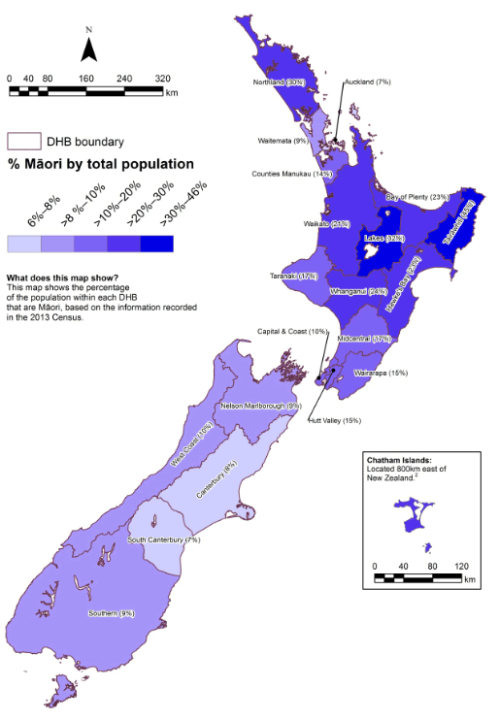

**Source**: <http://www.health.govt.nz/our-work/populations/maori-health/tatau-kahukura-maori-health-statistics/tatauranga-taupori-demographics/population-projections>

### Other ethnic based contracts

As well as the Māori DIAS providers, there are a number of providers who deliver this type of service under their main contract such as North Able and Life Unlimited. There are three other ethnic specific contracts funded through DIAS. Kapo Māori Aotearoa NZ is the National Blind Māori Office and a membership based advocacy group. Vaka Tautua, is a national Pacific health and social services provider, which has services in Auckland, Wellington, and Christchurch, and has direct contracts with the Ministry as well through the Independent Living Service (ILS) hub and spoke model for its Auckland operations. There is also a funding line within Auckland for Asian disabled populations.

## The key issues

##### Large number of small providers

The current model of DIAS contracts, especially the service specification and reporting requirements, is outdated and unsustainable. The large number of small contracts (108) have been rationalised by establishing hub, spoke, and trust models to a more manageable 58. While at first it was mainly seen as a method for distributing the funds, these models do try to provide an element of provider support and training through seminars, although this varies. However, this still means there are many small providers and a lot of competition for small amounts of charitable and other funding sources, so that they can provide the requirements of the service.

##### Contracts and understanding of DIAS services not reflective of what services they provide

There is a lack of clarity within the contracts as to what is the current best intent of DIAS contracts. Consequently, there is a huge variety in how these services have been interpreted and how they evolved over time. Information is the core element, and services have evolved to supply that information either through websites, centres, or in person. What we have heard is that many of those services support disabled people and their families to ‘sort things out’. The most accurate contract would appear to be the Māori DIAS contracts, which explicitly state this as the provision of information to Māori and whanau, to act as a resource as Māori go through the NASC process, provide support, and work with service providers. We believe the service specifications and outcome measures for reporting need to be changed. Outcome measures should be developed from the bottom up, with the sector and disabled people and their families.

##### Providers challenged by resource constraints and a rapidly changing environment

The providers struggle with the various demands on them from both the funder and the clients. One of the questions we asked the providers was what they saw as their biggest challenge – nearly half stated funding, and half said maintaining relevance; but both are inextricably linked. The large number of relatively small providers, the competitive nature between providers for scarce community and philanthropic resources, as well as the demands for information and technology, outpace the budgets and capabilities of many of these providers. The challenges they cited were:

* Maintaining relevance to disabled people and their whānau, youth, elderly, increasingly diverse populations and crown funders.
* Maintaining information in a variety of formats to meet those population needs.
* Keeping up to date with the volume of information and interpreting what is relevant.
* Keeping up with technology and the variety of media channels; and
* Doing all the above on limited funding.

##### Information overload

For a small country, there is a plethora of information sources that are confusing for information providers and consumers alike (consumers meaning anyone who needs access to this information, not just disabled people). A lack of consistency in branding and service provision means that for the consumer, it is hard to know if the information they are looking at is reliable, whether it is a government funded service or advertising by private providers. Current and future expectations are that (all) entities will have an online presence. For small organisations this is a huge resource implication to create but more importantly maintain and many do not (at least may not be up to date) – leaving an important channel for connection to disabled people and the general public untapped. Equally providers have stated that they would like to make better use of technology and social media channels such as Facebook, twitter, and videos of seminars online, but do not have the knowledge or resources to do so.

In the first instance, while information is commonly sought by the majority online or by email, there are a wide range of media channels that suit different cohorts of people, by age, gender, geography, and disability. While half of all disabled people receiving funded supports live in the urban centres of Auckland, Waikato, and Christchurch, the other half will be dispersed around the country with varying levels of access to mobile phone signals, internet, and community. We have also heard that the “high touch local people” being available are a very important resource for many.

## The impact and the key changes

### Proposed key changes include a national disability brand across disability services

The proposed key changes are:

* Build on the model currently in place by providing a national brand (broader than DIAS and DRCs, to include the wider disability sector, having the same brand for NASCs) to support consumer and others’ awareness of where and how to get information and support.
* Create quality resources centrally, and distribute widely – have a nationally branded “disability service” as a go to point for evidence-based information to be sourced, developed and shared; have local spaces for retaining local information and understanding of local communities, and to provide support and resources.
* Refine DRCs and other DIAS providers as regional/local touch points or hubs where face-to-face support and further services can be accessed, aligned to the national disability service/brand.
* With providers, review contract arrangements, requirements and reporting, with relevant specifications and outcome measures in line with inputting into national identity and local collaboration.
* Align contracts within disability specific cohorts to rationalise number e.g. group up provider contracts where there is more than one to a national contract and allow them to be flexible and geographically responsive within that.
* Encourage collaboration and cooperation between disability specific organisations to create cohesive evidence-based information on their disability specialities (quality of information), and NASC functions (e.g. share disability specific resources and foster sector and community growth); and
* Acknowledge that some of the services provided are more akin to ‘local area coordinator’ roles than traditional information services and foster these, and stronger links between these and future NASC functions.

### National Disability Service – vertical integration

It is important to establish what the future of information services for disability support services should look like before attempting to restructure the current service and contracts structures. Today’s society expects to be able to find information and answers to their questions instantaneously from online sources and for that information to be up-to-date, reliable and trustworthy. The government has set expectations in both its Better Public Services[[35]](#footnote-36) and ICT strategies[[36]](#footnote-37) that the public should be able to engage with the public sector in the same way it can with the commercial one, and in some areas that is happening with online processes for Inland Revenue Department and the Ministry of Social Development.

The key way in which information and knowledge dissemination has changed is the shift from passive one-way communication to an actively engaged two-way communication via a variety of channels. Modern technology sees every interaction with a consumer as a potential transaction, a sharing of information from the user and the provider for mutual benefit. Many websites use “cookies” to help shape the user’s experience of the site, it can show regionally based information on services that are local to you, or remember specific services that you visited previously.

Many information agencies have already realised that they need to develop a strategy to remain relevant in today’s multi-media society. Both the New Zealand Public Libraries[[37]](#footnote-38) and Citizens Advice Bureau[[38]](#footnote-39) are ‘information agencies’ that have redefined their services based on how they distribute that knowledge. Both provide important physical community hubs, supported by digital strategies that provide online services.

The pool of funding used for DRCs and WEKA, or part thereof, should be considered as part of creating a national disability information service and how that is connected to the DRC model of local touch points, including DIAS and NASCs. The current location of centres and service provision may need to be reviewed in light of a national/local model and consumer needs.

We believe it is strategic to develop a nationally recognisable brand and services, including a website that serves as a front facing entity for “disability” (wider than traditional disability supports) which DIAS providers input into. Create a unified ‘one system’, which links the various parts and pathways of the support system for the consumer.

The following figure depicts how this might look in practice:

Figure 13 Information model

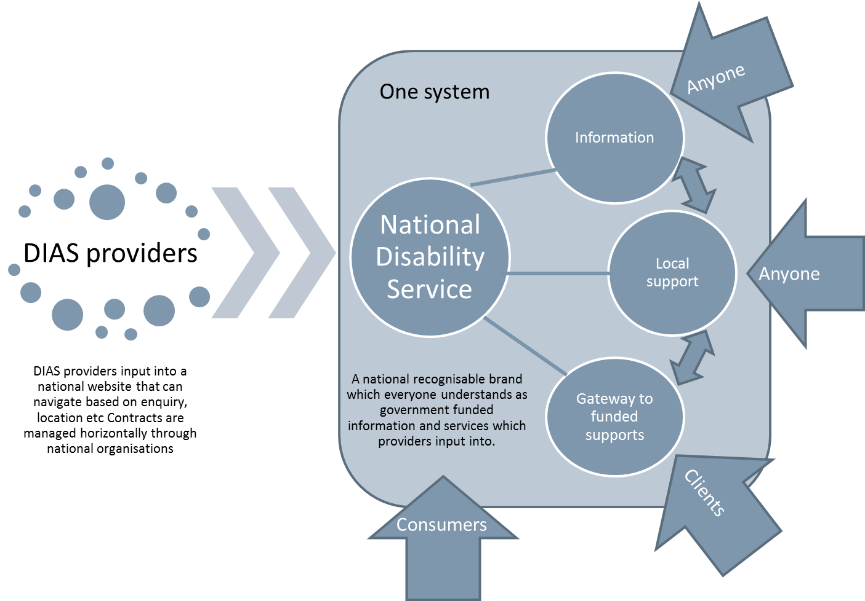

Through clever use of technology, a national entity can support a platform for getting the information digitally to a national audience. The national entity will need to provide disability specific and generic information. This should be provided by a collaboration or agreement by various bodies within the wider disability system – by connecting up; with a lead provider. The aim will be to provide an agreed, professional set of information to front face the consumer and others, e.g. health professionals, carers, policy makers, etc., which can then lead off to the individual organisations and/or websites, if they wish, or with further information supported on the national website.

We believe aligning contracts within disability specific cohorts, to rationalise the number and to contract for specialist information into a national entity is a positive move. In addition, we need to encourage collaboration and cooperation between disability specific organisations to create cohesive evidence-based information on their disability specialities (quality of information).

##### Enablers

* Leadership to foster development of a disability brand and revised contracts.
* Smart use of technology – to allow easy collaboration between content providers and a tailored experience by the user.
* Cooperation and collaboration between disability providers – to ensure a clear, consistent set of best practice evidence based information is easily accessible by the consumer.
* A ‘one system’ approach so that information, policy, and strategic direction is shared and aligned across the elements of the sector to support outcomes of disabled people.

### National Disability Service – horizontal integration

A secondary issue here, is the collection and use of information about the disabled person as part of the NASC process. Disabled people commonly refer to frustrations about having to repeat their information. Part of this may be attributed to the assessment policy or process, but it is also about information management. Clients have stated that greater transparency would improve their interactions with the disability support services and increase trust. They have also told us that their information is at times, being incorrectly collected (or interpreted), stored and then re-used in processes about them without their knowledge (due to a lack of transparency in the system regarding these processes, specifically the escalation process for high cost packages).

Many government agencies currently utilise ‘Real Me’ which is a branded portal which provides extra security about the user’s identity to enable access to official services such as passport applications through the Department of Internal Affairs and benefit applications through the Ministry of Social Development. The Ministry of Health continues to work on its strategy for a single electronic health record. Once in place this record could be shared (or part) with those involved in assessment processes or support the verification of a person’s disability rather than requiring GP visits and letters at additional cost and time burden for both the client and GP (i.e. the overall health system). All of these systems have in common that aspects of a person’s information can be viewed and corrected by the individual as the ‘owner’ of that information. This is a very important and empowering position for the person.

Part of the other cross government initiatives occurring such as Enabling Good Lives have at their forefront the ability for the consumers to create their own plan. From what we have heard, young consumers equally feel that greater access to information and assessments online would help them understand what support they may be able to get. This was particularly in reference to multi-ethnic youth groups who may struggle to get their families to allow them to access support (for fear of losing other supports). They cited an online ‘quick test or tool’ in a similar vein to the tax refund process on the IRD websites would give them an idea of whether they might be eligible and could / should pursue accessing funded supports.

While DIAS providers are contracted to support disabled person’s access to community and supports, they can act at odds with one another and not as part of the same support system. While we are focusing on this section on DIAS providers, they are all part of one system and operate on a continuum. The problem is that this continuum is not connected.

Table 9 Review of advantages and disadvantages for revising DIAS contracts

|  |  |  |
| --- | --- | --- |
| Potential change | Possible advantages | Possible disadvantages |
| Co-create a national disability brand[[39]](#footnote-40) | * Reaffirm core purpose of service * Modernise service provision * Create a single neutral identity to unify the system – higher profile for ease of access * Greater visibility/awareness for improved consumer access * Increased support for DIAS providers and improved quality control * More efficient use of resources as information, resources, seminars can be created once and shared often | * Lengthy process as covers all of DSS not just information * Difficulty in gaining consensus * Considerable process and resource required to establish new system * IT considerations may overshadow quality of information requirements * Requires the right “provider” to deliver a quality and future proofed service |
| Review/replace / or update WEKA and DRCs creating more connectivity | * Opportunity to reconsider business/operating models and modernise * Significant opportunity to harness synergies and create collaboration * Consider other partnerships rather than just equipment | * Loss to regional/local connectivity |
| Align national and local contracts | * Greater transparency of contracting requirements * Increased visibility | * May decrease regional connections |
| Review purpose, benefits and coverage of APEPSI and hub and spoke models | * Improve equity of flexi-fund access * Improve networking linkages to wider sector * Seminars and training can be recorded and shared online | * May decrease regional connections |

### Contract implications

As described earlier in this section the current contacting specifications and reporting requirements for DIAS are out of date and need updating. Before the contracts can be reviewed there will need to be a process of engaging with the providers about the services they deliver, who to and how. This needs to be then considered in light of the proposed changes to create an aligned modern information service that is smart about the production and dissemination of information and resources to the sector. Below is a table that compares the existing reporting measures and a selection of outcome measure suggestions that were submitted through our DIAS survey.

Table 10 Examples of outcome measures as suggested through survey

|  |  |
| --- | --- |
| Current contracted outputs | Potential outcome measures |
| Total number of requests for information | Client satisfaction surveys |
| Number of requests for information (face-to-face, email, telephone etc.). | Result outcomes/stories  E.g. Maintaining someone in their own home for longer |
| Total number of newsletters disseminated | People do not feel alone/they feel informed /empowered |
| Number of pamphlets distributed | Increased employment/education/community opportunities |
| Number of seminars held | People have wider life choices due to empowerment via information |
| In addition we propose the results based accountability framework be used :   * How much did we do? * How well did we do it? * Is anyone better off? | |

# The proposed changes/framework design

## Overview

Within the RFP and scope of the project, there were several issues identified for change. In addition, from our research, there have been additional matters recognised that would benefit from change. We summarise the impetus for change (i.e. what needs to be addressed by future developments) as:

* The **primary** concern is to make the system more client focused, permissive and localised, and from that other benefits should follow;
* The **secondary** need is to streamline and release resources to do things differently – moving from many input controls, and
* The **tertiary** consideration is who carries the financial risk of full budget management.

In more detail, we express this as:

* 1. **A need to be more client-centred**: Gateway/services not easy to find; not always client centred; not able to meet people’s needs or expectations; people cannot get what they need/want (i.e. prescriptive versus flexible and responsive). There have been many reports of supports not delivering what is really needed, so many “work arounds” being done at all layers of the system.

The secondary indications of issues in the service, articulated by stakeholders as follows:

* 1. **Model**: Framework model and service delivery model is out of date (circa 20 years old), and needs to be more permissive and flexible.
  2. **Efficiency**: Some waste in the system, both at NASC level due to the process and system requirements on them and service delivery level; limited ability to make efficient trade-offs.
  3. **Rules and confusion**: Non-clarity of what DSS actually stands for/delivers in to the future; a relatively new environment of meeting community inclusion principles of the United Nations Convention on the Rights of Persons with Disabilities and EGL principles; rules are no longer clear; tools and processes required to be used can be burdensome, especially for NASC, e.g. assessment tools.
  4. **Boundaries and integration**: Continued boundary issues; lack of integration of services or supports across and within personal health, mental health, Children Young person and Family (CYF), and DSS – causing delays and a non-client centred approach; causing costs to people (e.g. financial and wellbeing) and the system; not outcomes focused.
  5. **Quality**: There is a variable quality of service provision: from access (NASC functions) through to support delivery; made more complex by current demonstrations in various geographic areas.
  6. **Systems and data**: reports of systems and data collection being clunky; not easy to use or extract information in a meaningful way.
  7. **Outcomes**: outcome measures are not clear.
  8. **Costs and forecasting**: Increased eligibility to the pool of clients (e.g. ASD in 2014) a need to take an early investment approach, and a lifetime cost forecasting approach (where possible) to enable more effective future planning; inability to make trade-offs to the maximum benefit across the system.

We liken this in part to letting go of input controls and moving more into an outcomes focus – a bit like the Treasury did in the 1990s in State Sector Reforms. Here they eliminated the so-called Treasury Instructions, combined with the need to re-organise services around clients.

### The challenge of achieving this change and managing risks is large

##### Priorities for change

There are several strong themes about priorities for change to the access framework. Whichever of the options, these changes that are required include:

* **Streamline and simplify access, and take an investment approach:** together with the disabled person, assess early, and where possible get people’s needs met early (e.g. quick wins, non-funded, cross-government or DSS funded supports) so that they do not enter the long-term disability support system (ongoing funded supports). Focus early and invest in the right things that will assist the person and their wellbeing and, where possible, prevent ongoing or escalating needs thus preventing costs downstream.
* **Simplify and make transparent**: make the system much easier to use, understand, and be transparent so people know what they can expect, including eligibility and access criteria.
* **Responsive**: have a responsive system that truly puts the person at the centre and is not about processing to a myriad of rules, e.g. have flexible planning processes and review periods (not mandatory annually or three yearly).
* **Align accountability and incentives**: devolve accountability for budget management to be closer to the person therefore to the agencies who are allocating supports.
* **Outcome indicators**: change reporting to be more meaningful and focus on outcome indicators.
* **Early intervention and investment**: Confirm what DSS is for in to the future, and shift the focus from long-term supports to intervening early and enabling people to live their lives without long-term supports where possible. Allow more permissive options to better meet people’s needs flexibly.

### Workforce implications are significant for NASC

Many people wanted NASC staff / contractors to understand the actual disability and related requirements they were working with. Not necessarily to have lived with that disability, but to have an understanding and have empathy so they can really “*hear*” what the person is saying. They also want staff to understand what they do not know, e.g. at times disability specific information so the person doesn’t have to “educate” the assessor, and to ask for support when required. Mentoring of staff with a disabled person who had been through the process was one option, or as a support for the person going through the assessment. This is where DIAS providers can support NASC and the disabled people in this process, through effective links to specialist disability knowledge, training, and support. Equally, there are some contracts in place that support disabled people through this process.[[40]](#footnote-41)

In addition, it was suggested by many that there be a national or regional expert resource(s) established or, if already in existence, funded differently / appropriately for NASC type agencies of the future to draw on, e.g. deaf specific, deaf and blind specific, autism, etc.

The traditional view of the NASC and the recruitment profile for those working in NASC to ‘manage the process’ is a very different skillset to the ones required to enact the EGL principles and shift to client centred approach. Workforce changes will be required to change the paradigm and culture (the way things are done) in how NASC functions are delivered, as well as for some DIAS functions. There is a need to shift the disability workforce to more of a “professional” nature, not necessarily by qualification, but by skill sets, for example:

* Active listening, i.e. to listen effectively.
* Emotional intelligence (EQ).
* Organisational skills.
* Critical thinking.
* Setting professional boundaries.
* Empathy.
* Effective communication.
* Innovative solutions and flexibility.
* Specialist knowledge.

The issues clients are experiencing with staff are likely to be compounded by workforce pressures and potential misalignment between the operational functions of the NASC and the policy requirements of the Ministry. It is also important to note, as we have previously, that despite asking stakeholders what was working well for them, most wanted to focus on their negative experience.

A significant issue we heard was the approach some NASC staff take with clients, and how disempowering and non-inclusive it feels for the person. Some reported feelings of loss of wellbeing, and anger. This needs to change.

1. *“It’s like I have to go there and an assessment is done to me. And even though my needs haven’t changed they reassess me all the time. Well that is what it feels like anyway.”*
2. *“The NASC don’t even understand my disability type. I asked her, what do you know about [disability type] and what supports are available? And she said “Nothing”. Well that’s not good enough. How can she help in a situation like that? It made me so angry.”*
3. *“I know people who have been on the NASC waiting list for so long their whole life is breaking down. The family is so stressed they are no longer coping. There have become issues with the justice system because they can’t get any help.”*

This would suggest an enhanced skillset is required to achieve a different experience and outcome for disabled people. It is important to note that the NASC also had a set of principles, which are not dissimilar to those of the EGL, which highlights how simply stating the vision is not enough; there needs to be a framework to enact the change and create the “paradigm shift”.

There is also a Disability Support Services Workforce Action Plan 2013-2016[[41]](#footnote-42), which acknowledges that there will need to be “a strategic shift from a service delivery approach to a person-centred model” and it sets out an expectation that the evaluations from the Enabling Good Lives and New Model will help shape the required skillsets. It is important that this be developed in the next iteration of the plan.

### Workforce implications are also present for DIAS

As the review progressed, it became more apparent that there is a need for DIAS and information providers to link more closely with NASCs, and vice versa.

Therefore, this may have implications for how staff and volunteers work and what workforce is required in the future. DIAS providers talked of the extensive use of volunteers but how that is getting harder to maintain in the current environment.

## The disability information component

### Summary recommendation - grow and develop what is in place; make some national change for both DIAS and NASC

We are recommending an evolutionary, quality growth, wide-spread change to DIAS and NASC contracts. There is a need for the contracts to be brought together and reviewed, with aligned and relevant long-term contracts. These should clearly reflect the required service and delivery, with meaningful outcome reporting. Consideration must be given for equity of service and efficiency of delivery, utilising modern technology and the ability to produce common sets of information to be shared widely.

In that vein, there is a need to grow, brand, and raise the profile of a national disability service that can be the “go to; peak” place for people and be evidence-based, supporting local DIAS and NASC providers (as well as others). The contracts of the Disability Resource Centres and WEKA need to be reconsidered in the context of providing a national brand and access points for disability information and resources. There needs to be also consideration of how NASC in particular can link in to EMS providers and non-complex equipment and housing modifications, to get early gains for people and save other DSS spend, e.g. home and community support services.

There is a secondary issue here as well, the collection of information about the disabled person as part of the “needs assessment” process. Disabled people commonly refer to frustrations about having to repeat their information; part of this may be attributed to the assessment policy or process, but also it is about information management.

### Current issues

The main issue reported by stakeholders was that these services were hard to find. They need a higher community presence and profile. The national branding may assist with this however we note that some DIAS providers have their own strong brand.

DIAS providers reported two key issues both related to funds:

* Lack of available resources to do the amount of work they wished to do; and
* Increasing demand for their services as other services retrenched, most frequently cited as DHB community services e.g. social work

### Our conclusion - DIAS services and supports are cost effective for the Ministry, yet opportunities for improvement

That leads to a conclusion that the current mix and spread of DIAS meets the needs of people when people get to them, but is not geographically consistent, and is not meeting needs the best it can. This information component needs upgrading to ensure disability information and supports have:

* A higher profile;
* Are of greater, more contemporary use and consistent quality,
* However, vitally, the sector must retain the ability to have local people, or face-to-face (“high touch”) contact, for interpretation of information and “*getting things done*; *connecting people*”. Often information is being sought at a time of stress, so many people need assistance with interpreting it to know what it means for them and what they might need to do, as well as follow up.

## For NASC: The independent planning and assessment components

Independent planning and assessment are both important components of the wider process. It is these components that many disabled people we heard from had issues with. Independent means being separate from any budget allocation, to ensure that the conversations with the person and/or family are neutral and consider all options (community, other government agencies, natural supports etc.), as well as not be influenced by what the agency might be able to allocate.

This was always the intention of the NASC functions, but some have been eroded or changed over time. Some of this is due to requirements on NASCs by the Ministry and others are more related to practice, with the pressures of constrained resources.

### Summary recommendation – a paradigm shift is needed, and link LAC function with DIAS (information) and NASC

We have heard a lot how currently this process is not “user friendly” and is not person centric. This means people feel that many NASCs are not always:

* Listening;
* Empathetic to the person and their situation;
* Whole of life focused (e.g. just thinking about this year’s budget); and
* Do not really consider how to meet needs innovatively or how the person might require supports, e.g. flexing up or down over time without an onerous process.

### Current issues

The nub of the issue here is a summary of the issues – at times, the way the service is delivered. Of course there will be also examples of positive experiences for people, but what we heard in our interviews was a general dissatisfaction.

People we heard from were asking for the planning and assessment process to be “*less invasive*” and to be only undertaken when the person needed it, not at uniform periods irrelevant of need.

In addition, as previously mentioned, the tendency is to at times default straight to the suite of DSS funded supports means that more innovative and tailored solutions may not be explored.

### Our conclusion – independent planning needs to be evolved and implemented widely along with LAC type functions

In some of the demonstrations, the independent planning function has been implemented. We believe that this should be further evolved and widely used in the functions of NASC. We also believe that the functions of LAC should be linked to this function due to their strong overlap and in the interest of reducing duplication and fragmentation for disabled people and families, as well as consideration of how this fits with some DIAS roles. Some we believe are already undertaking the LAC functions, but are not well recognised for that. We heard from people that they do not want to have to go to several places. This means, along with our recommendation to streamline the upfront access entry and make it quicker for people, they should sit together for efficiency and best use of resources.

## Independent facilitation, navigation: “getting things done” and/or “connecting up”

### Summary recommendation – this is an important function for many and links to LAC functions

To realise the paradigm shift required to streamline and make faster the front end of entry and access to wide supports, some form of facilitation or navigation will be required for some people. This will enable quick responses to many non-complex needs, which will free up previously used resources.

For those with needs that are more complex, there may be a need for some to have ongoing or intermittent facilitation . For a few, it may even look like a longer-term “key worker” role, and this is important.

### Current issues

The three key issues are:

* 1. A one size fits all current NASC system is inefficient, too invasive for many, and slows down outcomes for people;
  2. People reported finding it difficult to “navigate” the disability and wider system(s), and
  3. Some people require facilitation or navigation that is more intensive to ensure their needs are met.

### Our conclusion

“Service coordination” was originally intended in part to be like the navigation function that now sits in the LAC demonstrations. It appears it was, and continues to be, a very important function for some people who desire to understand the cross-government system, or even wider life needs that they may need to access and interpret. Some people do not need this function and others do – intermittently or on an ongoing basis. Currently, it is not routinely available from NASCs, although some do deliver it on an ad hoc basis.

## Budget allocation

### Summary recommendation – budget allocation needs to be separate to planning and assessment, yet linked

As most are saying, currently, budget allocation for long-term DSS supports needs to sit separately to independent planning and assessment – especially as we are recommending the planning function needs to look wide and broad. However, there also needs to be links as it became clear that allocation needs an understanding of the person’s individual situation and cannot just be an “algorithm”. The majority of stakeholders interviewed talked about the importance of allocation understanding the individual situation well.

In addition, if there are to be more trade-offs fostered and entered into, there will need to be conversations between planners, facilitators, and allocators to ensure the best fit for personal outcomes and most cost effective package is achieved.

### Current issues

The significant issue is that DSS funded supports are often used as a default, as in a first port of call, for many. Expectations of many referrers and disabled people, and their families, are that is what you go to NASCs for; i.e. funded supports.

We are recommending a significant inverse change to that approach. We also note however, that some of that practice is driven by tight resources in the NASCs. We heard from some that “it is easier and quicker to default to what we know.”

### Our conclusion

The functions of planning, facilitation, and allocation need to somehow link, while keeping their independence. Structural and governance solutions will need to be found to achieve this. Separating them completely will be inefficient and make it more difficult for trade-offs and innovative solutions, not least of all difficult for people to find and navigate. Allocation needs to be the back end of the system, a small part of it, not the intent or purpose of it.

|  |
| --- |
| We are strongly recommending that in the future world, allocation of DSS long-term supports is a minor component of the whole DSS system (invert the system). That there is an early investment approach taken where people can, where possible, get their needs met early with LAC type functions, links to DIAS providers and other community supports. In addition, we also strongly recommend a shift to a lifetime cost planning approach to DSS, as many people over time become stable and their lifetime costs to DSS can be predicted. This will be highly useful in communicating budgetary needs to government over time. |

# Change approach

Above, we recommend an evolutionary approach. We set out the reasons and other options below. We weighed these options against the evaluation criteria above and tested the result against the following Impetus for Change criteria:

* 1. Client focused.
  2. Model: flexible.
  3. Efficiency.
  4. Rules and confusion.
  5. Boundaries and integration.
  6. Quality.
  7. Systems and data.
  8. Outcomes.
  9. Costs and forecasting.
  10. Innovation.

## DIAS contracts minimal change

Although we recognise there is a need to change the service specifications and change to outcomes reporting, we are not recommending whole-scale change to DIAS contracts, due to there being value for money based on contributory funding and local presence.

There will remain a geographic inequity, but unless more investment is undertaken over time, this cannot be addressed.

## Two levels of options considered for NASC and LAC type functions; plus, is devolution of funds an option?

We are asked to consider three options for change; however, we believe there are only two:

* 1. Status quo: discounted by Sapere, as there is a clear need for change.
  2. A change in paradigm service delivery and culture as depicted below.

In addition, there is a second phase option of fully devolving budgets to NASC, once the paradigm service change has been achieved.

We consider that fully devolving funding accountability to NASC agencies should be a second phase consideration (e.g. in three years’ time) to avoid major disruption across the sector while change is made now. Devolution would require fewer NASC agencies for critical mass of budget management, so this would necessitate significant contractual change.

Table 11 Three broad framework options for NASC type functions

|  |  |  |
| --- | --- | --- |
| Level | Detail | Rationale |
| Status quo | * No change | * Not recommended due to the level of issues and impetus for change themes already highlighted * System needs to be modernised |
| Paradigm and culture change | * Simplify the system and promote early intervention * Promote more trade-offs and flexibility * Have simple but clear outcome measures for the system * Status quo for budget management: No devolution of budget and financial decisions | * Improves responsiveness to the person and families at the same time as streamlining the system – freeing up resource to undertake functions differently * Takes an investment approach * Keeps the budget management at one central location, with the Ministry of Health |

##### Status quo

This option is not recommended.

This is because the whole purpose of this review was that the current system is not working as best it could and needs to be modernised. This has been reinforced by the stakeholder interviews.

##### Paradigm and culture change

This option is recommended.

It encompasses all the change elements as below:

The two options are highlighted at concept stage below. Note within each option there are various components that should be adopted. These are:

* Simplify the system: take away the highly Ministry focused input approach.
* Promote early investment (link to the cross-government social investment conversations).
* Consider a lifetime cost approach, where possible.
* Enable and incentivise trade-offs, including how does EMS link.
* Consider how LAC type functions align with the new streamlined functions of the access (NASC) agency.
* Work towards an outcomes contract from a sector up approach of development.

## The preferred option of paradigm and culture change with option of devolution of funds in the future

We discuss our preferred option in more detail below.

### Implications

The table below sets out the implications for the primary purpose and for the institutional components and functions of LAC, NASC, and DIAS.

Note: The grey shaded rows indicate two parts of the “framework” that technically sit outside the scope of this review; however, we believe they need to be “modernised” as well to create a seamless flexible system that works towards the objectives of this review and the principles of EGL.

Table 12 Disability Framework Components

|  |  |
| --- | --- |
| Components | Rationale/Comment |
| 1: What is DSS (definition) | * Current DSS funds spent on traditional DSS supports. * However, a lot of work has been underway and has been about moving away from the perceived traditional scope of DSS to a more community inclusive approach, e.g. via demonstrations of:   + LAC: a new approach – broad information and community knowledge and navigation – walking alongside people; connecting people, and   + EGL: a new approach – similar to the above, but more cross-government and assisting people to arrange supports when required; * Both LAC and EGL work with people in an approach that is broader and more community focused than the traditional disability supports; * Stakeholders report there is a need to:   + Broaden the functions and DSS approach in line with LAC and EGL intents with an earlier investment option for some people, i.e. simplify access, make it more permissive and where possible prevent need for DSS funded supports – cost neutral, better outcomes.   + By simplifying and shortening the assessment and review systems, free up some funds to do more navigation (e.g. akin to LAC) function and at the same time invest to reduce dependence on traditional long-term DSS supports (efficiency and early investment). |
| 2: Framework design or structure | * Merge some functions of information provision, LAC[[42]](#footnote-43), independent planning, independent facilitation/brokering (walking alongside; connecting) etc. * Keep the planning independent (even if it is in the same agency). * Consideration should be given to where budget allocation sits for long-term DSS services and functions – but be clear this should be separate but linked (e.g. for trade off discussions at least) to independent “planning” with people. * Move to a more devolved and accountable structure with less providers over time (phased approach, e.g. three years) |
| 3: Rules and levers | * Clarify roles and accountabilities, especially budget management accountabilities and levers. Create contractual platforms to manage this. * Foster change in access systems and processes. Move away from a “one size fits all” to a more streamlined and individual based system (especially to streamline and fast track those with less complex needs) with agreed criteria and nationally consistent risk flags, e.g. not everyone needs to have an annual review and a three year reassessment; simple payment options for low cost needs. * Test how to have a “fast track” system for less complex needs; free up some current NASC resource to invest in people early and independent facilitation/brokering roles. * Engage early and meaningfully with the person and where appropriate family, when doing planning, considering options for outcomes. |
| 4: Budget Allocation Process | * Move to a highly transparent, low rule allocation system that is permissive, flexible, and based on individuals’ needs. * Working in collaboration: Have the budget allocators creating the rules in conjunction with careful guidelines, scope, and agreement from the Ministry. |
| 5: DSS Purchase Framework (Procurement) | * Revise the purchasing framework to allow and incentivise “providers” to deliver more flexible and cost effective supports. * Over time, revise how the contracts are written for more traditional providers so that services can more meet the needs of individuals and be outcome focused, as well as enabling trade-offs and a less siloed system. |
| 6: Mechanisms of funding/payment delivery (e.g. IF, EIF, direct payments, funded family care, flexible disability supports, etc.) | * We believe the mechanisms of how supports are funded or delivered, are secondary to the access framework, but are currently combined in one “conversation” regarding disability supports. Whether IF or EIF, or direct payments etc., are a mechanism is a secondary conversation. * A variety of mechanisms should be available to all people on a choice and (self or supported) control basis and not have a “one size fits all” mechanism, e.g. many people have commented that they like the concept of IF and EIF but do not want the role and responsibilities of being an employer, and are fearful IF and EIF are the one avenue the Ministry will go down. * It is not possible to stratify the population and assume one way will work for all based on disability levels or current package cost/type – it will depend on their needs, skills, resilience and/or other natural supports and goals; hence the earlier statement. |

**Source**: Sapere initial analysis

### Summary of key recommended key changes

The following table is a summary of the recommended key changes.

Table 13 Preferred options in detail

|  |  |  |  |
| --- | --- | --- | --- |
| Key change | Description | Advantage | Risk |
| * Branding of a “disability go to peak body”[[43]](#footnote-44) * Development of national quality high profile information * Potentially undergo a contestable process for a national contract | * Take some of the DIAS information functions and link to or include to the new access agency which has the changed LAC and NASC functions included | * High profile disability brand – ease of finding and improved access and quality control functions – across the system not just for information e.g. same name and brand for NASC type agencies also * Linking information with LAC and NASC type functions means reduced fragmentation and improved information for people * Use of synergies for efficiencies * Create higher quality resources in a more efficient way and disseminate widely * Ensure evidence-based information * Support of local delivery of information and DIAS functions including field workers | * New information service does not improve quality or profile – this risk is greater if it is not aligned as part of the new entity * Push back/political risk for change in DRCs and WEKA contracts explicitly |
| * Modernise LAC and NASC type functions and greatly simplify * Simplify and speed planning and access “fast track” for those who have non-complex needs * Change to take a lifetime investment approach * Responsive: Simplification and flexibility close to the person | * Take away some of the prescriptive rules and allow the NASC type agencies to make more flexible decisions close to the person being more permissive * Simplify the access/assessment and planning processes and free up some assessment resource to work in a more navigation (LAC type functions) way with those who would benefit * Have a streamlined easy and quick process for people who don’t have complex needs * Invest in a responsive process for those with complex needs including a navigation/key worker type function, in the disabled people’s words “an ally” | * Linking up functions streamlines entry and access for disabled people and their families * Takes the focus off “entitlement to long-term DSS supports” and changes it to what can be done/how can you get what you need from a range of sources * Frees up some NASC function resources (yet to be quantified) through simplification and efficiencies | * Making the system simpler and more permissive may create more demand, i.e. induced demand * Need for more transparent prioritisation criteria to manage demand |
| * Create stronger incentives for effective budget management performance, including use of trade offs | * Currently NASC have “budget management” functions, but no full accountability for this and limited levers as the Ministry is prescriptive in its inputs | * Decisions closer to the person * Accountability for robust budget management * Aligns budget management incentives and allows for more flexibility closer to the person | * Ministry perceive loss of control * Inability to manage budgets due to increased demand (note: can happen under any scenario) * Access decisions could be made that vary across agencies (note: happens currently) |
| * Consistency and transparency | * Consistency of process so people know what to expect even though the outcomes might vary * Transparency and use of various mediums – one option being an online assessment tool and criteria so people can understand what eligibility criteria is and then investigate further if they meet it | * Managing expectations * Clarity of what might be available so people can make choices about private funding if desired and possible | * Misinterpretation of information could raise expectations * With a more permissive and flexible system it might be difficult to clearly articulate |
| * Allow more trade-offs * Link some equipment and modification services (EMS) items to the NASC functions | * Change the purchase framework (purchasing of services) over time to allow for people to make trade-offs and use supports more flexibly * Consider how EMS can be accessed by NASCs and/or budget allocators to allow for early investment and trade offs for efficiency * EMS providers and NASCs, alongside DIAS providers, working together | * Potential efficiencies from making better decisions and meeting needs more flexibly * Better outcomes for people * Quicker access | * Depending on what level of access to EMS items, could undermine the EMS procurement and prioritisation processes * Could create a two tiered system for access to EMS items |
| * Implement a system for enabling NASCs to access specialist disability advice | * This could entail reworking the two NASC contracts with Deaf Aotearoa and The Blind Foundation to share expert resources and skill to, enable them to provide expert advice to all access agencies | * Disabled people know that their specific disability needs are understood as part of the planning process * Could be done remotely | * Stretch on limited resources * May not be available in a timely manner |

##### Changes for DIAS type functions

We are not recommending full-scale change for DIAS providers. This is mainly due to the reliance many disabled people and their families, as well as some health professionals, have on their local DIAS agency; we believe it is too risky to make large-scale change..

What we do recommend is:

* Clarify what the DIAS programme is really intended for;
* Move those contracts that are not information and advice, e.g. riding for the disabled to another portfolio in DSS, e.g. where rehabilitation sits;
* Create a national expert information agency that can support DIAS providers;
* Change the service specification to be in line with current and desired services and to be more outcomes focused, including in the reporting requirements, and
* Improve regional inequities by improving use of technology to create virtual supports by specialist information providers, where possible and practical.

### Implications of preferred option

##### Induced demand?

One of the fears is that any change is not going to be fiscally sustainable.

To some extent, this risk is real. A risk with changing to this more responsive model is that more people will try to access it – i.e. those who do not currently access it, thinking they do not like the current system or it does not meet their needs.[[44]](#footnote-45) Therefore, careful consideration of prioritisation will need to be undertaken. One key assumption, as stated earlier in this paper, is that shifting to a more streamlined approach is that the functions of NASC will need to change, and more funding and emphasis be shifted to the front end of supporting people. This will include a navigation role for those who need it.

More likely, however, is that careful administrative streamlining will release some efficiencies, and short-term gains may be made in more innovative allocations with an investment approach – additional flexibility need not mean additional cost. Overall, lifetime costs should reduce.

The risk of sustainability suggests a phased approach rather than a big-bang approach, with careful evaluation of client experience and satisfaction, as well as carefully monitoring of financial implications.

### Impact analysis

In summary we are recommending:

* Building on and transforming what is in place.
* Freeing up systems and using some resources differently.
* The exception to more change being needed may be the DRCs and WEKA

## Implementation considerations

There are various considerations to be made for implementation of any change.

* 1. Change management investment and skill will be required including:
     1. Active and skilled project management, including risk management.
     2. Clear and regular communication.
  2. “Consulting” on preferred service change options with a further co-design approach with disabled people, families, providers and cross-government, ensuring effective cultural, disability specific and non-complex and complex needs inputs – includes discussion on meaningful outcome measures. Ensure a strong approach to a bottom up process for outcome measures.
  3. Be clear re expectations of disabled people involved in governance and decision making rights of agencies going forward, especially the NASC agencies and the new disability branded service.
  4. It will be important to take a system wide approach, as just changing some parts will not fix the systemic underlying problems (e.g. reviewing the purchase framework).
  5. Use a range of contracting tools and levers to ensure the changes are made. For example move to outcome reporting, a range of up to date service specifications and contracts, clear communication and transparent simplified processes.
  6. Establish ongoing evaluation to ensure intended consequences are being achieved. For example it may be beneficial to have a 2 or 3 year review of data to ascertain if changes made a difference to peoples’ experience and outcomes, e.g. are people with non-complex needs getting their needs met quicker, what trade offs are able to be made, are more of the solutions for people non DSS long term funded.

1. EGL Principles

There are eight principles, based on what is needed, to improve the quality of life of disabled people. These are:

* 1. **Self-determination**: disabled people are in control of their lives.
  2. **Beginning early**: invest early in families and whānau to support them to be aspirational for their disabled child, to build community and natural supports, and to support disabled children to become independent.
  3. **Person-centred**: disabled people have supports that are tailored to their individual needs and goals, and that take a whole-life approach.
  4. **Ordinary life outcomes**: disabled people are supported to live an everyday life in everyday places, and are regarded as citizens with opportunities for learning, employment, having a home and family, and social participation – like others at similar stages of life.
  5. **Mainstream first**: disabled people are supported to access mainstream services before specialist disability services.
  6. **Mana enhancing**: the abilities and contributions of disabled people and their families are recognised and respected.
  7. **Easy to use**: disabled people have supports that are simple to use and flexible.
  8. **Relationship building**: relationships between disabled people, their whanau, and community are built and strengthened.[[45]](#footnote-46)

1. Stakeholder list

The following organisations were involved in some way in interviews. In addition there was the e-survey run for the DIAS providers.

|  |  |
| --- | --- |
| Organisation | Organisation |
| AccessAbility | Life Unlimited |
| APEPSI Trust (groups of DIAS providers) | LifeLinks |
| Aspire Canterbury | Ministry of Health |
| Attitude Live | Ministry of Social Development |
| Capital Support | NASCA |
| Carers New Zealand | Northable |
| Community Connections | Options |
| Complex Carers Group | SIDU |
| Coromandel Community Living Trust | Spectrum Care |
| Disability Connect | Synergia |
| Disability Information Service, Otago | Taranaki DRC |
| Disability Resource Services, West Coast | The Cube (Youth engagement group) |
| Disabled persons assembly | Vaka Tautua |
| Disability Support Services Consumer Group Consortium | Whakatane DRC |
| Enable New Zealand | Yes Disability |
| Enabling Good Lives, Christchurch |  |
| Enabling Good Lives, Waikato |  |
| Federation of Disability Resource Centres |  |
| Imagine Better |  |
| Independent Living Service |  |
| Kapati Disability Information Centre |  |

1. Interview questions

Review of NASC and DIAS

* 1. How do the NASC and DIAS services work similar and/or vary now and why is this? Is this an advantage or not?
  2. What works well in the current system and why is this? (enablers)
  3. Are there any issues with the system and if so, what are the key drivers of these?
  4. What do you think would address those issues/drivers?
  5. What is your vision for the future for NASC, DIAS and access for disabled people?
  6. Is there anything else we need to focus on or know?

1. Timeline of disability reviews and key milestones

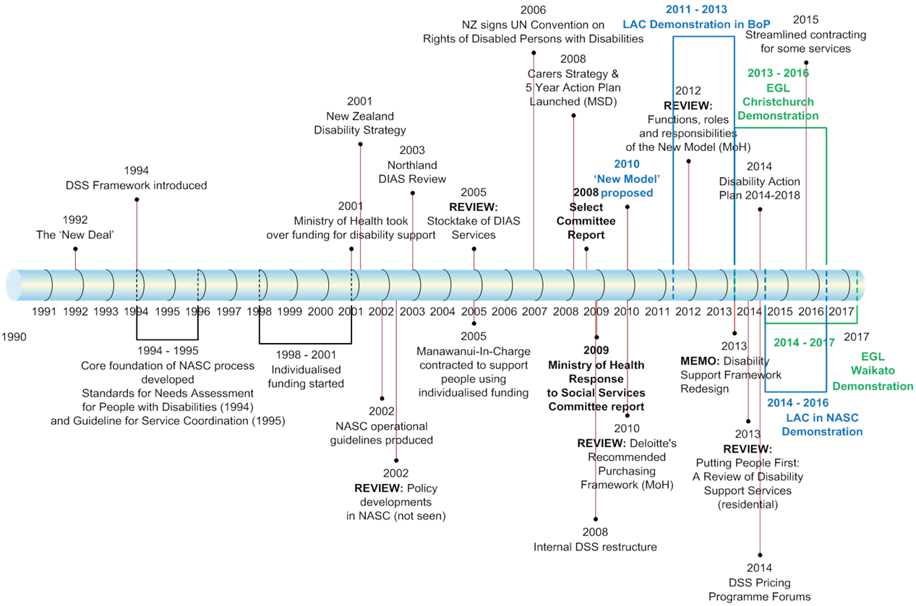

**Source:** Timeline developed by Sapere from various documents provided and research

1. DIAS Providers

Figure 14 DIAS providers



**Source:** DSS provided contract lists

Figure 15 Hub and spoke DIAS contract providers



**Source:** DSS provided contract lists

# Works cited for this report

Note: there is a full list of references in previous reports. The following were the additional ones for this report.

Deloitte. (April 2010). *Recommended Purchasing Framework - Review of the Purchasing Framework for Disability Support Services.* Wellington: Ministry of Health.

Esplin, J., Moore, D., & Rook, H. (2016). *DRAFT Disability Information and Advisory Services and Needs Assessment and Service Cooridnation Review: Initial Think Piece.* Auckland: Sapere Research Group.

Ministry of Health. (2012). *Whāia Te Ao Mārama: The Māori Disability Action Plan for Disability Support Services 2012 to 2017.* Wellington: Ministry of Health.

Ministry of Health. (2015). *Disability Support Services Strategic Plan 2014-2018.* Wellington: Ministry of Health.

Ministry of Health. (2015a). *Demographic Information on Clients Using the Ministry of Health's Disability Support Services as at September 2013.* Wellington: Ministry of Health.

Ministry of Health. (2016b). *Demographic Information on Clients Using the Ministry of Health's Disability Support Services as at September 2014.* Wellington: Ministry of Health.

Ministry of Social Development. (2014). *The New Zealand Carers' Strategy Action Plan for 2014 to 2018.* Wellington: Ministry of Social Development.

National Health Board. (2010). *Faiva Ora National Pasifika Disability Plan 2010-2013.* Wellington: Ministry of Health.

Office for Disability Issues. (2014). *Disability Action Plan 2014-2018.* Wellington: Office for Disability Issues.

UN General Assembly. (24 January 2007). *Convention on the Rights of Persons with Disabilities : resolution / adopted by the General Assembly.* UN General Assembly.

1. Note this is system wide and broader than just current disability information. It profiles disability. [↑](#footnote-ref-2)
2. Note that many of the disabled people and DPOs interviewed said that the approach and attitude of NASC assessors can feel disrespectful. We also note that the sample we interviewed is likely to be skewed, based on the fact we were undertaking a review for change. [↑](#footnote-ref-3)
3. [https://www.likeminds.org.nz](https://www.likeminds.org.nz/) [↑](#footnote-ref-4)
4. Esplin, J. Moore, D. & Rook, H. (2016). [↑](#footnote-ref-5)
5. Consumers were identified through a series of mechanisms: those that were part of DPOs, a disabled youth group that were contacted through a DRC, as well as individual clients who personally contacted Sapere to provide input. [↑](#footnote-ref-6)
6. p.2 Government response to Select Committee. [↑](#footnote-ref-7)
7. UN General Assembly. (24 January 2007). *Convention on the Rights of Persons with Disabilities : resolution / adopted by the General Assembly.* UN General Assembly. [↑](#footnote-ref-8)
8. Office for Disability Issues. (2014). *Disability Action Plan 2014-2018.* Wellington: Office for Disability Issues. Note: currently being consulted on for updating, led by the Office of Disability Issues. [↑](#footnote-ref-9)
9. Ministry of Social Development. (2014). *The New Zealand Carers' Strategy Action Plan for 2014 to 2018.* Wellington: Ministry of Social Development. [↑](#footnote-ref-10)
10. [http://www.enablinggoodlives.co.nz](http://www.enablinggoodlives.co.nz/) [↑](#footnote-ref-11)
11. Ministry of Health. (2015). *Disability Support Services Strategic Plan 2014-2018.* Wellington: Ministry of Health. [↑](#footnote-ref-12)
12. <http://www.health.govt.nz/system/files/documents/publications/whaia-te-ao-marama-maori-disability-action-plan.pdf> [↑](#footnote-ref-13)
13. <http://www.health.govt.nz/our-work/disability-services/pasifika-disability-support-services/faiva-ora-national-pasifika-disability-plan> [↑](#footnote-ref-14)
14. http://www.ssc.govt.nz/pif-framework [↑](#footnote-ref-15)
15. <https://www.ict.govt.nz/strategy-and-action-plan/strategy/digital-services/> [↑](#footnote-ref-16)
16. These are available to people who have a physical, intellectual or sensory disability (or a combination of these) which:

    * Is likely to continue for at least six months.
    * Limits their ability to function independently, to the extent that ongoing support is required.
    * These are mainly younger people under the age of 65 years.
    * The ministry will also fund DSS for people with:
      + 1. some neurological conditions that result in permanent disabilities some developmental disabilities in children and young people, such as autism, physical, intellectual or sensory disability that co-exists with a health condition and/or injury.

    **Source**: Ministry website. [↑](#footnote-ref-17)
17. Abbreviated from “What Everybody Keeps Asking”. [↑](#footnote-ref-18)
18. Brokerage is the term used here but any one of many terms could be used, e.g. navigation, connection, and different people have varying preferences. [↑](#footnote-ref-19)
19. Simply, for the purposes of this report, spending money early to improve outcomes and potentially save money later. [↑](#footnote-ref-20)
20. Ministry of Health (2015), (2016). [↑](#footnote-ref-21)
21. We note at the time of writing evaluations of the EGL demonstrations are underway. [↑](#footnote-ref-22)
22. We note that Focus, as the smallest NASC, also runs Wairarapa DHB’s Health of Older People and Mental Health NASCs together to create scale – although the budgets are managed separately. [↑](#footnote-ref-23)
23. The 2013 Disability Survey found that the prevalence of disability increases with age, with the rate being 11% for children aged under 15 years, 16% for people aged 15-44 years, and 28% for people aged 45-64 years. (Statistics NZ, 2014) <http://www.stats.govt.nz/browse_for_stats/health/disabilities/DisabilitySurvey_HOTP2013.aspx> [↑](#footnote-ref-24)
24. Over 87% of survey respondents stated that they were in existence before 1990 or during the 1990s (**source**: Sapere analysis of e survey of DIAS providers). [↑](#footnote-ref-25)
25. We note that providers can use a range of terms for the same types of functions and roles. [↑](#footnote-ref-26)
26. We note that stakeholder input suggested that cultural specific needs to expand to at least Asian – both in the North and South Islands. [↑](#footnote-ref-27)
27. As noted on the Federation of Disability Resource Centre’s website. [↑](#footnote-ref-28)
28. Part of Enable New Zealand. [↑](#footnote-ref-29)
29. This information has been provided by DSS as indicative only and will need further investigation for breakdown of contracts into DRC and other components. [↑](#footnote-ref-30)
30. Note – these organisations receive their funding through the hub ILS, but are for national offices. There are also regional offices for these organisations that receive their funding through hub models. [↑](#footnote-ref-31)
31. The Brain Injury Association actually covers 15 separate centres, but funding flows through the Auckland office for administration purposes. [↑](#footnote-ref-32)
32. <http://www.disabilityscot.org.uk/home/about-us/> [↑](#footnote-ref-33)
33. http://www.disabilityonline.community/index.php [↑](#footnote-ref-34)
34. https://www.likeminds.org.nz/ [↑](#footnote-ref-35)
35. <http://www.ssc.govt.nz/bps-interaction-with-govt#result10> [↑](#footnote-ref-36)
36. <https://www.ict.govt.nz/strategy-and-action-plan/strategy/digital-services/> [↑](#footnote-ref-37)
37. <http://www.publiclibraries.org.nz/Portals/150/Resources/NZ_Public_Libraries_Strategic_Framework.pdf?ver=2015-11-20-202119-673> [↑](#footnote-ref-38)
38. <http://www.cab.org.nz/aboutus/oh/Pages/home.aspx> [↑](#footnote-ref-39)
39. Noting that this is broader than DIAS and should include NASC and the DSS purchase framework, at the least. Over time, it could include also other disability services, like Special Education etc. [↑](#footnote-ref-40)
40. Such as Maori DIAS contracts and Citizen Advocacy, although the latter is more of a general long-term support then specifically for this process. [↑](#footnote-ref-41)
41. Ministry of Health, 2013. [↑](#footnote-ref-42)
42. Note: Fewer than five people commented on not wanting to put LAC type functions to be coordinated with NASC type functions – a streamlined “branded” service, easy to find, in one place, simple to use, and easy to understand is what most people want. [↑](#footnote-ref-43)
43. Note there will need to be links with carer bodies as well. [↑](#footnote-ref-44)
44. For example, as evidenced by the Waikato EGL demonstration where some people, who were not known to NASC, accessed it. [↑](#footnote-ref-45)
45. Source: <http://www.odi.govt.nz/what-we-do/improving-disability-supports/enabling-good-lives/questions-and-answers-july-2013.html#WhataretheEnablingGoodLivesprinciples10> [↑](#footnote-ref-46)