Demographic Report on Clients Allocated the Ministry of Health’s Disability Support Services
as at September 2014

Citation: Ministry of Health. 2016. Demographic Report on Clients Allocated the
Ministry of Health’s Disability Support Services: as at September 2014.
Wellington: Ministry of Health.
Published in June 2016
by the Ministry of Health
PO Box 5013, Wellington 6140, New Zealand
ISBN 978-0-947515-74-4 (online)
HP 6429
This document is available at health.govt.nz

This work is licensed under the Creative Commons Attribution 4.0 International licence. In essence, you are free to: share ie, copy and redistribute the material in any medium or format; adapt ie, remix, transform and build upon the material. You must give appropriate credit, provide a link to the licence and indicate if changes were made.

Contents
Executive summary ix
Introduction ix
Overall Client demographics ix
Disability support services x
Disability types xi
Trends xii
Introduction 1
Purpose 1
Audience 1
Scope 1
Exclusions 2
Terminology 2
Methodology 3
Demographic profile data 3
Statistics New Zealand census data 3
DSS Clients compared with the New Zealand population 4
Age and sex 4
Ethnicity 5
Disability services 7
Disability Support Services groups 7
Overall Client demographics 9
Age and sex 9
Ethnicity 11
Ethnicity−age profiles 12
Marital status 13
Accommodation 14
Location 15
Principal disabilities 16
Support package allocation 17
Needs Assessment Service Coordination organisations (NASCs) 18
Client demographics, by service 19
Home and community support 19
Carer support 26
Community residential services 34
Supported living 42
Respite services 50
Day programmes 58
Client demographics, by disability 64
Intellectual disability 65
Physical disability 67
Autism spectrum disorder 69
Sensory disability 72
Neurological disability 73
Service usage, by ethnicity 74
Glossary 77
Appendix: Disability types 78

List of Tables
Table 1: Ethnicity of DSS Clients compared with the New Zealand population aged 0−79 years 5
Table 2: Client numbers per service type 7
Table 3: DSS Clients, by age and sex, September 2014 9
Table 4: DSS Clients, by age and ethnicity 11
Table 5: DSS Clients, by marital status and sex 13
Table 6: DSS Clients, by accommodation type and sex 14
Table 7: DSS Clients, by ethnicity and regional council 15
Table 8: DSS Clients, by sex and class of principal disability 16
Table 9: DSS Clients, by SPA level and age 17
Table 10: DSS Clients, by NASC 18
Table 11: HCSS Clients, by age and sex 19
Table 12: HCSS Clients, by age and ethnicity 20
Table 13: HCSS Clients, by marital status and sex 21
Table 14: HCSS Clients, by sex and accommodation type 22
Table 15: HCSS Clients, by region and ethnicity 23
Table 16: HCSS Clients, by principal disability type and sex 24
Table 17: HCSS Clients, by SPA level and sex 25
Table 18: Carer support Clients, by age and sex 26
Table 19: Carer support Clients, by age and ethnicity 28
Table 20: Carer support Clients, by sex and accommodation type 29
Table 21: Carer support Clients, by marital status and sex 30
Table 22: Carer support Clients, by region and ethnicity 31
Table 23: Carer support Clients, by sex and principal disability 32
Table 24: Carer support Clients, by SPA level and sex 33
Table 25: Community residential services Clients, by age and sex 34
Table 26: Community residential services Clients, by ethnicity and age 36
Table 27: Community residential services Clients, by marital status and sex 37
Table 28: Community residential services Clients, by accommodation type and sex 38
Table 29: Community residential services Clients, by region and ethnicity 39
Table 30: Community residential services Clients, by principal disability and sex 40
Table 31: Community residential services Clients, by SPA level and sex 41
Table 32: Clients using supported living services, by age and sex 42
Table 33: Clients using supported living services, by ethnicity and age 44
Table 34: Clients using supported living services, by marital status and sex 45
Table 35: Clients using supported living services, by accommodation type and sex 46
Table 36: Clients using supported living services, by ethnicity and region 47
Table 37: Clients using supported living services, by principal disability and sex 48
Table 38: Clients using supported living services, by SPA level and sex 49
Table 39: Respite Clients, by age and sex 50
Table 40: Respite Clients, by age and ethnicity 52
Table 41: Respite Clients, by sex and marital status 53
Table 42: Respite Clients, by sex and accommodation type 54
Table 43: Respite Clients, by ethnicity and region 55
Table 44: Respite Clients, by sex and disability type 56
Table 45: Respite Clients, by SPA level and sex 57
Table 46: Day-programme Clients, by age and sex 58
Table 47: Day-programme Clients, by age and ethnicity 60
Table 48: Day-programme Clients, by region 61
Table 49: Day-programme Clients, by principal disability 62
Table 50: Day-programme Clients, by SPA level 63
Table 51: Clients with intellectual disability, by age and sex 65
Table 52: Clients with physical disability, by age and sex 67
Table 53: Clients with ASD, by age and sex 69
Table 54: ASD Clients, by sex and service usage 70
Table 55: Sensory disability Clients, by age and sex 72
Table 56: Clients with neurological disability, by age and sex 73
Table A1: Principal disability types, by number of DSS Clients 78

List of Figures
Figure 1A: Age and sex of DSS Clients, 2014 4
Figure 1B: Age and sex of the New Zealand population 2013 census 4
Figure 2: Ethnicity of DSS Clients compared with the New Zealand population aged 0−79 years 5
Figure 3: DSS Client profile, by age and sex 10
Figure 4: DSS Clients, by main ethnic group 12
Figure 5: DSS Clients, by sex and class of principal disability 16
Figure 6: DSS Clients, by SPA level and age 17
Figure 7: DSS Clients, by NASC 18
Figure 8: HCSS Clients, by age and sex 20
Figure 9: HCSS Clients, by age and ethnicity 21
Figure 10: HCSS Clients, by region and ethnicity 23
Figure 11: HCSS Clients, by principal disability type and sex 24
Figure 12: HCSS Clients, by SPA level and sex 25
Figure 13: Age and sex of carer support Clients 27
Figure 14: Carer support Clients, by age and ethnicity 28
Figure 15: Carer support Clients, by region and ethnicity 31
Figure 16: Carer support Clients, by sex and principal disability 32
Figure 17: Carer support Clients, by SPA level and sex 33
Figure 18: Age and sex of community residential services Clients 35
Figure 19: Community residential services Clients, by ethnicity and age 36
Figure 20: Community residential services Clients, by region and ethnicity 39
Figure 21: Community residential services Clients, by principal disability and sex 40
Figure 22: Community residential services Clients, by SPA level and sex 41
Figure 23: Age and sex of Clients using supported living services 43
Figure 24: Clients using supported living services, by ethnicity and age group 44
Figure 25: Clients using supported living services, by ethnicity and region 47
Figure 26: Clients using supported living services, by principal disability and sex 48
Figure 27: Clients using supported living services, by SPA level and sex 49
Figure 28: Age and sex of respite Clients 51
Figure 29: Respite Clients, by age and ethnicity 52
Figure 30: Respite Clients, by ethnicity and region 55
Figure 31: Respite Clients, by sex and disability type 56
Figure 32: Respite Clients, by SPA level and sex 57
Figure 33: Day-programme Clients, by age and sex 59
Figure 34: Day-programme Clients, by age and ethnicity 60
Figure 35: Day-programme Clients, by region 61
Figure 36: Day-programme Clients, by principal disability 62
Figure 37: Day-programme Clients, by SPA level 63
Figure 38: Age and sex of Clients with intellectual disability 66
Figure 39: Clients with physical disability, by age and sex 68
Figure 40: Age and sex of Clients with ASD 70
Figure 41: ASD Clients, by sex and service usage 71
Figure 42: Age and sex of Clients with sensory disabilities 72
Figure 43: Age and sex of Clients with neurological disability 73
Figure 44: Overall service usage, by ethnicity 74
Figure 45: Service usage by Clients of European/Other ethnicity 74
Figure 46: Service usage by Clients of Māori ethnicity 75
Figure 47: Service usage by Clients of Pacific ethnicity 75
Figure 48: Service usage by Clients of Asian ethnicity 76

Executive summary

Introduction
The purpose of this report is to provide demographic information about the disabled people allocated the majority of disability support services funded by the Ministry of Health’s Disability Support Services (DSS): home and community support, carer support, community residential services, supported living, and respite and day programmes.

The report excludes information about disabled people allocated the following services: equipment and modifications; behaviour support; child development; regional intellectual supported accommodation services; and assessment, treatment and rehabilitation.

It is important to note that the report is based on information about services allocated to people by the Needs Assessment and Service Coordination (NASC) organisations. It is not based on services used.

Overall Client demographics
- More males (56%) than females (44%) are allocated disability support services. Males dominate the age groups from 5 to 24 years; females dominate the 40+ years age groups.
- The median age of DSS Clients is 31 years.
- The ethnicity of Clients allocated disability support services is: 69% European/Other, 17% Māori, 6% Pacific and 5% Asian, with 4% of unknown ethnicity. European/Other and Pacific people are slightly under-represented when compared with the total New Zealand population; Māori are slightly over-represented, while Asian people are significantly under-represented.
- Among Asian Clients, males have a significant presence in the 5–24 years age group.
- Males make up 57% of Clients with intellectual disabilities. Females make up 58% of Clients with physical disabilities. Males (80%) dominate the Clients with autism spectrum disorder (ASD).
- Almost half of DSS Clients live in their own home or their family home.
- Half of DSS Clients reside in the three most populated regions, which include the major cities of Auckland, Christchurch and Hamilton.
- Almost half of all DSS Clients have an intellectual disability as their principal disability. Many of these Clients also have a physical disability.
- Almost a third have a physical disability as their principal disability.
- Only 5% of DSS Clients have a sensory (hearing or sight) or neurological disability.

Disability support services

Home and community support
- The median age of Clients is 46 years.
- People with physical disabilities make up 56% of the Clients allocated home and community support.
- Just over half (54%) of Clients are male.
- All ethnicities are well represented among Clients of home and community support.

Carer support
- The median age of Clients is 15 years.
- People with intellectual disabilities make up 45% of the Clients whose carers receive carer support.
- Carer support is used predominantly for male Clients (65%) and for Clients under 20 years (65%).
- Clients of Māori, Pacific and Asian ethnicities are over-represented among those allocated carer support, while European/Other Clients are under-represented.

Community residential services
- The median age of Clients is 47 years.
- There are more males (58%) than females allocated residential services.
- Clients of residential services are predominantly European/Other (77%) and Māori (15%). People of Pacific and Asian ethnicities are under-represented.
- People with intellectual disabilities account for 82% of the Clients allocated residential services.

Supported living
- The median age of Clients is 41 years.
- People with intellectual disabilities make up 66% of the Clients using supported living.
- People using supported living services are predominantly European/Other (78%) and Māori (15%). People of Pacific and Asian ethnicities are under-represented.

Respite
- Almost two-thirds (63%) of Clients allocated respite services are male, and over half (55%) are aged under 20 years.
- Māori represent 20% and Pacific people 7% of the Clients allocated respite.
- Almost half (49%) of respite Clients are on Very High support packages.

Day programmes
- The median age of Clients is 45 years.
- DSS only funds day programmes for Clients who:
- were once living in institutions such as Tokanui and Kimberley, and/or
- are currently using High and Complex services allocated by the National Intellectual Disability Care Agency.
- There are more male day-programme Clients (55%) than female (45%).
- The majority of day-programme Clients are aged between 30 and 55 years.
- European/Other people (75%) are significantly over-represented among day-programme Clients.
- The majority (83%) of Clients using day-programme services have intellectual disabilities.
- A large majority (67%) of day-programme Clients have a Very High support package allocation level, and a further 26% have a High support package.

Disability types

Intellectual disabilities
- The median age is 28 years.
- Clients whose primary disability is an intellectual disability make up almost half of all DSS Clients. Many of them also have a physical disability.
- There are significantly more males (57%) with an intellectual disability allocated disability support services than females.
- There are two peaks in the age group profiles for both sexes: 10–19 years and 40–54 years.

Physical disabilities
- The median age is 52 years.
- Clients whose primary disability is a physical disability make up a quarter of all DSS Clients.
- Females make up 58% of Clients with a physical disability.
- More than half of Clients with a physical disability are aged over 45 years.

Autism spectrum disorder
- The median age is 12 years.
- Clients with ASD are predominantly male (81%).
- The majority (80%) of ASD Clients are aged under 20 years.

Sensory disabilities
- The median age is 40 years.
- Males and females are evenly spread in this group.

Neurological disabilities
- The median age is 53 years.
- Almost two-thirds of Clients are aged over 50 years.

Trends
- The number of Clients receiving disability support services increased by 3.7% between September 2013 and September 2014.
- The number of Clients using Supported Living services increased by 17% from 2013.
- The number of Clients with intellectual, physical and ASD disabilities increased slightly, while those with sensory and neurological disabilities decreased slightly.
- There was little change in the ethnicity and location of DSS Clients from 2013.
- Support allocation packages increased by 2% in the Very High band and by 1% in the Medium band from 2013.

Introduction

Purpose
The purpose of this report is to inform decision-making on the planning and procurement of disability support services in both the New Zealand Ministry of Health (the Ministry) and the wider disability sector. This is the second annual demographic report, and it provides demographic information about the disabled people and their families / whānau who were allocated services funded by Disability Support Services (DSS) of the Ministry of Health in 2014. It also provides a comparison with the 2013 DSS demographic report to identify the extent of any changes.

Audience
The principal intended audience of this report is the staff and managers of DSS who are involved in developing and implementing strategic and annual plans for the procurement of services.

Scope
The report provides demographic information obtained from the Ministry’s Socrates database collected by the Needs Assessment Service Coordination (NASC) organisation from the disabled people who have been allocated Ministry-funded disability support services. The information relates to people who were allocated the following disability support services in September 2014:
- home and community support
- carer support
- community residential services
- supported living
- respite
- day programmes.

The demographics presented relate to:
- age
- sex
- ethnicity
- marital status
- type of accommodation
- regional location within New Zealand
- type of disability
- support package allocation (SPA).

Exclusions
This report excludes people allocated the following Ministry-funded services:
- equipment and modifications
- child development
- assessment, treatment and rehabilitation
- regional intellectual disability supported accommodation services
- behaviour support.

It is important to note that the report is based on information about services allocated to people by the NASC organisations. It is not based on services used.

Terminology
Throughout this report we have used the capitalised noun ‘Client’ to refer to a person with a disability who is allocated a service funded by DSS.

Methodology
This report analyses data about people who were allocated Ministry-funded disability support services in September 2014.

Demographic profile data
The data presented in this report were derived from the Ministry’s Socrates database in an extract provided by the Contract and Information Support (CIS) team within the National Services Purchasing Unit of the Ministry. The Socrates database includes all clients who have ever been assessed by NASC for eligibility to access Ministry-funded disability support services. There are 15 NASCs across New Zealand.

The extract contained one record for each client for each service allocated to that client. This means that the demographic data for any client accessing multiple services appears more than once; that is, in each service-related table.

Statistics New Zealand census data
The majority of comparisons with the New Zealand population made in the report use the 2013 New Zealand census data.

Note: many tables do not total 100% due to rounding.

DSS Clients compared with the New Zealand population
There are notable differences between the age and sex demographics of DSS Clients compared with the overall New Zealand population, using the 2013 census data.

Age and sex
Figure 1A: Age and sex of DSS Clients, 2014
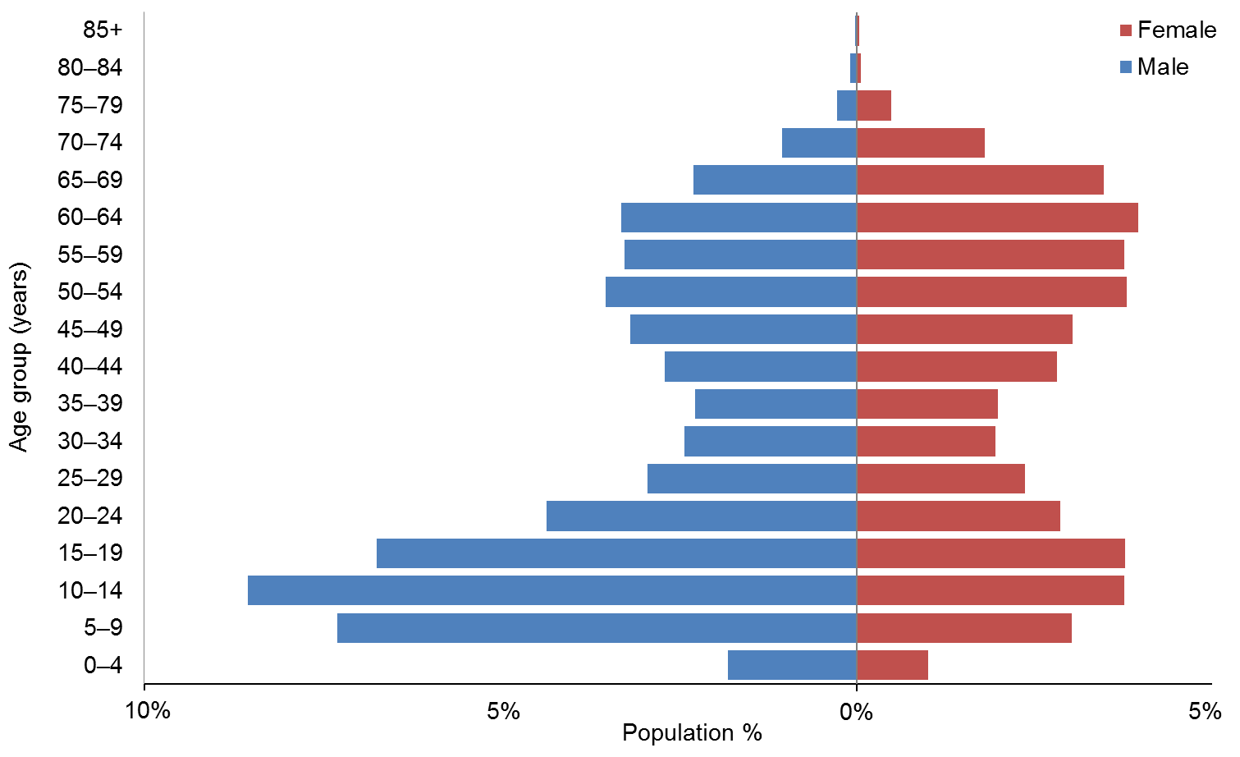

Figure 1B: Age and sex of the New Zealand population 2013 census
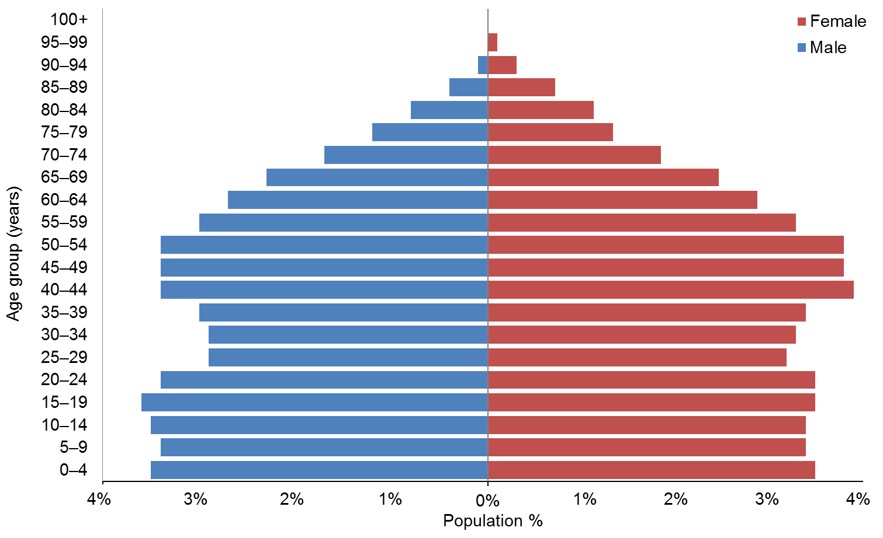

Observations
- DSS Clients are markedly more concentrated in the 5–19 and 45–65 age groups, with males predominant in the younger age groups and females predominant in the older age groups.
- Generally, eligibility for DSS services is for people aged under 65, hence the lower numbers of people in the over-65 age groups compared with the general population. As at September 2014 there were 3087 (9.5%) DSS Clients aged 65+ years (compared with 14% aged 65+ years in the total New Zealand population).

Ethnicity
A comparison between DSS Clients’ ethnicities in 2014 and the 2013 census ethnicity statistics for people aged 0−79 years is set out below.

Table 1: Ethnicity of DSS Clients compared with the New Zealand population aged
0−79 years
Ethnicity | DSS 2014 | Census 2013 | DSS 2014 | Census 2013
European/Other | 22,242 | 2,945,220 | 69.0% | 72.1%
Māori | 5352 | 594,135 | 16.6% | 14.5%
Pacific | 1893 | 293,814 | 5.9% | 7.2%
Asian | 1532 | 467,769 | 4.8% | 11.4%
Not stated | 1228 | 212,253 | 3.8% | 5.2%
Total | 32,247 | 4,087,707* | 100.0% | 110.4%**
* This total is less than the sum of the figures because some people identify as having more than one ethnicity.
** Some people identify as having more than one ethnicity.

Figure 2: Ethnicity of DSS Clients compared with the New Zealand population aged
0−79 years**
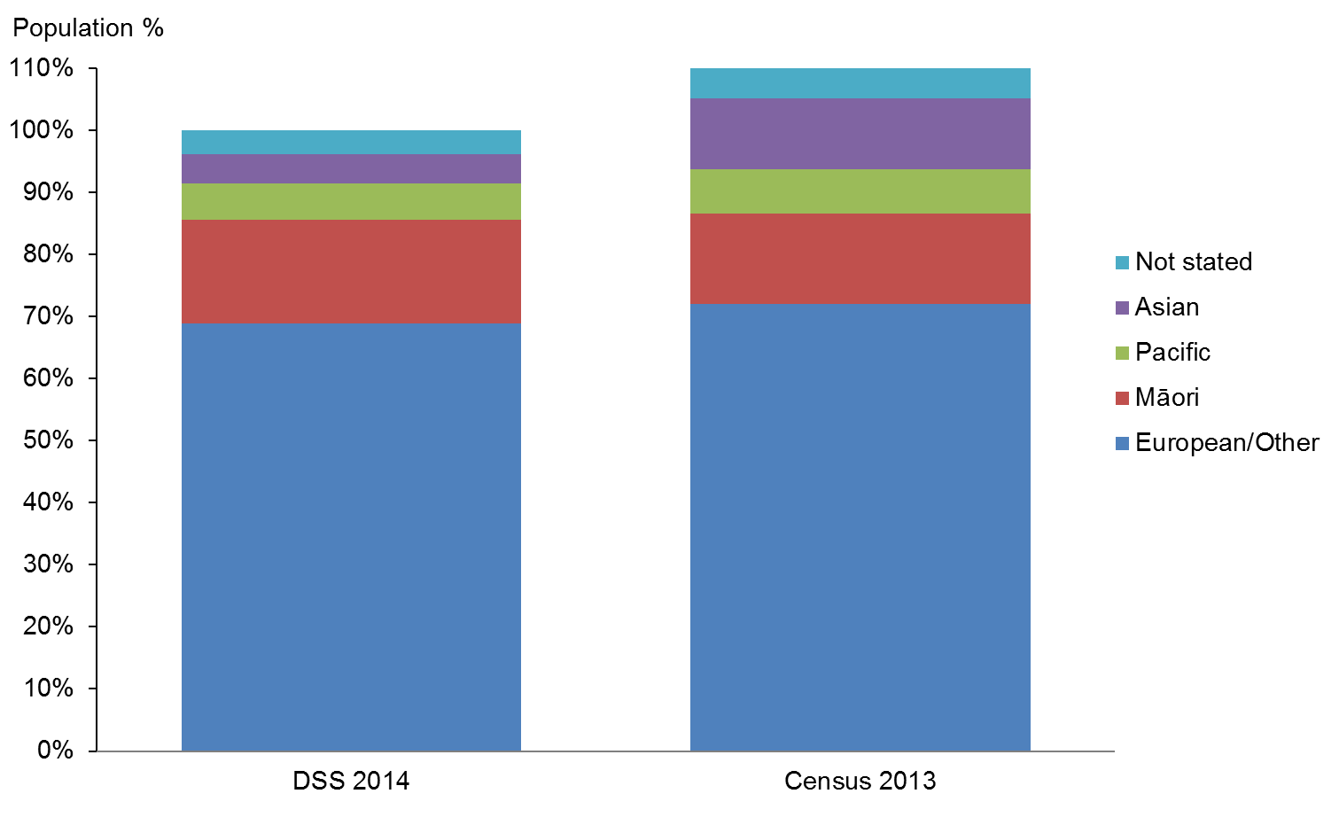

Observations
- European/Other and Pacific ethnicities are slightly under-represented in the DSS Client group.
- Asian ethnicity is significantly under-represented in DSS services.
- Māori are slightly over-represented in the DSS Client group.
- There is little change in the ethnicity profile since 2013.

Caveat: care is needed when making inferences from comparisons between DSS and New Zealand-wide numbers because DSS ethnicities are ‘prioritised’, and this will tend to exaggerate the proportion of Māori and Pacific people over Asian, European and Other people.

Disability services

Disability Support Services groups
The numbers of Clients using different services are set out in Table 2.

Table 2: Client numbers per service type
Service group description | Clients | Group total | Demographics analysed
Home support, including household management, personal care (including people using individualised funding for this) | 16,813 | 16,813 | Yes
Enhanced Individualised Funding | 193 | 193 | No
Enabling Good Lives | 42 | 42 | No
Carer support | 16,785 | 16,785 | Yes
Community residential | 6660 | 7510 | Yes
Residential: rest homes | 282
Residential: hospitals | 568
Supported independent living | 3282 | 3282 | Yes
Respite | 2163 | 2163 | Yes
Day programmes | 1866 | 1866 | Yes
Other |  | 415 | No
Total non-unique Clients* |  | 49,069**
* Clients are counted more than once if they are allocated to more than one service type.
** This number has increased by 10% from 44,784 in the 2013 DSS Demographic Report.

This report provides demographic information about Clients allocated to the following services:
- home support (also referred to as home and community support), which provides one, or a combination, of the following services:
- personal care (ie, assistance with activities of daily living that enables a person with a disability to maintain their functional ability at an optimal level)
- household management (ie, assistance to a person with a disability to maintain, organise and control their household / home environment, enabling them to continue living within their own environment)
- sleepover care or night support (ie, a support worker sleeps at the home of the disabled person in order to provide intermittent care throughout the night)
- carer support, which provides reimbursement of some of the costs of using a support person to care for and support a disabled person and allows their carer to take some time out for themselves
- community residential services, which provide 24-hour support for people to have a safe and satisfying home life, with opportunities for learning and employment, and participation in family and social life as well as the community
- supported living, which provides a range of services to disabled people to live independently in their own home (eg, assistance with shopping and accessing community services)
- respite, which provides short-term relief support in a residential setting with the aim of providing a break for the disabled person’s carer in order to sustain their longer-term support for the person to live in the community, while also providing the disabled person with a positive, stimulating and worthwhile experience
- day programmes, which provide a range of activities that help disabled people to take part in their community and improve their personal skills by providing access to regular meaningful social contact and stimulating activities.

Overall Client demographics
This section shows the demographic details of all the Clients allocated services from DSS service providers. The total number of Clients as at September 2014 was 32,247.

Age and sex
Table 3: DSS Clients, by age and sex, September 2014
Age groups | Female | Male | Total
0−4 | 324 | 582 | 906
5−9 | 975 | 2351 | 3326
10−14 | 1214 | 2758 | 3972
15−19 | 1216 | 2173 | 3389
20−24 | 922 | 1403 | 2325
25−29 | 765 | 947 | 1712
30−34 | 630 | 779 | 1409
35−39 | 641 | 730 | 1371
40−44 | 909 | 869 | 1778
45−49 | 981 | 1025 | 2006
50−54 | 1225 | 1135 | 2360
55−59 | 1215 | 1049 | 2264
60−64 | 1278 | 1064 | 2342
65−69 | 1120 | 738 | 1858
70−74 | 581 | 337 | 918
75−79 | 158 | 86 | 244
80−84 | 19 | 27 | 46
85+ | 14 | 7 | 21
Total | 14,187 | 18,060 | 32,247
 | 44% | 56% | 100%

Observations
- The total number of individuals allocated disability support services increased by 3% (from 31,101) from 2013.
- The median age was 31 years.

Figure 3: DSS Client profile, by age and sex

Observations
- There are significantly more males (56%) than females (44%) using DSS services. The proportions have not changed since 2013.
- There are two high points in the age profiles of DSS Clients: one in teenage years and the second in the 50–69 years age groups.
- Males dominate the age groups from 0–25 years, and females are significantly more numerous than males in the 50–70 years age groups.

Ethnicity
Table 4: DSS Clients, by age and ethnicity
Age group | European / Other | Māori | Pacific | Asian | Not stated / don’t know | Total
0–4 | 459 | 190 | 62 | 69 | 126 | 906
5–9 | 1888 | 656 | 253 | 262 | 267 | 3326
10–14 | 2527 | 750 | 255 | 280 | 160 | 3972
15–19 | 2204 | 647 | 228 | 240 | 70 | 3389
20–24 | 1543 | 412 | 191 | 159 | 20 | 2325
25–29 | 1160 | 295 | 114 | 95 | 48 | 1712
30–34 | 979 | 241 | 91 | 70 | 28 | 1409
35–39 | 997 | 221 | 88 | 38 | 27 | 1371
40–44 | 1315 | 283 | 89 | 29 | 62 | 1778
45–49 | 1455 | 335 | 99 | 53 | 64 | 2006
50–54 | 1767 | 372 | 96 | 50 | 75 | 2360
55–59 | 1684 | 344 | 90 | 62 | 84 | 2264
60–64 | 1798 | 315 | 100 | 52 | 77 | 2342
65–69 | 1471 | 191 | 85 | 40 | 71 | 1858
70–74 | 728 | 76 | 44 | 29 | 41 | 918
75–79 | 208 | 18 | 8 | 4 | 6 | 244
80–84 | 40 | 6 |  |  |  | 46
85+ | 19 |  |  |  | 2 | 21
Total | 22,242 | 5352 | 1893 | 1532 | 1228 | 32,247
 | 69.0% | 16.6% | 5.9% | 4.8% | 3.8% | 100%

Observation
- There has been no significant change in the ethnicity profile of DSS Clients since 2013.

Ethnicity−age profiles
There are distinct differences in the age profiles of the four main ethnic groups.

Figure 4: DSS Clients, by main ethnic group
European/Other  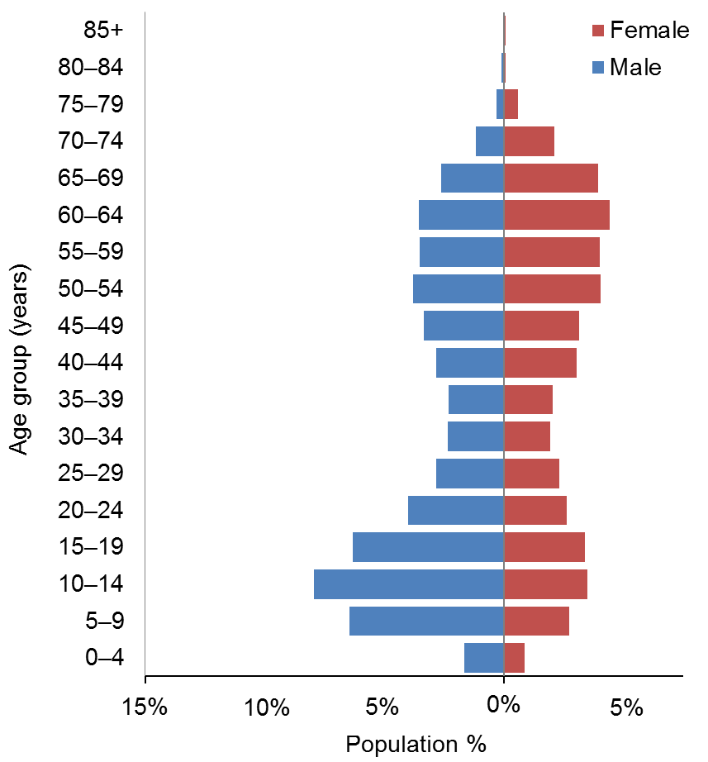 | Māori  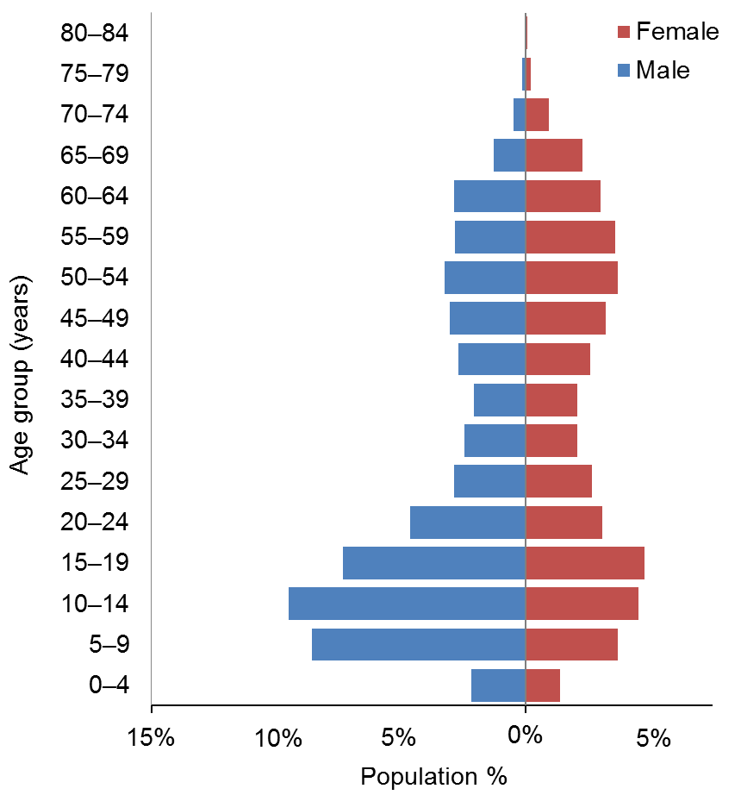
Pacific  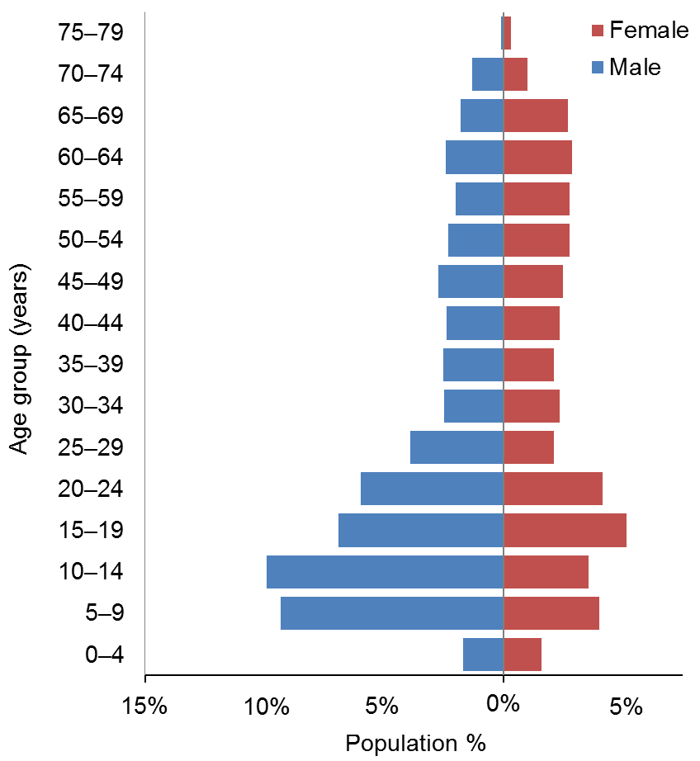 | Asian  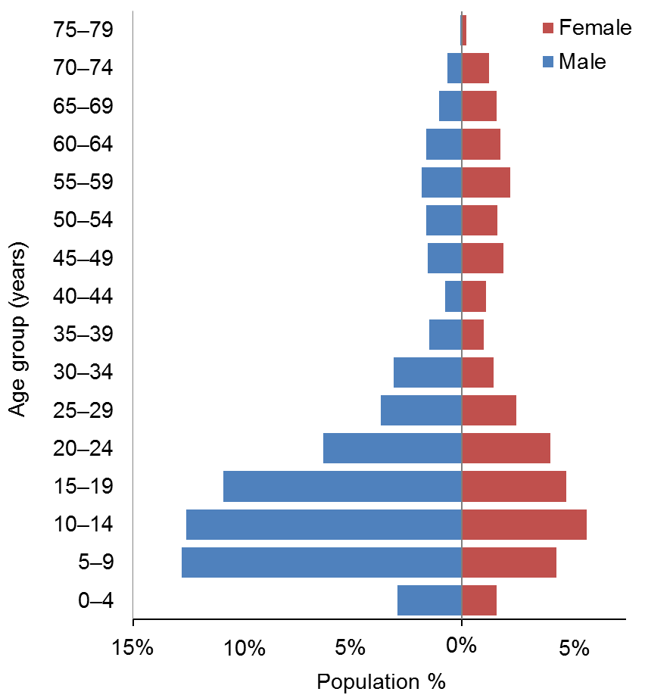

Observations
- Young people of both sexes are over-represented in the Māori, Pacific and especially the Asian Clients, particularly young males.
- Asians are particularly under-represented in the older age groups.
- The Pacific population does not have the bulge in middle-aged people evident in the other ethnic groups.

Marital status
Table 5: DSS Clients, by marital status and sex
Marital status | Male | Female | Total
Non-partnered, not further defined | 3369 | 2473 | 5842
Non-partnered, never married | 1572 | 969 | 2541
Married (not separated), not further defined | 460 | 834 | 1294
Not stated | 337 | 280 | 617
Non-partnered, divorced | 102 | 211 | 313
Partnered, not further defined | 118 | 147 | 265
Non-partnered, separated | 109 | 141 | 250
Non-partnered, widowed | 39 | 197 | 236
First marriage (not separated) | 20 | 32 | 52
Don’t know | 13 | 20 | 33
Response outside scope | 14 | 9 | 23
Remarried (not separated) | 5 | 10 | 15
Opposite-sex partnership | 4 | 7 | 11
Same-sex partnership | 1 | 5 | 6
Blank | 11,897 | 8852 | 20,749
Total | 18,060 | 14,187 | 32,247

Observations
- Marital status is not recorded for 64% of DSS Clients.
- Of DSS Clients where data is recorded, 80% do not have partners.

Accommodation
Table 6: DSS Clients, by accommodation type and sex
Accommodation | Male | Female | Total
Own / family home | 8601 | 6566 | 15,167
Community residential home | 3295 | 2433 | 5728
Rental accommodation | 2446 | 1912 | 4358
Unknown | 1419 | 1160 | 2579
Other | 896 | 759 | 1655
Housing New Zealand accommodation | 813 | 802 | 1615
Rest home / continuing care hospital | 284 | 306 | 590
Boarder | 176 | 125 | 301
Council accommodation | 97 | 81 | 178
Unit in a retirement village | 16 | 27 | 43
Prison | 8 | 4 | 12
Unit in a retirement village − licence to occupy | 5 | 6 | 11
No fixed abode | 4 | 5 | 9
Blank |  | 1 | 1
Total | 18,060 | 14,187 | 32,247

Observations
- Almost half of DSS Clients live in their own or their family home, and over half (57%) of these are male.
- The accommodation profiles for male and female DSS Clients are generally similar.

Location
Table 7: DSS Clients, by ethnicity and regional council
Regional council | European / Other | Māori | Pacific | Asian | Not stated | Total | %
Auckland | 5204 | 1294 | 1405 | 1029 | 625 | 9556 | 30
Canterbury | 3560 | 362 | 62 | 113 | 246 | 4343 | 13
Waikato | 2080 | 747 | 64 | 80 | 116 | 3087 | 10
Wellington | 2161 | 375 | 202 | 141 | 92 | 2971 | 9
Bay of Plenty | 1482 | 657 | 28 | 41 | 13 | 2221 | 7
Manawatu−Wanganui | 1561 | 381 | 32 | 29 | 33 | 2036 | 6
Otago | 1639 | 124 | 23 | 25 | 29 | 1840 | 6
Northland | 725 | 549 | 17 | 21 | 4 | 1316 | 4
Hawke’s Bay | 798 | 249 | 30 | 22 | 27 | 1126 | 3
Taranaki | 812 | 181 | 6 | 11 | 9 | 1019 | 3
Southland | 749 | 79 | 8 | 2 | 7 | 845 | 3
Nelson | 529 | 61 | 3 | 10 |  | 603 | 2
Gisborne | 147 | 195 | 8 | 2 | 6 | 358 | 1
Marlborough | 301 | 54 | 1 | 2 |  | 358 | 1
Tasman | 307 | 28 | 3 | 4 |  | 342 | 1
West Coast | 187 | 16 | 1 |  | 21 | 225 | 1
Total | 22,242 | 5352 | 1893 | 1532 | 1228 | 32,247

Observations
- Half of DSS Clients reside in the three most populated regions, which include the major cities of Auckland, Christchurch and Hamilton.
- 74% of Pacific Clients reside in the Auckland region.
- 67% of Asian Clients reside in the Auckland region.

Principal disabilities
Each DSS Client is recorded in Socrates with a principal disability (see Appendix). Some Clients have multiple disability types, and occasionally a Client will have two principal disabilities. Only the first principal disability is counted in the data presented in this report.

There are six disability classes: intellectual, physical, autism spectrum disorder (ASD), sensory, neurological and ‘Not DSS’ (eg, mental health, cancer, medical).

Table 8: DSS Clients, by sex and class of principal disability*
Principal disability type | Male | Female | Total | %
Intellectual | 8897 | 6681 | 15,578 | 48
Physical | 4200 | 5701 | 9901 | 31
Autism spectrum disorder | 4111 | 966 | 5077 | 16
Sensory | 520 | 510 | 1030 | 3
Neurological | 332 | 329 | 661 | 2
Total | 18,060 | 14,187 | 32,247 | 100
* Where a Client was recorded as having two principal disabilities, only the first one was used in this analysis.

Figure 5: DSS Clients, by sex and class of principal disability
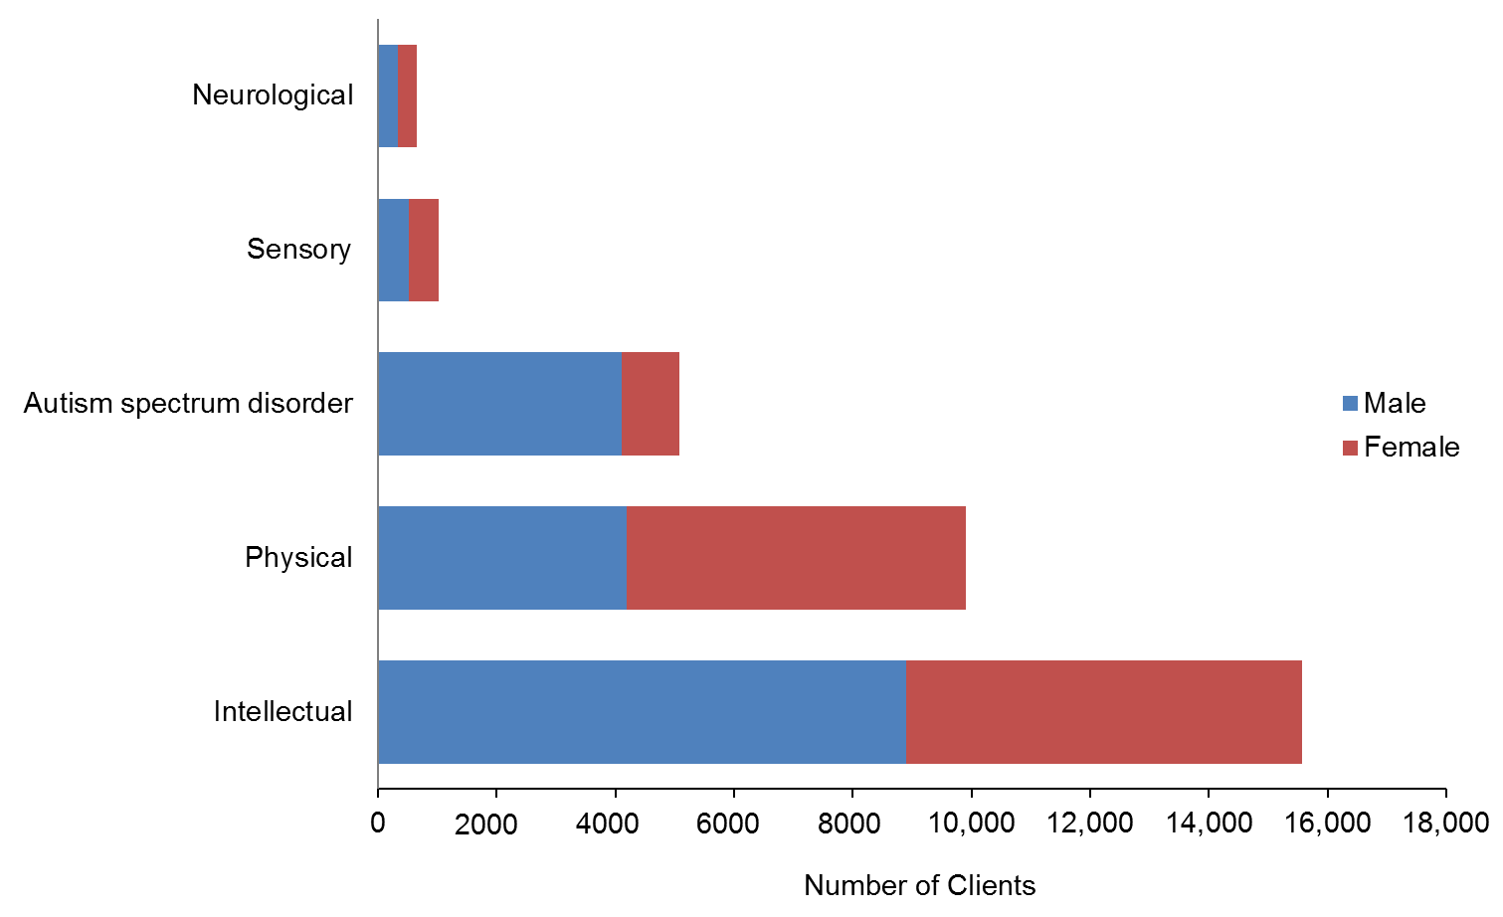

Observations
- Almost half of all DSS Clients have an intellectual disability as their primary disability. Many of these Clients also have a physical disability.
- Almost a third have a physical disability.
- Males are predominant in the groups of Clients with ASD (81%) and intellectual disabilities (57%).
- Females (58%) are predominant in the group of Clients with physical disabilities.

Support package allocation
Each DSS Client has a support package allocation (SPA) determined by their NASC on the basis of a detailed needs assessment.

Table 9: DSS Clients, by SPA level and age
Age group | Very High | High | Medium | Low | Very Low | Total
0−4 | 128 | 307 | 380 | 87 | 4 | 906
5−9 | 408 | 1085 | 1637 | 192 | 4 | 3326
15−19 | 742 | 1170 | 1370 | 104 | 3 | 3389
20−24 | 639 | 875 | 742 | 68 | 1 | 2325
25−29 | 580 | 612 | 483 | 37 |  | 1712
30−34 | 530 | 488 | 364 | 27 | 0 | 1409
35−39 | 489 | 499 | 356 | 27 |  | 1371
40−44 | 677 | 616 | 451 | 34 | 0 | 1778
45−49 | 771 | 670 | 522 | 42 | 1 | 2006
50−54 | 893 | 808 | 608 | 49 | 2 | 2360
55−59 | 756 | 796 | 646 | 65 | 1 | 2264
10−14 | 561 | 1305 | 1926 | 174 | 6 | 3972
60−64 | 682 | 765 | 780 | 115 | 0 | 2342
65−69 | 486 | 598 | 652 | 122 |  | 1858
70−74 | 227 | 273 | 343 | 75 |  | 918
75−79 | 78 | 84 | 73 | 9 |  | 244
80−84 | 15 | 20 | 10 | 1 |  | 46
85+ | 12 | 8 | 1 |  |  | 21
Total | 8674 | 10,979 | 11,344 | 1228 | 22 | 32,247
 | 27% | 34% | 35% | 4% | 0% | 100%

Figure 6: DSS Clients, by SPA level and age
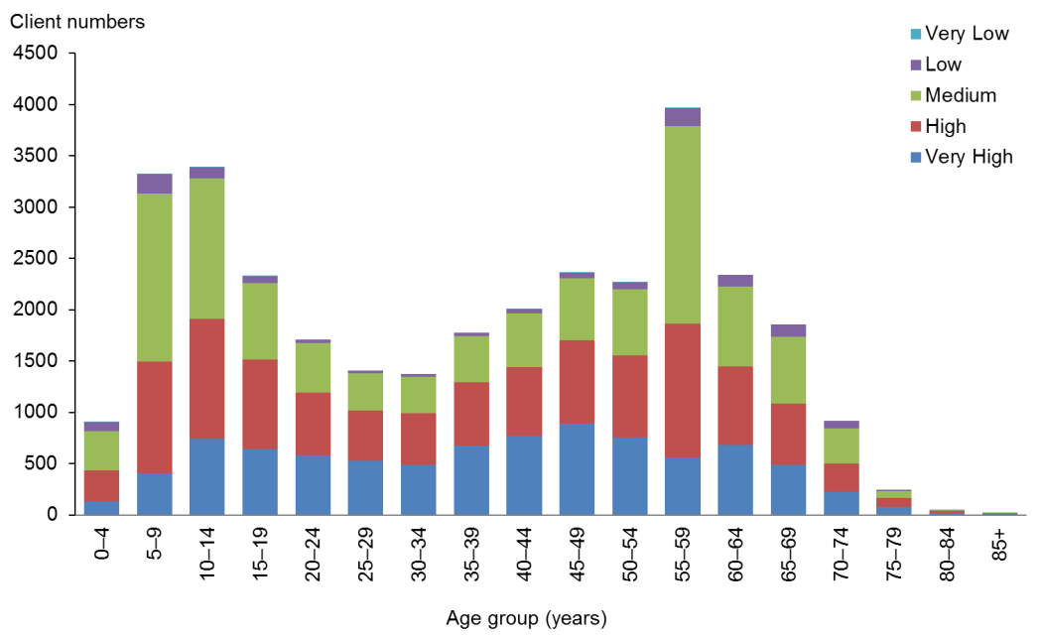

Observation
- Medium SPA levels are more common in the 5−19 years age groups. This is the same as in the 2013 report.

Needs Assessment Service Coordination organisations (NASCs)
Table 10: DSS Clients, by NASC
NASC | Male | Female | Total | %
Taikura Trust – Auckland | 5764 | 3887 | 9651 | 30
Life Links – Christchurch | 2489 | 2074 | 4563 | 14
Disability Support Link – Hamilton | 1650 | 1253 | 2903 | 9
Access Ability – Dunedin | 1432 | 1261 | 2693 | 8
Support Net – Whakatane | 1286 | 1122 | 2408 | 7
Support Links − Palmerston North | 752 | 687 | 1439 | 4
Capital Support – Porirua | 793 | 596 | 1389 | 4
Northland Disabilities Resource Centre – Whangarei | 705 | 611 | 1316 | 4
Support Works – Nelson | 684 | 613 | 1297 | 4
Life Unlimited − Lower Hutt | 665 | 545 | 1210 | 4
Bay Home Support – Napier | 647 | 475 | 1122 | 3
Access Ability − New Plymouth | 545 | 474 | 1019 | 3
Access Ability – Whanganui | 270 | 262 | 532 | 2
L.I.F.E. Unlimited Charitable Trust – Tairawhiti | 195 | 163 | 358 | 1
Focus – Masterton | 183 | 164 | 347 | 1
Total | 18,060 | 14,187 | 32,247

Figure 7: DSS Clients, by NASC
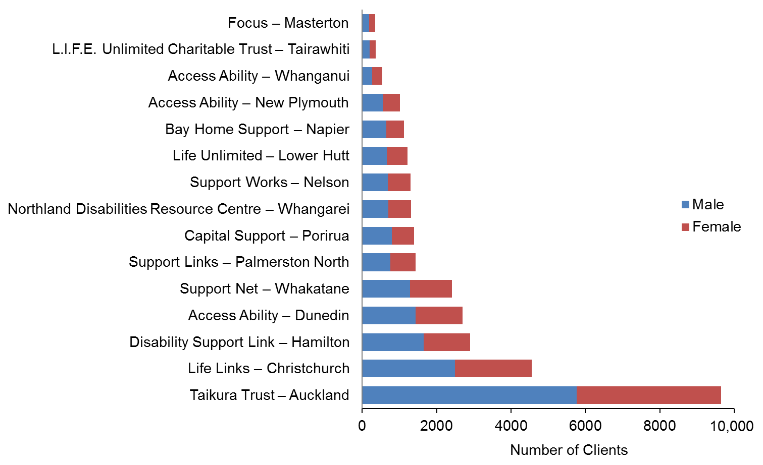

Observation
- Taikura Trust in Auckland has more than twice as many Clients as the second-largest NASC and works with 30% of DSS Clients.

Client demographics, by service

Home and community support
This section provides demographic profiles for the 16,813 DSS Clients who are receiving home and community support services (HCSS). These services include personal care and/or household management carried out in the Client’s home.

Age and sex
Table 11: HCSS Clients, by age and sex
Age group | Male | Female | Total
0−4 | 129 | 86 | 215
5−9 | 506 | 292 | 798
10−14 | 898 | 481 | 1379
15−19 | 923 | 585 | 1508
20−24 | 713 | 513 | 1226
25−29 | 392 | 400 | 792
30−34 | 345 | 311 | 656
35−39 | 263 | 348 | 611
40−44 | 346 | 559 | 905
45−49 | 430 | 639 | 1069
50−54 | 591 | 838 | 1429
55−59 | 637 | 975 | 1612
60−64 | 746 | 1156 | 1902
65−69 | 553 | 1090 | 1643
70−74 | 236 | 601 | 837
75−79 | 56 | 147 | 203
80−84 | 13 | 12 | 25
85+ |  | 3 | 3
Total | 7776 | 9036 | 16,813
 | 54% | 46%

Figure 8: HCSS Clients, by age and sex
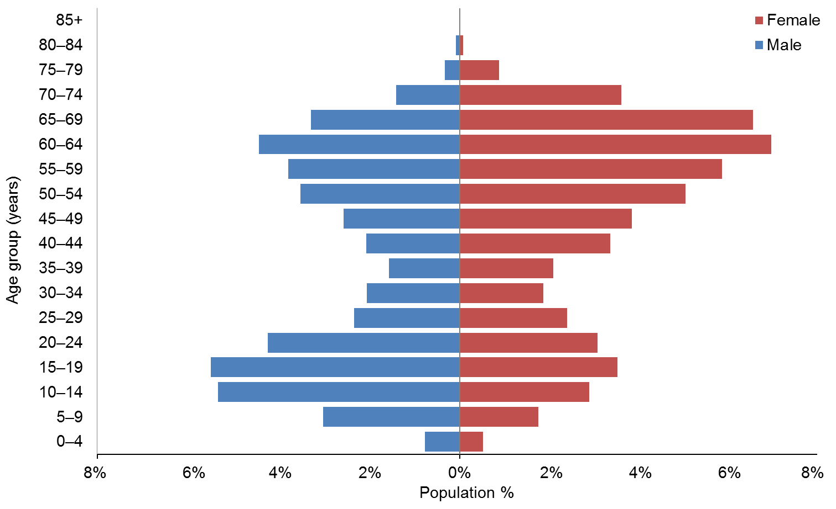

Observations
- The median age is 46 years.
- There are more female than male HCSS Clients.
- There are two peaks in the age distribution of HCSS Clients: male teenagers and females in the 55–69 years age range.

Ethnicity
Table 12: HCSS Clients, by age and ethnicity
Age group | European / Other | Māori | Pacific | Asian | Not stated | Total
0−4 | 128 | 42 | 10 | 9 | 26 | 215
5−9 | 505 | 138 | 55 | 66 | 34 | 798
10−14 | 880 | 251 | 92 | 113 | 43 | 1379
15−19 | 960 | 261 | 125 | 141 | 21 | 1508
20−24 | 787 | 199 | 118 | 115 | 7 | 1226
25−29 | 520 | 130 | 70 | 50 | 22 | 792
30−34 | 448 | 112 | 45 | 43 | 8 | 656
35−39 | 427 | 91 | 58 | 23 | 12 | 611
40−44 | 608 | 172 | 70 | 19 | 36 | 905
45−49 | 727 | 213 | 72 | 37 | 20 | 1069
50−54 | 1000 | 263 | 85 | 49 | 32 | 1429
55−59 | 1129 | 278 | 93 | 67 | 45 | 1612
60−64 | 1437 | 254 | 98 | 51 | 62 | 1902
65−69 | 1279 | 180 | 100 | 34 | 50 | 1643
70−74 | 629 | 81 | 56 | 33 | 38 | 837
75−79 | 170 | 13 | 11 | 6 | 3 | 203
80−84 | 23 | 2 |  |  |  | 25
85+ | 3 |  |  |  |  | 3
Total | 11,660 | 2680 | 1158 | 856 | 459 | 16,813
 | 69% | 16% | 7% | 5% | 3%
Figure 9: HCSS Clients, by age and ethnicity
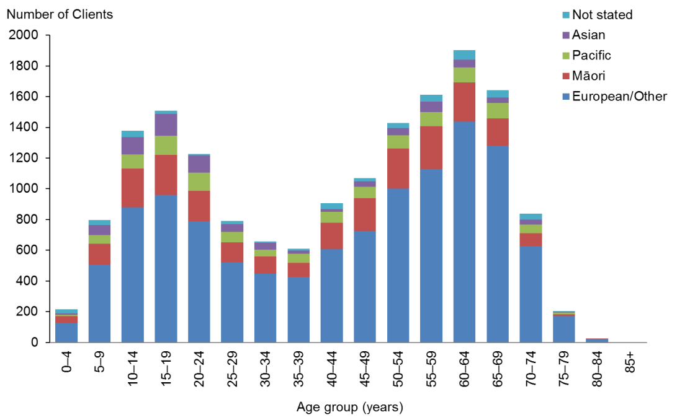

Observation
- Pacific Clients are slightly over-represented in the HCSS Client group.

Marital status
Table 13: HCSS Clients, by marital status and sex
Marital status | Male | Female | Total
Non-partnered, not further defined | 1616 | 1542 | 3158
Married (not separated), not further defined | 448 | 867 | 1315
Non-partnered, never married | 697 | 519 | 1216
Not stated | 193 | 250 | 443
Non-partnered, divorced | 110 | 236 | 346
Non-partnered, widowed | 46 | 247 | 293
Non-partnered, separated | 124 | 164 | 288
Partnered, not further defined | 94 | 135 | 229
First marriage (not separated) | 17 | 33 | 50
Don’t know | 14 | 20 | 34
Remarried (not separated) | 3 | 11 | 14
Response outside scope | 6 | 7 | 13
Opposite-sex partnership | 1 | 5 | 6
Same-sex partnership |  | 4 | 4
Blank | 4408 | 4996 | 9404
Total | 7777 | 9036 | 16,813

Observations
- Marital status was not recorded for most Clients (56%).
- Of the Clients with marital status recorded, 72% were not in any form of partnership or marriage.

Accommodation
Table 14: HCSS Clients, by sex and accommodation type
Accommodation type | Male | Female | Total
Own / family home | 4170 | 4886 | 9056
Rental accommodation | 1271 | 1408 | 2679
Unknown | 701 | 924 | 1625
Housing New Zealand accommodation | 660 | 834 | 1494
Other | 386 | 485 | 871
Community residential home | 371 | 267 | 638
Council accommodation | 88 | 94 | 182
Boarder | 60 | 60 | 120
Rest home / continuing care hospital | 42 | 42 | 84
Unit in a retirement village | 20 | 28 | 48
Unit in a retirement village − licence to occupy | 5 | 8 | 13
Prison | 2 |  | 2
No fixed abode | 1 |  | 1
Total | 7777 | 9036 | 16,813

Observation
- Of the HCSS Clients whose accommodation type was recorded, the majority (54%) lived in their own home or their family home (a drop from 65% in 2013).

Location
Table 15: HCSS Clients, by region and ethnicity
Region | European / Other | Māori | Pacific | Asian | Not stated | Total | %
Auckland | 2792 | 674 | 899 | 609 | 188 | 5162 | 31
Canterbury | 1857 | 209 | 30 | 64 | 122 | 2282 | 14
Wellington | 1060 | 173 | 106 | 77 | 46 | 1462 | 9
Waikato | 887 | 254 | 29 | 31 | 27 | 1228 | 7
Manawatu−Wanganui | 923 | 216 | 30 | 11 | 23 | 1203 | 7
Otago | 931 | 47 | 15 | 8 | 10 | 1011 | 6
Bay of Plenty | 652 | 323 | 9 | 16 | 7 | 1007 | 6
Northland | 546 | 388 | 10 | 17 | 2 | 963 | 6
Taranaki | 481 | 103 | 3 | 5 | 3 | 595 | 4
Hawke’s Bay | 367 | 94 | 18 | 6 | 2 | 487 | 3
Southland | 432 | 46 |  | 1 | 6 | 485 | 3
Marlborough | 228 | 30 |  |  |  | 258 | 2
Nelson | 201 | 21 | 1 | 7 |  | 230 | 1
Gisborne | 74 | 89 | 6 | 1 | 9 | 179 | 1
Tasman | 151 | 10 | 1 | 3 |  | 165 | 1
West Coast | 78 | 3 | 1 |  | 14 | 96 | 1
Total | 11,660 | 2680 | 1158 | 856 | 459 | 16,813 | 100

Figure 10: HCSS Clients, by region and ethnicity
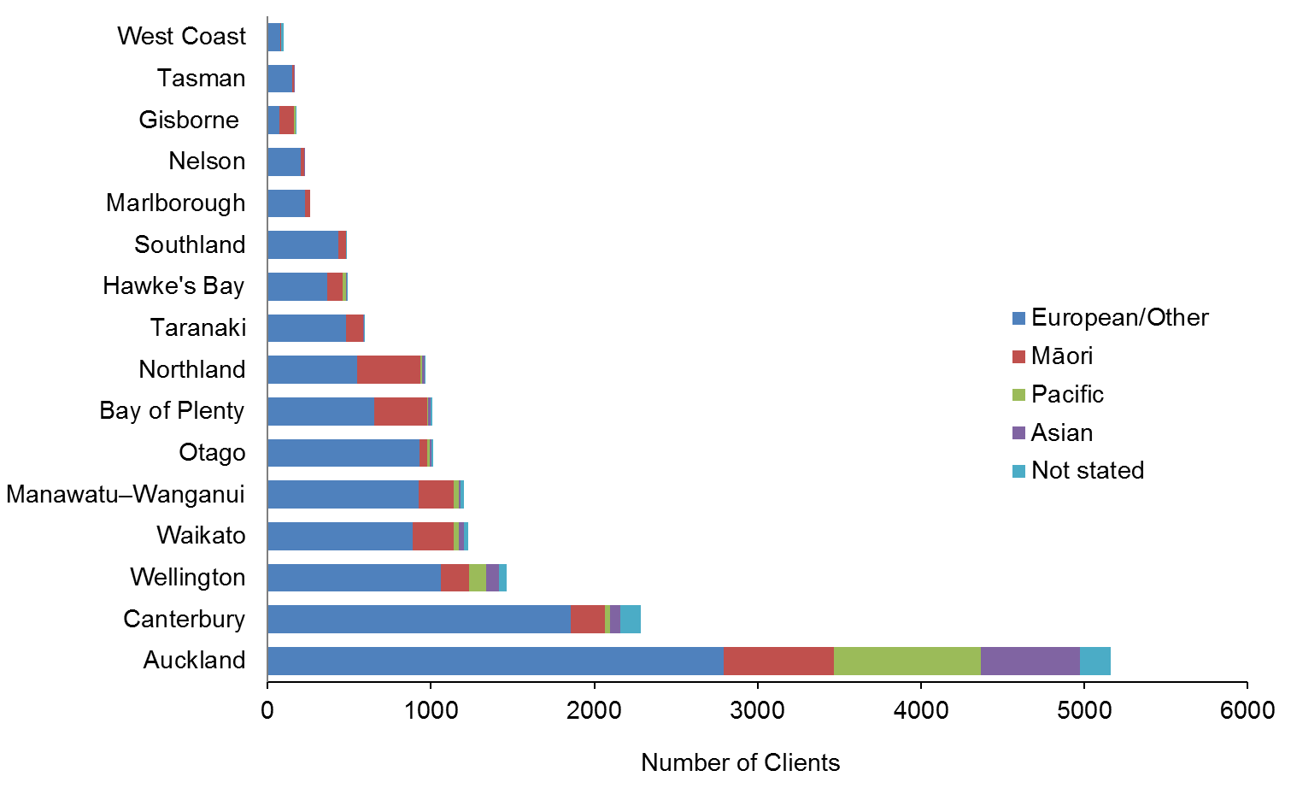

Observations
- Almost one-third (31%) of HCSS Clients live in the Auckland region.
- The Auckland region has the largest ethnic diversity of HCSS Clients: 54% European/Other, 17% Pacific, 13% Māori and 12% Asian.

Principal disability
Table 16: HCSS Clients, by principal disability type and sex*
Principal disability | Male | Female | Total | %
Physical | 3527 | 5822 | 9349 | 56
Intellectual | 2719 | 2257 | 4976 | 30
Autism spectrum disorder | 983 | 281 | 1264 | 8
Sensory | 323 | 384 | 707 | 4
Neurological | 225 | 292 | 517 | 3
Total | 7777 | 9036 | 16,813 | 100
* Where Clients recorded two principal disabilities, only the first one has been used in this report.

Figure 11: HCSS Clients, by principal disability type and sex
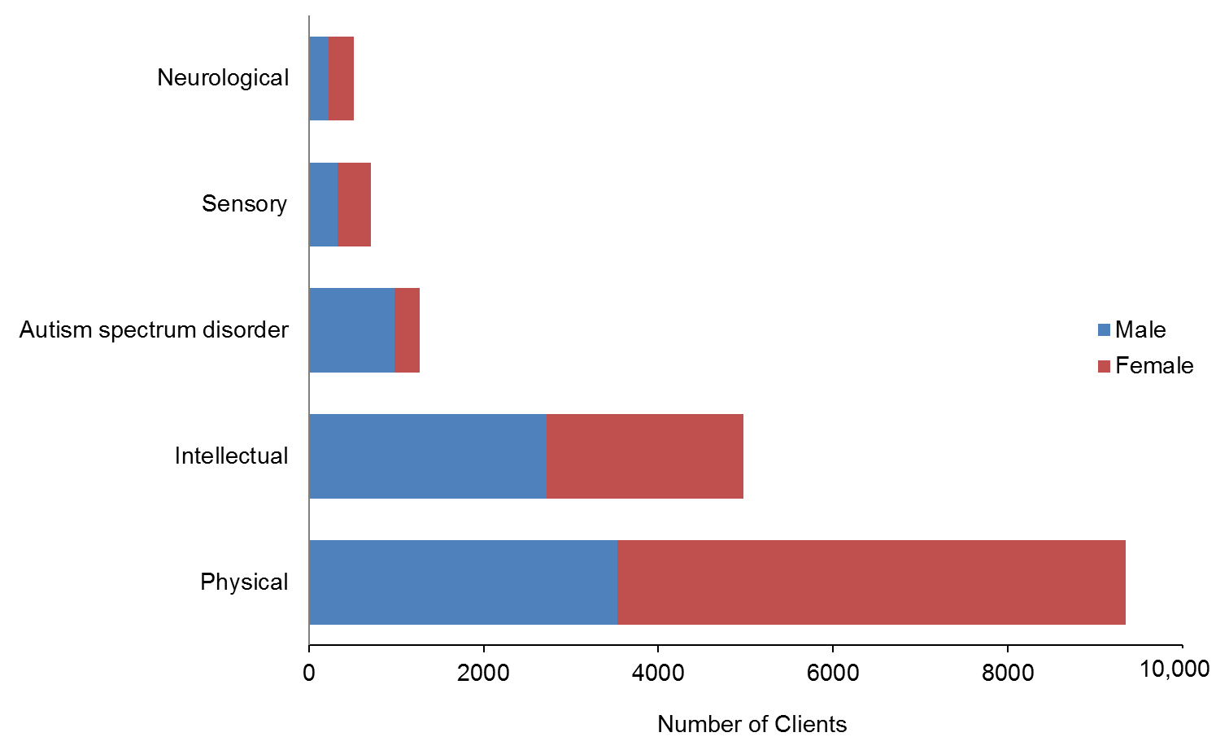

Observations
- Over half of Clients using HCSS have a physical disability as their primary disability.
- The single largest Client group using HCSS is women with physical disabilities (35%).

Support package allocation
Table 17: HCSS Clients, by SPA level and sex
SPA level | Male | Female | Total | %
Very Low | 1 | 1 | 2 | 0
Low | 120 | 331 | 451 | 3
Medium | 1714 | 2970 | 4684 | 28
High | 3373 | 3712 | 7085 | 42
Very High | 2569 | 2022 | 4591 | 27
Total | 7656 | 8704 | 16,360 | 97

Figure 12: HCSS Clients, by SPA level and sex
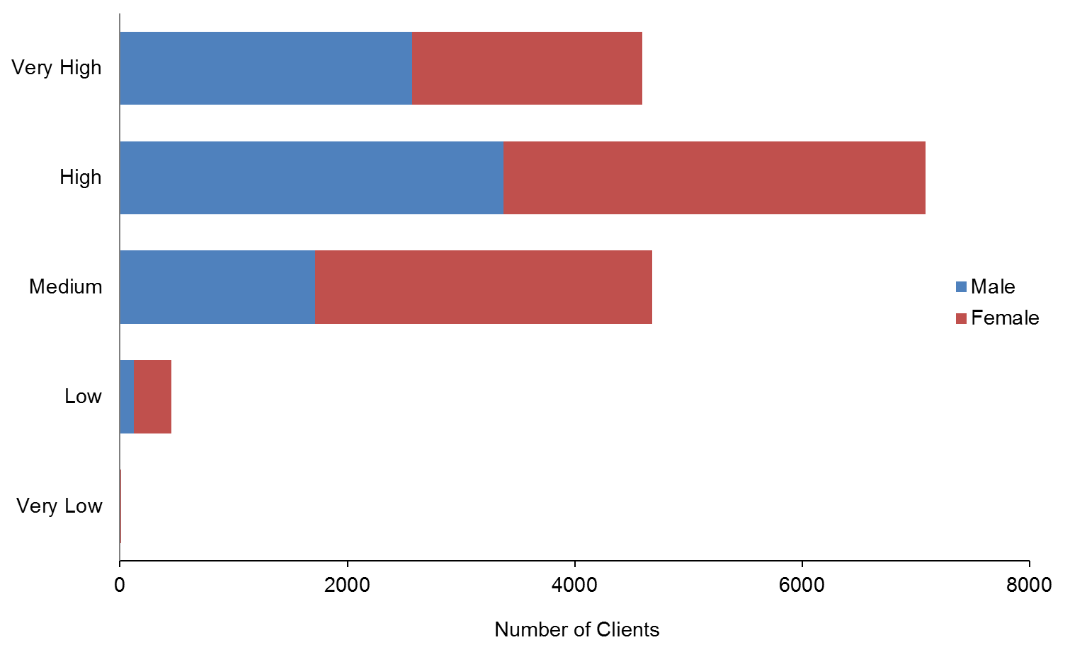

Observations
- One-quarter of HCSS Clients have Very High SPAs.
- Two-thirds of HCSS Clients have High (42%) or Medium (28%) SPAs.

Carer support
This section provides demographic profiles for the 16,785 DSS Clients whose carers were allocated the carer support subsidy of $76 per day in order to access a break from caring. The NASC allocates a number of days per year to each carer on the basis of need. Some of these Clients also appear in demographics for other services.

Age and sex
Table 18: Carer support Clients, by age and sex
Age group | Male | Female | Total
0−4 | 565 | 307 | 872
5−9 | 2293 | 942 | 3235
10−14 | 2636 | 1166 | 3802
15−19 | 1933 | 1073 | 3006
20−24 | 944 | 600 | 1544
25−29 | 446 | 356 | 802
30−34 | 258 | 223 | 481
35−39 | 198 | 181 | 379
40−44 | 184 | 201 | 385
45−49 | 175 | 185 | 360
50−54 | 195 | 251 | 446
55−59 | 189 | 236 | 425
60−64 | 209 | 253 | 462
65−69 | 173 | 230 | 403
70−74 | 67 | 83 | 150
75−79 | 11 | 18 | 29
80−84 | 3 | 1 | 4
85+ | 0 |  | 0
Total | 10,479 | 6306 | 16,785
 | 62% | 38%

Figure 13: Age and sex of carer support Clients
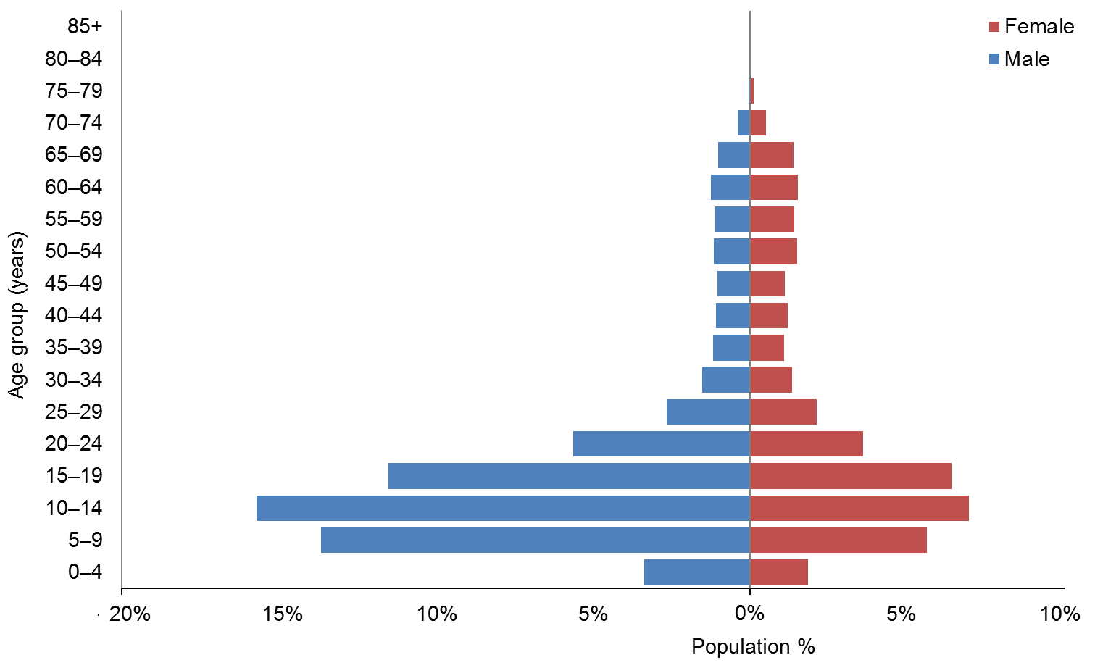

Observations
- The median age of carer support Clients is 15 years.
- Almost two-thirds (65%) of Clients whose carers are receiving carer support are aged under 20.

Ethnicity
Table 19: Carer support Clients, by age and ethnicity
Age group | European/Other | Māori | Pacific | Asian | Not stated | Total
0−4 | 447 | 182 | 57 | 65 | 121 | 872
5−9 | 1838 | 637 | 247 | 249 | 264 | 3235
10−14 | 2423 | 712 | 247 | 269 | 151 | 3802
15−19 | 1930 | 582 | 211 | 221 | 62 | 3006
20−24 | 981 | 279 | 150 | 124 | 10 | 1544
25−29 | 503 | 148 | 77 | 54 | 20 | 802
30−34 | 299 | 90 | 52 | 33 | 7 | 481
35−39 | 260 | 62 | 38 | 16 | 3 | 379
40−44 | 247 | 73 | 49 | 8 | 8 | 385
45−49 | 227 | 67 | 34 | 21 | 11 | 360
50−54 | 296 | 84 | 39 | 19 | 8 | 446
55−59 | 268 | 70 | 47 | 23 | 17 | 425
60−64 | 300 | 81 | 45 | 23 | 13 | 462
65−69 | 255 | 61 | 52 | 15 | 20 | 403
70−74 | 81 | 25 | 30 | 10 | 4 | 150
75−79 | 17 | 3 | 5 | 2 | 2 | 29
80−84 | 4 |  |  |  |  | 4
85+ | 0 |  |  |  |  | 0
Total | 10,376 | 3156 | 1380 | 1152 | 721 | 16,785
 | 62% | 19% | 8% | 7% | 4%

Figure 14: Carer support Clients, by age and ethnicity
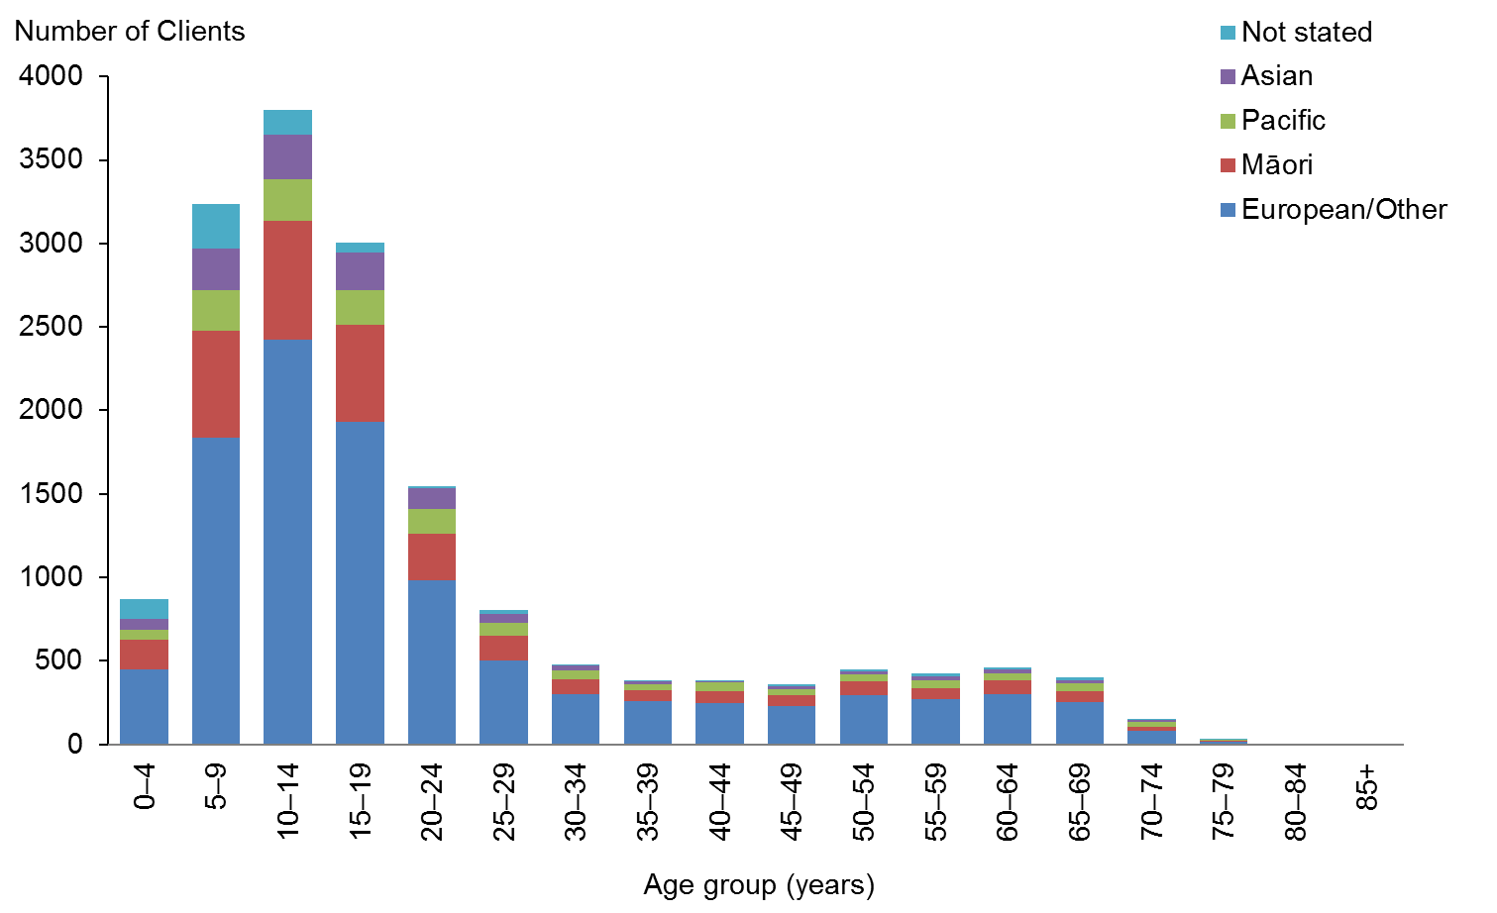

Observations
- Māori, Pacific and Asian Clients are over-represented among the DSS Clients using carer support.
- European/Other people are under-represented in carer support, compared with 69% in the DSS Client population.

Accommodation
Table 20: Carer support Clients, by sex and accommodation type
Accommodation | Male | Female | Total
Own / family home | 6926 | 4179 | 11,105
Rental accommodation | 1517 | 840 | 2357
Unknown | 958 | 574 | 1532
Housing New Zealand accommodation | 516 | 370 | 886
Other | 405 | 249 | 654
Community residential home | 77 | 41 | 118
Boarder | 44 | 36 | 80
Rest home / continuing care hospital | 13 | 7 | 20
Council accommodation | 6 | 3 | 9
Prison | 5 | 3 | 8
Unit in a retirement village | 6 | 2 | 8
No fixed abode | 4 | 1 | 5
Unit in a retirement village − licence to occupy | 2 | 1 | 3
Total | 10,479 | 6306 | 16,785

Observation
- Two-thirds (66%) of carer support Clients are living in their own homes, which reflects the youthful nature of this Client group.

Marital status
Table 21: Carer support Clients, by marital status and sex
Marital status | Male | Female | Total
Non-partnered, not further defined | 1747 | 1061 | 2808
Non-partnered, never married | 936 | 508 | 1444
Married (not separated), not further defined | 285 | 396 | 681
Not stated | 157 | 98 | 255
Partnered, not further defined | 43 | 47 | 90
Non-partnered, separated | 14 | 20 | 34
Non-partnered, divorced | 13 | 16 | 29
Non-partnered, widowed | 8 | 18 | 26
First marriage (not separated) | 10 | 9 | 19
Response outside scope | 12 | 5 | 17
Don’t know | 5 | 7 | 12
Remarried (not separated) | 5 | 3 | 8
Same-sex partnership |  | 2 | 2
Opposite-sex partnership |  | 1 | 1
Blank | 7244 | 4115 | 11,359
Total | 10,479 | 6306 | 16,785

Observations
- Marital status was not recorded for 68% of carer support Clients. Given the young age of the majority of Clients, it can be assumed that most would be single.
- Of the remaining Clients, carer support is used mostly by Clients who do not have partners.

Location
Table 22: Carer support Clients, by region and ethnicity
Region | European / Other | Māori | Pacific | Asian | Not stated | Total | %
Auckland | 2852 | 799 | 1072 | 812 | 519 | 6054 | 36
Canterbury | 1774 | 250 | 43 | 91 | 79 | 2237 | 13
Waikato | 1009 | 459 | 45 | 54 | 31 | 1598 | 10
Wellington | 947 | 208 | 131 | 92 | 37 | 1415 | 8
Bay of Plenty | 741 | 402 | 20 | 26 | 4 | 1193 | 7
Manawatu−Wanganui | 558 | 193 | 17 | 24 | 9 | 801 | 5
Otago | 661 | 68 | 11 | 13 | 11 | 764 | 5
Northland | 337 | 326 | 10 | 15 | 4 | 692 | 4
Taranaki | 334 | 94 | 3 | 6 | 5 | 442 | 3
Hawke’s Bay | 261 | 126 | 16 | 13 | 8 | 424 | 3
Southland | 323 | 49 | 4 | 1 | 4 | 381 | 2
Marlborough | 146 | 28 |  | 1 |  | 175 | 1
Tasman | 149 | 21 | 1 | 1 |  | 172 | 1
Nelson | 131 | 28 | 1 | 2 |  | 162 | 1
Gisborne | 57 | 92 | 6 | 1 | 2 | 158 | 1
West Coast | 97 | 12 |  |  | 8 | 117 | 1
Total | 10,377 | 3155 | 1380 | 1152 | 721 | 16,785 | 100

Figure 15: Carer support Clients, by region and ethnicity
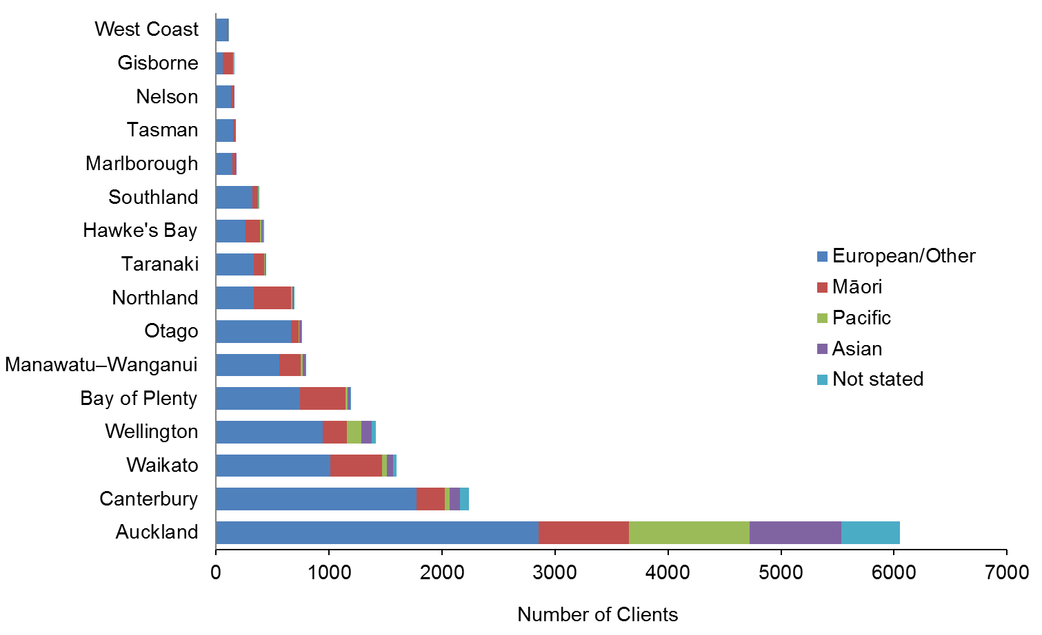

Observations
- Over one-third (36%) of carer support Clients live in the Auckland region.
- Auckland is the only region where less than half (47%) of carer support Clients are European/Other.

Principal disability
Table 23: Carer support Clients, by sex and principal disability*
Principal disability | Male | Female | Total | %
Intellectual | 4460 | 3107 | 7567 | 45%
Autistic spectrum disorder | 3650 | 832 | 4482 | 27%
Physical | 1963 | 2007 | 3970 | 24%
Sensory | 277 | 250 | 527 | 3%
Neurological | 129 | 110 | 239 | 1%
Total | 10,479 | 6306 | 16,785 | 100%
* Where Clients recorded two principal disabilities, this research has used only the first one.

Figure 16: Carer support Clients, by sex and principal disability
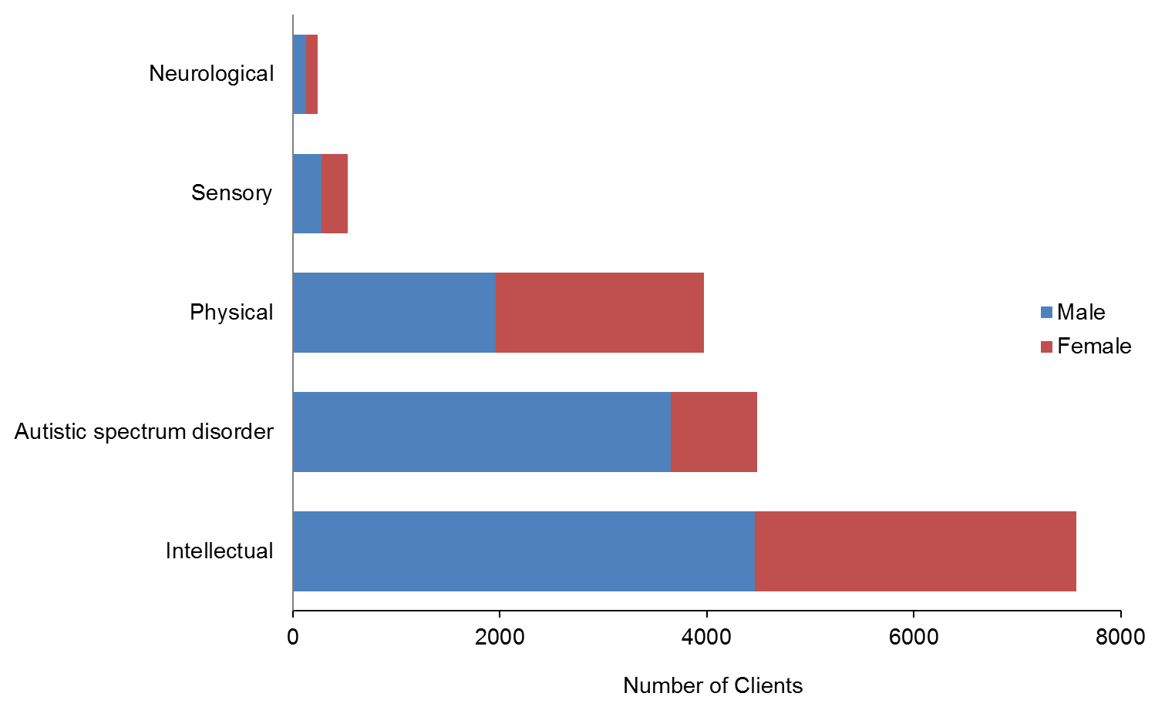

Observations
- Almost a half of carer support Clients have an intellectual disability.
- More than a quarter of carer support clients have ASD and 81% of these are male.

Support package allocation
Table 24: Carer support Clients, by SPA level and sex
SPA level | Male | Female | Total | %
Very Low | 15 | 6 | 21 | 0
Low | 508 | 250 | 758 | 5
Medium | 4714 | 2631 | 7345 | 44
High | 3696 | 2441 | 6137 | 37
Very High | 1546 | 978 | 2524 | 15
Total | 10,464 | 6300 | 16,764 | 100

Figure 17: Carer support Clients, by SPA level and sex
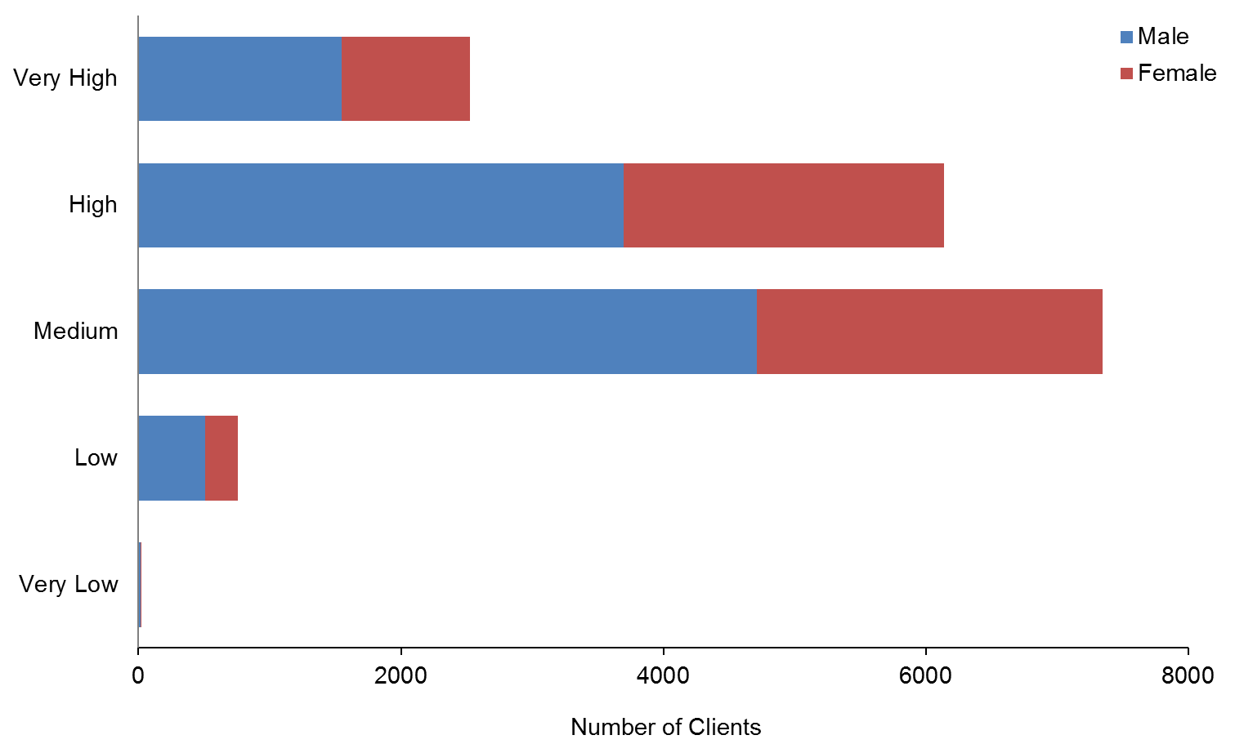

Observation
- Most (81%) carer support Clients have Medium to High SPA levels.

Community residential services
This section provides demographic profiles of the 6600 DSS Clients receiving community residential services. It does not analyse residential Clients living in hospitals or rest home services.

Age and sex
Table 25: Community residential services Clients, by age and sex
Age group | Male | Female | Total
0−4 | 1 | 1 | 2
5−9 | 5 | 3 | 8
10−14 | 28 | 2 | 30
15−19 | 149 | 63 | 212
20−24 | 271 | 165 | 436
25−29 | 316 | 203 | 519
30−34 | 340 | 196 | 536
35−39 | 333 | 218 | 551
40−44 | 438 | 345 | 783
45−49 | 488 | 344 | 832
50−54 | 521 | 405 | 926
55−59 | 392 | 311 | 703
60−64 | 284 | 223 | 507
65−69 | 169 | 159 | 328
70−74 | 89 | 78 | 167
75−79 | 33 | 48 | 81
80−84 | 13 | 10 | 23
85+ | 5 | 11 | 16
Total | 3875 | 2785 | 6660
 | 58% | 42%

Figure 18: Age and sex of community residential services Clients
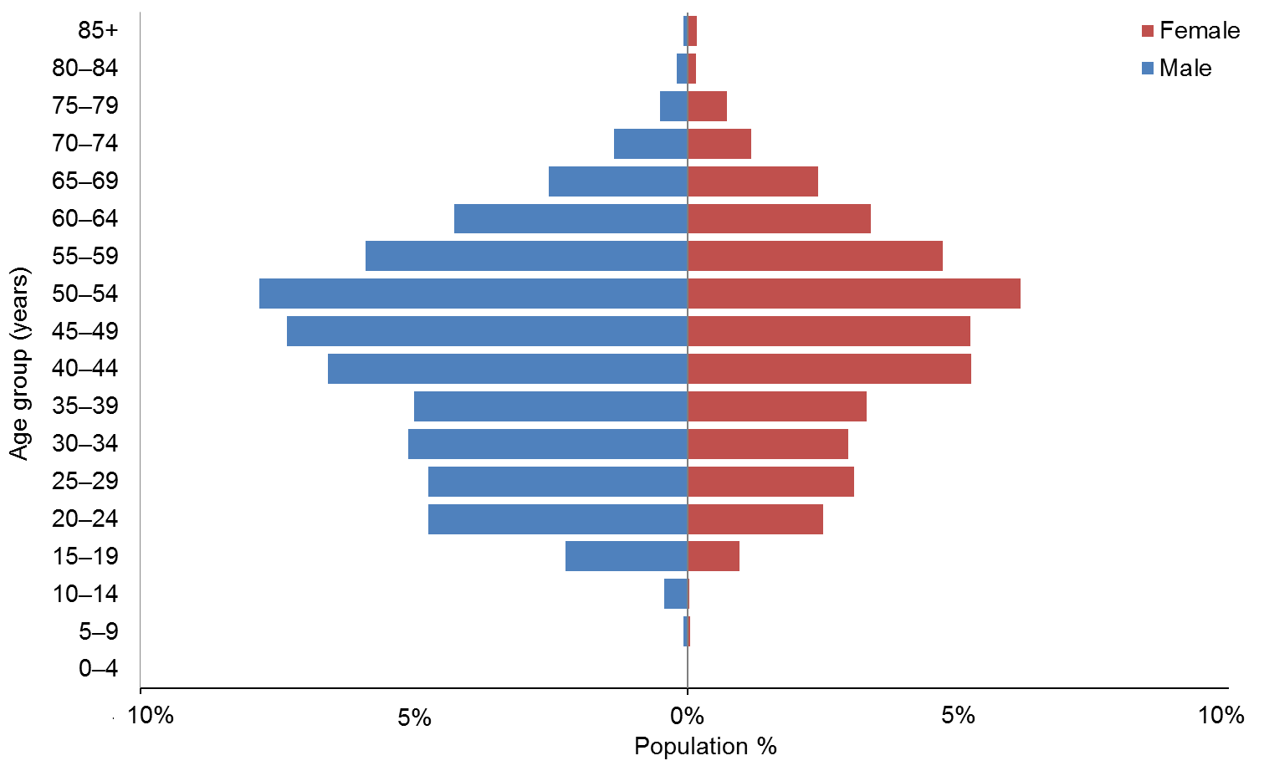

Observations
- The median age of community residential Clients is 47.
- There are significantly more males than females using community residential services.
- The 45–54 years age groups are the largest for both males and females.

Ethnicity
Table 26: Community residential services Clients, by ethnicity and age
Age group | European / Other | Māori | Pacific | Asian | Not stated | Total
0−4 | 2 |  |  |  |  | 2
5−9 | 5 | 2 |  | 1 |  | 8
10−14 | 20 | 8 | 1 | 1 |  | 30
15−19 | 142 | 46 | 15 | 7 | 2 | 212
20−24 | 308 | 88 | 16 | 17 | 7 | 436
25−29 | 373 | 87 | 17 | 21 | 21 | 519
30−34 | 375 | 94 | 30 | 26 | 11 | 536
35−39 | 401 | 98 | 27 | 11 | 14 | 551
40−44 | 618 | 114 | 21 | 6 | 24 | 783
45−49 | 620 | 130 | 37 | 12 | 33 | 832
50−54 | 724 | 133 | 26 | 8 | 35 | 926
55−59 | 561 | 94 | 9 | 5 | 34 | 703
60−64 | 414 | 64 | 9 | 3 | 17 | 507
65−69 | 281 | 27 | 7 | 3 | 10 | 328
70−74 | 152 | 6 |  | 1 | 8 | 167
75−79 | 71 | 8 |  | 1 | 1 | 81
80−84 | 18 | 5 |  |  |  | 23
85+ | 14 |  |  |  | 2 | 16
Total | 5099 | 1004 | 215 | 123 | 219 | 6660
 | 77% | 15% | 3% | 2% | 3% | 100%

Figure 19: Community residential services Clients, by ethnicity and age
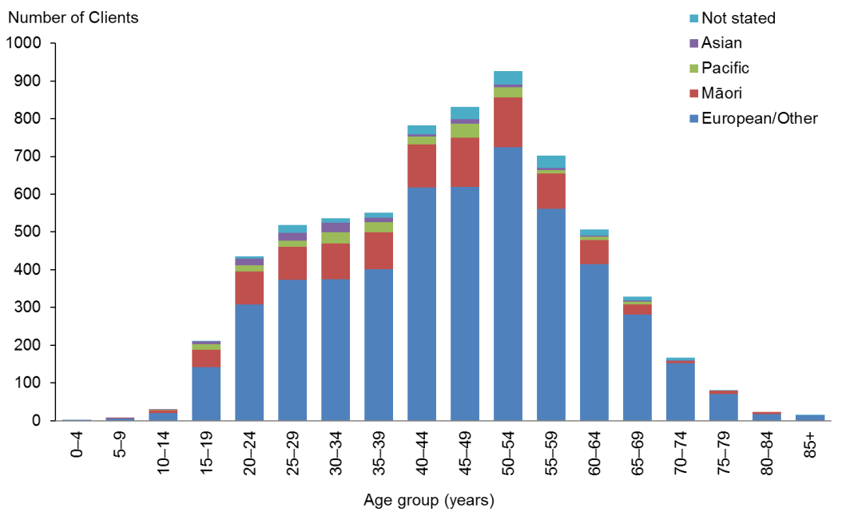

Observations
- Pacific and Asian Clients are significantly under-represented users of residential services.
- Māori are only slightly under-represented.
- European/Other Clients are over-represented.

Marital status
Table 27: Community residential services Clients, by marital status and sex
Marital status | Male | Female | Total
Non-partnered, not further defined | 845 | 626 | 1471
Non-partnered, never married | 403 | 236 | 639
Not stated | 91 | 37 | 128
Married (not separated), not further defined | 21 | 29 | 50
Non-partnered, divorced | 8 | 10 | 18
Non-partnered, separated | 8 | 8 | 16
Partnered, not further defined | 8 | 6 | 14
Non-partnered, widowed | 1 | 9 | 10
First marriage (not separated) | 2 | 1 | 3
Opposite-sex partnership | 1 | 2 | 3
Don’t know | 1 | 1 | 2
Response outside scope | 1 | 1 | 2
Same-sex partnership | 1 | 1 | 2
Blank | 2484 | 1818 | 4302
Total | 3875 | 2785 | 6660

Observations
- Marital status is not recorded for 65% of community residential services Clients.
- Of those for whom marital status was recorded, only 3% were in some form of partnership.

Accommodation
Table 28: Community residential services Clients, by accommodation type and sex
Accommodation | Male | Female | Total
Community residential home | 3135 | 2224 | 5359
Other | 249 | 214 | 463
Own / family home | 235 | 140 | 375
Rental accommodation | 62 | 70 | 132
Unknown | 78 | 47 | 125
Boarder | 73 | 50 | 123
Rest home / continuing care hospital | 29 | 27 | 56
Housing New Zealand accommodation | 6 | 11 | 17
Council accommodation | 2 | 1 | 3
Prison | 3 |  | 3
No fixed abode | 1 | 1 | 2
Unit in a retirement village | 1 |  | 1
Unit in a retirement village − licence to occupy | 1 |  | 1
Total | 3875 | 2785 | 6660

Observation
- The majority (80%) of Clients are living in community residential homes.

Location
Table 29: Community residential services Clients, by region and ethnicity
Region | European / Other | Māori | Pacific | Asian | Not stated | Total | %
Auckland | 1109 | 261 | 150 | 76 | 19 | 1615 | 24
Canterbury | 849 | 52 | 7 | 7 | 74 | 989 | 15
Waikato | 553 | 185 | 11 | 7 | 59 | 815 | 12
Wellington | 511 | 81 | 24 | 11 | 25 | 652 | 10
Manawatu−Wanganui | 432 | 95 | 2 | 1 | 12 | 542 | 8
Otago | 340 | 23 | 4 | 5 | 8 | 380 | 6
Hawke’s Bay | 280 | 50 | 5 | 9 | 12 | 356 | 5
Bay of Plenty | 256 | 87 | 3 | 1 | 2 | 349 | 5
Nelson | 208 | 23 | 1 | 2 | 1 | 235 | 4
Northland | 133 | 70 | 3 | 1 |  | 207 | 3
Southland | 135 | 5 | 2 |  | 2 | 144 | 2
Taranaki | 119 | 20 |  | 1 | 1 | 141 | 2
Marlborough | 56 | 13 | 1 | 1 |  | 71 | 1
Gisborne | 29 | 34 |  |  | 1 | 64 | 1
Tasman | 52 | 3 | 1 | 1 |  | 57 | 1
West Coast | 37 | 2 | 1 |  | 3 | 43 | 1
Total | 5099 | 1004 | 215 | 123 | 219 | 6660 | 100

Figure 20: Community residential services Clients, by region and ethnicity
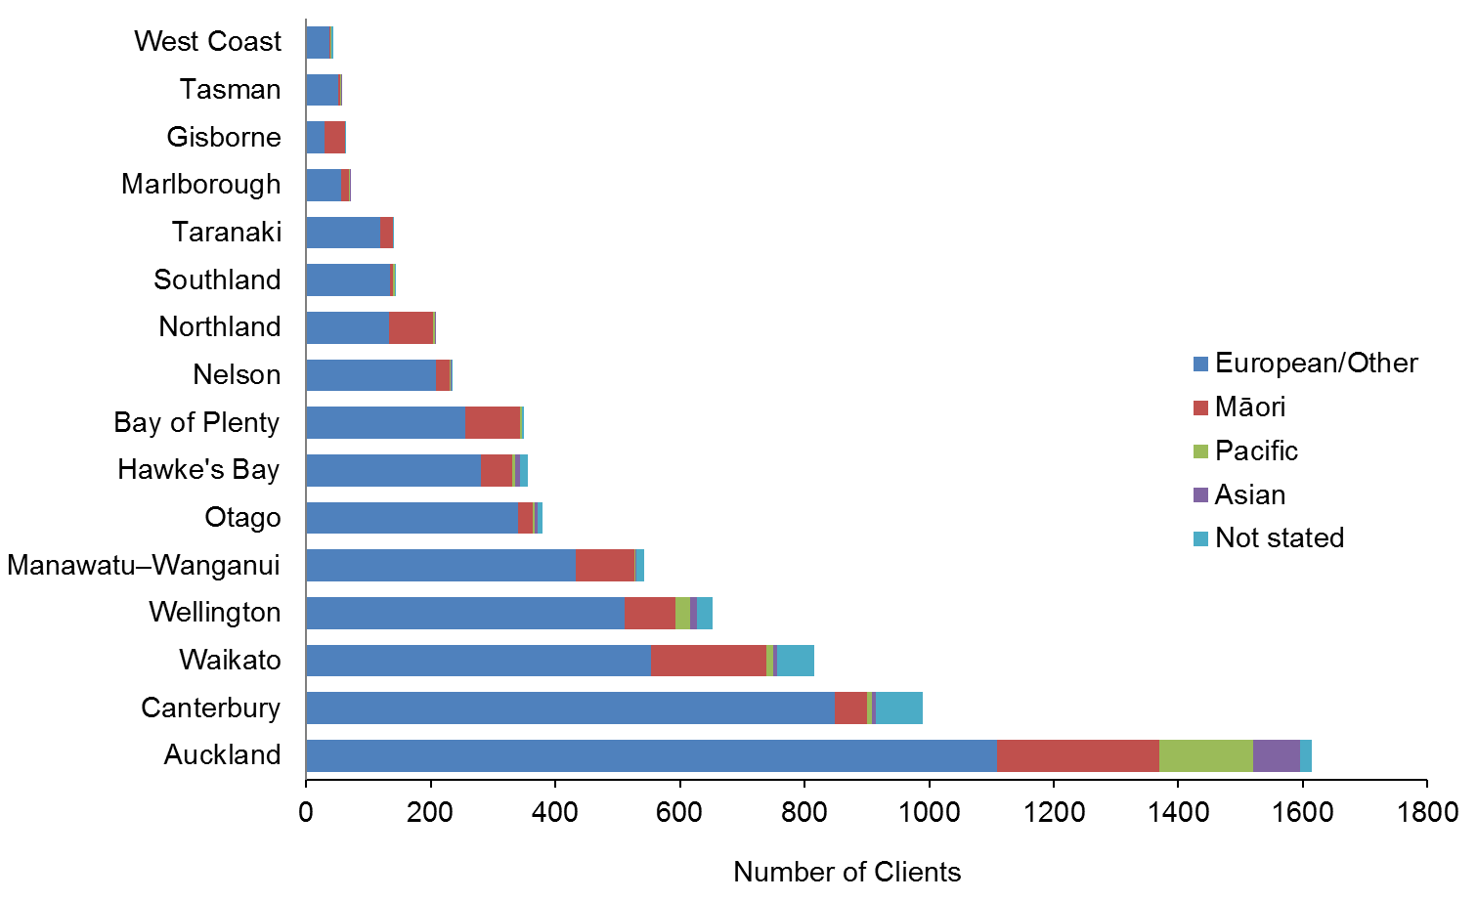

Observation
- The Auckland and Waikato regions have the largest proportion (one-third) of residential Clients who are non-European/Other.

Principal disability
Table 30: Community residential services Clients, by principal disability and sex*
Principal disability | Male | Female | Total | %
Intellectual | 3160 | 2325 | 5485 | 82
Physical | 388 | 336 | 724 | 11
Autism spectrum disorder | 257 | 68 | 325 | 5
Neurological | 35 | 28 | 63 | 1
Sensory | 35 | 28 | 63 | 1
Total | 3875 | 2785 | 6660 | 100
* Where a Client recorded two principal disabilities, this report has used only the first one.

Figure 21: Community residential services Clients, by principal disability and sex
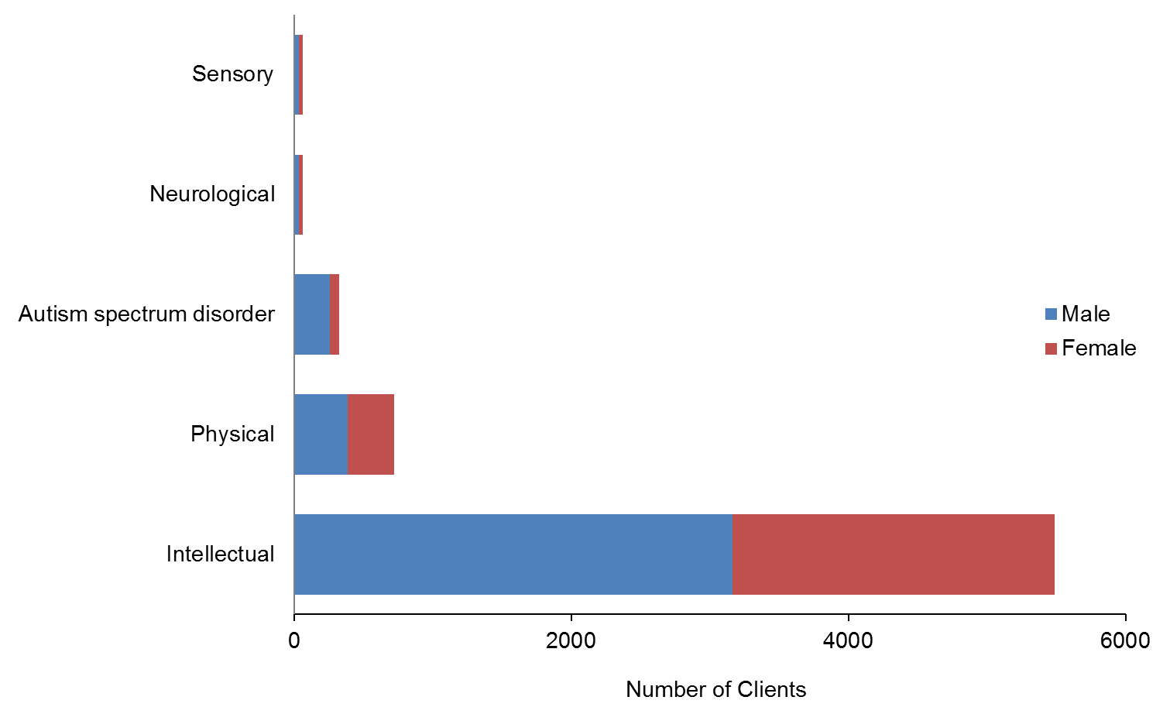

Observation
- Over 80% of Clients in community residential services have an intellectual disability as their primary disability. Many of these Clients also have a physical disability.

Support package allocation
Table 31: Community residential services Clients, by SPA level and sex
SPA level | Male | Female | Total
Very High | 2571 | 1863 | 4434
High | 1006 | 800 | 1806
Medium | 106 | 97 | 203
Low | 8 | 2 | 10
Very Low | 1 | 0 | 1
Blank | 183 | 23 | 206
Total | 3875 | 2785 | 6660

Figure 22: Community residential services Clients, by SPA level and sex
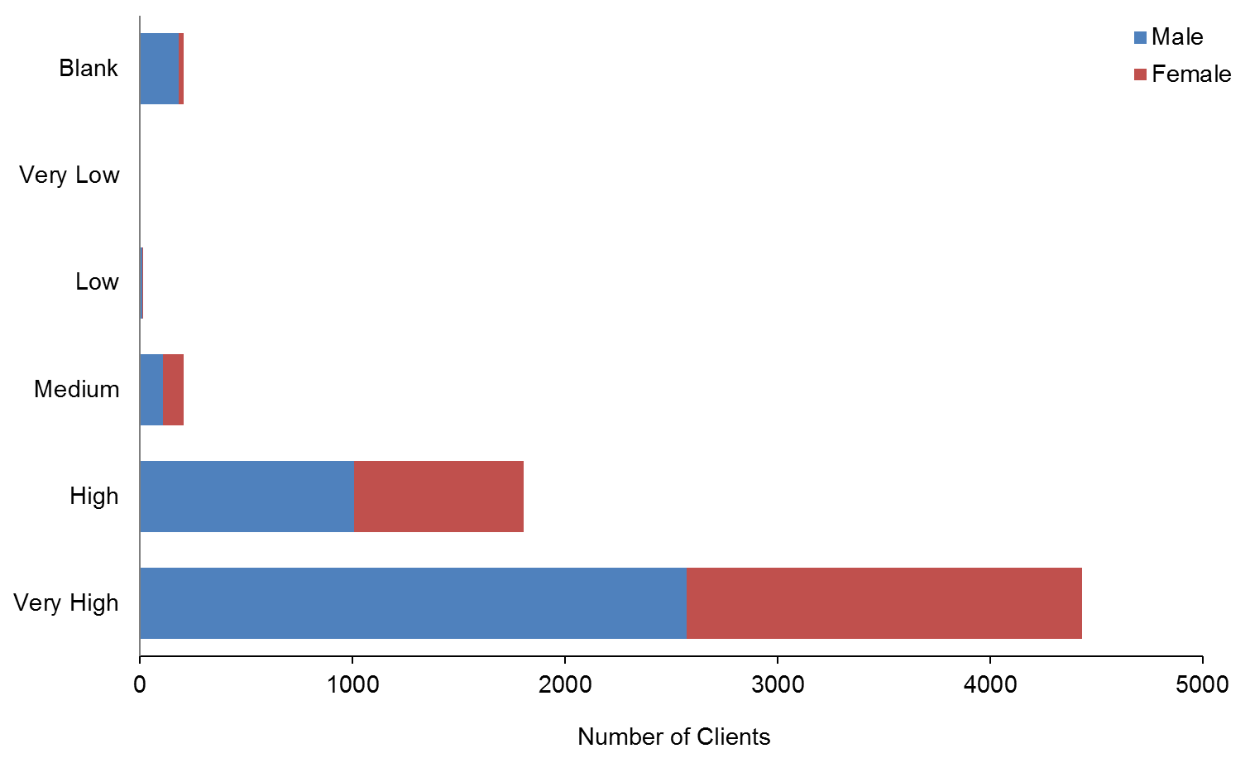

Observation
- 94% of community residential services Clients have High or Very High SPAs.

Supported living
This section provides demographic profiles of the 3283 DSS Clients using supported living services. Some of these Clients will also appear in demographics for other services.

Age and sex
Table 32: Clients using supported living services, by age and sex
Age group | Male | Female | Total
0−4 | 3 | 2 | 5
5−9 | 8 | 2 | 10
10−14 | 7 | 2 | 9
15−19 | 68 | 43 | 111
20−24 | 218 | 158 | 376
25−29 | 210 | 179 | 389
30−34 | 161 | 133 | 294
35−39 | 163 | 150 | 313
40−44 | 159 | 185 | 344
45−49 | 201 | 161 | 362
50−54 | 187 | 165 | 352
55−59 | 149 | 143 | 292
60−64 | 124 | 111 | 235
65−69 | 76 | 55 | 131
70−74 | 27 | 15 | 42
75−79 | 5 | 6 | 11
80−84 | 3 | 1 | 4
85+ |  | 2 | 2
Total | 1769 | 1513 | 3282
 | 54% | 46%

Figure 23: Age and sex of Clients using supported living services
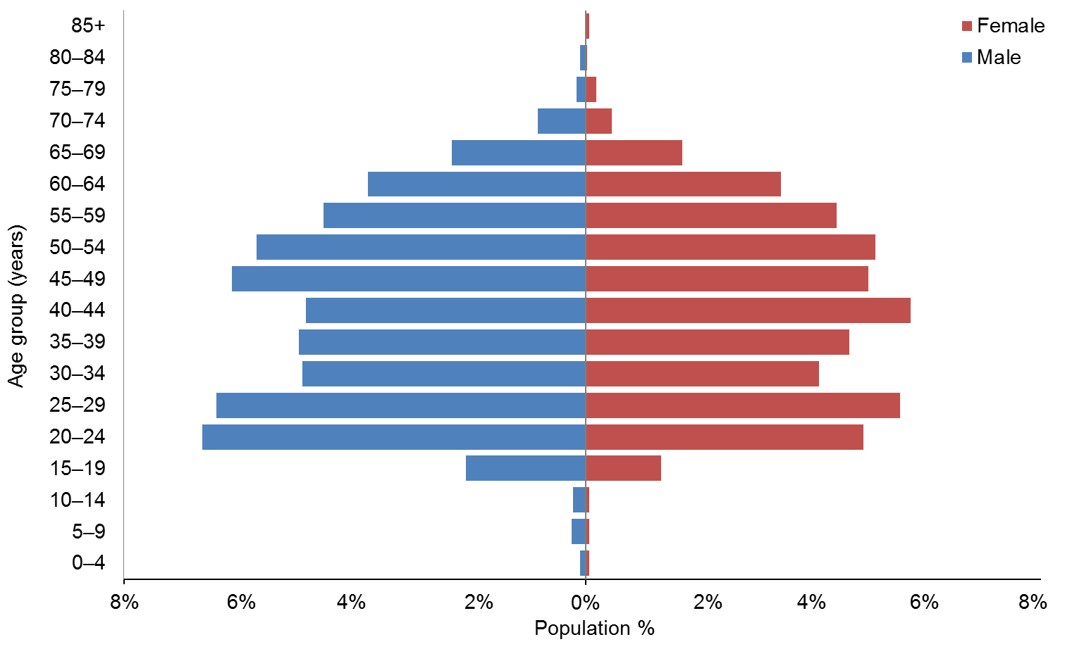

Observations
- The median age of supported living Clients is 41 years.
- There are slightly more males than females receiving supported living services.
- The number of Clients using supported living services has increased by 486 (17%) since 2013.

Ethnicity
Table 33: Clients using supported living services, by ethnicity and age
Age group | European / Other | Māori | Pacific | Asian | Not stated | Total
0−4 | 2 | 2 |  |  | 1 | 5
5−9 | 3 |  | 3 | 1 | 3 | 10
10−14 | 7 | 2 |  |  |  | 9
15−19 | 78 | 26 | 2 | 2 | 3 | 111
20−24 | 274 | 64 | 21 | 13 | 4 | 376
25−29 | 286 | 66 | 12 | 16 | 9 | 389
30−34 | 228 | 44 | 8 | 5 | 9 | 294
35−39 | 241 | 48 | 10 | 6 | 8 | 313
40−44 | 271 | 53 | 8 | 2 | 10 | 344
45−49 | 293 | 50 | 6 | 4 | 9 | 362
50−54 | 287 | 44 | 5 | 3 | 13 | 352
55−59 | 235 | 40 |  | 5 | 12 | 292
60−64 | 186 | 28 | 4 | 6 | 11 | 235
65−69 | 114 | 10 | 1 |  | 6 | 131
70−74 | 37 | 3 |  |  | 2 | 42
75−79 | 11 |  |  |  |  | 11
80−84 | 4 |  |  |  |  | 4
85+ | 2 |  |  |  |  | 2
Total | 2559 | 480 | 80 | 63 | 100 | 3282
 | 78% | 15% | 2% | 2% | 3%

Figure 24: Clients using supported living services, by ethnicity and age group
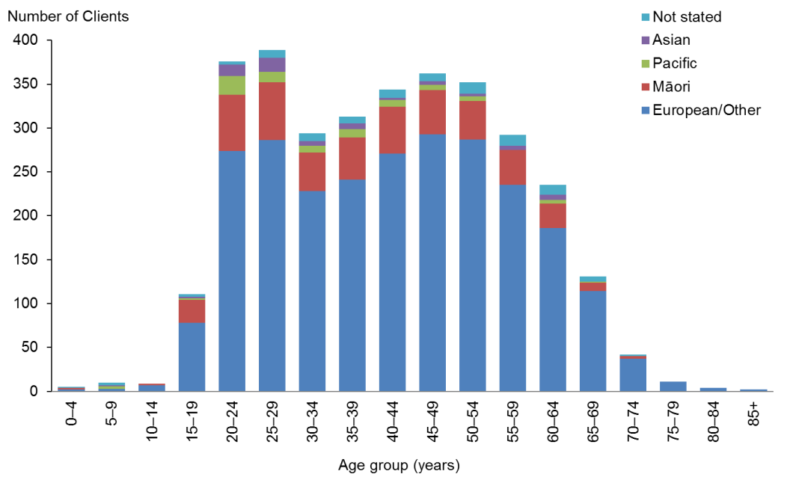

Observations
- European/Other people are significantly over-represented among users of supported living services.
- Māori are slightly under-represented.
- Pacific and Asian people are significantly under-represented.

Marital status
Table 34: Clients using supported living services, by marital status and sex
Marital status | Male | Female | Total
Non-partnered, not further defined | 382 | 276 | 658
Non-partnered, never married | 148 | 121 | 269
Married (not separated), not further defined | 52 | 62 | 114
Not stated | 34 | 28 | 62
Partnered, not further defined | 23 | 33 | 56
Non-partnered, separated | 8 | 20 | 28
Non-partnered, divorced | 6 | 16 | 22
First marriage (not separated) | 2 | 8 | 10
Non-partnered, widowed | 1 | 6 | 7
Opposite-sex partnership | 1 | 3 | 4
Don’t know | 1 | 2 | 3
Blank | 1111 | 938 | 2049
Total | 1769 | 1513 | 3282

Observations
- Marital status was not recorded for almost two-thirds of Clients.
- Of the remaining Clients, 80% do not have a partner.

Accommodation
Table 35: Clients using supported living services, by accommodation type and sex
Accommodation | Male | Female | Total
Own / family home | 615 | 537 | 1152
Rental accommodation | 542 | 479 | 1021
Unknown | 166 | 139 | 305
Community residential home | 160 | 105 | 265
Housing New Zealand accommodation | 84 | 102 | 186
Other | 105 | 74 | 179
Council accommodation | 42 | 34 | 76
Boarder | 43 | 30 | 73
Rest home / continuing care hospital | 7 | 4 | 11
Unit in a retirement village | 2 | 3 | 5
No fixed abode |  | 3 | 3
Prison | 2 | 1 | 3
Unit in a retirement village − licence to occupy | 1 | 2 | 3
Total | 1769 | 1513 | 3282

Observations
- One-third of Clients receiving supported living services are living in their own or the family home.
- Almost another third live in rental accommodation.

Location
Table 36: Clients using supported living services, by ethnicity and region
Region | European / Other | Māori | Pacific | Asian | Not stated | Total | %
Auckland | 317 | 91 | 43 | 32 | 20 | 503 | 15
Canterbury | 366 | 24 | 4 | 3 | 31 | 428 | 13
Bay of Plenty | 302 | 71 | 3 | 9 | 2 | 387 | 12
Otago | 340 | 25 | 5 | 6 | 5 | 381 | 12
Wellington | 236 | 41 | 10 | 2 | 7 | 296 | 9
Waikato | 187 | 47 | 3 | 3 | 18 | 258 | 8
Manawatu−Wanganui | 173 | 32 | 4 | 3 | 7 | 219 | 7
Taranaki | 145 | 28 | 1 | 1 | 2 | 177 | 5
Southland | 116 | 15 | 2 |  | 1 | 134 | 4
Hawke’s Bay | 101 | 27 | 2 |  | 2 | 132 | 4
Nelson | 87 | 11 |  | 2 |  | 100 | 3
Northland | 50 | 31 | 2 |  |  | 83 | 3
Marlborough | 60 | 15 |  | 1 |  | 76 | 2
Gisborne | 21 | 20 |  |  | 2 | 43 | 1
Tasman | 36 | 1 | 1 | 1 |  | 39 | 1
West Coast | 22 | 1 |  |  | 3 | 26 | 1
Total | 2559 | 480 | 80 | 63 | 100 | 3282 | 100

Figure 25: Clients using supported living services, by ethnicity and region
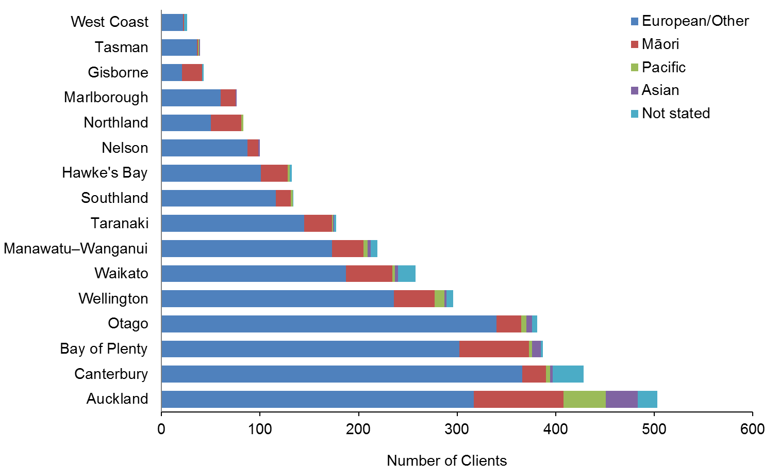

Observation
- More than a third of Auckland Clients using supported living services are of non-European/Other ethnicity.
- The Bay of Plenty and Otago regions are significantly over-represented in numbers of people using supported living services.

Principal disability
Table 37: Clients using supported living services, by principal disability and sex*
Principal disability | Male | Female | Total | %
Intellectual | 1137 | 1038 | 2175 | 66
Physical | 356 | 335 | 691 | 21
Autism spectrum disorder | 178 | 50 | 228 | 7
Sensory | 62 | 61 | 123 | 4
Neurological | 36 | 29 | 65 | 2
Total | 1769 | 1513 | 3282 | 100
* Where a Client recorded two principal disabilities, this research has used only the first one.

Figure 26: Clients using supported living services, by principal disability and sex
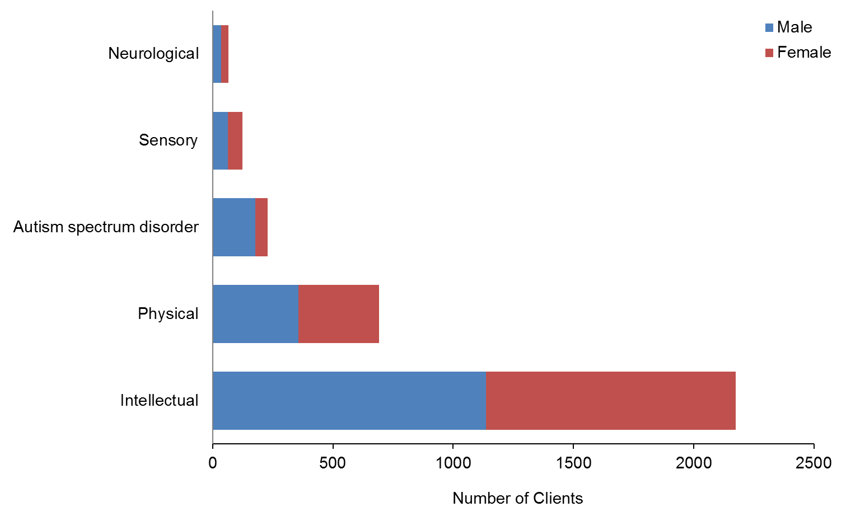

Observation
- Two-thirds (66%) of Clients using supported living services have an intellectual disability as their primary disability.

Support package allocation
Table 38: Clients using supported living services, by SPA level and sex
SPA level | Male | Female | Total
Very Low | 1 | 0 | 1
Low | 18 | 11 | 29
Medium | 586 | 524 | 1110
High | 898 | 760 | 1658
Very High | 266 | 218 | 484
Total | 1769 | 1513 | 3282

Figure 27: Clients using supported living services, by SPA level and sex
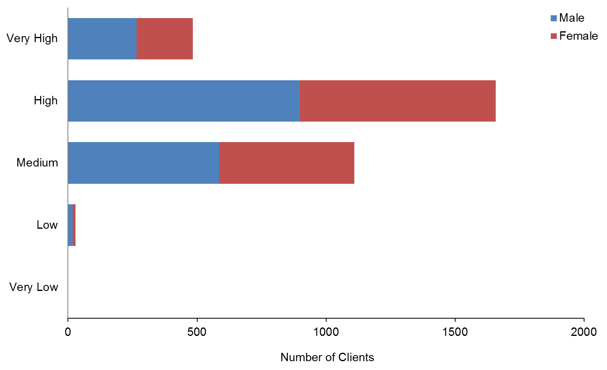

Observation
- Most Clients using supported living services have a Medium (33%) or High (51%) SPA level.

Respite services
This section provides demographic profiles of the 2163 DSS Clients using respite services. Some of these Clients will also appear in demographics for other services.

Age and sex
Table 39: Respite Clients, by age and sex
Age group | Male | Female | Total
0−4 | 17 | 12 | 29
5−9 | 209 | 66 | 275
10−14 | 282 | 136 | 418
15−19 | 312 | 145 | 457
20−24 | 142 | 75 | 217
25−29 | 46 | 43 | 89
30−34 | 32 | 30 | 62
35−39 | 29 | 22 | 51
40−44 | 29 | 35 | 64
45−49 | 31 | 34 | 65
50−54 | 44 | 53 | 97
55−59 | 50 | 41 | 91
60−64 | 61 | 56 | 117
65−69 | 46 | 45 | 91
70−74 | 18 | 10 | 28
75−79 | 2 | 7 | 9
80−84 | 3 |  | 3
85+ |  |  | 0
Total | 1353 | 810 | 2163
 | 63% | 37%

Figure 28: Age and sex of respite Clients
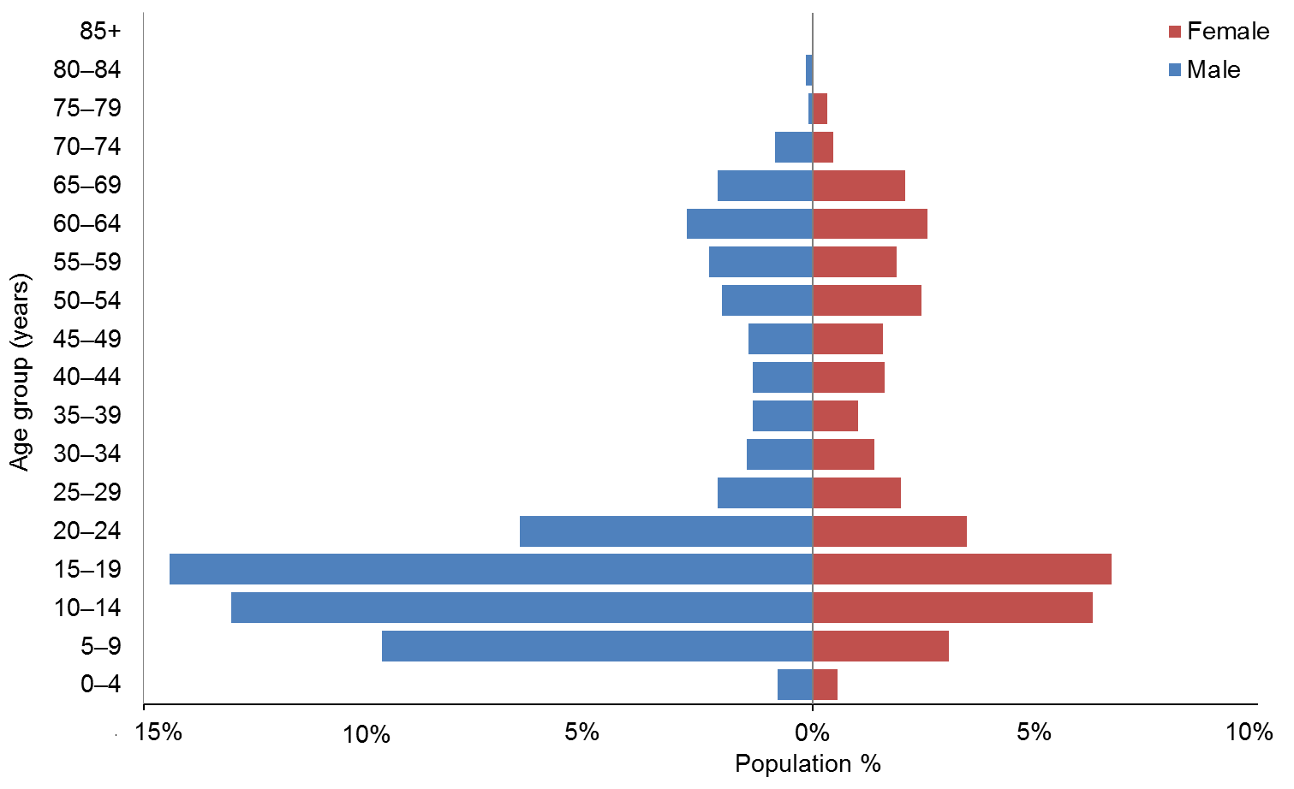

Observations
- The median age of respite Clients is 18 years.
- There are significantly more males (63%) than females using respite.
- Over half (55%) of respite users are under the age of 20 years.

Ethnicity
Table 40: Respite Clients, by age and ethnicity
Age group | European / Other | Māori | Pacific | Asian | Not stated | Total
0−4 | 7 | 11 | 7 | 4 |  | 29
5−9 | 154 | 69 | 24 | 22 | 6 | 275
10−14 | 262 | 93 | 28 | 28 | 7 | 418
15−19 | 299 | 87 | 26 | 41 | 4 | 457
20−24 | 145 | 42 | 9 | 20 | 1 | 217
25−29 | 50 | 21 | 10 | 8 |  | 89
30−34 | 41 | 10 | 7 | 3 | 1 | 62
35−39 | 38 | 9 | 3 | 1 |  | 51
40−44 | 41 | 17 | 3 | 2 | 1 | 64
45−49 | 44 | 12 | 5 | 3 | 1 | 65
50−54 | 70 | 17 | 5 | 2 | 3 | 97
55−59 | 67 | 14 | 3 | 5 | 2 | 91
60−64 | 89 | 14 | 7 | 3 | 4 | 117
65−69 | 74 | 4 | 2 | 6 | 5 | 91
70−74 | 21 | 3 | 2 | 1 | 1 | 28
75−79 | 7 | 1 |  | 1 |  | 9
80−84 | 3 |  |  |  |  | 3
85+ |  |  |  |  |  | 0
Total | 1412 | 424 | 141 | 150 | 36 | 2163
 | 65% | 20% | 7% | 7% | 2%

Figure 29: Respite Clients, by age and ethnicity
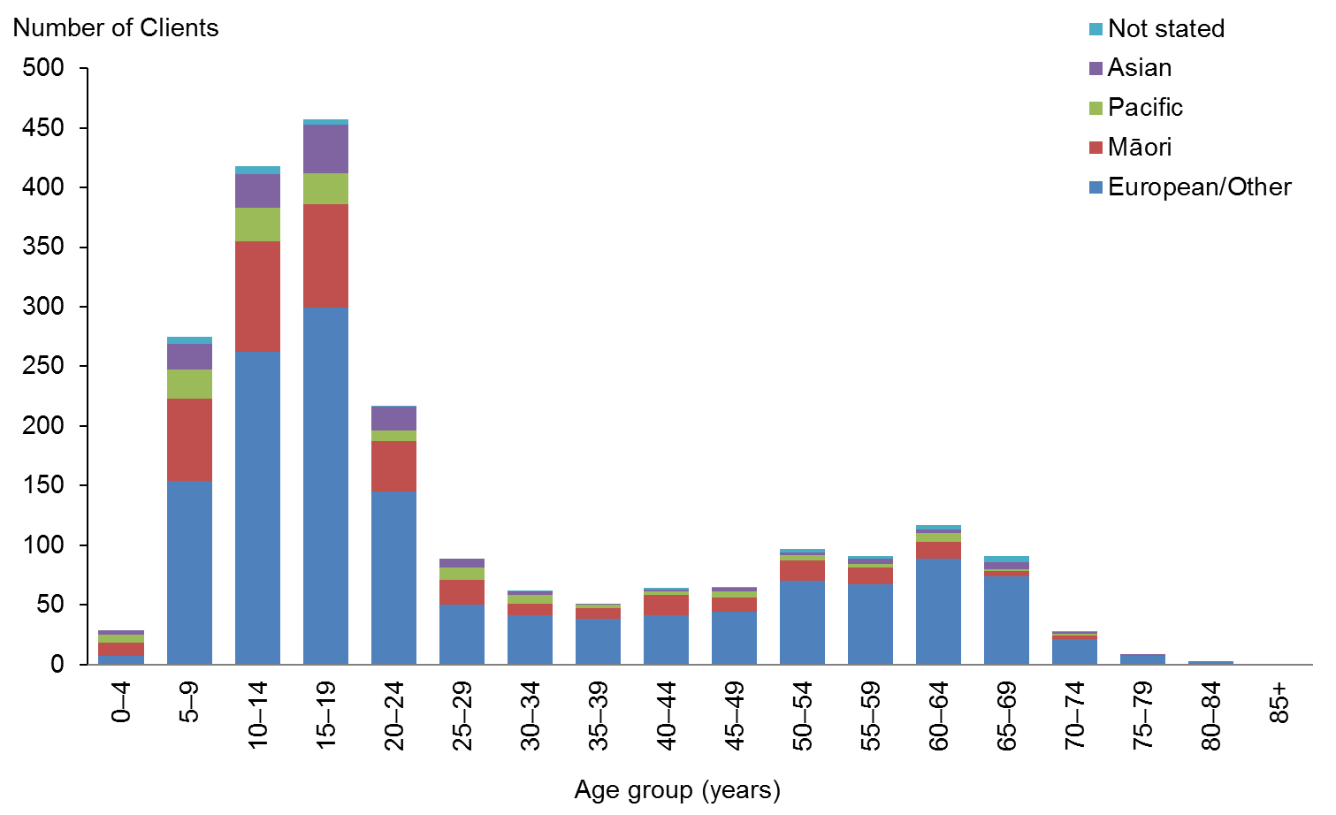

Observations
- European/Other people are slightly under-represented among users of respite.
- Māori and Asian people are slightly over-represented among users of respite. In 2013 Asian people were under-represented.

Marital status
Table 41: Respite Clients, by sex and marital status
Marital status | Male | Female | Total
Non-partnered, not further defined | 271 | 158 | 429
Non-partnered, never married | 123 | 57 | 180
Married (not separated), not further defined | 61 | 64 | 125
Not stated | 23 | 23 | 46
Partnered, not further defined | 10 | 11 | 21
Non-partnered, separated | 7 | 8 | 15
Non-partnered, divorced | 5 | 7 | 12
Response outside scope | 3 |  | 3
First marriage (not separated) | 1 |  | 1
Don’t know |  | 1 | 1
Non-partnered, widowed |  | 9 | 9
Remarried (not separated) |  | 2 | 2
Same-sex partnership |  | 1 | 1
Blank | 849 | 469 | 1318
Total | 1353 | 810 | 2163

Observation
- Over three-quarters (76%) of Clients for whom marital status is recorded are single. This aligns with the large numbers of respite Clients who are aged under 20 years.

Accommodation
Table 42: Respite Clients, by sex and accommodation type
Accommodation | Male | Female | Total
Own / family home | 806 | 473 | 1279
Rental accommodation | 153 | 105 | 258
Unknown | 121 | 83 | 204
Other | 108 | 55 | 163
Housing New Zealand accommodation | 95 | 51 | 146
Community residential home | 45 | 24 | 69
Rest home / continuing care hospital | 10 | 10 | 20
Boarder | 8 | 5 | 13
Council accommodation | 5 | 2 | 7
Unit in a retirement village | 2 | 1 | 3
No fixed abode |  | 1 | 1
Total | 1353 | 810 | 2163

Observation
- The majority (59%) of respite Clients live in their own home or the family home.

Location
Table 43: Respite Clients, by ethnicity and region
Region | European / Other | Māori | Pacific | Asian | Not stated | Total | %
Auckland | 335 | 118 | 88 | 92 | 9 | 642 | 30
Wellington | 233 | 54 | 27 | 23 | 2 | 339 | 16
Canterbury | 168 | 19 | 6 | 8 | 11 | 212 | 10
Waikato | 109 | 32 | 5 | 6 | 5 | 157 | 7
Manawatu−Wanganui | 116 | 29 | 3 |  | 2 | 150 | 7
Bay of Plenty | 90 | 42 | 1 | 7 | 2 | 142 | 7
Hawke’s Bay | 55 | 34 | 5 | 4 | 5 | 103 | 5
Northland | 46 | 38 | 3 | 3 |  | 90 | 4
Taranaki | 59 | 21 | 1 | 3 |  | 84 | 4
Otago | 73 | 9 |  | 2 |  | 84 | 4
Marlborough | 44 | 5 |  |  |  | 49 | 2
Tasman | 23 | 6 | 1 |  |  | 30 | 1
Nelson | 24 | 3 |  | 2 |  | 29 | 1
Southland | 26 | 2 | 1 |  |  | 29 | 1
Gisborne | 9 | 12 |  |  |  | 21 | 1
West Coast | 2 |  |  |  |  | 2 | 0
Total | 1412 | 424 | 141 | 150 | 36 | 2163 | 100

Figure 30: Respite Clients, by ethnicity and region
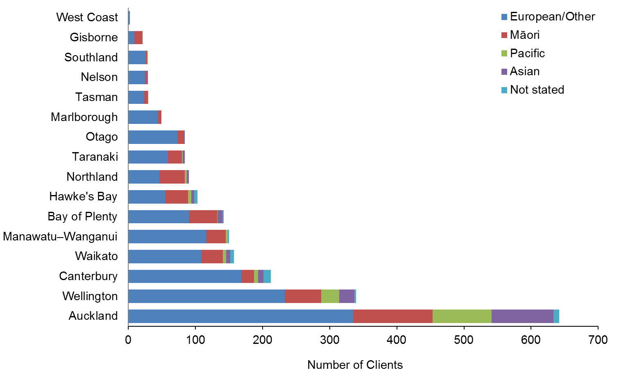

Observations
- There are regional disparities in the allocation of respite.
- The Wellington region is over-represented, with 10% of the country’s DSS Clients living in the region but 16% of the Clients using respite.
- The Canterbury region is under-represented, with 13% of the country’s DSS Clients living in the region but only 10% of the Clients using respite.

Principal disability
Table 44: Respite Clients, by sex and disability type*
Disability type | Male | Female | Total | %
Intellectual | 649 | 363 | 1012 | 47
Physical | 371 | 339 | 710 | 33
Autism spectrum disorder | 286 | 70 | 356 | 16
Neurological | 30 | 25 | 55 | 3
Sensory | 17 | 13 | 30 | 1
Total | 1353 | 810 | 2163 | 100
* Where a Client recorded two principal disabilities, this report has used only the first one.

Figure 31: Respite Clients, by sex and disability type
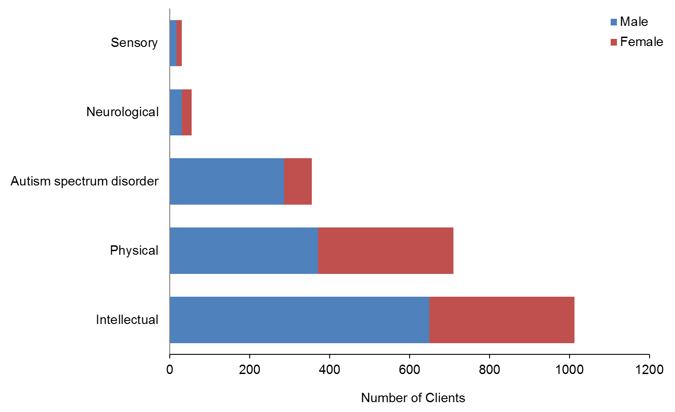

Observation
- Clients with intellectual disabilities make up 47% of respite care users.

Support package allocation
Table 45: Respite Clients, by SPA level and sex
SPA level | Male | Female | Total
Low | 3 | 3 | 6
Medium | 138 | 84 | 222
High | 555 | 323 | 878
Very High | 657 | 403 | 1060
Total | 1353 | 813 | 2166

Figure 32: Respite Clients, by SPA level and sex
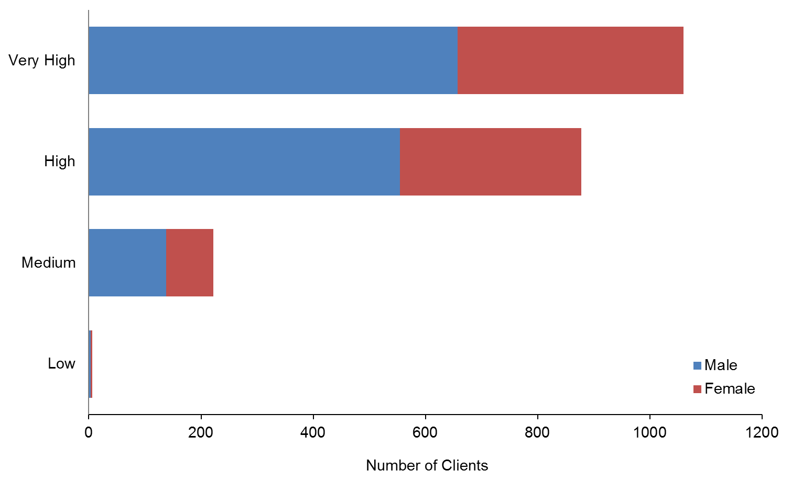

Observation
- Almost half (49%) of respite Clients have Very High SPAs.

Day programmes
DSS only funds day programmes for Clients who:
- were once living in institutions such as Tokanui and Kimberley, and/or
- are using High and Complex services allocated by the National Intellectual Disability Care Agency (NIDCA).

This section provides demographic profiling of the 1866 Clients allocated day-programme services from DSS. Many of these Clients may also appear in the demographics for other services.

Age and sex
Table 46: Day-programme Clients, by age and sex
Age group | Male | Female | Total
0−4 | 0 | 0 | 0
5−9 | 0 | 0 | 0
10−14 | 1 | 0 | 1
15−19 | 9 | 10 | 19
20−24 | 56 | 40 | 96
25−29 | 61 | 53 | 114
30−34 | 69 | 65 | 134
35−39 | 82 | 62 | 144
40−44 | 111 | 83 | 194
45−49 | 140 | 92 | 232
50−54 | 132 | 117 | 249
55−59 | 119 | 97 | 216
60−64 | 104 | 94 | 198
65−69 | 59 | 45 | 104
70−74 | 43 | 39 | 82
75−79 | 24 | 34 | 58
80−84 | 7 | 7 | 14
85+ | 6 | 5 | 11
Total | 1023 | 843 | 1866
 | 55% | 45%

Figure 33: Day-programme Clients, by age and sex
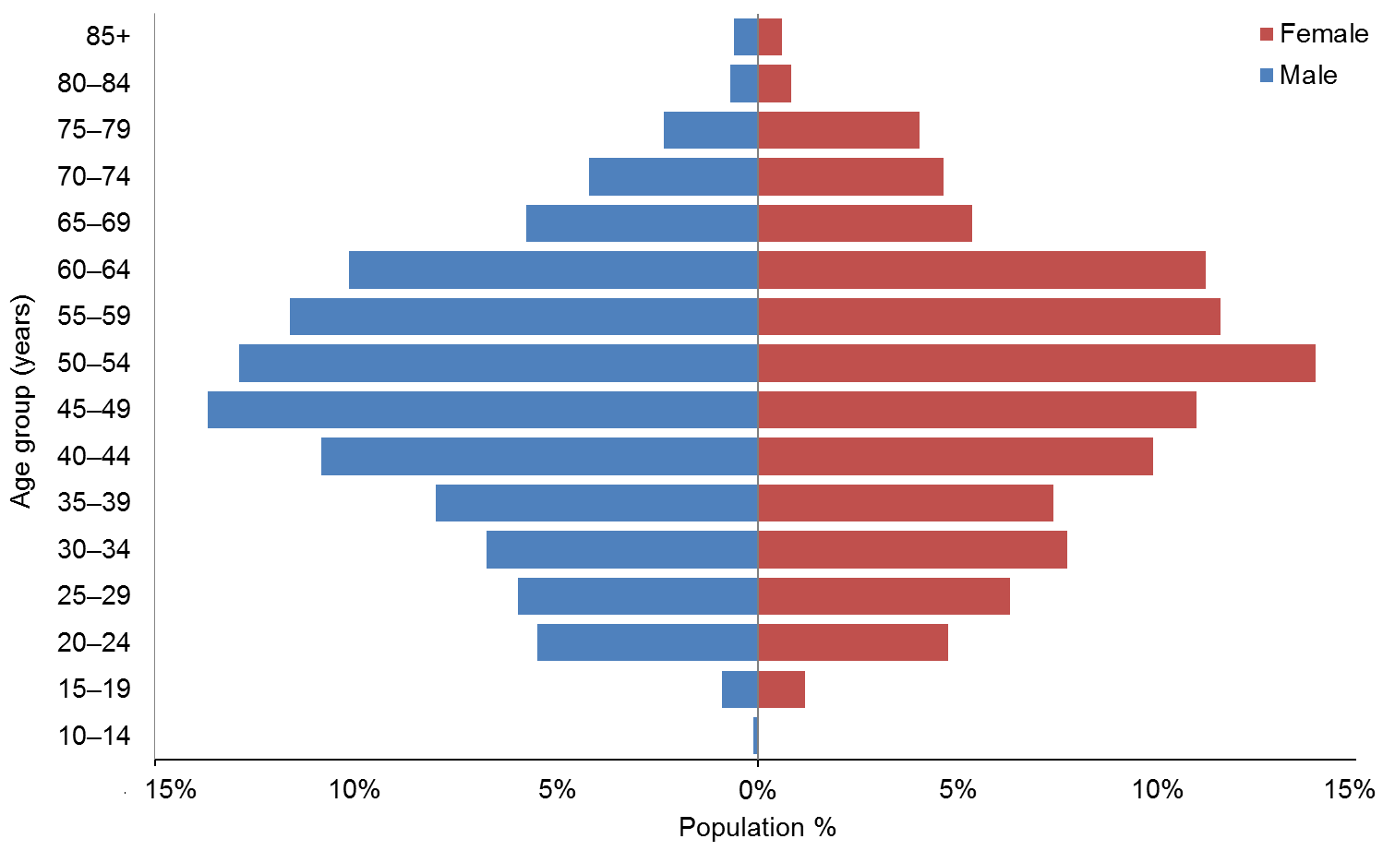

Observations
- The median age of day-programme Clients is 45 years.
- There are more male day-programme Clients (55%) than female (45%).
- The majority of day-programme Clients are aged between 30 and 55 years.

Ethnicity
Table 47: Day-programme Clients, by age and ethnicity
Age group | European / Other | Māori | Pacific | Asian | Not stated | Total
10−14 | 1 |  |  |  |  | 1
15−19 | 15 | 4 |  |  |  | 19
20−24 | 61 | 25 | 3 | 7 |  | 96
25−29 | 80 | 27 | 1 | 2 | 4 | 114
30−34 | 93 | 29 | 4 | 6 | 2 | 134
35−39 | 92 | 38 | 6 | 5 | 3 | 144
40−44 | 139 | 46 | 3 | 2 | 4 | 194
45−49 | 165 | 54 | 2 | 2 | 9 | 232
50−54 | 192 | 44 | 3 | 1 | 9 | 249
55−59 | 171 | 33 | 1 | 1 | 10 | 216
60−64 | 149 | 33 | 4 | 1 | 11 | 198
65−69 | 85 | 14 | 2 | 1 | 2 | 104
70−74 | 75 | 5 |  | 1 | 1 | 82
75−79 | 53 | 4 |  |  | 1 | 58
80−84 | 14 |  |  |  |  | 14
85+ | 9 |  |  |  | 2 | 11
Total | 1394 | 356 | 29 | 29 | 58 | 1866
 | 75% | 19% | 1.5% | 1.5% | 3%

Figure 34: Day-programme Clients, by age and ethnicity
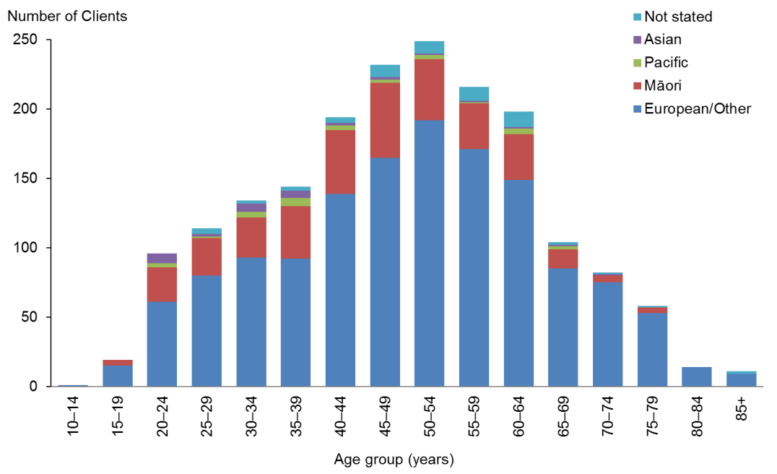

Observations
- European/Other (75%) are significantly over-represented in day-programme Clients.
- Māori (19%) are slightly over-represented.
- Pacific (1.5%) and Asian (1.5%) people are significantly under-represented.

Location
Table 48: Day-programme Clients, by region
Region | European / Other | Māori | Pacific | Asian | Not stated | Total | %
Waikato | 344 | 126 | 9 | 13 | 25 | 517 | 28
Canterbury | 224 | 12 |  | 1 | 12 | 249 | 13
Manawatu−Wanganui | 192 | 23 | 2 | 3 | 7 | 227 | 12
Bay of Plenty | 121 | 61 | 2 | 1 | 2 | 187 | 10
Auckland | 103 | 24 | 6 | 9 | 3 | 145 | 8
Northland | 89 | 40 |  |  |  | 129 | 7
Wellington | 74 | 6 | 5 | 1 | 5 | 91 | 5
Nelson | 68 | 11 |  | 1 |  | 80 | 4
Hawke’s Bay | 58 | 13 | 3 |  | 2 | 76 | 4
Taranaki | 46 | 11 |  |  |  | 57 | 3
Gisborne | 13 | 26 |  |  | 1 | 40 | 2
Tasman | 27 | 1 | 1 |  |  | 29 | 2
Otago | 17 | 1 | 1 |  |  | 19 | 1
Marlborough | 9 | 1 |  |  |  | 10 | 1
West Coast | 6 |  |  |  | 1 | 7 | 0
Southland | 3 |  |  |  |  | 3 | 0
Total | 1394 | 356 | 29 | 29 | 58 | 1866

Figure 35: Day-programme Clients, by region
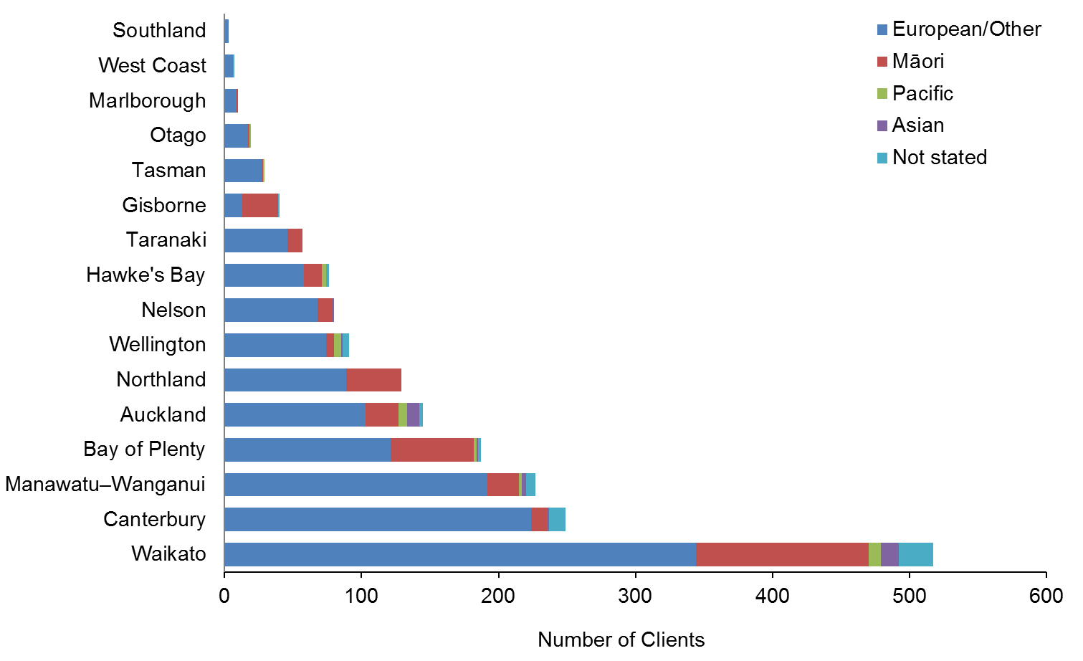

Observations
- Waikato region has twice as many day-programme Clients as the next largest region, Canterbury.
- Waikato, Canterbury and Manawatu−Wanganui have the largest numbers of day-programme Clients due to the closures of Tokanui, Sunnyside and Kimberley, respectively, in these areas, and the agreement of the Ministry to fund day programmes for these Clients.

Principal disability
Table 49: Day-programme Clients, by principal disability
Disability type | Male | Female | Total | %
Intellectual | 838 | 716 | 1554 | 83
Physical | 123 | 98 | 221 | 12
Autism spectrum disorder | 41 | 13 | 54 | 3
Neurological | 17 | 11 | 28 | 2
Sensory | 4 | 5 | 9 | 0
Total | 1023 | 843 | 1866 | 100

Figure 36: Day-programme Clients, by principal disability
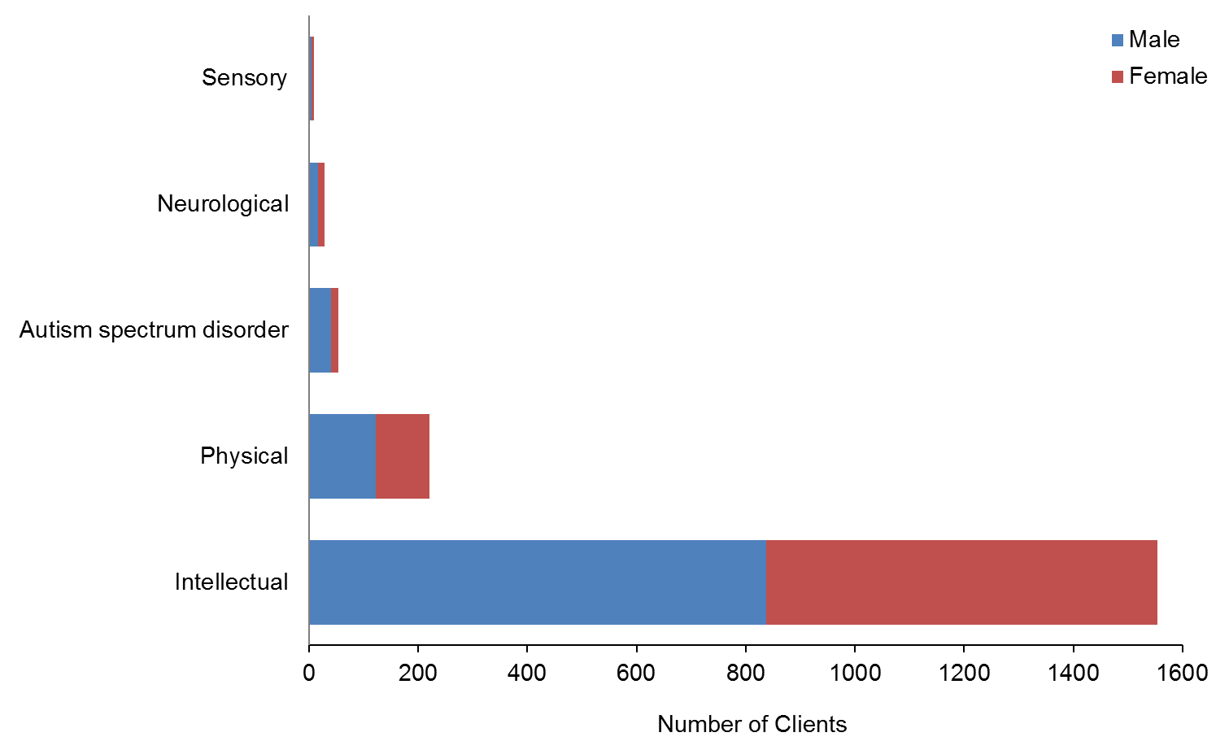

Observation
- The majority (83%) of Clients using day-programme services have intellectual disabilities.

Support package allocation
Table 50: Day-programme Clients, by SPA level
SPA level | Male | Female | Total
Very Low |  | 0 | 0
Low | 1 | 1 | 2
Medium | 58 | 65 | 123
High | 283 | 210 | 493
Very High | 681 | 567 | 1248
Total | 1023 | 843 | 1866

Figure 37: Day-programme Clients, by SPA level
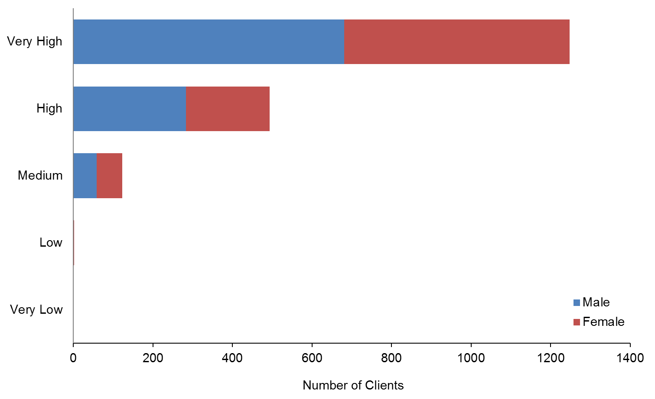

Observation
- A large majority (67%) of day-programme Clients have a Very High SPA level, and a further 26% have a High level.

Client demographics, by disability
This section focuses on the five broad disability types and provides the demographic profiles of the DSS Clients with each of these disabilities.

While all Clients are recorded as having one principal disability, some Clients are listed with two principal disabilities. This report focuses on only the first principal disability that was recorded.

Principal disability type | Total | %
Intellectual | 15,578 | 48
Physical | 9901 | 31
Autism spectrum disorder | 5077 | 16
Sensory | 1030 | 3
Neurological | 661 | 2
Total | 32,247 | 100

For a list of disabilities included in the different principal disability types see the Appendix. Note that if a person has two principal disabilities, then both disabilities are counted in this table.

Intellectual disability

Age and sex
Table 51: Clients with intellectual disability, by age and sex
Age group | Male | Female | Total
0−4 | 266 | 178 | 444
5−9 | 920 | 511 | 1431
10−14 | 1140 | 672 | 1812
15−19 | 1020 | 723 | 1743
20−24 | 774 | 618 | 1392
25−29 | 583 | 513 | 1096
30−34 | 508 | 423 | 931
35−39 | 479 | 381 | 860
40−44 | 597 | 510 | 1107
45−49 | 651 | 483 | 1134
50−54 | 649 | 546 | 1195
55−59 | 496 | 431 | 927
60−64 | 374 | 311 | 685
65−69 | 241 | 210 | 451
70−74 | 125 | 93 | 218
75−79 | 45 | 56 | 101
80−84 | 22 | 11 | 33
85+ | 7 | 11 | 18
Total | 8897 | 6681 | 15,578
 | 57% | 43%

Figure 38: Age and sex of Clients with intellectual disability
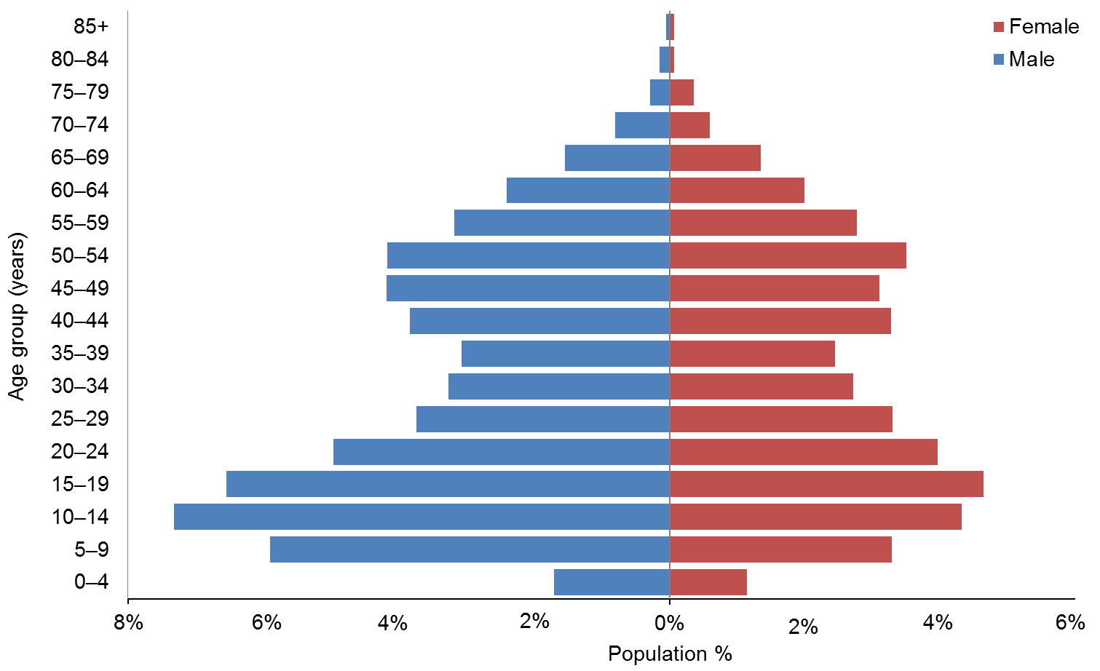

Observations
- The median age of Clients with an intellectual disability is 28 years.
- There are significantly more males (57%) with an intellectual disability using DSS than females.
- There are two peaks in the age group profiles for both sexes: 10–19 years and 40–54 years.

Physical disability

Age and sex
Table 52: Clients with physical disability, by age and sex
Age group | Male | Female | Total
0−4 | 99 | 79 | 178
5−9 | 223 | 175 | 398
10−14 | 298 | 216 | 514
15−19 | 321 | 252 | 573
20−24 | 254 | 181 | 435
25−29 | 164 | 177 | 341
30−34 | 155 | 160 | 315
35−39 | 156 | 200 | 356
40−44 | 197 | 329 | 526
45−49 | 268 | 433 | 701
50−54 | 372 | 570 | 942
55−59 | 457 | 678 | 1135
60−64 | 577 | 862 | 1439
65−69 | 434 | 831 | 1265
70−74 | 185 | 454 | 639
75−79 | 35 | 94 | 129
80−84 | 5 | 7 | 12
85+ |  | 3 | 3
Total | 4200 | 5701 | 9901
 | 42% | 58%

Figure 39: Clients with physical disability, by age and sex
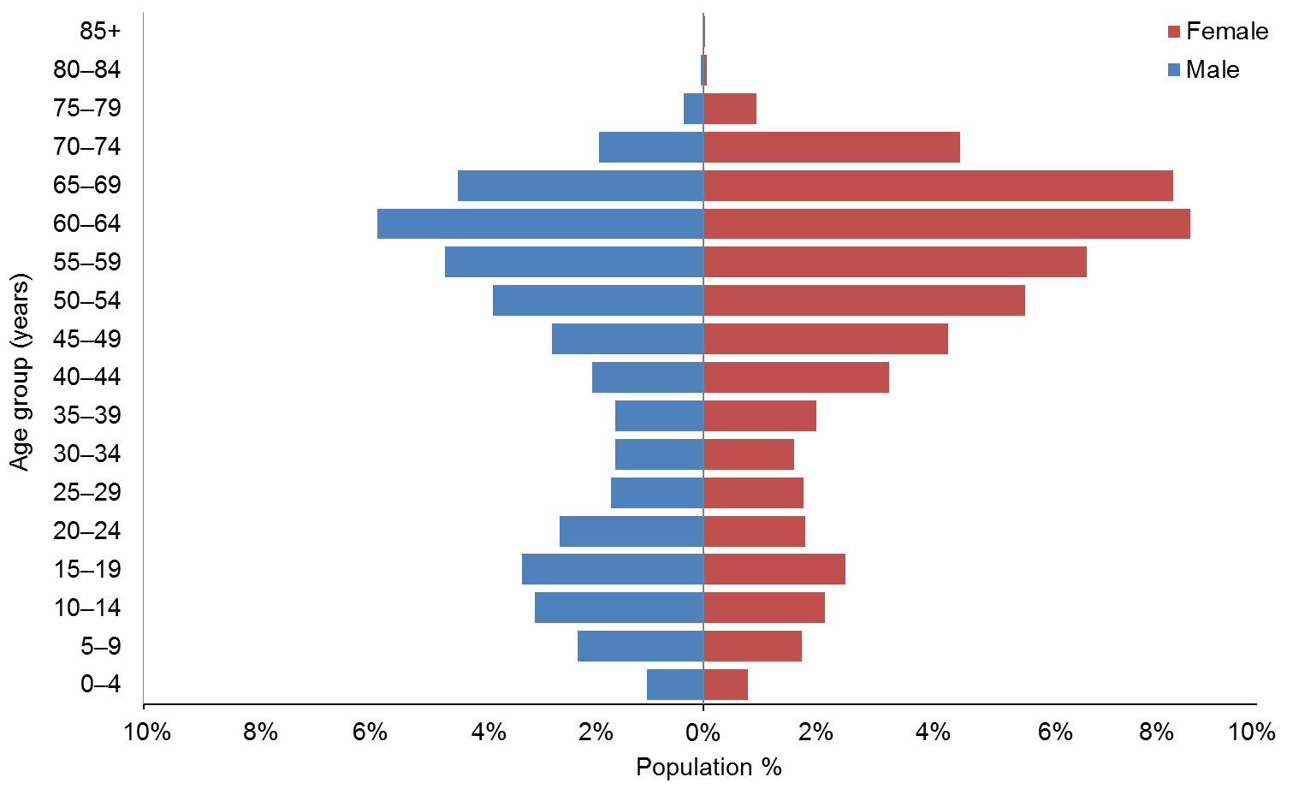

Observations
- The median age of Clients with a physical disability is 52 years.
- Females make up 58% of Clients with a physical disability.
- Clients with a physical disability are a markedly older group, with 56% of Clients aged over 45 years.

Autism spectrum disorder
This section describes Clients who have one of the following disabilities: Asperger’s syndrome; autism spectrum disorder (ASD); other ASD.

Age and sex
Table 53: Clients with ASD, by age and sex
Age group | Male | Female | Total
0−4 | 199 | 50 | 249
5−9 | 1144 | 244 | 1388
10−14 | 1242 | 269 | 1511
15−19 | 766 | 180 | 946
20−24 | 330 | 90 | 420
25−29 | 180 | 47 | 227
30−34 | 81 | 17 | 98
35−39 | 55 | 20 | 75
40−44 | 29 | 15 | 44
45−49 | 34 | 7 | 41
50−54 | 30 | 10 | 40
55−59 | 9 | 5 | 14
60−64 | 10 | 7 | 17
65−69 | 2 | 3 | 5
70−74 |  | 1 | 1
80−84 |  | 1 | 1
Total | 4111 | 966 | 5077
 | 81% | 19%

Figure 40: Age and sex of Clients with ASD
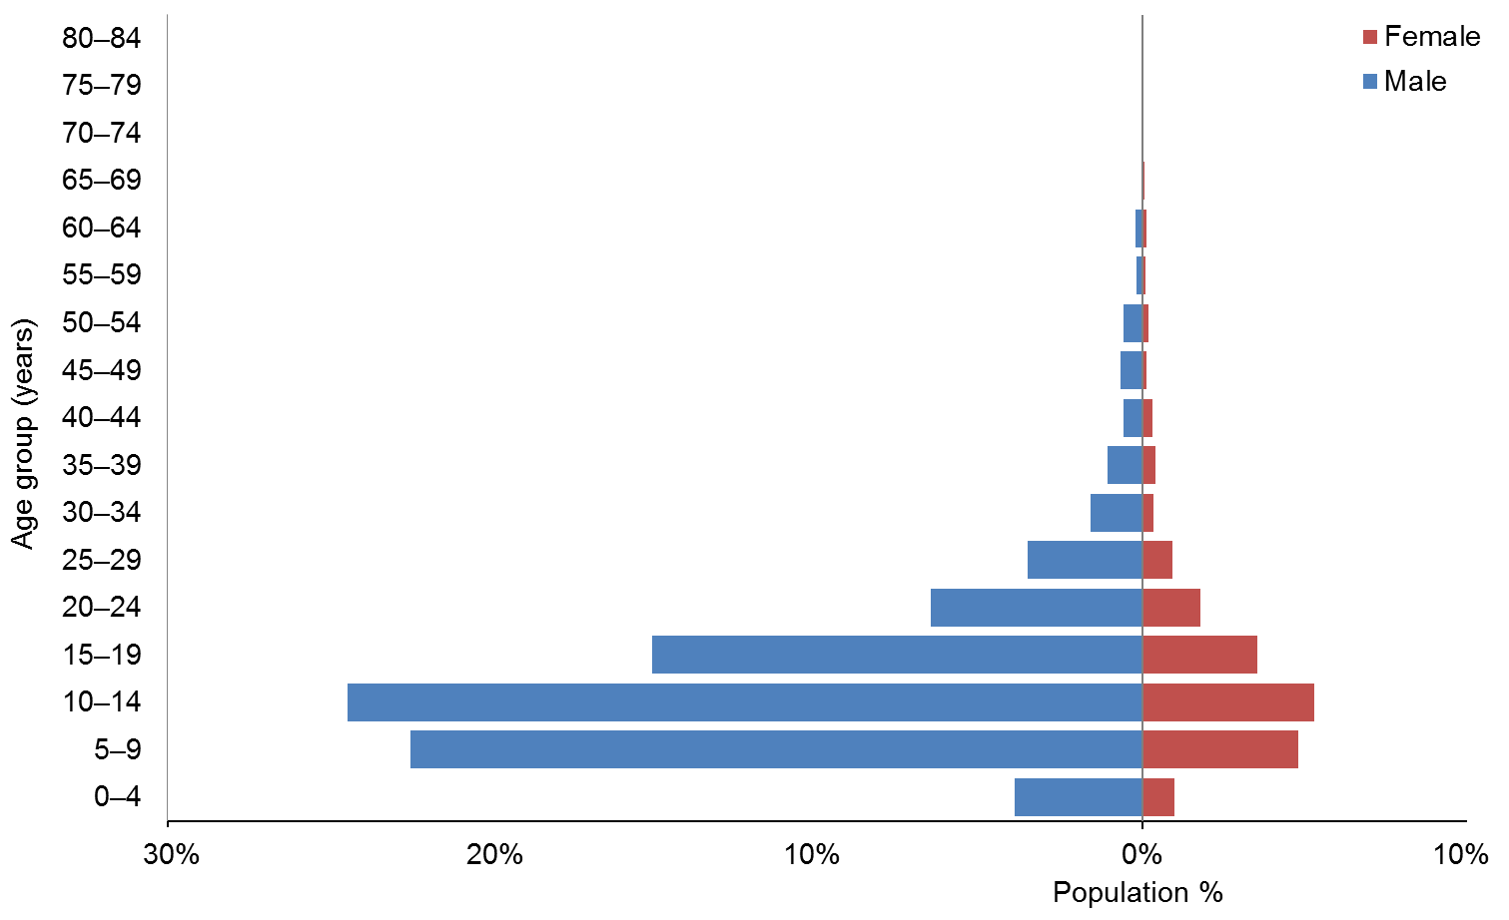

Observations
- The median age of Clients with ASD is 12 years.
- ASD Clients are predominantly male (81%).
- ASD Clients are predominantly young (80% of ASD Clients are aged under 20).

Service usage
Table 54: ASD Clients, by sex and service usage
Service type | Male | Female | Total | %
Carer support | 2834 | 627 | 3461 | 68
Home support | 660 | 179 | 839 | 17
Community residential | 235 | 61 | 296 | 6
Respite care | 187 | 47 | 234 | 5
Supported independent living | 148 | 35 | 183 | 4
Other | 47 | 17 | 64 | 1
Total | 4111 | 966 | 5077

Figure 41: ASD Clients, by sex and service usage
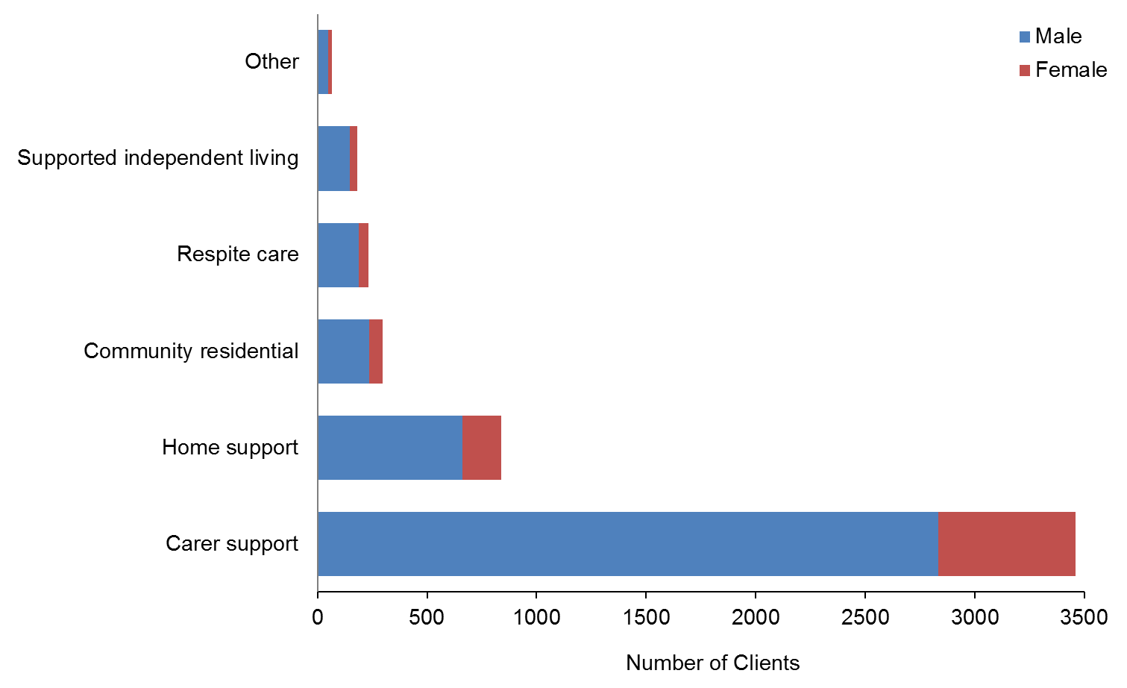

Observation
- Two-thirds of ASD Clients use carer support services, which is by far the most used disability support service used by this disability group.

Sensory disability

Age and sex
Table 55: Sensory disability Clients, by age and sex
Age group | Male | Female | Total
0−4 | 12 | 14 | 26
5−9 | 49 | 30 | 79
10−14 | 67 | 47 | 114
15−19 | 54 | 53 | 107
20−24 | 38 | 24 | 62
25−29 | 18 | 23 | 41
30−34 | 21 | 18 | 39
35−39 | 23 | 25 | 48
40−44 | 29 | 34 | 63
45−49 | 40 | 39 | 79
50−54 | 41 | 46 | 87
55−59 | 42 | 53 | 95
60−64 | 44 | 46 | 90
65−69 | 19 | 32 | 51
70−74 | 19 | 19 | 38
75−79 | 4 | 7 | 11
Total | 520 | 510 | 1030
 | 50% | 50%

Figure 42: Age and sex of Clients with sensory disabilities
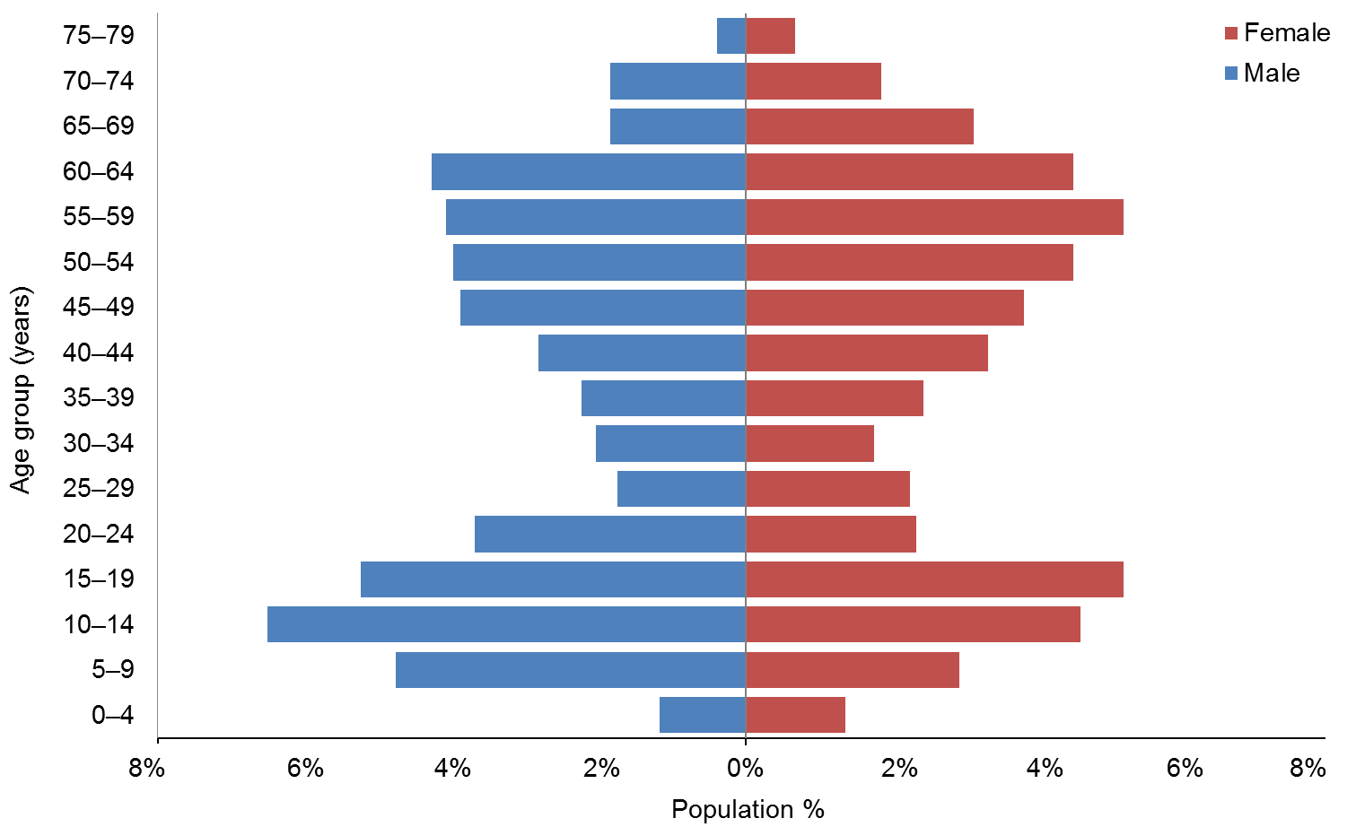

Observations
- The median age of Clients with sensory disabilities is 40 years.
- Males and females are evenly represented in this disability group.
- There are two peaks in the age distributions, with slightly more males in the 10–24 years age group and slightly more females in the 45–69 years group.

Neurological disability

Age and sex
Table 56: Clients with neurological disability, by age and sex
Age group | Male | Female | Total
0−4 | 6 | 3 | 9
5−9 | 15 | 15 | 30
10−14 | 11 | 10 | 21
15−19 | 12 | 8 | 20
20−24 | 7 | 9 | 16
25−29 | 2 | 5 | 7
30−34 | 14 | 12 | 26
35−39 | 17 | 15 | 32
40−44 | 17 | 21 | 38
45−49 | 32 | 19 | 51
50−54 | 43 | 53 | 96
55−59 | 45 | 48 | 93
60−64 | 59 | 52 | 111
65−69 | 42 | 44 | 86
70-74 | 8 | 14 | 22
75−79 | 2 | 1 | 3
Total | 332 | 329 | 661
 | 50% | 50%

Figure 43: Age and sex of Clients with neurological disability
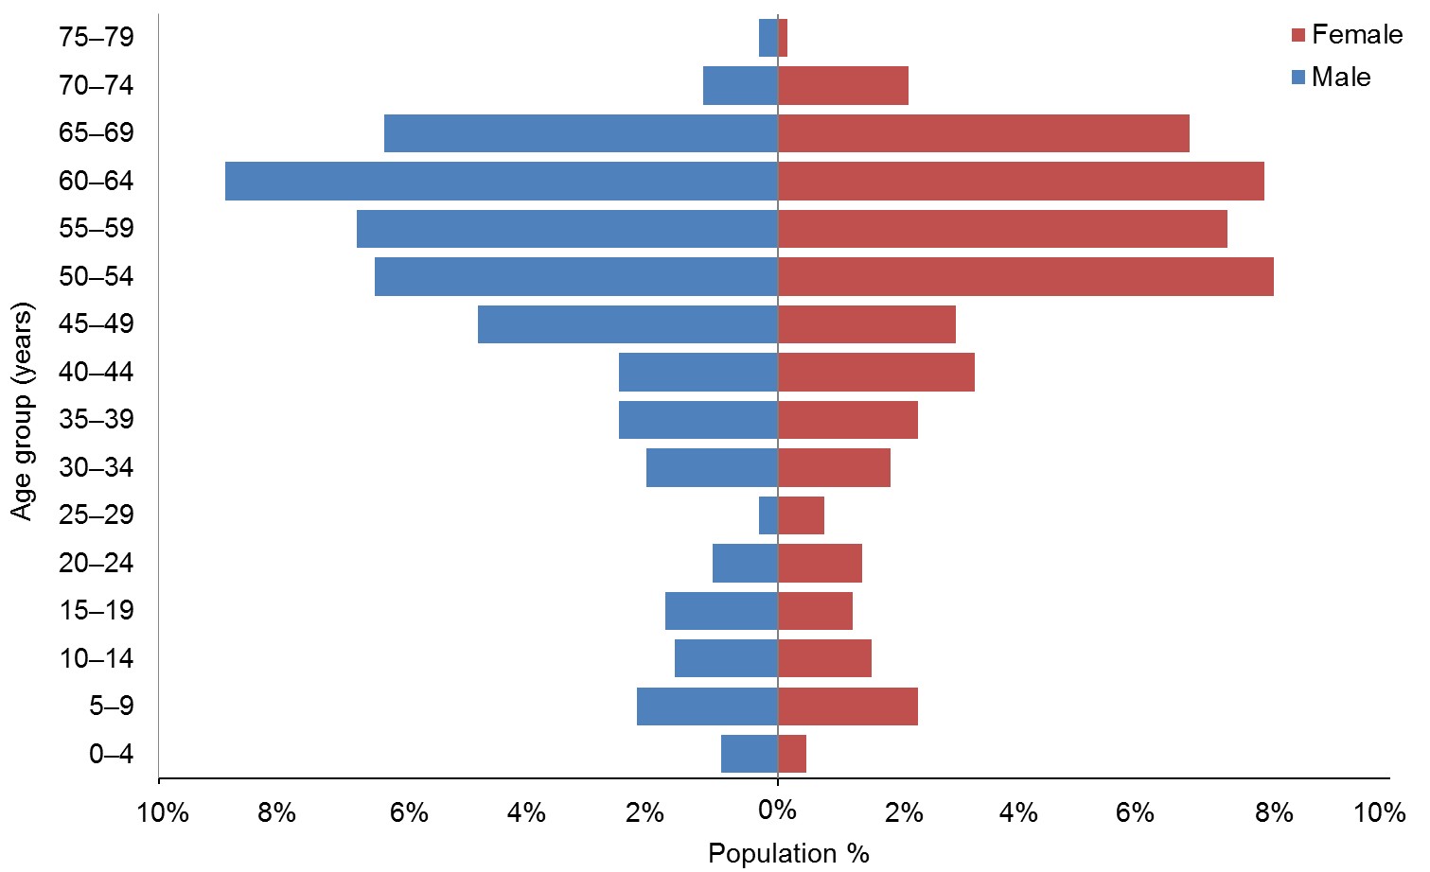

Observations
- The median age of Clients with neurological disabilities is 53 years.
- Almost two-thirds (62%) of Clients with neurological disabilities using disability support services are aged over 50 years.

Service usage, by ethnicity
This section illustrates service usage by each of the four main ethnic groups: European/Other, Māori, Pacific and Asian.

Figure 44: Overall service usage, by ethnicity
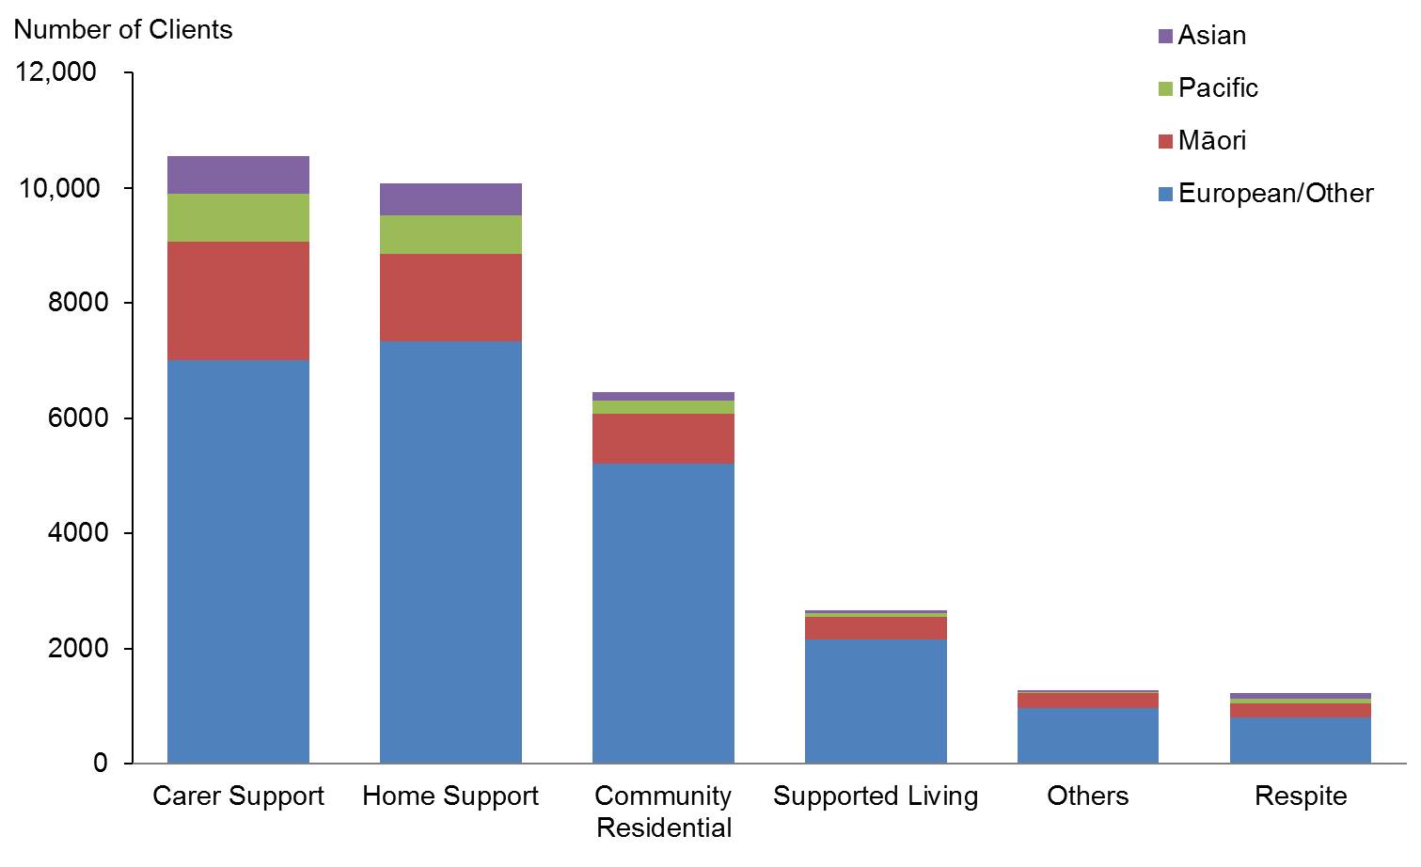

Figure 45: Service usage by Clients of European/Other ethnicity
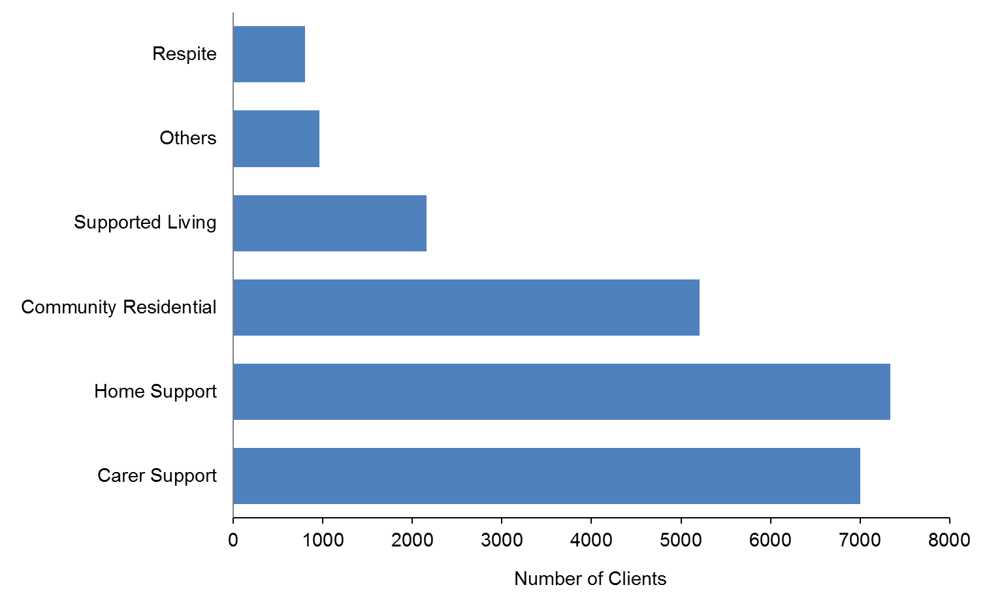

Figure 46: Service usage by Clients of Māori ethnicity
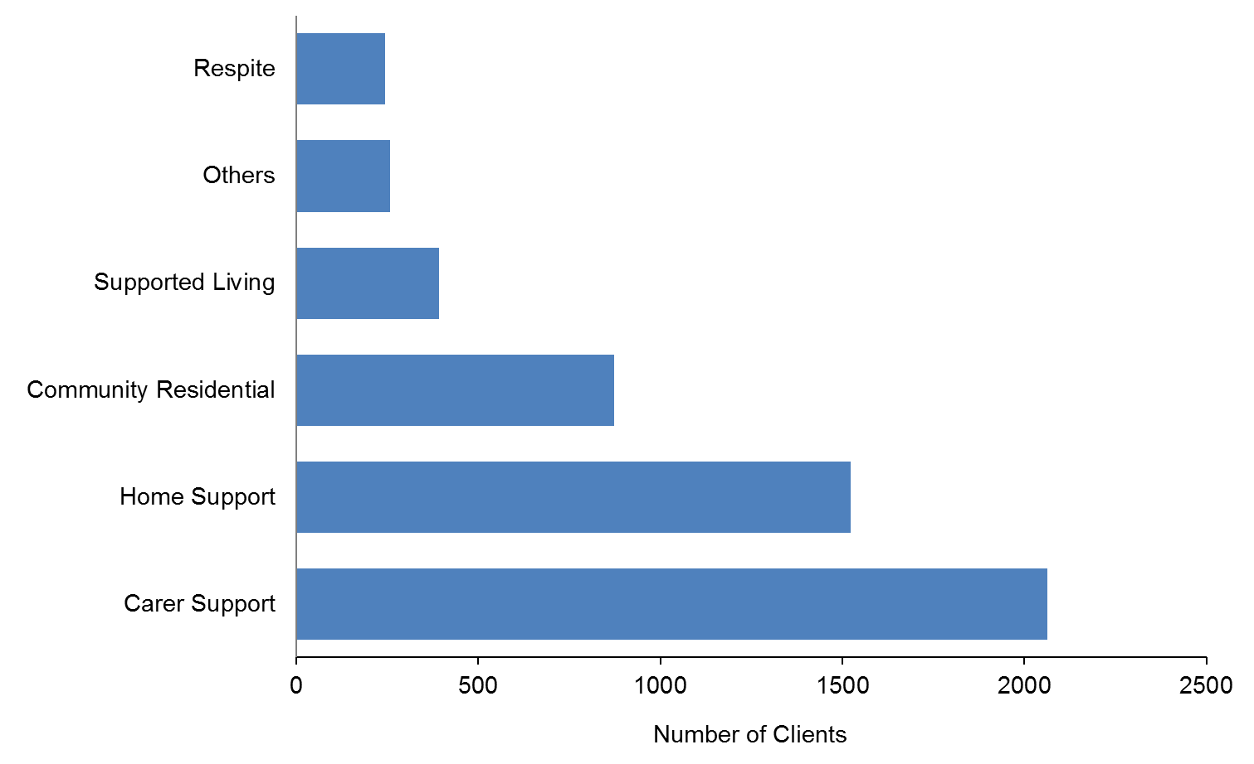

Figure 47: Service usage by Clients of Pacific ethnicity
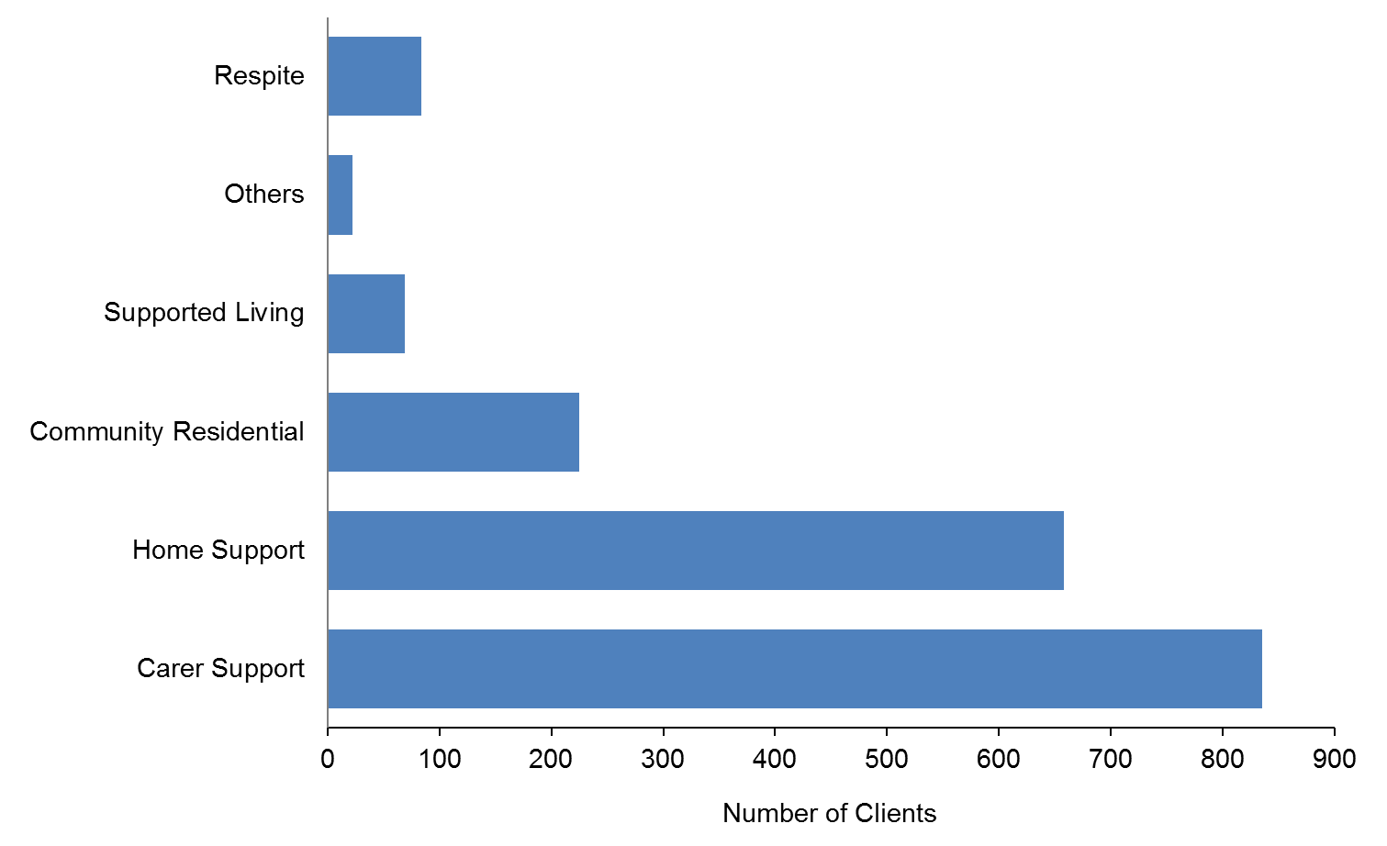

Figure 48: Service usage by Clients of Asian ethnicity
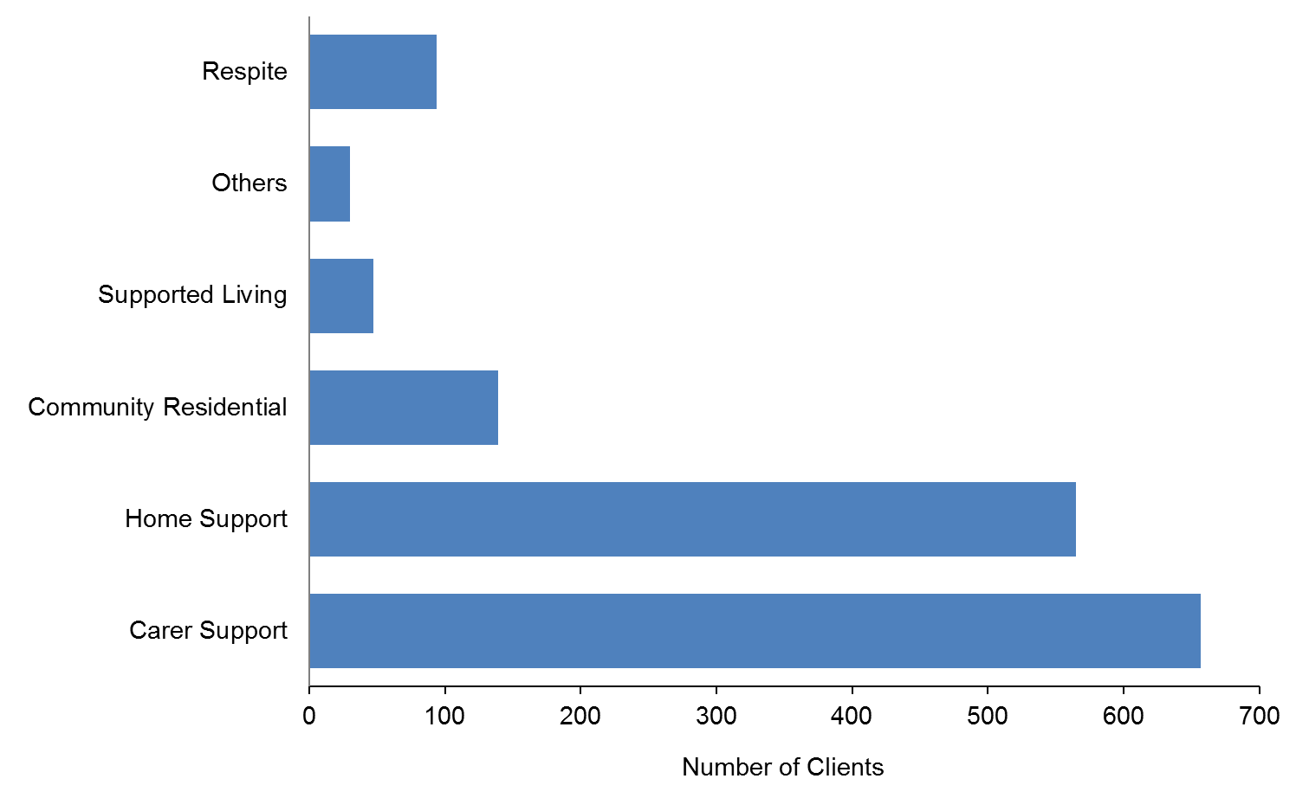

Glossary
ASD Autism spectrum disorder.
Ethnicity Each Client is allocated to a single ethnic group using the priority system. The aim of prioritisation is to ensure that where some need exists to assign people to a single ethnic group, ethnic groups of policy importance, or of small size, are not swamped by the NZ European ethnic group.
NASC Needs Assessment Service Coordination. These services are funded by the Ministry of Health. Their role is to assess a person’s disability-related support needs, and then to allocate and/or coordinate funding or services to meet these needs.
Socrates A Ministry of Health information system, consisting of a database and computer application for managing the delivery of services to DSS Clients.
SPA Support package allocation. This is the funding or range of disability support services allocated to a disabled Client to address their disability support needs, as identified by the Needs Assessment and Service Coordination organisation.

Appendix: Disability types
Table A1: Principal disability types, by number of DSS Clients
Disability class | Principal disability | Count
Autism spectrum disorder | Asperger’s syndrome | 1139
 | Autism spectrum disorder (ASD) | 4183
 | Total | 5322
Intellectual | Birth asphyxia or intrauterine hypoxia | 18
 | Developmental delay, type not specified | 1581
 | Down syndrome (Trisomy 21) | 1985
 | Edwards’ syndrome (Trisomy 18) | 8
 | Fragile X syndrome | 96
 | Intellectual disability (ID), type not specified | 10,383
 | Klinefelter’s syndrome | 27
 | Learning disability / difficult / delay, type not specified | 1001
 | Microcephalus / microcephaly | 78
 | Other intellectual, learning or developmental disorder (specify) | 484
 | Prader-Willi syndrome | 17
 | Total | 15,678
Neurological | Brain injury / head injury caused by accident (external cause) | 100
 | Brain injury, cause not specified | 144
 | Encephalitis | 29
 | Neurological disorder / disability, type not specified | 81
 | Total | 354
Physical | Amputation / partial amputation of arm / hand | 29
 | Amputation / partial amputation of leg / foot | 171
 | Ankylosing spondylitis | 36
 | Arthrogryposis | 37
 | Ataxia (cerebellar, spinocerebellar, Friedreich’s) | 163
 | Back injury due to accident (external cause) | 27
 | Cerebral palsy | 1744
 | Club foot or feet (talipes) | 17
 | Congenital absence / partial absence of arm / hand (upper limb reduction) | 11
 | Congenital absence / partial absence of leg / foot (lower limb reduction) | 17
 | Guillain Barre syndrome | 24
 | Kyphosis, lordosis or scoliosis | 72
 | Low birth weight / prematurity / short gestation | 30
 | Muscular dystrophy | 271
 | Non-malignant growth / tumour | 13
 | Osteoarthritis | 758
 | Other bone, joint or cartilage disorder (specify) | 215
Physical (continued) | Other conditions originating around time of birth (specify) | 42
 | Other muscle and tendon disorder (specify) | 85
 | Other musculoskeletal (specify) | 131
 | Other spine or back disorder (specify) | 183
 | Paralysis, paresis (hemiplegia, paraplegia, tetraplegia, quadraplegia, diplegia) | 548
 | Polio and post-polio | 92
 | Polymyalgia rheumatica | 9
 | Prolapsed disc, disc degeneration, sciatica | 45
 | Rheumatoid arthritis | 504
 | Short stature / dwarfism (eg, achondroplasia) | 37
 | Spina bifida | 335
 | Spinal muscular atrophy | 33
 | Spinal stenosis | 65
 | Spondylosis | 30
 | Stroke, brain / subarachnoid haemorrhage, cerebrovascular accident (CVA), parietal / cerebral / cerebellar / middle cerebral artery (MCA) / thalamic / frontal lobe infarct | 1796
 | Systemic lupus erythematosus (lupus, SLE) | 29
 | Total | 7599
Physical / intellectual | Other congenital or chromosomal defects affecting multiple systems (specify) | 738
 | Angleman’s syndrome | 1
 | Patau’s syndrome (Trisomy 13) | 2
 | Total | 741
Physical / intellectual / neurological | Hydrocephalus / hydrocephaly | 87
 | Other brain or nervous system disorder (specify) | 682
 | Total | 769
Physical / neurological | Huntington’s | 152
 | Meningitis | 22
 | Motor neuron disease | 117
 | Multiple sclerosis | 971
 | Parkinson’s disease | 205
 | Total | 1467
Sensory | Blind or vision impaired, type not specified | 482
 | Congenital cataract (present at birth) | 17
 | Deaf or hearing impaired, type not specified | 311
 | Glaucoma | 12
 | Optic neuritis, optic atrophy | 5
 | Other cataract | 2
 | Other ear or hearing disorder (specify) | 32
 | Other eye or vision disorder (specify) | 97
 | Retinopathy, retinal dystrophy, retinitis pigmentosa, detached retina | 54
 | Other | 1
 | Total | 1013
Other | Alcohol / drug-related disorder (excluding Korsakov’s syndrome) | 1
 | Alzheimer’s (including early onset) | 6
 | Angina | 3
 | Asthma | 5
 | Attention deficit / hyperactivity (eg, ADD, ADHD) | 9
 | Bipolar disorder (manic depression) | 1
 | Cancer (malignant, CA) (eg, leukaemia, lymphoma, melanoma, breast, lung, prostate, colon, neuroblastoma) | 6
 | Chronic back pain, type not specified | 9
 | Chronic fatigue syndrome / ME (myalgic encephalomyelitis) | 36
 | Chronic obstructive pulmonary or respiratory disease (COPD / CORD) (eg, chronic bronchitis, emphysema) | 18
 | Chronic pain / chronic pain syndrome, cause not specified (excludes chronic back pain) | 3
 | Congenital heart disease / defects / problems | 6
 | Cystic fibrosis | 9
 | Depression | 2
 | Diabetes (NIDDM or IDDM) | 9
 | Epilepsy, seizures | 26
 | Fibromyalgia | 29
 | Foetal alcohol syndrome (FAS) | 4
 | Haemophilia | 1
 | Heart attack (myocardial infarction) | 3
 | Heart failure | 2
 | Hypertension / high blood pressure | 1
 | Inflammatory bowel disease (eg, Crohn’s disease, ulcerative colitis, other non-infective bowel disease) | 1
 | Ischaemic heart disease (IHD), type not specified | 6
 | Korsakov’s syndrome / alcohol-related dementia | 6
 | Language delay | 1
 | Liver disease (eg, hepatitis, cirrhosis) | 1
 | Motor delay, developmental dyspraxia | 9
 | Neurofibromatosis | 8
 | Osteoporosis | 20
 | Other cancer / tumour (specify) | 1
 | Other connective tissue disorder (specify) | 12
 | Other dementia (specify) | 4
 | Other digestive disorder (specify) | 3
 | Other genitourinary disorder (specify) | 2
 | Other heart or blood vessel disorder (specify) | 5
 | Other nutritional, hormonal or metabolic disorder (specify) | 3
 | Other respiratory disorder (specify) | 3
 | Pick’s | 1
 | Renal (kidney) failure, renal dialysis, haemodialysis | 4
Other (continued) | Schizophrenia | 4
 | Systemic sclerosis / scleroderma | 8
 | TIA (transient ischaemic attack) | 1
 | Vascular dementia | 1
 | Unspecified | 16
 | Total | 309
Total |  | 33,252
Note: If a Client has two principal disabilities, then both disabilities are counted.

Not everyone who is allocated carer support takes advantage of the subsidy.

