Delivering better public services
A good start to life
Better public services result 2
Healthy mums and babies
Better public services result 3
Keeping kids healthy
Result action plan

Citation: Ministry of Health. 2017. Delivering Better Public Services.
Wellington: Ministry of Health.
Published in June 2017
by the Ministry of Health
PO Box 5013, Wellington 6140, New Zealand
ISBN 978-1-98-850241-0 (print)
ISBN 978-1-98-850238-0 (online)
This document is available at www.health.govt.nz
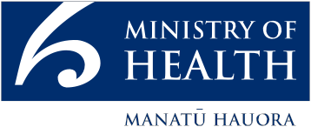
This work is licensed under the Creative Commons Attribution 4.0 International licence. In essence, you are free to: share ie, copy and redistribute the material in any medium or format; adapt ie, remix, transform and build upon the material. You must give appropriate credit, provide a link to the licence and indicate if changes were made.

Minister’s foreword
Improving the health of all New Zealanders continues to be a vital goal for this Government. Our achievements in health have been real and substantial. We have increased real spending levels, with health funding keeping up with demographic pressure and inflation in a time of considerable financial constraint. We have maintained and expanded the delivery of core services, while also funding important initiatives targeted at specific groups in the population. These include the Prime Minister’s Youth Mental Health Project, the Childhood Obesity Plan, the Fruit in Schools programme, and School Based Health Services in low-decile secondary schools.

This is a record to be proud of, but there can be no room for complacency in the field of health. We need to be continually on the lookout for new ways to tackle the health issues faced by our population.

The New Zealand Health Strategy, released last year, provides a clear direction for the health system. The strategy challenges government agencies to collaborate to improve the health and social outcomes of children, young people, families and whānau, particularly those in priority groups or who are at risk.

This Result Action Plan, comprising two new Better Public Service results – Result 2: Healthy mums and babies and Result 3: Keeping kids healthy – represents a significant addition to the range of approaches we are using to improve health outcomes for New Zealanders.

The focus of the new targets on achieving a good start to life is significant. This Government is committed to actions that promise better social outcomes in the longer term as well as achieving more immediate results. We know that taking effective steps to improve the wellbeing of children from the earliest stage of pregnancy will affect not only health outcomes, but also educational achievement and lifelong learning. Not only individuals but society as a whole will be better off.

A great deal of work goes into developing a plan like this, and I wish to thank those who have put so much time and thought into the final product. Settling on a plan is important, but it is just the first step. The focus of effort now shifts out into the community, as district health boards, service providers, health professionals and system users combine their efforts to achieve these important targets. I wish them well, and will be watching their progress with great interest.

Hon Dr Jonathan Coleman
Minister of Health

Contents
Minister’s foreword iii
A good start to life will improve the health and wellbeing of pregnant women and children 1
Why a good start to life is important to New Zealanders 1
Better Public Services Results 2 and 3 will help to ensure a good start to life 2
Result 2: Healthy mums and babies 2
Result 3: Keeping kids healthy 3
We will work on priority areas 5
Working together to achieve Results 2 and 3 7
Where we’re starting from 8
Result 2: Healthy mums and babies 8
Result 3: Keeping kids healthy 9
Measuring success 10

List of Figures
Figure 1: Percentage of first trimester registrations, by ethnic group including current forecast rates without intervention 8
Figure 2: Percentage of first trimester registrations, by deprivation quintile including current forecast rates without intervention 8
Figure 3: Age-standardised rate (per 1,000) of hospital admissions by ethnicity, for selected conditions in children aged 0 to12 years, including current forecast rates without intervention 9
Figure 4: Hospital admissions by deprivation quintile, for children aged 0 to 12 years, July 2013 to June 2016 9

A good start to life will improve the health and wellbeing of pregnant women and children

Why a good start to life is important to New Zealanders
Children who receive the right supports from an early age go on to have better health outcomes, better educational achievements, and lifelong learning.

The importance of a good start to life is supported by international and national research. The Growing Up in New Zealand longitudinal study states:
Well targeted strategies from as early as possible in children’s lives will potentially provide the most cost-efficient way to reduce the downstream effects of vulnerability and give all children the best possible start in life.

Healthy pregnancy and safe birth are the foundations of a good start to life. Maternal health is important because the status of a pregnant woman’s health can have a life-long impact on her child. The medical literature now identifies a range of chronic diseases in adulthood as having their origins in childhood or fetal life. The broader social determinants of health (eg, housing, economic status) play a major role in ensuring a good start for New Zealand children.

Most pregnant women and children experience good health and wellbeing most of the time, but for a range of reasons some do not. In particular, Māori and Pacific families, and families in high deprivation areas, have poorer maternal and child health outcomes on average. Government agencies are focused on working collaboratively, both together and with sector bodies, to address these inequities.

The Government is working to keep people healthy and prevent sickness and injury where possible. Intervening early when issues are identified can stop problems escalating and becoming more costly to treat.

The Government will progress BPS Results 2 and 3 using a social investment approach.
Social investment is about improving the lives of New Zealanders with a rigorous and evidence-based investment approach to social services.
One important focus of social investment is on early investment to achieve better long-term results for people and helping them to become more independent. This focus is seen clearly in the aim of ‘A good start to life’.

Better Public Services Results 2 and 3 will help to ensure a good start to life

Result 2: Healthy mums and babies
By 2021, 90% of pregnant women are registered with a Lead Maternity Carer in the first trimester, with an interim target of 80% by 2019, with equitable rates for all population groups (baseline is 2015).

Under this Result, an additional 11,000 women will register with a Lead Maternity Carer in the first trimester by 2019, and an additional 18,000 women by 2021.

We chose this Result because:
Having a Lead Maternity Carer, usually a midwife, helps set up children for a good start in life. Early and continued regular engagement with a Lead Maternity Carer is associated with normal healthy births and better pregnancy outcomes.

Lead Maternity Carers connect mother and child with other core health services, such as general practice, immunisation, Well Child Tamariki Ora, and oral health services. They also connect families to other social services that may be needed.

Result 3: Keeping kids healthy
By 2021, a 25% reduction in hospital admission rates for a selected group of avoidable conditions in children aged 0–12 years, with an interim target of 15% by 2019 (baseline is 2015/16).

Under this Result, approximately 4,900 hospital admissions will be avoided by 2019. Another 3,300 will be avoided by 2021.

We chose this Result because:
We want to keep kids healthy and out of hospital. Some hospital admissions could be avoided by government agencies and providers working together to influence the underlying determinants of health. By intervening early, we can stop conditions getting worse to the point where hospitalisation is needed. These avoidable hospitalisations include dental conditions, respiratory conditions (such as bronchiolitis, pneumonia, asthma and wheeze), skin conditions (such as skin infections, dermatitis and eczema), and head injuries.

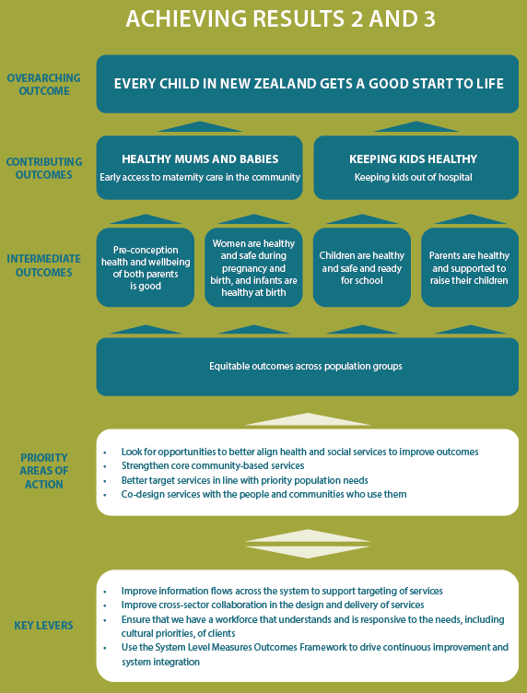

We will work on priority areas
In 2017/18 we have a number of priority actions underway or planned that will contribute to healthy mums and babies and keeping kids healthy.

The Government will ...
- work with maternity providers, district health boards and others to ensure all pregnant women have access to maternity services provided by Lead Maternity Carers
- work with district health boards and stakeholders to explore primary/community service models that improve the availability of preventive initiatives, and access to services, for children and pregnant women
- work with district health boards and their district alliance partners to improve outcomes for pregnant women and children through continuing to implement the System Level Measures. These form an improvement framework that concentrates on improving core health outcomes, with a particular focus on equity. Initiatives that impact on pregnant women and children include:
- increasing the number of women registering with a Lead Maternity Carer in the first trimester
- improving pre-conception health and wellbeing by increasing access to health services for youth (for ages 10–24) including sexual and reproductive health, mental health and wellbeing, and alcohol and other drug treatment services
- increasing the rates of babies living in smoke-free households
- implementing prevention and early treatment of respiratory conditions in the community
- improving maternal and child immunisation rates
- improving children’s attendance at dental clinics
- implement the Fetal Alcohol Spectrum Disorder (FASD) Action Plan, a comprehensive set of cross- government actions to prevent FASD. The Plan includes expanding the pregnancy and parenting services for women with addictions. It includes actions to identify and support children affected by FASD
- work with experts and stakeholders to develop a National Sudden Unexpected Death in Infancy
- prevention programme. This ensures every infant and their family is provided with comprehensive and customised safe sleep information with follow-up support
- work with district health boards and other agencies to improve availability of, and access to, appropriate housing
- work across government agencies, and with Well Child Tamariki Ora services and other providers, to develop head injury prevention actions
- promote good oral health practices to parents and children in high-need communities
- continue to support water fluoridation in communities
- review the Well Child Tamariki Ora programme to ensure it aligns with the evidence about what works, reflects key priorities, and is able to be delivered with sufficient intensity to meet the needs of pregnant women, children, families and whānau
- continue the New Zealand childhood obesity programme – a multi-agency programme that aims to equitably reduce childhood obesity in New Zealand so that children and young people can live well and stay well.

Working together to achieve Results 2 and 3
The lead agency for Results 2 and 3 is the Ministry of Health. The Director-General of Health will be the lead Chief Executive.

The Ministry of Health will work in partnership with other agencies contributing to achieving Results 2 and 3. These include:
- district health boards
- Ministry of Social Development
- Ministry for Vulnerable Children, Oranga Tamariki
- Ministry of Business, Innovation and Employment
- Housing New Zealand Corporation
- Department of Internal Affairs.

We will work in partnership with district health boards and midwives to deliver the Results, as well as seeking feedback from other specialist groups.

There are already multiple government initiatives under way that contribute to achieving Result 3. These include:
- increasing the social housing stock
- the Healthy Homes Initiative
- requirements under the law that all rental properties have underfloor and ceiling insulation installed
- educational initiatives that aim to inform tenants and landlords about changes to the law and how to help make rental homes warmer, drier and safer
- investigation of complaints or breaches of the Residential Tenancies Act involving a significant risk to tenant health and safety: a particular focus is where there are vulnerable tenants, including children.

Where we’re starting from

Result 2: Healthy mums and babies
The baseline for Result 2 is 67% of women registered with a Lead Maternity Carer in the first trimester in 2015. Rates vary widely according to age, deprivation, ethnic group and geographical location, as Figures 1–2 below illustrate.

The challenge we will address with Result 2 is reducing the disparities that exist between population groups, while continuing to lift overall rates.

Figure 1: Percentage of first trimester registrations, by ethnic group including current forecast rates without intervention
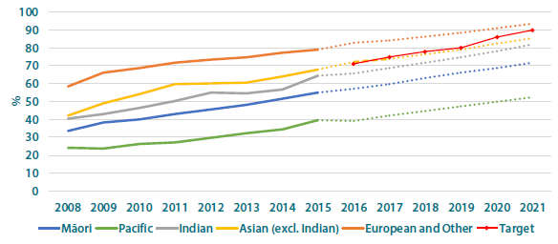
Source: Ministry of Health

Figure 2: Percentage of first trimester registrations, by deprivation quintile including current forecast rates without intervention
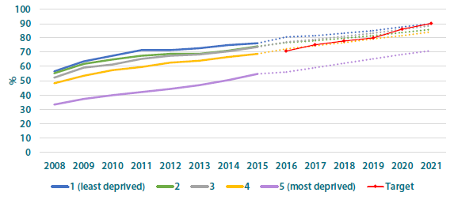
Source: Ministry of Health

Result 3: Keeping kids healthy
Rates of avoidable hospitalisation vary by health condition but are significantly higher for children living in more deprived neighbourhoods, as well as for Māori children and Pacific children.

The baseline rate for Result 3 is 40.3 hospitalisations per 1,000 population in 2015/16.

Figure 3: Age-standardised rate (per 1,000) of hospital admissions by ethnicity, for selected conditions in children aged 0 to12 years, including current forecast rates without intervention
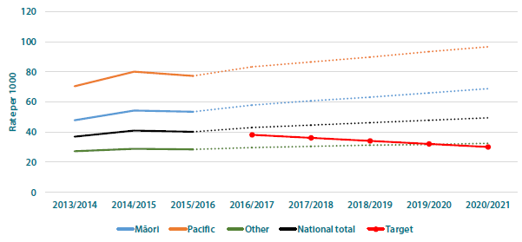
Source: Ministry of Health

Figure 4: Hospital admissions by deprivation quintile, for children aged 0 to 12 years, July 2013 to June 2016
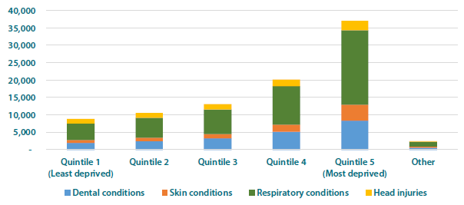
Source: Ministry of Health

Measuring success
Progress will be monitored using two key measures:
- percentage of pregnant women who registered with a Lead Maternity Carer in the first trimester
- hospitalisations for avoidable conditions in children aged 0–12.

PERCENTAGE OF  PREGNANT WOMEN  WHO REGISTERED WITH A LEAD MATERNITY CARER  IN THE FIRST TRIMESTER | In addition to the key measures above, we will publicly report on the following supporting measures:  - babies who live in smoke-free households  - pregnant women immunised against whooping cough  - a breakdown of the different conditions under Result 3: dental, respiratory and skin conditions, and head injuries  - rates of rheumatic fever.
HOSPITALISATIONS FOR AVOIDABLE CONDITIONS IN CHILDREN AGED 0–12

Lead Maternity Carers are usually midwives but can also be obstetricians or general practitioners.
This is based on 6.0 hospital admissions per 1,000 children (approximately 4,900 admissions, based on 2018/19 projected population) being avoided by 2019. An additional 4.0 hospital admissions per 1,000 children (approximately 3,300 admissions based on 2020/21 projected population) will be avoided by 2021.
http://www.health.govt.nz/new-zealand-health-system/system- level-measures-framework
Department of Internal Affairs is the current agency lead for SmartStart (Life Event Services).

