Case and contact management: monitoring and reporting to achieve and sustain elimination of COVID-19
9 May 2020

Prepared by the COVID-19 Public Health Response Strategy Team

Contents
Case and contact management: monitoring and reporting to achieve and sustain elimination of COVID-19 1
Executive summary 2
Key findings 2
Current situation 2
How COVID-19 elimination is operationalised 2
How case and contact management works 3
Implications for de-escalation from Alert Levels (Level 4 to Level 3 and Level 2) 3
Monitoring and reporting of case and contact management 4
Document Purpose 5
Rationale for data approach 5
The elimination strategy in Aotearoa/New Zealand 5
The safety net principle 5
Implications for de-escalation from Alert Level 4 6
WHO criteria for transition and de-escalation of pandemic response 6
Case and contact management of COVID-19 infection 8
Framework for monitoring and reporting 9
Implications of case and control management for specific control measures 15
References 16
Appendix A 17
Definition of terms 17
Appendix B: Elimination strategy failure pathways 18

Executive summary
This working paper forms part of background work commissioned by the Ministry of Health (via the Director of Public Health) to help inform the ongoing response to COVID-19. It outlines the information required to: understand whether elimination is being successfully achieved and maintained; inform adaptation of control measures (including alert level de-escalation); and ensure that the equity implications of the COVID-19 response are considered and mitigated.

Key findings
- De-escalation will induce a critical dependence on the capacity of the case and contact management system to identify and extinguish all remaining transmission chains.
- The World Health Organization (WHO) has articulated six key criteria that must be satisfied in order to de-escalate control measures while maintaining a low-level or no transmission. The criteria are stringent: for example, all suspected cases should have test results within 24 hours of identification and sampling.
- Testing and tracing are essential stepping stones to stop transmission chains, but in themselves these activities do not prevent transmission. Transmission is only prevented by isolating cases and contacts. Confidence in comprehensive, effective, equitable, and timely isolation is vital to ensure elimination of viral spread: measurement and reporting should accordingly reflect this key priority.
- Monitoring and reporting of the system requires information about the degree to which elimination has been achieved – including operational effectiveness, equity of outcomes (including outcomes of response measures), and minimisation of error and bias in the data and analyses.
- Ensuring all symptomatic cases are identified and tested through active case finding is key to the success of the elimination effort.

Current situation
- COVID-19 has had a devastating and inequitable impact on populations where the pandemic has not been contained.
- The infection is highly transmissible and the population of Aotearoa/New Zealand is still almost completely susceptible. There is no vaccine or specific antiviral treatment. This vulnerability leaves very little margin for error in the pandemic response.

How COVID-19 elimination is operationalised
COVID-19 elimination will be achieved through three key systems:
- management of cases and contacts to stop onward transmission from identified cases
- physical distancing and hygiene measures to stop onward transmission of undetected cases
- border controls to prevent seeding of new clusters from outside the country.

Because no system is completely failsafe, each system provides a safety net against error in the others. For this process to work, each of these systems needs to work well for all population groups. Inequitable access to testing, case/contact identification and management, and isolation, will undermine the effectiveness of the entire pandemic response. Inequitable ability to undertake physical distancing and hygiene measures will also undermine the response.

How case and contact management works
We use the term ‘case and contact management’ to describe a system of connected activities undertaken to prevent disease clusters. Activities include:
- identification of cases
- testing
- contact tracing
- isolation of cases
- isolation of close contacts of cases.

Testing and contact tracing are necessary for elimination but these activities do not in themselves prevent transmission. Only timely isolation of cases and contacts can stop viral spread: even if testing and contact tracing is highly effective, transmission will still occur if identified cases and contacts are not rapidly and appropriately isolated.

There is a critical and highly limited time window for the case and contact management to occur once a case is symptomatic, as infected contacts are likely to be already infectious themselves.

The capacity of individuals to isolate themselves is likely to be highly inequitable, with those in crowded households or in low-income employment least able to protect themselves and others.

Implications for de-escalation from Alert Levels (Level 4 to Level 3 and Level 2)
Exiting lockdown induces a critical dependence on the capacity of the case and contact system to identify and extinguish all remaining transmission chains.

The high degree of physical distancing at Alert Level 4 (the lockdown) currently protects Aotearoa/New Zealand from any weaknesses in the case and contact management system (as a large proportion of the population is already isolated).

De-escalation (especially from Alert Level 4) is unsafe without robust evidence that case and contact management is able to contain transmission. This includes a high degree of confidence that all contacts of a case are rapidly and effectively traced and isolated.

Monitoring and reporting of case and contact management
To determine the appropriate alert level for Aotearoa/New Zealand, we need to evaluate (as sufficient/not sufficient) and quantify (how much):
- the degree to which elimination has been achieved
- the current and predicted operational effectiveness of response activities
- equity in elimination of the virus and in the response
- level of error and bias in the data and analyses used to examine the above.

Monitoring and reporting needs to be strongly linked to the aims and objectives of the elimination strategy. Implications for the system include a requirement for detailed and reliable (high validity) information covering the above four points. Information that is not currently available or routinely reported externally includes:
- the sources and settings where infection and close contacts are occurring
- the timeliness of actions, and in particular the time intervals to isolation
- demographic data about both cases and contacts (currently, information about contacts is sparse) to identify and mitigate inequities
- measures of compliance with isolation and barriers to achieving effective isolation
- measures of the validity of the data.

As noted above, transmission is only prevented if cases and contacts are isolated. Confidence in isolation is vital to assess successful elimination of viral spread and measurement and reporting must reflect this key priority.

Figure 1: Overview of key case and contact information domains to inform COVID-19 de-escalation decisions.

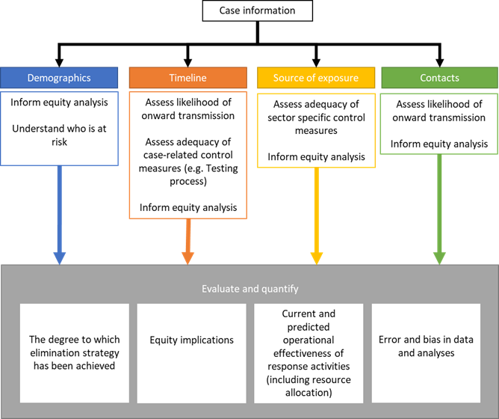

Document Purpose
Case management and contact tracing is an essential part of the COVID-19 pandemic response. High quality case management and contact tracing is necessary to underpin Aotearoa/New Zealand’s efforts to eliminate COVID-19.

This document outlines the information required to: understand whether elimination is being successfully achieved and maintained; inform adaptation of control measures (including alert level de-escalation); and ensure that the equity implications of the COVID-19 response are considered and mitigated.

We present the rationale for identifying this information and a data framework to ensure that all areas are adequately covered. We do not discuss the analysis framework as we understand this is being developed elsewhere. We also do not discuss clinical components of case management (eg, advice around hospitalisation); the focus of this report is on actions taken to prevent onward transmission to close contacts.

This document is one of a number of papers prepared by the COVID-19 Public Health Response Strategy Team (a group of epidemiologists and public health medicine specialists seconded temporarily to the Ministry of Health).

This draft document has not been formally peer reviewed.

Rationale for data approach

The elimination strategy in Aotearoa/New Zealand
Aotearoa/New Zealand is currently employing an elimination strategy for COVID-19. The two primary aims of this strategy are:
- to eliminate transmission chains in Aotearoa New Zealand
- to prevent the emergence of new transmission chains originating from cases that arrive from outside the country.
To achieve these aims the effective reproduction number R_{t} must be reduced throughout the country to less than 1, or as near to 1 as possible. As such, the COVID-19 elimination strategy has four key objectives:
- to identify and stop each transmission chain (ie, case and contact management)
- to prevent undetected transmission (ie, physical distancing measures)
- to prevent seeding of new clusters into communities (ie, border control measures)
- to prioritise equity.

The safety net principle
Although the above disease elimination objectives are distinct in terms of their contribution to elimination and the settings in which they occur, they work together and act as safety nets for one another. For example, if a COVID-19 case passes through border controls into the community, onward transmission might be stopped either by detection and management of the case and their close contacts, or by physical distancing measures currently implemented at Alert Level 4. If transmission is not prevented, or effectively managed, COVID-19 disease will exacerbate existing health inequities, and likely create new health inequities, particularly for Māori and Pacific communities.
This safety net function is a very important aspect of COVID-19 control because no control measure is completely failsafe, and in the current situation of a highly transmissible virus and completely susceptible population, there is very little margin for error.

Implications for de-escalation from Alert Level 4
Currently, the intense physical distancing measures implemented at Alert Level 4 are acting as a strong safety net for cases not detected at the border and the case and contact management system. If the intensity of physical distancing decreases (by de-escalating to Alert Level 3 or by a decrease in compliance), this lowering of protection will induce a critical reliance on effective case management (including detection) for stopping existing transmission and any new transmission associated with a ‘leaky’ border.

WHO criteria for transition and de-escalation of pandemic response
The WHO has articulated six key criteria that must be satisfied in order to de-escalate control measures while maintaining a low-level or no transmission (see Table 1). The criteria are stringent: for example, we note that all suspected cases should have test results within 24 hours of identification and sampling, and that all close contacts can be traced, quarantined and monitored for 14 days.

Table 1. WHO criteria for transition and de-escalation of pandemic response (Reproduced verbatim from the WHO COVID-19 Strategy update of 14 April 2020).

Six key criteria for transitioning to and maintaining a steady state of low-level or no transmission
- COVID‑19 transmission is controlled to a level of sporadic cases and clusters of cases, all from known contacts or importations and the incidence of new cases should be maintained at a level that the health system can manage with substantial clinical care capacity in reserve.
- Sufficient health system and public health capacities are in place to enable the major shift from detecting and treating mainly serious cases to detecting and isolating all cases, irrespective of severity and origin:
- Detection: suspect cases should be detected quickly after symptom onset through active case finding, self-reporting, entry screening, and other approaches;
- Testing: all suspected cases should have test results within 24 hours of identification and sampling, and there would be sufficient capacity to verify the virus-free status of patients who have recovered;
- Isolation: all confirmed cases could be effectively isolated (in hospitals and/or designated housing for mild and moderate cases, or at home with sufficient support if designated housing is not available) immediately and until they are no longer infectious;
- Quarantine: all close contacts could be traced, quarantined and monitored for 14 days, whether in specialized accommodation or self-quarantine. Monitoring and support can be done through a combination of visits by community volunteers, phone calls, or messaging.
- Outbreak risks in high-vulnerability settings are minimized, which requires all major drivers and/or amplifiers of COVID‑19 transmission to have been identified, with appropriate measures in place to minimize the risk of new outbreaks and of nosocomial transmission (e.g. appropriate infection prevention and control, including triage, and provision of personal protective equipment in health care facilities and residential care settings).
- Workplace preventive measures are established to reduce risk, including the appropriate directives and capacities to promote and enable standard COVID-19 prevention measures in terms of physical distancing, hand washing, respiratory etiquette and, potentially, temperature monitoring.
- Risk of imported cases managed through an analysis of the likely origin and routes of importations, and measures would be in place to rapidly detect and manage suspected cases among travellers (including the capacity to quarantine individuals arriving from areas with community transmission).
- Communities are fully engaged and understand that the transition entails a major shift, from detecting and treating only serious cases to detecting and isolating all cases, that behavioural prevention measures must be maintained, and that all individuals have key roles in enabling and in some cases implementing new control measures.
Further details are in the online strategy document.

See also the WHO Director-General's opening remarks at the Mission briefing on COVID-19 - 16 April 2020.

Case and contact management of COVID-19 infection
Confirmed and probable COVID-19 cases are required to self-isolate for the duration of their illness. This includes keeping separate from other household members. Those awaiting results of a COVID-19 test are also required to self-isolate and follow the same guidance as confirmed cases (until the outcome of the test is known). Close and casual contacts of the case are identified and provided with appropriate guidance (see Appendix 1 for definitions of close and casual contacts).

The Ministry of Health advice (at the time of preparing this paper) is for close contacts of a confirmed case to self-isolate (quarantine) for 14 days from the date of contact. The purpose of isolation of close contacts is to extinguish potential onward transmission of infection. Casual contacts are not required to self-isolate but are provided advice about COVID-19 symptoms and advised to seek health advice in the event that they become symptomatic.

Symptom onset occurs on average five days following exposure [1] and a case may be infectious up to 3.8 days prior to the onset of symptoms [2]. This provides a very short window of time in which close contacts need to be self-isolated to prevent onward transmission (see Figure 2). Where close contacts are not isolated prior to becoming infectious, the chain of transmission can continue (as occurs with Person C infecting Person D in Figure 2). Given that ~80 percent of those infected with COVID-19 experience only mild to moderate symptoms [3], and there is some evidence that COVID-19 can be transmitted by individuals who never develop any symptoms [4, 5], this leaves no margin of error for the case and contact management process. This underlines the need for high quality, and timely, data collection and systems.

Figure 2: Case and contact pathway, with window for isolating contacts to prevent onward transmission highlighted. Person A infects Person B and Person C prior to being tested for COVID-19 and isolated. Contact tracing identifies Person B and they are isolated prior to becoming infectious. Person C is not successfully isolated prior to becoming infectious and this results in onward transmission (the infection of Person D), and eventually outbreak (Persons E, F, and G).
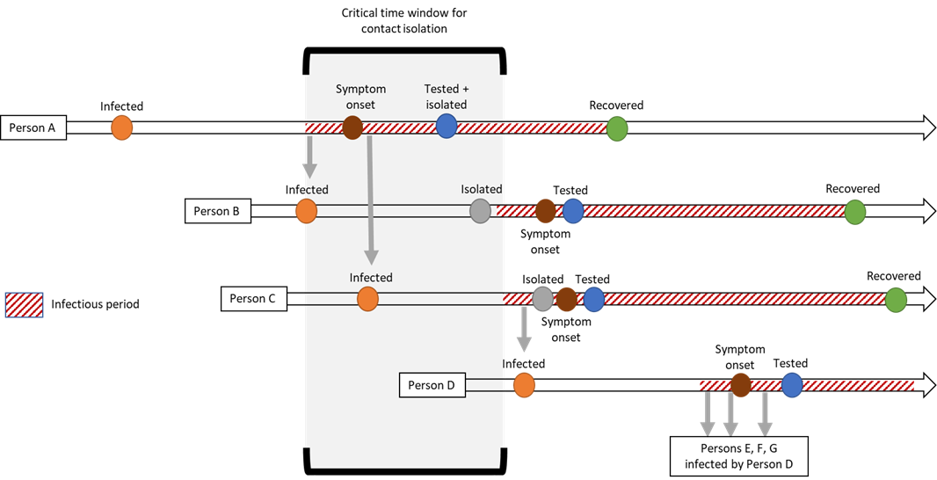
To know whether case and control management is sufficient for de-escalation, data systems that enable reporting on the timeline of each case and contact are required. Each step in the case pathway needs to be dated to inform the appropriateness of the response. For example, if there is a large delay between symptom onset and a case seeking health care, it reduces the time available for the case to be tested, and contacts to be traced and isolated and thereby minimise the chance of transmission. For this process to work, it has to work well for all population groups. Inequitable access to testing, case/contact identification and management, and isolation will undermine the effectiveness of the entire pandemic response. There is a risk of generating inequities, and widening existing inequities, if there are differences in the timeliness of the case and contact management process across different population groups.

The characteristics of COVID-19 infection (including incubation time, and evidence of pre-symptomatic transmission) suggest the critical timeframe available for contacts to be isolated from the onset of symptoms in the originating case is 24 to 48 hours.

Framework for monitoring and reporting
To determine the appropriate alert level for Aotearoa/New Zealand, we need to evaluate (as sufficient/not sufficient) and quantify (how much):
- the degree to which elimination has been achieved
- the current and predicted operational effectiveness of response activities
- equity in elimination of the virus and in the response
- minimisation of error and bias in the data and analyses used to examine the above.

Table 2 illustrates a framework/approach to data for monitoring and reporting on COVID-19 elimination. Note: these tables are intended to identify topic areas and are not intended to be exhaustive in identifying data fields and analyses. We suggest instead that the analyses are fully worked up to identify specific data fields required for each analysis or set of analyses.

Table 2. Case and contact indicators for evaluation of COVID-19 elimination
(NOTE: This table is indicative only: definitive list of indicators and measures to be developed from the analysis plan).

DATA ON CASE AND CONTACT MANAGEMENT SYSTEM:
INFORMATION FOR MONITORING AND REPORTING
 | Elimination | Response | Validity
 | Is COVID-19 spread contained? | Is the response equitable, appropriate and timely? | Can this information be relied on for decisions?
Symptomatic case seeks help | Date of onset of symptoms  Date of first contact with health services  Demographic descriptors of symptomatic cases (including ethnicity, DHB/region, NZDep)  Flag for health worker or other essential worker | Type/location of provider  Accessibility of provider | Estimate proportion of missing records:  - Does the distribution of cases seen at CBACs reflect the populations they serve; is first contact accessible?  - How many symptomatic cases do not seek help?  - How many asymptomatic cases are there for each symptomatic case?
Case is tested | Number of positive tests  Proportion of positive tests (among those tested) | Proportion of individuals who meet the testing criteria that are tested  Testing is timely (performance indicators to be determined) eg, interval from symptoms to test, by ethnicity and location | Report any differences in testing rates and timeliness by ethnicity, age or location
Case is informed of result and assigned status (eg, confirmed/ probable) | Test result  Date of status | Time interval between testing and result to case, by ethnicity, age and location  WHO criterion is 24 hours from case identification and sampling to test results | Sensitivity and specificity of test  Differences in positivity by ethnicity, age or location
Case is isolated | Date of entering isolation | Advice and support available  Availability of case information in appropriate language  Feasibility of isolation, by ethnicity, location, age, sex, NZDep and disability  Number of people in immediate household  Numbers of cases in residential facilities (eg, prison, aged care) | Compliance with isolation, by ethnicity, age, sex and location (eg, digital solutions)
Contact tracing | How many close contacts identified (to contribute to reporting of number of contacts per case)  Contact settings, including occupational categories (eg, healthcare worker) | Proportion of close contacts that are traced, by ethnicity and location  Met agreed standards (to be determined) for time/effort in tracing contacts, by ethnicity  Proportion of contacts who do not speak English as a first language  Identified language barriers in contact tracing | Quality of data linkage of cases and contacts  Quality of ethnicity data  Coverage (access and opt-out) of digital contact tracing
Case severity | Date of hospital/ICU admission or out of hospital death. | Severity level of cases (eg, hospital admission severity score), by ethnicity, age, sex, NZDep and location  Severity level relative to health service capacity, by location  Comorbidities/severity risk factors of case, by ethnicity, age, sex and NZDep  Severity rate and timeliness of care in certain settings (eg, prisons, aged-care facilities) | Use National Health Index (NHI) to validate in National Minimum Dataset
Case outcome | Date died/recovered, by ethnicity, location and NZDep  Date isolation completed, by ethnicity, location and NZDep  Measure infection fatality risk, by ethnicity, location and NZDep  Estimate case fatality risk | Timely status update  Fatality rate in certain settings (eg, prisons, aged-care facilities) | Use mortality data to validate
Contact informed | Demographic data on contact, including age, ethnicity, occupation, NZDep, location/DHB  Flag for health worker or other essential worker  Source, setting, and date of last close contact with case  Close contact or casual contact | (As for case, but reported using contacts as the unit of measurement)  Time interval from identification of contact by case, and contact reached and informed  Inequities in time delays and proportions | Contact linked to NHI  Concordance between information obtained from cases and contacts
Close contact isolated | Time interval between date of last close contact and isolation  Time interval between informed of contact status and isolation  Completed 14 days (reported by demographic descriptors) | Daily monitoring of isolated person  Compliance with isolation  Report by demographic descriptors | Use of app technology could help to validate degree of isolation achieved (at a person or population level)  Identify and report on barriers to effective isolation by demographic descriptors
Contact symptomatic | Date of onset of symptoms (time interval between last close contact with case and onset)  Severity information as for case  Report probability of becoming symptomatic by demographic descriptors | Follow up of contacts to ensure capture of symptomatic contacts, reported by demographic descriptors | Assess adequacy of follow up of contacts, report and adjust for loss to follow up
Contact tested | Report as for case, but analyse using contacts as the unit of analysis and also relate back to case (ie, analysis of clusters) | Report as for case, but analyse using contacts as the unit of analysis and also relate back to case (ie, analysis of clusters) | Report as for case, but analyse using contacts as the unit of analysis and also relate back to case (ie, analysis of clusters)

Implications of case and control management for specific control measures
Timely data collected on each case provides the opportunity to tailor control measures and other features of the elimination strategy. This includes information about the case (eg, age, occupation, ethnicity), their source of exposure (eg, overseas, household, workplace), and their contacts (eg, number of contacts). At the time of writing, these data were not widely available.

Case information provides a starting point to assess the sufficiency of control measures in different settings. For example, cases in health care staff may suggest a need to adapt protocols for health care settings (eg, use of PPE) whereas cases through social events may inform control measures adopted in community settings (eg, restrictions on size of gathering or opening of venues such as restaurants). Cases in communities particularly vulnerable to COVID-19 disease impacts (eg, aged care facilities and other residential communities) have important implications for transmission and control measures. If cases have multiple possible exposures (eg, unclear whether from a social event or from a household member who attended the same social event) this should also be stated.

Case information (particularly number and nature of contacts) can be used to gauge possible future case numbers and may signal a need to increase specific capacities. For example, if large numbers of older adults are identified as close contacts of a case then this may inform preparations to increase local health system capacity. If contacts of a case are geographically widespread, this has different implications than if they are not.

Case information is necessary to detect inequities in the effectiveness of the COVID-19 response to allow rapid and appropriate mitigation. For example, if workplace cases are arising in low paid workers but not in high paid workers then this may indicate there are discrepancies in workplace compliance or inequities in the overall levels of risk that are being borne by different workers. Some communities may need different support to eliminate transmission chains (eg, contact tracing and information in languages other than English). Data from the UK demonstrates large inequities in the ability for individuals from different socioeconomic backgrounds to self-isolate [6]. Inequities in household exposure for those in crowded households may suggest a need to support cases or close contacts to self-isolate away from others in their household (eg, through provision of alternative accommodation where requested).

The use of case and contact management to inform control measures requires the data and analyses to be designed to meet this purpose. Whilst practice, at the time of writing, provides some of the aforementioned details about a contact (eg, age), other details are not currently presented in a way that is conducive to informing the response (eg, ethnicity). For example, source of exposure information is not disaggregated to a level that can be utilised to evaluate control measures. Whilst information on which cluster a case may be linked to is important, what is more useful is knowing whether the case was exposed at a social event, or through household transmission from a household member attending the event. The former situation can be investigated to inform control measures around social events whilst the latter may suggest guidance, policies, or support around household contacts may need to be amended.

Without timely and appropriate case and contact management that is tailored to meeting the requirements of the COVID-19 response, we lack the ability to fine tune how the response is managed and assess if the elimination strategy is succeeding. This presents a high risk of COVID-19 resurgence (ie, a second wave of transmission), a high risk that stringent control measures will need to be re-implemented (ie, a return to a strict Alert Level 4 lockdown), and a high risk of generating or exacerbating inequities (either through control measures being too strict for the COVID-19 situation or not being strict enough).

References

1. Lauer, S.A., et al., The Incubation Period of Coronavirus Disease 2019 (COVID-19) From Publicly Reported Confirmed Cases: Estimation and Application. Annals of internal medicine, 2020.
2. Zhang, W., Estimating the presymptomatic transmission of COVID19 using incubation period and serial interval data. medRxiv, 2020: p. 2020.04.02.20051318-2020.04.02.20051318.
3. World Health Organization, Report of the WHO-China Joint Mission on Coronavirus Disease 2019 (COVID-19). 2020.
4. Bai, Y., et al., Presumed Asymptomatic Carrier Transmission of COVID-19. Jama, 2020. 21: p. 21.
5. Hu, Z., et al., Clinical Characteristics of 24 Asymptomatic Infections with COVID-19 Screened among Close Contacts in Nanjing, China. medRxiv, 2020: p. 2020.02.20.20025619.
6. Atchison, C.J., et al., Perceptions and behavioural responses of the general public during the COVID-19 pandemic: A cross-sectional survey of UK Adults. medRxiv, 2020: p. 2020.04.01.20050039-2020.04.01.20050039.

Appendix A
Background information relevant to this report can be found on the Ministry of Health public-facing web pages, including:
- the case notification form
- advice to individuals who are self-isolating
- contact tracing procedure.

Definition of terms
Close contact

The Ministry of Health defines close contact as ‘any person with the following exposure to a suspect, confirmed or probable case during the case’s infectious period, without appropriate personal protective equipment (PPE):
- direct contact with the body fluids or the laboratory specimens of a case
- presence in the same room in a health care setting when an aerosol generating procedure is undertaken on a case
- living in the same household or household-like setting (eg, shared section of in a hostel) with a case
- face-to-face contact in any setting within 2-metres of a case for 15 minutes or more
- having been in a closed environment (eg, a classroom, hospital waiting room, or conveyance other than aircraft) within 2-metres of a case for 15 minutes or more
- having been seated on an aircraft within 2-metres of a case (for economy class this would mean two seats in any direction including seats across the aisle, other classes would require further assessment)
- aircraft crew exposed to a case (a risk assessment conducted by the airline is required to identify which crew should be managed as close contacts).’

Casual contact

The Ministry of Health defines a casual contact as ‘Any person with exposure to the case who does not meet the criteria for a close contact.’

Appendix B: Elimination strategy failure pathways

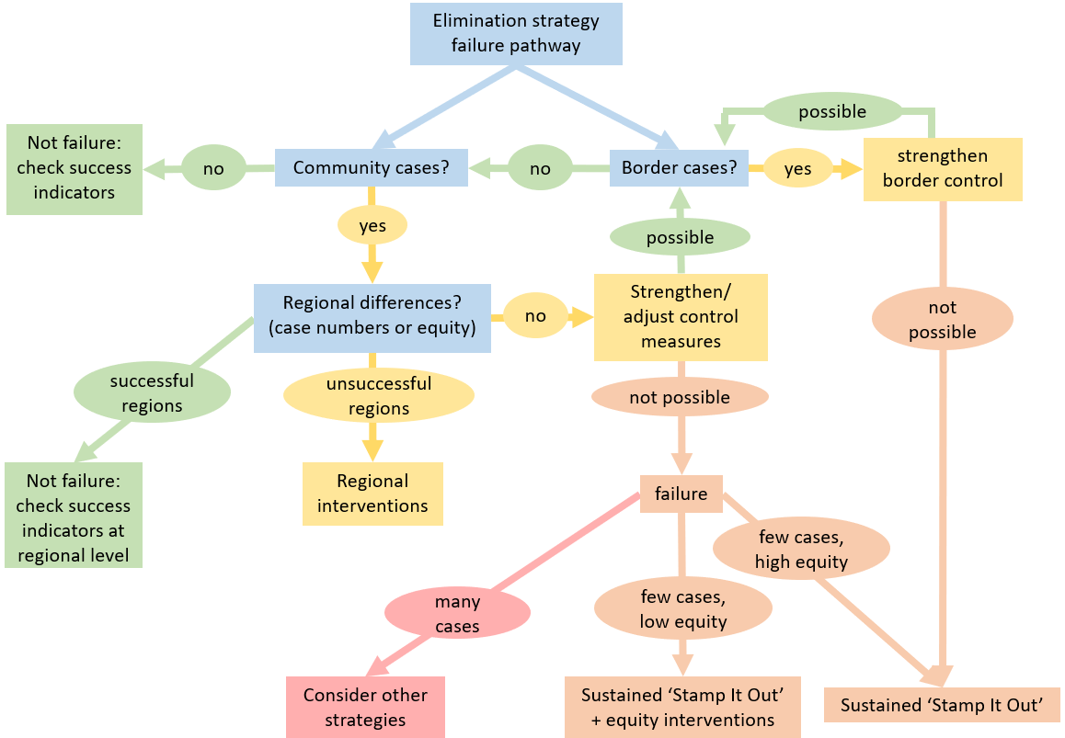
Equity: equitable infection and progression rates between Māori and non-Māori; and equitable infection and progression rates across population groups defined by ethnicity, gender, socioeconomic status, and disability status.

Until 48 hours after cessation of symptoms or 10 days after symptoms began, whichever is longer. All suspect, confirmed and probable cases cannot be released from isolation unless advised by the health professional responsible for monitoring of their health and wellbeing.

