Consultation on Proposals for a Smokefree Aotearoa 2025 Action Plan
Analysis of submissions
Acknowledgements
Thank you to everyone who provided feedback to our public consultation on Proposals for a Smokefree Aotearoa 2025 Action Plan.
Your feedback was valuable in informing and contributing to the development of the final Smokefree Aotearoa 2025 Action Plan.
Citation: Ministry of Health. 2021. Consultation on Proposals for a Smokefree Aotearoa 2025 Action Plan: Analysis of submissions. Wellington: Ministry of Health.
Published in December 2021 by the Ministry of Health
PO Box 5013, Wellington 6140, New Zealand
ISBN 978-1-99-110002-3 (online)
HP 8005
This document is available at health.govt.nz
This work is licensed under the Creative Commons Attribution 4.0 International licence. In essence, you are free to: share ie, copy and redistribute the material in any medium or format; adapt ie, remix, transform and build upon the material. You must give appropriate credit, provide a link to the licence and indicate if changes were made.

Contents
Introduction 1
Methodology 2
Data collection and handling 2
Analysis 3
Results 3
Summary of responses 5
Appendix one: Hāpai te Hauora social media promotion of the Smokefree Action Plan 25
Appendix two: Groupings of submissions for figures 26
Appendix three: Cancer Society of New Zealand additional feedback 27

List of Figures
Figure 1: Responses to question 2a from all submissions 9
Figure 2: Responses to question 2b from all submissions 10
Figure 3: Response to question 2c from respondents, excluding individual Māori responses collected by Hāpai te Hauora 12
Figure 4: Response to question 2d from all submissions 14
Figure 5: Response to question 3a from all submissions 16
Figure 6: Response to question 3b from all submissions 17
Figure 7: Response to question 3c from all submissions 19
Figure 8: Response to question 4a from all submissions 21

List of Tables
Table 1: Submissions by submitter type 4
Table 2: Organisation types of submitters 4

Introduction
A decade has passed since New Zealand adopted the goal to reduce smoking prevalence and tobacco availability to minimal levels, essentially making Aotearoa New Zealand smokefree by 2025. Over this time, smoking rates have continued to decline. However, we still have much work to do – particularly to reduce smoking rates among Māori, Pacific peoples and those living in New Zealand’s most disadvantaged communities.

The Ministry of Health has developed the Smokefree Aotearoa 2025 Action Plan to achieve the smokefree goal. To this end, we consulted on Proposals for a Smokefree Aotearoa 2025 Action Plan in April and May 2021.

This document sets out the submissions process and summarises the responses we received.

Methodology
Consultation period

The consultation period ran for six weeks (15 April – 31 May 2021). It was publicised on the Ministry website, in several mainstream media news items and on social media.

The Ministry also engaged Hāpai te Hauora, a Māori provider which holds the National Tobacco Control Advocacy contract, to ensure Māori and Pacific communities and individuals had input into the consultation during this period.

Data collection and handling
The Ministry developed a consultation submission form which was available as a word document and on Citizen Space, the Ministry’s online consultation platform, to guide feedback.

Hāpai te Hauora led the engagement for Māori and Pacific communities. Partnerships were formed with their existing networks, in particular with Tala Pasifika to support Pacific engagement.

Hāpai te Hauora engaged whānau and kaimahi (workers) in the stop-smoking sector for face-to-face discussion in key areas across Aotearoa. In addition, Hāpai te Hauora created an online survey for whānau Māori to engage with.

Pacific consultation was also organised, including family and community groups, and took place in person and over Zoom.

Hāpai te Hauora used social media platforms to promote the consultation and adopted actions similar to those they had used in their previous promotion of the vaping regulations consultation. Hāpai te Hauora posted a suite of online media content to encourage community participation in the consultation process and posted additional social media content in the lead-up to the due date to encourage whānau Māori to complete online submissions (see Appendix one).

New Zealand has an obligation under article 5.3 of the World Health Organization’s Framework Convention on Tobacco Control when ‘setting and implementing public health policies with respect to tobacco control … to protect these policies from the commercial and other vested interests of the tobacco industry’.

The internationally agreed Guidelines for Implementation of article 5.3 recommend that parties to the treaty ‘should interact with the tobacco industry only when and to the extent strictly necessary to enable them to effectively regulate the tobacco industry and tobacco products’.
The Ministry therefore asked all submitters to the consultation to disclose any direct or indirect links to, or receipt of funding from, the tobacco industry.

Additional information was collected to support analysis, including organisation type, age, ethnicity, and country of location.

Analysis
We collated submissions from Citizen Space, emails to the Smokefree 2025 inbox and submissions collected by Hāpai te Hauora and analysed them together.

Some of the consultation proposals called for free-text answers, and some for a yes or no selection. In analysing submissions, we collated data in the free-text sections using tools in the Citizen Space application, and organised and analysed the yes or no answers. Multiple themes could be extracted from each response. A significant number of submitters raised the topics of equity, vaping, smokefree areas, and compliance and enforcement. We therefore included these as categories in our analysis.

We have summarised submissions according to submitter category.

Results
Over 5,200 people and organisations engaged with the consultation process, either through a written submission or by attending hui (399) or Pacific-focused community meetings (788) organised by Hāpai te Hauora. Many of these face-to-face meetings included community members who smoked or had been affected by smoking in their whānau.

Written submissions came in a variety of formats. The Ministry’s online consultation platform, Citizen Space, received 2,254 submissions. 1,722 Citizen Space submissions disclosed a tobacco industry link. Of these submissions, eight were from importers of tobacco. Many of these submissions (1,589) were completed through two anonymously organised form submissions for small retailers. The remaining Citizen Space submissions (665) were mostly from academics in New Zealand and overseas; local government and health care organisations; retail and tobacco industry groups; and iwi, advocacy, and political interest groups. These submissions were often detailed, and included a range of attachments, references, and information. Finally, many submitters completed form submissions via surveys by the Cancer Society (844) or Hāpai te Hauora (921).

We excluded 116 submissions that were classified as spam or duplicates.

Table 1 shows the number of submissions we received and included in this analysis.

Table 1: Submissions by submitter type
Submitter type | Number of submissions/participants
Citizen Space | 2,254
Hāpai te Hauora Māori community hui (11 hui) | 399
Hāpai te Hauora Māori-focused survey | 921
Hāpai te Hauora Pacific-focused community meeting (45 Pacific groups) | 788
Cancer Society collated submissions | 844
Total | 5206

Table 2: Organisation types of submitters
Type of submission | Individual
 | Organisation
Additional organisational information* | Personal submission
 | Community or advocacy organisation
 | Iwi-/hapū-affiliated, and/or Māori organisation
 | Pacific community or organisation
 | Government organisation
 | Health care provider (eg, primary care provider, stop smoking provider)
 | Professional organisation
 | Tobacco manufacturer, importer or distributor
 | Research or academic organisation (eg, university, research institute)
 | Other
* Submitters could indicate more than one sector.
* The submitters who identified as ‘Other’ included parish groups, local government, community groups, kaimahi in the stop smoking sector, whānau, parents, clients of stop smoking support services and their whānau.

Summary of responses
There was strong engagement with the consultation. Submitters with a community, health care or personal interest were mostly in favour of the proposals. Those with a commercial interest in smoked tobacco (ie, tobacco importers and retailers) were mostly against the proposals. Many tobacco retailers felt the proposals would adversely impact their business.

We have organised the following summary according to the proposed focus areas within the action plan, as follows:
      - Strengthen the tobacco control system
      - Make smoked tobacco products less available
      - Make smoked tobacco products less addictive and less appealing
      - Make tobacco products less affordable

A fifth section, ‘Final questions’, covers themes submitters raised that were not explicitly covered by the consultation document.

Each of the four main sections sets out the relevant consultation question, and then discusses submitters’ responses.

1. Strengthen the tobacco control system

(a) Strengthen Māori governance of the tobacco control programme
What would effective Māori governance of the tobacco control programme look like? Please give reasons.

Many submissions, from both Māori and non-Māori, highlighted the need for Māori leadership at both national and local levels for Smokefree 2025 to be a success. Submitters also stated that Māori governance needed to be well funded and resourced.

‘Māori are disproportionately harmed by tobacco, so effective Māori governance would mean Māori leadership & decision making from top to bottom – from a policy making level all the way down to cessation support. Smoking is an effect – not a cause. What I mean by that is there are risk factors for smoking, there are also risk factors for relapsing so Māori governance would be given space to practice holistic methods of helping people quit & never start. For example, linking them up with social services, cultural services etc.’

Personal submission – Māori 18–34

Many submitters did not elaborate in detail on what effective Māori governance looked like but indicated it should be by Māori for Māori.

Submitters who did elaborate in detail fell into two broad categories:
- submitters who recommended a new governance structure
- submitters who recommended principles (or other things) to underpin any new governance arrangement.

‘Positioning of Māori with kaupapa Māori, governance, mātauranga, hauora and wellbeing expertise skills and knowledge as the leaders of this kaupapa. This means effective Māori governance from the time prior to conception of ideas … through all levels and steps of decision-making. Māori would make up at least 50% of the governance group and ideally the majority – given that this is a particularly Māori target.’
Principal kaupapa Māori researcher

Many submitters recommended the Māori Health Authority and a ‘Task Force 2025’ (made up of Māori tobacco control leaders and other appropriate subject matter experts) as appropriate governance bodies. These two models were not mutually exclusive: many submitted that we need both. Many stated the need to transfer parts or all the tobacco control programme to the Māori Health Authority.

Many submissions stated that Māori governance of the tobacco control system must extend across Māori health, social, economic, education and social systems, because all these systems play a role in addressing the impact of smoked tobacco. Submitters noted that clear lines of accountability to Māori communities must form part of this.

Many Pacific submitters felt that enhancing Māori governance would be of broad benefit to Pacific communities. However, they also wanted to see opportunities for Pacific leadership.

Other submitters, particularly those who felt negatively about the action plan in general, did not agree with Māori governance, or felt it would not add anything useful.

(b) Support community action for a Smokefree 2025
What action are you aware of in your community that supports Smokefree 2025?
What is needed to strengthen community action for a Smokefree 2025? Please give reasons.

Most submitters were aware of local activities supporting Smokefree 2025, mostly stop smoking services, as well as services run by district health boards (DHB) and Quitline. Many submissions mentioned smokefree areas (schools, workplaces, and other areas with smokefree signage) and events (such as smokefree sports events). However, a significant number of submitters who identified as Pacific were not aware of any community activities supporting Smokefree 2025.

There was strong advocacy for enhanced community action, stop smoking services, education, and media campaigns. Submitters were interested in better coordination, training, and engagement with, for example, councils and iwi. Many submitters suggested more, new, and longer national campaigns to support Smokefree 2025, and stated the need to ensure Māori and Pacific peoples were seen and heard in campaign material, with transparent mechanisms for funding. Retailers emphasised the need for further public education on smoking harms.

There were also many comments about the need to focus on youth, and some submitters expressed a sense of general frustration and felt that New Zealand should just ban tobacco. Several others commented that we should not shame or stigmatise smokers.

A number of submitters felt that additional community action was not required.

(c) Increase research, evaluation, monitoring, and reporting
What do you think the priorities are for research, evaluation, monitoring, and reporting? Please give reasons.

Feedback on this question was similar across submitters identifying as Māori or Pacific. Priorities raised included kaupapa Māori research, upholding Te Tiriti o Waitangi and the broader cultural, social, and economic influences on addiction. These submitters stated that approaches should be collaborative across disciplines and sectors, consider equity, and prioritise certain population and community groups.

Several submissions also called for a focus on smokers, rural populations, rainbow communities and those with mental health issues or experiencing mental distress. There was a repeated call for the work of researching, evaluating, monitoring, and reporting to be carried out by members of each respective group.

Many submissions expressed a wish for the Ministry to monitor rates for different Pacific ethnic groups (rather than Pacific peoples as a whole), and by DHB region rather than just nationally.

Many submitters wanted the policies of the Smokefree 2025 Action Plan to be monitored and evaluated, alongside enhanced monitoring of, compliance with and enforcement of the Smokefree Environments and Regulated Products Act 1990. Others wanted to have more evaluation and monitoring data published in a timely fashion; for example, on tobacco returns and the performance of stop smoking services.

Other priorities mentioned included monitoring tobacco industry tactics, illicit trade and the health impacts of vaping.

(d) Strengthening the tobacco control system
What else do you think is needed to strengthen New Zealand’s tobacco control system? Please give reasons.

There was a diverse range of responses to this question. Common themes included variations on the need for partnership, such as across government, or with iwi. There was also a focus on the workforce, funding needs and health promotion activities (for example, through social media), and on other topics not directly consulted on.

Many submitters emphasised the need for focused action to achieve the goal, particularly compliance and enforcement of action plan policies. Many submitters were concerned that the proposals will lead to an increase in the black market. Others refuted claims about the size of this issue or felt the risk could be adequately managed with increased monitoring, enforcement, and resources.

Some submitters recommended increasing the New Zealand Customs Service’s resources and powers.

2. Make smoked tobacco products less available

(a) License all retailers of tobacco and vaping products
Do you support the establishment of a licensing system for all retailers of tobacco and vaping products (in addition to specialist vape retailers)?
Yes
No
Please give reasons.
Figure 1: Responses to question 2a from all submissions
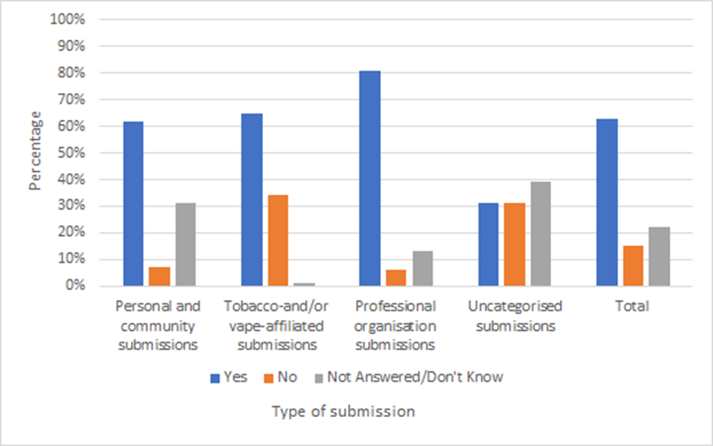

All groups, including tobacco importers and vaping retailers, were supportive of establishing a licensing system for all retailers of tobacco and vaping products (in addition to specialist vape retailers). Many submitters supported licensing, viewing it as a prerequisite for other policies to make smoked tobacco products less available.

Submitters broadly supported licensing in conjunction with, and to enable, other Smokefree 2025 policies. Submitters generally indicated that they would support licensing if it could contribute to removing inequitable disproportionate tobacco retail clusters in Māori and Pacific communities and lower socioeconomic areas.

Most groups of submitters stated that licencing could be useful to identify and manage numbers of existing retailers of tobacco, to achieve the equity-based retail measures. Some submitters stated that licensing of retailers would support compliance and enforcement, especially of tobacco sales to minors. Small retailers that supported licensing stated that it could reduce tobacco-related crime rates for their businesses.

Most vaping retailers did not support licensing, with many expressing a reluctance for vaping products to be treated like tobacco products.

Among tobacco manufacturers, there was an even split of those that did and did not support licensing.

(b) Significantly reduce the number of smoked tobacco product retailers based on population size and density
Do you support reducing the retail availability of smoked tobacco products by significantly reducing the number of retailers based on population size and density?
Yes
No
Please give reasons.

Figure 2: Responses to question 2b from all submissions
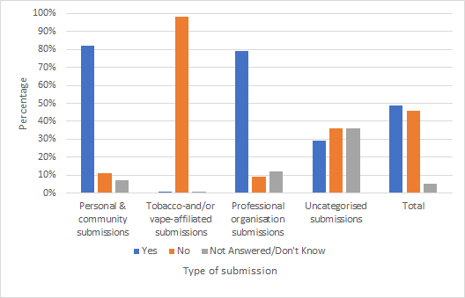

Most submitters supported reducing the number of tobacco retailers based on population size and density.

There was very strong support for this proposal from community and advocacy organisations, iwi-/hapū-affiliated respondents, Pacific communities, government organisations and health care providers.

Most tobacco manufacturers, tobacco retailers and vaping industry members opposed this proposal.

Most submissions in support mentioned the proposal’s potential to remove current inequities in smoking retailer distribution, denormalise tobacco, support quit attempts and prevent youth from accessing tobacco.
Among those submitters not in favour, negative impacts on retailers were the main concern. These included potential financial losses, store closures and unfairness in the selection process of retailers who would be permitted to sell tobacco.

There was mixed feedback on proposed timeframes for retail reductions. Many submitters, including current smokers (and Māori, Pacific, and youth submitters), recommended a process of rapid reduction, to achieve Smokefree 2025 as soon as possible.

‘OMG Yes! Just do it, Why didn't we do this earlier. 7 people in the group agreed that it will support them to quit and probably would've quit by now. But because it’s so easy to get – there’s more chance of temptation and too easy to buy.’
Pacific youth group (including non-smokers, smokers, and vapers)

Some submitters noted that an extended timeframe for reduction would better support retailers to transition and allow for the impacts to be iteratively monitored and evaluated. They felt this would be less likely to result in an increase in the black market and allow smokers more time to quit.

We received several submissions from research organisations who strongly supported the proposal to reduce clustering of tobacco retailers in low-income neighbourhoods. Many community and advocacy organisations also included research in their submissions to support this proposal. The Cancer Society New Zealand submission stated that its research in Auckland, Wellington and Christchurch found a disproportionately high number of tobacco retailers in low-income areas, compared to high-income areas. This supports the research cited by many other submissions.

Some retailers of tobacco and/or vaping products stated that they would support the proposal if it was implemented over a staged amount of time, to allow them time to diversify their business.

Several group and individual submitters supported a reduction of tobacco retailers to 300 stores (approximately 5 percent of current retailers).

Submitters often referenced vaping, both positively and negatively. Some submitters wanted increased access to vaping products to support smoking cessation. Others wanted vaping products to be included with smoked tobacco products in any retail reduction policies.

(c) Restrict sales of smoked tobacco products to a limited number of specific store types
Do you support reducing the retail availability of tobacco products by restricting sales to a limited number of specific store types (eg, specialist R18 stores and/or pharmacies)?
Yes
No
Please give reasons.

Figure 3: Response to question 2c from respondents, excluding individual Māori responses collected by Hāpai te Hauora
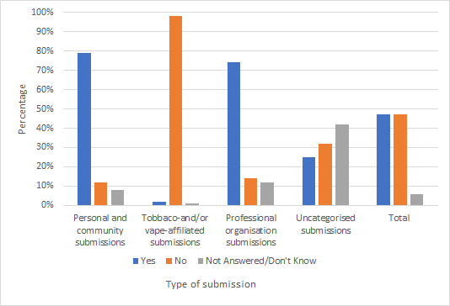

This figure excludes the individual Māori responses to the Hāpai te Hauora survey as it consulted on only two retail options – sale via pharmacies and R18 stores. These responses showed majority support for reducing the retail availability of smoked tobacco products, particularly through R18 stores. Most did not support restricting tobacco sales to pharmacies.

Almost all submitters supported restricting tobacco sales to some type of specific store. The main reasons given were to protect children and young people from exposure to tobacco products and reduce the temptation and availability of tobacco to existing smokers. Many submitters wanted tobacco to be removed from dairies, supermarkets, convenience stores, petrol stations and online stores.

Submitters that opposed this proposal mostly identified as retailers of tobacco, those in the vaping industry and tobacco manufacturers. These submitters raised concerns related to impact on business, a perceived rise in crime and an increase in the black market, noting potential difficulties smokers might face in safely accessing tobacco if they cannot or choose not to quit.

Many submitters qualified their support or opposition. Often this was because they had differing views on the two examples given or wanted to put forward a different option.
Among the options for a specialist store, the concept of a specialist R18 or age-restricted store received the most support, with submitters envisaging that this would create a level playing field for retailers. Some submitters suggested a government-owned store allowing for transfer of profits back into tobacco control initiatives. This was the second most supported option.

Many submitters mentioned that specialist store proposals need to be considered alongside factors like licensing, population size and density, and compliance and enforcement.

Some industry submitters suggested that service stations could be seen as specialist stores, as they have existing systems such as security measures and nationwide coverage, which could be useful to control and regulate tobacco sales.

There were mixed views about specialist stores selling both tobacco and vaping products. Some supported this, expressing a belief that vaping products should be widely available to support the switch from smoked tobacco and support quit attempts. Others had concerns about vaping exposure and harm to children.

Overall, submitters either explicitly opposed the pharmacy model or cautioned against it. Some expressed a belief that it would create a contradictory and confusing message that tobacco is safe if sold by a health provider, and that this would conflict with the profession’s code. Additionally, there was concern that there are too many pharmacies (which would hamper retail reduction). Notably, the Pharmacy Guild of New Zealand opposed this model.

There was some explicit support for the pharmacy model as part of phasing out of tobacco and vaping products. Some submitters suggested that a prescription from a general practitioner should be needed for vaping products and/or tobacco products, and others through that a pharmacy model would support the provision of cessation advice along with the purchase of tobacco.

A number of submitters were concerned about the potential for dual harm of tobacco being sold with alcohol products (under a potential R18 store policy). Additionally, concern was raised about the overconcentration of liquor stores in low socioeconomic areas.

(d) Introduce a smokefree generation policy
Do you support introducing a smokefree generation policy?
Yes
No
Please give reasons.

Figure 4: Response to question 2d from all submissions
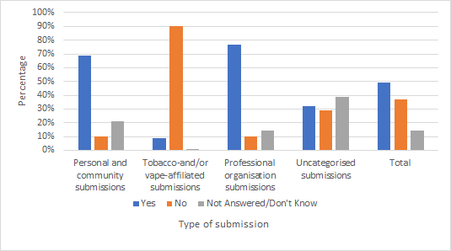

Many submitters supported the smokefree generation proposal and saw it as an innovative way to dramatically lower smoking rates progressively. Many saw this as being the most hard-line approach of the proposals in the document. Several stated that it would have a targeted approach in addressing inequity in Māori and Pacific health, considering the disproportionate representation of those populations in youth smoking statistics. Some submitters viewed this proposal as sympathetic to older smokers who have struggled to quit: the majority of the group impacted by the smokefree generation policy will not yet have started smoking.

Submitters on both sides stated they would need to see a clearer plan for implementation and enforcement of this policy before they could give their full considered opinion. Many responses made cases for and against the proposal based on assumptions about how it would be structured.

Retailers, manufacturers and distributors of tobacco and vaping products mostly opposed the smokefree generation proposal.

Of the submissions opposing a smokefree generation, many stated the proposal was too vague about how the cultural shift would be created, or felt it would be difficult to comply with, or were concerned with enforcement and the consequences for those who sourced tobacco by illicit means. Others were concerned about the impact that this proposal could have on overseas tourists and migrant workers. Some felt that the proposal could result in an increase in illicit trade, and potentially criminalise already vulnerable and at-risk groups.

‘Minimum-age laws for sale of tobacco products send a misleading message that there is a ‘safe age’ for smoking and establish the cigarette as ‘a badge of coming of age, a symbol of the onset of maturity.’

Stop Smoking Service, health care provider

(e) Small businesses that sell tobacco products
(e) Are you a small business that sells smoked tobacco products? Are you a small business that sells smoked tobacco products?
Yes
No
Please explain any impacts that making tobacco less available would have on your business that other questions have not captured. Please be specific.

Over 30 percent of submitters categorised themselves as small businesses that sell smoked tobacco products. The majority of these submitters were dairy/convenience store owners. Many of these submissions were anonymously submitted via two independently organised surveys.

Many small business retailers of tobacco stated that, although tobacco products bring low profit margins, they make up a significant percentage of their sales, and drive foot traffic into their businesses, as customers purchase other products when they come in for cigarettes. They indicated that removing tobacco from their shops would have negative impacts on their businesses, such as a loss of revenue, inability to pay staff and a need to reduce store hours or close stores down.

A few submissions by small business owners retailing tobacco supported removing tobacco from stores to reduce crime and support communities to be smokefree. We received a submission from a tobacco-free service station in the Otago region, and other submitters referenced smokefree dairies and petrol stations around the country.

3. Make smoked tobacco products less addictive and less appealing

(a) Reduce nicotine in smoked tobacco products to very low levels
Do you support reducing the nicotine in smoked tobacco products to very low levels?
Yes
No
Please give reasons.

Figure 5: Response to question 3a from all submissions
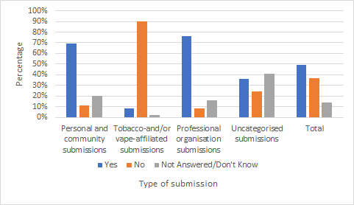

Overall, most submitters supported reducing the nicotine in tobacco to low levels, agreeing that this could help reduce addiction, which would encourage people to give up smoking. There was strong support for this from submitters identifying as community groups, Māori and iwi/hapū groups, Pacific groups, government organisations, academics, and health care organisations.

Over 50 health care providers and research or academic organisations supported reducing nicotine in smoked tobacco products to very low levels. We received substantial literature supporting reducing the nicotine in tobacco to low levels from tobacco researchers in New Zealand and some overseas. These submissions provided insight into how New Zealand could implement low-nicotine tobacco products while reducing concerns raised by some submitters, including the potential for smokers to smoke a greater number of cigarettes.

Almost all small and medium retailers, vape retailers and tobacco manufacturers opposed this proposal. Reasons given included that the scientific evidence was limited, with some submitters expressing concerns that low-nicotine cigarettes could not be implemented feasibly. Small and medium tobacco retailers and vape retailers generally raised concerns including a risk of compensatory smoking, increased vaping, increased black-market activity and the negative impact on businesses.

(b) Prohibit filters in smoked tobacco products
Do you support prohibiting filters in smoked tobacco products?
Yes
No
Please give reasons.

Figure 6: Response to question 3b from all submissions
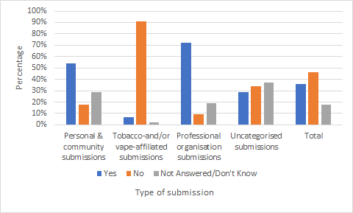

Overall, there were slightly more submitters who disagreed with the proposal to prohibit filters, although many submitters did not answer this question. Groups without commercial interests in tobacco or vaping products mostly supported prohibiting filters in smoked tobacco products. There was very high support among submissions identifying as Māori, Pacific peoples, iwi-/hapū-affiliated respondents, health care providers and government organisations. The main reasons submitters supported prohibiting filters were environmental and to reduce the appeal of cigarettes, particularly to youth.
The main reasons submitters without commercial interest in tobacco or vaping products opposed removing filters were based on a misunderstanding of or disagreement with the statement included in the discussion document, that filters do not reduce harm from smoking tobacco.

Tobacco manufacturers generally opposed and contested the science on the health impact of filters, felt the proposal limited consumer choice, expressed concerns about the effects the proposal would likely have on the black market and refuted evidence about the size of the littering problem associated with filters. These submitters encouraged further measures to limit littering.

Tobacco and vaping product retailers opposed prohibiting filters in smoked tobacco products. Many of these submitters raised concerns about the potential effects on crime and the black market. Almost all these concerns were raised by small retailers. Small retailers also raised concerns about the unfair impact this proposal might have on their businesses. There was a high level of misunderstanding of and disagreement with the stated health impacts of filters (that is, that they bring no health benefits).

Many submitters who supported prohibiting filters cited evidence that filters give smokers a false sense of safety and can actually do more harm than good. Several also felt that tobacco companies intentionally encourage the view that filters make smoked tobacco products less harmful.

‘The overwhelming majority of research shows that filters do not reduce the harms associated with smoking. In fact, filters may increase the harms caused by smoking by enabling smokers to inhale smoke more deeply into their lungs. Furthermore, toxic fibres shed from the cut end of the filter are inhaled and ingested by smokers.’
Pinnacle Midlands Health Network, Healthcare provider

Many submitters (especially Māori respondents) strongly supported prohibiting filters on environmental grounds, stating an opinion that the health of the land and people are intertwined.

‘This will support the protection of our natural environment as filters are the biggest pollutants for waterways, oceans and whenua. This will also support whānau who are motivated to quit as it will eliminate the palatable flavours that hide the nasty taste of the raw tobacco and their chemicals.’

Tākiri Mai te Ata Regional Stop Smoking Service

There was strong support for banning filters as a deterrent to existing – and particularly new and young – smokers by making smoking less palatable. Some submitters drew attention to the use of flavours and crush balls in filters to make products appeal to young/new smokers.

(c) Prohibit innovations aimed at increasing the appeal and addictiveness of smoked tobacco products
Do you support allowing the Government to prohibit tobacco product innovations through regulations?
Yes
No
Please give reasons.

Figure 7: Response to question 3c from all submissions
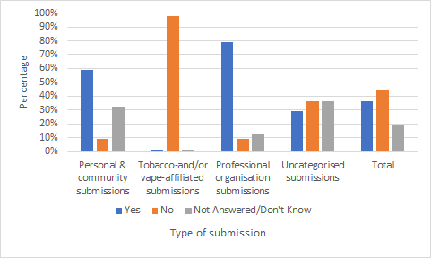

Submitters had different ideas about what this question might mean. Groups without commercial interests in tobacco or vaping products mostly supported allowing the Government to prohibit tobacco product innovations through regulations.

There was very strong support for this proposal among Pacific communities and organisations, health care providers and government organisations. Some expressed a desire to stop tobacco companies from developing more addictive products. Many stated that this proposal could support other action plan policies, by potentially reducing the appeal of smoked tobacco products. Submitters also saw the proposal as a means of protecting youth: they felt that innovations (including the addition of flavours like menthol, mint and fruit, and crush balls) can increase the palatability and appeal of tobacco products to young people.

‘DHBs support the proposal for Government to have the means of prohibiting innovations in the future which make products more addictive, palatable, desirable and appealing, especially to youth.’
Submission representing 20 DHB chief executives

Several submitters commented that the Government should make every effort to pre-empt marketing tricks by tobacco companies that make smoking tobacco products more palatable and appealing to youth.

Small retailers of tobacco strongly opposed allowing the Government to prohibit tobacco product innovations through regulations. Most medium and large retailers also opposed this proposal. However, some were in favour.

The main reasons submitters opposed this proposal were concerns about encouraging trade in illicit tobacco, concerns that prohibiting innovation might lead to stopping the potential creation of safer smoked tobacco products and a general desire for the government not to be involved in the tobacco market.

Many submissions mentioned vaping, but these comments were mixed. Some submitters wanted vaping products to be included in this proposal. Others considered vaping products to be a positive example of product innovations leading to less harmful alternatives to smoked tobacco.

4. Make tobacco products less affordable

(a) Set a minimum price for tobacco
Do you support setting a minimum price for all tobacco products?
Yes
No
Please give reasons.

Figure 8: Response to question 4a from all submissions
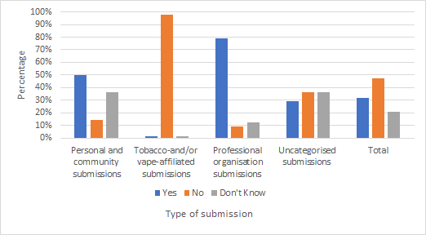

There were mixed responses to the proposal to set a minimum price for all tobacco products, with slightly more submissions against than in favour. In favour of the proposal were most of the submissions from community/advocacy organisations, iwi-/hapū-affiliated submitters, Māori submitters, Pacific community and organisations, government organisations, health care providers, professional organisations, research/academic organisations, and personal submitters. Against the proposal were submitters who mostly identified as tobacco and vaping product manufacturers and retailers.

A main argument by those in favour of this proposal was that setting a minimum price would prevent price shifting, which maintains budget tobacco products. Submitters stated that the policy would decrease health inequities, as budget products tend to be purchased by those with a low income, encouraging quitting and decreasing uptake in this group. Many expressed supported for the policy because it would have the effect of preventing young people purchasing tobacco products, especially those with less disposable income. Submitters also argued that the proposal would result in a decrease in tobacco industry and retailer marketing, and thus sales and profits.
Submitters who were against this proposal argued that it would cause disproportionate harm and stress to the already vulnerable low socioeconomic group of people who smoke. They argued that if the proposal were in place, current smokers would go without necessities for themselves and their dependants rather than quitting smoking. Some also expressed concern that the proposal would generate increased profits for tobacco companies rather than increasing tax revenue, or that it would unnecessarily prevent competition between retailers. There were concerns about a potential increase in illicit tobacco use and tobacco-related crime.

Some submitters also raised concerns about premium products such as cigars, arguing that these are not ‘everyday products’ and therefore did not need to have a minimum price. Another concern submitters expressed was that, because the entire cigar is not usually smoked, this policy would disproportionately disadvantage cigar smokers if a minimum price was set by weight.

5. Final questions
Of all the issues raised in this discussion document, what would you prioritise to include in the action plan? Please give reasons.
Do you have any other comments on this discussion document?

Many submitters used this section to urge the Government to take action and implement the proposed policies, particularly making tobacco less addictive and appealing by reducing the nicotine in smoked tobacco products to very low levels, removing filters and making smoked tobacco products less available by reducing retail supply.

Many submissions called for scaling up of non-policy options, such as increasing funding to smoking cessation, mental health and addiction services, engaging with smokers and communities, and expanding the Māori and Pacific stop smoking workforce.

Many retailers used this section to express how the loss of tobacco products from their stores would negatively affect them.

Submissions commonly mentioned themes relating to equity, vaping, smokefree areas and compliance and enforcement. These comments are summarised below.

Equity
Equity was mentioned by many submitters, who often saw it as underpinning all aspects of the action plan. A significant number of responses made suggestions to implement or enhance policy proposals to achieve equity for youth (tamariki and rangatahi), Māori, Pacific peoples and those living in rural or deprived neighbourhoods.

Some submissions raised concerns that the proposals might cause increased hardship for people who are unable to quit smoking. Some submitters suggested that if the number of tobacco retailers were reduced, people who are unable to quit smoking would have to travel further to buy tobacco products, and may not have the money (eg, for petrol), transport or time to do so. These submitters stressed the importance of ensuring safe access to tobacco for these groups and suggested that there should be no single level of reduction for the retail landscape nationally.

There were many suggestions for equity-based non-regulatory policies to accompany the action plan, including increasing stop smoking support services proportionate to retail reduction; ensuring equitable access to nicotine/tobacco for people who are heavily addicted; and increasing availability and access to nicotine replacement therapy, quitting advice and psychological support, regardless of people’s financial circumstances.

Submitters identified certain additional groups as experiencing disproportionately high rates of smoking and smoking-related harm or needing additional support to become smokefree. These included older people, women (particularly pregnant women), vulnerable children, migrants and mental health and disability system users.

Vaping
Most questions in the discussion document attracted responses that mentioned vaping – both positively and negatively.

Generally, those in the tobacco and vaping industries, retailers and some submitters in other categories supported reducing the regulation of vaping products to make them more easily accessible to smokers. Many cited the importance of vaping products as a harm reduction tool.

On the other hand, health providers, government agencies, professional organisations and some submitters in other categories supported strengthening vaping regulations, including by aligning them with the proposals for tobacco. Often this was associated with concerns about youth uptake, addiction, and the unknown long-term risks of vaping.

Smokefree areas
A significant number of submitters strongly advocated for additional mandated smokefree areas and provided evidence of the impact of smokefree areas legislation. The main reasons in support of smokefree areas included reducing exposure to second-hand smoke, denormalising smoking (particularly for youth), reducing cigarette butt litter, increasing quitting attempts and reducing relapses.

Several submitters stated the importance of fresh air to Māori, and the right of tamariki and pēpī in particular to have fresh air through smokefree areas.

Many local governments, non-government organisations and health care organisations noted the work already done to create smokefree areas. However, local smokefree outdoor policies have been difficult to enforce. Many submitters argued that national legislation would improve this.

Submitters cited several other benefits to a consistent national approach to smokefree areas, such as equitable management across regions, consistency in messaging between regions and improved efficiency for smokefree measures.

Compliance and enforcement
Many submissions strongly supported increased monitoring and enforcement of existing and proposed smokefree legislation, a main reason being to manage the risks of increased crime and illicit-market impacts. Many submitters stated that increased resourcing at the border would be required to enforce the proposed changes adequately. Some also saw a need for strengthening smokefree enforcement officers’ powers.

Many submitters suggested promulgating new regulations aimed at preventing tobacco companies exploiting the potential loopholes of action plan policies. Several brought up the risk of tobacco companies challenging the policies, and suggested we investigate litigation against tobacco companies.

Many submitters made suggestions about appropriate retailers to sell tobacco, based on their ability to comply with legislative requirements. Some submitters warned that compliance costs for retailers could be unfair, and some suggested that the Government should view retailers as allies.

Appendix one: Hāpai te Hauora social media promotion of the Smokefree Action Plan

The following is an example of a message Hāpai te Hauora used to promote consultation on Proposals for a Smokefree Aotearoa 2025 Action Plan on its social media channels, as well as the Tala Pasifika Facebook page and the Te Ara Hā Ora Facebook page.

Community Voices Are Needed for Smokefree Action Plan Public Consultation

Hāpai te Hauora CEO, Selah Hart says ‘We support and encourage our whānau and communities to use this as an opportunity to have a say on the Government’s Smokefree Action Plan as this will affect our most impacted communities. It is important that the public consultation activities are accessible for Māori and Pacific communities.’

Appendix two: Groupings of submissions for figures
For the purposes of the figures that appear in this document, we grouped submissions as follows. Note that submitters could indicate that they belonged to more than one sector.

Personal and community submissions includes all submitters identifying as personal submitters or part of a community or advocacy organisation. This includes responses from the Hāpai te Hauora Māori surveys, Pacific community surveys and Cancer Society responses.

Tobacco- and/or vape-affiliated submissions includes all tobacco and/or vaping or smokeless tobacco product retailers, distributers or manufacturers.

Professional organisation submissions includes professional organisations, iwi-/hapū-affiliated respondents, health care providers, research or academic organisations and government organisations.

Appendix three: Cancer Society of New Zealand additional feedback
Additional survey by the Cancer Society New Zealand

The Cancer Society created a community template to identify support for strategies in the Ministry discussion document. It used this template to collect feedback at events around the country from early February until April 2021, prior to the launch of the discussion document. Respondents also completed 57 forms online during May. A total of 844 people completed the template. These were attached to the Cancer Society submission to this consultation.

See Ministry of Health. 2017. Consultation on Electronic Cigarettes: Analysis of submissions. Wellington: Ministry of Health. URL: http://www.health.govt.nz/system/files/documents/publications/consultation-e-cigarettes-analysis-submissions-mar17.pdf (accessed 10 November 2021).
Categories used were personal submission, community or advocacy organisation, iwi-/hapū-affiliated and/or Māori organisation, Pacific community or organisation, government organisation, health care provider, professional organisation, tobacco manufacturer, importer or distributor, and other.
We received 1,229 submissions from one IP address and 360 from another. These submitters did not directly enter text into the submission form. It is unclear who collected and submitted this information.
The Cancer Society carried out its survey independently to the Ministry consultation (see Appendix three).
See Appendix two for information on groupings of submissions for figures.
We received literature from submitters representing universities and research institutions across many states in the United States, and some from Australian states.
We received 1,229 submissions from one IP address and 360 from another. These submitters did not directly enter text into the submission form. It is unclear who collected and submitted this information.
We received 1,229 submissions from one IP address and 360 from another. These submitters did not directly enter text into the submission form. It is unclear who collected and submitted this information. All these submissions strongly opposed allowing the Government to prohibit tobacco product innovations through regulations.
Te Ara Hā Ora - Pathway to the breath of life for all, is the National Maori Tobacco Control Leadership Service established by Hāpai te Hauora Tapui in partnership with Action on Smoking and Health. https://www.facebook.com/tearahaora/about/
The Cancer Society community template was created independently of the Ministry of Health.

