Cancer
New registrations and deaths
2012

Citation: Ministry of Health. 2015. Cancer: New registrations and deaths 2012. Wellington: Ministry of Health.
Published in October 2015
by the Ministry of Health
PO Box 5013, Wellington 6145, New Zealand
ISBN: 978-0-478-44860-3 (online)
HP 6241
This document is available at www.health.govt.nz

Acknowledgements
Many people have assisted in the production of this publication. In particular, the Ministry of Health thanks the peer reviewers for their valuable contribution.

Source
Cancer registration data for this publication is sourced from the New Zealand Cancer Registry, and mortality data is sourced from the New Zealand Mortality Collection. Both are held by the Ministry of Health.

Copyright
The copyright owner of this publication is the Ministry of Health, which is part of the New Zealand Crown. The Ministry of Health permits the reproduction of material from this publication without prior notification, provided that all the following conditions are met:
- the content is not distorted or changed
- the information is not sold
- the material is not used to promote or endorse any product or service
- the material is not used in an inappropriate or misleading context having regard to the nature of the material
- any relevant disclaimers, qualifications or caveats included in the publication are reproduced
- the Ministry of Health is acknowledged as the source.

Disclaimer
The purpose of this publication is to inform discussion and assist policy development. The opinions expressed in the publication do not necessarily reflect the official views of the Ministry of Health.

All care has been taken in the production of this publication. The data is considered to be accurate at the time of publication, but may be subject to slight changes over time as further information is received. It is advisable to check the current status of figures given here with the Ministry of Health before quoting or using them in further analysis.

National collection, coding and collation of cancer registrations is a complex process. This is because the information in the New Zealand Cancer Registry comes from laboratory reports, hospital information and mortality information, and cannot be finalised until data has become available from all sources. In addition, several steps are required to ensure the final information is of good quality.

The Ministry of Health makes no warranty, expressed or implied, nor assumes any legal liability or responsibility for the accuracy, correctness, completeness or use of the information or data in this publication. Further, the Ministry of Health shall not be liable for any loss or damage arising directly or indirectly from the information or data presented in this publication.

The Ministry of Health welcomes comments and suggestions about this publication.

Contents
Acknowledgements iii
Key facts for 2012 ix
Cancer registrations ix
Cancer deaths x
Introduction 1
Overview 1
Data sources 1
Structure 1
How cancers are grouped in this report 2
Data presentation 3
New cancer registrations 4
Registrations in 2012 4
Registrations between 2002 and 2012 5
Common cancers 7
Life-stage age groups 9
Māori and non-Māori 15
Deprivation 18
Variation within New Zealand, 2010–2012 21
Cancer deaths 23
Cancer deaths in 2012 23
Cancer deaths between 2002 and 2012 25
Common cancer deaths 27
Life-stage age groups 29
Māori and non-Māori 35
Deprivation 38
Variation within New Zealand 2010–2012 41
Appendices
Appendix A: Technical notes 43
Appendix B: Cancer registrations and deaths data for all cancers, 2012 52
Appendix C: Full text of the Cancer Registry Act 1993 70
Appendix D: Full text of the Cancer Registry Regulations 1994 73
References 76

List of tables
Table I1: Grouped cancers and relevant ICD three-character codes 2
Table 1: Number and rate of cancer registrations, by sex, 2002–2012 6
Table 2: Numbers and rates of cancer deaths, by sex, 2002–2012 25
Table A1: ICD-O, third edition morphology codes used to group lymphohaematopoietic cancers 46
Table A2: The WHO World Standard Population 48
Table B1: Numbers and rates of new cancer cases, by cancer type and sex, 2012 52
Table B2: Numbers and rates of new cancer cases, by cancer type and sex, for Māori, 2012 55
Table B3: Numbers and rates of new cancer cases, by cancer type and sex, for non-Māori, 2012 58
Table B4: Numbers and rates of cancer deaths, by cancer type and sex, 2012 61
Table B5: Numbers and rates of cancer deaths, by cancer type and sex, for Māori, 2012 64
Table B6: Numbers and rates of cancer deaths, by cancer type and sex, for non-Māori, 2012 67

List of figures
Figure 1: Numbers and age-specific rates of cancer registrations, by age group, 2012 4
Figure 2: Age-specific rates of cancer, by sex and age group, 2012 5
Figure 3: Number and rate of cancer registrations, 2002–2012 5
Figure 4: Number and rate of cancer registrations, by sex, 2002–2012 6
Figure 5: The 10 most common cancers in males, 2012 7
Figure 6: The 10 most common cancers in females, 2012 8
Figure 7: Cancer registration rates for males and females, by life-stage group,
2002–2012 9
Figure 8: The most common cancer registrations for males and females aged 0–24 years, 2012 10
Figure 9: The most common cancer registrations for males and females aged 25–44 years, 2012 11
Figure 10: The most common cancer registrations for males and females aged 45–64 years, 2012 12
Figure 11: The most common cancer registrations for males and females aged 65–74 years, 2012 13
Figure 12: The most common cancer registrations for males and females aged 75 years and older, 2012 14
Figure 13: Cancer registration rates for males and females, by ethnic group, 2002–2012 15
Figure 14: Cancer registration rates of the most common cancers for Māori and non-Māori males, 2012 16
Figure 15: Cancer registration rates of the most common cancers for Māori and non-Māori females, 2012 17
Figure 16: Cancer registration rates for males and females, by deprivation quintile, 2012 18
Figure 17: Registration rates of the most common cancers for males, by deprivation quintile, 2012 19
Figure 18: Registration rates of the most common female cancers, by deprivation quintile, 2012 20
Figure 19: Cancer registration rates, by DHB, 2010–2012 21
Figure 20: Comparison of DHB region cancer registration rates, 2010–2012 22
Figure 21: Numbers and age-specific rates of cancer deaths, by age group, 2012 23
Figure 22: Age-specific rates of cancer death, by sex and age group, 2012 24
Figure 23: Numbers and rate of cancer deaths, 2002–2012 25
Figure 24: Numbers and rate of cancer deaths, by sex, 2002–2012 26
Figure 25: The 10 most common cancer deaths in males, 2012 27
Figure 26: The 10 most common cancer deaths in females, 2012 28
Figure 27: Cancer mortality rates for males and females, by life-stage group, 2002–2012 29
Figure 28: The most common causes of cancer death for males and females aged 0–24 years, 2012 30
Figure 29: The most common causes of cancer death for males and females aged 25–44 years, 2012 31
Figure 30: The most common causes of cancer death for males and females aged 45–64 years, 2012 32
Figure 31: The most common causes of cancer death for males and females aged 65–74 years, 2012 33
Figure 32: The most common causes of cancer death for males and females aged 75+ years, 2012 34
Figure 33: Cancer mortality rates for males and females, by ethnic group, 2002–2012 35
Figure 34: Cancer mortality rates of most common cancer deaths for Māori and non-Māori males, 2012 36
Figure 35: Cancer mortality rates of most common cancer deaths for Māori and non-Māori females, 2012 37
Figure 36: Cancer mortality rates, by deprivation quintile, 2012 38
Figure 37: Mortality rates of the most common causes of cancer death for males, by deprivation quintile, 2012 39
Figure 38: Mortality rates of the most common causes of cancer death for females, by deprivation quintile, 2012 40
Figure 39: Cancer mortality rates, by DHB, 2010–2012 41
Figure 40: Comparison of DHB region cancer mortality rates, 2010–2012 42
Figure A1: Data and the New Zealand Cancer Registry 43

Key facts for 2012

Cancer registrations
- There were 21,814 new cases of cancer registered in New Zealand.
- More than half of cancers registered were for males (11,345 cases, 52%).
- The age-standardised registration rate was 337.5 cases per 100,000 population.

Most common cancers
- The most commonly registered cancers were prostate (3129 cases), breast (3054), colorectal (3016), melanoma (2324) and lung (2027).
- For males the most commonly registered cancers were prostate (3129 cases), colorectal (1570), melanoma (1228), lung (1059) and non-Hodgkin lymphoma (432).
- For females the most commonly registered cancers were breast (3025 cases), colorectal (1446), melanoma (1096), lung (968) and uterine (513).

Age
- People aged 65 years and older accounted for nearly 6 out of 10 new cancer cases.
- In people aged 0–24 years, the most common cancer registered was leukaemia for both males and females.
- In people aged 25–44 years, the most common cancer registered was testicular cancer for males and breast cancer for females.
- In people aged 45–64 and 65–74 years, the most common cancer registered was prostate cancer for males and breast cancer for females.
- In people aged 75 years and older, the most common cancer registered was prostate cancer for males and colorectal cancer for females.

Ethnic group
- 2105 Māori and 19,709 non-Māori were registered with cancer.
- Māori had a registration rate of 414.7 per 100,000 Māori population, which was 26.2% higher than the rate for non-Māori (328.5 per 100,000 non-Māori population).

District Health Board (2010–2012)
- The highest registration rate for 2010–2012 was in Whanganui DHB (361.5 per 100,000), followed by Lakes DHB (361.2 per 100,000). The lowest registration rate was in Nelson Marlborough DHB (321.8 per 100,000), followed by Capital & Coast DHB (323.8 per 100,000).

Cancer deaths
- There were 8905 deaths due to cancer in New Zealand.
- More than half of cancer deaths were male (4735 cases, 53.2%).
- The age-standardised mortality rate was 124.0 deaths per 100,000 population.

Most common cancer deaths
- The most common cancer deaths were from lung (1628 deaths), colorectal (1283), breast (618), prostate (607) and pancreatic cancer (463).
- For males the most common cancer deaths were from lung (891 deaths), colorectal (664), prostate (607) and pancreatic (229) cancer, and melanoma (222).
- For females the most common cancer deaths were from lung (737 deaths), colorectal (619), breast (617), pancreatic (234) and ovarian (175) cancer.

Age
- People aged 65 years and older accounted for at least 7 out of 10 cancer deaths.
- In people aged 0–24 years, the most common cause of cancer death was brain cancer for males and leukaemia for females.
- In people aged 25–44 years, the most common cause of cancer death was brain cancer for males and breast cancer for females.
- In people aged 45–64 years the most common cause of cancer death was lung cancer for males and breast cancer for females.
- In people aged 65–74 years the most common cause of cancer death was lung cancer for both males and females.
- In people aged 75 years and older, the most common cause of cancer death was prostate cancer for males and colorectal cancer for females.

Ethnic group
- A total of 936 Māori and 7969 non-Māori died from cancer.
- Māori had a cancer mortality rate of 199.4 per 100,000 Māori population, which was 1.7 times the rate for non-Māori (116.5 per 100,000 non-Māori population).

District Health Board (2010–2012)
- The highest cancer mortality rate for 2010–2012 was in Tairawhiti DHB (143.7 per 100,000), followed by Northland DHB (142.6 per 100,000). The lowest mortality rate was in Nelson Marlborough DHB (111.9 per 100,000).

Introduction

Overview
Cancer: New registrations and deaths 2012 presents information about new cases of primary cancer diagnosed and reported to the New Zealand Cancer Registry for the 2012 calendar year. It also presents information on deaths registered in New Zealand in the same time period where cancer was recorded as the underlying cause of death.

Data sources
New cancer cases diagnosed in New Zealand are registered with the New Zealand Cancer Registry. Cancers are registered once, in the year of their first known diagnosis. Registrations cover new cases of primary cancer, or secondary cancers where the primary cancer is unknown. Data in this publication relating to cancer deaths comes from the New Zealand Mortality Collection (see Appendix A for further information).

Structure

Cancer: new registrations and deaths report
This report presents information for cancer registrations followed by information for cancer deaths for 2012. Both sections follow the same format, presenting data by sex, age, ethnicity, deprivation quintile and DHB region of domicile. Data is presented for all cancers combined, followed by a focus on the most common cancer registrations and deaths for the above breakdowns, except DHB regions. Some data is presented from 2002 to 2012 to provide a time trend.

Data is presented in graphs and maps so that you can observe trends and relationships. Graphs and maps are not designed as a means for you to look up individual values. The underlying numbers used to create graphs and maps in this publication are provided in the accompanying online tables (‘Cancer trends 2012’).

Appendix B provides supplementary tables containing numbers and rates of cancer registrations and deaths for all individual cancers and cancer groups.

Online accompanying tables: Cancer trends 2012
The online tables that accompany this report provide the following additional data.
- Selected cancers: key commentary for registration and mortality data (numbers and rates) for a selection of the most common cancers by Māori and non-Māori and by sex, 2003–2012.
- Cancer groups: registration and mortality data (numbers and rates) for all cancer sites grouped by cancer area/type and sex, 2012.
- Individual cancers: numbers of registrations and deaths for individual cancer sites, by sex, ethnic group, life-stage group, deprivation quintile, DHB region of domicile and regional cancer network, 2012.

How cancers are grouped in this report
This report classifies cancers using the International Statistical Classification of Diseases and Related Health Problems, Tenth Revision, Australian Modification (ICD-10-AM), sixth edition. It uses the International Classification of Diseases for Oncology (ICD-O), third edition to classify the morphology (histology, type and behaviour) of tumours.

In this report, data for all cancers combined includes ICD codes C00–C96 and D45–D47. Cancers are presented at the level of the ICD three-character code (eg, breast cancer is C50). The three-character codes for the following cancer sites are grouped and presented together: colorectum and anus (C18–C21), lung and trachea (C33–C34), leukaemia (C91–C95) and non-Hodgkin lymphoma (C82–C85, C96). Table I-1 details the relevant codes for these groups alongside specific coding details for three other cancers. Appendix B, Tables B1–B6 provide codes for all cancer sites.

Table I1: Grouped cancers and relevant ICD three-character codes
Cancer (ICD codes) | Sites (ICD three-character code) | Cancer group (ICD codes)
Colorectal cancer  (C18–C21) | - Colon (C18)  - Rectosigmoid junction (C19)  - Rectum (C20)  - Anus and anal canal (C21) | Digestive organs (C15–C26)
Lung cancer  (C33–C34) | - Trachea (C33)  - Bronchus and lung (C34) | Respiratory system and intrathoracic organs (C30–C39)
Leukaemia  (C91–C95) | - Lymphoid leukaemia (C91)  - Myeloid leukaemia (C92)  - Monocytic leukaemia (C93)  - Other leukaemias of specified cell type (C94)  - Leukaemia of unspecified cell type (C95) | Lymphoid, haematopoietic and related tissue (C81–C96,  D45–D47)
Non-Hodgkin lymphoma  (C82–C85, C96) | - Follicular (nodular) non-Hodgkin lymphoma (C82)  - Diffuse non-Hodgkin lymphoma (C83)  - Peripheral and cutaneous T-cell lymphomas (C84)  - Other and unspecified types of non-Hodgkin lymphoma (C85)  - Other and unspecified malignant neoplasms of lymphoid, haematopoietic and related tissue (C96) | Lymphoid, haematopoietic and related tissue (C81–C96,  D45–D47)
Liver cancer (C22) | - Liver and intrahepatic bile ducts (C22) | Digestive organs (C15–C26)
Uterus  (C54–C55) | - Corpus uteri (C54)  - Uterus, part unspecified (C55) | Female genital organs  (C51–C58)
Kidney cancer (C64) | - Kidney – except renal pelvis (C64) | Urinary tract (C64–C68)

Data presentation

Numbers and rates
This report presents data as numbers and rates. It provides two types of rates: age-specific and age-standardised. Age-specific rates measure the frequency of cancer registrations or deaths for specific age groups (eg, five-year age groups and life-stage age groups). Age-standardised rates measure the frequency of cancer registrations and deaths in a group, and are adjusted to take account of differences in age distribution of the population over time or between groups.

Rates for specific groups (eg, Māori, those residing in the least deprived areas, females, and populations in specific DHB regions) are calculated using the best available population for that specific group.

All percentage calculations comparing numbers or rates between years have been undertaken using the raw data. Due to rounding, this may mean the resultant information is slightly different to any calculations based on tabular data supplied in this report.

District health board region
Age-standardised rates were calculated for each DHB region of domicile. The cancer data for DHB regions was aggregated over three years (2010–2012), since rates can vary considerably from year to year for each DHB.

The figures provide 99% confidence intervals to aid interpretation. Where a DHB region’s confidence interval crosses the national rate, this means that the DHB region’s registration or mortality rate was not statistically significantly different from the national rate.

New cancer registrations
The New Zealand Cancer Registry records cancers diagnosed in New Zealand. It registers cancers once, in the year of their first known diagnosis. Registrations cover new cases of primary cancer, or secondary cancers where the primary cancer is unknown. This report presents data for all cancers combined (ICD codes C00–C96 and D45–D47), as well as by individual cancers. It does not include in situ cancers. The following section focuses on registrations for all cancers combined in 2012 and between 2002 and 2012.

Registrations in 2012
In 2012, the New Zealand Cancer Registry received 21,814 new cancer registrations. This was a rate of 337.5 new cases of cancer per 100,000 population. Males accounted for more than half (52%) of new cancer cases registered. The registration rate for males was significantly higher than the rate for females.

Cancer was mainly registered in older people. People aged 60 years and older accounted for 7 out of 10 new cancer cases. In 2012 the age group with the largest number of cancer cases registered was 65–69 years (3180 cases); however, the registration rate was highest for those aged 85 years and over (2705.2 cases per 100,000) (Figure 1). Registration rates for females were significantly higher than rates for males for ages 30–54 years. However, registration rates for those 55 years and older were significantly higher for males than for females (Figure 2).

Figure 1: Numbers and age-specific rates of cancer registrations, by age group, 2012
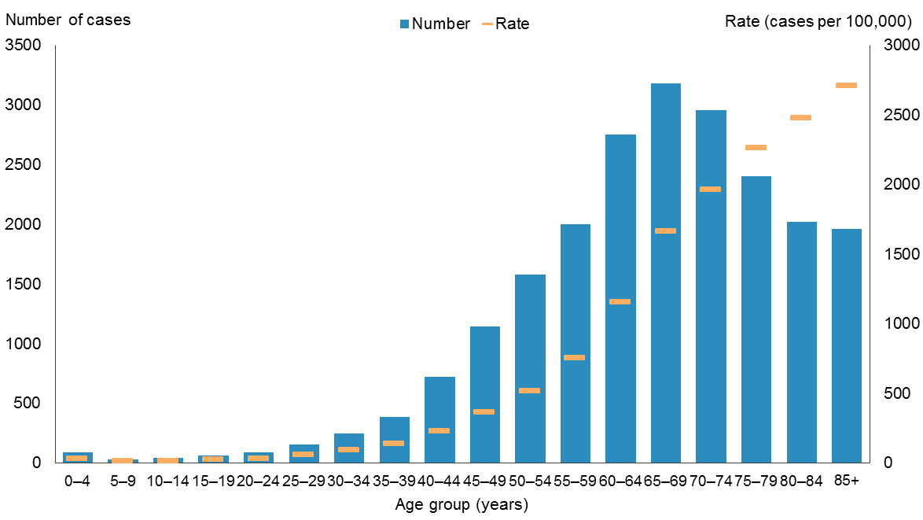
Note: rates are expressed as cases per 100,000 population.
Source: New Zealand Cancer Registry

Figure 2: Age-specific rates of cancer, by sex and age group, 2012
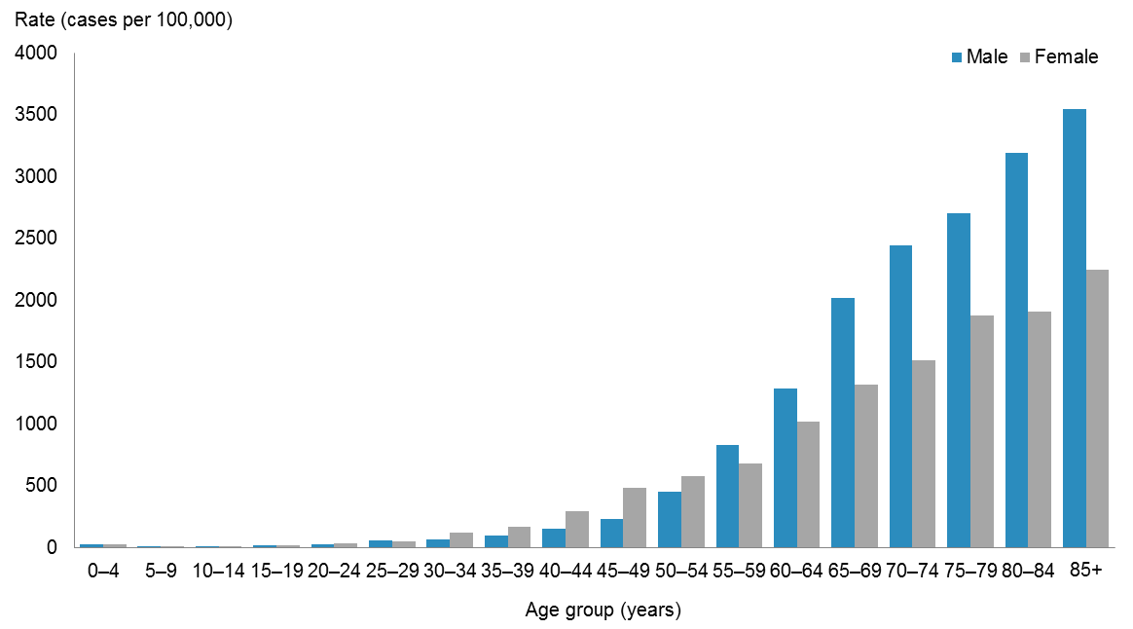
Note: rates are expressed as cases per 100,000 population.
Source: New Zealand Cancer Registry

Registrations between 2002 and 2012
The number of new cancer registrations increased by 21.2% between 2002 and 2012, from 17,991 to 21,814. However, after adjusting for age and population growth, the registration rate decreased slightly over this period, from 351.3 to 337.5 per 100,000 population (Figure 3, Table 1).

Between 2002 and 2012 the registration rates for males were significantly higher than the registration rates for females. Over this period, the male registration rate fell by 7.7 %; the corresponding female rate fell by 1.6 % (Figure 4).

Figure 3: Number and rate of cancer registrations, 2002–2012
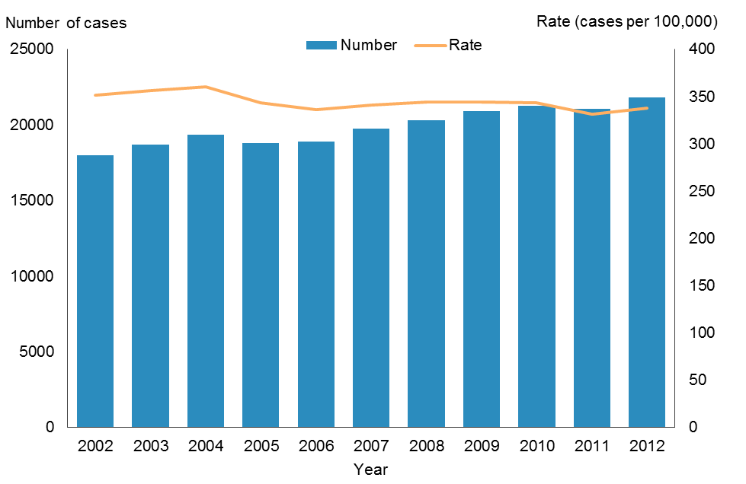
Note: rates are expressed per 100,000 population and age-standardised to the WHO World Standard population.
Source: New Zealand Cancer Registry

Table 1: Number and rate of cancer registrations, by sex, 2002–2012
Year | Males |  | Females |  | Total
 | Number | Rate | Number | Rate | Number | Rate
2002 | 9421 | 396.0 | 8570 | 319.4 | 17,991 | 351.3
2003 | 9900 | 404.7 | 8781 | 319.7 | 18,681 | 356.5
2004 | 10,224 | 407.1 | 9129 | 324.4 | 19,353 | 360.1
2005 | 9754 | 380.3 | 9022 | 314.3 | 18,776 | 343.0
2006 | 9849 | 373.4 | 9046 | 306.8 | 18,895 | 335.9
2007 | 10,425 | 381.2 | 9311 | 309.1 | 19,736 | 340.5
2008 | 10,482 | 374.2 | 9835 | 320.4 | 20,317 | 344.0
2009 | 11,151 | 388.3 | 9724 | 307.2 | 20,875 | 344.4
2010 | 11,068 | 375.4 | 10,167 | 316.3 | 21,235 | 342.9
2011 | 11,057 | 362.9 | 9993 | 304.6 | 21,050 | 331.0
2012 | 11,345 | 365.5 | 10,469 | 314.2 | 21,814 | 337.5
Notes:
ICD-10 codes D45–D47 are included from 2003 onwards: see Appendix A.
Rates are expressed per 100,000 population and age-standardised to the WHO World Standard population.
Source: New Zealand Cancer Registry

Figure 4: Number and rate of cancer registrations, by sex, 2002–2012
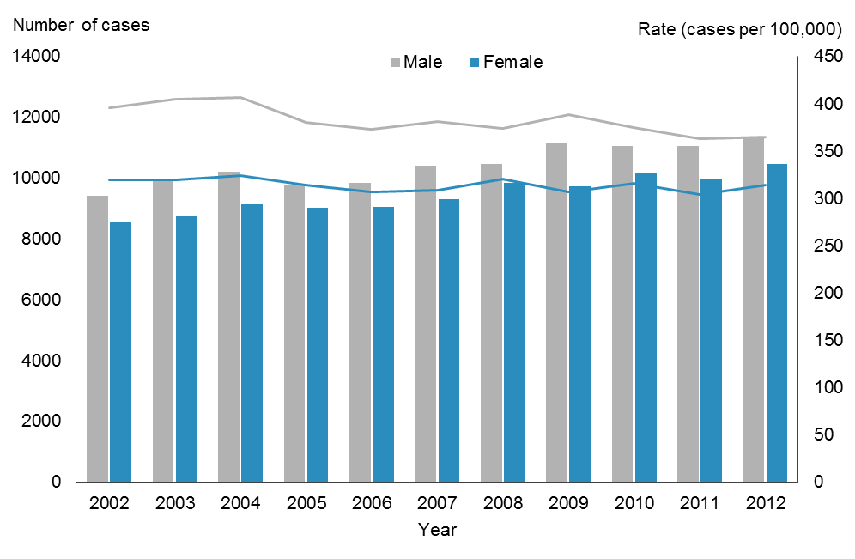
Notes:
Rates are expressed per 100,000 male or female population and age-standardised to the WHO World Standard population.
The lines represent rates and the bars represent numbers of cancer cases.
Source: New Zealand Cancer Registry

Common cancers
The following section presents information on registrations for individual cancer sites. These are reported at the level of a three-character ICD code. The three-character codes for the following cancer sites are grouped and presented together: colorectum and anus (C18–C21), lung and trachea (C33–C34), leukaemia (C91–C95) and non-Hodgkin lymphoma (C82–C85, C96).
In 2012, there were registrations for nearly 90 different cancer sites, but just five sites accounted for 62.1 % of all registrations. The following section focuses on the most commonly registered cancers in 2012 for the total population and for males and females. Appendix B, Tables B1–B3 and the online tables accompanying this publication (‘Cancer trends 2012’) present more detailed data for all individual cancers.

Most commonly registered cancers
Prostate cancer was the most common cancer registered in 2012; there were 3129 new cases. Breast cancer was the second commonest with 3054 new cases (3025 females and 29 males). Together prostate and breast cancers accounted for 28.3% of all registrations. These were followed by colorectal cancer (3016, 13.8%), melanoma (2324, 10.7%) and lung cancer (2027, 9.3%).

Top 10 for males
Prostate cancer was the most commonly diagnosed cancer in males (3129 cases) in 2012, followed by colorectal cancer (1570), melanoma (1228), lung cancer (1059) and non-Hodgkin lymphoma (432). Together these five cancers accounted for 65.4% of cancers registered for males.

Prostate cancer was the only sex-specific cancer in the 10 most common cancers in males. Kidney, stomach and bladder cancer were also among the 10 most common cancers diagnosed in males, but not in females (Figure 5).

Figure 5: The 10 most common cancers in males, 2012
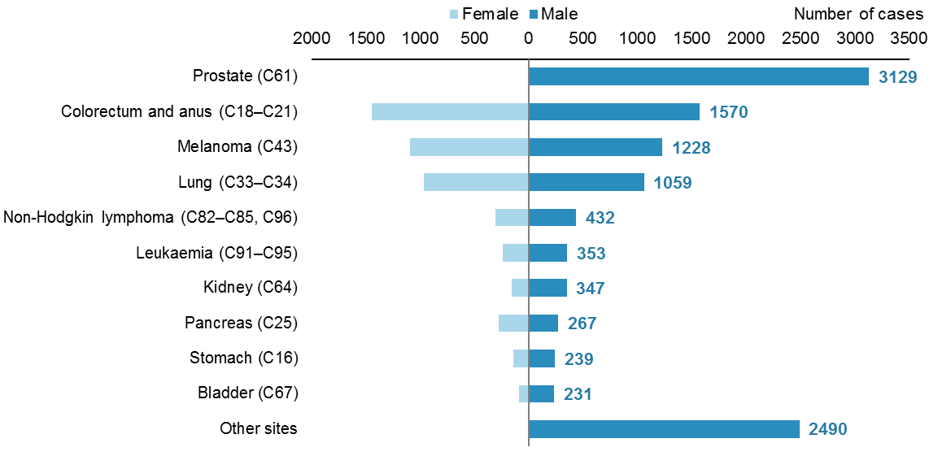
Source: New Zealand Cancer Registry

Top 10 for females
In 2012, breast cancer was the most commonly diagnosed cancer in females (3025 cases), accounting for almost 30% of all new female cancer cases. The next most common cancers were colorectal cancer (1446), melanoma (1096), lung cancer (968) and uterine cancer (513). Together these five cancers accounted for 67.3% of cancers registered for females in 2012.

There were two sex-specific cancers among the 10 most common cancers in females (uterus and ovary). Apart from these, thyroid cancer was the only other cancer of this group commonly diagnosed in females but not in males (Figure 6).

Figure 6: The 10 most common cancers in females, 2012
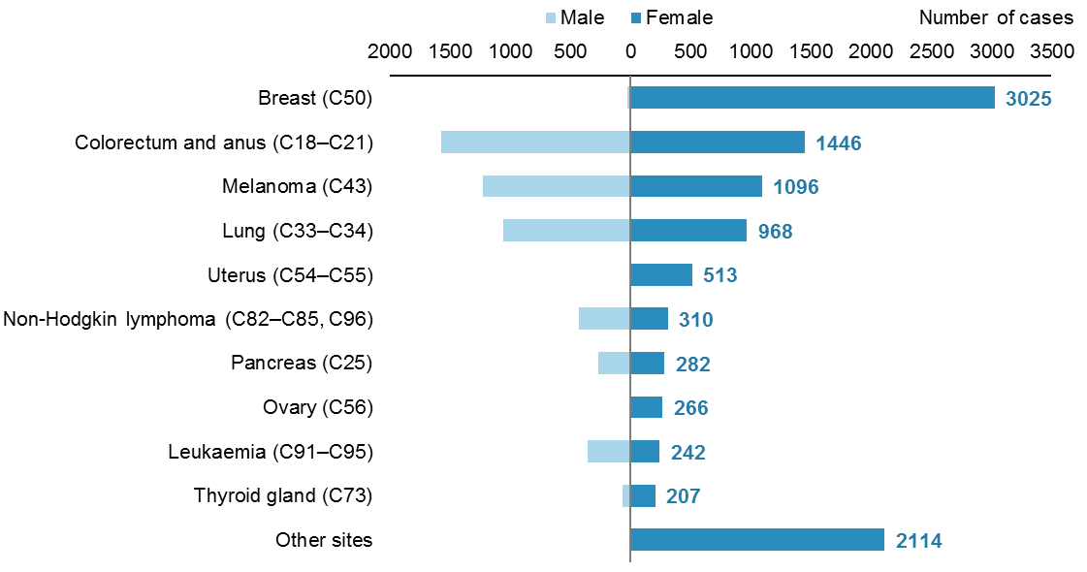
Source: New Zealand Cancer Registry

Life-stage age groups
This section focuses on cancer registrations by five life-stage age groups: 0–24, 25–44, 45–64, 65–74 and 75+ years. The rates it presents are age-specific, showing the number of cancer registrations per 100,000 population in each of these age groups for 2012, and how they changed between 2002 and 2012.
This section presents registration rates for all cancers combined and the most common cancers diagnosed in each life-stage group.

Overview
In 2012, registration rates by life-stage age group increased with age. Rates for males and females aged 0–24, 25–44 and 45–64 years were similar. Males aged 65 years and older had rates much higher than females.

Between 2002 and 2012, registration rates for all cancers combined remained relatively stable for those aged under 65 years, and age-specific rates were similar in males and females. Male cancer registration rates for those aged 65–74 and 75+ years showed a downward trend between 2002 and 2012, but female rates for the same age groups were more stable.

Registration rates for males aged 65–74 and 75+ years continued to be markedly higher than rates for females aged 65–74 and 75+ years (Figure 7).

Figure 7: Cancer registration rates for males and females, by life-stage group, 2002–2012
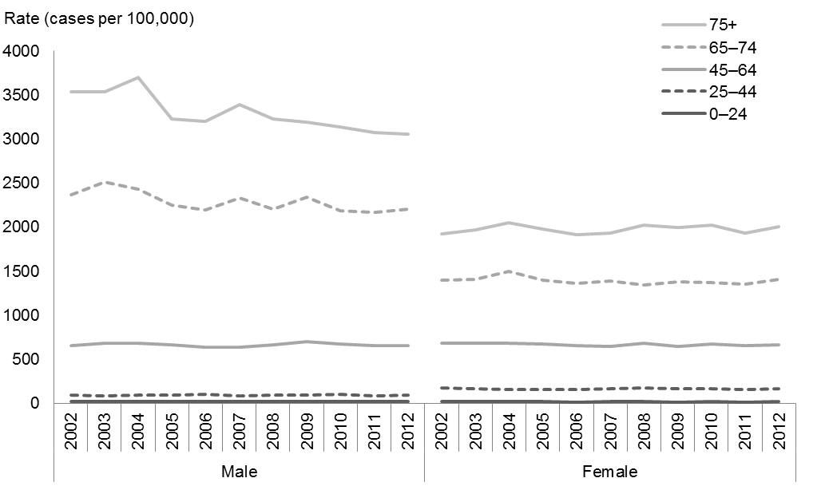
Note: rates are expressed as cases per 100,000 population.
Source: New Zealand Cancer Registry

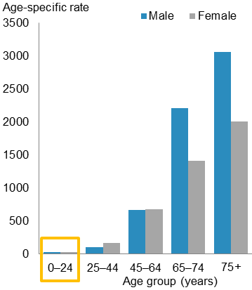
Life-stage group: 0–24 years
Cancer is relatively uncommon in young people. Those aged 0–24 years accounted for less than 2% of all new cancers in 2012. There were 157 new cases in males and 150 in females. The age-specific rate for males and females was 20 cases per 100,000 population.

Leukaemia accounted for almost 1 in 4 cancer registrations for this age group. Melanoma, brain cancer and Hodgkin lymphoma were also common in those aged 0–24 years. The five most common cancers registered for males and females were similar, except for testicular cancer in males and thyroid cancer in females (Figure 8).

Figure 8: The most common cancer registrations for males and females aged 0–24 years, 2012
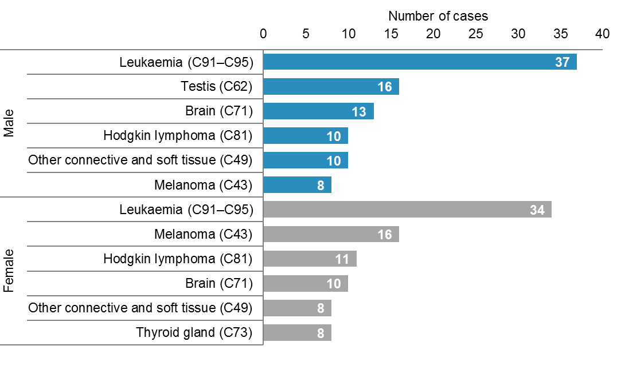
Source: New Zealand Cancer Registry

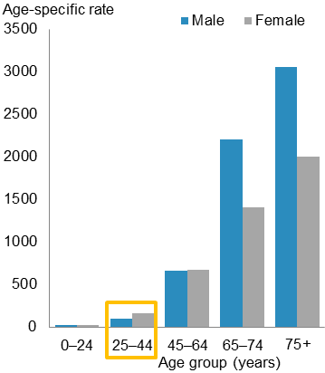
Life-stage group: 25–44 years
In 2012, only 6.9% of all cancers were registered in the
25–44-year age group (527 male and 978 female cases). The age-specific registration rate for females in this age group was significantly higher than the male rate (163.7 and 96.1 cases per 100,000 respectively).

The most common cancer registered for males in this age group was testicular cancer, followed by melanoma. For females, breast cancer was by far the most common cancer diagnosed (368 cases). Melanoma was the second most common (Figure 9).

Figure 9: The most common cancer registrations for males and females aged 25–44 years, 2012
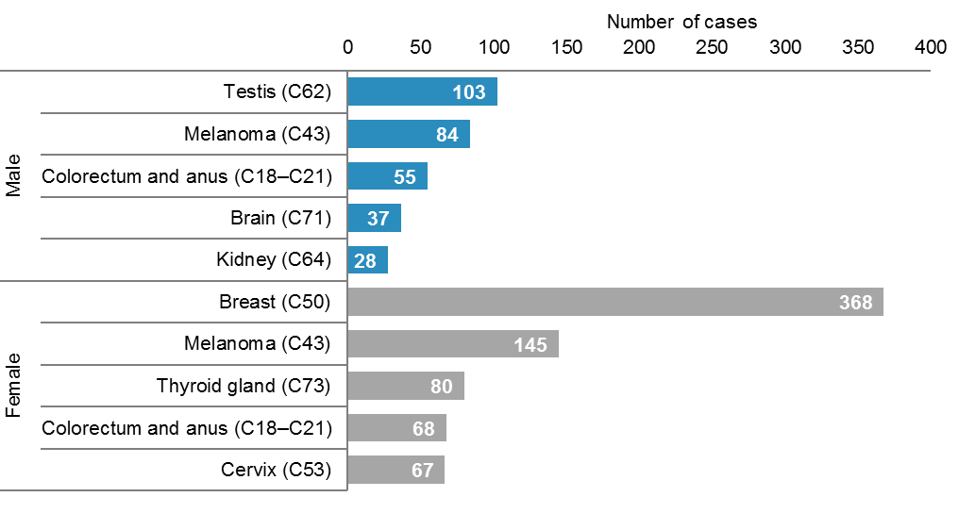
Source: New Zealand Cancer Registry

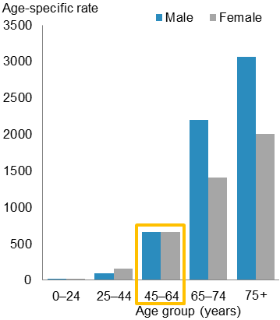
Life-stage group: 45–64 years
In 2012, 34.3% of all cancers were registered in the
45–64-year age group (3612 male and 3865 female cases). This age group accounted for the largest proportion of new cancer cases in 2012. The age-specific registration rates for males and females in this age group were similar (659.4 and 666.7 cases per 100,000).

Prostate cancer was the most common cancer registered in males aged 45–64 years. For females, breast cancer was by far the most common cancer registered, accounting for 40.1% (1551) of new cases in women aged 45–64 years. The next most common cancers were melanoma, colorectal and lung cancer for both males and females (Figure 10).

Figure 10: The most common cancer registrations for males and females aged 45–64 years, 2012
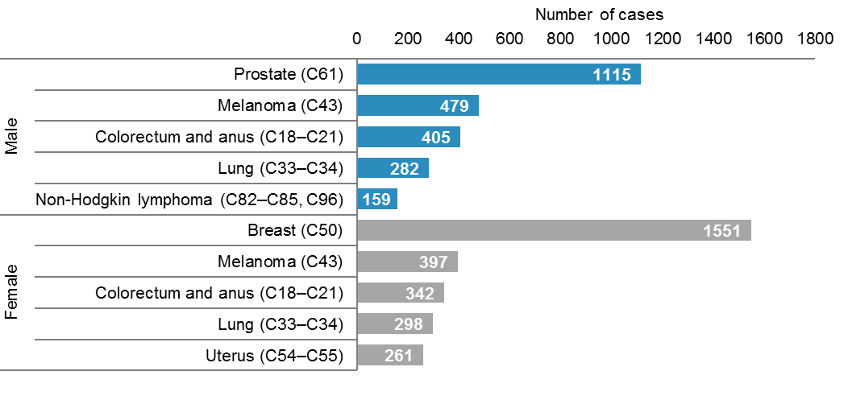
Source: New Zealand Cancer Registry

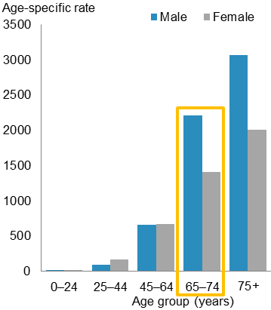
Life-stage group: 65–74 years
In 2012 there were 6135 new cases of cancer in people aged 65–74 years (3656 male and 2479 female cases). This age group accounted for 28.1% of new cancer cases in 2012. The age-specific registration rate for males in this age group was significantly higher than the rate for females (2202.5 and 1405.3 cases per 100,000 respectively).

For males in this age group, prostate cancer was by far the most common cancer diagnosed, accounting for over one-third (1312) of new cases in males aged 65–74 years. For females, breast cancer was the most common cancer diagnosed. Other common cancers were colorectal, lung and melanoma (Figure 11).

Figure 11: The most common cancer registrations for males and females aged 65–74 years, 2012
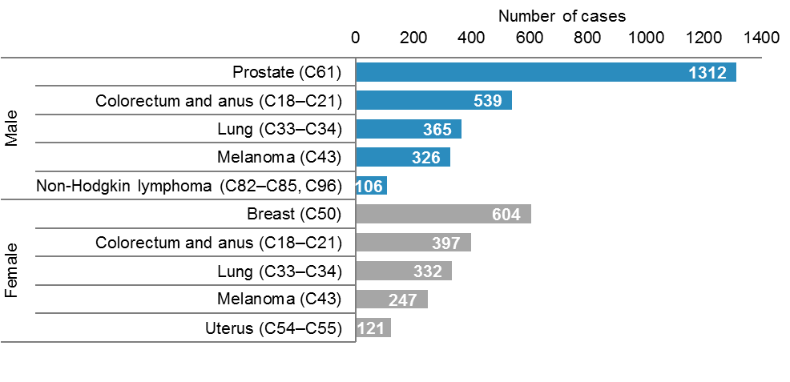
Source: New Zealand Cancer Registry

Life-stage group: 75+ years
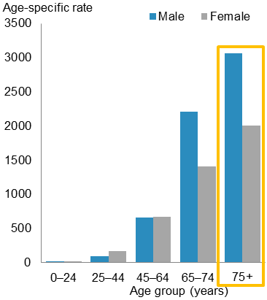
In 2012, there were 6390 new cases of cancer in people aged 75 years and older (3393 male and 2997 female cases). This age group accounted for 29.3% of all new cancer cases in 2012. The age-specific registration rate for males in this group was significantly higher than the rate for females (3058.4 and 2002.4 cases per 100,000 respectively).

For males aged 75 years and older, prostate cancer was the most common cancer diagnosed, followed by colorectal and lung cancer, melanoma and non-Hodgkin lymphoma. Colorectal cancer was the most common cancer in females accounting for one in five new cancer cases in females aged 75 years and older. The next most common cancers were breast, lung, melanoma and pancreatic (Figure 12).

Figure 12: The most common cancer registrations for males and females aged 75 years and older, 2012
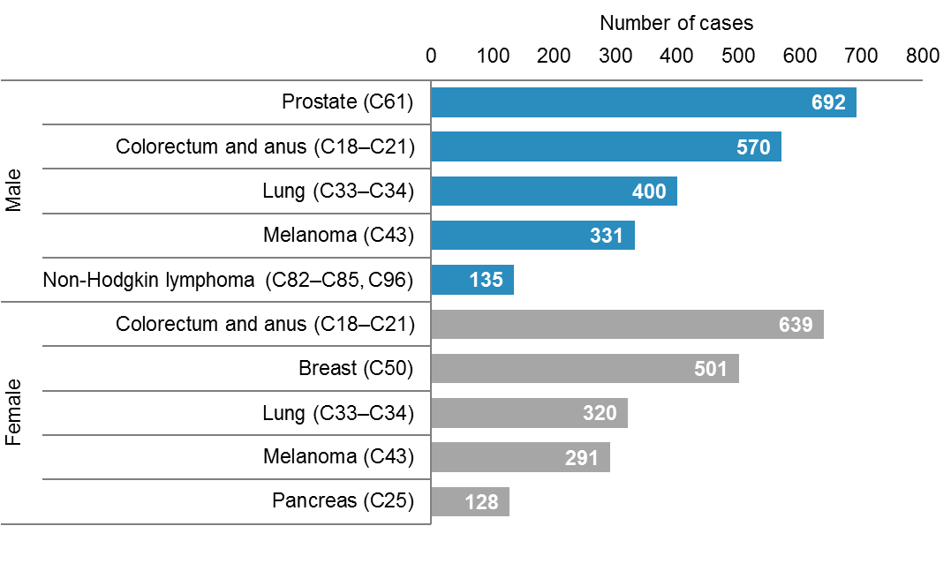
Source: New Zealand Cancer Registry

Māori and non-Māori
This section presents cancer data for Māori and non-Māori ethnic groups. Ethnicity information for registrations is based on self-identification. For more information on this see Appendix A. This section provides registration rates for all cancers combined for 2002–2012. The remaining focus is on the most commonly diagnosed cancers in each of these ethnic groups in 2012. Appendix B, Tables B2 and B3 and the online tables accompanying this publication (‘Cancer trends 2012’) present more detailed data for individual cancers by ethnic group.

Overview
In 2012, there were 2105 cancer registrations for Māori (930 males and 1175 females) and 19,709 for non-Māori (10,415 males and 9294 females). The registration rate for Māori was 414.7 per 100,000 Māori population, which was 26.2% higher than the rate for non-Māori (328.5 per 100,000 non-Māori population).
In 2012 there was greater disparity between Māori and non-Māori rates for females than between equivalent rates for males. The registration rate for Māori females was 1.4 times the rate for non-Māori females (424.2 and 303.2 per 100,000 respectively). The Māori male registration rate was 1.1 times the non-Māori rate for males (406.3 and 358.6 per 100,000 respectively).
Between 2002 and 2012, the registration rate for Māori females was significantly higher than the rate for non-Māori females each year. There was no consistent difference between rates for Māori and non-Māori males.
Over this period, registration rates showed a general downward trend for each group except Māori females, for whom the rate increased by 11.0% (Figure 13).

Figure 13: Cancer registration rates for males and females, by ethnic group, 2002–2012
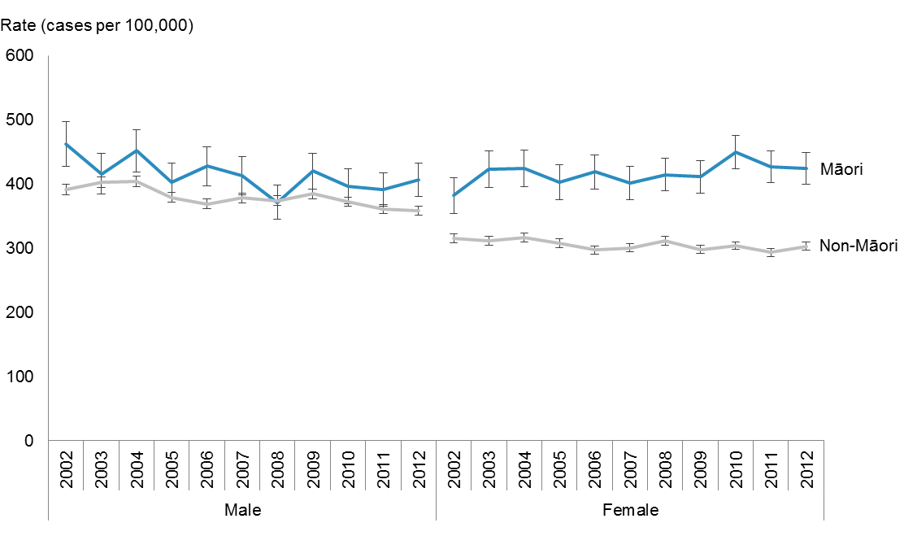
Notes:
Rates are expressed per 100,000 Māori or non-Māori population and age-standardised to the WHO World Standard population.
Error bars represent 95% confidence intervals.
Source: New Zealand Cancer Registry

Common cancers in Māori and non-Māori
In 2012, the most common cancers diagnosed in Māori and non-Māori were similar. Prostate, colorectal, breast, lung, non-Hodgkin lymphoma, leukaemia, pancreatic and uterine cancer were among the 10 most common cancers diagnosed in both ethnic groups. Among these cancers, the disparity between ethnic groups was greatest for pancreatic, uterine and lung cancer where Māori had rates 1.7–3.4 times the rates for non-Māori.

Stomach and liver cancer were commonly diagnosed in Māori but not non-Māori. Melanoma and kidney cancer were commonly diagnosed in non-Māori but not Māori. The non-Māori rate for melanoma was 5.6 times the rate for Māori (see Appendix B, Tables B2 and B3).

Males
The most common cancer registration for Māori males was prostate cancer (82.1 per 100,000), followed closely by lung cancer (77.4 per 100,000). Together these two cancers accounted for nearly 40% of Māori male cancers.

Prostate cancer was also the most common cancer registered for non-Māori males (99.1 per 100,000), and accounted for nearly 3 in 10 non-Māori male cancer cases. Colorectal cancer featured prominently for both ethnic groups (Figure 14).

Figure 14: Cancer registration rates of the most common cancers for Māori and non-Māori males, 2012
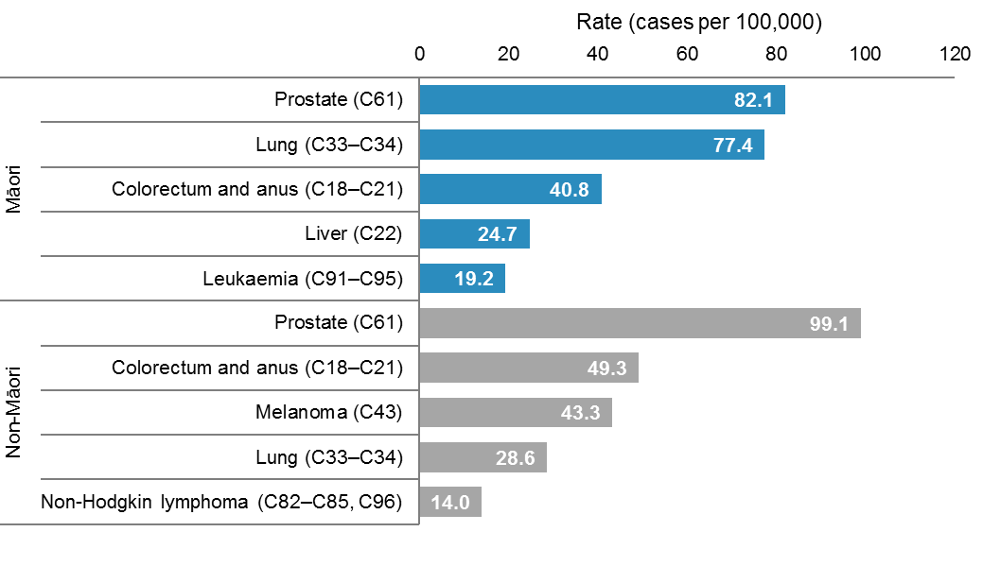
Note: rates are expressed per 100,000 Māori or non-Māori population and age-standardised to the WHO World Standard population.
Source: New Zealand Cancer Registry

Females
The five most common cancers registered for Māori and non-Māori females were similar, except for cervical cancer in Māori and melanoma in non-Māori. Breast cancer was by far the most common cancer registration for both ethnic groups. The greatest disparity was in lung cancer, where the rate for Māori females was 4.2 times the rate for non-Māori females (89.8 and 21.5 per 100,000 respectively) (Figure 15).

Figure 15: Cancer registration rates of the most common cancers for Māori and non-Māori females, 2012
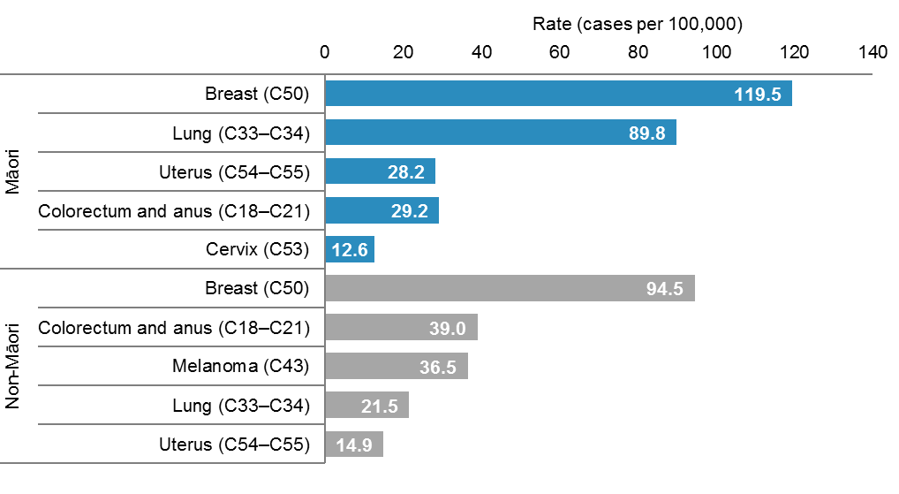
Note: rates are expressed per 100,000 Māori or non-Māori population and age-standardised to the WHO World Standard population.
Source: New Zealand Cancer Registry

Deprivation
This section presents registration rates by deprivation quintile for all cancers combined and for the most commonly diagnosed cancers in males and females in 2012.
Deprivation quintiles represent the level of deprivation of a particular area of residence, according to the New Zealand Deprivation Index 2006 (NZDep 2006). Deprivation quintile 1 represents the least deprived and quintile 5 represents the most deprived. See Appendix A for more information.

Overview
In 2012, cancer registration rates were higher for those residing in more deprived areas. Registration rates in quintiles 1─3 were significantly lower than rates in quintiles 4 and 5, and furthermore quintile 3 rates were significantly higher than rates in quintiles 1 and 2.

For males, cancer registration rates were highest for those residing in deprivation quintile 4 (417.5 cases per 100,000) and lowest for those residing in quintile 1 (325.1 per 100,000).

For females, registration rates increased steadily with deprivation level, from 271.9 per 100,000 in quintile 1 to 365.1 per 100,000 in quintile 5 (Figure 16).

Figure 16: Cancer registration rates for males and females, by deprivation quintile, 2012
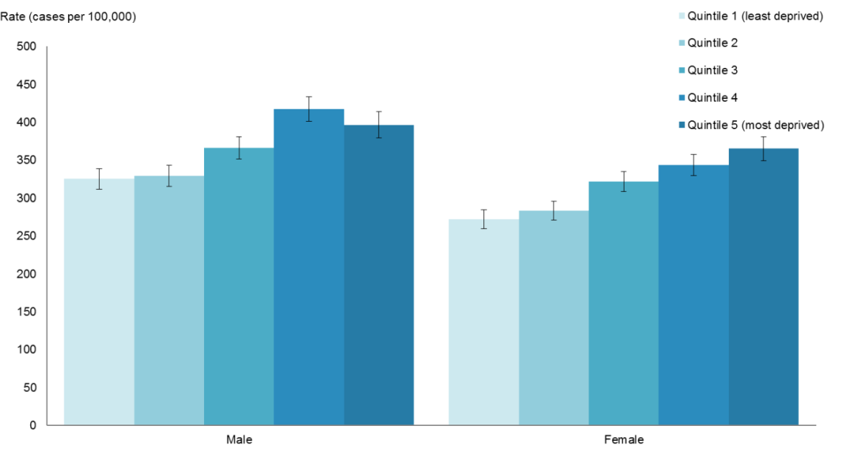
Notes:
Rates are expressed per 100,000 quintile population and age-standardised to the WHO World Standard population.
Error bars represent 95% confidence intervals.
There were 40 registrations (0.2%) with no deprivation quintile information.
Source: New Zealand Cancer Registry

Common cancers, by deprivation quintile

Males
In 2012, registration rates for the five most common male cancers differed by deprivation quintile. Rates for prostate and colorectal cancer and non-Hodgkin lymphoma were highest for those residing in deprivation quintile 4.

The greatest disparity was seen in lung cancer rates. Males residing in the most deprived areas had a lung cancer rate that was 2.6 times the rate for those living in the least deprived areas (50.9 per 100,000 for quintile 5 compared with 19.4 per 100,000 for quintile 1). Melanoma rates showed the opposite trend; the registration rate for males residing in the least deprived areas (quintile 1) was 1.7 times the rate for males residing in the most deprived areas (quintile 5) (Figure 17).

Figure 17: Registration rates of the most common cancers for males, by deprivation quintile, 2012
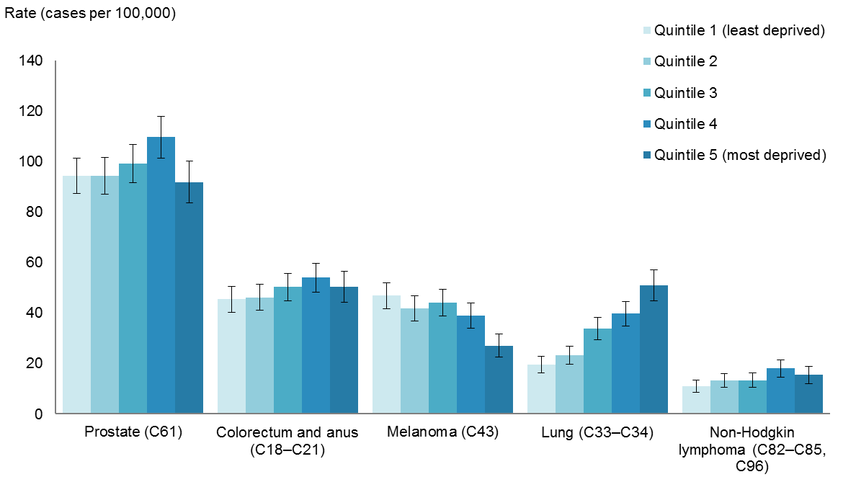
Notes:
Rates are expressed per 100,000 quintile population and age-standardised to the WHO World Standard population.
Error bars represent 95% confidence intervals.
Source: New Zealand Cancer Registry

Females
In 2012, the largest difference in female cancer registration rates across deprivation quintiles was seen for lung cancer, where the rate for females residing in the most deprived areas was more than three times the rate for females residing in the least deprived areas (48.4 per 100,000 for quintile 5 compared with 14.4 per 100,000 for quintile 1). Females living in the most deprived areas (quintile 5) had higher registration rates for uterine (2.7 times) and breast cancer (1.2 times) than those living in the least deprived areas (quintile 1).

For colorectal cancer, there was no consistent difference between rates across deprivation quintiles. Melanoma rates were similar across quintiles 1─4, and significantly lower in quintile 5.

Figure 18: Registration rates of the most common female cancers, by deprivation quintile, 2012
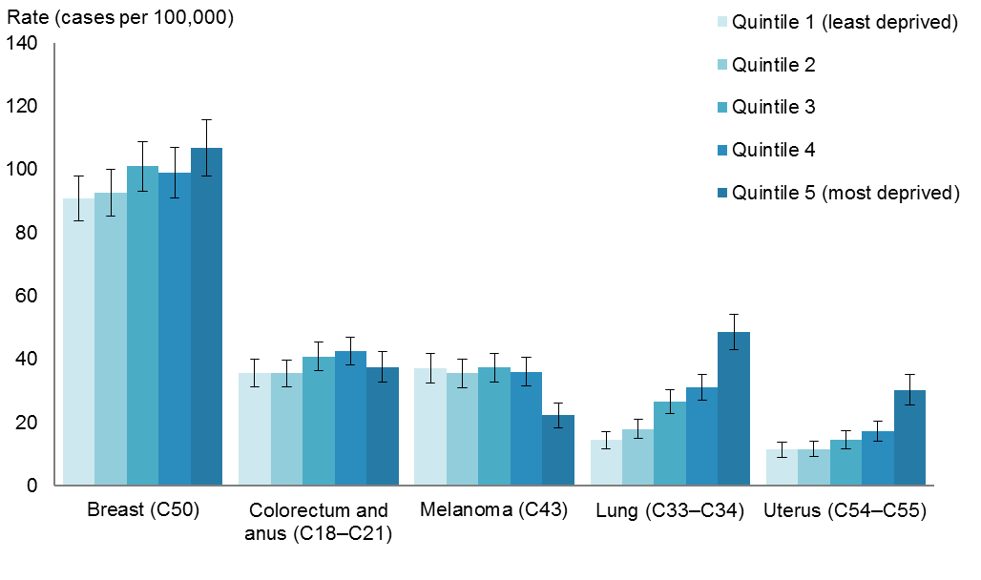
Notes:
Rates are expressed per 100,000 quintile population and age-standardised to the WHO World Standard population.
Error bars represent 95% confidence intervals.
Source: New Zealand Cancer Registry

Variation within New Zealand, 2010–2012
This section presents data by DHB region of domicile for cancers registered between 2010 and 2012. This data has not been adjusted by ethnicity or deprivation level. Different regions have different proportions of Māori in their populations, and the fact that Māori have higher rates of most cancers will have affected regional rates of registration to some extent. Data for DHB regions was aggregated for 2010–2012 since rates can vary considerably from year to year for some DHBs.

Registration rates for all cancers combined varied throughout New Zealand (Figures 19–20). The highest registration rate was in Whanganui DHB (361.5 per 100,000), followed by Lakes (361.2 per 100,000). The lowest registration rate was in Nelson Marlborough DHB (321.8 per 100,000), followed by Capital & Coast (323.8 per 100,000) (Figure 19).

Canterbury DHB had a registration rate significantly higher than the national rate (338.2 per 100,000). Waitemata and Capital & Coast DHBs had registration rates significantly lower than the national rate.

Figure 19: Cancer registration rates, by DHB, 2010–2012
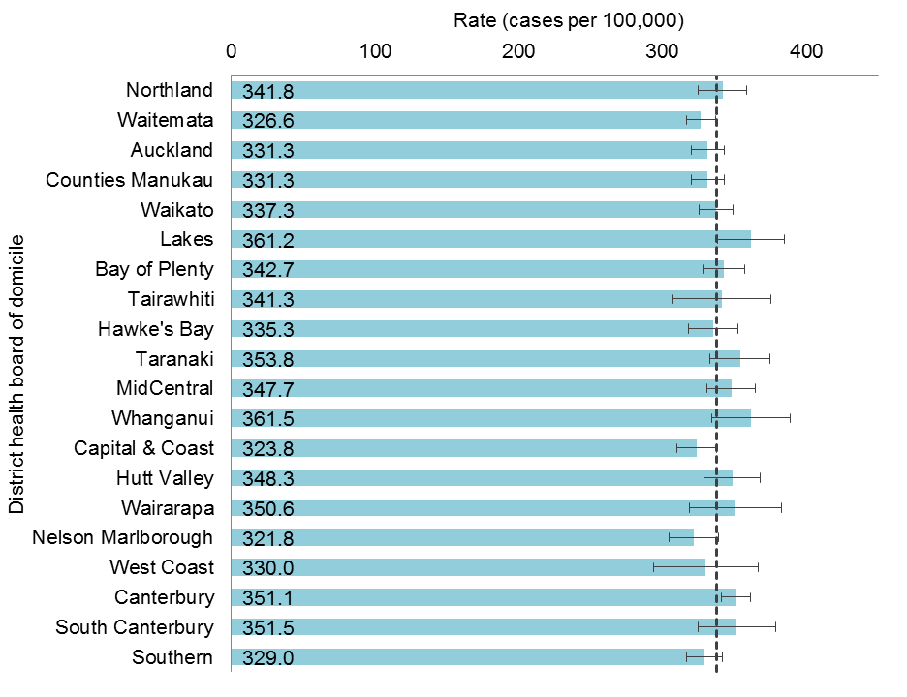
Notes:
The dashed line represents the aggregated national rate for 2010–2012 of 338.2 cases per 100,000 population.
Rates are expressed per 100,000 DHB population and age-standardised to the WHO World Standard population.
Error bars represent 99% confidence intervals.
Source: New Zealand Cancer Registry

Figure 20: Comparison of DHB region cancer registration rates, 2010–2012
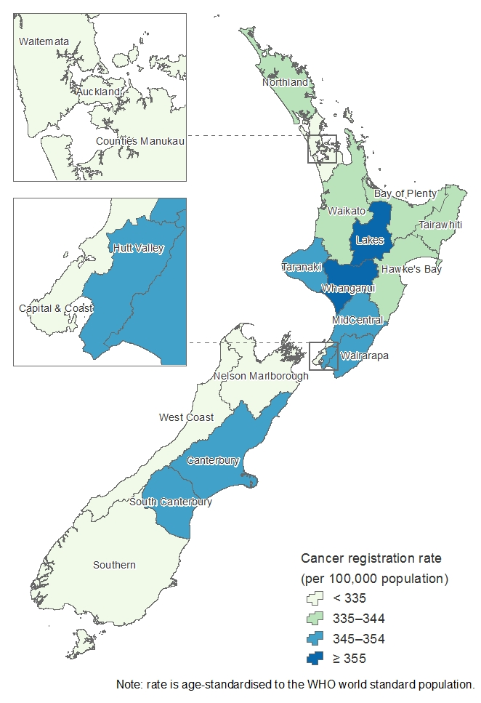
Note: age-standardised rates are expressed per 100,000 DHB population.
Source: New Zealand Cancer Registry

Cancer deaths
This report presents information on deaths registered in New Zealand in 2012, for which cancer was recorded as the underlying cause of death. Data comes from the New Zealand Mortality Collection. This report presents deaths data for all cancers combined (C00–C96 and D45–D47), as well as for individual cancers. This section focuses on deaths for all cancers combined in 2012 and between 2002 and 2012.

Cancer deaths in 2012
In 2012 there were 8905 deaths from cancer, which is a rate of 124.0 cancer deaths per 100,000 population. Cancer was the most common cause of death in New Zealand in 2012, accounting for nearly one in three deaths (29.4%) (Ministry of Health 2015). Males accounted for more than half (53%) of cancer deaths. The mortality rate for males was significantly higher than the rate for females (143.4 and 109.0 per 100,000 respectively).

In 2012, more than 70% of cancer deaths were in people aged 65 years and older. The age-specific mortality rate was higher for children aged 0─4 than those aged 5─19 years, after which rates increased steadily with age. The highest mortality rate was seen in people aged 85 years and older (2296.1 per 100,000) (Figure 21).

Figure 21: Numbers and age-specific rates of cancer deaths, by age group, 2012
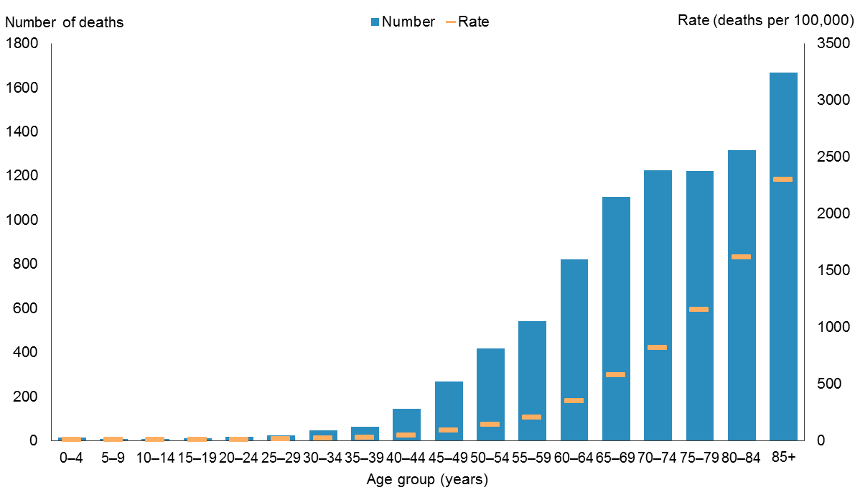
Note: rates are expressed as deaths per 100,000 population.
Source: New Zealand Mortality Collection

Males and females in age groups under 40 years had similar mortality rates. Females aged
40–49 years had significantly higher mortality rates than males. However, after 65 years of age, males had significantly higher mortality rates than females (Figure 22).

Figure 22: Age-specific rates of cancer death, by sex and age group, 2012
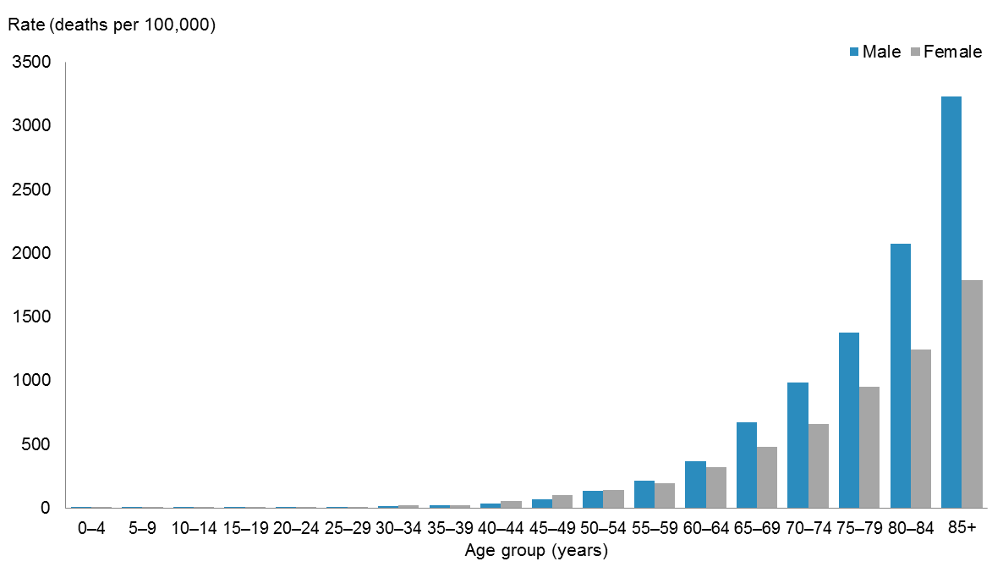
Note: rates are expressed as deaths per 100,000 population.
Source: New Zealand Mortality Collection

Cancer deaths between 2002 and 2012
The number of cancer deaths increased by 14.2% between 2002 and 2012, from 7800 to 8905. However, after adjusting for age and population growth, the mortality rate decreased over this period, from 140.7 to 124.0 deaths per 100,000 population (Table 2, Figure 23).
Between 2002 and 2012, the mortality rate for males was significantly higher than for females each year. Over this period the male mortality rate fell by 15.1%; the corresponding female rate fell by 9.8% (Figure 24).
Table 2: Numbers and rates of cancer deaths, by sex, 2002–2012
Year | Males |  | Females |  | Total
 | Number | Rate | Number | Rate | Number | Rate
2002 | 4125 | 168.9 | 3675 | 120.9 | 7800 | 140.7
2003 | 4292 | 170.1 | 3735 | 121.7 | 8027 | 141.8
2004 | 4246 | 164.1 | 3899 | 124.1 | 8145 | 140.7
2005 | 4184 | 156.6 | 3787 | 116.9 | 7971 | 133.6
2006 | 4144 | 151.3 | 3950 | 118.5 | 8094 | 132.4
2007 | 4539 | 159.4 | 3980 | 117.3 | 8519 | 135.1
2008 | 4561 | 154.9 | 4005 | 115.3 | 8566 | 132.3
2009 | 4402 | 145.4 | 4035 | 112.6 | 8437 | 126.8
2010 | 4511 | 143.9 | 4082 | 110.6 | 8593 | 125.2
2011 | 4650 | 143.3 | 4241 | 112.6 | 8891 | 125.9
2012 | 4735 | 143.4 | 4170 | 109.0 | 8905 | 124.0
Notes:
ICD-10 codes D45–D47 are included from 2003 onwards: see Appendix A.
Rates are expressed per 100,000 population and age-standardised to the WHO World Standard population.
Source: New Zealand Mortality Collection

Figure 23: Numbers and rate of cancer deaths, 2002–2012
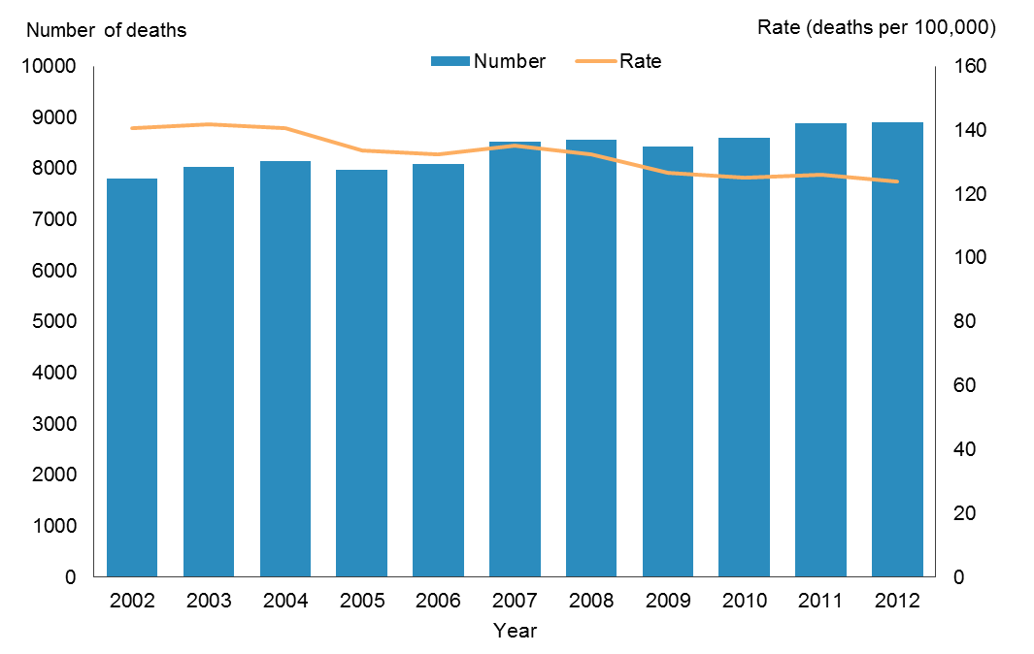
Note: rates are expressed per 100,000 population and age-standardised to the WHO World Standard population.
Source: New Zealand Mortality Collection
Figure 24: Numbers and rate of cancer deaths, by sex, 2002–2012
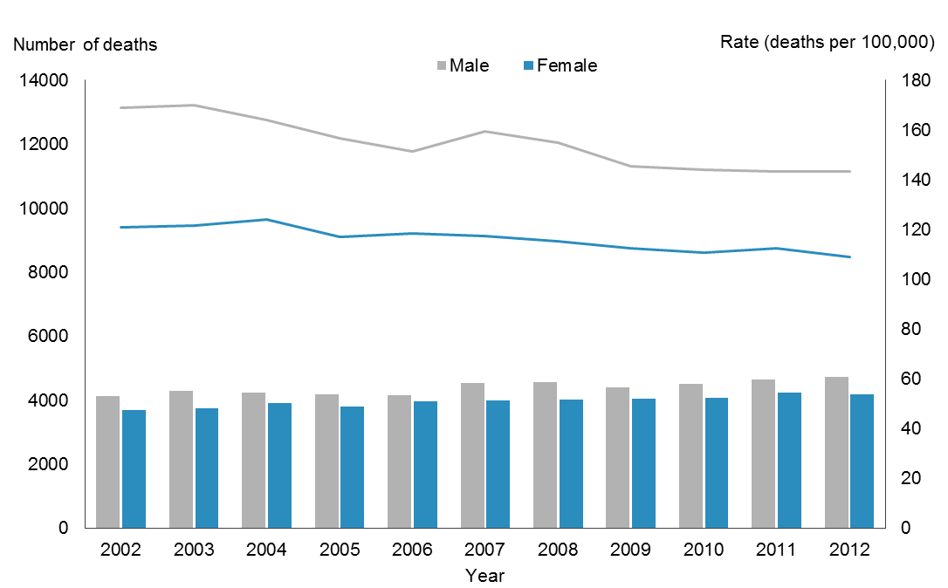
Notes:
Rates are expressed per 100,000 male or female population and age-standardised to the WHO World Standard population.
The lines represent rates and the bars represent number of cancer cases.
Source: New Zealand Mortality Collection

Common cancer deaths
This section presents cancer deaths data is presented for individual cancer sites, at the level of a three-character ICD code. The three-character codes for the following cancer sites are grouped and presented together: colorectum and anus (C18–C21), lung and trachea (C33–C34), leukaemia (C91–C95) and non-Hodgkin lymphoma (C82–C85, C96).
In 2012, cancer deaths related to over 80 different cancer sites, but just five sites accounted for half of all deaths. The following section focuses on the most common cancer deaths in 2012 for the total population and for males and females. Appendix B, Tables
B4–B6 and the online tables accompanying this publication (‘Cancer trends 2012’) present more detailed data for all individual cancers.

Most common cancer deaths
In 2012, lung cancer was the leading cause of cancer deaths (1628 deaths), accounting for nearly 1 in every 5 deaths from cancer. Colorectal cancer was the second commonest, accounting for 1283 deaths. Together lung and colorectal cancers accounted for nearly one-third of all cancer deaths. These were followed by breast (617 females and 1 male), prostate (607), and pancreatic cancer (463).

Top 10 for males
In 2012, lung cancer was the most common cause of cancer deaths in males (891 deaths), followed by colorectal (664), prostate (607), and pancreatic cancer (229), and melanoma (222). Together these five cancers accounted for 55.2% of cancer deaths in males. Prostate cancer was the only sex-specific cancer in the 10 most common cancer deaths in males. Brain, oesophageal and liver cancer were also among the 10 most common cancer deaths for males, but not for females (Figure 25).

Figure 25: The 10 most common cancer deaths in males, 2012
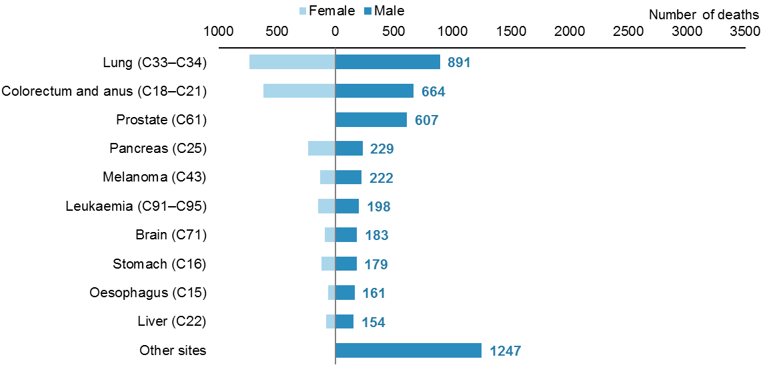
Source: New Zealand Mortality Collection

Top 10 for females
In 2012, lung cancer was also the leading cause of cancer deaths in females (737 deaths). The next most common cancer deaths were due to colorectal (619) and breast cancer (617). Together these three cancers accounted for nearly half of all cancer deaths in females.

The top 10 causes of cancer death in females were the same as in males, except non-Hodgkin lymphoma for females and female-only cancers (ovarian and uterine cancer) (Figure 26).

Figure 26: The 10 most common cancer deaths in females, 2012
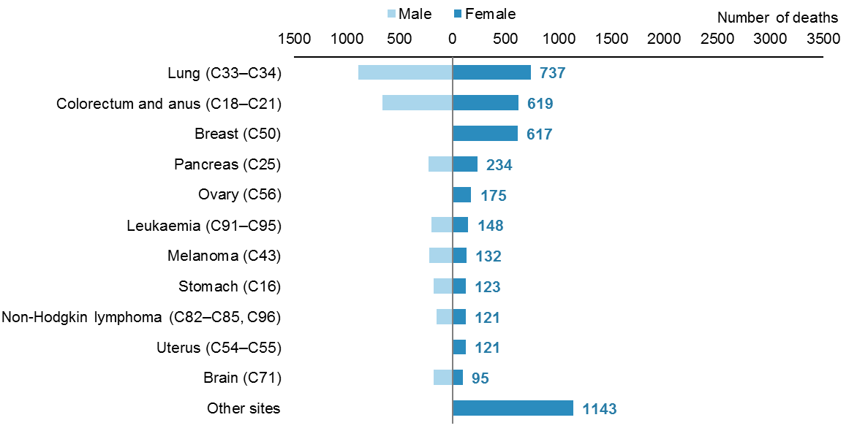
Source: New Zealand Mortality Collection

Life-stage age groups
This section focuses on cancer deaths by five life-stage age groups: 0–24, 25–44, 45–64, 65–74, and 75+ years. The rates it presents are age-specific, showing the number of cancer deaths per 100,000 population in each of these age groups for 2012, and how they changed between 2002 and 2012.
This section presents mortality rates for all cancers combined and the most common cancer deaths in each life-stage group for 2012.

Overview
In 2012, mortality rates for all cancers combined by life-stage group increased with age. Rates for males and females aged 0–24, 25–44 and 45–64 years were similar. Rates for males aged 65–74 and 75+ years were much higher than those for females (1.4 and 1.6 times the equivalent female rate, respectively).

Mortality rates remained relatively stable in those aged under 65 years between 2002 and 2012, and age-specific rates were similar in males and females. Mortality rates for males aged 65–74 and 75+ years continued to be markedly higher and more variable than rates for females aged 65–74 and 75+ years (Figure 27).

Figure 27: Cancer mortality rates for males and females, by life-stage group, 2002–2012
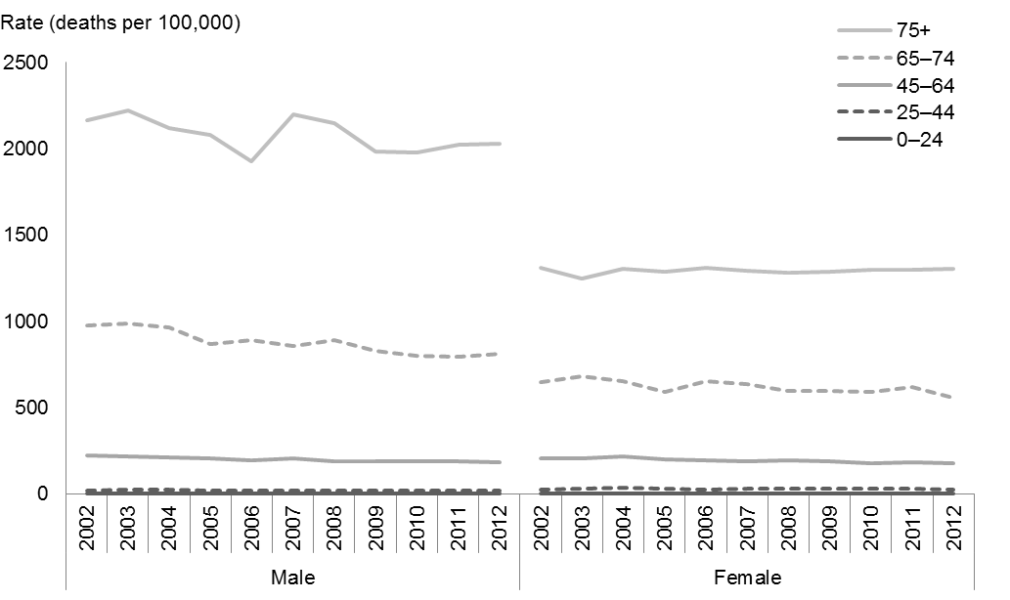
Note: rates are expressed as deaths per 100,000 population.
Source: New Zealand Mortality Collection

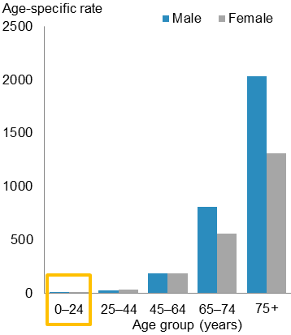
Life-stage: 0–24 years
People aged 0–24 years accounted for less than 1% of all cancer deaths in 2012. There were 29 male and 25 female deaths from cancer in this age group. The age-specific rate for males and females was 3.7 and 3.3 deaths per 100,000 population respectively.

Brain cancer and leukaemia together accounted for nearly 1 in 2 cancer deaths for this age group. Non-Hodgkin lymphoma and other connective and soft tissue cancers were also common (Figure 28).

Figure 28: The most common causes of cancer death for males and females aged 0–24 years, 2012
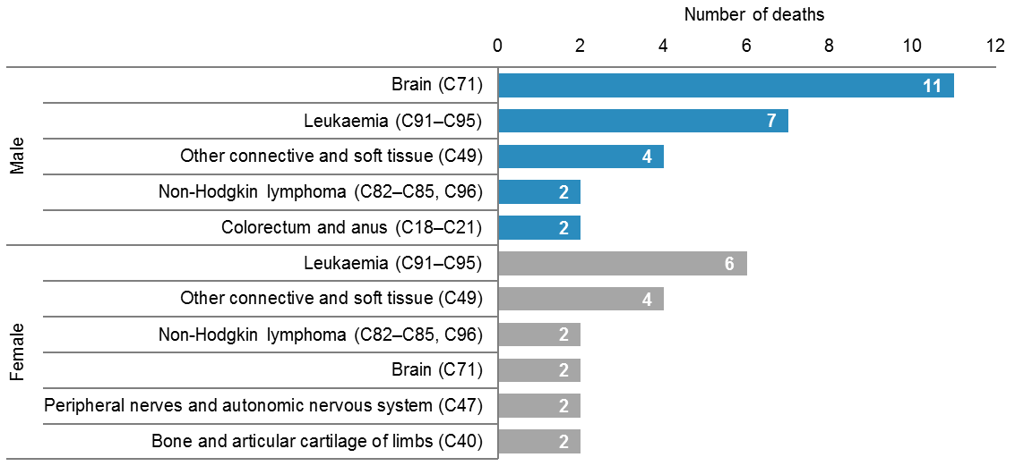
Source: New Zealand Mortality Collection

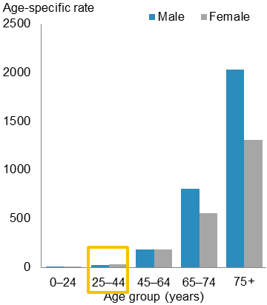
Life-stage: 25–44 years
In 2012, 3.1% of cancer deaths were in people aged 25–44 years (107 male and 166 female deaths). The age-specific mortality rate for females in this age group was significantly higher than the male rate (27.8 and 19.5 deaths per 100,000 respectively).

The most common cancer death for males and females in this age group were brain cancer and breast cancer respectively. Colorectal cancer was the second most common cancer death for both sexes (Figure 29).

Figure 29: The most common causes of cancer death for males and females aged 25–44 years, 2012
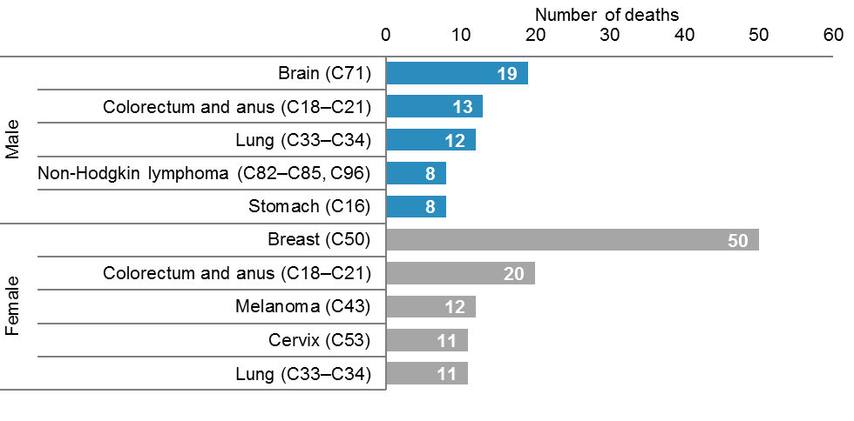
Source: New Zealand Mortality Collection

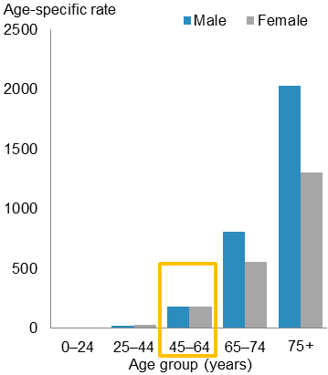
Life-stage: 45–64 years
In 2012, 23% of all cancer deaths were in the 45–64 years age group (1006 male and 1041 female deaths). The age-specific mortality rates for males and females in this age group were similar (183.7 and 179.6 deaths per 100,000).

Lung cancer was the leading cause of cancer death in males aged 45–64 years. For females breast cancer was the most common cancer death, accounting for approximately 1 in 5 cancer deaths. Colorectal cancer was also a common cause of death for both males and females (Figure 30).

Figure 30: The most common causes of cancer death for males and females aged 45–64 years, 2012
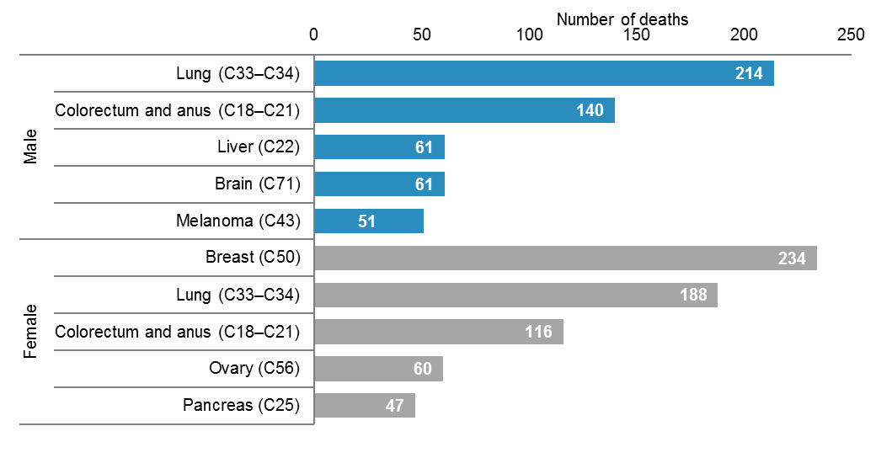
Source: New Zealand Mortality Collection

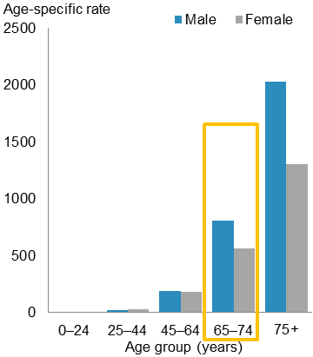
Life-stage: 65–74 years
In 2012, 26.2% of all cancer deaths were in people aged 65–74 years (1343 male and 986 female deaths). The age-specific mortality rate for males in this age group was significantly higher than the rate for females (809.1 and 559 deaths per 100,000 respectively).

Lung cancer was the leading cause of death for both males and females in this age group, followed by colorectal cancer. Prostate, breast and pancreatic cancer deaths were also common (Figure 31).

Figure 31: The most common causes of cancer death for males and females aged 65–74 years, 2012
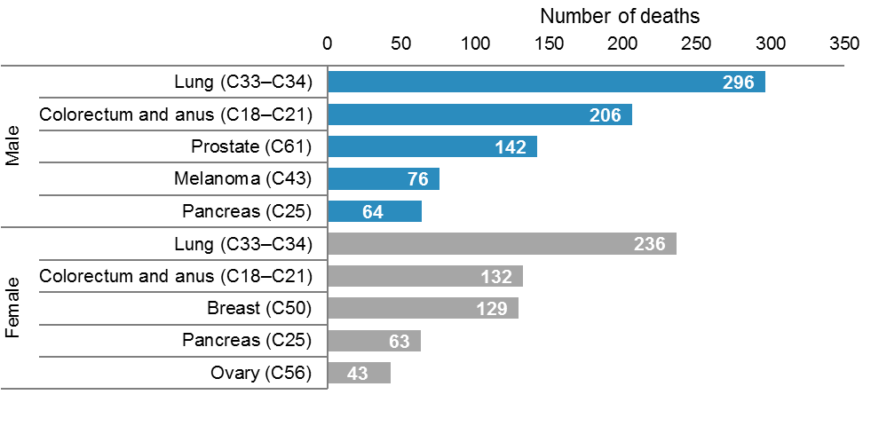
Source: New Zealand Mortality Collection

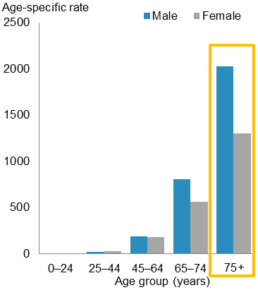
Life-stage: 75+ years
In 2012, 47.2% of all cancer deaths were in people aged 75 years and older (2250 male and 1952 female deaths). The age-specific mortality rate for males in this age group was significantly higher than the rate for females (2028.1 and 1304.2 deaths per 100,000 respectively).

Prostate cancer was the leading cause of cancer death for males in this age group, accounting for nearly 1 in 5 male cancer deaths. Colorectal cancer was the most common cancer death in females accounting for 18.0% of cancer mortality in females aged 75 years and older. Lung and pancreatic cancer and leukaemia were also common causes of cancer mortality in this group (Figure 32).

Figure 32: The most common causes of cancer death for males and females aged 75+ years, 2012
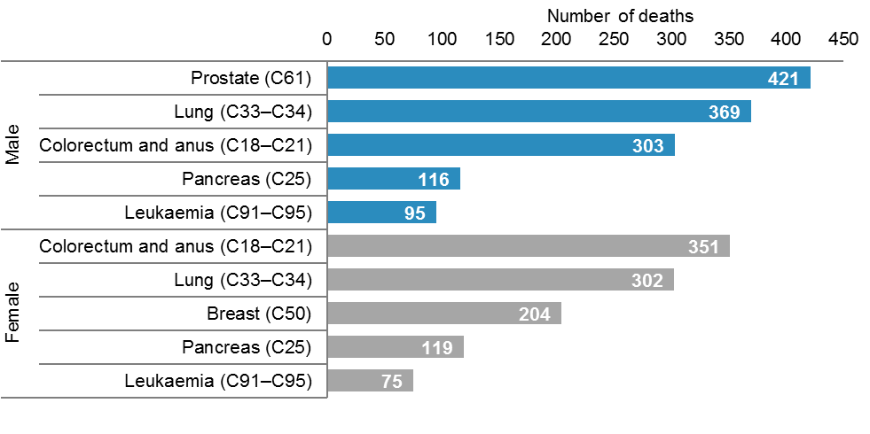
Source: New Zealand Mortality Collection

Māori and non-Māori
Ethnicity data for deaths was sourced from Births, Deaths and Marriages. This section presents cancer data for Māori and non-Māori groups. It presents mortality rates for all cancers combined for 2002–2012. The remaining focus is on the most common cancer deaths for each of these ethnic groups in 2012. Appendix B, Tables B5 and B6, and the online tables accompanying this publication (‘Cancer trends 2012’) present more detailed data for individual cancers by ethnic group.

Overview
In 2012, there were 936 Māori (441 males and 495 females) and 7969 non-Māori (4294 males and 3675 females) deaths from cancer. The cancer mortality rate for Māori was 199.4 per 100,000 Māori population, which was 1.7 times the rate for non-Māori (116.5 per 100,000 non-Māori population).

In 2012 there was greater disparity between the Māori and non-Māori rates for females than for males. The mortality rate for Māori females was 1.9 times the rate for non-Māori females (192.5 and 101.1 per 100,000). The Māori male mortality rate was 1.5 times the non-Māori male rate for males (209.5 and 135.9 per 100,000).

Between 2002 and 2012, the mortality rate for Māori males and females was consistently significantly higher than the rate for non-Māori males and females each year. Over this period mortality rates showed a general downward trend for each group except Māori females, where the rate was variable and did not show a clear trend (Figure 33).

Figure 33: Cancer mortality rates for males and females, by ethnic group, 2002–2012
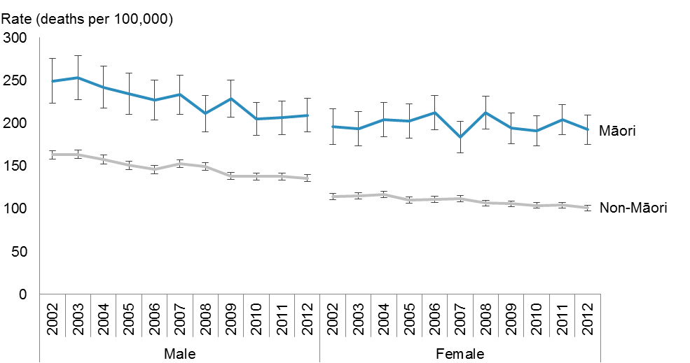
Notes:
Rates are expressed per 100,000 Māori or non-Māori population and age-standardised to the WHO World Standard population.
Error bars represent 95% confidence intervals.
Source: New Zealand Mortality Collection

Common causes of cancer death in Māori and non-Māori
In 2012, the most common cancer deaths for Māori and non-Māori were similar. Mortality from the following cancers featured prominently in both ethnic groups: lung, colorectal, breast, prostate, pancreatic, leukaemia, non-Hodgkin lymphoma and stomach. Comparing these sites, the disparity between Māori and non-Māori mortality rates was greatest for stomach (3.7 times), lung (3.4 times) and breast (1.6 times) cancer. Mortality rates for colorectal cancer were higher for non-Māori than Māori.

Mortality from liver and oesophageal cancer was more common in Māori than in non-Māori and mortality from melanoma and brain cancer was common for non-Māori, but not for Māori. Non-Māori mortality rates for melanoma were 7.0 times the rate for Māori (see Appendix B, Tables B5 and B6).

Males
The most common cancer death for Māori and non-Māori males in 2012 was lung cancer. The Māori mortality rate for lung cancer was 2.7 times the rate for non-Māori males; lung cancer accounted for 3 out of every 10 Māori male cancer deaths. Colorectal cancer was the second most common cause of cancer death for both ethnic groups. Mortality rates for prostate cancer were similar for Māori and non-Māori males (Figure 34).

Figure 34: Cancer mortality rates of most common cancer deaths for Māori and non-Māori males, 2012
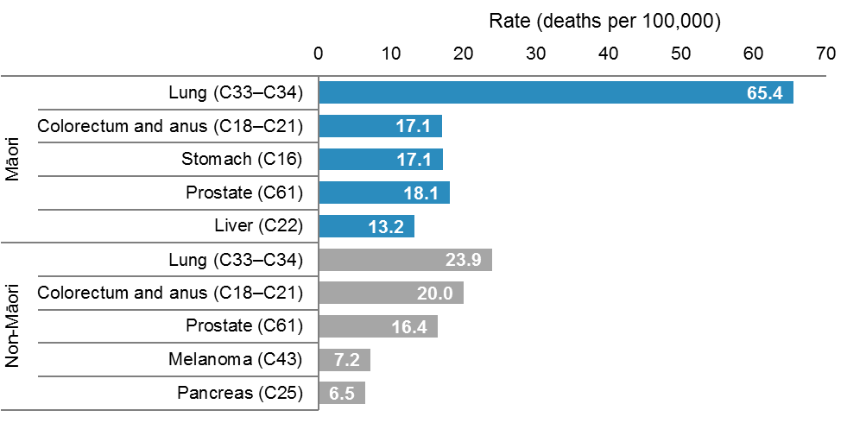
Note: rates are expressed per 100,000 Māori or non-Māori male population and age-standardised to the WHO World Standard population.
Source: New Zealand Mortality Collection

Females
The leading causes of cancer death for Māori and non-Māori females in 2012 were similar to those for males, and included lung, breast, colorectal and pancreatic cancer. Lung cancer was by far the most common cancer death for Māori females, accounting for 1 in every 3 cancer deaths. The lung cancer mortality rate for Māori females was 4.2 times that for non-Māori females (66.4 and 15.7 per 100,000 respectively). Breast cancer was the leading cause of cancer death for non-Māori females, followed closely by lung and colorectal cancer (Figure 35).

Figure 35: Cancer mortality rates of most common cancer deaths for Māori and non-Māori females, 2012
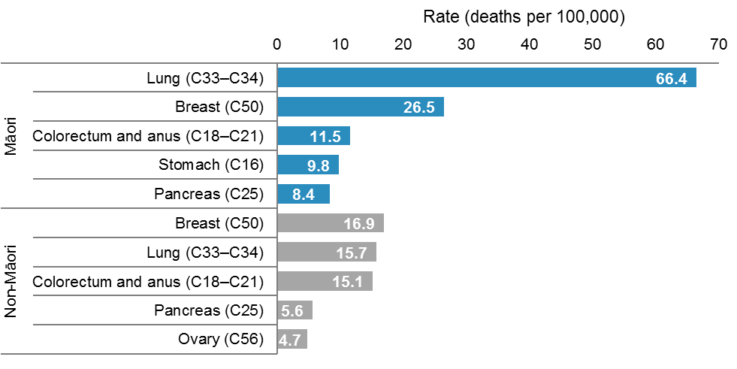
Note: rates are expressed per 100,000 Māori or non-Māori female population and age-standardised to the WHO World Standard population.
Source: New Zealand Mortality Collection

Deprivation
This section presents mortality rates by deprivation quintile for all cancers combined and for the most common cancer deaths in males and females for 2012.
Deprivation quintiles represent the level of deprivation of a particular area of residence, according to the New Zealand Deprivation Index 2006 (NZDep 2006). Deprivation quintile 1 represents the least deprived and quintile 5 represents the most deprived. See Appendix A for more information.

Overview
In 2012, cancer mortality rates for all cancers combined were higher for those residing in more deprived areas. Mortality rates in quintiles 3─5 were significantly higher than those in quintiles 1 and 2.

For males, the cancer mortality rate was highest for those residing in deprivation quintiles 4 and 5 (179.5 and 177.9 deaths per 100,000 respectively) and lowest for those residing in quintile 1 (108.4 per 100,000).

For females, mortality rates increased steadily with deprivation level, from 86.5 per 100,000 in quintile 1 to 141.1 per 100,000 in quintile 5 (Figure 36).

Figure 36: Cancer mortality rates, by deprivation quintile, 2012
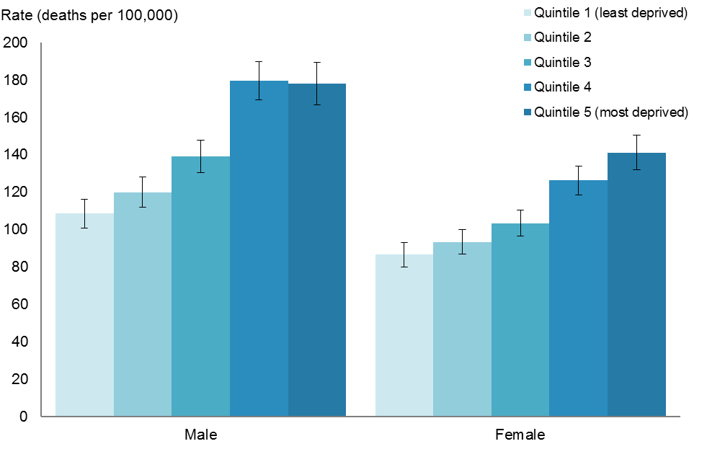
Notes:
Rates are expressed per 100,000 quintile population and age-standardised to the WHO World Standard population.
Error bars represent 95% confidence intervals.
There were 26 deaths (0.3%) with no deprivation quintile information.
Source: New Zealand Mortality Collection

Common cancer deaths, by deprivation quintile

Males
Mortality rates for the five most common male cancer deaths differed by deprivation quintile in 2012. Rates for colorectal and prostate cancer were highest for those residing in deprivation quintile 4.

The greatest disparity was in lung cancer rates. Males residing in the most deprived areas had a lung cancer mortality rate 3.1 times the rate for those living in the least deprived areas (46.4 per 100,000 for quintile 5 compared with 15.0 per 100,000 for quintile 1). For pancreatic cancer and melanoma there was no consistent difference between mortality rates across deprivation quintiles (Figure 37).

Figure 37: Mortality rates of the most common causes of cancer death for males, by deprivation quintile, 2012
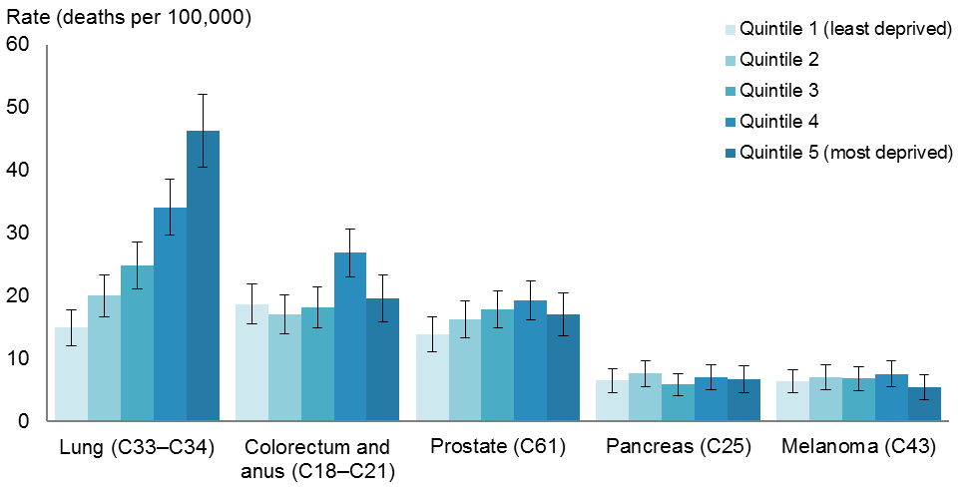
Notes:
Rates are expressed per 100,000 quintile population and age-standardised to the WHO World Standard population.
Error bars represent 95% confidence intervals.
Source: New Zealand Mortality Collection

Females
In 2012, for females, mortality rates for lung and colorectal cancer were highest for those residing in the most deprived areas (quintile 5). Females residing in quintile 5 had a lung cancer mortality rate 3.4 times the rate for females residing in the least deprived areas (36.0 and 10.7 per 100,000 respectively).

Mortality rates for breast cancer were highest for females residing in quintile 4. For pancreatic and ovarian cancer there was no consistent difference between mortality rates across deprivation quintiles (Figure 38).

Figure 38: Mortality rates of the most common causes of cancer death for females, by deprivation quintile, 2012
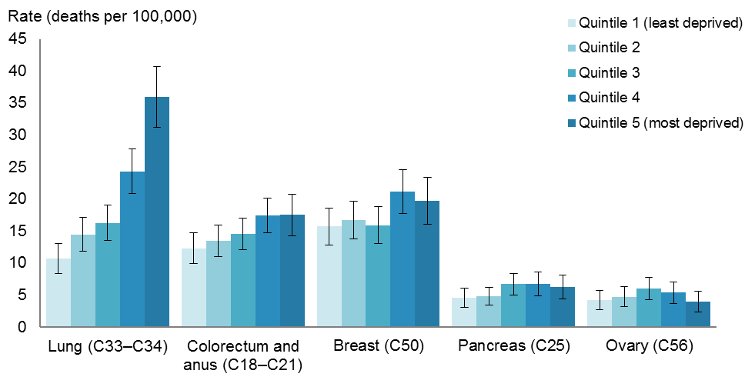
Notes:
Rates are expressed per 100,000 quintile population and age-standardised to the WHO World Standard population.
Error bars represent 95% confidence intervals.
Source: New Zealand Mortality Collection

Variation within New Zealand 2010–2012
This section presents data by DHB region of domicile for cancer deaths between 2010 and 2012. This data has not been adjusted by ethnicity or deprivation level. Different regions have different proportions of Māori in their populations, and the fact that Māori have higher mortality rates for some cancers will have affected regional rates of mortality to some extent. Data for DHB regions was aggregated for 2010–2012 since rates can vary considerably from year to year for some DHBs.

Mortality rates for all cancers combined varied throughout New Zealand (Figures 39–40). The highest cancer mortality rate was in Tairawhiti DHB (143.7 deaths per 100,000), followed by Northland (142.6 per 100,000). The lowest mortality rate was in Nelson Marlborough DHB (111.9 per 100,000), followed by Auckland and Waitemata (113.1 and 113.3 per 100,000) (Figure 39).

Northland DHB had a mortality rate significantly higher than the national rate (125.7 per 100,000). Waitemata, Auckland, Capital & Coast and Nelson Marlborough DHBs had mortality rates significantly lower than the national rate.

Figure 39: Cancer mortality rates, by DHB, 2010–2012
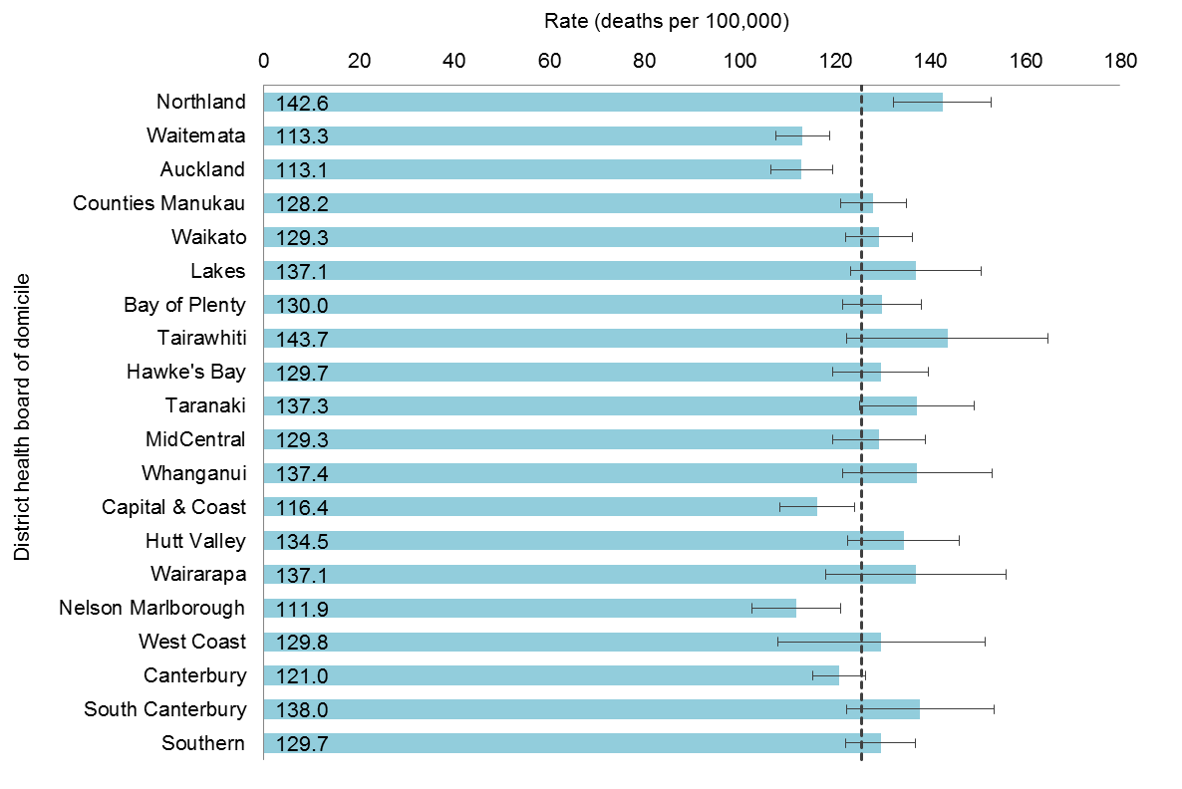
Notes:
The dashed line represents the aggregated national rate for 2010–2012 of 125.7 deaths per 100,000 population.
Rates are expressed per 100,000 DHB population and age-standardised to the WHO World Standard population.
Error bars represent 99% confidence intervals.
Source: New Zealand Mortality Collection

Figure 40: Comparison of DHB region cancer mortality rates, 2010–2012
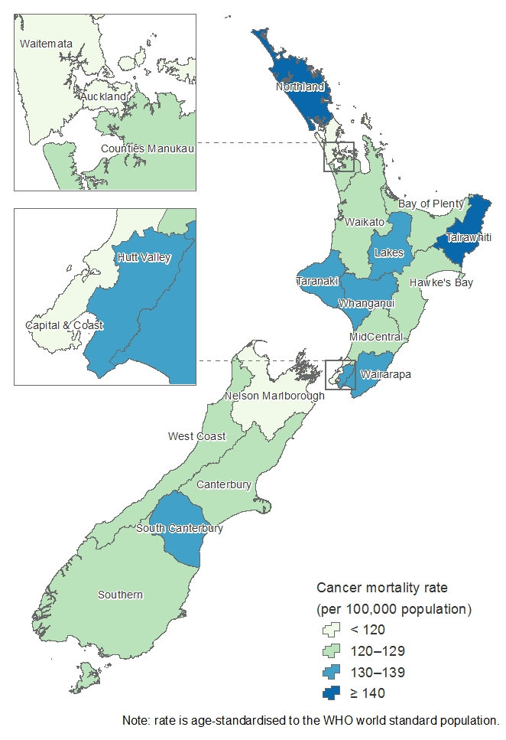
Note: age-standardised rates are expressed per 100,000 DHB population.
Source: New Zealand Mortality Collection

Appendix A: Technical notes

Data sources

Registration data
The New Zealand Cancer Registry is a collection of data on malignant disease cases that have been diagnosed in New Zealand. Registrations are based on discrete primary cancer cases that are distinguished by differences in topography or histology. Cancers are registered once, in the year of their first known diagnosis (see the Cancer Registry Act 1993 in Appendix C). Registrations cover new cases of primary cancer, or secondary cancers where the primary cancer is unknown. The process of collecting, coding and collating national information on cancer registrations and deaths is complex. Data in the Cancer Registry comes from laboratory reports, hospital information and mortality information (Figure A1). To ensure a high standard of data, registry staff comprehensively screens all records before adding them to the registry. Deaths from cancer are reconciled with cancer registrations recorded on the registry.

Figure A1: Data and the New Zealand Cancer Registry
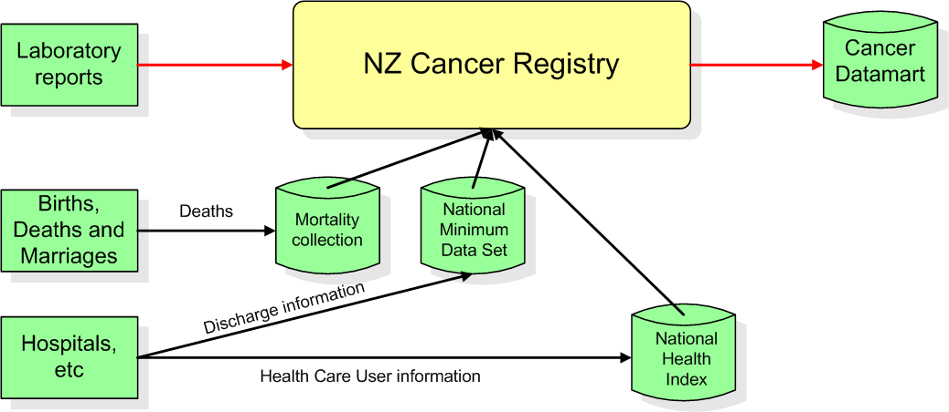

Changes in legislation
On 1 July 1994 the Cancer Registry Act 1993 and Cancer Registry Regulations 1994 came into force, introducing fundamental changes to the collection of cancer data in New Zealand. Appendices A and C contain the full text of the Cancer Registry Act and Cancer Registry Regulations. The effect of legislation on cancer registration statistics is discussed in Cancer: New registrations and deaths 1996 (Ministry of Health 2001).

Mortality data
Cancer mortality data is sourced from the New Zealand Mortality Collection. This contains data on all deaths registered in New Zealand. Death and stillbirth registration data is sent electronically to the Collection monthly from Births, Deaths and Marriages. In addition, the Ministry of Health receives medical certificates of causes of death (completed by certifying doctors) from funeral directors, as well as coronial findings relating to deaths from Coronial Services of New Zealand (Ministry of Justice). The Ministry of Health assigns each death an underlying cause of death, using the ICD-10-AM, sixth edition (National Centre for Classification in Health 2008).The timing of publication of this data is affected by manual processing of death data and the need to wait until almost all coroners’ findings for any particular year have been received. Several final steps ensure the final information is of good quality.

Ethnicity data
The Ministry of Health requires providers to collect and classify ethnicity data according to its ethnicity data protocols for the health and disability sector (see Ministry of Health 2004).Under the protocols, ethnicity information is collected through self-identification or, when this is not possible, by appropriate proxy using a standard question format. Individuals may select up to three ethnicities they feel they belong to.

The ethnicity data in this publication is based on prioritised ethnic group. This system allocates each individual to a single ethnicity on the basis of the following priority: Māori, Pacific peoples, Asian, other groups except New Zealand European, New Zealand European. Thus, any person who selects Māori as one of their three ethnicities will be recorded as Māori.

This publication categorises ethnicity information as either Māori or non-Māori. Registrations without an ethnic identification have been included in the non-Māori group.

Cancer registrations
The Cancer Registry gathers ethnicity information from hospital discharge information, the National Health Index and the Mortality Collection The less contact a patient has with the hospital system, the less likely they are to have an accurate ethnicity recorded. In 2012 ethnicity was not recorded for 694 cancer registrations (3.2%).

Cancer deaths
The New Zealand Mortality Collection sources ethnicity data for deaths from Births, Deaths and Marriages. Family members or others assisting with a death registration provide ethnicity data to funeral directors, who record it on the BDM28 ‘Notification of Deaths for Registration’ form. There have been no recent changes in the way ethnicity is assigned to death records. All records of cancer deaths in 2012 included ethnicity.

Changes to ethnicity coding
In 2009 the New Zealand Cancer Registry adjusted the way it recorded ethnicities, in order to rectify a perceived undercount of some ethnicities. The changes were applied to information from 1989 onwards, and resulted in some significant changes in the proportions of cancer registrations allocated to particular ethnicities. Updated registration data was used in Cancer: New registrations and deaths 2006 (Ministry of Health 2011a). This change means that information relating to ethnicities in publications prior to 2006 cannot be directly compared with that presented in this publication.

Re-extraction of registration data
The use of the new ethnic group system has produced a set of data that is not directly comparable with the data published prior to 2006. The cancer registration data in this publication relating to 1998–2005 was extracted from the Cancer Registry on 15 April 2009. The 2006 data was extracted on 9 February 2009, the 2007 data on 6 January 2011, the 2008 data on 31 August 2011, the 2009 data on 1 September 2011, the 2010 data on 25 July 2012, the 2011 data on 22 August 2013 and the 2012 data on 21 August 2014.

Population data

This publication
Cancer rates in this publication were calculated using the following population data sets supplied by Statistics New Zealand:
- estimated resident population by age and sex mean year ended 31 December, 2012
- estimated resident population for Māori and non-Māori, by age and sex mean year ended 31 December, 2012*
- estimated resident population by age, sex and DHB as at 30 June, 2010–2012
- population projections by deprivation quintile, age and sex, based on estimated resident population as at 30 June 2012*.

These populations are updated to align with 2013 Census results except for those marked with an asterisk, which are based on 2006 Census results.

Rates presented for years prior to 2012 are as published in the ‘Cancer: new registrations and deaths’ series. They were calculated using the estimated resident population available at the time of release (ie, aligned with the 2006 Census results) and have not been recalculated for this report.

Clinical coding of cancer data

Registration data
The ICD-10-AM, sixth edition was used to classify the site or topography for the 2009–2012 cancer registrations. For data from 2003–2008 the ICD-10-AM third edition was used; for data from 2002, the second edition was used.

Mortality data
The ICD-10-AM, second edition was used to classify cancer sites for the 2002–2007 mortality data. The ICD-10-AM, sixth edition was used to classify the 2008–2012 mortality data.

Morphology
The ICD-O was used to classify the morphology (histology, type and behaviour) of tumours. For registrations with a diagnosis date prior to 1 January 2003, the ICD-O second edition was used, and for registrations with a diagnosis date after this time the ICD-O third edition was used.

The third edition of ICD-O contains a revised morphology section (Table A1). New classifications were introduced and new codes assigned to accommodate them. This has resulted in changes to the coding of cancers diagnosed since 1 January 2003. For some tumour types – particularly haematological malignancies and ovarian cancer – these changes may affect incidence reporting, and therefore registrations may not be directly comparable with those from 2002 and earlier.

Ovarian tumours of borderline malignancy were considered malignant in the second edition of the ICD-O, but were considered to be of uncertain behaviour in the third edition, and have been excluded from incidence reporting since 2003. This has resulted in a slight reduction in the number of cases of ovarian cancer recorded since 2003.

Since 1 January 2005, superficial transitional cell carcinoma of the bladder has not been coded as an invasive cancer. This coding change has resulted in a decrease in the number of bladder cancer registrations when compared with previous years.

A diagnosis of leukaemia in a person already registered with one of the above malignancies may not have been counted in incidence statistics because of the way the coding rules for multiple primary tumours have been applied (see ‘Multiple primary tumours’ below).

Table A1: ICD-O, third edition morphology codes used to group lymphohaematopoietic cancers
Type of cancer | Code(s)
Lymphoid cancers
Hodgkin lymphoma | 9650–55, 9659, 9661–65, 9667
Mature B-cell cancers
Chronic lymphocytic leukaemias/small lymphocytic lymphomas | 9670, 9823
Diffuse large B-cell lymphomas | 9680
Follicular lymphomas | 9690–91, 9695, 9698
Plasma cell disorders | 9731–34
Other mature B-cell cancers | 9671, 9673, 9675, 9678–79, 9684, 9687, 9689, 9699, 9761, 9764, 9826, 9833, 9940
Mature T- and NK-cell cancers | 9700–02, 9705, 9708–09, 9714, 9716–19, 9827, 9831, 9834, 9948
Acute lymphoblastic leukaemia | 9727–29, 9835–37
Non-Hodgkin lymphoma, NOS | 9591, 9766, 9820, 9832
Lymphoid cancers, NOS | 9590, 9596
Myeloid cancers
Acute myeloid leukaemias | 9805, 9840, 9861, 9866–67, 9870–74, 9891, 9895–97, 9910, 9920, 9930–31
Chronic myeloid leukaemias | 9863, 9875
Other chronic myeloproliferative diseases | 9950, 9960–64
Myelodysplastic syndromes | 9980, 9982–87, 9989
Myelodysplastic/myeloproliferative diseases | 9876, 9945–46
Myeloid cancers, NOS | 9860
Lymphoid/myeloid cancers, NOS | 9800–01
Other lymphohaematopoietic cancers | 9740–42, 9750, 9754–58, 9760, 9762
Note: NOS = Not otherwise specified.

Codes in the range D45–D47
Polycythaemia vera, myelodysplastic syndromes and chronic myeloproliferative disorders are considered malignant in the third edition of the ICD-O, whereas in the second edition they were considered to be of uncertain behaviour. The ICD-10 codes for these new malignancies are in the range D45–D47, and were included for the first time in the 2003 data. In this publication these are referred to as chronic myeloproliferative disorders and myelodysplastic syndromes. For this reason, in this publication new malignancy registrations and deaths in the D45–D47 range are only included in the data from 2003.

Skin cancers
The Cancer Registry does not record basal cell epithelioma and squamous cell carcinoma of the skin except when of the skin of genital organs. The registration of these cancers was discontinued in 1958 because of resource considerations.

A small number of non-melanoma cases (for example, dermatofibrosarcoma and Merkel cell tumours) have been registered and classified to site ICD C44.

In situ cancers
In situ cancers are localised lesions that have not invaded beyond the basement membrane. All in situ cancers have been excluded from data presented.

Multiple primary tumours
Incidence counts and rates in this publication are based on the number of primary tumours, rather than the number of individuals with cancer. The New Zealand Cancer Registry database records multiple primary cancers in the same person, of which only some are counted for incidence purposes, according to rules set down by the International Agency for Research on Cancer and the International Association of Cancer Registries. In brief, these rules state the following.
1. Recognition of the existence of two or more primary cancers does not depend on time.
2. A primary cancer is one that originates in a primary site or tissue and is thus neither an extension, nor a recurrence or a metastasis (transfer of cancerous cells to other parts of the body) of a pre-existing tumour.
3. Only one tumour shall be recognised in an organ or pair of organs or tissue (as defined by a letter and a series of numerals of the ICD-10 topography) unless of different histology.

Under these rules, a cancer with a different histology in the same organ is counted as a new tumour. There are 12 defined groups of malignant neoplasms considered to be histologically different (Fritz et al 2001, p 37). Incidence reporting of multiple tumours is based on these groups.

Analytical methods definitions

Numbers, rates and ratios
The number of cancer registrations and deaths refers to the number of people who have been registered with cancer, or died due to cancer.

The rate of cancer registrations or deaths refers to the frequency with which these events occur relative to the number of people in a defined population and a defined time period.

Age-specific rates
An age-specific rate measures the frequency with which an event occurs relative to the number of people in a defined age group. In Cancer: New registrations and deaths, age-specific rates are given in both five-year age groups and life-stage age groups.

Age-standardised rates and rate ratios
An age-standardised rate is a rate that has been adjusted to take account of differences in the age distribution of the population over time or between different groups (for example, different ethnic groups). They are calculated by the direct standardisation method, which multiplies the age-specific rates by a standard population. The standard population used in this publication is the WHO world standard population (Table A2) (Ahmad et al 2001). All rates in this publication are age-standardised unless otherwise stated.

Prior to 2005, publications in the Cancer: New registrations and deaths series used Segi’s world population, and therefore the rates published are not comparable with those stated in this document. Rates for all years back to 1996 have been recalculated using the WHO world standard population.

Table A2: The WHO World Standard Population
Age group (years) | Population
0–4 | 8860
5–9 | 8690
10–14 | 8600
15–19 | 8470
20–24 | 8220
25–29 | 7930
30–34 | 7610
35–39 | 7150
40–44 | 6590
45–49 | 6040
50–54 | 5370
55–59 | 4550
60–64 | 3720
65–69 | 2960
70–74 | 2210
75–79 | 1520
80–84 | 910
85+ | 635
Total | 100,035
Source: Waterhouse et al 1976.

Confidence intervals and statistical significance
The confidence intervals in this report have been calculated for rates at the 95% or 99% level, using the method presented in Keyfitz (1966).

A confidence interval is a range of values used to describe the uncertainty around a single value (such as an age-standardised rate). Confidence intervals describe how different the estimate could have been if chance had led to a different set of data. Confidence intervals are calculated with a stated probability, typically 95% (which would indicate that there is a 95% chance that the true value lies within the confidence intervals). Confidence intervals for DHB rates are calculated at the 99% level, which gives a wider interval than 95% and provides greater certainty that the value is contained within the interval.

Significance testing has not been applied to most of the data in this report (with the exception of the addition of confidence intervals); therefore most differences discussed are not necessarily statistically significant. If two confidence intervals do not overlap for two time periods or groups, then the differences can be said to be statistically significantly different (ie, any difference between the two groups being compared is not due to chance). If they do overlap, it is not possible to draw any conclusion about the significance of any difference between the two groups being compared.

Deprivation
Deprivation has been associated with various adverse health outcomes. From the social inequalities literature, it is evident that those who are most deprived generally experience poorer health (Benzeval et al 2001; White et al 2008). This report presents cancer registration and mortality rates by deprivation quintile according to the New Zealand Deprivation Index 2006 (NZDep2006) (Salmond et al 2002).

The New Zealand Deprivation Index is a measure of socioeconomic status calculated for small geographic areas. The calculation uses a range of variables from the 2006 Census of Population and Dwellings that represent nine dimensions of social deprivation. The Deprivation Index is calculated at the level of meshblocks (the smallest geographical units that Statistics New Zealand uses to collect and measure statistical data, containing a median of 90 people), and the Ministry of Health maps these meshblocks to domicile codes, which are built up to the relevant geographic scale using weighted average census (usually resident population) counts.

The nine variables (proportions in small areas) in the index, by decreasing weight, are:
1. income: people aged 18–64 years receiving a means-tested benefit
2. income: people living in an equivalised household whose income is below a certain threshold
3. home ownership: people not living in their own home
4. support: people aged under 65 years living in a single-parent family
5. employment: people aged 18–64 years who are unemployed
6. qualifications: people aged 18–64 years with no qualifications
7. living space: people living in an equivalised household below a bedroom occupancy threshold
8. communication: people with no access to a telephone
9. transport: people with no access to a car.

Further information is available from www.health.govt.nz (search for ‘NZDep2006 Index of Deprivation’).

Additional information available from the Ministry of Health

Selected Cancers 2012, 2013 and 2014
The Ministry of Health publishes online tables containing numbers of new cancer registrations and registration rates for selected sites for 2012–2014. Data is provisional for 2013 and 2014 and is subject to change. The information is sourced from the New Zealand Cancer Registry, and is broken down by age, sex and ethnic group. See: www.health.govt.nz/nz-health-statistics/health-statistics-and-data-sets/cancer-data-and-stats

Cancer: Historical summary 1948–2012
The Ministry of Health publishes tables containing numbers and rates of cancer registrations and deaths by sex and year since 1948. The tables only cover selected cancers. Data in this document reflects that published in the Cancer: new registrations and deaths series and is sourced from the New Zealand Cancer Registry and the New Zealand Mortality Collection. See: www.health.govt.nz/nz-health-statistics/health-statistics-and-data-sets/cancer-data-and-stats

Cancer patient survival 1994–2011
The Ministry of Health publishes an interactive report on cancer survival for 1994–2011 that presents a broad overview of cancer survival in New Zealand, including survival information for 24 cancers by age, sex, ethnic group, extent of disease and deprivation. To produce this report survival data was analysed over time, to show how o.ne-year and five-year survival changed between 1998 and 2011. This report also presents cumulative relative and interval-specific survival, to show survival for up to 10 years after the dates of diagnosis. Data is sourced from the New Zealand Cancer Registry and the New Zealand Mortality Collection. See: www.health.govt.nz/publication/cancer-patient-survival-1994-2011

The Ministry of Health’s Cancer Projections publication
The Ministry of Health released Cancer Projections: Incidence 2004–08 to 2014–18 in 2010 to report on the estimated future burden of cancer in New Zealand. Like this publication, the Cancer Projections document uses data obtained from the New Zealand Cancer Registry. Cancer registration rates reported in the Cancer Projections publication have not been calculated using the same criteria as those used in this report, and therefore the two documents cannot be compared. See: www.health.govt.nz/publication/cancer-projections-incidence-2004-08-2014-18

If you require additional information, analysis or material not included in this report, or material tabulated in different ways, please contact:
National Collections and Reporting
National Health Board
Ministry of Health
PO Box 5013
Wellington
New Zealand
Phone: (04) 496 2001
Fax: (04) 816 2898
Email: data-enquiries@moh.govt.nz

Further Ministry of Health publications can be found online at:
www.health.govt.nz/nz-health-statistics/publications-data-sets-and-stats

Appendix B: Cancer registrations and deaths data for all cancers, 2012
Table B1: Numbers and rates of new cancer cases, by cancer type and sex, 2012
Cancer (ICD code) | Number of cases |  |  | Rate (cases per 100,000)
 | Male | Female | Total | Male | Female | Total
All cancers (C00–C96, D45–D47) | 11,345 | 10,469 | 21,814 | 365.5 | 314.2 | 337.5
Lip, oral cavity and pharynx (C00–C14) | 274 | 144 | 418 | 9.4 | 4.4 | 6.8
Lip (C00) | 38 | 14 | 52 | 1.3 | 0.4 | 0.8
Tongue – base of (C01) | 25 | 5 | 30 | 0.8 | 0.1 | 0.5
Tongue – other and unspecified (C02) | 35 | 37 | 72 | 1.2 | 1.1 | 1.2
Gum (C03) | 7 | 8 | 15 | 0.2 | 0.2 | 0.2
Mouth – floor of (C04) | 16 | 7 | 23 | 0.5 | 0.2 | 0.3
Palate (C05) | 7 | 8 | 15 | 0.2 | 0.3 | 0.2
Mouth – other and unspecified (C06) | 18 | 15 | 33 | 0.5 | 0.4 | 0.5
Parotid gland (C07) | 21 | 15 | 36 | 0.7 | 0.5 | 0.6
Major salivary glands – other and unspecified (C08) | 5 | 3 | 8 | 0.2 | 0.1 | 0.2
Tonsil (C09) | 52 | 14 | 66 | 1.9 | 0.5 | 1.1
Oropharynx (C10) | 10 | 3 | 13 | 0.4 | 0.1 | 0.2
Nasopharynx (C11) | 22 | 10 | 32 | 0.9 | 0.4 | 0.6
Pyriform sinus (C12) | 8 | 1 | 9 | 0.3 | 0.0 | 0.1
Hypopharynx (C13) | 6 | 0 | 6 | 0.2 | 0.0 | 0.1
Lip, oral cavity and pharynx – other and ill-defined sites (C14) | 4 | 4 | 8 | 0.1 | 0.1 | 0.1
Digestive organs (C15–C26) | 2669 | 2247 | 4916 | 83.7 | 59.8 | 71.0
Oesophagus (C15) | 210 | 95 | 305 | 6.5 | 2.3 | 4.3
Stomach (C16) | 239 | 142 | 381 | 7.5 | 4.1 | 5.6
Small intestine (C17) | 60 | 54 | 114 | 1.9 | 1.5 | 1.7
Colorectum (C18–C20) | 1550 | 1394 | 2944 | 48.5 | 37.0 | 42.4
Anus (C21) | 20 | 52 | 72 | 0.6 | 1.6 | 1.1
Liver and intrahepatic bile ducts (C22) | 219 | 82 | 301 | 7.2 | 2.5 | 4.7
Gallbladder (C23) | 13 | 52 | 65 | 0.4 | 1.4 | 0.9
Biliary tract – other and unspecified parts (C24) | 44 | 40 | 84 | 1.4 | 1.1 | 1.2
Pancreas (C25) | 267 | 282 | 549 | 8.2 | 7.2 | 7.7
Digestive organs – other and ill-defined (C26) | 47 | 54 | 101 | 1.4 | 1.2 | 1.3
Respiratory system and intrathoracic organs (C30–C39) | 1159 | 999 | 2158 | 35.9 | 27.9 | 31.5
Nasal cavity and middle ear (C30) | 14 | 8 | 22 | 0.5 | 0.3 | 0.4
Accessory sinuses (C31) | 8 | 2 | 10 | 0.3 | 0.1 | 0.2
Larynx (C32) | 59 | 14 | 73 | 1.9 | 0.4 | 1.1
Lung (C33–C34) | 1059 | 968 | 2027 | 32.5 | 26.9 | 29.4
Thymus (C37) | 11 | 6 | 17 | 0.4 | 0.2 | 0.3
Heart, mediastinum and pleura (C38) | 8 | 1 | 9 | 0.3 | 0.0 | 0.2
Respiratory system and intrathoracic organs – other and ill-defined sites (C39) | 0 | 0 | 0 | 0.0 | 0.0 | 0.0

Table B1 (continued)
Cancer (ICD code) | Number of cases |  |  | Rate (cases per 100,000)
 | Male | Female | Total | Male | Female | Total
Bones, joints and articular cartilage (C40–C41) | 29 | 26 | 55 | 1.3 | 1.2 | 1.2
Bone and articular cartilage of limbs (C40) | 17 | 13 | 30 | 0.8 | 0.6 | 0.7
Bone and articular cartilage of other and unspecified sites (C41) | 12 | 13 | 25 | 0.5 | 0.6 | 0.5
Skin (C43–C44) | 1300 | 1155 | 2455 | 42.6 | 35.2 | 38.7
Melanoma (C43) | 1228 | 1096 | 2324 | 40.4 | 33.8 | 36.9
Skin – other (C44) | 72 | 59 | 131 | 2.2 | 1.4 | 1.8
Mesothelial and soft tissue (C45–C49) | 177 | 73 | 250 | 5.9 | 2.6 | 4.1
Mesothelioma (C45) | 83 | 10 | 93 | 2.4 | 0.3 | 1.3
Kaposi sarcoma (C46) | 3 | 0 | 3 | 0.1 | 0.0 | 0.1
Peripheral nerves and autonomic nervous system (C47) | 6 | 4 | 10 | 0.3 | 0.2 | 0.2
Retroperitoneum and peritoneum (C48) | 11 | 19 | 30 | 0.4 | 0.6 | 0.5
Other connective and soft tissue (C49) | 74 | 40 | 114 | 2.6 | 1.5 | 2.0
Breast (C50) | 29 | 3025 | 3054 | 0.9 | 96.9 | 50.9
Breast (C50) | 29 | 3025 | 3054 | 0.9 | 96.9 | 50.9
Female genital organs (C51–C58) | – | 1063 | – | – | 17.7 | –
Vulva (C51) | – | 67 | – | – | 1.9 | –
Vagina (C52) | – | 14 | – | – | 0.4 | –
Cervix (C53) | – | 166 | – | – | 6.3 | –
Uterus (C54–C55) | – | 513 | – | – | 16.2 | –
Ovary (C56) | – | 266 | – | – | 8.0 | –
Female genital organs – other and unspecified (C57) | – | 35 | – | – | 1.0 | –
Placenta (C58) | – | 2 | – | – | 0.1 | –
Male genital organs (C60–C63) | 3291 | – | – | 106.0 | – | –
Penis (C60) | 15 | – | – | 0.5 | – | –
Prostate (C61) | 3129 | – | – | 98.2 | – | –
Testis (C62) | 145 | – | – | 7.3 | – | –
Male genital organs – other and unspecified (C63) | 2 | – | – | 0.1 | – | –
Urinary tract (C64–C68) | 619 | 278 | 897 | 19.8 | 7.6 | 13.3
Kidney – except renal pelvis (C64) | 347 | 159 | 506 | 11.6 | 4.8 | 8.0
Renal pelvis (C65) | 17 | 16 | 33 | 0.5 | 0.4 | 0.5
Ureter (C66) | 10 | 7 | 17 | 0.3 | 0.2 | 0.2
Bladder (C67) | 231 | 89 | 320 | 7.0 | 2.1 | 4.3
Urinary organs – other and unspecified (C68) | 14 | 7 | 21 | 0.4 | 0.2 | 0.3
Eye, Brain and other parts of the central nervous system (C69–C72) | 217 | 163 | 380 | 8.1 | 5.6 | 6.8
Eye and adnexa (C69) | 28 | 30 | 58 | 1.0 | 1.0 | 1.0
Meninges (C70) | 1 | 1 | 2 | 0.0 | 0.0 | 0.0
Brain (C71) | 182 | 127 | 309 | 6.8 | 4.3 | 5.5
Spinal cord, cranial nerves and other parts of central nervous system (C72) | 6 | 5 | 11 | 0.3 | 0.2 | 0.3
Thyroid and other endocrine glands (C73–C75) | 79 | 217 | 296 | 3.1 | 8.4 | 5.8
Thyroid gland (C73) | 66 | 207 | 273 | 2.5 | 7.9 | 5.3
Adrenal gland (C74) | 10 | 7 | 17 | 0.5 | 0.4 | 0.4
Endocrine glands and related structures – other (C75) | 3 | 3 | 6 | 0.1 | 0.2 | 0.2

Table B1 (continued)
Cancer (ICD code) | Number of cases |  |  | Rate (cases per 100,000)
 | Male | Female | Total | Male | Female | Total
Ill-defined, secondary or unspecified sites  (C76–C80) | 246 | 216 | 462 | 7.4 | 5.1 | 6.1
Other and ill-defined sites (C76) | 4 | 8 | 12 | 0.1 | 0.2 | 0.1
Lymph nodes – secondary and unspecified (C77) | 33 | 19 | 52 | 1.1 | 0.5 | 0.8
Respiratory and digestive organs – secondary (C78) | 121 | 121 | 242 | 3.6 | 2.9 | 3.2
Secondary other sites (C79) | 58 | 40 | 98 | 1.8 | 1.0 | 1.3
Malignant neoplasm without specification of site (C80) | 30 | 28 | 58 | 0.8 | 0.5 | 0.6
Lymphoid, haematopoietic and related tissue (C81–C96, D45–D47) | 1256 | 863 | 2119 | 41.4 | 25.9 | 33.1
Hodgkin lymphoma (C81) | 49 | 42 | 91 | 2.0 | 1.8 | 1.9
Non-Hodgkin lymphoma (C82–C85, C96) | 432 | 310 | 742 | 14.1 | 9.4 | 11.5
Malignant immunoproliferative diseases (C88) | 20 | 8 | 28 | 0.6 | 0.2 | 0.4
Multiple myeloma and malignant plasma cell neoplasms (C90) | 223 | 135 | 358 | 7.0 | 3.8 | 5.3
Leukaemia (C91–C95) | 353 | 242 | 595 | 12.2 | 7.7 | 9.8
Polycythaemia vera (D45) | 8 | 12 | 20 | 0.3 | 0.3 | 0.3
Myelodysplastic syndromes (D46) | 121 | 71 | 192 | 3.6 | 1.6 | 2.5
Lymphoid, haematopoietic and related tissue – other neoplasms of uncertain or unknown behaviour (D47) | 50 | 43 | 93 | 1.6 | 1.2 | 1.4
Note: rates are expressed per 100,000 population and age-standardised to the WHO World Standard population.
Source: New Zealand Cancer Registry

Table B2: Numbers and rates of new cancer cases, by cancer type and sex, for Māori, 2012
Cancer (ICD code) | Number of cases |  |  | Rate (cases per 100,000)
 | Male | Female | Total | Male | Female | Total
All cancers (C00–C96, D45–D47) | 930 | 1175 | 2105 | 406.3 | 424.2 | 414.7
Lip, oral cavity and pharynx (C00–C14) | 25 | 17 | 42 | 10.6 | 5.9 | 8.1
Lip (C00) | 2 | 0 | 2 | 0.9 | 0.0 | 0.4
Tongue – base of (C01) | 2 | 1 | 3 | 0.8 | 0.3 | 0.6
Tongue – other and unspecified (C02) | 1 | 4 | 5 | 0.4 | 1.5 | 1.0
Gum (C03) | 0 | 1 | 1 | 0.0 | 0.3 | 0.2
Mouth – floor of (C04) | 0 | 1 | 1 | 0.0 | 0.5 | 0.3
Palate (C05) | 1 | 1 | 2 | 0.9 | 0.4 | 0.6
Mouth – other and unspecified (C06) | 0 | 1 | 1 | 0.0 | 0.4 | 0.2
Parotid gland (C07) | 5 | 2 | 7 | 2.2 | 0.8 | 1.5
Major salivary glands – other and unspecified (C08) | 0 | 1 | 1 | 0.0 | 0.3 | 0.2
Tonsil (C09) | 7 | 4 | 11 | 2.4 | 1.2 | 1.8
Oropharynx (C10) | 2 | 0 | 2 | 0.7 | 0.0 | 0.3
Nasopharynx (C11) | 2 | 1 | 3 | 0.9 | 0.3 | 0.6
Pyriform sinus (C12) | 2 | 0 | 2 | 0.7 | 0.0 | 0.3
Hypopharynx (C13) | 1 | 0 | 1 | 0.6 | 0.0 | 0.3
Lip, oral cavity and pharynx – other and ill-defined sites (C14) | 0 | 0 | 0 | 0.0 | 0.0 | 0.0
Digestive organs (C15–C26) | 259 | 190 | 449 | 117.6 | 73.7 | 93.6
Oesophagus (C15) | 18 | 8 | 26 | 8.0 | 3.2 | 5.4
Stomach (C16) | 48 | 25 | 73 | 23.3 | 9.8 | 15.8
Small intestine (C17) | 11 | 10 | 21 | 4.7 | 3.5 | 4.0
Colorectum (C18–C20) | 85 | 71 | 156 | 40.4 | 27.6 | 33.3
Anus (C21) | 1 | 5 | 6 | 0.4 | 1.6 | 1.0
Liver and intrahepatic bile ducts (C22) | 59 | 16 | 75 | 24.7 | 6.2 | 14.8
Gallbladder (C23) | 0 | 10 | 10 | 0.0 | 3.9 | 2.1
Biliary tract – other and unspecified parts (C24) | 2 | 7 | 9 | 0.9 | 2.8 | 1.9
Pancreas (C25) | 26 | 32 | 58 | 10.9 | 12.9 | 12.1
Digestive organs – other and ill-defined (C26) | 9 | 6 | 15 | 4.3 | 2.3 | 3.1
Respiratory system and intrathoracic organs (C30–C39) | 184 | 235 | 419 | 82.7 | 91.8 | 87.5
Nasal cavity and middle ear (C30) | 3 | 1 | 4 | 0.9 | 0.3 | 0.6
Accessory sinuses (C31) | 0 | 0 | 0 | 0.0 | 0.0 | 0.0
Larynx (C32) | 6 | 2 | 8 | 2.5 | 0.8 | 1.6
Lung (C33–C34) | 170 | 230 | 400 | 77.4 | 89.8 | 83.9
Thymus (C37) | 4 | 1 | 5 | 1.6 | 0.5 | 1.0
Heart, mediastinum and pleura (C38) | 1 | 1 | 2 | 0.2 | 0.4 | 0.3
Respiratory system and intrathoracic organs – other and ill-defined sites (C39) | 0 | 0 | 0 | 0.0 | 0.0 | 0.0
Bones, joints and articular cartilage (C40–C41) | 5 | 5 | 10 | 1.5 | 1.3 | 1.4
Bone and articular cartilage of limbs (C40) | 3 | 1 | 4 | 0.9 | 0.3 | 0.6
Bone and articular cartilage of other and unspecified sites (C41) | 2 | 4 | 6 | 0.6 | 1.1 | 0.8
Skin (C43–C44) | 13 | 26 | 39 | 5.4 | 9.3 | 7.5
Melanoma (C43) | 13 | 24 | 37 | 5.4 | 8.5 | 7.1
Skin – other (C44) | 0 | 2 | 2 | 0.0 | 0.8 | 0.4

Table B2 (continued)
Cancer (ICD code) | Number of cases |  |  | Rate (cases per 100,000)
 | Male | Female | Total | Male | Female | Total
Mesothelial and soft tissue (C45–C49) | 9 | 12 | 21 | 3.1 | 3.9 | 3.6
Mesothelioma (C45) | 1 | 1 | 2 | 0.5 | 0.4 | 0.4
Kaposi sarcoma (C46) | 0 | 0 | 0 | 0.0 | 0.0 | 0.0
Peripheral nerves and autonomic nervous system (C47) | 0 | 1 | 1 | 0.0 | 0.3 | 0.2
Retroperitoneum and peritoneum (C48) | 1 | 5 | 6 | 0.4 | 1.7 | 1.1
Other connective and soft tissue (C49) | 7 | 5 | 12 | 2.2 | 1.5 | 1.9
Breast (C50) | 3 | 351 | 354 | 1.3 | 119.5 | 64.3
Breast (C50) | 3 | 351 | 354 | 1.3 | 119.5 | 64.3
Female genital organs (C51–C58) | – | 157 | – | – | 54.1 | –
Vulva (C51) | – | 3 | – | – | 1.1 | –
Vagina (C52) | – | 2 | – | – | 0.9 | –
Cervix (C53) | – | 40 | – | – | 12.6 | –
Uterus (C54–C55) | – | 80 | – | – | 28.2 | –
Ovary (C56) | – | 27 | – | – | 9.5 | –
Female genital organs – other and unspecified (C57) | – | 5 | – | – | 1.8 | –
Placenta (C58) | – | 0 | – | – | 0.0 | –
Male genital organs (C60–C63) | 212 | – | – | 93.1 | – | –
Penis (C60) | 1 | – | – | 0.6 | – | –
Prostate (C61) | 181 | – | – | 82.1 | – | –
Testis (C62) | 30 | – | – | 10.4 | – | –
Male genital organs – other and unspecified (C63) | 0 | – | – | 0.0 | – | –
Urinary tract (C64–C68) | 46 | 21 | 67 | 18.3 | 7.5 | 12.5
Kidney – except renal pelvis (C64) | 37 | 13 | 50 | 14.3 | 4.5 | 9.0
Renal pelvis (C65) | 0 | 0 | 0 | 0.0 | 0.0 | 0.0
Ureter (C66) | 0 | 0 | 0 | 0.0 | 0.0 | 0.0
Bladder (C67) | 9 | 8 | 17 | 4.0 | 3.0 | 3.5
Urinary organs – other and unspecified (C68) | 0 | 0 | 0 | 0.0 | 0.0 | 0.0
Eye, Brain and other parts of the central nervous system (C69–C72) | 20 | 18 | 38 | 8.3 | 5.9 | 6.9
Eye and adnexa (C69) | 2 | 3 | 5 | 1.1 | 1.0 | 1.0
Meninges (C70) | 0 | 1 | 1 | 0.0 | 0.4 | 0.2
Brain (C71) | 17 | 12 | 29 | 6.9 | 4.1 | 5.3
Spinal cord, cranial nerves and other parts of central nervous system (C72) | 1 | 2 | 3 | 0.2 | 0.4 | 0.3
Thyroid and other endocrine glands (C73–C75) | 14 | 35 | 49 | 5.4 | 11.4 | 8.6
Thyroid gland (C73) | 12 | 32 | 44 | 4.8 | 10.7 | 7.9
Adrenal gland (C74) | 0 | 1 | 1 | 0.0 | 0.2 | 0.1
Endocrine glands and related structures – other (C75) | 2 | 2 | 4 | 0.6 | 0.6 | 0.6
Ill-defined, secondary or unspecified sites  (C76–C80) | 17 | 24 | 41 | 8.4 | 9.5 | 8.9
Other and ill-defined sites (C76) | 0 | 0 | 0 | 0.0 | 0.0 | 0.0
Lymph nodes – secondary and unspecified (C77) | 2 | 1 | 3 | 0.7 | 0.4 | 0.6
Respiratory and digestive organs – secondary (C78) | 13 | 13 | 26 | 6.6 | 5.3 | 5.9
Secondary other sites (C79) | 1 | 8 | 9 | 0.3 | 3.1 | 1.8
Malignant neoplasm without specification of site (C80) | 1 | 2 | 3 | 0.7 | 0.7 | 0.7

Table B2 (continued)
Cancer (ICD code) | Number of cases |  |  | Rate (cases per 100,000)
 | Male | Female | Total | Male | Female | Total
Lymphoid, haematopoietic and related tissue (C81–C96, D45–D47) | 123 | 84 | 207 | 50.8 | 30.3 | 39.8
Hodgkin lymphoma (C81) | 1 | 6 | 7 | 0.4 | 1.7 | 1.1
Non-Hodgkin lymphoma (C82–C85, C96) | 29 | 30 | 59 | 11.9 | 10.8 | 11.3
Malignant immunoproliferative diseases (C88) | 2 | 0 | 2 | 1.3 | 0.0 | 0.5
Multiple myeloma and malignant plasma cell neoplasms (C90) | 26 | 16 | 42 | 10.9 | 6.0 | 8.3
Leukaemia (C91–C95) | 49 | 22 | 71 | 19.2 | 7.8 | 13.2
Polycythaemia vera (D45) | 2 | 3 | 5 | 0.8 | 1.2 | 1.0
Myelodysplastic syndromes (D46) | 10 | 3 | 13 | 4.6 | 1.1 | 2.8
Lymphoid, haematopoietic and related tissue – other neoplasms of uncertain or unknown behaviour (D47) | 4 | 4 | 8 | 1.7 | 1.6 | 1.7
Note: rates are expressed per 100,000 population and age-standardised to the WHO World Standard population.
Source: New Zealand Cancer Registry

Table B3: Numbers and rates of new cancer cases, by cancer type and sex, for non-Māori, 2012
Cancer (ICD code) | Number of cases |  |  | Rate (cases per 100,000)
 | Male | Female | Total | Male | Female | Total
All cancers (C00–C96, D45–D47) | 10415 | 9294 | 19709 | 358.6 | 303.2 | 328.5
Lip, oral cavity and pharynx (C00–C14) | 249 | 127 | 376 | 9.3 | 4.2 | 6.7
Lip (C00) | 36 | 14 | 50 | 1.3 | 0.4 | 0.9
Tongue – base of (C01) | 23 | 4 | 27 | 0.8 | 0.1 | 0.5
Tongue – other and unspecified (C02) | 34 | 33 | 67 | 1.3 | 1.1 | 1.2
Gum (C03) | 7 | 7 | 14 | 0.2 | 0.2 | 0.2
Mouth – floor of (C04) | 16 | 6 | 22 | 0.5 | 0.2 | 0.4
Palate (C05) | 6 | 7 | 13 | 0.2 | 0.3 | 0.2
Mouth – other and unspecified (C06) | 18 | 14 | 32 | 0.6 | 0.4 | 0.5
Parotid gland (C07) | 16 | 13 | 29 | 0.5 | 0.5 | 0.5
Major salivary glands – other and unspecified (C08) | 5 | 2 | 7 | 0.2 | 0.1 | 0.1
Tonsil (C09) | 45 | 10 | 55 | 1.8 | 0.4 | 1.1
Oropharynx (C10) | 8 | 3 | 11 | 0.3 | 0.1 | 0.2
Nasopharynx (C11) | 20 | 9 | 29 | 0.9 | 0.4 | 0.6
Pyriform sinus (C12) | 6 | 1 | 7 | 0.2 | 0.0 | 0.1
Hypopharynx (C13) | 5 | 0 | 5 | 0.2 | 0.0 | 0.1
Lip, oral cavity and pharynx – other and ill-defined sites (C14) | 4 | 4 | 8 | 0.1 | 0.1 | 0.1
Digestive organs (C15–C26) | 2410 | 2057 | 4467 | 79.9 | 58.1 | 68.4
Oesophagus (C15) | 192 | 87 | 279 | 6.3 | 2.2 | 4.2
Stomach (C16) | 191 | 117 | 308 | 6.2 | 3.5 | 4.8
Small intestine (C17) | 49 | 44 | 93 | 1.7 | 1.2 | 1.4
Colorectum (C18–C20) | 1465 | 1323 | 2788 | 48.6 | 37.4 | 42.8
Anus (C21) | 19 | 47 | 66 | 0.7 | 1.5 | 1.1
Liver and intrahepatic bile ducts (C22) | 160 | 66 | 226 | 5.7 | 2.2 | 3.9
Gallbladder (C23) | 13 | 42 | 55 | 0.4 | 1.2 | 0.8
Biliary tract – other and unspecified parts (C24) | 42 | 33 | 75 | 1.4 | 0.9 | 1.2
Pancreas (C25) | 241 | 250 | 491 | 7.7 | 6.7 | 7.2
Digestive organs – other and ill-defined (C26) | 38 | 48 | 86 | 1.1 | 1.0 | 1.1
Respiratory system and intrathoracic organs (C30–C39) | 975 | 764 | 1739 | 31.8 | 22.4 | 26.7
Nasal cavity and middle ear (C30) | 11 | 7 | 18 | 0.4 | 0.3 | 0.4
Accessory sinuses (C31) | 8 | 2 | 10 | 0.3 | 0.1 | 0.2
Larynx (C32) | 53 | 12 | 65 | 1.8 | 0.4 | 1.1
Lung (C33–C34) | 889 | 738 | 1627 | 28.6 | 21.5 | 24.7
Thymus (C37) | 7 | 5 | 12 | 0.3 | 0.2 | 0.2
Heart, mediastinum and pleura (C38) | 7 | 0 | 7 | 0.3 | 0.0 | 0.2
Respiratory system and intrathoracic organs – other and ill-defined sites (C39) | 0 | 0 | 0 | 0.0 | 0.0 | 0.0
Bones, joints and articular cartilage (C40–C41) | 24 | 21 | 45 | 1.2 | 1.1 | 1.1
Bone and articular cartilage of limbs (C40) | 14 | 12 | 26 | 0.7 | 0.7 | 0.7
Bone and articular cartilage of other and unspecified sites (C41) | 10 | 9 | 19 | 0.5 | 0.4 | 0.4
Skin (C43–C44) | 1287 | 1129 | 2416 | 45.6 | 38.0 | 41.5
Melanoma (C43) | 1215 | 1072 | 2287 | 43.3 | 36.5 | 39.7
Skin – other (C44) | 72 | 57 | 129 | 2.3 | 1.5 | 1.9

Table B3 (continued)
Cancer (ICD code) | Number of cases |  |  | Rate (cases per 100,000)
 | Male | Female | Total | Male | Female | Total
Mesothelial and soft tissue (C45–C49) | 168 | 61 | 229 | 6.0 | 2.4 | 4.1
Mesothelioma (C45) | 82 | 9 | 91 | 2.5 | 0.3 | 1.3
Kaposi sarcoma (C46) | 3 | 0 | 3 | 0.1 | 0.0 | 0.1
Peripheral nerves and autonomic nervous system (C47) | 6 | 3 | 9 | 0.3 | 0.2 | 0.3
Retroperitoneum and peritoneum (C48) | 10 | 14 | 24 | 0.4 | 0.5 | 0.4
Other connective and soft tissue (C49) | 67 | 35 | 102 | 2.6 | 1.4 | 2.0
Breast (C50) | 26 | 2674 | 2700 | 0.9 | 94.5 | 49.4
Breast (C50) | 26 | 2674 | 2700 | 0.9 | 94.5 | 49.4
Female genital organs (C51–C58) | – | 906 | – | – | 31.3 | –
Vulva (C51) | – | 64 | – | – | 2.0 | –
Vagina (C52) | – | 12 | – | – | 0.4 | –
Cervix (C53) | – | 126 | – | – | 5.3 | –
Uterus (C54–C55) | – | 433 | – | – | 14.9 | –
Ovary (C56) | – | 239 | – | – | 7.7 | –
Female genital organs – other and unspecified (C57) | – | 30 | – | – | 0.9 | –
Placenta (C58) | – | 2 | – | – | 0.1 | –
Male genital organs (C60–C63) | 3079 | – | – | 106.1 | – | –
Penis (C60) | 14 | – | – | 0.5 | – | –
Prostate (C61) | 2948 | – | – | 99.1 | – | –
Testis (C62) | 115 | – | – | 6.5 | – | –
Male genital organs – other and unspecified (C63) | 2 | – | – | 0.1 | – | –
Urinary tract (C64–C68) | 573 | 257 | 830 | 19.5 | 7.5 | 13.2
Kidney – except renal pelvis (C64) | 310 | 146 | 456 | 11.2 | 4.8 | 7.9
Renal pelvis (C65) | 17 | 16 | 33 | 0.6 | 0.4 | 0.5
Ureter (C66) | 10 | 7 | 17 | 0.3 | 0.2 | 0.3
Bladder (C67) | 222 | 81 | 303 | 7.0 | 1.9 | 4.3
Urinary organs – other and unspecified (C68) | 14 | 7 | 21 | 0.4 | 0.2 | 0.3
Eye, Brain and other parts of the central nervous system (C69–C72) | 197 | 145 | 342 | 8.2 | 5.6 | 6.8
Eye and adnexa (C69) | 26 | 27 | 53 | 1.1 | 1.1 | 1.1
Meninges (C70) | 1 | 0 | 1 | 0.0 | 0.0 | 0.0
Brain (C71) | 165 | 115 | 280 | 6.8 | 4.4 | 5.5
Spinal cord, cranial nerves and other parts of central nervous system (C72) | 5 | 3 | 8 | 0.2 | 0.2 | 0.2
Thyroid and other endocrine glands (C73–C75) | 65 | 182 | 247 | 2.9 | 8.1 | 5.6
Thyroid gland (C73) | 54 | 175 | 229 | 2.3 | 7.6 | 5.0
Adrenal gland (C74) | 10 | 6 | 16 | 0.6 | 0.4 | 0.5
Endocrine glands and related structures – other (C75) | 1 | 1 | 2 | 0.1 | 0.1 | 0.1
Ill-defined, secondary or unspecified sites  (C76–C80) | 229 | 192 | 421 | 7.2 | 4.6 | 5.8
Other and ill-defined sites (C76) | 4 | 8 | 12 | 0.1 | 0.2 | 0.1
Lymph nodes – secondary and unspecified (C77) | 31 | 18 | 49 | 1.1 | 0.5 | 0.8
Respiratory and digestive organs – secondary (C78) | 108 | 108 | 216 | 3.4 | 2.7 | 3.0
Secondary other sites (C79) | 57 | 32 | 89 | 1.8 | 0.8 | 1.3
Malignant neoplasm without specification of site (C80) | 29 | 26 | 55 | 0.8 | 0.4 | 0.6

Table B3 (continued)
Cancer (ICD code) | Number of cases |  |  | Rate (cases per 100,000)
 | Male | Female | Total | Male | Female | Total
Lymphoid, haematopoietic and related tissue (C81–C96, D45–D47) | 1133 | 779 | 1912 | 40.0 | 25.4 | 32.2
Hodgkin lymphoma (C81) | 48 | 36 | 84 | 2.3 | 1.7 | 2.0
Non-Hodgkin lymphoma (C82–C85, C96) | 403 | 280 | 683 | 14.0 | 9.2 | 11.4
Malignant immunoproliferative diseases (C88) | 18 | 8 | 26 | 0.6 | 0.2 | 0.4
Multiple myeloma and malignant plasma cell neoplasms (C90) | 197 | 119 | 316 | 6.6 | 3.5 | 4.9
Leukaemia (C91–C95) | 304 | 220 | 524 | 11.4 | 7.8 | 9.5
Polycythaemia vera (D45) | 6 | 9 | 15 | 0.2 | 0.2 | 0.2
Myelodysplastic syndromes (D46) | 111 | 68 | 179 | 3.4 | 1.6 | 2.4
Lymphoid, haematopoietic and related tissue – other neoplasms of uncertain or unknown behaviour (D47) | 46 | 39 | 85 | 1.6 | 1.2 | 1.4
Note: rates are expressed per 100,000 population and age-standardised to the WHO World Standard population.
Source: New Zealand Cancer Registry

Table B4: Numbers and rates of cancer deaths, by cancer type and sex, 2012
Cancer (ICD code) | Number of cases |  |  | Rate (cases per 100,000)
 | Male | Female | Total | Male | Female | Total
All cancers (C00–C96, D45–D47) | 4735 | 4170 | 8905 | 143.4 | 109.0 | 124.0
Lip, oral cavity and pharynx (C00–C14) | 74 | 41 | 115 | 2.4 | 1.2 | 1.8
Lip (C00) | 0 | 0 | 0 | 0.0 | 0.0 | 0.0
Tongue – base of (C01) | 5 | 2 | 7 | 0.2 | 0.1 | 0.1
Tongue – other and unspecified (C02) | 9 | 9 | 18 | 0.3 | 0.2 | 0.3
Gum (C03) | 2 | 0 | 2 | 0.1 | 0.0 | 0.0
Mouth – floor of (C04) | 5 | 2 | 7 | 0.1 | 0.1 | 0.1
Palate (C05) | 2 | 1 | 3 | 0.1 | 0.0 | 0.0
Mouth – other and unspecified (C06) | 7 | 8 | 15 | 0.2 | 0.2 | 0.2
Parotid gland (C07) | 5 | 3 | 8 | 0.2 | 0.0 | 0.1
Major salivary glands – other and unspecified (C08) | 0 | 0 | 0 | 0.0 | 0.0 | 0.0
Tonsil (C09) | 12 | 4 | 16 | 0.4 | 0.1 | 0.3
Oropharynx (C10) | 6 | 2 | 8 | 0.2 | 0.1 | 0.1
Nasopharynx (C11) | 9 | 5 | 14 | 0.3 | 0.2 | 0.3
Pyriform sinus (C12) | 2 | 4 | 6 | 0.1 | 0.1 | 0.1
Hypopharynx (C13) | 4 | 1 | 5 | 0.1 | 0.0 | 0.1
Lip, oral cavity and pharynx – other and ill-defined sites (C14) | 6 | 0 | 6 | 0.2 | 0.0 | 0.1
Digestive organs (C15–C26) | 1484 | 1257 | 2741 | 45.1 | 30.9 | 37.5
Oesophagus (C15) | 161 | 66 | 227 | 4.9 | 1.6 | 3.1
Stomach (C16) | 179 | 123 | 302 | 5.5 | 3.2 | 4.3
Small intestine (C17) | 20 | 22 | 42 | 0.6 | 0.5 | 0.6
Colorectum (C18–C20) | 653 | 610 | 1263 | 19.8 | 14.8 | 17.1
Anus (C21) | 11 | 9 | 20 | 0.3 | 0.3 | 0.3
Liver and intrahepatic bile ducts (C22) | 154 | 82 | 236 | 4.9 | 2.2 | 3.5
Gallbladder (C23) | 9 | 33 | 42 | 0.3 | 0.9 | 0.6
Biliary tract – other and unspecified parts (C24) | 23 | 16 | 39 | 0.7 | 0.4 | 0.5
Pancreas (C25) | 229 | 234 | 463 | 6.8 | 5.8 | 6.2
Digestive organs – other and ill-defined (C26) | 45 | 62 | 107 | 1.3 | 1.3 | 1.3
Respiratory system and intrathoracic organs (C30–C39) | 941 | 747 | 1688 | 28.6 | 19.9 | 23.9
Nasal cavity and middle ear (C30) | 0 | 2 | 2 | 0.0 | 0.1 | 0.0
Accessory sinuses (C31) | 6 | 2 | 8 | 0.2 | 0.1 | 0.1
Larynx (C32) | 37 | 3 | 40 | 1.1 | 0.1 | 0.5
Lung (C33–C34) | 891 | 737 | 1628 | 27.1 | 19.7 | 23.1
Thymus (C37) | 3 | 2 | 5 | 0.1 | 0.1 | 0.1
Heart, mediastinum and pleura (C38) | 3 | 0 | 3 | 0.1 | 0.0 | 0.0
Respiratory system and intrathoracic organs – other and ill-defined sites (C39) | 1 | 1 | 2 | 0.0 | 0.0 | 0.0
Bones, joints and articular cartilage (C40–C41) | 8 | 7 | 15 | 0.3 | 0.2 | 0.3
Bone and articular cartilage of limbs (C40) | 5 | 3 | 8 | 0.2 | 0.1 | 0.2
Bone and articular cartilage of other and unspecified sites (C41) | 3 | 4 | 7 | 0.1 | 0.1 | 0.1
Skin (C43–C44) | 292 | 194 | 486 | 8.7 | 4.8 | 6.5
Melanoma (C43) | 222 | 132 | 354 | 6.8 | 3.6 | 5.1
Skin – other (C44) | 70 | 62 | 132 | 1.9 | 1.2 | 1.5

Table B4 (continued)
Cancer (ICD code) | Number of cases |  |  | Rate (cases per 100,000)
 | Male | Female | Total | Male | Female | Total
Mesothelial and soft tissue (C45–C49) | 105 | 52 | 157 | 3.3 | 1.7 | 2.4
Mesothelioma (C45) | 66 | 9 | 75 | 1.9 | 0.2 | 1.0
Kaposi sarcoma (C46) | 0 | 0 | 0 | 0.0 | 0.0 | 0.0
Peripheral nerves and autonomic nervous system (C47) | 1 | 2 | 3 | 0.0 | 0.1 | 0.1
Retroperitoneum and peritoneum (C48) | 6 | 19 | 25 | 0.2 | 0.6 | 0.4
Other connective and soft tissue (C49) | 32 | 22 | 54 | 1.1 | 0.7 | 0.9
Breast (C50) | 1 | 617 | 618 | 0.0 | 17.7 | 9.4
Breast (C50) | 1 | 617 | 618 | 0.0 | 17.7 | 9.4
Female genital organs (C51–C58) | – | 394 | – | – | 10.9 | –
Vulva (C51) | – | 14 | – | – | 0.4 | –
Vagina (C52) | – | 8 | – | – | 0.2 | –
Cervix (C53) | – | 56 | – | – | 1.8 | –
Uterus (C54–C55) | – | 121 | – | – | 3.2 | –
Ovary (C56) | – | 175 | – | – | 4.8 | –
Female genital organs – other and unspecified (C57) | – | 20 | – | – | 0.5 | –
Placenta (C58) | – | 0 | – | – | 0.0 | –
Male genital organs (C60–C63) | 616 | – | – | 17.4 | – | –
Penis (C60) | 2 | – | – | 0.1 | – | –
Prostate (C61) | 607 | – | – | 17.0 | – | –
Testis (C62) | 7 | – | – | 0.3 | – | –
Male genital organs – other and unspecified (C63) | 0 | – | – | 0.0 | – | –
Urinary tract (C64–C68) | 274 | 143 | 417 | 8.0 | 3.4 | 5.5
Kidney – except renal pelvis (C64) | 129 | 54 | 183 | 3.9 | 1.4 | 2.6
Renal pelvis (C65) | 4 | 9 | 13 | 0.1 | 0.2 | 0.2
Ureter (C66) | 5 | 3 | 8 | 0.1 | 0.1 | 0.1
Bladder (C67) | 133 | 74 | 207 | 3.8 | 1.7 | 2.6
Urinary organs – other and unspecified (C68) | 3 | 3 | 6 | 0.1 | 0.0 | 0.1
Eye, Brain and other parts of the central nervous system (C69–C72) | 193 | 109 | 302 | 6.8 | 3.2 | 4.9
Eye and adnexa (C69) | 7 | 10 | 17 | 0.2 | 0.3 | 0.3
Meninges (C70) | 0 | 3 | 3 | 0.0 | 0.1 | 0.0
Brain (C71) | 183 | 95 | 278 | 6.4 | 2.8 | 4.5
Spinal cord, cranial nerves and other parts of central nervous system (C72) | 3 | 1 | 4 | 0.1 | 0.0 | 0.1
Thyroid and other endocrine glands (C73–C75) | 17 | 21 | 38 | 0.7 | 0.6 | 0.6
Thyroid gland (C73) | 12 | 18 | 30 | 0.4 | 0.4 | 0.4
Adrenal gland (C74) | 4 | 1 | 5 | 0.2 | 0.1 | 0.1
Endocrine glands and related structures – other (C75) | 1 | 2 | 3 | 0.0 | 0.1 | 0.1
Ill-defined, secondary or unspecified sites  (C76–C80) | 204 | 190 | 394 | 6.0 | 4.3 | 5.0
Other and ill-defined sites (C76) | 5 | 7 | 12 | 0.1 | 0.1 | 0.1
Lymph nodes – secondary and unspecified (C77) | 0 | 0 | 0 | 0.0 | 0.0 | 0.0
Respiratory and digestive organs – secondary (C78) | 0 | 0 | 0 | 0.0 | 0.0 | 0.0
Secondary other sites (C79) | 0 | 0 | 0 | 0.0 | 0.0 | 0.0
Malignant neoplasm without specification of site (C80) | 199 | 183 | 382 | 5.8 | 4.2 | 4.9

Table B4 (continued)
Cancer (ICD code) | Number of cases |  |  | Rate (cases per 100,000)
 | Male | Female | Total | Male | Female | Total
Lymphoid, haematopoietic and related tissue (C81–C96, D45–D47) | 526 | 398 | 924 | 16.1 | 10.2 | 12.9
Hodgkin lymphoma (C81) | 10 | 16 | 26 | 0.3 | 0.5 | 0.4
Non-Hodgkin lymphoma (C82–C85, C96) | 153 | 121 | 274 | 4.9 | 3.2 | 4.0
Malignant immunoproliferative diseases (C88) | 6 | 3 | 9 | 0.2 | 0.0 | 0.1
Multiple myeloma and malignant plasma cell neoplasms (C90) | 96 | 60 | 156 | 2.9 | 1.5 | 2.1
Leukaemia (C91–C95) | 198 | 148 | 346 | 6.1 | 4.0 | 5.0
Polycythaemia vera (D45) | 4 | 4 | 8 | 0.1 | 0.1 | 0.1
Myelodysplastic syndromes (D46) | 46 | 30 | 76 | 1.3 | 0.6 | 0.9
Lymphoid, haematopoietic and related tissue – other neoplasms of uncertain or unknown behaviour (D47) | 13 | 16 | 29 | 0.4 | 0.3 | 0.3
Note: rates are expressed per 100,000 population and age-standardised to the WHO World Standard population.
Source: New Zealand Mortality Collection

Table B5: Numbers and rates of cancer deaths, by cancer type and sex, for Māori, 2012
Cancer (ICD code) | Number of cases |  |  | Rate (cases per 100,000)
 | Male | Female | Total | Male | Female | Total
All cancers (C00–C96, D45–D47) | 441 | 495 | 936 | 209.5 | 192.5 | 199.4
Lip, oral cavity and pharynx (C00–C14) | 10 | 0 | 10 | 4.1 | 0.0 | 1.9
Lip (C00) | 0 | 0 | 0 | 0.0 | 0.0 | 0.0
Tongue – base of (C01) | 2 | 0 | 2 | 0.9 | 0.0 | 0.4
Tongue – other and unspecified (C02) | 2 | 0 | 2 | 0.8 | 0.0 | 0.4
Gum (C03) | 1 | 0 | 1 | 0.5 | 0.0 | 0.2
Mouth – floor of (C04) | 0 | 0 | 0 | 0.0 | 0.0 | 0.0
Palate (C05) | 0 | 0 | 0 | 0.0 | 0.0 | 0.0
Mouth – other and unspecified (C06) | 0 | 0 | 0 | 0.0 | 0.0 | 0.0
Parotid gland (C07) | 2 | 0 | 2 | 0.9 | 0.0 | 0.4
Major salivary glands – other and unspecified (C08) | 0 | 0 | 0 | 0.0 | 0.0 | 0.0
Tonsil (C09) | 1 | 0 | 1 | 0.4 | 0.0 | 0.2
Oropharynx (C10) | 1 | 0 | 1 | 0.3 | 0.0 | 0.2
Nasopharynx (C11) | 1 | 0 | 1 | 0.3 | 0.0 | 0.2
Pyriform sinus (C12) | 0 | 0 | 0 | 0.0 | 0.0 | 0.0
Hypopharynx (C13) | 0 | 0 | 0 | 0.0 | 0.0 | 0.0
Lip, oral cavity and pharynx – other and ill-defined sites (C14) | 0 | 0 | 0 | 0.0 | 0.0 | 0.0
Digestive organs (C15–C26) | 146 | 111 | 257 | 68.0 | 43.9 | 54.8
Oesophagus (C15) | 15 | 7 | 22 | 7.3 | 2.7 | 4.8
Stomach (C16) | 35 | 25 | 60 | 17.1 | 9.8 | 13.1
Small intestine (C17) | 2 | 4 | 6 | 0.7 | 1.8 | 1.3
Colorectum (C18–C20) | 33 | 28 | 61 | 15.7 | 11.2 | 13.2
Anus (C21) | 3 | 1 | 4 | 1.3 | 0.4 | 0.8
Liver and intrahepatic bile ducts (C22) | 31 | 13 | 44 | 13.2 | 4.5 | 8.5
Gallbladder (C23) | 1 | 7 | 8 | 0.4 | 2.7 | 1.6
Biliary tract – other and unspecified parts (C24) | 1 | 0 | 1 | 0.4 | 0.0 | 0.2
Pancreas (C25) | 19 | 20 | 39 | 8.9 | 8.4 | 8.7
Digestive organs – other and ill-defined (C26) | 6 | 6 | 12 | 3.0 | 2.4 | 2.7
Respiratory system and intrathoracic organs (C30–C39) | 143 | 170 | 313 | 66.7 | 67.3 | 66.8
Nasal cavity and middle ear (C30) | 0 | 1 | 1 | 0.0 | 0.3 | 0.2
Accessory sinuses (C31) | 0 | 1 | 1 | 0.0 | 0.5 | 0.3
Larynx (C32) | 2 | 0 | 2 | 0.8 | 0.0 | 0.4
Lung (C33–C34) | 140 | 168 | 308 | 65.4 | 66.4 | 65.7
Thymus (C37) | 1 | 0 | 1 | 0.5 | 0.0 | 0.2
Heart, mediastinum and pleura (C38) | 0 | 0 | 0 | 0.0 | 0.0 | 0.0
Respiratory system and intrathoracic organs – other and ill-defined sites (C39) | 0 | 0 | 0 | 0.0 | 0.0 | 0.0
Bones, joints and articular cartilage (C40–C41) | 2 | 1 | 3 | 0.7 | 0.3 | 0.5
Bone and articular cartilage of limbs (C40) | 0 | 1 | 1 | 0.0 | 0.3 | 0.1
Bone and articular cartilage of other and unspecified sites (C41) | 2 | 0 | 2 | 0.7 | 0.0 | 0.3
Skin (C43–C44) | 1 | 3 | 4 | 0.9 | 1.3 | 1.1
Melanoma (C43) | 1 | 2 | 3 | 0.9 | 0.8 | 0.8
Skin – other (C44) | 0 | 1 | 1 | 0.0 | 0.6 | 0.4

Table B5 (continued)
Cancer (ICD code) | Number of cases |  |  | Rate (cases per 100,000)
 | Male | Female | Total | Male | Female | Total
Mesothelial and soft tissue (C45–C49) | 6 | 7 | 13 | 2.4 | 2.3 | 2.3
Mesothelioma (C45) | 1 | 1 | 2 | 0.4 | 0.4 | 0.4
Kaposi sarcoma (C46) | 0 | 0 | 0 | 0.0 | 0.0 | 0.0
Peripheral nerves and autonomic nervous system (C47) | 0 | 0 | 0 | 0.0 | 0.0 | 0.0
Retroperitoneum and peritoneum (C48) | 0 | 4 | 4 | 0.0 | 1.3 | 0.7
Other connective and soft tissue (C49) | 5 | 2 | 7 | 2.0 | 0.6 | 1.2
Breast (C50) | 0 | 73 | 73 | 0.0 | 26.5 | 14.5
Breast (C50) | 0 | 73 | 73 | 0.0 | 26.5 | 14.5
Female genital organs (C51–C58) | – | 48 | – | – | 18.6 | –
Vulva (C51) | – | 2 | – | – | 0.7 | –
Vagina (C52) | – | 3 | – | – | 1.3 | –
Cervix (C53) | – | 11 | – | – | 3.7 | –
Uterus (C54–C55) | – | 17 | – | – | 7.1 | –
Ovary (C56) | – | 15 | – | – | 5.8 | –
Female genital organs – other and unspecified (C57) | – | 0 | – | – | 0.0 | –
Placenta (C58) | – | 0 | – | – | 0.0 | –
Male genital organs (C60–C63) | 34 | – | – | 18.9 | – | –
Penis (C60) | 0 | – | – | 0.0 | – | –
Prostate (C61) | 32 | – | – | 18.1 | – | –
Testis (C62) | 2 | – | – | 0.8 | – | –
Male genital organs – other and unspecified (C63) | 0 | – | – | 0.0 | – | –
Urinary tract (C64–C68) | 17 | 12 | 29 | 8.9 | 5.0 | 6.7
Kidney – except renal pelvis (C64) | 12 | 4 | 16 | 6.6 | 1.6 | 3.8
Renal pelvis (C65) | 0 | 1 | 1 | 0.0 | 0.5 | 0.3
Ureter (C66) | 0 | 0 | 0 | 0.0 | 0.0 | 0.0
Bladder (C67) | 5 | 7 | 12 | 2.3 | 2.9 | 2.7
Urinary organs – other and unspecified (C68) | 0 | 0 | 0 | 0.0 | 0.0 | 0.0
Eye, Brain and other parts of the central nervous system (C69–C72) | 13 | 4 | 17 | 4.9 | 1.4 | 3.0
Eye and adnexa (C69) | 0 | 0 | 0 | 0.0 | 0.0 | 0.0
Meninges (C70) | 0 | 0 | 0 | 0.0 | 0.0 | 0.0
Brain (C71) | 13 | 4 | 17 | 4.9 | 1.4 | 3.0
Spinal cord, cranial nerves and other parts of central nervous system (C72) | 0 | 0 | 0 | 0.0 | 0.0 | 0.0
Thyroid and other endocrine glands (C73–C75) | 5 | 6 | 11 | 2.2 | 2.2 | 2.2
Thyroid gland (C73) | 4 | 5 | 9 | 1.8 | 2.0 | 1.9
Adrenal gland (C74) | 1 | 0 | 1 | 0.4 | 0.0 | 0.2
Endocrine glands and related structures – other (C75) | 0 | 1 | 1 | 0.0 | 0.3 | 0.1
Ill-defined, secondary or unspecified sites  (C76–C80) | 18 | 22 | 40 | 9.2 | 8.4 | 8.5
Other and ill-defined sites (C76) | 0 | 0 | 0 | 0.0 | 0.0 | 0.0
Lymph nodes – secondary and unspecified (C77) | 0 | 0 | 0 | 0.0 | 0.0 | 0.0
Respiratory and digestive organs – secondary (C78) | 0 | 0 | 0 | 0.0 | 0.0 | 0.0
Secondary other sites (C79) | 0 | 0 | 0 | 0.0 | 0.0 | 0.0
Malignant neoplasm without specification of site (C80) | 18 | 22 | 40 | 9.2 | 8.4 | 8.5

Table B5 (continued)
Cancer (ICD code) | Number of cases |  |  | Rate (cases per 100,000)
 | Male | Female | Total | Male | Female | Total
Lymphoid, haematopoietic and related tissue (C81–C96, D45–D47) | 46 | 38 | 84 | 22.7 | 15.6 | 18.6
Hodgkin lymphoma (C81) | 0 | 1 | 1 | 0.0 | 0.4 | 0.2
Non-Hodgkin lymphoma (C82–C85, C96) | 13 | 13 | 26 | 6.6 | 5.4 | 5.9
Malignant immunoproliferative diseases (C88) | 0 | 0 | 0 | 0.0 | 0.0 | 0.0
Multiple myeloma and malignant plasma cell neoplasms (C90) | 11 | 5 | 16 | 5.3 | 1.8 | 3.3
Leukaemia (C91–C95) | 17 | 16 | 33 | 7.3 | 6.5 | 6.9
Polycythaemia vera (D45) | 0 | 0 | 0 | 0.0 | 0.0 | 0.0
Myelodysplastic syndromes (D46) | 4 | 1 | 5 | 2.5 | 0.6 | 1.4
Lymphoid, haematopoietic and related tissue – other neoplasms of uncertain or unknown behaviour (D47) | 1 | 2 | 3 | 0.9 | 0.8 | 0.8
Note: rates are expressed per 100,000 population and age-standardised to the WHO World Standard population.
Source: New Zealand Mortality Collection

Table B6: Numbers and rates of cancer deaths, by cancer type and sex, for non-Māori, 2012
Cancer (ICD code) | Number of cases |  |  | Rate (cases per 100,000)
 | Male | Female | Total | Male | Female | Total
All cancers (C00–C96, D45–D47) | 4294 | 3675 | 7969 | 135.9 | 101.1 | 116.5
Lip, oral cavity and pharynx (C00–C14) | 64 | 41 | 105 | 2.2 | 1.3 | 1.7
Lip (C00) | 0 | 0 | 0 | 0.0 | 0.0 | 0.0
Tongue – base of (C01) | 3 | 2 | 5 | 0.1 | 0.1 | 0.1
Tongue – other and unspecified (C02) | 7 | 9 | 16 | 0.3 | 0.2 | 0.2
Gum (C03) | 1 | 0 | 1 | 0.0 | 0.0 | 0.0
Mouth – floor of (C04) | 5 | 2 | 7 | 0.2 | 0.1 | 0.1
Palate (C05) | 2 | 1 | 3 | 0.0 | 0.0 | 0.0
Mouth – other and unspecified (C06) | 7 | 8 | 15 | 0.3 | 0.2 | 0.2
Parotid gland (C07) | 3 | 3 | 6 | 0.1 | 0.0 | 0.1
Major salivary glands – other and unspecified (C08) | 0 | 0 | 0 | 0.0 | 0.0 | 0.0
Tonsil (C09) | 11 | 4 | 15 | 0.4 | 0.1 | 0.3
Oropharynx (C10) | 5 | 2 | 7 | 0.2 | 0.1 | 0.1
Nasopharynx (C11) | 8 | 5 | 13 | 0.3 | 0.2 | 0.3
Pyriform sinus (C12) | 2 | 4 | 6 | 0.1 | 0.1 | 0.1
Hypopharynx (C13) | 4 | 1 | 5 | 0.1 | 0.0 | 0.1
Lip, oral cavity and pharynx – other and ill-defined sites (C14) | 6 | 0 | 6 | 0.2 | 0.0 | 0.1
Digestive organs (C15–C26 ) | 1338 | 1146 | 2484 | 42.6 | 29.3 | 35.5
Oesophagus (C15) | 146 | 59 | 205 | 4.7 | 1.4 | 2.9
Stomach (C16) | 144 | 98 | 242 | 4.7 | 2.6 | 3.5
Small intestine (C17) | 18 | 18 | 36 | 0.6 | 0.5 | 0.5
Colorectum (C18–C20) | 620 | 582 | 1202 | 19.7 | 14.8 | 17.1
Anus (C21) | 8 | 8 | 16 | 0.3 | 0.3 | 0.3
Liver and intrahepatic bile ducts (C22) | 123 | 69 | 192 | 4.1 | 1.9 | 3.0
Gallbladder (C23) | 8 | 26 | 34 | 0.3 | 0.7 | 0.5
Biliary tract – other and unspecified parts (C24) | 22 | 16 | 38 | 0.7 | 0.4 | 0.5
Pancreas (C25) | 210 | 214 | 424 | 6.5 | 5.6 | 5.9
Digestive organs – other and ill-defined (C26) | 39 | 56 | 95 | 1.2 | 1.2 | 1.2
Respiratory system and intrathoracic organs (C30–C39) | 798 | 577 | 1375 | 25.4 | 15.9 | 20.3
Nasal cavity and middle ear (C30) | 0 | 1 | 1 | 0.0 | 0.0 | 0.0
Accessory sinuses (C31) | 6 | 1 | 7 | 0.2 | 0.0 | 0.1
Larynx (C32) | 35 | 3 | 38 | 1.1 | 0.1 | 0.5
Lung (C33–C34) | 751 | 569 | 1320 | 23.9 | 15.7 | 19.5
Thymus (C37) | 2 | 2 | 4 | 0.1 | 0.1 | 0.1
Heart, mediastinum and pleura (C38) | 3 | 0 | 3 | 0.1 | 0.0 | 0.0
Respiratory system and intrathoracic organs – other and ill-defined sites (C39) | 1 | 1 | 2 | 0.0 | 0.0 | 0.0
Bones, joints and articular cartilage (C40–C41) | 6 | 6 | 12 | 0.3 | 0.2 | 0.2
Bone and articular cartilage of limbs (C40) | 5 | 2 | 7 | 0.2 | 0.1 | 0.2
Bone and articular cartilage of other and unspecified sites (C41) | 1 | 4 | 5 | 0.0 | 0.1 | 0.1
Skin (C43–C44) | 291 | 191 | 482 | 9.1 | 5.0 | 6.9
Melanoma (C43) | 221 | 130 | 351 | 7.2 | 3.8 | 5.4
Skin – other (C44) | 70 | 61 | 131 | 1.9 | 1.2 | 1.5

Table B6 (continued)
Cancer (ICD code) | Number of cases |  |  | Rate (cases per 100,000)
 | Male | Female | Total | Male | Female | Total
Mesothelial and soft tissue (C45–C49) | 99 | 45 | 144 | 3.2 | 1.6 | 2.3
Mesothelioma (C45) | 65 | 8 | 73 | 2.0 | 0.2 | 1.0
Kaposi sarcoma (C46) | 0 | 0 | 0 | 0.0 | 0.0 | 0.0
Peripheral nerves and autonomic nervous system (C47) | 1 | 2 | 3 | 0.0 | 0.2 | 0.1
Retroperitoneum and peritoneum (C48) | 6 | 15 | 21 | 0.2 | 0.5 | 0.4
Other connective and soft tissue (C49) | 27 | 20 | 47 | 1.0 | 0.7 | 0.8
Breast (C50) | 1 | 544 | 545 | 0.0 | 16.9 | 8.9
Breast (C50) | 1 | 544 | 545 | 0.0 | 16.9 | 8.9
Female genital organs (C51–C58) | – | 346 | – | – | 10.3 | –
Vulva (C51) | – | 12 | – | – | 0.3 | –
Vagina (C52) | – | 5 | – | – | 0.2 | –
Cervix (C53) | – | 45 | – | – | 1.6 | –
Uterus (C54–C55) | – | 104 | – | – | 2.9 | –
Ovary (C56) | – | 160 | – | – | 4.7 | –
Female genital organs – other and unspecified (C57) | – | 20 | – | – | 0.5 | –
Placenta (C58) | – | 0 | – | – | 0.0 | –
Male genital organs (C60–C63) | 582 | – | – | 16.7 | – | –
Penis (C60) | 2 | – | – | 0.1 | – | –
Prostate (C61) | 575 | – | – | 16.4 | – | –
Testis (C62) | 5 | – | – | 0.2 | – | –
Male genital organs – other and unspecified (C63) | 0 | – | – | 0.0 | – | –
Urinary tract (C64–C68) | 257 | 131 | 388 | 7.9 | 3.2 | 5.3
Kidney – except renal pelvis (C64) | 117 | 50 | 167 | 3.8 | 1.4 | 2.5
Renal pelvis (C65) | 4 | 8 | 12 | 0.1 | 0.2 | 0.2
Ureter (C66) | 5 | 3 | 8 | 0.1 | 0.1 | 0.1
Bladder (C67) | 128 | 67 | 195 | 3.7 | 1.5 | 2.5
Urinary organs – other and unspecified (C68) | 3 | 3 | 6 | 0.1 | 0.0 | 0.1
Eye, Brain and other parts of the central nervous system (C69–C72) | 180 | 105 | 285 | 6.9 | 3.4 | 5.1
Eye and adnexa (C69) | 7 | 10 | 17 | 0.2 | 0.3 | 0.3
Meninges (C70) | 0 | 3 | 3 | 0.0 | 0.1 | 0.0
Brain (C71) | 170 | 91 | 261 | 6.5 | 2.9 | 4.7
Spinal cord, cranial nerves and other parts of central nervous system (C72) | 3 | 1 | 4 | 0.1 | 0.0 | 0.1
Thyroid and other endocrine glands (C73–C75) | 12 | 15 | 27 | 0.5 | 0.4 | 0.5
Thyroid gland (C73) | 8 | 13 | 21 | 0.3 | 0.3 | 0.3
Adrenal gland (C74) | 3 | 1 | 4 | 0.2 | 0.1 | 0.1
Endocrine glands and related structures – other (C75) | 1 | 1 | 2 | 0.0 | 0.0 | 0.0
Ill-defined, secondary or unspecified sites  (C76–C80) | 186 | 168 | 354 | 5.6 | 3.8 | 4.6
Other and ill-defined sites (C76) | 5 | 7 | 12 | 0.1 | 0.1 | 0.1
Lymph nodes – secondary and unspecified (C77) | 0 | 0 | 0 | 0.0 | 0.0 | 0.0
Respiratory and digestive organs – secondary (C78) | 0 | 0 | 0 | 0.0 | 0.0 | 0.0
Secondary other sites (C79) | 0 | 0 | 0 | 0.0 | 0.0 | 0.0
Malignant neoplasm without specification of site (C80) | 181 | 161 | 342 | 5.5 | 3.7 | 4.5

Table B6 (continued)
Cancer (ICD code) | Number of cases |  |  | Rate (cases per 100,000)
 | Male | Female | Total | Male | Female | Total
Lymphoid, haematopoietic and related tissue (C81–C96, D45–D47) | 480 | 360 | 840 | 15.4 | 9.8 | 12.3
Hodgkin lymphoma (C81) | 10 | 15 | 25 | 0.4 | 0.5 | 0.5
Non-Hodgkin lymphoma (C82–C85, C96) | 140 | 108 | 248 | 4.7 | 3.0 | 3.8
Malignant immunoproliferative diseases (C88) | 6 | 3 | 9 | 0.2 | 0.0 | 0.1
Multiple myeloma and malignant plasma cell neoplasms (C90) | 85 | 55 | 140 | 2.7 | 1.4 | 2.0
Leukaemia (C91–C95) | 181 | 132 | 313 | 5.8 | 3.9 | 4.7
Polycythaemia vera (D45) | 4 | 4 | 8 | 0.1 | 0.1 | 0.1
Myelodysplastic syndromes (D46) | 42 | 29 | 71 | 1.2 | 0.6 | 0.8
Lymphoid, haematopoietic and related tissue – other neoplasms of uncertain or unknown behaviour (D47) | 12 | 14 | 26 | 0.3 | 0.3 | 0.3
Note: rates are expressed per 100,000 population and age-standardised to the WHO World Standard population.
Source: New Zealand Mortality Collection

Appendix C: Full text of the Cancer Registry Act 1993
1993 | Cancer Registry | No. 102

Title  1. Short Title and commencement  2. Interpretation  3. Act to bind the Crown  4. Maintenance of Cancer Registry  5. Reporting of cancer | 6. Director General may require supply of further information  7. Protection against actions  8. Offences  9. Regulations

1993, No. 102

An Act to make better provision for the compilation of a statistical record of the incidence of cancer in its various forms, to provide a basis for the better direction of programmes for research and for cancer prevention.

BE IT ENACTED by the Parliament of New Zealand as follows:
1. Short Title and commencement
(1) This Act may be cited as the Cancer Registry Act 1993.
(2) This Act shall come into force on the 1st day of July 1994.
2. Interpretation – In this Act, unless the context otherwise requires:
“Cancer”:
(a) means a malignant growth of human tissue that, if unchecked:
(i) is likely to spread to adjacent tissue or beyond its place of origin; and
(ii) may have the propensity to recur; and
(b) without limiting the generality of paragraph (a) of this definition, includes carcinoma-in-situ, carcinoma, sarcoma (including Kaposi’s sarcoma), any mixed tumour, leukaemia, any type of lymphoma, and melanoma; but
(c) does not include:
(i) any secondary or metastatic cancer, except where the primary cancer is not identified;
(ii) any type of cancer that is declared by regulations made under this Act to be a cancer to which this Act does not apply.
“Cancer test” means any examination or test (including the examination of any blood, cytological or tissue biopsy specimen, or other material) that is carried out in any pathology laboratory to determine the presence or absence of cancer in any person (including a deceased person).
“Director-General” means the Director-General of Health.
3. Act to bind the Crown – This Act binds the Crown.
4. Maintenance of Cancer Registry
(1) The Director-General shall maintain or arrange for the maintenance of a Cancer Registry.
(2) The purposes of the Cancer Registry are:
(a) to provide information on the incidence of, and mortality from, cancer; and
(b) to provide a basis for cancer survival studies and research programmes.
5. Reporting of cancer
(1) Where a cancer test indicates the presence of cancer in any person (including a deceased person) the person in charge of the laboratory where that test was carried out shall cause a report of that test to be made to the Director-General for the purposes of the Cancer Registry.
(2) Where a post-mortem examination of any deceased person indicates the presence of cancer in that person, the person who carried out that examination shall cause a report of that examination to be made to the Director-General for the purposes of the Cancer Registry.
(3) Every report under subsection (1) or subsection (2) of this section:
(a) shall be made within the prescribed time; and
(b) shall be made in the prescribed form and manner.
(4) No person is required to make a report under this section with respect to:
(a) any cancer test that indicates the presence of cancer in any person (including a deceased person); or
(b) any post-mortem examination of any deceased person that indicates the presence of cancer in that person –
if the first-mentioned person has good reason to believe that the presence of that particular cancer in that other person has already been reported to the Director-General, whether in a report made under this section or pursuant to any arrangements that were in place before the commencement of this Act or otherwise.
6. Director-General may require supply of further information
(1) Where any report made under section 5 of this Act is incomplete in any respect by reason that the person making the report does not have available to that person certain information necessary to enable a complete report to be made, the Director-General may, for the purpose of obtaining that information, by notice in writing require any person (being a medical practitioner or the person in charge of any hospital) that the Director-General reasonably believes may have all or any of that information to provide to the Director-General such information as may be specified in the notice.
(2) Every person to whom a notice is given under this section and who has any of the information specified in that notice shall provide that information within such time, and in such form and manner, as may be specified in the notice.
(3) In subsection (1) “medical practitioner” means a health practitioner who is, or is deemed to be, registered with the Medical Council of New Zealand continued by section 114(1)(a) of the Health Practitioners Competence Assurance Act 2003 as a practitioner of the profession of medicine.
7. Protection against actions
(1) No proceedings, civil or criminal, shall lie against any person by reason of that person having made available any information for the purposes of complying with the requirements of section 5 or section 6(2) of this Act.
(2) Nothing in subsection (1) of this section applies in respect of proceedings for an offence against section 8 of this Act.
8. Offences – Every person commits an offence and is liable on summary conviction to a fine not exceeding $500 who:
(a) fails, without reasonable excuse, to comply with the requirements of section 5 or section 6(2) of this Act; or
(b) knowingly supplies information that is false or misleading in purported compliance with section 5 or section 6(2) of this Act.
9. Regulations – The Governor-General may from time to time, by Order in Council, make regulations for all or any of the following purposes:
(a) prescribing the form and manner in which reports are to be made to the Director-General under section 5 of this Act:
(b) prescribing the time within which reports are to be made to the Director-General under section 5 of this Act:
(c) declaring any type of cancer to be a cancer to which this Act does not apply:
(d) providing for such other matters as are contemplated by or necessary for giving full effect to this Act and for its due administration.

This Act is administered by the Ministry of Health.

Appendix D: Full text of the Cancer Registry Regulations 1994
1994/89
THE CANCER REGISTRY REGULATIONS 1994
CATHERINE A TIZARD, Governor-General
ORDER IN COUNCIL
At Wellington this 30th day of May 1994
Present:
Her Excellency the Governor-General in Council

Pursuant to section 9 of the Cancer Registry Act 1993, Her Excellency the Governor-General, acting by and with the advice and consent of the Executive Council, hereby makes the following regulations.

REGULATIONS
1. Title and commencement
(1) These regulations may be cited as the Cancer Registry Regulations 1994.
(2) These regulations shall come into force on the 1st day of July 1994.
2. Interpretation
(1) In these regulations, unless the context otherwise requires:
“the Act” means the Cancer Registry Act 1993;
“Report” means a report to the Director-General under section 5 of the Act.
(2) Where any expression used in these regulations is not defined in these regulations but is defined in the Act, that expression shall, unless the context otherwise requires, have, in these regulations, the meaning given to it by the Act.
3. Time within which reports to be made – Every report shall be made no later than 21 days after the end of the calendar month in which the cancer test to which the report relates was carried out.
4. Form of reports
(1) Every report shall contain the following information:
(a) The full name of the person who carried out the cancer test to which the report relates.
(b) In relation to the person who requested the carrying out of the cancer test to which the report relates:
(i) the full name of that person; and
(ii) the name of the health-care institution by which that person is employed or engaged or in which that person otherwise works (if any).
(c) In relation to the person in respect of whom the cancer test to which the report relates was carried out:
(i) either that person’s National Health Index Identifier or that person’s full name, maiden name (if any) and any known aliases;
(ii) that person’s date of birth;
(iii) that person’s sex;
(iv) where available, that person’s ethnic group;
(v) where available, that person’s full address;
(vi) where available, that person’s occupation.
(d) In relation to the cancer test to which the report relates:
(i) the category into which the test falls, which shall be one of the categories set out in subclause (2) of this regulation;
(ii) a description of the anatomical site from which the sample in respect of which the test was carried out was obtained, as indicated with the request for the test;
(iii) whether that site is the primary site or the secondary site of the cancer indicated by the test.
(e) In relation to the cancer indicated by the cancer test to which the report relates:
(i) a full description of the pathological nature of the cancer;
(ii) in the case of melanoma of the skin:
(A) the thickness of the tumour, measured in accordance with Breslow’s method;
(B) the extent of tumour invasion, expressed by reference to Clark’s levels;
(iii) where available, the stage of the cancer (other than for lymphoma, leukaemia, and melanoma of the skin).
(2) The categories referred to in subclause (1)(d)(i) of this regulation are as follows:
(a) the histology of the primary lesion or, in the absence of a known primary lesion, the metastases;
(b) cytology or haematology, or both;
(c) specific biochemical or immunological test, or both;
(d) autopsy with concurrent or previous histology.
(3) Where any information required to be included in any report is unavailable at the time the report is made, or is unobtainable:
(a) the report shall indicate that the information is unavailable or, as the case may be, unobtainable; and
(b) if that information subsequently becomes available, the person required to make the report shall, as soon as practicable, transmit that information to the Director-General.
5. Manner in which reports to be made – A report shall be made:
(a) in a written document; or
(b) on computer tape, disk, or diskette; or
(c) by directly inputting data into a database maintained in electronic form by the Director-General for the purposes of the Cancer Registry, such inputting being made by means of remote logon access to the database.
6. Act not to apply to certain cancers – It is hereby declared that the following types of cancer are cancers to which the Act does not apply:
(a) basal cell cancer arising in the skin
(b) squamous cell cancer arising in the skin.
MARIE SHROFF
Clerk of the Executive Council.

Explanatory note
This note is not part of the regulations, but is intended to indicate their general effect.
These regulations, which come into force on 1 July 1994, prescribe certain matters for the purposes of the Cancer Registry Act 1993. The regulations:
(a) prescribe the form and manner in which reports on cancer tests are to be made to the Director-General of Health under the Act; and
(b) prescribe the time within which such reports are to be made; and
(c) declare that certain types of cancer are cancers to which the Act does not apply.
Issued under the authority of the Acts and Regulations Publication Act 1989.
Date of notification in Gazette: 2 June 1994.

These regulations are administered by the Ministry of Health.

References
Ahmad O, Boschi-Pinto C, Lopez AD, et al. 2001. Age Standardization of Rates: A new WHO standard. GPE Discussion Paper Series No. 31. Geneva: World Health Organization. URL: www.who.int/healthinfo/paper31.pdf (accessed 27 June 2015).
Benzeval M, Judge K, Shouls S. 2001. Understanding the relationship between income and health: How much can be gleaned from cross-sectional data? Social Policy and Administration 35: 376–96.
Fritz A, Percy C, Jack A, et al. 2001. International Classification of Diseases for Oncology, third edition. Geneva: World Health Organization.
Keyfitz N. 1966. Sampling variance of standardized mortality rates. Human Biology 38: 309–17.
Ministry of Health. 2001. Cancer: New registrations and deaths 1996. Wellington: Ministry of Health.
Ministry of Health. 2004. Ethnic group Data Protocols for the Health and Disability Sector. Wellington: Ministry of Health.
Ministry of Health. 2011a. Cancer: New registrations and deaths 2006. Wellington: Ministry of Health.
Ministry of Health. 2011b. Cancer Projections: Incidence 2004–08 to 2014–18. Wellington: Ministry of Health.
Ministry of Health. 2015. Mortality 2012 online tables. Wellington: Ministry of Health.
National Centre for Classification in Health. 2008. International Statistical Classification of Diseases and Related Health Problems, Tenth Revision, Australian Modification, sixth edition. Sydney: National Centre for Classification in Health.
Salmond C, Crampton P. 2002. NZDep2001 Index of Deprivation User’s Manual. Wellington: Wellington School of Medicine and Health Sciences.
Waterhouse J, Muir C, Correa P, et al (eds). 1976. Cancer Incidence in Five Continents, Vol III. IARC Scientific Publications No. 15. Lyon, France: International Agency for Research on Cancer.
White P, Gunston J, Salmond C, et al. 2008. Atlas of Socioeconomic Deprivation in New Zealand NZDep2006. Wellington: Ministry of Health.

Appendix B Tables B1–B6 present colorectum and anus separately.
The upper age boundary of 65 years has been increased from the NZDep2001 value of 60 years to better reflect societal norms.
Equivalisation is a method used to control the range of possible household compositions.

