Annual Report

for the year ended 30 June 2015

Ministry of Health

Presented to the House of Representatives  
pursuant to section 44 of the Public Finance Act 1989

Citation: Ministry of Health. 2015. *Annual Report for the year ended 30 June 2015: Ministry of Health*.  
Wellington: Ministry of Health.

Published in October 2015  
by the Ministry of Health  
PO Box 5013, Wellington 6145, New Zealand

ISBN 978-0-947491-13-0 (print)  
ISBN 978-0-947491-14-7 (online)  
HP6280

This document is available at health.govt.nz



### CCBY This work is licensed under the Creative Commons Attribution 4.0 International licence. In essence, you are free to: share ie, copy and redistribute the material in any medium or format; adapt ie, remix, transform and build upon the material. You must give appropriate credit, provide a link to the licence and indicate if changes were made.

# Director-General’s overview

I am pleased to present the Ministry of Health’s 2014/15 Annual Report.

This Annual Report highlights the progress the Ministry has made during 2014/15 in delivering on government expectations for the health of New Zealanders. It focuses on the Ministry’s sustainable stewardship of the resources with which it has been entrusted. Our achievements have been made possible through the commitment and professionalism of people across the health and disability system, and our colleagues in the social sector, who work to improve, promote and protect the health of New Zealanders.

Over the past year, we have made steady progress towards meeting the government’s health targets. Immunisation rates for infants under eight months old continue to increase, and we are close to reaching our target of 95 percent. Elective surgeries in the past year have increased stays in our emergency departments are shorter. The target of 95 percent of patients admitted, discharged or transferred within six hours of presenting at an emergency department has been achieved. The implementation of ‘patient portals’ has been successful, allowing 65000 patients in over 170 general practices to access their files and health services.

Free B4 School Checks are giving children the best start in school by identifying and addressing any potential health or development problems at an early age. These and more initiatives, such asthe extended bowel cancer screening pilot, are helping, through prevention, to maintain wellness for longer.

There is an increasing rate of obesity in New Zealand with no simple solution evident. The Healthy Families NZ initiative brings community leadership together to improve people’s health where they live, learn, work and play in order to prevent chronic disease.

The Prime Minister’s Youth Mental Health Project has led to an increase in awareness and focus on youth mental health, with over 3000 young people seen by primary mental health services since July last year.

The Better Public Services work programme continues to deliver results and enables social sector organisations to work together to proactively support New Zealanders. We are collaborating with our agencies to support the vulnerable children target through the Healthy Homes initiative, where more than 3000 families are assessed for housing interventions each year, working to reduce household crowding and lessen the risk of rheumatic fever.

Our health system contributes in many ways to the overall wellbeing of New Zealanders and their families. It supports good health through the traditional health and disability system activities of promoting wellness and preventing and managing ill health.

In order to meet the emerging challenges and deliver a world-class health system, we have been working with the health and disability system to review and update the New Zealand Health Strategy. The updated strategy will provide our health and disability system with a new high-level direction for the next 10 years, with clarity about the government’s expectations in relation to:

* taking a more people-centred approach
* strengthening services to meet needs and deliver outcomes
* building a more cohesive and sustainable system.

I’m looking forward to the coming year; working with other agencies, communities and the health and disability system as we continue to strengthen the health and disability system, provide models of care that meet changing needs and, ultimately, improve the health services we deliver to ensure New Zealanders live longer, healthier and more independent lives.

Ora pai, pai noho, te tiki pai.



Chai Chuah

Director-General of Health

Contents

Director-General’s overview iii

The Ministry’s year in review 1

The health and disability system 1

Updating the New Zealand Health Strategy 1

The Ministry’s strategic direction 2

The Government’s strategic priorities 3

Contributing to government priority actions 4

The health targets 10

Implementing the Minister’s objectives for the sector 20

Achieving our impacts, outcomes and objectives 28

The Ministry’s outcomes framework 28

Outcome 1: New Zealanders are healthier and more independent 33

Outcome 2: High-quality health and disability services are delivered in a timely and accessible manner 41

Outcome 3: The future sustainability of the health and disability system is assured 50

Organisational health and capability 54

People and capability 54

Building for Our Future 54

Health and safety 56

Support services 57

Information technology (IT) 57

Procurement strategy 57

Land, buildings, leased premises, furniture, plant and other equipment 58

Motor vehicles 58

Property management 58

Business continuity 58

Risk and assurance 59

Internal audit and assurance 59

Risk 59

Departmental capital and asset management intentions 60

Capital Investment Committee 60

Controlling costs and improving effectiveness 60

Additional information 61

Additional statutory reporting requirements 61

Statement of performance 62

Introduction 62

Health sector information systems 63

Managing the purchase of services 65

Payment services 68

Regulatory and enforcement services 71

Sector planning and performance 76

Policy advice and ministerial servicing (MCA) 80

Statement of Responsibility 82

Independent Auditor’s Report 83

Section 2: Financial statements 89

Introduction to the financial reports 89

Statement of comprehensive revenue and expense for the year ended 30 June 2015 92

Statement of movements in equity for the year ended 30 June 2015 93

Statement of financial position as at 30 June 2015 94

Statement of cash flows for the year ended 30 June 2015 95

Statement of commitments as at 30 June 2015 96

Statement of contingent liabilities and contingent assets as at 30 June 2015 96

Statement of unappropriated departmental expenditure and capital expenditure for the year ended 30 June 2015 96

Notes to the financial statements for the year ended 30 June 2015 97

Non-departmental statements and schedules for the year ended 30 June 2015 121

Statement of non-departmental expenses and capital expenditure against appropriations for the year ended 30 June 2015 121

Schedule of non-departmental revenue and capital receipts for the year ended 30 June 2015 122

Schedule of non-departmental assets as at 30 June 2015 123

Schedule of non-departmental liabilities as at 30 June 2015 124

Schedule of non-departmental commitments as at 30 June 2015 124

Schedule of non-departmental contingent liabilities and contingent assets as at 30 June 2015 125

Problem Gambling Levy Report for the year ended 30 June 2015 125

Statement of trust monies for the year ended 30 June 2015 126

Notes to the non-departmental statements and schedules 127

Appropriation statements 132

Statement of departmental expenses and capital expenditure against appropriations for the year ended 30 June 2015 132

Statement of departmental capital injections for the year ended 30 June 2015 133

Statement of non-departmental expenses and capital expenditure against appropriations for the year ended 30 June 2015 133

Appendix A: Glossary 135

Appendix B: Legal and regulatory framework 138

Appendix C: Section 11 committees 140

Appendix D: Organisational structure 143

Appendix E: Staff information 145

Appendix F: Staff location 150

List of Figures

Figure 1: Patients admitted, discharged or transferred from an emergency department within six hours, 2009/10–quarter four 2014/15 11

Figure 2: Volume of elective surgery, 2007/08–2014/15 12

Figure 3: Percentage of patients receiving radiation treatment or chemotherapy within four weeks since 2009/10 13

Figure 4: Percentage of patients receiving their first cancer treatment within target timeframe, quarter two 2014/15–quarter four 2014/15 14

Figure 5: Percentage of eight-month-olds fully immunised, 2012/13–quarter four 2014/15 15

Figure 6: Percentage of smokers offered help to quit, 2009/10–Quarter four 2014/15 16

Figure 7: Percentage of cardiovascular risk assessments completed, 2011/12–quarter four 2014/15 18

Figure 8: The Ministry’s 2014/15 outcomes framework 29

Figure 9: 2014/15 departmental operational appropriations – actual expenditure ($000s) 90

Figure 10: Comparative data for 2013/14 departmental operational appropriations – actual expenditure ($000s) 90

Figure 11: 2014/15 non-departmental operational appropriations – actual expenditure ($000s) 91

Figure 12: Comparative data for 2013/14 non-departmental operational appropriations – actual expenditure ($000s) 91

Figure E1: Staff numbers by business unit 145

Figure E2: Staff numbers by length of service 146

Figure E3: Staff ethnicity 146

Figure E4: Staff numbers by age group and gender 147

Figure E5: Gender proportion by age group 147

Figure E6: Staff numbers by salary band 148

Figure E7: Gender proportion by salary band 149

Figure F1: Staff location 150

List of Tables

Table 1: Annual service quality scores (0 to 100) for individual services 42

Table 2: Staff engagement scores 55

Table 3: People capability measures 56

Table 4: Summary of service performance measures by departmental expense appropriation 62

Table 5: Financial performance for health sector information systems 64

Table 6: Financial performance for managing the purchase of services 67

Table 7: Financial performance for payment services 70

Table 8: Financial performance for regulatory and enforcement services 75

Table 9: Financial performance for sector planning and performance 79

Table 10: Financial performance for policy advice 81

# The Ministry’s year in review

In 2014/15, the Ministry of Health (the Ministry), and the health and disability system continued to deliver the government’s priorities. The Ministry worked to ensure convenient and timely access to quality health and disability services.

Over 2014/15, the Ministry continued to:

* deliver its core functions: to provide advice to the Minister of Health (the Minister) and whole of government on health issues
* provide regulatory functions that protect the public
* purchase national health and disability support services
* provide health sector information and payment services
* support the development consultation and implementation of significant pieces of legislation.

## The health and disability system

Vote Health was $15.557 billion in 2014/15, making up 21 percent of government expenditure and about 6 percent of Gross Domestic Product (GDP).

The Ministry:

* contributes to government goals by identifying need and intervening when individuals or families have additional health and social support needs
* manages this expenditure and ensures the health and disability system is managed efficiently and productively
* influences the allocation of resources across a number of agencies, including district health boards (DHBs), the Pharmaceutical Management Agency (PHARMAC) and clinicians.

## Updating the New Zealand Health Strategy

The New Zealand Health Strategy was published in 2000 and, while the population health goals and principles underpinning that strategy remain current, the challenges facing the health and disability system have increased during the intervening 15 years. In light of these challenges and the level of sector interest in developing a unifying vision, the Minister has asked the Ministry to lead an update of the New Zealand Health Strategy. This update will set a vision and road map for the health and disability system over the next five to ten years.

In response, the Ministry has sought extensive sector engagement, and the Director-General commissioned two independent reviews, one on health and disability system funding arrangements and another on sector capability and capacity, to inform the development of the draft strategy. Consultation on the draft strategy is scheduled for later in 2015.

# The Ministry’s strategic direction

The improved wellbeing and health of New Zealanders will be achieved by delivering health services that are accessible, safe, individual- and family-centred, clinically effective and cost-effective. The Ministry has a multifaceted strategic direction, as is appropriate for a complex organisation with complex sector requirements. In 2014/15 the Ministry:

1. contributed to the Government’s strategic priorities by:

* delivering Better Public Services
* responsibly managing the government’s finances
* supporting the Christchurch rebuild
* building a more competitive and productive economy

2. delivered on the Government’s other priority actions through:

* Supporting Vulnerable Children
* Whānau Ora
* The Prime Minister’s Youth Mental Health Project
* Tackling Methamphetamine: An action plan
* social sector trials
* the Australia New Zealand Therapeutic Products Agency (ANZTPA)
* Smokefree Aotearoa New Zealand 2025
* health targets

3. implemented the Minister’s objectives for the sector through:

* maintaining wellness for longer by improving prevention
* improving the quality and safety of health services
* making services more accessible, including more care closer to home
* implementing Rising to the Challenge[1]
* supporting the health of older people
* making the best use of information technologies (IT) and ensuring the security of patients’ records
* strengthening the health and disability workforce
* supporting regional and national collaboration.

## The Government’s strategic priorities

### Delivering Better Public Services

The Ministry leads Better Public Services areas of increasing infant immunisation and reducing the incidence of rheumatic fever (working with government agencies, providers, communities and businesses to raise community awareness of rheumatic fever and reduce household crowding). Progress in these areas is reported below, under Contributing to government priority actions: Supporting Vulnerable Children.

It also contributes to the Better Public Services areas of reducing welfare dependence, supporting vulnerable children, boosting skills and employment and reducing crime.

The health and disability system works to promote health and wellbeing at work, increasing health services in schools as well as participation in early childhood education.

The Ministry enables researchers and analysts to look at health information together with other information collected across government, without compromising privacy, by making national health information collections available through Statistics New Zealand’s integrated data infrastructure.

The Ministry established the ‘Improving together’ website and associated resources to support social sector workers to make improvements to their work in collaboration with the Ministries of Education and Social Development and the Health Quality and Safety Commission New Zealand.

### Responsibly managing the government’s finances

The Ministry is ensuring that government finances are managed responsibly by working with other organisations including:

* **Accident Compensation Corporation (ACC) Public health services:** The Ministry works with ACC to develop the annual agreement between the Minister of Health and the Minister for ACC for the ACC public health acute services. The 2014/15 agreement was approved and the 2015/16 agreement is in draft.
* **Health Benefits Limited:** Health Benefits Limited (HBL) was established in July 2010 to deliver ‘back-office’ cost savings for DHBs to help DHBs to work within their means. National procurement went live on 1 July 2014.

With other shared services programmes developed by HBL moving towards implementation and responsibility for implementation needing to sit with DHBs, during 2014/15, the government agreed to a proposal from DHBs to explore options to move implementation of the shared services programme to a DHB-owned vehicle. The Ministry provided support to the sector for this work and the transition of HBL to a DHB-owned vehicle. NZ Health Partnership Limited was established and, on 1 July 2015, took over the role of implementing the shared services programmes.

### Supporting the Christchurch rebuild

In 2014/15, the Ministry continued to support Canterbury DHB on the hospital redevelopment programme through the Hospital Redevelopment Partnership Group. The following Ministry project management took place in 2014/15:

* Construction is under way on the $215 million Burwood Hospital redevelopment, which will be completed in early 2016.
* The enabling works for the $481 million acute services building commenced at Christchurch Hospital, with the detailed design finalised, leading to procurement of the main construction contractor.
* Design work commenced for an outpatients’ facility.

The Ministry, working with the Canterbury Earthquake Recovery Authority (CERA), supports psychosocial recovery from the impacts of the earthquakes being felt by Canterbury residents. Support includes continuing funding for the All Right? mental health awareness and support campaign. All Right? is a Healthy Christchurch campaign led by the Mental Health Foundation of New Zealand and Canterbury DHB, with support from the Ministry, CERA, New Zealand Red Cross and the Ministry of Social Development.

The Ministry has a significant role in the Enabling Good Lives programme, which provides disabled people with greater choice and control over their supports and lives. The Ministries of Health, Education and Social Development are working together, pooling funding to support the project, as well as with the Christchurch Enabling Good Lives team and the local disability community.

In December 2014, joint agencies completed an initial evaluation that found some positive early outcomes, highlighting that ‘navigators’ have a pivotal role in helping disabled people achieve their vision of a good life. Leadership and collaborative effort were seen as important in addressing identified implementation challenges and bringing about the desired changes.

Meeting the ongoing psychosocial recovery needs is a key element of the government response to the Canterbury earthquakes. The Ministry has been supporting initiatives to address mental health issues stemming from stress and anxiety associated with the earthquakes. The Ministry continued to work with Canterbury DHB and CERA to provide input to the draft Transition Recovery Plan and to support the Community in Mind Strategy and the accompanying shared Programme of Action.

## Contributing to government priority actions

The Ministry works across government on a number of initiatives including:

* Supporting Vulnerable Children
* Whānau Ora
* The Prime Minister’s Youth Mental Health Project
* Tackling Methamphetamine: An action plan
* social sector trials
* the Australia New Zealand Therapeutic Products Agency (ANZTPA)
* Smokefree Aotearoa New Zealand 2025
* health targets.

### Supporting Vulnerable Children

#### Maternity and child health services

Maternity and child health services play a central role in maintaining the health of all New Zealanders and provide an important opportunity to identify and intervene when individuals or families have additional health and social support needs. In this way, these services contribute to wider government Better Public Services goals.

Our primary maternity and child health services have high access rates and perform well for most women and their families. New Zealand has similar or better maternal outcomes compared with other developed countries. Around 90 percent of pregnant women access a Lead Maternity Carer (LMC) early in their pregnancy. Similarly, over 90 percent of babies receive their first contact with Well Child/Tamariki Ora (WCTO) services before they are three months old, and over 90 percent of four year olds receive their B4 School Check in preparation for starting school.

To support maternity and child health services, in 2014/15 the Ministry:

* focused on ensuring that maternity care in New Zealand is safe, effective and woman-centred
* continued to deliver the Maternity Quality Initiative, including implementing the WCTO Quality Improvement Framework to ensure that children and their families receive the same high-quality services and follow-up support across New Zealand
* updated maternity and child health information on the Your Health website, targeting Māori, Pacific families and families for whom English is second language
* changed the contract with the Royal New Zealand Plunket Society, the national WCTO provider, to improve integration and focus on more meaningful performance outcomes
* developed national WCTO and DHB WCTO contracts to include the requirement for a child protection policy in accordance with section 16 of the Vulnerable Children’s Act
* implemented a new Health Worker Online Tool to support better outcomes for children through protecting, promoting and supporting breastfeeding, thereby providing children with the best start in life
* developed an online tool to raise awareness of the World Health Organization (WHO) International Code of Marketing of Breast-milk Substitutes (WHO Code) and improve the ability of health workers to provide advice on safe and adequate nutrition for infants.

#### Increasing immunisation rates for infants – Better Public Services Result Area

The Ministry is responsible for a cross-government programme to achieve the Better Public Services Result Area target of 95 percent of infants receiving their scheduled immunisations by the time they are eight months old by 2014/15. At the end of June 2015, 92.9 percent of eight-month-olds were fully immunised. Four DHBs have reached the 95 percent eight-month health target, and 12 more have exceeded 90 percent.

#### A substantial reduction in rheumatic fever cases among children – Better Public Services Result Area

The Ministry is responsible for delivering the Rheumatic Fever Prevention Programme (RFPP), which aims to meet the Better Public Services Result Area target to reduce the rate of new cases from a baseline rate of 4.0 cases per 100,000 total population[2] to 1.4 cases per 100,000 total population by June 2017.

The incidence rate for first-episode rheumatic fever hospitalisations for 2014/15 was 3.0 per 100,000 (135 hospitalisations). This was a statistically significant decrease from the 2013/14 rate of 3.9 per 100,000 (175 hospitalisations). There has been a 24 percent decrease from a baseline rate of 4.0 per 100,000 (2009/10–2011/12), which is also statistically significant.

To continue to reduce the incidence rate the Ministry is:

* implementing sore throat management services (either school-based programmes or/and rapid response drop-in clinics), healthy homes initiatives and awareness raising activities in DHBs with a high incidence of rheumatic fever
* improving completion of antibiotic courses for target groups through a free e-learning course aimed at primary health care nurses, public health nurses and community health workers
* supporting community groups to communicate with target groups, including the Pacific Engagement Strategy in Auckland (Counties Manukau, Waitemata and Auckland Central) and Wellington (Porirua and Hutt Valley). The strategy involves in-home face-to-face engagement with Pacific families and events for the community and groups of families. In 2014/15, over 15,200 families were involved in this strategy
* developing, in conjunction with the Health Promotion Agency, a Living Well Together resource tool for health workers to help them implement the RFPP, including information on how to keep homes warm and dry, creating as much space as possible between sleeping children and where to get help with housing, heating and electricity costs
* developing a cross-government action plan to reduce household crowding.

#### Reducing the number of assaults on children

The Ministry is supporting the health sector’s contribution to the Children’s Action Plan (CAP). The plan provides a framework for health and social services and communities to help them change the lives of vulnerable children and their families.

In 2014/15, the Ministry:

* supported the health sector to implement the requirements of the Vulnerable Children Act 2014, requiring all state-funded organisations to screen children’s workers to a new consistent standard and adopt organisational child protection policies
* provided local implementation support to establish new children’s teams in eight areas, including Horowhenua/Otaki, and the Marlborough, Lakes, Northland, Rotorua and Whangarei DHBs
* continued to work with the CAP agencies on an approved information sharing agreement, ‘the Hub’ contact and triage point, and the Vulnerable Kids Information System
* developed the National Child Protection Alert System (NCPAS) to alert DHB health professionals to child protection concerns when children arrive at hospital
* worked with all DHBs to agree upon a memorandum of understanding with New Zealand Police and Child, Youth and Family. The purpose of this memorandum is to set out the commitment to collaborate and to ensure health and safety outcomes for children and young people are met
* implemented the national Shaken Baby Prevention programme in 14 DHBs. All 20 DHBs will be delivering the programme by the end of 2015.

### Whānau Ora

The Ministry works with Te Puni Kōkiri (the lead government agency) and the Ministries of Social Development, Pacific Island Affairs and Education to introduce the Whānau Ora approach among service providers. The approach requires strong engagement from DHBs, the most substantial funders of Whānau Ora.

In 2014/15, the Ministry:

* published regular analysis of the performance of general practices involved in Whānau Ora collectives
* worked with DHBs to support their responses to the second phase of Whānau Ora. This included preparing DHBs for the different roles played by the three Whānau Ora Commissioning agencies and setting requirements in the 2015/16 annual plans for DHBs
* led the work programme to implement a Whānau Ora information system to support planning and track progress against whānau goals
* progressed the Whānau Ora information system, which has included contracting a vendor, identifying and working with four trial sites across the country, finalising the requirements of the system and beginning user acceptance testing. The system will go live with the first collectives in 2015/16.

### The Prime Minister’s Youth Mental Health Project

The Ministry is responsible for implementing The Prime Minister’s Youth Mental Health Project, which aims to improve mental health and wellbeing for young people with, or at risk of developing, mild to moderate mental health issues.

In 2014/15 the Ministry:

* completed HEEADSSS[3] wellness checks
* improved the youth-friendliness of mental health resources
* implemented social support for Youth One Stop Shops (YOSS)
* reviewed the youth referral pathways and alcohol and other drug education programmes
* provided youth mental health training for social services
* co-located additional social services in schools
* exceeded its national wait-time target (80 percent) with nationally 82.3 percent of 12–19 year olds who contact a youth alcohol and drug service being seen within three weeks
* improved the number of 12–19 year olds being seen by primary mental health services across New Zealand increased; from approximately 7,500 in 2013/14 compared to approximately 14,300 in 2014/15)
* assisted the Canterbury DHB to implement the Christchurch Youth Mental Health Action Plan, providing targeted interventions within 77 schools.

Preliminary evaluation of The Prime Minister’s Youth Mental Health Project showed:

* an increased awareness and focus on youth mental health ‘on the ground’
* youth one-stop shops and drop-in organisations appear effective in improving access
* school-based health services and programmes, such as Positive Behaviour for Learning (PB4L),[4] are well received by schools, with PB4L School-Wide supporting positive changes to schools’ cultures, including decreases in major behaviour incidents and in lower-level disruptions in class
* increased engagement in school, academic and personal goal setting through the Youth Workers in Secondary Schools mentoring programme
* the Whānau Ora strengths-based approach for youth mental health has had a positive impact on 20 rangatahi in the Hastings region and 22 in South Auckland
* improved insights into what is important and what works well in schools to support wellbeing through the Education Review Office’s recently published Wellbeing report
* more primary mental health services offered to young people through their general practitioner (GP) or primary health care provider.

### Tackling Methamphetamine: An action plan

Tackling Methamphetamine: An action plan is a cross-agency plan that focuses on reducing harm to communities from methamphetamine. It involves the New Zealand Police, New Zealand Customs Service and the Ministry of Health.

The Ministry is responsible for:

* improving routes into treatment for methamphetamine users
* improving the availability of information about methamphetamine and treatment for users and those concerned about someone else’s use
* updating legislation that allows for compulsory treatment of people with addictions
* developing the addiction treatment workforce to better respond to methamphetamine issues.

In 2014/15, the Ministry:

* worked across government to deliver a collective impact through the Inter-Agency Committee on Drugs (IACD) and will report on key indicators from Tackling Methamphetamine: An action plan every six months
* developed a draft revised national drug policy to set the direction for New Zealand’s approach to alcohol and other drugs
* provided input into the six-monthly reports to the Department of the Prime Minister and Cabinet demonstrating progress with methamphetamine-related initiatives
* reviewed methamphetamine treatment service contracts and moved to outcomes-focused contracts for adult residential treatment services
* worked with DHBs to develop explicit models of care for withdrawal management services for alcohol and other drugs, including methamphetamine.

### Social sector trials

The Ministry of Health, with Ministries of Education, Justice and Social Development and the New Zealand Police are working together with selected communities on social-sector trials to test the integration of services within and devolution of decision-making to local communities.

In 2014/15, the Ministry:

* extended 16 trials that focus on achieving outcomes for young people for the 2015/16 financial year
* funded DHBs to focus on trials about preventive and early interventions to reduce young people’s drug and alcohol consumption
* promoted closer working relationships between DHBs and trial leads, including DHBs demonstrating how they are providing opportunities to influence decision-making and how their planning is being aligned with the trials’ action plans in 2015/16 annual plans
* continued the Porirua social-sector trial, which focuses on reducing Porirua people’s hospital emergency department attendances and hospitalisation for avoidable conditions. The trial has worked across agencies to improve children’s hand washing in order to impact upon children developing skin infections and respiratory conditions, two of the major reasons for emergency department attendance and avoidable hospital admissions. The trial has also achieved a 58 percent increase in the number of under-fives in Porirua enrolled with the Bee Healthy Regional Dental Service. The impact of these initiatives will become clearer during 2015/16.

### The Australia New Zealand Therapeutic Products Agency

In November 2014, the Australian and New Zealand Ministers of Health announced that their governments would cease efforts to establish the Australia New Zealand Therapeutic Products Agency (ANZTPA). This decision followed a comprehensive review of progress and an assessment of the costs and benefits to each country.

Since November 2014, a comprehensive regulatory regime is being developed for New Zealand therapeutic products. The regime will replace the Medicines Act 1981. The regime will be efficient, cost-effective, risk appropriate and aligned with international standards. It will modernise regulatory arrangements for therapeutic products, including medical devices, emerging cell and tissue therapies and evolving technologies, and assure the safety of products used in health care delivery in New Zealand.

### Smokefree Aotearoa New Zealand 2025

Smoking is the single leading preventable cause of health loss in New Zealand and causes 4500 to 5000 premature deaths each year. The smoking rate is steadily decreasing but remains high in some groups, particularly Māori and Pacific.

New Zealand’s approach for tobacco control involves a comprehensive tobacco control programme that incorporates the internationally recommended strategies of legislation, taxation, health promotion and smoking cessation services towards minimising the harm from tobacco in this country. New Zealand has been at the forefront of tobacco control internationally for some time and has made steady progress in reducing smoking prevalence and tobacco consumption. The government has set an aspirational goal of reducing smoking prevalence and tobacco availability to minimal levels to make New Zealand essentially a smokefree nation by 2025.

#### Regulation

Since 2010, a series of 10 percent tax increases has seen the price of some cigarette brands reach $20 for a pack of 20 cigarettes. Tobacco consumption has fallen by over 20 percent since 2009.[5] The amount of duty-free tobacco able to be brought into New Zealand decreased in November 2014, from 200 cigarettes to 50 cigarettes, which is in line with Australia. All gifts of tobacco from overseas now incur duty.

In 2014, ‘plain packaging’ legislation was introduced to Parliament. This legislation is awaiting its second reading.

To support the health target better help for smokers to quit, 96 percent of smokers seen in public hospitals were offered advice on quitting, as were 90 percent of smokers seen by GPs or other primary health care providers. Media campaigns to inform people about the harms caused by tobacco use and to promote quitting have also continued.

#### Smokefree New Zealand 2025 Innovation Fund

The Smokefree New Zealand 2025 Innovation Fund was established to invest in the design, development, promotion and delivery of innovative efforts to reduce the harm and wider costs of smoking through a supportive and comprehensive public health environment approach. The purpose of the fund is to make meaningful progress towards the Smokefree Aotearoa New Zealand 2025 goal. Funding is targeted at populations with high smoking prevalence: Māori, Pacific people, pregnant women and young people.

## The health targets

The health targets are a set of six national performance measures designed to improve the performance of key health services of particular concern to patients, in accordance with the drive for clear and quantifiable results. The Ministry and DHBs are collectively responsible for achieving the health targets. Meeting these targets makes a practical difference to individuals and families by improving access to services, reducing waiting times or preventing harmful conditions.

Health targets were introduced in 2007/08 and refocused in 2009. The targets are reviewed annually to ensure they continue to align with the government’s priorities.

The 2014/15 six key health targets were:

* shorter stays in emergency departments
* improved access to elective surgery
* shorter waits for cancer treatment (quarter one 2014/15); faster cancer treatment (from quarter two 2014/15)
* increased immunisation
* better help for smokers to quit (in public hospitals and primary health care services)
* more heart and diabetes checks.

Nationally during 2014/15, there has been a general pattern of improvement in the health target results across the quarters. DHBs and their primary health organisations (PHOs) have continued this progress, with positive fourth-quarter results confirming that four health targets have been met at a national level. The better help for smokers to quit primary health care target was met for the first time. The shorter stays in emergency departments target was achieved for the second consecutive quarter. All DHBs met the improved access to elective surgery target – both this target and the better help for smokers to quit hospital target have now been met consistently at the national level since 2009/10 and 2012/13 respectively.

The Ministry continues to measure and report on the health targets, and works closely with DHBs to achieve them.[6] It has appointed a Ministry ‘champion’ for each target, to work with the sector to ensure good practice and innovation sharing. The champion provides support and is the key link between the Ministry and people working to achieve target results in the health and disability system.

### Shorter stays in emergency departments

**The health target:** 95 percent of patients will be admitted, discharged or transferred from the emergency department within six hours.

Figure 1: Patients admitted, discharged or transferred from an emergency department within six hours, 2009/10–quarter four 2014/15

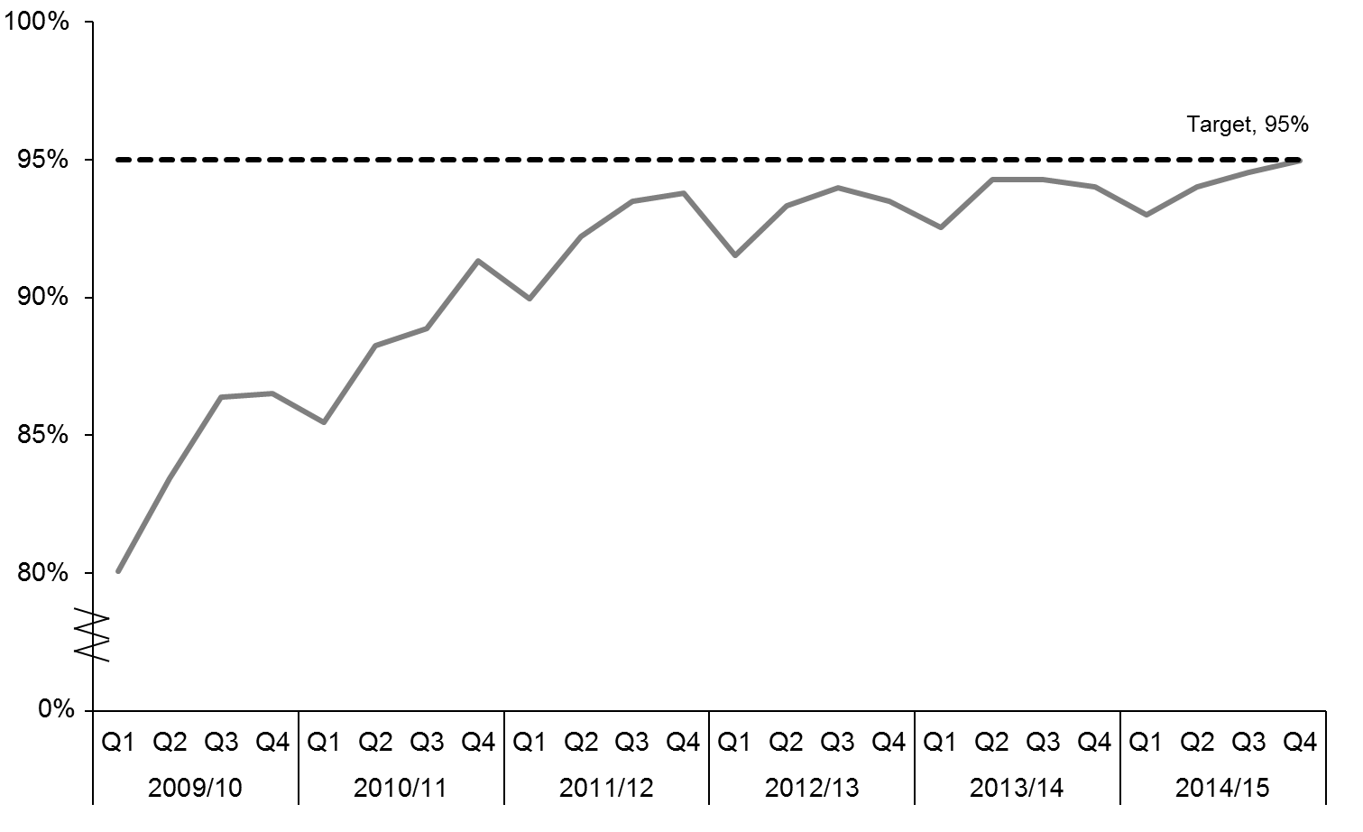

The length of time that a person spends in an emergency department is an important measure of the quality of acute (urgent) care in our public hospitals. The shorter stays in emergency departments health target measures how efficiently acute patients flow through our public hospitals. Longer stays within the emergency department are linked to negative clinical outcomes for patients, including increased risk of mortality and longer inpatient lengths of stay.

By the end of 2014/15, 95.0 percent of patients were being admitted, discharged or transferred from their emergency department within six hours, and 14 DHBs had achieved the health target. Performance on the health target increased steadily since it was first introduced in 2009, when 80.1 percent of patients were being admitted, discharged or transferred from their emergency department within six hours. Improvements have continued throughout 2014/15, with the target being achieved nationally for the first time in quarter three[7] and again in quarter four despite an increasing number of presentations to emergency departments over the year.

To support achievement of this health target, the Ministry has:

* published *A Quality Framework and Suite of Quality Measures for the Emergency Department Phase of Acute Patient Care in New Zealand* to help DHBs achieve continued quality improvements within their emergency departments
* held a workshop for DHBs to share their experiences with implementing the mandatory measures from the quality framework
* developed definitions for each of the measures in the quality framework, as well as a set of audit tools so that each DHB is implementing the quality framework consistently
* provided tailored one-on-one support to DHBs, including regular visits and teleconferences with DHBs that are not meeting the target.

### Improved access to elective surgery

**The health target:** The volume of elective surgery[8] will be increased by at least 4000 discharges per year.

Figure 2: Volume of elective surgery, 2007/08–2014/15

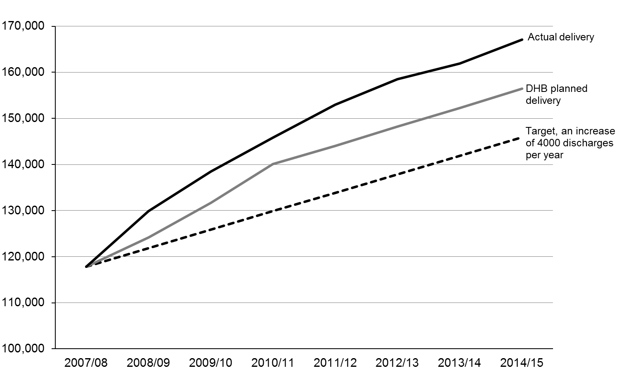

This target has consistently been exceeded since 2008/09. DHBs planned to deliver 156,490 elective surgical discharges in 2014/15 and delivered 167,104 (6.8 percent more than the target). The delivery also represents an increase of more than 41 percent since 2007/08, or an average increase of more than 7000 elective discharges a year.

To support achievement of this health target, the National Health Board’s (NHB) electives team engages with a wide range of clinical and management teams within DHBs and across professional bodies. The NHB team clearly communicates its expectations and works closely with sector teams to support progress and actively identify and resolve issues as they arise.

### Shorter waits for cancer treatment (quarter one 2014/15)

**The health target:** All patients, ready-for-treatment, wait less than four weeks for radiotherapy or chemotherapy.

Figure 3: Percentage of patients receiving radiation treatment or chemotherapy within four weeks since 2009/10[9]

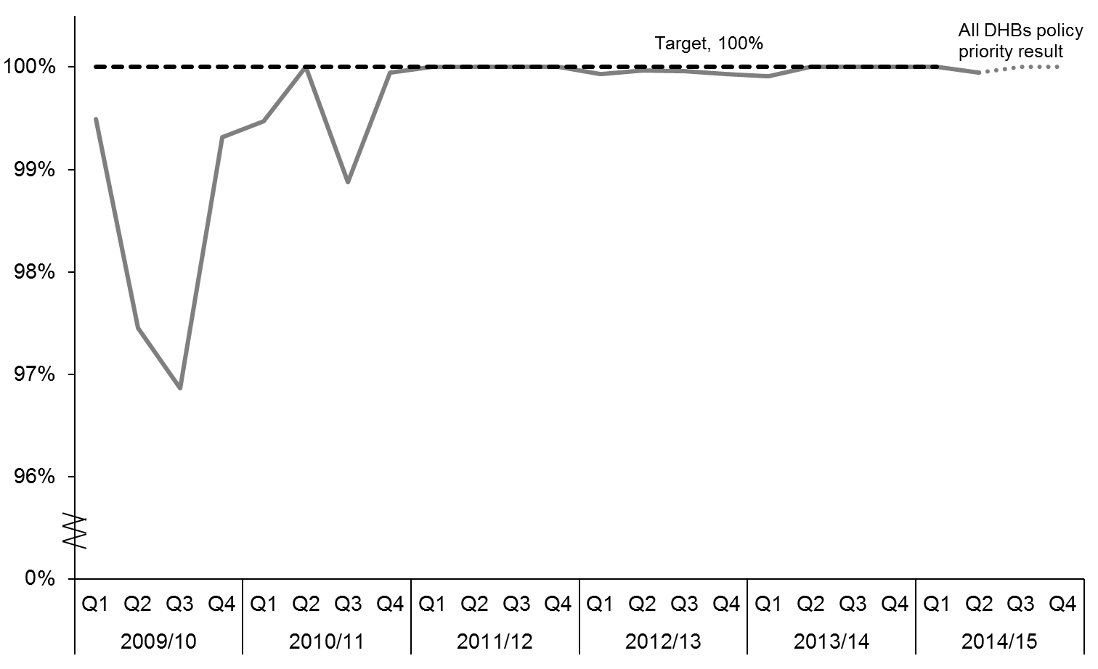

With DHBs consistently achieving the shorter waits for cancer treatment target, in October 2014, it transitioned to a policy priority measure. The Ministry continues to monitor DHB performance on a quarterly basis.[10] From 1 October 2014, the shorter waits for cancer treatment health target was replaced by the faster cancer treatment health target.

### Faster cancer treatment (from quarter two 2014/15)

**The health target:** 85 percent of patients receive their first cancer treatment (or other management) within 62 days of being referred with a high suspicion of cancer and need to be seen within two weeks by July 2016, increasing to 90 percent by June 2017.

Figure 4: Percentage of patients receiving their first cancer treatment within target timeframe, quarter two 2014/15–quarter four 2014/15

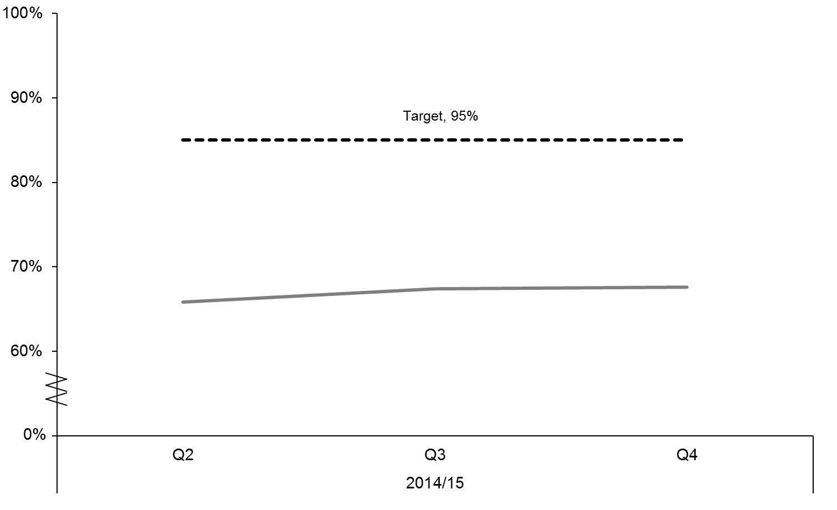

Cancer is a leading cause of morbidity and mortality in New Zealand, accounting for nearly one-third of all deaths. We want to improve the quality of care and the patient’s experience across the cancer pathway. Prompt investigation, diagnosis and treatment is more likely to ensure better outcomes for cancer patients and an assurance about the length of waiting time can reduce the stress on patients and families at a difficult time.

Significant improvements have been made in the quality of cancer services, and we need to continue those improvements. The target aims to support improvements in access and patient experience through the cancer pathway, including the period of investigations before treatment begins. It supports DHBs to monitor the whole cancer pathway from referral to first treatment to identify any bottlenecks in the system and opportunities for improvement that will benefit all cancer patients. The 62-day timeframe is based on measures used in both the United Kingdom and Canada. In many cases patients will start treatment sooner.

In the nine months since its introduction in October 2014, achievement of the faster cancer treatment health target has increased from 66.6 percent to 67.6 percent.

To support achievement of this health target, key initiatives include:

* the ongoing development of, and service reviews against, national tumour standards for 10 main tumour types describing the level of services that a person with cancer should have access to, promoting nationally coordinated and consistent levels of service provision across New Zealand
* instigating an $11.2 million service improvement fund to support DHBs to deliver faster cancer treatment
* improving the coverage and functionality of multidisciplinary meetings so that there is better continuity of care, more patients benefitting from a range of expert opinion and less duplication of services
* introducing cancer nurse coordinators so that patients who need more personalised support have access to a specialist nurse
* implementing the cancer psychological and social support initiative to meet the psychological and social support needs of cancer patients.

### Increased immunisation

**The health target:** 95 percent of eight-month-olds have their primary course of immunisation at six weeks, three months and five months on time by December 2014. This coverage is to be maintained until 2017 as part of the Prime Minister’s Better Public Services results commitment.

Figure 5: Percentage of eight-month-olds fully immunised, 2012/13–quarter four 2014/15

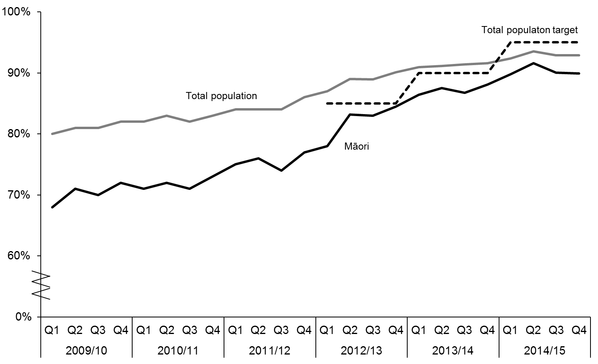

Immunisation provides not only individual protection for a number of vaccine-preventable diseases but also population-wide protection by reducing the incidence of infectious diseases and preventing spread to vulnerable people. Some of these population-wide benefits only arise with high immunisation rates. Widespread immunisation reduces the impact of vaccine-preventable diseases on our health system.

Performance on the increased immunisation health target has improved steadily since it was first introduced, when only 86 percent of eight month olds were fully immunised on time for their primary vaccine series. Immunisation coverage for eight-month-olds was 92.9 percent in the fourth quarter of 2014/15. This is a 1.3 percent increase compared with the result of 91.6 percent for same time period last year. Of the 15,011 eligible children aged eight months in quarter four, 13,946 were fully immunised. Timely immunisation of another 314 children was needed to meet the target.

Results for the eight-month milestone by ethnicity for quarter four of 2014/15 were as follows: New Zealand European 93.6 percent, Māori 89.9 percent, Pacific 95.1 percent, Asian 97.2 percent and Other 89.5 percent. Coverage increased to 91 percent for those living in deprivation quintiles 9 and 10.

When coverage for the primary series of vaccines is measured at age 12 months rather than 8 months, the coverage rate is almost 95 percent. This shows that children are being protected, although not in the optimal timeframe. For the two-year-old measure, which includes additional immunisation against measles, coverage was 93.2 percent in quarter four.

To support achievement of this health target, key initiatives include:

* the Ministry’s health target champion and immunisation team working closely with DHBs and PHOs to increase immunisation coverage, using a variety of mechanisms, including providing leadership, promoting immunisation, sharing best practice, reporting on coverage and sharing data to support the identification of children overdue for immunisation
* implementing of a four-point plan that focuses on planning, engaging, promoting and monitoring
* building closer interagency relationships, for example, with the Department of Corrections and the Ministry of Social Development.

### Better help for smokers to quit

**The health target:** 95 percent of patients who smoke and are seen by a health practitioner in public hospitals and 90 percent of patients who smoke and are seen by a health practitioner in primary care will be offered brief advice and support to quit smoking.

Within the target, pregnant women (who identify as smokers at the time of confirmation of pregnancy in general practice or booking with lead maternity carer (LMC)) who are offered advice and support to quit have been identified as a specific subgroup that will seek progress towards a 90 percent target.

Figure 6: Percentage of smokers offered help to quit, 2009/10–Quarter four 2014/15

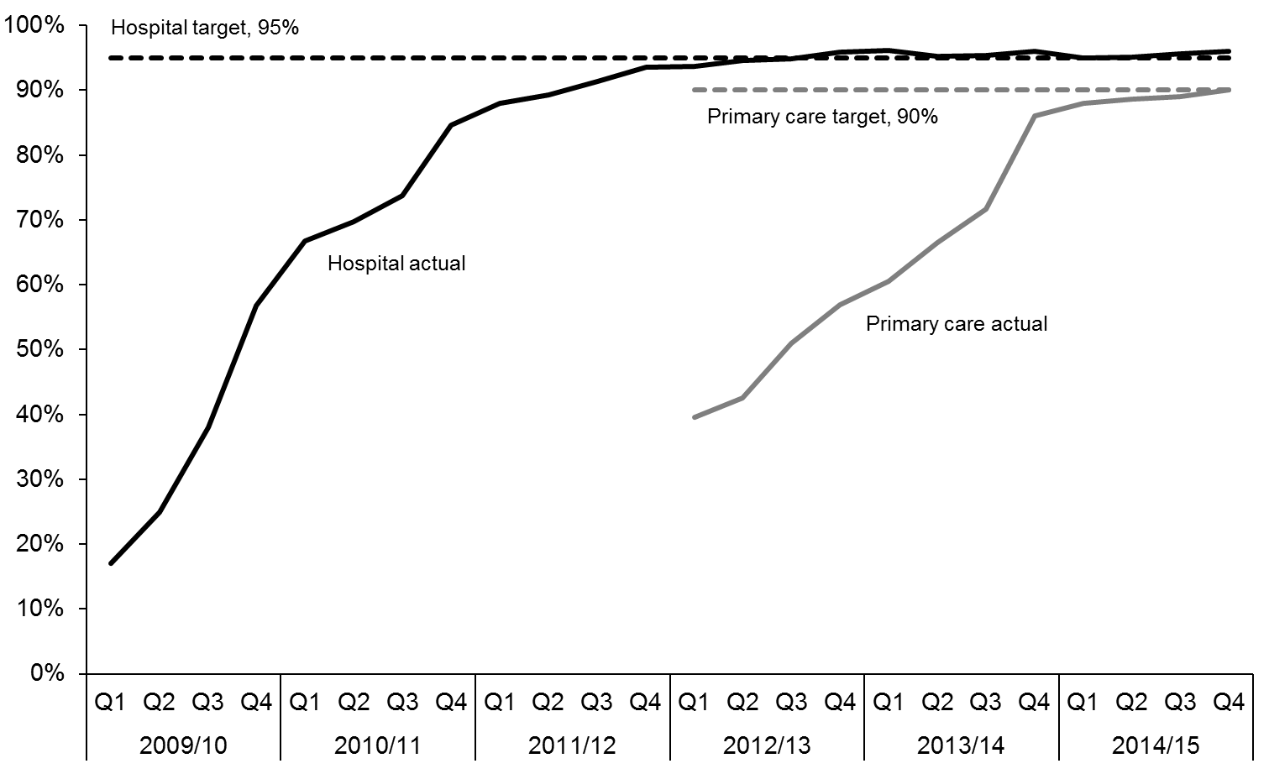

This target is designed to prompt clinicians to ask routinely about smoking status as a clinical ‘vital sign’ and then to offer brief advice and quit support to current smokers. There is strong evidence that brief advice from clinicians is effective at prompting quit attempts and long-term quit success. The quit rate is further improved by the provision of effective cessation therapies, including pharmaceuticals and face-to-face support.

Significant progress has been made since this target was introduced in 2009. When the Ministry first began reporting on the target, only 17 percent of smokers who were admitted to hospital were being offered brief advice and cessation support. Six years on, the hospital component of the target has been achieved, meaning that over 95 percent of hospital patients who smoke are now being offered help to quit. A number of initiatives have helped DHBs to achieve this substantial change, including accessible and relevant training and smokefree champions working in each ward.

Advice and support to quit is being offered to over half of New Zealand’s smokers through the primary health care component of this target. The quarter four 2014/15 result against the target for primary health care was 90.5 percent (a 4.7 percent improvement from the 85.8 percent result in quarter four 2013/14). This means primary health care providers offered brief advice and support to quit smoking to approximately 422,933 people during the 2014/15 financial year. Some of these smokers were offered brief advice outside primary health care settings, as a result of PHO outreach programmes.

In 2014/15, a total of 11 DHBs met the primary health care target, and 8 more achieved over 80 percent. Performance on the health target increased steadily since it was first introduced in quarter one 2012/13 where 40 percent of people were offered brief advice and support to quit smoking.

Data from the Midwifery and Maternity Provider Organisation Ltd and LMC services (which represents around 80 percent of pregnant women registered with a midwife) shows that, as of the June quarter 2015, 94 percent of pregnant women (1090 out of 1160 smokers) who smoked and were registered with a LMC were offered advice and/or support to quit during the quarter. The Ministry has not publicly reported on the maternity target since it was introduced in July 2012, because none of the existing reporting systems capture all of the required ‘Ask, Brief advice and Cessation’ (ABC) information. However, the Ministry has requested additional data from the DHBs to improve data accuracy and will start public reporting of the maternity target from quarter one 2015/16. The maternity results will be published on the Ministry’s website. The Ministry expects the additional data set to have a minimal impact on the quarter one 2015/16 target result.

The quarter four hospital target result for Māori was 95.6 percent and the result for Pacific peoples was 95.5 percent. The maternity target result for Māori in quarter four was 94 percent, which is slightly lower than the national result at 94.1 percent. The Pacific peoples result for the same period was 94.4 percent.

The Ministry has worked closely with the health and disability system to support the achievement of the better help for smokers to quit health target. Examples of this work include:

* developing and implementing a range of practice-level policies in primary health care
* encouraging the development and roll out of a range of IT tools in primary health care to facilitate delivery of brief advice and cessation support to all smokers
* working with clinical champions and practice leaders in hospitals to encourage sustainable health target practices
* working with midwifery groups and DHBs to ensure access to best practice guidelines and innovative ways of smoking cessation support for pregnant women.

Although the health target is supporting clinical practice change and driving positive results in the reduction of smoking rates, other initiatives in the wider tobacco control programme are also contributing to these outcomes.

### More heart and diabetes checks

**The health target:** 90 percent of the eligible population will have had their cardiovascular risk assessed in the last five years.

Figure 7: Percentage of cardiovascular risk assessments completed, 2011/12–quarter four 2014/15

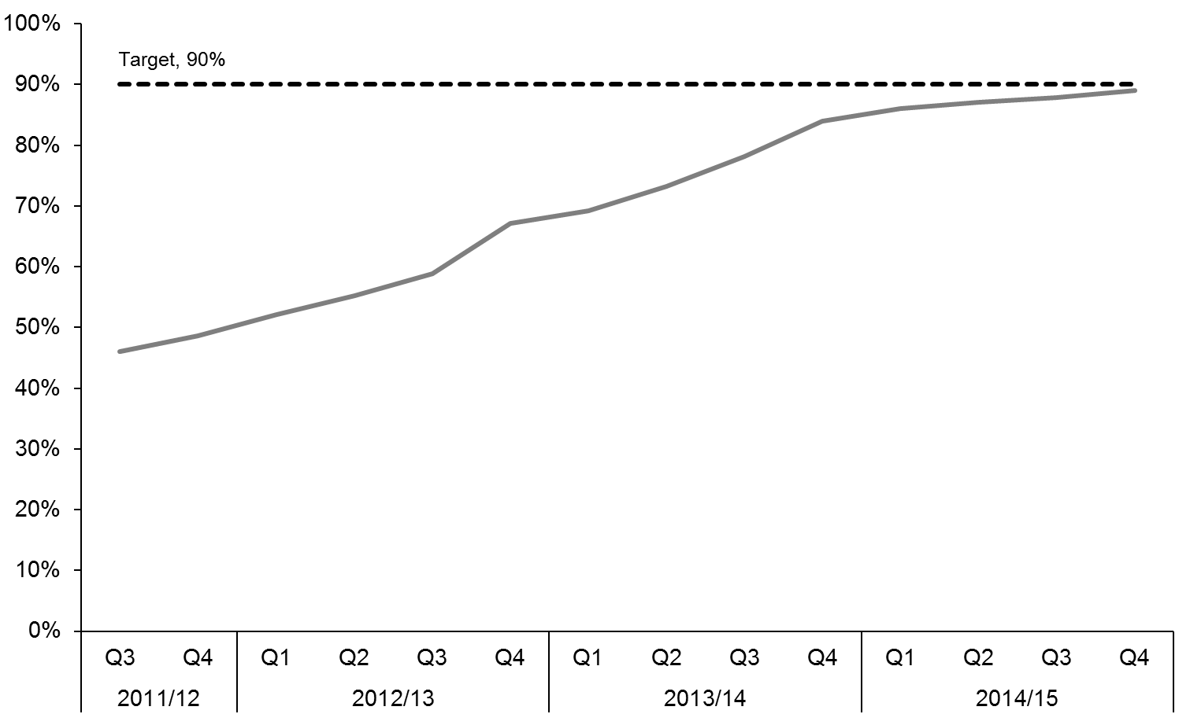

Long-term conditions represent a significant health burden for New Zealanders. Cardiovascular conditions are the leading cause of morbidity (the incidence of disease) in New Zealand and disproportionately affect Māori, Pacific and South Asian people. Cardiovascular disease (CVD) includes heart attacks and strokes.

This health target aims to increase the proportion of the eligible population who have had a CVD risk assessment, including the tests to screen for diabetes, in the preceding five-year period. For those assessed at moderate or higher risk, the addition of lifestyle advice and treatment can substantially prevent the occurrence of heart attacks and strokes.

The more heart and diabetes checks health target 2014/15 quarter four result was 89.0 percent, an increase of 1.1 percent compared with the previous quarter’s result of 87.9 percent. This is also a 4.6 percent improvement over the quarter four 2013/14 final results of 84.4 percent. Performance on the health target increased steadily since it was first published in quarter three 2011/12 where 46.0 percent of the eligible population had their cardiovascular risk assessed in the last five years.

Eleven DHBs met the target of 90 percent, and nearly all DHBs have achieved over 85 percent.

To support achievement of this health target, key initiatives have involved:

* visits by the target champion and frequent communication between Ministry advisors and DHBs, PHOs and general practices throughout the year to achieve these results
* funding for the Heart Foundation to work with the health and education sectors to promote and support cardiovascular health focusing on healthy eating, tobacco control and being physically active. This work will continue over the next year.

In 2013, additional funding of $15.9 million over four years was approved to increase the more heart and diabetes checks health target. The funding has continued to be used in the 2014/15 year in three main areas:

* workforce development, to increase the number of nurse-led clinics, after hours clinics and outreach services for hard-to-reach populations
* technology improvements and further investment in decision support tools, reporting programmes such as Patient Dashboard and electronic referral pathways to specialist services
* other initiatives, such as subsidised assessments for eligible people, non-face-to-face appointments and point-of-care testing equipment to enable more convenient blood tests.

## Implementing the Minister’s objectives for the sector

In 2014/15, the Ministry continued to implement the Minister’s objectives for the sector:

* maintaining wellness for longer by improving prevention
* improving the quality and safety of health services
* making services more accessible, including more care closer to home
* implementing Rising to the Challenge[11]
* supporting the health of older people
* making the best use of information technologies (IT) and ensuring the security of patients’ records
* strengthening the health and disability workforce
* supporting regional and national collaboration.

### Maintaining wellness for longer by improving prevention

New Zealanders are living longer but are also more likely to spend a period of their later years managing a long-term condition. It is important that we invest in ways to help people stay well for longer and prevent the onset of these conditions. This focus on maintaining wellness underpins a wide range of Ministry actions.

In 2014/15, the Ministry progressed:

* programmes that promote healthier lifestyles and are proven to reduce the incidence of long term conditions, such as the Healthy Families NZ pilot, which brings community leadership together in a united effort for better health and aims to improve people’s health where they live, learn, work and play in order to prevent chronic disease
* programmes that work to keep people well, such as newborn immunisations and screening, influenza immunisations, promoting good hygiene and working with other agencies on healthy housing
* health and disability system changes to support people being well, such as programmes to improve health literacy, increasing access to Healthline and online resources and increasing awareness of mental health issues and the services available through activities such as the Suicide Prevention Action Plan
* extending the zero fees for children under six scheme to include free general practice visits and prescriptions for children aged 6–12 years of age. By 30 June 2015, 96 percent of practices opted into providing free daytime visits for their enrolled children aged under 13 years of age. DHBs are required to ensure that 95 percent of their enrolled population has access to free after-hours care (including both general practice and pharmacy services). By 30 June 2015, after-hours coverage has reached over 90 percent. The Ministry will continue to support DHBs and PHOs to ensure free access to general practice visits for children aged under 13 years
* newborn enrolment with general practices to ensure babies receive essential health care, including on time immunisations. By April 2015, 76.2 percent of newborns were enrolled with general practice by three months of age. This has increased from 57.4 percent in January 2013. The Ministry will work closely with both DHBs and PHOs to ensure more newborns are being enrolled early
* health screening programmes (via the National Screening Unit), including for breast and cervical screening. Screening programmes for antenatal HIV, newborn hearing and newborn metabolic disorders reduce morbidity, and in some cases mortality associated with these conditions
* the Universal Newborn Hearing Screening and Early Intervention Programme (UNHSEIP), which detects about 60 babies per year with a moderate to severe or profound congenital hearing loss (this programme is jointly overseen by the Ministries of Health and Education)
* the Newborn Metabolic Screening Programme, which screens babies for more than 20 rare but life-threatening metabolic disorders. In order to reduce morbidity and mortality, timely detection of disorders is critical. In 2014/15, the National Screening Unit progressed a range of quality improvement strategies to improve the timeliness of newborn metabolic screening, including measures to improve the transit times (the time taken for a blood spot sample to reach the laboratory after it has been taken). Collaborative work by the Ministry, the screening laboratory and DHBs is continuing to improve transit processes and reinforce messages about timeliness.
* a review of the BreastScreen Aotearoa service delivery and funding model in response to the digital and centralised IT environment, demographic and workforce pressures. The purpose of the review is to analyse the current state of the system and to explore and evaluate options for future improvements to the programme to ensure it continues to provide a high-quality, sustainable service to eligible women. The service delivery model review concluded that overall the programme is performing well and did not recommend large-scale change. The funding model review recommends a new funding model be implemented, and this recommendation is being worked on with the sector
* a review of and consultation on support to breast and cervical cancer screening services in 2014. The aim of the review was to obtain feedback from key stakeholders about how to improve the current service model and optimise support for priority women[12] in the cancer screening programmes. The outcome of the consultation is that the Ministry will further engage with the sector to co-design a new service model to better target priority women
* promotion of regular cervical smears every three years, through the National Cervical Screening Programme. Three-year coverage data collected by the National Cervical Screening Programme at the end of June 2015 shows that 76.5 percent of New Zealand women aged 25–69 years old are participating in the programme; the target is 80 percent.
* the focus of the National Cervical Screening Programme on improving community based services for Māori, Pacific and Asian women and women who have never been screened or are overdue for screening, as these women are at greatest risk of developing cervical cancer
* contributing to the Parliamentary Review of the National Cervical Screening Programme, an independent review required every parliamentary term under Part 4A, section 1120 of the Health Act, 1956. The Review Committee focuses on the continuous quality improvement of components of the programme, with a view to reducing the incidence and mortality rates of cervical cancer. The *Report of the Parliamentary Review Committee regarding the New Zealand Cervical Screening Programme: 2015* shows the number of women developing and dying from cervical cancer has reduced by 60 percent since the screening programme was introduced in 1990 and states that the programme is among the most successful cervical screening programmes in the world. The report provides a set of recommendations to help further strengthen the programme, with five priority areas highlighted – addressing the participation barriers experienced by Māori women, auditing screening histories of women who develop cervical cancer, completing the electronic colposcopy project, encouraging clinical leadership and transitioning to primary human papillomavirus (HPV) screening
* the development of options for implementing primary HPV screening in New Zealand. The National Screening Unit has commenced policy work to consider a major change from primary cytology screening to primary HPV screening
* the development of a population health data warehouse. The first ‘data mart’ being created in the data warehouse is for the National Cervical Screening Programme. A project to improve the timeliness, quality and completeness of colposcopy data received at the National Cervical Screening Programme register continued in 2014/15. The programme has been working closely with DHBs to support the implementation of the electronic reporting system in DHB colposcopy clinics. By 30 June 2015, seven DHBs had gone live with electronic reporting of colposcopy data, with the remaining DHBs expected to be live by December 2015.

### Improving the quality and safety of health services

The Ministry has a programme of work aimed at further strengthening quality and safety in the health and disability system.

In 2014/15, the Ministry:

* reviewed regulating an accreditation process for the home and community support workforce collaborated with the Health Quality and Safety Commission New Zealand on the national patient safety campaign ‘Open for better care’, which focuses on reducing harm in the areas of falls, surgery, health-care associated infections and medication safety
* worked with the Health Quality and Safety Commission New Zealand to ensure that DHB boards exercise their responsibility for quality and safety
* implemented a patient experience indicator across DHBs
* reviewed the *Health and Disability Services Standards NZS HDSS 8134:2008* in consultation with the sector. Reviews of the Standards occur every four years in accordance with the Health and Disability Services (Safety) Act 2001. The outcome of the review was that the Standards should remain in force
* completed a refresh of the medicines strategy action plan (*Implementing Medicines New Zealand 2015–2020*). This plan supports the outcomes of the medicines strategy, Medicines New Zealand, with a range of actions that have been devised with the health sector, including other government agencies, regulatory bodies, health professionals and consumers. The plan was launched by Associate Minister of Health, Hon Peter Dunne, in June 2015
* commissioned the Health Quality and Safety Commission New Zealand to lead a project to strengthen the infrastructure for suicide prevention: the trial of a suicide mortality review mechanism. The trial is investigating the feasibility of a suicide mortality review mechanism and whether it can reveal new information to improve suicide prevention. Decisions about the future of a mortality review mechanism will be made in late 2015.

### Making services more accessible, including more care closer to home

Delivering better, sooner, more convenient care is an ongoing focus for the Ministry. Central to achieving this is integrating primary health care with other parts of the health services to better manage conditions. Primary health care is the first point of contact for access to the health system. It is also the gateway to secondary health care and is integral to the success of the health system, in terms of both enabling care to be provided close to home and managing health service costs.

In 2014/15 the Ministry:

* continued to advance care closer to home by monitoring DHB performance against planned integration activities
* worked with health sector experts to develop and implement the integrated performance and incentive framework designed to evaluate and incentivise the performance of both the individual parts of each DHB’s health system and the collective performance of the DHB as a whole
* continued to support the Ministerial Committee on Disability Issues and the Disability Action Plan
* continued work on the programme for improving health outcomes of people with learning/intellectual disabilities, with updates provided to a number of sector groups
* completed consultation on the review of the system for voluntary out-of-home placements for disabled children, under sections 141 & 142 of the Children, Young Persons, and Their Families Act 1989.

### Implementing Rising to the Challenge

The Ministry is continuing to monitor progress on the implementation of Rising to the Challenge: The Mental Health and Addiction Service Development Plan 2012–2017. The Plan sets the direction for mental health and addiction service delivery across the health and disability system over a five-year period. It outlines key priority actions for achieving further sector-wide changes, to make service provision more consistent and to improve outcomes for both the people who use services and their families and whānau. The Plan helps health services across the spectrum, from health promotion through primary health care and other general health services to specialist mental health and addiction services.

Examples of key initiatives under the Plan include:

* The Prime Minister’s Youth Mental Health Project
* the full implementation of the adolescent e-therapy tool SPARX[13]
* the New Zealand Suicide Prevention Action Plan 2013–2016
* new acute perinatal and infant mental health services being delivered in the North Island
* two alcohol and other drug treatment courts (in Auckland and Waitakere)
* treatment programmes for repeat impaired (drink) drivers.

Each year, DHBs outline which of the Plan’s prioritised actions have been implemented in their regions and which actions they propose to implement during the coming year. In 2014/15, DHBs have made progress on a number of initiatives under the Plan including:

* working to use their existing resources more effectively and take a proactive role in progressing implementation of the Plan
* improving integration between primary and secondary health services by placing specialist staff in primary health care settings, and providing psychiatry expertise to GPs through single point of entry systems
* cementing and building on gains for people with high needs by addressing local service gaps in relation to mental health and wellbeing, physical health and social inclusion among people with low-prevalence conditions and/or high needs
* delivering increased access for infants, children and youth while building resilience and averting future adverse outcomes with the New Zealand Police, Child, Youth and Family, the Ministries of Justice and Education, and the Department of Corrections.

### Supporting the health of older people

During 2014/15, the Ministry worked with older people and their families and whānau, DHBs, primary health care, service providers, non-governmental organisations (NGOs) and other government agencies to ensure health services are addressing the priority health needs of older people in consistent and integrated ways.

Achievements in 2014/15 included:

* improving the quality and safety of health services for older people, with the number of four-year rest home certifications up from 89 in 2013/14 to 114 in 2014/15. Full rest home audit reports are now published online, giving people the information they need about how a rest home is performing. The audit framework for home and community support services is now fully implemented
* implementing the interRAITM comprehensive clinical assessment framework in residential care for older people, meaning that all older people who require either home care or residential care are assessed under an integrated, best practice assessment framework. This will result in more consistent and transparent care planning and, ultimately, well-targeted services that better meet the care needs of older people
* supporting the implementation of the current dementia care position statement and dementia care pathways. The Ministry has worked with DHBs, NGOs and the aged care sector to further develop dementia care pathways through regionally oriented services and implementing priorities identified in the dementia care position statement
* enhancing clinical capability with the appointment of a new Chief Advisor, Health of Older People to the Ministry. This will help ensure we have high quality clinical advice in relation to the health of older people and maintain good connections with those directly involved in the clinical care of older people
* monitoring DHB initiatives to encourage DHB geriatricians and gerontology nurse specialists to work with and advise and support health professionals in primary health care and aged residential care to improve the quality of care for older people. Some DHBs are using multidisciplinary community rehabilitation teams to assist older people who are discharged from hospital. The Ministry monitors DHB progress through the DHB annual planning and reporting cycle
* strengthening collaboration with other government agencies to improve services to older people, including ACC and DHBs to reduce the impact on older people of fractures and falls
* working with the Ministry of Social Development and other agencies to develop more joined-up or integrated services to better meet the changing needs of New Zealand’s ageing population
* implementing the settlement in relation to home care workers’ claim for time spent travelling between clients to be paid. The settlement, reached by DHBs, providers, unions and the Ministry, includes paying for travel time at the minimum wage from 1 July 2015, paying standard mileage rates from 1 March 2016, reviewing the home and community support sector, a move towards a regulated accreditation process for the home and community support workforce, establishing and implementing systems to provide in-between travel payments and enacting legislation to prevent future similar claims
* assisting with coordinating the production of Māori Health research reports (Life and Living in Advanced Age Cohort Study, LiLACS) from The University of Auckland. A number of short reports have been released that show how older Māori and non-Māori compare in terms of health status and access to health care
* monitoring the implementation of the additional charging framework in residential care. This framework was introduced in 2014 to enable residential care providers to charge higher prices for higher quality facilities, while ensuring that beds would continue to be available at standard prices for those who could not pay additional charges. The additional $10 million per annum funding announced in Budget 2014 for aged care has been implemented resulting in increased funding to residential care providers for rest home beds from 1 October 2014
* refreshing the Health of Older People Strategy. This follows the Government’s request for the Ministry to develop an updated New Zealand Health Strategy. The refreshed Health of Older People Strategy will provide a road map for future improvements to health services for older people over the next 10 to 15 years. The refreshed strategy will be put in place in the 2015/16 year and provides the first opportunity in some time to take a whole-of-system, collaborative approach to improving the health services that older people rely on.

### Making the best use of information technologies and ensuring the security of patient records

National and regional information technology (IT) systems, operating together in an integrated way, provide the technology platform to enable secure electronic access to reliable, trusted information for consumers and treatment providers. This supports improvements in clinical quality, integration of services and new models of care for the health and disability system.

Telehealth services are integrated telephone and web based services that:

* allow access to prompt triage, care, health advice and information
* enable changes to the delivery of healthcare, including service delivery when patients and care providers are not in the same place
* enable more flexible use of the health workforce and addresses some of the barriers that limit access for patients, such as distance, time or cost.

New Zealand has multiple individual telehealth services that handle around two million contacts per annum. The procurement process for the National Telehealth Service is underway, with the service due to commence on 1 July 2015. The Service will integrate the current services: Healthline; Poisonline; Quitline; Gambling Helpline; Alcohol and Other Drug Helpline; National Depression Initiative and immunisation advice for the public.

Empowering New Zealanders by providing them with access to their own health information via patient portals is an important initiative that will enable people to take more control of their health care and change the ways services are delivered. The Minister has approved a $3 million funding package to support practices to implement patient portals. Over 65,000 patients from more than 170 practices have registered to use a portal, and this number is growing steadily.

The National Health IT Board is promoting national systems to support key clinical specialities, including maternity, older persons, cardiac health and cancer. National systems can improve equity of access and consistency of care by reporting on quality initiatives and long-term trends. Some examples of work delivered over the past year include:

* enabling information to be shared across disciplines for the delivery of maternity and neonatal services at the frontline through the national maternity clinical information system
* providing a comprehensive view of the patient’s secondary health care referral pathway to measure access to elective and cancer services through the National Patient Flow collection
* introducing electronic systems into hospitals and the community to ensure accurate, up-to-date information about people’s medications is accessible to support safe, effective and appropriate use of medicines through the eMedicines Programme
* rolling out community prescribing, which has been completed by almost all community pharmacies and has been installed in 36 general practices through the New Zealand Electronic Prescription Service (NZePS).

### Strengthening the health and disability workforce

The Ministry is committed to building a sustainable flexible and fit-for-purpose workforce in a dynamic environment. The Ministry continues to drive the workforce response to shifting patterns of illness and disease and the increasing focus on prevention, self-care, home-based care and community care, including initiatives aimed at developing a workforce that is capable, appropriately trained, motivated, supported and flexible to deliver on health targets, government and wider Ministry priorities for health.

In 2014/15, the Ministry funded the following health and disability workforce initiatives:

* Voluntary Bonding Scheme – including 387 new registrants: doctors, GP trainees, nurses, midwives, medical physicists and radiation therapists. For the first time, sonographers were also included on the scheme.
* Advanced Trainee Fellowship (AFT) Scheme – 37 trainees have participated since the scheme’s inception in 2009. Trainees are required to work in their scope of practice for a minimum of two years in New Zealand upon completing the scheme.
* Multidisciplinary Rural Immersion Health Training Programme – working with Auckland and Otago Universities to promote rural practice and interdisciplinary learning at Whakatāne and Gisborne sites. A total of 227 health students have participated on the programme, which encourages health students to consider working in regional and remote areas upon graduation.
* New graduate nurses programmes – including 160 nurse entry to practice placements in DHBs, 40 in aged residential care settings and 175 nurse entry to specialist practice placements.
* Midwifery First Year of Practice (MFYP) Programme –161 New Zealand registered midwifery graduates are participating in this compulsory programme, which provides a mix of mentoring and education to support them in their first year in the workplace.
* General Practice Education Programme (GPEP),– 169 registrars were enrolled on the programme in 2015, an increase of 45 registrars on 2014. The Royal New Zealand College of General Practitioners also manages the postgraduate Generalist Placement Education Programme (PGGP), which provides a three-month placement for postgraduate doctors in general practice.
* Sonographer Workforce – supporting a pilot 12-week intensive clinical course at The University of Auckland to assist in meeting demand for this workforce.

### Supporting regional and national collaboration

#### National service planning

The Ministry continues to develop and support vulnerable services designated as national services. These include services such as clinical genetics, adult and paediatric metabolics, renal transplants, hyperbaric medicine and intestinal failure.

During 2014/15, the Ministry:

* worked with the national clinical genetics service, provided by Auckland and Capital & Coast DHBs, to improve waiting times for first specialist assessment
* established a New Zealand National Intestinal Failure Service hosted by Auckland DHB. The service will coordinate, manage and report on patients suffering intestinal failure. There is a particular focus on supporting clinicians in regional hospitals to identify and appropriately manage this complex group of patients to improve outcomes. A clinical governance board has been established to oversee the progress within the service
* introduced a new national renal transplant service. The new service includes a clinical director to lead the implementation of a national plan, which aims to increase the number of people receiving live donor kidney transplants by 10 per year. The new service provides support for identifying live donors through funding the appointment of donor liaison coordinators and continuing a piloted kidney exchange programme
* supported the development of referral pathways for extracorporeal membrane oxygenation (ECMO) treatment and paediatric epilepsy and defined service specifications for vascular services.

# Achieving our impacts, outcomes and objectives

## The Ministry’s outcomes framework

The Ministry’s 2014/15 outcomes framework (see Figure 8) contained two outcomes for the health and disability system:

* New Zealanders live longer, healthier, more independent lives
* The health system is cost-effective and supports a productive economy.

These health and disability system outcomes support the achievement of wider government priorities and are not expected to change significantly over the medium term.

The Ministry itself has three high-level outcomes that support the achievement of the health and disability system outcomes above:

1. New Zealanders are healthier and more independent.

2. High-quality health and disability services are delivered in a timely and accessible manner.

3. The future sustainability of the health and disability system is assured.

Many factors influence outcomes. In helping to achieve these outcomes, the Ministry will have a real impact on the lives of New Zealanders. The health and disability system is dynamic and integrated, and many of our activities contribute to a number of our long-term outcomes and impacts. The Ministry’s work is directly aimed at achieving seven impacts, which contribute to our higher-level outcomes.

1. The public is supported to make informed decisions about their own health and independence.

2. Health and disability services are closely integrated with other social services, and health hazards are minimised.

3. The public can access quality services that meet their needs in a timely manner, where they need them.

4. Personalised and integrated support services are provided for people who need them.

5. Health services are clinically integrated and better coordinated.

6. The health and disability system is supported by suitable infrastructure, workforce and regulatory settings.

7. Quality, efficiency and value for money improvements are enhanced.

The Ministry receives funding for its operations from the Crown and generates revenue from its regulatory activity; it also manages funding on behalf of the Crown. Collectively this funding is known as Vote Health. Information on Vote Health is supplied annually in the Estimates of Appropriations. Measures and targets for the Ministry’s operations are listed under Departmental Operating Expenses, while measures and targets for services purchased on behalf of the Crown are listed under Non-Departmental Operating Expenses.

Figure 8: The Ministry’s 2014/15 outcomes framework

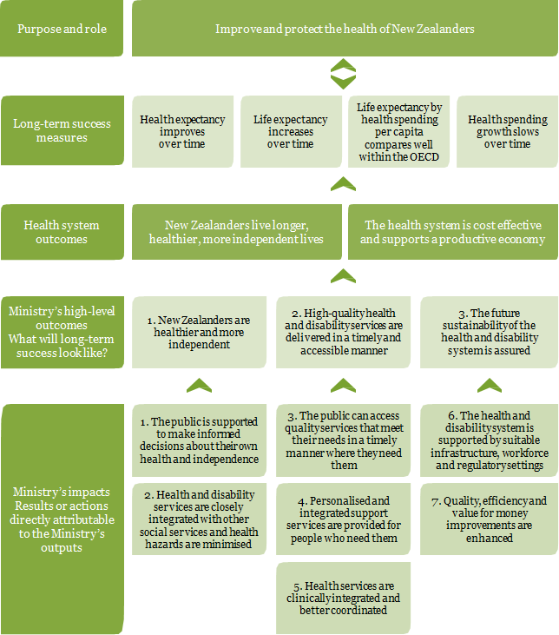

The Ministry’s outcomes framework (including the impact measures) will be reviewed once the update of the New Zealand Health Strategy has been completed.

A well-functioning health system contributes to improved health outcomes for the New Zealand population as a whole, and for particular groups such as Māori, Pacific peoples, older people and vulnerable children.

### Health system outcome: New Zealanders live longer, healthier, more independent lives

| **Target and benchmarks** | **Update** |
| --- | --- |
| Health expectancy improves over time.  Health expectancy (or independent life expectancy) is the number of years a person can expect to live in good health and without an impairment needing assistance.[14]  In 2006, health expectancy for males was 67.4 years, and health expectancy for females was 69.2 years. This reflects an improvement of 2.7 years for males and 1.7 years for females since 1996, and the Ministry expects to see further improvements.  The findings of the 2006 Disability Survey may be less comparable and should be used cautiously. The disability rate reported in the 2006 Disability Survey (17%) was lower than in the other surveys (20% in 1996 and 2001; 24% in 2013), independent life expectancy estimates for 2006 are correspondingly higher.[15] | Health expectancy is a summary measure of population health in terms of both quality and quantity. It shows the average number of years that a person born today can expect to live in good health.  A New Zealand male born in 2013 can expect to live 65.2 years independently (82.0% of his life), while a female can expect to live 66.5 years independently (79.9% of her life).  However, health expectancy at birth for Māori is much lower than for non-Māori: 12.4 years lower for males and 7.0 years lower for females. A Māori male born in 2013 could expect to live 54.3 years in good health, and a Māori female 60.4 years.  Health expectancy for Pacific male and female in 2006 compared with total population was 4.4 and 5.3 years lower, respectively.[16]  Between 1996 and 2013, independent life expectancy at birth increased for all groups apart from Māori males. In relative terms, however, all groups experienced a decrease: that is, the proportion of years they lived independently relative to their life expectancy was lower than it was for their counterparts in 1996. Part of the reason for this trend is the ageing population structure, since with a higher proportion of older people in the population, the proportion of people with functional limitations is likely to be correspondingly higher. |
| Life expectancy increases over time.  Life expectancy at birth indicates the number of years a person can expect to live, based on the mortality rates of the population at each age in a given year or period.  In the period 2007–2009, life expectancy at birth was 78.4 years for males and 82.4 years for females. Between 1985–1987 and 2007–2009, life expectancy at birth increased by 7.3 years for males and 5.3 years for females. The Ministry expects to see further increases over time. | Life expectancy is a summary measure of mortality. Life expectancy at birth is the number of years a person born today can expect to live, given the current age-specific mortality patterns.  Overall, New Zealanders are living longer than ever before. In 2013, life expectancy at birth was 79.5 years for males and 83.2 years for females. Recent improvements in life expectancy are mainly due to lower mortality rates in the older age groups. The gap between male and female life expectancy has narrowed over time.  Improvements in Māori life expectancy over the past 15 years have narrowed the gap between Māori and non-Māori. However, Māori life expectancy at birth remained 7.3 years lower for males and 6.8 years lower for females than that for non-Māori in 2012–2014.  Improvements in Pacific life expectancy over the past years have also narrowed the gap between Pacific and the total New Zealand population. In the 2012-2014 year, Pacific males and females life expectancy was 5.0 years and 4.5 years (respectively) lower compared with their total New Zealand counterparts.[17]  **How do we compare with other countries?**  New Zealand compares well with similar countries for life expectancy. For males, life expectancy at birth was 1.7 years above the Organisation for Economic Co‑operation and Development (OECD) average in 2012 (77.8 years); for females it was 0.1 years above the OECD average (83.1 years).  In 2013 the average NZ life expectancy of 81.45 was 0.95 years above the OECD average of 80.5.[18] |

### Health system outcome: The health system is cost effective and supports a productive economy

| **Target and benchmarks** | **Update** |
| --- | --- |
| Life expectancy by health spending per capita compares well within the OECD.  New Zealand maintains its position within the OECD as having relatively high life expectancy for relatively modest expenditure. | New Zealand performs well: it has relatively high life expectancy for comparatively modest expenditure.  In 2013, New Zealand achieved higher life expectancy (81.5 years – 14th highest among 34 countries) than expected given expenditure on health care (USD PPP 3328 – 18th highest among 34 countries) relative to other OECD countries.[19] |
| Health spending growth slows over time.  The projected rate of growth in health spending between 2010 and 2019 is less than the rate of growth between 2000 and 2009 (25.8%, based on real per capita expenditure in 2011 dollars). | Vote Health is a significant component of government expenditure; the Minister is responsible for appropriations in the Vote for the 2014/15 financial year. The Ministry has a duty to ensure the wider health and disability system is managed in an efficient and productive manner, while ensuring continuous improvements in the health services New Zealanders receive. The Ministry also works with sector partners to manage funds effectively.  The biggest challenge has been (and will be) to ensure that New Zealanders are continuously provided with excellent health care while ensuring that the cost of our health sector is sustainable over the long term.  Publicly funded spending on health care has more than doubled as a share of GDP over the past 60 years, rising from 3.1 percent in 1950 to 6.9 percent in 2012. This rate of increase is typical of countries in the OECD. Annual government spending on health care rose from $555 per person in 1950 to $3,008 per person in 2013 (both figures in 2013 dollars). |

## Outcome 1: New Zealanders are healthier and more independent

The Ministry wants a health system that improves, maintains and restores the health of the population within available resources. To achieve that we are improving and strengthening the capacity of the health and disability system to protect and promote wellness, and we are constantly improving and monitoring the quality of health care provided to the public.

We want a health and disability system that does much more than treat people when they are ill: it also focuses on prevention and maintaining independence. We are protecting the overall health of the nation by minimising the risks of contagious diseases and environmental hazards, and by supporting people to manage their own health and wellbeing.

### Impact 1. The public is supported to make informed decisions about their own health and independence

Impact 1 will be achieved if the public is supported to protect, manage and improve their own health and independence, and if people can access information and advice that promotes, and helps manage risks to their health and wellbeing and can involve their families and whānau in considering health issues and choices. The following measures show the level of our achieving Impact 1.

| **Measures and target** | **Update** | |
| --- | --- | --- |
| The results of burden of disease[20] and health surveys[21] are improved. | **New Zealand Burden of Disease Study**  The Ministry has established an agreement for annual updates of the New Zealand Burden of Disease study with the Institute for Health Metrics and Evaluation (IHME) at the University of Washington, Seattle. The IHME produces the global burden of disease estimates. By providing New Zealand-specific data to the study, the Ministry has been able to ensure improved New Zealand information is available on a regular basis for monitoring health and disability system performance. The first annual reports using the improved data inputs will be published in 2016.  **New Zealand Health Survey**  The New Zealand Health Survey (NZHS) is an important data collection tool for monitoring the health of the population. The survey provides evidence for health service planning, health policy and strategy development.  Thirty-five key indicators are published annually in December. These reports and further information about the NZHS can be found at the Ministry’s website (www.health.govt.nz). The latest available data is for 2013/14. | |
| **Selected New Zealand indicators: unadjusted prevalence (%)**   |  |  |  |  | | --- | --- | --- | --- | | **Among adults aged 15 years and over** | **2006/07 (percent)** | **2011–14 (percent)** | **Significance of difference (p-value)** | | Excellent, very good or good self-rated health | 89.6 | 90.1 | 0.22 | | Hazardous drinking | 18.0 | 15.5 | 0.00 | | Physically active | 52.0 | 52.4 | 0.73 | | Obesity | 26.5 | 29.7 | 0.00 | | Mood or anxiety disorder (diagnosed) | 12.7 | 17.0 | 0.00 | | Unable to get appointment at usual medical centre within 24 hours | 17.6 | 15.8 | 0.00 | | | |
| At least 85% of new babies are enrolled with Plunket national Well Child services.[22] | | In the 2014/15 year, Plunket enrolled just over 53,000 new babies (87 percent).  The Ministry is responsible for funding comprehensive Well Child/Tamariki Ora (WCTO) service coverage in each DHB district via two contracted programmes, the national WCTO agreement with Plunket and each DHB’s WCTO Crown Funding Agreement (CFA). Plunket is expected to provide WCTO services for at least 49,900 new babies per annum (approximately 85 percent of the actual live births of 58,717 in the year to December 2013) and equivalent numbers of older children (core contacts up to age two-and-a-half years and additional contacts up to age five). |
| The youth suicide rate is reduced. | | * Approximately one in three deaths in males and females aged 5–24 years were due to suicide in 2012. * In 2012, there were 107 male and 43 female youth suicides (32.3 and 13.8 per 100,000 males and females respectively). * The Māori youth suicide rate was 2.8 times the non-Māori youth rate (48.0 per 100,000 Māori youths compared with 17.3 per 100,000 non-Māori youths). * Over the 10 years from 2003 to 2012, Māori youth suicide rates have been at least 1.7 times the non-Māori youth suicide rates.   The Ministry is the lead agency for the cross-government New Zealand Suicide Prevention Action Plan 2013–2016 (the Action Plan), which was publicly released in May 2013. Over $25 million will be committed from within agency baselines over four years for this plan, including $15.575 million from Vote Health. This funding is in addition to existing investment in suicide prevention and mental health services. It also complements other government priorities that share a focus on the risk and protective factors for suicide.  The Action Plan comprises 30 actions across eight government agencies, and builds on existing suicide prevention work and addresses identified gaps. It aims to:   * strengthen support for family, whānau and communities affected by suicide * build the evidence base, extend existing services and strengthen suicide prevention in high-risk populations * build the capacity of Māori and Pacific communities. |
| Daily smoking prevalence falls to 10% by 2018 and the Māori and Pacific rates halve from their 2011 levels[23] as part of Smokefree 2025.[24] | | The rate of daily smoking has decreased by about one-third over the last decade, from 23.0 percent in 2002/03.[25] The rate of daily smoking has declined for both males and females in the total population, and for Māori males and Māori females. However, the rate of daily smoking remains considerably higher in Māori adults.  A series of 10-percent tax increases (2010–2015) has seen the price of the more expensive brands of cigarettes reach $20 for a pack of 20. Tobacco consumption has fallen by over 20 percent since 2009. The reduction in duty-free allowances and removal of the postal gifting concessions of tobacco from overseas will further limit the availability of cheaper tobacco.  The better help for smokers to quit health target, Pathway to Smokefree New Zealand 2025 Innovation Fund projects, continued media campaigns aimed at prompting quitting and youth not to start, and the introduction of ‘plain packaging’ legislation, will all continue to reinforce that smoking is not part of New Zealanders’ future. |
| A B4 School Check is provided to 90% of the eligible population. | | The purpose of the B4 School Check is to promote health and wellbeing in preschool children, ensure that children and their family and whānau are prepared for school and identify any health and development issues that may adversely affect a child’s ability to learn in the school environment. It is followed by connecting families to any health and support services they need.  The B4 School Check is the final core contact, provided as close to four years of age as possible. It is delivered separately from the WCTO programme. By July 2015, 92 percent of the eligible population had received B4 School Checks, as had 92 percent of the high-deprivation population. While a total of 58,626 children were checked during 2014/15, exceeding the national targets, the overall and high-deprivation targets were not achieved by Bay of Plenty and Capital & Coast DHBs. Northland and Wairarapa DHBs just missed their overall target but well exceeded their high deprivation target. The Ministry is working closely with Bay of Plenty and Capital & Coast DHBs to meet their new targets levels. |
| There is a reduced suicide rate for all ages.[26] | | Suicide and suicidal behaviours continue to be a major public health issue in New Zealand.  A total of 549 people died by suicide in New Zealand in 2012. Almost 75 percent of these suicides were male.  The age-standardised suicide rate decreased by 19.5 percent from the peak rate of 15.1 deaths per 100,000 population in 1998 to 12.2 deaths per 100,000 population in 2012.  Numerous factors influence a person’s decision to take their own life or to self-harm. The number of suicides and self-harm hospitalisations can also vary considerably from year to year. It is therefore difficult to quantify the precise effect that programmes such as suicide prevention-related initiatives have on suicide and suicidal behaviour.  The current suicide prevention strategy and action plan end in 2016. The Ministry has begun work on refreshing the strategy and developing a new action plan in recognition that suicide continues to be a major health and social issue in New Zealand. A refreshed strategy will build on the current strategy and previous action plans and incorporate thinking and knowledge that have emerged since these were released. As suicide prevention requires a multi-sectoral approach, the support and commitment from a range of government agencies will be essential.  The first stage of a suicide prevention outcomes framework is complete. Implementation will be ongoing and will inform the development of the refreshed suicide prevention strategy.  Waka Hourua, the national Māori and Pacific suicide prevention programme, has supported 63 community-based suicide prevention initiatives with a one-off contestable community fund. An evaluation framework has been completed. All initiatives are being evaluated between June and December 2015. Evaluations on five initiatives have been completed, and results indicate that, in the areas where the projects occurred, Māori whānau have greater knowledge about suicide risk and increased understanding about accessing services. |

#### Contribution to Impact 1

A number of work programmes contributed to Impact 1; they have mostly been already described under various priorities:

* The Prime Minister’s Youth Mental Health Project: including oversight and coordination of the cross-agency implementation; contract management; reports to the Cabinet Social Policy Committee; and contracting, review and monitoring of the implementation of the e‑therapy programme
* Suicide Prevention Action Plan 2013–16: including implementing the plan, coordinating cross-agency implementation, reporting to the Cabinet Social Policy Committee and developing a Suicide Prevention Outcomes Framework
* Rising to the Challenge: including implementing the mental health and addiction service development plan, overseeing cross-agency implementation, carrying out quarterly monitoring and coordinating the external reference group
* National Depression Initiative
* Minimising Gambling Harm
* Smokefree New Zealand 2025 Innovation Fund
* Well Child / Tamariki Ora: including carrying out extra Well Child visits for around 18,000 mothers.

The Ministry also leads and coordinates health literacy programmes. The *Health Literacy Review: A guide* and *A Framework for Health Literacy* were both released in May 2015. *He Māramatanga Huango: Asthma Health Literacy* was released in July 2015.

### Impact 2. Health and disability services are closely integrated with other social services, and health hazards are minimised

Impact 2 will be achieved when more integrated health and social services make it easier for those with social needs to look after their health and independence, and when the public are protected from environmental and disease risk factors that lead to ill health. The following measures show the level of our achieving Impact 2.

| **Measures and target** | **Update** |
| --- | --- |
| The annual influenza programme of 1.2 million doses of flu vaccine is delivered. | The 2014 seasonal influenza immunisation programme ended on 11 September 2015 with 1,211,152 doses of influenza vaccine distributed.  Efforts to increase influenza immunisation among health care workers are paying off – data for the previous year (2014) shows 68 percent of doctors, 59 percent of nurses and 57 percent of midwives were immunised against influenza. This represents a steady increase on previous years for doctors and nurses and a significant improvement for midwives. |
| Health and disability services are closely integrated with other social services.[27] | Experience tells us that we can achieve better results when we work in partnerships. With Whānau Ora, an integrated approach to whānau wellbeing has been achieved through collaborative relationships between government and communities, enabling innovative responses to opportunities for whānau. The difference being made is evidenced in tangible outcomes, such as whānau living healthy lifestyles, being self‑managing and participating fully in society.  Family Start, including Early Start, is a child-centred, intensive home visit programme to improve children’s growth, health, learning, relationships, whānau circumstances, environment and safety. Family Start providers are developing innovative ways of working with other services to provide integrated care to overcome barriers to access.  A programme of interrelated actions works across the whole community, led by the Children’s Action Plan directorate in Wellington, is working closely with NGOs, the community and other government agencies in bringing this programme to life. Teams are operating in Rotorua and Whangarei. The teams put children at the centre of everything they do, wrapping services and supports around them and their needs so they can thrive, belong and achieve. An integrated plan is developed for each child, with clear cross-agency accountabilities and monitoring, leading to better results. |
| The incidence of rheumatic fever rates is reduced by two-thirds to 1.4 cases per 100,000 people by June 2017. | The Ministry continued to lead the programme of work to address high rates of rheumatic fever among vulnerable populations, by timely diagnosis and treatment of Group A streptococcal throat infections in high-risk children and young adults.  The programme targets areas of New Zealand that have the highest incidence rates of rheumatic fever. The incidence rate for first episode rheumatic fever hospitalisations for 2014/15 was 3.0 per 100,000 (135 hospitalisations). This was a statistically significant decrease from the 2013/14 rate of 3.9 per 100,000 (175 hospitalisations). There has been a 24 percent decrease from a baseline rate of 4.0 per 100,000 (2009/10-2011/12) – this decrease was also statistically significant. |

#### Contribution to Impact 2

The following work programmes contributed to Impact 2.

The Ministry is involved in a range of regulatory, leadership and purchasing roles aimed at protecting the public from environmental and communicable disease risk factors that lead to ill health. This includes interventions to reduce risks and manage outbreaks. The Ministry provides ongoing purchasing and monitoring of communicable disease, border control and environmental health services on behalf of the Crown. It exercises regulatory powers that minimise risks to the public and supports the statutory and clinical leadership role of the Director of Public Health.

##### Hazardous substances

The Ministry provided an annual report to the Minister on hazardous substances injuries in December 2014. The report summarised a range of data, including notified cases of lead poisoning, poisonings arising from chemical contamination of the environment, and poisonings and chemical burns resulting in inpatient/hospital admission. The key findings included:

* there were no deaths of children under five years old from 2006 to 2011
* huffing continues to be an issue in the 15–24 year age group
* children under five years old had the highest rates of hospital discharges in New Zealand
* Māori have higher discharge rates for poisoning than non-Māori.

##### Solaria

Staff from DHB public health units made visits to commercial solaria (tanning services) in their regions during 2014/15. As has been found in previous visits in 2012, there is a continued trend for operators either to have stopped offering sunbed services or to report their intention to do so in the near future.

During 2014/15, the Health (Protection) Amendment Bill was considered by the Health Select Committee. Part 2 of the Bill introduces a ban on providing commercial artificial ultraviolet (UV) solaria to people under 18 years of age. The ban recognises that young people have an increased risk of developing melanoma and may be particularly vulnerable because of poor decision-making and risk-taking behaviours. The Bill passed its second reading in the House during 2014/15.

##### Ebola virus disease readiness response

The Ministry routinely monitors emerging communicable disease threats, which includes closely monitoring the Ebola virus disease (EVD) outbreak in West Africa throughout 2014/15. Following the declaration of a public health emergency of international concern, by the World Health Organization (WHO), the Ministry implemented low-level border screening of travellers entering New Zealand from countries affected by EVD. Border screening began on 10 August 2014 and, by 30 June 2015, 143 travellers had entered New Zealand from a country affected by Ebola. Three returned humanitarian aid workers were assessed as potential suspected cases of EVD but were not cases. The outbreak will not be over until the last case has been symptom free for 42 days. Given that the response is still having difficulties locating, treating and quarantining all cases, this is likely to be some months away.

##### Middle East Respiratory Syndrome (MERS) readiness response

As part of the Ministry’s ongoing monitoring of emerging communicable disease threats, it has been closely monitoring the Middle East Respiratory Syndrome (MERS) situation. MERS was first detected in Saudi Arabia in 2012, and confirmed case numbers have been fluctuating since, predominantly in the Middle East. The Ministry has provided updated advice to health professionals and the public since early 2013. In 2015, there have been almost 400 cases across the Middle East, Asia and Germany. No MERS cases have been reported in New Zealand to date.

##### Polio border health response

The WHO declared that the international spread of polio was a public health emergency of international concern in May 2014. It did not recommend specific measures at borders but asked affected countries to ensure or encourage polio vaccination for anyone leaving. At the Ministry’s request, Immigration New Zealand advised people seeking visas to travel to New Zealand from Pakistan, Afghanistan, Cameroon, Equatorial Guinea, Nigeria, Somalia, Ethiopia, Iraq, Israel and Syria that polio vaccination was strongly recommended before travelling to New Zealand.

##### Surveillance and response to exotic mosquitoes of public health significance

Surveillance of fresh-water container breeding species was undertaken by DHB border health protection staff in the vicinity of international ports and airports. During 2014/15, there were 44 responses to suspected interceptions of exotic mosquitoes of public health significance at air or sea ports, within containers, at devanning or transitional facilities. Three of these interceptions were confirmed to be exotic mosquitoes: *Aedes vexans* in February 2015, *Aedes aegypti* in March 2015 and *Aedes aegypti* in June 2015. DHB public health units responded to the interceptions, undertaking habitat mitigation, delimiting surveys and enhanced surveillance.

##### Surveillance of communicable diseases

The Ministry continues its surveillance of notifiable communicable diseases and other communicable disease issues of public health concern, such as antimicrobial resistance. During 2014/15, new surveillance was implemented for antimicrobial resistant organisms, enhancements were made to the surveillance of influenza-like illness and severe acute respiratory infections and new programmes were implemented for the surveillance of rotavirus, hospital-based *Clostridium difficile* infection and *Neisseria gonorrhoeae.*

##### National coordination of measles outbreak responses

The Ministry provided national coordination of multiple measles outbreaks across a number of DHBs during 2014/15. During this period, there were 59 confirmed measles cases in 10 DHBs. All cases were imported and linked to cases that had become infected overseas.

The Ministry’s Pacific Health Improvement team reports on ‘Ala Mo’ui indicators to the Associate Minister of Health Hon Peseta Sam Lotu-liga. The report focuses on data specific for Pacific for the top seven DHBs with the highest Pacific population. Immunisation and rheumatic fever rates are two of the indicators reported against.

By March 2015, the immunisation coverage for Pacific peoples was 76 percent (79 percent for total population) against a target of 95 percent coverage. The first episode of rheumatic fever hospitalisation rates for Pacific was 32.5 per 100,000 for 2013 and 26.8 per 100,000 for 2014. The target is to reduce the rates to 8.0 per 100,000 by 2017. The six-monthly ‘Ala Mo’ui report to the Minister provides a tool to make DHBs more accountable for immunisation rates for Pacific peoples.

## Outcome 2: High-quality health and disability services are delivered in a timely and accessible manner

Under Outcome 2, we are seeking to achieve a health system that is people-centric and more convenient; a quality system that meets people’s health needs and their legitimate expectations and that New Zealanders have confidence in. We are doing this so that clinical integration of health services deliver a better health care experience to New Zealanders, which will mean strong coordination at every level of the health and disability system to ensure the different parts work well together. In this way, sector participants will work together to provide health and disability services across organisational and disciplinary boundaries so that patients receive the best possible care. Sector coordination contributes to efficiencies across the system and ensures a similar level of care for patients, regardless of where they live.

### Impact 3. The public can access quality services that meet their needs in a timely manner, where they need them

Impact 3 will be achieved when the public have access to quality services and the health and disability system is supported to embed sustainable improvements in service delivery. Harm from the use of alcohol, tobacco and other drugs will be minimised and monitoring sector performance and communicating that information will provide the public with confidence and trust in the sector. The following measures show the level of our achieving Impact 3.

| **Measures and target** | **Update** |
| --- | --- |
| Infant mortality rates continue to decrease from a baseline of 4.8 deaths per 1000 live births in 2009. | Infant mortality was 4.7 per 1000 live births in 2012 (5.2 per in 2011). |
| Serious and sentinel events reduce from a baseline of 374 in 2009/10. | Serious and sentinel events are events that have generally resulted in harm to patients. DHBs report information on such events for the previous year to the Health Quality and Safety Commission New Zealand (HQSC). The numbers for 2014/15 are: 510 ‘general’ events (489 in 2012/13) and 185 mental health cases (177 in 2012/13).  The increase in numbers since the baseline of 2009/10 is misleading and is thought to be a result of improved reporting rather than an actual increase.  Further information is available on the HQSC website (www.hqsc.govt.nz). |
| There is reduced amenable mortality.[28] | The amenable mortality rate has decreased by 28 percent over the last 10 years (from 136.6 per 100,000 people aged 0–74 years in 2003 to 98.5 per 100,000 in 2012). The decrease was evident across all ethnic groups; the largest decline has been seen in Māori, with the amenable mortality rate falling by one-third (33 percent). However, in 2012, the amenable mortality rate was still 2.6 times higher in Māori, and 2.4 times higher in Pacific peoples, compared with non-Māori, non-Pacific peoples. |
| The overall quality score in the health group continues to improve as measured through the Kiwis Count Survey.[29]  Forty-two individual services are rated in terms of quality by those New Zealanders who have used them in the past 12 months. The results are used to calculate a service quality score.[30] | Table 1: Annual service quality scores (0 to 100) for individual services   |  |  |  |  |  | | --- | --- | --- | --- | --- | | **2007** | **2009** | **2012** | **2013** | **2014** | | Received outpatient services from a public hospital (includes A & E) | | | | | | 69 | 68 | 72 | 74 | 73 | | Stayed in a public hospital | | | | | | 68 | 71 | 74 | 74 | 72 | | Average overall quality score in the health group | | | | | | **68.5** | **69.5** | **73.0** | **74.0** | **72.5** | |

#### Contribution to Impact 3

The following work programmes contributed to Impact 3.

##### System integration

The Ministry provided much more specific DHB annual plan guidance to drive integration in the development of 2015/16 annual plans, with an emphasis on shifting services closer to home. The Ministry worked closely with DHBs and PHOs to ensure annual plans were jointly developed, evidenced by a PHO letter of agreement or signature in the annual plans. Annual plans were going through sign-off in June 2015.

##### Young people accessing alcohol and other drug treatment services

The government previously established performance goals for young people accessing alcohol and other drug treatment services.

Those performance goals are for:

* 80 percent of non-urgent cases to be seen within three weeks of contacting a service
* 95 percent of cases to be seen within eight weeks of contacting a service.

From the latest information available: 85 percent nationally of 12–19 year olds contacting a youth alcohol and drug service were seen within three weeks, exceeding the national waiting time target of 80 percent; 10 DHBs have met or exceeded the 2015 three-week target. Ninety-four percent were seen within eight weeks of referral against a target of 95 percent; seven DHBs have met or exceeded the 2015 eight-week target of 95 percent.

##### The Bowel Screening Programme

In 2014/15, the Ministry continued to publish results for the first three years of the four-year bowel screening pilot (BSP) running in Waitemata DHB.

Results to date show that:

* more than 120,000 people were invited to participate in the pilot
* the participation rate for Round One (55.6 percent) was higher than the internationally accepted minimum, though not equal across all population groups
* the detection rate for bowel cancer was within the range reported by other population-based screening programmes around the world
* more than 6400 colonoscopies have been performed to date
* 228 people had their cancer detected through a colonoscopy delivered as part of the bowel screening pilot
* a further 27 people had their cancer detected after choosing to have a private colonoscopy
* more than 60 percent of cancers detected have been found at an early stage with a greater probability of cure.

The *Interim Evaluation Report of the Bowel Screening Pilot: Screening Round One* was published on 11 June 2015. The pilot provides important information around the possible roll‑out of a national bowel screening programme. Budget 2015 announced that the bowel screening pilot would be extended for another two years (to 2017) to allow a third round to be completed. This will provide the Ministry with additional information to inform decisions around potential service delivery model options.

Funding to reduce colonoscopy wait lists and to encourage regional solutions to long-term colonoscopy demands has been made available in this financial year. During this time, DHBs made significant gains leading to a reduction of the national wait list from 12,719 in February 2014 to 8212 by April 2015.

##### Prostate cancer programme

In the second year of the four-year Prostate Cancer Awareness and Quality Improvement Programme the Ministry, together with the Prostate Cancer Working Group and its subgroups, focused on developing resources to support health professionals to improve the quality and consistency of prostate cancer care. Maintaining a focus on equity and improving health outcomes for all men is an important part of this work.

The prostate cancer management and referral guidance was developed to help primary health care practitioners provide men and their family and whānau with consistent, culturally appropriate information on prostate cancer testing and treatment. It provides a flowchart for managing a man who presents to a primary health care team with prostate-related concerns and supports that man to make informed decisions about prostate cancer testing.

The guidance on using active surveillance to manage men with low-risk prostate cancer was developed for urologists and other health professionals. To ensure men with prostate cancer have access to timely treatment, a definition of high suspicion of prostate cancer was developed for the faster cancer treatment 62-day health target. Work is now under way to implement the guidance documents and high suspicion of prostate cancer definition into clinical practice.

Work is also under way to design an online decision support service to support men and their families and whānau to make informed decisions about prostate cancer testing and treatment. The Ministry will receive design options in December 2015.

##### Cardiovascular disease

The Ministry continued to support DHBs and PHOs to work towards achieving the more heart and diabetes checks health targets, resulting in half of the DHBs now at target. The Heart Foundation has been funded to work with the health and education sectors to promote and support cardiovascular health, focusing on healthy eating, tobacco control and being physically active. The New Zealand Cardiac Network’s plan was developed and a number of workstreams are in progress, including the implementation of the two cardiac registries, with results against the indicators showing overall improvement.

The Ministry continued to work closely with the sector to ensure that the focus on diabetes is maintained. The diabetes strategy has been developed and is currently circulating in the sector for consultation. The strategy focuses on integrated services across the sector designed to slow or halt the development of diabetes, ensuring delivery of high-quality services for the management of diabetes and to address disparities in prevalence of diabetes between population groups. The National Diabetes Work Programme 2014/15 included the 20 quality standards for diabetes care and the toolkit to support the implementation of those standards. This is also supported through the diabetes strategy.

The Ministry has continued to support DHBs and PHOs to risk stratify their populations and encourages DHBs and PHOs to provide support for those with long-term conditions to self-manage their conditions. The Ministry played an active role in planning and convening the Australasian Long-Term Conditions 2014 conference to enable learning and dissemination of best practice in relation to prevention, identification and management of long-term conditions.

The Ministry is supporting the DHBs and regions to continue to work towards improving stroke services. Work under way on primary prevention and public awareness includes encouraging faster presentations to emergency departments to ensure thrombolytic therapies can be administered. The National Stroke Network has achieved gains in stroke prevention and stroke management in New Zealand with current priorities being optimal acute care and rehabilitation.

##### Community oral health services

Since 2008, the government has provided $116 million of capital funding for new fixed oral health clinics and mobile clinics and an additional $32 million per annum in operational funding for staffing. By June 2015, new community oral health services operated from 169 fixed clinics (with eight more to open by December 2015) and 169 mobile clinics.

The Institute of Environmental Science and Research’s (ESR’s) report on the evaluation of the community oral health service reinvestment programme was completed and circulated to DHBs in 2014/15. The findings of the report will inform DHB service refinements and operational policy development for community oral health services during 2015/16.

At December 2013 (the latest published data), 225,502 preschool children were enrolled with a community oral health service, equating to 73 percent of the eligible population. The pre-school enrolment rate increased from 70 percent at December 2012 and has been steadily increasing since 2007, when it was 43 percent. The enrolment rates at December were 59 percent for Māori pre-schoolers, 68 percent for Pacific and 79 percent for other pre-school children.

##### Electronic Oral Health Record

The feasibility study for the Electronic Oral Health Record project was completed in 2014/15, and the project was endorsed by the National Health IT Board in November 2014. Funding of $1.7 million has been allocated to the project. The Ministry is establishing a governance group and project team for this initiative.

##### Oral Health Promotion Initiative

A strategic scoping study has been completed, to ensure the Budget 2014 Oral Health Promotion Initiative will maximise improvements in child oral health. The Associate Minister of Health has approved the core focus of the initiative, which will involve toothpaste and toothbrush distribution to preschool children and their families and whānau, supported by evidence-based messaging.

The Ministry is undertaking preparatory work for the roll-out of the initiative in 2015/16. This includes working with the Health Promotion Agency (HPA) to identify the key messages and interventions needed to achieve optimal tooth brushing behaviours in the target groups.

In 2014, due to public interest in seeing the Protected Quality Assurance Activity (PQAA) annual reports, the Ministry agreed to publish them at the end of each calendar year. The first publications, the 2012 and 2013 PQAA annual reports, were posted on the Ministry’s website in February 2015. The annual reports may have different reporting dates depending on when the PQAA notices came into force. The PQAA annual reports must not contain any information that may identify a particular health practitioner or consumer. This requirement may impact on the amount of information provided in the published reported.

### Impact 4. Personalised and integrated support services are provided for people who need them

Impact 4 will be achieved when integrated, effective, affordable, people-centred health services for people with disabilities (including older New Zealanders) are provided so that they can remain living in their homes longer and can live healthier and more independent lives. The following measures show the level of our achieving Impact 4.

| **Measures and target** | **Update** |
| --- | --- |
| There is a reduced incidences of falls.[31] | The Ministry was unable to verify the validity of the data set used in the previous annual report. The topic is a priority, and the Ministry will work HQSC to establish a measurable measure.  HQSC’s reducing harm from falls programme aims to reduce the harm that people can suffer if they fall and hurt themselves – especially older people receiving care, whether in hospital, residential care or in their own home.  The Ministry’s Office of the Chief Nurse provided clinical leadership to the sector through representation on the HQSC expert advisory group and acted as a conduit for Ministry and sector communications within the programme. |
| There is a reduced prevalence of people in the 65-plus years age group with dependent disability. | The term dependent disability is no longer used and the data set to support the measure no longer exists. A dependent disability (or a disability requiring assistance) was defined as an impairment that requires some kind of regular help from other people, or technical aids (such as a wheelchair or hearing aid).  People aged 65 years and older had the highest disability rate in 2013; 59 percent, up from 54 percent in 2001. People with disabilities require varying levels of support, based on their need for assistance and/or special equipment relating to their disability.  There is good evidence that people who continue to live in their own home – with personal care and home management support if necessary – experience greater wellbeing. Most older adults prefer to stay in their own home, and this arrangement is also usually less expensive than residential care.  In 2012/13, about 18,300 people aged 85 years and over (one in four) lived in aged residential care. The proportion has significantly reduced over the past five years. However, the number of people in aged residential care continues to rise, due to the growing size of the population aged 85 years and older. |
| Ethnic health disparities are reduced.[32] | Ethnic health disparities have reduced as health outcomes have improved, but challenges still exist, as follows.  From 2000 to 2012, New Zealand’s amenable mortality rates decreased across all ethnic groups; the greatest decline was seen for Māori, followed by Pacific peoples. However, in 2012, rates for Māori were still 2.6 times higher, and rates for Pacific people 2.4 times higher, than for non-Māori, non-Pacific peoples. The most common conditions contributing to deaths amenable to health care vary by life stage but are largely consistent between ethnic groups.  Smoking is strongly associated with neighbourhood deprivation. In 2013/14, the rate of daily smoking was 29.1 percent in the most deprived areas, compared with 5.6 percent in the least deprived areas.[33] This variation was not due to differences in the demographic mix across neighbourhoods, because after adjusting for differences in age, sex and ethnicity, adults living in the most deprived areas were four times as likely to be smokers as adults living in the least deprived areas.  The Māori and Pacific infant death rates (7.7 and 6.4 per 1000 live births respectively) remained much higher than the rate for the Other ethnic group in 2011 (3.7 per 1000).[34] |
| The proportion of people with a K10 score[35] ≥ 12 is reduced (an indicator of mental illness, such as anxiety or depressive disorder). | In 2013/14 it was estimated that 221,000 adults had experienced a K10 score of ≥ 12 in the last four weeks. This represents 6.2 percent of the population. Men are less likely to experience psychological distress than women, and Māori and Pacific adults are more likely to have experienced psychological distress. After adjusting for age, sex and ethnic differences, adults living in the most deprived areas were 1.7 times as likely to have experienced psychological distress as those living in the least deprived areas. |

#### Contribution to Impact 4

The following work programmes contributed to Impact 4.

* Policy advice is being provided on new initiatives and the future of aged care in New Zealand (dementia care pathways); health and support services are being developed for older people in the community; and there is support for implementing the dementia care position statement and dementia care pathways for aged care in New Zealand.
* In supporting the health of older people, the Ministry’s Māori Health business unit conducted research through the Life and Living in Advanced Age Cohort Study (LiLACS), with five short reports having been released during the year.
* The youth forensic community services have progressed well, with only two out of 40 community forensic staff left to recruit.
* Access to addiction treatments for community-based offenders is increasing, and better services are being provided for hard-to-reach communities, particularly Māori communities.
* The building of the youth forensic inpatient 10 bed unit at Kenepuru is progressing well with the opening expected to take place in April 2016.

### Impact 5: Health services are clinically integrated and better coordinated

Impact 5 will be achieved when health services are clinically integrated and better coordinated by a significant contribution having been made to the Better Public Services results, and when coordination throughout the health sector is improved and strengthened. The following measures show the level of our achieving Impact 5.

| **Measures and target** | **Update** |
| --- | --- |
| The number of DHBs that have implemented the National Child Protection Alert System (NCPAS) continues to increase.[36] | Implementation of the NCPAS by all 20 DHBs is an indicator of the Better Public Services target to reduce the number of assaults on children. Currently, 18 of the 20 DHBs are approved to lodge alerts on the system and two DHBs are working towards approval. Monitoring and reviewing implementation will ensure consistency and availability of the NCPAS across all DHBs. |
| The number of assaults on children decreases. | The Ministry continues to work towards reducing assaults on children by embedding the Violence Intervention Programme (VIP) in designated services, including routine partner abuse screening and child abuse and neglect risk assessment in maternity and child health, mental health, alcohol and drug, sexual health and emergency department services.  The health sector’s two key roles in relation to family and sexual violence are screening and injury treatment. Many of these services are delivered through ‘business as usual’. For example, screening for family and sexual violence occurs in a range of health services, including primary maternity care, the Well Child/ Tamariki Ora programme, and general practice. Treatment occurs throughout the health sector in primary, secondary and tertiary health care settings.  The VIP is now implemented in all 20 DHBs. The programme seeks to reduce and prevent intimate partner violence and child abuse and neglect through identification, assessment and referral of victims presenting to health services. Under the VIP, all DHBs have comprehensive systems in place, including policies, initial and ongoing training, and quality improvement activities. |
| Personal health information is readily available to patients and clinicians, no matter where care is delivered.[37] | Progress is being made to implement patient portals, which is one way for patients to access their personal health information independently. Over 65,000 New Zealanders who are eligible already have access, and this number is steadily growing. General practices are also allowing emergency departments and after-hours practices to access information held in primary health care services. The focus continues to be on collecting and making health information available electronically through a limited set of national and regional platforms. |

#### Contribution to Impact 5

A new way of allocating rural funding through local Service Level Alliance Teams (SLATs) was implemented on 1 July 2014 following a review of the previous allocation method, called the Rural Ranking Score (RRS). All rural funding has now been devolved to DHBs and is available for rural SLATs as a flexible funding pool to support access to rural primary health care services. Rural SLATs comprise representatives from DHBs, rural PHOs and rural practices. Other groups, such as ambulance services, can also be included as a party to a SLAT. In addition to making decisions about how rural funding can be allocated, rural SLATs can collaborate to make decisions about what services are required to best meet the needs of their own populations. This allows for the development of new service models across a range of providers that can deliver services in more effective and efficient ways. There is variability in the rate of development of rural SLATs. Of the 18 DHBs who have rural communities, all have formally confirmed that they have either established a rural SLAT or have the process under way. The Ministry is continuing to provide ongoing supporting for DHBs to develop their rural SLATs.

The following work programmes also contributed to Impact 5.

* Violence Intervention Programme: including routine partner abuse screening and child abuse and neglect risk assessment in maternity and child health, mental health, alcohol and drug, sexual health and emergency department services and implementing NCPAS.
* Children’s Action Plan: including establishing new children’s teams in eight new sites, two teams (Horowhenua/Otaki and Marlborough) went live and are taking referrals; and the Ministry, DHBs and health sector have implemented the requirements of the Vulnerable Children Act 2014, specifically worker safety checking and child protection policies.
* Gateway assessments: including reducing wait times (partly as a result of a reduction in referrals to the service) from an average of 18.5 referrals waiting longer than the contracted wait times in March 2014 to 11.3 in March 2015.
* Procuring a national clinical guideline on managing hypertension in pregnancy, for consultation, and receiving maternity quality and safety plans from all DHBs and monitoring their performance against these plans. There is evidence across the DHBs of improved outcomes, including improvements in early registration with an LMC, reduced times between induction of labour and delivery, and reduced postpartum haemorrhage rates.
* The social sector trials have outlined systems barriers, including the mal-alignment of planning cycles, differing priorities and lack of ability to influence decision-making. This is being addressed by, among other things, aligning trial action plans with DHB annual planning, requiring DHBs to link the trials with The Prime Minister’s Youth Mental Health Project and including trial leads in youth service-level alliance teams.
* The Ministry progressed the development of the Whānau Ora Information System, which will go live with the first collectives in 2015/16.
* Producing a pharmacy road map that describes how the capacity and capability of the pharmacy workforce can be most effectively utilised to deliver quality, accessible and cost-effective health care services as part of an integrated health system.

## Outcome 3: The future sustainability of the health and disability system is assured

Under Outcome 3, we are seeking to achieve a health and disability system that is sufficiently funded to provide the necessary care and services, in an economically sustainable way over the long term, such that the rate of growth of health spending is managed to deliver the best services in an affordable way. We are doing this so that the health and disability system ensures effective financial management, fosters improvements in productivity, puts in place regional and national planning where appropriate and ensures the development of workforce and IT infrastructure is coordinated and rationalised across the country.

### Impact 6: The health and disability system is supported by suitable infrastructure, workforce and regulatory settings

The following measures show the level of our achieving Impact 6.

|  |  |
| --- | --- |
| **Measures and target** | **Update** |
| The annual number of postgraduate trainees is 5000 trainees and 1900 training units. | The number of postgraduate trainees trained in 2014/15 was 5369 and 1826 units. |
| Health-related legislation is reviewed and updated. | The Ministry continued to support the Law Commission’s review of the Burial and Cremation Act 1964.  An amendment to the Health Act 1956 to ban those under 18 years from commercial UV tanning services and improve communicable diseases management was introduced and received its second reading in the House.  Work on updating the Health (Quarantine Inspection Places) Notice and Health (Quarantine) Regulations progressed.  The Radiation Safety Bill was introduced in the House in December 2014 and as at 30 June 2015 was awaiting report back from the Health (Select) Committee. The Bill will repeal and replace the Radiation Protection Act 1965. The Bill will provide an enhanced legislative framework for radiation safety that responds effectively to the range of technological, scientific and organisational changes that have occurred over the last five decades while the current Act has been in force. |
| Integrated IT and security programmes are delivered.[38] | The National Health IT Plan work programme is delivering integrated national and regional systems across the hospital, primary health care and community sectors that allow clinicians to share trusted information at the point of care and allows patients to access their own information. Security controls are built into systems, and the sector is required to comply with the Health Information Security Framework (HISF) to ensure health data is adequately protected. |
| DHB implementation of finance, procurement and supply chain functions is monitored. | The Ministry continues to monitor DHB implementation of the finance, procurement and supply-chain programme. National procurement went live on 1 July 2014; the remainder of the programme has been re‑scoped with DHBs. From the re-scoping, implementation of the Financial Management Information System (FMIS) has been identified as the current priority. |

#### Contribution to Impact 6

A number of Ministry and sector activities, described previously under The Government’s Strategic Priorities, contribute to Impact 6. Other notable examples of activity in 2014/15 are outlined below.

Pacific Collective contracts have been established for Pacific health providers in all four regions. Network contracts have been established for three of the regions (Auckland, Midlands and Wellington). Discussions are occurring with the South Island Collective to set up a network contract for the South Island by December 2015. The network contract for the South Island is conditional on a project plan being developed and approved by the Ministry.

The Natural Health and Supplementary Products Bill is category 3 in the 2015 legislation programme and work continues on detailed regulatory design in anticipation of its third reading in the House, and ahead of public consultation. All aspects of the regime have been discussed with representatives from the natural health sector, and their feedback has been actively considered and incorporated throughout the design phase. Development of supporting business processes and systems is under way to ensure that the new regulatory authority will be fully operational at commencement.

### Impact 7: Quality, efficiency and value for money improvements are enhanced

Impact 7 will be achieved when service efficiencies are identified and ways are found to increase value and manage overall cost growth. DHBs will be supporting system integration and creating efficiencies by working together in an intentional, collaborative way. Services will be planned, funded and provided to ensure the clinical and financial viability of a safe, high-quality public health and disability service. A cost-effective, sustainable health sector will focus on quality improvement and safety, providing value for money and effective health interventions to improve New Zealanders’ health status. The following measures show the level of our achieving Impact 7.

| **Measures and target** | **Update** |
| --- | --- |
| DHBs’ forecast deficits reduce from a baseline of $23.4 million in 2011/12. | The overall performance result was a net deficit of $68 million,[39] which was $32 million unfavourable to budget.  The Ministry has used its monitoring and intervention framework to work with DHBs identified as having performance issues, including deficits. These DHBs are being regularly monitored.  Ten DHBs were favourable or in line with plan, and 11 DHBs were unfavourable to plan. |
| DHBs manage within their budgets, collectively. | Eleven DHBs were unfavourable to plan; Bay of Plenty, Canterbury, Hutt Valley, Lakes, MidCentral, Southern, Tairawhiti, Taranaki, Waikato, Wairarapa, and West Coast. |
| The performance of health Crown entities is monitored. | The Ministry engages regularly with the non-DHB health Crown entities through the legislated accountability cycle (ie, review and comment on statements of intent, statements of performance expectations and annual reports), the review of regular reporting to the Minister (ie, entity quarterly performance reports) and through routine and regular meetings with the entities themselves. All quarterly and monthly monitoring reports about Crown entities provided to the Minister during 2014/15 were within agreed timeframes. |
| Ministerial advisory committees are supported. | On a scale of 1 to 5 (1 being very dissatisfied; 5 being very satisfied), the measure of average satisfaction with the support provided to committees by the Ministry in the past 12 months was 4.1.  Appendix C shows the committees, established under Section 11 of the New Zealand Public Health and Disability Act 2000, that the Ministry supports. |

#### Contribution to Impact 7

The following work programmes contributed to Impact 7.

The Ministry has been making progress on all of the actions identified as priorities by the Ministerial Committee on Disability Issues in the Disability Action Plan for which Health has lead or joint responsibility.

The Ministry has been working with the Ministries of Social Development and Education on trialling disability support models that promote disabled people having greater choice and control over their supports and services. The Enabling Good Lives Christchurch demonstration commenced in 2013. In December 2014, the joint agencies completed an initial evaluation of the demonstration. The evaluation found some positive early outcomes. Work was also invested during the year on the detailed design and implementation of the Enabling Good Lives demonstration in the Waikato, which commenced on 1 July 2015.

The Ministry has led health improvement work for people with intellectual/learning disabilities. A project reference group has been established to develop key priorities and identify interventions needed to improve health outcomes for people with intellectual/learning disabilities. The Ministry and project reference group will report to the Ministerial Committee on Disability Issues in 2015/16.

Over 2014/15, the Ministry worked jointly with the Ministry of Social Development to review the care and support processes for disabled children who are, or are likely to be, subject to care under the Children, Young Persons, and Their Families Act 1989 to establish whether they are being treated equitably and fairly and in their best interests.

The Ministry reviews annual and regional service plans and DHB Māori health plans, including improving the planning process and documentation of DHBs’ annual plans. All 20 DHB Māori health plans for 2015-16 were pre-approved by 30 June 2015.

Other work programmes that contributed to Impact 7 are:

* Invest in more home and community support services, over the next four years, to help people with disabilities to continue living in their community; provide more help with supports; increase the number of disabled people using residential support services and give more disabled people greater control of the services they receive.
* Implement a Quality Work Programme to work collaboratively with DHBs and the HQSC.
* Advise on matters of high impact or strategic significance to DHBs and Crown entities; provide policy input into a review of the Population-Based Funding Formula (PBFF) and work with DHBs/regions that are not tracking to agreed expectations to improve their performance.
* Provide support for ministerial advisory committees, including functional improvements to the information management system; make evidence-based assessments of health technologies and develop an integrated performance and incentive framework.
* Undertake system integration work with DHBs, including: facilitating support to DHB/PHO alliances; working collaboratively with DHBs towards achieving the emergency department health target; providing support to DHBs for the productive series and strengthening links with wider productivity, quality and safety initiatives.

# Organisational health and capability

## People and capability

In order for the Ministry to achieve its strategic direction, it must be supported by the right people, in the right places with the right capability. Other important enabling functions that support achievement of the Ministry’s priorities involve effective management of IT, finances and capital.

## Building for Our Future

Building for Our Future is an organisational improvement programme to prepare the Ministry for challenges facing the health and disability system. The programme has been developed by engaging with Ministry staff and stakeholders, and by reference to performance benchmarks and external reviews. It aims to develop the Ministry as a:

* leading advisor
* sector leader
* leading public service
* high-performing organisation.

The Ministry’s people and its supporting structures are critical to achieving these aims. Work most relevant to organisational health and capability in the Ministry includes:

* recruitment and retention
* organisational development
* individual performance
* staff engagement
* equal employment opportunities.

### Recruitment and retention

Work over the past 12 months has included streamlining recruitment processes and practices, including introducing Springboard, which is a recruitment system that supports candidates and their hiring managers through a straightforward process. This new system provides enhanced reporting, which will support managers to make more informed recruitment-related decisions. This will assist the Ministry in its focus on becoming a high-performing organisation.

### Organisational development

Organisational development is focused on building the Ministry’s people and support structures to help it be a high-performing organisation.

#### Building the people

To be a high-performing organisation, the Ministry has been developing capability with a whole-of-organisation view on recruiting, developing people, leading and building engagement. Work over the past 12 months has included:

* updating the Ministry’s induction programme for new staff
* improving the organisation’s learning management system LearningSpace, which is a key repository of learning opportunities and resources for people
* encouraging opportunities for career development within the organisation (around 100 staff have been internally appointed to different roles within the Ministry within the past 12 months)
* further refining the performance and development framework
* continuing to develop leaders and managers, with the introduction of two new programmes: Emerging Leaders and the Management Essentials Foundation programme
* developing succession plans for senior leaders and identifying Ministry-critical roles.

### Individual performance

Over the past year, the Ministry has focused on embedding the renewed performance management framework, which was implemented in 2013. The Ministry has continued to consolidate the changes, ensuring quality performance and development conversations between staff and their managers.

### Staff engagement

The Ministry conducted its latest engagement survey in April 2015, and its overall score showed an increase to 3.86, up from 3.80 in 2013 and 3.68 in 2012. The Gallup survey of Ministry staff is used as a measure of how engaged they are at work. It is noteworthy that the proportion of actively engaged staff rose from 33 percent in 2013 to 38 percent in the most recent survey, and there was a statistically significant increase in the number of people who responded they were proud to work for the Ministry.

Table 2: Staff engagement scores

|  |  |  |  |
| --- | --- | --- | --- |
| [40] | **2015** | **2013** | **2012** |
| Staff engagement score (out of 5) | 3.86 | 3.80 | 3.68 |
| Percentage of actively engaged staff | 38 | 33 | 28 |
| Percentage of actively disengaged staff | 11 | 12 | 15 |

### Equal employment opportunities

The Ministry recognises the importance of ensuring human resource processes embrace equity, diversity and fairness. The Ministry’s workforce is 66 percent female, and 57 percent of the Executive Leadership Team (ELT) is female.

A focus for the coming years will be ensuring that recruitment processes provide opportunities for creating a workforce that is representative of New Zealand’s diverse population. This is particularly important when it comes to providing services that are culturally sensitive and have a positive effect on encouraging people to take increased responsibility for their own health. The Ministry remains committed to creating a diverse culture with a wide range of skills and perspectives.

Table 3: People capability measures

|  |  |
| --- | --- |
| **Voluntary turnover** | The voluntary turnover rate is 14.8 percent for permanent staff, which is more than the Ministry’s 14 percent per annum target. |
| **Retention of new staff** | The 92 percent of new staff still in their role after 12 months is higher than the Benchmarking Administrative and Support Services (BASS)[41] median of 75 percent in 2012. |
| **Sick leave** | Average days of absence per employee (excluding maternity/paternity leave) is 7.7 days, which is higher than the BASS median of 6.84 days in 2013. |
| **Capability building** | 60 percent of staff create learning plans in LearningSpace. |

## Health and safety

The Ministry takes health and safety obligations seriously and is committed to ensuring the safety of all staff, contractors and visitors whilst on Ministry premises.

In 2014, the Ministry successfully achieved a ‘Tertiary’ rating for the ACC Partnership Programme[42] and remains committed to maintaining this rating going forward. To do this, the Ministry focuses on continuous improvement, increasing safety awareness, staff wellness initiatives and the effective management of hazards. Some examples of this are:

* improved health and safety reporting
* smoothly and quickly relocating Wellington staff temporarily to the Freyberg building
* issuing all staff with emergency grab bags
* instigating the 10,000 steps wellness initiative
* encouraging all staff to have the free flu vaccinations.

Wellnomics® Workpace® software has been put on all work computers to address the risk of repetitive strain injuries. It provides staff with regular automatic reminders to take breaks and micro-pauses during the day, gives useful tips for working at a computer and offers useful exercises to help avoid computer-related injury. The software also helps to identify those employees who are at a higher risk of injury due to ignoring the break reminders.

# Support services

## Information technology (IT)

The Ministry’s IT infrastructure supports national and sector functions, such as the National Health Index (NHI), national registers, payment systems and other national services and infrastructure. In addition the Ministry’s IT also supports the internal functions of the Ministry such as policy development, service contracting and monitoring, and a set of regulatory and other operational functions.

Internal and national health IT priorities are guided by the Ministry’s IT plan and the national health IT plan. These plans are complimentary and aligned to ensure a whole of system approach to coordinated IT delivery.

The Ministry is delivering a range of national health IT initiatives supporting policy implementation, such as free GP visits for children under 13 years old and travel payments for home carers. Other significant initiatives include:

* capability developed to support the introduction (in upcoming year) of the national electronic enrolment system with PHOs
* new capability developed to allow primary health care practitioners direct access to the NHI
* continued roll-out of the NZePS programme to pharmacy and community prescribers



* continued development of the National Patient Flow project, which maps a patient’s journey through secondary health care. Phase 1 is complete. DHBs are now submitting phase 1 information to the new collection.

## Procurement strategy

The Ministry continues to support the Government Procurement Reform Programme to ensure the procurement of social-sector contracting is more effective and efficient and aligns with the Government’s Better Public Services priorities. The Ministry is engaged in all-of-government and cross-agency activities, which involves significant partnership with our colleagues in the Ministry of Social Development; Ministry of Business, Innovation and Employment; The Treasury, and other agencies.

The Ministry continues to focus on internal procurement capability. The commitment to improve the effectiveness of interventions and develop new procurement models to get better outcomes from available government funding, has been realised through several key projects, such as the Social Bonds pilot and NGO streamlined contracting.

The procurement improvement programme continues to enhance Ministry procurement planning and supplier selection and contracting as well as refining implementation and monitoring of service contracts and providing better support for Ministry staff involved in procurement processes. The recommendations from the procurement effectiveness review, undertaken as part of the Government Procurement Functional Reform Programme, have been dovetailed into relevant workstreams under the Ministry’s improvement programme. The Ministry has work under way and solid foundations in place to further improve procurement out to 2016, with the aim of gaining a silver rating with Ministry of Business, Innovation and Employment, to formally recognise our procurement effectiveness.

## Land, buildings, leased premises, furniture, plant and other equipment

The Ministry leases 11 premises and owns one building and the land it is situated on. In line with best practice, the Ministry is continuing to move away from owning property and to reduce its footprint. Improvements, such as refurbishments and the installation of partitions, have been made to all of the Ministry’s premises.

## Motor vehicles

The Ministry owns a small fleet of ‘pool cars’, available to staff for business purposes. These mid-range compact cars are mostly less than five years old and are replaced if they either do not suit requirements or are not in good driving condition.

## Property management

A major deliverable over the next two years will be new facilities for all Wellington-based staff. A major redesign and refit of the Molesworth Street building is under way and will be completed by March 2017. When complete, the 133 Molesworth Street building will house all Wellington staff. To enable the refurbishment to take place, the project temporarily relocated Wellington staff who had been located in the Molesworth Street and Brandon Street sites to a site in Aitken Street in late 2014.

The Ministry is also relocating its Christchurch based staff back into the CBD as part of the Christchurch Integrated Government Accommodation (CIGA) project. The Ministry will co‑locate with the Ministry of Education and Housing New Zealand. This project is expected to be completed in April 2017.

Both projects are being delivered under the leadership of the Ministry, with support from the Property Management Centre of Expertise (PMCoE) within the Ministry of Social Development as part of an all-of-government approach.

## Business continuity

The Ministry maintains a business continuity management system, which is aligned to the international business continuity management standard ISO 22301:2012. The Ministry’s business continuity management process follows a continuous cycle of identifying priorities, analysing requirements, planning, implementing and reviewing.

A key output of the process is a business continuity plan. Due to the size and complexity of the Ministry, we have a framework that covers different components of planning in separate plans. Together the suite of plans forms a comprehensive, holistic plan for the Ministry. The plans also allow the greatest flexibility to manage events of varying type, scale and impact.

In 2014/15, the Ministry continued to build awareness and understanding of business continuity management through its annual training, education and awareness programme. An annual work programme is also in place that incorporates regular review of business units and Ministry-wide plans and process, as well as activities to enhance preparedness across the organisation.

# Risk and assurance

To support the Ministry’s strategic direction and the government’s priorities, the Ministry maintains an active and structured programme of risk management and internal control across its operations. All managers and staff are responsible for these principles.

The Ministry has an active Audit Finance and Risk Committee that includes external members, one of whom chairs the Committee. The Committee provides advice to the Director-General and the ELT on a range of topics, including:

* the quality of financial and performance reporting
* risk management and audit functions
* the establishment and enforcement of financial and other business policies and practices
* the Ministry’s compliance with significant legal and regulatory requirements.

## Internal audit and assurance

The Ministry maintains an internal audit and assurance function. A Ministry team provides independent, objective assurance on the effectiveness of the Ministry’s governance, planning, performance and risk management, operational processes and internal controls. It also identifies opportunities for improving the efficiency and effectiveness of how the Ministry uses its resources. The team’s work programme is based on a long term internal audit plan, which is risk based. Delivery against the plan remained substantially on track for 2014/15.

## Risk

In 2014/15, the Ministry continued to build risk awareness and embrace pragmatic risk management practices and behaviours. Our ongoing journey to build risk maturity throughout the Ministry means we are better placed to use risk information to inform our decision-making and help us achieve our goals.

The Ministry has an established risk management framework that is aligned to the international risk management standard AS/NZ ISO 31000:2009. It encourages a top-down, bottom-up and Ministry-wide approach to risk identification, management and reporting to give a holistic view of risk. The framework is supported by the Ministry’s Be Ready approach, which keeps risk relevant and jargon-free and helps promote a risk aware culture at all levels of the Ministry. The Ministry has continued to build this ‘risk ready’ culture via its ongoing risk education programme, aimed at enhancing risk awareness in our day-to-day work.

The Ministry has a dedicated risk function that has provided risk support via an extensive programme of risk management activity. This includes providing targeted risk management training across the Ministry, promoting the flow of risk information to the ELT and around the Ministry, and providing best practice advice, frameworks and tools.

# Departmental capital and asset management intentions

## Capital Investment Committee

The Capital Investment Committee (CIC) has been established to prioritise the national allocation of health capital funding. The committee drives better and more robust investment decisions across the health system, which leads to improved services and value for money. The committee provides advice to the Ministers of Health and Finance on DHB capital proposals.

## Controlling costs and improving effectiveness

As part of building capacity to enable the Ministry to carry out its work more effectively, the Ministry is committed to improving the cost effectiveness of its operations. The BASS indicators provide measures of departmental efficiency, and the Ministry will use these to identify opportunities for improving efficiencies.

# Additional information

The Minister of Finance has not specified any additional reporting requirements.

## Additional statutory reporting requirements

### Health Act 1956

The Health Act 1956 requires the Director-General of Health to report annually on the current state of public health. A Health and Independence reportis tabled each year in parliament by the Minister of Health. The Act also requires the Director-General to report before 1 July each year on the quality of drinking-water in New Zealand. The Minister is required to table the report by the 12th sitting day of the House of Representatives after the date on which the Minister receives the report. Copies of the most recent report are made available to the public through the Ministry’s website.

### New Zealand Public Health and Disability Act 2000

The New Zealand Public Health and Disability Act 2000 requires the Minister of Health to report annually on the implementation of the New Zealand Health Strategy, the New Zealand Disability Strategy and the National Strategy for Quality Improvement. The Minister must make the report publicly available and present it to the House of Representatives as soon as practicable after the report has been made.

### Public Finance Act 1989

Section 19B of the Public Finance Act 1989 requires the Minister to report annually on non-departmental expenditure relating to health sector agencies other than Crown entities. The Vote Health Report, in relation to selected non-departmental appropriations for the year ended 30 June 2015, will be tabled in parliament by the Minister of Health within four months after the end of the financial year (by the end of October) or, if parliament is not in session, as soon as possible after the commencement of the next session of parliament. Copies of the report will made available to the public through the Ministry’s website.

### Other legislation

Other reporting requirements relate to the following legislation:

* Disabled Persons Community Welfare Act 1975
* Hazardous Substances and New Organisms Act 1996
* Human Assisted Reproductive Technology Act 2004
* Social Security Act 1964.

# Statement of performance

## Introduction

This section outlines the Ministry’s performance and meets the requirements of the Public Finance Act 1989.

Performance measures enable the reporting of the quantity, quality, timeliness and cost-effectiveness of the Ministry’s outputs. The measures also provide key information about the Ministry’s overall performance and role.

This section groups and presents the Ministry’s performance measure results by appropriation within Vote Health. The Ministry has met or exceeded most of its targets; where it has not, explanations are provided.

Table 4: Summary of service performance measures by departmental expense appropriation

|  |  |  |  |
| --- | --- | --- | --- |
|  | **Total measures** | **Targets achieved** | **Targets not achieved** |
| Health sector information systems | 5 | 5 | 0 |
| Managing the purchase of services | 6 | 6 | 0 |
| Payment services | 15 | 8 | 7 |
| Regulatory and enforcement services | 15 | 12 | 3 |
| Sector planning and performance | 11 | 8 | 3 |
| Policy advice and ministerial servicing (MCA) | 6 | 5 | 1 |
| **Total** | 58 | 44 (76%) | 14 (24%) |

## Health sector information systems

The Ministry operates and manages IT infrastructure that underpins national data collections and systems used in service delivery. As part of this, the Ministry manages the national collections that provide access to information and coded data. This enables the health and disability system to undertake local, regional and national planning of resources for current and future service demand.

In addition, frontline health-sector staff use systems such as the NHI to identify patients in real time and make sure they get appropriate services and support.

### Summary of output performance measures and standards for health sector information systems

|  |  |  |  |
| --- | --- | --- | --- |
| **Actual 2013/14** | **Performance measure** | **Standard** | **Actual 2014/15** |
|  | **National infrastructure and systems** |  |  |
| 99.5% | The percentage of time for which key sector- and public-facing systems are available | 99% | 99.5% |
| 14,971 | The number of active user logins to National Systems | 10,000 | 15,500 (see Note A) |
|  | **National collections** |  |  |
| 11 | The number of National Collection reports produced annually | 10 | 16 |
| 99.15% | The percentage of data submitted by DHBs that is processed within two working days | 97% | 100% |
| 2,814 | Number of requests, for data and/or analysis, responded to in respect of information held within the national collections datasets | 2,400 | 3,082 (see Note B) |

### National infrastructure and systems

Six key systems are used widely across the health sector. These are:

* the National Health Index (NHI)
* the National Immunisation Register (NIR)
* online pharmacy claiming
* special authorities
* the Oracle financial system
* the Ministry’s website.

Disruptions in service are unproductive and would damage the Ministry’s reputation. In 2014/15, all systems were available for almost 100 percent of the time.

Note A: Information from national systems was available to more than 15,000 external user accounts with log-in access to the systems. An active user is either an individual user or an organisation. Although the number of active user log-ins has continued to grow over the year, due to budget constraints, the budget standard remains the same for 2015/16.

### National collections

The national collections are important as they provide valuable health information to support decision-making in policy development, funding, monitoring and research. This information contributes to improving the health outcomes of New Zealanders.

Information from the national collections was used to publish 16 reports (available at [www.health.govt.nz/publications](http://www.health.govt.nz/publications)).

In 2014/15, 100 percent of the data submitted by DHBs relating to the National Minimum Dataset (NMDS) (hospital events) and the National Booking and Reporting System (NBRS) (patients waiting for elective surgery) was processed within two working days of receipt. The Ministry is committed to the efficient and accurate processing of data. The Ministry also provides information services to the public.

Note B: The number of requests for data and/or analysis is a demand-driven measure that indicates use of the national data collections by external parties. Since 2013/14, the end-of-year figures have been above the target of 2400, so the target was reforecast to 2900 for 2015/16.

Table 5: Financial performance for health sector information systems

|  |  |  |  |  |
| --- | --- | --- | --- | --- |
| Actual **30/06/2014 $000** |  | **Actual  30/06/2015 $000** | **Main estimates 30/06/2015 $000** | **Supp. estimates 30/06/2015 $000** |
| 51,623 | Crown revenue | 50,673 | 51,099 | 50,673 |
| 47 | Third-party revenue | 31 | 0 | 0 |
| **51,670** | **Total revenue** | **50,704** | **51,099** | **50,673** |
| 51,116 | Total expenditure | 50,338 | 51,099 | 50,673 |
| **554** | **Net surplus** | **366** | **0** | **0** |

## Managing the purchase of services

The Ministry has a significant responsibility for purchasing health and disability services on behalf of the Crown. A total of $12.535 billion of funding was provided to DHBs and health-related Crown entities in 2014/15, and the Ministry purchased $1.616 billion worth of services directly through non-departmental funding.

This output class assesses how well the Ministry negotiates and manages a portfolio of contracts, within its purchasing and pricing frameworks, to deliver consumer-focused services while ensuring value for money. The output also ensures there is a consistent national approach to providing support services to people in need.

### Summary of output performance measures and standards for managing the purchase of services

|  |  |  |  |
| --- | --- | --- | --- |
| **Actual 2013/14** | **Performance measure** | **Standard** | **Actual 2014/15** |
|  | **Contracting** |  |  |
| 4,298 | Total number of contracts held by the Ministry for the purpose of purchasing goods and services on behalf of the Crown | 4,000 | 4,061 |
| Achieved | The Ministry Procurement Policy is assessed and confirmed to be in line with government standards | Achieved | Achieved |
| 1:80 | The ratio of departmental expenditure for the output class against relevant non-departmental expenditure | 1:80 | 1:75 |
|  | **Contract management** |  |  |
| 99.7% | The percentage of monitoring reports from service providers, for contracts with a value over $4 million, that receive a formal response from the Ministry | 85% | 98.9% (see Note A) |
| 100% | The percentage of Ministry feedback to Crown Funding Agreement Variation (CFAV) monitoring reports that are supplied to DHBs within agreed timeframes | 90% | 92% |
| 100% | The percentage of complaints from service users received by the National Quality Group, National Services Purchasing, National Health Board, that receive a timely initial response from the Ministry | 95% | 100% |

#### Contracting

These measures capture dimensions of work being undertaken in actively purchasing services using non-departmental expenditure (NDE) on behalf of the Crown. The following are defined as contracts for the purpose of these measures:

* any contract that has any dollar value and is managed under the Ministry’s Non-Departmental Contract Management System, or
* payments made under section 88 of the New Zealand Public Health and Disability Act 2000, or
* payments managed by the Ministry’s client claims processing system.

The measure does not include Crown Funding Agreements (CFAs) with the DHBs.

Contracts are held between the Ministry and other parties, on behalf of the Crown, for purchasing services for third parties. Such contracts are always paid from NDE appropriations. Included in the scope of these contracts are:

* new (or renewed) contracts supporting national service purchasing – for example, the National Screening Unit, disability support services, ambulance services, maternity services and public health services
* other new (or renewed) contracts entered into by the Ministry for providing services to external parties using NDE funding.

The Ministry reviews its own procurement policy and standards to ensure compliance with government standards as required.

The ratio of departmental expenditure and relevant NDE measure assesses how efficiently the Ministry manages its contracted NDE of $1.849 billion which is a component of the total $2.645 billion Ministry-managed NDE. The target is to have the Ministry manage $80 worth of contracted NDE for every dollar of related departmental expenditure spent. In 2014/15, the Ministry managed $75 contracted NDE for every dollar it spent ($80 in 2013/14).

#### Contract management

The contract management performance measures assess how well the Ministry handles monitoring information and act as a proxy for measuring the quality of contract performance management. Regular feedback to providers on contractual performance matters assists in both preventing poor performance and efficiently resolving existing performance issues. This measure applies to all monitoring reports sent to the Ministry by contracted service providers according to a regular reporting schedule, such as would normally be expected in a contracting arrangement. Reports may be sent monthly, quarterly or according to some other schedule.

The following reports are excluded from the measures:

* monitoring reports for contracts where the total value of the contract is below the financial threshold
* CFA variation monitoring reports
* extraordinary correspondence, issues management and other performance reporting outside the normal contractual schedules for reporting.

‘Service providers’ include all organisations that have a contract with the Ministry to deliver services funded from the NDE budget.

Note A: In 2014/15, the Ministry received a total of 382 monitoring reports from service providers in relation to 64 contracts with a value over $4 million. The Ministry formally responded to 378, representing an achievement of 98.9 percent against the target of 85 percent. In 2013/14, the Ministry achieved 99.7 percent. The existing measure of monitoring reports that receive a formal response from the Ministry will be replaced for 2015/16 with the following measure: *Social agencies are required to move contracts with NGOs to the streamlined contract framework as they are renewed. The Ministry will move 320 contracts by 30 June 2016.*

Crown Funding Agreement variations (CFAVs) comprise a significant amount of contracting activity. The Ministry monitors these contracts in a different way, according to their own rules and tracking system. CFAV monitoring reports are typically short confirmations of the funding that has been spent, along with some associated measures, such as volume of a service delivered and number of people employed. These reports are usually due on the 20th day of the month following the end of the quarter. A key facet of this system is that monitoring reports from DHBs should receive feedback from the Ministry within a standard timeframe of 14 business days. This year, all feedback to DHBs in relation to CFA variation monitoring reports was delivered on time.

Table 6: Financial performance for managing the purchase of services

|  |  |  |  |  |
| --- | --- | --- | --- | --- |
| **Actual  30/06/2014 $000** |  | **Actual  30/06/2015 $000** | **Main estimates 30/06/2015 $000** | **Supp. estimates 30/06/2015 $000** |
| 28,641 | Crown revenue | 32,918 | 29,163 | 32,918 |
| – | Third-party revenue | 0 | 0 | 0 |
| **28,641** | **Total revenue** | **32,918** | **29,163** | **32,918** |
| 28,626 | Total expenditure | 31,252 | 29,163 | 32,918 |
| **15** | **Net surplus/(deficit)** | **1,666** | **0** | **0** |

## Payment services

The Ministry is responsible for administering core health payment processes for the health and disability system, including administering agreements between health funding organisations and health providers, managing the subsequent payment of funds and capturing and tracking health care users’ entitlements and usage. The Ministry operates telephone contact centres that handle queries and service requests from funders, providers and health care users in support of the payment services function. The Ministry also carries out audit and investigation activities on payments made across the health and disability system.

### Summary of output performance measures and standards for payment services

|  |  |  |  |
| --- | --- | --- | --- |
| **Actual 2013/14** | **Performance measure** | **Standard** | **Actual 2014/15** |
|  | **Claim transactions** |  |  |
| 1,659,027 | The number of claims processed per annum | 1,800,000 | 1,744,780 |
| 99.7% | The percentage of claims paid on time | 95% | 100% |
| 98.8% | The percentage of claims processed accurately | 95% | 99% |
| $2.66 | The direct cost per claim transaction processed | $2.70 | $2.53 |
|  | **Agreements** |  |  |
| 7740 | The number of agreements processed per annum | 9,400 | 11,582 (see Note A) |
| 64.9% | The percentage of all draft agreements prepared for funders within target timeframes | 95% | 86.5% (see Note B) |
| 94.7% | The percentage of agreements prepared accurately | 95% | 93.4% |
| $119.82 | The cost per agreement processed | $155.00 | $83.23 (see Note C) |
|  | **Contact centres** |  |  |
| 544,718 | Number of contact centre calls per annum | 580,000 | 501,528 (see Note D) |
| 75.8% | The percentage of calls to contact centres answered within service specifications for timeliness (20 seconds currently) | >80% | 68.8% (see Note E) |
| 3.5% | The percentage of calls abandoned by callers prior to being answered by the contact centre | <5% | 5% |
| $4.36 | The cost per enquiry | $4.70 | $4.61 |
| 97.01% | The percentage of enquiries resolved in under 10 business working days | 95% | 89% |
|  | **Financial audit and compliance activities** |  |  |
| 88% | The total dollar value of payments made to those primary health and disability providers who have been subject to audit and compliance activities during the year, expressed as a percentage of the budget for those providers | 70% | 90% (see Note F) |
| New | The total number of Ministry prosecuted cases against the percentage of those cases that contain adverse judicial comments | <10% | 0% |

### Claim transactions

The Ministry pays a variety of health and disability system providers, such as midwives and pharmacies, typically in response to claims from those providers. Claims include all transactions where payment is required, including registrations, invoices and other support claims. The Ministry aims to deliver the service as efficiently as possible.

Ongoing improvements made to the health payment systems have seen the volume of manual claiming reduced in recent years. The number of claims processed is a demand-driven measure and the volume for 2014/15 is at a similar level to that in the previous year.

### Agreements

The area covers all agreements administered where a service is provided to the sector; it includes contracts between funders (either the Ministry or DHBs) and service providers but excludes CFAs and their variations, since these are administered outside the payment services systems.

Note A: The number of agreements processed, which is a demand-driven measure, was above budget standard, mainly due to an additional 1400 age-related residential care (ARRC) service agreements that were processed during the year. These agreements relate to the 2014/15 annual extension processed in July 2014, which would have normally been processed before the start of the financial year, and a variation to the agreements that was applied in October 2014.

Note B: The timeliness target has not been met, mainly due to the high demand of agreement services in July. A high level of accuracy has been maintained throughout the year while the overall volume of agreements processed has increased by 50 percent compared with the previous year.

Note C: The year end cost per agreement processed target of $155.00 was exceeded due to the high volume of agreement requests.

### Contact centres

The national contact centre (NCC) supports the health and disability system and the wider public by responding to health-related enquiries in approximately 60 areas, including carer support, pharmacy, the NHI and the Ministry’s general line. Ministry-funded, outsourced contact centre work (such as that provided by PlunketLine, Healthline and Quitline) is excluded from the measures reported here.

The NCC answers an average of 2000 calls per day, and close to 2500 on the busiest days. A systems upgrade has recently improved the NCC’s monitoring of customer demand and the effectiveness of its workflow management. The upgrade resulted in a reduced calls abandonment rate and led to the standard being met.

Note D: The number of contact centre calls per annum is demand-driven; the budget standard has been reduced to 500,000 for 2015/16.

Note E: The key factor contributing to the result for timeliness in answering calls for the year being below target was unexpected volumes due to unplanned system outages. The NCC implemented a new cluster initiative that aims to improve responsiveness to calls.

### Financial audit and compliance activities

The Ministry undertook audit activities in relation to 88 percent of the funding that made up the $6.4 billion worth of sector services payments for 2014/15 across 14 funding streams.

Note F: Performance was[43] 20 percent above target, this is in part a reflection of the audit programme moving towards targeted audits based on a risk and intelligence assessment, as opposed to randomly selected audits of providers.

The Ministry continues to work on improving compliance and preventing fraud in the health sector. This is a cost-effectiveness measure for the Ministry’s audit activities on sector financial payments. As a result of the 2014/15 audit and investigation activities, the Ministry identified $7.2 million worth of recoverable losses and averted $14.9 million worth of future losses.

A new performance measure to monitor the quality of prosecutorial outcomes was introduced for the 2014/15 year – *The total number of Ministry prosecuted cases against a percentage of those cases than contain adverse judicial comment*.

Any adverse judicial commentary is in regards to the evidential basis for bringing the case before the Court and/or whether the matter was sufficiently serious to warrant the invention of the criminal law. In 2014/15, there were eight successful prosecutions undertaken, with no (zero percent) adverse judicial comments.

Table 7: Financial performance for payment services

|  |  |  |  |  |
| --- | --- | --- | --- | --- |
| **Actual  30/06/2014 $000** |  | **Actual  30/06/2015 $000** | **Main estimates 30/06/2015 $000** | **Supp. estimates 30/06/2015 $000** |
| 19,698 | Crown revenue | 17,326 | 19,276 | 17,326 |
| 211 | Third-party revenue | 0 | 622 | 622 |
| **19,909** | **Total revenue** | **17,326** | **19,898** | **17,948** |
| 18,301 | Total expenditure | 17,908 | 19,898 | 17,948 |
| **1,608** | **Net surplus/(deficit)** | **(582)** | **0** | **0** |

## Regulatory and enforcement services

The Ministry is responsible for a range of core regulatory functions within the health sector. Various sections within the Ministry have specific areas of responsibility. These include:

* New Zealand Medicines and Medical Devices Safety Authority (Medsafe), which is responsible for the regulation of therapeutic products
* Office of Radiation Safety, which is responsible for the regulation of ionising radiation
* HealthCERT, which is responsible for ensuring hospitals, aged residential care providers (including rest homes), residential disability care providers and fertility service providers provide safe and reasonable levels of service for consumers
* Medicines Control, which is responsible for the regulation of the local distribution chain of medicines and controlled drugs within New Zealand
* Psychoactive Substances Regulatory Authority, which is responsible for the operation of the Psychoactive Substances legislation.

The Ministry carries out several key statutory functions related to health protection. These include the roles of the Directors of Public Health and Mental Health, which both carry important leadership and decision-making responsibilities, including interpreting and administering the relevant legislation. The Ministry also supports a range of ministerial committees.

### Summary of output performance measures and standards for regulatory and enforcement services

|  |  |  |  |
| --- | --- | --- | --- |
| **Actual 2013/14** | **Performance measure** | **Standard** | **Actual 2014/15** |
|  | **Compliance** |  |  |
|  | Number of quality audits of providers conducted or assessed: |  |  |
| 565 | * Total | 627 | 663 |
| New | * Medsafe | 37 | 51 (see Note A) |
| New | * HealthCERT | 330 | 346 |
| New | * Medicines Control | 260 | 266 |
| 97.3% | The percentage of complaints about providers or products that receive an initial response from the Ministry within 7 working days where a response is required | 90% | 63% (see Note B) |
|  | **Implementation** |  |  |
| New | The percentage of medium and high priority quality incident notifications relating to medicines and medical devices that undergo an initial review within 5 working days | 90% | 98% |
| New | The percentage of all certificates issued to providers under the Health and Disability Services (Safety) Act 2001 within 20 working days of the receipt of all information and payment of the required fee (of an estimated total of 300 certificates issued) | 90% | 72% (see Note C) |
| New | The percentage of all licences and authorities issued to providers under the Medicines Act 1981 and Misuse of Drugs Act 1975 within target timeframes (of an estimated total of 2800 licences and authorities issued) | 90% | 93% |

|  |  |  |  |
| --- | --- | --- | --- |
| **Actual 2013/14** | **Performance measure** | **Standard** | **Actual 2014/15** |
| New | The percentage of all licences and consents issued to radiation users under the Radiation Protection Act 1965 within 10 working days of the receipt of all information and payment of the required fee (of an estimated total of 4,500 licences and consents issued) | 90% | 100% |
| 88.9% | The percentage of all New Medicines Applications (for ministerial consent to market) that receive an initial assessment within 200 days (of an estimated total of 250 applications processed) | 80% | 88% |
| 100% | The percentage of all Changed Medicines Notifications (for ministerial consent to market) responded to within 45 days (of an estimated total of 1500 applications processed) | 100% | 100% |
|  | **Sector leadership and advice** |  |  |
| Achieved | All statutory officers appointed by the Ministry meet the criteria set by the Director-General of Health and any statutory prerequisites for appointment | Achieved | Achieved |
|  | **Statutory committees and regulatory authorities** |  |  |
| 100% | All recommendations for appointments meet the requirements of health legislation | 100% | 100% |
| 75 | The number of appointments to statutory committees and regulatory authorities | 77 | 57 (see Note D) |
| 100% | The percentage of recommendations for appointments (of approximately 200 planned appointments) where recommendations are presented to the Minister prior to the expiration of term for the current appointee | 95% | 100% |
| 4.6 | Average rating for statutory committee satisfaction with secretariat services provided by the Ministry | ≥4 out of 5 | 4.1 |

#### Compliance

The Ministry conducts quality audits of pharmacies licenced under the Medicines Act 1981 and reviews surveillance audits performed by designated auditing agencies for providers certified under the Health and Disability Services (Safety) Act 2001. It also audits manufacturers and packers of medicines. The Ministry conducts quality audits to ensure that providers of health care services continue to improve the quality of their services beyond formal licensing/ certification events.

Note A: In 2015/16, the expected number of surveillance audits reviewed for providers certified under the Health and Disability Services (Safety) Act 2001 is expected to be around 267. Providers are certified for a number of years, and therefore the number of mid-point surveillance audits fluctuates from year to year. The number of quality audits of pharmacies regulated under the Medicines Act 1981 is expected to remain at around 260 in 2015/16. However, in 2015/16, licencing audits of other providers regulated under the Medicines Act 1981 and Misuse of Drugs Act 1975 will be added to this measure, taking the total expected to 360.

The Ministry receives and responds to complaints made under the Health and Disability Services (Safety) Act 2001 against: certified hospitals, rest homes, mental health facilities and residential disability services. Complaints are tracked and an initial response is provided within seven working days, where the complaint was received by the HealthCERT team in the Ministry and a response is possible (ie, the complainant has supplied a return address, physical or electronic). Complaints initially received by other agencies (eg, the Health and Disability Commissioner or DHBs) may be notified to and logged by HealthCERT, but the other agency is responsible for providing the initial response to the complainant.

Note B: The number of complaints received directly by the Ministry has been falling over time as DHBs take more of a frontline role in managing complaints about aged residential care providers. In 2015, only 30 complaints were received directly by the Ministry. Of these, 19 had their initial response within the required seven days. Of the remaining 11 late responses, 10 related to a catch-up conducted earlier in the financial year. This measure has been withdrawn for 2015/16, as the number of complaints the Ministry receives directly, as opposed to those that first go to DHBs, has changed markedly. This is a direct result of the integrated auditing approached between the Ministry and DHBs.

#### Implementation

Hospitals, rest homes, residential disability care providers and fertility providers are certified under the Health and Disability Services (Safety) Act 2001. Under that Act the expected timeframes for certification are within 20 working days of receipt of all information and payment of the required fee.

Pharmacies and other parties involved in the pharmaceutical supply chain (such as wholesalers and researchers) are licensed to handle medicines and drugs under the Medicines Act 1981 and the Misuse of Drugs Act 1975. Providers are licenced to use and possess radioactive substances under the Radiation Protection Act 1965. When certificates are issued, in accordance with legislative requirements, the key operational measure is timeliness. This is the principal dimension of service quality, particularly when viewed from the customer perspective. Issuing certificates is central to the Ministry’s regulatory activity.

Of the measures for the full year:

* 1109 of 1131 (98%) medium- and high-priority quality incident notifications relating to medicines and medical device notifications received an initial review within five working days
* Note C: 217 of 301 (72%) certificates were issued on time. A combination of staff changes and bedding in a new IT system has meant that this 20-day target was not achieved. The accuracy of the Ministry’s data has improved with the new IT system. The HealthCERT team can now pinpoint issues where the key performance indicator may not be met and address those issues early. Other operating procedures within HealthCERT have been changed in order to achieve this measure
* 2744 of 2984 (93%) licences and authorities issued to providers under the Medicines Act 1981 and Misuse of Drugs Act 1975 were issued on time
* 4868 (100%) licences and consents issued to radiation users under the Radiation Protection Act 1965 were issued on time
* 172 of 196 (88%) of new medicine applications had an initial assessment within 200 days
* all 1432 changed medicine notifications were responded to in time.

#### Sector leadership and advice

The Ministry is involved in a range of regulatory, leadership and purchasing roles aimed at protecting the public from environmental and disease risk factors that lead to ill health. It is also involved in promoting safe practice and increasing consumer confidence in the products and services they access. This includes interventions to reduce the risks from environmental hazards and communicable diseases and to manage outbreaks. The Ministry provides ongoing purchasing and monitoring of border control and environmental health services on behalf of the Crown, exercises regulatory powers that minimise risks to the public, and supports the statutory and clinical leadership role of the Director of Public Health. The Ministry gives advice to the health and disability system on regulatory functions. Key recipients of advice are individuals employed in the sector who are appointed as statutory officers by the Director-General and therefore having powers to act in a regulatory capacity.

The Ministry undertakes a range of activities to coordinate public health protection and related regulatory functions across the country and between DHBs. The Ministry administered and provided advice on environmental health-related aspects of legislation as required. Six-monthly meetings were convened for DHB public health unit environmental health managers. Statutory officers employed by DHB public health units were provided with manuals, guidelines and training on implementing legislation and policy in areas of border health, drinking-water, hazardous substances, emergency management, legislation, environmental health surveillance and health protection.

The Ministry administered the Burial and Cremation Act 1964, including processing disinterment licences, applications for burials in special places, burial ground/cemetery applications, medical referee appointments and cremator applications. Health officials supported the Law Commission’s review of the Burial and Cremation Act 1964.

The coordination of public health protection and related regulatory functions includes the appointment of statutory officers under the Health Act 1956, the Hazardous Substances and New Organisms Act 1996 and the Biosecurity Act 1993. The Director-General also appoints statutory officers under a range of other Acts, in particular the Smoke-free Environments Act 1990, the Tuberculosis Act 1948 and the Hazardous Substances and New Organisms Act 1996. All Directors of Area Mental Health Services appointed under the Mental Health (Compulsory Assessment and Treatment) Act 1992 also met the criteria set by the Director-General of Health.

In late 2014, the Director-General of Health provided advice to public health managers on the roles, responsibilities and accountabilities of public health officers employed or contracted by DHB public health units. In June 2015, this advice was incorporated into a revised version of the Ministry’s Criteria for Appointment as a Public Health Statutory Officer, so it is readily available to public health managers and public health statutory officers. It will also be given effect in the annual returns furnished by public health managers on statutory officers they employ, and in applications for the new appointments of statutory officers.

#### Statutory committees and regulatory authorities

The Ministry assists the Minister with the process of appointing members to statutory committees and regulatory authorities by sourcing candidates, compiling recommendations for appointment, conducting interviews with candidates and preparing Cabinet documentation concerning appointments. The Ministry complies with the State Services Commission guidelines when assisting the Minister with appointments and provides the Minister with quality advice in a timely manner before members’ terms expire.

The annual statutory committee satisfaction survey, covering the period July 2014 to June 2015, was conducted during July 2015. Of the ten committees surveyed, nine responded. On a scale of 1 to 5 (1 being very dissatisfied to 5 being very satisfied), the measure of average satisfaction with the support provided by the Ministry to committees in the past 12 months was 4.1.

Note D: The performance standard is based on the total number of appointments expected to be made in any given year, which is estimated in advance of that year. The actual number of appointments made will depend on a number of factors, including unexpected vacancies arising and the operational needs of the board. The target has been adjusted for 2015/16 to align with an expected number of 107 appointments.

Table 8: Financial performance for regulatory and enforcement services

|  |  |  |  |  |
| --- | --- | --- | --- | --- |
| **Actual  30 June 2014 $000** |  | **Actual  30 June 2015 $000** | **Main estimates 30 June 2015 $000** | **Supp. estimates 30 June 2015 $000** |
| 10,979 | Crown revenue | 10,852 | 10,480 | 10,852 |
| 11,387 | Third-party revenue | 11,201 | 15,298 | 15,298 |
| **22,366** | **Total revenue** | **22,053** | **25,778** | **26,150** |
| 23,980 | Total expenditure | 23,424 | 25,778 | 26,150 |
| **(1,614)** | **Net surplus/(deficit)** | **(1,371)** | **0** | **0** |

## Sector planning and performance

The Ministry works with DHBs to create accountability documents that outline what DHBs will deliver and help improve their performance. The Ministry also monitors progress throughout the year against targets (both service and financial) and works with DHBs to address issues that may be affecting on their performance. The Ministry provides support for sector employment relations negotiations and pays particular attention to monitoring elective services. It is also responsible for DHB funding.

### Summary of output performance measures and standards for sector planning and performance

|  |  |  |  |
| --- | --- | --- | --- |
| **Actual 2013/14** | **Performance measure** | **Standard** | **Actual 2014/15** |
|  | **Planning and funding support systems** |  |  |
| Achieved | Planning and funding advice for the financial year is provided to Crown entities by 31 December | Achieved | Achieved |
| Achieved | The Ministry provides the Minister with advice on agreement of all DHB annual plans by 30 June | Achieved | Achieved |
|  | **Performance monitoring** |  |  |
| 95.4% | The percentage of monitoring feedback reports about performance supplied to DHBs no more than 11 working days after the 20th of the month following the end of each quarter, or as timeframes are specified in the guidance document provided to DHBs at the beginning of each reporting year | 90% | 100% |
| 100% | The percentage of all letters to DHBs, with Health Target performance tables and supporting information, sent within 5 working days of the date for publication of results agreed with the Minister | 100% | 100% |
|  | The percentage of quarterly and monthly monitoring reports about DHBs provided to the Minister within agreed timeframes | 100% | 50% (see Note A) |
| 83.3% | The percentage of quarterly and monthly monitoring reports about Crown entities provided to the Minister within agreed timeframes | 100% | 100% |
|  | Emergency response |  |  |
| Within 2 hours | Emergency response to national emergencies is available within 2 hours | Within 2 hours | Within 2 hours |
| 50 people | The number of people who annually receive two training/exercise sessions on National Health Coordination Centre (NHCC) activation and response | 30 people | 5 people (see Note B) |
| Achieved | Quarterly regional or national health sector emergency planner meetings held in each region | Achieved | Achieved |
|  | **Governance** |  |  |
| New | The percentage of appointments to DHBs and other health Crown entity boards where advice is presented to the Minister prior to the current appointee’s term expiring | 100% | 100% |
| New | The number of appointments to DHBs and other health Crown entity boards | 33[44] | 7 (see Note C) |

#### Planning and funding support systems

Advice to assist Crown entities plan for the upcoming financial year needs to be provided by the end of the calendar year. The 2015/16 planning package was distributed to DHBs in early December 2014.

By working closely and collaboratively with DHBs, the Ministry expects to facilitate agreements on plans by 30 June of each year. The timeliness target for agreements between DHBs and the Ministry is a proxy measure of the quality of the activities undertaken by the Ministry in support of this aim, such as facilitation, feedback and advice on draft plans. The Ministry is only an advisor to the process, since ministers and DHBs sign off the plans. In 2014/15, the Ministry met the target for this measure.

#### Performance monitoring

The Ministry uses a number of performance indicators to set expectations and monitor performance to ensure that DHBs appropriately work towards New Zealand Health Strategy priorities and achieve stated government priorities for performance improvement and health outcomes. A vital part of the reporting process is the feedback (assessments) the Ministry gives to DHBs on each of these measures, particularly when improvement on performance is necessary and/or remedial actions are required. Feedback must be timely so DHBs can introduce modifications to improve performance in the relevant period.

DHBs are accountable for achieving the health targets. Results are published in national and local newspapers and online (these results rank DHBs against each other). Early advice on targets performance allows DHBs to manage the impact of the publication of the results. This year, all letters from the Ministry to DHBs containing health-target performance tables and supporting information were sent within five working days after the publication of results. In quarters where the Minister sent health target letters to DHBs, advice to the Minister on the content of the letters was provided within five working days after the publication of results. The Ministry produces and circulates the tables used to publish health target results to DHBs quarterly. This is a significant way in which performance of the sector is communicated to the public.

The Ministry is responsible for the funding, monitoring and planning of DHBs and other health Crown entities. As such, it reports to the Minister periodically in the following performance areas:

* DHB financial performance: monthly report highlighting where a DHB reports a significant variance against a plan-enabling areas of financial pressure and risk to be identified as well as best practice within the DHB sector
* DHB performance on health targets: quarterly report containing detailed results and remedial actions
* overall quarterly report on DHB performance, including non-financial information, information on health targets performance and financial information ; this provides the Minister with an integrated high-level view of DHB performance
* health Crown entity performance: quarterly report describing major achievements, performance against planned outputs, financial performance and governance commentary.

The Minister requested that he, rather than the Ministry, send the health target letters out to DHBs. This was a policy change from the Ministry providing written feedback. The Ministry provided the quarterly letters to the Minister’s Office within five days of publication.

Note A: The Ministry’s monitoring reports form the basis of the Ministry’s advice to DHBs and health Crown entities, as well as to the Minister. DHB monitoring reports to the Minister did not achieve the target set, and one of the three quarterly reports relating to the DHB performance dashboard was also not completed on time. The delay to the sector report was due to a transition to a new formal reporting system, requiring both layout and content discussions with the incoming Minister. Staff turnover and changes to the approval process also added to the longer than anticipated timeframes.

#### Emergency response

The Ministry maintains the capability and capacity to lead and coordinate a national health response to an emergency. In addition, it has prepared plans to continue functioning during and after an emergency, in accordance with sections 58 and 59 of the Civil Defence Emergency Management Act 2002 (which require all government departments to prepare such plans).

The Ministry has the necessary processes, facilities and staffing structure in place to enable the National Health Coordination Centre (NHCC) to go live within two hours of any emergency event that requires national health coordination. Primary and alternative sites for the NHCC have been identified at Ministry offices. The emergency management information system also allows for the NHCC to be set up at an alternative location with internet access, if required.

##### Emergency response capability

The capability to activate an emergency response within two hours of notification has been maintained throughout 2014/15. While there have been no declared national emergencies during this period, the Ministry has responded to a wide range of hazards and threats managed within the national security system. This has seen an effective collaborative response across teams in the Ministry (including the Office of the Director of Public Health, Communicable Disease Team, the Environmental Health Team, and Communications) coordinated by the Emergency Management Team.

Key response activity included: support to Civil Defence and health agencies for Northland, South Island and Central North Island severe weather events, support to the Ministry of Primary Industry in response to threats to contaminate infant and other formula with 1080 (fluroacetate), Ebola virus disease readiness activity and response to suspect cases across the health sector and central government agencies, deployment of the New Zealand Medical Assistance Team (NZMAT) to Vanuatu in response to Tropical Cyclone Pam and preparation for deployment of NZMAT to Nepal following the earthquake there. The emergency management team also supported the all-of-government readiness activity and daily reporting during the FIFA under-20 soccer World Cup and the Cricket World Cup.

##### Number of trainees

Note B: Training was initiated in the first quarter, but ongoing responses to national hazards and threats resulted in training being postponed, as the priorities required resources to be diverted. By mid-year, only five staff had been fully trained, although the target was still expected to be met. The third quarter saw the emergency management team fully engaged, with response activity resulting in training not occurring due to time and resource constraints. Response activity undertaken by the Ministry provided significant operational experience for staff. Response activity was supported by mentoring to response staff and debriefing to identify areas that could enhance the response.

#### Governance

The Minister, in consultation with Cabinet and Caucus, appoints suitable candidates to DHB and other health Crown entity boards. The Ministry assists the Minister with the appointments process by sourcing candidates, compiling recommendations for appointment, conducting interviews with candidates, and preparing Cabinet documentation concerning appointments. The Ministry complies with the State Services Commission guidelines when assisting the Minister with appointments and provides the Minister with quality advice in a timely manner before members’ terms expire.

Note C: The performance standard is based on the total number of appointments expected to be made in any given year, which is estimated in advance of that year. The target has been adjusted for 2015/16 to align with the expected number of 15 appointments. The actual number of appointments made will depend on a number of factors, including unexpected vacancies arising and the operational needs of the board. The Ministry advised the Minister on all seven appointments to DHB and Crown entity boards in 2014/15.

Table 9: Financial performance for sector planning and performance

|  |  |  |  |  |
| --- | --- | --- | --- | --- |
| **Actual  30/06/2014 $000** |  | **Actual  30/06/2015 $000** | **Main estimates 30/06/2015 $000** | **Supp. estimates 30/06/2015 $000** |
| 46,114 | Crown revenue | 47,641 | 46,200 | 47,641 |
| 298 | Third-party revenue | 300 | 360 | 360 |
| **46,412** | **Total revenue** | **47,941** | **46,560** | **48,001** |
| 46,456 | Total expenditure | 49,439 | 46,560 | 48,001 |
| **(44)** | **Net surplus/(deficit)** | **(1,498)** | **0** | **0** |

## Policy advice and ministerial servicing (MCA)

The Policy advice category is intended to provide Ministers with policy advice that appropriately informs them on issues affecting the health portfolio, Government priorities and when otherwise appropriate. The Ministerial servicing category is intended to provide Ministers with support so that they can discharge their portfolio responsibilities.

### Summary of output performance measures and standards for policy advice

|  |  |  |  |
| --- | --- | --- | --- |
| **Actual 2013/14** | **Performance measure** | **Standard** | **Actual 2014/15** |
|  | **Policy advice** |  |  |
| 80% | The average score for Minister’s overall satisfaction with written and verbal advice (as assessed on an four-monthly annual basis) | 80% | 80% |
|  | **Ministerial servicing** |  |  |
| 93.9% | The percentage of responses provided to the Minister within agreed timeframes; for written parliamentary questions, Ministerial letters and requested briefings (out of a total expected volume of 5800 responses) | 96% | 96.8% |
| 98.7% | The percentage of Ministerial letters that required no revision (out of a total expected volume of 3500 letters) | 98% | 98% |
| 92.4% | The percentage of responses to Official Information Act requests, provided to the Minister or requestor within agreed timeframes (for requests made to the Minister) or to the requestor within the statutory timeframe, including where extended in line with the Act (for requests made to the Ministry) (out of an expected 600 requests) | 95% | 92% |
|  | **Advice** |  |  |
| 7.36 | The average score attained by written policy advice as assessed by an external reviewer | ≥7 out of 10 | 7.43 |
| $166.61 | Total policy function cost per output hour | $165–175[45] | $167.06 |

#### Policy advice

The Ministry surveys the Minister on the degree to which the Ministry’s verbal and written advice met his expectations, using a five-point scoring system, 5 being the highest score. Generally, the Ministry undertakes the survey at quarterly intervals. Due to the general election and changes to the ministerial portfolio, the Minister only provided feedback for the period 1 December to 30 April 2015. The process has now been picked up again, with the return to general flow of information at quarter three mid-May 2015, and the actual measure is provided in the table above.

As part of the Ministry’s commitment to improving its performance, each year it asks an independent assessor to review the quality of its written advice to ministers. Papers were randomly selected for this purpose. In the latest review report, the independent assessor noted:

The Ministry has made a further improvement in the quality of its advice. We saw an increasing number of really good papers, and a decrease in the number of poorer papers. This is a great improvement on last year and positions you really well to make the next step up. Just a little bit more effort on those very good papers will move them from being good to excellent.

#### Ministerial servicing

The Ministry provides a wide range of advice and services to ministers. During 2014/15, the Ministry responded to 3706 pieces of ministerial correspondence (made up of direct replies, written parliamentary questions and ministerial letters and briefings); 120 items were overdue (3.2 percent).

Of the 2152 ministerial letters drafted by the Ministry, 2103 (97.7 percent) required no revision and 49 were returned from the Minister’s office for amendment. The Ministry requires staff to seek peer review for briefings, responses to ministerial letters and written responses to parliamentary questions to ensure accuracy and quality.

##### Official Information Act (OIA) requests

During 2014/15, the Ministry responded to 630 OIA requests (119 less than in 2013/14), meeting the agreed timeframe for 576 of those. This represents an achievement of 91.4 percent against the 95 percent target. Performance in the first two months of the 2014/15 year meant the target could not be reached at year end. There has been a concerted effort across the Ministry to improve our OIA timeliness performance.

On 14 July 2014, the Ministry rolled out its new OIA process and online training module for staff. The focus of these changes was to ensure staff were well supported when dealing with OIA responses and to improve the Ministry’s overall timeliness performance. The Ministry has also instituted a more proactive follow-up approach on current OIA requests. These measures should improve timeliness performance going forward. The Ministry acknowledges that requests for official information must be met within the statutory timeframes in order to promote transparency and open government.

Table 10: Financial performance for policy advice

|  |  |  |  |  |
| --- | --- | --- | --- | --- |
| **Actual  30/06/2014 $000** |  | **Actual  30/06/2015 $000** | **Main estimates 30/06/2015 $000** | **Supp. estimates 30/06/2015 $000** |
| 20,574 | Crown revenue | 21,188 | 20,574 | 21,188 |
| – | Third-party revenue | 0 | 0 | 0 |
| **20,574** | **Total revenue** | **21,188** | **20,574** | **21,188** |
| 20,036 | Total expenditure | 20,825 | 20,574 | 21,188 |
| **538** | **Net surplus** | **363** | **0** | **0** |

# Statement of Responsibility

I am responsible, as Director-General of Health and Chief Executive of the Ministry of Health (the Ministry), for:

* the preparation of the Ministry’s financial statements, and statements of expenses and capital expenditure, and for the judgements expressed in them
* having in place a system of internal control designed to provide reasonable assurance as to the integrity and reliability of financial reporting
* ensuring that end-of-year performance information on each appropriation administered by the Ministry is provided in accordance with sections 19A to 19C of the Public Finance Act 1989, whether or not that information is included in this annual report
* the accuracy of any end-of-year performance information prepared by the Ministry, whether or not that information is included in the annual report.

In my opinion:

* the financial statements fairly reflect the financial position of the Ministry as at 30 June 2015 and its operations for the year ended on that date
* the forecast financial statements fairly reflect the forecast financial position of the Ministry as at 30 June 2016 and its operations for the year ending on that date.



Chai Chuah

Director-General of Health

30 September 2015

# Independent Auditor’s Report



**Independent Auditor’s Report**

**To the readers of  
Ministry of Health’s  
annual report for the year ended 30 June 2015**

The Auditor-General is the auditor of Ministry of Health (the Ministry). The Auditor-General has appointed me, Kelly Rushton, using the staff and resources of Audit New Zealand, to carry out the audit on her behalf of:

* the financial statements of the Ministry on pages 92 to 120, that comprise the statement of financial position, statement of commitments, statement of contingent liabilities and contingent assets as at 30 June 2015, the statement of comprehensive revenue and expense, statement of movements in equity, and statement of cash flows for the year ended on that date and the notes to the financial statements that include accounting policies and other explanatory information;
* the performance information prepared by the Ministry for the year ended 30 June 2015 on pages 10 to 19, 28 to 53 and 62 to 81;
* the statements of expenses and capital expenditure of the Ministry for the year ended 30 June 2015 on pages 132 to 134; and
* the schedules of non‑departmental activities which are managed by the Ministry on behalf of the Crown on pages 121 to 131 that comprise:
  + the schedules of: assets; liabilities; commitments; contingent liabilities and contingent assets; expenses; and revenue for the year ended 30 June 2015;
  + the statement of trust monies for the year ended 30 June 2015;
  + Problem Gambling levy report for the year ended 30 June 2015; and
  + the notes to the schedules that include accounting policies and other explanatory information.

Opinion on the financial statements

In our opinion:

* the financial statements of the Ministry on pages 92 to 120:
  + present fairly, in all material respects:
    - its financial position as at 30 June 2015; and
    - its financial performance and cash flows for the year ended on that date
  + comply with generally accepted accounting practice in New Zealand and have been prepared in accordance with the Public Benefit Entity Reporting Standards.

**Qualified opinion on the performance information because of limited control on information from third-party health providers**

Some significant performance measures of the Ministry of Health, (including the national health targets relating to increased immunisation, better help for smokers to quit, and more heart and diabetes checks) rely on information from third-party health providers, such as primary health organisations. The Ministry of Health’s control over much of this information for the current year and the previous year is limited, and there are no practical audit procedures to determine the effect of this limited control.

In our opinion, except for the effect of the matter described above, the performance information of the Ministry on pages 10 to 19, 28 to 53 and 62 to 81:

* presents fairly, in all material respects, for the year ended 30 June 2015:
  + what has been achieved with the appropriation; and
  + the actual expenses or capital expenditure incurred compared with the appropriated or forecast expenses or capital expenditure.
* complies with generally accepted accounting practice in New Zealand.

**Opinion on the statements of expenses and capital expenditure**

In our opinion, the statements of expenses and capital expenditure of the Ministry on pages 132 to 134 are presented fairly, in all material respects, in accordance with the requirements of section 45A of the Public Finance Act 1989.

**Opinion on the schedules of non-departmental activities**

In our opinion, the schedules of non-departmental activities which are managed by the Ministry on behalf of the Crown on pages 121 to 131 present fairly, in all material respects, in accordance with the Treasury Instructions:

* the assets; liabilities; commitments; contingent liabilities and assets; expenses; and revenue for the year ended 30 June 2015; and
* the statement of trust monies for the year ended 30 June 2015

Our audit was completed on 30 September 2015. This is the date at which our opinion is expressed.

The basis of our opinion is explained below. In addition, we outline the responsibilities of the Director-General of Health and our responsibilities, and we explain our independence.

Basis of opinion

We carried out our audit in accordance with the Auditor‑General’s Auditing Standards, which incorporate the International Standards on Auditing (New Zealand). Those standards require that we comply with ethical requirements and plan and carry out our audit to obtain reasonable assurance about whether the information we audited is free from material misstatement.

Material misstatements are differences or omissions of amounts and disclosures that, in our judgement, are likely to influence readers’ overall understanding of the information we audited. We were unable to determine whether there are material misstatements in the performance information because the scope of our work was limited, as we referred to in our opinion.

An audit involves carrying out procedures to obtain audit evidence about the amounts and disclosures in the information we audited. The procedures selected depend on our judgement, including our assessment of risks of material misstatement of the information we audited, whether due to fraud or error. In making those risk assessments, we consider internal control relevant to the Ministry’s preparation of the information we audited in order to design audit procedures that are appropriate in the circumstances, but not for the purpose of expressing an opinion on the effectiveness of the Ministry’s internal control.

An audit also involves evaluating:

* the appropriateness of accounting policies used and whether they have been consistently applied;
* the reasonableness of the significant accounting estimates and judgements made by the Director-General of Health;
* the appropriateness of the reported performance information within the Ministry’s framework for reporting performance;
* the adequacy of the disclosures in the information we audited; and
* the overall presentation of the information we audited.

We did not examine every transaction, nor do we guarantee complete accuracy of the information we audited. Also, we did not evaluate the security and controls over the electronic publication of the information we audited.

We believe that the audit evidence we have obtained is sufficient and appropriate to provide a basis for our unmodified audit opinions on the Ministry’s financial statements, statements of expenses and capital expenditure and schedules of non-departmental activities, and our qualified audit opinion on the Ministry’s performance information.

Responsibilities of the Director-General of Health

The Director-General of Health is responsible for preparing:

* Financial statements that present fairly the Ministry’s financial position, financial performance, and its cash flows, and that comply with generally accepted accounting practice in New Zealand.
* Performance information that presents fairly what has been achieved with each appropriation, the expenditure incurred as compared with expenditure expected to be incurred, and that complies with generally accepted accounting practice in New Zealand.
* Statements of expenses and capital expenditure of the Ministry, that are presented fairly, in accordance with the requirements of the Public Finance Act 1989.
* Schedules of non‑departmental activities, in accordance with the Treasury Instructions, that present fairly those activities managed by the Ministry on behalf of the Crown.

The Director-General of Health’s responsibilities arise from the Public Finance Act 1989.

The Director-General of Health is responsible for such internal control as is determined is necessary to ensure that the annual report is free from material misstatement, whether due to fraud or error. The Director-General of Health is also responsible for the publication of the annual report, whether in printed or electronic form.

Responsibilities of the Auditor

We are responsible for expressing an independent opinion on the information we are required to audit, and reporting that opinion to you based on our audit. Our responsibility arises from the Public Audit Act 2001.

Independence

When carrying out the audit, we followed the independence requirements of the Auditor-General, which incorporate the independence requirements of the External Reporting Board.

Other than the audit, we have no relationship with or interests in the Ministry.

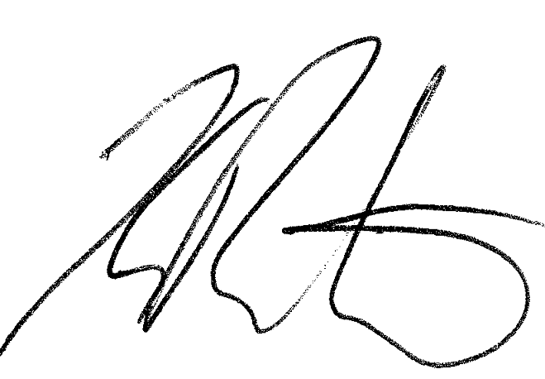

Kelly Rushton

Audit New Zealand

On behalf of the Auditor-General

Wellington, New Zealand

Section 2:  
Financial statements

# Introduction to the financial reports

The Ministry receives funding from Parliament for its own operations which is included in its departmental appropriations.

The Ministry also receives and manages significant other appropriations to administer on behalf of the Crown to fund third party service providers including District Health Boards (DHBs) and Non-Governmental Organisations (NGOs). The majority of this funding is for operational purposes with some being appropriated for capital expenditure. All the funding appropriated by Parliament and administered by the Ministry is known collectively as Vote Health.

The Ministry receives funding for Non Departmental operations in the annual budget. A major purpose of the additional health funding received each year is to recognise the effects of inflation and of demographic changes to the New Zealand population. New or reprioritized funding is also used to implement the Government’s new initiatives.

Figure 9: 2014/15 departmental operational appropriations – actual expenditure ($000s)

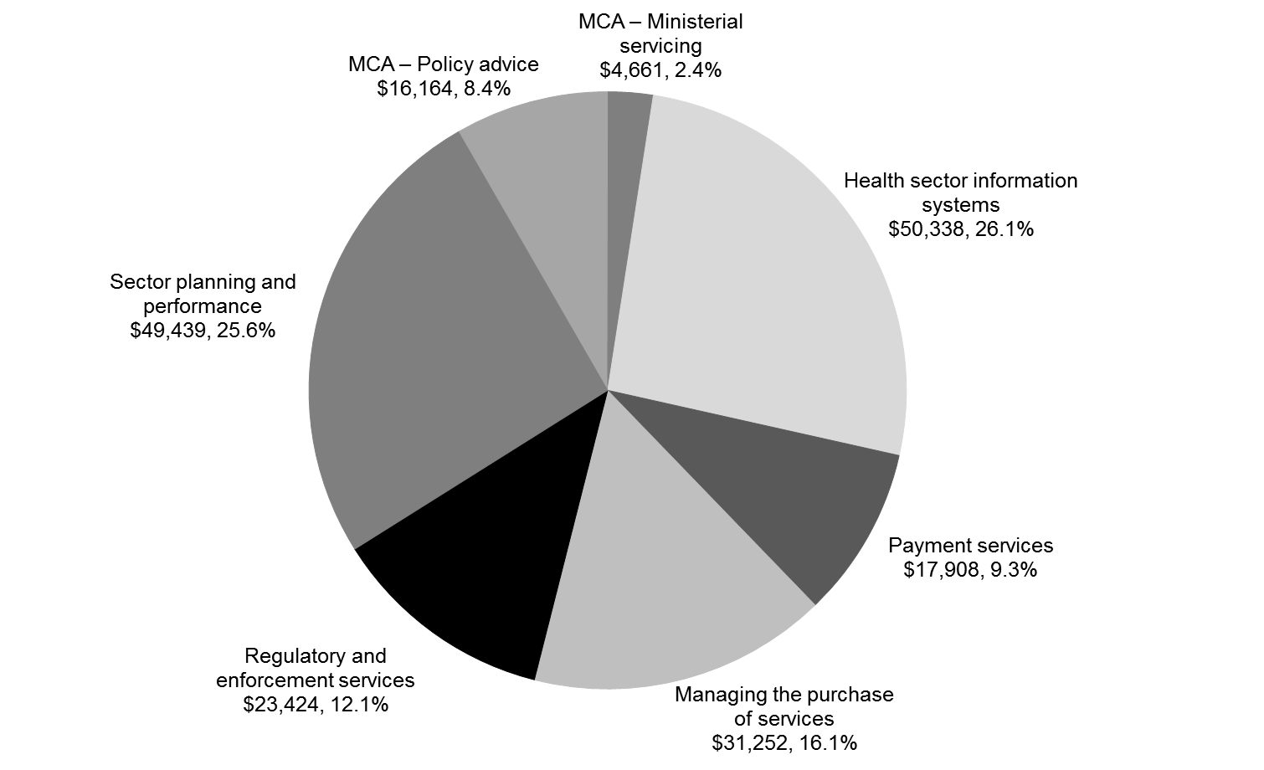

Note: Total actual expenditure was $193.186 million.

Figure 10: Comparative data for 2013/14 departmental operational appropriations – actual expenditure ($000s)

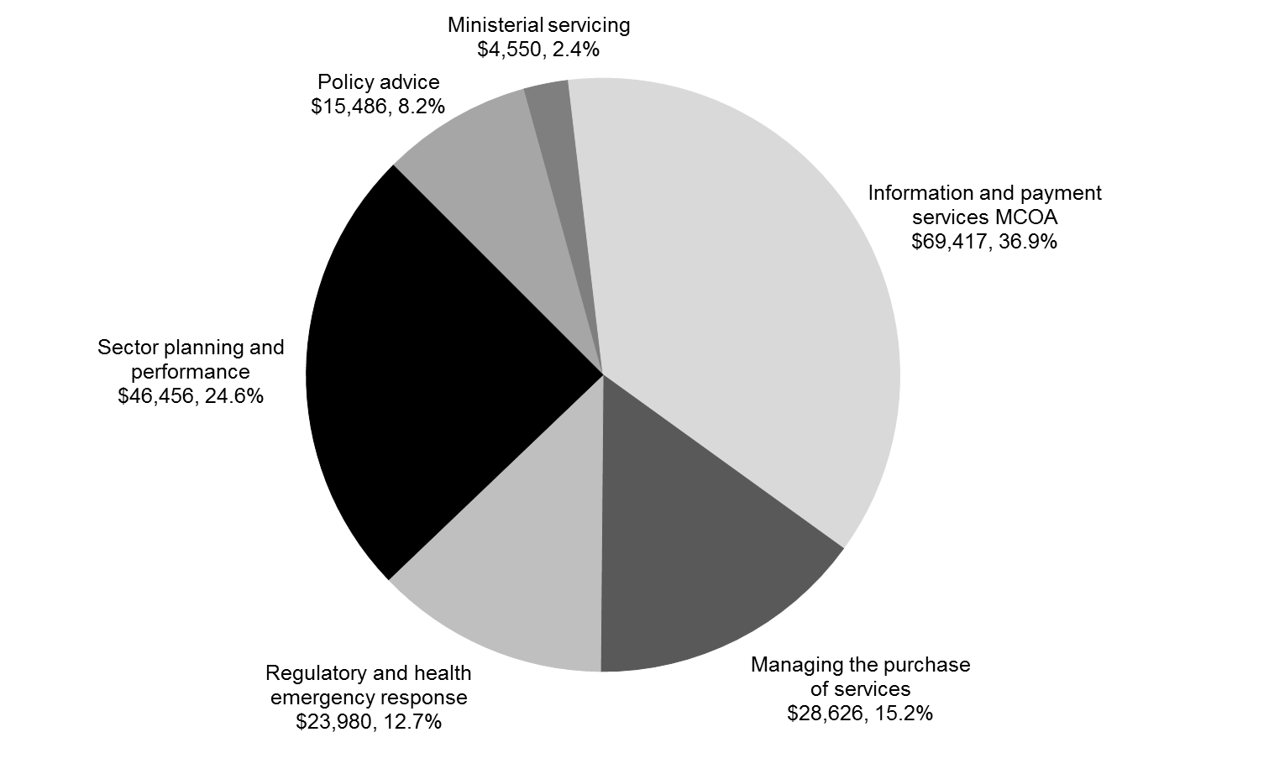

Note: Total actual expenditure was $188.515 million.

Figure 11: 2014/15 non-departmental operational appropriations – actual expenditure ($000s)

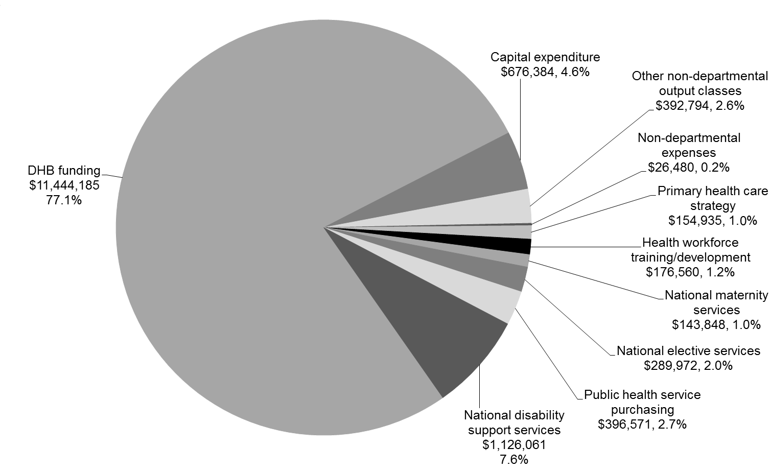

Note: Total actual expenditure was $14.828 billion.

Figure 12: Comparative data for 2013/14 non-departmental operational appropriations – actual expenditure ($000s)

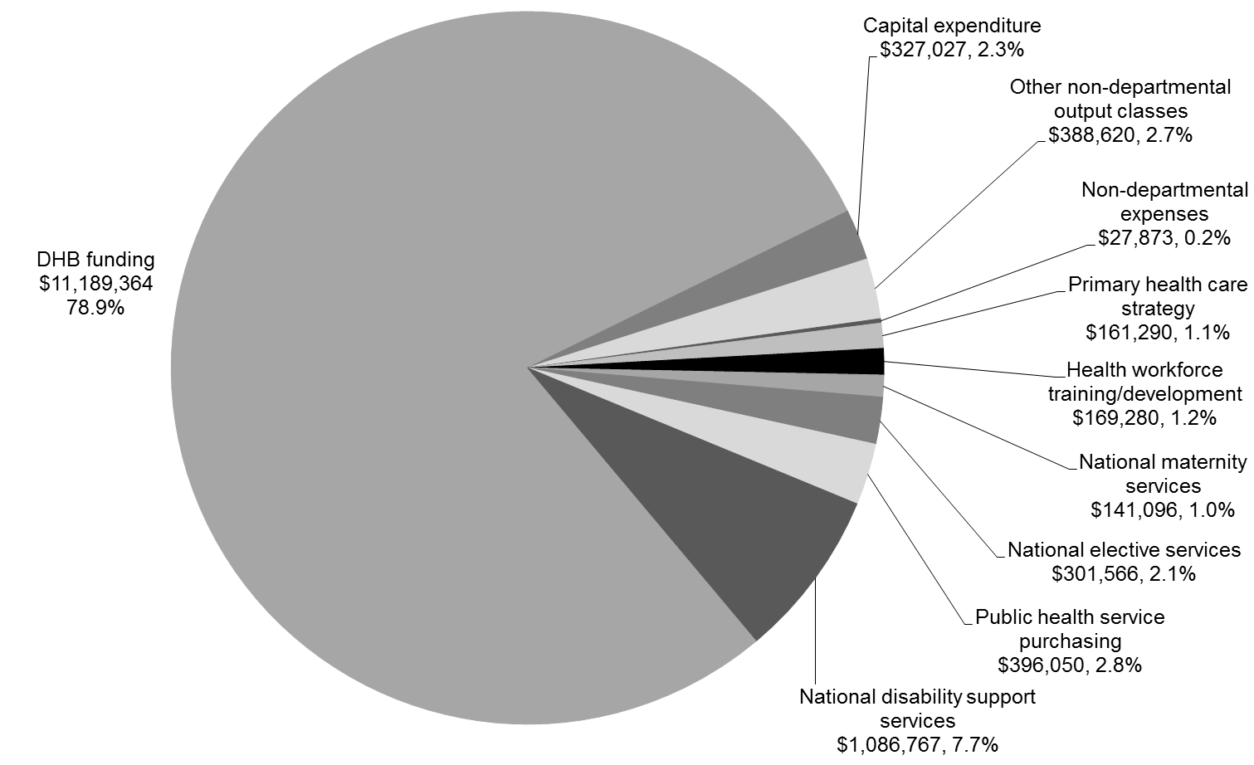

Note: Total actual expenditure was $14.189 billion.

## 

## Statement of comprehensive revenue and expense for the year ended 30 June 2015

| **Actual  2014 $000** |  | **Note** | **Actual  2015 $000** | **Main estimates 2015 $000** | **Supp. estimates 2015 $000** | **Unaudited forecast 2016 $000** |
| --- | --- | --- | --- | --- | --- | --- |
|  | **Revenue** |  |  |  |  |  |
| 177,628 | Revenue Crown |  | 180,598 | 176,792 | 180,598 | 178,275 |
| 11,943 | Revenue other | **2** | 11,983 | 16,280 | 11,683 | 14,157 |
| 2 | Gains on sale of property, plant and equipment | **3** |  | – | – | – |
| **189,573** | **Total operating revenue** |  | **192,581** | **193,072** | **192,281** | **192,432** |
|  | **Expenses** |  |  |  |  |  |
| 108,150 | Personnel costs | **4** | 113,049 | 105,422 | 111,961 | 113,697 |
| 10,377 | Depreciation and amortisation expense | **8, 9** | 9,965 | 15,275 | 10,416 | 10,397 |
| 2,524 | Capital charge | **5** | 2,579 | 2,377 | 2,524 | 2,524 |
| 67,464 | Other operating expenses | **6** | 67,541 | 69,998 | 71,977 | 65,814 |
| – | Losses on sale/disposal of property, plant and equipment | **3** | 52 | – | – | – |
| **188,515** | **Total expenses** |  | **193,186** | **193,072** | **196,878** | **192,432** |
| **1,058** | **Net surplus/(deficit)** |  | **(605)** | **–** | **(4,597)** | **–** |
|  | **Other comprehensive revenue and expense** |  |  |  |  |  |
| – | Gain/(Loss) on property revaluations | **14** | (500) | – | – | – |
| **1,058** | **Total comprehensive revenue and expense** |  | **(1,105)** | **–** | **(4,597)** | **–** |

Explanations of significant variances against budget are detailed in note 22.

## Statement of movements in equity for the year ended 30 June 2015

| **Actual  2014 $000** |  | **Note** | **Actual  2015 $000** | **Main estimates 2015 $000** | **Supp. estimates 2015 $000** | **Unaudited forecast 2016 $000** |
| --- | --- | --- | --- | --- | --- | --- |
| 35,837 | **Balance at 1 July** |  | 34,647 | 35,838 | 36,165 | 35,292 |
| 1,058 | Total comprehensive revenue and expense |  | (1,105) | – | (4,597) | – |
| – | Memorandum account transfer |  | 233 | – | – | – |
|  | **Owner transactions** |  |  |  |  |  |
| – | Capital injection |  | 1,517 | – | – | 315 |
| (2,248) | Return of operating surplus to the Crown | **11** | – | – | – | – |
| **34,647** | **Balance at 30 June** | **14** | **35,292** | **35,838** | **31,568** | **35,607** |

## Statement of financial position as at 30 June 2015

| **Actual  2014 $000** |  | **Note** | **Actual  2015 $000** | **Main estimates 2015 $000** | **Supp. estimates 2015 $000** | **Unaudited forecast 2016 $000** |
| --- | --- | --- | --- | --- | --- | --- |
|  | **Equity** |  |  |  |  |  |
| 29,012 | Taxpayer’s funds | **14** | 30,159 | 33,298 | 31,568 | 30,474 |
| 2,540 | Land and building revaluation reserve | **14** | 2,040 | 2,540 | 2,540 | 2,040 |
| 3,095 | Memorandum accounts | **14** | 3,093 | – | – | 3.093 |
| **34,647** | **Total equity** |  | **35,292** | **35,838** | **34,108** | **35,607** |
|  | Represented by: |  |  |  |  |  |
|  | **Assets** |  |  |  |  |  |
|  | **Current assets** |  |  |  |  |  |
| 2,356 | Cash and cash equivalents |  | 207 | 6,000 | 2,000 | 2,000 |
| 12,458 | Debtors and other receivables | **7** | 12,133 | 11,782 | 6,363 | 9,835 |
| 4,141 | Prepayments |  | 2,617 | 3,234 | 2,169 | 2,601 |
| **18,955** | **Total current assets** |  | **14,957** | **21,016** | **10,552** | **14,436** |
|  | **Non-current assets** |  |  |  |  |  |
| 12,484 | Property, plant and equipment | **8** | 14,508 | 14,723 | 15,874 | 14,076 |
| 35,663 | Intangible assets | **9** | 35,325 | 33,397 | 38,148 | 36,860 |
| **48,147** | **Total non-current assets** |  | **49,833** | **48,120** | **54,022** | **50,936** |
| **67,102** | **Total assets** |  | **64,790** | **69,136** | **64,574** | **65,372** |
|  | **Liabilities** |  |  |  |  |  |
|  | **Current liabilities** |  |  |  |  |  |
| 14,384 | Creditors and other payables | **10** | 15,365 | 13,415 | 14,444 | 14,361 |
| 2,248 | Operating surplus to be returned to the Crown | **11** | – | 8,650 | – | – |
| 3,086 | Provisions | **12** | 1,132 | 2,069 | 4,134 | 1,451 |
| 10,487 | Employee entitlements | **13** | 8,840 | 7,906 | 10,592 | 8,977 |
| **30,205** | **Total current liabilities** |  | **25,337** | **32,040** | **29,170** | **24,789** |
|  | **Non-current liabilities** |  |  |  |  |  |
| 1,000 | Provisions | **12** | 2,750 | – | – | 3,522 |
| 1,250 | Employee entitlements | **13** | 1,411 | 1,258 | 1,296 | 1,454 |
| **2,250** | **Total non-current liabilities** |  | **4,161** | **1,258** | **1,296** | **4,976** |
| **32,455** | **Total liabilities** |  | **29,498** | **33,298** | **30,466** | **29,765** |
| **34,647** | **Net assets** |  | **35,292** | **35,838** | **34,108** | **35,607** |

Explanations of significant variances against budget are detailed in note 22.

## Statement of cash flows for the year ended 30 June 2015

| **Actual  2014 $000** |  | **Note** | **Actual  2015 $000** | **Main estimates 2015 $000** | **Supp. estimates 2015 $000** | **Unaudited forecast 2016 $000** |
| --- | --- | --- | --- | --- | --- | --- |
|  | **Cash flows from operating activities** |  |  |  |  |  |
|  | Cash was provided from: |  |  |  |  |  |
|  | Supply of outputs to: |  |  |  |  |  |
| 177,628 | Receipts from Crown revenue |  | 180,373 | 179,851 | 186,483 | 180,774 |
| 10,766 | Receipts from other revenue |  | 12,271 | 16,280 | 11,683 | 14,485 |
| (68,408) | Payments to suppliers |  | (67,121) | (76,158) | (75,325) | (73,407) |
| (106,737) | Payments to employees |  | (111,865) | (101,717) | (108,249) | (106,094) |
| (2,524) | Payments for capital charge |  | (2,579) | (2,377) | (2,524) | (2,524) |
| 575 | Net GST received/(paid) |  | 214 | – | – | (256) |
| **11,300** | **Net cash provided from operating activities** | **15** | **11,293** | **15,879** | **12,068** | **12,978** |
|  | **Revenue in advance** |  |  |  |  |  |
|  | **Cash flows from investing activities** |  |  |  |  |  |
| 8 | Receipts from sale of property, plant and equipment |  | 41 | – | – | – |
| (1,951) | Purchase of property, plant and equipment |  | (7,463) | (7,000) | (7,000) | (3,500) |
| (7,454) | Purchase of intangible assets |  | (5,289) | (5,875) | (9,291) | (8,000) |
| **(9,397)** | **Net cash outflow from investing activities** |  | **(12,711)** | **(12,875)** | **(16,291)** | **(11,500)** |
|  | **Cash flows from financing activities** |  |  |  |  |  |
| – | Capital injections |  | 1,517 | – | 1,517 | 315 |
| (5,509) | Repayment of surplus to the Crown |  | (2,248) | (3,004) | (2,247) | – |
| **(5,509)** | **Net cash flows from financing activities** |  | **(731)** | **(3,004)** | **(730)** | **315** |
|  | Surplus/(deficit) of memorandum accounts |  |  |  |  |  |
| **(3,606)** | **Net increase/(decrease) in cash and cash equivalents held** |  | **(2,149)** | **–** | **(4,953)** | **1,793** |
| 5,962 | Add cash and cash equivalents at the beginning of the year |  | 2,356 | 6,000 | 2,356 | 207 |
| **2,356** | **Cash and cash equivalents at the end of the year** |  | **207** | **6,000** | **(2,597)** | **2,000** |

The GST (net) component of operating activities reflects the net GST paid to and received from the Inland Revenue Department (IRD). The GST (net) component has been presented on a net basis, as the gross amounts do not provide meaningful information for financial statement purposes and to be consistent with the presentation basis of the other primary financial statements.

## Statement of commitments as at 30 June 2015

| **Actual  2014 $000** |  | **Actual  2015 $000** |
| --- | --- | --- |
|  | **Capital commitments** |  |
| 1,300 | Property, plant and equipment | – |
| 18,279 | Intangible assets | 1,987 |
| – | Other capital commitments | – |
| **19,579** | **Total capital commitments** | **1,987** |
|  | **Non-cancellable operating lease commitments** |  |
| 7,197 | Not later than one year | 6,801 |
| 29,799 | Later than one year and not later than five years | 28,762 |
| 64,434 | Later than five years | 55,769 |
| **101,430** | **Total non-cancellable operating lease commitments** | **91,332** |
| **121,009** | **Total commitments** | **93,319** |

The Ministry has medium- to long-term leases on its premises in Auckland, Christchurch, Dunedin, Hamilton, Whanganui and Wellington. The annual lease payments are subject to regular reviews, ranging from one year to four years. The amounts disclosed above as future commitments are based on current rental rates.

## Statement of contingent liabilities and contingent assets as at 30 June 2015

The Ministry had no contingent liabilities as at 30 June 2015 (2014: Nil).

The Ministry had no contingent assets as at 30 June 2015 (2014: Nil).

## Statement of unappropriated departmental expenditure and capital expenditure for the year ended 30 June 2015

There was no unappropriated departmental expenditure for the year ended 30 June 2015 (2014: Nil).

## Notes to the financial statements for the year ended 30 June 2015

### Note 1: Statement of accounting policies for the year ended 30 June 2015

#### Reporting entity

The Ministry of Health (the Ministry) is a government department as defined by section 2 of the Public Finance Act 1989 and is domiciled in New Zealand. The relevant legislation governing the Ministry’s operations includes the Public Finance Act 1989 and New Zealand Public Health and Disability Act 2000. The Ministry’s ultimate parent is the New Zealand Crown.

The primary objective of the Ministry is to act as the Government’s agent to fund, administer and monitor the delivery of health services to New Zealanders, rather than to make a financial return. Accordingly, the Ministry has designated itself as a public benefit entity (PBE) for financial reporting purposes.

The Ministry’s financial statements are for the year ended 30 June 2015. The financial statements were authorised for issue by the Director-General of Health on 30 September 2015.

In addition, the Ministry has reported the activities and trust monies that it administers on behalf of the Crown.

#### Basis of preparation

The financial statements have been prepared on a going concern basis, and the accounting policies have been applied consistently throughout the period.

#### Statement of compliance

The financial statements of the Ministry have been prepared in accordance with the requirements of the Public Finance Act 1989, which include the requirement to comply with New Zealand generally accepted accounting practice (NZ GAAP), and Treasury Instructions.

These financial statements have been prepared in accordance with Tier 1 PBE accounting standards as appropriate for public benefit entities.

These financial statements are the first to be presented in accordance with the new PBE accounting standards.

#### Measurement base

The measurement base applied to these financial statements is the historical cost basis modified by the revaluation of certain assets and liabilities as described in this statement of accounting policies.

#### Functional and presentation currency

The financial statements are presented in New Zealand dollars being the functional currency of the Ministry. Unless stated otherwise, all values are rounded to the nearest thousand dollars ($000).

#### Standards issued and not yet effective and not early adopted

In May 2013, the External Reporting Board issued a new suite of PBE accounting standards for application by public sector entities for reporting periods beginning on or after 1 July 2014. The Ministry has applied these standards in preparing the 30 June 2015 financial statements.

In October 2014, the PBE suite of accounting standards was updated to incorporate requirements and guidance for the not-for-profit sector. These updated standards apply to PBEs with reporting periods beginning on or after 1 April 2015. The Ministry will apply these updated standards in preparing its 30 June 2016 financial statements. The Ministry expects there will be minimal or no change in applying these updated accounting standards.

#### Summary of significant accounting policies

##### Foreign currency transactions

Foreign currency transactions are translated into New Zealand dollars using the exchange rates prevailing at the dates of the transactions. Foreign exchange gains and losses resulting from the settlement of such transactions are recognised in the Statement of Comprehensive Revenue and Expense.

Monetary assets and liabilities denominated in foreign currency are translated at the rate of exchange applying at balance date. Any unrealised foreign exchange gains or losses resulting from such translation are recognised in the Statement of Comprehensive Revenue and Expense.

##### Budget and forecast figures

The budget figures (Main Estimates) are the original figures for the 2015 financial year as presented in the 2014 Budget Economic and Fiscal Update and were published in the 2013/14 annual report as the 2015 Forecast.

The 2016 forecast figures are for the year ending 30 June 2016 and are consistent with the best estimate financial forecast information submitted to Treasury in the Budget Economic and Fiscal Update out-year 1 figures.

The budget and forecast figures have been prepared in accordance with NZ GAAP and PBE FRS‑42 Prospective Financial Statements, using accounting policies that are consistent with those adopted in preparing these financial statements.

Forecast information is unaudited and has been included as required by the Public Finance Amendment Act 2013 to increase transparency by providing the reader with further context of this year’s results by providing next year’s forecast for comparison.

##### Judgements and estimations

The preparation of financial statements is in conformity with NZ GAAP and requires judgements, estimates, and assumptions that affect the application of policies and reported amounts of assets and liabilities, income and expenses. The estimates and associated assumptions are based on historical experience and various other factors that are believed to be reasonable under the circumstances. Actual results may differ from these estimates.

The estimates and underlying assumptions are reviewed on an ongoing basis. Revisions to accounting estimates are recognised in the reporting period in which the revision is made and in any future periods that will be affected by those revisions.

##### Significant assumptions

The forecasts have been compiled on the basis of existing government policies and Ministerial expectations at the time the statements were finalised and reflect all government decisions and circumstances as at 20 April 2015.

The main assumptions are as follows:

* The department’s main activities will remain substantially the same as for the previous year.
* Operating costs are based on historical experience. The general historical pattern is expected to continue.
* Estimated year-end information for 2014–15 is used as the opening position for the 2015–16 forecasts.

The forecast financial statements were approved for issue by the Chief Executive on 20 April 2015. The Chief Executive is responsible for the forecast financial statements, including the appropriateness of the assumptions underlying them and all other required disclosures.

##### Variations to forecast

The actual financial results for the forecast period covered are likely to vary from the information presented in these forecasts. Factors that may lead to a material difference between information in these forecast financial information statements and the actual reported results include:

* changes to the budget through initiatives approved by Cabinet
* technical adjustments to the budget including transfers between financial years
* the timing of expenditure relating to significant programmes and projects.

Any changes to budgets during 2015-16 will be incorporated into *The Supplementary Estimates of Appropriations* for the year ending 30 June 2016.

##### Revenue

The Ministry derives revenue through the provision of outputs to the Crown and for services to third parties. Such revenue is recognised at fair value of consideration received.

Revenue from the Crown is measured based on the Ministry’s funding entitlement for the reporting period. The funding entitlement is established by Parliament when it passes the Appropriation Acts for the financial year. The amount of revenue recognised takes into account any amendments to appropriations approved in the Appropriation (Supplementary Estimates) Act for the year and certain other unconditional funding adjustments formally approved prior to balance date.

There are no conditions attached to the funding from the Crown. However, the Ministry can incur expenses only within the scope and limits of its appropriations.

The fair value of Revenue Crown has been determined to be equivalent to the funding entitlement.

Other revenue from the supply of services is recognised by reference to the stage of completion of the transaction at balance date and only to the extent that the outcome of the transaction can be estimated reliably.

##### Cost allocation

Direct costs are those costs directly attributed to an output. Indirect costs are those costs that cannot be identified in an economically feasible manner with any one specific output.

Direct costs are charged directly to outputs while indirect costs are allocated to outputs based on the level of activity associated with relevant cost drivers.

Depreciation is primarily charged as direct costs to outputs on the basis of asset utilisation: the remainder is charged as indirect costs.

There have been no changes in the cost allocation policy since the date of the last audited financial statements.

##### Taxation

As a government department, the Ministry is exempt from the payment of income tax in terms of the Income Tax Act 2007. Accordingly, no charge for income tax is recognised.

##### Equity

Equity is the Crown’s net investment in the Ministry and is measured as the difference between total assets and total liabilities. Equity is disaggregated and classified as taxpayers’ funds, property revaluation reserves and memorandum accounts.

###### Property Revaluation Reserves

These reserves relate to the revaluation of land and buildings to fair value.

###### Memorandum Accounts

Memorandum Accounts reflect the cumulative surplus/(deficit) on those departmental services provided that are intended to be fully cost recovered from third parties through fees, levies or charges. The balance of each memorandum account is expected to trend toward zero over time.

##### Financial instruments

Financial assets and liabilities are initially measured at fair value plus transaction costs, unless they are carried at fair value through surplus or deficit, in which case the transaction costs are recognised in the surplus or deficit.

##### Cash and cash equivalents

Cash and cash equivalents includes cash on hand, deposits held at call with banks, and other short-term highly liquid investments with original maturities of three months or less.

##### Debtors and other receivables

Short-term debtors and other receivables are recorded at their face value, less any provision for impairment.

Impairment of a receivable is established when there is objective evidence that the Ministry will not be able to collect amounts due according to the original term of the receivable. Significant financial difficulties of the debtor, probability that the debtor will enter into bankruptcy, receivership or liquidation, and default in payments are considered indicators that the debtor is impaired. The amount of the impairment is the difference between the asset’s carrying amount and the present value of estimated future cash flows, discounted using the original effective interest rate. The carrying amount of the asset is reduced through the use of a provision for impairment account, and the amount of the loss is recognised in the surplus or deficit. Overdue receivables that are renegotiated are reclassified as current (that is, not past due).

##### Property plant and equipment

Items of property, plant and equipment are initially recorded at cost. Where an asset is acquired for nil or nominal consideration the asset will be recognised initially at fair value, where fair value can be reliably determined. The fair value of the asset received, less costs incurred to acquire the asset, is recognised as revenue in the Statement of Comprehensive Revenue and Expense.

All individual assets or groups of assets are capitalised if their historical cost is $4,000 or greater.

Land is recorded at fair value less impairment losses. Buildings are recorded at fair value less impairment losses and less depreciation accumulated since the assets were last revalued. Valuations are based on either valuation undertaken in accordance with standards issued by the New Zealand Property Institute if available, or valuation conducted in accordance with the Rating Valuation Act 1998 that has been confirmed as appropriate by an independent valuer.

Revaluations are carried out for the Ministry’s land and buildings to reflect the service potential or economic benefit obtained through control of the asset. Revaluation is based on the fair value of the asset, with changes reported by class of asset.

Accumulated depreciation at revaluation date may be either restated proportionately or eliminated against the gross carrying amount so that the carrying amount after revaluation equals the revalued amount. The elimination approach is applied unless otherwise indicated.

All other asset classes are initially carried at depreciated historical cost, with a review of the carrying values of revalued items performed at each balance date to determine whether any material adjustment is required.

Classes of property, plant and equipment subject to fair value review are revalued at least every three years or sooner where indicators suggest the carrying amount differs materially to fair value. Unrealised gains and losses arising from changes in the value of property, plant and equipment are recognised as at each balance date. To the extent that a gain reverses a loss previously charged to the Statement of Comprehensive Revenue and Expense for the asset class, the gain is credited to the Statement of Comprehensive Revenue and Expense; otherwise gains are credited to the asset revaluation reserve for that class of asset. To the extent that there is a balance in the asset revaluation reserve for the asset class, any loss on revaluation is debited to the reserve to the extent that a balance remains in such reserve. All other losses on property, plant and equipment are reported in the Statement of Comprehensive Revenue and Expense.

For each property, plant and equipment asset, project borrowing costs incurred during the period required to complete and prepare the asset for its intended use are expensed.

Depreciation is charged on a straight-line basis at rates calculated to allocate the cost or valuation of an item of property, plant and equipment, less any estimated residual value, over its estimated useful life. Typically, the estimated useful lives of different classes of property, plant and equipment are as follows:

|  |  |  |
| --- | --- | --- |
|  | **Useful life** | **Depreciation rate** |
| Buildings | 40 years | 2.5% |
| Motor vehicles | 5 years | 20% |
| Furniture and fittings | 5–10 years | 10–20% |
| Machinery | 5 years | 20% |
| Leasehold improvements | 5–10 years | 10–20% |
| IT equipment | 3–5 years | 20–33.3% |

###### Additions

The cost of an item of property, plant and equipment is recognised as an asset if, and only if, it is probable that future economic benefits or service potential associated with the item will flow to the Ministry and the cost of the item can be measured reliably.

Work in progress is recognised at cost less impairment and is not depreciated.

###### Disposals

Gains and losses on disposals are determined by comparing the sale proceeds with the carrying amount of the asset. Gains and losses on disposals are included in the Statement of Comprehensive Revenue and Expense. When revalued assets are sold, the amounts included in asset revaluation reserves in respect of those assets are transferred to retained earnings.

###### Subsequent costs

Costs incurred subsequent to initial acquisition are capitalised only when it is probable that future economic benefits or service potential associated with the item will flow to the Ministry and the cost of the item can be measured reliably.

##### Intangible assets

Intangible assets are initially recorded at cost. The cost of an internally generated intangible asset represents expenditure incurred in the development phase of the asset only. The development phase occurs after the following can be demonstrated: technical feasibility; ability to complete the asset; intention and ability to sell or use; and where development expenditure can be reliably measured. Expenditure incurred on research related to an internally generated intangible asset is expensed when it is incurred. Where the research phase cannot be distinguished from the development phase, the expenditure is expensed when it is incurred.

###### Software acquisition and development

Acquired computer software licenses are capitalised on the basis of the costs incurred to acquire and bring to use the specific software.

Costs that are directly associated with the development of software for internal use by the Ministry are recognised as an intangible asset. Direct costs include the software development, employee costs, and an appropriate portion of relevant overheads.

Staff training costs are recognised as an expense when incurred.

Costs associated with maintaining computer software are recognised as an expense when incurred.

Intangible assets with finite lives are subsequently recorded at cost less any amortisation and impairment losses. Amortisation is charged to the Statement of Comprehensive Revenue and Expense on a straight-line basis over the useful life of the asset. Typically, the estimated useful lives of assets are as follows:

|  |  |  |
| --- | --- | --- |
|  | **Useful life** | **Amortisation rate** |
| Software – internally generated | 3–7 years | 14.3–33.3% |
| Software – other | 3–7 years | 14.3–33.3% |
| Warranties | 3 years | 33.3% |

Realised gains and losses arising from disposal of intangible assets are recognised in the Statement of Comprehensive Revenue and Expense in the period in which the transaction occurs.

##### Impairment of property, plant and equipment and intangible assets

The Ministry does not hold any cash-generating assets. Assets are considered cash-generating where their primary objective is to generate a commercial return.

###### Non-cash-generating assets

Intangible assets subsequently measured at cost that have an indefinite useful life or are not yet available for use, are not subject to amortisation and are tested annually for impairment.

Property, plant, and equipment and intangible assets held at cost that have a finite useful life are reviewed for impairment whenever events or changes in circumstances indicate that the carrying amount may not be recoverable. An impairment loss is recognised for the amount by which the asset’s carrying amount exceeds its recoverable service amount. The recoverable service amount is the higher of an asset’s fair value less costs to sell and value in use.

Value in use is the present value of the asset’s remaining service potential. Value in use is determined using an approach based on either a depreciated replacement cost approach, restoration cost approach, or a service units approach. The most appropriate approach used to measure value in use depends on the nature of the impairment and availability of information.

If an asset’s carrying amount exceeds its recoverable service amount, the asset is regarded as impaired and the carrying amount is written down to the recoverable service amount. The total impairment loss is recognised in the surplus or deficit.

The reversal of an impairment loss is recognised in the surplus or deficit.

##### Non-current assets held for sale and discontinued operations

Non-current assets or disposal groups are separately classified where their carrying amount will be recovered through a sale transaction rather than continuing use; that is, where such assets are available for immediate sale and where sale is highly probable. These assets are recorded at the lower of their carrying amount and fair value less costs to sell.

##### Creditors and other payables

Short-term creditors and other payables are recorded at their face value.

##### Employee benefits

Employee entitlements to salaries and wages, annual leave, long service leave, retiring leave and other similar benefits are recognised in the Statement of Comprehensive Revenue and Expense when they accrue to employees. Employee entitlements to be settled within 12 months are reported at the amount expected to be paid. The liability for long-term employee entitlements is calculated on an actuarial basis at the present value of estimated future cash outflows.

Termination benefits are recognised in the Statement of Comprehensive Revenue and Expense only when there is a demonstrable commitment to either terminate employment prior to normal retirement date or to provide such benefits as a result of an offer to encourage voluntary redundancy. Termination benefits settled within 12 months are reported at the amount expected to be paid, otherwise they are reported as the present value of the estimated future cash outflows.

Obligations for contributions to the State Sector Retirement Savings Scheme, KiwiSaver, and the Government Superannuation Fund are recognised in the Statement of Comprehensive Revenue and Expense as they fall due. Obligations for defined benefit retirement plans are recorded at the latest actuarial value of the Ministry’s liability. All movements in the liability, including actuarial gains and losses, are recognised in full in the Statement of Comprehensive Revenue and Expense in the period in which they occur.

##### ACC Partnership Scheme

The Ministry belongs to the Accident Compensations Corporation (ACC) Partnership Programme whereby the Ministry accepts the management and financial responsibility for work-related illnesses and accidents of employees. Under the ACC Partnership Programme, the Ministry is effectively providing accident insurance to employees: this is accounted for as an insurance contract as the Ministry accepts liability for all its claims costs for a period of four years up to a specified maximum. At the end of the four- year period, the Ministry pays a premium to ACC for the value of residual claims, and the liability for ongoing claims beyond that point passes to ACC.

The liability relating to the Ministry’s ACC Partnership Programme obligations is measured at the present value of expected future payments to be made in respect of employee injuries and claims, for which the Ministry has responsibility up to the reporting date, using actuarial techniques. Consideration is given to expected future wage and salary levels and experience of employee claims and injuries to date, and may include a risk margin that represents the inherent uncertainty of the present value of the expected future payments. Expected future payments are discounted using market yields applying as at the reporting date based on government bonds with terms to maturity that match, as closely as possible, the estimated future cash outflows.

##### Leases

An operating lease is a lease that does not transfer substantially all the risks and rewards incidental to ownership of an asset.

Lease incentives received are recognised evenly over the term of the lease as a reduction in rental expense.

Leasehold improvements are capitalised and the cost is amortised over the unexpired period of the lease, or the estimated useful life of the improvements whichever is shorter.

##### Provisions

The Ministry recognises a provision, based on probable cost, for future expenditure of uncertain amount or timing where there is a present obligation (either legal or constructive) as a result of a past event.

Provisions are recorded at the best estimate of the expenditure required to settle the obligation using a pre-tax discount rate that reflects current market assessments of the time value of money and the risks specific to the obligation. Provisions to be settled beyond 12 months are recorded at their present value.

##### Contingent assets and contingent liabilities

Contingent liabilities and contingent assets are recorded in the Statement of Contingent Liabilities and Contingent Assets at the point at which the contingency becomes evident. Contingent liabilities are disclosed if the possibility that they will crystallise is not remote. Contingent assets are disclosed if it is probable that the benefits will be realised.

##### Commitments

Expenses yet to be incurred on non-cancellable contracts that have been entered into on or before balance date are disclosed as commitments to the extent that there are equally unperformed obligations. Cancellable commitments that have penalty or exit costs explicit in the agreement on exercising that option to cancel are included in the statement of commitments at the value of that penalty or exit cost.

##### Changes in accounting policies

Accounting policies are changed only if the change is required by a standard or interpretation or otherwise provides more reliable and more relevant information. The transition to the new PBE accounting standards has meant some policies have been changed to align with the new standards. PBE IPSAS 20 Related Party Disclosures has reduced disclosure requirements for the Ministry as outlined in Note 16. All other policies have been applied on a basis consistent with the previous year.

##### Comparative figures

When presentation or classification of items in the financial statements is amended or accounting policies are changed, comparative figures are restated to ensure consistency with the current period unless it is impracticable to do so.

##### Goods and Service Tax (GST)

All items in the financial statements are stated exclusive of GST, except for receivables and payables, which are stated on a GST inclusive basis. Where GST is not recoverable as input tax, then it is recognised as part of the related asset or expense.

The net amount of GST recoverable from, or payable to, the Inland Revenue Department (IRD) as at balance date is included as part of receivables or payables in the Statement of Financial Position.

The net GST paid to, or received from the IRD, including the GST relating to investing and financing activities, is classified as an operating cash flow in the Statement of Cash Flows.

Commitments and contingencies are disclosed exclusive of GST.

### Note 2: Revenue – other

| **Actual  2014 $000** |  | **Actual  2015 $000** | **Main estimates 2015 $000** | **Unaudited forecast 2016 $000** |
| --- | --- | --- | --- | --- |
| 8,531 | Medicines registration | 8,567 | 8,500 | 8,400 |
| 420 | Service fees | 635 | 1,000 | 600 |
| 1,885 | Annual licence and registration fees | 1,979 | 4,000 | 1,900 |
| 9 | Other government departmental revenue | – | – | – |
| 1,098 | Other revenue | 802 | 2,780 | 3,257 |
| **11,943** | **Total revenue other** | **11,983** | **16,280** | **14,157** |

### Note 3: Gains/(losses)

| **Actual  2014 $000** |  | **Actual  2015 $000** | **Unaudited forecast 2016 $000** |
| --- | --- | --- | --- |
| 2 | Net gain (loss) on disposal of property, plant and equipment | (52) | – |
| **2** | **Total gains/(losses)** | **(52)** | **–** |

### Note 4: Personnel

| **Actual  2014 $000** |  | **Actual  2015 $000** | **Unaudited forecast 2016 $000** |
| --- | --- | --- | --- |
| 100,857 | Salaries and wages | 105,318 | 106,224 |
| 3,139 | Employer contributions to defined contribution plans | 3,338 | 3,400 |
| 1,405 | Increase in employee entitlements | 1,875 | 1,900 |
| 2,749 | Other | 2,518 | 2,173 |
| **108,150** | **Total personnel costs** | **113,049** | **113,697** |

### Note 5: Capital charge

The Ministry pays a capital charge to the Crown on its equity (adjusted for memorandum accounts) as at 30 June and 31 December each year. The capital charge rate for the year ended 30 June 2015 was 8.0% (2014: 8.0%).

### Note 6: Other operating expenses

| **Actual  2014 $000** |  | **Actual  2015 $000** | **Main estimates 2015 $000** | **Unaudited forecast 2016 $000** |
| --- | --- | --- | --- | --- |
| 350 | Fees to Audit New Zealand for the audit of the financial statements | 366 | 358 | 370 |
| 21,025 | Computer services | 19,976 | 20,371 | 19,700 |
| 12,634 | Contractors and consultants | 12,218 | 10,994 | 12,000 |
| 7,496 | Operating lease payments | 8,022 | 7,496 | 7,900 |
| 4,269 | Domestic travel | 4,663 | 4,288 | 4,600 |
| 425 | Overseas travel | 526 | 534 | 500 |
| 21,265 | Other operating expenses | 21,770 | 25,958 | 20,744 |
| **67,464** | **Total other operating expenses** | **67,541** | **69,998** | **65,814** |

### Note 7: Debtors and other receivables

| **Actual  2014 $000** |  | **Actual  2015 $000** | **Unaudited forecast 2016 $000** |
| --- | --- | --- | --- |
| – | Debtors – intercompany | – |  |
| 10,700 | Debtors – Crown (non-exchange transactions) | 10,700 | 8,200 |
| 258 | Debtors – departments (exchange transactions) | 394 | 394 |
| 1,412 | Debtors – other (exchange transactions) | 1,039 | 1,241 |
| **12,370** | **Net debtors** | **12,133** | **9,835** |
| 88 | Accrued revenue | – | – |
| **12,458** | **Total debtors and other receivables** | **12,133** | **9,835** |

The carrying value of debtors and other receivables approximates their fair value.

As at 30 June 2015, all overdue receivables have been assessed for impairment and appropriate provisions applied, as detailed below:

|  |  |  |  |  |  |  |
| --- | --- | --- | --- | --- | --- | --- |
|  | **2014** | | | **2015** | | |
| **Gross $000** | **Impairment $000** | **Net $000** | **Gross $000** | **Impairment $000** | **Net $000** |
| Not past due | 10,793 | – | 10,793 | 11,983 | – | 11,983 |
| Past due 1–30 days | 1,352 | – | 1,352 | 135 | – | 135 |
| Past due 31–60 days | 291 | – | 291 | 8 | – | 8 |
| Past due 61–90 days | 8 | – | 8 | 2 | – | 2 |
| Past due > 90 days | 14 | – | 14 | 5 | – | 5 |
| **Total debtors** | **12,458** | **–** | **12,458** | **12,133** | **–** | **12,133** |

The Ministry has no provision for doubtful debts as at 30 June 2015 (2014: Nil). There were no expected losses for the Ministry’s pool of debtors, based on analysis of the Ministry’s losses in previous periods, and review of specific debtors at balance date.

### Note 8: Plant, property and equipment

|  |  |  |  |  |  |  |
| --- | --- | --- | --- | --- | --- | --- |
|  | **Land   $000** | **Buildings/ leasehold improvements $000** | **Furniture plant and equipment $000** | **Motor vehicles  $000** | **Computer hardware  $000** | **Total   $000** |
| **Cost or valuation** |  |  |  |  |  |  |
| **Balance as at 1 July 2013** | **5,300** | **8,144** | **6,464** | **403** | **19,262** | **39,571** |
| Additions | – | 965 | 414 | – | 572 | 1,951 |
| Revaluation increase/(decrease) | – | – | – | – | – | – |
| Disposals | – | – | – | (30) | (185) | (215) |
| **Balance as at 30 June 2014** | **5,300** | **9,109** | **6,876** | **373** | **19,649** | **41,307** |
| **Balance as at 1 July 2014** | **5,300** | **9,109** | **6,876** | **373** | **19,649** | **41,307** |
| Additions | – | 3,990 | 1,871 | – | 227 | 6,088 |
| Revaluation increase/(decrease) | (500) | – | – | – | – | (500) |
| Disposals | – | (2,390) | (3,677) | – | (943) | (7,010) |
| Transfers |  |  |  |  | 1,376 | 1,376 |
| **Balance as at 30 June 2015** | **4,800** | **10,709** | **5,070** | **373** | **20,309** | **41,261** |
| **Accumulated depreciation and impairment losses** |  |  |  |  |  |  |
| **Balance as at 1 July 2013** | **–** | **4,976** | **4,535** | **182** | **14,958** | **24,651** |
| Depreciation expense | – | 771 | 513 | 53 | 3,044 | 4,381 |
| Eliminate on disposals | – | – | – | (24) | (185) | (209) |
| **Balance as at 30 June 2014** | **–** | **5,747** | **5,048** | **211** | **17,817** | **28,823** |
| **Balance as at 1 July 2013** | **–** | **5,747** | **5,048** | **211** | **17,817** | **28,823** |
| Depreciation expense | – | 1,517 | 512 | 28 | 1,114 | 3,171 |
| Eliminate on disposals | – | (2,072) | (3,392) | – | (943) | (6,407) |
| Transfers | – | – | – | – | 1,166 | 1,166 |
| **Balance as at 30 June 2014** | **–** | **5,192** | **2,168** | **239** | **19,154** | **26,753** |
| **Carrying amounts** |  |  |  |  |  |  |
| At 30 June 2013 | 5,300 | 3,168 | 1,927 | 221 | 4,304 | 14,920 |
| At 30 June 2014 | 5,300 | 3,362 | 1,828 | 162 | 1,832 | 12,484 |
| **At 30 June 2015** | **4,800** | **5,517** | **2,902** | **134** | **1,155** | **14,508** |
| **Work in progress** |  |  |  |  |  |  |
| At 30 June 2013 | – | – | – | – | 10 | 10 |
| At 30 June 2014 | – | – | 16 | – | 6 | 22 |
| **At 30 June 2015** | **–** | **1,029** | **89** | **–** | **64** | **1,182** |

The total of property, plant and equipment in the course of construction (work in progress) and included in the above carrying amounts is $1,182,000 ($22,000 2014).

The land at 108 Victoria Street, Christchurch was valued by Knight Frank, an independent valuer. The effective date of the evaluation is 30 June 2015. There has been a decrease of $500,000 to the value of this land.

There are no restrictions over the title of the Ministry’s PPE.

### Note 9: Intangible assets

|  |  |  |  |
| --- | --- | --- | --- |
|  | **Acquired software  $000** | **Internally generated software $000** | **Total   $000** |
| **Cost** |  |  |  |
| **Balance as at 1 July 2013** | **18,938** | **55,667** | **74,605** |
| Additions | – | 7,454 | 7,454 |
| Disposals | – | – | – |
| **Balance as at 30 June 2014** | **18,938** | **63,121** | **82,059** |
| **Balance as at 1 July 2014** | **18,938** | **63,121** | **82,059** |
| Additions | – | 6,665 | 6,665 |
| Disposals | – | (3) | (3) |
| Transfers |  | (1,376) | (1,376) |
| **Balance as at 30 June 2015** | **18,938** | **68,407** | **87,345** |
| **Accumulated amortisation and impairment losses** |  |  |  |
| **Balance as at 1 July 2013** | **13,890** | **26,510** | **40,400** |
| Amortisation expense | 1,665 | 4,331 | 5,996 |
| Disposals | – | – | – |
| **Balance as at 30 June 2014** | **15,555** | **30,841** | **46,396** |
| **Balance as at 1 July 2014** | **15,555** | **30,841** | **46,396** |
| Amortisation expense | 1,665 | 5,128 | 6,793 |
| Disposals | – | (3) | (3) |
| Transfers |  | (1,166) | (1,166) |
| **Balance as at 30 June 2015** | **17,220** | **34,800** | **52,020** |
| **Carrying amounts** |  |  |  |
| At 30 June 2013 | 5,048 | 29,157 | 34,205 |
| At 30 June 2014 | 3,383 | 32,280 | 35,663 |
| **At 30 June 2015** | **1,718** | **33,607** | **35,325** |
| **Work in progress** |  |  |  |
| At 30 June 2013 | – | 8,961 | 8,961 |
| At 30 June 2014 | – | 11,344 | 11,344 |
| **At 30 June 2015** | **–** | **10,998** | **10,998** |

The total of intangible assets in the course of construction (work in progress) and included in the above carrying amounts is $10,998,000 ($11,344,000 2014).

There are no restrictions over the title of the Ministry’s intangible assets.

### Note 10: Creditors and payables

| **Actual  2014 $000** |  | **Actual  2015 $000** | **Unaudited forecast 2016 $000** |
| --- | --- | --- | --- |
| 1,615 | Creditors | 1,936 | 1,720 |
| 2,038 | Revenue in advance | 2,453 | 2,983 |
| 9,232 | Accrued expenses | 9,490 | 8,428 |
| 1,499 | GST payable | 1,486 | 1,230 |
| **14,384** | **Total creditors and other payables** | **15,365** | **14,361** |

Creditors and other payables are non-interest bearing and are normally settled in the following month. Therefore, the carrying value of creditors and other payables approximates their fair value.

### Note 11: Provision for repayment of surplus to the Crown

| **Actual  2014 $000** |  | **Actual  2015 $000** | **Unaudited forecast 2016 $000** |
| --- | --- | --- | --- |
| 1,058 | Net surplus/(deficit) before other expenses | (605) | – |
|  | Add: |  |  |
| – | Revaluation gains/(losses) not recognised in the net surplus | – |  |
| 1,190 | Surplus/(deficit) of memorandum accounts | 235 |  |
| 2,248 | Total operating surplus/(deficit) | (370) |  |
| **2,248** | **Total operating surplus to be returned to Crown** | **–** | **–** |

### Note 12: Provisions

| **Actual  2014 $000** |  | **Actual  2015 $000** | **Unaudited forecast 2016 $000** |
| --- | --- | --- | --- |
|  | **Current provisions are represented by:** |  |  |
| – | Restructuring | – | – |
| 184 | Performance incentive | 184 | 236 |
| – | Taxation | 30 | 39 |
| 548 | Assets to be written off | 372 | 476 |
| 100 | Redecoration | – | – |
| 115 | Redundancies | 239 | 306 |
| 300 | NRL building demolition | 300 | 384 |
| 8 | ACC Partnership Programme | 7 | 10 |
| 1,831 | Lease exit makegood | – | – |
| **3,086** | **Total current portion** | **1,132** | **1,451** |
|  | **Non-current provisions are represented by:** |  |  |
| 967 | Lease exit makegood | 2,720 | 3,484 |
| 33 | ACC Partnership Programme | 30 | 38 |
| 1,000 | Total non-current portion | 2,750 | 3,522 |
| **4,086** | **Total provisions** | **3,882** | **4,973** |

### Movements in provisions during the year

|  |  |  |  |  |  |  |  |  |  |
| --- | --- | --- | --- | --- | --- | --- | --- | --- | --- |
|  | **Performance incentive  $000** | **Taxation   $000** | **Lease exit makegood** | **NRL building demolition $000** | **Assets to be written off** | **Redecoration** | **Redundancies** | **ACC Partnership Programme $000** | **Total   $000** |
| Opening balance 1 July 2014 | 184 | – | 2,798 | 300 | 548 | 100 | 115 | 41 | 4,086 |
| Additional provision made | 184 | 30 | 698 |  | 372 | – | 239 | – | 1,523 |
| Amounts applied | (184) | – | (354) | – | (548) | (100) | (115) | (4) | (1,305) |
| Unused amounts reversed | – | – | (422) | – | – | – | – | – | (422) |
| **Closing balance 30 June 2015** | **184** | **30** | **2,720** | **300** | **372** | **–** | **239** | **37** | **3,882** |

#### Performance incentive

The estimated amount due to employees under the Ministry’s remuneration guidelines or employment contracts.

#### Taxation

The Ministry has provided for tax in relation to eye care subsidies.

#### Lease make good

In respect of a number of its leased premises, the Ministry is required at the expiry of the lease term to make good any damage caused to the premises and to remove any fixtures or fittings installed by the Ministry. In many cases, the Ministry has the option to renew these leases, which affects the timing of the expected cash outflows to make good the premises.

#### NRL building demolition

The NRL building was damaged during the Christchurch earthquakes. A provision of $300,000 has been provided for the demolition of the building.

#### Assets to be written-off

A provision has been made to provide for assets that will be written off when moving premises.

#### Redundancies

The Ministry has provided for redundancies.

#### ACC Partnership Programme

The liability for the ACC Partnership Programme is measured at the present value of expected future payments to be made with respect to employee injuries and claims received up until the reporting date using actuarial calculations. Consideration is given to expected future salary levels and experience of employee injuries and claims history. Expected future payments are discounted using market yields on national government bonds at the reporting date with terms to maturity that match, as closely as possible, the estimated future cash outflows.

The Ministry manages its exposure arising from the programme by promoting a safe and healthy working environment through:

* implementing and monitoring health and safety policies
* induction training on health and safety
* actively managing work place injuries to ensure employees return to work as soon as practical
* recording and monitoring work place injuries and near miss events to identify risk areas and implementing mitigating actions
* identifying of work hazards and implementing of appropriate safety procedures.

The Ministry has adopted a stop loss limit of 192% of the industry premium for the year ended 30 June 2015 (2014: 150%). The stop loss limit meant the Ministry only carried exposure for total cost of claims up to $141,000 (2014: $145,000). The Ministry is not exposed to any significant concentrations of insurance risk as work related injuries are generally the result of an isolated event to an individual employee.

The value of the liability is not material for the Ministry’s financial statements. Any changes in assumptions will not, therefore, have a material effect on these financial statements.

### Note 13: Employee entitlements

| **Actual  2014 $000** |  | **Actual  2015 $000** | **Unaudited forecast 2016 $000** |
| --- | --- | --- | --- |
|  | **Current employee entitlements are represented by:** |  |  |
| 5,948 | Annual leave | 6,668 | 6,236 |
| 303 | Sick leave | 424 | 1,236 |
| 1,114 | Retirement and long service leave | 1,046 | 916 |
| 3,122 | Accrued salaries | 702 | 589 |
| **10,487** | **Total current portion** | **8,840** | **8,977** |
|  | **Non-current employee entitlements are represented by:** |  |  |
| 1,250 | Retirement and long service leave | 1,411 | 1,454 |
| – | Sick leave | – | – |
| **1,250** | **Total non-current portion** | **1,411** | **1,454** |
| **11,737** | **Total employee entitlements** | **10,251** | **10,431** |

The present value of the retirement and long service leave entitlements depend on a number of factors that are determined on an actuarial basis using a number of assumptions. Two key assumptions applied when calculating this liability include the discount rates and the salary inflation factors. Any changes in these assumptions will have significant impact on the carrying value of the liability.

The discount rates used are taken from the Treasury’s centrally produced risk free discount rates. The methodology of how these rates are calculated is provided on the Treasury website. The short term salary inflation factor has been determined after considering historical salary inflation patterns and current budgeting predictions. The long term salary assumption is a Treasury provided figure.

If the discount rates were to differ by 1 percentage point from the Ministry’s estimates, with all other factors held constant, the carrying amount of the total liability would be an estimated average $77,909 higher/lower.

If the salary inflation rates were to differ by 1 percentage point from the Ministry’s estimates, with all other factors held constant, the carrying amount of the total liability would be an estimated average $112,342 higher/lower.

### Note 14: Equity

Equity compromises three components: taxpayers’ funds, revaluation reserves and memorandum accounts.

| **Actual  2014 $000** |  | **Actual  2015 $000** | **Unaudited forecast 2016 $000** |
| --- | --- | --- | --- |
|  | **Taxpayers’ funds** |  |  |
| **29,012** | **Balance at 1 July** | **29,012** | **30,159** |
| 1,058 | Surplus/(deficit) | (605) | – |
| 1,190 | Transfer of memorandum account net deficit for the year | 235 | – |
| (2,248) | Return of operating surplus to the Crown | – |  |
| – | Capital injection | 1,517 | 315 |
| **29,012** | **Balance at 30 June** | **30,159** | **30,474** |
|  | **Revaluation reserves** |  |  |
| **2,540** | **Balance at 1 July** | **2,540** | **2,040** |
| – | Revaluation losses on land and building | (500) | – |
| **2,540** | **Balance at 30 June** | **2,040** | **2,040** |
|  | **Memorandum accounts** |  |  |
| **4,285** | **Balance at 1 July** | **3,095** | **3,093** |
| – | Transfer balance in discontinued account | 233 | – |
| (1,190) | Net memorandum account deficits for the year | (235) | – |
| **3,095** | **Balance at 30 June** | **3,093** | **3,093** |
| **34,647** | **Total equity** | **35,059** | **35,374** |
|  | **Revaluation reserves consist of:** |  |  |
| 2,540 | Land and building revaluation reserve | 2,040 | 2,040 |
| **2,540** | **Total revaluation reserves** | **2,040** | **2,040** |

### Note 15: Reconciliation of the net surplus/(deficit) to the net cash from operating activities

| **Actual  2014 $000** |  | **Actual  2015 $000** | **Unaudited forecast 2016 $000** |
| --- | --- | --- | --- |
| **1,058** | **Net surplus/(deficit)** | **(605)** | **–** |
|  | **Add/(less) non-cash items:** |  |  |
| 10,377 | Depreciation and amortisation expense | 9,965 | 10,397 |
| – | Net gains on derivative financial instruments | – | – |
| – | Other non-cash items | – | – |
| **10,377** | **Total non-cash items** | **9,965** | **10,397** |
|  | **Add/(less) items classified as investing or financing activities:** |  |  |
| (2) | (Gains)/losses on disposal of property, plant and equipment | 52 | – |
| **(2)** | **Total items classified as investing or financing activities** | **52** | **–** |
|  | **Add/(less) movements in working capital items:** |  |  |
| (1,014) | (Increase)/decrease in debtors and receivables | 325 | (202) |
| – | (Increase)/decrease in debtor Crown | – | 2,500 |
| (182) | (Increase)/decrease in prepayments | 1,524 | 16 |
| (1,358) | Increase/(decrease) in creditors and other payables | 1,489 | (1,004) |
| 1,017 | Increase/(decrease) in provisions | (204) | 1,091 |
| – | Increase/(decrease) in deferred liabilities | – |  |
| 1,404 | Increase/(decrease) in employee entitlements | (1,486) | 180 |
| **(133)** | **Net movements in working capital items** | **1,648** | **2,581** |
| **11,300** | **Net cash from operating activities** | **11,060** | **12,978** |

### Note 16: Related party transactions

The Ministry is a wholly owned entity of the Crown.

Related party disclosures have not been made for transactions with related parties that are within a normal supplier or client/recipient relationship on terms and condition no more or less favourable than those that it is reasonable to expect the Ministry would have adopted in dealing with the party at arm’s length in the same circumstances. Further, transactions with other government agencies (for example, government departments and Crown entities) are not disclosed as related party transactions when they are consistent with the normal operating arrangements between government agencies and undertaken on the normal terms and conditions for such transactions.

#### Key management personnel compensation

| **Actual  2014 $000** |  | **Actual  2015 $000** |
| --- | --- | --- |
|  | **Leadership Team, including the Chief Executive** |  |
| 2,512 | Remuneration | 2,545 |
| 8 | Full-time equivalent staff | 8 |

The above key management personnel disclosure excludes the Minister of Health. The Minister’s remuneration and other benefits are not received only for his role as a member of the key personnel of the Ministry. The Minister’s remuneration and other benefits are set by the Remuneration Authority under the Civil List 1979 and are paid under Permanent Legislative authority, and not paid by the Ministry of Health.

### Note 17: Events after the balance sheet date

There are no significant events after the balance date.

### Note 18: Financial instrument risks

The Ministry’s activities expose it to a variety of financial instrument risks including market risk, credit risk and liquidity risk. The Ministry has policies in place to manage the risk associated with financial instruments and continually seeks to minimise risk from exposure to financial instruments. These policies do not allow any transactions of a speculative nature to be entered into.

#### Market risk

* **Currency risk:** Currency risk is the risk that the fair value of future cash flows from a financial instrument will fluctuate as a result of changes in foreign exchange rates. The Ministry has no significant exposure to currency risk on any financial instruments.
* **Interest rate risk:** Interest rate risk is the risk that the fair value of future cash flows from a financial instrument will fluctuate as a result of changes in market interest rates. The Ministry has no significant exposure to interest rate risk on any of its financial instruments.

#### Credit risk

Credit risk is the risk that a third party will default on its obligations to the Ministry, causing the Ministry to incur a loss.

In the normal course of business, credit risk arises from debtors and other accounts receivable, deposits with banks, and derivative financial instruments.

In accordance with New Zealand Treasury policy, the Ministry is only permitted to deposit funds with Westpac Banking Corporation, a registered bank, and to enter into foreign exchange forward contracts with the New Zealand Debt Management Office. These entities have high market credit ratings. With respect to its remaining financial instruments, the Ministry does not have significant concentrations of credit risk.

The Ministry’s maximum credit exposure for each class of financial instruments is represented by the total carrying amount of cash, cash equivalents, net debtors and derivative financial instrument assets. The Ministry holds no collateral as security against these financial instruments, including those that are overdue or impaired.

The fair value of all financial instruments is equivalent to the carrying value disclosed in the Statement of Financial Position.

The Ministry held no bank overdraft facilities as at 30 June 2015.

#### Liquidity risk

Liquidity risk is the risk that the Ministry will encounter difficulty with raising liquid funds to meet its payment commitments as they fall due.

In meeting its liquidity requirements the Ministry closely monitors its forecast cash requirements with expected cash draw-downs from the New Zealand Debt Management Office. The Ministry maintains a target level of available cash to meet its liquidity requirements.

The table below analyses the Ministry’s financial liabilities that will be settled based on the remaining period at the balance date to the contracted maturity date. The amounts disclosed are the contracted undiscounted cash flows.

|  |  |  |  |  |
| --- | --- | --- | --- | --- |
|  | **Less than 6 months $000** | **Between 6 months and 1 year $000** | **Between 1 and 5 years $000** | **Over 5 years $000** |
| **2014** |  |  |  |  |
| Creditors and other payables | 14,384 | – | – | – |
| **2015** |  |  |  |  |
| Creditors and other payables | 15,365 | – | – | – |

### Note 19: Categories of financial instruments

The carrying amounts of financial assets and financial liabilities in each of the PBE IPSAS 29 *Financial Instruments: Recognition and Measurement* categories are as follows:

| **Actual  2014 $000** |  | **Actual  2015 $000** |
| --- | --- | --- |
|  | **Loans and receivables** |  |
| 2,356 | Cash and cash equivalents | 207 |
| 12,458 | Debtors and other receivables | 12,133 |
| **14,814** | **Total loans and receivables** | **12,340** |
|  | **Financial liabilities measured at amortised cost** |  |
| **(14,384)** | **Creditors and other payables** | **(15,365)** |

### Note 20: Capital management

The Ministry’s capital is its equity, which comprises taxpayers’ funds, revaluation reserves and memorandum accounts. Equity is represented by net assets.

The Ministry manages its revenues, expenses, assets, liabilities and general financial dealings in a prudent manner. The Ministry’s equity is largely managed as a by-product of managing revenue, expenses, assets, liabilities and its need to comply with both Government Budget processes and New Zealand Treasury instructions.

The objective of managing the Ministry’s equity is to ensure the Ministry effectively achieves its goals and objectives, for which it has been established, while remaining a going concern.

### Note 21: Memorandum accounts

The accumulated surpluses/(losses) during the year result in a net increase/(decrease) in the memorandum accounts of ($2,000). The debit balance in the PsychoActive Substances memorandum account has been cleared as there is no likelihood of receiving revenue in the short to medium term to offset this.

#### Summary of Memorandum Accounts

|  |  |
| --- | --- |
| **Opening balance** |  |
| Office of Radiation Safety | 702 |
| Medsafe | 3,059 |
| Psychoactive Substances | (233) |
| Problem Gambling | (433) |
| **Opening Equity Balance** | **3,095** |
| **2014/15 Revenue and Appropriation** |  |
| Office of Radiation Safety Revenue | 897 |
| Medsafe Revenue | 8,318 |
| Psychoactive Substances | – |
| Problem Gambling Appropriation | 979 |
|  | **10,194** |
| **2014/15 expenditure** |  |
| Office of Radiation Safety expenditure | 626 |
| Medsafe expenditure | 8,741 |
| Psychoactive Substances | – |
| Problem Gambling expenditure | 1,062 |
|  | **10,429** |
| **2014/15 transfers** |  |
| Psychoactive Substances | **233** |
| **Closing balance** |  |
| Office of Radiation Safety | 973 |
| Medsafe | 2,636 |
| Psychoactive Substances | – |
| Problem Gambling | (516) |
| **Closing equity balance** | **3,093** |

#### Problem gambling departmental

Since October 2004 the Ministry has, in accordance with the Gambling Act 2003, received an appropriation for problem gambling that over time is intended to be fully funded from the levies collected from the industry, on behalf of the Crown, by the IRD. The departmental balance in the problem gambling memorandum account as at 30 June 2015 is ($516,000).

| **Actual  2014 $000** |  | **Actual  2015 $000** |
| --- | --- | --- |
|  | **Problem gambling departmental expenditure** |  |
| **(380)** | **Balance 1 July** | **(433)** |
| 957 | Revenue | 979 |
| (1,010) | Expenses | (1,062) |
| **(433)** | **Balance 30 June** | **(516)** |

* Revenue is as specified in the “Preventing and Minimising Gambling Harm: Three-year service plan  
2013/14–2015/16”.

#### Office of radiation safety: licensing activities

Following the sale of the National Radiation Laboratory to ESR the Ministry has retained a range of regulatory activities including licensing, issuing consents and maintenance of codes of safe practice, which now fall under the Office of Radiation Safety.

A memorandum account was established on 1 July 1998 for licensing activities required by the Radiation Protection Act 1965. The following table shows the amounts of revenue and expenses relating to licensing activities.

| **Actual  2014 $000** |  | **Actual  2015 $000** |
| --- | --- | --- |
|  | **Licensing fees** |  |
| **619** | **Balance 1 July** | **702** |
| 804 | Revenue | 897 |
| (721) | Expenses | (626) |
| **702** | **Balance 30 June** | **973** |

#### Medsafe

Pursuant to the Medicines Act 1981, Medsafe derives third-party fee revenue from the medicines and pharmaceutical industry from licence applications to approve new or changed medicines, and for clinical trials. A memorandum account has been established effective from 1 July 2007 to match accumulated licence revenue collected against the expenses incurred to process applications. This information will be used to ensure that, over time, fees will be set at a level as to ensure revenue collected equates to equivalent levels of costs incurred.

| **Actual  2014 $000** |  | **Actual  2015 $000** |
| --- | --- | --- |
|  | **Medsafe** |  |
| **4,046** | **Balance 1 July** | **3,059** |
| 8,218 | Revenue | 8,318 |
| (9,205) | Expenses | (8,741) |
| **3,059** | **Balance 30 June** | **2,636** |

#### Psychoactive substances

The Psychoactive Regulatory Authority was established in 2013 pursuant to the Psychoactive Substances Act 2013 to be funded by third-party fees from the industry. A memorandum account was established to match accumulated revenue collected against expenses incurred.

However due to policy changes fees are unlikely to be collected in the foreseeable future and the balance of the memorandum account has been written off.

| **Actual  2014 $000** |  | **Actual  2015 $000** |
| --- | --- | --- |
|  | **Psychoactive substances** |  |
| **–** | **Balance 1 July** | **(233)** |
| 556 | Revenue | – |
| (789) | Expenses | – |
| – | Transfers | 233 |
| **(233)** | **Balance 30 June** | **–** |

### Note 22: Explanation of major variances against budget

Explanations for major variances from the Ministry’s estimated figures are as follows.

#### Statement of Comprehensive Revenue and Expense

##### Revenue Crown

Revenue Crown was $3.806 million higher than the Main Estimates. This was mainly due to fiscally neutral transfers of totalling $3.8 million from non-departmental appropriations to departmental appropriations for information technology projects.

##### Revenue other

Revenue other was $4.297 million lower than the Main Estimates, mostly because the Natural Health and Supplementary Products and Psychoactive Substances regulators are not yet generating revenue.

##### Personnel costs

Personnel costs were $7.627 million higher than the Main Estimates mainly due to increased salary costs. The increase was caused by staff appointments being made higher within salary bands.

##### Depreciation

Depreciation costs were $5.310 million lower than the Main Estimates which relates to the timing of projects in information technology services.

##### Other operating expenses

Other operating expenses were $2.457 million lower than the Main Estimates mainly due to the underspend related to Natural Health and Supplementary Products and Psychoactive Substances regulators.

#### Statement of financial position

##### Current assets

Current assets, comprising cash and cash equivalents, debtors and other receivables and prepayments were $6.059 million lower than the Main Estimates. This was mainly due to revenue other being lower than expected.

##### Property, plant and equipment, and intangible assets

Property, plant and equipment, and intangible assets were $1.713 million higher than the Main Estimates. This is mainly because intangible assets were higher than the Main Estimates due to amortisation expenditure being lower than expected as there has been a delay in completion of projects.

##### Repayment of surplus

As there was no operating surplus, there was no requirement to return funds to the Crown.

#### Statement of cash flows

##### Cash from operating activities

Cash from operating activities was $4.586 million lower than the Main Estimates mainly due to reduced cash receipts from third party revenue ($4.009 million) because Natural Health Products and Psychoactive Substances regulators have not generated revenue.

##### Cash from financing activities

Cash from financial activities was $2.273 million higher than the Main Estimates mainly due to a Capital Injection of $1.517 million for information technology capital projects, which was agreed during the year.

# Non-departmental statements and schedules for the year ended 30 June 2015

The following non-departmental statements and schedules record the income, expenses, assets, liabilities, commitments, contingent liabilities, contingent assets and trust accounts that the Ministry manages on behalf of the Crown.

## Statement of non-departmental expenses and capital expenditure against appropriations for the year ended 30 June 2015

| **Actual  2014 $000** |  | **Actual  2015 $000** | **Main estimates 2015 $000** | **Voted^ appropriation 2015 $000** |
| --- | --- | --- | --- | --- |
|  | **Non-departmental output expenses** |  |  |  |
| 11,189,364 | Health and disability support services for District health boards | 11,444,185 | 11,404,729 | 11,454,893 |
| 2,644,669 | National services | 2,680,741 | 2,816,222 | 2,697,044 |
| 27,873 | Non-departmental other expenses | 26,480 | 28,472 | 28,181 |
| 327,027 | Non-departmental capital contributions to other persons or organisations | 676,384 | 1,099,300 | 824,386 |
| **14,188,933** | **Total non-departmental appropriations** | **14,827,790** | **15,348,723** | **15,004,504** |

^ These amounts include adjustments made in the Supplementary Estimates and adjustments made under the Public Finance Act 1989.

## Schedule of non-departmental revenue and capital receipts for the year ended 30 June 2015

Non-departmental revenues and capital receipts are administered by the Ministry on behalf of the Crown. As these revenues are not established by the Ministry nor earned in the production of the Ministry’s outputs, they are not reported in the Ministry’s financial statements.

| **Actual  2014 $000** |  | **Actual  2015 $000** | **Main estimates 2015 $000** | **Supp. estimates 2015 $000** |
| --- | --- | --- | --- | --- |
|  | **Revenue** |  |  |  |
|  | **Reimbursement from ACC+** |  |  |  |
| 5,476 | ACC – reimbursement of complex burns costs | 5,599 | 5,476 | 5,476 |
| 28,589 | ACC – reimbursement of work-related public hospital costs | 29,271 | 29,217 | 29,217 |
| 269,915 | ACC – reimbursement of non-earners’ account | 276,398 | 275,881 | 275,881 |
| 81,943 | ACC – reimbursement of earners’ non-work-related public hospital costs | 83,901 | 83,745 | 83,745 |
| 67,883 | ACC – reimbursement of motor vehicle-related public hospital costs | 69,506 | 69,377 | 69,377 |
| 2,494 | ACC – reimbursement of medical misadventure costs | 2,554 | 2,549 | 2,549 |
| 7,805 | ACC – reimbursement of self-employed public hospital costs | 7,992 | 7,977 | 7,977 |
| **464,105** | **Total ACC reimbursements** | **475,221** | **474,222** | **474,222** |
| 191,082 | Payment of capital charge by DHBs | 194,350 | 193,207 | 203,063 |
| (4,433) | Net surplus/(deficit) from DHBs* | (37,207) | – | – |
| 8,811 | Other Crown entities surplus/(deficits)** | 4,492 | – | – |
| **659,565** | **Total non-departmental revenue** | **636,856** | **667,429** | **677,285** |
|  | **Capital receipts** |  |  |  |
| 11,424 | Repayment of residential care loans | 14,701 | 15,000 | 15,000 |
| 1,521 | Repayment of DHB debt | 600 | – | – |
| 363,674 | Equity repayments by DHBs | 132,499 | 132,499 | 132,499 |
| **376,619** | **Total non-departmental capital receipts** | **147,800** | **147,499** | **147,499** |
| **1,036,184** | **Total non-departmental revenue and capital receipts** | **784,656** | **814,928** | **824,784** |

+ Accident Compensation Corporation.

* Based on unaudited financial statements of the 20 DHBs: accordingly these have not been reflected in the investments in Crown entities figure within the schedule of non-departmental assets.

** Based on unaudited financial statements of the other non-DHB health sector Crown entities: accordingly these have not been reflected in the Investments in Crown entities figure within the schedule of non-departmental assets.

## Schedule of non-departmental assets as at 30 June 2015

| **Actual  2014 $000** |  | **Note** | **Actual  2015 $000** | **Main estimates 2015 $000** | **Supp. estimates 2015 $000** |
| --- | --- | --- | --- | --- | --- |
|  | **Assets** |  |  |  |  |
|  | **Current assets** |  |  |  |  |
| 162,385 | Cash and cash equivalents | **2.15** | 125,654 | 95,000 | 95,000 |
| 25,201 | Inventory | **2.16** | 20,558 | 31,984 | 21,903 |
|  | Debtors and other receivables: |  |  |  |  |
| 5,404 | District Health Boards |  | 275 | 10,000 | 10,000 |
| 147,722 | ACC | **2.17** | – | 118,556 | 118,554 |
| 34 | Government departments |  | 945 | 58 | 134 |
| 3,739 | Others |  | 3,012 | 900 | 2,922 |
| 20,621 | Prepayments |  | 12,496 | 10,400 | 20,972 |
| **365,106** | **Total current assets** |  | **162,940** | **266,898** | **269,485** |
|  | **Non-current assets** |  |  |  |  |
|  | Advances: |  |  |  |  |
| 39,702 | Residential care loans | **2.18** | 35,426 | 47,531 | 39,702 |
| 11,137 | Other advances |  | 3,038 | 4,354 | 7,653 |
|  | Investments: |  |  |  |  |
| 62,685 | Christchurch and West Coast Hospital Rebuild Project | **2.19** | 161,505 | 438,025 | 182,036 |
| 24,225 | Other investments |  | 33,783 | 24,225 | 24,225 |
| **137,749** | **Total non-current assets** |  | **233,752** | **514,135** | **253,616** |
| **502,855** | **Total non-departmental assets** |  | **396,692** | **781,033** | **523,101** |

In addition, the Ministry monitors a number of Crown entities (including the 20 DHBs). The investment in those entities is recorded in the financial statements of the Government on a line‑by-line basis. No disclosure of investments in Crown entities is made in this schedule.

## Schedule of non-departmental liabilities as at 30 June 2015

| **Actual  2014 $000** |  | **Note** | **Actual  2015 $000** | **Main estimates 2015 $000** | **Supp. estimates 2015 $000** |
| --- | --- | --- | --- | --- | --- |
|  | **Liabilities** |  |  |  |  |
|  | **Current liabilities** |  |  |  |  |
|  | **Creditors and other payables:** |  |  |  |  |
| 4,488 | District Health Boards |  | 4,845 | – | – |
| – | Other Crown entities |  |  | – | – |
| 24,297 | Other payables | **2.20** | 19,761 | – | – |
|  | **Accrued liabilities and provisions:** |  |  |  |  |
| 216,122 | District Health Boards |  | 219,138 | 195,095 | 228,324 |
| 1,178 | Other Crown entities |  | 1,079 | – | – |
| 191,138 | Other accrued liabilities |  | 165,802 | 233,655 | 226,543 |
| **437,223** | **Total non-departmental liabilities** |  | **410,625** | **428,750** | **454,867** |

## Schedule of non-departmental commitments as at 30 June 2015

The Crown has the following capital commitments.

| **2014 $000** |  | **2015 $000** |
| --- | --- | --- |
|  | **Capital commitments** |  |
| 160,061 | Property, plant and equipment | 123,108 |
| – | Intangible assets | – |
| – | Other capital commitments | – |
| **160,061** | **Total capital commitments** | **123,108** |
| **160,061** | **Total commitments** | **123,108** |

## Schedule of non-departmental contingent liabilities and contingent assets as at 30 June 2015

### Quantifiable contingent liabilities

| **Actual 2014 $000** |  | **Actual 2015 $000** |
| --- | --- | --- |
| 17,630 | Legal proceedings and disputes | 6,030 |
| **17,630** | **Total quantifiable contingent liabilities** | **6,030** |

### Legal proceedings and disputes

Legal claims against the Crown are mainly seeking recompense in relation to perceived issues regarding treatment and care. The Crown is in the process of defending these claims. In the normal course of events previous experience indicates that any settlements are likely to be significantly less than the claims made.

### Contingent assets

The Ministry on behalf of the Crown has no contingent assets as at 30 June 2015 (2014: Nil).

## Problem Gambling Levy Report for the year ended 30 June 2015

Since October 2004 the Ministry has, in accordance with the Gambling Act 2003, received an appropriation for problem gambling that over time is intended to be fully funded from the levies collected from the industry, on behalf of the Crown, by the IRD. The following report shows the IRD levies collected to date and actual expenditure in relation to problem gambling. The balance in the problem gambling memorandum account as at 30 June 2015 is ($352) million.

| **Actual  2014 $000** |  | **Non-departmental actual 2015 $000** | **Departmental actual 2015 $000** | **Total actual 2015 $000** |
| --- | --- | --- | --- | --- |
|  | **Problem Gambling Non-Departmental Expenditure** |  |  |  |
| **(380)** | **Balance at 1 July** | **(921)** | **(433)** | **(1,354)** |
| 17,706 | Revenue* | 16,820 | 979 | 17,799 |
| (18,680) | Expenses | (15,735) | (1,062) | (16,797) |
| **(1,354)** | **Balance at 30 June** | **164** | **(516)** | **(352)** |

* Revenue is actual levies collect by IRD, less the Departmental revenue based on the “Preventing and Minimising Gambling Harm: Three-year service plan 2013/14–2015/16”.

## Statement of trust monies for the year ended 30 June 2015

| **Actual 2014 $000** |  | **Actual 2015 $000** |
| --- | --- | --- |
|  | **District Health Boards Deposit Trust Account\*** |  |
| 883 | Balance as at 1 July 2014 | 875 |
| 6,768,710 | Contributions | 6,993,705 |
| (6,768,705) | Distributions | (6,994,224) |
| – | Revenue | – |
| (13) | Expenditure | 732 |
| **875** | **Balance as at 30 June 2015** | **1,088** |

## Notes to the non-departmental statements and schedules

### Note 1: Statement of accounting policies for the year ended 30 June 2015

#### Reporting entity

The non-departmental statements and schedules for the Crown: Vote Health have been prepared by the Ministry and present the public funds managed by the Ministry that are not incorporated in its financial statements.

The Ministry is responsible for an effective and efficient management of revenue, expenditure, assets and liabilities on behalf of the Crown. These statements have been produced pursuant to the Public Finance Act 1989.

#### Measurement system

The non-departmental statements and schedules have been prepared on an historical cost basis modified by the revaluation of certain assets.

#### Revenue and receipts

Revenue from ACC recoveries and capital charges from DHBs is recognised when earned and is reported in the financial period to which it relates.

#### Debtors and receivables

Receivables from ACC recoveries are recorded at the value of the contract and agreed with ACC. Receivables from capital charges are recorded at estimated realisable value.

#### Residential care loans

The carrying value of residential care loans is based on an actuarial valuation, which was undertaken in May 2015.

#### Inventory

Inventories held for consumption in the provision for services are recorded at the lower of cost or current replacement cost. Any write-down from cost to replacement cost is recognised in the Statement of Non-Departmental Expenses and Capital Expenditure against appropriations.

#### Investments

Investmentsare recorded in the Schedule of Non-Departmental Assets at historical cost. The carrying value represents the aggregate of equity injections made by the Ministry less subsequent repayments of equity returned to the Crown.

#### Payables and provisions

Payables and provisions are recorded at the estimated obligation to pay.

#### Accrued expenses

Accrued expenses are recorded at either the value of funding entitlements owing under Crown funding agreements or the estimated value of contracts already started but not yet completed.

#### Financial instruments

The Crown: Vote Health is party to financial instruments as part of its normal operations. These instruments include bank accounts, short-term deposits, debtors and creditors. All financial instruments are recognised in the Schedules of Non-Departmental Assets and Non‑Departmental Liabilities and all revenues and expenses in relation to financial instruments are recognised in the Schedules of Non-Departmental Revenue and Non-Departmental Expenses.

#### Goods and services tax (GST)

All items in the financial statements, including appropriation statements, are stated exclusive of GST, except for receivables and payables, which are stated on a GST-inclusive basis. In accordance with Treasury Instructions, GST is returned on revenue received on behalf of Crown, where applicable. However, an input tax deduction is not claimed on non-departmental expenditure. Instead, the amount of GST applicable to non-departmental expenditure is recognized as a separate expense and eliminated against GST revenue on consolidation of the Financial Statements and Government.

#### Commitments

Future expenses and liabilities to be incurred on contracts that have been entered into as at balance date are disclosed as commitments to the extent that there are equally unperformed obligations.

#### Budget figures

The budget figures are consistent with the financial information in the Mains Estimates. In addition, these financial statements also present the updated budget information about the Supplementary Estimates.

#### Contingent liabilities

Contingent liabilities are disclosed at the point at which the contingency is evident.

#### Changes in accounting policies

There have been no changes in accounting policies.

#### Events after the balance date

There are no significant events after the balance date.

### Note 2: Explanation of major variances against budget

Explanations for major variances from the Ministry’s non-departmental appropriations within the Main Estimates are as follows.

#### Schedule of non-departmental expenses and capital expenditure against appropriations

##### 2.1 National disability support services

The overspend of $8.514 million of the Main Estimates is related to a demand increase in the disability support services including community living services and family and community services. A fund transfer for the overspend was approved by the Minister of Finance under Section 26A of the Public Finance Act 1989.

##### 2.2 Public health services purchasing

The underspend of $32.957 million of the Main Estimates mainly relates to the timing of projects in the Sanitary Works Subsidy Scheme. The funding was transferred to 2015/16 where it was needed to meet the expected cost of contracts.

##### 2.3 National elective services

The underspend of $7.855 million of the Main Estimates relates mainly to the colonoscopy capacity initiative being transferred to the National Personal Health Services appropriation (because its scope fit better with the type of expenditure).

##### 2.4 National emergency services

The overspend of $3.366 million of the Main Estimates mainly relates to additional funding to establish a 111 Clinical Hub servicing the three Auckland Metro DHBs for one year.

##### 2.5 National Maori Health Services

The underspend of $3.113 million of the Main Estimates mainly relates to delays with contracting.

##### 2.6 National Mental Health Services

The underspend of $10.250 million of the Main Estimates mainly relates to funding transferred to other Votes and/or years: $6.8 million for the Specialist Sexual Violence Sector and Youth One Stop Shops was transferred to Vote Social Development and $3 million for Youth Forensic Services was transferred to 2015/16.

##### 2.7 Health services funding

This appropriation holds funds contingent upon the Ministers of Finance and Health jointly agreeing to transfer funds to progress initiatives or to meet sector risks. The appropriation does not incur expenditure. During the year Joint Ministers approved the transfer of funding to other appropriations and/or years.

##### 2.8 Primary Health Care Strategy

The underspend of $14.806 million of the Main Estimates mainly relates to the post-budget devolution of $15 million of afterhours funding to DHBs.

##### 2.9 Deficit support for DHBs

Each year, the provision for deficit support is held in Health Services Funding appropriation until Ministers have agreed DHB annual plans. $39.500 million was transferred in the October Budget update. The underspend of $26 million of the Supplementary Estimates was due to better financial performance than planned by DHBs.

##### 2.10 Equity for capital projects for DHBs

The underspend of $243.720 million of the Main Estimates relates to the timing of funding required for District Health Board capital projects. This appropriation holds capital funds pending their drawdown by DHBs to meet the funding requirements for capital projects approved by Cabinet or joint Ministers of Health and Finance. This funding has been carried forward for projects in out-years.

##### 2.11 Health sector projects

The underspend of $225.250 million of the Main Estimates is due to the timing of funding required for health sector capital projects mainly relating to the Canterbury Hospital Rebuild that are managed or co-managed by the Ministry. The underspend was carried forward to 2015/16 for work on the Canterbury hospitals rebuild.

##### 2.12 Loans for capital projects

The overspend of $50.700 million of the Main Estimates relates to the timing of funding required for District Health Board capital projects. Funding from the capital envelope, which is appropriated into the Equity for Capital Projects for DHBs and Health Sector Crown Agencies appropriation, is transferred to this appropriation as the Ministry and DHBs agree during the year. In 2014/15 year the total of $82.546 million was transferred.

##### 2.13 Refinance of DHB private debt

The underspend of $50.000 million of the Main Estimates relates to a private debt held by Auckland DHB. The funding was transferred to the 2015/16 year as the debt will not require refinancing until then.

##### 2.14 Refinance of Crown loans

The overspend of $36.336 million of the Main Estimates relates to short term loans that rolled over within the financial year. Additional funding was approved by the Cabinet [Sec Min (15) 4/3].

#### Schedule of non-departmental assets

##### 2.15 Cash and cash equivalents

Cash holdings were $30.654 million higher than the Main Estimates due to a closing balance of 2013/14 year ($67 million), $124 million higher cash receipts from ACC and DHBs, partially offset by $105 million lower cash drawdowns from Treasury and $56 million higher cash payments to DHBs and other entities.

##### 2.16 Inventory

Stocks of vaccines were $11.426 million less than the Main Estimates (56 percent), due to the write-off of out-of-date emergency stocks of vaccines.

##### 2.17 Debtors – ACC

Debtors – ACC were $118.556 million lower than the Main Estimates due to ACC’s fourth quarterly payment being made in June 2015 as agreed between ACC and the Ministry. At the Main Estimates, the payment was forecasted in July 2015.

##### 2.18 Residential care loans

Residential care loans were $12.105 million lower than the Main Estimates mainly due to repayments being higher than expected.

##### 2.19 Christchurch and West Coast Hospital Rebuild Project

Christchurch and West Coast Hospital Project was $276.520 million lower than the Main Estimates which relates to the underspend of the Canterbury Hospital Rebuild, which was carried forward to 2015/16 year.

#### Schedule of non-departmental liabilities

##### 2.20 Other payables

Other payables were not provided for in the Main Estimates.

# Appropriation statements

The following statements report information about the expenses and capital expenditure incurred against each appropriation administered by the Ministry for the year ended 30 June 2015.

## Statement of departmental expenses and capital expenditure against appropriations for the year ended 30 June 2015

| **Actual expenditure 2014 $000** | **Appropriation title** | **Actual expenditure 2015 $000** | **Main estimates 2015 $000** | **Voted^ appropriation 2015 $000** | **Unaudited forecast 2016 $000** |
| --- | --- | --- | --- | --- | --- |
|  | **Departmental output expenses** |  |  |  |  |
| 69,417 | Information and payment services MCOA | – | – | – | – |
| 4,550 | Ministerial servicing | 4,661 | 4,552 | 4,747 | 4,747 |
| 28,626 | Managing the purchase of services | 31,252 | 29,163 | 32,918 | 30,807 |
| 15,486 | Policy advice | 16,164 | 16,022 | 16,441 | 16,441 |
| 23,980 | Regulatory and enforcement services | 23,424 | 25,778 | 24,650 | 24,027 |
| 46,456 | Sector planning and performance | 49,439 | 46,560 | 49,501 | 48,038 |
| – | Health sector information systems | 50,338 | 51,099 | 50,673 | 50,201 |
| – | Payment services | 17,908 | 19,898 | 17,948 | 18,171 |
| **188,515** | **Total departmental output expenses** | **193,186** | **193,072** | **196,878** | **192,432** |
|  | **Departmental capital expenditure** |  |  |  |  |
| 9,405 | Ministry of Health – permanent legislative authority | 12,753 | 15,010 | 18,010 | 15,010 |

^ These amounts include adjustments made in the Supplementary Estimates and adjustments made under the Public Finance Act 1989.

The end-of-year performance information has been reported for each appropriation administered by the Ministry, in the Ministry’s Annual Report, Statement of Performance.

## Statement of departmental capital injections for the year ended 30 June 2015

| **Actual capital injections 2014 $000** |  | **Actual capital injections 2015 $000** | **Voted^ appropriation 2015 $000** |
| --- | --- | --- | --- |
|  | **Vote Health** |  |  |
| – | Ministry of Health – capital injection | 1,517 | 1,517 |

## Statement of non-departmental expenses and capital expenditure against appropriations for the year ended 30 June 2015

| **Actual 2014 $000** | **Appropriation title** | **Actual 2015 $000** | **Main estimates 2015 $000** | **Voted^ appropriation 2015 $000** | **Location of end-of-year performance information\*\*** |
| --- | --- | --- | --- | --- | --- |
|  | **Non-departmental output expenses** |  |  |  |  |
|  | Health and disability support services for District health boards (DHBs): |  |  |  |  |
| 476,204 | Northland DHB | 487,868 | 485,966 | 487,869 | 1 |
| 1,258,963 | Waitemata DHB | 1,311,848 | 1,306,937 | 1,311,848 | 1 |
| 1,081,812 | Auckland DHB | 1,092,298 | 1,077,847 | 1,092,299 | 1 |
| 1,208,599 | Counties Manukau DHB | 1,246,364 | 1,244,046 | 1,246,364 | 1 |
| 981,494 | Waikato DHB | 1,002,406 | 1,009,624 | 1,002,408 | 1 |
| 273,226 | Lakes DHB | 278,253 | 277,660 | 278,253 | 1 |
| 594,254 | Bay of Plenty DHB | 614,392 | 613,338 | 614,392 | 1 |
| 141,540 | Tairawhiti DHB | 144,332 | 143,812 | 144,333 | 1 |
| 297,729 | Taranaki DHB | 304,188 | 303,148 | 304,189 | 1 |
| 426,971 | Hawke’s Bay DHB | 435,492 | 438,248 | 435,492 | 1 |
| 198,470 | Whanganui DHB | 202,295 | 201,641 | 202,295 | 1 |
| 448,449 | Mid-Central DHB | 458,021 | 457,062 | 460,022 | 1 |
| 350,077 | Hutt Valley DHB | 357,834 | 357,039 | 357,834 | 1 |
| 672,682 | Capital Coast DHB | 678,807 | 678,655 | 678,807 | 1 |
| 119,821 | Wairarapa DHB | 122,511 | 122,138 | 122,511 | 1 |
| 368,536 | Nelson–Marlborough DHB | 378,204 | 377,176 | 378,204 | 1 |
| 117,472 | West Coast DHB | 119,604 | 119,159 | 119,605 | 1 |
| 1,252,766 | Canterbury DHB | 1,268,439 | 1,255,285 | 1,277,138 | 1 |
| 161,181 | South Canterbury DHB | 164,568 | 163,818 | 164,569 | 1 |
| 759,118 | Southern DHB | 776,461 | 772,130 | 776,461 | 1 |
| **11,189,364** | **Total health and disability support services for District health boards** | **11,444,185** | **11,404,729** | **11,454,893** |  |

^ These amounts include adjustments made in the Supplementary Estimates and adjustments made under the Public Finance Act 1989.

| **Actual 2014 $000** | **Appropriation title** | **Note** | **Actual 2015 $000** | **Main estimates 2015 $000** | **Voted^ appropriation 2015 $000** | **Location of end-of-year performance information\*\*** |
| --- | --- | --- | --- | --- | --- | --- |
| 1,086,767 | National disability support services | **2.1** | 1,126,061 | 1,117,547 | 1,126,410 | 2 |
| 396,050 | Public health services purchasing | **2.2** | 396,571 | 429,528 | 400,927 | 2 |
| 78,821 | National child health services |  | 82,538 | 82,183 | 83,704 | 2 |
| 301,566 | National elective services | **2.3** | 289,972 | 297,827 | 290,177 | 2 |
| 95,490 | National emergency services | **2.4** | 97,105 | 93,739 | 98,318 | 2 |
| 4,697 | National Māori health services | **2.5** | 4,195 | 7,308 | 4,808 | 2 |
| 141,096 | National maternity services |  | 143,848 | 147,166 | 144,666 | 2 |
| 47,594 | National mental health services | **2.6** | 45,626 | 55,876 | 46,139 | 2 |
| 22,927 | National contracted services – other |  | 21,171 | 23,897 | 21,630 | 2 |
| 230 | National advisory and support services |  | 242 | 260 | 260 | 3 |
| 26,996 | Monitoring and protecting health and disability consumer interests |  | 27,583 | 27,096 | 27,596 | 2 |
| – | Health services funding | **2.7** | – | 75,336 | – | 3 |
| 17,670 | Problem gambling services |  | 15,735 | 17,533 | 19,333 | 2 |
| 169,280 | Health workforce training/ development |  | 176,560 | 173,714 | 177,441 | 2 |
| 161,290 | Primary health car strategy | **2.8** | 154,935 | 169,741 | 155,290 | 2 |
| 85,233 | National personal health services |  | 84,748 | 85,062 | 86,145 | 2 |
| 8,962 | National health information systems |  | 13,851 | 12,409 | 14,200 | 2 |
| **13,834,033** | **Total non-departmental output expenses** |  | **14,124,926** | **14,220,951** | **14,151,937** |  |
|  | **Non-departmental other expenses** |  |  |  |  |  |
| 1,582 | International health organisations |  | 1,480 | 2,030 | 1,530 | 3 |
| 836 | Legal expenses |  | 607 | 1,028 | 1,028 | 3 |
| 25,455 | Provider development |  | 24,393 | 25,414 | 25,623 | 2 |
| **27,833** | **Total non-departmental other expenses** |  | **26,480** | **28,472** | **28,181** |  |
|  | **Non-departmental capital expenditure** |  |  |  |  |  |
| 16,100 | Deficit support for DHBs | **2.9** | 13,500 | – | 39,500 | 1 |
| 21,179 | Equity for capital projects for DHBs and the NZ Blood Service | **2.10** | 15,880 | 259,600 | 51,970 | 2 |
| 44,411 | Health sector projects | **2.11** | 109,750 | 335,000 | 155,280 | 2 |
| 90,335 | Loans for capital projects | **2.12** | 50,700 | – | 82,546 | 2 |
| – | Refinance of DHB private debt | **2.13** | – | 50,000 | – | 2 |
| 143,359 | Refinance of Crown loans | **2.14** | 476,036 | 439,700 | 480,090 | 2 |
| 11,643 | Residential care loans |  | 10,518 | 15,000 | 15,000 | 2 |
| **327,027** | **Total non-departmental capital contributions to other persons or organisations** |  | **676,384** | **1,099,300** | **824,386** |  |
| **14,188,933** | **Total non-departmental appropriations** |  | **14,827,790** | **15,348,723** | **15,004,504** |  |

^ These amounts include adjustments made in the Supplementary Estimates and adjustments made under the Public Finance Act 1989.

** The numbers in this column represent where the end-of-year performance information has been reported for each appropriation administered by the Ministry, as detailed below:

1. DHBs annual report.

2. The Vote Health report contains the results of measures that were set out in the Information Supporting the Estimates to be reported on by DHBs and other entities.

3. No reporting due to an exemption obtained under section 15D of the PFA.

# Appendix A: Glossary

|  |  |
| --- | --- |
| amenable mortality | Deaths potentially avoidable through health care. |
| B4 School Check | A nationwide programme offering a free health and development check for four year olds. |
| cardiovascular disease (CVD) | Also known as heart and blood vessel disease. The leading cause of death in New Zealand. About 22,000 patients are admitted to hospital with a heart attack or stroke each year. |
| Crown entities | Bodies established by law (Crown Entities Act 2004) in which the government has a controlling interest (eg, by owning a majority of the voting shares or through having the power to appoint and replace a majority of the governing members), but these bodies are legally separate from the Crown. |
| Crown Funding Agreement (CFA) | An agreement between the Minister and DHBs. Through the CFA, the Crown agrees to provide funding in return for service provision, as specified in the CFA. The CFA incorporates, by reference, mandatory requirements detailed in the *Operational Policy Framework* and the *Service Coverage Schedule* documents. A DHB is required to have a CFA in place, in accordance with the New Zealand Public Health and Disability Act 2000, in order to receive Crown funding. |
| District health board (DHB) | A Crown entity established in January 2001 by the New Zealand Public Health and Disability Act 2000 that has a common goal: to improve the health of their populations by delivering high-quality and accessible health care. DHB functions include both funding and planning services and providing services. |
| elective surgery | Surgery that is scheduled in advance and is non-emergency, such as a cataract operation or a knee replacement. |
| health expectancy (also known as independent life expectancy) | The number of years a person could expect to live independently (that is, without any functional limitation requiring the assistance of another person or complex assistive device). |
| health loss | A process of measuring the gap between a population’s current state of health and that of an ideal population in which everyone experiences long lives free from illness or disability. Health loss is measured using the disability-adjusted life year (DALY), which combines information on both fatal outcomes (premature mortality) and non-fatal outcomes (illness or disability). |
| Health Quality and Safety Commission (HQSC) | Established under the New Zealand Public Health and Disability Amendment Act 2010 to ensure all New Zealanders receive the best health and disability care within the available resources. The HQSC is responsible for assisting providers across the whole health and disability system (private and public) to improve service safety and quality. |
| health targets | A set of goals that support improvements across all four of the intermediate outcomes in the Ministry’s outcomes framework, although principally ‘people receive better health and disability services’ and ‘good health and independence are protected and promoted’. |
| HealthCERT | Responsible for ensuring hospitals, rest homes and residential disability care facilities provide safe and reasonable levels of service for consumers. |
| immunisation | A medical intervention to protect people against harmful infections, which can cause serious complications, including death. It is one of the most physically and cost-effective medical interventions to prevent disease. |
| impact | The contribution made to an outcome. |
| intermediate outcome | The contribution made to an outcome by a specified mix of interventions. It normally describes results that are directly attributable to the interventions of a particular agency. |
| InterRAITM | An international collaborative to improve the quality of life of vulnerable people through a seamless assessment system. |
| national collections | Collections that provide valuable health information to support decision-making in policy development, funding and at the point of care. This information contributes to improving the health outcomes of New Zealanders. |
| National Health Board (NHB) | Established by the New Zealand Government in November 2009, with the role of overcoming the challenges facing our health and disability system and improving the quality, safety and sustainability of health care for New Zealanders. |
| National Health Index (NHI number) | A unique identifier that is assigned to every person who uses health and disability support services in New Zealand. |
| National Immunisation Register (NIR) | A computerised information system that has been developed to hold the immunisation details of New Zealand children. |
| outcome | A change in state of society, the economy or the environment. The term refers to the end result expected from services delivered. |
| outputs | The goods and services delivered by the Ministry. |
| primary health care | Health services delivered by providers who act as the principal point of consultation for patients within a health care system, such as general practitioners, practice nurses or pharmacists. |
| primary health organisation (PHO) | A not-for-profit community-based health care provider, including general practitioners, nurses and other health care providers. |
| public health unit | An entity that concentrates on major public health services, such as tobacco control and health promotion. |
| rheumatic fever | An illness that can result from untreated group A streptococcal throat infections. It can lead to rheumatic heart disease, which is life threatening and can cause serious heart damage. |
| Section 11 committees | Committees established under section 11 of the New Zealand Public Health and Disability Act 2000. |
| suicidal ideation | Thoughts about or an unusual preoccupation with suicide. The range of suicidal ideation varies greatly from fleeting thoughts to extensive thoughts to detailed planning, role playing and incomplete attempts (which may range from deliberately constructed to not complete or to be discovered or fully intended to result in death but the individual survives). Most people who undergo suicidal ideation do not go on to make suicide attempts, but it is considered a risk factor. |
| suicide postvention | A postvention is an intervention conducted after a suicide, largely taking the form of support for the bereaved. Family and friends of the suicide victim may be at increased risk of suicide themselves. Postvention is a process that aims to alleviate the effects of this stress and help survivors to cope with the loss they have just experienced. |
| tuberculosis | An infectious wasting disease in which tubercles appear on body tissue, especially in the lungs. |

# Appendix B: Legal and regulatory framework

### Legislation the Ministry administers

* Alcoholism and Drug Addiction Act 1966
* Burial and Cremation Act 1964
* Cancer Registry Act 1993
* Children’s Health Camps Board Dissolution Act 1999
* Disabled Persons Community Welfare Act 1975 (Part 2A)
* Epidemic Preparedness Act 2006
* Health Act 1956
* Health and Disability Commissioner Act 1994
* Health and Disability Services (Safety) Act 2001
* Health Benefits (Reciprocity with Australia) Act 1999
* Health Benefits (Reciprocity with the United Kingdom) Act 1982
* Health Practitioners Competence Assurance Act 2003
* Health Research Council Act 1990
* Health Sector (Transfers) Act 1993
* Human Tissue Act 2008
* Intellectual Disability (Compulsory Care and Rehabilitation) Act 2003
* Medicines Act 1981
* Mental Health (Compulsory Assessment and Treatment) Act 1992
* Mental Hospitals Reserves Act 1908
* Misuse of Drugs Act 1975
* New Zealand Council for Postgraduate Medical Education Act Repeal Act 1990
* New Zealand Public Health and Disability Act 2000
* Psychoactive Substances Act 2013
* Radiation Protection Act 1965
* Sleepover Wages (Settlement) Act 2011
* Smoke-free Environments Act 1990
* Tuberculosis Act 1948.

### Other regulatory roles and obligations

In addition to administering legislation, key personnel within the Ministry (such as the Directors of Public Health and Mental Health) have specific statutory powers and functions under various pieces of legislation. The Ministry also has certain statutory roles and relationships defined in other legislation, including:

* Biosecurity Act 1993
* Civil Defence Emergency Management Act 2002
* Education Act 1989
* Food Act 1981
* Gambling Act 2003
* Hazardous Substances and New Organisms Act 1996
* Human Assisted Reproductive Technology Act 2004
* Litter Act 1979
* Local Government Act 2002
* Maritime Security Act 2004
* Prostitution Reform Act 2003
* Sale and Supply of Alcohol Act 2012
* Social Security Act 1964
* Victims’ Rights Act 2002
* Waste Minimisation Act 2008.

### International compliance

The Ministry helps the government to comply with certain international obligations by supporting and participating in international organisations such as the World Health Organization. The Ministry also ensures New Zealand complies with particular international requirements, such as the International Health Regulations (2005) and the Framework Convention on Tobacco Control, and a range of United Nation conventions.

Regulations administered by the Ministry can be accessed on the Ministry website: www.health.govt.nz

Full, searchable copies of the Acts and associated regulations administered by the Ministry can be found on: [www.legislation.govt.nz](http://www.legislation.govt.nz)

# Appendix C: Section 11 committees

Section 12(5) of the New Zealand Public Health and Disability Act 2000 requires that, in every Annual Report, the Ministry must specify the name, chairperson and members of all committees established under Section 11 of the Act.[46] This appendix fulfils that requirement.

### Cancer Control New Zealand

**Andrew Blair (Chair)**

Ms Shelley Campbell

Dr Kate Grundy

Associate Professor Jonathan Koea

Dr Richard Sullivan

Dr Scott MacFarlane

Dr Richard North

Catherine Smith

### Health Workforce New Zealand

**Professor Des Gorman (Chair)**

Ms Helen Pocknall (Deputy Chair)

Mr Graham Dyer

Dr David Kerr

Ms Stella Ward

Ms Sally Webb

Professor Tim Wilkinson

Dr Andrew Wong

### National Health Board

**Mr Hayden Wano (Acting Chair) (resigned May 2015)**

**Dr Margaret Wilsher (Acting Chair)**

Dr Jeff Brown

Ms Mary Gordon (resigned November 2014)

Professor Des Gorman

Mrs Marion Guy

Dr Tom Marshall

Dr Murray Milner

Dr Bev O’Keefe

### National Health Committee

**Mrs Anne Kolbe (Chair)**

Dr Mark O’Carroll

Mr Ross Laidlaw

Ms Sharon Mariu

Mr Alex Price

Ms Joanna Perry (appointed August 2014)

Dr Monique Jonas (appointed August 2014)

### Northern A Health and Disability Ethics Committee

**Dr Brian Fergus (Chair)**

Dr Karen Bartholomew

Ms Susan Buckland

Ms Shamim Chagani

Ms Christine Crooks

Mr Kerry Hiini

Ms Michèle Stanton

### Northern B Health and Disability Ethics Committee

**Ms Raewyn Sporle (Chair)**

Mrs Mali Erick

Mrs Phyllis Huitema

Miss Tangihaere Macfarlane

Ms Kate O’Connor

Mrs Stephanie Pollard

Dr Paul Tanser

Ms Kerin Thompson

### Central Health and Disability Ethics Committee

**Mrs Helen Walker (Chair)**

Mr Paul Barnett

Dr Kay de Vries (resigned February 2015)

Mrs Gael Donoghue

Ms Sandy Gill

Dr Patries Herst

Dr Dean Quinn

Dr Cordelia Thomas

### Southern Health and Disability Ethics Committee

**Ms Raewyn Idoine (Chair)**

Mrs Angelika Frank-Alexander

Dr Sarah Gunningham

Dr Nicola Swain

Dr Martin Than

Dr Devonie Waaka

Dr Mathew Zacharias

Assoc Prof Mira Harrison-Woolrych (appointed September 2014)

Dr Fiona McCrimmon (appointed September 2014)

### Ethics Committee on Assisted Reproductive Technology

**Ms Kate Davenport (Chair)**

Dr Deborah Rowe (Deputy Chair)

Dr Deborah Payne

Dr Brian Fergus

Dr Freddie Graham

Dr Carolyn Mason

Dr Adriana Gunder

Ms Jo Fitzpatrick

### Advisory Committee on Assisted Reproductive Technology

Dr John Angus (deceased January 2015)

**Ms Alison Douglass (Chair)**

Dr Karen Buckingham

Mr Jonathan Darby

Ms Nikki Horne

Associate Professor Michael Legge (Deputy Chair)

Mrs Sue McKenzie

Dr Barry Smith

Dr Kathleen Logan

### National Ethics Advisory Committee[47]

**Victoria Hinson (Chair)**

Associate Professor Martin Wilkinson (Deputy Chair)

Dr Julian Crane

Ms Nola Dangen

Dr Fiona Imlach

Mr Andrew Hall

Dr Maureen Holdaway

Dr Robert Logan

Dr Neil Pickering

Dr Adriana Gunder (QSM)

Dr Wayne Miles

# Appendix D: Organisational structure

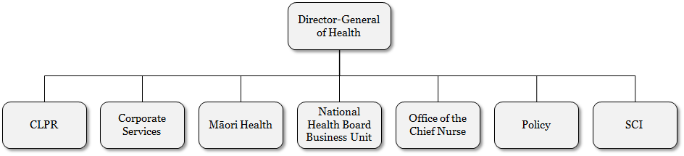

### Clinical Leadership, Protection and Regulation

Clinical Leadership, Protection and Regulation provides clinical leadership and advice on overarching clinical matters within the Ministry and acts as an interface for key health sector issues and input into the Ministry’s policy and operational work. It is also accountable for carrying out key statutory health protection functions, particularly in public and mental health, plus regulatory functions in relation to health care service providers and medicines.

### Corporate Services

Corporate Services assists and leads the Ministry to become a high-performing and effective Ministry, supporting the Minister and the public to make a positive difference to health. It plays a key role in the drive for improving organisational health, capability and performance and in providing assurance.

### Te Kete Hauora/Māori Health

Te Kete Hauora, the Māori Health business unit, provides policy advice on achieving the government objectives for Māori health. It works with other business units, sections and teams across the Ministry to improve the health of Māori; manages key relationships with other government agencies, DHBs, health-sector providers and organisations, iwi and Māori and takes a leadership role in Māori health for the health sector.

### National Health Board

The National Health Board (NHB) business unit provides leadership for strategic planning and funding of future capacity so that aspects such as IT, facilities and workforce are better integrated and driven by future requirements. The NHB is also responsible for funding, monitoring and planning DHBs, including annual regional and designated national service planning and funding rounds.

The NHB provides a number of processing support services to the health sector (eg, the contact centre, payment processing, preparing agreements and national data collections).

### Office of the Chief Nurse

The Office of the Chief Nurse provides expert advice on nursing to the government, as well as professional leadership to the nursing profession in New Zealand, working closely with nurse leaders within the health and disability system, the professional statutory bodies, professional and staff associations and unions, DHB chief executives and managers, and the voluntary and independent sectors.

### Policy

The Policy business unit provides advice that positions the health and disability system to deliver on government policy, respond to emerging priorities and meet future challenges. Policy works across the health and disability system and with other social-sector partner agencies to ensure the Ministry’s advice is well informed and contributes to improving the health and wellbeing of New Zealanders now and in the future.

### Sector Capability and Implementation

The Sector Capability and Implementation business unit works closely with the health and disability system to support implementation of the government’s strategic priorities in health. It identifies opportunities for improving health-sector performance; develops strategies that ensure integrated patient care and shares best practice, innovations, new evidence and learning across the health and disability system.

# Appendix E: Staff information

### Permanent staff

The number of permanent staff at the Ministry as at 30 June 2015 was 1083.93 full-time equivalents (FTEs), or 1129 individuals.

Figure E1: Staff numbers by business unit

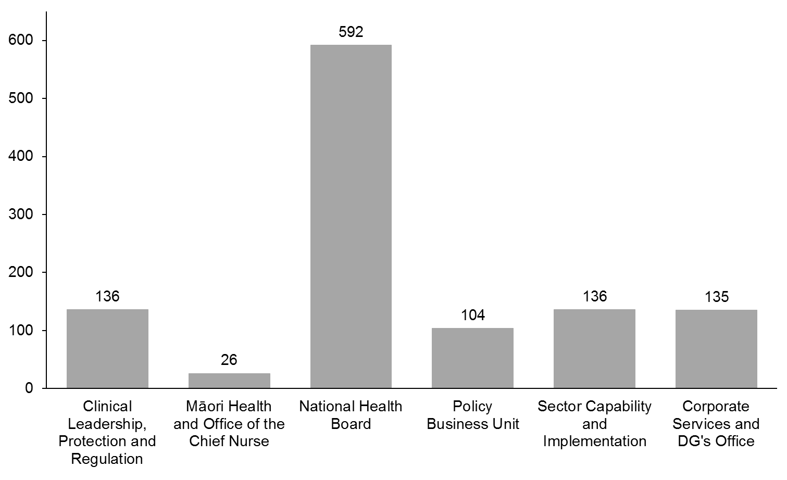

### Turnover

The 12-month rolling average turnover rate for 2014/15 was 14.8 percent; 166 staff left the Ministry during the year.

### Length of service

The average length of service for Ministry staff is six years.

Over 50 percent of current staff have been with the Ministry over five years; this is the same result since 2012/13.

Figure E2: Staff numbers by length of service

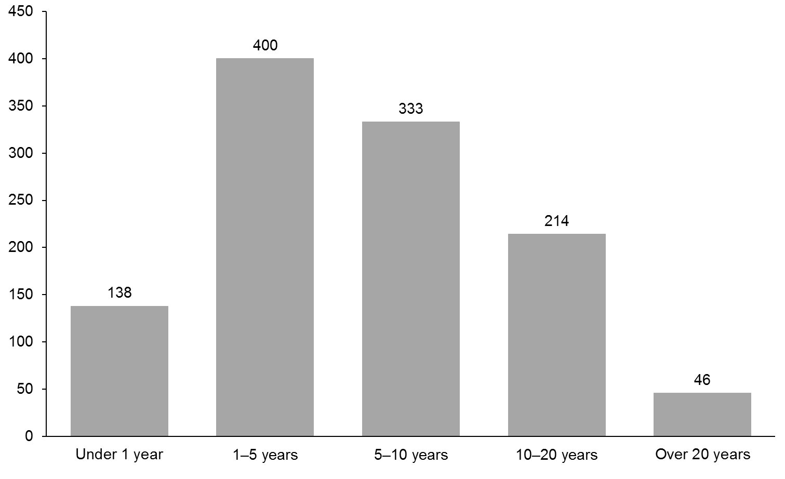

### Ethnicity

The New Zealand European ethnic group is the most dominant group within the Ministry, at 63 percent.

Figure E3: Staff ethnicity

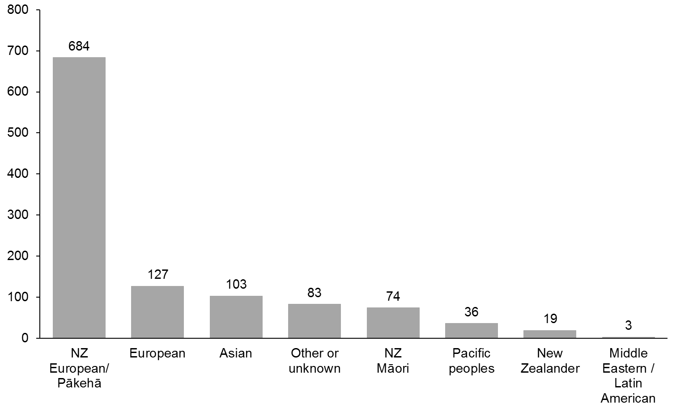

### Gender and age

Approximately 33 percent of Ministry staff are male, and 67 percent are female; in the previous year, the percentages were 35 and 65 respectively.

The overall average age of Ministry staff is 45 years (47 for males and 44 for females).

Figure E4: Staff numbers by age group and gender

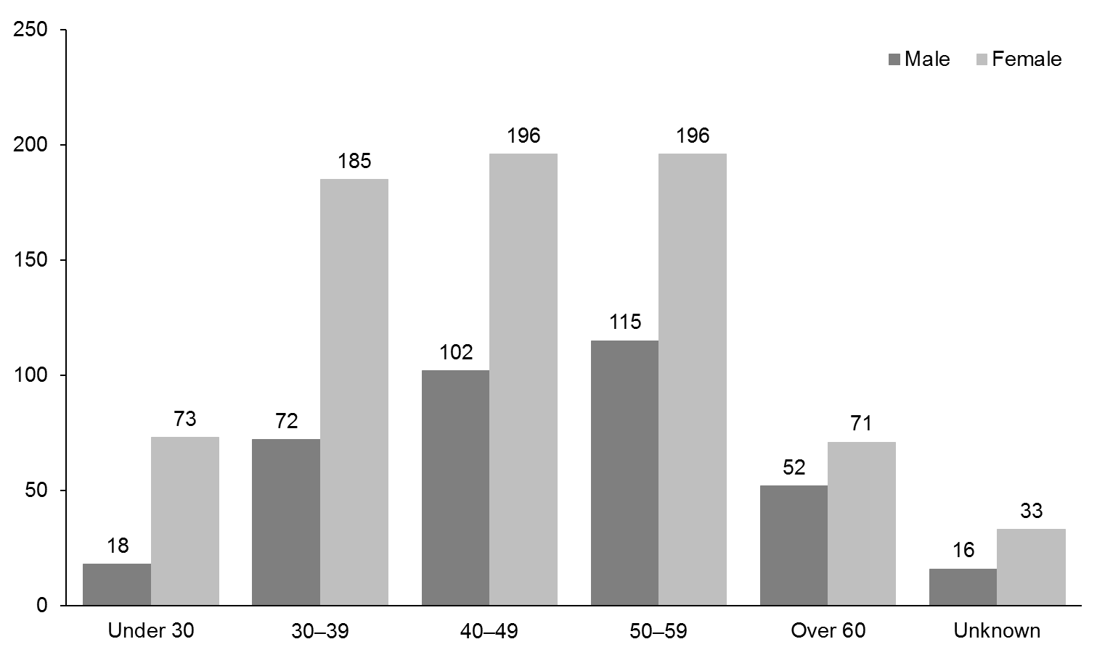

Figure E5: Gender proportion by age group

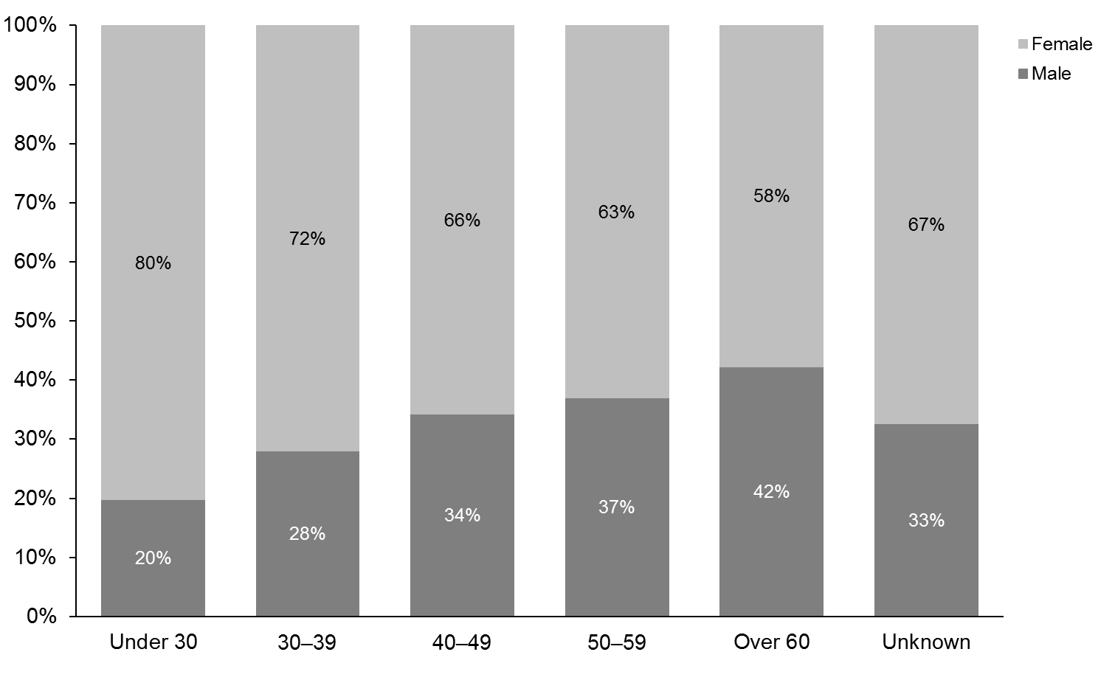

### Salary

Overall, average salaries of Ministry staff have increased over the last two years; from approximately $84,787 in 2012/13 to $88,504 in 2013/14 (an increase of approximately 6.2 percent) to approximately $90,000 in 2014/15 (an increase of approximately 2.5 percent).

Approximately 31 percent of staff are paid over $100,000, and there is approximately a $17,329 difference between the average salaries paid to male and female staff ($102,388 for male staff and $85,058 for female staff). There are a number of potential factors relating to this difference. A major influence is that more female staff work part time.

The Ministry is an equal employment opportunity employer. The Ministry’s remuneration policy ensures that all roles in the Ministry are evaluated using a recognised methodology and that salary bands are set accordingly, ensuring all employees, regardless of their age, gender or ethnicity, are rewarded on an appropriate salary scale.

The Ministry is committed to equal employment opportunities and has a transparent system for job applications.

Figure E6: Staff numbers by salary band

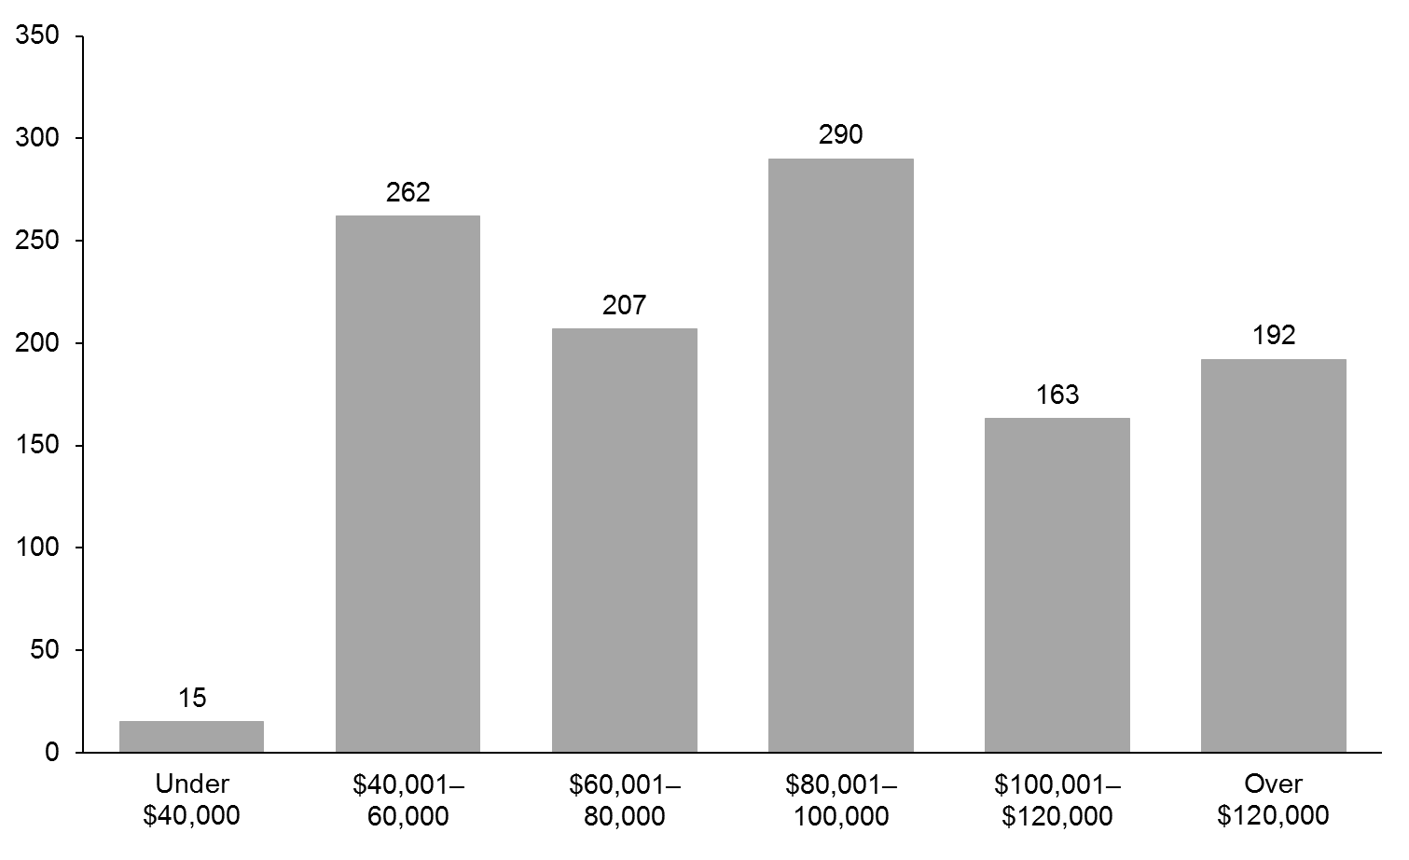

Figure E7: Gender proportion by salary band

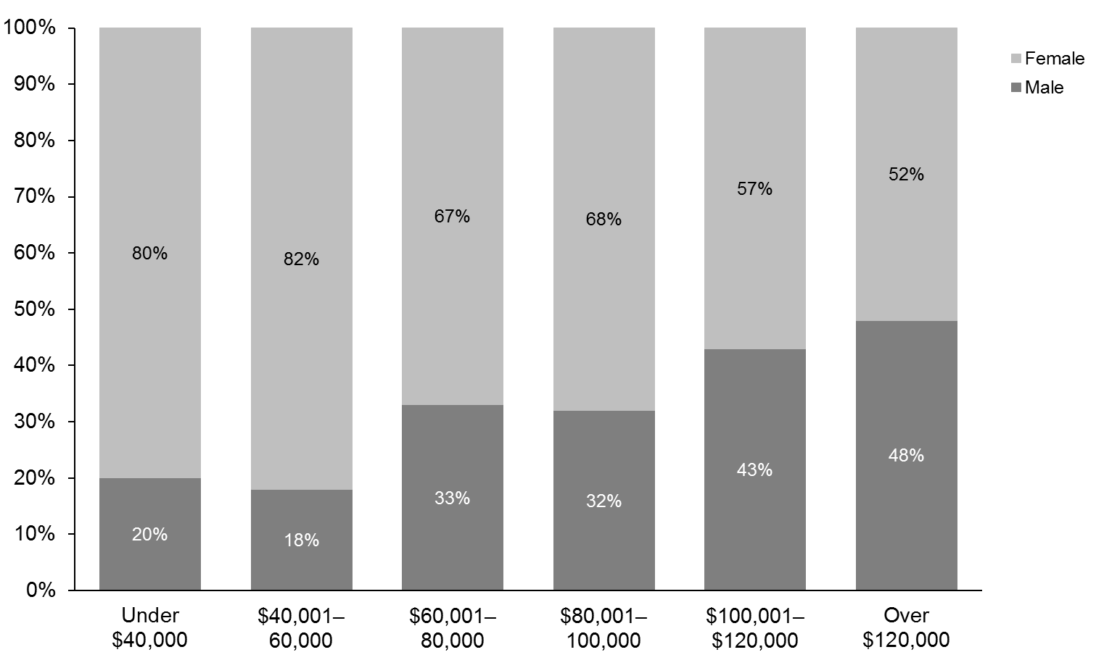

# Appendix F: Staff location

Ministry of Health permanent staff are located throughout the country, with the highest concentration of numbers being in Wellington.

|  |  |  |
| --- | --- | --- |
|  | **FTE** | **%** |
| Auckland | 63.63 | 5.8 |
| Waikato | 11 | 1.0 |
| Manawatu–Whanganui | 44.43 | 4.1 |
| Wellington | 868.71 | 80.2 |
| Canterbury | 36.5 | 3.4 |
| Otago | 59.66 | 5.5 |
| **Total** | **1083.93** | **100** |

Figure F1: Staff location

Figure F1: Staff location

1. Rising to the Challenge aims to improve outcomes for people who use primary and/or specialist mental health and addiction services, as well as offering support for their families and whānau. It provides direction to planners, funders and providers of publicly funded mental health and addiction services on priority areas for service development.
2. Three-year average rate 2009/10–2011/12.
3. HEEADSSS (Home, Education/Employment, Eating, Activities, Drugs and Alcohol, Sexuality, Suicide and Depression, Safety) Assessment allows for early identification of mental health, Alcohol and Other Drug (AOD) issues and other information to assist young people in their development.
4. Positive Behaviour for Learning (PB4L) School-wide is made up of practices and organisational systems that help schools create positive teaching and learning environments. Based on international evidence, it looks at behaviour and learning from a whole-school as well as an individual child’s perspective.
5. Source: Annual tobacco returns filed by manufacturers and importers to the Ministry of Health. http://www.health.govt.nz/our-work/preventative-health-wellness/tobacco-control/tobacco-returns/tobacco-returns-2014
6. Health target results are sourced from individual DHB reports, national collections systems and information provided by PHOs.
7. The national result for quarter three 2014/15 was 94.5 percent which was rounded to 95 percent for public reporting
8. ‘Elective surgery’ refers to planned rather than emergency procedures.
9. Between July 2008 and January 2011, the target was for patients who were ready for treatment to receive radiotherapy within six weeks of the decision to treat. This changed to four weeks from January 2011. The target was expanded to include patients needing chemotherapy from July 2012.
10. In quarter two 2014/15, one patient from Northland DHB did not receive treatment within four weeks due to an administrative error.
11. Rising to the Challenge aims to improve outcomes for people who use primary and/or specialist mental health and addiction services, as well as offering support for their families and whānau. It provides direction to planners, funders and providers of publicly funded mental health and addiction services on priority areas for service development.
12. ‘Priority women’ in BreastScreen Aotearoa and the National Cervical Screening Programme are Māori and Pacific women, women who have never been screened and women who are under-screened. In addition, Asian women are a priority group in the NCSP.
13. SPARX, is an online game-style tool to help young people develop skills to deal with feeling down, depressed, anxious or stressed. It was developed by a team of researchers from The University of Auckland and has been made available for free online through The Prime Minister’s Youth Mental Health Project. SPARX is available at from the [www.sparx.org.nz](http://www.sparx.org.nz) website. As well as the SPARX e-therapy programme, the website also offers a mood quiz to help young people identify depression and information on where to get help.
14. Impairment needing assistance means the need for assistance with everyday routines, which may come from another person or from a complex assistive device and may be either intermittent or continuous.
15. Statistics NZ. 2007. *2006 Disability Survey*. Wellington: Statistics New Zealand. URL: www.stats.govt.nz/browse_for_stats/health/disabilities/DisabilitySurvey2006_HOTP06/Technical%20Notes.aspx (accessed 3 July 2015).
16. Ministry of Health. 2012. *Tupu Ola Moui Pacific Health Chart Book 2012.* Wellington: Ministry of Health.
17. Life expectancy (NZ data): Statistics New Zealand (2014). NZ Social indicators – Life Expectancy. available from www.stats.govt.nz/
18. Life expectancy (OECD data): OECD (2015). OECD Health Statistics 2015, available from www.stats.oecd.org/
19. OECD Health Statistics 2015. OECD converts local currency units to United States dollars (USD), using a purchasing power parity (PPP) exchange rate.
20. The New Zealand Burden of Diseases, Injuries and Risk Factors Study, 2006–2016 (the New Zealand Burden of Disease Study) analyses health losses sustained by New Zealanders of all ages, both sexes and both major ethnic groups. More information on the study and the key findings can be found in the Health and Independence Report 2013 (Ministry of Health. 2013. *Annual Report of the year ended 30 June 2013 including the Director-General of Health’s Annual Report on the State of Public Health*. Wellington: Ministry of Health.)
21. The New Zealand Health Survey (NZHS) is an important data collection tool for monitoring the health of the population. A survey methodology report, the questionnaires and the content guides have been published.
22. Plunket is contracted to provide approximately 85 percent service coverage. The balance of service coverage is by local providers contracted via DHBs.
23. In 2011/12, daily smoking prevalence was 16.4 percent for adults aged 15 and over. For Māori and Pacific peoples, the rates were much higher, at 38 percent and 22.7 percent respectively. Ministry of Health. 2012. *The Health of New Zealand Adults 2011/12: Key findings of the New Zealand Health Survey*. Wellington: Ministry of Health.
24. Government Response to the Report of the Māori Affairs Committee on Its Inquiry into the Tobacco Industry in Aotearoa and the Consequences of Tobacco Use for Māori (Final Response), March 2011.
25. Ministry of Health. 2014. *Annual Update of Key Results 2013/14: New Zealand Health Survey*. Wellington: Ministry of Health.
26. The Ministry is the lead agency for the cross-government New Zealand Suicide Prevention Action Plan  
    2013–2016.
27. This is a new measure, which draws on the *Delivering Social Services Every Day: Changing how we work together to support New Zealanders* report, published by social sector agencies in May 2014. Further such reports are expected. See: [www.msd.govt.nz/documents/about-msd-and-our-work/publications-resources/corporate/every-day/delivering-services-every-day.pdf](http://www.msd.govt.nz/documents/about-msd-and-our-work/publications-resources/corporate/every-day/delivering-services-every-day.pdf) for a copy of the report.
28. Deaths from those conditions for which variation in mortality rates (over time and across populations) reflects variation in the cover and quality of health care (preventive or therapeutic services) delivered to individuals.
29. Source: [www.ssc.govt.nz/resources/9728/all-pages](http://www.ssc.govt.nz/resources/9728/all-pages) (accessed 24 July 2015).
30. The latest findings relate to data collected between October 2014 and March 2015. Sample number: 1142; overall response rate: 47 percent; completed online: 56 percent.
31. Falls refers to incidents that required hospitalisation for older people (not serious and sentinel events).
32. Although the national picture of health is positive, there are substantial variations in outcomes for different populations, particularly for Māori and Pacific peoples and for those living in more socioeconomically deprived areas. For example, rates of some illnesses (such as rheumatic fever and skin infections) are much higher among Māori and Pacific peoples. Ethnic health disparities are described in more detail in the Ministry’s *Health and Independence Report 2013*.
33. Ministry of Health. 2014. *Annual Update of Key Results 2013/14*. New Zealand Health Survey. Wellington.
34. Source: http://www.health.govt.nz/publication/fetal-and-infant-deaths-2011.
35. A 10-item questionnaire intended to yield a global measure of distress, based on questions about anxiety and depressive symptoms.
36. Nine DHBs are now approved to place alerts on the NCPAS, with another three DHBs to be approved by June 2014 and all 20 DHBs approved to place alerts by June 2015.
37. Reported against the National Infrastructure and Information Systems work programme for: system integration; the health information platform; leveraging health identity; and IT infrastructure and platforms.
38. The National Health IT Plan outlines the priority programmes required to deliver this target.
39. These figures are unaudited as the DHBs will not be audited until 31 October.
40. Surveys were undertaken in September 2012, September 2013 and April 2015.
41. In October 2010, Cabinet mandated annual reporting of the cost, efficiency and effectiveness of administrative and support services. These services cover five functions: Human Resources, Finance, ICT, Procurement, and Corporate and Executive Services. Data for the property management function is collected and reported separately by the Property Management Centre of Expertise in the Ministry of Social Development.
42. Within the ACC Partnership Programme audit standards there are three measurable levels of performance: Primary (programme entry level requirements); Secondary (consolidation of good practice); and Tertiary (continuous improvement best practice framework).
43. The percentage relates to audit activity occurring across the 14 streams of funding that makes up the total estimated funding of $6.4 billion. Provided there has been audit activity within a particular funding stream, then the entire funding stream is used to calculate the percentage. The total estimated funding is broken down to the following funding streams: Clinical Training Agency, Dental, Disability Support Services, GMS/MMS/PN, Internal Allocations, Laboratory, Māori Health, Maternity, Meningococcal, Mental Health, Personal Health, Pharmacy, PHO/Capitation, and Public Health.
44. The Ministry reforecast the budget number of appointments to DHBs and other health Crown entity boards from 117 to 33, in the Supplementary Estimates of Appropriations 2014/15 B.7; page 359.
45. The Ministry reforecast the budget standard from $109–119 to $165–175 in the Supplementary Estimates of Appropriations 2014/15 B.7; page 388.
46. Section 11 committees are not DHB or Crown entity boards.
47. National Ethics Advisory Committee was established under s16 of the New Zealand Public Health and Disability Act 2000. As such, it would not fall under the annual report requirement in s12(5).