Annual Report

for the year ended  
30 June 2014

Including the Director-General of Health’s Annual Report on the State of Public Health and the Minister of Health’s Report on Implementing the New Zealand Health Strategy

Citation: Ministry of Health. 2014. *Annual Report for the year ended 30 June 2014: Including the Director-General of Health’s Annual Report on the State of Public Health and the Minister of Health’s Report on Implementing the New Zealand Health Strategy*.  
Wellington: Ministry of Health.

Published in October 2014  
by the Ministry of Health  
PO Box 5013, Wellington 6145, New Zealand

ISBN 978-0-478-42895-7 (print)  
ISBN 978-0-478-42896-4 (online)  
HP6015

This document is available at www.health.govt.nz



### CCBY This work is licensed under the Creative Commons Attribution 4.0 International licence. In essence, you are free to: share ie, copy and redistribute the material in any medium or format; adapt ie, remix, transform and build upon the material. You must give appropriate credit, provide a link to the licence and indicate if changes were made.

# Director-General’s overview

The Ministry of Health has a leading role in shifting our health and disability system towards a wellness model. We can be proud that New Zealand has one of the highest performing health and disability systems in the world. To ensure the continued sustainability and suitability of the system, we are committed to moving towards services that focus on keeping people well and supporting them to take more control of their health.

Lifestyle factors continue to contribute to long-term conditions that are a growing area of concern, particularly conditions like obesity and cardiovascular disease. The health sector is increasingly focused on prevention, and healthier lifestyles are being promoted through new programmes like Healthy Families New Zealand. Keeping New Zealanders well will require our health system to work closely with other public services and local authorities, in partnership with individuals, whānau and communities.

Information technology is a key tool for supporting people to manage their own health and treatment. New Zealand is leading the way internationally with the new Electronic Patient Record, with which people can view and share their health information collected on one secure online site.

We are continuing to focus on improving quality and safety in our health and disability system. This is reflected in declining hospital readmission rates and ongoing improvements in achieving national health targets. For the third consecutive year, both the Improved access to elective surgery and Shorter waits for cancer treatment targets have been met by every DHB in the fourth quarter.

As at 30 June 2014, the national health targets for both the hospital and primary care component continue to show improvements against the national target as well as over the last year.

The Ministry is investing in workforce development and innovation in service delivery to enable health professionals to better respond to the challenges we face. Case management and care coordination training, for example, have been piloted and evaluated to assess demand for a national training programme for frontline workers supporting patients from before diagnosis through to the end of treatment.

Many of the more complex health issues some population groups face cannot be solved by the health sector alone. By working more closely with social sector colleagues, we continue to improve the way we deliver and integrate services to achieve health and wider social outcomes. Initiatives such as the Prime Minister’s Youth Mental Health project and Supporting Vulnerable Children work programme have established new norms in cross-agency public service delivery.

Health professionals too are being asked to work together across communities to provide people-driven solutions. Regional and national collaboration means district health boards working together with other partners in the sector to decide on the package of care and means of delivery that is most relevant, effective and sustainable for their communities.

We all have a role to play in shifting our health system towards a wellness model, in which people are at the centre of everything we do. The health sector will need:

* leaders who have the ability to innovate within financial constraints, hold challenging conversations, and possess the skills to work collaboratively across and beyond traditional boundaries
* a workforce willing to respond to changing population patterns, and prepared to develop new ways of delivering services that are responsive to the health needs of their community
* local populations that are equipped to live well longer in their own homes and communities, and have greater ownership of their health and wellbeing
* social sector colleagues who become key partners in achieving better health and wider social outcomes.

How we continue to respond, today and tomorrow, will determine the ongoing sustainability of our high-quality health system. In this *Annual Report*, you will find an account of our responses and how they are supporting the health and wellbeing of New Zealanders.



Chai Chuah

Acting Director-General of Health

Contents

Director-General’s overview iii

Section 1: The New Zealand health and disability sector 1

The 2013/14 health sector overview 1

The year in review 1

Government priorities 3

Better Public Services 3

Other multi-agency work 7

Responsibly managing government finances 10

Supporting the Christchurch recovery 10

Building a more competitive and productive economy 11

Minister’s priorities 12

Health targets 12

Improving access to services 19

Outcomes framework 26

Health and disability outcomes 26

Health sector outcomes 27

High-level Outcome 1: New Zealanders are healthier and more independent 29

High-level Outcome 2: Health services are delivered better, sooner and more conveniently 47

High-level Outcome 3: The future sustainability of the health system is assured 82

Organisational health and capability 89

Building for Our Future 89

Procurement strategy 92

Improving the performance of assets 93

Risk and assurance 95

Statement of service performance 97

Introduction 97

Information and payment services (MCOA) 98

Managing the purchase of services 103

Policy advice and ministerial servicing (MCOA) 106

Regulatory and enforcement services 109

Sector planning and performance 113

Statement of Responsibility 117

Independent Auditor's Report 118

Section 2: Financial statements 123

Introduction to the financial reports 123

Statement of comprehensive income for the year ended 30 June 2014 126

Statement of movements in taxpayers’ funds for the year ended 30 June 2014 126

Statement of financial position as at 30 June 2014 127

Statement of cash flows for the year ended 30 June 2014 128

Statement of commitments as at 30 June 2014 129

Statement of contingent liabilities and contingent assets as at 30 June 2014 129

Statement of departmental expenses and capital expenditure against appropriations for the year ended 30 June 2014 130

Statement of unappropriated departmental expenditure and capital expenditure for the year ended 30 June 2014 130

Notes to the financial statements for the year ended 30 June 2014 131

Non-departmental statements and schedules for the year ended 30 June 2014 156

Statement of non-departmental expenses and capital expenditure against appropriations for the year ended 30 June 2014 157

Statement of unappropriated non-departmental expenditure and capital expenditure for the year ended 30 June 2014 159

Schedule of non-departmental income and capital receipts for the year ended 30 June 2014 160

Schedule of non-departmental assets as at 30 June 2014 161

Schedule of non-departmental liabilities as at 30 June 2014 162

Schedule of non-departmental commitments as at 30 June 2014 162

Schedule of non-departmental contingent liabilities and contingent assets as at 30 June 2014 163

Problem Gambling Levy Report for the year ended 30 June 2014 164

Statement of trust monies for the year ended 30 June 2014 164

Notes to the non-departmental statements and schedules 165

Section 3: Health and Independence Report 2014 171

Purpose of this report 171

Summary of findings from this year’s report 171

Health system performance 177

People-centred health care 178

Access to services 181

Timeliness 185

Effectiveness 187

Patient safety 195

Efficiency and sustainability 197

Changing health needs 199

Population growth and change 199

Changing patterns of disease 201

Non-communicable diseases 206

Cancers 207

Cardiovascular diseases 210

Diabetes 212

Chronic obstructive pulmonary disease 214

Arthritis and other musculoskeletal conditions 215

Mental health conditions 216

Dementia 219

Risk factors for non-communicable diseases 220

Smoking 221

Alcohol consumption 223

Physical activity 225

Diet 226

Obesity 226

Blood pressure 229

Infectious diseases 231

Rheumatic fever 231

Vaccine-preventable diseases 233

Influenza 235

Sexually transmitted diseases 235

Emerging infectious disease threats 236

Notes for the Health and Independence Report 237

Indicators, measures and data sources 237

Implementing the New Zealand Health Strategy 2014 238

From the Minister of Health 238

1 Introduction 239

2 Health targets 240

3 Better public services 242

Supporting vulnerable children 242

Reducing long-term welfare dependence 242

Boosting skills and employment and reducing crime 243

4 Other government priorities 244

Whānau Ora 244

Youth mental health 244

5 Integration 245

6 Financial management and sustainability 246

DHB spending 246

Ministry of Health departmental spending 246

PHARMAC 246

Health Benefits Limited 247

7 Ensuring quality and safety 248

Quality and safety markers 248

Tracking quality and safety 249

References 250

Appendices

Appendix A: Glossary 253

Appendix B: Legal and regulatory framework 256

Appendix C: Section 11 committees 258

Appendix D: Organisational structure 262

Appendix E: Staff information 264

Appendix F: Staff location 268

List of Tables

Table 1.1: Health system outcome – New Zealanders live longer, healthier, more independent lives 27

Table 1.2: Health system outcome – the health sector is cost-effective and supports a productive economy 28

Table 1.3: Measures for Impact 1 30

Table 1.4: Measures for Impact 2 38

Table 1.5: Measures for Impact 3 43

Table 1.6: Measures for Impact 4 45

Table 1.7: Measures for Impact 5 48

Table 1.8: Measures for Impact 6 61

Table 1.9: Measures for Impact 7 66

Table 1.10: Ministry investment activities in the Pacific workforce 73

Table 1.11: Measures for Impact 8 77

Table 1.12: Measures for Impact 9 82

Table 1.13: Measures for Impact 10 86

Table 1.14: Measures for Impact 11 87

Table 1.15: People capability measures 91

Table 1.16: Expenditure on major IT projects, 2013/14 93

Table 1.17: Summary of service performance measures by departmental expense appropriation 97

Table 1.18: Summary of output performance measures and standards for health sector information systems 98

Table 1.19: Financial performance for health sector information systems 99

Table 1.20: Summary of output performance measures and standards for payment services 100

Table 1.21: Financial performance for payment services 102

Table 1.22: Summary of output performance measures and standards for managing the purchase of services 103

Table 1.23: Financial performance for managing the purchase of services 105

Table 1.24: Summary of output performance measures and standards for policy advice 106

Table 1.25: Financial performance for policy advice 108

Table 1.26: Summary of output performance measures and standards for regulatory and enforcement services 110

Table 1.27: Financial performance for regulatory and enforcement services 112

Table 1.28: Summary of output performance measures and standards for sector planning and performance 113

Table 1.29: Financial performance for sector planning and performance 116

Table 3.1: Patient experience indicators for adults, 2011/12 179

Table 3.2: Patient-centred care measures: New Zealand performance in Commonwealth Fund surveys 179

Table 3.3: Coordinated care measures: New Zealand performance in Commonwealth Fund surveys 180

Table 3.4: Percentage of adults and children reporting unmet need for primary care, 2012/13 182

Table 3.5: Number of people waiting over four months for elective first specialist appointment and elective treatment, 2012−2014 186

Table 3.6: Most common conditions causing ambulatory sensitive hospitalisations, by age and ethnic group, 2011−2o13 191

Table 3.7: Most common condition contributing to deaths amenable to health care, by age and ethnic group, 2009–2011 192

Table 3.8: Percentage and number of older people living in aged residential care, adults aged 85 years and older, 2006/07–2013/14 195

Table 3.9: Population of major ethnic groups, 2006 and 2013 200

Table 3.10: Parental perception of child’s weight, by BMI category, 2011/13 229

List of Figures

Figure 1.1: Patients admitted, discharged or transferred from an emergency department within six hours, 2009/10–2013/14 12

Figure 1.2: Volume of elective surgery, 2007/08–2013/14 14

Figure 1.3: Percentage of patients receiving radiation treatment or chemotherapy within target timeframe, 2009/10–2013/14 15

Figure 1.4: Percentage of eight-month-olds fully immunised, 2012/13–2013/14 16

Figure 1.5: Percentage of smokers offered help to quit, 2009/10–2013/14 17

Figure 1.6: Percentage of cardiovascular risk assessments completed, 2011/12–2013/14 18

Figure 1.7: Number of patients waiting over four months for treatment since 2007/08 23

Figure 1.8: The 2013/14 Outcomes Framework 26

Figure 1.9: Building for Our Future 89

Figure 2.1: 2013/14 departmental operational appropriations – actual expenditure ($000s) 124

Figure 2.2: Comparative data for 2012/13 departmental operational appropriations – actual expenditure ($000s) 124

Figure 2.3: 2013/14 non-departmental operational appropriations – actual expenditure ($000s) 125

Figure 2.4: Comparative data for 2012/13 non-departmental operational appropriations – actual expenditure ($000s) 125

Figure 3.1: Breast screening coverage rates in the past 24 months, women aged 45–69 years, by ethnic group, July 2007–May 2014 183

Figure 3.2: Cervical screening coverage rates in the past three years, women aged 25–69 years, by ethnic group, 2007–2013 183

Figure 3.3: Percentage of adults only visiting a dental health care worker for a problem (or never visiting), by neighbourhood deprivation, 2012/13 184

Figure 3.4: Percentage of total population accessing mental health and addiction services, Māori and non-Māori, 2002/03–2012/13 185

Figure 3.5: Percentage of patients waiting more than three months for elective procedures, by procedure type, 2010 and 2013 187

Figure 3.6: Caries-free (fluoridated and non-fluoridated) five-year-olds, by ethnic group, 2005–2013 188

Figure 3.7: Caries-free (fluoridated and non-fluoridated) Year 8 students, by ethnic group, 2005–2013 189

Figure 3.8: Proportion of new clients seen in acute inpatient mental health services (rather than specialist community mental health services), by ethnic group, 2002/03–2012/13 189

Figure 3.9: Ambulatory-sensitive hospitalisation admission rates per 100,000 people aged 0–74 years, by ethnic group, 2009–2013 190

Figure 3.10: Amenable mortality rate per 100,000 people aged 0–74 years, by ethnic group, 2000–2011 191

Figure 3.11: Five-year relative survival, by cancer type and sex, 2000–05 and 2006–10 193

Figure 3.12: Five-year relative survival, by cancer type, Māori and non-Māori, 2000−05 and 2006−10 193

Figure 3.13: Five-year relative survival, by cancer type, New Zealand and OECD average, 2006–11 (or nearest period) 194

Figure 3.14: Mortality rate within 30 days of admission to hospital with an acute myocardial infarction or stroke, adults aged 45 years or older, 2001, 2006 and 2011 194

Figure 3.15: Post-operative complication rate, New Zealand and OECD average, 2011 or nearest year 196

Figure 3.16: Average number of days spent in hospital by inpatients: medical, surgical and total, 2004–2013 198

Figure 3.17: Population counts, by age group, 2014–2026 (projected) 201

Figure 3.18: Leading causes of mortality, 1950–2010 202

Figure 3.19: Life expectancy at birth, by sex, 1950−52 to 2011−13 203

Figure 3.20: Adults with one or more long-term condition, by age group, 2012/13 204

Figure 3.21: Percentage of people with disability, by age group, 2001 and 2013 205

Figure 3.22: Cancer registration rate, Māori and non-Māori, 2002−2011 208

Figure 3.23: Cancer registration rate, by cancer type and sex, 2002–2011 208

Figure 3.24: Cancer mortality rate, by cancer type and sex, 2002–2011 209

Figure 3.25: IHD and stroke mortality rate, by sex, 2002–2011 211

Figure 3.26: Prevalence of diabetes, by age group, 2005 and 2013 213

Figure 3.27: Prevalence of diabetes, by ethnic group, 2013 213

Figure 3.28: Prevalence of arthritis in adults, by age group and sex, 2012/13 215

Figure 3.29: Prevalence of psychological distress in adults, by neighbourhood deprivation and sex, 2012/13 217

Figure 3.30: Suicide death rate, by sex, 2002–2011 218

Figure 3.31: Suicide death rate for youth, Māori and non-Māori, 2002–2011 219

Figure 3.32: Health loss attributed to 14 selected risk factors, 2006 221

Figure 3.33: Prevalence of daily smoking in adults, by neighbourhood deprivation and sex, 2012/13 222

Figure 3.34: Prevalence of daily smoking in Māori and non-Māori adults, by sex, 2002/03–2012/13 222

Figure 3.35: Prevalence of hazardous drinking in adults, by age group, 2006/07 and 2012/13 224

Figure 3.36: Travel to school in children aged 5−12 years, 1989/90 to 2009−2013 226

Figure 3.37: Prevalence of obesity, by age group and sex, 2012/13 227

Figure 3.38: Prevalence of obesity in adults, by decade of birth, 1997–2012/13 228

Figure 3.39: Prevalence of hypertension in adults, by age group, 2012/13 230

Figure 3.40: First episode rheumatic fever hospitalisation rate, 2002–2013 and five-year goal 232

Figure 3.41: First episode rheumatic fever hospitalisation rate, Māori and Pacific peoples, 2011–2013 232

Figure 3.42: Number of pertussis notifications, 1997–2013 233

Figure 3.43: Number of meningococcal disease notifications, 1997–2013 234

Figure 3.44: Weekly consultation rate for influenza-like illness, 2010 to August 2014 235

Figure E1: Staff numbers by business unit 264

Figure E2: Staff numbers by length of service 265

Figure E3: Staff ethnicity 265

Figure E4: Staff numbers by age group and gender 266

Figure E5: Gender proportion by age group 266

Figure E6: Staff numbers by salary band 267

Figure E7: Gender proportion by salary band 267

Figure F1: Staff location 268

Section 1: The New Zealand health and disability sector

# The 2013/14 health sector overview

## The year in review

The 2013/14 year has seen considerable activity by the Ministry of Health and the wider health and disability sector and increased engagement with other agencies to deliver the Government’s priorities and to ensure that New Zealanders have convenient and timely access to a wide range of quality health and disability services.

### Contributing to government priorities

As the lead agency for the New Zealand health and disability sector, the Ministry is a major contributor to the Government’s key priority areas. Budget 2013 affirmed those priority areas as being:

* delivering Better Public Services within tight financial constraints
* responsibly managing Government’s finances
* rebuilding Christchurch
* building a more competitive and productive economy.

During 2013/14 the Ministry worked with other agencies towards Government aims that included supporting vulnerable children, strengthening Whānau Ora services and promoting youth mental health, including suicide prevention. In addition, the health sector is responsible for increasing immunisation rates, a substantial reduction in rheumatic fever cases among children and a reduction in the number of assaults on children.

### Delivering the Ministry’s priorities

The Ministry’s individual priorities include:

* meeting health targets
* providing care closer to home
* supporting the health of older people
* making the best use of information technology (IT) and ensuring the security of patients records
* strengthening the health workforce
* regional and national collaboration.

The Ministry’s contribution to all of these priorities over 2013/14 is outlined in the following pages.

### The Ministry’s core business

Over 2013/14 the Ministry continued to deliver its core functions: to provide advice to the Minister and whole of government on health issues, provide regulatory functions that protect the public, purchase national health and disability support services and provide health sector information and payment services.

The Ministry has supported the Government to develop, consult on and implement significant pieces of legislation. The Psychoactive Substances Amendment Act 2014 was developed and passed under urgency, and the Smoke-free Environments (Tobacco Plain Packaging) Amendment Bill was introduced to Parliament and has been considered by the Health Select Committee. The Medicines Amendment Act 2013 was passed in December 2013, and the Health (Protection) Amendment Bill was introduced in Parliament in July 2014.

Further details on the Ministry’s specific activities and its progress towards outcome goals appear in the following sections.

# Government priorities

During 2013/14 the Ministry was responsible for supporting vulnerable children, one of the Government’s 10 key results for the public sector. The Ministry also contributed to the Government’s goal of Better Public Services Functional Leadership through using the Government IT infrastructure, improving procurement processes and property management.

The Ministry regularly works jointly with other agencies to deliver Whānau Ora services, youth mental health services (including suicide prevention) and the methamphetamine action plan.

Further details appear in the following pages.

## Better Public Services

The Government aims to provide Better Public Services for New Zealanders by collectively working across government agencies to achieve ten key results by 2017. These results are grouped into five themes; social sector agencies are held jointly responsible for two:

* supporting vulnerable children
* reducing long-term welfare dependence (through welfare reform).

The Ministry has also made a particular contribution to another theme: addressing the drivers of crime.

### Supporting vulnerable children

The Ministry and the health sector are responsible for increasing immunisation rates and reducing the incidence of rheumatic fever among children, and for reducing the number of assaults on children. To achieve these results, the health sector is working with other sectors, because the issues involved cut across traditional boundaries (for example, action on rheumatic fever requires involvement with schools and housing agencies).

#### Children’s Action Plan

The Children’s Action Plan (CAP) calls for the implementation of ‘children’s teams’: groups of professionals from health, education, welfare and social service agencies who work with individual at-risk children and their families. This year, the Ministry supported Lakes and Northland DHBs in implementing the local health contribution to the first children’s team demonstration sites in Rotorua and Whangarei. The Ministry worked with DHBs to ensure their annual plans included actions and timeframes for the establishment of regional governance and cross-sector collaboration to implement local children’s teams.

The Ministry has worked closely with the Ministry of Social Development (MSD)’s CAP Directorate to provide local implementation support to the establishment of new children’s teams in Horowhenua, Marlborough, Hamilton City, Clendon/Manurewa/Papakura, Gisborne, Whanganui, Christchurch and Whakatane.

The Ministry is also working closely with MSD on key initiatives that will underpin local efforts in identifying vulnerable children and youth and providing required services, including:

* developing an approved information sharing agreement
* developing whole of child and family multi-agency assessments
* planning a trial of the Predictive Risk Modelling tool
* developing the Vulnerable Kids Information System, to support practice and information sharing.

#### Increasing immunisation rates for infants

The Ministry has made considerable progress towards increasing infant immunisation coverage in New Zealand, working with district health boards (DHBs) and primary health organisations (PHOs) to achieve the 2013/14 target of 90 percent of infants receiving their scheduled immunisations by the time they are eight months old. At the end of June 2014, 92 percent of eight-month-olds were fully immunised. This exceeded the health target goal of 90 percent coverage by July 2014. Fifteen DHBs were successful in reaching the target of 90 percent.

Maintaining immunisation coverage rates for two-year-old children continues to be a priority since the Ministry’s target changed in June 2011. Currently 93 percent of two-year-olds are fully immunised (a two percent increase over the last year).

#### Child, Youth and Family hospital social workers

Child Youth and Family (CYF), police and DHBs are collaborating on defining the roles and responsibilities of CYF-funded hospital liaison social workers , according to a nationwide multi-agency memorandum of understanding (MOU) established in February 2014. DHBs’ 2013/14 annual plans must include planning to implement and monitor this MOU.

#### Reducing rheumatic fever among children

The Rheumatic Fever Prevention Programme began on 1 July 2011, and has been significantly expanded since then. It aims to reduce rates of new cases of rheumatic fever by two-thirds, from a baseline rate of 4.2 cases per 100,000 people in 2011 to 1.4 cases by June 2017.

The Ministry initially allocated $24 million to the Programme over four years for the implementation of school-based throat swabbing services to cover more than 50,000 children. District health boards and non-governmental organisations (NGOs) have been contracted to provide these services, and achieved the coverage target in 2013/14.

The Ministry developed plans with key sector and cross-agency stakeholders to expand the Programme in 2012/13, and implemented them during 2013/14, allocating an additional $21.6 million from July 2013. Budget 2014 allocated a further $20 million to expand primary care access and healthy housing initiatives to areas with high incidence of rheumatic fever outside Auckland and Porirua, the initial areas of focus for the Programme.

The rate of hospitalisations for 2013/14 is 4.3 per 100,000 (194 hospitalisations). This is an increase over the prior year but may be due to increased awareness and diagnosis of rheumatic fever, a natural variation due to small numbers of incidence or a true increase.

The Ministry continues to work with key stakeholders to develop and implement new initiatives to combat rheumatic fever, including sore throat drop-in clinics, rheumatic fever awareness campaigns and focused engagement work with Pacific communities, which are at higher risk. These initiatives are integrated through DHB Rheumatic Fever Prevention Plans.

##### Healthy housing

Addressing household crowding is an important part of rheumatic fever prevention – reducing the incidence of transmission of *Streptococcus* A sore throats. In the 2013/14 year, the Ministry has led a programme of cross-government action to reduce household crowding, with a specific focus on Auckland. As part of this programme, the Ministry has funded a new initiative to coordinate housing interventions for families identified as at risk.

The Auckland-wide Healthy Homes Initiative (AWHI) works with low-income families with children at risk of rheumatic fever who are living in crowded circumstances to put together a package of interventions to reduce that crowding. These interventions are delivered by a range of government agencies and community organisations, and include a fast track to rehousing; household repairs, insulation and curtains to improve the warmth of houses, along with grants and loans for heating sources; beds and bedding to improve sleeping conditions; and financial and housing literacy advice and support. Since April 2014, MSD has administered the assessment and prioritisation of social housing; the initiative has since been extended to other high-risk regions.

The Ministry has also facilitated the development of a cross-government action plan to reduce household crowding, agreed to by the Social Sector Forum (SSF), which will be providing regular oversight. This plan includes additional Ministry funding (allocated in Budget 2014) to enable further action in 2014/15 and out years to strengthen housing interventions in Auckland. It extends actions to reduce household crowding for populations at high risk of rheumatic fever to seven other DHB regions.

#### Mentoring vulnerable children

Over 2013/14 the Ministry produced resources containing practical tips and guidance on mentoring vulnerable children, together with MSD (Family and Community Services; CYF), Ministry of Education, Te Puni Kōkiri and Ministry of Pacific Island Affairs. These resources were published on the Ministry of Health’s and Children’s Action Plan (CAP) websites. The Ministry commissioned the Health Promotion Agency to complete a literature review and environmental survey to inform a community responsibility programme for CAP. The Ministry funded Philanthropy New Zealand to provide advice on CAP’s proposed programme of scholarships and mentoring programmes for vulnerable children and youth.

### Reducing long-term welfare dependence through welfare reform

The welfare reform programme aims to support more people into sustainable employment by investing in support and services that have the greatest lifetime impact.

In Budget 2013Vote Health was allocated an extra $1.398 million per annum to provide support to beneficiaries who fail, refuse to take, or are likely to fail the recently introduced pre‑employment drug testing for beneficiaries.

To support the Government’s programme of welfare reform, and ensure the value for money and effectiveness of the programme, the Ministry has taken a number of steps.

* The Ministry has contracted, Alcohol Drug Association New Zealand, the provider of a nationwide alcohol and other drug helpline service, to support beneficiaries who are likely to fail a work-related drug test. This service has assisted beneficiaries in accessing relevant treatment services.
* The Ministry, the provider and Canterbury DHB have entered into an arrangement to implement an extended alcohol brief intervention service through primary care to assist families affected by the earthquakes, and Canterbury’s influx of construction workers.
* The Ministry has provided improved assessment and customised support for people with health and disability conditions that affect their employment chances.

### Addressing the drivers of crime

Over 2013/14 the Ministry worked with other agencies on initiatives to reduce crime, including the following initiatives.

* The Ministry devolved funding for primary mental health, including $1.07 million for alcohol brief interventions, in October 2013.
* Following a contestable process, the Ministry contracted two youth exemplar services for youth alcohol and other drug treatment, in Northland and Southern DHBs. Additionally, it provided resources (increased capacity and assistance with planning/change management) to four other DHBs that responded to the tender process.
* Eleven providers (10 NGOs and one DHB) provided increased treatment programmes for repeat drink-drivers.
* The Ministry contracted six DHBs to provide additional treatment programmes for community-based offenders, through improving referral efficiency and increasing capacity.

#### Methamphetamine action plan

The overall goal of the Prime Minister’s *Tackling Methamphetamine: An Action Plan* is a significant reduction in methamphetamine use, which will lead to a reduction in the harm methamphetamine causes. Four measurement areas in the Plan that have been achieved (or are ongoing) include:

* improving routes into treatment for methamphetamine patients by re-contracting and maintaining 60 residential beds and 20 social detox beds
* reclassifying pseudoephedrine (a basic product used to manufacture methamphetamine) from an over-the-counter drug to a class B2 drug, to limit its domestic availability
* improving access to education about methamphetamine through MethHelp (www.methhelp.org.nz)
* workforce development via Te Rau Matatini, which provides scholarships and internships for Māori health workers wishing to develop specialist skills in addiction treatment.

These initiatives are in addition to those that DHBs already fund. Since the Plan was launched in October 2009, over 600 people have been treated through the residential beds, and a further 500 have accessed the social detoxification services (to 30 June 2014). Without these additional services, it is likely these people would have faced serious delays in accessing treatment, and may not have accessed treatment at all.

A recently implemented free, nationwide, confidential telephone service and the MethHelp ([www.methhelp.org.nz](http://www.methhelp.org.nz)) website (improving access to information about methamphetamine and its effects, and what treatment involves) allow people to obtain accurate information when they want it, in order to manage their own treatment.

The Ministry is also currently developing legislation for compulsory alcohol and drug treatment. The proposed Substance Addiction (Compulsory Assessment and Treatment) Bill will repeal and replace the Alcoholism and Drug Addiction Act 1966, in accordance with the recommendations of the Law Commission. The Bill is category 3 on the legislative programme.

## Other multi-agency work

### Social Sector Forum

Through its work in the Social Sector Forum (SSF) and with other agencies, the Ministry continues to address some significant challenges facing New Zealanders. SSF leads collective work on social sector priorities. It is chaired by the Chief Executive of MSD, and includes the Secretaries of Justice and Education, the Director-General of Health, Chief Executives of the Ministry of Business Innovation and Employment, Pacific Island Affairs and Te Puni Kōkiri and the Commissioner of Police. In addition to achieving the Better Public Services results listed above, the Forum has also focused on the following:

* social sector trials and social sector integration
* improvement methodology
* the Youth Crime Action Plan
* *New Zealand Suicide Prevention Action Plan 2013–2016*
* youth mental health
* family violence
* contracting.

#### Social sector trials

The Ministries of Education, Health, Justice and Social Development and the New Zealand Police are working together with selected communities on social sector trials to test the integration of services within and devolution of decision-making to local communities. Trials in the six original locations have been extended until December 2014, and 10 second tranche trials are midway through their two-year trial. Lessons learnt from the trials will be applied widely in future, further integrating the social sector.

#### Improvement methodology

On behalf of the SSF the Ministry of Health has convened an Improvement Methodology Panel of Suppliers, to deliver education, training and evaluation and project support to social sector agencies and organisations in their sectors as they implement improvement methodology.

Under improvement methodology, organisations constantly identify problems and opportunities, and use frequent small-change trials to evaluate developed solutions, thereby accelerating both learning and innovation and ultimately enhancing the consumer experience. By trialling solutions on a small scale, organisations can amend or stop changes that are not working, to try other ideas. When the change seems to be working effectively on a reasonable scale, it is formalised and becomes business as usual.

Improvement methodology has been used in some areas of the Rheumatic Fever Prevention Programme and in an initiative with Well Child/Tamariki Ora services to increase early childhood education participation.

### Whānau Ora

The Ministry continues to work with lead agency Te Puni Kōkiri on the Government’s ongoing Whānau Ora work programme. Whānau Ora is an approach supporting the aspirations of whānau to be self-managing and take responsibility for their economic, social and cultural development.

Whānau Ora puts whānau in the centre, and in control of achieving their own goals. While it supports the independence of whānau, it also entails government services developing and implementing health services that are responsive to the needs of whānau and their wider communities.

The Ministry works closely with DHBs to support the 32 Whānau Ora collectives (comprising approximately 180 health and social providers) to implement programmes of action that have been assessed by the Ministry in collaboration with relevant DHBs.

### Youth mental health

The Ministry is responsible for implementing the Prime Minister’s Youth Mental Health Project (YMHP), a cross-agency package of 26 initiatives that aim to improve mental health and wellbeing for young people with, or at risk of developing, mild to moderate mental health issues. The initiatives are set across schools, the health sector, communities and online. Achievements of the Project in 2013/14 were as follows.

* Four initiatives were completed (Improving the youth-friendliness of mental health resources, Social support for Youth One Stop Shops, Youth Referral Pathways Review and Youth mental health training for social services).
* Forty-four decile 3 schools, teen parent units and alternative education facilities are now delivering school-based health services to young people as of term 3 in 2014 (decile 1 and 2 schools are already funded for nursing services).
* An evaluation of school-based health services indicated that high-quality services impact positively on student health and wellbeing.
* The SPARX e-therapy tool was launched in April 2014. Since the launch, there have been over 10,000 unique hits on the website, and 1668 people have registered to use the programme.
* Transition guidelines for Child and Adolescent Mental Health Services and youth Alcohol and Other Drug (AOD) services were published, and are now available online.
* Exemplar youth AOD services were established in Northland and Southern DHBs.
* Thirty-one secondary schools are currently taking part in the trial of My FRIENDS Youth.
* Draft indicators of student wellbeing in schools were developed and distributed to schools.
* The Education Review Office published the report *Improving Guidance and Counselling for Students in Secondary Schools.*
* Fifteen new youth workers started work in secondary schools in Auckland, Wellington and Hawke’s Bay.
* Feedback and assessments indicate that the Te Puni Kōkiri led Whānau Ora for Youth Mental Health Approach had a positive impact on 20 rangatahi in the Hastings region. The initiative will continue for a further year.

The Social Policy Research and Evaluation Unit at the Families Commission has been contracted to complete an evaluation of the YMHP. A formative evaluation report is due in September 2014.

### Canterbury youth mental health action plan

A local cross-agency action plan has been published to address emerging youth mental health issues in the Canterbury region. The action plan covers a range of work streams, including a schools-based mental health team, which provides services to schools in Greater Christchurch and has recently been extended to schools in North Canterbury. The action plan is Initiative 26 of the YMHP, and is also part of the wider psychosocial response to the Canterbury earthquakes, which is coordinated by the Canterbury Earthquake Recovery Authority (with input from other government and non-government agencies).

### Suicide prevention

Suicide remains a concerning health and social issue in New Zealand. The most current statistics are as follows.

* At total of 493 people (a rate of 10.9 per 100,000 people) died from suicide in 2011. The suicide rate declined by 27.8 percent between 1998 (when it peaked at 15.1 per 100,000) and 2011.
* A total of 377 males died from suicide (a rate of 17.0 per 100,000) and 116 females died from suicide (a rate of 5.1 per 100,000) in 2011.
* Youth suicide remains a concern. In particular, rates for Māori youth remain higher than those for non-Māori youth, and have not shown a downward trend over time (as the non-Māori youth rate has). The New Zealand male and female youth suicide rates in 2011 were the second-highest among OECD countries.

The Ministry of Health is the lead agency for the cross-government *New Zealand Suicide Prevention Action Plan 2013–2016* (the SPAP). The SPAP comprises 30 actions, which sit under five objectives, designed to build on existing work in suicide prevention. It has a particular emphasis on assisting communities and frontline workers to identify and respond to suicidal behaviour, and reducing the impact of suicide on communities. A key focus area is building the capacity of Māori and Pasifika communities to prevent suicide. In developing the SPAP, the Ministry took into account the experiences of communities that have responded to suicide.

Key achievements to date include the following.

* The Victim Support Initial Response Service now covers the nation.
* The Ministry has delivered specialist training in recognising and responding to self-harm and suicide risk to CYF caregivers around the country. This is now a permanent module in the suite of training offered by CYF.
* The Ministry has established the national coordination hub for Māori Community Suicide Prevention.
* The Ministry has established the national coordination hub for Pasifika Community Suicide Prevention.
* By the end of June 2014, 2300 Work and Income staff who had face-to-face contact with clients had received training on how to recognise, relate to and respond to clients experiencing mental stress or illness, or who need extra support.

## Responsibly managing government finances

Vote Health is a significant component of government expenditure ($14.655 billion in 2013/14). It is essential that New Zealanders get the best value for their tax dollars. In addition to managing its own funding responsibly, the Ministry’s stewardship role means it has a duty to ensure the wider health and disability system is managed in an efficient and productive manner, and delivers continuous improvements in the health services New Zealanders receive. The Ministry works with sector partners to manage funds effectively; for example, working with the ACC (via service agreements) to provide injury cover for all New Zealand citizens, residents and temporary visitors to New Zealand.

As the second largest area of public spending (after social development), health spending will play a key role in Government’s aim of returning to budget surplus in 2014/15. The challenge is to continue providing New Zealanders with excellent health care while ensuring the cost of our health system is sustainable.

Publicly funded spending on health care has more than doubled as a share of gross domestic product (GDP) over the past 60 years, rising from around 3.1 percent in 1950 to 6.9 percent in 2012. This rate of increase is typical of countries in the OECD. Annual government spending on health care rose from $589 per person in 1950 to $3,181 per person in 2012 (both figures in 2012 dollars).

The Ministry of Health influences how DHBs, PHARMAC, clinicians and others in the health sector allocate resources and manage cost pressures. The way the sector works together affects how efficiently resources are used and how spending pressures are managed.

A strategy for the Ministry is to encourage investment towards models of care and services that efficiently meet individual needs. Such models incorporate better use of information technology, ensuring, for example, that patients’ health records are available to them and to their health care providers no matter where services are delivered.

## Supporting the Christchurch recovery

Meeting the health needs of Cantabrians is a key element of Government’s response to the Christchurch earthquakes. The Ministry has been supporting initiatives to address mental health issues stemming from stress and anxiety associated with the earthquakes. It is working with Canterbury DHB and other agencies, such as the Canterbury Earthquake Recovery Authority (CERA), to implement the Community in Mind Strategy which raises community awareness through a public relations campaign and encourages individual and community resilience, supported by DHBs providing tailored solutions across the health spectrum.

The Ministry’s role in rebuilding Christchurch also involves supporting CERA and Canterbury DHB to address structural and capacity issues.

Under the governance of the Hospitals Redevelopment Partnership Group, the Ministry is managing the design and construction of new buildings at Burwood Hospital and the main Canterbury Health Campus. The Ministry has appointed architects, engineers, quantity surveyors and project managers for the design of Burwood Hospital, and awarded the contract to build Burwood Hospital in December 2013. The main Canterbury Health Campus design and support functions will also be contracted.

## Building a more competitive and productive economy

A strong health and disability sector is central to a more competitive and productive economy.

A healthy population is better able to participate in the workforce, and in education and training. Lower rates of sickness and greater rates of productivity contribute to economic growth, and reduce reliance on sickness and disability benefits. District health boards and other health sector organisations provide a direct contribution to economic activity as employers and purchasers within their local communities.

# Minister’s priorities

## Health targets

Health targets are a set of national performance measures specifically designed to improve the performance of the health system. Health targets were introduced in 2007/08 and refocused in 2009. The targets are reviewed annually to ensure they continue to align with the Government’s priorities. The six key health targets for 2013/14 were:

* shorter stays in emergency departments
* improved access to elective surgery
* shorter waits for cancer treatment
* increased immunisation
* better help for smokers to quit (in public hospitals and primary health care)
* more heart and diabetes checks.

The Ministry continues to measure and report on the health targets, and works closely with DHBs to achieve them.[1] It has appointed a Ministry ‘champion’ for each target, to work with the sector to ensure good practice and share innovations. The champion provides support, and is the key link between the Ministry and people working to achieve target results in the sector.

### Shorter stays in emergency departments

**The health target:** 95 percent of patients will be admitted, discharged or transferred from the emergency department within six hours.

Figure 1.1: Patients admitted, discharged or transferred from an emergency department within six hours, 2009/10–2013/14

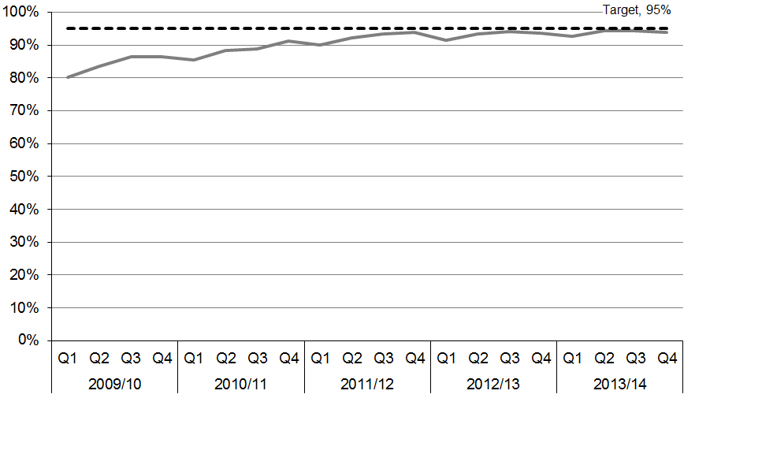

The length of a person’s stay in an emergency department is an important measure of the quality of acute (urgent) care in our public hospitals. This health target measures the efficient flow of acute patients through the hospital.

From quarter one 2013/14, some agreed level two emergency departments were included in the target: Taupo (Lakes DHB), Kaitaia (Northland DHB), Tokoroa and Taumarunui Hospitals (Waikato DHB).

By the end of 2013/14, 93.9 percent of patients were being admitted, discharged or transferred from an emergency department within six hours, and 11 DHBs had achieved the health target, despite quarter four 2013/14 being the second busiest quarter in terms of emergency department presentations since the target began. Presentations in quarter four 2013/14 were 4.7 percent higher than in quarter four 2012/13 when excluding the agreed level two emergency departments, and 7.9 percent higher when including the level two departments.

To support achievement of this health target, the Ministry has:

* published *A Quality Framework and Suite of Quality Measures for the Emergency Department Phase of Acute Patient Care in New Zealand* (the framework) to support DHBs with continued quality improvements in their emergency departments
* held a workshop to support DHBs with implementing the framework, including discussion of the need to develop definitions for the mandatory measures and tools to enable audit
* commenced the development of audit tools and definitions for the mandatory measures of the framework
* provided tailored one-on-one support to DHBs, including visits, teleconferences and weekly meetings with DHBs that have not yet met the target
* alongside emergency department and cardiology clinicians, commenced development of the Accelerated Chest Pain Pathway to improve the acute patient journey
* commenced a review of the suicide prevention in emergency departments guideline, to improve the experience of people presenting to emergency departments with self-harm injuries.

### Improved access to elective surgery

**The health target:** The volume of elective surgery[2] will be increased by at least 4000 discharges per year.

Figure 1.2: Volume of elective surgery, 2007/08–2013/14

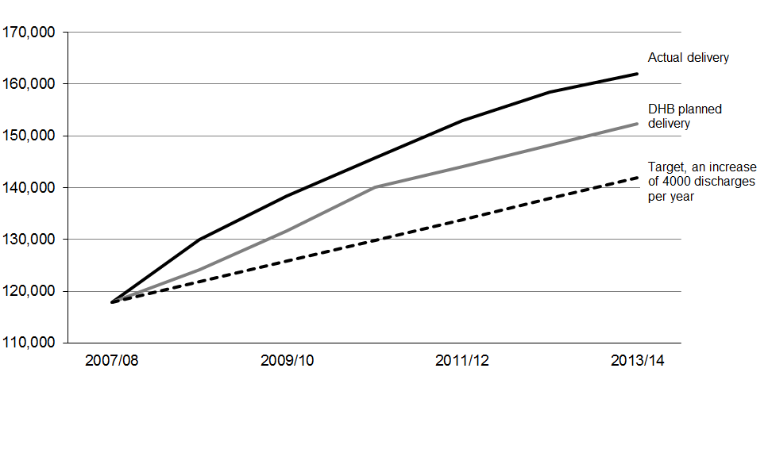

This target has consistently been exceeded, including in 2013/14. District health boards planned to deliver 152,287 elective surgical discharges in 2013/14, and delivered 9646 (6 percent) more than this. This represents an increase of more than 37 percent since 2007/08, or an average increase of more than 7300 elective discharges a year.

To support achievement of this health target, the National Health Board’s (NHB) electives team engages with a wide range of clinical and management teams: within DHBs, across professional bodies and through the general practitioner (GP) liaison network. The NHB team clearly communicates its expectations, and works closely alongside sector teams to support progress and to actively identify and resolve issues as they arise.

### Shorter waits for cancer treatment

**The health target:** All patients, ready-for-treatment, wait less than four weeks for radiotherapy or chemotherapy.

Figure 1.3: Percentage of patients receiving radiation treatment or chemotherapy within target timeframe, 2009/10[3]–2013/14

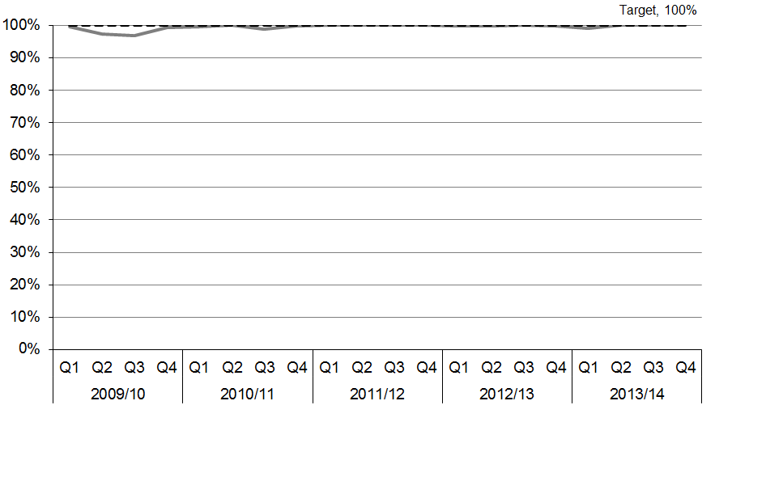

Specialist cancer treatment and symptom control are essential to reducing the impact of cancer and delivering better outcomes for patients.

DHBs have performed consistently well against the shorter waits for cancer treatment target since the four-week target was introduced in July 2011. In July 2013, two Waikato DHB patients waited longer than four weeks to receive chemotherapy. In August 2013, Canterbury DHB had one patient who waited longer than four weeks for radiotherapy.

Continued achievement of the target has been maintained through a range of Cancer Programme initiatives, including:

* the development of a National Radiation Oncology Plan and the Medical Oncology Models of Care
* sector engagement through the Radiation and Medical Oncology Work Groups and the Cancer Treatment Advisory Group
* development of good data reporting systems in each DHB to identify areas for improvement.

### Increased immunisation

**The health target:** 90 percent of eight-month-olds have their primary course of immunisation at six weeks, three months and five months on time by July 2014 and 95 percent by December 2014.

Figure 1.4: Percentage of eight-month-olds fully immunised, 2012/13–2013/14

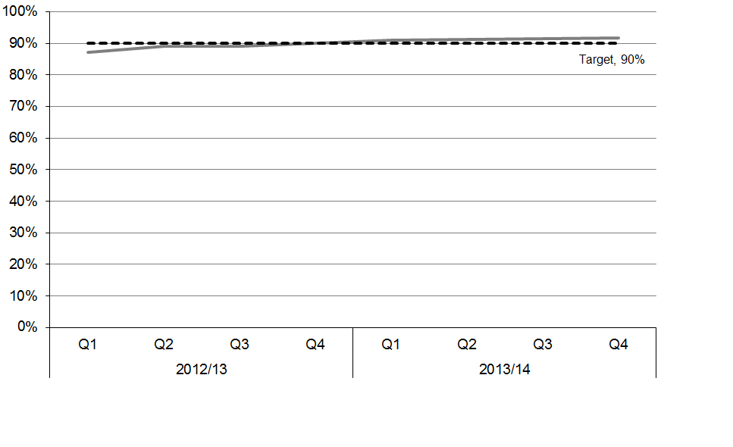

Immunisation not only provides individual protection for a number of vaccine-preventable diseases, but also provides population-wide protection by reducing the incidence of infectious diseases and preventing spread to vulnerable people. Some of these population-wide benefits only arise with high immunisation rates. Widespread immunisation reduces the impact of vaccine-preventable diseases on our health system.

Over 2013/14, immunisation coverage for eight-month-olds increased nationally from 91 percent in the first quarter to 92 percent in the fourth quarter. Fifteen DHBs were successful in reaching the target. This achievement builds on the outstanding accomplishment of increasing two-year-old immunisation coverage to 93 percent. Achievement of the target by ethnicity was as follows: New Zealand European 92 percent, Māori 88 percent, Pacific 95 percent, Asian 97 percent. Coverage increased to 89 percent for those living in deprivation quintiles 9 and 10.

The *increased immunisation* health target of 95 percent needs to be achieved by December 2014 and maintained until 2017, as part of the Prime Minister’s Better Public Services results commitment.

The Ministry’s health target champion and immunisation team work closely with DHBs and PHOs to increase immunisation coverage using a variety of mechanisms, including monthly teleconferences with DHBs and PHOs (regionally and nationally) to share best practice, discuss coverage and look at ways to increase rates.

The Ministry is increasing its promotion of infant immunisation over the coming months, to support DHBs and PHOs in reaching the target, with a campaign weighted towards those regions that have low immunisation rates and high populations. Promotion will focus on raising awareness of the new rotavirus vaccine, and reinforcing the importance of babies receiving all three infant immunisations on time.

### Better help for smokers to quit

**The health target:** 95 percent of patients who smoke and are seen by a health practitioner in public hospitals, and 90 percent of patients who smoke and are seen by a health practitioner in primary care will be offered brief advice and support to quit smoking.

Within the target a specialised identified group will include progress towards 90 percent of pregnant women (who identify as smokers at the time of confirmation of pregnancy in general practice or booking with lead maternity carer (LMC)) are offered advice and support to quit.

Figure 1.5: Percentage of smokers offered help to quit, 2009/10–2013/14

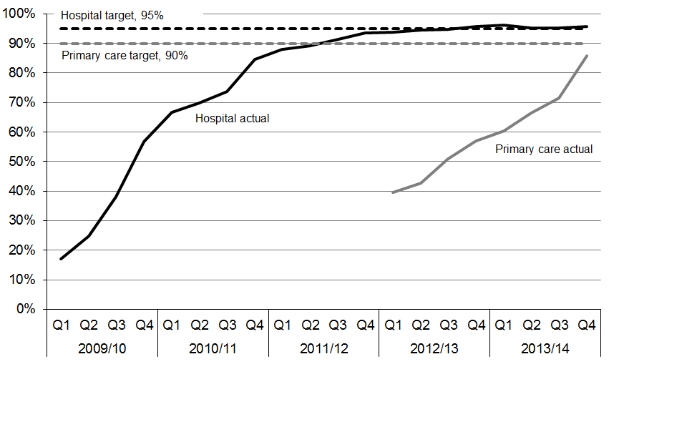

This target is designed to prompt clinicians to routinely ask about smoking status as a clinical ‘vital sign’, and then to offer brief advice and quit support to current smokers. There is strong evidence that brief advice from clinicians is effective at prompting quit attempts and long-term quit success. The quit rate is further improved by the provision of effective cessation therapies, including pharmaceuticals and face-to-face support.

Significant progress has been made since this target was introduced in 2009. When the Ministry first began reporting on the target, only 17 percent of smokers who were admitted to hospital were being offered brief advice and cessation support. Five years on, the hospital component of the target has been achieved, meaning that over 95 percent of hospital patients who smoke are now being offered help to quit. A number of initiatives have helped DHBs to achieve this substantial change, including accessible and relevant training, and smokefree champions working in each ward.

Advice and support to quit is being offered to over half of New Zealand’s smokers through the primary care component of this target. The quarter four 2013/14 result against the target was 85.8 percent (a 28.9 percent point improvement from 30 June 2013). This means primary care providers offered brief advice and support to quit smoking to approximately 407,000 people during the 2013/14 financial year. Some of these smokers were offered brief advice outside of primary care settings, as a result of PHO outreach programmes.

In 2013/14 six DHBs met the primary care target, and five more achieved over 80 percent. All DHBs improved their performance compared to the previous year.

Data from the Midwifery and Maternity Provider Organisation and LMC services (which represents around 80 percent of pregnant women registered with a midwife) show that as of the June quarter 2014, 92.1 percent of pregnant women (1271 out of 1380 smokers) who smoked and registered with a LMC were offered advice and/or support to quit during the quarter. The Ministry continues to look for a data source for the maternity target that represents a greater proportion of the population.

Although the health target is supporting clinical practice change and driving positive results in reduction of smoking rates, other initiatives in the wider tobacco control programme are also contributing to these outcomes.

### More heart and diabetes checks

**The health target:** By 1 July 2014, at least 90 percent of the eligible population will have had their cardiovascular risk assessed in the last five years.

Figure 1.6: Percentage of cardiovascular risk assessments completed, 2011/12–2013/14

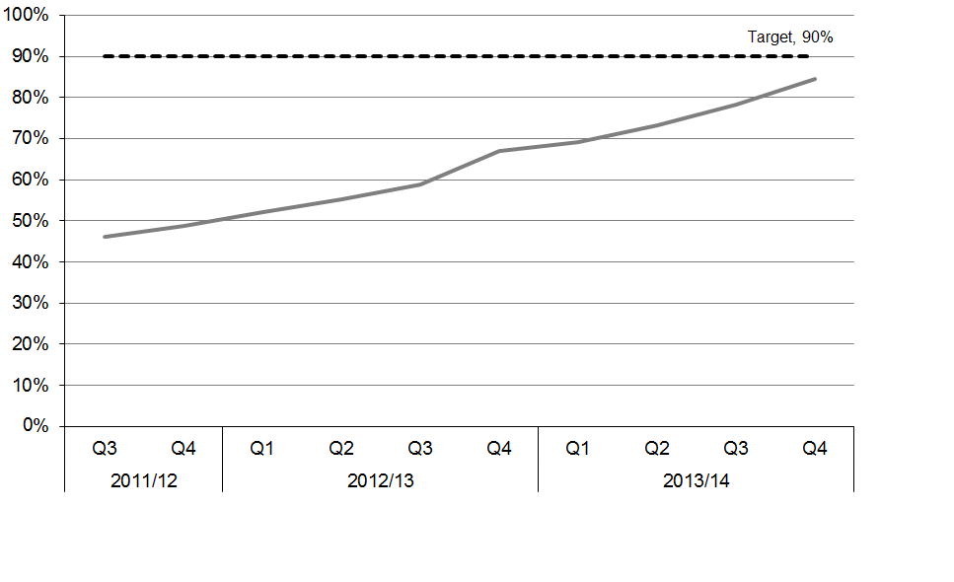

Long-term conditions represent a significant health burden for New Zealanders. Cardiovascular conditions are the leading cause of morbidity (the incidence of disease) in New Zealand, and disproportionately affect Māori, Pacific and South Asian people.

Cardiovascular disease (CVD) includes heart attacks and strokes. This health target aims to increase the proportion of the eligible population who have had a CVD risk assessment, including the tests to screen for diabetes, in the preceding five-year period. For those assessed at moderate or higher risk, the addition of lifestyle advice and treatment can substantially prevent the occurrence of heart attacks and strokes.

The *more heart and diabetes checks* health target result to June 2014 was 84.4 percent: an increase of 6.2 percentage points on last quarter’s final result and a 17.4 percentage point improvement over the past year.

Four DHBs met the target of 90 percent, and more than half of all DHBs achieved over 80 percent. The Ministry and clinical advisors have supported DHBs, PHOs and general practices throughout the year to achieve these results.

In 2013, additional funding of $15.9 million over four years was approved to increase the *more heart and diabetes checks* health target. The funding has been used in the 2013/14 year in three main areas:

* workforce development to enable an increase in the number of nurse-led clinics, after hours clinics and outreach services for hard-to-reach populations
* technology improvements and further investment in decision support tools, reporting programmes such as Patient Dashboard and electronic referral pathways to specialist services
* other initiatives such as subsidised assessments for eligible people, non-face-to-face appointments, and point-of-care testing equipment to enable more convenient blood tests.

The Heart Foundation has supported the target through tailored workshops for clinical staff and development of tools and training resources such as the *Taking Control* workbook, with videos and associated e-learning activities. This work will continue over the next two years. During 2013/14 the Health Promotion Agency also ran a successful mass-media campaign to promote the target.

## Improving access to services

Delivering better, sooner, more convenient care is an ongoing focus for the Ministry. Central to achieving this goal is integrating primary care with other parts of the health service.

There is strong evidence that integrated care (the coordination of care, systems and information) improves patient experience and health outcomes, particularly for older people with multiple health needs and patients with complex conditions. Integrated care also supports a more effective, efficient and sustainable health system, which makes better use of our specialist workforce and technologies.

Primary care is the first point of contact for access to the health system, and the gateway to secondary care. It is integral to the success of the health system, both in terms of enabling care to be provided close to home and in terms of managing health service costs.

Care that is carefully coordinated between service providers and professionals and delivered closer to home is particularly valuable for vulnerable populations such as frail, older people and those with long-term conditions. More timely and efficient patient-focused services are more cost-effective and reduce duplication of effort (eg, in collecting patient information).

Integration of services to better meet people’s needs requires effective leadership, including clinical and professional leadership, and engagement with the sector. Good governance and information systems will be key to the success of this work.

Over 2013/14, the Ministry supported health professionals, service providers and DHBs to ensure patients and carers are at the centre of service delivery, and to provide consistent high-quality care and service.

### Preventative and population health measures

Proven preventative measures and earlier intervention can result in significant health gains and benefit New Zealanders. Three of the six health targets focus on prevention:

* increasing immunisation
* better help for smokers to quit
* increasing heart and diabetes checks.

The Ministry also focuses on prevention by:

* promoting physical activity to help people live longer, healthier lives
* delivering youth mental health initiatives such as the *New Zealand Suicide Prevention Action Plan 2013–2016*
* ensuring that nutrition recommendations for New Zealand health practitioners and consumers have a sound evidence base.

The Ministry also focuses on population health by supporting health screening programmes (via the National Screening Unit), including for breast and cervical screening. Screening programmes for antenatal HIV, newborn hearing and newborn metabolic disorders reduce morbidity and in some cases mortality associated with these conditions.

### Supporting the health of older people

The Government is committed to providing people-centred health services for older New Zealanders so that they can live healthier and more independent lives. The Ministry’s work in this area includes raising standards for home and community support services, developing dementia care pathways, improving access to health of older people specialists and closely monitoring the aged residential care sector.

Work is under way to complete the Government’s requirements to have audits of home and community support services placed on the Ministry website. The Ministry is monitoring DHBs against certain expectations in the context of care for elder people, including expenditure of additional funding for home and community support services. It is also working with DHBs to develop a better range of indicators to report against. Providers are required to comply with Home and Community Support Sector Standard NZS8158 2012, and DHBs are reporting on this compliance.

Statistics New Zealand has estimated that 14.3 percent of New Zealanders are aged over 65 years in 2013. Maintaining the health and independence of older people now represents the greatest area of health spending pressure. During 2013/14 DHBs spent approximately $217 million on home support services, including over 10 million hours of care.

The quality of home support services remains a priority. In 2013/14 the Ministry supported DHBs to provide ‘wrap-around’ services for older people, to increase their independence and prevent avoidable hospitalisations. District health board geriatricians and gerontology nurse specialists are working with, advising and supporting health professionals in primary care and aged residential care to improve the quality of care for older people. District health boards are also using multidisciplinary community rehabilitation teams to assist older people discharged from hospital.

### Making the best use of information technology and ensuring the security of patient records

Having the right integrated information technology (IT) is essential to clinicians’ ability to provide seamless care to patients. The Ministry aims to establish an electronic health record for every person, and invest in more opportunities for patient self-care, including IT tools that enable people to take greater control of their own care.

The National Health IT Board is overseeing the implementation of national and regional health IT solutions to enable secure electronic access to reliable, trusted clinical information, regardless of the setting, for clinicians and patients. Privacy remains a top priority.

Integrated IT systems between hospitals, GPs, pharmacies and other community settings support clinical integration, and will enable information sharing across and between regions. Correct and up-to-date information increases patient safety, reduces the need for repeat tests, saves time for clinicians and patients and contributes to savings resulting from reduced acute admissions and readmissions. New IT systems will support multidisciplinary ways of working, including shared care plans. Tight security controls will be in place to protect people’s privacy.

In the future, New Zealanders will have access to their electronic health records through a patient portal. Patient portals will support and enhance primary care delivery, allow emergency departments to view a primary care summary record, and enable people to take more control of their own care. They will change the way care is delivered. Portals will be a self-care tool for individuals. If required, a shared care plan may be added to the portal, to deal with more difficult health needs.

In developing electronic health records, the National Health IT Board is working closely with PHOs, general practices, DHBs and the Health Quality and Safety Commission.

### Strengthening the health workforce

The New Zealand health workforce is a key contributor to good health outcomes for New Zealanders. The health workforce has grown over the past five years, and is changing to meet the challenges of the future, which include an increase in long-term conditions and an ageing population. The health workforce is also ageing, and continues to depend on overseas-trained professionals to meet the demand for health and disability professionals in rural and provincial areas, and in some specialty areas. New technology will deliver better health outcomes for New Zealanders, but we also need to train health professionals who are skilled in maximising the potential of those new technologies.

An ongoing investment in additional places for medical and nursing students has resulted in larger numbers of graduates entering the health professions. For the first time in 2013, New Zealand had sufficient numbers of medical graduates to fill all DHBs’ first-year post-graduate medical vacancies. However, there continues to be a significant shortage of GPs. The role of GPs, and of specialists capable of delivering generalist care, is becoming increasingly important as health care service delivery is moved closer to patients and their communities.

The number of New Zealand-trained nursing graduates increased from 1321 in 2010 to 1817 in 2013. Health Workforce New Zealand (HWNZ) and the Ministry of Health Chief Nurse’s Office have been working with stakeholders to increase employment opportunities for nursing graduates.

Although the current supply is good, New Zealand has an ageing nursing workforce. The Ministry knows New Zealand will need more nurses in 2017, to replace those due to retire, particularly in the aged care sector. Funding for places in the Nurse Entry to Practice scheme to place nurses in aged residential care is one of a range of initiatives in response to this increasing demand. HWNZ has developed, and continues to work on, a range of new roles that will enable improved response to the increasing burden of disease. An example is the diabetes nurse prescriber role, which allows specialist nurses working within DHBs to manage routine cases of diabetes treatment safely and independently.

HWNZ is currently developing the health workforce in the following ways:

* assisting the development of the allied health, science and technical professions
* working on a more efficient clinical education programme for sonographers, which will assist in the need to double this workforce by 2023
* working with medical physicists to address pressing workforce supply issues
* working with the Midwifery Council of New Zealand and the New Zealand College of Midwives to strengthen the Midwifery First Year of Practice Programme to ensure the ongoing quality of maternity care in New Zealand.

As prevention and self-care become increasingly important, new health practitioner roles are being tested that encourage New Zealanders to play a greater part in their own health and wellbeing. One example is the role of clinical exercise physiologist, to deliver exercise and lifestyle programmes to prevent chronic conditions and injuries.

The Voluntary Bonding Scheme (VBS) continues to address retention and recruitment issues in hard-to-staff communities and specialties. As at 30 June 2014, the Ministry had paid a total of $15 million to participants in the Scheme. A total of 1230 payments have been made to 700 eligible participants since 2009.

There are approximately 63,000 care and support workers in New Zealand. This ‘kaiāwhina’ workforce is critical to the delivery of community-based care to an ageing population. In the future, New Zealand will need more and better trained home-based and residential carers, to support older people with long-term conditions living in their own homes and in residential care. HWNZ and Careerforce (the industry training organisation for health, disability and social services) have been working on a five-year action plan within a broader strategy for the development of the care and support workforce.

### Regional, national and local collaboration

District health boards are working together regionally and nationally to enhance clinical and financial sustainability and increase the public’s access to health services. In recent years, significant progress has been made to lay the foundations for more effective regional work, including the establishment of regional governance and clinical leadership functions. For example, there are more nominated regional clinical leaders for specific areas than there have been in the past. Regional service plans focus on Government priorities in specific clinical areas, taking a regional approach to workforce and technology issues.

#### Lifting health sector performance through greater clinical integration

The Ministry has been making progress in a number of areas to improve organisation, networking and accountability within the sector to support an integrated approach. The Ministry is supporting the sector to achieve change through:

* supporting DHB annual planning for integration (including joint planning with primary care partners)
* developing integrated family health centres (IFHCs)
* supporting wider implementation of key enablers, such as IT
* implementing work programmes to support health and social sector priorities including youth mental health and better public services (see ‘Government priorities’ above)
* developing the Integrated Performance and Incentive Framework.

#### Integrated family health centres

Integrated family health centres provide increased access to services closer to patients’ homes in a coordinated setting. They encourage multidisciplinary team work, and allow for a range of hospital-based services to be shifted to community settings. The Ministry has continued to support IFHC development by funding technical expertise and support, tailored to the needs of each site. In 2013/14 this support spanned 13 DHB regions.

#### Elective first specialist appointments and treatment

In February 2011 the Ministry introduced a multi-year programme to reduce maximum waiting times for elective services. The milestone goals are that all patients who have been assessed as needing an elective medical or surgical first specialist assessment (FSA) or treatment will receive this within:

* a maximum of six months from 1 July 2012
* a maximum of five months from 1 July 2013
* a maximum of four months from 1 January 2015.

Throughout 2013/14, DHBs have continued to focus on reducing waiting times and establishing sustainable improvements in systems, processes, scheduling and pathways for patients. In line with the programme, DHBs have shifted their attention in 2013/14 towards the next milestone goal of seeing and treating patients within four months by December 2014.

Figure 1.7: Number of patients waiting over four months for treatment since 2007/08



Progress towards this goal has been very positive. Nationwide results at the end of June 2014 showed that 3547 patients had been waiting more than four months for a FSA, compared with 9197 patients in July 2012.[4] Similarly, at the end of June 2014 there were 2030 patients who had been waiting over four months for elective treatment, compared with 4192 at the end of June 2012.[5]

#### Diagnostic tests

Development of diagnostic testing as a priority area began in 2012/13. From 1 July 2012, the Ministry required DHBs to report on their waiting times against indicators for four diagnostic tests: colonoscopy, coronary angiography, computed tomography (CT scans) and magnetic resonance imaging (MRI scans). There have since been some meaningful improvements across a number of DHBs. Quality improvement initiatives have commenced; the Ministry expects to see waiting times for diagnostic tests reduce further in 2014/15, as the performance focus is strengthened, and service improvements take effect.

As part of the faster cancer treatment programme, the Ministry is also working with clinical working groups (which include radiologists) to define appropriate diagnostic tests for patients with different cancers, and timeframes for accessing these tests. In January 2013, DHBs began collecting baseline data against the faster cancer treatment indicators. This data will provide DHBs with an initial view of where there are bottlenecks in the cancer diagnosis and treatment pathway, and help them identify ways to improve their services.

#### Universal Newborn Hearing Screening and Early Intervention Programme

The core goals of the Universal Newborn Hearing Screening and Early Intervention Programme (UNHSEIP) are described as ‘1–3–6 goals’:

1 Babies to be screened by one month of age.

3 Audiology assessment completed by three months of age.

6 Initiation of appropriate medical and audiological services, and early intervention education services, by six months of age.

All babies born in New Zealand are eligible for newborn hearing screening. The programme is jointly overseen by the Ministry of Health and the Ministry of Education. The UNHSEIP detects about 60 babies per year with a moderate to severe or profound congenital hearing loss.

As a result of a screening incident in 2012 whereby screeners did not screen babies according to the screening protocol, the National Screening Unit (NSU) led a review of screening in the UNHSEIP. Consequently, the report *Quality Improvement Review of a screening event in the Universal Newborn Hearing Screening and Early Intervention Programme, December 2012* included 21 recommendations to strengthen the programme. In response to recommendation one (to reassess the screening protocol with a view to changing to a two stage AABR[6] -only protocol) the NSU received an independent report in March 2014: *Review of Newborn Hearing Screening Regimes and Associated Screening Devices*. This report recommends a change to the current screening test, standardised screening equipment and a national centralised database for the UNHSEIP. This work has commenced, and will be completed by December 2014.

#### Free after-hours GP visits for children under six and free GP visits for children under 13

The Ministry has worked with DHBs to implement policies that reduce the financial barriers faced by children and their families when accessing health services. The policy of free after-hours GP visits for children under six was introduced in July 2012. Nationally, more than 95 percent of children under six have access to free after-hours visits: 13 DHBs are achieving 100 percent coverage.

In May 2014, the Government announced that from 1 July 2015, children under 13 years will be able to visit their GP for free, and receive free prescriptions. The Ministry will work with DHBs and PHOs to implement this initiative.

# Outcomes framework

This section reports on progress towards achieving the impacts and outcomes identified in the Ministry of Health’s outcomes framework (Figure 1.8) and shows how the Ministry’s work during 2013/14 is contributing to these results.

## Health and disability outcomes

Figure 1.8: The 2013/14 Outcomes Framework



Two sector-level outcomes in the Ministry’s *Statement of Intent 2013 to 2016* support the achievement of wider Government priorities.

* New Zealanders live longer, healthier, more independent lives.
* The health system is cost-effective and supports a productive economy.

Three high-level outcomes support the achievement of the above health system outcomes.

* New Zealanders are healthier and more independent.
* Health services are delivered better, sooner and more conveniently.
* The future sustainability of the health system is assured.

By achieving these high-level outcomes, the Ministry will have a real impact on the lives of New Zealanders. Achievement of these outcomes is assessed against a range of measures, which are discussed in this section.

## Health sector outcomes

### **New Zealanders live longer, healthier, more independent lives**

A well-functioning health system contributes to improved health outcomes for the New Zealand population as a whole, and for particular groups such as Māori, Pacific peoples, older people and vulnerable children.

Table 1.1: Health system outcome – New Zealanders live longer, healthier, more independent lives

| **Target** and **Benchmark** | **Update** |
| --- | --- |
| **Health expectancy improves over time**  Health expectancy (or independent life expectancy) is the number of years a person can expect to live in good health and without an impairment needing assistance.  In 2006, health expectancy for males was 67.4 years and health expectancy for females was 69.2 years. This reflects an improvement of 2.7 years for males and 1.7 years for females since 1996, and the Ministry expects to see further improvements. Over the same 10-year period, 72 percent (2.6/3.6) of the life years gained by males and 65 percent (1.7/2.6) of the life years gained by females were lived in good health. | Health expectancy at birth is a summary measure of current patterns of health loss from illness, disability and death. It shows the average number of years that a person born today can expect to live in good health.  Overall, New Zealanders are living longer in good health: health expectancy at birth improved from 1996 to 2006 for both males and females (Ministry of Health and Statistics New Zealand 2009). A boy born in 2006 could expect to live 67.4 years in good health, and a girl 69.2 years.  However, health expectancy at birth for Māori is much lower than for non-Māori: 6.8 years lower for males and 6.2 years lower for females. A Māori boy born in 2006 could expect to live 62.0 years in good health, and a Māori girl 64.2 years. |
| **Life expectancy increases over time**  Life expectancy at birth indicates the number of years a person can expect to live, based on the mortality rates of the population at each age in a given year or period.  In the period 2007–2009, life expectancy at birth was 78.4 years for males and 82.4 years for females. Between 1985–1987 and 2007–2009, life expectancy at birth increased by 7.3 years for males and 5.3 years for females. The Ministry expects to see further improvements over time. | Life expectancy is a summary measure of mortality. Life expectancy at birth is the number of years a person born today can expect to live, given the current age-specific mortality patterns.  Overall, New Zealanders are living longer than ever before. A boy born in 2011–2013 could expect to live 79.7 years and a girl 83.2 years. Recent improvements in life expectancy are mainly due to lower mortality rates in the older age groups. The gap between male and female life expectancy has narrowed over time.  Improvements in Māori life expectancy over the past 15 years have narrowed the gap between Māori and non-Māori. However, Māori life expectancy at birth remained 7.3 years lower than that for non-Māori in 2010–2012.  **How do we compare with other countries?**  New Zealand compares well with similar countries for life expectancy. For males, life expectancy at birth was 2.2 years above the OECD average in 2012 (77.5 years); for females it was 0.4 years above the OECD average (82.8 years). |

Further information on New Zealanders’ life expectancy and health expectancy can be found in the *Health and Independence Report 2014*,attached to this Annual Report.

#### The health sector is cost-effective and supports a productive economy

There is a complex relationship between economic performance and health, but investing in health helps to secure a healthier labour force and improve work attendance.

Table 1.2: Health system outcome – the health sector is cost-effective and supports a productive economy

|  |  |  |
| --- | --- | --- |
| **Target** and **Benchmark** | **Update** | |
| **Life expectancy by health spending per capita compares well within the OECD**  New Zealand maintains its position within the OECD as having relatively high life expectancy for relatively modest expenditure. | New Zealand performs well: it has relatively high life expectancy (12th among 39 countries) for comparatively modest expenditure (19th among 39 countries). | |
| **Health spending growth slows over time**  The projected rate of growth in health spending between 2010 and 2019 is less than the rate of growth between 2000 and 2009 (25.8% based on real per capita expenditure in 2011 dollars). | Vote Health is a significant component of government expenditure; the Minister of Health is responsible for appropriations in the Vote for the 2013/14 financial year.[7] The Ministry has a duty to ensure the wider health and disability sector is managed in an efficient and productive manner while ensuring continuous improvements in the health services New Zealanders receive. The Ministry also works with sector partners to manage funds effectively.  The biggest challenge has been (and will be) to ensure that New Zealanders are continuously provided with excellent health care while ensuring that the cost of our health sector is sustainable over the long term.  Publicly funded spending on health care has more than doubled as a share of GDP over the past 60 years, rising from 3.1 percent in 1950 to 6.9 percent in 2012. This rate of increase is typical of countries in the OECD. Annual government spending on health care rose from $555 per person in 1950 to $3008 per person in 2013 (both figures in 2013 dollars). |

## High-level Outcome 1: New Zealanders are healthier and more independent

The defining goal of any health system is to improve, maintain and restore the health of the population within available resources. ‘Health’ includes quality of life as well as length of life. Keeping people healthy and enabling those with disability to live good lives, are key components of this.

The Ministry has a responsibility to protect the overall health of the nation: minimising the risks of infectious diseases and environmental hazards and supporting people to manage their own health and wellbeing. The health and disability system does much more than treating people when they are ill: it also focuses on prevention and maintaining independence. We want to improve and strengthen the capacity of the health and disability system to protect and promote wellness. The quality of health care provided to the public should be constantly improving.

This outcome encompasses the Government’s priorities of a substantial reduction in rheumatic fever rates, a reduced number of smokers, more health screening, integrated services for older people, increased immunisation rates and improving mental health services.

### Impact 1: The public is supported to make informed decisions about their own health and independence[8]

The Ministry will support the public to protect, manage and improve their own health and independence. In particular, the Ministry will be involved with ensuring that people can:

* access information and advice that promotes, and helps manage risks to, their health and wellbeing
* actively manage and make decisions about their own health care and support
* involve their families and whānau in considering health issues and choices.

Table 1.3: Measures for Impact 1

| **Measures and target** | **Update** |
| --- | --- |
| The Government has set a term goal of reducing smoking prevalence and tobacco availability to minimal levels, thereby making New Zealand essentially a smokefree nation by 2025. |  |
| To achieve the long-term smokefree 2025 goal:   * daily smoking prevalence falls to 10% in 2018 * the Māori and Pacific rates halve from their 2011 levels (respectively 41% and 26%). | The rate of daily smoking has decreased by about one-third over the last decade, from 23.0 percent in 2002/03 to 15.5 percent in 2012/13. The rate of daily smoking has declined for both males and females in the total population, and for Māori males and Māori females. However, the rate of daily smoking remains considerably higher in Māori adults, at around 36 percent. |
| Results of burden of disease and health surveys are improved. | **New Zealand Burden of Disease Study**  The New Zealand Burden of Diseases, Injuries and Risk Factors Study 2006–2016 analysed health losses sustained by New Zealanders of all ages, both sexes and both major ethnic groups. Health loss (or the ‘burden of disease’) measures how much healthy life is lost due to premature death, illness or impairment from a comprehensive set of 217 diseases and injuries and 28 behavioural and biological risk factors.  Three key reports from the study were published by the Ministry of Health during 2013:   * *Health Loss in New Zealand: A report from the New Zealand Burden of Diseases, Injuries and Risk Factors Study, 2006–2016* * *Injury-related Health Loss: A report from the New Zealand Burden of Diseases, Injuries and Risk Factors Study 2006–2016* * *Ways and Means: A report on methodology from the New Zealand Burden of Diseases, Injuries and Risk Factors Study, 2006–2016*.   More information on the Study and its key findings can be found in the *Health and Independence Report 2014*.  **New Zealand Health Survey**  The New Zealand Health Survey (NZHS) is an important data collection tool for monitoring the health of the population. The survey provides evidence for health service planning, health policy and strategy development.  A survey methodology report, the questionnaires and the content guides have been published. These reports and further information about the NZHS can be found at the Ministry’s website (www.health.govt.nz). The latest available data is for 2011/12. |
| All New Zealanders have secure electronic access to their personal health information which enables New Zealanders to make informed decisions about their own health and independence. | The National Health IT Board (NHITB) is promoting the implementation of patient portals to provide New Zealanders with access to their personal health information. Implementation of patient portals is a key component of the National Health IT Plan (NHITP). All four regions have started work, and more than 20 percent of practices have implemented patient portals. These early adopters have confirmed that the portals confer real benefits for consumers and clinicians. |
| All health targets are achieved. | See the ‘Health targets’ section of this Report. |
| All newborns are enrolled with a GP at birth.  Plunket is contracted to provide approximately 85% service coverage, the balance of service coverage is by local providers contracted via DHBs. | An estimated 52,825 babies were enrolled with a GP at birth (89.9% based on actual births in year to 31 December 2013).  The national Plunket agreement has been renewed to June 2015. The agreement provides Well Child/Tamariki Ora (WCTO) service entitlements for at least 49,909 new baby cases per annum (approximately 85 percent of the actual live births of 58,717 in the year to December 2013), and equivalent numbers of older children (core contacts up to age two and a half years and additional contacts up to age five). Plunket delivered 117,609 more additional contact equivalents, for infants under 122 days of age, which is 53,483 more than in 2010/11. Contracts for the remaining 10–15 percent of service coverage have also been renewed to June 2015. These services are the responsibility of local providers contracted via DHBs, but are funded by the Ministry of Health after funding was repatriated in 2011. The Ministry is now responsible for funding comprehensive WCTO service coverage in each DHB district via two contracted programmes, the Plunket national contract and each DHB’s WCTO Crown Funding Authority. |
| A B4 School Check is provided to 90% of the eligible population. | The purpose of the B4 School Check is to promote health and wellbeing in preschool children, ensure that children and their family/whānau are prepared for school and identify any health, behavioural or developmental concerns that may adversely affect a child’s ability to learn in the school environment. It is followed by appropriate and timely referrals to improve child health and education outcomes, and reduce inequalities.  The B4 School Check is the eighth scheduled core contact, provided usually between the ages of four and four and a half years and delivered separately from the WCTO programme. By July 2014, 91 percent of the eligible population had received B4 School Checks, as had 90 percent of the high-deprivation population. While a total of 59,582 children were checked during 2013/14, meeting the national target, the overall and high-deprivation targets were not achieved by Auckland DHB, Capital & Coast DHB and West Coast DHB. The Ministry is working closely with those three DHBs to meet the new targets levels. |
| The youth (15–24-years-old) suicide rate (which may be an indicator of serious uncontrolled mental illness) is reduced. | In 2011, about one in four suicide deaths were in young people aged 15–24 years (93 male deaths and 33 female deaths) and the youth suicide rate was 19.3 per 100,000, which is high in comparison with other OECD countries. Māori youth suicide rates are particularly high, being more than 2.4 times greater than non-Māori youth rates.  The Ministry is the lead agency for the cross-government *New Zealand Suicide Prevention Action Plan 2013–2016* (SPAP), which was publicly released in May 2013. Over $25 million will be committed from within agency baselines over four years for this plan, including $15.575 million from Vote Health. This funding is in addition to existing investment in suicide prevention and mental health services. It also complements other Government priorities that share a focus on the risk and protective factors for suicide. The investment represents a substantial boost to the suicide prevention sector.  The plan comprises 30 actions across eight government agencies, which will build on existing suicide prevention work and address identified gaps. This plan aims to strengthen support for family, whānau and communities affected by suicide, build the evidence base, extend existing services and strengthen suicide prevention in high-risk populations. Building the capacity of Māori and Pasifika communities to prevent suicide is a key focus area. |
| There is a reduced suicide rate for all ages. | Self-inflicted injury (suicide and intentional self-harm) is the leading cause of health loss due to injury, accounting for 33.2 percent of injury-related health loss in 2006 (Ministry of Health 2013 data).  Work is continuing on the development of an Outcomes Framework for suicide prevention – a deliverable under the SPAP. In early June a workshop was held to inform the development of the suicide prevention outcomes framework. Attendees included representatives from government agencies (including the Ministry of Health) and key suicide prevention providers. The workshop was an opportunity for the Ministry to build relationships with providers and to hear about their views on the suicide prevention outcomes Government is or should be working towards.  The Waka Hourua – National Māori and Pasifika suicide prevention programme has been established, including the national leadership group and the Māori and Pasifika national coordination hubs. There have been two rounds for the community development fund. There were 77 applications for round one; of these, 21 were approved for funding. In round two there were108 applications; contracting of the successful applicants will be completed in August 2014 and publicly announced in September 2014. Expressions of interest (EOIs) for funding from the Te Rā o Te Waka Hourua research fund closed on 30 April 2014. Ten EOIs were received and assessed, and five were recommended for a full application process. On 24 June 2014, the panel recommended funding for four of the five research applications, to a total value of $600,000. |
| The proportion of people with a K10[9] score ≥12 is reduced (an indicator of mental illness, such as anxiety or depressive disorder). | In 2012/13 it was estimated that 218,000 adults had experienced a K10 score of ≥12 in the last four weeks. This represents 6.1 percent of the population: a statistically significant change from 4.5 percent in 2011/12.  Men are less likely to experience psychological distress than women, and Māori and Pacific adults are more likely to have experienced psychological distress. After adjusting for age, sex and ethnic differences, adults living in the most deprived areas were 2.5 times as likely to have experienced psychological distress as those living in the least deprived areas. |
| Ethnic health disparities are reduced. | Ethnic health disparities have reduced as health outcomes have improved, but challenges still exist, as follows.   * Smoking is strongly associated with neighbourhood deprivation. In 2012/13 the rate of daily smoking was 28.4 percent in the most deprived areas, compared with 9.5 percent in the least deprived areas. This variation was not due to differences in the demographic mix across neighbourhoods, because after adjusting for differences in age, sex and ethnicity, adults living the most deprived areas were 3.2 times as likely to be smokers as adults living in the least deprived areas. * The Māori and Pacific infant death rates (7.7 and 6.4 per 1000 live births respectively) remained much higher than the rate for the Other ethnic group in 2010 (3.7 per 1000). * From 2000 to 2011 New Zealand’s amenable mortality rates decreased across all ethnic groups; the greatest decline was seen for Māori, followed by Pacific peoples. However, in 2011, rates for Māori were still 2.7 times higher, and rates for Pacific people 2.4 times higher, than for non-Māori, non-Pacific peoples. The most common conditions contributing to deaths amenable to health care vary by life cycle stage, but are largely consistent between ethnic groups. |

A number of Ministry and sector activities, described in the ‘priorities’ sections of this Report, contribute towards Impact 1. Other notable examples of activity in 2013/14 are outlined below.

#### Reducing smoking prevalence and tobacco availability

##### Plain packaging

In August 2013 Cabinet approved policy recommendations on ‘plain packaging’ for inclusion in a Bill, and agreed that the legislation needed to include wide regulation-making powers of both a restrictive and a permissive nature to ensure that every aspect of the appearance, and all other designed features and sensory impacts of tobacco products and tobacco product packaging, can be controlled. The Smoke-free Environments (Tobacco Plain Packaging) Amendment Bill, in the name of Hon Tariana Turia, had its first reading on 11 February 2014, and was referred to the Health Committee for consideration. The Committee invited public submissions. The Ministry of Foreign Affairs and Trade notified the Bill to the World Trade Organization, and invited intergovernmental submissions concerning international trade aspects of the Bill. The Health Committee has now completed hearing oral submissions and reported back to Parliament on 5 August 2014.

##### Duty-free concession

From 1 November 2014, the duty-free allowance will fall from 200 cigarettes to 50 cigarettes. The new limit will align New Zealand with the duty-free tobacco concession that has been in place in Australia since 2012. In addition, and also from 1 November 2014, tobacco will be removed from the gift concession that currently allows gifts sent from overseas to be free of duty and GST when they arrive in New Zealand, providing they exceed no more than $110 in total value. This means all gifts of tobacco products sent to New Zealand will now be subject to excise duty and GST.

##### Electronic cigarettes

There is a market for products providing smokers with nicotine that are less harmful than smoking. Many nicotine-containing products currently on the market are marketed as an alternative to tobacco, and some make claim to reduce the harm of smoking, or help smokers to quit. The rapid evolution of this market and the lack of high-quality data on the products make it challenging for the health sector to respond.

In New Zealand, electronic cigarettes have polarised the tobacco control sector. Some believe these devices will contribute towards a Smokefree New Zealand/Aotearoa 2025 by assisting people to quit tobacco. Others have concerns that electronic cigarettes may impact adversely on individual and population health: perpetuating nicotine addiction, re-normalising smoking behaviour, promoting dual use and becoming a gateway to smoking tobacco. The tobacco industry is currently purchasing companies producing these products.

The Ministry has acted on the World Health Organization’s advice, recommending a precautionary approach. New Zealand has opted to apply its existing regulations to provide a regulatory framework for electronic cigarettes: the Medicines Act 1981 and the Smoke-free Environments Act 1990. The Ministry has advised Government on the various concerns and the challenges of regulatory enforcement, and proposed that regulatory improvement is needed.

##### Pathway to New Zealand 2025 Smokefree Innovation Fund

The Pathway to New Zealand 2025 Smokefree Innovation Fund was established in 2012 to advance progress towards the Government’s aspirational goal of a Smokefree New Zealand by 2025. Its purpose is to support innovative approaches to reducing the smoking prevalence among Māori, Pacific peoples, pregnant women and young people across New Zealand. Two funding rounds have now taken place, and 22 projects are currently receiving funding. Examples of projects funded include marae-based cessation support and education sessions in Northland, a workplace cessation and wellbeing programme in Gisborne, a mobile quit bus in Auckland and a month-long stop smoking campaign whereby smokers across the entire country will be targeted. Community grants are also being offered in selected areas for smaller, community-based projects. These projects must focus on youth aged 12–24 years, with emphasis on Māori and Pacific peoples and pregnant women of any ethnicity. Six projects were funded in round one – in Camberley and Opotiki – and round two is currently being administered. Round two funding is available for projects in Whanganui/Manawatu and Gisborne/East Coast.

#### Building health literacy to improve health outcomes

Health literacy is generally defined as the capacity to access, understand and use health information and services in order to make informed health decisions. The quality of practitioner communication and the user-friendliness of health services are also factors that influence health literacy.

New Zealanders on average have poor health literacy skills. Of the total New Zealand population, Māori have the poorest health literacy of all population groups across a set of measured variables.

The Ministry has made a commitment to improving health literacy, and has a dedicated work programme aimed at:

* extending health literacy research
* ensuring health programmes work for those with poorer health literacy
* raising awareness of health literacy within the health workforce.

The Ministry has commissioned a number of projects to support the work programme, including three health literacy research reports with a specific focus on gout, skin infections and gestational diabetes.[10] The projects are aimed at developing approaches and interventions to strengthen health literacy. A series of palliative care research reports with the same aim will be published soon.

In line with this work, the Ministry will soon begin its Whānau Health Literacy – Fit for Surgery Programme, a two-year pilot programme aimed at helping bariatric/cardiac patients and their whānau develop the health literacy skills required to support and manage the lifestyle changes needed for effective long-term health management, including weight loss.

The Ministry has a project, Review of Health Literacy Environments in Hospitals and Health Clinics, which is aimed at developing a tool (or guide) to review health literacy that is fit for purpose for the New Zealand health system. A review tool has been developed and trialled across three DHBs (Northland, Counties Manukau and Capital & Coast). It aims to support health organisations in embedding good health literacy into the hospital and health clinic environments, by building practitioners’ and health leaders’ awareness and understanding of health literacy. The process of review will contribute towards building leadership and momentum for health literacy as a core business value and health literacy friendly environments in New Zealand.

The Ministry’s Foundation Course in Cultural Competency complements the health literacy review by giving health practitioners a basic understanding of cultural competency and health literacy so they can effectively engage and interact with their patients.

#### Guidelines to support healthy lifestyles

##### New guidance for healthy weight gain in pregnancy

The Ministry has developed new guidance for healthy weight gain in pregnancy, with support from key stakeholder groups including Dietitians New Zealand, the New Zealand College of Midwives, the Royal Australian and New Zealand College of Obstetricians and Gynaecologists and the Royal College of General Practitioners. The guidance and resources were released by Minister Goodhew on 18 June 2014, and the documents for health practitioners are available on the Ministry of Health website.[11]

The guidance:

* supports optimal weight gain during pregnancy
* updates the advice provided in the Ministry’s *Food and Nutrition Guidelines for Healthy Pregnant and Breastfeeding Women* (2006) to align with the 2009 Institute of Medicine position
* highlights the importance of attaining and maintaining a healthy weight both before and following pregnancy by linking with the New Zealand clinical guidelines for weight management.

##### Physical activity resources in te reo

Resources for consumers published by the Ministry that encourage walking, cycling, water activities and going to the gym are now available in te reo on the Ministry of Health website.[12]

#### Healthy weight

As in many countries around the world, obesity and its associated health problems are increasing in New Zealand. The costs of obesity are borne not only by individuals and families but also by the community and the health system. Encouraging New Zealand families to live healthy, active lives (including making good food choices, being physically active and sustaining a healthy weight) is a key component of the Government**’**s wider approach to promoting good health. The Ministry is taking a number of actions to achieve this goal, some of which are integrated into larger programmes or services. This year, Cabinet agreed to a new initiative that will build on existing activities through a programme of targeted investments. This initiative, Healthy Families New Zealand, brings together a mix of leadership, encouragement, information and resources to help people make healthier choices for themselves and their families. The programme also aims to reduce smoking rates and moderate the consumption of alcohol.

#### Disability support services

##### Supporting choice and independence

The purpose of the New Model has been to offer more choice, control and flexibility for disabled people in terms of the support they receive and the lives they lead and to ‘test’ new elements of a disability support system. The elements of the New Model include:

* local area coordinators, who assist disabled people to plan for a good life
* enhanced individualised funding, to give disabled people more choice and control over funding: they may use their own budgets in line with the newly developed guidelines to purchase and control supports via a host organisation
* ‘Choice in Community Living’: an alternative to existing residential services that supports people to choose how they live, where they live and who they live with.

At the conclusion of trial periods in the Bay of Plenty, Waikato and Auckland, the evaluation of these elements will provide an informed base for incorporating them into Enabling Good Lives, a partnership between government agencies and the disability sector aimed at long-term transformation of how disabled people and families are supported to live everyday lives.

The Ministry has been an active participant in the DHB Chief Executive Group meetings on disability issues. The Group supports the Ministerial Committee on Disability Issues, and facilitates and supports a cross-government approach to improving the disability system.

##### Enabling Good Lives

A demonstration of the principles-based transformation of the cross-government disability support system envisaged by Enabling Good Lives continued in Christchurch in 2013/14. The demonstration is being co-governed and co-designed by officials and local and national groups from the disability community. The focus of the demonstration in 2013/14 was on supporting school leavers with high needs to build their lives, with the support of navigators who walk alongside them, and personal budgets that disabled people can use flexibly to purchase the support that is most suitable for them. Plans have been made for expanding the Christchurch demonstration in 2014/15. Funding was also made available in Budget 2014 for another Enabling Good Lives demonstration in the Waikato.

##### Paid family care

In 2010 the Human Rights Review Tribunal found the policy of not paying parents, spouses and resident family members to provide support to disabled people to be unjustified discrimination under the New Zealand Bill of Rights Act 1990. This finding was upheld by the Court of Appeal in 2012. In response to the Court’s findings, the Government changed the policy so that parents and resident family members may be paid for the personal care and household management supports they provide to disabled adults with high and very high needs.[13] The Funded Family Care policy was developed by a technical advisory group and supported by a public consultation period. It was implemented and has been operational since 1 October 2013. Through the policy Disability Support Services allocates funding to eligible disabled adults who wish to receive paid family care, who will employ the family carer directly.

##### Sleepover Wages (Settlement) Act 2011 implementation

The Sleepover Wages (Settlement) Act 2011 was passed in October 2011 to enable the implementation of provider settlements for sleepovers. This followed the Court of Appeal’s decision that sleepovers constitute work for the purposes of the Minimum Wage Act 1983, and that at least the minimum wage must be paid for every hour a person employed in residential disability care works. The Ministry has completed negotiations with 104 employers and their employees, and all have complied with the Act. The Ministry’s role throughout this process has been to provide advice to ensure contracts are consistent with the provisions of the Act and to support employers with their claims.

##### Putting People First

In 2013, a ministerial independent review panel was established to review the effectiveness of current disability support services performance and quality management processes.

In November 2013, the panel presented its findings to the Minister of Health, *Putting People First: A Review of Disability Support Services Performance and Quality Management Processes for Purchased Provider Services*. The review contained 36 recommendations aimed at improving the systems, processes and tools to ensure the safety and wellbeing of people with impairments. The Ministry is committed to addressing these recommendations and has incorporated supporting actions within this plan. The review provides an excellent platform for the Ministry and the disability sector – both consumers and providers – to work together to achieve better quality of life for disabled people.

##### Pricing Project

The Pricing Project was established to tackle inequities and unnecessary complexity resulting from the use of a variety of pricing models across New Zealand for community residential services, supported living, facility-based respite services and home and community support services. The Ministry commissioned KPMG to develop the new pricing methodology and models, with the support of a project reference group that was established from within the sector. The reference group included four disability support service provider representatives, a consumer representative, a carers’ representative and a union representative.

The new pricing models support implementation of recommendations made in the ministerial review *Putting People First*. A number of recommendations made in that report identified the need to improve provider performance and encourage new providers into the market. The new models will ensure that pricing going forward, particularly for residential services, is fair, consistent and transparent across the country. Implementation of the new models is planned to begin in November 2014.

##### Services for people with Autism Spectrum Disorder

People diagnosed with Autism Spectrum Disorder (ASD) and no co-existing disabilities have experienced inconsistent access to disability support services , due to differing interpretations of the access criteria for funding. The Ministry confirmed that, from 2 April 2014, all people with ASD and no co-existing disability will be eligible to be assessed for disability support services, based on their level of need, consistently with the way other people with disabilities are supported.

The Ministry has contracted two clinical psychologists to provide the National Practice Advisor function for people with ASD accessing disability services. ASD training workshops for Needs Assessment and Service Coordination (NASC) organisations have been completed. Since the eligibility clarification of 2 April 2014, 222 people with ASD and no co-existing disability have registered for disability services; the majority of these people are under 15 years. The average annual size of all packages of disability services is $3071.

### Impact 2: Environmental and disease hazards are minimised

The Ministry is involved in a range of regulatory, leadership and purchasing roles aimed at protecting the public from environmental and disease risk factors that lead to ill health. These include smoking prevention and reduction programmes, efforts to substantially reduce rheumatic fever rates, efforts to increase child immunisation rates, and effective surveillance and management of environmental hazards and disease outbreaks.

Table 1.4: Measures for Impact 2

|  |  |
| --- | --- |
| **Measure and target** | **Update** |
| At least 40 communities are assisted to improve the quality of their drinking-water by 2015. | The drinking-water subsidy scheme was established in 2005 as time-limited transitional assistance to small, disadvantaged water suppliers, to help them improve water quality. The final date for applications for subsidies is 28 February 2015; works will be carried out until around June 2017. By the end of the programme, the drinking-water provisions of the Health Act 1956 (as amended in 2007) will apply to all water suppliers. New Zealand’s drinking-water standards set out detailed specifications for drinking-water quality, including maximum acceptable values for a range of contaminants, along with monitoring requirements. A water supplier that has been approved for a drinking-water subsidy will have an approved risk management plan, and will have upgraded their water supply as far as is practicable to achieve the standards.  Twenty-six drinking-water subsidy applications were received for the 2013/14 funding round. Twenty projects were recommended for approval, with a value of $9.24 million. Successful completion of these projects will result in safer drinking-water for an estimated 14,000 people.  Since 2006, not including the projects approved in the 2013/14 round, of the 269 drinking-water subsidies approved, 193 projects have been completed, 17 have been completed but lack final reports and/or invoices, 47 are under way and 12 did not proceed. The total value of drinking-water subsidies approved to date is $83 million, out of $117 million available for the duration of the programme. There are 23 projects still under way from subsidy rounds held before 2010; these have been placed on a watch list, with monthly updates provided to the Associate Ministry of Health. Fourteen of the projects from before 2010 are reported as having been completed; health officials are awaiting the final reports for these projects before removing them from the watch list. Eight projects that were approved in 2011 are still under way, and have all been placed on the watch list. |
| Deliver the annual influenza programme of 1.2 million doses of flu vaccine | The 2013 seasonal influenza immunisation programme ended on 31 July 2013. More than 1.25 million doses of influenza vaccine were distributed, of which more than 695,000 doses went to those eligible to receive the vaccine for free. Influenza coverage among DHB health care workers during 2013 was 58 percent. The 2014 seasonal influenza immunisation programme ended on 31 August 2014 with more than 1.2 million doses of influenza vaccine distributed. |

A number of Ministry and sector activities, described under the priorities, contribute to Impact 2. Other notable examples of activity in 2013/14 are outlined below.

#### Drinking-water supplies and sanitation

The Health Act 1956 requires the Director-General of Health, drinking-water suppliers, laboratories, drinking-water assessors and designated officers to meet certain statutory requirements with regard to drinking-water, including the provision and maintenance of registers and the publication of an annual report. At present, the database tool used to assist stakeholders administering that Act is the Water Information New Zealand database, which has been utilised since 1998 and captures information and compliance data for over 1421 supplies. However, the database predates the legislation, and falls short of meeting present and future requirements. Health officials are seeking a database that better serves the Ministry and sector, and aligns with the Government’s key result area of allowing New Zealanders to complete their transactions easily in a digital environment. As the first step in this process, a notice to prospective suppliers was uploaded on the Government Electronic Tendering Service (GETS) website, and six workshops were held with potential suppliers, to test officials’ assumptions, further develop the business case and prepare a request for proposals on GETS.

In March 2013 the Director-General of Health reported on the quality of drinking-water in New Zealand. This report described the microbiological and chemical quality of water in New Zealand drinking-water supplies serving populations of more than 100 people, and the progress made towards meeting the requirements of the Health Act 1956, from July 2011 to June 2013. The report showed that achievement of all bacterial, protozoal and chemical standards increased by 0.2 percentage points to 76.9 percent, in population terms, in the 2012/13 reporting period (up from 76.7 percent reported in 2011/12).

In 1995, the Ministry set a target of over 95 percent compliance with bacterial and chemical standards for drinking-water supplies serving over 500 people. In 2012/13, 96.7 percent of the population received water that complied with bacterial standards, and 95.3 percent of the population received water that was chemically compliant. These rates included people receiving their water from small drinking-water supplies (serving 100 to 500 people), which generally experience greater difficulty in achieving compliance. Although previous years have showed ongoing improvement in protozoal compliance, over the last year there was a slight decrease, from 79.8 to 79.2 percent, due to technical failures. (Water that does not comply 100 percent with protozoal standards is not necessarily unsafe, but does not have adequate barriers at all times to ensure it is free of protozoa.) Rates of achievement for the chemical standards had also dropped (95.3 percent, down from 95.7 percent reported in 2011/12). The drop appears to have been mainly driven by zones that met the chemical standards in previous reports: over 60 percent of these were due to inadequate monitoring rather than exceedances of the maximum acceptable values.

#### Influenza programme

The Ministry’s seasonal influenza programme reached its goal of 1.2 million doses of vaccine to be distributed by 31 July 2014 and the programme was extended to 31 August 2014. As well as delivering vaccine, the programme aims to ensure the at-risk sectors of the population (such as over 65-year-olds, pregnant women, children and adults with medical conditions) have access to the funded influenza vaccine. The Ministry produced a comprehensive communications campaign for the programme that included television advertisements and interviews; Google AdWords; radio, newspaper and back of bus advertisements; regular media releases; the flu website (www.influenza.org.nz); and the Ministry website.

#### Border control

The International Health Regulations 2005 (IHR) cover the detection and mitigation of international threats to public health in a manner that aims to avoid unnecessary interference with travel and trade. The regulations take an all-risks (biological, chemical, radiological) approach, specifying responses that are proportionate to the public health risk. In 2013/14, under the IHR core capacity monitoring framework, the Ministry provided the annual questionnaire to the World Health Organization, and undertook a review of selected designated aviation and maritime points of entry, against the core capacities outlined in the IHR.

One of the requirements in the IHR 2005 is for states to ensure their public health officials are trained to carry out routine inspections of vessels undertaking international voyages. The World Health Organization has developed several tools to ensure its Ship Sanitation Certification programme is harmonised internationally, including a set of standardised inspection criteria, a codified evidence reporting system and a training schedule for health officials. The Ministry has endorsed the World Health Organization training model, and requires all border health protection officers whose duties include ship sanitation certification to have completed the WHO eLearning course and the Ministry**’**s face-to-face residential training.

In 2013/14 the Ministry provided support for mosquito interception responses, and provided advice on mosquito surveillance programmes at ports of first arrival. Australian mosquito experts reviewed DHB public health unit mosquito surveillance at sea and air ports for the Ministry. The reviewers found that border surveillance had improved since their previous review, and that the border surveillance programme largely met the Ministry**’**s requirements. The reviewers’ recommendations help officials prioritise efforts to improve border surveillance and compliance with the IHR 2005.

#### Improved home insulation rates

Housing is an important determinant of health. There is an increased risk of chronic diseases (such as respiratory diseases) for those living in substandard housing. Research has shown that children under five years of age are more susceptible to developing respiratory illness and other conditions such as otitis media (‘glue ear’) if they live in uninsulated housing. There is also a clear association between inadequately warmed, damp, overcrowded housing and infectious diseases such as group A streptococcus (the precursor to acute rheumatic fever) and meningococcal disease, as well as skin infections.

The Ministry contributes $25 million annually to the Energy Efficiency and Conservation Authority’s (EECA) Warm Up New Zealand: Healthy Homes programme, which has seen around 215,000 homes insulated since July 2009. When the scheme ended in September 2013, it had reached its target of insulating 230,000 households. Budget 2013 announced a continuation of the programme for another three years, to deliver insulation retrofits to about 46,000 low-income households occupied by people with health needs related to cold, damp housing (young children and those over the age of 65 years). The programme has also been interfacing with the Budget announcement in May 2013 of funding of $3.75 million over four years for the Auckland-wide healthy homes referral and advice service, as part of the target to reduce New Zealand’s high rate of rheumatic fever among those aged 17 years and under.

#### Health care-associated infection

Health care-associated infections are common, cause significant morbidity and increase health care costs. The Healthcare Associated Infections Governance Group provides national leadership on health care-associated infections, including surveillance and infection prevention and control. The group is helping the Ministry to develop and implement a national plan for managing health care-associated infections. Additionally, the Ministry has engaged the Institute of Environmental Science and Research Limited (ESR) to establish and implement national hospital-based surveillance for Clostridium difficile infections.

#### Health protection services

The Ministry is involved in a range of regulatory, leadership and purchasing roles aimed at protecting the public from environmental and disease risk factors that lead to ill health. This includes interventions to reduce the risks from environmental hazards and communicable diseases, and to manage outbreaks. The Ministry provides ongoing purchasing and monitoring of border control and environmental health services on behalf of the Crown, exercises regulatory powers that minimise risks to the public and supports the statutory and clinical leadership role of the Director of Public Health.

##### Hazardous substances

The Ministry provided an annual report to the Minister of Health on hazardous substances injuries, as required by the Hazardous Substances and New Organisms Act 1996. The report summarised a range of data, including notified cases of lead poisoning and poisonings arising from chemical contamination of the environment, and poisonings and chemical burns resulting in inpatient/hospital admission.

The key findings were as follows.

* Four percent of injury-related health loss in New Zealand is due to poisoning.
* The annual rate of poisoning fatalities in New Zealand is comparable to other industrialised countries, and New Zealand has fewer deaths due to unintentional poisoning.
* The numbers of deaths and hospital discharges from poisonings have decreased since 2006.
* In all age groups carbon monoxide was the most common substance causing death, and most cases were intentional poisoning; butane inhalation was the leading cause of unintentional poisoning deaths in the 15–24 year age group.
* There were no reported poisoning deaths of children younger than five years old.
* Children under five years old had the highest hospital discharge rates for poisoning; the rate of poisonings for this age group was lower in 2012 than it was in 2011.
* Males account for the majority of fatal and non-fatal injuries from hazardous substances exposure.
* Reports of hazardous substances incidents (eg, chemical spills and fires) have decreased since 2009; the most common incidents involved petroleum products.
* The number of hazardous substance-related calls made to the National Poisons Centre has decreased slightly each year since 2009; over 60 percent of the calls in 2012 pertained to exposures of children to household substances.

##### Solaria

In 2012, staff from DHB public health units were asked to undertake visits to solaria in their regions to ensure that operators were familiar with the voluntary best practice guidelines *AS/NZS 2635:2008 Solaria for cosmetic purposes*, to reduce the risks from exposure to ultra-violet (UV) radiation from sunbeds. Staff made second and third rounds of visits to commercial solaria in their regions during 2013/14. Public health officers reported that 162 establishments had sunbeds, down from 173 in the previous survey. A few establishments commented that sunbeds were less popular than they used to be, due to bad publicity. Several operators said that they may cease operations when the new legislation comes in: the Government introduced the Health (Protection) Amendment Bill in August 2014 that intends to regulate commercial sunbed use, including through a ban on access by persons under 18 years. The Auckland Council Health and Hygiene Bylaw, which effectively mandates AS/NZS 2635:2008 and requires commercial solaria to be licenced, comes into force on 1 July 2014. While most operators appeared to find the guidelines useful, some complained that they (and their clients) found some of the forms too complex, and that they took too long to complete.

##### Methamphetamine laboratory sites

In 2010 the Ministry released *Guidelines for the Remediation of Clandestine Methamphetamine Laboratory Sites* , which deals with non-workplace exposure to buildings contaminated from activities associated with the manufacture of methamphetamine. The guidance was developed to assist public health staff in DHBs and other agencies such as territorial authorities in addressing public concerns and giving practical advice. The Ministry is currently reviewing the 2010 Guidelines, and is also working with Standards New Zealand and Local Government New Zealand, which are contemplating developing a national standard for the site remediation of non-workplace dwellings that have been contaminated through the illicit manufacture of drugs.

### Impact 3: Integrated home care services for older people

The Government and the Ministry are committed to providing integrated, effective, affordable, people-centred health services for older New Zealanders so that they can remain living in their homes longer and can live healthier and more independent lives.

Table 1.5: Measures for Impact 3

|  |  |
| --- | --- |
| **Measure and target** | **Update** |
| There are reduced incidences of falls.  Falls refers to incidents that required hospitalisation for older people (not serious and sentinel events). | HQSC reducing harm from falls programme continued to focus on falls reduction in public hospital wards.  The rate of falls per 1000 for the over 65+ population was; 2010/11 16.6, 2011/12 16.1 and 2012/13 16.4.  The Office of the Chief Nurse provided clinical leadership to the sector through representation on the HQSC expert advisory group, and acted as a conduit for Ministry and sector communications within the programme. |
| There is a reduced prevalence of people in the 65+ age group with dependent disability. | People aged 65 years and older had the highest disability rate in 2013: 59 percent, up from 54 percent in 2001. The age-adjusted disability rate was higher for Māori (32 percent) and Pacific people (26 percent). People with disabilities require varying levels of support, based on their need for assistance and/or special equipment relating to their disability.  There is good evidence that people who continue to live in their own home – with personal care and home management support if necessary – experience greater wellbeing. Most older adults prefer to stay in their own home, and this arrangement is also usually less expensive than residential care.  In 2012/13 about 18,300 people aged 85 years and over (one in four) lived in aged residential care. This proportion has significantly reduced over the past five years. However, the number of people in aged residential care continues to rise, due to the growing size of the population aged 85 years and older. |

A number of Ministry and sector activities, described in the ‘priorities’ sections of this Report, contribute to Impact 3. Other notable examples of activity in 2013/14 are outlined below.

#### Treatment of older people with fractures

In 2013/2014 the Ministry worked with DHBs to improve performance in the prevention and treatment of fractures in older people: particularly those with increased fragility. Improvements were focused on identification, investigation and intervention to prevent future fractures. The Ministry asked DHBs to establish a fracture liaison service by the end of 2013/14. It funded four regional workshops with an international expert for DHB representatives and other interested parties, to assist DHBs in developing these services. Under the Cross-Government Injury Prevention Work Plan, the Ministry has been working with ACC and the Health Quality and Safety Commission to identify opportunities to better align information or funding approaches to ensure that older people needing support to reduce the incidence or impact of falls receive appropriate treatment and support, regardless of location or source of funding.

#### Empowering older people experiencing abuse

The Ministry continues to work with DHBs and monitor their reports on the implementation of elder abuse guidelines, through DHB Family Violence Intervention Programme coordinators.

#### Dementia care pathways

Over 2013/14 the Ministry supported DHBs to apply best practice in dementia care locally, including clarity of access to services across the continuum of needs for people with dementia and their carers. This continuum of care is set out in the *New Zealand Framework for Dementia Care*, which the Ministry published in November 2013. For 2013/14, the Ministry asked DHBs to implement dementia care pathways, following the guidance provided in the Framework, to improve clinical integration, support families and whānau who are supporting members with dementia and provide a holistic approach to dementia care regardless of location or life stage. All DHBs have now implemented dementia care pathways.

Budget 2013 committed a further $3.2 million over three years to support dementia awareness programmes, provide assistance for clinical teams to facilitate earlier detection of dementia and provide dementia care training for health care workers. The Ministry ensured that this additional funding was appropriately allocated: $1.2 million was provided for health care worker training, $1.25 million for public awareness initiatives and $750,000 for DHB regional groups, working in partnership with the dementia sector and primary health organisations, to improve health sector awareness of dementia and responsiveness in primary health care.

#### Aged residential care

In 2013/14 the Ministry worked with DHBs and the aged residential care sector to establish a framework to allow residential care facilities to set additional charges for rest home beds that had additional facilities. There is demand for such ‘premium beds’, but the Ministry was concerned that insufficient premium beds may have been available for those who truly needed them and could not afford them. The additional charging framework aims to ensure that anyone assessed as needing a rest home bed without resources to pay additional charges will have access to a rest home bed within 10 kilometres of their location. The framework has been included in the age-related residential care agreement for 2014/15.

#### Access to specialists for older people’s health

Over 2013/2014 the Ministry worked with DHBs to specify initiatives DHBs would undertake to improve access to specialist health of older people services (geriatricians and gerontology nurse specialists) by health professionals in primary care and aged residential care. The Ministry asked DHBs to indicate increased numbers of hours spent by specialists consulting with primary care and residential care, or maintained numbers of hours, if these were already at optimum levels.

#### Reduction in acute admissions and readmissions to hospitals for older people

In 2013/14 the Ministry asked DHBs to monitor and review their investment in smarter services for older people living at home to reduce rates of acute admission and readmission, including rapid response and discharge management teams and processes. Initiatives such as CREST (in Canterbury DHB) and START (in Waikato DHB), which are both programmes aiming to deliver personalised services for older people, have demonstrated improved outcomes. All DHBs reported some level of reduction in duration of admissions and readmission rates.

#### Consistent quality of care by home and community support service providers

Budget 2013 allocated an additional $5 million per annum for home and community support services. In 2013/14 the Ministry worked with DHBs to create consistent frameworks for aged care performance measurement and quality indicators, for both residential care and home and community support services. The information that interRAI assessments in home care and residential care settings provide will contribute to the development of performance measures and quality indicators. These initiatives will help build quality and consistency in home care services across the country and will be tested in the 2014/15 year.

### Impact 4: Health services are closely integrated with other social services

The Ministry will lead and make a significant contribution to the Better Public Services results, in particular increasing immunisation rates for infants, reducing the incidence of rheumatic fever and reducing assaults on children.

More integrated health and social services make it easier for those with social needs to look after their health and independence.

The Ministry of Health is a member of the Social Sector Forum, which focuses on the following:

* Children’s Action Plan
* Social Sector Trial work programme – a joint work programme with the Minister of Health (in his role as Chair of the Cabinet Social Policy Committee) as the lead Minister and the Ministry of Social Development as the lead agency
* aligning services and programmes to deliver effective support and value for money through integrated frontline systems and effective procurement process.

Table 1.6: Measures for Impact 4

| **Measure and target** | **Update** |
| --- | --- |
| The number of DHBs that have implemented the National Child Protection Alert Systems (which allows safe information-sharing of child protection concerns among frontline health workers in DHBs) increases to 12 by 30 June 2014. | Fourteen DHBs were approved before 30 June 2014 to place alerts on the National Child Protection Alert System, exceeding the target of 12. The system now provides coverage for 71 percent of the population aged 0–14 years. All 20 DHBs are on track to be approved to place alerts by June 2015. |
| The number of people on a working age sickness benefit for more than 12 months decreases. | **Characteristics of working-age recipients of Supported living payment[14] – last five years**   |  |  |  |  |  |  | | --- | --- | --- | --- | --- | --- | | June year | 2010 | 2011 | 2012 | 2013 | 2014 | | Continuous duration of more than one year | 86,163 | 86,912 | 86,506 | 87,167 | 85,659 |   Source: 19 August www.msd.govt.nz/about-msd-and-our-work/publications-resources/statistics/benefit/index.html#SupportedLivingPaymentSLP5 |
| Rheumatic fever rates reduce by two-thirds to 1.4 cases per 100,000 people by June 2017. | The Rheumatic Fever Prevention Programme initially allocated $24 million over four years for the implementation of school-based throat swabbing services to cover more than 50,000 children. DHBs and NGOs are providers. The goal was achieved in 2013/14. An expansion of the Programme was implemented in 2013/14, in consultation with key sector and cross-agency stakeholders, and an additional $21.6 million was allocated from July 2013, to reduce the incidence rate for rheumatic fever initial hospitalisations from 4.2 to 1.4 cases per 100,000 people by 2017.  The incidence rate for the 2013 calendar year is 4.3 per 100,000 (194 hospitalisations). The 2013 rate represents an increase compared to the 2012 calendar year rate of 3.7 per 100,000 (168 hospitalisations). Possible reasons for this include: natural variation due to small numbers, or more people being diagnosed with rheumatic fever due to an increased awareness or a true increase. |
| Families reached by the Pacific engagement service:  Auckland region 11,000 home visits and 40 community sessions Wellington region 3,000 home visits and 24 community sessions | The targets for Auckland and Wellington Pacific engagement service to be achieved by 30 June 2014 have been met.  In total, as at the end of May 2014, 11,769 families had been engaged in the Auckland region through home visits and 169 community sessions.  In the Wellington region, 3404 families had been engaged through home visits and 24 community sessions. |
| Infant immunisation rates are increased so that 90% of eight-month-olds are fully immunised by July 2014 and 95% by December 2014. | See the ‘Health targets’ section of this Report. |
| The number of assaults on children decreases. | **The Violence Implementation Programme**  Violence Implementation Programme services continue to be delivered in DHBs, and the NCPAS continues to be implemented. The Ministry continues to work with other agencies to implement changes in contracts as required.  **Social workers in hospitals**  The Ministry continues to collaborate with the MSD, the police and DHBs to implement recommendations for social workers in hospitals from the CAP.  **The Children’s Action Plan**  Work on the first phase of a national public awareness campaign for the CAP has started, but has been delayed at the request of the National Children’s Director. The Ministry expects to further develop the campaign during 2014/15.  In 2013/14 the Ministry of Health, together with the MSD and the New Zealand Youth Mentoring Network, developed *Safe Practice Guidelines for Youth Mentoring Programmes*. To date 12 agencies have been evaluated as operating according to the guidelines, and accordingly have been supplied with promotional material to support their mentor recruitment. Decisions will be made in 2014/15 about how best to promote youth mentoring, both within communities with children’s teams and to a wider audience.  The Vulnerable Children Bill incorporated a proposal to set up KiwiSaver accounts for all children in long-term state care. Individuals, corporates and other donors would be encouraged to contribute to these KiwiSaver accounts in the same way that parents might for their own child.  The Ministry has contracted with Philanthropy New Zealand to provide advice regarding approaches to establishing a trust to fund scholarships and grants for vulnerable children. |

A number of Ministry and sector activities, described in the ‘priorities’ sections of this Report, contribute to Impact 4. Other notable examples of activity in 2013/14 are outlined below.

#### National Child Protection Alert Systems

National Child Protection Alert Systems (NCPAS) provides a national policy to ensure the consistency and quality of child protection alert data entered on the National Health Index Medical Warning System. The warning system provides a means for any clinician providing health care to a child to readily access their health information. Fourteen DHBs have been approved to use the NCPAS as at 30 June 2014; all DHBs have signed the NCPAS memorandum of agreement. NCPAS:

* facilitates standardised procedures and quality practices
* overcomes current system variances and limitations
* maintains appropriate standards of confidentiality and privacy
* improves child safety.

#### Immunisation

The Ministry amended the National Immunisation Schedule in 2013/14, to reinforce and sustain childhood immunisation coverage. The change required an update of information resources and promotion of the new schedule, including:

* a new edition of the *Immunisation Handbook*, incorporating latest best practice information for health professionals
* new resources informing health professionals and the public about the rotavirus vaccine in particular, and about the Immunisation Schedule as a whole
* changes to the National Immunisation Register to support the change to the Schedule.

## High-level Outcome 2: Health services are delivered better, sooner and more conveniently

This outcome reflects a health system that is people-centric and more convenient. A high-quality health system is one that meets people’s health needs and their legitimate expectations. Quality includes technical quality, safety and responsiveness to people’s human rights. New Zealanders need to have confidence in their health system.

Clinical integration of health services to deliver a better health care experience to New Zealanders is a key focus for the Ministry over the medium term. This means strong coordination at every level of the health and disability system so that the different parts work well together.

The health and disability system is made up of a dynamic network of interacting organisations and individuals, such as DHBs, other Crown entities, PHOs, community providers, rest homes, and individual health professionals. These sector participants need to work together to provide health and disability services across organisational and disciplinary boundaries so that patients receive the best possible care. Sector coordination also contributes to efficiencies across the system and ensures a similar level of care for patients regardless of where in the country they live.

The Government’s commitments to improve child and maternity services, services for older people, waiting times, unplanned and urgent care and care for long-term conditions are covered within this outcome, together with encouraging DHBs to work regionally, having more doctors and nurses, and supporting rural health care.

### Impact 5: The public can access quality services that meet their needs in a timely manner where they need them

Table 1.7: Measures for Impact 5

| **Measure and target** | **Update** | |
| --- | --- | --- |
| All health targets are achieved. | See the ‘Health targets’ section of this Report. | |
| Infant mortality rates continue to decrease from a baseline of 5.2 deaths per 1000 live births in 2009.[15] | New Zealand’s infant mortality rate is higher than the OECD average of 4.1 per 1000, putting us in the bottom third of countries.  In 2011 there were 323 deaths in children under one year old (5.2 deaths per 1000 live births), compared with 359 in 2010 (5.5 deaths per 1000 live births).  More detail can be found in the *Health and Independence Report 2014*. | |
| Serious and sentinel events reduce from a baseline of 374 in 2009/10. | Serious and sentinel events are events that have generally resulted in harm to patients. District health boards report information on such events for the previous year to the Health Quality and Safety Commission (HQSC). In 2012/13, HQSC published two serious and sentinel events reports – one for ‘general’ events (totalling 489) and one for mental health events (totalling 177). The increase in numbers since 2009/10 is thought to be a result of improved reporting rather than an actual increase. Further informationis available on the HQSC website ([www.hqsc.govt.nz](http://www.hqsc.govt.nz)), including the report *Making health and disability services safer* (November 2013). |
| There is reduced amenable mortality.[16] | From 2000 to 2011 New Zealand’s amenable mortality rate decreased from 150 per 1000 people aged 0–74 to 100. The decrease was evident across all ethnic groups; the greatest decline was seen for Māori, followed by Pacific people. However, in 2011, rates for Māori were still 2.7 times higher, and rates for Pacific people 2.4 times higher, than for non-Māori, non-Pacific people.  More detail can be found in the *Health and Independence Report 2014* section of this report. |
| There is a reduced ambulatory-sensitive hospitalisation rate. | Overall ASH rates over the past five years have been relatively static with Māori and Pacific ASH rates remaining more than twice the rates for non-Māori/non-Pacific peoples.  **Standardised ASH rate**   |  |  |  | | --- | --- | --- | |  | **2012/2013** | **2013/2014** | | Māori | 3602 | 3454 | | Pacific | 3676 | 3640 | | Other | 1586 | 1610 | | All | 1980 | 1978 |   More detail can be found in the *Health and Independence Report 2014* section of this report. |
| The overall quality score in the health group continues to improve. | This is measured through the Kiwis Count survey, which measures New Zealanders’ satisfaction with public sector organisations, and identifies areas for improvement. Scores over 2007–2013 were as follows.  **Service quality scores**   |  |  |  |  |  | | --- | --- | --- | --- | --- | | Service | **Service quality scores** | | | | | **2007** | **2009** | **2012** | **2013** | | Received outpatient services from a public hospital | 69 | 68 | 72 | 74 | | Stayed in a public hospital | 68 | 71 | 73 | 74 | | Obtained family services or counselling | 68 | 65 | 66 | 64 | | Used an 0800 number for health information | 67 | 70 | 70 | 77 | | **Overall** | **68** | **69** | **72** | **73** |   Source: [State](http://www.ssc.govt.nz/sites/all/files/kiwis-count-quarterly-update-dec2012.pdf) Services Commission |

A number of Ministry and sector activities, described in the ‘priorities’ sections of this Report, contribute to Impact 5. Other notable examples of activity in 2013/14 are outlined below.

#### Improved care for patients with long-term conditions

##### Cardiovascular disease (CVD)

The Ministry has supported DHBs and PHOs in making significant progress in the ‘more heart and diabetes checks’ health target. Achievement of the target reached 78 percent nationally at quarter three (the target being 90 percent by the end of quarter four). This represents a 19.3 percent improvement since quarter three 2012/13. The Heart Foundation provided training and education to primary care staff across the country, and the Health Promotion Agency undertook a national television campaign to encourage people to ask their GP about a heart check. In order to support improvement in care for people with acute coronary syndrome, all DHBs across the country are now reporting against agreed national indicators into a national registry using a database newly commissioned by the Ministry and supervised by the national cardiac network. The Ministry has facilitated national agreement with all stakeholders on the agreed Accelerated Chest Pain Pathway, which the DHBs will introduce over the next year.

##### Diabetes

Budget 2013 provided the Ministry with $12.4 million to support DHBs to improve the quality of the diabetes services they provide via enhanced diabetes care improvement packages. The Ministry has worked with the National Diabetes Service Improvement Group to develop 20 national quality standards, and is establishing baselines for performance against the standards and creating a toolkit to support DHBs to meet the standards. The Ministry has also produced national advice on prediabetes care and self-management support.

##### Stroke

The Ministry continued to work with the Stroke Network, developing two further stroke indicators covering rehabilitation from stroke in 2013/14. Over the past year, the Ministry has been leading the implementation of the national stroke guidelines. The Network has developed a consensus statement with emergency department specialists to enable safe and equitable access to thrombolysis treatment. All regions are now meeting the 6 percent target for thrombolysis treatment, and smaller DHBs within the regions are being supported to achieve it. District health boards are also implementing national transient ischaemic attack pathways and minimum workforce standards.

##### Long-term conditions

In order to promote an integrated approach to care for people with long-term conditions such as CVD, diabetes and respiratory disease, the Ministry has produced advice and tools to support DHBs and PHOs in providing coordinated care.

#### Colonoscopy services

Monitoring of colonoscopy wait time indicators continues; with improvement in both urgent and non-urgent colonoscopy wait times, and more DHBs are now meeting the targets. From June 2013 to June 2014:

* the number of people waiting for an urgent colonoscopy decreased by 18%
* the number of people waiting for a non-urgent (the majority of all colonoscopies) decreased by 15%.

Budget 2013 invested $3.75 million in reducing colonoscopy waiting times. Through this national initiative, an additional 3155 colonoscopies have been performed. The Ministry facilitated an endoscopy workforce symposium in April 2014 to bring the sector together to look at possible solutions to the current colonoscopy supply and demand imbalance. Potential strategies put forward by the symposium included:

* expanded endoscopy nursing roles, including nurse endoscopy
* improving training across the endoscopy workforce
* assessing surgical capacity to perform colonoscopies
* establishing endoscopy governance that includes wide sector representation
* seeking buy-in from professional colleges
* exploring an expanded role for CT colonography in the public and private sector
* expanding the role of the private sector in delivering colonoscopy.

An endoscopy quality improvement tool – the global rating scale (GRS) – was rolled out in all DHBs over 2013/14. The GRS is a web-based self-assessment tool that provides a quality framework for service improvement, enabling services to monitor progress against the endoscopy standards.

### Prostate cancer awareness

The Ministry launched the four-year Prostate Cancer Awareness and Quality Improvement Programme in 2013 to improve outcomes for men with prostate cancer.

Improvements envisaged through the programme include:

* greater access to information
* care along the cancer pathway
* monitoring, evaluation and research.

The Prostate Cancer Working Group is supporting the Programme. The focus for the year was to ensure men had the information they need in order to have an informed discussion with their GP or health professional about their prostate health, and make better decisions.

A brief leaflet and a more detailed booklet were developed and published in November 2013. They are the first in a range of initiatives designed to raise awareness of prostate cancer, and encourage men to be alert to their prostate health and enter conversations with their doctor, nurse or health practitioner accordingly.

Work is now under way to develop guidance, training and tools to help GPs and other health professionals provide consistent, quality prostate care. The development of a decision support tool is also under way. Maintaining a focus on equity and improving health outcomes for all men is an important part of the Group’s work.

#### The bowel screening programme

In 2013/14 the Ministry published provisional results for the first full screening round (two years) of the four-year bowel screening pilot (BSP). In the first 21 months of the programme 58,600, 53.8 percent of people invited to take part in the pilot, returned a completed bowel screening test kit. The results will remain provisional until the end of 2014, to allow time for people invited during the first screening round to complete the bowel screening pathway. Of those people invited during round one, 164 people had their cancer detected through a colonoscopy delivered as part of the BSP, and a further 18 had their cancer detected after choosing to have a private colonoscopy. The pilot is providing important information to inform decisions around the possible roll-out of a national bowel screening programme.

Four research studies were completed during the year:

* an immersion visit report with a focus on the later stages of the BSP screening pathway: in particular the investigation, surveillance and treatment stages
* a follow-up provider survey
* a follow-up eligible population survey
* a report focusing on the role of GPs within the pilot.

These reports will be published in the latter half of 2014.

#### Faster cancer treatment

The faster cancer treatment programme monitored the timeliness of cancer treatment against the following three indicators.

* All patients being referred urgently with a high suspicion of cancer receive their first cancer treatment (or other management) within 62 days.
* All patients referred urgently with a high suspicion of cancer have their first specialist assessment within 14 days.
* All patients with a confirmed diagnosis of cancer receive their first cancer treatment (or other management) within 31 days of the decision to treat.

District health boards first provided data against the indicators in May 2013, and continue to report on them. A range of tumour types is now being included in the reporting.

To further improve the collection and reporting of data, the Ministry provided additional funding to DHBs and regional cancer networks in November 2013. It also strengthened the faster cancer treatment indicator data definitions and business rules, and published a ‘what’s changed’ document to explain the amendments. District health boards are using these documents and producing their own information to help train staff.

The Ministry also developed a comprehensive set of use cases (scenarios), to help staff involved in collection of faster cancer treatment data interpret the data definitions and business rules and to promote consistency across the country.

##### Breast cancer

The Ministry has overseen the implementation of digital mammography and the central Picture Archive and Communication System for BreastScreen Aotearoa. All breast screening providers had transitioned to digital mammography by the end of December 2013. This system will allow more efficient utilisation of the national radiologist workforce, more secure data and image storage, and improved cancer detection rates, particularly for women with dense breast tissue.

In response to the new digital and centralised BreastScreen Aotearoa IT environment, demographic and workforce pressures, a review of the BreastScreen Aotearoa service delivery and funding model is under way. In addition to analysing the current state of the system, the review is exploring and evaluating options for future improvements to the programme to ensure it continues to provide a high quality, sustainable service to eligible women.

##### Cervical cancer

In 2008 the Ministry launched the Human Papillomavirus (HPV) Immunisation Programme across New Zealand. The Programme aims to reduce cervical cancer in New Zealand by protecting young women against HPV infection, which if left untreated can develop into cervical cancer.

The Ministry published an evaluation report on the HPV Immunisation Programme in 2012. It focused on Māori, Pacific and other young women across two key groups: girls born in 1997, and young women born between 1990 and 1991, who could access the free vaccine up to 31 December 2011. The evaluation concluded that the Programme successfully targeted population groups with the greatest need.

The evaluation also identified key challenges for the Programme, including increasing uptake of the vaccine by girls born in 1997 while maintaining equity of uptake by Māori and Pacific girls. The Ministry is addressing this challenge by developing a communications strategy targeting students in Year 12 and 13, as well as first-year tertiary students, reminding them to check their HPV vaccine status.

Three-year coverage data at the end of June 2014 collected by the National Cervical Screening Programme (NCSP) show that 76.6 percent of New Zealand women aged 25–69 years old are participating in the Programme; the target is 80 percent. Regular cervical smears every three years alongside HPV immunisation are important for preventing cervical cancer. The NCSP is commencing policy work to consider a major change from primary cytology screening to primary HPV screening. This work will take approximately 12 months, and involve sector consultation.

A key focus for the NCSP remains initiatives that promote the greater participation of women who have never been screened, and Māori, Pacific and Asian women, who are at greatest risk of developing cervical cancer. The NCSP is addressing this challenge by developing and monitoring provider initiatives to improve participation.

#### Health quality and safety improvements

The Ministry is collaborating with the Health Quality and Safety Commission (HQSC) on the national patient safety campaign ‘Open for better care’, which focuses on reducing harm in the areas of falls, surgery, health-care associated infections and medication safety. The Ministry continues to work with HQSC to ensure that DHB boards exercise their responsibility for quality and safety.

In July 2013 the Ministry, in consultation with HQSC, published a guide to help DHB boards to assess the robustness of their quality and safety processes and tools.[17] This sets out a series of questions to guide board-level discussions, categorised under six broad themes that reflect key components of quality and safety, including supporting a culture of care and compassion, communicating with and listening to patients, and effective information and monitoring systems.

In addition, the Ministry is working with HQSC to help DHBs meet the requirement to review their quality and safety processes, to develop a dashboard of key quality and safety measures to assist regular monitoring of their performance, and to produce and publish annual quality accounts.

HQSC is leading a significant project on behalf of the Ministry as part of the *New Zealand Suicide Prevention Action Plan 2013–2016* to strengthen the infrastructure for suicide prevention: the trial of a suicide mortality review mechanism. This trial seeks, among other things, to make better use of the information the Government already collects on suicidal deaths and suicidal behaviour. HQSC has established a time-limited mortality review committee to oversee the work, and will report to the Ministry by the end of June 2015.

##### National tumour standards

In December 2013, the Ministry published ten sets of provisional national tumour standards for bowel, breast, gynaecological, lymphoma, myeloma, head and neck, melanoma, sarcoma, thyroid and upper gastrointestinal cancers. Since January 2014, DHBs have worked with their regional cancer networks to begin reviewing their services against some of the standards (at least one provisional tumour standard document per DHB). A national provider was contracted in June 2014 to commence the second phase of the tumour standards work with the clinical working groups. This work includes updating the provisional tumour standard documents following feedback from the DHBs’ reviews.

##### Service improvement fund

The Ministry has established a service improvement fund to help DHBs improve services for cancer patients. It sought proposals from DHBs and regional cancer networks for the first round of funding (up to $5.2 million) in March 2014, and received over 40 responses. Of these, 25 proposals were successful; most commenced in June 2014. All the funded projects support achievement of the 62-day faster cancer treatment indicator and/or improvement of services against the national tumour standards; they will be fully implemented by June 2015.

##### Strengthening of multidisciplinary meetings

The Ministry has continued to support DHBs and the regional cancer networks to improve the functionality and coverage of their multidisciplinary meetings (MDMs), including through:

* implementing MDM overview groups
* using electronic MDM forms to collect all tumour-specific data for each patient discussed at an MDM
* upgrading videoconferencing equipment to support regional participation in MDMs
* implementing MDM coordinators to support clinical staff leading MDMs.

##### Cancer nurse coordinators

Last year all DHBs appointed dedicated cancer nurse coordinators to act as points of contact and assist patients and their families across different parts of the health service. The initiative has made good progress during 2013/14, as follows.

* The national lead nurse visited all DHBs and met with the cancer nurse coordinators and their wider teams to offer support and advice and to further clarify the cancer nurse coordinator role.
* In June 2014 the Ministry held a cancer nurse coordinator forum in Wellington. This provided an opportunity to review the initiative’s progress, showcase successful initiatives and share resources across DHBs, and plan for 2014/15.
* A formal evaluation of the initiative has commenced; providers are using a suite of evaluation tools for data collection. Early evaluation data were shared with the cancer nurse coordinators at the June 2014 forum.

From patient feedback the Ministry received this year, it is clear that the cancer nurse coordinators are already making a huge difference.

##### New medical oncology models of care

The Ministry published the new Medical Oncology National Implementation Plan in August 2013; it outlines activities to be undertaken in 2013/14 to increase capacity and improve the delivery of medical oncology services. While the Ministry led the majority of these activities nationally, DHBs worked with the Ministry to implement some regionally and locally. Key achievements include the following.

* Medical oncology services within DHBs have provided feedback on a draft report on senior medical officer roles within a new model of care. The feedback received is supportive of the approach taken to date, but warns against being too ambitious with any next steps. The Ministry continues work on how to best implement recommendations across the different regions.
* A cancer nursing knowledge and skills framework has been developed, supported by a writing reference group with leadership from the nursing sector. The Ministry anticipates that the framework will be ready for approval by the National Nursing Consortium by October 2014.

##### Radiation oncology

In June 2014 the Ministry published the Radiation Oncology National Linear Accelerator and Workforce Plan, developed by the Radiation Oncology Work Group. The Plan provides a nationally coordinated approach to radiation oncology service and capacity development, within the context of the National Cancer Programme.

The Plan focuses in particular on projected demand growth for radiation therapy, its implications for linear accelerator and workforce capacity, and associated cost impacts. It also considers issues arising from this capacity modelling.

##### New Zealand Cancer Plan

In June 2014, the Cancer Services team finalised the New Zealand Cancer Plan 2014–17, which provides a strategic framework for an ongoing programme of cancer-related activities for the Ministry, DHBs and regional cancer networks.

Building on what has already been achieved, the Plan sets out the cancer-related programmes, activities and services to be implemented across the country over the next three years. It also signals potential future initiatives.

#### The Health Information Standards Organisation

The Health Information Standards Organisation (HISO) is the expert advisory group on standards to the National Health IT Board. It supports and promotes the development, understanding and use of fit-for-purpose health information standards to improve the New Zealand health system. Ongoing areas of focus for HISO include ensuring security of information, use of health identifiers, use of consistent laboratory test codes and the introduction of international clinical terminology. In 2013/14 HISO completed and published standards for clinical document architecture, comprehensive clinical assessments for aged care, patient/consumer health identity, hospital discharge summaries and an update to the mental health data standard.

##### **Child and adolescent oral health services**

The child and adolescent oral health capital reinvestment programme is approaching completion. By 30 June 2014, 168 of the 177 planned fixed-site clinics were fully operational and all 112 new mobile units had been commissioned (this will bring the number of mobile units in the fleet to 143). The Ministry has commissioned ESR to undertake an evaluation of the reinvestment programme.

In the year ended December 2013, preschool enrolments in the Community Oral Health Service increased from 70 percent of the eligible population to 73 percent, and the percentage of enrolled preschool and primary school children overdue for scheduled examinations reduced from 13 percent to 10 percent. Use of publicly funded dental services by adolescents under the age of 18 years increased from 73 percent to 74 percent of the eligible age cohort.

Information on oral health outcomes can be found in the *Health and Independence Report 2014* section of this report.

##### **Community water fluoridation**

During the year the Ministry commissioned a new website – fluoridefacts.govt.nz – and published an associated brochure to provide clear evidence-based information to the public regarding the safety, efficacy and cost-effectiveness of community water fluoridation. In addition, the Ministry developed a toolkit of information for DHBs to assist them to contribute to deliberations on community water fluoridation undertaken by territorial local authorities.

#### Whānau Ora

The Ministry of Health continues to work closely with Te Puni Kōkiri and the Ministry of Social Development on Whānau Ora. There are 32 Whānau Ora collectives, comprising approximately 180 providers of health and social services. Whānau Ora aims to provide practical, community-based support to build whānau capability to meet their own development needs and take responsibility for their own lives.

District health boards have an important role to play in the implementation of Whānau Ora. The Ministry supports this role by regularly communicating with DHBs both on general developments in Whānau Ora and specific developments with the collectives in their district.

Since 2009, the work of Whānau Ora has evolved to include the establishment of three Whānau Ora commissioning agencies, which purchase a range of whānau-centred services at a local level.

Working with Te Puni Kōkiri to support these initiatives is one way that the health and disability sector can support Whānau Ora, but is certainly not the only way. As the work of the commissioning agencies grows, the health and disability sector will need to continue to consider how it can go about its business in a way that empowers whānau to achieve their own aspirations relating to health and wellbeing.

#### He Korowai Oranga

On 20 June 2014 the Ministry launched the refreshed *He Korowai Oranga: Māori Health Strategy*. *He Korowai Oranga* sets the overarching framework to guide the Government and health sector to achieve the best health outcomes for Māori. It has been updated to ensure it continues to provide a strong platform for achieving healthy futures. The goal of the new *He Korowai Oranga* pae ora (healthy futures), encompassing three elements: mauri ora (healthy individuals), whānau ora (healthy families) and wai ora (healthy environments). All three elements are interconnected and mutually reinforcing, and work together to strengthen the strategic direction for Māori health over the next decade. *He Korowai Oranga* supports the Ministry, DHBs and the health sector to continue to implement the New Zealand Public Health and Disability Act 2000, in relation to Māori health.

#### Māori/Pacific innovations programmes

##### Māori Health Innovation Fund – Te Ao Auahatanga Hauora Māori

The Māori Health Innovation Fund seeks to improve Māori health outcomes and advance Whānau Ora by supporting new Māori health innovation programme pilots over a four-year funding cycle. Since 2013, 21 providers have successfully applied for new Te Kākano: Seeding innovations funding category. Projects have included telehealth, community-based maternity services, tamariki and rangatahi health services and disability pilots. Funding was provided for 10 additional innovation programmes for the spreading and sharing of innovation models under the Te Ruinga: Spreading innovations category, and 23 providers profiled their innovations through the development of visual and paper resources. A key highlight for 2013/14 was the roll‑out to Southland and Otago of an innovation trialled in the Bay of Plenty and Hawke’s Bay and in nurse-led clinics in rural locations for the assessment and ongoing support of Māori with chronic health issues.

##### Pacific Innovations Fund

The Pacific Innovations Fund supports Pacific health initiatives that demonstrate innovation through the application of new strategies, models and methods of service delivery: particularly those that strengthen Pacific child and youth protective factors and reduce the prevalence of risk factors affecting Pacific people’s health, such as obesity and smoking. The Ministry has undertaken two open procurement rounds to select projects for investment, with input from external Pacific experts. Five projects were selected in 2012/13, and two more in 2013/14. The projects are spread across the country, and entail community, church and provider-led groups delivering services to address diabetes prevention, obesity, health literacy, antenatal care and youth suicide.

#### InterRAI

Comprehensive clinical assessment using the interRAI long-term care facility assessment tool is being implemented throughout the aged residential care sector. This follows successful implementation of the interRAI home care assessment tool for assessing older people’s need for home and community support services.

The Ministry requires all aged residential care facilities to be using interRAI as their primary assessment tool by July 2015. It has worked closely with DHBs throughout 2013/14 to ensure their aged care providers are training nurses accordingly, and has supported providers by providing computer software and hardware for assessments and payments to help meet the costs of backfilling for nurses undergoing training. All aged residential care sector providers are fully engaged in the national training programme, and a small number of large providers have agreed to undertake their own training programmes.

Budget 2014 announced additional funding of $18 million over four years to support infrastructure and data management associated with interRAI. The Ministry has worked with interRAI New Zealand to develop governance arrangements that enable interRAI assessments to become to move into a business-as-usual state following implementation. This work will continue in 2014/15 and, combined with secured funding, will enable the full potential of interRAI to be realised. Once fully embedded, better assessment through the interRAI assessment tools will lead to better care for older people.

#### Policy development on alcohol and drugs

The Ministry is leading the development of a refreshed National Drug Policy (NDP). This Policy is the Government’s framework for coordinated action in relation to alcohol, tobacco, illegal drugs and other drugs. Though the Ministry is leading development, the NDP will guide future inter-agency action; the Inter-Agency Committee on Drugs (which meets at Chief Executive level) is therefore providing governance. Agencies attending the Inter-Agency Committee on Drugs are the Ministries of Health, Social Development, Education and Justice, along with Customs, Police, Corrections and the Department of the Prime Minister and Cabinet. A discussion document seeking feedback on the issues and priorities for the NDP was open for submissions between 16 December 2013 and 28 February 2014. 120 submissions were received. The Ministry expects to report to Government with a draft NDP and associated action plans by the end of 2014.

In the past financial year the Ministry has also lent secretariat support to the Ministerial Forum on Alcohol Advertising and Sponsorship, appointed by Cabinet in February 2014 to consider whether further restrictions on alcohol advertising and sponsorship are desirable. The Forum is due to report to Government with its recommendations by December 2014.

#### Disability support services

##### Increased access to cochlear implants

Traditionally, wait times for cochlear implants for adults have averaged over two years, and demand continues to increase. In 2013/14, work to improve this situation continued. Disability Support Services invested an additional $1.6 million to provide cochlear implants to a further 22 adults who have been waiting more than two years. The cochlear implant programme was extended from 1 July 2014 with $6.3 million of funding over four years for cochlear implants for children under 19 years of age. Additionally, children under six who have received Ministry funding for one implant can now receive an implant for their other ear if their specialist recommends it.

##### Waiting lists for access to equipment

The Ministry’s Disability Support Services supports disabled people by funding equipment (eg, wheelchairs, shower stools and computer reading software) as well as housing and vehicle modifications. This service is provided by Enable New Zealand and Accessible Environmental Health Management Services on behalf of the National Health Board. In 2013/14, additional funding of $2.5 million was invested in equipment and modification services, which has enabled providers to maintain a nil waiting list.

In 2013/14 Disability Support Services commenced working with providers on developing an equipment modification service prioritisation tool, which will identify the allocation of equipment and housing and vehicle modifications based on individual needs and available funding. A trial of this tool was completed in 2013/14, and national roll-out is planned to be completed by December 2014.

#### A new approach to action under New Zealand’s medicines strategy

The Ministry released *Actioning Medicines New Zealand* in 2007 to support New Zealand’s medicines strategy. It released an updated action plan in 2010, comprising 25 actions focused on building systems and capability. These actions were primarily the responsibility of the Ministry, the HQSC and PHARMAC; the Ministry monitored the Plan and reported on progress. The majority of these actions have now been completed or have become business as usual.

Over the past financial year Cabinet has charged the Ministry with developing a new approach to achieving the three core outcomes of the strategy: quality, safety and efficacy; access; and optimal use). This new approach will focus on a small number of impact areas in place of an itemised list of actions. The Ministry will continue to develop impact areas in consultation with relevant stakeholders, for presentation to ministers by the end of 2014.

The Medicines Amendment Bill was introduced to parliament in 2012 and constituted one of the activities in the Action Plan; the Medicines Amendment Act was enacted in December 2013. Further information on this legislative change is provided in the next section.

#### Access to primary health care

Over 4.2 million people (approximately 95 percent of all New Zealanders) are currently enrolled with a PHO. Of these, approximately 1.3 million are recorded as belonging to ‘high needs’ sectors of the population, including 600,000 Māori, 300,000 Pacific people and 800,000 living in high deprivation areas. Currently, 294 general practices are part of the Very Low Cost Access (VLCA) scheme, which ensures low patient fees for these New Zealanders. More than 98 percent of children under six now have access to free daytime GP visits through the VLCA or the Zero Fees for Under-Sixes scheme, and over 95 percent of children under six have access to free after‑hours visits.

In September 2013, the Minister of Health announced funding of $4 million annually to provide additional support for VLCA practices with 50 percent or more high-needs patients. The Ministry requires DHBs and PHOs to work with eligible VLCA practices to determine how the funding will be used to support the sustainability of the practice.

In September 2013 the Minister of Health also announced funding for 48 new nurse graduate 12‑month placements in VLCA practices with 50 percent or more high-needs patients. These graduates have been employed until the end of December 2014. A similar programme is planned for 2014/15.

The Ministry introduced the Patient Access Subsidy in late July 2013. A VLCA practice may apply to the Ministry for this if it intends to merge with other practices and the combined enrolment register of the new entity is comprised of less than 50 percent or more high–needs patients and, therefore, the new practice would not be eligible for VLCA funding. The Ministry and DHBs assess applications for the Patient Access Subsidy on a case-by-case basis.

#### *Mental Health and Addiction Service Development Plan 2012–2017*

The Ministry is continuing to monitor progress on the implementation of *Rising to the Challenge: The Mental Health and Addiction Service Development Plan 2012–2017* within the Ministry, DHBs and NGOs. The Plan sets the direction for mental health and addiction service delivery across the health sector over a five-year period. It outlines key priority actions for achieving further sector-wide changes, to make service provision more consistent and to improve outcomes for people who use services and their families/whānau. The Plan assists health services across the spectrum, from health promotion through primary care and other general health services to specialist mental health and addiction services.

Examples of key initiatives under the Plan include the Prime Minister’s Youth Mental Health Project, incorporating the launch of the adolescent e-therapy tool SPARX and the *New Zealand Suicide Prevention Action Plan 2013–2016* ; new acute perinatal and infant mental health services being developed in the North Island; two Alcohol and Other Drug Treatment Courts (in Auckland and Waitakere); and treatment programmes for repeat impaired (drink) drivers.

District health boards have made progress on a number of initiatives under the Plan; the following list provides a cross-section.

* Overarching Goal A: make better use of resources
* increased focus on planning across services
* cross-sector consumer-centred initiatives to improve access to mental health and addiction services, and to streamline access into community, residential and alcohol and other drug services.
* Overarching Goal B: improve integration between primary and secondary services
* placement of specialist staff in primary care settings, and provision of psychiatry expertise to GPs through single point of entry systems
* implementation of single point of entry services.
* Overarching Goal C: cement and build on gains for people with high needs
* development of peer-led services as an acute care alternative, and for alcohol and other drug and mental health support
* establishment of Māori advisory groups to address service development needs.
* Overarching Goal D: deliver increased access for all age groups (with a focus on infants, children and youth, older people and adults with common mental health and addiction disorders, such as anxiety and depression)
* participation in social sector trials
* development of dementia care pathways.

#### Youth forensic services

Youth forensic mental health services are specialist community and inpatient services for youth with mental health and alcohol and other drug disorders who are involved with the justice system. In 2013/14, eight new community staff were appointed in such services, in addition to the 25 new community staff appointed in 2012/13. The funding approval process for a 10-bed secure inpatient youth forensic service is nearing completion; subject to this approval, an inpatient youth forensic service is expected to begin operation at the end of 2015.

#### Primary mental health services

The Ministry funds PHOs and other primary care providers to deliver a range of primary mental health services. For the first three quarters of 2013/14 this included:

* 29,512 extended consultations by GPs and practice nurses
* 42,271 assessments, brief interventions and/or counselling sessions provided by primary mental health clinicians
* 18,983 packages of care for patients, covering a variety of services such as cognitive behavioural therapy, medication reviews, counselling and other psychosocial interventions.

#### Problem gambling services

The Ministry is implementing the Preventing and Minimising Gambling Harm service plan 2013/14–2015/16, which guides problem gambling prevention and intervention services for New Zealand. The Ministry undertook an open tender to improve the mix and coverage of services during the 2013/14 year, but has placed this process on hold pending the outcome of a legal challenge. There were 7164 people seeking support from problem gambling services as at 30 June 2014. The Gambling Helpline received an average of 148 calls per month from new clients.

#### National Depression Helpline service

The Ministry provides joint funding with the Health Promotion Agency for the national depression helpline service. The service is part of the wider National Depression Initiative, which provides information on depression, including self-help advice, to both youth and the wider population. Depression support for youth is available through www.thelowdown.co.nz, and for the wider population through [www.depression.org.nz](http://www.depression.org.nz)

The national depression helpline service is provided by Lifeline New Zealand; it enables users to connect via multiple communication channels, including phone, text, email and instant messaging. In 2013/14 there were 22,999 contacts made through the national depression helpline.

### Impact 6: Health services are clinically integrated and better coordinated

The Ministry wants to improve and strengthen coordination throughout the health sector. This includes ensuring DHBs continue to work regionally, that sector planning is integrated across the sector and involves both clinicians and service users.

Table 1.8: Measures for Impact 6

| **Measure and target** | **Update** |
| --- | --- |
| Personal health information is readily available to patients and clinicians, no matter where care is delivered, by 2014. | The NHITB is promoting the implementation of integrated information systems, regionally and nationally, that will support the Government’s and Ministry’s priorities, such as clinical integration, incentives and DHB performance. The NHITB targets investments that enable secure access to clinical information to help clinicians deliver improved patient care and to support self-care by providing patients with access to their own information.  The National Health IT Plan outlines the priority programmes required to deliver this target which has achieved so far:   * all DHBs have either a local or a regional clinical workstation and a clinical data repository * all four regions have undertaken work to share primary care information with emergency departments and after-hours care * all regions are starting work on patient portals * 18 DHBs are sending over 43,000 electronic referrals per month * GP2GP, an electronic patient transfer system, is sending over 30,000 patient files per month between GPs * all DHBs send the majority of inpatient discharges electronically; and patients and clinicians have access to multidisciplinary shared care plans through pilots in Auckland and Canterbury. |
| Systems that support the Community Pharmacy Services Agreement, New Zealand ePrescribing and Administration System and multidisciplinary shared care/medicines management plans will be available to all general practices and pharmacies, and for all patients with long-term conditions. | The New Zealand ePrescription Service (NZePS) supports the Community Pharmacy Services Agreement and the creation of medicines management plans for patients with long-term conditions. The NZePS is being rolled out nationally. So far it has been implemented in over 45% of pharmacies and 5% of GP practices; this should reach 100% by the end of 2014. The NZePS produces a barcoded script that enables pharmacies to download dispensing information quickly and accurately. Through the system, GPs can track dispensed and prescribed medicines. |

A number of Ministry and sector activities, described in the ‘priorities’ sections of this Report, contribute to Impact 6. Other notable examples of activity in 2013/14 are outlined below.

#### Integration in child and maternity services

The Ministry is working with DHBs on initiatives to increase integration in maternity and child health services. Seven maternity and child health integration demonstration sites within three DHBs (Lakes, Nelson Marlborough and Counties Manukau) started trialling new integrated ways of working in January 2014. The demonstration sites are being evaluated, and will run until February 2016.

#### DHB regional service plans

##### National service planning

The National Health Board continues to develop and support vulnerable services designated as national services between 2010/11 and 2013/14. These include clinical genetics services, adult and paediatric metabolic services, paediatric and congenital cardiac services, paediatric and perinatal pathology, renal transplant services, hyperbaric bubble injury treatment services and intestinal failure services.

National service improvement programmes under way cover paediatric gastroenterology, major trauma, complex epilepsy and spinal cord impairment. Successful implementation of these programmes involves working through clinical networks and the prioritisation and development of enablers such as the workforce and IT systems to provide an appropriate framework for continued service sustainability.

##### Regional service planning

Regional governance and clinical networks are becoming more widely established as clinical leaders are identified for specific clinical areas. In addition, a regional approach to workforce planning and technology is emerging.

District health board sector regional service plans continue to focus on Government priorities for health services (see the ‘Government priorities’ section of this Report).

#### Whānau Ora IT solutions

The Ministry of Health leads a workstream within the Whānau Ora programme focused on information systems, according to a memorandum of understanding with Te Puni Kōkiri. In 2013/14 the Ministry led work to scope an IT system that will enable provider collectives to collect, utilise and report on whānau information consistently, and enable whānau to access their information. At a high level the solution provides IT tools to support needs assessments and to develop whānau planning and track the achievement of whānau goals.

The new Whānau Ora information system will enhance providers’ ability to link whānau to a range of services across the collective.

#### Maternity quality initiative

In 2013/14 the Ministry supported the second full year of local maternity quality and safety programmes in every DHB. These programmes bring together multidisciplinary teams to monitor outcomes and implement improvements for women and their families across hospital and community settings.

This year the Ministry published *National Consensus Guidance for Treatment of Postpartum Haemorrhage*, and funded the development of a national consensus guidance for the diagnosis and management of gestational diabetes, for publication in 2014/15.

The Ministry has recently released a refreshed Pregnancy and Parenting Information and Education DHB Service Specification, to improve service quality and equity. District health boards endorsed this for implementation from 1 July 2014.

During 2013/14 other key achievements of the Ministry, in partnership with DHBs and the National Maternity Monitoring Group, included the following.

* The Ministry began to collect data on DHB-funded primary maternity services to integrate into the National Maternity Collection.
* The National Maternity Monitoring Group published their first annual report, and continued to provide national-level oversight of the Maternity Quality and Safety Programme.
* The Ministry began the 2014 Maternity Consumer Survey, for publication in 2014/15.
* The Ministry revised the New Zealand Maternity Clinical Indicators, for publication in 2014/15.

#### Well Child/Tamariki Ora Quality Improvement Framework

In 2013/14 the Ministry supported DHBs to meet the new B4 School Check 90 percent target, including 90 percent of four-year-olds living in areas of high deprivation. An additional 7200 children received a B4 School Check in 2013/14 compared to 2012/13.

The Ministry launched the Well Child/Tamariki Ora Quality Improvement Framework at four regional workshops, and published two reports of achievement against the Framework’s quality indicators.

The Ministry supported implementation of local Well Child/Tamariki Ora quality improvement programmes in every DHB. All DHBs have identified local quality priorities, and will undertake planned improvement activities in partnership with child health service providers in 2014/15.

The Ministry completed a number of national quality improvements in this area, including revising the *Well Child/Tamariki Ora Programme Practitioner Handbook* in November 2013 and fully refreshing and updating the *Well Child /Tamariki Ora My Health Book*, which all new parents in New Zealand have been receiving since 1 July 2014.

#### Youth health service improvement

The Ministry recently supported the roll-out of school-based health services to decile 3 secondary schools, reaching 40 of 47 schools, ahead of the 2013/14 target. It also developed a quality improvement framework for such services, to be launched in 2014/15. The Ministry continues to deliver actions to improve primary care responsiveness to youth, including through supporting the sustainability of Youth One Stop Shops and driving local Youth Service Level Alliances.

#### Strengthening primary care

During 2013/14 the Ministry worked with DHBs, PHOs and contracted provider representatives to negotiate version two of the PHO services agreement , focusing on ‘technical tidy-ups’ of unclear or repetitive clauses and incorporating new policy initiatives, including the extension to general medical services claiming, the introduction of VLCA sustainability payments and patient access subsidy payments and Part G: the Integrated Performance and Incentives Framework. The revised agreement came into effect on 1 July 2014.

The PHO services agreement requires all DHBs and PHOs to establish alliance leadership teams. All DHBs and PHOs have now signed alliance agreements. The larger alliances, involving more than one PHO, took longer to establish their alliance leadership teams; most are now developing service level plans for how their flexible funding pool will be used. Those DHBs and PHOs that had previous alliance service level plans in place are taking the opportunity provided by the revised agreement to review their alliance plans.

#### Integrated Performance and Incentive Framework

Health systems around the world are trying to address the challenges of an ever-growing and aging population, with a greater prevalence of long-term conditions, in an environment of increasing technology but also increasing financial constraints. Health systems based on strong and better integrated primary care can more efficiently deliver better patient outcomes. The Ministry of Health is working with clinicians and sector leaders to develop the Integrated Performance and Incentive Framework, which aims to encourage DHBS and PHOs to drive system integration and align primary care activity with health system objectives, to better deliver on Government priorities. It will provide a mechanism for assessing PHOs’ readiness to undertake an increasing role in the design, delivery and funding of health services.

Initially the Framework focuses on the performance relationships between DHBs and PHOs; it is intended that other parts of the health sector will be added over time. The Framework supports the health system to address issues relating to equity, safety, quality, access and cost of services. It will ultimately measure how the whole system is performing and how each part of the system contributes, and will incentivise the right activity. It seeks to promote local responsibility and discretion to enable innovation and quality improvement, while at the same time being very clear about accountability.

The Framework will be implemented in phases. Phase One (2014/15) implements the strengthened accountability arrangements for PHOs developed in 2013/14, including:

* a change to the performance payments for PHOs that aligns payments directly with actual performance
* an assessment of PHOs’ ability to meet the minimum requirements of the Framework.

#### Clinical networks

##### Regional cancer networks

Over the past year the four regional cancer networks (Northern, Midland, Central and Southern) have worked closely with DHBs to implement national and regional priorities for the National Cancer Programme. At a national level, the networks supported working groups of clinicians to complete the development of the 10 provisional tumour standard documents.

A focus of the regional cancer networks in 2013/14 was to improve the collection and reporting of faster cancer treatment indicator data. The networks also worked with their regional DHBs to improve the timeliness and quality of cancer MDMs, and each coordinated a review of cancer services against at least one of the provisionally published tumour standards.

##### National Child Cancer Network

This year the National Child Cancer Network assisted DHBs to develop shared care guidelines between paediatric oncology services.

##### Adolescent and young adult cancer services

This year the Ministry established a clinical network for adolescent and young adult cancer services. Network membership is open to anyone involved in the delivery of care to 12–24-year-olds with cancer in New Zealand, including nurses, doctors, social workers, dentists, pharmacists, psychologists, dieticians, educators, counsellors and allied health and patient and whānau support professionals. The network helps such professionals to find new and innovative ways of delivering care. A governance group provides strategic leadership to the network.

##### National Cardiac Surgery Clinical Network

The National Cardiac Surgery Clinical Network’s goals include ensuring appropriate levels of cardiac surgery and improving equity of access and the quality of cardiac surgery services. Cardiac surgery providers are maintaining the consistency of clinical prioritisation by using the national cardiac clinical priority assessment criteria tool, and treating patients in accordance with clinical urgency timeframes and time spent waiting. Over the past year, the Network has focused on improving acute coronary syndrome waiting times. Budget 2012 funding for cardiac surgery was contingent upon a requirement to implement both a cardiac surgical registry and an interventional registry; these have been implemented over the past year.

##### Stroke Network

The Stroke Network is in the process of developing a consensus statement with emergency department specialists to enable safe and equitable access to thrombolysis treatment. It is considering national transient ischaemic attack pathways and minimum workforce standards.

##### Major trauma clinical network

A major trauma clinical network has been established to provide clinical leadership and oversight for a planned and consistent approach to the provision of major trauma services across New Zealand. Since its establishment in June 2012, the network has overseen the development and implementation of national guidelines and plans, developed an inventory of trauma capability and capacity across all base hospitals, and begun work on the establishment of a national trauma registry.

### Impact 7: The health sector is supported by suitable infrastructure and workforce

The Ministry wants to achieve an ongoing supply of the right kind of workers, as and where needed, to maintain a sustainable workforce. The Ministry is working with the sector to:

* attract and retain the workers New Zealand needs
* ensure that workers better reflect the ethnic diversity of the New Zealand population.

Table 1.9: Measures for Impact 7

|  |  |
| --- | --- |
| **Measure and target** | **Update** |
| The number of clinicians involved in the Voluntary Bonding Scheme increases from a base of 429 in 2011. | The following table shows registrations in the VBS between 2010 and 2014.  **Number of clinicians’ registrations of interest in the VBS**   |  |  |  |  |  |  | | --- | --- | --- | --- | --- | --- | |  | **2010** | **2011** | **2012** | **2013** | **2014** | | Doctors | 64 | 41 | 43 | 39 | 43 | | GP trainees |  |  |  | 5 | 20 | | Nurses | 392 | 349 | 411 | 281 | 324 | | Midwives | 46 | 39 | 42 | 50 | 45 | | Medical physicists* |  |  | 1 | 1 | 3 | | Radiation therapists* |  |  | 13 | 10 | 15 | | **Total** | **502** | **429** | **510** | **386** | **450** |   * Introduced in 2012. |
| The number of post-entry clinical trainees increases from a base of 5816 in 2011 to 6000 in 2015. | The number of post-entry clinical trainees trained in 2013/14 was 6190. |

A number of Ministry and sector activities, described in the ‘priorities’ sections of this Report, contribute to Impact 7. Other notable examples of activity in 2013/14 are outlined below.

#### Retaining health professionals in hard-to-staff places and services

##### Voluntary Bonding Scheme

In 2013, a postgraduate entry option for GP trainees was introduced to the Voluntary Bonding Scheme(VBS). Doctors who had completed postgraduate year (PGY) 2 or 3 in the year prior to commencing GP training became eligible in 2013 to enter the Scheme. In 2014 this was extended to include doctors up to PGY6. This extension, aimed at increasing the number of New Zealand-trained GPs, has significantly increased the number of doctors on the VBS.

As a result of the decrease in the number of nurses who registered on the VBS between 2012 and 2013, Health Workforce New Zealand (HWNZ) worked with the Office of the Chief Nurse and DHB directors of nursing to promote the Scheme to nurses for 2014. The timing of the registration of interest period for the VBS is now aligned with the start of Nurse Entry to Practice and Nurse Entry to Specialist Practice programmes; this has led to a significant increase in the number of nurses registering on the VBS in 2014.

The number of midwives on the VBS slightly decreased from 2013 to 2014, consistent with a slight decrease in midwifery graduate numbers. Despite this reduction, given the recently lower birth rate, New Zealand continues to have a sufficient number of midwives.

In April 2014, 450 new registrants for the 2014 intake on the VBS were confirmed. The projected cost of payments to the registrants is $5.5 million over the five years 2016/17–2020/21. As at June 2014, the Ministry had paid a total of $15 million to 700 participants on the VBS since the commencement of the scheme in 2009; $5.7 million was paid in the 2013/14 financial year.

##### Advanced Trainee Fellowship Scheme

The Advanced Trainee Fellowship scheme continues to provide scholarships to assist health care professional trainees who demonstrate leadership ability to undertake advanced training or study overseas in a shortage specialty area. There are now 35 trainees participating in the Scheme. Upon completion of their advanced training, the Scheme requires them to work in their scope of practice for a minimum of two years.

##### Multidisciplinary rural immersion health training

HWNZ has been working with Auckland and Otago Universities, the Eastern and Waiariki Institutes of Technology and Auckland University of Technology on a scheme to promote rural practice encompassing interdisciplinary learning, and to train a variety of health students at a Whakatane site, a Gisborne site and a small Wairoa satellite site. This programme began in 2011, and will continue at least until 2015. Medical, nursing, pharmacy, physiotherapy, dental, dietetics and occupational therapy students have participated. The total number of students who have participated on the scheme will exceed 180 by December 2014. In the 2014 calendar year, significant efforts were made to broaden the range of participating disciplines. In 2015, at least two new sites will be established: one in the University of Auckland catchment and one in the University of Otago catchment, probably in the South Island.

##### Midwifery First Year of Practice programme

To support the recruitment and retention of midwifery graduates, HWNZ continues to fund the Midwifery First Year of Practice (MFYP) programme. The programme admits three cohorts per year. The Ministry has worked with the New Zealand Council of Midwives and the New Zealand College of Midwives to strengthen the programme; HWNZ will engage with the midwifery sector to implement the strengthened programme in 2014/15.

##### New graduate nurses

The Ministry continues to support the development of the nursing workforce, including through 12‑month Nurse Entry to Practice and Nurse Entry to Specialist Practice programmes. These programmes enable new graduate nurses to practise in well-supported and safe environments, and build a sustainable pathway for the nursing workforce into the future. To strengthen capacity and capability in the aged care sector and encourage new graduates into a career in aged residential care, HWNZ funded 15 Aged Residential Care Nurse Entry to Practice positions in 2013, and 16 in 2014; it will release an evaluation of the effectiveness of these positions to the sector in due course.

#### Workforce development

##### Medical school students (the medical pipeline)

Numbers of medical graduates continue to increase as a result of additional government-funded medical student places being available since 2010. A medical workforce taskforce established in August 2013 is working to ensure an ongoing career pathway for New Zealand-trained citizens and permanent residents training as doctors.

District health boards found places for all PGY1 New Zealand-trained citizens and permanent residents in 2014. The Medical Workforce Taskforce is working with DHBs and the wider sector to ensure all eligible medical graduates have a placement for 2015, and continues to provide governance and advice to the Ministry to ensure there is a sustainable medical workforce comprising all levels from PGY1 through to consultants.

##### General Practice Education Programme

HWNZ continues to fund the Royal New Zealand College of General Practitioners (RNZCGP) for the training and employment of GP registrars through the General Practice Education Programme (GPEP). Some 124 registrars were enrolled in December 2013 for the one-year programme; this number is expected to significantly increase in 2014.

The RNZCGP also runs the Post Graduate Generalist Placement Education Programme, which provides a three-month paid placement for a postgraduate house surgeon (usually year 2 or 3) in a general practice. This programme has been very successful, and a high percentage of the participants have subsequently been admitted to the GPEP programme. In 2013/14, there were a total of 40 placements in the Programme.

##### Nursing workforce

HWNZ is working with the Office of the Chief Nurse and the national nursing organisations on initiatives to further develop the nursing workforce and implement a nursing workforce delivery programme. The programme will aim to improve the integrity of workforce data, graduate nurse recruitment, nurse retention, workforce planning and development.

##### Sonography workforce

Workforce modelling of the public and private demand for sonographers in 2013 showed the need to more than double this workforce by at least 296 full-time-equivalents by 2023. To reduce the supervision burden and increase the number of sonographer trainees, HWNZ supported a pilot 12-week intensive clinical course in the Northern region that commenced in July 2014. The course will be evaluated to inform decision-making on future courses.

##### Endoscopy workforce

A symposium held in April 2014 discussed how to expand the endoscopy workforce. HWNZ and the Ministry have since established an advisory group for this project that includes key external stakeholders. The Group will work with the wider sector to develop an advanced nursing role in endoscopy for senior nurses with relevant postgraduate education and experience. Training of nurses performing endoscopy will complement the training of gastroenterology and general surgery registrars.

##### Training of the non-regulated workforce

In late 2013, HWNZ and Careerforce (the industry training organisation for health, disability and social services) entered into a partnership to develop a workforce action plan for the non-regulated health and disability workforce (also known as kaiāwhina). This relatively unskilled workforce is critical to the delivery of care in the home and residential services. The action plan will address the need for a competent and adaptable kaiāwhina workforce.

##### Career planning

To support workforce planning and development, HWNZ requires all medical trainees receiving HWNZ funding to be provided with robust career guidance that aligns trainees’ individual career aspirations with the needs of the wider health sector. Ministry monitoring of regional service plans has shown career planning and career advice and plans are in place for HWNZ funded trainees. HWNZ continues to work with professional bodies and colleges to ensure active career management is incorporated into their accreditation and reporting processes.

##### Regional training hubs

Regional directors of training continue to support and develop the postgraduate training of health professionals, and consolidate training resources in the four regional training hubs. As part of their remit, they work with key stakeholders on development and implementation of regional workforce plans and development of initiatives that strengthen health workforce capability and capacity.

##### Work with the Tertiary Education Commission

HWNZ continues to work with the Tertiary Education Commission on current strategic priorities and investment decisions for 2015 and beyond, to align the Commission’s investment with the Ministry’s priorities.

##### A national approach to workforce planning and development

HWNZ works closely with DHB general managers of human resources and DHB Shared Services on a national strategy for DHB workforce planning and development. Key approaches include building a national view of workforce data and identifying workforce pressure points, to enable a consistent approach to workforce planning and a national view of future DHB workforce requirements. One specific initiative, the ‘Grow our Own’ project, aims to inform the future workforce of the multiple career options available in the health sector. A proposed transformational leadership and management development programme for DHBs will be underpinned by an agreed capability framework.

#### Other workforce initiatives

##### Development of workforce roles

HWNZ has supported regulatory change designed to remove barriers to innovation and introduce health care models that will increase patient access to high-quality service delivery. For example, regulations to allow clinical pharmacists to prescribe came into force in July 2013.

A programme to develop a further cohort of diabetes nurse prescribers commenced in 2013. At the end of 2013, over 100 nurses either had been trained or were in training for this role. At the end of June 2014, six out of the 27 nurses had completed this.

Evaluations of credentialing for primary care nurses in mental health and addictions services have proven positive. Primary care nurses who have participated in a credentialing programme demonstrate improved competence in dealing with patients with mental health and addiction issues, and collaborate more closely with secondary care services and the community. The New Zealand College of Mental Health Nurses is continuing to support the further implementation of the credentialing framework.

A second cohort of the physician assistant scheme, comprising seven physician associates (assistants), has been employed in primary care and rural hospital settings. An evaluation of the Phase 2 demonstration will be finalised by early 2015. The Ministry is currently considering regulatory implications, in conjunction with the Medical Council of New Zealand.

Over 2013/14 HWNZ supported implementation of the clinical exercise physiologist role; as part of a multidisciplinary team, these physiologists work with general practice, physiotherapy and secondary care services. The draft evaluation has demonstrated positive results.

Another new role HWNZ has supported is the primary care practice assistant; 19 such assistants from 13 general practices have now completed their training. The role has created interest in the sector, and was supported by a positive evaluation. The primary care practice assistant qualification has been listed on the New Zealand Qualification Framework, with a target of July 2015 for delivery by education organisations.

##### Registration of international medical graduates

From 2011 to November 2013, HWNZ supported unregistered international medical graduates (IMGs) living in New Zealand to prepare for the Medical Council of New Zealand’s registration examination (NZREX), enabling them to work as doctors in New Zealand. Since the NZREX Preparation Placement Programme began in 2011, 57 IMGs have completed the programme. As at June 2014, 48 had passed the NZREX, and 25 were working as doctors in New Zealand.

The increased number of New Zealand government-funded medical graduates since November 2013, coupled with the fact that there are now fewer opportunities for New Zealand graduates to work in Australia and the United Kingdom, has resulted in limited supervised practice positions for IMGs. For this reason, the NZREX Preparation Placement Programme was suspended at the end of 2013; it will be reviewed in September/October 2014.

##### Diplomas in obstetrics and medical gynaecology for GPs

Health Workforce New Zealand continues to support general practitioners (GPs) to gain a diploma in obstetrics and medical gynaecology, to increase access to maternal health care. Sixteen GPs have enrolled for the certificate-level programme (a pre-requisite for the diploma) in 2013/14; one has enrolled in the diploma.

##### Multidisciplinary education framework for allied health workers

HWNZ, in conjunction with allied health, health science and technical professionals and health education sector members, has developed a multidisciplinary education framework for the allied health science and technical workforces. Professional groups whose qualifications include similar basic elements of education and training will be invited to participate in a joint initiative with tertiary education institutions to implement the framework during 2014/15. The aim is an education framework that will allows people to easily and quickly transfer from one similar profession to another.

##### Mental health and addictions workforce action Plan

Following the publication of *Rising to the Challenge*, HWNZ, together with the wider Ministry, is developing a mental health and addictions workforce action plan. The plan will focus on enhancing the competence and capability of the mental health and addiction workforce, and set out specific actions relating to workforce development, training pathways and supply modelling.

The plan will reflect a strong focus on enhancing this workforce in primary care and developing workforce models that contribute to integrated service provision. The plan will be implemented over the next three years; involvement from the sector will be integral to its success.

##### Public-private partnerships for training health professionals

HWNZ continues to implement public-private partnerships for training health professionals, including anatomical pathologists and medical physicists. Trainee sonographers employed by private radiology providers are currently involved in a HWNZ-funded 12-week intensive clinical training course being piloted as part of the University of Auckland’s Postgraduate Diploma in Health Sciences and Ultrasound. HWNZ is also supporting the Waitemata Elective Surgery Centre to develop a model to identify the costs associated with training surgeons; this model could inform future public-private partnerships.

##### Forecasting workforce requirements

HWNZ continues to work on the recommendations of a number of workforce service forecasts it has undertaken since 2011. These forecasts aimed to develop a ‘2020’ vision of New Zealand’s future workforce across a range of specialities, and set out future scenarios based on patient need, demographic and technological changes and emerging models of care. A large number of recommendations have since become ‘business as usual’ within the Ministry and wider sector. During 2013/14, HWNZ continued work on two further forecasts (for plastic surgery and dermatology) and published the Māori workforce service forecast and the ‘Mothers, Fathers and Babies’ workforce service forecast. The Pacific workforce service forecast will be published later in 2014.

##### Disability Workforce Action Plan 2013–2016

To support the continued development of the disability workforce, Disability Support Services has developed the *Disability Workforce Action Plan 2013–2016*, which outlines priority actions and outcomes to ensure a well-trained, skilled and competent disability workforce. The Plan draws on research, sector intelligence, consultation with stakeholders and guidance from the workforce reference group. It builds upon achievements from the previous disability workforce action plan and introduces some innovations.

The five objectives of the Plan are:

* to increase the skills of the disability workforce (regulated and non-regulated)
* to increase the skills of people with disabilities
* to improve learning opportunities for carers and family who support people with disabilities
* to improve information about the disability workforce
* to improve integration to support disability workforce development.

##### Carer Strategy

The Ministry is committed to the cross-government New Zealand Carer’s Strategy to be implemented over the next three years.. Actions to be taken through this plan sit under five strategic objectives:

* to enhance the capability of carers who support people with disabilities
* to provide flexible funding options for disabled peoples’ care arrangements
* to enable disabled adults to employ their family carers to support them
* to enable disabled carers to have a break
* to protect the health and wellbeing of disabled peoples’ carers.

#### The Māori health and disability workforce

##### National Māori workforce development programmes

Māori health workforce programmes are aimed at increasing the number of Māori students taking up health careers. Between 2010 and 2014, Otago University saw a 50 percent increase in Māori enrolled in the health science first year programme (150 Māori students are currently enrolled) and a 20 percent increase in Māori students across all health professional disciplines; in 2014 up to 406 Māori secondary school students participated in the University’s science wānanga. Similarly, there has been increased uptake in health-related courses and outreach activities in the Auckland University Whakapiki Ake programme. Kia Ora Hauora, a national Māori health career programme, focuses on the front end of the workforce pipeline by using social media and local events to promote health as a career. There are also a number of specific programmes to attract Māori nursing and midwifery students, including the Ngā Manukura ō Āpōpō leadership programme and the pre-entry to nursing programmes Ngā Mataapuna Oranga and Te Hononga O Tāmaki Me Hoturoa.

##### Whāia Te Ao Mārama: The Māori Disability Action Plan

According to *Whāia Te Ao Mārama: The Māori Disability Action Plan for Disability Support Services 2012 to 2017*, the Ministry has undertaken work to improve the capability and capacity of the Māori disability workforce. It has also provided funding to support disability workers to access training and development opportunities to strengthen their cultural competencies and equip them with the skills and knowledge to provide more responsive services.

#### The Pacific health and disability workforce

##### Pacific disability workforce

According to *Faiva Ora: National Pasifika Disability Plan 2010–2013*, the Ministry has undertaken a number of initiatives to improve the capability and capacity of the Pacific disability workforce.

The Ministry provides funding to support Pasifika disability workers to access training and development opportunities and gain qualifications. During 2013/14, it funded 150 Pacific disability workers to undertake Level 2 and Level 3 qualifications.

The Ministry has worked towards increasing awareness of and interest in careers in the disability sector among Pacific people, through the *Work That Matters* booklet, advertisements on Pacific radio, disability work profiles on the Le Va website and social media campaigns.

##### The Pacific Provider and Workforce Development Fund

The Ministry has invested in a pipeline approach to increase the Pacific health workforce through the Pacific Provider and Workforce Development Fund.

Table 1.10: Ministry investment activities in the Pacific workforce

|  |  |  |
| --- | --- | --- |
| **Priorities** | **Goals** | **Funded activities** |
| Attract | Increased number of Pacific students taking science subjects in years 11, 12 and 13 | Health science academies in Auckland  Mentoring for students studying health-related subjects at Otago University and Auckland tertiary institutions  Pacific Health and Disability Workforce Awards (scholarships) |
| Train | Increased number of Pacific students enrolled in a health qualification at a tertiary institution |
| Strengthen | Increased number of Pacific workers in the health and disability workforce | Aniva programmes:  Master of Nursing in Pacific health master class seminar for Pacific nurses in postgraduate study  Return to midwifery programme at Auckland University of Technology  Support for Pacific community health workers  Professional support for: Pasifika Medical Association, Aotearoa Tongan Health Workers Association, Cook Islands Health Network Association, Tongan Nurses Association of New Zealand, Samoan Nurses Association of New Zealand, Pasifikology and the Fiji Nursing Association |
| Upskill and retain | Increased number of Pacific health professionals advancing in professional and/or clinical development |

##### Pacific Health and Disability Awards 2014

The Pacific Health and Disability Awards are a national Pacific health workforce development initiative. The Awards aim to strengthen the Pacific health workforce by providing financial assistance and incentive to Pacific students undertaking tertiary health-related study. The Ministry received 200 applications for Awards in 2014, and granted 133, to students studying medicine (58), nursing (32), oral or dental health (8), midwifery (1), allied health (12) and other subjects (22).

##### Pacific Provider Development Fund

The Pacific Provider Development Fund supports Pacific providers to establish collectives. Four such collectives have been funded so far, in Auckland, Midlands, Wellington and the South Island. The Ministry expects that the funding will enhance business performance in the collectives and sustain organisational development. In 2013/14 the Ministry financially invested in forming regional networks for these collectives. The service delivery models of the regional networks will reflect research on evidence-based models of care, regional Pacific workforce planning and regional engagement.

#### Information systems infrastructure

The National Health IT Plan supports the consolidation of IT systems through a reduction in local systems and migration to national and regional systems. All IT systems require a robust infrastructure and network connections. In 2013/14 the Ministry undertook a number of significant improvements to strengthen infrastructure; further activity is planned for 2014/15.

##### Upgrade from Microsoft Windows XP

Microsoft ceased providing support for the Windows XP operating system on 8 April. Seventy-five percent of devices in the health sector are now migrated off Windows XP; DHBs will substantively complete the upgrade of remaining devices over the next six months. The Ministry purchased extended support for the DHBs that were not able to meet the deadline to ensure the security of systems while the migration progressed.

##### Infrastructure as a service

In alignment with a direction from the Department of Internal Affairs, the National Health IT Plan specifies the use of Infrastructure as a Service (IaaS), a provision model in which organisations outsource the IT equipment used to support operations. This model delivers substantial benefits for DHBs, such as reducing the time and effort that DHBs spend on provisioning additional computing capacity and storage, keeping information and communications technology equipment updated without continued capital outlay, and providing robust back-up and disaster recovery capability. The regions will use IaaS as a common platform for consolidated information systems.

#### Information technology initiatives

The focus for the National Health IT Board (NHITB) in 2013/2014 was establishing national and regional systems that support the integrated delivery of health care and enhance patient self-management. An important eHealth initiative is improving patients’ access to their electronic health information via patient portals. Key achievements during 2013/14 include:

* commencement of a programme to accelerate the uptake of secure online patient portals, and appointment of seven eHealth ambassadors to lead the programme: six GPs and one clinical researcher (previously a GP)
* significant reduction of duplicate national health index (NHI) numbers to below 1 percent; all DHBs are now meeting target criteria
* improvement of the address web service for validating NHI addresses, benefitting systems such as the National Immunisation Register and improving ‘did not attend’ rates at outpatient clinics
* establishment of five national contracts which provide significant economy of scale benefits to support DHB uptake and ensure a consistent approach toward implementation of relevant systems across the sector, supported by clinical leadership and strong governance
* greater use of eReferrals and eDischarges in DHBs, to manage the smooth transition of patients through the health sector, from primary to secondary and tertiary care
* development of regional clinical pathways to support clinical decision-making and standardise care processes across primary to secondary and tertiary care
* increased uptake of GP2GP, an electronic patient record transfer system: over 90 percent of GP practices now use the system.

The NHITB engages with DHBs for the purposes of their local and regional planning. It also reviews and endorses all Ministry and sector IT business cases with capital requirements over $500,000, or that have significant IT implications.

The NHITB currently has four priority programmes: the eMedicines Programme, the Regional Information Platform, National Solutions and Integrated Care Initiatives. Key activities across these programmes during 2013/14 include the following.

##### New Zealand ePrescription Service (NZePS)

The New Zealand ePrescription Service (NZePS) produces barcoded scripts that enable GPs to track dispensed and prescribed medicines. The service is currently being rolled out nationally; an average of 250,000 scripts are being created monthly, and more than four million prescriptions have been processed electronically since the Service was introduced in July 2013. The NZePS is expected to be used by 100 percent of pharmacies and general practices by the end of 2014.

##### Electronic prescribing and administration

The electronic prescribing and administration (ePA) system supports safe, effective prescribing and the appropriate use of medicines. It is in use in three hospitals, and three more are in the process of planning for its introduction. Because electronic sign-off for prescriptions does not meet the requirements of the relevant legislation, the Director-General of Health has approved prescribing waivers.

##### Electronic medicines reconciliation (eMR)

The electronic medicines reconciliation system (eMR) provides a list of medicines that is updated on a patient’s admission and discharge to hospital. It is now in use in four hospitals, and one more has started implementation.

##### ePharmacy

All DHBs will implement hospital ePharmacy as a regional system to manage medication dispensing and stock control in hospital pharmacies. MidCentral and Lakes DHBs are currently preparing to implement the first regional version for their regions.

##### Patient portals

Online patient portals will allow New Zealanders to access their personal health information. The NHITB is actively driving uptake of the portals with PHOs, GPs and patients, and DHBs are including implementation as a critical IT priority in their regional services plans. A promotional communications campaign is under way to raise awareness among consumers and providers. Practical implementation guides to support GPs as they implement portals are being developed in partnership with the eHealth ambassadors and the Royal New Zealand College of General Practitioners.

Over 35,000 patients and 75 general practices are already using a portal service. The number of eligible patients is considerably greater.

##### Shared Care programme

The Shared Care programme is being implemented in Auckland and Canterbury. It provides a care planning tool for patients with complex long-term conditions, using a multidisciplinary approach. 1351 patients are enrolled in the Shared Care programme in Auckland, across 44 general practices, 23 pharmacies and 32 secondary care services, and 401 plans have been developed in Canterbury by a team of eight care coordinators supporting 10 general practices.

##### eShared Care Record View (eSCRV)

The eShared Care Record View (eSCRV) system provides health care providers in hospitals, pharmacies and community care settings with access to various patient data via one portal. Canterbury DHB is currently using eSCRV, and a regional roll-out has been confirmed. West Coast will be the first DHB to implement eSCRV, and will do so before the end of 2014, followed by South Canterbury DHB. Use of the system continues to rise.

##### Clinical pathways

Clinical pathways are evidence-based condition-specific online guidelines that support clinical decision-making and resources for standardise care processes. All South Island DHBs have now implemented localised versions of the Canterbury Health Pathways a locally developed and agreed assessment, management, and referral information to health professionals across the system. Over 600 clinically-designed pathways and GP resource pages are now available, as have three central region DHBs. Midland region DHBs are implementing Map of Medicine, and the northern region is further developing the Healthpoint pathway website.

##### Maternity Clinical Information System (MCIS)

Providers of health and support services for pregnant women will soon have national secure access to the Maternity Clinical Information System (MCIS), making use of data from lead maternity carers, GPs, laboratories and maternity facility systems (birthing units). Five DHBs will be the early adopters of this system; two are already using it. Women will also have portal access to their own information, and the system will also offer them a secure way of communicating with their health providers.

##### Clinical data repository/clinical workstation (CWS)

Clinical data repository (CDR) / contain a nationally agreed core set of clinical information, and additional clinical data to be determined by each region. The data repositories will be accessed through a clinical workstation.

A clinical workstation (CWS) enables clinicians to view integrated patient information via a single, secure web-based system, regardless of the underlying ‘feeder’ applications. Information delivered through a clinical workstation becomes consistent and easy to interpret because it is presented through a common interface.. All DHBs are currently implementing regional CDR/CWS. Three South Island DHBs have implemented the South Island’s regional CDR/CWS, known as Health Connect South, and the remaining two are developing theirs. MidCentral DHB has completed the first implementation of the Central Region CDR/CWS. Lakes DHB is implementing the first Midland region CDR/CWS, and Waikato DHB is likely to be next. Northland DHB has aligned with the other DHBs in the Northern region to implement their CDR/CWS.

##### Patient administration systems (PAS)

All the DHBs have local PAS, and eight DHBs have a legacy PAS that will be replaced with a regional system. Northland DHB is replacing its legacy PAS, and the northern region is working to select a regional PAS. Central region is planning to replace legacy PASs at three DHBs. The South Island region has selected a regional patient information care system, and Canterbury DHB and Nelson Marlborough DHB will be the first DHBs to implement the regional system.

### Impact 8: The health system has fit-for-purpose regulatory settings

The Ministry wants to achieve ongoing improvements to the cost-effectiveness of regulation across the sector to reduce the cost of compliance with existing regulations. This will ensure home and community support providers meet minimum standards.

Table 1.11: Measures for Impact 8

|  |  |
| --- | --- |
| **Measure and target** | **Update** |
| The Radiation Safety Bill is developed. | Following consultation final instructions on the Radiation Safety Bill were forwarded to the Parliamentary Counsel Office on 27 June. A timeline allowing introduction prior to 31 July was forwarded to the Minister’s office on 2 July. |
| The Health Practitioners Competency Assurance Act 2003 is reviewed and implemented. | The review of the Act has been completed. The Minister approved recommendations made in August 2013 for amendments to the Act to be incorporated into the Amendment Bill. |
| The Misuse of Drugs Act 1975 is reviewed and rewritten, and a new regulatory regime for low-risk psychoactive substances is implemented. The Psychoactive Substance Regulatory Authority is established. | **The Misuse of Drugs Act 1975**  Amendments to the Misuse of Drugs Regulations, consequent to the Medicines Amendment Act 2013, came into effect on 1 July 2014, after the Social Policy and Legislation Cabinet Committees had agreed the policy decisions and regulations. The amendments enable nurse practitioners and midwives to continue prescribing controlled drugs, and remove some restrictions on prescribing with the intent of improving patient access to care.  **The Psychoactive Substance Regulatory Authority**  Further technical policy decisions, to be agreed on by the Ministry are being made to enable the new Regulatory Authority to function (including in terms of IT functionality). Regulations are being drafted for the permanent regime. In the meantime:   * a transitional authority is actively managing regulator tasks * the Psychoactive Substances Code of Manufacturing Practice has been published, and has been in force since 17 January 2014 * the transitional period for the Psychoactive Substances Amendment Act 2014 has ended. |
| Natural health and supplementary products legislation and amendments to the Medicines Act 1981 are developed and implemented. The Natural Health and Supplementary Products Regulatory Authority is established. | Development of a refreshed approach to New Zealand’s medicines strategy is on track. In April 2014 a workshop was held with key stakeholders that identified criteria for selecting areas where action will have most benefits for patients. Cabinet approved the proposed direction in May, and the Ministry is now selecting impact areas. |
| The Australia New Zealand Therapeutic Products Agency is established. | Following the change in government in Australia, Department of Prime Minister and Cabinet officials from both sides reviewed this project. The reviewers were directed to assess the Australia New Zealand Therapeutic Products Agency (ANZTPA) proposition with a view to delivering maximum benefits to business, individuals and governments on both sides of the Tasman. Work on the project was put on hold pending the outcome of this review and decisions by the respective governments. The ANZTPA project has supported the review to ensure that the outcome is in Medsafe’s and New Zealand’s interests. |

A number of Ministry and sector activities, described in the ‘priorities’ sections of this Report, contribute to Impact 8. Other notable examples of activity in 2013/14 are outlined below.

#### Radiation Safety Bill

During 2013/14 the Ministry received and provided comment on three successive drafts of the proposed Radiation Safety Bill. It liaised with multiple agencies, including the Ministry of Foreign Affairs and Trade in relation to international treaty obligations concerning nuclear material and response agencies in relation to the proposed provisions for managing radiation emergencies.

#### Health Practitioners Competence Assurance Act 2003

The purpose of the Health Practitioners Competence Assurance Act 2003 (the HPCA Act) is to protect the safety of health service consumers through the regulation of 22 health professions. The Act sets up responsible authorities that describe scopes of practice for their professions and register qualified applicants to work within those scopes. The responsible authorities issue annual practising certificates, consider complaints and take disciplinary action in cases relating to the competence of health practitioners. There have been two reviews of the HPCA Act. The first concluded that the HPCA Act was operating largely as intended. The second began in 2012 and attracted comment from a wide range of stakeholders (now published on the Ministry of Health website[18]). The Ministry is still considering the outcome of the 2012 review.

#### Smoke-free Environments Act 1990

##### Guidance on ‘open’ and ‘internal’ areas

From late 2005 to October 2013, the Ministry directed smokefree enforcement officers (who are responsible for enforcing the Smoke-free Environments Act 1990) to use the ‘open areas’ calculator to identify whether an area was ‘open’ or ‘internal’ for the purposes of regulation of the Act. However, following a judicial review of the calculator in 2013 (called for by the Cancer Society of New Zealand, the Salvation Army Trust and the Problem Gambling Foundation of New Zealand after SkyCity Casino’s Diamond Lounge was identified as an ‘open area’), the High Court ruled that the calculator could no longer be used.

The Ministry has developed a new approach, informed by a review of the approaches used in Australia, Canada and the United Kingdom. Smokefree enforcement officers will now calculate the surface area of the roof, walls and openings of a particular area to ascertain the area’s ‘open’ to ‘enclosed’ ratio. Areas that are more than 35 percent open will now be considered ‘open areas’, while areas that are more than 65 percent enclosed will be considered ‘internal areas’.

At the end of their assessment of an area, smokefree enforcement officers must ask themselves whether, in light of the Act’s statutory purpose (ie, to reduce the effect of other people’s smoking on the health of people), they still believe the area is ‘open’ or ‘internal’. This question introduces an element of flexibility to the approach, which the High Court found was required by law but missing from the original open areas calculator.

The new guidance is being presented for Cabinet consideration in late July 2014.

#### Infringement notices for selling tobacco or herbal smoking products to people under the age of 18

In the 2013/14 year, 75 infringement notices were issued for selling tobacco or herbal smoking products to minors.

#### Improvements to regulation of medicines and therapeutic products

The Medicines Amendment Act 2013 came into effect on 1 July 2014. This legislation modernised the definitions of medicine, medical devices and therapeutic purpose, and made the medicines approval process less prescriptive. It also made changes to the prescribing framework, including naming nurse practitioners as contactised prescribers and removing reference to midwives prescribing pethidine in the Misuse of Drugs Act 1975.

Consequential amendments to the Misuse of Drugs Regulations 1977 (the MoD Regulations) came into effect on 1 July 2014, ensuring nurse practitioners and midwives retained the ability to prescribe controlled drugs after these changes. The new regulations reflect current policy settings and changes in clinical practice. The amendments are expected to improve patient access to timely care, make best use of the nurse practitioner role and the midwifery workforce and reduce cost to patients.

More specifically, taken together, these legislative and regulatory changes:

* name nurse practitioners and optometrists as contactised prescribers
* create a new delegated prescriber category
* modernise the definitions of medicine, medical device and therapeutic purpose so that they are better aligned with international norms
* allow nurse practitioners to prescribe up to one month’s supply of Class A and B controlled drugs and up to three months’ supply of Class C controlled drugs
* allow midwives to prescribe morphine and fentanyl as well as pethidine
* allow for controlled drug prescriptions to be generated electronically.

#### Public health protection and related regulatory functions

The Ministry undertakes a range of activities to coordinate public health protection and related regulatory functions across the country and between DHBs, including through supporting the Law Commission’s review of the Burial and Cremation Act 1964.

##### New regulatory controls on laser pointers

New regulatory controls on high-power laser pointers come into force on 1 March 2014. The Customs Import Prohibition (High-power Laser Pointers) Order 2013 restricts the importation of high-power laser pointers, and the Health (High-power Laser Pointers) Regulations 2013 restrict the sale/supply or acquisition of high-power laser pointers.

To support implementation of the new controls, the Ministry provided updates and information to stakeholders including astronomers; universities; relevant Crown research institutes; fish and game associations; hunting shops; hunting associations; and air, sea and road transport stakeholders, including the Air Line Pilots Association, government agencies and DHB public health units. It also maintained information on high-power laser pointers on the Ministry’s website and provided media statements.

Since the Regulations came into force, 12 applications to acquire, import and/or supply high-power laser pointers have been approved and three have been declined. Exemptions were provided for the Armed Forces and Police.

##### Appointment of statutory officers

The Ministry appoints statutory officers under the Health Act 1956, the Hazardous Substances and New Organisms Act 1996 and the Biosecurity Act 1993. It provides statutory officers employed by DHB public health units with manuals, guidelines and training on the implementation of legislation and policy in the areas of border health, drinking-water, hazardous substances, emergency management, legislation, environmental health surveillance and health protection. It also provides circular letters to DHB public health unit managers each month, and updates the directory of statutory officers regularly. The Ministry updated and distributed the *Environmental Health: Analysis and Advice: Services Guide* prior to 31 August 2013, and sent border health quarterly reports to border agencies and other stakeholders. It provided medical officers of health with three specialised training days in addition to training they undertook to meet requirements for professional reaccreditation set by the Medical Council of New Zealand.

##### Compliance of water supplies

The Health Act 1956 includes drinking-water provisions introduced in 2007. Section 15 of the Health (Drinking Water) Amendment Act 2007 requires the Minister of Health to appoint an advisory committee and to report to Parliament by 30 June each year on progress in implementing those provisions. The Ministry’s evaluation is phased depending on the size of the supply. Large, medium and minor water suppliers (serving more than 5000 people) were required to comply by 30 June 2014.

The Minister reported that, overall, most drinking-water suppliers appear to be taking a proactive approach to protecting health, and many are meeting the requirements of the Act. However, although minor and small water suppliers generally comply with the Act by developing and implementing a water safety plan, they sometimes struggle to achieve all the standards. Such suppliers tend to meet the bacterial and chemical standards but struggle to achieve the protozoa standards. Meeting the bacterial standards is the highest priority, and a minimum requirement the committee considered acceptable.

Only large and medium drinking-water suppliers were required to meet sections 69S–69ZC of the Health Act 1956 in this period, including the requirements of monitoring, water safety plans, adequacy of supply and source protection. However, data collected for the 2012/13 reporting period show that generally all categories of drinking-water suppliers are making good progress towards meeting the legislative requirements.

##### Middle East Respiratory Syndrome

Following the emergence of Middle East Respiratory Syndrome (MERS) and advice from the World Health Organization to increase preparedness, in September 2013 the Ministry supported the development of amendments to the schedules of the Health Act 1956 to make MERS a notifiable and quarantinable disease.

##### Health (Protection) Amendment Bill

During 2013/14 the Ministry of Health prepared two Cabinet papers seeking policy approval for the proposed Health (Protection) Amendment Bill. This Bill will impose restrictions on the use of artificial UV tanning facilities, and improve the surveillance and management of infectious diseases. Subsequent to Cabinet agreeing to proceed with the Bill, the Parliamentary Counsel Office prepared four drafts, on which the Ministry provided detailed comments.

#### Trans-Pacific Partnership trade negotiations

Ministry of Health officials worked closely with negotiators in the Ministry of Foreign Affairs and Trade and the Ministry of Business, Innovation and Employment to advance and protect New Zealand health interests in the Trans-Pacific Partnership with respect to the treatment of intellectual property, transparency of health institutions and state-owned enterprises.

#### Implementation of the Australia New Zealand Therapeutic Products Agency

In July 2011, the New Zealand and Australian Prime Ministers agreed to implement a 2003 Treaty to establish a joint regulatory scheme and single market for therapeutic products, and a joint agency to administer the scheme by mid-2016. This was a significant step in the development of trans-Tasman institutional arrangements underpinning deeper and closer economic relations.

In addition to progressing business facilitation initiatives, the Ministry and the Australian Therapeutic Goods Administration’s bilateral efforts have focused on policy issues related to shared governance and accountability and administrative law design. The two agencies provided policy advice on these issues to ministers, and jointly engaged with the broad stakeholder community on key issues in the design of the regulatory scheme and business processes to support efficiency and cost-effectiveness.

Following the change in Government in Australia, the respective Prime Ministers asked their Departments of Prime Minister and Cabinet to conduct a joint review ‘into developments in the therapeutics sector focussing on harmonisation, deregulation, streamlined market approvals and reducing cost to business’. The reviewers were directed to ‘assess the ANZTPA proposition with a view to delivering maximum benefits to business, individuals and governments on both sides of the Tasman’. Further work will be guided by the outcome of the review and the decisions of the respective governments.

A number of Ministry and sector activities contribute to monitoring and communicating sector performance information, thereby providing the public with confidence and trust in the health system. These include:

* monitoring DHB performance against health targets, as outlined in ‘The Minister’s priorities’ above
* auditing aged residential care and home and community support services, as outlined in ‘The Minister’s priorities’ above.

#### New Zealand Health Survey

The New Zealand Health Survey monitors the health of the population to inform health service planning, health policy and strategy development. Each year the Survey collects information from approximately 14,500 adults and 4500 children randomly selected throughout New Zealand. Each participant completes an interview followed by a measurement of their height, weight and waist circumference. Each year some of the content of the survey is changed. In 2013/14 the survey content included a focus on long-term conditions, sociodemographic risk factors and disability.

The Ministry publishes results from the survey on its website. In 2013/14 publications included the following:

* *New Zealand Health Survey: Annual update of key findings 2012/13*
* Regional results from the 2011–2013 New Zealand Health Survey (webpage)
* *Amphetamine Use 2012/13: Key findings of the New Zealand Health Survey*
* *Patient Experience 2011/12: Key findings of the New Zealand Health Survey*
* *Emergency Department Use 2011/12: Key findings of the New Zealand Health Survey*.

Further information about the survey, including methodology and content guides, can be found on the Ministry’s website (www.health.govt.nz).

## High-level Outcome 3: The future sustainability of the health system is assured

The health system needs to be sufficiently funded in order to provide the necessary care and services to be economically sustainable over the long term. Health spending has grown as medical technology and medicines have advanced, but the rate of growth needs to be managed very carefully to deliver the best services in an affordable way.

### Impact 9: The efficiency and financial sustainability of service providers is enhanced

The Ministry is working with health sector agencies, health service funders and service providers to identify service efficiencies, find ways to increase value and manage overall cost growth. Workforce initiatives are covered under Impact 7.

Table 1.12: Measures for Impact 9

| **Measure and target** | **Update** |
| --- | --- |
| DHB forecast deficits reduce from a baseline of $23.4 million in 2011/12. | The Ministry has used its Monitoring and Intervention Framework to work with DHBs identified as having performance issues, including deficits.  As part of the annual plan process, the Ministry assesses DHBs’ savings and efficiencies plans. As a result, DHB sector deficits since 2010/11 have been significantly lower than in the three preceding years. The unaudited actual result for 2013/14 was a $28 million deficit, subject to final DHB audit. This result was favourable to plan by $7 million. |
| DHBs manage within their budgets, collectively. | Seventeen DHBs were favourable or in line with plan, and three DHBs were unfavourable to plan; Hutt Valley ($1.8 million), Southern ($6.7 million) and Wairarapa ($200,000). |
| Integrated IT and security programmes are delivered. These are:   * national IT systems, including an online cancer registry, a cardiac system and InterRAI * an aged care assessment programme * integrated care initiatives for shared access to information for providers and patients in the management of long-term conditions, maternity services, emergency services and primary care. | **Health information platform**  Implementation of the Maternity Clinical Information System at the early adopter DHBs continues. The project went live in the first two DHBs, MidCentral and Wanganui, in August 2014. Counties Manukau DHB is scheduled to go live in October 2014. South Canterbury DHB has asked to join the early adopter programme, and Tairawhiti DHB has re-joined the early adopter programme.  **Clinical coding services for the New Zealand Cancer Registry, the National Mortality Collection and private hospital discharge data**  A national clinical coding service will improve patient access and waiting times for diagnostics, and capture the ‘actual patient experience’. Phase 1 of this project, which captures data on referrals for first specialist assessment, began in July 2014; a further two phases of data collection are planned for 2015 and 2016.  **InterRAI**  District health boards use the InterRAI Home Care and Contact Assessments tools for assessing the needs of older people for long-term support services. The use of interRAI Long-Term Care Facilities assessment will be mandatory from July 2015. In preparation, 2370 nurses will be trained in using the tool by 30 June 2015. As at May 2014, 1018 nurses had been trained. |
|  | **Shared access to information**  The National Health IT Board is promoting the implementation of information systems that enable shared access to information, to empower patients to be more involved in decisions about their health care and to support a multidisciplinary approach. Current initiatives include:   * patients with long-term conditions and their clinicians have access to multidisciplinary shared care plans through pilots in Auckland and Canterbury * the national Maternity Information System Programme is developing a portal to give women access to their maternity information * a national clinical emergency department group has developed requirements for a nationally consistent regional emergency department system * all regions are working to share primary care information with emergency departments and after hours care services. |
| The Ministry’s payment system is upgraded by 2015. | Oracle sourcing and contract modules have been configured to allow the Ministry to replace the current Contract Management System. The ‘clean file’ concept of payments generated based on files generated by clinical system was successfully tested, and implemented in the roll-out of the new community pharmacy payments. The Ministry will continue to phase out legacy payment processes. |

A number of Ministry and sector activities, described in the ‘priorities’ sections of this Report, contribute to Impact 9. Other notable examples of activity in 2013/14 are outlined below.

#### District health board annual plans and regional service plans

The overall quality of DHBs’ annual plans (APs) showed considerable improvement on previous years. Significantly, DHBs more closely adhered to the Ministry’s primary care development guidance this year. Few DHBs did not adequately reflect that their APs had been developed with and agreed to by their primary care partners. Most plans were either fully or materially aligned with all national entity priorities.

The Ministry monitors and assesses regional performance against agreed objectives, and coordinates performance reporting and advice.

The quality of DHBs’ 2013/14 regional service plans (RSPs) improved in comparison with the previous year, with the continuation of the Ministry requirements for seven regional service areas (cancer, cardiac, electives, mental health and addictions, stroke services, workforce, and IT systems) to guide DHBs and their regional teams in their planning.

A key focus for 2013/14 DHB plans was the alignment of RSPs and APs. Alignment between these plans was noticeably better in the following service areas: cancer, cardiac, electives, child and youth health, health of older people, maternity health, mental health and addictions and stroke services. In addition, alignment between plans in the key enabler areas of workforce, IT systems and capital investment was much closer than it had been in previous years.

#### Integrated contracts within Whānau Ora collectives

Integrated contracting within Te Puni Kōkiri Whānau Ora collectives is led by the Ministry of Social Development and supported by Ministry of Health and DHB contract managers.

In 2013/14 this work became more aligned with the other Government initiatives to streamline contracts. In addition to new arrangements, existing integrated contract arrangements with Whānau Ora collectives were maintained (including contracts held by Whanganui, Bay of Plenty and Tairawhiti DHBs).

#### Māori Provider Development Scheme

The Māori Provider Development Scheme (MPDS) administers a fund that supports the Māori health provider sector to build their capability and capacity. In 2013/14, it funded 122 Māori health providers. This year there was a notable increase in providers seeking funding for results-based accountability training, as they moved to ensure that their services are outcome based. There was also an increase in applications for funding for quality assurance and accreditation processes. In 2013/14 the Ministry began to implement three-year contracting, to support Māori health providers in longer term strategic planning. By 2016/17 most MPDS contracts will be three-year terms; shorter term contracts will still apply to projects and health education/ training programmes.

##### Hauora Māori scholarships

The Hauora Māori Scholarship programme provides support to Māori students enrolled in health-related tertiary study. The programme received 912 applications in 2012/13, and the Ministry awarded 724 scholarships, an increase of 71 compared to last year. Scholarships were awarded in the following categories: community health workers (28), dentistry (12), dietitians (3), health management (3), midwifery (36), medicine (147), nursing (211), pharmacy (9), physiotherapy (18), postgraduate (99) and undergraduate (158).

#### Pacific Provider Development Scheme

To improve health outcomes for Pacific people, the Ministry has developed a strategic and integrated investment approach for Pacific provider and workforce development investment. The overview is published in *’Ala Mo’ui: Pathways to Pacific Health and Wellbeing 2014–2018*.

#### Community Pharmacy Services Agreement

Changes to the national Community Pharmacy Services Agreement (CPSA) between DHBs and community pharmacies (applied individually) were introduced on 1 July 2012, to:

* ensure best-quality medication management support for high-needs patients with long-term conditions
* fully utilise community pharmacist medicine management skills and encourage closer working relationships between pharmacists, GPs and specialist prescribers
* address unsustainable cost pressures (total expenditure for dispensing having risen at an average of around 8 percent per annum over the last decade).

The Ministry provided substantial support to DHBs and sector agents for the establishment and implementation of a new service funding model. This support included processes to guide the workforce through the changes, and representation on operational and working groups.

Under the CPSA, over 135,000 patients are registered for long-term condition services through pharmacies for support with adherence to their medication regime. The Agreement also contracts 125 pharmacies to provide community pharmacy anti-coagulation management services to more than 2441 patients.

The CPSA funding envelope was $373.8 million in 2013/14; this is $3.3 million more than in 2012/13.

#### Health Innovation Partnership

The National Health Committee (NHC) oversees a $3 million ‘Innovation Fund’ annually, for field evaluations. Part of this is administered through a joint initiative between the NHC and the Health Research Council known as the Health Innovation Partnership (HIP). The Partnership provides a mechanism to field test promising new technologies to determine their clinical effectiveness and the cost implications for the New Zealand population. During 2013/14, HIP work was focused in the areas of respiratory and cardiovascular diseases. The NHC has also been working with Callaghan Innovation in the development of innovative trials in the pre‑market space.

#### Monitoring of health Crown entity investment

The 2013 benchmarking exercise for other (non-DHB) health Crown entities, using an abbreviated form of the Treasury’s Better Administrative and Support Services methodology as a baseline, will be repeated in late 2014. Ongoing iterations of the process are planned, to provide a more accurate picture of ‘back office’ costs in comparison to other similar entities as accounting and measurement anomalies are smoothed out, and trends established.

#### Shared back-office functions for health responsible authorities

HWNZ consulted with the 16 health responsible authorities about a proposal for a single shared service organisation to undertake back-office functions on behalf of all authorities. After the consultations the authorities have agreed not to implement consolidation of secretariat functions. There is evidence of significant increased cooperation and collaboration between responsible authorities. However, the majority of responsible authorities continue to maintain separate databases, meaning that there is no single source of consistent, reliable and verifiable workforce data relating to regulated health professionals.

### Impact 10: Clinical and financial gains from DHBs working together, delivering regional workforce, IT and capital

DHBs are expected to support system integration and create efficiencies through working together in a more intentional and collaborative manner. Services should be planned, funded and provided at the national, regional (including sub-regional) or district level based on the size of the population best able to ensure the future clinical and financial viability of a safe, high-quality public health and disability service.

Table 1.13: Measures for Impact 10

| **Measure and target** | **Update** |
| --- | --- |
| By 2016: |  |
| * 100% of DHBs will be working with a regional clinical workstation and clinical data repository | **National infrastructure and information systems – system integration**  Three South Island DHBs are using a shared clinical workstation (CWS) and clinical data repository (CDR), and the other two DHBs are currently implementing these. Version 1.5 of the regional clinical workstation is available for uptake within central region DHBs, and is in use at MidCentral DHB. Lakes DHB is currently implementing the regional CWS/CDR for Midland, and will be followed by the other DHBs. |
| * legacy patient administration systems (in eight DHBs) will be replaced * 50% of DHBs will be on a regional patient administration system * 80% of DHBs will have implemented electronic prescribing and administration (ePA) and electronic medicines reconciliation (eMR). | **National infrastructure and information systems – leveraging health identity**  Northland DHB is currently implementing a new PAS, and the Northern Region is going to market for a regional PAS. The South Island will implement a regional PAS; Nelson Marlborough and Canterbury DHBs will implement the system first. The Central Region will implement a regional PAS as part of the Central Region’s Information System Plan (CRISP), with an initial focus on Whanganui and MidCentral DHBs. |

A number of Ministry and sector activities, described in the ‘priorities’ sections of this Report, contribute to Impact 10. Other notable examples of activity in 2013/14 are outlined below.

#### Roll-out of new systems

The National Health Information Technology Board (NHITB) engages with DHBs as for the purposes of their local and regional planning. It also reviews and endorses all Ministry and sector IT business cases with capital requirements over $500,000, or that have significant IT implications. The purpose of this involvement is to ensure that investments are aligned with the strategy detailed in the National Health IT Plan: to consolidate the IT systems in use across the sector and ensure that systems are kept up to date, robust and secure.

In 2013/14 the NHITB reviewed and endorsed 20 IT business cases.

The NHITB works closely with the sector through a number of mechanisms. In 2013/14, it invited the four regional IT CEOs to attend Board meetings, to encourage greater progress in implementing IT initiatives. It also formed a sector information and communications technology implementation group, to provide operational leadership for the implementation of IT strategy.

##### Regional IT planning

Each of the DHBs is making progress towards establishing regional IT governance and leadership, to support delivery of common IT systems across its region. Over the past year, clinical involvement has increased and there has been better alignment of regional initiatives with national priorities.

### **Impact 11: Quality, efficiency and value for money improvements from DHBs working with other health entities**

A cost effective, sustainable health sector with a focus on quality improvement and safety, providing value for money and effective health interventions to improve New Zealanders’ health status.

Table 1.14: Measures for Impact 11

| **Measure and target** | **Update** |
| --- | --- |
| Given the Ministry of Health provides leadership to the sector and distributes the Vote to enable delivery of services via other entities, it therefore has a role to: |  |
| * monitor DHB implementation of finance, procurement and supply chain functions | The Ministry has completed three-monthly monitoring of progress against DHBs’ Māori health plans.  The Ministry is progressively approving these plans (19 have been approved and one is still in the approval process), and requiring DHBs to publish them online.  District health boards in the Central Region have implemented the Finance Procurement Supply Chain (FPSC) initiative. Health Benefits Limited (HBL) has received a commitment from all DHBs to implement the FPSC, but the system will not be ready for roll-out until September/October 2014. Hutt DHB implemented the national finance system in April 2014. |
| * monitor performance of health Crown entities (Health Benefits Limited and the Health and Safety Quality Commission) | Over 2013/14 the Ministry actively monitored the health Crown entities, provided weekly updates to the Minister on HBL’s progress, a comprehensive report on quality assurance for FPSC implementation and a progress report to Cabinet’s Social Policy Committee.  The Ministry is working collaboratively with HQSC through being a member on various steering committees (eg, the Atlas of Healthcare Variation and Safer Medicines and Information Steering Groups). It also regularly communicates and collaborates with HQSC on a range of activities, including the Safer Surgery initiative. HQSC is a member of the Healthcare Associated Infections Governance Group. |
| * provide advice to ministerial advisory committees (Health Workforce New Zealand Board and National Health Committee). | **Health Workforce New Zealand**  Health Workforce New Zealand (HWNZ) was set up in 2009 to provide national leadership on the development of the country’s health and disability workforce. It has overall responsibility for planning and development of the health workforce, ensuring that staffing issues are aligned with planning on delivery of services and that our health care workforce is fit for purpose.  **National Health Committee**  The National Health Committee (NHC) provides the Minister of Health with independent advice on a broad spectrum of health and disability issues. It incorporates the Public Health Advisory Committee, which provides the Minister with public health advice. The NHC is an independent ministerial advisory committee set up under section 11 of the New Zealand Public Health and Disability Act 2000 to assess and prioritise new and existing health technologies. The Committee is supported in its work by Ministry staff. |

A number of Ministry and sector activities, described in the ‘priorities’ sections of this Report, contribute to Impact 11. Other notable examples of activity in 2013/14 are outlined below.

#### Support for health Crown entities

In 2013/14 the Ministry supported health Crown entities to work with DHBs and ensure their 2013/14 and subsequent annual plans aligned with national initiatives. This has allowed a continuing ‘line of sight’ between DHBs and national partners in the health sector, including HBL. National entity initiatives improve quality and safety, drive cost savings (eg, through technology prioritisation, medical device savings and back-office savings) and improve the use of the workforce and IT capability across the sector.

#### Supporting Health Benefits Limited (HBL) to achieve cost savings

The Ministry has monitored HBL’s progress against its Statement of Intent and related key work programme areas, including the Finance, Procurement and Supply Chain programme. The national finance system design for this programme is substantially completed. The establishment of national procurement services for all DHBs from healthAlliance took effect on 1 July 2014. Through provision of funding facilities, the Ministry has also supported the development of detailed business cases for linen and laundry services, food services and a national infrastructure platform programme.

#### National Health Committee

Throughout 2013/14 the NHC has been working to deliver independent evidence-based advice to the Minister of Health and the health sector on the most cost-effective technologies and interventions. The Ministry provides an expert team to the NHC, to enable it to undertake its remit.

During 2013/14, NHC assessment work focused on the areas of cardiovascular disease and respiratory disease, and on three referrals from the Health Sector Forum. Preliminary overview work has focused on the area of diagnostics.

# Organisational health and capability

## Building for Our Future

Building for Our Future is the Ministry’s framework for improving its performance. It has been created with the active involvement of staff in the organisation and in response to external assessments of performance. It focuses on four improvement themes, relating to the Ministry as a:

* leading advisor
* leader in the sector
* high-performing organisation
* leading public service organisation.

Figure 1.9: Building for Our Future

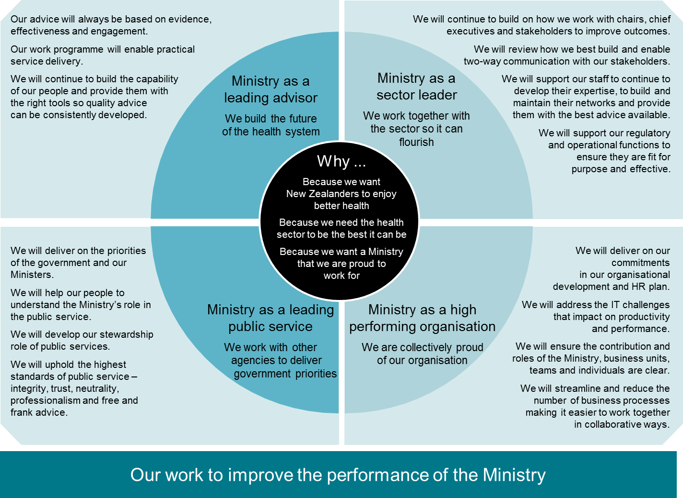

Throughout the year, the Building for Our Future programme has:

* delivered the Leading for Our Future programme to over 250 managers and leaders, to inform and advise them of the Ministry’s direction, and to improve overall leadership capability
* improved the quality of written advice to Ministers, as evidenced by recent New Zealand Institute of Economic Research (NZIER) results (an increase from an average score of 6.98 in the previous year to 7.34)
* ensured Ministry activity is aligned with activities within the MSD and the Ministry of Business, Innovation and Employment, to improve NGO contracting
* refocused the quarterly DHB chief executives and chairs meeting to collectively focus on key issues facing the health sector.

### People capability and performance

Over the past year, the Ministry has made three key changes to staff development and performance mechanisms, as follows.

* It has rolled out a new performance and development framework to help managers have consistent, effective performance and development conversations with their teams throughout the year.
* It has implemented a realigned competency model to identify the critical skills and competencies needed in the Ministry, and has applied it to all position descriptions and performance review conversations.
* It has placed greater emphasis on capability development, supported by targeted learning programmes for leadership, management and core skills, via Learning Space, a new online learning management system.

### Better administrative and support services

The 2012/13 Benchmarking Administrative and Support Services (BASS) results, released in May 2014 by Treasury, demonstrate that the Ministry is improving performance across the efficiency and effectiveness measures for administration and support (A&S) services. Comparisons between 2011/12 and 2012/13 show that the total cost of administrative and support services has fallen from $80 million to $76 million: a drop of 5 percent. This partly reflects the overall fall in the Ministry’s headcount and baseline operating expenditure.

The Ministry has succeeded in reducing total costs in corporate and executive services, information and communications technology and human resources. The number of employees per full-time-equivalent (FTE) dropped 37 percent, from 132 to 83, as a result of the replacement of contractors with full-time employees and tighter overall management of FTEs, and places the Ministry well against similar agencies. The Ministry is achieving gains in procurement through engagement in cross-agency Better Public Service initiatives, and rates highly against other agencies in terms of the percentage of commodity spend channelled through collaborative procurement and the spend against pre-established contract arrangements.

The Ministry has generally scored well in organisational effectiveness, between achieving (2) and exceeding (3) against the BASS Capability Maturity Model indicators. Opportunities for improvement include increasing performance against some management practice indicators and some maturity indexes. The Ministry recognises these opportunities as important components of the Ministry’s organisational development programme and the Building for Our Future programme for 2014/15.

Table 1.15: People capability measures

|  |  |
| --- | --- |
| **Measure/target** | **Result** |
| **Employee engagement**  The Ministry’s engagement score increases from a Gallup poll baseline of 3.68 out of 5 in 2012. | The Ministry’s engagement score increased to 3.8 in 2013. This is a meaningful increase, which reflects a tangible change in the Ministry’s work environment.  The Gallup New Zealand State Sector database included 28 agencies in 2013; the Ministry was in the 51st percentile of this database. This is a significant increase in relative position from 2012, when the Ministry was in the 43rd percentile. |
| **Quality of written advice, as measured independently by the New Zealand Institute of Economic Research**  A score of 7 or greater is achieved. | The policy advice quality review for 2013/14 resulted in an average score of 7.36. |
| **Voluntary turnover as a percentage of total staff**  Turnover is less than 12 percent per annum. | Voluntary turnover is 12 percent. This has decreased since a peak of 20 percent in 2007/8; there are currently no issues or concerns. |
| **Retention of new staff**  The percentage of new staff still in their role after 12 months is higher than the BASS median of 80 percent in 2011. | The percentage of staff still in their role after 12 months in 2013/14 was 86 percent. While this is higher than the BASS median of 80 percent, it should be noted that the figure includes staff taking up secondments or other roles within the Ministry. |
| **Sick leave (excluding maternity/parental leave)**  Average days of absence per employee is lower than the BASS median of 6.52 days in 2011. | Average days of absence per Ministry employee was 6.87 days: 0.35 days higher than the BASS median. |

### Equal employment opportunities

The Ministry recognises that equality and diversity are important for organisational success. The differences that all staff bring to the workplace represent benefits to the Ministry that need to be understood, appreciated and realised. The Ministry’s rules and processes for recruitment, selection, terms of employment, performance management, capability development and promotion aim to promote equity and diversity. For instance, the Ministry is proud to have a gender-balanced Executive Leadership Team (ELT), ensuring that equality and diversity are considered as a matter of course. Further to this, a recent addition to all advertisements advises candidates that the Ministry of Health is a disability-friendly organisation.

## Procurement strategy

The Ministry has continued to support the Governments Procurement Policy Transformation project to ensure the procurement of social sector contracting is more effective and efficient and aligns with the Government’s Better Public Services priorities. The Ministry is engaged in all-of-government and cross-agency activities, including significant partnership with colleagues in the MSD, the Ministry of Business, Innovation and Employment, the Treasury and other agencies. The Ministry procurement team has been an active participant on the Treasury’s Social Sector Contracting Improvement Group. In this role it has implemented the streamlined contracting with NGOs programme, the one Government contract with the top 30 social service providers and the adoption of five generic contract standards for the social sector.

Over the past year the Ministry has greatly improved its internal procurement capability and enhanced its contracting capability. The Ministry has realised a commitment to improve the effectiveness of interventions and develop new procurement models, in order to get better outcomes from available Government funding, through several key projects, such as the social bonds pilot and NGO streamlined contracting.

The Procurement Improvement Programme continues to improve Ministry procurement planning, supplier selection, contracting, implementation and monitoring of service contracts and support of Ministry staff involved in procurement. Recommendations from the Procurement Capability Effectiveness Review undertaken as part of the Government Procurement Reform programme will be dovetailed into relevant workstreams under the Ministry’s improvement programme. The Ministry is working to further improve procurement into 2015/16, and to gain a the Government’s silver rating for capability effectiveness within two years.

### Social Bonds Pilot Project

The Ministry is the lead government agency for the social bonds system, a mechanism for financing outcomes-based contracts to drive improvements. Social bonds will allow private and not-for-profit organisations to partner with the Government to fund and deliver services to improve social outcomes. If projects funded in this way achieve agreed results, the Government will pay the investors back their investment plus a return, up to an agreed maximum. In December 2013 the Ministry released a registration of interest (ROI) to identify suitable outcome areas and capable service providers with the potential to deliver a social bond pilot. Registrations were received at the end of February and after an evaluation a shortlist of successful providers was notified in July for the completion of the procurement process.

The Ministry has used innovative procurement processes developed as part of the social bonds process for other programmes aiming to deliver better social sector outcomes, such as Healthy Families New Zealand and national telehealth services. The Ministry has involved representatives from across Government in these projects. Templates for these approaches have been made available to other government agencies.

## Improving the performance of assets

The Ministry manages over $41 million of fixed assets including $19.6 million of IT infrastructure, $10.2 million of property, furniture, plant, equipment and fittings and $0.4 million of vehicles.[19]

The Major Projects Committee oversees sector- and Ministry-focused systems enhancement and continues to actively manage projects over $500,000 and any others deemed moderate risk. Around $9.4 million was invested, mostly in systems and hardware enhancements, in 2013/14.

### Information technology (IT)

In 2013 the Ministry completed a major technology update of the National Health Index (NHI), Healthcare Providers Index (HPI) and associated capabilities. The Ministry is now undertaking additional work that will further improve the efficiency and effectiveness of health sector operations.

A significant project to replace the Ministry’s legacy payment and contract management systems is in progress. The project involves National Clinical Systems and migrating current legacy payment systems to the Ministry’s existing Oracle system. In addition, the Ministry will maximise IT capability and leverage from all-of-government IT services.

#### IT capital investment

The Ministry’s IT strategy is to modernise core health data and management systems by upgrading and replacing information systems and their supporting hardware. IT infrastructure optimisation is being achieved by aligning investment with national, regional and local service priorities and new models of care. Priorities such as primary health care, quality improvement and fiscal sustainability are providing the focus for the Ministry’s IT capital intentions. Payment systems are being upgraded to improve reliability. Table 1.16 shows expenditure on major IT projects in 2013/14.

Table 1.16: Expenditure on major IT projects, 2013/14

|  |  |
| --- | --- |
| **IT capital project** | **$000** |
| Quality and Safety Systems | 1677 |
| SITS Data Warehouse Platform Upgrade | 314 |
| Corporate IT Assets | 1532 |
| New Zealand Cancer Registry Upgrade | 566 |
| Leveraging Health Identity | 1492 |
| Auckland Property Change | 1379 |
| Natural Health and Supplementary Products Database | 714 |
| National Patient Flow Data Collection – Stage 2 | 1234 |
| Sector Services Payment System Program | 292 |
| eEnrolment | 93 |
| CPSA – Stage 4 | 117 |
| PRMS – Stage 2 | 15 |

### Property

As in 2012/13, there was modest capital expenditure on Ministry property projects over 2013/14. The Auckland office was completed in December 2013; the new lease has provided the Ministry with a saving of $346,052 per annum. The lease and development agreements for the two Wellington sites, the Freyberg Building and 133 Molesworth Street, have been signed, and work has commenced on both sites. The staff from 133 Molesworth Street and Brandon Street will be moving into the Freyberg Building in late 2014.

The Wellington Accommodation Project (A Building for our future) and the Property Strategy will be the major deliverables over the next four years. The Ministry is looking at how it can make the best use of its resources in a way that makes it easier for staff to work together more collaboratively. This includes bringing all Wellington offices into one location in 2017, and updating the other offices to open plan arrangements.

The single site for the Wellington office will be the Ministry’s existing 133 Molesworth Street building. Prior to 2017 the landlord will be carrying out an extensive refurbishment of this building, which will include adding two floors to the existing building and carrying out seismic improvements. To allow the refurbishment of 133 Molesworth Street, staff are moving, with staff from the Brandon Street offices, to temporary premises in the Freyberg Building at 21 Aitken Street, Thorndon.

# Risk and assurance

To support the Ministry’s strategic direction and the Government’s priorities, the Ministry maintains an active and structured programme of risk management and internal control across its operations. All managers and staff are responsible for these principles.

The Ministry has an active Audit Finance and Risk Committee that includes external members, one of whom chairs the Committee. The Committee provides advice to the Director-General and the ELT on a range of topics, including:

* the quality of financial and performance reporting
* risk management and audit functions
* the establishment and enforcement of financial and other business policies and practices
* the Ministry’s compliance with significant legal and regulatory requirements.

### Internal audit and assurance

The Ministry maintains an internal audit and assurance function. This is an independent team with a direct reporting line to the Director-General. The team provides independent, objective assurance on the effectiveness of the Ministry’s governance, planning, performance management, risk management, operational processes and internal controls. It also identifies opportunities for improving the efficiency and effectiveness of how the Ministry uses its resources.

The team’s work programme is based on a long-term internal audit plan, which is risk-based. Delivery against the plan remained on track for 2013/14.

### Risk

As a large organisation, with a diverse range of responsibilities and objectives, the Ministry faces a variety of risks, from day-to-day through to longer-term strategic risks. In 2013/14, the Ministry reviewed and refreshed its risk management framework to ensure its approach to managing risk continues to be fit for purpose and reflects the Ministry’s changing work environment. The refreshed framework aims to ensure all key risks are identified, prioritised and managed appropriately.

The refreshed framework is aligned to the international risk management standard Australia New Zealand International Standard ISO 31000:2009,and is based on seven key principles:

1. We understand how risk management adds value by helping us to achieve the Ministry’s objectives.

This approach focuses on the most important risks that might prevent the Ministry from achieving its objectives.

2. We all take personal responsibility for proactively managing risk in everything we do and encourage others to do the same.

Risk management is the responsibility of all people in the Ministry, including managers, staff, temps and contractors. All are risk aware and understand the Ministry’s risk management responsibilities.

3. Our people are empowered to escalate risks, as appropriate, to ensure they are managed early, effectively and at the right level.

Staff are actively encouraged to discuss key risks with their next-level manager and further, where appropriate. The structured risk management framework supports timely risk escalation and communication.

4. We openly, honestly and constructively engage in risk discussions at all levels.

A risk-smart culture exists in which people feel comfortable talking about risk across the Ministry. These conversations result in taking action to proactively manage risks.

5. We integrate risk management into our planning, our processes and our daily decisions and actions.

Risk management is not seen as a stand-alone compliance exercise but is an integrated, iterative practice that is pragmatic and adds value.

6. We look for opportunities to do things better, bearing in mind that with opportunities come challenges and risks.

The Ministry recognise that with uncertainty come both risks and opportunities. Risk management practices are used to promote innovation, and support well-managed risk-taking.

7. Our risk management processes are fit-for-purpose, recognising the need for flexibility while maintaining Ministry-wide consistency for key elements.

Processes are sufficiently flexible to allow an agile and responsive response to the changing environment. As the Ministry improves at identifying and managing risks and opportunities, processes will mature and adapt to best suit the Ministry’s needs.

The roll-out of the Ministry’s refreshed framework was supported by a programme of targeted training across the Ministry during the year. As well as specifically addressing the new framework, this training formed part of the Ministry’s ongoing risk education programme, aimed at enhancing risk awareness in day-to-day work.

In April 2014, the ELT undertook a full review of its ‘Top Risks’, to ensure all key risks to achieving the Ministry’s outcomes had been identified. The timing of this review was scheduled to coincide with the annual planning process, to ensure alignment of key risks with Ministry objectives and to take account of any relevant changes to both the internal and external environment. The refreshed Top Risks are a blend of strategic and key operational risks that are critical to the Ministry’s core functions. The status of these risks, along with any significant new or emerging risks, or significant risks escalated from business unit-level risk registers or major projects, are reported monthly to ELT via the Ministry Monthly Report.

The Risk Management Steering Group, comprising cross-Ministry representation, continues to meet monthly to oversee the continuing development of risk management within each business unit. To further maximise the cascade of risk information and knowledge, the Ministry has also established the risk champion role. Each business unit now has at least one dedicated risk champion. The role is focused on promoting risk management activities within each business unit, and supporting business units in their use of the refreshed framework. Risk champions meet monthly, and provide support to the Risk Management Steering Group and the principal advisor risk in embedding the refreshed framework.

# Statement of service performance

## Introduction

This section outlines the Ministry’s service performance and meets the requirements of the Public Finance Act 1989.

Service performance measures enable the reporting of the quantity, quality, timeliness and cost-effectiveness of the Ministry’s outputs. The measures also provide key information about the Ministry’s overall performance and role.

This section groups and presents the Ministry’s service performance measure results by appropriation within Vote Health. The Ministry has met or exceeded most of its targets; where it has not, explanations are provided.

Prior to 2011/12, the Ministry undertook a comprehensive review of its output classes and associated performance measures. Since then the focus has been to refine existing measures and lift standards and performance. Table 1.17 provides a summary of service performance.

Table 1.17: Summary of service performance measures by departmental expense appropriation

|  |  |  |  |
| --- | --- | --- | --- |
|  | **Number achieved or exceeded** | **Number not achieved** | **Actual ($ million)** |
| Information and payment services (MCOA)[20] | 15 | 6 | 69.417 |
| *Health sector information systems* | *6* | *0* | *51.116* |
| *Payment services* | *9* | *6* | *18.301* |
| Managing the purchase of services | 7 | 0 | 28.626 |
| Policy advice and ministerial servicing (MCOA) | 3 | 3 | 20.036 |
| Regulatory and enforcement services | 9 | 1 | 23.980 |
| Sector planning and performance | 8 | 2 | 46.456 |
| **Total** | 42 | 12 | 188.515 |

## Information and payment services (MCOA)

There are two output classes under this multi-class output appropriation (MCOA): health sector information systems and payment services. Grouping these output classes together recognises the close relationship between these functions.

### Health sector information systems

The Ministry of Health operates and manages IT infrastructure that underpins national data collections and systems used in service delivery. As part of this, the Ministry manages the national collections that provide access to information and coded data. This enables the sector to undertake local, regional and national planning of resources for current and future service demand. In addition, frontline health sector staff use systems such as the National Health Index to identify patients in real time and make sure they get appropriate services and support.

Table 1.18: Summary of output performance measures and standards for health sector information systems

|  |  |  |  |
| --- | --- | --- | --- |
| **Actual 2012/13** | **Performance measure** | **Standard** | **Actual 2013/14** |
|  | **National infrastructure and systems** |  |  |
| 100% | Percentage of time for which key sector- and public-facing systems are available | 99% | 99.5% |
| 13,484 | Number of active user logins to national systems | 10,000 | 14,971 |
|  | **National collections** |  |  |
| 11 | Number of national collections reports produced annually | 10 | 11 |
| 98.9% | Percentage of data submitted by DHBs processed within two working days | 97% | 99.15% |
| 2,940 | Number of requests for data and/or analysis responded to in respect of information held within the national collections datasets | 2,400 | 2,814 |
| 29 | Number of reviews of national collections for maintenance and/or enhancement requirements | 24 | 31 |

#### National infrastructure and systems

Six key systems are used widely across the health sector. These are: the National Health Index (NHI), the National Immunisation Register, online pharmacy claiming, special authorities, Oracle Financials and the Ministry’s website. Disruptions in service are unproductive, and would damage the Ministry’s reputation. In 2013/14, all systems were available for almost 100 percent of the time. Information from national systems was available to almost 15,000 external user accounts with login access to the systems. The number of active user logins has continued to grow over the year.

#### National collections

Information from the national collections was used to publish 11 reports (available at [www.health.govt.nz/publications](http://www.health.govt.nz/publications)). The national collections are important, as they provide valuable health information to support decision-making in policy development, funding, monitoring and research, and in turn contribute to improving the health outcomes of New Zealanders.

In 2013/14, nearly 100 percent of the data submitted by DHBs relating to the National Minimum Dataset (hospital events) and the National Booking and Reporting System (patients waiting for elective surgery) were processed within two working days of receipt. The Ministry is committed to the efficient and accurate processing of data. The Ministry also provides information services to the public.

Thirty-one items pertaining to the maintenance or enhancement of national collections were submitted for review by the National Collections Annual Maintenance Project (NCAMP) in 2013/14. The project team and interested stakeholders had reviewed all of these by July 2014.

Table 1.19: Financial performance for health sector information systems

|  |  |  |  |  |
| --- | --- | --- | --- | --- |
| **Actual  30/06/2013 $000** |  | **Actual  30/06/2014 $000** | **Main estimates 30/06/2014 $000** | **Supp. estimates 30/06/2014 $000** |
| 54,835 | Crown revenue | 51,623 | 58,481 | 51,623 |
| 36 | Third party revenue | 47 | – | – |
| **54,871** | **Total revenue** | **51,670** | **58,481** | **51,623** |
| 53,788 | Total expenditure | 51,116 | 58,481 | 51,623 |
| **1,083** | **Net surplus** | **554** | **–** | **–** |

### Payment services

The Ministry is responsible for the administration of core health payment processes for the health sector, including administering agreements between health funding organisations and health providers, managing the subsequent payment of funds, and capturing and tracking health care users’ entitlements and usage. The Ministry operates telephone contact centres that handle queries and service requests from funders, providers and health care users in support of the payment services function. The Ministry also carries out audit and investigation activities on payments made across the sector.

Table 1.20: Summary of output performance measures and standards for payment services

|  |  |  |  |
| --- | --- | --- | --- |
| **Actual 2012/13** | **Performance measure** | **Standard** | **Actual 2013/14** |
|  | **Claim transactions** |  |  |
| 1.6 million | The number of claims processed per annum | 1.8 million | 1,659,027 (see Note A) |
| 99.8% | The percentage of claims paid on time | 95% | 99.7% |
| 98.0% | The percentage of claims processed accurately | 95% | 98.8% |
| $2.71 | The direct cost per payment transaction processed | $2.70 | $2.66 |
|  | **Contracts** |  |  |
| 10,543 | The number of agreements processed per annum | 9400 | 7740 (see Note B) |
| 68.9% | The percentage of all draft agreements prepared for funders within target timeframes | 95% | 64.9% (see Note C) |
| 95.8% | The percentage of agreements prepared accurately | 95% | 94.7% |
| $94.91 | The cost per agreement processed | $155.00 | $119.82 |
|  | **Contact centres** |  |  |
| 547,516 | Number of contact centre calls per annum | 580,000 | 544,718 (see Note D) |
| 72.9% | The percentage of calls to contact centres answered within service specifications for timeliness (20 seconds currently) | >80% | 75.8% (see Note E) |
| 5.6% | The percentage of calls abandoned by callers prior to being answered by the contact centre | <5% | 3.5% |
| $4.09 | The cost per enquiry | $4.70 | $4.36 |
| 97.6% | The percentage of enquiries resolved in under 10 business working days | 95% | 97.01% |
|  | **Financial audit and compliance activities** |  |  |
| 90.0% | The total dollar value of payments made to those primary health providers who have undergone financial audit during the year, expressed as a percentage of the budget for the primary health care providers (total dollar value primary sector payments is estimated to be $5.9 billion) | 70% | 88% |
| 2.7 | The ratio of the total dollar value of averted losses and identified recoverable losses from audit and compliance activities against the net operating cost for audit and compliance activities (net operating cost budget estimated for 2013/14 to be $2.5 million) | 5.1 | 6.8 |

#### Claim transactions

The Ministry makes payments to a variety of health sector providers, such as midwives and pharmacies, typically in response to claims by providers. Claims include all transactions where payment is required, including registrations, invoices and other support claims. The Ministry aims to deliver the service as efficiently as possible.

Note A: Ongoing improvements made to the health payment systems have seen the volume of manual claiming reduced in recent years. This is a demand-driven measure, although year-to-date volume is at a similar level to the previous year.

#### Contracts

The ‘contracts’ area covers all agreements administered where a service is provided to the sector; it includes contracts between funders (either the Ministry or DHBs) and service providers, but excludes Crown Funding Agreements and their variations, since these are administered outside of the payment services systems.

Note B: This is a demand-driven measure. The number of agreements processed was below forecast, mainly due to the number of annual age-related residential care service agreements that were processed after year-end. 2500 such agreements were processed in July (the average is 1100) – if these had been processed in June the result would have exceeded the target 9400. Conversely, this may mean that 2014/15 numbers will be higher than forecast. The number of agreements processed was high in the prior year (10,534), mainly due to processing of the variation to the community pharmacy services agreement.

Note C: This measure has historically not been met. The result for this year is below target due to the flow-on effect of agreements being processed during the peak period, between May and August each year. In order to improve current performance, the Ministry is monitoring its week-on-week and monthly performance and undertaking steps to lessen the demand for contract renewals in July, including by moving contracts to multi-year terms and implementing single contracts with providers where they provide multiple services.

#### Contact centre

The National Contact Centre (NCC) supports the sector and the wider public by responding to health-related enquiries in approximately 60 areas, including carer support, pharmacy, the NHI and the Ministry’s general line. Ministry-funded, outsourced contact centre work (such as that provided by PlunketLine, Healthline and Quitline) is excluded from the measures reported here.

The NCC answers an average of 2200 calls per day, and close to 3000 on the busiest days. A systems upgrade has recently improved the NCC’s monitoring of customer demand and the effectiveness of its workflow management. The upgrade resulted in improvement to the calls abandonment rate from the prior year, and led to the standard being met.

Notes D and E: Number of contact centre calls per annum is demand-driven. The result for timeliness of answering calls for the year was below target, largely due to peaks in demand and low staff availability. However, call timeliness continues to improve, and although the 20 seconds target was not consistently met, calls within high-volume queues are generally being answered within 30 seconds. The functionality of the system is currently being expanded. This, combined with changes already implemented, will improve timeliness performance in the coming year.

#### Financial audit and compliance activities

The Ministry undertook audit activities in relation to 88 percent of the funding that made up the $6 billion worth of sector services payments for 2013/14 across 14 funding streams. This performance was above the target of 70 percent.[21]

As a result of 2013/14 audit and investigation activities, the Ministry identified $5.7 million worth of recoverable losses, and averted $11.4 million worth of losses. The 2013/14 target was to recover 5.1 times the net operating cost budget of $2.5 million, or $12.75 million. The performance for the year was 6.8 times that figure, or $17 million.

The Ministry continues to work on improving compliance and preventing fraud in the health sector. This is a cost-effectiveness measure for the Ministry’s audit activities on sector financial payments. It compares specifically identified losses from non-compliant payments, and estimated future losses from the same identified sources, against the budget for the audit activities undertaken.

Table 1.21: Financial performance for payment services

|  |  |  |  |  |
| --- | --- | --- | --- | --- |
| **Actual  30/06/2013 $000** |  | **Actual  30/06/2014 $000** | **Main estimates 30/06/2014 $000** | **Supp. estimates 30/06/2014 $000** |
| 20,190 | Crown revenue | 19,698 | 19,895 | 19,698 |
| 299 | Third party revenue | 211 | 1,563 | 622 |
| **20,489** | **Total revenue** | **19,909** | **21,458** | **20,320** |
| 20,909 | Total expenditure | 18,301 | 21,458 | 20,320 |
| **(420)** | **Net surplus/(deficit)** | **1,608** | **–** | **–** |

## Managing the purchase of services

The Ministry has a significant responsibility for purchasing health and disability services on behalf of the Crown. A total of $12.309 billion of funding was provided to DHBs and health-related Crown entities in 2013/14, and $1.553 billion worth of services was directly purchased by the Ministry through non-departmental funding.

This output class assesses how well the Ministry negotiates and manages a portfolio of contracts within the Ministry’s purchasing and pricing frameworks, to deliver consumer-focused services while ensuring value for money. It also ensures there is a consistent national approach to the provision of support services to people in need.

Table 1.22: Summary of output performance measures and standards for managing the purchase of services

|  |  |  |  |
| --- | --- | --- | --- |
| **Actual 2012/13** | **Performance measure** | **Standard** | **Actual 2013/14** |
|  | **Contracting** |  |  |
| 4280 | Total number of contracts held by the Ministry for the purpose of purchasing goods and services on behalf of the Crown | 4000 | 4298 |
| Achieved | The Ministry Procurement Policy is assessed and confirmed to be in line with government standards | Achieved | Achieved |
| 84.0% | The percentage of new contracts issued, for the purpose of purchasing goods and services on behalf of the Crown, that are compliant with the Ministry Procurement Policy | 95% | 96.0% |
| 1:81 | The ratio of departmental expenditure for the output class against relevant non-departmental expenditure | 1:80 | 1:80 |
|  | **Contract management** |  |  |
| 97.4% | The percentage of monitoring reports from service providers, for contracts with a value over $4 million, that receive a formal response from the Ministry | 85% | 99.7% |
| 92.8% | The percentage of Ministry feedback to Crown Funding Agreement Variation (CFAV) monitoring reports that is supplied to DHBs within agreed timeframes | 90% | 100% |
| 100% | The percentage of complaints from service users received by the National Quality Group, National Services Purchasing, National Health Board, that receive a timely initial response from the Ministry | 95% | 100% |

### Contracting

These measures capture dimensions of work being undertaken in active purchasing of services using non-departmental expenditure (NDE) on behalf of the Crown. The following are defined as contracts for the purpose of these measures:

* any contract that has any dollar value and is managed under the Ministry’s Non-Departmental Contract Management System, or
* payments made under section 88 of the New Zealand Public Health and Disability Act, or
* payments managed by the Ministry’s client claims processing system.

The measure does not include Crown Funding Agreements with the DHBs.

Contracts are held between the Ministry of Health and other parties, on behalf of the Crown, for the purchasing of services for third parties. Such contracts are always paid from NDE appropriations. Included in the scope of these contracts are:

* new (or renewed) contracts supporting national service purchasing – for example, the National Screening Unit, disability support services, ambulance services, maternity services and public health services
* other new (or renewed) contracts entered into by the Ministry for provision of services to external parties using NDE funding.

The Ministry reviews its own procurement policy and standards to ensure compliance with government standards as required.

The contract compliance rate with the Ministry procurement policy between 1 June 2013 and 30 April 2014 was 96 percent, against a target of 95 percent. This measure has been removed for 2014/15.

The ratio of departmental expenditure and relevant NDE measure assesses how efficiently the Ministry manages its contracted NDE of $1.849 billion which is a component of the total $2.645 billion Ministry managed NDE. The target is that the Ministry manages $80 worth of contracted NDE for every dollar of related departmental expenditure spent. In 2013/14, the Ministry managed $80 contracted NDE for every dollar it spent.

### Contract management

The contract management performance measures measure how well the Ministry handles monitoring information, and act as a proxy for a measurement of the quality of contract performance management. Regular feedback to providers on contractual performance matters assists in both preventing poor performance and efficiently resolving existing performance issues. This measure applies to all monitoring reports sent to the Ministry by contracted service providers according to a regular reporting schedule, such as would normally be expected in a contracting arrangement. Reports may be sent monthly, quarterly or according to some other schedule.

The following reports are excluded from the measures:

* monitoring reports for contracts where the total value of the contract is below the financial threshold
* Crown Funding Agreement (CFA) variation monitoring reports
* extraordinary correspondence, issues management and other performance reporting outside of the normal contractual schedules for reporting.

‘Service providers’ include all organisations that have a contract with the Ministry to deliver services funded from the NDE budget. In 2013/14 the Ministry received a total of 353 monitoring reports from service providers in relation to 77 contracts with a value over $4 million and formally responded to 352, representing an achievement of 99.7 percent against the target of 85 percent.

CFA variations comprise a significant amount of contracting activity; the Ministry monitors these contracts in a different way, according to their own rules and tracking system. CFA variation monitoring reports are typically short confirmations of the funding that has been spent, along with some associated measures, such as volume of a service delivered and number of people employed. These reports are usually due on the 20th day of the month following the end of the quarter. A key facet of this system is that monitoring reports from DHBs should receive feedback from the Ministry within a standard timeframe of 14 business days. This year all feedback to DHBs in relation to CFA variation monitoring reports was delivered on time.

Table 1.23: Financial performance for managing the purchase of services

|  |  |  |  |  |
| --- | --- | --- | --- | --- |
| **Actual  30/06/2013 $000** |  | **Actual  30/06/2014 $000** | **Main estimates 30/06/2014 $000** | **Supp. estimates 30/06/2014 $000** |
| 27,832 | Crown revenue | 28,641 | 29,050 | 28,641 |
| – | Third party revenue | – | – | – |
| **27,832** | **Total revenue** | **28,641** | **29,050** | **28,641** |
| 26,310 | Total expenditure | 28,626 | 29,050 | 28,641 |
| **1,522** | **Net surplus/(deficit)** | **15** | **–** | **–** |

## Policy advice and ministerial servicing (MCOA)

Policy advice is the provision of advice (including second opinion advice and contributions to policy advice led by other agencies) to support decision-making by Ministers on government policy matters. The Ministry acts as the Minister of Health’s principal advisor on health policy, seeking to provide clear and practical advice supported by strong analysis of issues, in line with the Ministry’s quality standards for policy advice.

‘Ministerial servicing’ is the provision of services to Ministers to enable them to discharge their portfolio responsibilities other than policy decision-making.

Table 1.24: Summary of output performance measures and standards for policy advice

|  |  |  |  |
| --- | --- | --- | --- |
| **Actual 2012/13** | **Performance measure** | **Standard** | **Actual 2013/14** |
|  | **Advice** |  |  |
| 7.34 | The average score attained by written policy advice as assessed by an external reviewer | ≥7 out of 10 | 7.36 |
| New | Total policy function cost per output hour | $109-119 | $166.61 (see Note A) |
| 4 out of 5 | The average score for the Minister’s overall satisfaction with written and verbal advice (as assessed on a four-monthly basis) | 80% | 80.0% |
|  | **Ministerial servicing** |  |  |
| 97.2% | The percentage of responses provided to the Minister within agreed timeframes; for written parliamentary questions, Ministerial letters, and requested briefings (out of a total expected volume of 5800 responses) | 96% | 93.9% (see Note B) |
| New | The percentage of Ministerial that required no revision (out of a total expected volume of 3,500 letters) | 98% | 98.7% |
|  | **Official Information Act requests** |  |  |
| 92.4% | The percentage of responses to Official Information Act requests, provided to the Minister or requestor within agreed timeframes (out of an expected 600 requests) | 95% | 83.3% (see Note C) |

### Policy advice

As part of the Ministry’s commitment to improving its performance, each year it asks the New Zealand Institute of Economic Research (NZIER) to review the quality of its written advice to ministers. This year, 40 papers were randomly selected and forwarded to NZIER. In the latest review report, NZIER noted:

The Ministry has made good progress on the quality of its advice. We see an increasing proportion of good papers ... The progress does not come through in the average score – the same as last year’s. It reflects some weaker papers, but shouldn’t detract from the progress that’s been made.

Note A: The cost per output hour is estimated to be $138.70. Treasury has now updated the cost per output hour formula to exclude non-policy advice hours. For transparency reasons and to ensure consistency of information reported, all government departments are required to disclose the following in their 2013/14 statements of service performance (figures for the Ministry in brackets):

* 2013/14 standard in the estimates using the original formula ($109–119)
* 2013/14 actual result calculated using the original formula ($138.70)
* 2013/14 standard recalculated using the updated formula (not recalculated as the Treasury methodology was not used to calculate the Ministry’s original 2013/14 standard)
* 2013/14 actual result calculated using the updated formula ($166.61).

The Ministry surveys the Minister of Health on a four-monthly basis on the degree to which the Ministry of Health’s verbal and written advice met his expectations, using a five-point scoring system, 5 being the highest score. All three surveys were rated 4 out of 5 this year.

### Ministerial servicing

The Ministry provides a wide range of advice and services to ministers. During 2013/14, the Ministry responded to 4141 pieces of ministerial correspondence (made up of briefings, direct replies, parliamentary questions and ministerial letters); of these responses, 93.9 percent were completed within the following timeframes:

* written parliamentary questions – within four days from the day of receipt
* ministerial letters – dependent on urgency, usually within a day to 20 days from the day of receipt
* briefings – as stated by the Minister’s office.

Note B: The timeliness measure for providing responses was not met. Because all types of correspondence are placed together for measurement, one area being significantly out of time can affect the overall performance. In 2013/14, briefings were responded to in a timely manner 88.8 percent of the time, which lowered the total overall performance. Where delays occurred, in the majority of cases, the Ministry advised ministers and their staff in advance, to ensure minimal adverse impacts. The Ministry is reviewing its processes in this area.

The Ministry responded to 1363 parliamentary questions and 2115 ministerial letters and prepared 663 briefings (a total volume of 4141) during 2013/14. The total volume represented an increase of 9.2 percent compared to 2012/13. Of the 2115 ministerial letters drafted by the Ministry, only 28 were returned from the minister’s office for amendment.

The Ministry requires staff to seek peer review for briefings, responses to ministerial letters and written responses to parliamentary questions, to ensure accuracy and quality.

### Official Information Act (OIA) requests

The Ministry acknowledges that requests for official information must be met within the statutory timeframes, in order to promote transparency and open government.

Note C: During 2013/14, the Ministry responded to 749 OIA requests, meeting the agreed timeframe for 624 of those. This represents an achievement of 83.3 percent against the 95 percent target. On 14 July 2014, the Ministry rolled out its new OIA process and online training module for staff. The focus of these changes is to ensure staff are well supported when dealing with OIA responses, and to improve the Ministry’s overall timeliness performance. The Ministry has also instituted a more proactive follow-up approach on current OIA requests. These measures should improve timeliness performance going forward.

Table 1.25: Financial performance for policy advice

|  |  |  |  |  |
| --- | --- | --- | --- | --- |
| **Actual  30/06/2013 $000** |  | **Actual  30/06/2014 $000** | **Main estimates 30/06/2014 $000** | **Supp. estimates 30/06/2014 $000** |
| 16,935 | Crown revenue | 20,574 | 15,806 | 20,574 |
| – | Third party revenue | – | – | – |
| **16,935** | **Total revenue** | **20,574** | **15,806** | **20,574** |
| 15,750 | Total expenditure | 20,036 | 15,806 | 20,574 |
| **1,185** | **Net surplus** | **538** | **–** | **–** |

## Regulatory and enforcement services

The Ministry is responsible for a range of core regulatory functions within the health sector. Various sections within the Ministry have specific areas of responsibility. These include:

* New Zealand Medicines and Medical Devices Safety Authority (Medsafe), which is responsible for the regulation of therapeutic products
* Office of Radiation Safety, which is responsible for the regulation of ionising radiation
* HealthCERT, which is responsible for ensuring hospitals, aged residential care providers (including rest homes), residential disability care providers and fertility service providers provide safe and reasonable levels of service for consumers
* Medicines Control, which is responsible for the regulation of the local distribution chain of medicines and controlled drugs within New Zealand
* Office of the Psychoactive Substances Regulatory Authority, which is responsible for the operation of the Psychoactive Substances legislation.

The Ministry carries out several key statutory functions related to health protection. These include the roles of the Directors of Public Health and Mental Health, which both carry important leadership and decision-making responsibilities, including the interpretation and administration of the relevant legislation.

The Ministry provides support to a range of ministerial committees. See Appendix C for further details.

Table 1.26: Summary of output performance measures and standards for regulatory and enforcement services

|  |  |  |  |
| --- | --- | --- | --- |
| **Actual 2012/13** | **Performance measure** | **Standard** | **Actual 2013/14** |
|  | **Compliance** |  |  |
| 586 | Number of quality audits of providers conducted or assessed | 558 | 565 |
| 95.9% | The percentage of complaints about providers or products that receive an initial response from the Ministry within target timeframes where a response is required | 90% | 97.3% |
|  | **Implementation** |  |  |
| 96.3% | The percentage of all licences, certificates and authorities issued to providers within agreed timeframes (of an estimated total of 6880 licences, certificates, and authorities issued) | 90% | 97.6% |
| 96.6% | The percentage of all New Medicines Applications (for ministerial consent to market) that receive an initial assessment within 200 days (of an estimated total of 220 applications processed) | 80% | 88.9% |
| 100.0% | The percentage of all Changed Medicines Notifications (for ministerial consent to market) approved within 45 days (of an estimated total of 1400 applications processed) | 100% | 100% |
|  | **Sector leadership and advice** |  |  |
| Achieved | All statutory officers appointed by the Ministry meet the criteria set by the Director-General of Health and any statutory prerequisites for appointment | Achieved | Achieved |
|  | **Statutory committees and regulatory authorities** |  |  |
| New | All recommendations for appointments meet the requirements of health legislation | 100% | 100% |
| New | The number of appointments to statutory committees and regulatory authorities | 77 | 75 (see Note A) |
| 100% | The percentage of recommendations for appointments (of approximately 200 planned appointments) where recommendations are presented to the Minister prior to expiration of term for the current appointee | 95% | 100% |
| 4.1 | Average rating for statutory committee satisfaction with secretariat services provided by the Ministry | ≥4 out of 5 | 4.6 |

### Compliance

The Ministry conducts quality audits of pharmacies licenced under the Medicines Act 1981 and reviews surveillance audits performed by designated auditing agencies for providers certified under the Health and Disability Services (Safety) Act 2001. It also audits manufacturers and packers of medicines. The Ministry conducts quality audits to ensure that providers of health care services continue to improve the quality of their services outside of formal licensing/ certification events.

The Ministry receives and responds to complaints made: under the Health and Disability Services (Safety) Act 2001 against certified hospitals, rest homes, mental health facilities and residential disability services; and under the Medicines Act 1981 regarding the quality of medicines, medical devices and advertising. It tracks and responds to complaints within specified timeframes, which are between five and seven days. In the case of medicines complaints, many are international notifications that do not require a response to the complainant – in these cases the target is to carry out initial assessment of the complaint within five working days.

### Implementation

Hospitals, rest homes, residential disability care facilities and fertility providers are certified under the Health and Disability Services (Safety) Act 2001. Pharmacies and other parties involved in the pharmaceutical supply chain (such as wholesalers and researchers) are licensed to handle medicines and drugs under the Medicines Act 1981 and the Misuse of Drugs Act 1975. Providers are licenced to use and possess radioactive substances under the Radiation Protection Act 1965. While licences, certificates and authorities have to be issued in accordance with legislative standards, the key operational measure is timeliness – this is the principal dimension of service quality, particularly when viewed from the customer perspective. A key aspect of the Ministry’s work is the approval of applications to market new and changed medicines for use in New Zealand. The timeliness measure describes significant aspects of product regulation activity.

### Sector leadership and advice

One of the Ministry’s important functions is giving advice to the sector on regulatory functions. Key recipients of advice are individuals employed in the sector who are designated as officers by the Director-General of Health and therefore having powers to act in a regulatory capacity.

All statutory officers appointed under the Health Act 1956 must meet criteria set by the Director-General of Health and any statutory prerequisites for appointment. The Director-General also appoints statutory officers under a range of other Acts: in particular the Smoke-free Environments Act 1990, the Tuberculosis Act 1948 and the Hazardous Substances and New Organisms Act 1996. City and district councils also appoint environmental health officers under the Health Act 1956; these officers assist councils to perform their environmental health functions.

### Statutory committees and regulatory authorities

The Ministry assists the Minister with the process of appointing members to statutory committees and regulatory authorities by sourcing candidates, compiling recommendations for appointment, conducting interviews with candidates and preparing Cabinet documentation concerning appointments. The Ministry complies with the State Services Commission guidelines when assisting the Minister with appointments, and provides the Minister with quality advice in a timely manner before members’ terms expire.

Note A: The performance standard is based on the total number of appointments expected to be made in any given year, which is estimated in advance of that year. The actual number of appointments made will depend on a number of factors, including unexpected vacancies arising and the operational needs of the board.

The annual statutory committee satisfaction survey, covering the period July 2013 to June 2014, was conducted during June 2014. In the survey, the following three questions were asked.

* How satisfied are you with the quality of analysis, information, advice, committee papers and reports (ie, non-administrative support) provided over the past 12 months?
* How satisfied are you with the administrative support provided to you over the past 12 months, including meeting arrangements and timeliness/quality of papers?
* Overall, how satisfied are you with the support provided to your committee by the Ministry in the past 12 months?

The measure of average satisfaction with the support provided to committees by the Ministry in the past 12 months was 4.6. Of the eight committees surveyed, six responded; one committee chose to skip this question. Overall, comments from the committees confirmed their satisfaction with the Ministry and praised its support, while acknowledging increased workloads and reduced staffing.

Table 1.27: Financial performance for regulatory and enforcement services

|  |  |  |  |  |
| --- | --- | --- | --- | --- |
| **Actual  30 June 2013 $000** |  | **Actual  30 June 2014 $000** | **Main estimates 30 June 2014 $000** | **Supp. estimates 30 June 2014 $000** |
| 12,588 | Crown revenue | 10,979 | 12,280 | 10,980 |
| 10,588 | Third party revenue | 11,387 | 13,827 | 13,355 |
| **23,176** | **Total revenue** | **22,366** | **26,107** | **24,335** |
| 23,102 | Total expenditure | 23,980 | 26,107 | 24,335 |
| **74** | **Net surplus/(deficit)** | **(1,614)** | – | – |

## Sector planning and performance

The Ministry works with DHBs to create accountability documents which outline what DHBs will deliver, and help improve their performance. The Ministry also monitors progress throughout the year against targets (both service and financial) and works with DHBs to address issues that may be affecting on their performance.

The Ministry provides support for sector employment relations negotiations and pays particular attention to monitoring elective services. It is also responsible for DHB funding.

Table 1.28: Summary of output performance measures and standards for sector planning and performance

| **Actual 2012/13** | **Performance measure** | **Standard** | **Actual 2013/14** |
| --- | --- | --- | --- |
|  | **Planning and funding support system** |  |  |
| Achieved | Planning and funding advice for the 2013/14 year is provided to Crown entities by 31 December 2013 | Achieved | Achieved |
| Achieved | The Ministry provides the Minister with advice on agreement of all DHB plans by 30 June 2014 | Achieved | Achieved |
|  | **Performance monitoring** |  |  |
| 86.2% | The percentage of monitoring feedback reports about performance supplied to DHBs within agreed timeframes (non-financial) | 90% | 95.4% |
| 100% | The percentage of all letters to DHBs with Health Target performance tables and supporting information, sent within 5 working days of the date for publication of results agreed with the Minister | 100% | 100% |
| 81.8% | The percentage of quarterly and monthly monitoring reports about Crown entities provided to the Minister within agreed timeframes | 100% | 83.3% (see Note A) |
|  | **Emergency response** |  |  |
| Within 2 hours | The timeframe for activating emergency response to national emergencies | Within 2 hours in each case | Within 2 hours in each of case |
| 33 people | The number of people who annually receive two training/exercise sessions on National Health Coordination Centre (NHCC) activation and response | 30 people | 50 people |
| Achieved | Quarterly regional or national health sector emergency planner meetings held in each region | Achieved | Achieved |
|  | **Governance** |  |  |
| New | The percentage of appointments to DHBs and other health Crown entity boards where advice is presented to the Minister prior to the current appointee’s term expiring | 100% | 100% |
| New | The number of appointments to DHBs and other health Crown entity boards | 117 | 113 (see Note B) |

### Planning and funding support system

Advice to assist Crown entities in planning for the upcoming financial year needs to be provided by the end of the calendar year. The 2013/14 Planning Package was distributed to DHBs by 6 December 2013.

By working closely and collaboratively with DHBs, the Ministry expects to facilitate agreements on plans by 30 June 2014. The timeliness target for agreements between DHBs and the Ministry is a proxy measure of the quality of the activities undertaken by the Ministry in support of this aim, such as facilitation, feedback and advice on draft plans. The Ministry is only an advisor to the process, since ministers and DHBs sign off the plans. In 2013/14 the Ministry met the target for this measure.

### Performance monitoring

The Ministry uses a number of performance indicators to set expectations and monitor performance, to ensure that DHBs appropriately work towards New Zealand Health Strategy priorities and achieve stated Government priorities for performance improvement and health outcomes. A vital part of the reporting process is the feedback (assessments) the Ministry gives to DHBs on each of these measures, particularly when improvement on performance is necessary, and/or remedial actions are required. Feedback must be timely so DHBs can introduce modifications to improve performance in the relevant period.

District health boards are accountable for achieving the health targets. Results are published in national and local newspapers, and online ; these results rank DHBs against each other. Early advice on targets performance allows DHBs to manage the impact of publication. This year, all letters from the Ministry to DHBs containing health target performance tables and supporting information were sent within five working days after the publication of results. The Ministry produces and circulates the tables used to publish health target results to DHBs quarterly. This is a significant way in which performance of the sector is communicated to the public.

The Ministry is responsible for the funding, monitoring and planning of DHBs and other health Crown entities. As such, it reports to the Minister periodically in the following performance areas:

* DHBs’ financial performance: monthly report highlighting where a DHB reports a significant variance against a plan—enabling identification of areas of financial pressure and risk as well as best practice within the DHB sector
* DHB performance on health targets: quarterly report containing detailed results and remedial actions
* overall quarterly report on DHB performance, including non-financial information, information on health targets performance and financial information ; this provides the Minister with an integrated high-level view of DHB performance
* health Crown entity performance: quarterly report describing major achievements, performance against planned outputs, financial performance and governance commentary.

Note A: The Ministry’s monitoring reports form the basis of the Ministry’s advice to DHBs and health Crown entities, as well as to the Minister of Health. Although the feedback target was not achieved this year, delayed feedback was provided within a week of the due date. During 2013/14, the Ministry provided 12 monthly monitoring reports, four quarterly performance dashboards, four quarterly health target reports and four reports in relation to non-DHB health Crown entities to the Minister. Of 24 reports, 20 were delivered on time, achieving 83.3 percent against the target of 100 percent.

### Emergency response

The Ministry maintains the capability and capacity to lead and coordinate a national health response to an emergency. In addition, it has prepared plans to continue function during and after an emergency, in accordance with sections 58 and 59 of the Civil Defence Emergency Management Act 2002 (which require all government departments to prepare such plans).

The Ministry has the necessary processes, facilities and staffing structure in place to enable the National Health Coordination Centre (NHCC) to go live within two hours of any emergency event that requires national health coordination. Primary and alternate sites for the NHCC have been identified at Ministry of Health offices. The Emergency Management Information System also allows for the NHCC to be set up at an alternate location with internet access, if required.

The Ministry’s emergency management group has responded to six events in the past year. In each case, activation of response occurred within the timeframe required. Two earthquakes in Wellington required activation of both an emergency management and a business continuity response. Internationally, the flooding event in Honiara (Solomon Islands) in April 2014 resulted in the first full deployment of the New Zealand Medical Assistance Team (NZMAT). In March 2014 two NZMAT team members were also deployed to assist in the Philippines following tropical cyclone Yolanda.

Over 2013/14, 50 people attended two emergency training and education sessions/exercises. This included 41 Ministry staff and 9 participants from other agencies.

### Governance

The Minister, in consultation with Cabinet and Caucus, appoints suitable candidates to DHB and other health Crown entity boards. The Ministry assists the Minister with the appointments process by sourcing candidates, compiling recommendations for appointment, conducting interviews with candidates, and preparing Cabinet documentation concerning appointments. The Ministry complies with the State Services Commission guidelines when assisting the Minister with appointments, and provides the Minister with quality advice in a timely manner before members’ terms expire.

Note B: The performance standard is based on the total number of appointments expected to be made in any given year, which is estimated in advance of that year. The actual number of appointments made will depend on a number of factors, including unexpected vacancies arising and the operational needs of the board. The Ministry advised the Minister on all 110 appointments to DHB and Crown entity boards in 2013/14.

Table 1.29: Financial performance for sector planning and performance

|  |  |  |  |  |
| --- | --- | --- | --- | --- |
| **Actual  30/06/2013 $000** |  | **Actual  30/06/2014 $000** | **Main estimates 30/06/2014 $000** | **Supp. estimates 30/06/2014 $000** |
| 37,553 | Crown revenue | 46,114 | 39,965 | 46,112 |
| 252 | Third party revenue | 298 | 360 | 360 |
| **37,805** | **Total revenue** | **46,412** | **40,325** | **46,472** |
| 36,521 | Total expenditure | 46,456 | 40,325 | 46,472 |
| **1,284** | **Net surplus/(deficit)** | **(44)** | **–** | **–** |

# Statement of Responsibility

As Acting Director-General of the Ministry of Health, I am responsible under the Public Finance Act 1989 for preparing the Ministry’s financial statements and statement of service performance, and for the judgments made in them.

I am responsible for establishing, and I have established, a system of internal control procedures designed to provide reasonable assurance as to the integrity and reliability of financial and non-financial reporting.

In my opinion, these financial statements and this statement of service performance fairly reflect the Ministry’s financial position and operations for the year ended 30 June 2014.

In my opinion, the forecast financial statements fairly reflect the forecast financial position and operations of the Ministry for the financial year to which they relate.

|  |  |
| --- | --- |
|  | MikeMcCarthySig |
| Chai Chuah  Acting Director-General of Health  30 September 2014 | Mike McCarthy  Chief Financial Officer  30 September 2014 |



**Independent Auditor’s Report**

**To the readers of  
Ministry of Health’s  
financial statements and non‑financial performance information  
and schedules of non‑departmental activities  
for the year ended 30 June 2014**

The Auditor‑General is the auditor of Ministry of Health (the Ministry). The Auditor‑General has appointed me, Kelly Rushton, using the staff and resources of Audit New Zealand, to carry out the audit of the financial statements, and the non‑financial performance information and the schedules of non‑departmental activities of the Ministry on her behalf.

We have audited:

* the financial statements of the Ministry on pages 126 to 155, that comprise the statement of financial position, statement of commitments, statement of contingent liabilities and contingent assets as at 30 June 2014, the statement of comprehensive income, statement of movements in taxpayers’ funds, statement of departmental expenses and capital expenditure against appropriations, statement of unappropriated departmental expenditure and capital expenditure and statement of cash flows for the year ended on that date and the notes to the financial statements that include accounting policies and other explanatory information;
* the non‑financial performance information of the Ministry that comprises the statement of service performance on pages 97 to 116 and the report about outcomes and impacts on pages 27 to 88; and
* the schedules of non‑departmental activities of the Ministry on pages 157 to 170 that comprise the schedule of non-departmental assets, schedule of non-departmental liabilities, schedule of non-departmental commitments and schedule of non-departmental contingent liabilities and contingent assets as at 30 June 2014, the statement of non-departmental expenses and capital expenditure against appropriations, statement of unappropriated non-departmental expenditure and capital expenditure, schedule of non-departmental income and capital receipts, Problem Gambling levy report and statement of trust monies, for the year ended on that date and the notes to the schedules that include accounting policies and other explanatory information.

**Opinion on the financial statements**

In our opinion:

* the financial statements of the Ministry on pages 126 to 155:
* comply with generally accepted accounting practice in New Zealand; and
* fairly reflect the Ministry’s:
* financial position as at 30 June 2014;
* financial performance and cash flows for the year ended on that date;
* expenses and capital expenditure incurred against each appropriation administered by the Ministry and each class of outputs included in each output expense appropriation for the year ended 30 June 2014; and
* unappropriated expenses and capital expenditure for the year ended 30 June 2014.

**Qualified opinion on the performance information because of limited control on information from third-party health providers**

***Reason for our qualified opinion:***

Some significant performance measures of the Ministry of Health, (including the national health targets relating to increased immunisation, better help for smokers to quit, and more heart and diabetes checks) rely on information from third-party health providers, such as primary health organisations. The Ministry of Health’s control over much of this information for the current year and the previous year is limited, and there are no practical audit procedures to determine the effect of this limited control.

***Qualified opinion***

In our opinion, except for the effect of the matter described in the paragraph above, the performance information of the Ministry on pages 27 to 88 and 97 to 116:

* complies with generally accepted accounting practice in New Zealand; and
* fairly reflects the Ministry’s service performance and outcomes for the year ended 30 June 2014, including for each class of outputs:
* its service performance compared with the forecasts in the statement of forecast service performance at the start of the financial year; and
* its actual revenue and output expenses compared with the forecasts in the statement of forecast service performance at the start of the financial year.

**Opinion on the schedules of non-departmental activities of the Ministry**

In our opinion, the schedules of non‑departmental activities of the Ministry on pages 157 to 170 fairly reflect, in accordance with the Treasury Instructions:

* the assets, liabilities, contingencies, commitments and trust monies as at 30 June 2014 managed by the Ministry on behalf of the Crown; and
* the revenues, expenses, expenditure and capital expenditure against appropriations and unappropriated expenditure and capital expenditure for the year ended on that date managed by the Ministry on behalf of the Crown.

Our audit was completed on 30 September 2014. This is the date at which our opinion is expressed.

The basis of our opinion is explained below. In addition, we outline the responsibilities of the Director-General of Health and our responsibilities, and we explain our independence.

**Basis of opinion**

We carried out our audit in accordance with the Auditor‑General’s Auditing Standards, which incorporate the International Standards on Auditing (New Zealand). Those standards require that we comply with ethical requirements and plan and carry out our audit to obtain reasonable assurance about whether the financial statements, the non‑financial performance information and the schedules of non‑departmental activities are free from material misstatement.

Material misstatements are differences or omissions of amounts and disclosures that, in our judgement, are likely to influence readers’ overall understanding of the financial statements, the non‑financial performance information and the schedules of non‑departmental activities. We were unable to determine whether there are material misstatements in the performance information because the scope of our work was limited, as we referred to in our opinion.

An audit involves carrying out procedures to obtain audit evidence about the amounts and disclosures in the financial statements, the non‑financial performance information and the schedules of non‑departmental activities. The procedures selected depend on our judgement, including our assessment of risks of material misstatement of the financial statements, the non‑financial performance information and the schedules of non‑departmental activities, whether due to fraud or error. In making those risk assessments, we consider internal control relevant to the Ministry’s preparation of the financial statements, the non‑financial performance information and the schedules of non‑departmental activities that fairly reflect the matters to which they relate. We consider internal control in order to design audit procedures that are appropriate in the circumstances but not for the purpose of expressing an opinion on the effectiveness of the Ministry’s internal control.

An audit also involves evaluating:

* the appropriateness of accounting policies used and whether they have been consistently applied;
* the reasonableness of the significant accounting estimates and judgements made by the Director-General of Health;
* the appropriateness of the reported non‑financial performance information within the Ministry’s framework for reporting performance;
* the adequacy of all disclosures in the financial statements, the non‑financial performance information and the schedules of non‑departmental activities; and
* the overall presentation of the financial statements, the non‑financial performance information and the schedules of non‑departmental activities.

We did not examine every transaction, nor do we guarantee complete accuracy of the financial statements, the non‑financial performance information and the schedules of non‑departmental activities. Also we did not evaluate the security and controls over the electronic publication of the financial statements, the non‑financial performance information and the schedules of non‑departmental activities.

We have obtained all the information and explanations we have required about the financial statements. However, as referred to in our qualified opinion, we did not obtain all the information and explanations we required about the performance information of the Health Board. We believe we have obtained sufficient and appropriate audit evidence to provide a basis for our audit opinions.

**Responsibilities of the Director-General of Health**

The Director-General of Health is responsible for preparing:

* financial statements and non‑financial performance information that:
* comply with generally accepted accounting practice in New Zealand;
* fairly reflect the Ministry’s financial position, financial performance, cash flows, expenses and capital expenditure incurred against each appropriation and its unappropriated expenses and capital expenditure; and
* fairly reflect its service performance and outcomes; and
* schedules of non‑departmental activities, in accordance with the Treasury Instructions, that fairly reflect those activities managed by the Ministry on behalf of the Crown.

The Director-General of Health is also responsible for such internal control as is determined is necessary to enable the preparation of financial statements, non‑financial performance information and schedules of non‑departmental activities that are free from material misstatement, whether due to fraud or error. The Director-General of Health is also responsible for the publication of the financial statements, non‑financial performance information and schedules of non‑departmental activities, whether in printed or electronic form.

The Director-General of Health’s responsibilities arise from the Public Finance Act 1989.

**Responsibilities of the Auditor**

We are responsible for expressing an independent opinion on the financial statements, the non‑financial performance information and the schedules of non‑departmental activities and reporting that opinion to you based on our audit. Our responsibility arises from section 15 of the Public Audit Act 2001 and the Public Finance Act 1989.

**Independence**

When carrying out the audit, we followed the independence requirements of the Auditor-General, which incorporate the independence requirements of the External Reporting Board.

Other than the audit, we have no relationship with or interests in the Ministry.

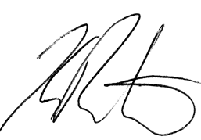

Kelly Rushton

Audit New Zealand

On behalf of the Auditor‑General

Wellington, New Zealand

Section 2:  
Financial statements

# Introduction to the financial reports

The Ministry receives funding from Parliament for its own operations which is included in its departmental appropriations.

The Ministry also receives and manages significant other appropriations to administer on behalf of the Crown to fund third party service providers including district health boards (DHBs) and non-governmental organisations (NGOs). The majority of this funding is for operational purposes with some being appropriated for capital expenditure. All the funding appropriated by Parliament and administered by the Ministry is known collectively as Vote Health.

The Ministry receives additional funding for non-departmental operations in the annual budget. A major purpose of the additional health funding received each year is to recognise the effects of inflation and of demographic changes to the New Zealand population. New or reprioritised funding is also used to implement the Government’s new initiatives.

Figure 2.1: 2013/14 departmental operational appropriations – actual expenditure ($000s)

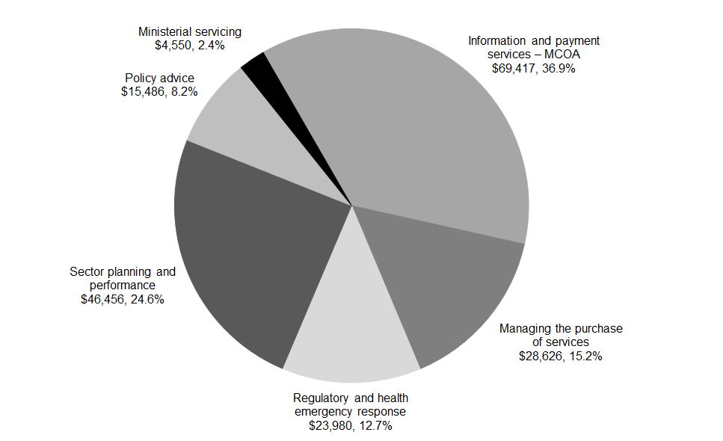

Note: Total actual expenditure was $188.515 million.

Figure 2.2: Comparative data for 2012/13 departmental operational appropriations – actual expenditure ($000s)

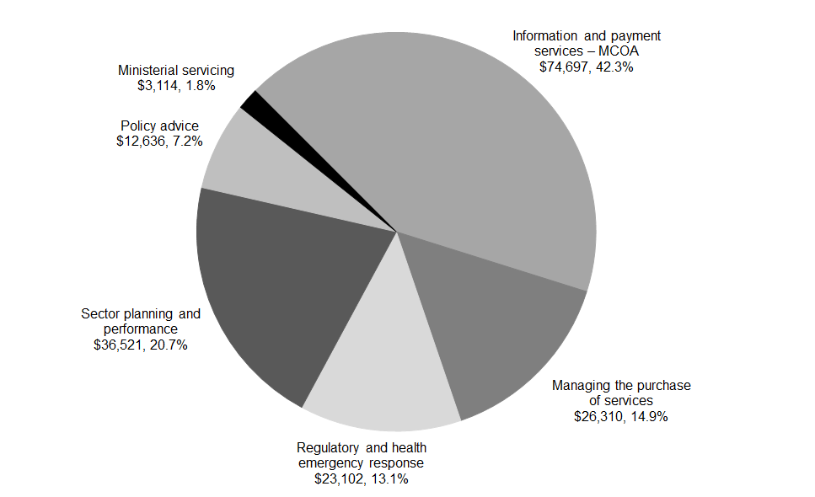

Note: Total actual expenditure was $176.380 million.

Figure 2.3: 2013/14 non-departmental operational appropriations – actual expenditure ($000s)

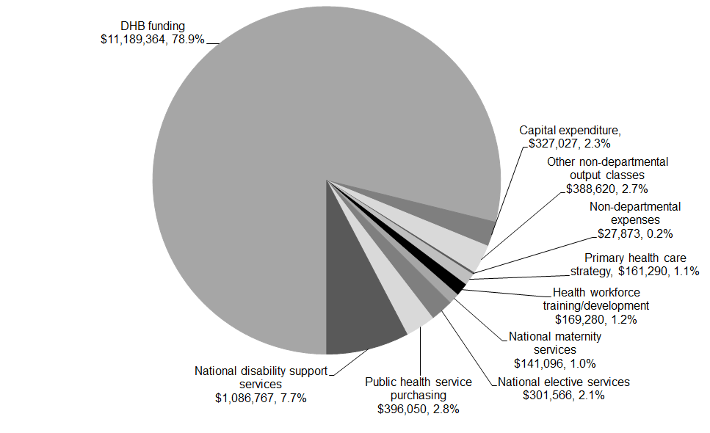

Note: Total actual expenditure was $14.189 billion.

Figure 2.4: Comparative data for 2012/13 non-departmental operational appropriations – actual expenditure ($000s)

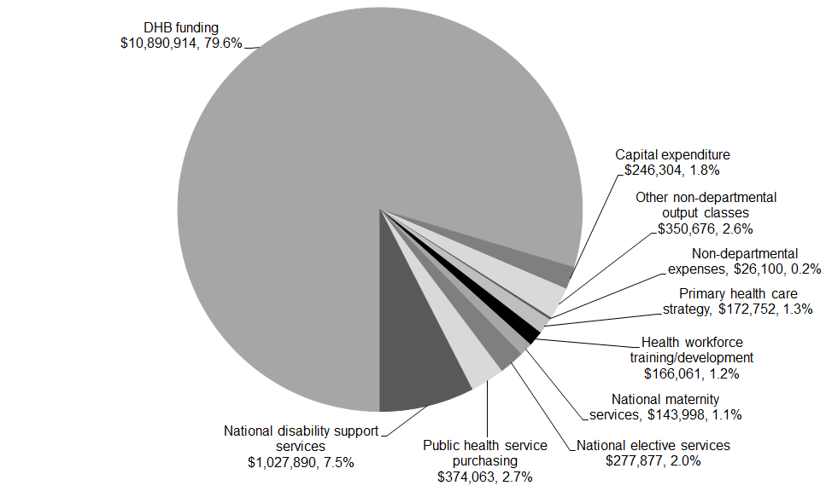

Note: Total actual expenditure was $13.677 billion.

## Statement of comprehensive income for the year ended 30 June 2014

| **Actual  2013 $000** |  | **Note** | **Actual  2014 $000** | **Main estimates 2014 $000** | **Supp. estimates 2014 $000** | **Forecast*  2015 $000** |
| --- | --- | --- | --- | --- | --- | --- |
|  | **Income** |  |  |  |  |  |
| 169,933 | Revenue Crown |  | 177,628 | 175,477 | 177,628 | 176,792 |
| 11,175 | Revenue other | **2** | 11,943 | 15,750 | 14,337 | 18,396 |
| – | Gains on sale of property, plant and equipment | **3** | 2 | – | – | – |
| **181,108** | **Total operating revenue** |  | **189,573** | **191,227** | **191,965** | **195,188** |
|  | **Expenditure** |  |  |  |  |  |
| 101,067 | Personnel costs | **4** | 108,150 | 103,321 | 107,480 | 106,850 |
| 9,738 | Depreciation and amortisation expense |  | 10,377 | 14,076 | 11,150 | 15,275 |
| 2,321 | Capital charge | **5** | 2,524 | 2,339 | 2,485 | 2,377 |
| 63,154 | Other operating expenses | **6** | 67,464 | 71,491 | 70,850 | 65,570 |
| 100 | Losses on sale/disposal of property, plant and equipment | **3** | – | – | – | – |
| **176,380** | **Total expenditure** |  | **188,515** | **191,227** | **191,965** | **190,072** |
| **4,728** | **Net surplus** |  | **1,058** | **–** | **–** | **5,116** |
|  | **Other comprehensive income** |  |  |  |  |  |
| 2,540 | Gain/(Loss) on property revaluations | **14** | – | – | – | – |
| **7,268** | **Total comprehensive income** |  | **1,058** | **–** | **–** | **5,116** |

Explanations of significant variances against budget are detailed in note 22.

* Forecast figures are unaudited.

## Statement of movements in taxpayers’ funds for the year ended 30 June 2014

| **Actual  2013 $000** |  | **Note** | **Actual  2014 $000** | **Main estimates 2014 $000** | **Supp. estimates 2014 $000** | **Forecast*  2015 $000** |
| --- | --- | --- | --- | --- | --- | --- |
| 34,079 | **Balance at 1 July** |  | 35,837 | 34,080 | 35,838 | 34,647 |
| 4,728 | Surplus/(deficit) for the year |  | 1,058 | – | – | 5,116 |
| 2,540 | Land and building revaluation reserve | **14** | – | – | – | – |
| **7,268** | **Total comprehensive income** |  | **1,058** | **–** | **–** | **5,116** |
| (5,510) | Operating surplus to be returned to Crown | **11** | (2,248) | – | – | (5,116) |
| **35,837** | **Balance at 30 June** | **14** | **34,647** | **34,080** | **35,838** | **34,647** |

* Forecast figures are unaudited.

## Statement of financial position as at 30 June 2014

| **Actual  2013 $000** |  | **Note** | **Actual  2014 $000** | **Main estimates 2014 $000** | **Supp. estimates 2014 $000** | **Forecast*  2015 $000** |
| --- | --- | --- | --- | --- | --- | --- |
|  | **Taxpayers’ funds** |  |  |  |  |  |
| 29,012 | General funds | **14** | 29,012 | 34,080 | 33,298 | 29,012 |
| 2,540 | Land and building revaluation | **14** | 2,540 | – | 2,540 | 2,540 |
| 4,285 | Memorandum accounts | **14** | 3,095 | – | – | 3,095 |
| **35,837** | **Total taxpayers’ funds** |  | **34,647** | **34,080** | **35,838** | **34,647** |
|  | Represented by: |  |  |  |  |  |
|  | **Assets** |  |  |  |  |  |
|  | **Current assets** |  |  |  |  |  |
| 5,962 | Cash and cash equivalents |  | 2,356 | 12,000 | 6,000 | 7,678 |
| 11,443 | Debtors and other receivables | **7** | 12,458 | 4,661 | 3,189 | 11,782 |
| 3,960 | Prepayments |  | 4,141 | 2,800 | 3,234 | 3,233 |
| **21,365** | **Total current assets** |  | **18,955** | **19,461** | **12,423** | **22,693** |
|  | **Non-current assets** |  |  |  |  |  |
| 14,920 | Property, plant and equipment | **8** | 12,484 | 14,964 | 12,998 | 14,723 |
| 34,205 | Intangible assets | **9** | 35,663 | 27,892 | 37,522 | 33,397 |
| **49,125** | **Total non-current assets** |  | **48,147** | **42,856** | **50,520** | **48,120** |
| **70,490** | **Total assets** |  | **67,102** | **62,317** | **62,943** | **70,813** |
|  | **Liabilities** |  |  |  |  |  |
|  | **Current liabilities** |  |  |  |  |  |
| 15,742 | Creditors and other payables | **10** | 14,384 | 18,614 | 15,177 | 15,025 |
| 5,510 | Operating surplus to be returned to Crown | **11** | 2,248 | – | – | 5,116 |
| 592 | Provisions | **12** | 3,086 | 459 | 2,844 | 459 |
| 9,198 | Employee entitlements | **13** | 10,487 | 7,906 | 7,906 | 11,344 |
| **31,042** | **Total current liabilities** |  | **30,205** | **26,979** | **25,927** | **31,944** |
|  | **Non-current liabilities** |  |  |  |  |  |
| 2,477 | Provisions | **12** | 1,000 | 36 | 33 | 3,000 |
| 1,134 | Employee entitlements | **13** | 1,250 | 1,222 | 1,145 | 1,222 |
| **3,611** | **Total non-current liabilities** |  | **2,250** | **1,258** | **1,178** | **4,222** |
| **34,653** | **Total liabilities** |  | **32,455** | **28,237** | **27,105** | **36,166** |
| **35,837** | **Net assets** |  | **34,647** | **34,080** | **35,838** | **34,647** |

Explanations of significant variances against budget are detailed in note 22.

* Forecast figures are unaudited.

## Statement of cash flows for the year ended 30 June 2014

| **Actual  2013 $000** |  | **Note** | **Actual  2014 $000** | **Main estimates 2014 $000** | **Supp. estimates 2014 $000** | **Forecast*  2015 $000** |
| --- | --- | --- | --- | --- | --- | --- |
|  | **Cash flows from operating activities** |  |  |  |  |  |
|  | Cash was provided from: |  |  |  |  |  |
|  | Supply of outputs to: |  |  |  |  |  |
| 183,811 | Crown |  | 177,628 | 181,421 | 180,561 | 175,767 |
| 289 | Department |  | 298 | – | 103 | – |
| 12,271 | Others |  | 10,468 | 15,750 | 11,410 | 18,396 |
| (975) | Net GST received/(paid) |  | 575 | – | 272 | 272 |
| **195,396** | **Total cash provided from operating activities** |  | **188,969** | **197,171** | **192,346** | **194,435** |
|  | Cash was disbursed to: |  |  |  |  |  |
|  | Produce outputs: |  |  |  |  |  |
| (100,483) | Personnel costs |  | (106,737) | (103,321) | (104,993) | (112,737) |
| (69,286) | Operating expenses |  | (68,408) | (71,491) | (66,778) | (58,876) |
| (2,321) | Capital charge |  | (2,524) | (2,339) | (2,485) | (2,377) |
| **(172,090)** | **Total cash to operating activities** |  | **(177,669)** | **(177,151)** | **(174,256)** | **(173,990)** |
| **23,306** | **Net cash inflow/(outflow) from operating activities** | **15** | **11,300** | **20,020** | **18,090** | **20,445** |
|  | **Cash flows from investing activities** |  |  |  |  |  |
|  | Cash was provided from: |  |  |  |  |  |
| 32 | Sale of property, plant and equipment |  | 8 | – | 8 | – |
|  | Cash was disbursed to: |  |  |  |  |  |
| (1,903) | Purchase of property, plant and equipment |  | (1,951) | (10,000) | (3,359) | (7,000) |
| (11,376) | Purchase of intangible assets |  | (7,454) | (5,000) | (9,192) | (5,875) |
| **(13,247)** | **Net cash inflow/(outflow) from investing activities** |  | **(9,397)** | **(15,000)** | **(12,543)** | **(12,875)** |
|  | **Cash flows from financing activities** |  |  |  |  |  |
|  | Cash was provided from: |  |  |  |  |  |
| – | Capital contribution from the Crown |  | **–** | – | – | – |
|  | Cash was disbursed to: |  |  |  |  |  |
| (13,945) | Repayment of surplus to the Crown |  | (5,509) | (5,020) | (5,509) | (2,248) |
| **(13,945)** | **Total cash disbursed to financing activities** |  | **(5,509)** | **(5,020)** | **(5,509)** | **(2,248)** |
| **(13,945)** | **Net cash inflow/(outflow) from financing activities** |  | **(5,509)** | **(5,020)** | **(5,509)** | **(2,248)** |
| **(3,886)** | **Net increase/(decrease) in cash and cash equivalents held** |  | **(3,606)** | **–** | **38** | **5,322** |
| 9,848 | Add cash and cash equivalents at the beginning of the year |  | 5,962 | 12,000 | 5,962 | 2,356 |
| **5,962** | **Cash and cash equivalents at the end of the year** |  | **2,356** | **12,000** | **6,000** | **7,678** |

* Forecast figures are unaudited.

The GST (net) component of operating activities reflects the net GST paid to and received from the Inland Revenue Department (IRD). The GST (net) component has been presented on a net basis, as the gross amounts do not provide meaningful information for financial statement purposes and to be consistent with the presentation basis of the other primary financial statements.

## Statement of commitments as at 30 June 2014

| **Actual 2013 $000** |  | **Actual 2014 $000** |
| --- | --- | --- |
|  | **Lease commitments** |  |
| 9,449 | Not later than one year | 7,197 |
| 21,594 | Later than one year and not later than five years | 29,799 |
| 135 | Later than five years | 64,434 |
| **31,178** | **Total non-cancellable operating lease commitments** | **101,430** |
| **31,178** | **Total commitments** | **101,430** |

The Ministry has medium- to long-term leases on its premises in Auckland, Christchurch, Dunedin, Hamilton, Whanganui and Wellington. The annual lease payments are subject to regular reviews, ranging from one year to four years. The amounts disclosed above as future commitments are based on current rental rates.

## Statement of contingent liabilities and contingent assets as at 30 June 2014

The Ministry had no contingent liabilities as at 30 June 2014 (2013: Nil).

The Ministry had no contingent assets as at 30 June 2014 (2013: Nil).

## Statement of departmental expenses and capital expenditure against appropriations for the year ended 30 June 2014

| **Actual  2013 $000** |  | **Actual  2014 $000** | **Main estimates 2014 $000** | **Voted^ appropriation 2014 $000** | **Forecast*  2015 $000** |
| --- | --- | --- | --- | --- | --- |
|  | **Vote: Health** |  |  |  |  |
|  | **Appropriations for output expenses** |  |  |  |  |
| 74,697 | Information and payment services MCOA | 69,417 | 79,939 | 71,943 | 70,997 |
| 3,114 | Ministerial Servicing | 4,550 | 3,318 | 4,552 | 4,552 |
| 26,310 | Managing the purchase of services | 28,626 | 29,050 | 28,641 | 29,163 |
| 12,636 | Policy advice | 15,486 | 12,488 | 16,022 | 16,022 |
| 23,102 | Regulatory and enforcement services | 23,980 | 26,107 | 24,335 | 25,778 |
| 36,521 | Sector planning and performance | 46,456 | 40,325 | 46,472 | 46,560 |
| **176,380** | **Total appropriations for output expenses** | **188,515** | **191,227** | **191,965** | **193,072** |
|  | **Appropriation for capital expenditure** |  |  |  |  |
| 13,729 | Ministry of Health – permanent legislative authority | 9,405 | 15,000 | 16,732 | 15,010 |

^ These amounts include adjustments made in the Supplementary Estimates.

* Forecast figures are unaudited.

## Statement of unappropriated departmental expenditure and capital expenditure for the year ended 30 June 2014

There was no unappropriated departmental expenditure for the year ended 30 June 2014 (2013: Nil).

## Notes to the financial statements for the year ended 30 June 2014

### Note 1: Statement of accounting policies for the year ended 30 June 2014

#### Reporting entity

The Ministry of Health (the Ministry) is a government department as defined by section 2 of the Public Finance Act 1989 and is domiciled in New Zealand.

The primary objective of the Ministry is to act as the Government’s agent to fund, administer and monitor the delivery of health services to New Zealanders, rather than to make a financial return. Accordingly, the Ministry has designated itself as a public benefit entity for the purposes of New Zealand equivalents to International Financial Reporting Standards (NZ IFRS).

The Ministry’s financial statements are for the year ended 30 June 2014. The financial statements were authorised for issue by the Director-General of Health on 30 September 2014.

In addition, the Ministry has reported the activities and trust monies that it administers on behalf of the Crown.

#### Statement of compliance

The financial statements of the Ministry have been prepared in accordance with the requirements of the Public Finance Act 1989, which include the requirement to comply with New Zealand generally accepted accounting practice (NZ GAAP), and Treasury Instructions.

These financial statements have been prepared in accordance with NZ GAAP as appropriate for public benefit entities and they comply with NZ IFRS.

#### Accounting policies

The accounting policies set out below have been applied consistently to all periods presented in these financial statements.

##### Measurement base

The measurement base applied to these financial statements is the historical cost basis modified by the revaluation of certain assets and liabilities as described in this statement of accounting policies.

##### Functional and presentation currency

The financial statements are presented in New Zealand dollars being the functional currency of the Ministry. Unless stated otherwise, all values are rounded to the nearest thousand dollars ($000).

##### Foreign currency transactions

Foreign currency transactions are translated into New Zealand dollars using the exchange rates prevailing at the dates of the transactions. Foreign exchange gains and losses resulting from the settlement of such transactions are recognised in the Statement of Comprehensive Income.

Monetary assets and liabilities denominated in foreign currency are translated at the rate of exchange applying at balance date. Any unrealised foreign exchange gains or losses resulting from such translation are recognised in the Statement of Comprehensive Income.

The accrual basis of accounting has been used unless otherwise stated.

#### Reporting period

The reporting period for these financial statements is the year ended 30 June 2014.

#### Budget and forecast figures

The budget forecast figures (Main Estimates) are the original figures for the financial year as presented in the 2013 Budget on 16 May 2013. The Supplementary Estimates figures are those budget figures as amended by the Supplementary Estimates (Supp. Estimates) as presented in the 2013 Budget on 15 May 2014 and as adjusted by any transfers made by Order in Council under section 26A of the Public Finance Act 1989. The forecast figures are those included in the Information Supporting the Estimates of Appropriations (Forecast) for the year ending 30 June 2015 (the Forecast is 2014 Budget and Economic and Fiscal Update (BEFU 2014) out-year 1 figures). The budget and forecast figures have been prepared in accordance with NZ GAAP and FRS-42 Prospective Financial Statements, using accounting policies that are consistent with those adopted in preparing these financial statements.

Forecast information is unaudited and has been included for the following financial year for the first time, as required by the Public Finance Amendment Act 2013, to increase transparency by providing the reader with further context of this year’s results by providing next year’s forecast for comparison.

#### Judgements and estimations

The preparation of financial statements is in conformity with NZ IFRS and requires judgements, estimates, and assumptions that affect the application of policies and reported amounts of assets and liabilities, income and expenses. The estimates and associated assumptions are based on historical experience and various other factors that are believed to be reasonable under the circumstances. Actual results may differ from these estimates.

The estimates and underlying assumptions are reviewed on an ongoing basis. Revisions to accounting estimates are recognised in the reporting period in which the revision is made and in any future periods that will be affected by those revisions.

#### Significant assumptions

The forecasts have been compiled on the basis of existing government policies and Ministerial expectations at the time the statements were finalised and reflect all government decisions and circumstances as at 29 April 2014.

The main assumptions are as follows:

* The department’s main activities will remain substantially the same as for the previous year.
* Operating costs are based on historical experience. The general historical pattern is expected to continue.
* Estimated year-end information for 2013-14 is used as the opening position for the 2014–15 forecasts.

These assumptions are adopted as at 29 April 2014.

#### Variations to forecast

The actual financial results for the forecast period covered are likely to vary from the information presented in these forecasts. Factors that may lead to a material difference between information in these forecast financial information statements and the actual reported results include:

* changes to the budget through initiatives approved by Cabinet
* technical adjustments to the budget including transfers between financial years
* the timing of expenditure relating to significant programmes and projects.

Any changes to budgets during 2014-15 will be incorporated into *The Supplementary Estimates of Appropriations* for the year ending 30 June 2015.

#### Revenue

The Ministry derives revenue through the provision of outputs to the Crown and for services to third parties. Such revenue is recognised at fair value of consideration received.

Crown revenue is recognised monthly as the amount of funding required to cover the portion of appropriated output expenses not covered by other third party revenue.

Other revenue from the supply of services is recognised by reference to the stage of completion of the transaction at balance date and only to the extent that the outcome of the transaction can be estimated reliably.

#### Cost allocation

Direct costs are those costs directly attributed to an output. Indirect costs are those costs that cannot be identified in an economically feasible manner with any one specific output.

Direct costs are charged directly to outputs while indirect costs are allocated to outputs based on the level of activity associated with relevant cost drivers.

Depreciation is primarily charged as direct costs to outputs on the basis of asset utilisation: the remainder is charged as indirect costs.

There have been no changes in the cost allocation policy since the date of the last audited financial statements.

#### Taxation

As a government department, the Ministry is exempt from the payment of income tax in terms of the Income Tax Act 2007. Accordingly, no charge for income tax is recognised.

#### Taxpayers’ funds

The Crown’s net investment in the Ministry is shown as taxpayers’ funds in the Statement of Movements in Taxpayers’ Funds and the Statement of Financial Position.

##### Memorandum accounts

Memorandum accounts reflect the cumulative surplus/(deficit) on those departmental services provided that are intended to be fully cost recovered from third parties through fees, levies or charges. The balance of each memorandum account is expected to trend toward zero over time.

#### Financial instruments

Financial assets and liabilities are initially measured at fair value plus transaction costs, unless they are carried at fair value through surplus or deficit, in which case the transaction costs are recognised in the surplus or deficit.

#### Cash and cash equivalents

Cash and cash equivalents includes cash on hand, deposits held at call with banks, and other short-term highly liquid investments with original maturities of three months or less.

#### Debtors and other receivables

Short-term debtors and other receivables are recorded at their face value, less any provision for impairment.

Impairment of a receivable is established when there is objective evidence that the Ministry will not be able to collect amounts due according to the original term of the receivable. Significant financial difficulties of the debtor, probability that the debtor will enter into bankruptcy, receivership or liquidation, and default in payments are considered indicators that the debtor is impaired. The amount of the impairment is the difference between the asset’s carrying amount and the present value of estimated future cash flows, discounted using the original effective interest rate. The carrying amount of the asset is reduced through the use of a provision for impairment account, and the amount of the loss is recognised in the surplus or deficit. Overdue receivables that are renegotiated are reclassified as current (that is, not past due).

#### Property, plant and equipment

Items of property, plant and equipment are initially recorded at cost. Where an asset is acquired for nil or nominal consideration the asset will be recognised initially at fair value, where fair value can be reliably determined. The fair value of the asset received, less costs incurred to acquire the asset, is recognised as revenue in the Statement of Comprehensive Income.

All individual assets or groups of assets are capitalised if their historical cost is $4000 or greater.

Land is recorded at fair value less impairment losses. Buildings are recorded at fair value less impairment losses and less depreciation accumulated since the assets were last revalued. Valuations are based on either valuation undertaken in accordance with standards issued by the New Zealand Property Institute if available, or valuation conducted in accordance with the Rating Valuation Act 1998 that has been confirmed as appropriate by an independent valuer.

Revaluations are carried out for the Ministry’s land and buildings to reflect the service potential or economic benefit obtained through control of the asset. Revaluation is based on the fair value of the asset, with changes reported by class of asset.

Accumulated depreciation at revaluation date may be either restated proportionately or eliminated against the gross carrying amount so that the carrying amount after revaluation equals the revalued amount. The elimination approach is applied unless otherwise indicated.

All other asset classes are initially carried at depreciated historical cost, with a review of the carrying values of revalued items performed at each balance date to determine whether any material adjustment is required.

Classes of property, plant and equipment subject to fair value review are revalued at least every three years or sooner where indicators suggest the carrying amount differs materially to fair value. Unrealised gains and losses arising from changes in the value of property, plant and equipment are recognised as at each balance date. To the extent that a gain reverses a loss previously charged to the Statement of Comprehensive Income for the asset class, the gain is credited to the Statement of Comprehensive Income; otherwise gains are credited to the asset revaluation reserve for that class of asset. To the extent that there is a balance in the asset revaluation reserve for the asset class, any loss on revaluation is debited to the reserve to the extent that a balance remains in such reserve. All other losses on property, plant and equipment are reported in the Statement of Comprehensive Income.

For each property, plant and equipment asset, project borrowing costs incurred during the period required to complete and prepare the asset for its intended use are expensed.

The carrying amounts of plant, property and equipment are reviewed at least annually to determine if there is any indication of impairment. Where an asset’s recoverable amount is less than its carrying amount, it will be reported at its recoverable amount and an impairment loss will be recognised. Losses resulting from impairment are reported in the Statement of Comprehensive Income unless the asset is carried at a revalued amount in which case any impairment loss is treated as a revaluation decrease to the extent that the revaluation relates to the impaired asset class.

Depreciation is charged on a straight-line basis at rates calculated to allocate the cost or valuation of an item of property, plant and equipment, less any estimated residual value, over its estimated useful life. Typically, the estimated useful lives of different classes of property, plant and equipment are as follows:

|  |  |  |
| --- | --- | --- |
|  | **Useful life** | **Depreciation rate** |
| Buildings | 40 years | 2.5% |
| Motor vehicles | 5 years | 20% |
| Furniture and fittings | 5–10 years | 10–20% |
| Machinery | 5 years | 20% |
| Leasehold improvements | 5–10 years | 10–20% |
| IT equipment | 3–5 years | 20–33.3% |

##### Additions

The cost of an item of property, plant and equipment is recognised as an asset if, and only if, it is probable that future economic benefits or service potential associated with the item will flow to the Ministry and the cost of the item can be measured reliably.

Work in progress is recognised at cost less impairment and is not depreciated.

##### Disposals

Gains and losses on disposals are determined by comparing the sale proceeds with the carrying amount of the asset. Gains and losses on disposals are included in the Statement of Comprehensive Income. When revalued assets are sold, the amounts included in asset revaluation reserves in respect of those assets are transferred to retained earnings.

##### Subsequent costs

Costs incurred subsequent to initial acquisition are capitalised only when it is probable that future economic benefits or service potential associated with the item will flow to the Ministry and the cost of the item can be measured reliably.

#### Intangible assets

Intangible assets are initially recorded at cost. The cost of an internally generated intangible asset represents expenditure incurred in the development phase of the asset only. The development phase occurs after the following can be demonstrated: technical feasibility; ability to complete the asset; intention and ability to sell or use; and where development expenditure can be reliably measured. Expenditure incurred on research related to an internally generated intangible asset is expensed when it is incurred. Where the research phase cannot be distinguished from the development phase, the expenditure is expensed when it is incurred.

##### Software acquisition and development

Acquired computer software licenses are capitalised on the basis of the costs incurred to acquire and bring to use the specific software.

Costs that are directly associated with the development of software for internal use by the Ministry are recognised as an intangible asset. Direct costs include the software development, employee costs, and an appropriate portion of relevant overheads.

Staff training costs are recognised as an expense when incurred.

Costs associated with maintaining computer software are recognised as an expense when incurred.

Intangible assets with finite lives are subsequently recorded at cost less any amortisation and impairment losses. Amortisation is charged to the Statement of Comprehensive Income on a straight-line basis over the useful life of the asset. Typically, the estimated useful lives of assets are as follows:

|  |  |  |
| --- | --- | --- |
|  | **Useful life** | **Amortisation rate** |
| Software – internally generated | 3–7 years | 14.3–33.3% |
| Software – other | 3–7 years | 14.3–33.3% |
| Warranties | 3 years | 33.3% |

Realised gains and losses arising from disposal of intangible assets are recognised in the Statement of Comprehensive Income in the period in which the transaction occurs.

Intangible assets are reviewed at least annually to determine if there is any indication of impairment. Where an intangible asset’s recoverable amount is less than its carrying amount, it will be reported at its recoverable amount and an impairment loss recognised. Losses resulting from impairment are recognised in the Statement of Comprehensive Income.

#### Non-current assets held for sale and discontinued operations

Non-current assets or disposal groups are separately classified where their carrying amount will be recovered through a sale transaction rather than continuing use; that is, where such assets are available for immediate sale and where sale is highly probable. These assets are recorded at the lower of their carrying amount and fair value less costs to sell.

#### Creditors and other payables

Short-term creditors and other payables are recorded at their face value.

#### Employee benefits

Employee entitlements to salaries and wages, annual leave, long service leave, retiring leave and other similar benefits are recognised in the Statement of Comprehensive Income when they accrue to employees. Employee entitlements to be settled within 12 months are reported at the amount expected to be paid. The liability for long-term employee entitlements is calculated on an actuarial basis at the present value of estimated future cash outflows.

Termination benefits are recognised in the Statement of Comprehensive Income only when there is a demonstrable commitment to either terminate employment prior to normal retirement date or to provide such benefits as a result of an offer to encourage voluntary redundancy. Termination benefits settled within 12 months are reported at the amount expected to be paid, otherwise they are reported as the present value of the estimated future cash outflows.

Obligations for contributions to the State Sector Retirement Savings Scheme, Kiwisaver, and the Government Superannuation Fund are recognised in the Statement of Comprehensive Income as they fall due. Obligations for defined benefit retirement plans are recorded at the latest actuarial value of the Ministry’s liability. All movements in the liability, including actuarial gains and losses, are recognised in full in the Statement of Comprehensive Income in the period in which they occur.

#### ACC Partnership Scheme

The Ministry belongs to the Accident Compensations Corporation (ACC) Partnership Programme whereby the Ministry accepts the management and financial responsibility for work-related illnesses and accidents of employees. Under the ACC Partnership Programme, the Ministry is effectively providing accident insurance to employees: this is accounted for as an insurance contract as the Ministry accepts liability for all its claims costs for a period of four years up to a specified maximum. At the end of the four- year period, the Ministry pays a premium to ACC for the value of residual claims, and the liability for ongoing claims beyond that point passes to ACC.

The liability relating to the Ministry’s ACC Partnership Programme obligations is measured at the present value of expected future payments to be made in respect of employee injuries and claims, for which the Ministry has responsibility up to the reporting date, using actuarial techniques. Consideration is given to expected future wage and salary levels and experience of employee claims and injuries to date, and may include a risk margin that represents the inherent uncertainty of the present value of the expected future payments. Expected future payments are discounted using market yields applying as at the reporting date based on government bonds with terms to maturity that match, as closely as possible, the estimated future cash outflows.

#### Leases

An operating lease is a lease that does not transfer substantially all the risks and rewards incidental to ownership of an asset.

Lease incentives received are recognised evenly over the term of the lease as a reduction in rental expense.

Leasehold improvements are capitalised and the cost is amortised over the unexpired period of the lease, or the estimated useful life of the improvements whichever is shorter.

#### Provisions

The Ministry recognises a provision, based on probable cost, for future expenditure of uncertain amount or timing where there is a present obligation (either legal or constructive) as a result of a past event.

Provisions are recorded at the best estimate of the expenditure required to settle the obligation using a pre-tax discount rate that reflects current market assessments of the time value of money and the risks specific to the obligation. Provisions to be settled beyond 12 months are recorded at their present value.

#### Contingent assets and contingent liabilities

Contingent liabilities and contingent assets are recorded in the Statement of Contingent Liabilities and Contingent Assets at the point at which the contingency becomes evident. Contingent liabilities are disclosed if the possibility that they will crystallise is not remote. Contingent assets are disclosed if it is probable that the benefits will be realised.

#### Commitments

Expenses yet to be incurred on non-cancellable contracts that have been entered into on or before balance date are disclosed as commitments to the extent that there are equally unperformed obligations. Cancellable commitments that have penalty or exit costs explicit in the agreement on exercising that option to cancel are included in the statement of commitments at the value of that penalty or exit cost.

#### Changes in accounting policies

Accounting policies are changed only if the change is required by a standard or interpretation or otherwise provides more reliable and more relevant information. All policies have been applied on a basis consistent with the previous year.

#### Standards, amendments and interpretations issued that are not effective and have not been early adopted

The Minister of Commerce has approved a new Accounting Standards Framework (incorporating a Tier Strategy) developed by the External Reporting Board (XRB). Under this Accounting Standards Framework, the Ministry is classified as a Tier 1 reporting entity and it will be required to apply full Public Benefit Entity Accounting Standards (PAS). The effective date for the new standards for public sector entities is for reporting periods beginning on or after 1 July 2014. This means the Ministry will transition to the new standards in preparing its 30 June 2015 financial statements.

Due to the change in the Accounting Standards Framework for public benefit entities, it is expected that all new NZ IFRS and amendments to existing NZ IFRS will not be applicable to public benefit entities. Therefore, the XRB has effectively frozen the financial reporting requirements for public benefit entities up until the new Accounting Standard Framework is effective. Accordingly, no disclosure has been made about new or amended NZ IFRS that exclude public benefit entities from their scope.

The Ministry anticipates that these standards will have no material impact on the financial statements in the period of initial application and it is not practicable to provide a reasonable estimate of any impact until a detailed review has been completed.

#### Comparative figures

When presentation or classification of items in the financial statements is amended or accounting policies are changed, comparative figures are restated to ensure consistency with the current period unless it is impracticable to do so.

#### Segment reporting

As a public benefit entity, the Ministry is not required to provide segment reporting.

#### Goods and Service Tax (GST)

All items in the financial statements are stated exclusive of GST, except for receivables and payables, which are stated on a GST inclusive basis. Where GST is not recoverable as input tax, then it is recognised as part of the related asset or expense.

The net amount of GST recoverable from, or payable to, the Inland Revenue Department (IRD) as at balance date is included as part of receivables or payables in the Statement of Financial Position.

The net GST paid to, or received from the IRD, including the GST relating to investing and financing activities, is classified as an operating cash flow in the Statement of Cash Flows.

Commitments and contingencies are disclosed exclusive of GST.

### Note 2: Revenue – other

| **Actual  2013 $000** |  | **Actual  2014 $000** | **Main estimates 2014 $000** | **Forecast*  2015 $000** |
| --- | --- | --- | --- | --- |
| 8,076 | Medicines registration | 8,531 | 8,500 | 8,500 |
| 576 | Service fees | 420 | 1,000 | 400 |
| 1,917 | Annual licence and registration fees | 1,885 | 4,000 | 8,500 |
| – | Other government departmental revenue | 9 | – | – |
| 606 | Other revenue | 1,098 | 2,250 | 996 |
| **11,175** | **Total revenue other** | **11,943** | **15,750** | **18,396** |

* Forecast figures are unaudited.

### Note 3: Gains/(losses)

| **Actual 2013 $000** |  | **Actual 2014 $000** | **Forecast* 2015 $000** |
| --- | --- | --- | --- |
| (100) | Net gain/(loss) on disposal of property, plant and equipment | 2 | – |
| **(100)** | **Total gains/(losses)** | **2** | – |

### Note 4: Personnel

| **Actual 2013 $000** |  | **Actual 2014 $000** | **Forecast* 2015 $000** |
| --- | --- | --- | --- |
| 94,349 | Salaries and wages | 100,857 | 98,350 |
| 2,510 | Employer contributions to defined contribution plans | 3,139 | 4,000 |
| (28) | Increase/(decrease) in employee entitlements | 1,405 | 1,500 |
| 4,236 | Other | 2,749 | 3,000 |
| **101,067** | **Total personnel costs** | **108,150** | **106,850** |

* Forecast figures are unaudited.

### Note 5: Capital charge

The Ministry pays a capital charge to the Crown on its taxpayers’ funds as at 30 June and 31 December each year. The capital charge rate for the year ended 30 June 2014 was 8.0% (2013: 8.0%).

### Note 6: Other operating expenses

| **Actual  2013 $000** |  | **Actual  2014 $000** | **Main estimates 2014 $000** | **Forecast*  2015 $000** |
| --- | --- | --- | --- | --- |
| 352 | Audit fees for the financial statements audit | 350 | 358 | 370 |
| 20,382 | Computer services | 21,025 | 20,371 | 20,075 |
| 10,206 | Contractors and consultants | 12,634 | 10,994 | 13,640 |
| 7,956 | Operating lease payments | 7,496 | 7,496 | 7,496 |
| 4,434 | Domestic travel | 4,269 | 4,288 | 4,536 |
| 461 | Overseas travel | 425 | 534 | 537 |
| 19,363 | Other operating expenses | 21,265 | 27,450 | 18,916 |
| **63,154** | **Total other operating expenses** | **67,464** | **71,491** | **65,570** |

* Forecast figures are unaudited.

### Note 7: Debtors and other receivables

| **Actual 2013 $000** |  | **Actual 2014 $000** | **Forecast* 2015 $000** |
| --- | --- | --- | --- |
| 10,699 | Debtors – Crown | 10,700 | 10,791 |
| 23 | Debtors – departments | 258 | 224 |
| 494 | Debtors – other | 1,412 | 767 |
| **11,216** | **Net debtors** | **12,370** | **11,782** |
| 227 | Accrued revenue | 88 | – |
| **11,443** | **Total debtors and other receivables** | **12,458** | **11,782** |

* Forecast figures are unaudited.

The carrying value of debtors and other receivables approximates their fair value.

As at 30 June 2014, all overdue receivables have been assessed for impairment and appropriate provisions applied, as detailed below:

|  | **2013** | | | **2014** | | |
| --- | --- | --- | --- | --- | --- | --- |
| **Gross $000** | **Impairment $000** | **Net $000** | **Gross $000** | **Impairment $000** | **Net $000** |
| Not past due | 11,407 | – | 11,407 | 10,793 | – | 10,793 |
| Past due 1–30 days | 9 | – | 9 | 1,352 | – | 1,352 |
| Past due 31–60 days | 6 | – | 6 | 291 | – | 291 |
| Past due 61–90 days | 2 | – | 2 | 8 | – | 8 |
| Past due >90 days | 19 | – | 19 | 14 | – | 14 |
| **Total debtors** | **11,443** | **–** | **11,443** | **12,458** | **–** | **12,458** |

The Ministry has no provision for doubtful debts as at 30 June 2014 (2013: Nil). There were no expected losses for the Ministry’s pool of debtors, based on analysis of the Ministry’s losses in previous periods, and review of specific debtors at balance date.

### Note 8: Property, plant and equipment

|  | **Land   $000** | **Buildings/ leasehold improvements $000** | **Furniture plant and equipment $000** | **Motor vehicles  $000** | **Computer hardware  $000** | **Total   $000** |
| --- | --- | --- | --- | --- | --- | --- |
| **Cost or valuation** |  |  |  |  |  |  |
| **Balance as at 1 July 2012** | **2,760** | **8,114** | **6,463** | **411** | **20,354** | **38,102** |
| Additions |  | 30 | 15 | 112 | 1,745 | 1,902 |
| Revaluation increase/(decrease) | 2,540 | – | – | – | – | 2,540 |
| Disposals | – | – | (16) | (120) | (2,837) | (2,973) |
| **Balance as at 30 June 2013** | **5,300** | **8,144** | **6,462** | **403** | **19,262** | **39,571** |
| **Balance as at 1 July 2013** | **5,300** | **8,144** | **6,462** | **403** | **19,262** | **39,571** |
| Additions | – | 965 | 414 | – | 572 | 1,951 |
| Revaluation increase/(decrease) | – | – | – | – | – | – |
| Disposals | – | – | – | (30) | (185) | (215) |
| **Balance as at 30 June 2014** | **5,300** | **9,109** | **6,876** | **373** | **19,649** | **41,307** |
| **Accumulated depreciation and impairment losses** |  |  |  |  |  |  |
| **Balance as at 1 July 2012** | **–** | **4,255** | **3,929** | **227** | **14,353** | **22,764** |
| Depreciation expense | – | 721 | 622 | 50 | 3,435 | 4,828 |
| Eliminate on disposals | – | – | (16) | (95) | (2,830) | (2,941) |
| **Balance as at 30 June 2013** | **–** | **4,976** | **4,535** | **182** | **14,958** | **24,651** |
| **Balance as at 1 July 2013** | **–** | **4,976** | **4,535** | **182** | **14,958** | **24,651** |
| Depreciation expense | – | 771 | 513 | 53 | 3,044 | 4,381 |
| Eliminate on disposals | – | – | – | (24) | (185) | (209) |
| **Balance as at 30 June 2014** | **–** | **5,747** | **5,048** | **211** | **17,817** | **28,823** |
| **Carrying amounts** |  |  |  |  |  |  |
| At 30 June 2012 | 2,760 | 3,859 | 2,534 | 184 | 6,001 | 15,338 |
| At 30 June 2013 | 5,300 | 3,168 | 1,927 | 221 | 4,304 | 14,920 |
| **At 30 June 2014** | **5,300** | **3,362** | **1,828** | **162** | **1,832** | **12,484** |

The land at 108 Victoria Street Christchurch was valued by Knight Frank in May 2014. There has been no change to the value of this land.

### Note 9: Intangible assets

|  | **Acquired software  $000** | **Internally generated software $000** | **Total   $000** |
| --- | --- | --- | --- |
| **Cost** |  |  |  |
| **Balance as at 1 July 2012** | **22,018** | **46,556** | **68,574** |
| Additions | – | 11,376 | 11,376 |
| Disposals | (3,080) | (2,265) | (5,345) |
| **Balance as at 30 June 2013** | **18,938** | **55,667** | **74,605** |
| **Balance as at 1 July 2013** | **18,938** | **55,667** | **74,605** |
| Additions | – | 7,454 | 7,454 |
| Disposals | – | – | – |
| **Balance as at 30 June 2014** | **18,938** | **63,121** | **82,059** |
| **Accumulated amortisation and impairment losses** |  |  |  |
| **Balance as at 1 July 2012** | **15,286** | **25,450** | **40,736** |
| Amortisation expense | 1,683 | 3,227 | 4,910 |
| Disposals | (3,079) | (2,167) | (5,246) |
| **Balance as at 30 June 2013** | **13,890** | **26,510** | **40,400** |
| **Balance as at 1 July 2013** | **13,890** | **26,510** | **40,400** |
| Amortisation expense | 1,665 | 4,331 | 5,996 |
| Disposals | – | – | – |
| **Balance as at 30 June 2014** | **15,555** | **30,841** | **46,396** |
| **Carrying amounts** |  |  |  |
| At 30 June 2012 | 6,732 | 21,106 | 27,838 |
| At 30 June 2013 | 5,048 | 29,157 | 34,205 |
| **At 30 June 2014** | **3,383** | **32,280** | **35,663** |

There are no restrictions over the title of the Ministry’s intangible assets nor are any intangibles pledged as security for liabilities.

### Note 10: Creditors and payables

| **Actual 2013 $000** |  | **Actual 2014 $000** | **Forecast* 2015 $000** |
| --- | --- | --- | --- |
| 2,013 | Creditors | 1,615 | 1,600 |
| 2,202 | Income in advance | 2,038 | 2,000 |
| 10,613 | Accrued expenses | 9,232 | 9,382 |
| 914 | GST payable | 1,499 | 2,043 |
| **15,742** | **Total creditors and other payables** | **14,384** | **15,025** |

* Forecast figures are unaudited.

Creditors and other payables are non-interest bearing and are normally settled in the following month. Therefore, the carrying value of creditors and other payables approximates their fair value.

### Note 11: Provision for repayment of surplus to the Crown

| **Actual 2013 $000** |  | **Actual 2014 $000** | **Forecast* 2015 $000** |
| --- | --- | --- | --- |
| 4,728 | Net surplus/(deficit) before other expenses | 1,058 | 5,116 |
|  | Add: |  |  |
| 782 | Loss / (gains) of memorandum accounts | 1,190 | – |
| **5,510** | **Total operating surplus to be returned to Crown** | **2,248** | **5,116** |

* Forecast figures are unaudited.

### Note 12: Provisions

| **Actual 2013 $000** |  | **Actual 2014 $000** | **Forecast* 2015 $000** |
| --- | --- | --- | --- |
|  | **Current provisions are represented by:** |  |  |
| 184 | Performance Incentive | 184 | – |
| 100 | Taxation | – | – |
| – | Assets to be written-off | 548 | 459 |
| – | Redecoration | 100 | – |
| – | Redundancies | 115 | – |
| 300 | NRL Building Demolition | 300 | – |
| 8 | ACC Partnership Programme | 8 | – |
| – | Lease Exit Makegood | 1,831 | – |
| **592** | **Total current portion** | **3,086** | **459** |
|  | **Non-current provisions are represented by:** |  |  |
| 2,444 | Lease Exit Makegood | 967 | – |
| 33 | ACC Partnership Programme | 33 | 3,000 |
| **2,477** | **Total non-current portion** | **1,000** | **3,000** |
| **3,069** | **Total provisions** | **4,086** | **3,459** |

* Forecast figures are unaudited.

### Movements in provisions during the year

|  | **Performance incentive  $000** | **Taxation   $000** | **Lease exit  makegood** | **NRL building demolition $000** | **Assets to be  written-off** | **Redecoration** | **Redundancies** | **ACC Partnership Programme $000** | **Total   $000** |
| --- | --- | --- | --- | --- | --- | --- | --- | --- | --- |
| Opening balance 1 July 2013 | 184 | 100 | 2,444 | 300 | – | – | – | 41 | 3,069 |
| Additional provision made | 184 | – | 354 | – | 548 | 100 | 115 | – | 1,301 |
| Amounts applied | (184) | (100) | – | – | – | – | – | – | (284) |
| Unused amounts reversed | – | – | – | – | – | – | – | – | – |
| **Closing balance 30 June 2014** | **184** | **–** | **2,798** | **300** | **548** | **100** | **115** | **41** | **4,086** |

#### Performance incentive

The estimated amount due to employees under the Ministry’s remuneration guidelines or employment contracts.

#### Lease make good

In respect of a number of its leased premises, the Ministry is required at the expiry of the lease term to make good any damage caused to the premises and to remove any fixtures or fittings installed by the Ministry. In many cases, the Ministry has the option to renew these leases, which affects the timing of the expected cash outflows to make good the premises.

#### ACC Partnership Programme

The liability for the ACC Partnership Programme is measured at the present value of expected future payments to be made with respect to employee injuries and claims received up until the reporting date using actuarial calculations. Consideration is given to expected future salary levels and experience of employee injuries and claims history. Expected future payments are discounted using market yields on national government bonds at the reporting date with terms to maturity that match, as closely as possible, the estimated future cash outflows.

The Ministry manages its exposure arising from the programme by promoting a safe and healthy working environment through:

* implementing and monitoring health and safety policies
* induction training on health and safety
* actively managing work place injuries to ensure employees return to work as soon as practical
* recording and monitoring work place injuries and near miss events to identify risk areas and implementing mitigating actions
* identifying of work hazards and implementing of appropriate safety procedures.

The Ministry has adopted a stop loss limit of 150% of the industry premium for the year ended 30 June 2014 (2013: 165%). The stop loss limit meant the Ministry only carried exposure for total cost of claims up to $141,000 (2013: $164,000). The Ministry is not exposed to any significant concentrations of insurance risk as work related injuries are generally the result of an isolated event to an individual employee.

The value of the liability is not material for the Ministry’s financial statements. Any changes in assumptions will not, therefore, have a material effect on these financial statements.

### Note 13: Employee entitlements

| **Actual 2013 $000** |  | **Actual 2014 $000** | **Forecast* 2015 $000** |
| --- | --- | --- | --- |
|  | **Current employee entitlements are represented by:** |  |  |
| 5,508 | Annual leave | 5,948 | 6,000 |
| 186 | Sick leave | 303 | 300 |
| 971 | Retirement and long service leave | 1,114 | 1,200 |
| 2,533 | Accrued salaries | 3,122 | 3,844 |
| **9,198** | **Total current portion** | **10,487** | **11,344** |
|  | **Non-current employee entitlements are represented by:** |  |  |
| 1,134 | Retirement and long service leave | 1,250 | 1,222 |
| **1,134** | **Total non-current portion** | **1,250** | **1,222** |
| **10,332** | **Total employee entitlements** | **11,737** | **12,566** |

* Forecast figures are unaudited.

The present value of the retirement and long service leave entitlements depend on a number of factors that are determined on an actuarial basis using a number of assumptions. Two key assumptions applied when calculating this liability include the discount rates and the salary inflation factors. Any changes in these assumptions will have significant impact on the carrying value of the liability.

The discount rates used are taken from the Treasury’s centrally produced risk free discount rates. The methodology of how these rates are calculated is provided on the Treasury website. The short term salary inflation factor has been determined after considering historical salary inflation patterns and current budgeting predictions. The long term salary assumption is a Treasury provided figure.

If the discount rates were to differ by 1 percentage point from the Ministry’s estimates, with all other factors held constant, the carrying amount of the total liability would be an estimated average $71,328 higher/lower.

If the salary inflation rates were to differ by 1 percentage point from the Ministry’s estimates, with all other factors held constant, the carrying amount of the total liability would be an estimated average $102,818 higher/lower.

### Note 14: Taxpayers’ funds

Taxpayers’ funds compromises three components: general funds, revaluation reserve and memorandum accounts.

| **Actual 2013 $000** |  | **Actual 2014 $000** | **Forecast* 2015 $000** |
| --- | --- | --- | --- |
|  | **General funds** |  |  |
| **29,012** | **Balance at 1 July** | **29,012** | **29,012** |
| 4,728 | Net surplus/(deficit) | 1,058 | 5,116 |
| 782 | Transfer (gain) / loss of memorandum accounts | 1,190 | – |
| (5,510) | Operating surplus to be returned to Crown | (2,248) | (5,116) |
| **29,012** | **General funds at 30 June** | **29,012** | **29,012** |
|  | **Revaluation reserves** |  |  |
| **–** | **Balance at 1 July** | **2,540** | **2,540** |
| 2,540 | Revaluation gains/(losses) on land and building | – | – |
| **2,540** | **Revaluation reserves at 30 June** | **2,540** | **2,540** |
|  | **Memorandum accounts** |  |  |
| **5,067** | **Balance at 1 July** | **4,285** | **3,095** |
| – | Capital Injection for memorandum account opening balances | – | – |
| (782) | Surplus / (deficit) on memorandum accounts | (1,190) | – |
| **4,285** | **Memorandum accounts at 30 June** | **3,095** | **3,095** |
| **35,837** | **Total taxpayers’ funds** | **34,647** | **34,647** |
|  | **Revaluation reserves consist of:** |  |  |
| 2,540 | Land and building revaluation reserve | 2,540 | 2,540 |
| **2,540** | **Total revaluation reserves** | **2,540** | **2,540** |

* Forecast figures are unaudited.

### Note 15: Reconciliation of the net surplus/(deficit) to the net cash from operating activities

| **Actual 2013 $000** |  | **Actual 2014 $000** | **Forecast* 2015 $000** |
| --- | --- | --- | --- |
| **4,728** | **Net surplus/(deficit)** | **1,058** | **5,116** |
|  | **Add/(less) non-cash items:** |  |  |
| 9,738 | Depreciation and amortisation expense | 10,377 | 15,275 |
| – | Other non-cash items | – | – |
| **9,738** | **Total non-cash Items** | **10,377** | **15,275** |
|  | **Add/(less) items classified as investing or financing activities:** |  |  |
| 100 | (Gains)/losses on disposal of property, plant and equipment | (2) | – |
| **100** | **Total items classified as investing or financing activities** | **(2)** | **–** |
|  | **Add/(less) movements in working capital items:** |  |  |
| 313 | (Increase)/decrease in debtors and receivables | (1,014) | 767 |
| 13,879 | (Increase)/decrease in debtor Crown | – | (91) |
| (2,092) | (Increase)/decrease in prepayments | (182) |  |
| (3,453) | Increase/(decrease) in creditors and other payables | (1,358) | (622) |
| 121 | Increase/(decrease) in provisions | 1,017 | – |
| (28) | Increase/(decrease) in employee entitlements | 1,404 | – |
| **8,740** | **Net movements in working capital items** | **(133)** | **54** |
| **23,306** | **Net cash from operating activities** | **11,300** | **20,445** |

* Forecast figures are unaudited.

### Note 16: Related party transactions and key management personnel

#### Related party transactions

The Ministry is a wholly owned entity of the Crown. The Government significantly influences the roles of the Ministry as well as being its major source of revenue.

#### Significant transactions with government-related entities

The Ministry has received funding from the Crown of $178 million (2013 $170 million) to provide services to the public for the year ended 30 June 2014.

#### Collectively, but not individually significant transactions with government-related entities

In conducting its activities, the Ministry is required to pay various taxes and levies (such as GST, FBT, PAYE and ACC levies) to the Crown and entities related to the Crown. The payment of these taxes and levies, other than income tax, is based on the standard terms and conditions that apply to all tax and levy payers. The Ministry is exempt from paying income tax.

The Ministry also purchases goods and services from entities controlled, significantly influenced, or jointly controlled by the Crown. Purchases from these government-related entities for the year ended 30 June 2014 totalled $12.79 million (2013 $14.33 million).

The following transactions were carried out with related parties:

* There are no close family members of key management personnel employed by the Ministry.
* During the year the Ministry contracted on behalf of the Crown with:
* Te Ohu Rata, for which the Deputy Director-General – Māori Health’s daughter is the Chief Executive. The value of services provided this year by Te Ohu Rata totalled $231,725 including GST and were negotiated on normal commercial terms. The outstanding balance as at year end was $38,333.
* Te Runanga O Toa Rangatira, for which the Deputy Director-General – Māori Health’s husband is Executive Director. The value of services provided this year by Te Runanga O Toa Rangatira totalled $1,011,540 including GST and were negotiated on normal commercial terms. The outstanding balance as at year end was $38,353.

During the year the Ministry entered into transactions with some entities which had associations with members of the National Health Board and Capital Investment Committee. These transactions are considered by the Ministry to be within normal provider-funder arrangements or arms-length commercial terms. The related-party disclosures for the National Health Board and Capital Investment Committee members are shown below.

### National Health Board and Capital Investment Committee members

#### Related-party disclosures for the year ended 30 June 2014

| **Board member or committee member** | **Interest** | **Entity** | **Total payables to entity 2014 $000** | **Outstanding payables to entity at 30/06/14 $000** | **Total receivables from entity 2014 $000** | **Outstanding receivables from entity at 30/06/14 $000** |
| --- | --- | --- | --- | --- | --- | --- |
| Philip Jeffrey Brown | Committee Member of Paediatric Education Committee | Royal Australasian College of Physicians | 33 | 0 | 0 | 0 |
| Janice Amelia Dawson | Disciplinary Tribunal Member | Institute of Chartered Accountants | 67 | 8 | 0 | 0 |
| Director | Westpac New Zealand | 46 | 3 | 0 | 0 |
| Councillor | University of Auckland | 5,597 | 317 | 14 | 1 |
| Director | Meridian Energy Limited | 18 | 0 | 0 | 0 |
| Director | Beca | 4,616 | 54 | 0 | 0 |
| Mary Catherine Gordon | Employee, Executive Director of Nursing | Canterbury DHB | 1,570,890 | 4,208 | 19,394 | 0 |
| Registered Nurse | Nursing Council of NZ | 43 | 43 | 0 | 0 |
| Desmond Francis Gorman | Associate Dean, Professor of Medicine | University of Auckland | 5,597 | 317 | 14 | 1 |
| Director and Shareholder | Gorman Health Services Limited | 188 | 0 | 0 | 0 |
| Director | Accident Compensation Corporation | 8,045 | 1,446 | 526,874 | 162 |
| Marion Margaret Guy | Member | Bay of Plenty DHB | 730,006 | 2,185 | 6,763 | 0 |
| Board Member | Western Bay of Plenty PHO | 115 | 57 | 0 | 0 |
| President | NZ Nurses Organisation | 1 | 0 | 0 | 0 |
| Murray James Horn | Board Member | Telecom NZ | 1,020 | 72 | 0 | 0 |
| Director | Como Corp Ltd | 88 | 13 | 0 | 0 |
| Murray Owen Milner | Director | Milner Consulting Ltd | 61 | 1 | 0 | 0 |
| Advisory Expert Group on Information Security | Ministry of Social Development | 817 | 135 | 491 | 2 |
| Beverly Margaret O’Keefe | Director and Shareholder | O’Keefe Professional Services Ltd | 7 | 2 | 0 | 0 |
| Hayden Paul Waretini Wano | Chief Executive Officer and Executive Director | Tui Ora Ltd | 1,023 | 0 | 53 | 24 |
| Margaret Lesley Wilsher | Hon Clinical Teacher, Faculty of Medical and Health Sciences | University of Auckland | 5,597 | 317 | 14 | 1 |
| Chief Medical Officer | Auckland DHB | 1,399,155 | 12,066 | 37,407 | 0 |

Totals of less than $1000 are not shown.

No provision has been required, nor any expense recognised, for impairment from related parties.

#### Key management personnel compensation

| **Actual 2013 $000** |  | **Actual 2014 $000** |
| --- | --- | --- |
| 2,480 | Salaries and other short-term employee benefits | 2,512 |
| **2,480** | **Total key management personnel compensation** | **2,512** |

### Note 17: Events after the balance sheet date

There are no significant events after the balance date.

### Note 18: Financial instrument risks

The Ministry’s activities expose it to a variety of financial instrument risks including market risk, credit risk and liquidity risk. The Ministry has policies in place to manage the risk associated with financial instruments and continually seeks to minimise risk from exposure to financial instruments. These policies do not allow any transactions of a speculative nature to be entered into.

#### Market risk

* **Currency risk**

Currency risk is the risk that the fair value of future cash flows from a financial instrument will fluctuate as a result of changes in foreign exchange rates.

The Ministry has no significant exposure to currency risk on any financial instruments.

* **Interest rate risk**

Interest rate risk is the risk that the fair value of future cash flows from a financial instrument will fluctuate as a result of changes in market interest rates.

The Ministry has no significant exposure to interest rate risk on any of its financial instruments.

#### Credit risk

Credit risk is the risk that a third party will default on its obligations to the Ministry, causing the Ministry to incur a loss.

In the normal course of business, credit risk arises from debtors and other accounts receivable, deposits with banks, and derivative financial instruments.

In accordance with New Zealand Treasury policy, the Ministry is only permitted to deposit funds with Westpac Banking Corporation, a registered bank, and to enter into foreign exchange forward contracts with the New Zealand Debt Management Office. These entities have high market credit ratings. With respect to its remaining financial instruments, the Ministry does not have significant concentrations of credit risk.

The Ministry’s maximum credit exposure for each class of financial instruments is represented by the total carrying amount of cash, cash equivalents, net debtors and derivative financial instrument assets. The Ministry holds no collateral as security against these financial instruments, including those that are overdue or impaired.

The fair value of all financial instruments is equivalent to the carrying value disclosed in the Statement of Financial Position.

The Ministry held no bank overdraft facilities as at 30 June 2014. In January 2014, funding due to the Ministry was paid in error by the funder to another party. This resulted in an overdraft, which was immediately corrected.

#### Liquidity risk

Liquidity risk is the risk that the Ministry will encounter difficulty with raising liquid funds to meet its payment commitments as they fall due.

In meeting its liquidity requirements the Ministry closely monitors its forecast cash requirements with expected cash draw downs from the New Zealand Debt Management Office. The Ministry maintains a target level of available cash to meet its liquidity requirements.

The table below analyses the Ministry’s financial liabilities that will be settled based on the remaining period at the balance date to the contracted maturity date. The amounts disclosed are the contracted undiscounted cash flows.

|  | **Less than 6 months $000** | **Between 6 months and 1 year $000** | **Between 1 and 5 years $000** | **Over 5 years 000** |
| --- | --- | --- | --- | --- |
| **2013** |  |  |  |  |
| Creditors and other payables | 15,742 | – | – | – |
| **2014** |  |  |  |  |
| Creditors and other payables | 14,384 | – | – | – |

### Note 19: Categories of financial instruments

The carrying amounts of financial assets and financial liabilities in each of the NZ IAS 39 *Financial Instruments: Recognition and Measurement* categories are as follows:

| **Actual 2013 $000** |  | **Actual 2014 $000** |
| --- | --- | --- |
|  | **Loans and receivables** |  |
| 5,962 | Cash and cash equivalents | 2,356 |
| 11,443 | Debtors and other receivables | 12,458 |
| **17,405** | **Total loans and receivables** | **14,814** |
|  | **Financial liabilities measured at amortised cost** |  |
| **(15,742)** | **Creditors and other payables** | **(14,384)** |

### Note 20: Capital management

The Ministry’s capital is its equity (or taxpayers’ funds) that comprise general funds and revaluation reserves. Equity is represented by net assets.

The Ministry manages its revenues, expenses, assets, liabilities and general financial dealings in a prudent manner. The Ministry’s equity is largely managed as a by-product of managing income, expenses, assets, liabilities and its need to comply with both Government Budget processes and New Zealand Treasury instructions.

The objective of managing the Ministry’s equity is to ensure the Ministry effectively achieves its goals and objectives, for which it has been established, while remaining a going concern.

### Note 21: Memorandum accounts

The accumulated surpluses/(losses) during the year result in a net increase/(decrease) in the memorandum accounts of ($1,190,000).

#### Summary of Memorandum accounts

|  |  |
| --- | --- |
| **Opening balance** |  |
| Office of Radiation Safety | 619 |
| Medsafe | 4,046 |
| Psychoactive Substances | – |
| Problem Gambling | (380) |
| **Opening equity balance**  **2013/14 revenue and appropriation** | **4,285** |
| Office of Radiation Safety revenue | 804 |
| Medsafe revenue | 8,218 |
| Psychoactive Substances | 556 |
| Problem Gambling appropriation | 957 |
|  | **10,535** |
| **2013/14 expenditure** |  |
| Office of Radiation Safety expenditure | 721 |
| Medsafe expenditure | 9,205 |
| Psychoactive Substances | 789 |
| Problem Gambling expenditure | 1,010 |
| **Closing balance** | **11,725** |
| Office of Radiation Safety | 702 |
| Medsafe | 3,059 |
| Psychoactive Substances | (233) |
| Problem Gambling | (433) |
| **Closing equity balance** | **3,095** |

#### Problem gambling departmental

Since October 2004 the Ministry has, in accordance with the Gambling Act 2003, received an appropriation for problem gambling that over time is intended to be fully funded from the levies collected from the industry, on behalf of the Crown, by the IRD. The departmental balance in the problem gambling memorandum account as at 30 June 2014 is ($433,000).

| **Actual 2013 $000** |  | **Actual 2014 $000** |
| --- | --- | --- |
|  | **Problem gambling departmental expenditure** |  |
| **(452)** | **Balance 1 July** | **(380)** |
| 1,207 | Revenue | 957 |
| (1,135) | Expenses | (1,010) |
| **(380)** | **Balance 30 June** | **(433)** |

* Revenue is as specified in the “Preventing and Minimising Gambling Harm: Three-year service plan 2013/14–2015/16”.

#### Office of radiation safety: licensing activities

Following the sale of the National Radiation Laboratory to ESR the Ministry has retained a range of regulatory activities including licensing, issuing consents and maintenance of codes of safe practice, which now fall under the Office of Radiation Safety.

A memorandum account was established on 1 July 1998 for licensing activities required by the Radiation Protection Act 1965. The following table shows the amounts of revenue and expenses relating to licensing activities.

| **Actual 2013 $000** |  | **Actual 2014 $000** |
| --- | --- | --- |
|  | **Licensing fees** |  |
| **644** | **Balance at 1 July** | **619** |
| 823 | Revenue | 804 |
| (848) | Expenses | (721) |
| **619** | **Balance at 30 June** | **702** |

#### Medsafe

Pursuant to the Medicines Act 1981, Medsafe derives third-party fee revenue from the medicines and pharmaceutical industry from licence applications to approve new or changed medicines, and for clinical trials. A memorandum account has been established effective from 1 July 2007 to match accumulated licence revenue collected against the expenses incurred to process applications. This information will be used to ensure that, over time, fees will be set at a level as to ensure revenue collected equates to equivalent levels of costs incurred.

| **Actual 2013 $000** |  | **Actual 2014 $000** |
| --- | --- | --- |
|  | **Medsafe** |  |
| **4,875** | **Balance 1 July** | **4,046** |
| 7,739 | Revenue | 8,218 |
| (8,568) | Expenses | (9,205) |
| **4,046** | **Balance 30 June** | **3,059** |

#### Psychoactive Substances

| **Actual 2013 $000** |  | **Actual 2014 $000** |
| --- | --- | --- |
|  | **Psychoactive substances** |  |
| **–** | **Balance 1 July** | **–** |
| – | Revenue | 556 |
| – | Expenses | (789) |
| **–** | **Balance 30 June** | **(233)** |

### Note 22: Explanation of major variances against budget

Explanations for major variances from the Ministry’s estimated figures are as follows.

#### Statement of comprehensive income

* **Revenue Crown:** Revenue Crown was $2.15 million higher than the Main Estimates due to underspends from 2012/13 being transferred into the current year.
* **Revenue other:** Revenue other was $3.8 million (24 percent) lower than the Main Estimates mainly due to delays in the legislation establishing the Natural Health Products regulator, resulting in budgeted fees not being collected.
* **Personnel costs:** Personnel costs were $4.83 million higher than the Main Estimates due to the Ministry having higher staffing levels mainly due to the establishment of two new Regulators and an increase in the liability for leave.
* **Depreciation:** Depreciation costs were $3.7 million less than the Main Estimates due to delays in completing some information technology capital expenditure projects.
* **Other operating expenses:** Other operating expenses were $4.03 million lower than the Main Estimates due to cost savings measures and tighter rules applied to some expenditure items during the year, including the use of consultants.

#### Statement of financial position

* **Current assets:** Current assets, comprising cash and cash equivalents, debtors and other receivable and prepayments were $6.5 million higher than the Supplementary Estimates, due to the Debtor Crown being higher than forecast because capital project delays reduced the need for funding.
* **Property, plant and equipment, and intangible assets:** Property, plant and equipment, and intangible assets were $5.3 million higher than the Main Estimates due to the opening balance being $6.3 million higher than expected due increased capital expenditure last year partly offset by reduced capital expenditure and depreciation this year.
* **Repayment of surplus:** The repayment of surplus provision was $2.3 million higher than the Main Estimates because the Main Estimates did not forecast a surplus.

#### Statement of cash flows

* **Cash from operating activities:** Cash from operating activities was $8.720 million less than the Main Estimates mainly due to reduced revenue $5.95 million and increased receivables – principally the Debtor Crown.

# Non-departmental statements and schedules for the year ended 30 June 2014

The following non-departmental statements and schedules record the income, expenses, assets, liabilities, commitments, contingent liabilities, contingent assets and trust accounts that the Ministry manages on behalf of the Crown.

## Statement of non-departmental expenses and capital expenditure against appropriations for the year ended 30 June 2014

| **Actual  2013 $000** |  | **Note** | **Actual  2014 $000** | **Main estimates 2014 $000** | **Supp. estimates 2014 $000** |
| --- | --- | --- | --- | --- | --- |
|  | **Vote Health:** |  |  |  |  |
|  | **Appropriation for output expenses** |  |  |  |  |
|  | **Health and disability support services for district health boards (DHBs):** |  |  |  |  |
| 465,630 | Northland DHB |  | 476,204 | 474,887 | 476,204 |
| 1,217,875 | Waitemata DHB |  | 1,258,963 | 1,252,792 | 1,258,963 |
| 1,051,151 | Auckland DHB |  | 1,081,812 | 1,068,598 | 1,081,856 |
| 1,174,745 | Counties Manukau DHB |  | 1,208,599 | 1,203,381 | 1,208,599 |
| 948,108 | Waikato DHB |  | 981,494 | 977,884 | 984,494 |
| 268,494 | Lakes DHB |  | 273,226 | 272,759 | 273,226 |
| 584,772 | Bay of Plenty DHB |  | 594,254 | 593,556 | 594,254 |
| 137,333 | Tairawhiti DHB |  | 141,540 | 141,224 | 141,540 |
| 290,877 | Taranaki DHB |  | 297,729 | 296,026 | 297,729 |
| 419,205 | Hawke’s Bay DHB |  | 426,971 | 430,355 | 427,971 |
| 195,688 | Whanganui DHB |  | 198,470 | 197,978 | 198,470 |
| 440,480 | MidCentral DHB |  | 448,449 | 447,614 | 450,449 |
| 342,306 | Hutt Valley DHB |  | 350,077 | 346,019 | 350,077 |
| 643,506 | Capital and Coast DHB |  | 672,682 | 661,037 | 672,682 |
| 115,965 | Wairarapa DHB |  | 119,821 | 119,191 | 119,821 |
| 359,054 | Nelson-Marlborough DHB |  | 368,536 | 367,526 | 368,536 |
| 114,610 | West Coast DHB |  | 117,472 | 116,046 | 117,472 |
| 1,221,996 | Canterbury DHB |  | 1,252,766 | 1,218,559 | 1,252,766 |
| 156,132 | South Canterbury DHB |  | 161,181 | 160,922 | 161,181 |
| 742,987 | Southern DHB |  | 759,118 | 758,005 | 759,118 |
| **10,890,914** | **Total health and disability support services for district health boards** |  | **11,189,364** | **11,104,359** | **11,195,408** |
| 1,027,890 | National disability support services | **2.1** | 1,086,767 | 1,103,234 | 1,098,886 |
| 374,063 | Public health services purchasing | **2.2** | 396,050 | 434,559 | 405,240 |
| 81,366 | National child health services |  | 78,821 | 80,482 | 79,842 |
| 277,877 | National elective services* | **2.3** | 301,566 | 277,406 | 291,976 |
| 90,274 | National emergency services* | **2.4** | 95,490 | 93,009 | 94,009 |
| 5,285 | National Māori health services |  | 4,697 | 7,635 | 4,800 |
| 143,998 | National maternity services |  | 141,096 | 144,212 | 144,212 |
| 29,263 | National mental health services | **2.5** | 47,594 | 59,927 | 48,088 |
| 114,224 | National contracted services – other | **2.6** | 22,927 | 28,846 | 24,138 |
| 282 | National advisory and support services |  | 230 | 340 | 260 |
| 12,838 | Monitoring and protecting health and disability consumer interests |  | 26,996 | 26,596 | 26,996 |
| – | Health services funding | **2.7** | – | 90,222 | 2,000 |
| 17,144 | Problem gambling services |  | 17,670 | 17,739 | 19,469 |
| 166,061 | Health workforce training/development |  | 169,280 | 173,495 | 173,291 |
| 172,752 | Primary health care strategy | **2.8** | 161,290 | 178,936 | 163,412 |
| – | National Personal Health Services | **2.9** | 85,233 | 93,921 | 88,005 |
| – | National Health Information Systems | **2.10** | 8,962 | – | 9,481 |
| **13,404,231** | **Total appropriations for non-departmental output expenses** |  | **13,834,033** | **13,914,918** | **13,869,513** |
|  | **Appropriation for other expenses to be incurred by the Crown** |  |  |  |  |
| 1,543 | International health organisations |  | 1,582 | 2,030 | 1,630 |
| 713 | Legal expenses |  | 836 | 1,028 | 1,028 |
| 23,844 | Provider development |  | 25,455 | 25,414 | 25,664 |
| **26,100** | Total appropriations for other expenses to be incurred by the Crown |  | **27,873** | **28,472** | **28,322** |
|  |  |  |  |  |  |
|  | **Appropriation for capital expenditure** |  |  |  |  |
| 19,400 | Deficit support for DHBs | **2.11** | 16,100 | – | 27,950 |
| 36,022 | Equity for capital projects for DHBs and the NZ Blood Service | **2.12** | 21,179 | 452,289 | 129,626 |
| 7,345 | Health sector projects | **2.13** | 44,411 | 8,065 | 86,675 |
| 142,245 | Loans for capital projects | **2.14** | 90,335 | 30,000 | 185,850 |
| 28,000 | Refinance of DHB private debt |  | – | – | – |
| – | Refinance of Crown loans | **2.15** | 143,359 | – | 143,400 |
| 13,292 | Residential care loans |  | 11,643 | 15,000 | 15,000 |
| **246,304** | **Total appropriations for capital contributions to other persons or organisations** |  | **327,027** | **505,354** | **588,501** |
| – | **Total appropriations for purchase or development of capital assets by the Crown** |  | – | – | – |
| **13,676,635** | **Total appropriations** |  | **14,188,933** | **14,448,744** | **14,486,336** |

* This unappropriated expenditure has been approved by the Minister of Finance under section 26A of the Public Finance Act 1989.

### Appropriation transfers under section 26A of the Public Finance Act 1969

There were no appropriation transfers under section 26A of the Public Finance Act 1989 for the year ended 30 June 2014.

## Statement of unappropriated non-departmental expenditure and capital expenditure for the year ended 30 June 2014

There was no unappropriated non-departmental expenditure for the year ended 30 June 2014 (2013: Nil).

## Schedule of non-departmental income and capital receipts for the year ended 30 June 2014

Non-departmental revenues and capital receipts are administered by the Ministry on behalf of the Crown. As these revenues are not established by the Ministry nor earned in the production of the Ministry’s outputs, they are not reported in the Ministry’s financial statements.

| **Actual  2013 $000** |  | **Note** | **Actual  2014 $000** | **Main estimates 2014 $000** | **Supp. estimates 2014 $000** |
| --- | --- | --- | --- | --- | --- |
|  | **Income** |  |  |  |  |
|  | **Reimbursement from the ACC+** |  |  |  |  |
| 2,003 | ACC – reimbursement of complex burns costs |  | 5,476 | 5,476 | 5,476 |
| 27,948 | ACC – reimbursement of work-related public hospital costs |  | 28,589 | 28,589 | 28,589 |
| 263,865 | ACC – reimbursement of non-earners’ account |  | 269,915 | 269,914 | 269,915 |
| 80,103 | ACC – reimbursement of earners’ non-work-related public hospital costs |  | 81,943 | 81,943 | 81,943 |
| 66,359 | ACC – reimbursement of motor vehicle-related public hospital costs |  | 67,883 | 67,883 | 67,883 |
| 2,440 | ACC – reimbursement of medical misadventure costs |  | 2,494 | 2,494 | 2,494 |
| 8,999 | ACC – reimbursement of self-employed public hospital costs |  | 7,805 | 7,805 | 7,805 |
| **451,717** | **Total ACC reimbursements** |  | **464,105** | **464,104** | **464,105** |
| 173,807 | Payment of capital charge by DHBs | **2.16** | 191,082 | 166,307 | 192,747 |
| (20,914) | Net surplus/(deficit) from DHBs* |  | (4,433) | – | – |
| 1,107 | Other Crown entities surplus/(deficits)** |  | 8,811 | – | – |
| **605,717** | **Total non-departmental income** |  | **659,565** | **630,411** | **656,852** |
|  | **Capital receipts** |  |  |  |  |
| 13,010 | Repayment of residential care loans |  | 11,424 | 15,000 | 15,000 |
| (550) | Repayment of DHB debt |  | 1,521 | – | – |
| 13,185 | Equity repayments by DHBs | **2.17** | 363,674 | 12,499 | 362,499 |
| **25,645** | **Total non-departmental capital receipts** |  | **376,619** | **27,499** | **377,499** |
| **631,362** | **Total non-departmental income and capital receipts** |  | **1,036,184** | **657,910** | **1,034,351** |

+ Accident Compensation Corporation.

* Based on unaudited financial statements of the 20 DHBs: accordingly these have not been reflected in the investments in Crown entities figure within the schedule of non-departmental assets.

** Based on unaudited financial statements of the other non-DHB health sector Crown entities: accordingly these have not been reflected in the Investments in Crown entities figure within the schedule of non-departmental assets.

## Schedule of non-departmental assets as at 30 June 2014

| **Actual  2013 $000** |  | **Note** | **Actual  2014 $000** | **Main estimates 2014 $000** | **Supp. estimates 2014 $000** |
| --- | --- | --- | --- | --- | --- |
|  | **Assets** |  |  |  |  |
|  | **Current assets** |  |  |  |  |
| 120,388 | Cash and cash equivalents | **2.18** | 162,385 | 95,000 | 95,000 |
| 38,671 | Inventory | **2.19** | 25,201 | 39,689 | 31,984 |
|  | Debtors and other receivables: |  |  |  | – |
| 17,466 | District health boards |  | 5,404 | 10,019 | 10,000 |
| 137,438 | ACC |  | 147,722 | 141,479 | 147,722 |
| 27 | Government departments |  | 34 | – | 58 |
| 4,917 | Others |  | 3,739 | 951 | 1,500 |
| 10,465 | Prepayments | **2.20** | 20,621 | 8,609 | 13,349 |
| **329,372** | **Total current assets** |  | **365,106** | **295,747** | **299,613** |
|  | **Non-current assets** |  |  |  |  |
|  | Advances: |  |  |  |  |
| 41,188 | Residential care loans | **2.21** | 39,702 | 50,958 | 51,885 |
| 4,238 | Other advances | **2.22** | 11,137 |  | – |
|  | Investments: |  |  |  |  |
| 18,256 | Christchurch and West Coast Hospital Rebuild Project |  | 62,685 | 65,000 | 103,025 |
| 24,225 | Other investments |  | 24,225 | 24,225 | 24,225 |
| **87,907** | **Total non-current assets** |  | **137,749** | **140,183** | **179,135** |
| **417,279** | **Total non-departmental assets** |  | **502,855** | **435,930** | **478,748** |

In addition, the Ministry monitors a number of Crown entities (including the 20 DHBs). The investment in those entities is recorded in the financial statements of the Government on a line-by-line basis. No disclosure of investments in Crown entities is made in this schedule.

## Schedule of non-departmental liabilities as at 30 June 2014

| **Actual  2013 $000** |  | **Note** | **Actual  2014 $000** | **Main estimates 2014 $000** | **Supp. estimates 2014 $000** |
| --- | --- | --- | --- | --- | --- |
|  | **Liabilities** |  |  |  |  |
|  | **Current liabilities** |  |  |  |  |
|  | Creditors and other payables: |  |  |  |  |
| 26,333 | District health boards | **2.23** | 4,488 | – | – |
| – | Other Crown entities |  | – | – | – |
| 27,925 | Other payables | **2.23** | 24,297 | – | – |
|  | Accrued liabilities and provisions: |  |  |  |  |
| 209,320 | District health boards | **2.24** | 216,122 | 198,629 | 160,095 |
| 1,401 | Other Crown entities | **2.24** | 1,178 | – | – |
| 163,769 | Other accrued liabilities | **2.24** | 191,138 | 201,602 | 233,665 |
| **428,748** | **Total non-departmental liabilities** |  | **437,223** | **400,231** | **393,760** |

## Schedule of non-departmental commitments as at 30 June 2014

The Crown has the following capital and operating commitments for the supply of goods and services.

| **Actual  2013 $000** |  | **Actual  2014 $000** |
| --- | --- | --- |
|  | **Capital commitments** |  |
| – | Property, plant and equipment | 160,061 |
| – | Intangible assets | – |
| 62,467 | Other capital commitments | – |
| **62,467** | **Total capital commitments** | **160,061** |
| **62,467** | **Total commitments** | **160,061** |

## Schedule of non-departmental contingent liabilities and contingent assets as at 30 June 2014

### Quantifiable contingent liabilities

| **Actual  2013 $000** |  | **Actual  2014 $000** |
| --- | --- | --- |
| 26,455 | Legal proceedings and disputes | 17,630 |
| **26,455** | **Total quantifiable contingent liabilities** | **17,630** |

### Legal proceedings and disputes

Legal claims against the Crown are mainly seeking recompense in relation to perceived issues regarding treatment and care. The Crown is in the process of defending these claims. In the normal course of events previous experience indicates that any settlements are likely to be significantly less than the claims made.

### Contingent assets

The Ministry on behalf of the Crown has no contingent assets as at 30 June 2014 (2013: Nil).

## Problem Gambling Levy Report for the year ended 30 June 2014

Since October 2004 the Ministry has, in accordance with the Gambling Act 2003, received an appropriation for problem gambling that over time is intended to be fully funded from the levies collected from the industry, on behalf of the Crown, by the IRD. The following report shows the IRD levies collected to date and actual expenditure in relation to problem gambling. The balance in the problem gambling memorandum account as at 30 June 2014 is ($1.354) million.

| **Actual  2013 $000** |  | **Non-departmental actual 2014 $000** | **Departmental actual 2014 $000** | **Total actual 2014 $000** |
| --- | --- | --- | --- | --- |
|  | **Problem gambling non-departmental expenditure** |  |  |  |
| **1,836** | **Balance at 1 July** | **–** | **(380)** | **(380)** |
| 18,773 | Revenue* | 16,749 | 957 | 17,706 |
| (18,279) | Expenses | (17,670) | (1,010) | (18,680) |
| **2,330** | **Balance at 30 June** | **(921)** | **(433)** | **(1,354)** |

* Revenue is actual levies collect by IRD, less the Departmental revenue based on the “Preventing and Minimising Gambling Harm: Three-year service plan 2013/14–2015/16”.

Note: 2013/14 is the first year of the three-year 2013/14–2015/16 service plan, so the opening balance is zero. The balance of $2.7 million at 30 June 2013 is cleared by the Department of Internal Affairs by setting the levy for the next three-year period.

## Statement of trust monies for the year ended 30 June 2014

| **Actual  2013 $000** |  | Note | **Actual  2014 $000** |
| --- | --- | --- | --- |
|  | **District Health Boards Deposit Trust Account\*** |  |  |
| 878 | Balance as at 1 July 2013 |  | 883 |
| 5,718,878 | Contributions |  | 6,768,710 |
| (5,718,307) | Distributions |  | (6,768,705) |
| – | Revenue |  | – |
| (566) | Expenditure |  | (13) |
| **883** | **Balance as at 30 June 2014** |  | **875** |

**\*** This trust account was set up to hold funds received from DHBs for the delivery of processing services and disbursements.

Another trust account was set up to hold deposits made by those new medicines applications that have been rejected by the Medicines Assessment Advisory Committee (MAAC). Deposits are made when applicants request the Medicines Review Committee to consider their objections to recommendations made by MAAC. Once the Medicines Review Committee has completed its review, these deposits are refunded to depositors subject to the deduction of any costs ordered by the Committee. The balance of this trust account remains under $500.00 and is not significant enough to show separately.

## Notes to the non-departmental statements and schedules

### Note 1: Statement of accounting policies for the year ended 30 June 2014

#### Reporting entity

The non-departmental statements and schedules for the Crown: Vote Health have been prepared by the Ministry and present the public funds managed by the Ministry that are not incorporated in its financial statements.

The Ministry is responsible for an effective and efficient management of revenue, expenditure, assets and liabilities on behalf of the Crown. These statements have been produced pursuant to the Public Finance Act 1989.

#### Measurement system

The non-departmental statements and schedules have been prepared on an historical cost basis modified by the revaluation of certain assets.

#### Revenue and receipts

Revenue from ACC recoveries and capital charges from DHBs is recognised when earned and is reported in the financial period to which it relates.

#### Debtors and receivables

Receivables from ACC recoveries are recorded at the value of the contract and agreed with ACC. Receivables from capital charges are recorded at estimated realisable value.

#### Residential care loans

The carrying value of residential care loans is based on an actuarial valuation, which was undertaken in May 2014.

#### Inventory

Inventories held for consumption in the provision for services are recorded at the lower of cost or current replacement cost. Any write-down from cost to replacement cost is recognised in the Statement of Non-Departmental Expenses and Capital Expenditure against appropriations.

#### Investments

Investmentsare recorded in the Schedule of Non-Departmental Assets at historical cost. The carrying value represents the aggregate of equity injections made by the Ministry less subsequent repayments of equity returned to the Crown.

#### Payables and provisions

Payables and provisions are recorded at the estimated obligation to pay.

#### Accrued expenses

Accrued expenses are recorded at either the value of funding entitlements owing under Crown funding agreements or the estimated value of contracts already started but not yet completed.

#### Financial instruments

The Crown: Vote Health is party to financial instruments as part of its normal operations. These instruments include bank accounts, short-term deposits, debtors and creditors. All financial instruments are recognised in the Schedules of Non-Departmental Assets and Non-Departmental Liabilities and all revenues and expenses in relation to financial instruments are recognised in the Schedules of Non-Departmental Revenue and Non-Departmental Expenses.

#### Goods and services tax (GST)

All items in the financial statements, including appropriation statements, are stated exclusive of GST, except for receivables and payables, which are stated on a GST-inclusive basis. In accordance with Treasury Instructions, GST is returned on revenue received on behalf of Crown, where applicable. However, an input tax deduction is not claimed on non-departmental expenditure. Instead, the amount of GST applicable to non-departmental expenditure is recognised as a separate expense and eliminated against GST revenue on consolidation of the Financial Statements and Government.

#### Commitments

Future expenses and liabilities to be incurred on contracts that have been entered into as at balance date are disclosed as commitments to the extent that there are equally unperformed obligations.

#### Budget figures

The budget figures are consistent with the financial information in the Mains Estimates. In addition, these financial statements also present the updated budget information about the Supplementary Estimates.

#### Contingent liabilities

Contingent liabilities are disclosed at the point at which the contingency is evident.

#### Changes in accounting policies

There have been no changes in accounting policies.

#### Events after the balance date

There are no significant events after the balance date.

### Note 2: Explanation of major variances against budget

Explanations for major variances from the Ministry’s non-departmental appropriations within the Main Estimates are as follows.

#### Schedule of non-departmental expenses and capital expenditure against appropriations

Further explanations for some items, including a description of delivery against expected non-financial performance, is contained in the separate report prepared in accordance with Section 32A of the Public Finance Act.

##### 2.1 National disability support services

The underspend of $16.467 million of the Main Estimates (1.49 percent ) reflects continued targeting of supports for clients using individual and flexible support packages to reduce waiting times and improve options for transitioning to community support services. Savings have also been achieved by improved contracting arrangements through the 15 Needs Assessment and Service Coordination (NASC) organisations and lower uptake of Funded Family Care (FFC) payments by eligible clients.

##### 2.2 Public health services purchasing

The underspend of $38.509 million of the Main Estimates (8.86 percent ) mainly relates to project delays in the Safe Water Subsidy and Sanitary Works Schemes, and a transfer of funding between appropriations to better reflect the services being purchased.

##### 2.3 National elective services

The overspend of $24.160 million of the Main Estimates (8.71 percent) relates to additional funding for electives agreed during the year by Ministers and additional expenditure of $10 million approved by the Minister of Finance under S26A of the Public Finance Act 1989.

##### 2.4 National emergency services

The overspend of $2.481 million of the Main Estimates (2.67 percent) relates to additional funding for electronic patient reporting agreed during the year by Ministers and additional expenditure of $1.5 million approved by the Minister of Finance under Section26A of the Public Finance Act.

##### 2.5 National mental health services

The underspend of $12.333 million of the Main Estimates (20.58 percent) relates mainly to funding transferred to district health boards ($11.829 million) and to other appropriations ($5.100 million).

##### 2.6 National contracted services – other

The underspend of $5.919 million of the Main Estimates (20.52 percent) relates mainly to the transfer of funding to other appropriations.

##### 2.7 Health services funding

This appropriation holds funds contingent upon the Ministers of Finance and Health jointly agreeing to transfer funds for new initiatives or to meet sector risks. The appropriation does not incur expenditure. During the year Joint Ministers approved the transfer of funding to other appropriations and/or years.

##### 2.8 Primary health care strategy

The underspend of $17.646 million of the Main Estimates (9.86 percent) mainly relates to $23 million devolved to district health boards, less $6 million additional funding to meet cost pressures.

##### 2.9 National personal health services

The underspend of $8.688 million of the Mains Estimates (9.25 percent ) relates mainly to transfers to other appropriations.

##### 2.10 National health information systems

This appropriation was established during the year and had no funding in the Main Estimates. Joint Ministers agreed during the year to transfer funding into this appropriation from other appropriations.

##### 2.11 Deficit support for DHBs

Each year, the provision for deficit support is held in Health Services Funding appropriation until Ministers have agreed DHB annual plans. $27.950 million was transferred in the October Budget update. The underspend of $11.850 million of the Supplementary Estimates (42.40 percent)was due to better than planned financial performance by DHBs.

##### 2.12 Equity for capital projects for DHBs and the New Zealand Blood Service

The underspend of $431.110 million of the Main Estimates (95.32 percent) relates to the timing of funding required for district health board capital projects. This appropriation holds capital funds pending their drawdown by DHBs to meet the funding requirements for capital projects approved by Cabinet or joint Ministers of Health and Finance. The amount of the appropriation changes depending upon capital project.

##### 2.13 Health sector projects

The overspend of $36.346 million of the Main Estimates (450.66 percent) relates to the timing of payments relating to the Canterbury Hospital Rebuild Project. This appropriation is funding the Canterbury hospital rebuild through transfers from Equity for capital projects for DHBs and the New Zealand Blood Service appropriation.

##### 2.14 Loans for capital projects

The overspend of $60.335 million of the Main Estimates (201.12 percent) relates to the timing of funding required for district health board capital projects. The Main Estimates of $30 million was increased through the budget updates during the year to $185.850 million by an expense transfer of an underspend last year of $137.099 million and a transfer in of $18.751 million from Equity for Capital Projects for DHBs and the New Zealand Blood Service.

##### 2.15 Refinance of Crown loans

This appropriation was established during the year and had no funding in the Main Estimates. The underspend of $0.410 million of the Supplementary Estimates relates to minor variances in the value of the Crown loans refinanced.

#### Schedule of non-departmental income and capital receipts

##### 2.16 Payment of capital charge by DHBs

The capital charge is levied on the net assets of DHBs. During the year the DHBs’ net assets increased from those in the Main Estimates which increased the capital charge payable by $24.775 million (14.90 percent).

##### 2.17 Equity repayments by DHBs

Equity repayments by DHBs were $351.175 million higher than the Main Estimates due to Canterbury District Health Board’s contributions towards the Canterbury hospital rebuild and earthquake repairs.

#### Schedule of non-departmental assets

##### 2.18 Cash and cash equivalents

Cash holdings were $67.385 million higher than the Main Estimates (70.93 percent) due to a closing balance last year ($25.388 million), lower operating and capital payments ($105.889 million), partially offset by lower cash drawdowns from Treasury ($52.144 million) and higher transfers of receipts received on behalf of the Crown ($11.757 million).

##### 2.19 Inventory

Stocks of vaccines were $14.488 million less than the Main Estimates (36.50 percent), due to write-off of out-of-date emergency stocks of vaccines.

##### 2.20 Prepayments

Prepayments were $12.012 million higher than the Main Estimates (139.53 percent ) due to contractual commitments.

##### 2.21 Residential care loans

Residential care loans were $11.256 million lower than the Main Estimates (22.09 percent) mainly due to the actuarial revaluation of the portfolio.

##### 2.22 Other advances

Other advances were not provided in the Main Estimates. They were $6.899 million higher than last year due to an advance to Health Benefits Limited.

#### Schedule of non-departmental liabilities

##### 2.23 Other payables

Other payables were not provided for in the Main Estimates.

##### 2.24 Accrued liabilities and provisions

Accrued liabilities and provisions were $8.207 million higher than the Main Estimates (2.05 percent) due to an increased level of provisions and accruals.

Section 3: Health and Independence Report 2014

## Purpose of this report

The *Health and Independence Report* gives an overview of the public health system performance and the current state of health in New Zealand. The report fulfils the responsibility of the Director-General of Health under section 3C of the Health Act 1956 to report annually to the Minister of Health on the current state of public health in New Zealand. The report accompanies the Ministry of Health’s *Annual Report* *for the year ended 30 June 2014*.

This year’s report contains the following sections:

* Health system performance
* Changing health needs
* Non-communicable diseases
* Risk factors for non-communicable diseases
* Infectious diseases.

## Summary of findings from this year’s report

This year’s report includes a wealth of information about the health of New Zealanders and the performance of the health and disability system. Some highlights, challenges and opportunities are presented below.

### The New Zealand health system is high performing and continues to improve

The health system plays an important role in helping people stay healthy through preventive care, treating acute and serious illness, and managing long-term conditions. The New Zealand health and disability system is high performing, and achieves good results by international standards. For example, life expectancy at birth is now around 80 years for males and 83 years for females, which is above the OECD average. The strong performance and results are significant given that our expenditure in health is lower than in many other countries.

#### Most New Zealanders are happy with the services they receive

Four out of five people have a high level of confidence and trust in their general practitioner (GP), and are satisfied with the care provided by their usual medical centre. Almost all adults (97 percent) report that their GP and practice nurse treats them with respect and dignity. Most people who recently visited an emergency department or medical specialist also reported a good patient experience.

#### There is good coordination between primary and secondary care

New Zealand ranks highly by international standards for coordinated care. Nine out of ten adults report that their doctor or staff at their usual medical centre seemed up to date about their last visit to an emergency department, hospital or medical specialist. Good and improving technology for sharing information within the health system is a key driver of well-coordinated care.

#### Health services are generally provided where and when people need them

Nearly all New Zealanders (95 percent) are enrolled in a primary health care organisation (PHO). Every year four out of five adults and three out of four children visit a GP. Around 85 percent of adults and children are able to get an appointment at their usual medical centre within 24 hours of wanting one. New Zealand ranks highly by international standards for people being able to see a doctor or nurse the same or next day.

Wait times for emergency care have improved and are low by international standards. A recent international survey showed New Zealand’s average waiting times in emergency departments to be the lowest; only 14 percent of people waited two hours or more in New Zealand emergency departments, compared with 50 percent for the worst performing country (Canada). These results are consistent with results for the New Zealand Government’s health target ‘shorter stays in emergency departments’. The latest data show that 94 percent of people were admitted, discharged or transferred from an emergency department within six hours against the target of 95 percent.

The number of elective surgical discharges being performed has exceeded the government health target. Waiting times for major elective procedures, including hip replacements, coronary bypasses and cataract surgery, have all declined since 2010. The combination of increased access to elective surgery and reduced waiting times for elective surgery is very positive; more people are being seen and treated, faster.

#### Preventive health services are becoming more accessible

Preventive health initiatives help people stay well and live well, reducing the need for treatment. Several indicators show that preventive health services are becoming more accessible.

* Immunisation rates in children aged eight months and two years are as high as they have ever been (at 92 and 93 percent respectively) since the introduction of the National Immunisation Register in 2008. Immunisation rates have improved for all ethnic groups, although the rate for Māori children is lower than for other children.
* Overall since 2005 more children are caries-free when they start and finish primary school, although Māori and Pacific children are less likely to be caries-free than other children.
* Breast and cervical cancer screening rates have improved for all ethnic groups. The breast screening rate for Pacific women is now higher than the rate for the total population, although the rate for Māori women is lower than for other women.

#### Health services are generally safe and effective

Survival from leading causes of health loss such as acute myocardial infarction, stroke and some cancers is increasing, which indicates that the health system is becoming more effective at preventing, detecting and treating these conditions.

There has been a steady decline in the amenable mortality rate, which refers to deaths that could have been prevented if health services had been delivered more effectively, or if patients had accessed services earlier.

### The health system needs to adapt to meet new challenges

The health system needs to adapt to meet the challenges that lie ahead. These challenges include meeting the needs of a changing population, dealing with a large and increasing burden of non-communicable diseases (NCDs), managing ongoing and new infectious disease threats and reducing health inequities.

#### Our population is growing and changing

The New Zealand population is growing by about 110 people per day. The size of all major ethnic groups is increasing, with particularly fast growth in the Asian ethnic group. New Zealand has a high proportion of overseas-born people. The 2013 Census showed that one in four New Zealanders (25 percent) was born overseas, up from one in five (20 percent) in 2001.

The number of people aged 65 years or older is projected to nearly double by 2031, reaching about 1.1 million. While structurally youthful, the number of Māori aged 65 years or older has grown substantially in the last decade. In the short term, the biggest increase in numbers will be in the 65–74-year age group, as the cohort of ‘baby boomers’ ages. This will be closely followed by growth in the 75–84-year age group. To minimise the impact of an ageing population, we need to ensure that prevention and early intervention occurs much earlier in the life course.

#### Life expectancy is increasing, but some of the extra life is being spent in poor health

As people live longer, they are more likely to develop long-term conditions such as cardiovascular diseases, cancers, diabetes, chronic respiratory diseases, arthritis and dementia. By age 65 years, half of adults have two or more long-term conditions.

A person with multiple long-term conditions is more likely to experience physical impairment. Over 1 million New Zealanders now have a disability, up from around 600,000 in 2001. While population ageing has contributed to the increase, it does not account for it all. On a positive note, a high and increasing proportion of older people live independently in their own home.

#### Cancers are becoming more prominent

Cancers are replacing cardiovascular diseases as the leading cause of health loss. Total cancer incidence and mortality rates are declining slowly; however, declines are slower for Māori than non-Māori. Due to the growing older population, the number of people developing cancer is increasing each year.

Cancer trends vary by cancer type and sex. Colorectal cancer incidence and mortality rates are declining in both males and females. Lung cancer incidence and mortality is declining in males but not females. Breast and prostate cancer incidence rates have been relatively stable over the last decade, and mortality rates are declining.

#### Cardiovascular diseases remain a priority

Ischaemic heart disease and stroke mortality rates have fallen by 75 percent over the last four decades. This success story shows what can be achieved through a combination of primary prevention (eg, reduced smoking and lower saturated fat intake), early detection of disease and better medical care. However, cardiovascular diseases still account for one in three deaths and one in six years of life lost to illness, disability or premature mortality.

#### Mental health conditions cause considerable health loss in young and middle-aged adults

Mental health conditions are the third-highest cause of total health loss in New Zealand, after cancers and cardiovascular diseases. Most of this health loss is non-fatal but can cause severe functional impairment and occurs in young and middle-aged adults. For about half of adults with mental illness, their condition will have developed before the age of 15 years. Therefore, early detection and treatment is important.

Suicide death rates remain relatively high in New Zealand, showing only a small decline for males and no change for females over the last decade. Suicide rates are twice as high for Māori as for non-Māori; this gap is wider for youth.

#### Diabetes rates are increasing in all population groups

Nearly 245,000 New Zealanders have diabetes; this figure represents a 75 percent increase in numbers since 2005. In the last year the number of people with diabetes grew by 17,400, which is nearly 50 people per day. Most of these people have type 2 diabetes, which is largely preventable. Many more New Zealanders have pre-diabetes.

Some of this growth reflects increased screening, improved survival and demographic change. However, diabetes rates have increased in all population groups, and there have been larger (relative) increases in younger adults. This trend is consistent with increases in obesity, including the finding that New Zealanders are becoming obese at younger ages.

Lifestyle changes involving weight loss, improved diet and increased physical activity can prevent or delay the onset of type 2 diabetes and reduce diabetes complications. Currently, only half of adults with type 2 diabetes received advice about their weight, diet or exercise from their usual medical centre in the last year.

#### Infectious disease challenges are ongoing

Although NCDs account for most of the burden of disease in New Zealand, communicable (or infectious) diseases still account for many outbreaks and avoidable hospitalisations. Immunisation rates in young children have improved markedly since the introduction of the health target ‘increased immunisation’, however lower coverage in the past usually explains these outbreaks.

Infectious disease threats to population health include re-emerging and new infections such as Ebola, avian influenza A (H7N9) and Middle East respiratory syndrome coronavirus (MERS-CoV). In response to these new threats, New Zealand has made human infection with influenza A (H7N9) a notifiable disease, and MERS-CoV a notifiable and quarantinable disease. New Zealand continues to work with international health authorities to monitor the progress of the recent Ebola outbreak. The New Zealand health system has the capacity and capability to manage and control the situation, including protocols for border response, contact tracing, patient transport, isolation, laboratory testing and infection prevention and control measures.

Antibiotic resistance is a recognised global threat to the effective prevention and treatment of some common infections. New Zealand has relatively good surveillance of antimicrobial resistance, and contributes to global action to mitigate its effects.

#### Equity has improved but significant gaps remain

In New Zealand, Māori, Pacific peoples and socioeconomically disadvantaged groups generally experience worse health outcomes than other New Zealanders. The causes of these differential outcomes are complex, but include differences in access, use and experience of health services, as well as differences in exposure to risk factors.

Life expectancy for Māori has improved over the past 15 years, reducing the gap between Māori and non-Māori. However, Māori life expectancy at birth is currently about seven years lower than it is for non-Māori. As a group, Māori have poorer health outcomes than non-Māori for many other indicators, including higher mortality rates for ischaemic heart disease, stroke and cancers and a higher prevalence of diabetes and chronic respiratory diseases. Some of these differences are due to higher exposure to a range of risk factors, including smoking. Variation in access to – and subsequent use and experience of – health services is also likely to play a role. Māori are more likely than non-Māori to experience unmet need for primary health care, which is likely to contribute to higher rates of potentially avoidable hospitalisations and deaths.

Pacific peoples also fare less well for some health indicators. For example, they have very high rates of obesity and diabetes. Pacific peoples experience higher levels of unmet need for primary care, with the cost of GP visits and prescriptions identified as being key barriers. Pacific children have poorer dental health than other children, and gaps are widening as dental health improves in non-Pacific children.

### The health system is focusing on opportunities for health gain and improved wellness

The health system needs to continue to focus on treating people when they are acutely unwell. In addition, the health system needs to proportionately shift its focus to help people to stay well. This requires a stronger focus on the prevention and early detection of NCDs and their risk factors, as well as ongoing improvements to the quality and safety of health services. Addressing risk factors requires the health system to work with other public service agencies, local authorities and in partnership with individuals, whānau/families and communities.

#### Halting the increase in obesity

An estimated 1.2 million New Zealanders are now obese. High body mass index (including obesity) is projected to overtake smoking as the leading risk to health by 2016. As of 2012/13, there was no sign that obesity rates were stabilising in any population group. There are considerable inequities in obesity, with the highest rates among Pacific peoples, Māori and people living in deprived areas. Unless obesity rates are reduced, the burden of diabetes and other obesity-related diseases will be a major challenge for the health sector in the years to come.

Early intervention to prevent obesity in children and young people needs to go hand in hand with interventions for the many New Zealanders who are currently obese. There may be scope to improve the management of obesity in primary care. Currently, less than half of adults who are already obese had their weight measured at their usual medical centre in the past year, and only one in four received advice about their weight, diet or physical activity. Community based approaches to reduce exposure to obesogenic environments are being trialled internationally. Healthy Families NZ, which is a new initiative to prevent and reduce lifestyle risk factors such as obesity, is being implemented in ten communities across New Zealand.

#### Smoking rates are declining but challenges remain

The recent reduction insmoking rates is a good example of what can be achieved when a wide range of population and individual focussed initiatives is sustained over many years. The daily smoking rate has declined by one-third over the last decade, from 23 to 15.5 percent. This is due to fewer young people starting to smoke and more smokers quitting. Despite this success, daily smoking rates remain high for Māori adults (36 percent) and adults living in the most deprived areas (28 percent). If this trend continues, inequities in smoking and related diseases could increase. Initiatives underway to increase the smoking cessation rate include the health target ‘better help for smokers to quit’, improved smoking cessation services, further tobacco tax increases, and new media campaigns.

#### Preventing and treating cardiovascular disease and high blood pressure

An ongoing focus on the prevention, early detection and effective management of cardiovascular diseases remains a priority. The health target ‘more heart and diabetes checks’ will help with the detection of cardiovascular diseases, and reducing exposure to key risk factors such as smoking and high blood pressure will help to prevent them.

High blood pressure is a major risk factor for cardiovascular disease. Almost one in three New Zealand adults has hypertension, with much higher rates in older adults (two-thirds are affected). Many of these people have undiagnosed or poorly-controlled high blood pressure. Among adults with hypertension, two out of five are undiagnosed. Among adults currently taking medication for high blood pressure, nearly half have poorly-controlled blood pressure.

#### The quality and safety of health care continue to improve

The New Zealand health and disability system has a continuous focus on improving the quality and safety of health care. Overall, the health system achieves good results for a range of quality indicators. However, more work and focus on areas such as medication management, falls, hospital acquired infections remains a high priority. This report highlights another area where there may be scope for improved safety. New Zealand has relatively high rates of post-operative complications compared with some OECD countries. While this might be partly explained by reporting differences, it may also represent an opportunity for improvement. The Health Quality and Safety Commission is making this an area of priority.

#### Caring for all New Zealanders

High-quality health and disability services respond to the needs and aspirations of diverse population groups. The health system must work to eliminate barriers to accessing high-quality health care. Infrastructural, financial, physical and other barriers to high-quality health care also exist between health and other sectors. Strong cross-sectoral collaboration is therefore critical for achieving health equity for all New Zealanders.

Some gains have been made towards health equity. For example, immunisation rates for Māori and Pacific children have improved markedly over the last few years. However, more work needs to be done especially for vulnerable groups and those living in lower socioeconomic communities.

Equity is a cross-cutting dimension of quality. High-quality health care results from the simultaneous implementation of three quality dimensions: improved quality, safety and experience of care, improved health and equity for all populations, and best value for public health system resources.

# Health system performance

Key messages

* The New Zealand health and disability system is high performing, and achieves good results by international standards for its level of expenditure.
* Most people are happy with the health care they receive. Over 90 percent of people report being treated with respect and dignity by their GP, practice nurses, emergency department staff and medical specialists.
* There is good coordination between primary and secondary care, which is facilitated by good and improving technology for sharing technology.
* Services are generally provided where and when people need them. Nearly all New Zealanders are enrolled in a PHO, and most are able to get an appointment at their usual medical centre when they need one. However, around one in four adults and one in five children experienced one or more types of unmet need for primary care in 2012/13. Māori and Pacific peoples report higher levels of unmet need.
* Preventive health services, such as immunisation and breast screening, are becoming more accessible for all New Zealanders.
* Timeliness is improving. Wait times for emergency care have improved and are low by international standards. More people are being seen and treated more quickly for elective services.
* Health services are more effective. Deaths preventable by health care are declining steadily. Survival from some of our leading causes of health loss – acute myocardial infarction, stroke and some cancers – is improving.
* Indicators of efficiency and productivity are improving. There has been growth in the use of generic medicines. The average length of stay in hospitals has decreased.

The health and disability system plays an important role in helping people stay healthy through preventive care, treating acute and serious illness, managing long-term conditions, and providing support services when needed. Continuous quality improvement is an important focus for the health sector, even when very good work is already taking place.

This section presents information on the following internationally recognised aspects of health system quality and performance:

* **people-centred**: health services respond to patients’ needs
* **access to services**: health services are accessible to everyone
* **timeliness**: people receive health services when they need them
* **effectiveness**: health services and treatments are effective
* **patient safety**: health services do not cause harm to patients
* **efficiency and sustainability**: health services are efficient and provide value for money to ensure the long-term sustainability of the health system.

Equity is a cross-cutting dimension of quality. High-quality health care results from the simultaneous implementation of three quality dimensions: improved quality, safety and experience of care, improved health and equity for all populations, and best value for public health system resources.

## People-centred health care

A high-quality health and disability system is people-centred, is based on care and compassion, is responsive to patients’ needs, and provides a positive patient experience. Such a system treats patients with respect and dignity, involving them and their whānau/families in decision-making about their own care, protecting their privacy and making sure they understand their conditions and treatments.

### Most people are satisfied with health services

The 2011/12 New Zealand Health Survey found that 80 percent of adults were satisfied with the care they had received at their usual medical centre in the past 12 months (Ministry of Health 2013c). People aged 75 years and over were most likely to report being satisfied with their usual medical centre (95 percent) and people aged 25–34 years were least likely to be satisfied (72 percent).

### Health professionals are trusted

Most adults (81 percent) and parents of children (82 percent) who had visited their GP in the past three months reported high levels of confidence and trust in their GP, according to the 2011/12 New Zealand Health Survey (Ministry of Health 2013b). Māori adults (76 percent) and parents of Māori children (74 percent) were less likely to have confidence and trust in their GP.

### Good results for patient experience indicators

Almost all adults who had visited a GP in the past three months (97 percent) felt that their GP had treated them with respect and dignity, according to the 2011/12 New Zealand Health Survey (Ministry of Health 2012b). Similar levels of satisfaction were reported by those who had visited a practice nurse (without seeing a GP at the same time) in the past three months (see Table 3.1).

A relatively high proportion of adults also reported that their GP and/or practice nurse were good at explaining conditions and treatments to them, and at involving them in decisions about their care, as well as a range of other patient experience indicators.

Rates of satisfaction with emergency department doctors and medical specialists were also relatively high in adults, although after-hours doctors elicited somewhat lower results. There could be many reasons for this, including a lack of continuity of care, which is valued by patients and clinicians alike.

Table 3.1: Patient experience indicators for adults, 2011/12

|  |  |  |  |  |  |
| --- | --- | --- | --- | --- | --- |
| **Patient experience indicator** | **Percentage of adults (among those who had recently visited)\*** | | | | |
| **GP** | **Practice nurse** | **After-hours doctor** | **ED doctor** | **Medical specialist** |
| Good at treating patient with respect and dignity | 97 | 97 | 76 | 91 | 94 |
| Good at explaining conditions and treatments | 93 | 94 | 67 | 84 | 89 |
| Good at involving patient in decisions | 90 | 92 | – | – | 86 |
| Patient had confidence and trust | 84 | 90 | 58 | 72 | 82 |
| Good at asking about patient’s symptoms | 93 | 94 | – | – | – |
| Good at listening to patient | 94 | 96 | – | – | – |
| Good at taking patient’s problems seriously | 94 | 95 | – | – | – |
| Good at giving patient enough time | 93 | 95 | – | – | – |

Notes:

– Data not collected in the survey.

* This refers to those who had visited a GP or practice nurse (without seeing a GP at the same visit) in the past three months, and those who had visited an after-hours doctor, emergency department and/or medical specialist in the past 12 months.

Source: 2011/12 New Zealand Health Survey (Ministry of Health 2013c)

### International comparisons of patient-centred health care

Patient-centred health care is care that is delivered ‘with the patient’s needs and preferences in mind’ (Davis et al 2014). Measures of patient-centred care cover communication, continuity and feedback, and engagement and patient preferences.

New Zealand ranked sixth out of eleven OECD countries in an overall measure of patient-centred care in the Commonwealth Fund 2014 *Mirror, Mirror* report (Davis et al 2014). Table 3.2 summarises selected individual measures of patient-centred care.

Table 3.2: Patient-centred care measures: New Zealand performance in Commonwealth Fund surveys

|  |  |  |  |
| --- | --- | --- | --- |
| **Indicator** | **Year** | **Score (percent)** | **Rank** |
| Patients reporting always or often getting telephone answer from doctor the same day (base: have a regular doctor and tried to contact by phone) | 2013 | 80 | 5 |
| Doctor always or often explains things in a way that is easy to understand | 2013 | 91 | 3 |
| Regular doctor always or often knows important information about patient’s medical history | 2011 | 89 | 4 |
| Specialist always or often involves patient as much as they want in decisions about care and treatment (base: saw or needed to see specialist in past two years) | 2011 | 75 | 6 |
| Specialist always or often tells patient about treatment choices (base: saw or needed to see specialist in past two years) | 2011 | 78 | 5 |
| Regular doctor always or often encourages patient to ask questions | 2011 | 70 | 5 |
| Doctor or health care professional gives clear instructions about symptoms, when to seek further care (base: has chronic condition) | 2011 | 63 | 8 |

Note: Rank is out of 11 countries (1=best performer, 11=worst performer).

Source: Commonwealth Fund International Health Policy Surveys, 2013 (general population) and 2011 (sicker adults) (Davis et al 2014).

### Most people experience continuity and coordination of care

Continuity and coordination of health care are other aspects of putting patients at the centre of service delivery, and contribute to better outcomes for patients. Continuous, coordinated care can ensure resources are used more effectively, reducing duplication and fragmentation.

Patients who consistently visit the same medical centre are more likely to experience continuity and coordination of care. The 2011/12 New Zealand Health Survey found that almost all children (97 percent) and adults (93 percent) had a GP clinic or medical centre they usually went to when they were feeling unwell or injured (Ministry of Health 2013c). Nine out of ten children (91 percent) went to the same GP clinic or medical centre as their parent/caregiver.

Improving the links between primary health care and secondary health care (such as hospitals and specialists) can enhance patient experience and improve the quality of care. In the 2011/12 New Zealand Health Survey, 91 percent of adults reported that, after their last visit to an emergency department, hospital or medical specialist, their doctor or staff at their usual medical centre seemed up to date about their care (Ministry of Health 2013c).

In the Commonwealth Fund 2014 *Mirror, Mirror* report (Davis et al 2014), New Zealand ranked second out of eleven countries in an overall measure of coordinated care. Table 3.3 summarises selected individual measures of coordinated care.

Table 3.3: Coordinated care measures: New Zealand performance in Commonwealth Fund surveys

|  |  |  |  |
| --- | --- | --- | --- |
| **Indicator** | **Year** | **Score (percent)** | **Rank** |
| When primary care physicians refer a patient to a specialist, they always or often receive a report back with all relevant health information | 2012 | 96 | 1 |
| Specialist did not have information about medical history | 2011 | 10 | 2 |
| Primary care physician always or often receives notification that patient is being discharged from hospital | 2012 | 89 | 2 |
| Regular doctor or place always or often helps coordinate and arrange care from other doctors or places | 2011 | 56 | 6 |
| Receive written care plan after discharge (base: those hospitalised or having surgery in past two years) | 2011 | 66 | 7 |

Note: Rank is out of 11 countries (1=best performer, 11=worst performer).

Source: Commonwealth Fund International Health Policy Surveys, 2012 (primary care physicians) and 2011 (sicker adults) (Davis et al 2014).

### Improving technology for sharing information between health professionals

Better information sharing between health professionals can enable more coordinated and patient-centred care. The 2012 Commonwealth Fund International Health Policy Survey of primary care physicians showed that New Zealand made good use of health information technology compared with other participating countries (Commonwealth Fund 2012). Almost all New Zealand doctors reported using electronic medical records in their practice (97 percent); this rate was similar to that in the United Kingdom (97 percent) and higher than those in Australia (92 percent) and Canada (56 percent).

In addition, over half of New Zealand doctors (55 percent) reported that they could electronically exchange patient summaries and test results with doctors outside their practice – this was the highest rate of the 11 OECD countries in the study, and much higher than equivalent rates in the United Kingdom (38 percent) and Australia (27 percent).

The *National Health IT Plan* (National Health IT Board 2010) outlines priority programmes required to enable secure access to clinical information. Such access will help clinicians deliver improved patient care, and support patients’ ability to care for themselves. All four regions are currently working to share primary care information with emergency departments and after-hours care. In addition, all four regions are starting work on patient portals, which will allow patients access to their own records. The *Annual Report* provides further information on progress with improved information sharing.

## Access to services

Good access to health care includes being able to obtain affordable and appropriate health care in a timely manner. At the present time, health services are generally provided where and when New Zealanders need them. However, there are some barriers to accessing primary care and different patterns of utilisation by ethnic group.

### Almost everyone is enrolled in a PHO and every year most New Zealanders visit a GP

People enrolled with a PHO are able to access cheaper GP visits and reduced prescription charges. Most New Zealanders (95 percent) were enrolled in a PHO as at 1 July 2014; this continues a generally stable trend over the last five years.

Every year, most New Zealanders visit a GP. The 2012/13 New Zealand Health Survey found that 79 percent of adults and 75 percent of children had visited a GP in the past 12 months (Ministry of Health 2013b). The use of GPs showed little variation by ethnic group or neighbourhood deprivation.

The survey also found that about 30 percent of adults and 25 percent of children had visited a practice nurse (without seeing a GP at the same time) in the past 12 months.

### Unmet need for primary health care is an issue for some

The 2012/13 New Zealand Health Survey found that around one in four adults (27 percent) and one in five children (21 percent) experienced one or more types of unmet need for primary care (Ministry of Health 2013b). The most common types of unmet need were patients being unable to get an appointment at their usual medical centre within 24 hours and being unable to visit a GP due to cost (see Table 3.4). About one in twenty reported the cost of after-hours clinics and being unable to collect a prescription as reasons for unmet primary health care needs. Māori and Pacific peoples reported higher levels of unmet need than the total population.

Table 3.4: Percentage of adults and children reporting unmet need for primary care, 2012/13

|  |  |  |  |  |  |  |
| --- | --- | --- | --- | --- | --- | --- |
|  | **Adults** | | | **Children** | | |
| **Indicator** | **All** | **Māori** | **Pacific** | **All** | **Māori** | **Pacific** |
| Any unmet need | 27 | 39 | 31 | 21 | 28 | 24 |
| Unable to get an appointment at usual medical centre within 24 hours | 16 | 21 | 11 | 13 | 16 | 11 |
| Unable to visit GP due to cost | 15 | 25 | 21 | 6 | 9 | 8 |
| Unable to visit after-hours clinic due to cost | 7 | 15 | 10 | 5 | 7 | 8 |
| Unable to collect prescription due to cost | 6 | 15 | 15 | 4 | 9 | 10 |

Source: 2012/13 New Zealand Health Survey (Ministry of Health 2013b)

People living in the most deprived areas are more likely to experience unmet need for primary care due to cost. The 2012/13 New Zealand Health Survey found that adults and children living in the most deprived areas were about twice as likely to report cost as a reason for not visiting a GP or after-hours clinic, and more than six times as likely to report cost as a reason for being unable to collect a prescription (Ministry of Health 2013b).

### Breast and cervical screening rates improving for all ethnic groups

Cancer screening involves a test to identify individuals at risk of a specific type of cancer, with the aim of preventing cancer from developing or detecting the cancer at an early enough stage to treat it effectively. In New Zealand breast screening is free for eligible women, but most women pay a primary health care fee for a cervical smear. A colorectal (bowel) screening programme is currently being piloted in the Waitemata District Health Board area.

Breast screening rates continue to improve. As at May 2014, 72 percent of women aged 45–69 years reported having had a breast screen in the past two years, up from 58 percent in 2007. Breast screening rates increased for both Māori women (from 43 to 66 percent) and Pacific women (from 41 to 73 percent) during this period. The breast screening rate for Pacific women is now similar to the rate for non-Māori non-Pacific women, although the rate for Māori women remains lower (see Figure 3.1).

Figure 3.1: Breast screening coverage rates in the past 24 months, women aged 45–69 years, by ethnic group, July 2007–May 2014

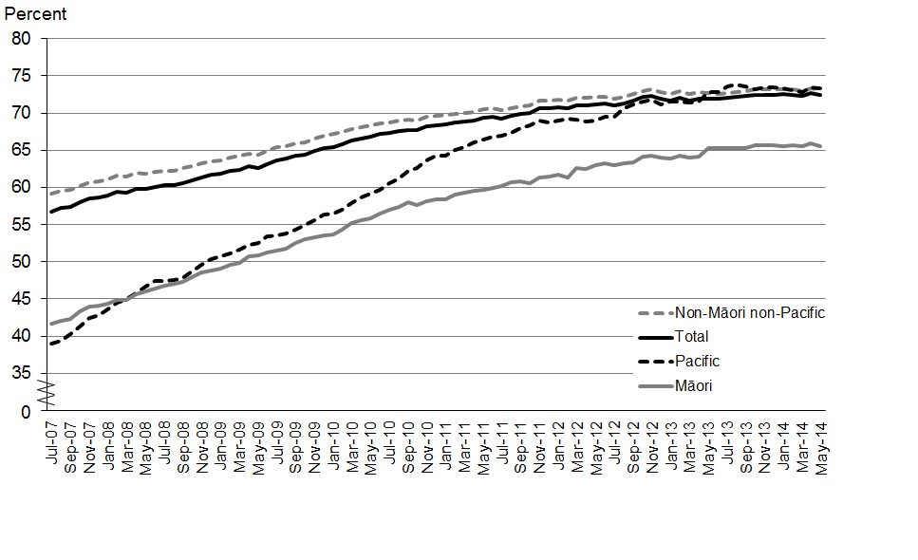

Source: BreastScreen Aotearoa

Cervical screening rates have also improved since 2007, but are still below the target of 80 percent coverage by 2014. As at December 2013, 77 percent of women aged 25–69 years had been screened in the past three years, up from 74 percent in 2007. Although cervical screening rates have improved for all ethnic groups, they remain lower in women of Māori (63 percent), Pacific (69 percent) and Asian (65 percent) ethnicity (Figure 3.2).

**Figure 3.2: Cervical screening coverage rates in the past three years, women aged 25–69 years, by ethnic group, 2007**–**2013**

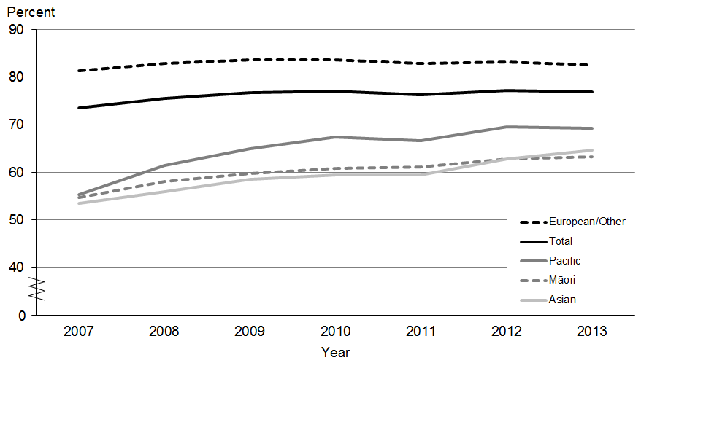

Notes:

Coverage includes eligible women screened by the National Cervical Screening Programme in the previous 36 months.

Populations are Statistics New Zealand 2006 Census population projections for 2012 and adjusted for hysterectomy prevalence.

Source: National Screening Unit, Ministry of Health

### Gaps in dental care for adults

Regular dental visits are important for the early detection of dental problems such as decay. The Ministry of Health and the New Zealand Dental Association recommend regular dental checks as one way to keep teeth and gums healthy. In New Zealand, basic oral health services are funded for children and adolescents from birth up until their 18th birthday.

The 2012/13 New Zealand Health Survey found that 55 percent of adults only visit a dental health care worker when they have dental problems, or never visit at all (Ministry of Health 2013b). A 2010 national survey showed that these people were much more likely to have untreated dental decay than people who usually visit for a check-up (Ministry of Health 2010b). Only visiting for dental problems (or never) was more common among adults living in the most deprived areas (see Figure 3.3), and was also more common among Māori (76 percent) and Pacific peoples (78 percent).

Figure 3.3: Percentage of adults only visiting a dental health care worker for a problem (or never visiting), by neighbourhood deprivation, 2012/13

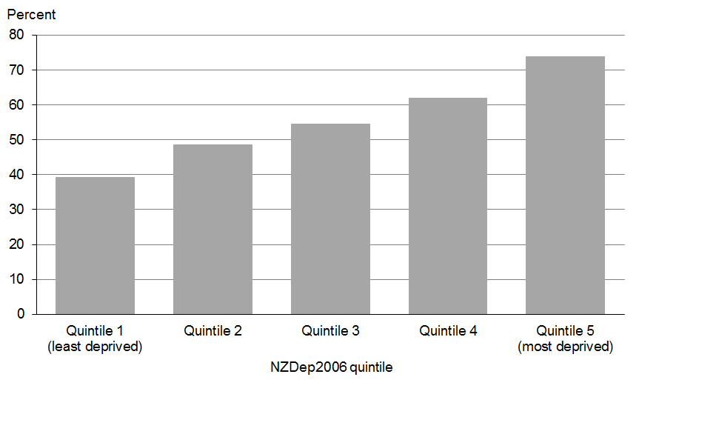

Source: 2012/13 New Zealand Health Survey (Ministry of Health 2013b)

In the 2013 Commonwealth Fund International Health Policy Survey, 41 percent of New Zealand adults reported that they had not visited a dentist/hygienist/dental clinic in the last two years (ranking New Zealand last of eleven OECD countries). One in three New Zealand adults (32 percent) reported that they had skipped dental care because of the cost in the last year (ranking New Zealand tenth of eleven) (Osborn and Schoen 2013).

### More people are accessing mental health and addiction services

It is important that people experiencing mental illness and addictions can access specialist services. Since 2002/03, the use of specialist mental health services in New Zealand has increased. A higher proportion of the Māori population uses specialist mental health services than the non-Māori population (see Figure 3.4). The level of access to specialist services has increased at a faster rate for Māori than for non-Māori, particularly since 2004/05.

Figure 3.4: Percentage of total population accessing mental health and addiction services, Māori and non-Māori, 2002/03–2012/13

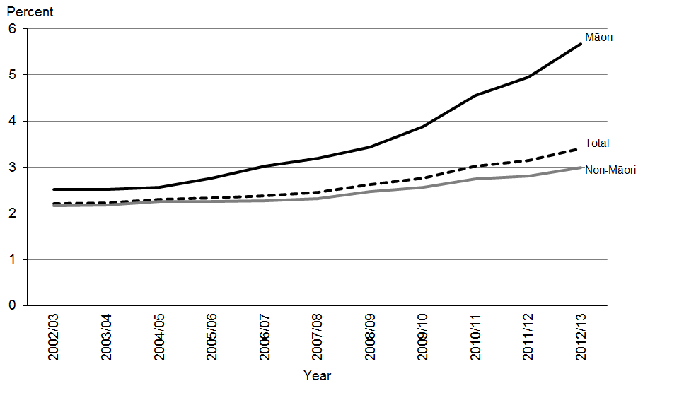

Notes: The number of NGOs reporting to PRIMHD has increased from 50 in 2008 (when PRIMHD was implemented) to 228 currently. Therefore some of the increase in access rates is due to more complete reporting. Because services for older persons are funded differently across the country, not all older persons mental health services report to PRIMHD.

Source: Mental Health Information National Collection – until 2008; Programme for the Integration of Mental Health Data (PRIMHD) – since 2008.

## Timeliness

Timely access to health care when it is needed is an important dimension of service quality, and may affect outcomes. Delays in access to health care can lead to emotional distress and worse health outcomes, particularly if the delay results in later diagnosis or treatment.

### Good results for urgent appointments in primary care

Primary health care providers are generally people’s first point of contact with the health care system; it is important that people can access primary care when they need to. Currently, most New Zealanders are able to access primary care within 24 hours of needing it.

In the 2012/13 New Zealand Health Survey, 84 percent of adults and 87 percent of children were able to get an appointment at their usual medical centre within 24 hours of wanting one (Ministry of Health 2013b). Results were slightly lower for Māori adults (79 percent) and Māori children (84 percent). The result for adults overall was an improvement from 2006/07, when the equivalent figure was 82 percent (no time trends were available for children).

New Zealand ranks highly by international standards for people being able to see a doctor or nurse the same or next day. In 2013, nearly three out of four New Zealand adults (72 percent) reported being able to get a same- or next-day appointment with a doctor or nurse when they needed care, compared with only 58 percent in Australia and 52 percent in the United Kingdom (Osborn and Schoen 2013).

### Wait times for emergency care have improved and are low by international standards

The Commonwealth Fund 2014 *Mirror, Mirror* report (Davis et al 2014) showed that New Zealand’s average waiting times for emergency care were lowest compared with 10 other OECD countries. Only 14 percent of those who had attended an emergency department in the past two years waited for more than two hours, in contrast to the worst performing country (Canada), where nearly half waited two hours or more.

These results are consistent with progress towards the New Zealand Government’s health target ‘shorter stays in emergency departments’. The latest data show that 94 percent of people were admitted, discharged or transferred from an emergency department within six hours against the target of 95 percent. See the ‘Health targets’ section in the *Annual Report* for further information.

### More people are being seen and treated more quickly for elective services

Elective services are medical or surgical services for people who do not need to be treated right away. In February 2011 the Ministry of Health introduced a multi-year programme that specified maximum waiting-time expectations for elective services. The goal is that by December 2014 no patients will have been waiting for elective services for over four months.

In the last two years there has been a marked reduction in the number of patients waiting over four months for an elective first specialist assessment and over four months for elective treatment following their first specialist appointment (see Table 3.5).

Table 3.5: Number of people waiting over four months for elective first specialist appointment and elective treatment, 2012−2014

|  |  |  |
| --- | --- | --- |
| **Month ending** | **Waiting over four months for first specialist appointment** | **Waiting over four months for treatment** |
| June 2012 | 9197* | 4192 |
| June 2013 | 4988 | 2260 |
| June 2014 | 3547 | 2030 |

Notes: * District health boards commenced monthly reporting this measure in July 2012, so June 2012 data is not available; this figure relates to July 2012.

Source: National Booking and Reporting System

From 2010 to 2013, the percentage of patients waiting more than three months declined for seven key elective procedures (see Figure 3.5).

Figure 3.5: Percentage of patients waiting more than three months for elective procedures, by procedure type, 2010 and 2013

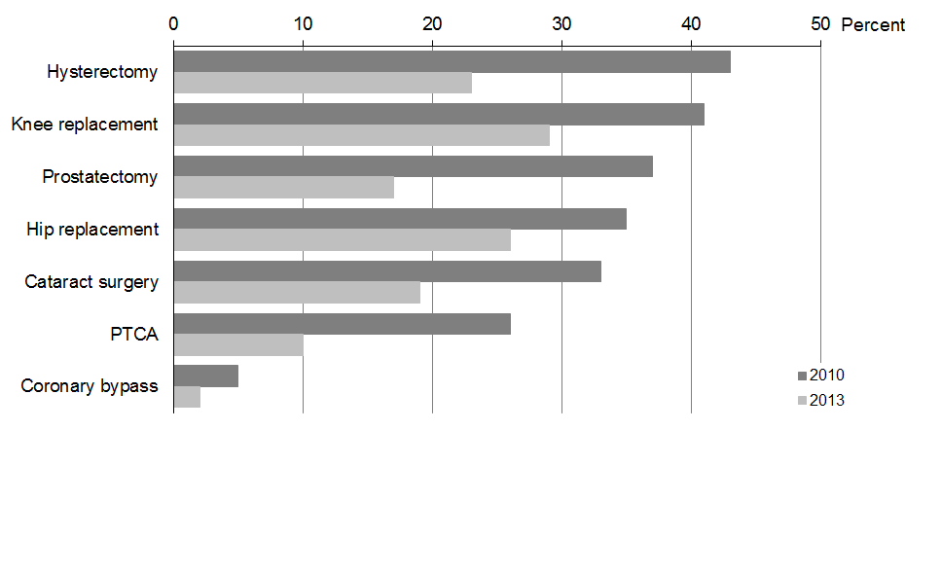

Notes:

1. The time elapsed from the date of referral from a GP to the date of specialist assessment is excluded.

2. PTCA refers to percutaneous transluminal coronary angioplasty.

Source: National Booking and Reporting System

The number of elective surgeries being performed has exceeded the government health target. By the fourth quarter of 2013/14, district health boards (DHBs) had achieved the target of increasing the volume of elective surgery by at least 4000 discharges per year: they provided 161,933 elective surgical discharges against a target of 152,287, which is an additional 9646 discharges. See the ‘Health targets’ section in the *Annual Report* for further information.

The combination of increased access to elective surgery and reduced waiting times for elective surgery is very positive; more people are being seen and treated, faster.

## Effectiveness

The health system’s effectiveness is measured by the extent to which patients receive services that are effective and appropriate for preventing or treating their health conditions, both in the community and in hospitals.

### Immunisation levels have increased for all ethnic groups

Immunisation is one of the most effective and cost-effective interventions to protect people against harmful infections that can cause serious complications, including death. The National Immunisation Programme comprises a series of vaccines that are offered at no cost, providing protection from diseases such as pertussis and measles.

One of the government health targets is increased immunisationfor children. Until June 2012 the target was to fully immunise 95 percent of two-year-olds. As a result, the immunisation coverage for two-year-olds improved markedly, from 67 percent in quarter one of 2007/08 to 93 percent in quarter four of 2013/14.

The more recent target aimed to ensure that 90 percent of all eight-month-olds will be fully immunised (ie, that they will have had their primary course of immunisations at six weeks, three months and five months on time) by July 2014. This target was exceeded: 92 percent of eight‑month-olds were fully immunised in quarter four of 2013/14. Coverage rates for vulnerable groups improved substantially from quarter one of 2012/13 to quarter four of 2013/14: Māori children (78 to 88 percent), Pacific children (87 to 95 percent), and children living in the most deprived areas (81 to 89 percent). See the ‘Health targets’ section in the *Annual Report* for further information.

### More children caries free overall but there are large differences between ethnic groups

In 2013, 57 percent of children were caries-free (that is, they had no dental decay, missing teeth or fillings due to decay in their primary teeth) when they started school. This was an improvement since 2000, when 52 percent were caries-free. Similarly, there was an increase in the proportion of children who were caries free in their permanent teeth at the end of Year 8 (age 12–13 years) between 2000 and 2013 (from 42 to 54 percent).

Pacific and Māori children are less likely to be caries-free than other children, particularly as five-year-olds. In 2013, 36 percent of Pacific children and 37 percent of Māori children were caries-free when they started school, compared with 67 percent of other children (see Figure 3.6).

Figure 3.6: Caries-free (fluoridated and non-fluoridated) five-year-olds, by ethnic group, 2005–2013

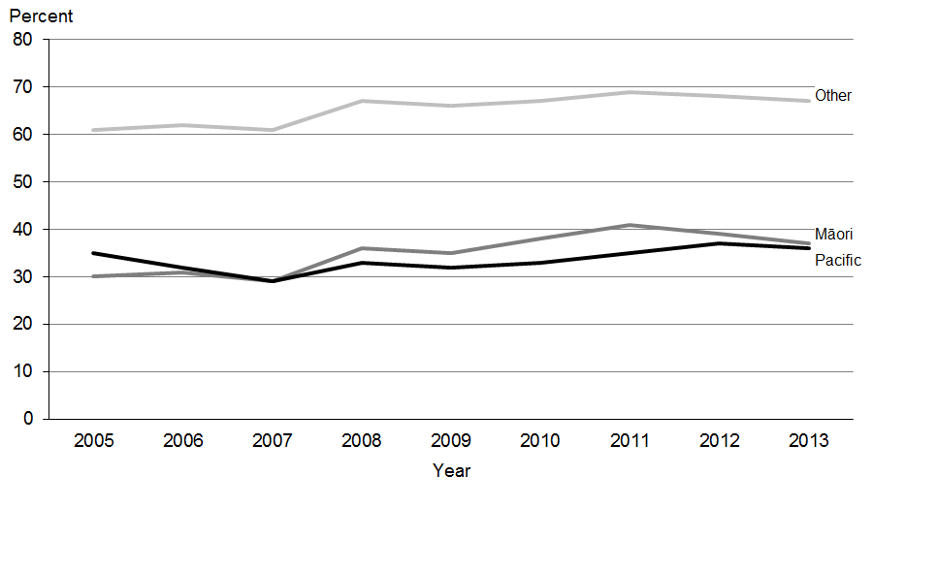

Note: Figures pertain to primary teeth for five-year-olds.

Source: District health board reporting from the Community Oral Health Service

In Year 8, 40 percent of Pacific children and 42 percent of Māori children were caries-free, compared with 59 percent of other children (see Figure 3.7). In contrast to the Māori and ‘Other’ ethnic groups, there has been very little improvement in the proportion of caries-free Pacific children in Year 8 since 2005.

Figure 3.7: Caries-free (fluoridated and non-fluoridated) Year 8 students, by ethnic group, 2005–2013

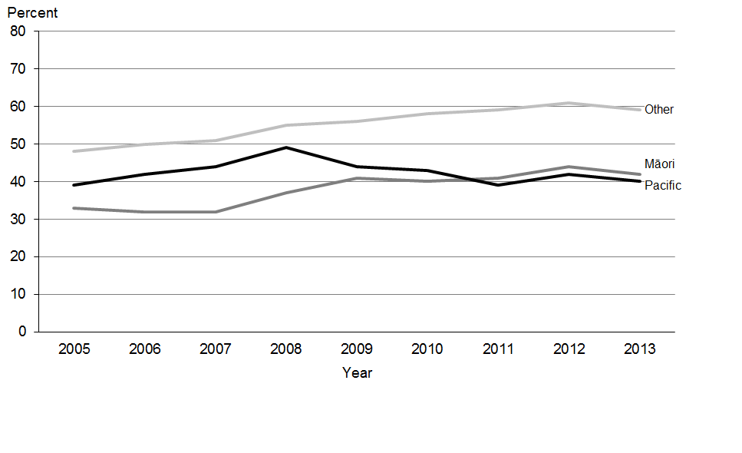

Note: Figures pertain to permanent teeth for Year 8 students.

Source: District health board reporting from the Community Oral Health Service

### Fewer new admissions directly to acute inpatient mental health services

Ideally people with mental health conditions are managed in the community, rather than in hospital. The proportion of new mental health clients first seen in acute inpatient mental health services decreased from 6.0 percent in 2002/03 to 4.1 percent in 2012/13. The decrease for Māori and Pacific was greater than for the total population over this period (see Figure 3.8). This suggests that community mental health services became more accessible and effective over that period across all ethnic groups.

Figure 3.8: Proportion of new clients seen in acute inpatient mental health services (rather than specialist community mental health services), by ethnic group, 2002/03–2012/13

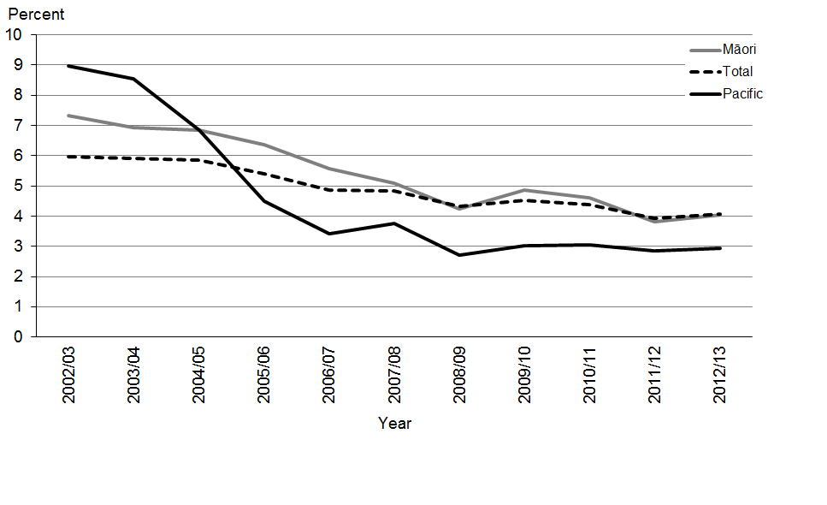

Note: ‘New clients’ are defined as people who were seen at a service for the first time in the previous 12 months.

Source: PRIMHD

### Ambulatory sensitive hospitalisations

Ambulatory sensitive hospitalisation (ASH) rates measure the number of people who appear in hospital with conditions that could have been prevented or treated in out-of-hospital settings such as primary health care. Therefore, ASH is a measure of both effectiveness and efficiency.

From 2009 to 2013 ASH rates have been relatively stable for the total population, but they have declined by 10 percent for Māori and 3 percent for Pacific peoples (see Figure 3.9). However, ASH rates in Māori and Pacific peoples remain over double the rate for the ‘Other’ ethnic group.

Figure 3.9: Ambulatory-sensitive hospitalisation admission rates per 100,000 people aged 0–74 years, by ethnic group, 2009–2013

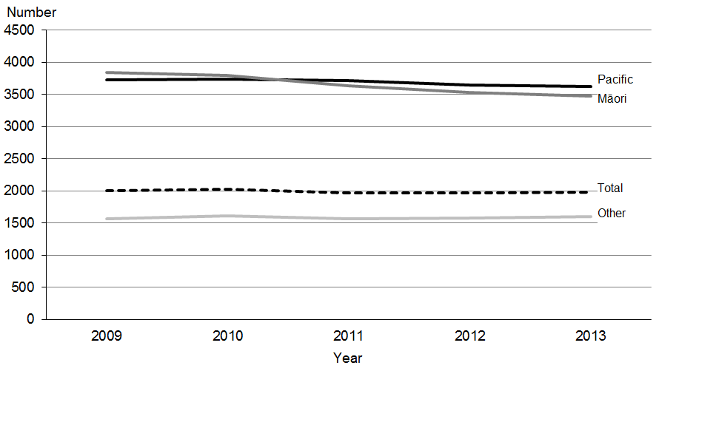

Notes:

1. The data for Pacific peoples is taken from the seven DHBs with a substantial Pacific population: Waitemata, Auckland, Counties Manukau, Waikato, Capital & Coast, Hutt and Canterbury. All other DHBs’ Pacific populations are grouped into the ‘Other’ ethnic group. Rates are age-standardised to the World Health Organization (WHO) world population.

2. As there are some limitations to the denominator measure, it is difficult to interpret trends by ethnicity with certainty.

Source: National Minimum Dataset, Ministry of Health

The specific conditions contributing to the overall ASH rate vary by age and ethnic group (see Table 3.6). For Māori, dental conditions predominate in children, cellulitis (a bacterial skin infection) in adults aged up to 64 years and pneumonia in adults aged 65–74 years. For Pacific peoples, cellulitis is the predominant condition affecting the ASH rate in all age groups except adults aged 65–74 years, where pneumonia is most common. For non-Māori, non-Pacific peoples, gastroenteritis/dehydration is the most common condition affecting the ASH rate in children under five years, dental conditions in older children, cellulitis in adults aged 15–44 years and angina and chest pain in adults aged 45–74 years.

Table 3.6: Most common conditions causing ambulatory sensitive hospitalisations, by age and ethnic group, 2011−2o13

|  |  |  |  |
| --- | --- | --- | --- |
| **Age group (years)** | **Māori** | **Pacific** | **Non-Māori, non-Pacific** |
| 0–4 | Dental conditions | Cellulitis | Gastroenteritis/dehydration |
| 5–14 | Dental conditions | Cellulitis | Dental conditions |
| 15–24 | Cellulitis | Cellulitis | Cellulitis |
| 25–44 | Cellulitis | Cellulitis | Cellulitis |
| 45–64 | Cellulitis | Cellulitis | Cellulitis |
| 65–74 | Respiratory infections – pneumonia | Respiratory infections – pneumonia | Angina and chest pain |

Source: National Minimum Dataset, Ministry of Health

### Deaths preventable by health care declining steadily

‘Amenable mortality’ refers to deaths that might have been prevented if health services had been delivered more effectively or if patients had accessed services earlier (either in primary care or in hospital).

From 2000 to 2011 New Zealand’s amenable mortality rates decreased across all ethnic groups; the greatest decline was seen for Māori, followed by Pacific peoples (see Figure 3.10). However, in 2011, rates for Māori were still 2.7 times higher, and for Pacific peoples 2.4 times higher, than they were for non-Māori, non-Pacific peoples.

Figure 3.10: Amenable mortality rate per 100,000 people aged 0–74 years, by ethnic group, 2000–2011

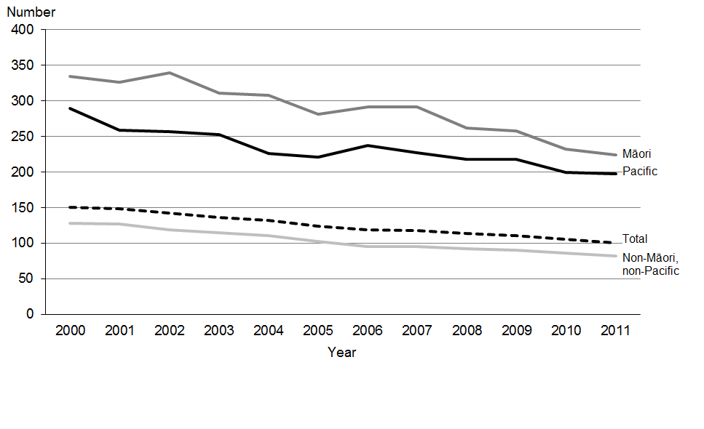

Notes: Amenable mortality includes deaths from some types of infection and cancer; maternal, perinatal and infant conditions/ complications; injuries; and a range of chronic disorders. Rates are age-standardised to the WHO world population.

Source: National Minimum Dataset, Ministry of Health

The most common conditions contributing to deaths amenable to health care vary by age group, but are largely consistent across ethnic groups (see Table 3.7). Over the three-year period from 2009 to 2011, injuries were the leading cause of deaths amenable to health care for people aged 5–44 years, except for Pacific adults aged 25–44 years where cardiovascular diseases and diabetes were the leading cause. Cardiovascular diseases and diabetes were the leading cause of deaths amenable to health care across for adults aged 45–75 years.

Table 3.7: Most common condition contributing to deaths amenable to health care, by age and ethnic group, 2009–2011

|  |  |  |  |
| --- | --- | --- | --- |
| **Age group (years)** | **Māori** | **Pacific** | **Non-Māori, non-Pacific** |
| 0–4 | Maternal and newborn | Maternal and newborn | Maternal and newborn |
| 5–14 | Injuries | Injuries | Injuries |
| 15–24 | Injuries | Injuries | Injuries |
| 25–44 | Injuries | CVD and diabetes | Injuries |
| 45–64 | CVD and diabetes | CVD and diabetes | CVD and diabetes |
| 65–74 | CVD and diabetes | CVD and diabetes | CVD and diabetes |

Source: National Minimum Dataset, Ministry of Health

### People are more likely to survive cancer

Cancer survival rates are a key measure of the effectiveness of the health system in delivering early detection, diagnosis and treatment. Cancer survival is measured using the five-year relative survival ratio, which compares observed survival of cancer patients after five years from diagnosis to that of comparable cancer-free individuals in the general population. This section looks at cancer survival for three specific cancers – colorectal, breast and cervical cancers – as indicators for the effectiveness of the health system in improving cancer survival overall.

Between 2000 and 2010 there were improvements in survival for colorectal cancer (in both males and females) and breast cancer, but not for cervical cancer (see Figure 3.11). The trend of declining cervical cancer survival over this period (from 74.1% to 71.0%) is explained by two factors: an increasing proportion of cervical cancers caused by a subtype that is both more aggressive (less curable) and less detectable through screening; and an increasing proportion of cervical cancers that have already spread to other parts of the body at the time of diagnosis and therefore do not respond as well to treatment. There is no evidence that the quality of cervical cancer treatment is worsening. Note that trends in cancer survival are not an indicator of the coverage or quality of cervical cancer screening.

Figure 3.11: Five-year relative survival, by cancer type and sex, 2000–05 and 2006–10

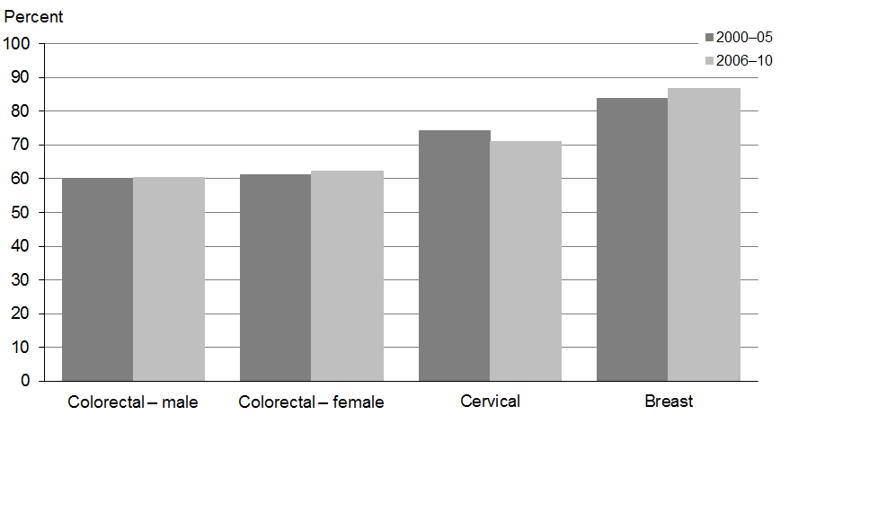

Note: Age-standardised survival (%).

Source: New Zealand Cancer Registry and the Mortality Collection, Ministry of Health

Although colorectal and breast cancer survival have improved for Māori, survival for colorectal, cervical and breast cancer remains lower in Māori compared with non-Māori (see Figure 3.12).

Figure 3.12: Five-year relative survival, by cancer type, Māori and non-Māori, 2000−05 and 2006−10

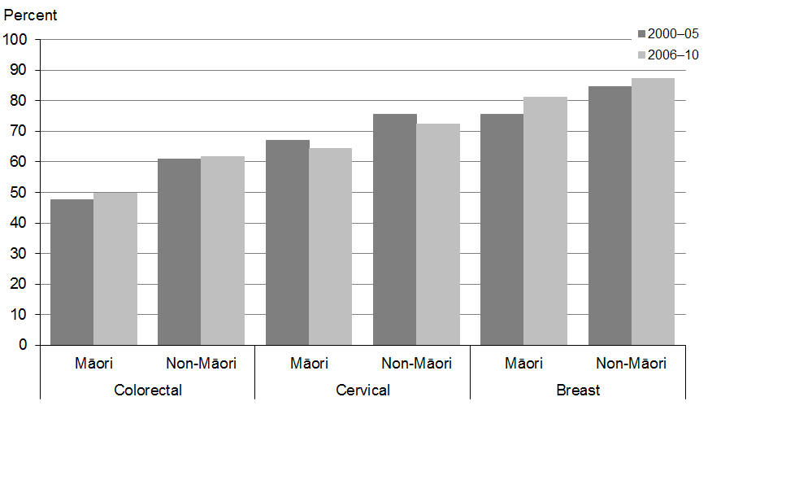

Note: Age-standardised survival (%).

Source: New Zealand Cancer Registry and the Mortality Collection, Ministry of Health

New Zealand’s survival for colorectal and breast cancer are slightly above the OECD average (see Figure 3.13). However, our survival rates for cervical cancer are slightly below the OECD average.

**Figure 3.13: Five-year relative survival, by cancer type, New Zealand and OECD average, 2006–11 (or nearest period)**

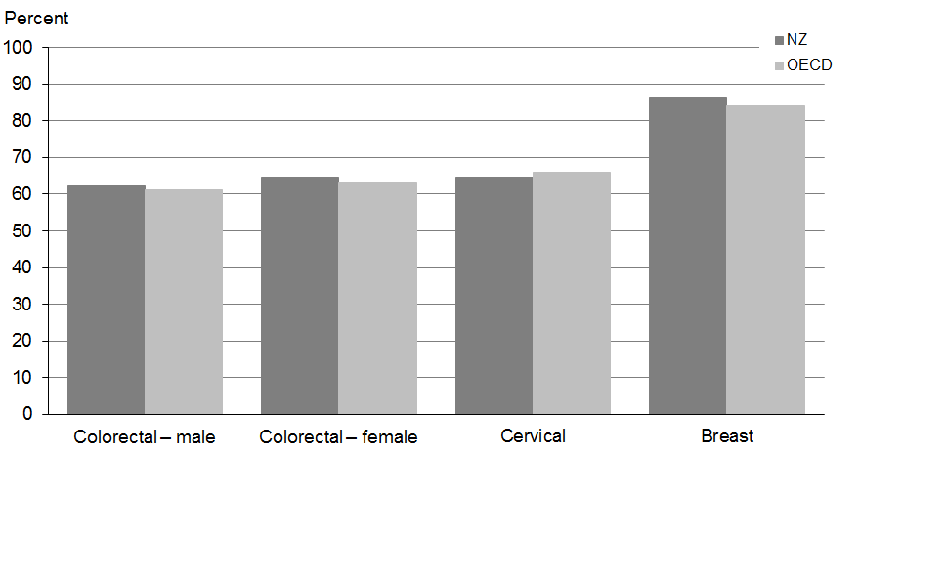

Note: Age-standardised survival (%).

Source: OECD 2013

### **Better survival after heart attacks and strokes**

Survival after admission to hospital for acute myocardial infarction or stroke is a measure of the effectiveness of health services at delivering treatment for these conditions. A commonly used indicator of survival is the mortality rate from acute myocardial infarction and stroke within 30 days of admission, for adults aged 45 years or older.

From 2001 to 2011, 30-day mortality rates declined by about 50 percent for acute myocardial infarction, 30 percent for ischaemic stroke and 17 percent for haemorrhagic stroke (see Figure 3.14). These improvements can be attributed to better treatments in the acute phase of myocardial infarction and improved access to diagnosis and optimal treatment for stroke patients (partly due to the introduction of dedicated stroke units).

Figure 3.14: Mortality rate within 30 days of admission to hospital with an acute myocardial infarction or stroke, adults aged 45 years or older, 2001, 2006 and 2011

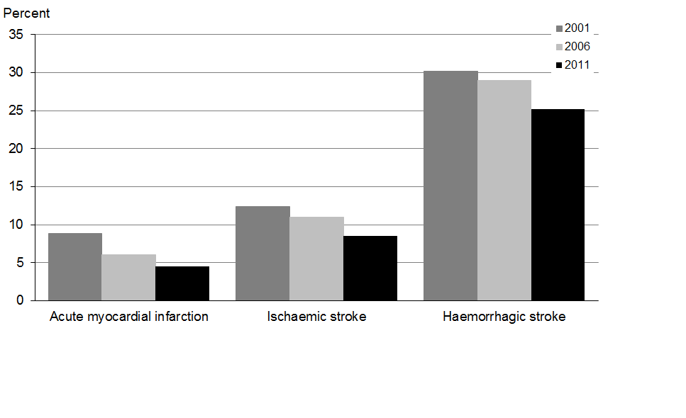

Note: Age-sex standardised rate per 100 patients.

Source: OECD 2013

New Zealand’s 30-day mortality for acute myocardial infarction (4.5 percent) is lower than the OECD average (7.9 percent). Our 30-day mortality rate for ischaemic stroke is similar to the OECD average, but our 30-day mortality rate for haemorrhagic stroke (25 percent) is higher than the OECD average (22 percent) (OECD 2013).

### Most older people live independently in their own homes

Effective health care and support services enable people to live independently for longer. There is evidence that older people who continue to live in their own home – with personal care and home management support if necessary – experience greater wellbeing.

In 2013/14, 23 percent of people aged 85 years or older lived in aged residential care, down from 28 percent in 2006/07 (see Table 3.8). This means that a high and increasing proportion of older people live independently in their own home.

Table 3.8: Percentage and number of older people living in aged residential care, adults aged 85 years and older, 2006/07–2013/14

|  |  |  |  |
| --- | --- | --- | --- |
| **Year** | **People aged 85+ years living in aged residential care** | | **Estimated population aged 85+ years** |
| **Percentage** | **Number** | **Number** |
| 2006/07 | 28 | 16,707 | 59,685 |
| 2007/08 | 26 | 16,445 | 62,408 |
| 2008/09 | 26 | 16,647 | 64,623 |
| 2009/10 | 26 | 17,195 | 67,120 |
| 2010/11 | 25 | 17,576 | 69,708 |
| 2011/12 | 25 | 18,069 | 71,943 |
| 2012/13 | 23 | 17,282 | 74,248 |
| 2013/14 | 23 | 17,930 | 76,868 |

Source: Aged Residential Care Demand Planner; population estimates from Statistics New Zealand

## Patient safety

Patient safety is one of the main dimensions of health system performance. Patients are sometimes unintentionally harmed in a health care setting, resulting in a longer length of stay, permanent injury or even death. A multitude of interactions with different providers can make it difficult to ensure safe health care. Recognising the importance of patient safety and maintaining a focus on prevention can help improve the performance of the health system.

### International benchmarking suggests post-operative complications could be reduced

Compared with other OECD countries, New Zealand has relatively high rates of two types of adverse events: post-operative pulmonary embolism and deep vein thrombosis, and post-operative sepsis (see Figure 3.15).

Figure 3.15: Post-operative complication rate, New Zealand and OECD average, 2011 or nearest year

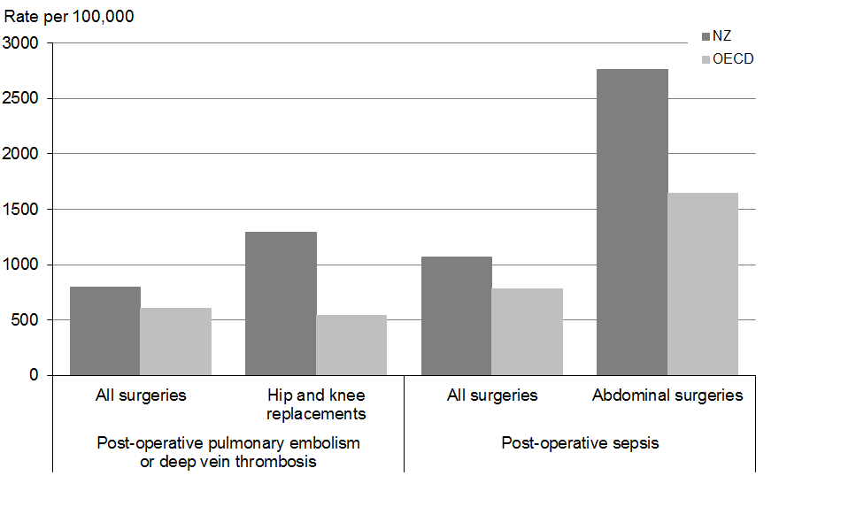

Note: Adjusted rate per 100,000 hospital discharges.

Source: OECD 2013

Pulmonary embolism (a blockage of the main lung artery) and deep vein thrombosis (a blood clot in a deep vein; usually in the legs) cause pain and can cause death. Both complications can be prevented by the administration of anticoagulants and other measures before, during and after surgery. Sepsis (a potentially life-threatening bloodstream infection) can lead to organ failure and death. Sepsis can be prevented or minimised by appropriate prophylactic antibiotics, surgical measures and post-operative care.

While these post-operative complication findings might be partly explained by reporting differences, it may also represent an opportunity for improvement. The Health Quality and Safety Commission is making post-operative complications an area of priority through its peri-operative harm programme. This programme includes promoting use of the WHO safe surgery checklist, an approach shown to reduce post-operative complications.

### Safe care measures

‘Safe care’ is care that proactively minimises injuries to patients. In the 2012 Commonwealth Fund International Health Policy Survey, nine out of ten New Zealand primary care doctors (89 percent) said that they routinely receive information to assist in the provision of safe care; that is they receive a prompt about a potential problem with drug dose or interaction (Davis et al 2014). In the same survey, just over half of doctors (53 percent) routinely received reminders about guideline-based interventions and/or tests.

## Efficiency and sustainability

A high-performing health system will be able to meet the substantial challenges that lie ahead. The overarching challenge for health care in the future will be raising the quality of health and disability services within a constrained funding path.

Within this context, it will continue to be important to improve the efficiency and productivity of health and disability services and organisations, to ensure that New Zealand is obtaining the best value for money for the investment in health care.

### Good overall systems outcomes for expenditure

Despite lower relative health spending than some countries, New Zealand achieves relatively good health and systems outcomes. In the Commonwealth Fund 2014 *Mirror, Mirror* report (Davis et al 2014), New Zealand ranked seventh highest out of 11 OECD countries for performance overall across four main dimensions of systems performance: quality care (with four sub-domains for effective, safe, coordinated and patient-centred care), access (with two sub-domains for cost-related problems and timeliness of care), efficiency and equity. New Zealand performed very well on the two sub-dimensions of effective care and coordinated care (ranking second best for both). In contrast, New Zealand has consistently spent less per capita since 1980 on health care than all of the other 10 OECD countries represented in the report.

### Growth in generic medicines

Generic medicines have the same active ingredient, dose and strength as an original branded medicine, and are manufactured to the same international quality standards, but are less expensive.

There has been a growth in the use of generic medicines in New Zealand. In 2013, generic medicines accounted for 77 percent of the total volume and 34 percent of the dollar value of medicines reimbursed by the Government. This placed New Zealand as the third highest ranking country in the OECD on the volume measure from 16 countries submitting data; the OECD average for the measure was 45 percent (OECD 2014c). This reflects the efficiency of the New Zealand pharmaceutical purchasing model, which encourages a focus on effectiveness and generic competition.

### Average length of stay in hospital has decreased

Longer stays increase the cost of care and can reduce patient wellbeing. Average length of stay can be decreased by measures such as advances in treatment technologies (eg, new and less invasive surgical techniques), more effective drugs, improved community and follow-up care, and more effective hospital administration.

From 2004 to 2013, the average length of stay for total medical and surgical procedures decreased from 4.2 to 3.8 days (see Figure 3.16). During the same period average length of stay for surgical procedures decreased from 5.6 to 4.9 days, and for medical procedures it decreased from 3.7 to 3.4 days.

Figure 3.16: Average number of days spent in hospital by inpatients: medical, surgical and total, 2004–2013

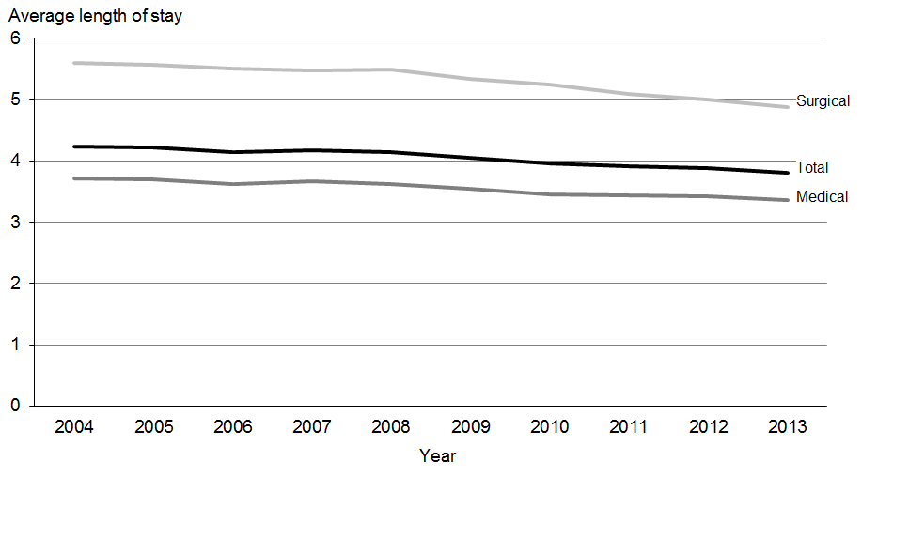

Source: National Minimum Dataset, Ministry of Health

The challenge for hospital staff is to ensure that minimising length of stay − thus potentially achieving benefits to patient wellbeing and efficiency gains for providers − does not result in reduced quality of care or unnecessary readmissions.

### The elective day case rate is increasing

In many cases, admitting and discharging a patient for a surgical procedure on the same day can result in a less disruptive hospital visit for the patient and ensure hospital resources are used more efficiently. Day surgery is most effective for less complex surgery.

From 2003 to 2013 there was an increase in the proportion of all surgical procedures that were carried out as day case procedures, from 53 to 58 percent. This is in line with international trends, and suggests that hospitals are becoming more efficient at patient management.

# Changing health needs

Key messages

* The health system needs to adapt to meet the challenges that lie ahead. These challenges include changes in our population and patterns of disease.
* The population is growing by about 110 people per day. The population size has increased in all ethnic groups, with the largest growth in the Asian ethnic group.
* The population is ageing. The number of people aged 65 years or older is projected to nearly double by 2031. While structurally youthful, the proportion of Māori aged 65 years or older has increased over the last decade.
* New Zealanders are living longer than ever before, although some of the extra years of life are spent in poor health.
* Patterns of disease are changing. As the burden of cardiovascular disease declines, cancers are becoming more prominent.
* Multimorbidity is common in older adults: half of adults aged 65 years or older have two or more two long-term conditions.
* Disability rates are increasing in all age groups. The most common causes of impairment are diseases, injuries and ageing.

The health system needs to adapt to meet the challenges that lie ahead. This section provides an overview of challenges associated with population change and changing patterns of disease. Some of the other challenges facing the health system, such as workforce development and advances in medicines and technologies, are covered in the *Annual Report*.

## Population growth and change

Our population is growing and changing. The increasing size, diversity and age of the New Zealand population will impact on the health sector by increasing the demand for services.

### Increasing population size and diversity

At June 2014, New Zealand’s resident population was 4.5 million; this figure has increased by 325,300 people since 2006 (Statistics New Zealand 2014b), and equates to an increase of about 110 people per day. The increase is due to both natural increase (births minus deaths) and net migration.

The New Zealand population has a high proportion of people born overseas. The 2013 Census found that about 25 percent of New Zealanders were born overseas, up from 20 percent in 2001.

All major ethnic groups have increased in size since 2006; the fastest growth has occurred in the Asian and Middle Eastern/Latin American/African (MELAA) ethnic groups (see Table 3.9).

Table 3.9: Population of major ethnic groups, 2006 and 2013

|  |  |  |  |  |  |  |
| --- | --- | --- | --- | --- | --- | --- |
|  | **Estimated resident population at 30 June** | | | | **Increase from 2006 to 2013** | |
| **Count** | | **Percent** | |  | |
| **2006** | **2013** | **2006** | **2013** | **Count** | **Percent** |
| European or Other | 3,213,300 | 3,312,100 | 76.8 | 74.6 | 98,800 | 3 |
| Māori | 624,300 | 692,300 | 14.9 | 15.6 | 68,000 | 11 |
| Asian | 404,400 | 541,300 | 9.7 | 12.2 | 136,900 | 34 |
| Pacific | 301,600 | 344,400 | 7.2 | 7.8 | 42,800 | 14 |
| Middle Eastern/Latin American/African | 38,600 | 53,100 | 0.9 | 1.2 | 14,500 | 38 |
| Total | 4,184,600 | 4,442,100 | – | – | 257,500 | 6 |

Notes: People who identify with more than one ethnic group are included in each group they identify with. Therefore, individual ethnic population counts and percentages do not sum to the total.

Source: Statistics New Zealand (Statistics New Zealand 2014b).

As well as increasing in size, the Asian ethnic group is becoming more heterogeneous. The fastest growing Asian subgroups are Indian and Filipino. The health status of Asian subgroups is hugely variable, so data for the total Asian ethnic group often masks important differences. For example, all-cause mortality for the Indian ethnic group is about 40 percent higher than for the Chinese ethnic group (Jatrana et al 2014). This difference in partly explained by higher rates of diabetes and cardiovascular diseases in the Indian ethnic group.

Māori and Pacific populations have a younger age structure than the European and Asian ethnic groups: in 2013 the median age was 23.9 years for Māori, 22.1 years for Pacific peoples, 41.0 years for European and 30.6 years for Asian. The median age of Māori and Pacific populations has increased since 2006, when it was 22.7 years and 21.1 years respectively (Statistics New Zealand 2013a).

### Our population is ageing

Population ageing is the shift in the distribution of a population towards older ages. It occurs due to a combination of increasing life expectancy and decreasing fertility. Population ageing will put pressure on the health system due to the increased health needs of older people. To minimise this impact, we need to improve the health of middle-aged and older adults. One way to achieve this is to ensure that prevention and early intervention occurs much earlier in the life course.

At June 2013, about 14 percent of the population were aged 65 years or older (650,400), up from 11 percent in 1994 (Statistics New Zealand 2014b). The number of people aged 65 years or older is projected to nearly double by 2031, reaching about 1.1 million (21 percent of the population) (Statistics New Zealand 2012). While the population size is increasing in most age groups, the biggest growth will be in the 65–74 and 75–84-year age groups (see Figure 3.17), as the cohort of ‘baby boomers’ ages. The proportion of Māori aged 65 years or older has increased from 4.1 percent in 2006 to 5.4 percent in 2013 (Statistics New Zealand 2013b).

Figure 3.17: Population counts, by age group, 2014–2026 (projected)

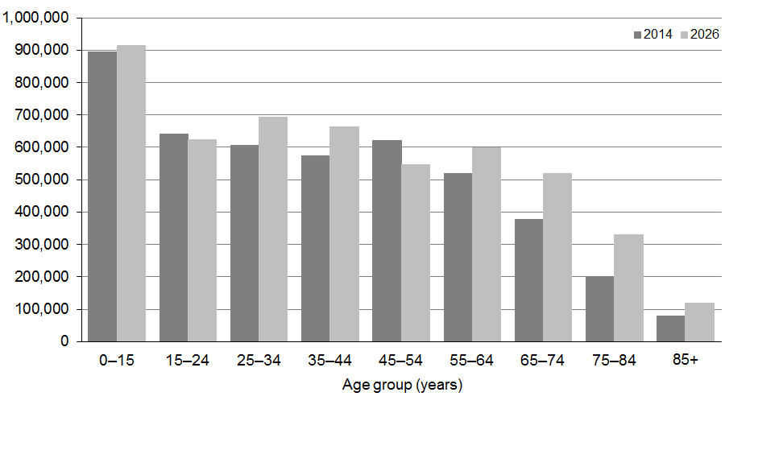

Source: Statistics New Zealand projections for Ministry of Health

## Changing patterns of disease

The pattern of health and illness in the population influences the demand for health services. This section summarises long-term trends in mortality and life expectancy, as well as more recent trends in health expectancy, multimorbidity and disability.

### Change in causes of death over time

Trends in major causes of death are key drivers of changes in life expectancy. Figure 3.18 shows changing causes of death over the last 60 years for the total New Zealand population.

Ischaemic heart disease mortality rates peaked from the late 1960s to the mid-1970s, and have declined steadily since. The pattern is similar for cerebrovascular disease (stroke), for which mortality rates peaked from the late 1950s to the early 1970s. These large declines in ischaemic heart disease and stroke mortality (about 75 percent in each case) are a success story for the health system: they show what can be achieved with a combination of population-based initiatives (eg, reduced smoking and saturated fat intake), early detection of disease and better medical care. It is thought that increasing rates of obesity and diabetes may slow or reverse the decline in cardiovascular disease mortality rates; however, there was no evidence of this happening as of 2010.

Figure 3.18: Leading causes of mortality, 1950–2010

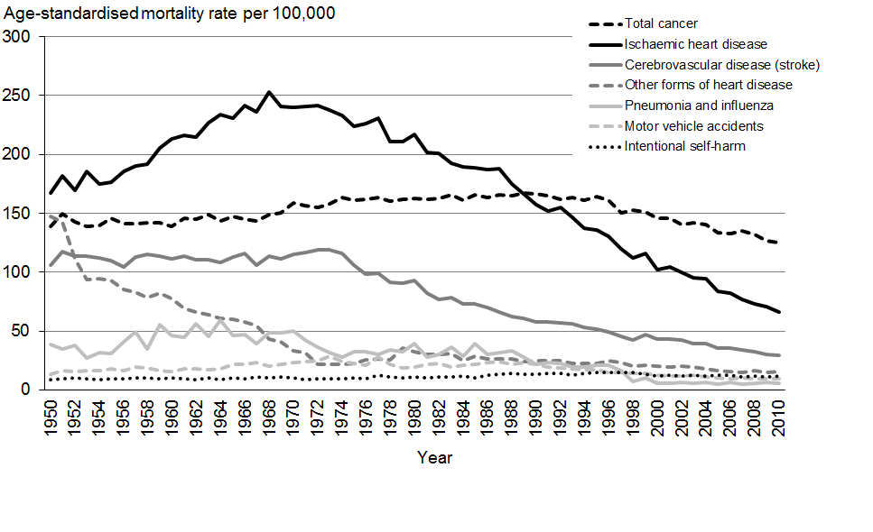

Note: Rates are age-standardised to the WHO world population.

Source: New Zealand Mortality Collection, Ministry of Health (Ministry of Health 2014b).

As cardiovascular disease mortality rates have declined, cancers have become more prominent as a cause of death. In the mid-1990s, mortality rates for all cancers combined started to decline (see Figure 3.18). This decline is due to a combination of primary prevention (eg, through reduced smoking), early detection (eg, through screening) and more timely and effective medical care.

Other important trends include declining mortality rates for pneumonia and influenza since the 1960s and declining motor vehicle accidents since the mid-1970s. In contrast, mortality rates from intentional self-harm (suicide) increased slightly over this period, peaking in the mid-1990s.

### New Zealanders are living longer than ever before

Life expectancy is the number of years a person can expect to live, given age-specific mortality patterns. If mortality rates are declining, as they are in New Zealand, actual life spans will be even longer.

New Zealanders are living longer than ever before. A boy born in 2012 could expect to live 79.7 years, and a girl 83.2 years (Statistics New Zealand 2014a). Since the 1950s, life expectancy at birth has increased by an average of two years per decade; there have been increases of about 2.5 years per decade (or three months per year) in more recent years. The gap in life expectancy between males and females has reduced since the mid-1970s, from 6.5 years to 3.5 years (see Figure 3.19).

Figure 3.19: Life expectancy at birth, by sex, 1950−52 to 2011−13

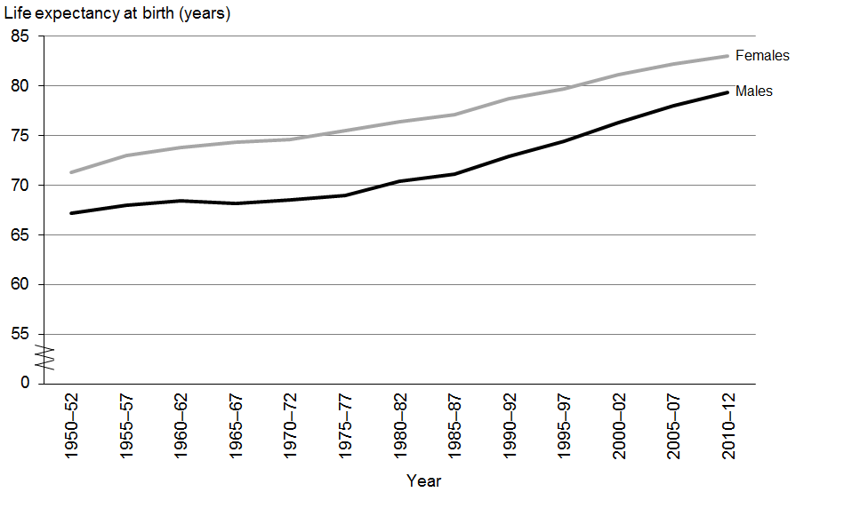

Source: Statistics New Zealand 2014d

New Zealand’s life expectancy compares well with similar countries. For New Zealand males, life expectancy at birth in 2012 was 2.2 years above the OECD average (77.5 years). For New Zealand females, it was 0.4 years above the OECD average (82.8 years) (OECD 2014d).

In 2011, life expectancy at birth was 72.8 years for Māori males and 76.5 years for Māori females. While improvements in Māori life expectancy over the past 15 years have narrowed the gap between Māori and non-Māori, the current gap of 7.3 years is still wider than it was in the mid-1980s (about 4.5 years) (Statistics New Zealand 2014a).

Once a person has reached the age of 65 years, they can expect to live another 20 years (up from about 15 years in the early 1980s). In 2012, New Zealand males aged 65 years could expect to live to the age of 84.1 years (another 19.1 years), while females aged 65 years could expect to live to 86.4 years (another 21.4 years) (Statistics New Zealand 2014a).

### Health expectancy is increasing, although not as quickly as life expectancy

Health expectancy is the number of years that a person can expect to live in good health; that is without functional limitation (disability) requiring assistance. Health expectancy is an important indicator of health system performance, reflecting the contribution of all sectors to keeping people healthy and independent throughout their lives.

Independent health expectancy is calculated using data from the Disability Survey run in Census years, so it cannot be updated every year. The latest estimates of health expectancy are for 2006, although an update based on 2013 data will be available next year.

Overall, New Zealanders are living longer in good health. Between 1996 and 2006 health expectancy at birth improved by 2.7 years for males and by 1.7 years for females (Ministry of Health and Statistics New Zealand 2009). A boy born in 2006 could expect to live 67.4 years in good health, and a girl 69.2 years. While health expectancy has improved for Māori, Māori health expectancy remains about 6.5 years lower than it is for non-Māori.

Although both life expectancy and health expectancy have improved, the increase in health expectancy has not kept pace with the increase in life expectancy. This means that while we are living longer, we are spending some of that extra time in poor health. This expansion of morbidity is projected to continue to at least 2016 (Ministry of Health 2013a). Turning this trend around will require a greater focus on preventing or delaying the onset of long-term conditions, and on slowing the rate of progression of disease in those already diagnosed.

### Multimorbidity is common in older adults

Many long-term conditions (such as cardiovascular diseases, diabetes and arthritis) are more common in older people. As people live longer, there is likely to be an increase in the number of people with one or more long-term condition (ie, multimorbidity). People with multiple long-term conditions place a larger burden on the health system, and require more integrated care.

In the 2012/13 New Zealand Health Survey, nearly one in four adults (about 816,000, or 23 percent) reported two or more of the following long-term conditions: ischaemic heart disease (angina, heart attack), stroke, high blood pressure (medicated), diabetes, asthma (medicated), arthritis, mental disorders (depression, anxiety and bipolar disorder) and chronic pain. Some adults reported multiple conditions; 6.4 percent (226,500) had three and 3.7 percent (129,800) had four or more. The true prevalence of multimorbidity is likely to be higher, given that only a limited number of conditions were covered in the survey.

The rate of multimorbidity increases with age (see Figure 3.20). By age 65–74 years, just over half of adults have two or more long-term conditions: 25 percent have two, 17 percent have three and 10 percent have four or more. By age 75 years, nearly two-thirds of adults have two or more long-term conditions: 26 percent have two, 21 percent have three and 15 percent have four or more.

Figure 3.20: Adults with one or more long-term condition, by age group, 2012/13

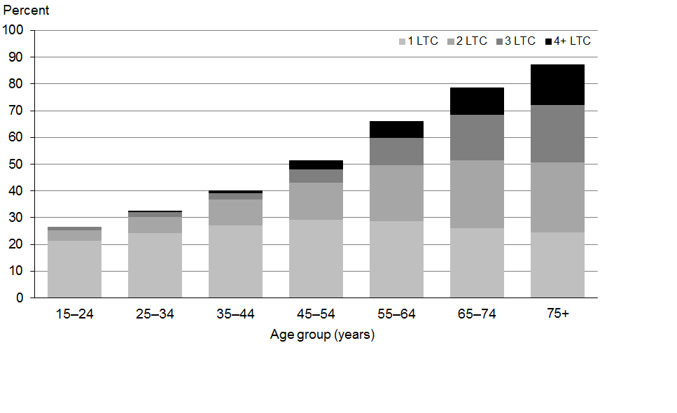

Note: This measure included eight long-term conditions: ischaemic heart disease (angina, heart attack), stroke, high blood pressure (medicated), diabetes, asthma (medicated), arthritis, mental disorders (depression, anxiety and bipolar disorder) and chronic pain.

Source: 2012/13 New Zealand Health Survey

### Disability rates are increasing in all age groups

Disability is defined as long-term limitation resulting from impairment in a person’s ability to carry out daily activities. The impairment or limitation may be physical, sensory, neurological, psychiatric or intellectual. People with disabilities require varying levels of support, based on their need for assistance and/or special equipment relating to their disability.

The 2013 Disability Survey found that 24 percent of New Zealanders (1.1 million) reported a disability (Statistics New Zealand 2014c). This represents a significant increase since 2001, when 20 percent of people reported a disability. Disability rates have increased in all adult age groups, and especially in those aged 65 years or older (see Figure 3.21). While population ageing has contributed to the increase, it does not account for all of it.

Figure 3.21: Percentage of people with disability, by age group, 2001 and 2013

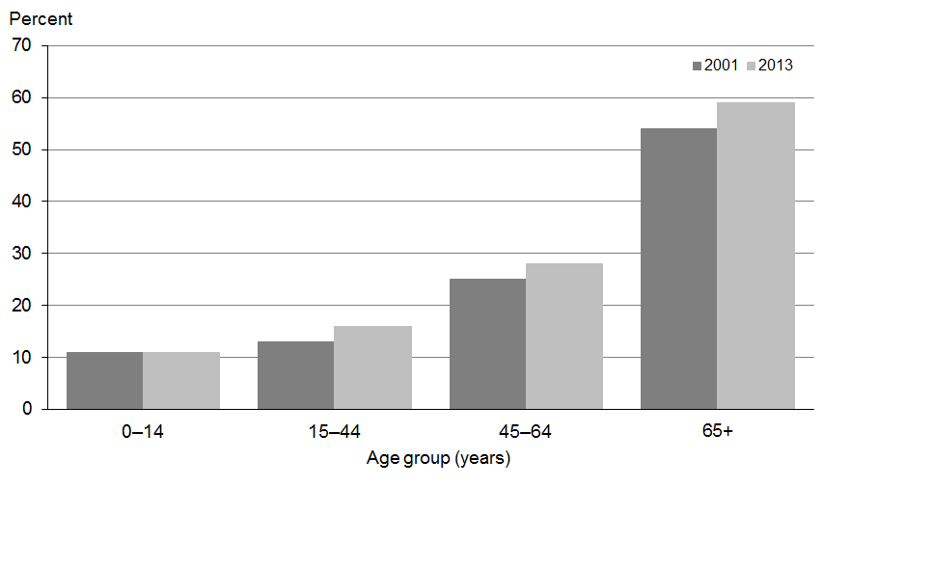

Source: 2013 Disability Survey (Statistics New Zealand 2014c)

People aged 65 years and older had the highest disability rate in 2013: 59 percent, up from 54 percent in 2001. The age-adjusted disability rate was higher for Māori (32 percent) and Pacific peoples (26 percent).

For adults, the most common types of impairment were physical limitations, whereas for children it was learning difficulties. Just over half of disabled people (53 percent) had more than one type of impairment.

For adults, the main underlying cause of impairment was disease or illness (42 percent), followed by accident or injury (34 percent) and ageing (31 percent).[22] For adults aged 65 years or older, the main cause of impairment was ageing (53 percent), closely followed by disease or illness (50 percent). For children, the main causes of impairment were conditions that existed at birth (49 percent), followed by other developmental or behavioural conditions (33 percent).

# Non-communicable diseases

Key messages

* Non-communicable diseases account for a large and increasing burden of ill health, disability and premature mortality across the world.
* In New Zealand, nearly 60 percent of all health loss is caused by the following conditions: ischaemic heart disease, stroke, diabetes, chronic respiratory diseases, cancers, musculoskeletal disorders, mental health disorders and dementia.
* Total cancer incidence and mortality rates are declining slowly, although declines are slower for Māori. Due to population ageing the number of people with cancer is increasing.
* Despite large declines over the last four decades, cardiovascular diseases still account for one in three deaths and about one in six years of life lost from illness, disability and premature mortality.
* Nearly 245,000 New Zealanders have diabetes; an approximately 75 percent increase in numbers since 2005. Diabetes rates are increasing in all age and ethnic groups. Diabetes rates are highest in Indian (11 percent) and Pacific peoples (9.6 percent), followed by Māori (6.1 percent) and European/Other (5.1 percent).
* One in six New Zealanders (15 percent) has arthritis; half of adults aged 75 years or older are affected.
* Nearly 600,000 adults have been diagnosed with a mental health disorder at some time in their lives. Most health loss from mental health disorders is non-fatal but can cause severe functional impairment and occurs in young and middle-aged adults.
* Suicide death rates remain high in New Zealand; rates are twice as high for Māori as for non-Māori.
* An estimated 48,000 New Zealanders have dementia. The number of people affected is projected to triple by 2051.

Globally, non-communicable diseases (NCDs)[23] account for more than half of all deaths (Lozano et al 2012), and a large and increasing proportion of all ill health, disability and premature mortality (Lim et al 2012). Recently there has been a renewed focus on NCDs, because the number of people affected is growing very quickly across the world. This has major health and economic implications, and has led to the development of a Global Monitoring Framework for the Prevention and Control of NCDs.

In 2012, all countries committed to a 25 percent reduction in premature mortality from major NCDs (cardiovascular diseases, cancers, chronic respiratory diseases and diabetes) by 2025 (the 25 x 25 target). In 2013, all countries agreed to a set of nine voluntary targets to accelerate action towards the 25 x 25 target. The targets focus on reducing exposure to risk factors for NCDs (tobacco use, harmful use of alcohol, salt intake, obesity, physical inactivity, raised blood pressure, raised blood glucose) and strengthening health system responses (treating people at high risk of heart attack and stroke, and ensuring the availability of drugs to treat NCDs).

This section covers the four main types of conditions covered by the Global Framework: cardiovascular diseases (ischaemic heart disease and stroke), cancers, diabetes and chronic respiratory diseases. It also covers other long-term conditions that account for considerable health loss in New Zealand but are not major causes of death (musculoskeletal and mental health conditions) and a condition that will become more common as the population ages (dementia). Collectively, these conditions account for about 60 percent of illness, disability and premature mortality in New Zealand (Ministry of Health 2013a).

## Cancers

Cancers accounted for 17.5 percent of all health loss in 2006, mostly due to premature mortality (Ministry of Health 2013a). In 2011 cancers accounted for 29 percent of all deaths (Ministry of Health 2014a). Cancers have become more prominent as the burden of cardiovascular diseases has declined (see Figure 3.18).

A person’s chance of surviving cancer depends on a number of factors, including age at diagnosis, type of cancer, cancer stage at diagnosis and availability of specialist cancer treatment and follow-up care. Potentially modifiable risk factors for cancer include smoking, poor diet, physical inactivity, obesity and harmful use of alcohol. For most cancers, a person’s chance of surviving cancer is improved by early detection and timely and effective treatment. The *Annual Report* provides more information on the health target ‘shorter waits for cancer treatment’.

### Total cancer incidence rates are declining slowly

A total of 21,050 new cancers[24] were registered in New Zealand in 2011, up from 17,991 registrations in 2002. Just over half (53 percent) of all cancer registrations in 2011 were for males.

The most commonly registered cancers in 2011 were colorectal or bowel cancer (3030), prostate cancer (3023), breast cancer (2894), melanoma (2204) and lung cancer (2016). These five cancers accounted for 63 percent of all cancer registrations.

The incidence of all cancers combined is declining slowly for the total population, but trends differ by sex and ethnic group. From 2002 to 2011 the age-standardised registration rate for total cancers decreased by 6 percent for the total population (from 351 to 331 per 100,000); there were larger declines for males (8 percent) than females (5 percent).

For Māori, the incidence rate for all cancers combined declined by only 1 percent between 2002 and 2011, compared with a 7 percent decline for non-Māori (see Figure 3.22). In 2011, the total cancer registration rate was 30 percent higher for Māori (410 per 100,000) than for non-Māori (324 per 100,000), after standardising for age.

Figure 3.22: Cancer registration rate, Māori and non-Māori, 2002−2011

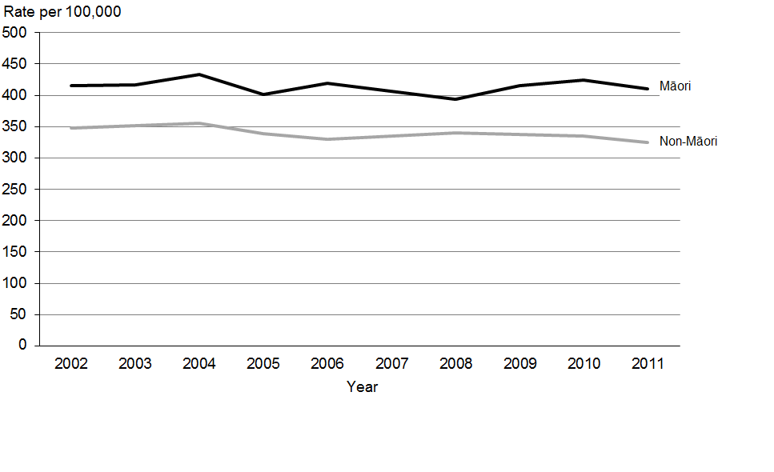

Note: Rates are age-standardised to the WHO world population.

Source: New Zealand Cancer Registry, Ministry of Health

### Trends in cancer incidence differ by cancer type

For males, age-standardised incidence rates for lung cancer and colorectal cancer declined between 2002 and 2011, but there was no change for melanoma (see Figure 3.23). Prostate cancer incidence fluctuated during this period, although rates were lower in 2011 than 2002. For females, incidence rates for colorectal cancer and melanoma declined between 2002 and 2011, but there was no change in incidence rates for breast cancer and lung cancer.

Figure 3.23: Cancer registration rate, by cancer type and sex, 2002–2011

|  |  |
| --- | --- |
| **Males** | **Females** |
| Figure 3.23: Cancer registration rate, by cancer type, males, 2002–2011 | Figure 3.23: Cancer registration rate, by cancer type, females, 2002–2011 |

Note: Rates are age-standardised to the WHO world population.

Source: New Zealand Mortality Collection, Ministry of Health

### Total cancer mortality is declining

In 2011 there were 8891 deaths from cancer: a rate of 126 per 100,000. Nearly half (47 percent) of cancer deaths were in people aged 75 years or older. Due to the growing older population, the number of cancer deaths is increasing each year.

The most common causes of cancer mortality in 2011 were lung cancer (1682 deaths), colorectal cancer (1191), female breast cancer (636), prostate cancer (585) and melanoma (359). These five cancers accounted for 50 percent of all cancer deaths.

From 2002 to 2011, the age-standardised total cancer mortality rate declined by 11 percent. The decline was larger for males (15 percent) than females (7 percent). The larger decline in cancer mortality among males has helped to reduce the gap in life expectancy between the sexes (see the ‘Life expectancy’ section of this report).

For Māori, the age-standardised mortality rate for total cancer declined by 7 percent between 2002 and 2011, compared with a 12 percent decline for non-Māori. In 2011, the total cancer mortality rate was 72 percent higher for Māori (205 per 100,000) than non-Māori (119 per 100,000), after standardising for age.

### Cancer mortality trends differ by cancer type

Between 2002 and 2011, the age-standardised mortality rate for colorectal cancer declined in both males and females; prostate cancer mortality declined in males; and breast cancer mortality declined in females (see Figure 3.24). The lung cancer mortality rate decreased for males, but not for females. There was little change in the mortality rate for melanoma in either males or females.

Figure 3.24: Cancer mortality rate, by cancer type and sex, 2002–2011

|  |  |
| --- | --- |
| **Males** | **Females** |
| Figure 3.24: Cancer mortality rate, by cancer type, males, 2002–2011 | Figure 3.24: Cancer mortality rate, by cancer type, females, 2002–2011 |

Note: Rates are age-standardised to the WHO world population.

Source: New Zealand Mortality Collection, Ministry of Health

Cancer survival has improved over the past decade, due in part to early detection (eg, through screening) and more timely and effective care. The ‘Health system performance’ section of this report discusses cancer survival in more detail.

## Cardiovascular diseases

The term ‘cardiovascular disease’ covers a range of diseases related to the circulatory system, including ischaemic heart disease (also known as coronary heart disease) and cerebrovascular disease (or stroke). Up to 80 percent of illness, disability and premature mortality from cardiovascular diseases is potentially avoidable through a combination of prevention and treatment. Modifiable risk factors include smoking, high blood pressure, poor diet, physical inactivity, obesity and diabetes. A person’s chance of surviving ischaemic heart disease and stroke is improved by early detection, effective treatment and rehabilitation. The *Annual Report* provides more information on the health target ‘more heart and diabetes checks’.

Despite large declines in incidence and mortality over the last four decades, cardiovascular diseases still account for one in three deaths (Ministry of Health 2014b) and about one in six years of life lost from illness, disability and premature mortality (Ministry of Health 2013a). Therefore, an ongoing focus on the prevention and management of cardiovascular diseases remains a priority.

### One in five older adults has ischaemic heart disease

About 5 percent of adults (175,600 people) have been diagnosed with ischaemic heart disease, according to the 2012/13 New Zealand Health Survey (Ministry of Health 2013b). This is likely to be an underestimate, because only angina and heart attacks requiring admission to hospital were included in the measure. The rate of self-reported ischaemic heart disease has not changed since 2006/07 (Ministry of Health 2013b).

Ischaemic heart disease is much more common in older adults; 22 percent of those aged 75 years or older are affected (Ministry of Health 2013b). Rates of diagnosed ischaemic heart disease are higher in men (6 percent) than women (4 percent).

In 2012/13, Māori adults were 80 percent more likely to be diagnosed with ischaemic heart disease than non-Māori adults, after adjusting for age and sex differences. Adults living in the most deprived areas were about 70 percent more likely to be diagnosed with ischaemic heart disease than adults living in the least deprived areas.

### One in twenty older adults has had a stroke

The 2012/13 New Zealand Health Survey found that 2 percent of adults (69,800 people) had been diagnosed with a stroke at some time in their life (Ministry of Health 2013b). This estimate excludes transient ischaemic attacks, which are sometimes referred to as mini-strokes. Strokes were more common in older adults; 10 percent of those aged 75 years or older had had a stroke.

In 2012/13, stroke rates did not vary significantly by ethnic group or neighbourhood deprivation, after adjusting for differences in age, sex and ethnicity. Men were slightly more likely to have had a stroke than women (2.2 and 1.7 percent respectively). The rate of stroke has not changed significantly since 2006/07 (Ministry of Health 2013b).

### Cardiovascular disease mortality rates continue to decline

Cardiovascular diseases accounted for 10,542 deaths in 2011 (35 percent of all deaths). Just over half (53 percent) of cardiovascular disease deaths were in females (reflecting higher numbers of older females). The leading causes of cardiovascular disease deaths were ischaemic heart disease (5534 deaths) and stroke (2665 deaths).

About one in four ischaemic heart disease deaths (26 percent) and one in five stroke deaths (19 percent) occurred in people aged less than 75 years (Ministry of Health 2014a). Males are more likely than females to die prematurely (that is, before age 75 years) from ischaemic heart disease (37 and 14 percent respectively) and stroke (27 and 15 percent).

From 2002 to 2011, the age-standardised total cardiovascular disease mortality rate declined by nearly one-third, from 178 to 124 per 100,000. Population ageing meant that the number of cardiovascular disease deaths declined more slowly (by about 8 percent) during this period.

Mortality rates for ischaemic heart disease declined by about one-third in both males and females between 2002 and 2011 (see Figure 3.25). Over that decade, the aged-standardised ischaemic heart disease mortality rate declined from 134 to 85.9 per 100,000 in males and from 71.4 to 47.3 per 100,000 in females. However, males experienced a larger absolute decline in mortality from ischaemic heart disease over this period (due to their having a higher rate to begin with), which helped to reduce the gap in life expectancy between the sexes (see the ‘Life expectancy’ section of this report).

From 2002 to 2011, the age-standardised mortality rate for stroke declined by 33 percent for males (falling from 42.7 to 28.7 per 100,000) and by 26 percent for females (falling from 41.3 to 30.6 per 100,000).

Figure 3.25: IHD and stroke mortality rate, by sex, 2002–2011

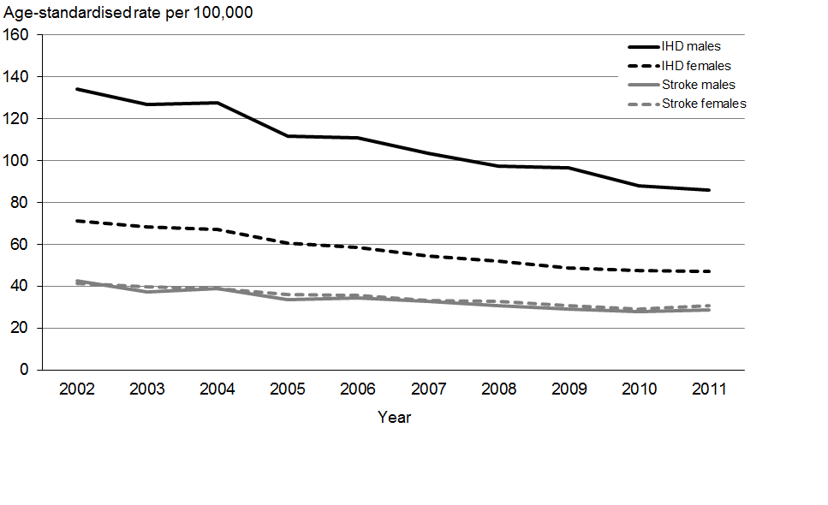

Note: Rates are age-standardised to the WHO world population.

Source: New Zealand Mortality Collection, Ministry of Health

In 2011, the age-standardised ischaemic heart disease mortality rate was 1.7 times higher for Māori males and 2.2 times higher for Māori females than for non-Māori males and females respectively. Ethnic differences in stroke mortality were smaller, with rates 1.1 times higher in Māori males and 1.3 times higher in Māori females, after adjusting for age. These ethnic differences have not changed over the last 10 years.

One of the reasons for declining mortality rates for ischaemic heart disease and stroke is better health care. The ‘Health system performance’ section of this report discusses improved survival from acute myocardial infarction and stroke in more detail.

## Diabetes

Diabetes accounted for nearly 5 percent of all illness, disability and premature mortality in 2006 (Ministry of Health 2013a). Diabetes can cause blindness and nerve damage, and may eventually require amputation of a foot or lower leg. It can lead to other health conditions, such as heart disease, stroke and kidney disease.

There are two main types of diabetes. Type 1 diabetes is less common, and generally develops in childhood. Type 2 diabetes is more common, is largely preventable, and usually develops in adulthood. Risk factors for type 2 diabetes include being obese or overweight, a lack of physical activity and poor diet. Type 2 diabetes can be controlled through weight loss, diet and regular physical activity and, in some cases medication (including insulin).

Nearly all adults with type 2 diabetes are either obese or overweight. In the 2011/12 New Zealand Health Survey, three out of four adults with type 2 diabetes (77 percent) reported that someone at their usual medical centre had checked their weight in the previous 12 months. However, less than half reported that someone at their usual medical centre had talked to them, or arranged for someone else to talk to them, about weight (42 percent), healthy food/nutrition (45 percent) or exercise/physical activity (43 percent) in the previous 12 months.

### Diabetes is increasing in all population groups

About 243,125 people had diabetes as at 31 December 2013, according to the New Zealand Virtual Diabetes Register. This represents a 75 percent increase since 2005, when 138,200 people had diabetes. In the last year the number of people with diabetes grew by 17,400, which is nearly 50 people per day. Some of the rise reflects increased screening, meaning we are detecting more cases. The *Annual Report* provides more information on the health target ‘more heart and diabetes checks’.

In 2013, the rate of diabetes in the PHO-enrolled population was 5.7 percent, up from 3.7 percent in 2005. The rate of diabetes has increased in all adult age groups (see Figure 3.26). The largest (relative) increases have occurred in young adults aged 30–39 years. Diabetes rates are highest in adults aged 75–79 years; about one in five adults (20 percent) in this age group were affected in 2013, up from one in seven (14 percent) in 2005.

Figure 3.26: Prevalence of diabetes, by age group, 2005 and 2013

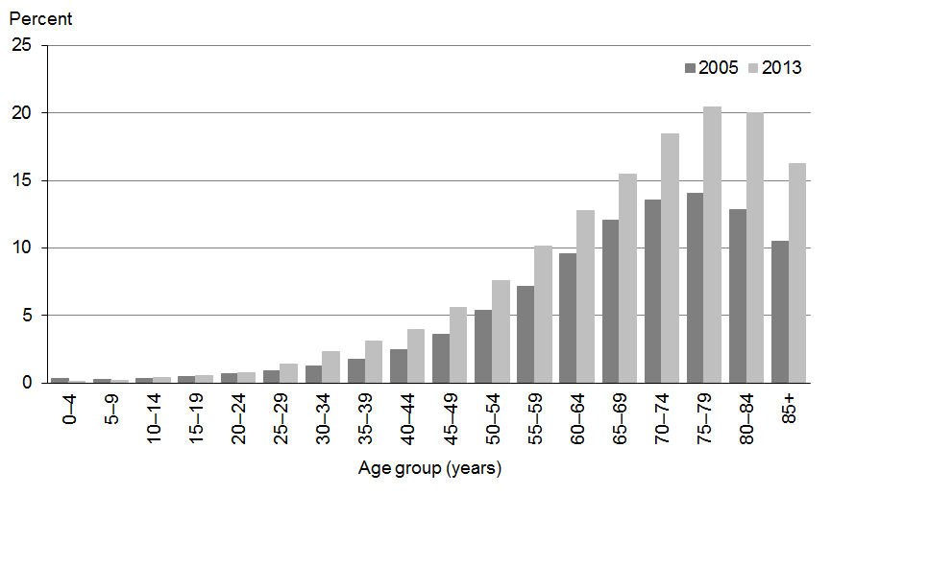

Note: Annual data is measured at 31 December each year from among the PHO-enrolled population.

Source: Virtual Diabetes Register, Ministry of Health

Since 2005, diabetes rates have increased by about 50 percent in all ethnic groups. In 2013, the highest rate of diabetes was in the Indian ethnic group (11.0 percent), followed by Pacific peoples (9.6 percent), Māori (6.1 percent) and European/Other (5.1 percent). Diabetes rates start to increase about 10–15 years earlier in Indian and Pacific adults than in European/Other adults. Nearly half of all Indian and Pacific adults aged 70−74 years have diabetes (see Figure 3.27).

Figure 3.27: Prevalence of diabetes, by ethnic group, 2013

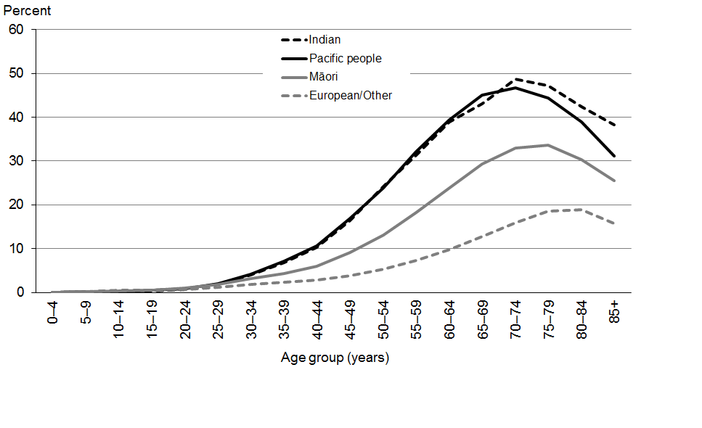

Note: Annual data is measured at 31 December each year from among the PHO‑enrolled population.

Source: Virtual Diabetes Register, Ministry of Health

The increasing rate of diabetes is due to rising incidence (new cases), as well as slower progression from uncomplicated to late-stage disease (which means that mortality rates are lower). Some of the rise in incidence reflects increased screening and population change. However, diabetes rates have increased in all age and ethnic groups, with larger (relative) increases in younger adults. The increase in diabetes in all population groups is consistent with trends in obesity (see the ‘Obesity’ section of this report).

### More people have undiagnosed diabetes or are at risk of diabetes

Some people have undiagnosed diabetes, and many more have pre-diabetes. The 2008/09 Adult Nutrition Survey found that about 2 percent of adults had undiagnosed diabetes – that is, they had not been told by a doctor that they had diabetes, but levels of glycated haemoglobin (HbA1c) in their blood indicated that they had diabetes (University of Otago and Ministry of Health 2011). This meant that about one-quarter of all people with diabetes were undiagnosed.

Furthermore, one in four adults (25 percent) has ‘pre-diabetes’, meaning their HbA1c levels were above normal but below that defined for diabetes (Coppell et al 2013). Obese adults were more likely to have pre-diabetes than healthy weight adults (32 and 20 percent respectively). The progression from pre-diabetes to type 2 diabetes can be slowed by lifestyle interventions involving weight loss, improved diet and increased physical activity (Yudkin 2014).

## Chronic obstructive pulmonary disease

Chronic obstructive pulmonary disease (COPD) is a lung disease that prevents normal breathing. Common types of COPD include chronic bronchitis and emphysema, which are permanent conditions that are usually caused by smoking. Chronic obstructive pulmonary disease accounted for nearly 4 percent of all illness, disability and premature mortality in New Zealand in 2006 (Ministry of Health 2013a).

### One in ten older adults has chronic obstructive pulmonary disease

The 2006/07 New Zealand Health Survey (Ministry of Health 2008) found that about 7 percent of New Zealand adults aged 45 years or older had been diagnosed with COPD. Rates of COPD are higher in older adults; about 10 percent of people aged 75 years or older are affected.

Among adults aged 45 years and over, rates of diagnosed COPD were twice as high for Māori as for other adults, but significantly lower for Asian ethnic groups, after adjusting for age. Rates were nearly three times higher for women living in the most deprived areas compared with women in the least deprived areas; for men the higher rate in high deprivation areas was much less pronounced. The higher rates of COPD in Māori and adults living in deprived areas mirror rates of smoking (see the ‘Smoking’ section of this report).

## Arthritis and other musculoskeletal conditions

Arthritis and other musculoskeletal disorders, such as back disorders, are large contributors to poor health and disability. Musculoskeletal disorders accounted for 9.1 percent of all health loss in 2006, mainly from illness and disability (Ministry of Health 2013a).

### More than 500,000 adults have arthritis

About 539,900 adults (15 percent) have been diagnosed with arthritis, according to the 2012/13 New Zealand Health Survey (Ministry of Health 2013b). Arthritis was more common in women (17 percent) than men (13 percent). After adjusting for age and sex differences, Māori adults were about 30 percent more likely to have arthritis compared with non-Māori adults. Asian adults were much less likely to have arthritis.

The rate of arthritis increases markedly with age (see Figure 3.28). Half of all adults aged 75 years or older have been diagnosed with arthritis.

Figure 3.28: Prevalence of arthritis in adults, by age group and sex, 2012/13

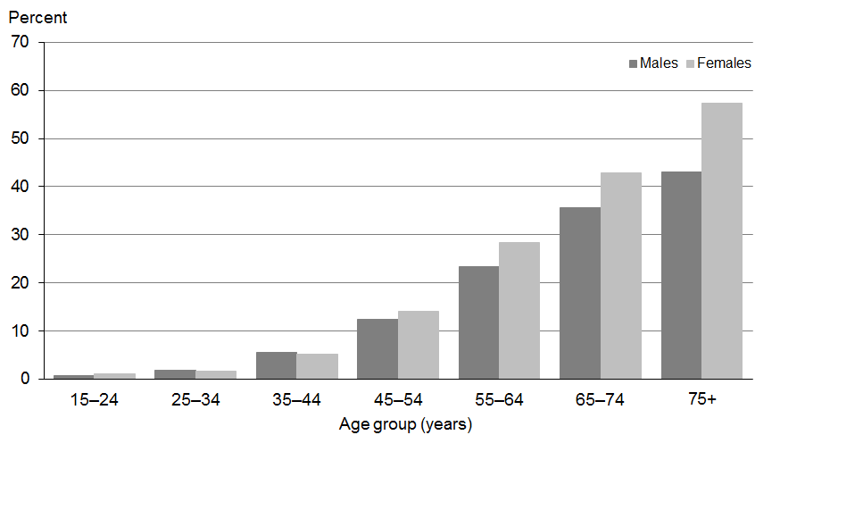

Source: 2012/13 New Zealand Health Survey (Ministry of Health 2013b)

Osteoarthritis is the most common type of arthritis, affecting 8.7 percent of adults in 2012/13 (Ministry of Health 2013b). Osteoarthritis can cause extensive joint damage, severe pain and disability. Patients may require joint replacement surgery.

Osteoarthritis accounted for 2.2 percent of health loss in 2006, mainly from illness and disability. About 60 percent of this health loss was attributable to high body mass (including obesity) (Ministry of Health 2013a).

### Chronic pain affects over 600,000 adults

Chronic pain is recognised as a condition in its own right. Chronic musculoskeletal pain syndromes accounted for 1.3 percent of illness, disability and premature mortality in New Zealand in 2006 (Ministry of Health 2013a).

The 2012/13 New Zealand Health Survey found that 18 percent of adults (633,000) experienced chronic pain, defined as pain that is present almost every day and has lasted, or is expected to last, more than six months (Ministry of Health 2013b). Rates of chronic pain were slightly higher in women (19 percent) than men (16 percent). Chronic pain was more common in older adults; one in three adults aged 75 years or older (34 percent) were affected. Māori adults were 30 percent more likely to have chronic pain compared with non-Māori adults, after adjusting for age and sex differences. Asian adults were much less likely to have chronic pain.

A more in-depth analysis of the 2006/07 New Zealand Health Survey found that the most common reasons for pain reported by respondents were injury or accident (42 percent), a health condition (28 percent) and age (11 percent) (Dominick et al 2011). The most common pain sites were joints (30 percent), back (24 percent), neck (12 percent) and pelvic region (8 percent). Two out of three adults (65 percent) reported only one pain site; 20 percent reported two; and 16 percent reported three or more. Health-related quality of life declined significantly as the number of pain sites increased.

## Mental health conditions

Mental health conditions accounted for 11.1 percent of all health loss in New Zealand in 2006 (Ministry of Health 2013a). Nearly all of this health loss was non-fatal (ie, functional impairment) and occurred in young and middle-aged adults.

Mental health conditions have a major impact on individuals, their families and society as a whole. Poor mental health can cause disability, affect quality of life and reduce productivity. The direct and indirect costs of mental disorders are estimated to account for at least 4 percent of gross domestic product (OECD 2014a).

### Nearly 600,000 adults have been diagnosed with a mental health disorder

The 2012/13 New Zealand Health Survey found that about one in six adults (582,200 people, or 16 percent) had been diagnosed with depression, anxiety disorder or bipolar disorder at some time in their life (Ministry of Health 2013b). This is an increase since 2006/07, when 13 percent of adults reported they had been diagnosed with depression, anxiety disorder or bipolar disorder.

The survey found that diagnosed mental health disorders were more common in women (20 percent) than men (13 percent). Rates of mental health disorders were highest in middle-aged adults; almost 20 percent of adults aged 45–64 years reported they had been diagnosed with depression, anxiety disorder or bipolar disorder at some time in their life.

Adults living in the most deprived areas were 60 percent more likely to have a diagnosed mental health disorder than adults living in the least deprived areas, after adjusting for age, sex and ethnic differences (Ministry of Health 2013b).

### Psychological distress is more common in deprived areas

Psychological (mental) distress refers to a person’s experience of symptoms such as anxiety, confused emotions, depression or rage. It is measured using the 10-question Kessler Psychological Distress Scale (Kessler et al 2003). High levels of psychological distress indicate a high or very high probability of having an anxiety or depressive disorder.

The 2012/13 New Zealand Health Survey (Ministry of Health 2013b) found that 6 percent of adults (218,000) had experienced high or very high levels of psychological distress in the four weeks preceding their survey interview. The rate of psychological distress has not changed significantly since 2006/07 (Ministry of Health 2013b).

Rates of psychological distress were higher in Māori (9.6 percent) and Pacific (8.9 percent) adults, and adults living in deprived areas (see Figure 3.29). After adjusting for age, sex and ethnic differences, adults living in the most deprived areas were 2.5 times as likely to experience psychological distress as adults living in the least deprived areas (Ministry of Health 2013b).

Figure 3.29: Prevalence of psychological distress in adults, by neighbourhood deprivation and sex, 2012/13

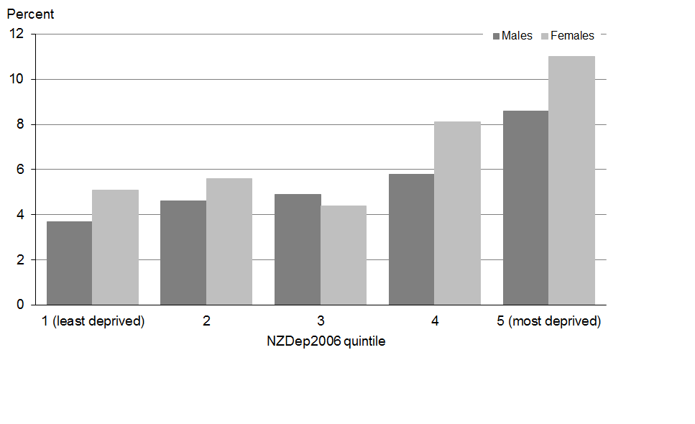

Source: 2012/13 New Zealand Health Survey (Ministry of Health 2013b)

### Depression and self-harm in secondary school students

For about half of adults with mental illness, their condition will have developed before the age of 15 years; early detection and treatment is important (OECD 2014a). In a 2013 national survey of the health and wellbeing of secondary school students, 16 percent of female students and 9 percent of male students reported symptoms of depression that were likely to have an impact on their daily life (using the Reynolds Adolescent Depression Scale – Short Form) (Clark et al 2013). The survey found that 29 percent of female students and 18 percent of male students had deliberately harmed themselves in the previous 12 months (Clark et al 2013).

### Suicide and self-inflicted injury

In 2011, a total of 493 New Zealanders died by suicide, an age-standardised rate of 10.9 deaths per 100,000 people. The suicide death rate was more than three times higher among males (377 suicides: 17.0 per 100,000) than females (116 suicides: 5.1 per 100,000). The suicide death rate for males has declined slightly since the mid-2000s, whereas the rate for females has fluctuated but not changed significantly (see Figure 3.30).

Figure 3.30: Suicide death rate, by sex, 2002–2011

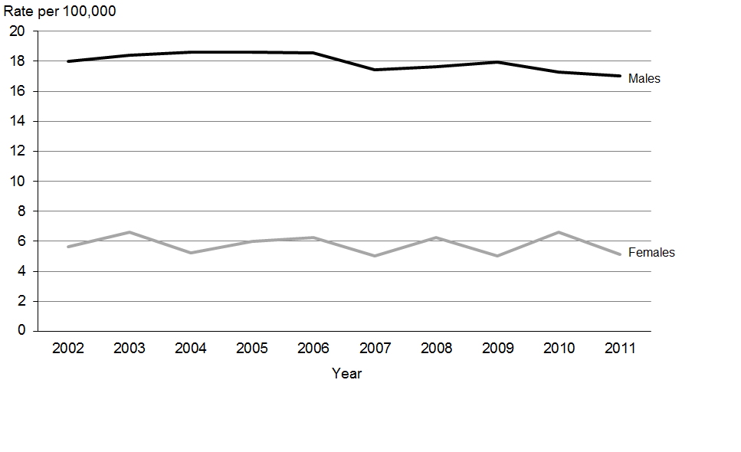

Note: Rates are age-standardised to the WHO world population.

Source: New Zealand Mortality Collection, Ministry of Health

In 2011, about one in four suicide deaths (129) were in young people aged 15–24 years. The youth suicide rate was 20.1 per 100,000; there was a higher rate in males (29.0 per 100,000) than females (10.0 per 100,000).

Suicide death rates in 2011 were higher for Māori than non-Māori, with a larger gap for females than males. Suicide death rates were nearly two times higher for Māori (17.5 per 100,000) than non-Māori (9.4 per 100,000), after adjusting for age. Youth suicide death rates were 2.5 times higher for Māori (38.8 per 100,000) than non-Māori (15.5 per 100,000). This gap closed a little around 2008, but has since widened (see Figure 3.31).

Figure 3.31: Suicide death rate for youth, Māori and non-Māori, 2002–2011

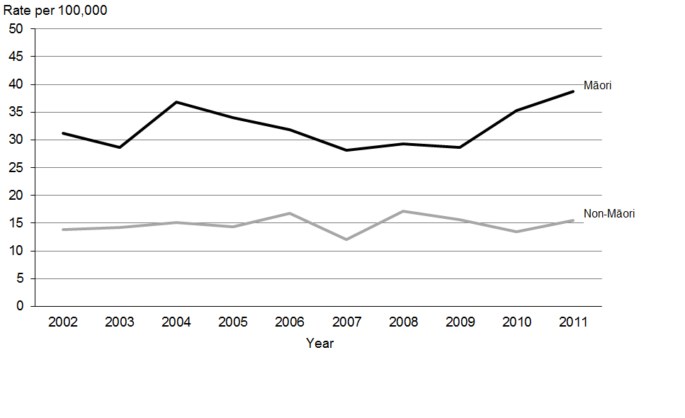

Note: Rates are age-standardised to the WHO world population.

Source: New Zealand Mortality Collection, Ministry of Health

In 2011 there were 2926 intentional self-harm hospitalisations in New Zealand (an age-standardised rate of 67.3 per 100,000). The intentional self-harm rate in females (86.9 per 100,000) was almost twice as high as the rate in males (47.7 per 100,000). Young people aged 15–19 years had the highest rate of intentional self-harm hospitalisations in 2011 (155.2 per 100,000).

## Dementia

In 2011, it was estimated that about 48,000 New Zealanders had dementia (Deloitte Access Economics 2012). The number of people with dementia is expected to increase in the coming decades as the cohort of ‘baby boomers’ ages. By 2050, an estimated 150,000 New Zealanders will have dementia. These estimates are conservative, because not everyone with early-stage dementia will be diagnosed.

The main types of dementia are Alzheimer’s disease, vascular dementia and mixed dementia (both types). Dementia usually occurs in those aged 65 years and over, but can affect those as young as 45 years. Risk factors for dementia are the same as those for cardiovascular diseases: hypertension, smoking, obesity, diabetes and dyslipidaemia (Rizzi et al 2014). Currently there are no effective treatments for dementia, so prevention is important.

# Risk factors for non-communicable diseases

Key messages

* Reducing exposure to modifiable risk factors for NCDs will help to reduce health loss and minimise the impact of population ageing.
* The daily smoking rate declined by one-third over the last decade, from 23 to 15.5 percent. However, daily smoking rates remain high in Māori adults (36 percent) and adults living in the most deprived areas (28 percent).
* Hazardous drinking rates have declined since 2006/07. Rates are highest in young people aged 18–24 years, although there some evidence of improving drinking patterns in young people.
* Physical activity rates in adults are stable, with just over half of adults meeting recommendations. Time spent watching television and video has increased slightly. Fewer children are walking and cycling to school.
* Obesity rates in adults have tripled in the last three decades, with increases in all population subgroups. An estimated 1.2 million New Zealanders are now obese. There are considerable ethnic and socioeconomic inequities in obesity.
* Many parents of obese children incorrectly classify their children as neither under nor over weight.
* Poorly controlled high blood pressure is common in middle-aged and older adults.

One way that the health sector can minimise the burden of NCDs is to prevent or delay their onset by reducing exposure to life style risk factors (eg, smoking) and effectively managing biological risk factors (eg, high blood pressure).

This section focuses on six major risk factors that are potentially modifiable or treatable: smoking, harmful use of alcohol, physical inactivity, diet, obesity, and high blood pressure. These risk factors are leading causes of health loss in New Zealand (see Figure 3.32).

Figure 3.32: Health loss attributed to 14 selected risk factors, 2006

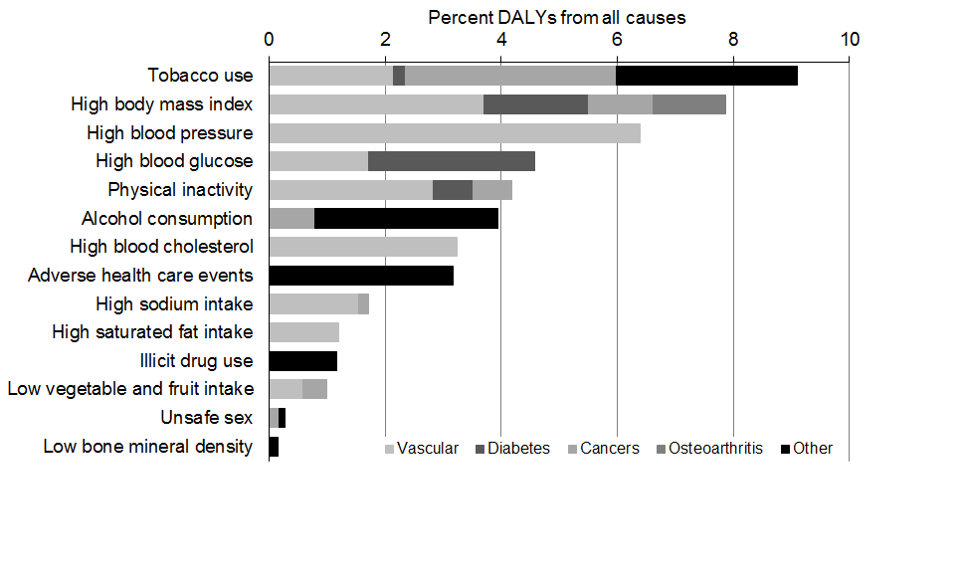

Note: The attributable burdens are not additive across risk factors. DALY = disability-adjusted life year.

Source: Ministry of Health 2013a

## Smoking

Smoking was the leading modifiable risk to health in 2006, accounting for 9.1 percent of all illness, disability and premature mortality (Ministry of Health 2013a). Smoking harms nearly every organ and system in the body. It is the main cause of lung cancer and COPD and also a major cause of heart disease, stroke and other cancers.

The 2012/13 New Zealand Health Survey found that 17.6 percent of New Zealanders aged 15 years and older were current smokers, including 15.5 percent who were daily smokers (Ministry of Health 2013b). This equates to about 625,900 current smokers, including 554,000 daily smokers. Daily smoking rates were highest in Māori women (38.5 percent) and lowest in Asian women (2.8 percent).

### Smoking is more common in deprived areas

Smoking is strongly positively associated with neighbourhood deprivation (see Figure 3.33). In 2012/13 the rate of daily smoking was 28.4 percent in the most deprived areas, compared with 9.5 percent in the least deprived areas. Adults living the most deprived areas were 3.1 times as likely to be daily smokers as adults living in the least deprived areas, after adjusting for differences in age, sex and ethnicity (Ministry of Health 2013b).

Figure 3.33: Prevalence of daily smoking in adults, by neighbourhood deprivation and sex, 2012/13

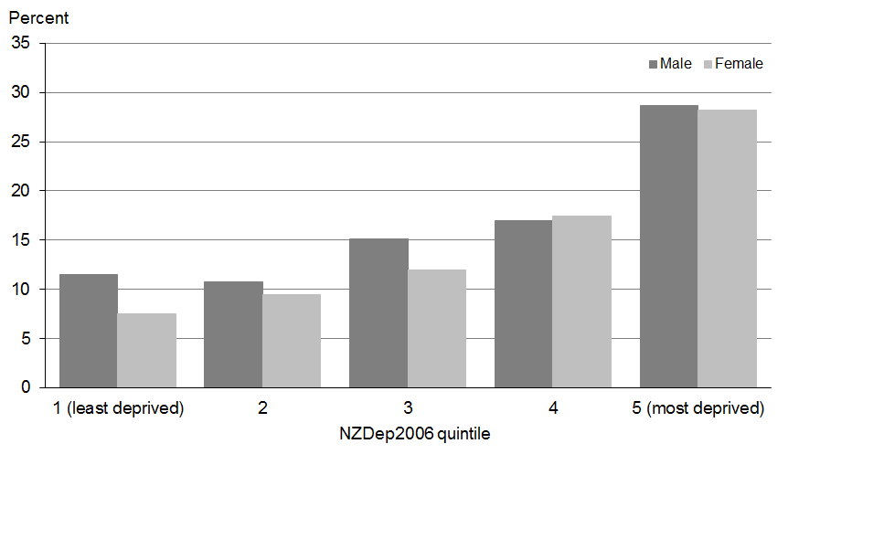

Source: 2012/13 New Zealand Health Survey (Ministry of Health 2013b)

### Smoking rates continue to decline

The rate of daily smoking has decreased by about one-third over the last decade, from 23.0 percent in 2002/03 to 15.5 percent in 2012/13. Daily smoking rates have declined both for males and females in the total population, and for Māori males and Māori females (see Figure 3.34). However, the rate of daily smoking remains considerably higher in Māori adults, at around 36 percent. In 2012/13, Māori adults were 2.7 times as likely to be daily smokers as non-Māori adults, after adjusting for differences in age and sex.

From 2002/03 to 2012/13, daily smoking rates decreased by 30–40 percent in less deprived areas (quintiles 1–4), but by only 18 percent in the most deprived areas (quintile 5).

Figure 3.34: Prevalence of daily smoking in Māori and non-Māori adults, by sex,  
2002/03–2012/13

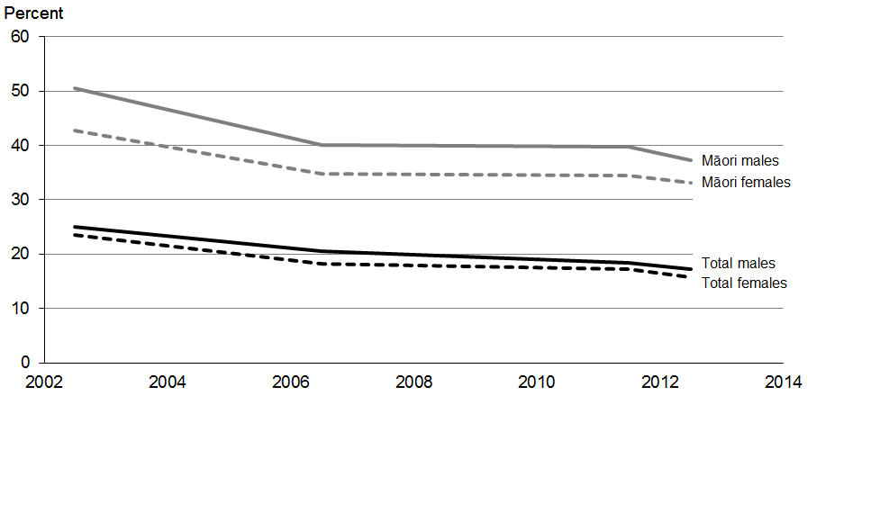

Note: Age-standardised to the WHO world population.

Source: New Zealand Health Surveys 2002/03, 2006/07, 2011/12, and 2012/13

New Zealand’s smoking rates are low by international standards. In 2012, our daily smoking rate was the eighth lowest of 34 OECD countries, and well below the average rate of 20.7 percent (OECD 2014c).

Declines in smoking are due to both decreasing ‘flow in’ and increasing ‘flow out’ of the smoking pool; that is, fewer young people are starting to smoke and more smokers are quitting. From 2006/07 to 2012/13, the daily smoking rate in 15−17-year-olds declined from 14 to 7 percent (Ministry of Health 2013b). During the same period, the percentage of smokers who had successfully quit in the previous year increased from 8 to 11 percent (Ministry of Health In Press-b).

The decline in youth smoking in the 2012/13 New Zealand Health Survey is consistent with other surveys conducted during the same period. A survey of smoking in Year 10 students (aged 14–15 years) found that the daily smoking rate had declined from 8 percent to 4 percent between 2006 and 2012 (ASH New Zealand 2013a); it fell further to 3 percent in 2013 (ASH New Zealand 2013b). The national health and wellbeing survey of secondary school students found that the percentage of students smoking cigarettes weekly or more often dropped from 8 percent to 5 percent between 2007 and 2012 (Clark et al 2013).

## Alcohol consumption

Excessive or harmful use of alcohol contributes to a range of diseases, including stroke, certain cancers, cirrhosis of the liver, mental health conditions and birth defects. Alcohol-related harm also includes injuries (for example through violence, self-harm and road traffic accidents) and social and economic harm.

Alcohol accounted for about 4 percent of total health loss in 2006 (Ministry of Health 2013a). Just over half (54 percent) of this impact was due to diseases (especially mental illness such as alcohol use disorder); the remainder was due to injury.

### Over 500,000 adults are hazardous drinkers

The 2012/13 New Zealand Health Survey found that one in six adults (550,700 people, or 15 percent) were hazardous drinkers, down from 18 percent in 2006/07 (Ministry of Health 2013b). ‘Hazardous drinking’ refers to a pattern of drinking with the potential to cause physical or mental harm to the drinker or to those around them. It is measured with the Alcohol Use Disorders Identification Test (AUDIT).

The hazardous drinking rate is more than twice as high in men (22 percent) as it is in women (9 percent). Almost one-third (31 percent) of Māori had a hazardous drinking pattern. After adjusting for age and sex differences, Māori were twice as likely to be hazardous drinkers as non-Māori. Asian adults were much less likely to have a hazardous drinking pattern than non-Asian adults. People aged 18–24 years had the highest hazardous drinking rate in 2012/13, although there was a significant decline in this age group since 2006/07 (see Figure 3.35).

Figure 3.35: Prevalence of hazardous drinking in adults, by age group, 2006/07 and 2012/13

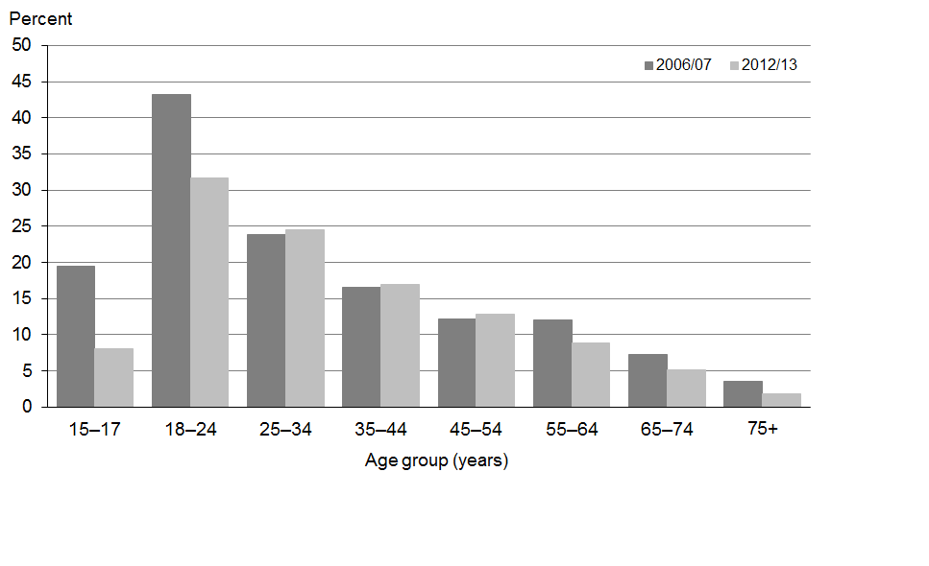

Source: 2012/13 New Zealand Health Survey (Ministry of Health 2013b)

Figure 3.35 also shows a significant decrease in the hazardous drinking rate in young people aged 15–17 years between 2006/07 and 2012/13 (Ministry of Health 2013b). This finding is consistent with the 2013 national survey of the health and wellbeing of secondary school students, which found that rates of binge drinking (defined as consuming five or more alcoholic drinks within four hours) declined from 34 to 23 percent between 2007 and 2012 (Clark et al 2013).

### Alcohol-related harm to self and others

Harmful effects of alcohol include impacts on friendships and social life, home life, work, study and employment opportunities and financial positions, as well as legal problems and learning difficulties.

In the 2012/13 New Zealand Health Survey, the most commonly reported harm among drinkers was to their physical health (8 percent), followed by harms to financial position (6 percent), friendship or social life (5 percent), mental health (5 percent) and home life (5 percent). Alcohol-related harm to self was more common in males than females (Ministry of Health In Press-a).

Many people experience harm from someone else’s drinking. In the 2012/13 New Zealand Health Survey, reported harms from someone else’s drinking included: verbal abuse (13 percent), harm to friendships or social life (8 percent), and being driven by a drunk driver (6 percent). Young people aged 15–24 years were more likely to report harm from their own or someone else’s alcohol use (Ministry of Health In Press-a).

## Physical activity

Low physical activity accounted for about 4 percent of all illness, disability and premature mortality in 2006 (Ministry of Health 2013a). Physical activity helps protect against heart disease, stroke, type 2 diabetes, certain cancers, osteoarthritis and depression. It is also important for maintaining a healthy weight and preventing and reducing obesity.

Physical activity is defined as any musculoskeletal movement that requires energy expenditure. It includes deliberate exercise (such as running and sports), incidental activity (such as housework), work-related activity and active transport.

### Physical activity levels in adults stable

In 2012/13, just over half of New Zealanders aged 15 years and over (52 percent) were classified as physically active; that is, they reported doing at least 30 minutes of moderate-intensity physical activity at least five days a week (Ministry of Health 2013b). Physical activity levels were higher in men (56 percent) than women (48 percent). There has been no change in physical activity levels in adults since 2006/07.

### More time spent watching television or video

The 2009/10 Time Use Survey found that the average amount of time New Zealanders aged 12 years or older spent on exercise or sporting activities was 19 minutes a day, which is the same figure as in 1998/99 (Statistics New Zealand 2011). In contrast, New Zealanders spent an average of two hours and eight minutes every day watching television and video – up seven minutes from 1998/99. This estimate excludes other leisure time activities involving computer or internet use.

### Fewer children walking and biking to school

The proportion of primary school-aged children walking and cycling to school has declined over the last two decades. The latest Household Transport Survey found that 28 percent of children aged 5−12 years walked to school over the five-year period 2009−2013, down from 42 percent in 1989/90 (Ministry of Transport 2014). Only 2 percent of children biked to school in the period 2009−2013, down from 12 percent in 1989/90. During the same period the proportion of children being driven to school increased (see Figure 3.36).

Figure 3.36: Travel to school in children aged 5−12 years, 1989/90 to 2009−2013

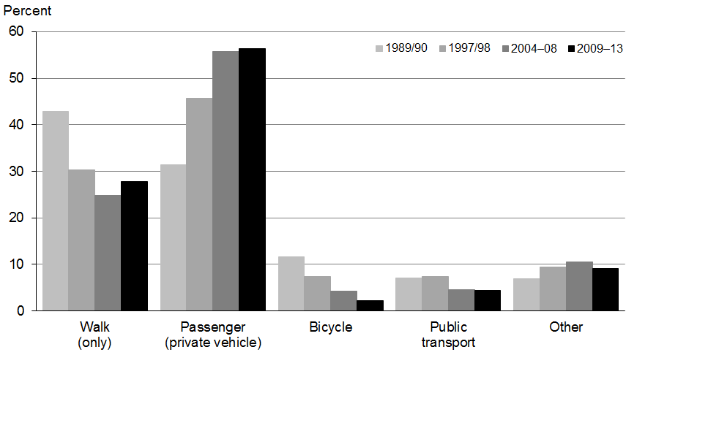

Source: Household Transport Survey (Ministry of Transport 2014)

## Diet

The foods and drinks we consume play a major role in our health and wellbeing. A healthy diet throughout life can help prevent nutritional deficiencies, protect against infection and help maintain a healthy body weight. It also reduces the risk of cardiovascular diseases, type 2 diabetes and some cancers.

Poor diet accounted for nearly 4 percent of all illness, disability and premature mortality in 2006 (Ministry of Health 2013a). This is likely to be an underestimate of the true impact of unhealthy diet, because it is based on only three dietary components: high sodium intake, low vegetable and fruit intake and high saturated fat intake. When high BMI (a marker of excess energy intake) was also included, poor diet accounted for 11.4 percent of all illness, disability and premature mortality in 2006.

## Obesity

High BMI (including obesity) accounted for about 8 percent of all illness, disability and premature mortality in 2006, making it the second leading causes of health loss after smoking. Given that obesity rates are increasing and smoking rates are decreasing, obesity is projected to overtake tobacco as the leading risk factor by 2016 (Ministry of Health 2013a).

Excess weight is a leading contributor to a number of health conditions, including type 2 diabetes, cardiovascular diseases, some common types of cancer (eg, colorectal), osteoarthritis, gout, sleep apnoea, reproductive disorders, gallstones, mental health conditions (especially depression) and dementia. Extreme obesity can reduce life expectancy by up to 10 years (Prospective Studies Collaboration 2009).

### An estimated 1.2 million New Zealanders are obese

The 2012/13 New Zealand Health Survey (Ministry of Health 2013b) found that 31 percent of adults and 10 percent of children (aged 2–14 years) were obese. This equates to about 1.2 million people (1,115,000 adults and 84,900 children). A further 34 percent of adults and 21 percent of children were overweight but not obese.

Obesity rates are similar in males and females, but vary markedly by age group (see Figure 3.37). Obesity rates increase rapidly in young adults before peaking in middle-aged adults. Obesity rates decline in older adults due to obese people dying or losing weight because of illness.

Figure 3.37: Prevalence of obesity, by age group and sex, 2012/13

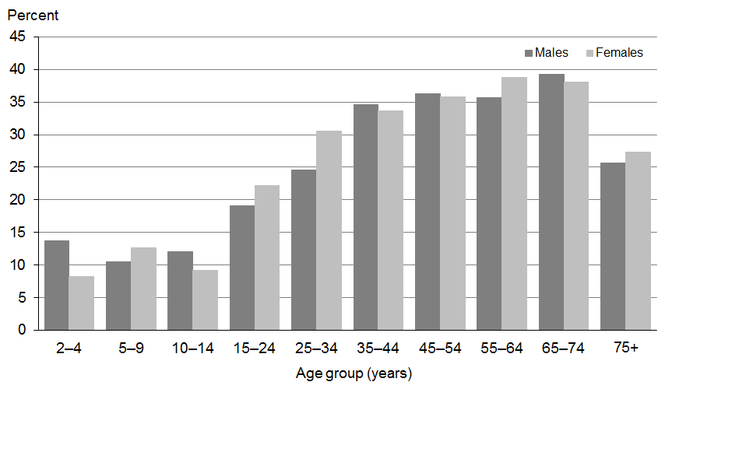

Source: 2012/13 New Zealand Health Survey

In 2012/13 obesity rates were higher among Māori adults (48 percent) and Pacific adults (68 percent). Among children, obesity rates were also higher for children of Māori (19 percent) and Pacific (27 percent) ethnicity (Ministry of Health 2013b).

Neighbourhood deprivation is strongly positively associated with obesity, particularly for children. After adjusting for age, sex and ethnic differences, adults living in the most deprived areas were 60 percent more likely to be obese than adults living in the least deprived areas. Children living in the most deprived areas were 2.7 times as likely to be obese as children living in the least deprived areas (Ministry of Health 2013b).

New Zealand has high rates of obesity compared with other OECD countries. In 2012, New Zealand adults ranked third highest out of 15 OECD countries that directly measured obesity, behind the United States and Mexico (OECD 2014b).New Zealand’s adult obesity rate is well above the OECD average of 23 percent for measured obesity (OECD 2014d). In 2010, New Zealand children (aged 5–17 years) ranked third highest out 40 countries for measured overweight (including obesity) (OECD 2014b).

### Obesity rates have tripled since the late 1970s

Obesity rates in adults have tripled since the late 1970s, from about 10 percent to 30 percent (Ministry of Health In Press-c). Obesity rates have increased in all age, sex and ethnic groups. As of 2012/13, there was no sign that the rate of increase in obesity is slowing in any group. In contrast, some countries are starting to see overweight and obesity rates stabilise or decline in some population groups (OECD 2014b).

Not only are obesity rates increasing for all population groups, but more New Zealanders are becoming obese at a younger age (see Figure 3.38). For example, the cohort of people born in the 1930s reached an obesity rate of 15 percent when they were aged about 50 years old, whereas those born in the 1990s reached this level of obesity when they were aged about 20 years. The earlier people become obese, and the longer they stay obese, the more likely they are to develop obesity-related diseases. These trends in obesity are likely to have contributed to increasing rates of diabetes and earlier onset of diabetes (see the ‘Diabetes’ section of this report).

Figure 3.38: Prevalence of obesity in adults, by decade of birth, 1997–2012/13

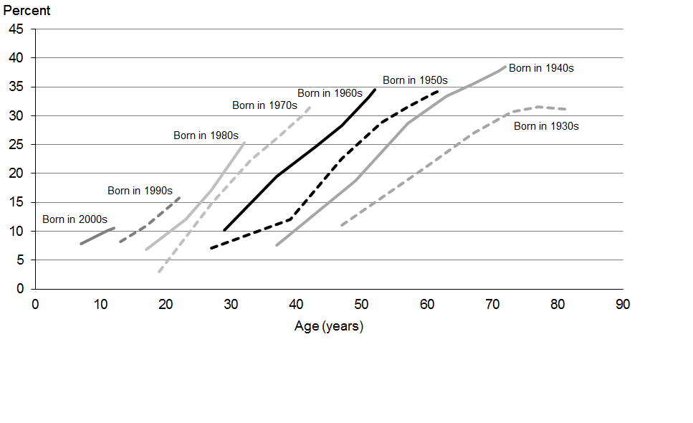

Note: Obesity rates appear to be declining in people born in the 1930s only because this group are now aged in their 80s. Obesity rates decline in older age groups due to obese people dying or losing weight because of illness.

Source: 1977 National Diet and Nutrition Study; 1989 Life in New Zealand Survey; 1997 National Nutrition Survey; and 2002/03, 2006/07, 2011/12 and 2012/13 New Zealand Health Surveys

Unless obesity rates are reduced, the burden of diabetes and other obesity-related diseases will be a major challenge for the health sector in the years to come. While early intervention is essential to prevent obesity in children and young people, the vast majority of New Zealanders who are currently obese are middle-aged or older.

There may be scope to improve the management of adult obesity in primary care. In the 2011/12 New Zealand Health Survey, 46 percent of obese adults and 36 percent of overweight adults reported that someone at their usual medical centre had measured their weight and/or height in the previous 12 months, compared with 29 percent of healthy weight adults. About one in four obese adults reported that someone at their usual medical centre had either talked with them or arranged for someone to talk with them about weight (27 percent), health food/nutrition (21 percent) and exercise/physical activity (23 percent) in the previous 12 months.

### Parental perception of child weight

Making parents aware that obesity is a health problem is an important first step in promoting healthy body weight in children. Studies in many countries show that a significant number of parents do not recognise that their children are overweight or obese.

The 2011/12 and 2012/13 New Zealand Health Surveys found that most New Zealand children are a healthy weight, and 87 percent of their parents correctly identified them as being neither under nor overweight (see Table 3.10). However, parents of overweight children were almost as likely to believe their child was neither under nor overweight (83 percent); only 15 percent correctly identified their child as overweight. The majority of parents of obese children also thought their child was neither under nor overweight (57 percent); only 3 percent correctly identified them as very overweight (Ministry of Health In Press-c).

Table 3.10: Parental perception of child’s weight, by BMI category, 2011/13

|  |  |  |  |  |  |
| --- | --- | --- | --- | --- | --- |
| **Child’s measured BMI category** | **Parental perception of child weight (%)** | | | | |
| **Very underweight** | **Underweight** | **Neither under nor overweight** | **Overweight** | **Very overweight** |
| Underweight | 4 | 37 | 59 | 0 | 0 |
| Healthy weight | 0 | 11 | 87 | 1 | 0 |
| Overweight | 0 | 1 | 83 | 15 | 0 |
| Obese | 0 | 1 | 57 | 38 | 3 |

Source: 2011/12 and 2012/13 New Zealand Health Surveys (provisional)

## Blood pressure

High blood pressure or hypertension is a risk factor for ischaemic heart disease, stroke, hypertensive heart disease, kidney failure and dementia. High blood pressure is the third-largest risk to health, after smoking and high body mass. High blood pressure accounted for 6.4 percent of illness, disability and premature mortality in 2006 (Ministry of Health 2013a).

High blood pressure can be caused by lifestyle factors such as diet (especially sodium/salt intake), physical inactivity, obesity and high alcohol consumption. Eating enough fruit and vegetables can help lower blood pressure. Medication can also help to lower blood pressure levels.

### Poorly-controlled high blood pressure is common in middle aged and older adults

The 2012/13 New Zealand Health Survey found that one in three adults (31 percent) could be classified as having hypertension, which is defined as having systolic blood pressure ≥140 mmHg and/or diastolic blood pressure ≥90 mmHg and/or currently taking medication for high blood pressure. Men were more likely than women to have hypertension (33 and 30 percent respectively). The prevalence of hypertension increases with age; about two thirds of adults aged 65 years or older are affected (see Figure 3.39).

Figure 3.39: Prevalence of hypertension in adults, by age group, 2012/13

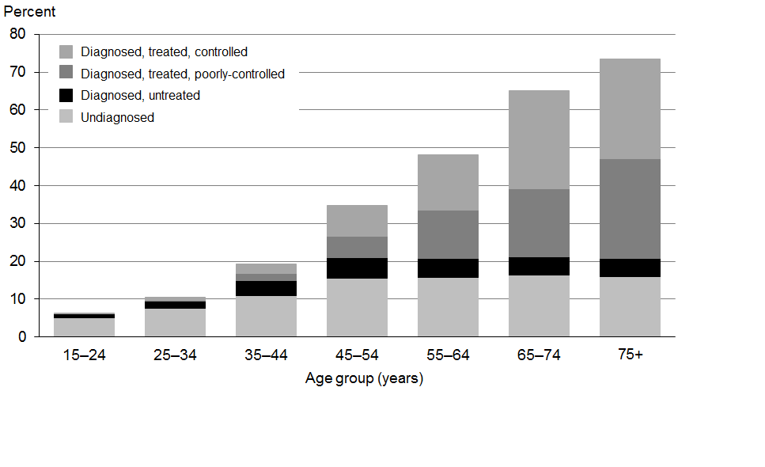

Note: Excludes adults with missing blood pressure measurements.

Source: 2012/13 New Zealand Health Survey

Of adults with hypertension, 38 percent were undiagnosed; that is they had not been told by a doctor that they had high blood pressure but their blood pressure measurements were above the cut-offs for hypertension. A higher proportion of younger adults were undiagnosed. Of adults currently taking medication for high blood pressure, just over half (55 percent) had their blood pressure well controlled (that is, they had systolic blood pressure <140 mmHg and diastolic blood pressure <90 mmHg).

# Infectious diseases

Key messages

* Infectious disease challenges include reducing outbreaks of vaccine-preventable diseases, reducing rates of sexually transmitted infections, and dealing with emerging microbial threats and drug resistance.
* The incidence of first episode rheumatic fever was 4.3 per 100,000 in 2013, an increase since 2012 (3.7 per 100,000). It is too soon to tell whether this is a real increase or due to natural variation and/or increased awareness.
* The pertussis epidemic that began in August 2011 is subsiding, but New Zealand’s 2013 pertussis notification rate is still higher than the OECD average.
* An outbreak of measles started at the end of 2013, with 268 cases reported as of 31 July 2014. The highest measles notification rate was in young people aged 15–19 years.
* Meningococcal notification rates remain low following the MeNZBTM vaccination programme implemented from 2004 to 2009.
* Chlamydia was the most commonly diagnosed sexually transmitted infection in 2013. The estimated chlamydia rate was more than four times that of the most commonly reported notifiable disease, campylobacteriosis.
* Emerging infectious disease threats include new infections such as avian influenza A (H7N9), which New Zealand has made a notifiable disease. New Zealand has made human infection MERS-CoV a notifiable and quarantinable disease.
* Antibiotic resistance is a recognised global threat to the effective prevention and treatment of some common infections. New Zealand has relatively good surveillance of antimicrobial resistance, and contributes to global action to mitigate its effects.

Although NCDs account for much of the burden of disease in New Zealand, communicable (or infectious) diseases still account for many outbreaks and an avoidable proportion of hospitalisations. This section discusses some current achievements and challenges in the area of infectious diseases.

## Rheumatic fever

Rheumatic fever is an autoimmune reaction to a group A streptococcal infection. It is a leading cause of acquired heart disease in New Zealand children. Rheumatic fever rates in New Zealand are much higher than in other developed countries.

In 2012 the Government announced a target of reducing the incidence of rheumatic fever by two-thirds, to 1.4 initial hospitalisations per 100,000 people by June 2017. This target is part of a set of Better Public Services targets, chosen for their importance to improving the lives of New Zealanders.

In 2013, the incidence of first episode rheumatic fever was 4.3 cases per 100,000 people (that is, a total of 194 people were admitted to hospital for the first time with rheumatic fever). The 2013 rate represents an increase compared with the 2012 rate of 3.7 cases per 100,000 people (a total of 168 people).

The increase in the rate of first episode rheumatic fever from 2012 to 2013 (see Figure 3.40) is likely to be due to one or more of the following factors:

* increased awareness of rheumatic fever among the public and health professionals, resulting in more diagnoses
* the natural annual variation of rheumatic fever cases (total numbers are small)
* an actual increase in the number of children and young people developing rheumatic fever.

Figure 3.40: First episode rheumatic fever hospitalisation rate, 2002–2013 and five-year goal

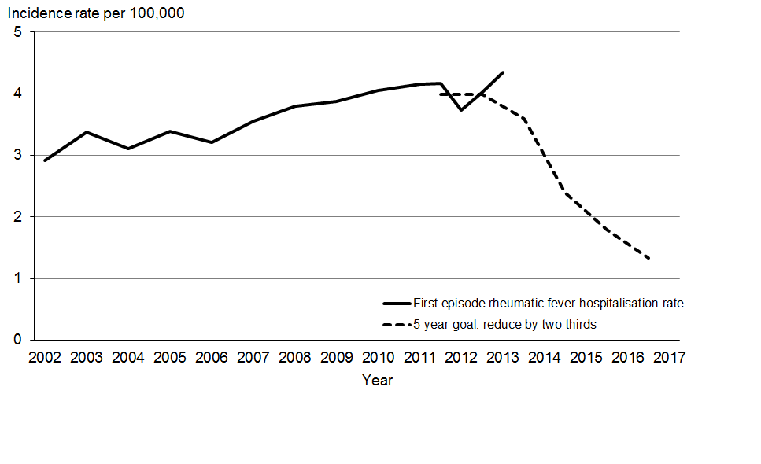

Source: National Minimum Dataset, Ministry of Health

The acute rheumatic fever incidence rate for Māori remained stable from 2011 to 2013 (see Figure 3.41). However, during the same period, it increased for Pacific peoples.

Figure 3.41: First episode rheumatic fever hospitalisation rate, Māori and Pacific peoples, 2011–2013

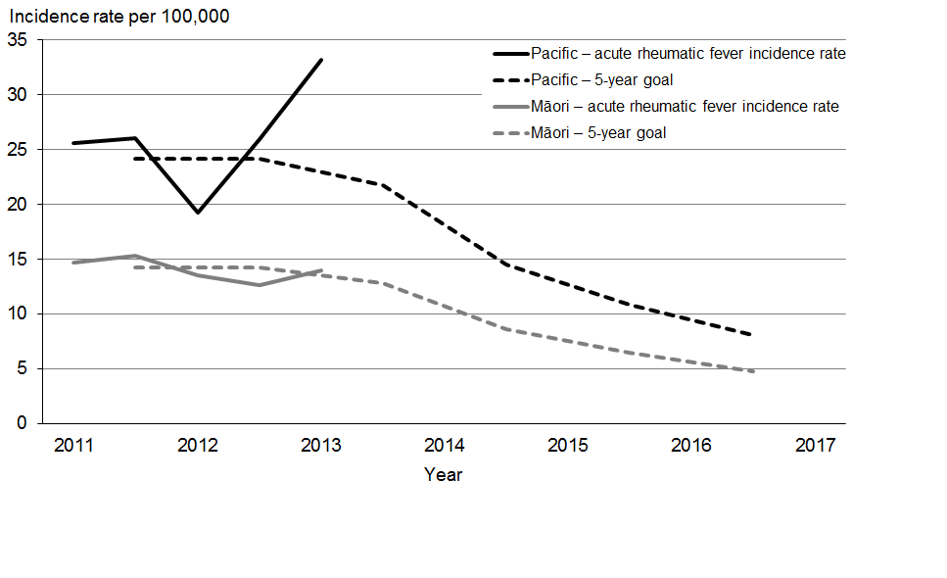

Source: National Minimum Dataset, Ministry of Health

## Vaccine-preventable diseases

Immunisation is one of the most effective and cost-effective interventions to protect people against harmful infections that can cause serious complications, including death. It provides protection by reducing the incidence of vaccine-preventable diseases and preventing their spread to vulnerable people. The National Immunisation Programme comprises a series of vaccines that are offered at no cost to babies, children, adolescents and adults, protecting them from a range of diseases.

Immunisation rates in children aged eight months and two years are as high as they have ever been (at 92 and 93 percent respectively) since the introduction of the National Immunisation Register in 2008 (see the ‘Immunisation rates’ section of this report). Childhood vaccination coverage rates in New Zealand at age one year are close to the OECD average, and our position improved from 2009 to 2012 (OECD 2013). However, low childhood immunisation rates in the past have meant that immunity across New Zealand is still lower than needed to prevent occasional outbreaks, particularly measles and pertussis.

### Pertussis epidemic on the decline

Pertussis, commonly known as whooping cough, is a highly contagious bacterial disease that causes severe coughing fits. There is usually a pertussis outbreak every three to five years in New Zealand; cases predominately appear in young children. A vaccination for pertussis is included on the free childhood immunisation schedule at six weeks, three months and five months of age. Since January 2013, pregnant women have been able to receive a whooping cough booster vaccination for free.

The current pertussis epidemic began in August 2011 (see Figure 3.42). In 2013 there were 3539 cases of pertussis notified (79 per 100,000); nearly 40 percent fewer than in 2012 (5898 cases; 133 per 100,000) (ESR 2014). However, the current rate is still well above the OECD average of 9 per 100,000 (OECD 2014c).

Figure 3.42: Number of pertussis notifications, 1997–2013

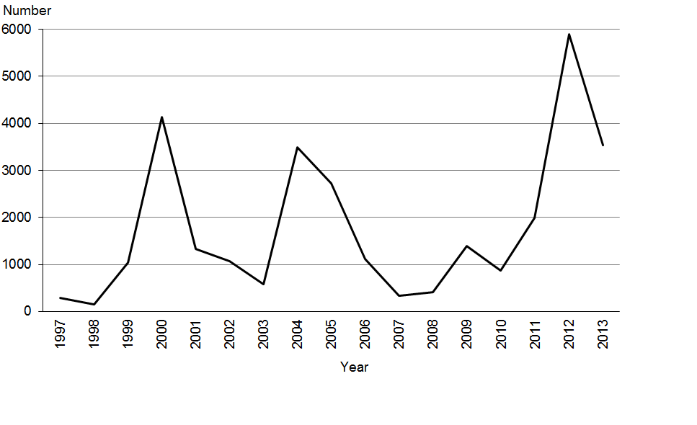

Source: ESR 2014

The highest pertussis notification rate was for children aged less than one year (441 per 100,000), followed by children aged 1–4 years (224 per 100,000). The European/Other ethnic group had the highest notification rate (87 per 100,000), closely followed by Pacific peoples (85 per 100,000).

Vaccination status was known for just over half of all pertussis cases in 2013. Of these, one-third (32 percent) had not been vaccinated, including about 2 percent who were aged less than six weeks so not eligible for vaccination. Of those who were known to have been vaccinated, 21 percent had received three or more doses of vaccine, 3 percent had received two doses, and 9 percent had received one dose. The remaining 17 percent had been vaccinated, but the number of doses was not known (ESR 2014).

### Recent measles outbreak

From 2012 to 2013 there was a large drop in the number of notifications of measles (from 68 to 8). However, since the end of 2013 there has been an outbreak of measles. A total of 268 cases were reported from December 2013 to 31 July 2014. Most of these cases were in the Waikato (123) and Auckland regions (112); cases were also reported in Bay of Plenty/Lakes (13), Hawke’s Bay (12), Northland (1), Wellington (4), Tairawhiti (2) and Taranaki (1).

The highest measles notification rate is in young people aged 15–19 years (30.4 per 100,000), closely followed by children aged 10–14 years (27.3 per 100,000). Vaccination status was known for 223 of the 268 cases. Of these, most (80 percent) had not been vaccinated, including a small number of cases in children too young for vaccination.

### Meningococcal disease rates remain low

There were 68 cases of meningococcal disease notified in 2013 (1.5 per 100,000), down from 85 cases in 2012 (1.9 per 100,000) and substantially less than the peak of over 600 cases in 2001 (see Figure 3.43). In 2013 the highest notification rates for meningococcal disease were in children aged less than one year (18.4 per 100,000) and those aged 1–4 years (5.2 per 100,000); there were higher than average rates in the Māori (3.4 per 100,000) and Pacific (3.3 per 100,000) ethnic groups (ESR 2014).

Figure 3.43: Number of meningococcal disease notifications, 1997–2013

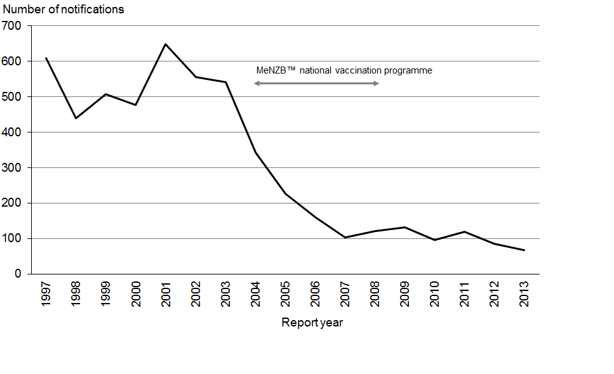

Source: ESR 2014

## Influenza

Influenza is a common cause of illness and hospitalisation in New Zealand. Annual activity generally occurs between May and September, with seasonal peaks in August and September. The 2013 influenza season saw relatively low rates of disease in comparison with previous years, according to weekly GP consultation rates (see Figure 3.44). So far it appears that rates in 2014 are higher than they were in 2013, but still lower than 2011 or 2012.

Figure 3.44: Weekly consultation rate for influenza-like illness, 2010 to August 2014

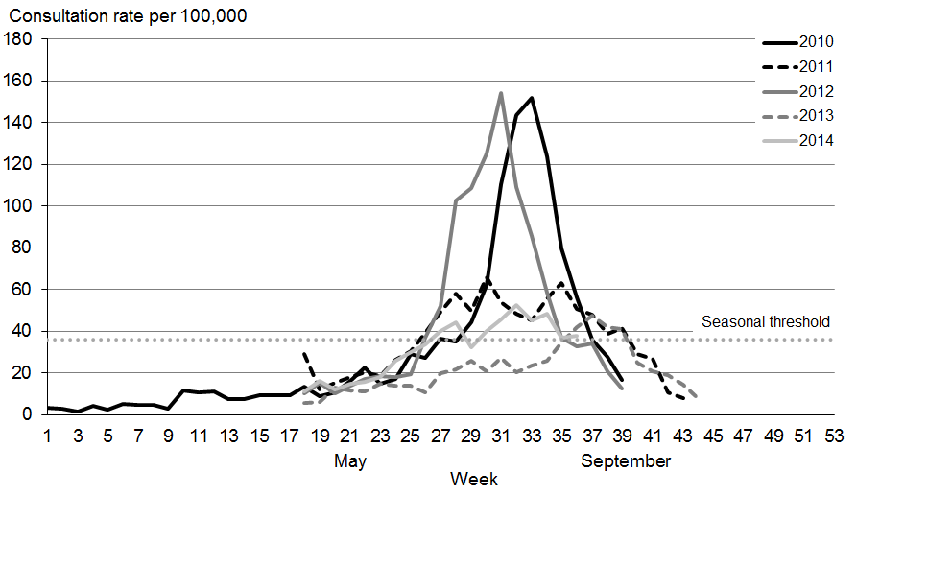

Source: Responding practices of the HealthStat GP practice panel, ESR

## Sexually transmitted diseases

In New Zealand, sexually transmitted infections are not notifiable; the surveillance system relies on the ongoing support of sexual health clinics, family planning clinics and laboratory staff. Estimated national rates can only be calculated for chlamydia and gonorrhoea.

In 2013 chlamydia was the most commonly diagnosed sexually transmitted infection. There were 28,316 positive tests for chlamydia, giving an estimated national rate of 633 per 100,000 (ESR 2014). This rate continues a decline from an estimated rate of 781 per 100,000 in 2009. The estimated population incidence rate for chlamydia was more than four times that of the most commonly reported notifiable disease, campylobacteriosis.

In 2013 there were 3344 positive tests for gonorrhoea. This gives an estimated national rate of 78 per 100,000, which is lower than the rate in 2012 (89 per 100,000) but higher than the rate in 2009 (66 per 100,000).

In 2013, sexual health and family planning clinics reported 1854 first presentations of genital warts. The number of cases of genital warts has declined by more than 50 percent since the HPV immunisation programme began in 2008.

## Emerging infectious disease threats

There are currently a number of emerging infectious disease threats to population health, including new and re-emergent infections and antimicrobial resistance.

### New and re-emerging infectious diseases

New viruses with pandemic potential include avian influenza A (H7N9), first identified in China, and Middle East respiratory syndrome coronavirus (MERS-CoV). In response to these new threats, New Zealand has made human infection with A (H7N9) a notifiable disease, and MERS-CoV a notifiable and quarantinable disease.

Re-emergent threats include avian influenza (H5N1), polio and Ebola. The international re‑emergence of polio in mid-2014 after near eradication led to WHO’s declaration of a Public Health Emergency of International Concern. New Zealand is collaborating with WHO in monitoring potential infection.

An outbreak of Ebola developed in three countries in western Africa in February 2014. As of 3 October 2014, there were 7470 cases of Ebola (including 3431 deaths), making this the most significant outbreak of the disease on record. New Zealand continues to work with international health authorities to monitor the progress of this disease and prepare responses if further spread occurs.

### Antimicrobial resistance is a global threat

Antibiotic resistance is a global threat to the effective prevention and treatment of some common infections. A recent WHO report shows that antimicrobial resistance has reached alarming levels in many parts of the world; there are few or no effective treatments options for common infections in some settings (WHO 2014).

New Zealand carries out relatively good surveillance of antimicrobial resistance by international standards. The WHO report found that there are problems with data sharing and coordination of surveillance activities around the world. Given the health and economic implications of increasing antimicrobial resistance, the WHO is developing a global action plan.

Methicillin/oxacillin-resistant *Staphylococcus aureus* (MRSA) is one example of antibiotic-resistant bacteria. The prevalence of MRSA in New Zealand nearly doubled from 2003 to 2013 (from 12.8 to 23.9 per 100,000), and more cases are now contracted in the community than in health care facilities. The increase in prevalence of MRSA is likely to reflect an increase in the incidence of *S. aureus* infections rather than an increase in the proportion of infections that are methicillin resistant (ESR 2014).

Multi-drug-resistant tuberculosis remains rare in New Zealand; there were four cases in 2012, accounting for 1.4 percent of culture-positive tuberculosis cases (Lim and Heffernan 2013).

Notes for the Health and Independence Report

## Indicators, measures and data sources

Health can be measured in many different ways. This report uses measures of disease and risk factor occurrence (eg, incidence and prevalence), mortality and overall health loss. Health loss is the gap between the population’s current state of health and that of an ideal population in which everyone lives a long life free from illness and disability. Health loss is measured using the disability-adjusted life year (DALY), which combines information on both fatal (premature death) and non-fatal outcomes (illness or disability).

In many comparisons the results are *adjusted* or *standardised* for factors that may be influencing (confounding) the comparison, such as age, sex and ethnicity. For example, age standardisation is often used in this report to account for differences in age structure between population groups, using the WHO world population (Ahmad et al 2000).

Where possible, time trends are provided and information is disaggregated by population group, including by sex, age group and ethnic group. Selected results are also presented by neighbourhood deprivation, as measured by the New Zealand Index of Deprivation 2006 (NZDep2006) (Salmond et al 2007). In this report, ‘most deprived areas’ refers to quintile 5; that is, the people living in the most deprived 20 percent of small areas in New Zealand.

This report uses data available from a range of sources, including the national administrative data sets (such as the Mortality Collection), the New Zealand Health Survey and the New Zealand Burden of Diseases, Injuries and Risk Factors Study (Ministry of Health 2013a), as well as data from other agencies, such as Statistics New Zealand.

All data reported is the latest available, although the time lag between the most recent data and the present can be substantial. For example, the most recent complete mortality data are for 2011.

International benchmarking is also included in the report because it provides valuable insights into how New Zealand compares with other countries. It can also help identify opportunities for improvement, by showing what is achievable. However, comparisons need to be interpreted with caution, due to differences in data collection and definitions between countries. Two key international sources used this year in the report’s section on health systems performance are OECD Health Statistics 2014 (OECD 2014c, 2014d) and the Commonwealth Fund’s *Mirror, Mirror* report (Davis et al 2014).

Implementing the New Zealand Health Strategy 2014

The Minister of Health’s report on progress on implementing the New Zealand Health Strategy, and on actions to improve quality.

## From the Minister of Health

New Zealand’s public health and disability services continue to offer better access to safe and effective services. Waiting times are reducing, and services are increasingly being planned, managed, funded, and delivered in a sustainable way.

The public health service continues to rise to the challenges set for it by the Government’s Health Targets and there have been further improvements in the six target priority areas.

The public health services have responded to the Government’s requirement for greater engagement with other social services by supporting the implementation of Whānau Ora and the Better Public Services result areas. In particular, significant investment has been made in the Rheumatic Fever Prevention Programme and I expect this to bear fruit in coming years.

Greater integration of health services continues between general practice or other community-based services and secondary (hospital-based) services. The focus of integration is making services easier to navigate for patients and in improving health outcomes.

These achievements have occurred alongside significant improvements to the efficiency of health services. Work continues in the Ministry, in DHBs and in non-government organisations to identify ways in which health services can deliver the most effective outcomes for New Zealanders.

Challenges remain as we respond to an ageing population and increasing rates of some long-term conditions. I am confident that health services are well placed to meet these challenges thanks to the hard work of individuals and organisations around New Zealand.

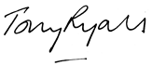

Hon Tony Ryall

Minister of Health

# 1 Introduction

This report presents a high-level overview of the major achievements of New Zealand’s public health system in 2014. Achievements are grouped according to medium-term priorities set by the Government. These priorities are consistent with the goals of the New Zealand Health Strategy and the National Strategy for Quality Improvement. The priorities are:

* Health Targets
* Better Public Services
* other government priorities
* integration
* financial management and sustainability
* ensuring quality and safety.

This report fulfils the Minister of Health’s responsibilities, set out in the New Zealand Public Health and Disability Act 2000 (the Act), to report annually on the progress in implementing the:

* New Zealand Health Strategy (required under section 8 of the Act)
* National Strategy for Quality Improvement (required under section 9 of the Act).

# 2 Health targets

The Government’s Health Targets ensure a continuing emphasis on high priority areas at both local and national levels. By focusing on prevention and patient access to health services the health targets have been effective in improving the service performance of New Zealand’s 20 district health boards (DHBs).

### Shorter stays in emergency departments[25]

* **Target**: 95 percent of patients will be admitted, discharged or transferred from an emergency department within six hours.
* **Results**: In quarter four 2013/14, 94 percent of patients were admitted, discharged or transferred from an emergency department within six hours. Eleven DHBs achieved the health target.

### Improved access to elective surgery[26]

* **Target**: The volume of elective surgery will increase by at least 4000 discharges per year.
* **Results**: DHBs delivered 161,933 elective surgical discharges in 2013/14, representing a total increase of 44,000 more elective discharges since 2008. All DHBs met the elective surgery target.

### Shorter waits for cancer treatment[27]

* **Target**: All patients, ready for treatment, wait less than four weeks for radiotherapy or chemotherapy.
* **Results**: Since its introduction, the four-week target has been achieved on a national level. In quarter one of 2013/14, only three patients did not get access to treatment within four weeks. This did not affect the health outcomes of these patients. All DHBs met the cancer treatment target in quarter four.
* **New target**: on 1 October 2014 the ‘shorter waits for cancer treatment’ will be replaced by a new health target – Faster Cancer Treatment. This new target will be first reported on in February 2015. The focus will be on patients with a high suspicion of cancer receiving their first cancer treatment within 62 days of being urgently referred by their GP.

### Increased immunisation[28]

* **Target**: 85 percent of eight-month-olds will have their primary course of immunisation (six weeks, three months and five months immunisation events) on time by July 2013, 90 percent by July 2014 and 95 percent by December 2014.
* **Results**: The immunisation target was achieved for the fourth consecutive quarter with the national result increasing to 92 percent of eight-month-olds fully immunised. Fifteen DHBs were successful in reaching the target of 90 percent of eight-month-olds fully immunised.

### Better help for smokers to quit[29]

* **Target**: 95 percent of patients who smoke and are seen by a health practitioner in public hospitals, and 90 percent of patients who smoke and are seen by a health practitioner in primary care, will be offered brief advice and support to quit smoking. Progress will be made towards 90 percent of pregnant women also being offered advice and support to quit smoking.
* ***Results****:* National performance in the primary care target has increased to 85.8 percent in quarter four – a 28.9 percentage point increase over the past year. Six DHBs met the primary care target and five more achieved over 80 percent.
* The hospital component of the target has been achieved for the sixth consecutive quarter, meaning that over 95 percent of hospital patients who smoke are now being offered *better help for smokers to quit*. A number of initiatives have helped DHBs to achieve this substantial change, including providing accessible and relevant training and nominating smokefree champions on each of the wards.

### More heart and diabetes checks[30]

* **Target**: By 1 July 2014, at least 90 percent of the eligible population will have had their cardiovascular risk assessed in the last five years.
* **Results**: The national quarter four result for 2013/14 was 84.4 percent – a 17.4 percentage point improvement over the past year. Four DHBs achieved the 90 percent target this quarter and more than half of all DHBs achieved over 80 percent.

# 3 Better public services

The Ministry of Health and the health sector continue to work with other agencies and across the wider social sector to focus on a number of result areas, including supporting vulnerable children, reducing long-term welfare dependence, boosting skills and employment, and reducing crime.

## Supporting vulnerable children

### Increasing infant immunisation[31]

See previous section for target and results.

### Reducing the incidence of rheumatic fever[32]

* **Target**: Reduce the incidence of rheumatic fever by two-thirds, to 1.4 cases per 100,000 people, by June 2017.

The Rheumatic Fever Prevention Programme had an initial allocation of $24 million over four years for the implementation of school-based throat swabbing services to cover more than 50,000 children. An expansion of the Rheumatic Fever Prevention Programme was implemented in 2013/14, in consultation with key sector and cross-agency stakeholders, with an additional $21.6 million allocated from July 2013. A further $20 million has been allocated through Budget 2014 to expand primary care access and healthy housing initiatives to other high incidence areas outside Auckland and Porirua. The Ministry has facilitated the development of a cross-government action plan – the Household Crowding Shared Agenda to which the Ministries of Social Development (MSD) and Business, Innovation and Employment (MBIE) contribute.

The incidence rate for rheumatic fever initial hospitalisations for the 2013 calendar year is 4.3 per 100,000 (194 hospitalisations). The 2013 rate represents an increase compared to the 2012 calendar year rate of 3.7 per 100,000 (168 hospitalisations). Possible reasons for this include: natural variation due to small numbers, or more people being diagnosed with rheumatic fever due to an increased awareness or a true increase.

## Reducing long-term welfare dependence[33]

Vote Health allocated an extra $1.4 million per annum to provide support to those who decline or fail the recently introduced pre-employment drug-testing obligations for beneficiaries. These funds have supported the provision of alcohol and drug helplines, alcohol brief intervention services, and further assessment and support for people with health and disability conditions that affect their employment chances.

## Boosting skills and employment and reducing crime[34]

The Ministry and the health sector are supporting two cross-government Better Public Service result areas – one focused on boosting skills and employment led by the Ministry of Education, and one focused on reducing crime led by the Ministry of Justice. Relevant actions include:

* Since the launch of the Prime Minister’s Tackling Methamphetamine: An Action Plan in October 2009, over 600 people have been treated through residential beds, and a further 500 have accessed detoxification services (to 30 June 2014).
* Recent reports on the Improving Access for Repeat Drink Drivers to Treatment programme show that, as at 30 June 2014, 454 people out of the 780 who were referred (approximately 60 percent) have completed courses, most of which are eight to ten weeks. This is a good result, as these courses tend to have a high drop-out rate.
* The Prime Minister announced funding from the Proceeds of Crime initiative to support various initiatives across the Health and Justice sector. Among other proposals, the Prime Minister has approved funding of $1.81 million to extend a service in metro-Auckland which works with pregnant women who have issues with alcohol or drugs.
* Following a contestable process, two youth exemplar services for youth alcohol and other drug treatment were contracted in Northland and Southern DHBs. Additional resources (increased capacity, and assistance with planning/change management) were also provided to four other DHBs that responded to the tender process.
* The Substance Addiction (Compulsory Assessment and Treatment) Bill will repeal and replace the Alcoholism and Drug Addiction Act 1966 following the recommendations of the Law Commission.

# 4 Other government priorities

## Whānau Ora

The Ministry continues to support Whānau Ora by working with Te Puni Kōkiri (the lead agency) in the Government’s ongoing Whānau Ora work programme. Whānau Ora puts whānau at the centre, and in control of achieving their own goals. The Ministry works closely with DHBs to support the 32 Whānau Ora collectives (comprising approximately 180 health and social providers) to implement programmes that support the aspirations of whānau so they can be self-managing and take responsibility for their economic, social and cultural development.

The Ministry monitors the performance of a sample of 37 general practices from Whānau Ora collectives on a quarterly basis. The results are compared against a national sample of 100 general practices using 11 indicators. The results have been positive, with the Whānau Ora sample performing as well as or better than the national sample in eight of the eleven indicators. High performance has been achieved particularly in the areas of cardiovascular disease assessment, diabetes patient review, and the provision of smoking cessation advice.

The Ministry leads the Whānau Ora information technology workstream on behalf of Te Puni Kōkiri. The trial phase of the Whānau Ora information system began in July 2014. This system will enable providers to collect, use and report on whānau information and outcomes, and share this information across providers in the collective.

## Youth mental health[35]

The Ministry is responsible for implementing the Prime Minister’s Youth Mental Health Project (YMHP), which involves working with a number of other agencies on a package of 26 initiatives that have a broad reach across schools, the health sector, communities as well as online. Four initiatives were completed in 2013/14 – Improving the youth-friendliness of mental health resources, Social support for Youth One Stop Shops, Youth Referral Pathways Review, and Youth mental health training for social services.

Positive progress to date includes the following.

* A total of 18,812 students in 44 schools (96 percent of eligible students) have access to school-based health services (Initiative 1) in decile 3 secondary schools.
* The SPARX e-therapy tool for young people was launched in April 2014 and has had 15,178 unique website hits and 2744 registrations.
* An evaluation of Positive Behaviour for Learning School-Wide (Initiative 8) showed that the programme is having a positive impact in classrooms and improving students’ chances to achieve at school and beyond.
* ‘Common Ground’ – an online information hub for parents, families and friends of those with mental health issues (Initiative 17) – was launched in July 2014.

# 5 Integration

An enduring focus for the health and disability sector is better care coordination and clinical integration. Closer integration within the health and disability sector means clinicians, allied health professionals and support workers working better together to adapt to the challenges of ageing populations, increasing chronic conditions and tighter fiscal environments, while meeting the expectations of patients for better, sooner, more convenient care.

Clinical networks of professionals, patients and NGOs, across various services, such as cancer, stroke, cardiac and major trauma services, have continued to work together to improve patient access to services and the quality of services. For example, the National Cardiac Surgery Clinical Network has enabled significant progress in increasing the volume of cardiac surgery operations, improving the geographic equity of cardiac surgery provision and reducing the number of patients waiting for surgery. The Major Trauma National Clinical Network has also been successful at ensuring better care across New Zealand, with coordinated management of injured patients regardless of where they receive their care. There is now a minimum dataset in place for a national major trauma registry to enable a consistent baseline data collection that will inform ongoing guideline development and quality improvement.

The Ministry of Health and the health sector have been making progress in three priority areas for supporting integrated care: urgent and unplanned care, long-term conditions and wrap-around services for older people.

Having the right information technology supports clinicians to work in a more integrated fashion and enables a smoother transition for patients between services. The National Health Board’s updated IT plan was launched in 2013 and details the work underway to provide improved information sharing across the health sector.

Some of these new initiatives include:

* The Ministry of Health is investing $3 million to expand the roll out of patient portals, which allow people to book appointments, order repeat medications and view their clinical information online.
* The South Island Patient Information Care System will connect hospitals and health services in the South Island so health professionals can share information securely and provide patients with better care. Replacing each district health board’s patient information system with a single streamlined regional system will provide health professionals with more accurate information, and allow them to spend less time on administration and more time on caring for patients.
* GPs across New Zealand are now referring patients for specialist care online with the new eReferral system. Health data, test results and medicine lists can be transmitted instantly and securely via this electronic system, reducing delays and enabling better communication between clinicians about how to provide the best possible care to a patient.

# 6 Financial management and sustainability

## DHB spending

The Ministry of Health introduced targets aimed at reducing the baseline deficits of DHBs and supported all 20 DHBs to manage within their planned budgets. Of note:

* DHB sector deficits have been significantly reduced from over $150 million in 2007/08 to a $28 million deficit in 2013/14 (unaudited). This result was $7 million better than expected.
* Seventeen DHBs were in line with the plan to operate within their budget and three DHBs did not reach this target.

In the 2013/14 financial year DHB funding increased by $297 million (2.7 percent) to a record level of $11.2 billion.

## Ministry of Health departmental spending

The Ministry has continued to limit expenditure on contractors, contracting arrangements, information technology and travel. As a result of these efficiencies, departmental spending for 2013/14 remained almost unchanged from the previous year at $191 million, with the Ministry effectively absorbing price pressures throughout the year.

## PHARMAC

PHARMAC plays a vital role in containing health spending in New Zealand. PHARMAC is a Crown entity that helps manage DHBs’ pharmaceutical budgets and decides which medicines and related products are publicly funded in New Zealand. In 2012/13, PHARMAC was able to save DHBs an estimated $56.5 million by negotiating lower prices through the Combined Pharmaceutical Budget.[36]

In the 12 months to 30 June 2014, PHARMAC added 26 pharmaceuticals to the Pharmaceutical Schedule and widened access to 35 others so they are accessible to more patients. Those decisions are estimated to lead to $51 million of gross expenditure and at least 48,300 patients receiving these medicines in the 2014/15 financial year, the first full year following the medicines being funded.

From 1 July 2013, the Hospital Medicines List (HML) came into effect. In this financial year, PHARMAC has added three new listings and widened access to four pharmaceuticals listed on the HML. Additional expenditure and savings were made through various tender and NPPA decisions.

PHARMAC’s procurement role has expanded beyond community medicines to include hospital medicines, vaccines and some medical devices. This is expected to return further significant savings for DHBs in the years ahead.

## Health Benefits Limited

HBL is a Crown-owned company established to create value for the health sector. Its role is to work in partnership with district health boards (DHBs) to save them money by reducing their administrative, support and procurement costs, with savings to go back into frontline patient care.

In 2013/14, HBL-assisted initiatives realised benefits of over $94 million, bringing total cumulative benefits since its formation in 2010 to more than $307 million.

HBL is currently focussed on four key programmes: the National Infrastructure Platform, Linen and Laundry Services, Food Services and Finance Procurement and Supply Chain (FPSC).

On 1 July, as part of the FPSC programme, HBL and its shared service partner healthAlliance, launched the National Procurement Service which has the potential to save DHBs approximately $90 million over the next two years.

# 7 Ensuring quality and safety

## Quality and safety markers

The Ministry continues to collaborate with the Health Quality and Safety Commission (HQSC) in focusing on the following quality and safety markers (see below), as part of the national patient safety campaign ‘Open for better care’. The markers currently show that New Zealand health care is increasingly on the right track to provide safe care, and in some instances we are already able to show improvements in outcomes.

### Central line associated bacteraemia (CLAB)

The use of catheters to deliver treatment into a patient’s blood stream is common practice, but also carries the risk of blood stream infections known as central line associated bacteraemia (CLAB). Nationally, 97 percent of insertions were compliant with CLAB insertion guidelines at the last update. Based on estimates, over 180 CLABs have been avoided in just under two years – a saving of over $3.5 million.

### Falls

Nationally, risk assessments of older patients remained consistent in the last quarter (90 percent in both quarters). Half the DHBs achieved 90 percent or above in the first quarter of 2014. The very low rates identified in the baseline (quarter one 2013) have been eliminated. There was a significant increase in the proportion of at risk cases where an individualised care plan was in place.

### Hand hygiene

Results for the most recent quarter show a continued increase in compliance with the recommended ‘5 moments for hand hygiene’. Nationally, 73 percent of observed moments were compliant, while eight DHBs showed compliance at 75 percent or above.

### Perioperative harm

Recorded use of the surgical safety checklist continues to increase. The national rate remained above 90 percent, and nearly three-quarters all DHBs achieved the threshold level of use.

### Surgical site infection

The three quality safety marker categories for surgical site infection measure antibiotics delivered at the right time, the right antibiotic delivered at the right dose (cefazolin 2g or more), and appropriate skin antisepsis in surgery. These are new measures first introduced in the third quarter of 2013.

## Tracking quality and safety

### Atlas of Healthcare Variation

The Atlas of Healthcare Variation is an interactive online tool displaying maps, graphs and tables to show the variation in health care service delivery, use and outcomes in different geographical regions. The purpose of the Atlas is to promote questions and debate about why variations exist and how acceptable they are for particular populations. There are now 15 Atlas domains, including asthma, diabetes and maternity, and a further four domains are planned for 2014/15. Clinicians are engaging with the tool and it has prompted at least one DHB to introduce clinical benchmarking against other DHBs to improve performance. A free ‘Find My Patients’ function for MedTech and MyPractice primary care patient management systems has also been released. This tool means GPs can easily extract information as part of clinical audit.

### New Zealand quality and safety indicators

The first full report on quality and safety indicators was published in June 2013, providing baselines to measure future progress. This set of summary indicators aims to give a clear picture of the quality and safety of health and disability services and key health care system outcomes. The indicators include measures of change over time and comparisons with other countries.

### Strengthening the infrastructure for suicide prevention

The HQSC are leading a significant project on behalf of the Ministry to strengthen the infrastructure for suicide prevention, as part of the New Zealand Suicide Prevention Action Plan (2013-2016). The trial of a suicide mortality review mechanism seeks, amongst other things, to make better use of the information the government already collects on suicidal deaths and suicidal behaviour. The HQSC have established a time limited suicide mortality review committee to oversee the work and will report to the Ministry by the end of June 2015.

### Framework for measuring patient experience

Following extensive testing, in July 2014 the HQSC launched a tool to provide national indicators about patient experience and a range of information for DHBs to use for quality improvement.

### The Quality Forum

The Quality Forum was formed in 2014 to maximise the effectiveness of quality and safety activities across participating organisations and the health sector by improving the alignment and flow of information. Quality Forum members include the Ministry, the HQSC, the Health and Disability Commissioner (HDC) and ACC.

References

ASH New Zealand. 2013a. *Factsheet 1 Youth Smoking in New Zealand*. URL: www.ash.org.nz/wp-content/uploads/2013/04/Factsheet-1-2012-Youth-smoking-in-NZ.pdf (accessed 9 April 2014).

ASH New Zealand. 2013b. *National ASH Year 10 Snapshot Survey: Topline.* URL: www.ash.org.nz/wp-content/uploads/2014/03/ASH-Year-10-topline-data-2013.pdf (accessed 25 August 2014).

Clark TC, Fleming T, Bullen P, et al. 2013. *Youth’12 Overview: The health and wellbeing of New Zealand secondary school students in 2012.* Auckland: The University of Auckland.

Commonwealth Fund. 2012. *2012 Commonwealth Fund International Survey of Primary Care Doctors.* URL: www.commonwealthfund.org/publications/surveys/2012/nov/2012-international-survey (accessed 15 September 2014).

Coppell KJ, Mann JI, Williams SM, et al. 2013. Prevalence of diagnosed and undiagnosed diabetes and prediabetes in New Zealand: findings from the 2008/09 Adult Nutrition Survey. *New Zealand Medical Journal* 126: 23-42.

Davis K, Schoen C, Stremikis K. 2014. *Mirror, Mirror on the Wall, How the Performance of the U.S. Health Care System Compares Internationally. 2014 Update*. URL: www.commonwealthfund.org/~/media/files/publications/fund-report/2014/jun/1755_davis_mirror_mirror_2014.pdf (accessed 17 July 2014).

Deloitte Access Economics. 2012. *Updated Dementia Economic Impact Report, 2011, New Zealand, Report for Alzheimers New Zealand.* URL: www.aparangi.co.nz/files/dementia/Updated_Dementia_Economic_Impact_Report_2012_New_Zealand.pdf (accessed 13 August 2013).

Dominick C, Blyth F, Nicholas M. 2011. Patterns of chronic pain in the New Zealand population. *New Zealand Medical Journal* 124: 63-76.

ESR. 2014. *Notifiable and Other Diseases in New Zealand:* *Annual Report 2013.* Porirua: The Institute of Environmental Sciences and Research Limited (ESR).

Jatrana S, Richardson K, Blakely T, et al. 2014. Does mortality vary between Asian subgroups in New Zealand: an application of hierarchical Bayesian modelling. *PLOS ONE* 9: e105141.

Kessler R, Barker P, Colpe L, et al. 2003. Screening for serious mental illness in the general population. *Archives of General Psychiatry* 60: 184–9.

Lim E, Heffernan H. 2013. *Tuberculosis in New Zealand:* *Annual Report 2012.* Porirua: Institute of Environmental Sciences and Research Limited (ESR).

Lim SS, Vos T, Flaxman AD, et al. 2012. A comparative risk assessment of burden of disease and injury attributable to 67 risk factors and risk factor clusters in 21 regions, 1990-2010: a systematic analysis for the Global Burden of Disease Study 2010. *The Lancet* 380: 2224–60.

Lozano R, Naghavi M, Foreman K, et al. 2012. Global and regional mortality from 235 causes of death for 20 age groups in 1990 and 2010: a systematic analysis for the Global Burden of Disease Study 2010. *The Lancet* 380: 2095–128.

Ministry of Health. 2008. *A Portrait of Health: Key results of the 2006/07 New Zealand Health Survey.* Wellington: Ministry of Health.

Ministry of Health. 2012b. *The Health of New Zealand Adults 2011/12: Key findings of the New Zealand Health Survey.* Wellington: Ministry of Health.

Ministry of Health. 2013a. *Health Loss in New Zealand: A report from the New Zealand Burden of Disease, Injury and Risk Study, 2006–2016.* Wellington: Ministry of Health.

Ministry of Health. 2013b. *New Zealand Health Survey: Annual update of key findings 2012/13.* Wellington: Ministry of Health.

Ministry of Health. 2013c. *Patient Experience 2011/12: Key findings of the New Zealand Health Survey.* Wellington: Ministry of Health.

Ministry of Health. 2014a. *Mortality and Demographic Data 2011*. URL: www.health.govt.nz/publication/mortality-2011-online-tables (accessed 25 August 2014).

Ministry of Health. 2014b. *Mortality: Historical summary 1948–2010.* URL: www.health.govt.nz/publication/mortality-historical-summary-1948-2010 (accessed 18 August 2014).

Ministry of Health. In Press-a. *Alcohol Use in New Zealand: Key findings from the 2012/13 New Zealand Health Survey alcohol module.* Wellington: Ministry of Health.

Ministry of Health. In Press-b. *Tobacco Use in New Zealand 2012/13: Key finding from the New Zealand Health Survey.* Wellington: Ministry of Health.

Ministry of Health. In Press-c. *Understanding excess body weight.* Wellington: Ministry of Health.

Ministry of Health and Statistics New Zealand. 2009. *Longer Life, Better Health? Trends in health expectancy in New Zealand, 1996–2006.* Wellington: Ministry of Health.

Ministry of Transport. 2014*. Comparing Travel Modes: New Zealand Household Travel Survey 2010-2013.* Wellington: Ministry of Transport.

National Health IT Board. 2010. *National Health IT plan.* Wellington: Ministry of Health.

OECD. 2013. *Health at a Glance 2013.* Paris: OECD Publishing.

OECD. 2014a. *Making mental health count.* URL: www.oecd.org/els/health-systems/Obesity-Update-2014.pdf (accessed 27 July 2014).

OECD. 2014b. *Obesity update.* URL: www.oecd.org/els/health-systems/Obesity-Update-2014.pdf (20 July 2014).

OECD. 2014c. *OECD Health Statistics 2014.* URL: www.oecd.org/els/health-systems/health-data.htm (accessed 28 July 2014).

OECD. 2014d. *OECD Health Statistics 2014 – Frequently Requested Data.* URL: www.oecd.org/els/health-systems/oecd-health-statistics-2014-frequently-requested-data.htm (accessed 15 July 2014).

Osborn R, Schoen C. 2013. *2013 International Health Policy Survey in Eleven Countries.* URL: www.commonwealthfund.org/~/media/files/publications/in-the-literature/2013/nov/pdf_schoen_2013_ihp_survey_chartpack_final.pdf (accessed 28 July 2014).

Prospective Studies Collaboration. 2009. Body-mass index and cause-specific mortality in 900,000 adults: collaborative analyses of 57 prospective studies. *The Lancet* 373: 1083-96.

Rizzi L, Rosset I, Roriz-Cruz M. 2014. Global epidemiology of dementia. *BioMed Research International* DOI: 10.1155/2014/908915.

Salmond C, Crampton P, Atkinson J. 2007. *NZDep2006 Index of Deprivation User’s Manual.* Wellington: Department of Public Health, University of Otago.

Statistics New Zealand. 2011. *Time Use Survey: 2009/10.* URL: www.stats.govt.nz/browse_for_stats/people_and_communities/time_use/TimeUseSurvey_HOTP2009-10.aspx (accessed 13 August 2014).

Statistics New Zealand. 2012. *National population projections: 2011 (base)-2061.* URL: [www.stats.govt.nz/browse_for_stats/population/estimates_and_projections/National](http://www.stats.govt.nz/browse_for_stats/population/estimates_and_projections/National)  
PopulationProjections_HOTP2011.aspx (accessed 11 August 2014).

Statistics New Zealand. 2013a. *2013 Census QuickStats about national highlights.* URL: http://www.stats.govt.nz/Census/2013-census/profile-and-summary-reports/quickstats-culture-identity.aspx (accessed 7 October 2014).

Statistics New Zealand. 2013b. *2013 Census QuickStats about Māori.* URL: http://www.stats.govt.nz/Census/2013-census/profile-and-summary-reports/quickstats-about-maori-english.aspx (accessed 7 October 2014).

Statistics New Zealand. 2014a*. Life expectancy.* URL: www.stats.govt.nz/browse_for_stats/snapshots-of-nz/nz-social-indicators/Home/Health/life-expectancy.aspx (accessed 25 July 2014).

Statistics New Zealand. 2014b. *National Population Estimates: At 30 June 2014.* URL: www.stats.govt.nz/browse_for_stats/population/estimates_and_projections/NationalPopulationEstimates_HOTPAt30Jun14.aspx (accessed 20 August 2014).

Statistics New Zealand. 2014c. *The New Zealand Disability Survey 2013.* URL: www.stats.govt.nz/browse_for_stats/health/disabilities/disabilitysurvey_hotp2013.aspx (accessed 17 July 2014).

University of Otago and Ministry of Health. 2011. *A Focus on Nutrition: Key findings of the 2008/09 New Zealand Adult Nutrition Survey.* Wellington: Ministry of Health.

World Health Organization. 2014. *Antimicrobial resistance: global report on surveillance.* Geneva: World Health Organization.

Yudkin JS. 2014. The epidemic of pre-diabetes: the medicine and the politics. *BMJ* 349: g4485.

# Appendix A: Glossary

|  |  |
| --- | --- |
| amenable mortality | Deaths potentially avoidable through health care. |
| B4 School Check | A nationwide programme offering a free health and development check for four-year-olds. |
| cardiac surgery | Surgery on the heart or great vessels. |
| cardiovascular disease (CVD) | Also known as heart and blood vessel disease. The leading cause of death in New Zealand. About 22,000 patients are admitted to hospital with a heart attack or stroke each year. |
| close control | A mechanism to permit any subsidised medicine to be dispensed more frequently than its default (ie, monthly). The prescriber endorses the prescription with the words ‘close control’, or ‘CC’, and states the period of supply (eg, ‘dispense monthly for three months’). PHARMAC conducted a review of the close control rule, and following feedback implemented a number of changes. |
| Community Pharmacy Services Agreement (CPSA) | The contract between pharmacy owners and their local district health board. |
| Crown entities | Bodies established by law (Crown Entities Act 2004) in which the Government has a controlling interest (eg, by owning a majority of the voting shares, or through having the power to appoint and replace a majority of the governing members), but which are legally separate from the Crown. |
| Crown Funding Agreement (CFA) | An agreement between the Minister of Health and district health boards. Through the CFA the Crown agrees to provide funding in return for service provision, as specified in the CFA. The CFA incorporates, by reference, mandatory requirements detailed in the *Operational Policy Framework* and the *Service Coverage Schedule* documents. A district health board is required to have a CFA in place, in accordance with the New Zealand Public Health and Disability Act, in order to receive Crown funding. |
| District health board (DHB) | A Crown entity established in January 2001 by the New Zealand Public Health and Disability Act 2000 with a common goal: to improve the health of their populations by delivering high quality and accessible health care. DHB functions include both funding and planning of services, and provision of services. |
| elective surgery | Surgery that is scheduled in advance and is non-emergency, such as a cataract operation or a knee replacement. |
| health expectancy (also known as independent life expectancy) | The number of years a person could expect to live independently (that is, without any functional limitation requiring the assistance of another person or complex assistive device). The measure uses information from the 1996, 2001 and 2006 Disability Surveys. Because of the 2011 Census being delayed, the next Disability Survey is expected to be conducted in 2014. |
| Health Improvement and Innovation Resources Centre (HIIRC) | A knowledge source aimed at improving New Zealand’s health care system. Sponsored by the Ministry of Health, HIIRC has been developed to support performance and quality improvement efforts. |
| health loss | Health loss measures the gap between a population’s current state of health and that of an ideal population in which everyone experiences long lives free from illness or disability. It is measured using the disability-adjusted life year (DALY), which combines information on both fatal outcomes (premature mortality) and non-fatal (illness or disability) outcomes. |
| Health Quality and Safety Commission (HQSC) | Established under the New Zealand Public Health and Disability Amendment Act 2010 to ensure all New Zealanders receive the best health and disability care within the available resources, the HQSC is responsible for assisting providers across the whole health and disability sector (private and public) to improve service safety and quality. |
| health targets | These support improvements across all four of the intermediate outcomes in the Ministry’s outcomes framework, although principally ‘people receive better health and disability services’ and ‘good health and independence are protected and promoted’. |
| HealthCERT | Responsible for ensuring hospitals, rest homes and residential disability care facilities provide safe and reasonable levels of service for consumers. |
| immunisation | Immunisation can protect people against harmful infections, which can cause serious complications, including death. It is one of the most effective and cost-effective medical interventions to prevent disease. |
| impact | The contribution made to an outcome. |
| intermediate outcome | The contribution made to an outcome by a specified mix of interventions. It normally describes results that are directly attributable to the interventions of a particular agency. |
| InterRAI | InterRAI is an international collaborative to improve the quality of life of vulnerable persons through a seamless assessment system. |
| Māori Provider Development Scheme (MPDS) | Māori health providers tend to deliver health and disability services predominantly, although certainly not exclusively, to Māori clients. MPDS supports the development of these providers. MPDS is administered and monitored by the Ministry of Health. |
| Multi-Class Output Appropriation (MCOA) | The Minister of Finance can agree that more than one specified class of outputs be supplied under a single appropriation. This is known as a Multi-Class Output Appropriation (MCOA). |
| national collections | These provide valuable health information to support decision-making in policy development, funding and at the point of care. This information contributes to improving the health outcomes of New Zealanders. |
| National Health Board (NHB) | Established by the New Zealand Government in November 2009, the NHB’s role is to overcome the challenges facing our health system and improve the quality, safety and sustainability of health care for New Zealanders. |
| National Health Index (NHI number) | A unique identifier that is assigned to every person who uses health and disability support services in New Zealand. |
| National Immunisation Register (NIR) | A computerised information system that has been developed to hold the immunisation details of New Zealand children. |
| National Travel Assistance Scheme (NTAS) | A scheme that helps people financially who are referred by their specialist to see another specialist and need to travel long distances or travel frequently. The specialists must both be part of a government-funded health and disability service. |
| non-communicable diseases (NCDs) | Non-infectious and non-transmissible diseases between persons. NCDs may be chronic diseases of long duration and slow progression, or they may result in more rapid death, such as some types of sudden stroke. |
| non-departmental expenditure (NDE) | Expenditure whereby the Ministry, on behalf of the Crown, purchases or funds health and disability services for the people of New Zealand. |
| notifiable diseases | Diseases that are notifiable to the medical officer of health (see www.health.govt.nz/our-work/diseases-and-conditions/notifiable-diseases). |
| oncology | A branch of medicine that deals with cancer. |
| outcome | A change in state of society, the economy or the environment. The term refers to the end result expected from services delivered. |
| outputs | The goods and services delivered by the Ministry of Health. |
| Policy Advisory Review Committee (PARC) | An internal committee which reviews the Ministry’s external (eg, Cabinet and ministerial) papers to ensure the quality and standards are met; formerly known as the Internal Cabinet Papers Committee. |
| primary care | Health services delivered by providers who act as the principal point of consultation for patients within a health care system, such as general practitioners, practice nurses or pharmacists. |
| primary health organisation (PHO) | A not-for-profit community-based health care provider, including general practitioners, nurses and other health care providers. |
| public health unit | An entity that concentrates on major public health services, such as tobacco control and health promotion. |
| respite services/care | Respite is designed to provide short-term breaks for the carers of a disabled person, while also providing a positive, stimulating and worthwhile experience for the disabled person. |
| rheumatic fever | An illness that can result from untreated ‘strep throat’. It can lead to rheumatic heart disease, which is life-threatening and can cause serious heart damage. |
| Section 11 committees | Committees established under section 11 of the New Zealand Public Health and Disability Act 2000. Please see Appendix C for further details. |
| Talk Teeth | Children in New Zealand are entitled to free basic oral health services from birth to 17 years of age (until their 18th birthday). |
| tier 1 statistics | Tier 1 statistics are the most important statistics, essential to understanding how well New Zealand is performing and to informing critical decisions. The tier 1 list is an enduring, coherent set of these statistics. |
| tuberculosis | An infectious wasting disease in which tubercles appear on body tissue, especially in the lungs. |

# Appendix B: Legal and regulatory framework

### Legislation the Ministry administers

* Alcoholism and Drug Addiction Act 1966
* Burial and Cremation Act 1964
* Cancer Registry Act 1993
* Children’s Health Camps Board Dissolution Act 1999
* Disabled Persons Community Welfare Act 1975 (Part 2A)
* Epidemic Preparedness Act 2006
* Health Act 1956
* Health and Disability Commissioner Act 1994
* Health and Disability Services (Safety) Act 2001
* Health Benefits (Reciprocity with Australia) Act 1999
* Health Benefits (Reciprocity with the United Kingdom) Act 1982
* Health Practitioners Competence Assurance Act 2003
* Health Research Council Act 1990
* Health Sector (Transfers) Act 1993
* Human Tissue Act 2008
* Intellectual Disability (Compulsory Care and Rehabilitation) Act 2003
* Medicines Act 1981
* Medicines Amendment Act 2013
* Mental Health (Compulsory Assessment and Treatment) Act 1992
* Misuse of Drugs Act 1975
* New Zealand Council for Postgraduate Medical Education Act Repeal Act 1990
* New Zealand Public Health and Disability Act 2000
* Psychoactive Substances Act 2013
* Radiation Protection Act 1965
* Sleepover Wages (Settlement) Act 2011
* Smoke-free Environments Act 1990
* Tuberculosis Act 1948.

### Other regulatory roles and obligations

In addition to administering legislation, key personnel within the Ministry (such as the Directors of Public Health and Mental Health) have specific statutory powers and functions under various pieces of legislation. The Ministry also has certain statutory roles and relationships defined in other legislation, including:

* Biosecurity Act 1993
* Civil Defence Emergency Management Act 2002
* Education Act 1989
* Food Act 1981
* Gambling Act 2003
* Hazardous Substances and New Organisms Act 1996
* Human Assisted Reproductive Technology Act 2004
* Litter Act 1979
* Local Government Act 2002
* Maritime Security Act 2004
* Prostitution Reform Act 2003
* Sale and Supply of Alcohol Act 2012
* Social Security Act 1964
* Victims’ Rights Act 2002
* Waste Minimisation Act 2008.

### International compliance

The Ministry also helps the government to comply with certain international obligations through supporting and participating in international organisations such as the World Health Organization, as well as ensuring New Zealand complies with particular international requirements such as the International Health Regulations (2005) and the Framework Convention on Tobacco Control.

Regulations administered by the Ministry can be accessed on the Ministry website: www.health.govt.nz.

Full, searchable copies of the Acts and associated Regulations administered by the Ministry can be found on: [www.legislation.govt.nz](http://www.legislation.govt.nz)

# Appendix C: Section 11 committees

Section 12(5) of the New Zealand Public Health and Disability Act 2000 requires that in every Annual Report the Ministry must specify the name, chairperson and members of all committees established under Section 11 of the Act.[37] This appendix fulfils that requirement.

### Cancer Control New Zealand

**Mr Dalton Kelly (Acting Chair)**

Associate Professor Christopher Atkinson

Ms Shelly Campbell

Professor David Lamb

Professor Brett Delahunt

Associate Professor Jonathan Koea

Dr Scott MacFarlane

Mrs Catherine Smith

Dr John Waldon

Dr Kate Grundy

Dr Richard North

### Health Workforce New Zealand

**Professor Des Gorman (Chair)**

Ms Helen Pocknall (Deputy Chair, appointed to that office May 2014)

Mr Graham Dyer

Dr David Kerr (appointed May 2014)

Ms Stella Ward (appointed August 2013)

Ms Sally Webb (appointed May 2014)

Professor Tim Wilkinson

Dr Andrew Wong

Professor Gregor Coster (resigned December 2013)

Professor Max Abbott (resigned August2013)

### National Health Board

**Mr Hayden Wano (Acting Chair)**[38]

Dr Jeff Brown

Ms Mary Gordon

Professor Des Gorman

Mrs Marion Guy

Dr Tom Marshall

Dr Murray Milner

Dr Bev O’Keefe

Dr Margaret Wilsher

Dr Murray Horn (resigned June 2014)

### National Health Committee

**Mrs Anne Kolbe (Chair)**

Dr Mark O’Carroll

Mr Ross Laidlaw

Ms Sharon Mariu

Mr Alex Price

Mr Craig Climo (resigned October 2013)

### Northern A Health and Disability Ethics Committee

**Dr Brian Fergus (Chair)**

Dr Karen Bartholomew (appointed July 2013)

Ms Susan Buckland

Ms Shamim Chagani

Ms Christine Crooks (appointed July 2013)

Mr Kerry Hiini

Ms Michèle Stanton

Professor Wayne Miles (resigned July 2013)

Dr Etuate Saafi (resigned April 2014)

### Northern B Health and Disability Ethics Committee

**Ms Raewyn Sporle (Chair)**

Mrs Mali Erick

Mrs Phyllis Huitema (appointed May 2014)

Miss Tangihaere Macfarlane (appointed May 2014)

Ms Kate O’Connor

Mrs Stephanie Pollard

Dr Paul Tanser

Ms Kerin Thompson

Ms Mary Anne Gill (resigned December 2013)

Mr David Stephens (resigned September 2013)

### Central Health and Disability Ethics Committee

**Mrs Helen Walker (Chair)**

Mr Paul Barnett

Dr Kay de Vries (appointed May 2014)

Mrs Gael Donoghue

Ms Sandy Gill

Dr Patries Herst

Dr Dean Quinn

Dr Cordelia Thomas (appointed May 2014)

Dr Angela Ballantyne (resigned December 2013)

Dr Lynne Russell (resigned August 2013)

### Southern Health and Disability Ethics Committee

**Ms Raewyn Idoine (Chair)**

Mrs Angelika Frank-Alexander

Dr Sarah Gunningham

Dr Nicola Swain

Dr Martin Than

Dr Devonie Waaka (appointed July 2013)

Dr Mathew Zacharias

Mr Doug Bailey (resigned July 2013)

Ms Gwen Neave (resigned June 2014)

### Ethics Committee on Assisted Reproductive Technology

**Ms Kate Davenport (Chair)**

Dr Deborah Rowe (Deputy Chair)

Dr Deborah Payne

Dr Brian Fergus

Associate Professor Huia Tomlins-Jahnke (term expired April 2013)

Dr Freddie Graham

Dr Carolyn Mason

Dr Adriana Gunder

Ms Jo Fitzpatrick

### Advisory Committee on Assisted Reproductive Technology

**Dr John Angus (Chair)**

Ms Alison Douglass (Deputy Chair)

Dr Karen Buckingham

Mr Jonathan Darby

Ms Nikki Horne

Associate Professor Michael Legge

Mrs Sue McKenzie

Dr Barry Smith

### National Ethics Advisory Committee[39]

**Victoria Hinson (Chair)**

Associate Professor Martin Wilkinson (Deputy Chair)

Dr Julian Crane

Ms Nola Dangen

Dr Fiona Imlach

Mr Andrew Hall

Dr Maureen Holdaway

Dr Robert Logan

Dr Neil Pickering

Dr Adriana Gunder (QSM)

Dr Wayne Miles

Mr Jacob Te Kurapa (resigned May 2014)

# Appendix D: Organisational structure

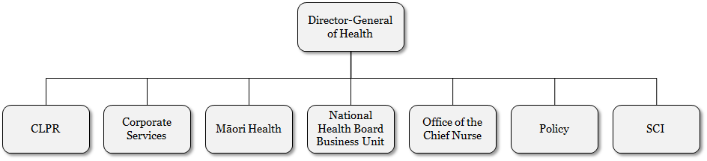

### Clinical Leadership, Protection and Regulation

Clinical Leadership, Protection and Regulation provides leadership and advice on overarching clinical matters within the Ministry, and acts as an interface for key health sector issues and input into the Ministry’s policy and operational work. It is also accountable for carrying out key statutory health protection functions, particularly in public health and mental health, plus regulatory functions in relation to health care service providers and medicines.

### Corporate Services

Corporate Services assists and leads the Ministry to become a high-performing and effective Ministry, supporting the Minister and the public to make a positive difference to health. It plays a key role in the drive for improving organisational health, capability and performance, and in providing assurance.

### Te Kete Hauora/Māori Health

Te Kete Hauora, the Māori Health Business Unit, provides policy advice on achieving the Government’s objective for Māori health. It works with other business units, sections and teams across the Ministry to achieve improvements in the health of Māori; manages key relationships with other government agencies, DHBs, health sector providers and organisations, iwi and Māori; and takes a leadership role in Māori health for the health sector.

### National Health Board

The NHB Business Unit provides leadership for strategic planning and funding of future capacity so that aspects such as IT, facilities and workforce are better integrated and driven by future requirements. The NHB is also responsible for the funding, monitoring and planning of DHBs, including annual regional and designated national service planning, and funding rounds.

The NHB provides a number of processing support services to the health sector (eg, the contact centre, payment processing, preparing agreements and national data collections).

### Policy

The Policy Business Unit provides advice that positions the health and disability system to deliver on government policy, respond to emerging priorities and meet future challenges. Policy works across the health and disability system and with other social sector partner agencies to ensure the Ministry’s advice is well informed and contributes to improving the health and wellbeing of New Zealanders now and in the future.

### Office of the Chief Nurse

The Office of the Chief Nurse provides expert advice on nursing to the Government, as well as professional leadership to the nursing profession in New Zealand, working closely with nurse leaders within the health sector, the professional statutory bodies, professional and staff associations and unions, DHB chief executives and managers, and the voluntary and independent sectors.

### Sector Capability and Implementation

The Sector Capability and Implementation Business Unit works closely with the health sector to support the implementation of the Government’s strategic priorities in health. It identifies opportunities for improved health sector performance; develops strategies that ensure integrated patient care; and shares best practice, innovations, new evidence and learning across the sector.

# Appendix E: Staff information

### Permanent staff

The number of permanent staff at the Ministry as at 30 June 2014 was 1072.83 full-time equivalents (FTEs), or 1126 individuals.

Figure E1: Staff numbers by business unit

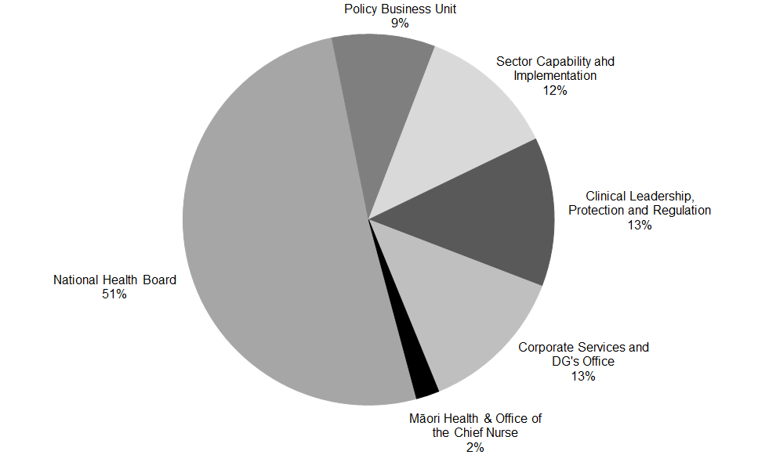

* Māori Health and the Office of the Chief Nurse are added together for this graph.

### Turnover

The 12-month rolling average turnover rate for 2013/14 was 12 percent; 131 staff left the Ministry during the year.

### Length of service

The average length of service for Ministry staff is six years.

Over 50 percent of current staff have been with the Ministry over five years. This compares with 50 percent in 2012/13.

Figure E2: Staff numbers by length of service

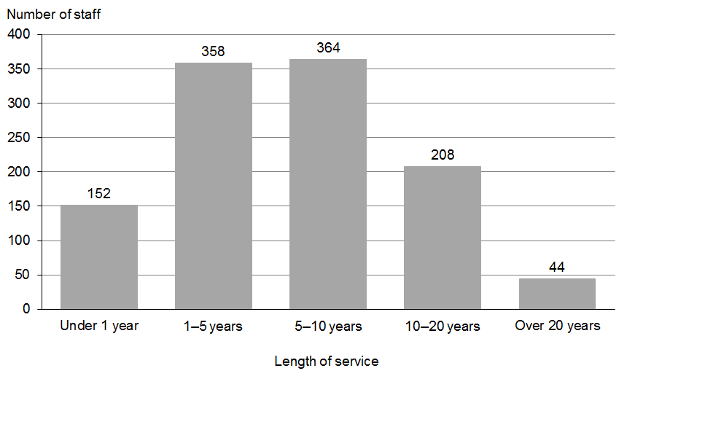

### Ethnicity

The New Zealand European ethnic group is the most dominant group within the Ministry, at 63 percent.

Figure E3: Staff ethnicity

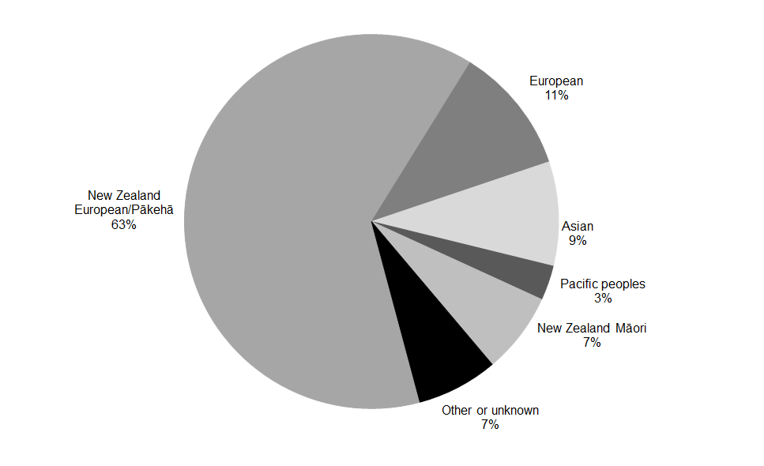

### Gender and age

Approximately 35 percent of Ministry staff are male and 65 percent are female.

The overall average age of Ministry staff is 43 years (44 for males and 42 for females).

Figure E4: Staff numbers by age group and gender

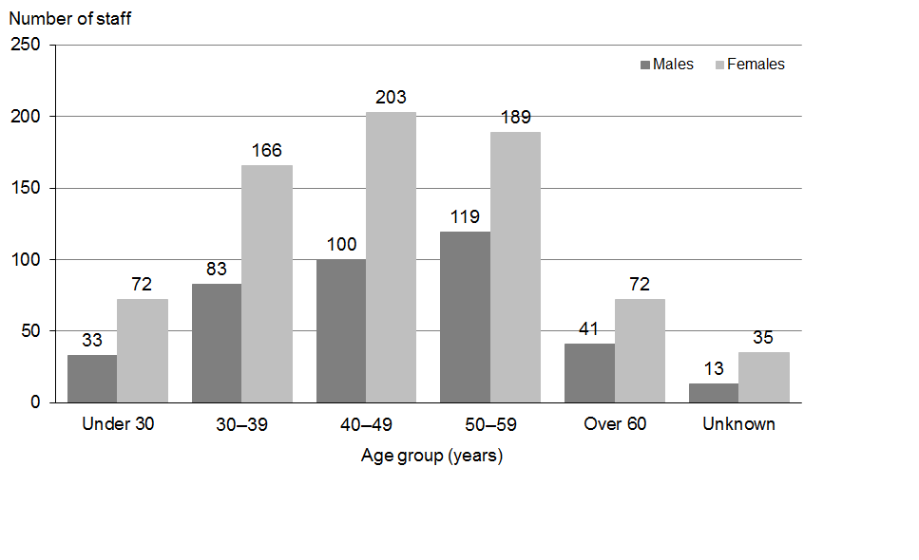

Figure E5: Gender proportion by age group

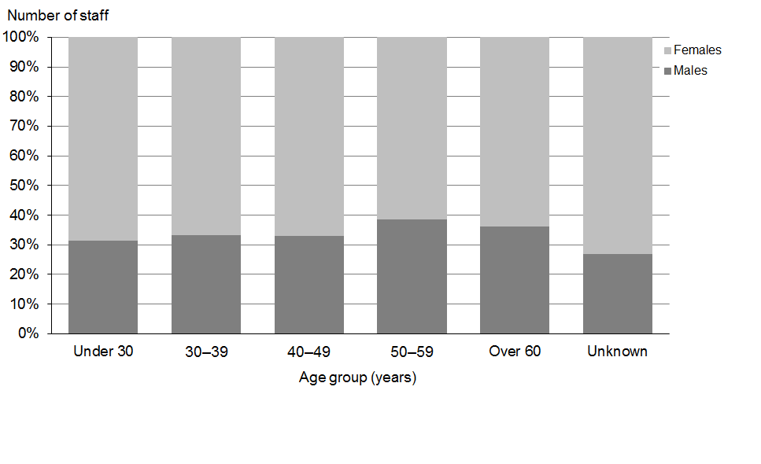

### Salary

Overall, average salaries of Ministry staff have increased since 2012/13 from approximately $84,784 to approximately $90,000. This is an increase of approximately 6.2 percent.

Approximately 29 percent of staff are paid over $100,000, and there is approximately a $17,218 difference between the average salaries paid to male and female staff ($99,774 for male staff and $82,556 for female staff). There are a number of potential factors relating to this difference. A major influence is that more female staff work part time.

The Ministry is an equal employment opportunity employer. The Ministry’s remuneration policy ensures that all roles in the Ministry are evaluated using a recognised methodology and that salary bands are set accordingly, ensuring all employees, regardless of their age, gender or ethnicity, are rewarded on an appropriate salary scale.

The Ministry is committed to equal employment opportunities and has a transparent system for job applications.

Figure E6: Staff numbers by salary band

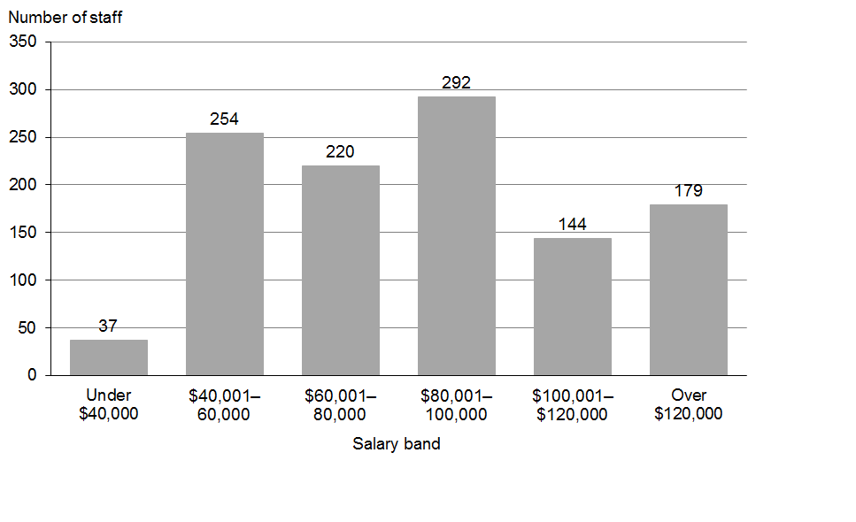

Figure E7: Gender proportion by salary band

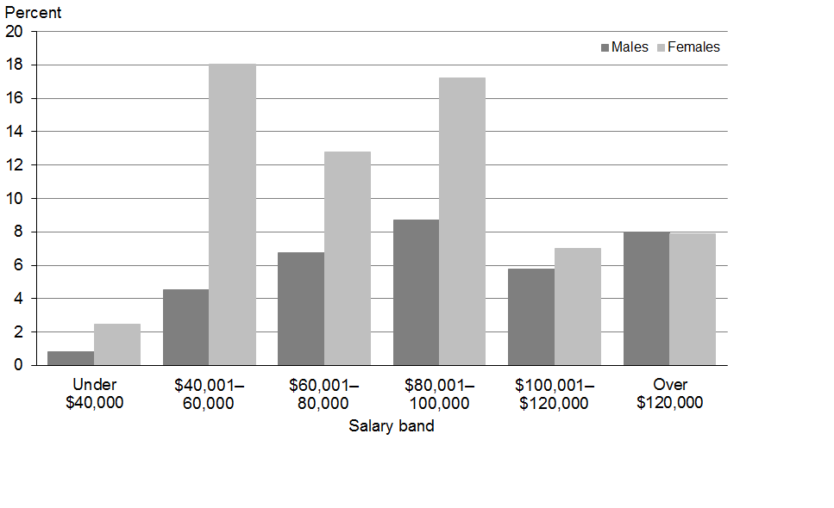

# Appendix F: Staff location

Ministry of Health permanent staff are located throughout the country, with the highest concentration of numbers being in Wellington.

|  |  |  |
| --- | --- | --- |
|  | **FTE** | **%** |
| Auckland | 62.76 | 6 |
| Waikato | 12.00 | 1 |
| Manawatu–Whanganui | 44.99 | 4 |
| Wellington | 856.41 | 80 |
| Canterbury | 38.40 | 4 |
| Otago | 58.27 | 5 |
| **Total** | **1072.83** | **100** |

Figure F1: Staff location

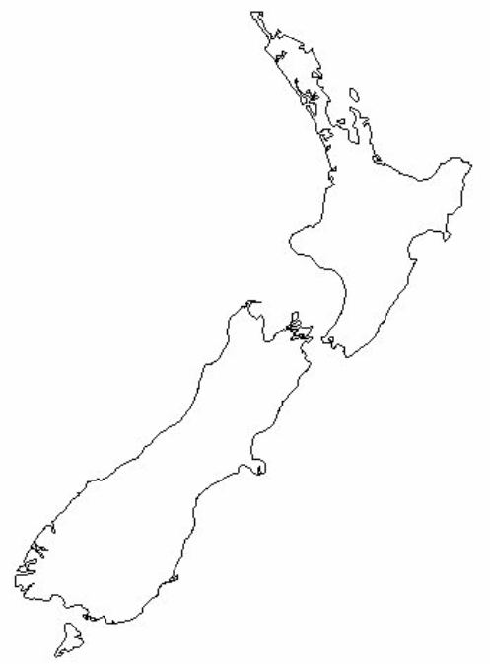

**Auckland**

**62.76**

**Manawatu**

**–**

**Whanganui**

**44.99**

**Waikato**

**12.00**

**Wellington**

***(Head Office)***

**856.41**

**Canterbury**

**38.40**

**Otago**

**58.27**

1. Health target results are sourced from individual DHB reports, national collections systems and information provided by primary care organisations.
2. ‘Elective surgery’ refers to planned rather than emergency procedures.
3. Between July 2008 and January 2011, the target was that patients who were ready for treatment would receive radiotherapy within six weeks of the decision to treat. This changed to four weeks from January 2011. The target was expanded to include patients needing chemotherapy from July 2012.
4. DHBs commenced monthly reporting of the number of patients waiting over four months for first specialist assessment in July 2012, so June 2012 data are not available.
5. Waiting time data is extracted from the National Booking and Reporting System (NBRS), which is a dynamic database. Results are based on data extracted on 4 August 2014.
6. AABR is an automated auditory brainstem response protocol.
7. Health Sector – Information Supporting the Estimates 2013/14 B.5A Vol.6.
8. Being supported to make good decisions is important for all New Zealanders and applies across our whole health and disability support system. It applies to services that support healthy people to stay that way (such as maternity, Well Child and screening services), and to services that help people to manage the impact of health conditions, particularly chronic health and mental health conditions. It also applies to those groups in our population for whom decisions around care and support can have a particularly significant impact, or who may need extra assistance to make decisions. This includes giving disabled people more choice and control over the supports they receive, and empowering older people to make informed decisions about their care.
9. Kessler Psychological Distress Scale (K10) is a 10-item questionnaire intended to yield a global measure of distress based on questions about anxiety and depressive symptoms.
10. www.healthliteracy.org.nz/research-and-projects/#4087
11. Ministry of Health. 2014. *Guidance for Healthy Weight Gain in Pregnancy* URL: [www.health.govt.nz/publication/guidance-healthy-weight-gain-pregnancy](http://www.health.govt.nz/publication/guidance-healthy-weight-gain-pregnancy)
12. Ministry of Health. 2014. www.health.govt.nz/your-health/healthy-living/food-and-physical-activity/physical-activity/activity-guides
13. Non-resident family members (other than parents and spouses) will continue to be eligible for payment as they were under the old policy.
14. Supported living payment (SLP) is a benefit for people who have or care for someone with a health condition, injury or disability that severely limits their ability to work on a long-term basis.
15. The previously recorded figure of 4.8 deaths per 1000 live births has now been amended to 5.2 deaths per 1000 due to a change in methodology in recording mortality rate.
16. Amenable mortality is defined as the rate of death from those conditions for which variation in mortality rates (over time and across populations) reflects variation in the coverage and quality of health care (preventive or therapeutic services) delivered to individuals.
17. www.hqsc.govt.nz/assets/Health-Quality-Evaluation/PR/quality-safety-guide-July-2013.pdf
18. Ministry of Health 2012 *2012 Review of the Health Practitioners Competence Assurance Act 2003: A discussion document* URL www.health.govt.nz/publication/2012-review-health-practitioners-competence-assurance-act-2003-discussion-document
19. Refer to Section 2: Financial statements, Note 8 Property, plant and equipment.
20. Multi-class output appropriation (see Appendix A: Glossary).
21. The percentage relates to audit activity occurring across the 14 streams of funding that makes up the total estimated funding of $5.9 billion. Provided there has been audit activity within a particular funding stream then the entire funding stream is used to calculate the percentage. The total estimated funding is broken down to the following funding streams: Clinical Training Agency, Dental, Disability Support Services, GMS/MMS/PN, Internal Allocations, Laboratory, Māori Health, Maternity, Meningococcal, Mental Health, Personal Health, Pharmacy, PHO/Capitation, Public Health.
22. More than one cause is possible, so percentages add to more than 100.
23. NCDs are conditions that are not acquired by transmission between people. Most NCDs are long-term conditions, which are defined as ongoing, long-term or recurring conditions.
24. This figure excludes non-melanoma skin cancers, which are not registered in New Zealand.
25. See page 12 for full information.
26. See page 14 for full information.
27. See page 15 for full information.
28. See page 16 for full information.
29. See page 17 for full information.
30. See page 18 for full information.
31. See page 4 for full information.
32. See pages 4 and 45 for full information.
33. See page 5 for full information.
34. See page 6 for full information.
35. See page 8 for full information.
36. Latest figures available at time of report’s publication.
37. Section 11 committees are not DHB or Crown entity boards.
38. As at 30 June 2014, Chair position is vacant. Mr Wano’s appointment as Acting Chair is effective 1 July 2014.
39. National Ethics Advisory Committee was established under s16 NZPHD Act. As such, it would not fall under the annual report requirement in s12(5).