  - Admissions to New Zealand Public Hospitals for Dental Care
  - A 20 Year Review
A report prepared for the New Zealand Ministry of Health

July 2012

FINAL REPORT

Admissions to New Zealand Public Hospitals for Dental Care
  - A 20 Year Review

Authors
This study was undertaken by
Dr Robin A Whyman BDS, MComDent, FRACDS, FRACDS (DPH), FICD, FADI
Dr Erin K Mahoney BDS, MDSc, PhD, FRACDS, MRACDS (Paed)
Dr James Stanley BA(Hons), PhD
Mr David Morrison BScTech (Hons)
This report has been prepared in partial fulfilment of the terms of an agreement between the Ministry of Health and Hutt Valley District Health Board (DHB) entitled “Oral Health Admissions Research”.
The use, ownership, citation and distribution of the material contained in this paper must be managed in a manner consistent with the terms and conditions of that agreement.

Acknowledgments
The research team acknowledge the support of the New Zealand Ministry of Health, in particular with access to the National Minimum Dataset source information, funding for the research team and constructive feedback on the initial research plan.
The team also acknowledge the support of Hutt Valley District Health Board and the University of Otago Wellington as employers of the research team and for ongoing support with time and with access to the facilities necessary to enable the analysis and writing to occur.
Table of Contents
List of Tables and Figures 4
Executive Summary 7
Introduction 10
Methods 11
Total Admissions, Age, Gender and Ethnicity Distribution 12
Total Admissions 12
Gender 13
Age 14
Ethnicity 15
Regional Variations 17
Deprivation 20
Discussion 22
Length of Stay 25
Discussion 27
Admission Types 28
Discussion 30
Reasons for Admission and Treatment Provided 32
Discussion 35
Repeat Admissions for Dental Care 37
Discussion 39
Hospital Discharges by Case Weighting 42
Discussion 46
Dental Admissions as a Result of Injury 48
Discussion 54
Co-morbidities Associated with Dental Admissions 57
Additional Co-morbidity Analysis 59
Intellectual Disability 59
Diabetes 61
Cancer 62
Mental Health 63
Discussion 64
References 67
Appendix 1: Detailed Methodology and Data Management 70

List of Tables and Figures
Table 1. Total hospital admissions and growth rates for inpatient dental care (1990 – 2009).
Table 2. Crude hospital admission rates for inpatient dental care and rates of growth by total ethnicity (1996 – 2009).
Table 3. Age and ethnicity standardised hospital admission rates for inpatient dental care by DHB of domicile (2005 – 2009).
Table 4. Hospital admissions for inpatient dental care by principal diagnosis ICD code (1990-1994 and 2005 – 2009)
Table 5. Hospital admissions for inpatient dental care by DRG code (1990 – 1994 and 2005 – 2009).
Table 6. Caseweighted admissions for inpatient dental care with dental as the primary diagnosis (2001 – 2009).
Table 7. Median caseweighting of admissions for inpatient dental care with dental as the primary diagnosis by DHB (2001 – 2009).
Table 8. Comorbidities coded for primary dental admissions to hospital in people under 18 years and 18 years and over (2005 – 2009).
Table 9. Prevalence of an intellectual disability as a comorbidity associated with a primary dental admission to hospital by age group (2005 – 2009).
Table 10. Prevalence of an intellectual disability as a comorbidity associated with a primary dental admission to hospital by ethnicity (2005 – 2009).
Table 11. Prevalence of an intellectual disability as a comorbidity associated with a primary dental admission to hospital by DHB (2005 – 2009).
Table 12. Prevalence of a diabetes comorbidity associated with a primary dental admissions to hospital by age group (2005 – 2009).
Table 13. Prevalence of a cancer comorbidity associated with a primary dental admission to hospital by age group (2005 – 2009).
Table 14: Prevalence of a mental health comorbidity associated with a primary dental admission to hospital by age group (2005 – 2009).
Table 15: ICD-10-AM codes used to define “dental health admissions” for analysis.
Table 16: ICD-10-AM codes used to define “dental injury admissions” for analysis.
Table 17: ICD10 codes used to identify intellectual disabilities listed as comorbidities on dental primary reason admissions.
Table 18: ICD10 codes used to identify mental health conditions listed as comorbidities on dental primary reason admissions.
Table 19. ICD10 codes used to identify oral cancers listed as comorbidities on dental primary reason admissions.
Figure 1. Hospital admission rates for inpatient dental care by gender (1990 – 2009).
Figure 2. Mean hospital admission rate for inpatient dental care by age (1990 – 2009).
Figure 3. Hospital admission rates for inpatient dental care by age (1990 – 2009).
Figure 4. Hospital admission rates for inpatient dental care by total ethnicity (1990 – 2009).
Figure 5. Age standardised hospital admission rates for inpatient dental care by total ethnicity (1990 – 2009).
Figure 6. Hospital admissions rates for inpatient dental care by DHB of domicile (2005 – 2009).
Figure 7. Hospital admissions rates for inpatient dental care by DHB of domicile (1990 – 2009).
Figure 8. Age and ethnicity standardised hospital admission rates for inpatient dental care by DHB of domicile (2005 – 2009).
Figure 9. Percentage of total hospital admissions for inpatient dental care by gender and deprivation index (2005 – 2009).
Figure 10. Percentage of total hospital admissions for inpatient dental care by deprivation level for each ethnic group (2005 – 2009).
Figure 11. Percentage of total hospital admissions for inpatient dental care by deprivation level for each age group (2005 – 2009).
Figure 12. Percentage of primary hospital admissions for inpatient dental care with an overnight stay by gender (1990 – 2009).
Figure 13. Percentage of primary hospital admission rates for inpatient dental care with an overnight stay by total ethnicity (1990 – 2009).
Figure 14. Percentage of primary hospital admissions for inpatient dental care with an overnight stay by age group (1990 – 2009).
Figure 15. Admission types as a percentage of hospital admissions for inpatient dental care (1990 – 2009).
Figure 16. Admission types of hospital admission for inpatient dental care (1990 – 2009).
Figure 17. Admission types as a percentage of hospital admissions for inpatient dental care by age group (2005 – 2009).
Figure 18. Percentage of hospital admissions for inpatient dental care with dental as the primary diagnosis by age group (1990 – 2009).
Figure 19. Percentage of hospital admissions for inpatient dental care with dental as the primary diagnosis by total ethnicity (1990 – 2009).
Figure 20. Hospital admissions for inpatient dental care by DRG code and age group (1990 – 1994).
Figure 21. Hospital admissions for inpatient dental care by DRG code and age group (2005 – 2009).
Figure 22. Percentage of people who had one or more repeat admissions for inpatient dental care following a first admission (1990 – 2005).
Figure 23. Percentage of repeat admissions for inpatient dental care by total ethnicity (1990 – 2004).
Figure 24. Percentage of repeat admissions for inpatient dental care by age group (1990 – 2004).
Figure 25. Percentage of repeat admissions for inpatient dental care by DHB of domicile (2000 – 2004).
Figure 26. Total admissions and summed caseweighting for inpatient dental care with dental as the primary diagnosis (2001 – 2009).
Figure 27. Median caseweighting of admissions for inpatient dental care with dental as the primary diagnosis by age group (2001 – 2009).
Figure 28. Summed caseweighting of admissions for inpatient dental care with dental as the primary diagnosis by age group (2009).
Figure 29. Summed annual caseweighting of admissions for inpatient dental care with dental as the primary diagnosis by DHB (2009).
Figure 30. Summed annual caseweighting (per 1,000 population) of admissions for inpatient dental care with dental as the primary diagnosis by DHB (2009).
Figure 31. Hospital admissions for inpatient dental care as a result of dental injury (1990 – 2009).
Figure 32. Rate of admissions due to dental injury (includes maxillofacial) per 100,000 population (1990 – 2009).
Figure 33. Rate of admissions due to dental injury (includes maxillofacial) per 100,000 population by total ethnicity (1990 – 2009).
Figure 34. Hospital admissions as a result of dental and/or maxillofacial injury as a percentage of total dental admissions (1990 – 2009).
Figure 35. Hospital admissions as a result of dental injury as a percentage of total dental admissions by total ethnicity (2005 – 2009).
Figure 36. Hospital admissions as a result of dental injury as a percentage of total dental admissions by age group (2005-2009).
Figure 37. Rate of admissions due to dental injury (includes maxillofacial) per 100,000 population (1990 – 2009).
Figure 38. Rate of admissions due to dental injury (includes maxillofacial) per 100,000 population by total ethnicity (1996 – 2009).
Figure 39. Rates of admission per 100,000 population as a result of dental and/or maxillofacial injury by DHB (2005-2009).

Executive Summary
Dental care comprises a leading cause of admission to hospital for young children in a number of District Health Boards (DHBs), but relatively little information is available about the details of admissions to hospital for dental care in New Zealand. This aim of this study was to describe the prevalence and characteristics of people of all ages admitted to public hospitals for dental care throughout New Zealand during the 20-year period 1990 - 2009. The primary data source for this study was discharge records from the National Minimum Data Set (NMDS), a collection held by the Ministry of Health.
Between 1990 and 2009 there were 152,696 dentally-related public hospital admissions in New Zealand and during this period 120,046 people were admitted for dental care as a primary reason for admission. The total rate of admission to hospital for dental care has increased from 0.76 per 1,000 population in 1990 to 3.01 per 1,000 population in 2009 and admissions with a primary dental diagnosis have increased from a rate of 0.67 per 1,000 population in 1990 to 2.32 per 1,000 population in 2009.
Children aged 8 years or under had the highest rates of admission to hospital for dental care and significantly more children aged 3 and 4 years required admission for dental treatment than any other age group. Increases in the rate of admission occurred for all age groups over the period 1900-2009.
Admission rates were highest for people of Maori and Pacific ethnicity and lowest among people of Asian and NZ European ethnicity. After taking the age structure of the population into account disparities in the rate of admission between ethnicities remain. Rates of admission for dental care have increased most for Maori and Pacific people and in the period 2005-2009 Maori and Pacific people were hospitalised for dental care at rates almost twice as high as for NZ European people, while hospitalisations for Asian people were comparable to NZ European.
Significant regional variation in the rate of dental admissions to hospital for dental care existed between DHBs. Throughout a study period of 2005-2009 admission rates ranged between 1.93 per 1,000 population in Otago and 5.57 admissions per 1,000 people in Whanganui with a national mean of 2.82 admissions per 1,000 population throughout this period. Age and ethnicity standardised rates of admission to hospital for dental care varied over 200% between DHBs in this period.
This study confirms a steady increase in the volumes of dental care provided to children and adults involving admission to public hospitals, and in the rates of admission. There are multiple interacting reasons for this including changing standards of care, particularly in general anaesthetic practice, variable access to primary dental care across population groups and a potential lack of primary prevention in both the child and adult population. They also appear to reflect the complex dental care needs of an aging adult population with greater retention of natural teeth.
The increases in admission volumes and rates are consistent with international literature on this topic, and so are unlikely to reflect changes that are unique to New Zealand.
Length of Stay
The majority of dental admissions involve only a day-stay admission and there is strong evidence of a substantial decrease in overnight stays throughout the study period. The percentage of dental admissions with an overnight stay decreased from 42.6% in 1990 to 11.7% in 2009. Overnight stays declined sharply in the early 1990s and continued to decrease at an annual rate of 0.9 percentage points until 2005. Overnight admissions have remained consistent between 10% and 12% since 2005.
Admission Types
In the period 2005-2009 three quarters of all dental admissions were from the waiting list and 10% were acute admissions. Of particular note was a significantly greater percentage of acute admissions amongst adults. In the period 2005-2009 acute admissions comprised between 23% and 32% of dental admissions for people aged over 18 years. In contrast acute admissions for dental care comprised fewer than 5% of admissions for children aged 3 to 12 years.
Reasons for Admission
In all age, gender and ethnicity groups dental caries accounted for approximately 76% of all of the dental admissions for dental disease. Diseases of the pulp and periapical tissues contributed a further 10-12% of admissions. A range of other disorders of the teeth, gums, mouth and supporting structures contributed to the other reasons for dental admissions and the range of diagnoses reported had increased in the later time period of this study.
Dental extractions and restorations made up the majority of treatments provided for all age groups, although after the age of 13 years a range of other treatment codes are used to describe the procedures undertaken.
Repeat Admissions for Dental Care
Between 1990 and 2004 4,268 people were admitted more than once for a dental reason within 4 years of the original admission. This represents an overall readmission rate of 5.6%. In the latest time-period analysed (2000-2004) repeat admissions were greatest, at 8.4%, in those patients aged 0-2 and around 6.7% for those aged 9-34 years; and varied between 2.6% and 9.1% of people admitted across the 21 DHBs.
Dental Admissions as a Result of Injury
Admissions to hospital as a result of dental and/or maxillofacial injuries increased from 650 in 1990 to 1840 in 2009. However, they declined significantly as a percentage of the people admitted to hospital with a dental condition. In 2009 people aged 13-34 years comprised the highest percentage of admissions due to dental injuries. In the 0-12 years age groups the vast majority of the injuries were maxillofacial while in the 18-34 year age group, who had the greatest number of admission due to injury, 59.5% of injuries were dental and 36.2% maxillofacial. The remaining 4.3% of injuries in this age group were those who sustained both dental and maxillofacial injuries.
In addition to an increase in absolute numbers of people admitted to hospital as a result of dental and/or maxillofacial injuries, the rate of admission has more than doubled from 19.5 people per 100,000 population in 1990 to 43.8 per 100,000 population in 2009.
Co-morbidities Associated with Dental Admissions
In people aged under 18 years additional coded conditions were not common, occurring for only 9.2% of children and young people admitted. However, in people aged 18 years and over additional coded conditions were substantially more prevalent. An additional condition was present for 61.3% of people aged 18 years and over. Details of additional conditions affecting hospital admissions for dental care were difficult to obtain from the data as there was frequent use of the description “factors influencing health status and contact with health services”.

Introduction
Dental care comprises a leading cause of admission to hospital for young children in a number of District Health Boards (DHBs) (Craig et al 2009; Craig et al 2008a, b) and is a significant contributor to the workload of hospital dental services. Commonly, children admitted to hospital for dental treatment present with advanced dental caries while adults can present with a complex interaction of disabilities, health conditions and dental disease.
While a small amount of information is available about hospital admission volumes for dental care for young children, little is known about the volumes and reasons for admission of older children and adults. There is also relatively little information available about other details of these admissions to hospital in New Zealand. Little recent analysis is available on issues such as regional variation in admission rates, length of stay, acuity of admissions, repeat admissions for dental care, the contribution of admissions resulting from an injury compared with the contribution of admissions for dental diseases or the interaction of co-morbidities.
There is also limited information about time trends in admission for dental care in New Zealand. Trends may reflect a variety of issues, including changing disease patterns, changing patterns of dental practice, and changes to service availability and funding. However, without descriptive data it is difficult to assess patterns in access to care and care provision, and to establish priorities for improvements to care and to systems.
This aim of this study was to describe the prevalence and characteristics of people of all ages admitted to public hospitals for dental care throughout New Zealand during the 20-year period 1990 – 2009. The study describes time-trends and variation in hospital admission rates for dental care.
In this report each analytical section is supported by a literature review and discussion of the findings. The report provides information relevant to supporting service improvement and future policy development initiatives for access to dental services, and in particular hospital-based dental services.

Methods
The primary data source for this study was discharge records from the National Minimum Data Set (NMDS), a collection held by the Ministry of Health. The NMDS records “discharges” from hospital, but in keeping with common usage the term “admissions” has been used to describe these events for dental care throughout this report. The NMDS data used for this report covered a 20-year period from 1 January 1990 to 31 December 2009.
The data file consisted of a single line per hospital admission. Individuals were anonymised through unique encryption of their national health index number by the Ministry of Health, prior to provision of the data file to the research team. This enabled identification of unique individuals within the dataset, but preserved the confidentiality of individual identities. Ethical approval was not required for this study as it involved secondary use of data for which confidentiality of the individual subjects had been assured by the Ministry of Health through the encryption process.
Hospital admission data were linked to an NZDep2006 concordance file.
A subset of ICD 10 codes for dental health was selected as identifying ambulatory care sensitive conditions. The subset of ICD 10 dental health codes selected was matched to those used to report dental admissions to hospital in Victoria, Australia in 2007 (Department of Human Services, 2007). These codes were used throughout the analysis to identify the dental health conditions leading to admission to hospital. The ICD 10 AM codes are listed in Table 15 in Appendix 1.
This study uses three cohorts of dental admissions at different points in the study.
The first cohort is ‘total’ admissions to hospital for dental care, where a dental diagnostic code described above was recorded at any point in the diagnostic fields available, up to the fifteenth listed diagnosis.
The second cohort is ‘primary’ admissions to hospital for dental care. These are admissions where the primary reason for the hospital stay (the first diagnostic field recorded) was a dental health reason. This smaller cohort is a subset of the “Total admissions” cohort.
A third cohort was selected specifically for the purpose of considering dental admissions that resulted from injury. This cohort included all admissions where one of the first fifteen diagnostic fields contained a dental injury ICD code (see Table 15 Appendix 1). A small number of admissions within this cohort contain both dental injury and dental health ICD codes, and this is covered in the analysis of dental injuries. Dental injury codes are in addition to the dental health conditions and were utilised only in the dental injury section of this study.
All data processing and cleaning was performed in SAS 9.2 (SAS Institute Inc., NC.) Diagnostic ICD codes prior to the 30th of June 1999, where diagnoses and procedures are stored in ICD-9-CM numerical codes, were mapped to the corresponding ICD-10 alphanumeric codes.
A detailed description of the methodology and data management decisions used in this study is contained in Appendix 1.

Total Admissions, Age, Gender and Ethnicity Distribution

Total Admissions (Table 1)
Between 1990 and 2009 there were 152,696 dentally-related public hospital admissions in New Zealand. These admissions include all admissions to hospital where a dental diagnosis code was recorded either as the primary reason for admission, or as a co-morbidity associated with admission to hospital for another principal reason.
During the period 1990-2009, 120,046 people were admitted for dental care as a primary reason for admission.
Overall, the total rate of admission to hospital for dental care has increased from 0.76 per 1,000 population in 1990 to 3.01 per 1,000 population in 2009. The annual growth rate in dentally-related admissions was substantial in the period 1990-94 (15% per annum). There has been a continued growth in dentally-related hospital admissions throughout the subsequent 15-year period, but growth rates have declined, although a notable increase in the rate is present in the 2009 year.
Similar changes in growth rate are present for the primary dental admissions. Admissions with a primary dental diagnosis have increased from a rate of 0.67 per 1,000 population in 1990 to 2.32 per 1,000 population in 2009. These time-related changes are reported in Table 1, pooled within five-year periods.

Table 1. Total hospital admissions and growth rates for inpatient dental care (1990 – 2009)
 | Within period |  |  |  | Per annum (most recent five years)
 | 1990-94 | 1995-99 | 2000-04 | 2005-09 | 2005 | 2006 | 2007 | 2008 | 2009
Total dental-related admissions: | 17260 | 31237 | 46481 | 57718 | 10900 | 11091 | 11372 | 11714 | 12641
Rate per 1,000 population | 1.00 | 1.72 | 2.44 | 2.82 | 2.75 | 2.75 | 2.78 | 2.83 | 3.01
Average annual growth rate (%) | 15.0 | 8.8 | 5.7 | 2.7 | 4.0 | 0.2 | 1.1 | 1.6 | 6.4
Admissions with primary reason dental: | 15731 | 25121 | 35222 | 43972 | 8065 | 8404 | 8720 | 9025 | 9758
Rate per 1,000 population | 0.92 | 1.38 | 1.85 | 2.15 | 2.03 | 2.09 | 2.13 | 2.18 | 2.32
Average annual growth rate (%) | 15.1 | 5.2 | 5.2 | 3.2 | 2.3 | 2.3 | 2.3 | 2.0 | 6.6

Gender (Figure 1)
Although minor differences exist across the entire time period, males have consistently experienced more admissions than females. The rate of increase for both males and females has been steady over the study period.
From 1990 to 2009, females were generally less likely to be admitted than males. These results are consistent regardless of whether the primary reason for admission is dental or dental treatment is a secondary procedure (Figure 1). Across the 20-year period male admission rates were greater than that of their female counterparts for all age bands except for the 19-24 and 25-34 age groups.

Figure 1. Hospital admission rates for inpatient dental care by gender (1990 – 2009).
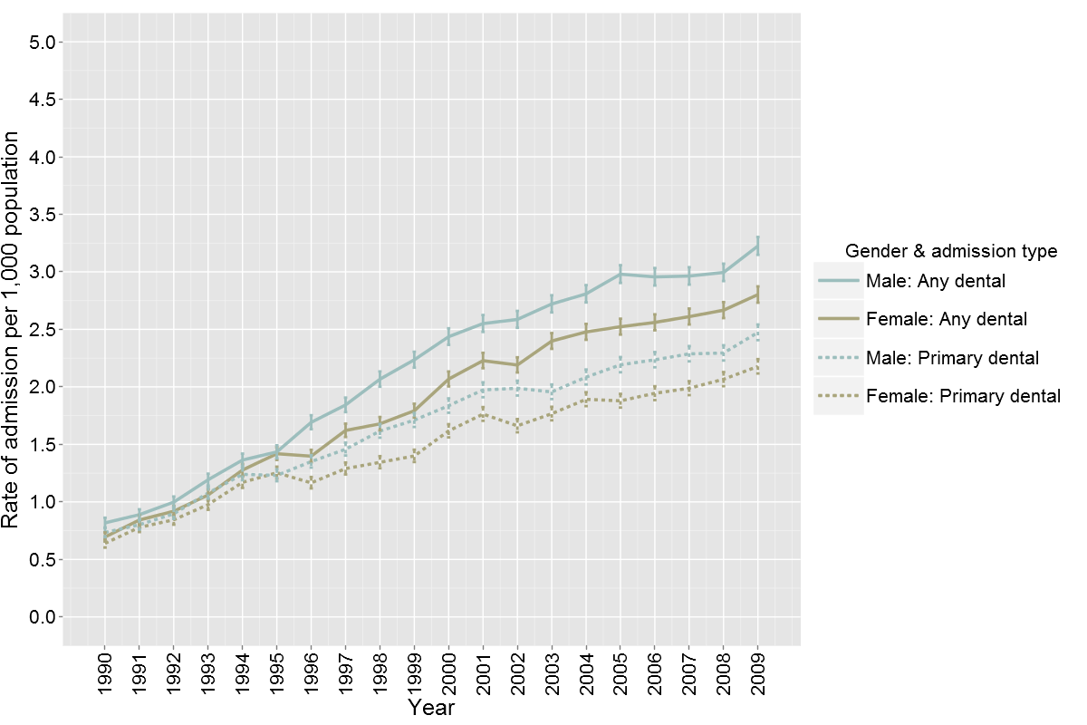

Age (Figure 2 and 3)
Total dental admission rates by age are reported in Figure 2. Children aged 8 years or under had the highest rates of admission. Significantly more children aged 3 and 4 years required admission for dental treatment than any other age group. An increase in the rate of admission has occurred for all age groups over the period 1900-2009 (Figure 3). Children aged between 3 and 8 years have had the greatest rates of increase in hospital admissions, but the rate of admission has increased across all age groups over time (Figure 3).
Figure 2. Mean hospital admission rate for inpatient dental care by age (1990 – 2009).
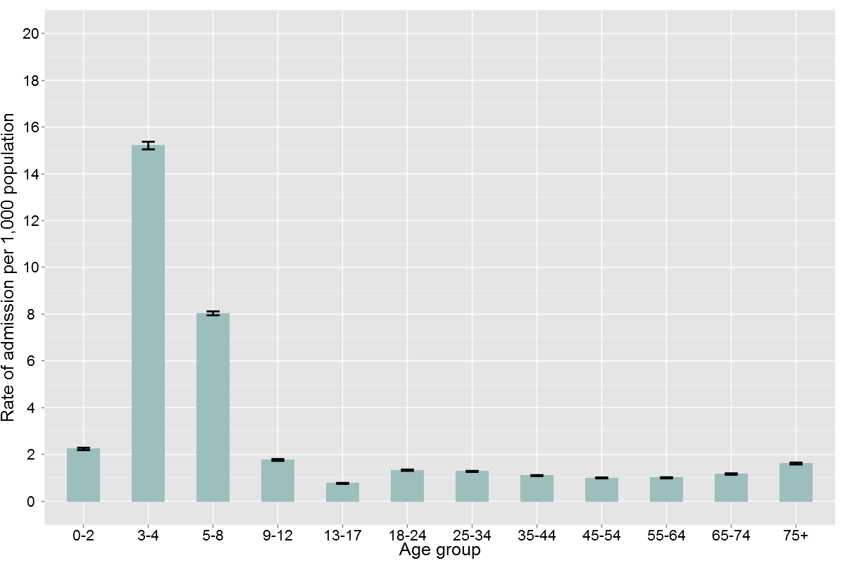
Figure 3. Hospital admission rates for inpatient dental care by age (1990 – 2009).

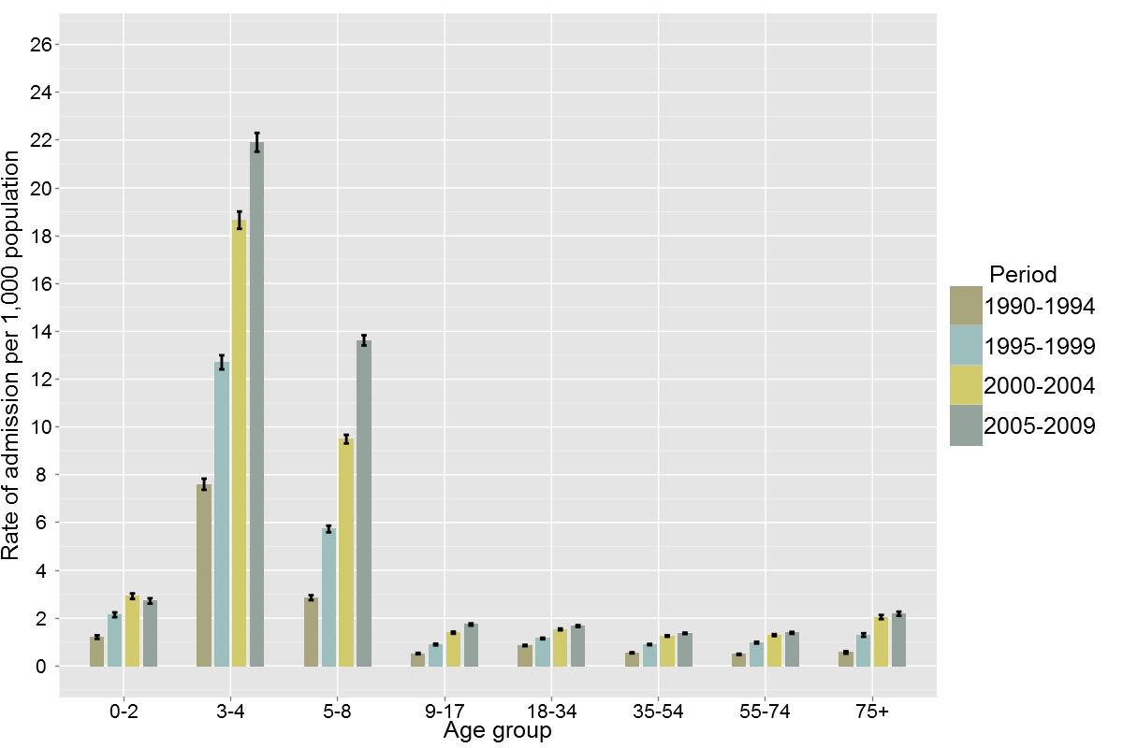
Ethnicity (Figure 4 and 5 and Table 2)
Total dental admission rates per 1,000 population for the four largest ethnic groups in New Zealand - NZ European, Maori, Pacific and Asian are reported in Figure 4. Admission rates for each time period were highest in the Maori and Pacific ethnicity groups, and lowest among Asian and NZ European people.

Figure 4. Hospital admission rates for inpatient dental care by total ethnicity (1990 – 2009).
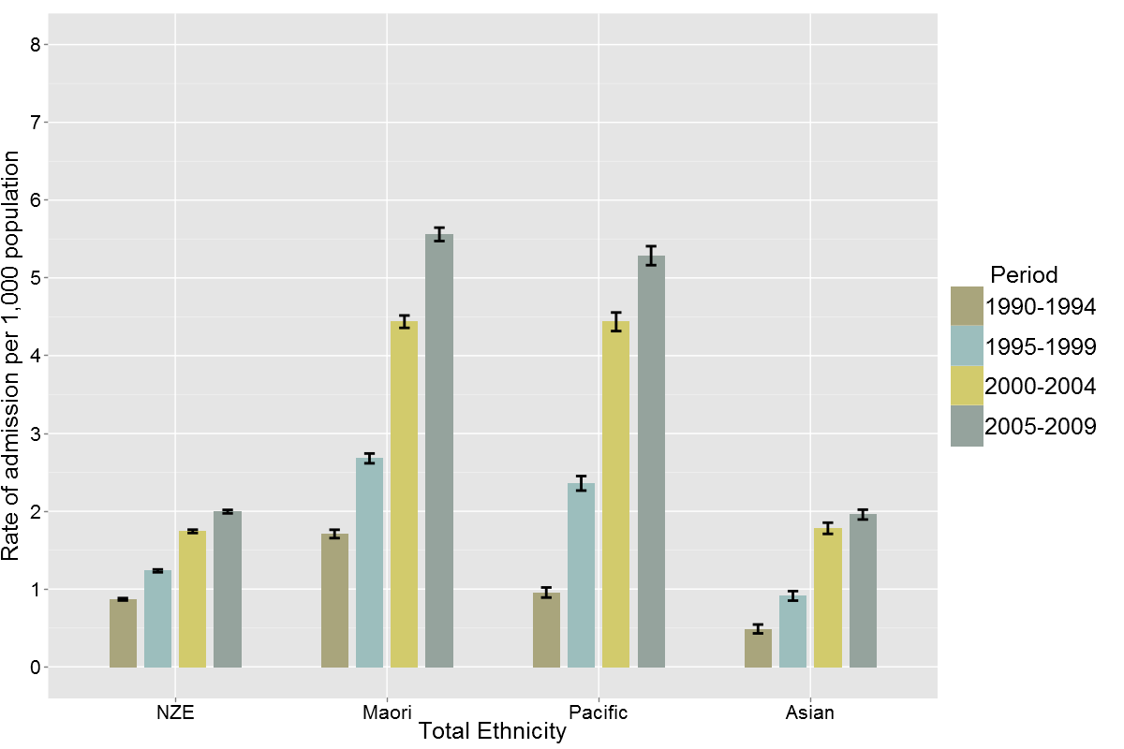
As already reported, age is an important influence on the rate of admission to hospital for dental care and so age-standardisation of the rate of admission by ethnicity is necessary to determine the underlying differences by ethnicity for the rates of admission to hospital for dental care. The detail with which ethnicity was recorded in the NMDS increased from 1 July 1996 (see Appendix 1) and so further analysis of the data age-standardised by ethnicity in this section has been undertaken for data from 1996 onwards.
Figure 5 presents the age standardised rate of admission for each ethnic group against NZ European. After taking the age structure of the population into account all ethnicities have experienced substantial increases in the rate of admission since 1990 and disparities in the rate of admission between ethnicities remain. Rates of admission for dental care have increased most for Maori and Pacific people and in the period 2005-2009 Maori and Pacific people were hospitalised for dental care at rates almost twice as high as for NZ European people, while hospitalisation rates for people of Asian ethnicity were comparable to NZ European rates.
Figure 5. Age standardised hospital admission rates for inpatient dental care by total ethnicity (1996 – 2009).
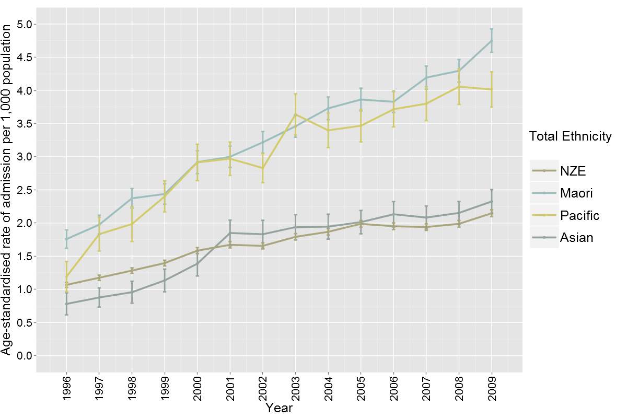
Table 2 reports the crude admission rates between 1996-99 and 2005-09 by ethnicity. In 1996-99 the crude admission rate for Maori was the greatest at 2.80 per 1,000 population and lowest for people of Asian ethnicity at 1.01 per 1,000 of population. By 2005-09 crude admission rates for dental care had risen for all ethnicities but had increased to 5.56 per 1,000 population for Maori, 5.28 per 1,000 for Pacific people and to 1.96 per 1,000 population for Asian people. For Maori, Pacific and Asian people this represents an approximately 200% increase in the admission rate between 1996-99 to 2005-09, while the increase to 2.00 for NZ Eurpoean people through the same period represents approximately a 150% increase.
The mean annual rate of growth in dental admissions for all ethnicities have declined through the 20-year period of this study but the annual rate of growth for Maori people in the 2005-2009 period remains higher than for NZ European people and indicates a continued widening disparity for these groups since the 1996-1999 period (Table 2).
Table 2. Crude hospital admission rates for inpatient dental care and rates of growth by total ethnicity (1996 – 2009).
 | Admissions per 1,000 population |  |  | Mean annual rate of growth  (percentage)
Total ethnicity | 1996-99 | 2000-04 | 2005-09 | 1996-99 | 2000-04 | 2005-09
Maori | 2.80 | 4.44 | 5.56 | 10.8 | 9.2 | 4.3
Pacific | 2.49 | 4.43 | 5.28 | 21.2 | 7.4 | 2.5
Asian | 1.01 | 1.78 | 1.96 | 33.3 | 10.1 | 2.1
NZ European | 1.27 | 1.74 | 2.00 | 7.6 | 5.7 | 2.5

Regional Variations (Figure 6-8 and Table 3)
Significant regional variation in the rate of total dental admissions to hospital for dental care existed between DHBs throughout the study period. During the 2005-2009 period admission rates ranged between 1.93 per 1,000 population in Otago and 5.57 admissions per 1,000 people in Whanganui, with a national mean of 2.82 admissions per 1,000 population throughout this period (Figure 6).
All DHBs experienced significant increases to the rate of admission to hospital for dental care during the period 1990-2009 but the rate of increase and the relative increases have varied substantially between regions.
In 11 DHBs (Waitemata, Counties Manukau, Waikato, Lakes, Bay of Plenty, Tairawhiti, Taranaki, Midcentral, Hutt Valley, Canterbury and Southland) marked increases in the admission rate were recorded in all of the four grouped year periods reviewed. In 7 DHBs (Auckland, Whanganui, Wairarapa, Capital and Coast, Nelson Marlborough, South Canterbury, Otago) rates of admission increased throughout the 20-year period but appear to have stabilised between the 2000-2004 to 2005-2009 period. In the remaining 3 DHBs (Northland, Hawkes Bay, West Coast) rates of admission had increased over the 20-year period, but patterns varied. In Northland admission rates declined in the 1995-1999 period but this was followed by significant increases through the next decade. In Hawkes Bay admission rates did not increase significantly through the 10-year period 1995-2004. On the West Coast admission rates peaked in the period 2000-2004 but have declined again in the period 2005-2009 and are now equivalent to rates in the period 1995-1999 (Figure 7).

Figure 6. Hospital admissions rates for inpatient dental care by DHB of domicile (2005 – 2009).
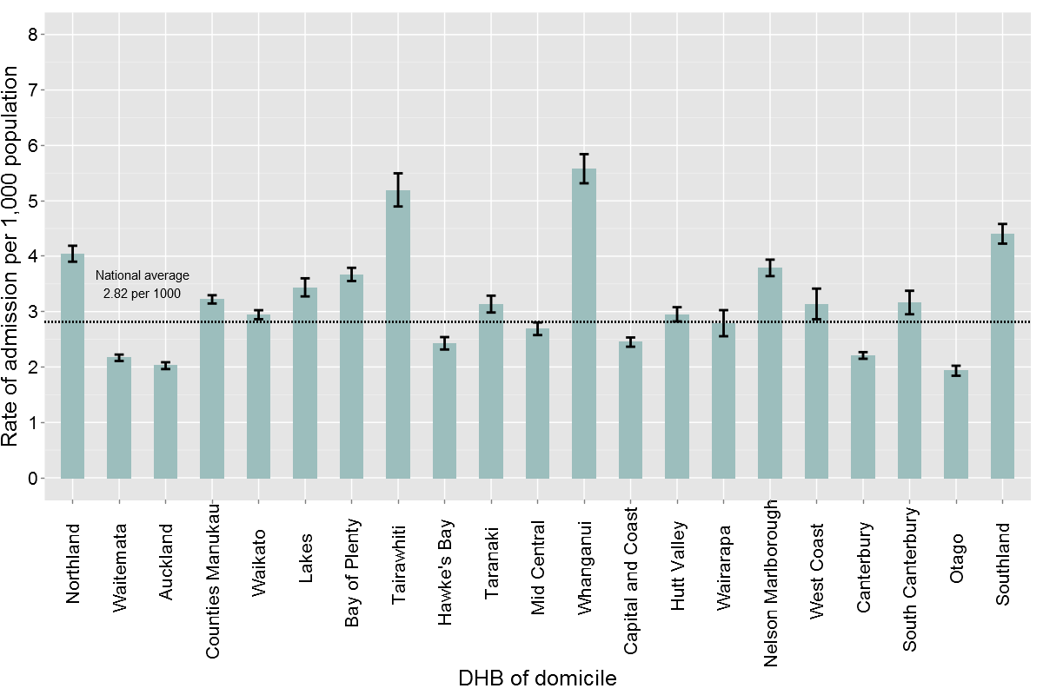
Figure 7. Hospital admissions rates for inpatient dental care by DHB of domicile (1990 – 2009).
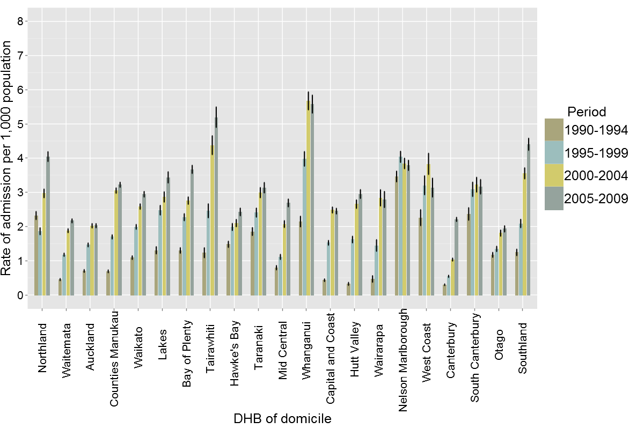
Variation in admission rates will be affected by a number of factors. Given the strong influence of age and ethnicity already demonstrated in this study, admission rates were standardised for age and ethnicity across DHBs for the period 2005 – 2009 and are reported in Figure 8. Age and ethnicity standardisation suggest that admission rates in Northland, Tairawhiti, Counties Manukau and Lakes DHBs were lower than previously calculated if we hypothesise a similar population structure across DHBs.
Figure 8. Age and ethnicity standardised hospital admission rates for inpatient dental care by DHB of domicile (2005 – 2009).
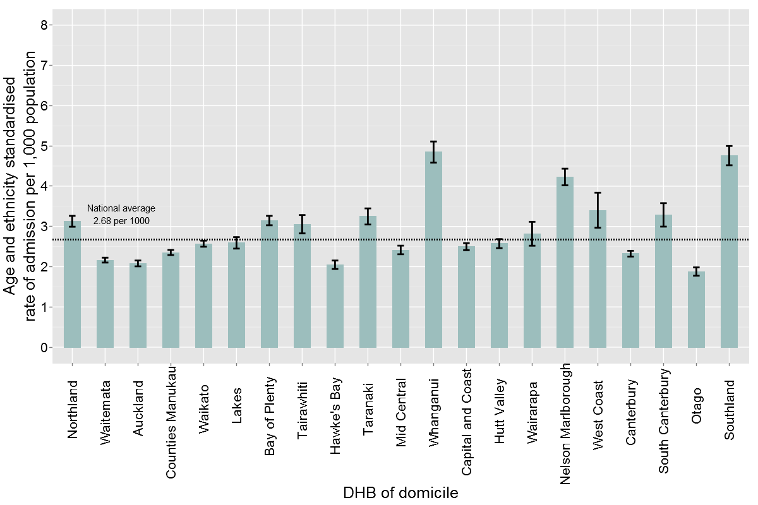
After age and ethnicity standardisation Whanganui, Nelson Marlborough and Southland DHBs present as regions with significantly higher rates of admission for dental care than all other DHBs.
Age and ethnicity standardised rates of admission to hospital for dental care varied over 200% between DHBs and are reported in order of the lowest to highest rates in Table 3.
Table 3. Age and ethnicity standardised hospital admission rates for inpatient dental care by DHB of domicile (2005 – 2009).
DHB | Standardised rate of admissions (per 1,000 population) | CI
Otago | 1.88 | 1.77 - 1.98
Hawke's Bay | 2.05 | 1.94 - 2.15
Auckland | 2.08 | 2.01 - 2.15
Waitemata | 2.16 | 2.1 - 2.22
Canterbury | 2.32 | 2.25 - 2.39
Counties Manukau | 2.35 | 2.29 - 2.42
Mid Central | 2.42 | 2.31 - 2.52
Capital and Coast | 2.5 | 2.41 - 2.58
Waikato | 2.57 | 2.5 - 2.65
Hutt Valley | 2.57 | 2.46 - 2.69
Lakes | 2.59 | 2.45 - 2.73
Wairarapa | 2.82 | 2.52 - 3.11
Tairawhiti | 3.05 | 2.83 - 3.28
Northland | 3.13 | 2.99 - 3.26
Bay of Plenty | 3.15 | 3.03 - 3.26
Taranaki | 3.25 | 3.05 - 3.45
South Canterbury | 3.29 | 3 - 3.58
West Coast | 3.4 | 2.97 - 3.84
Nelson Marlborough | 4.23 | 4.02 - 4.44
Southland | 4.76 | 4.52 - 5
Whanganui | 4.85 | 4.58 - 5.11

Deprivation (Figures 9-11)
Data analysis for this aspect of the study was limited to the most recent five years (2005-2009) as the records were linked to NZDep2006 records based on Domicile Code (see Appendix 1).
The percentage of total dental admissions increased with increasing deprivation as measured by NZDep 2006 quintiles. The NZDep profile of admitted patients was similar for males and females (Figure 9).

Figure 9. Percentage of total hospital admissions for inpatient dental care by gender and deprivation index (2005 – 2009).
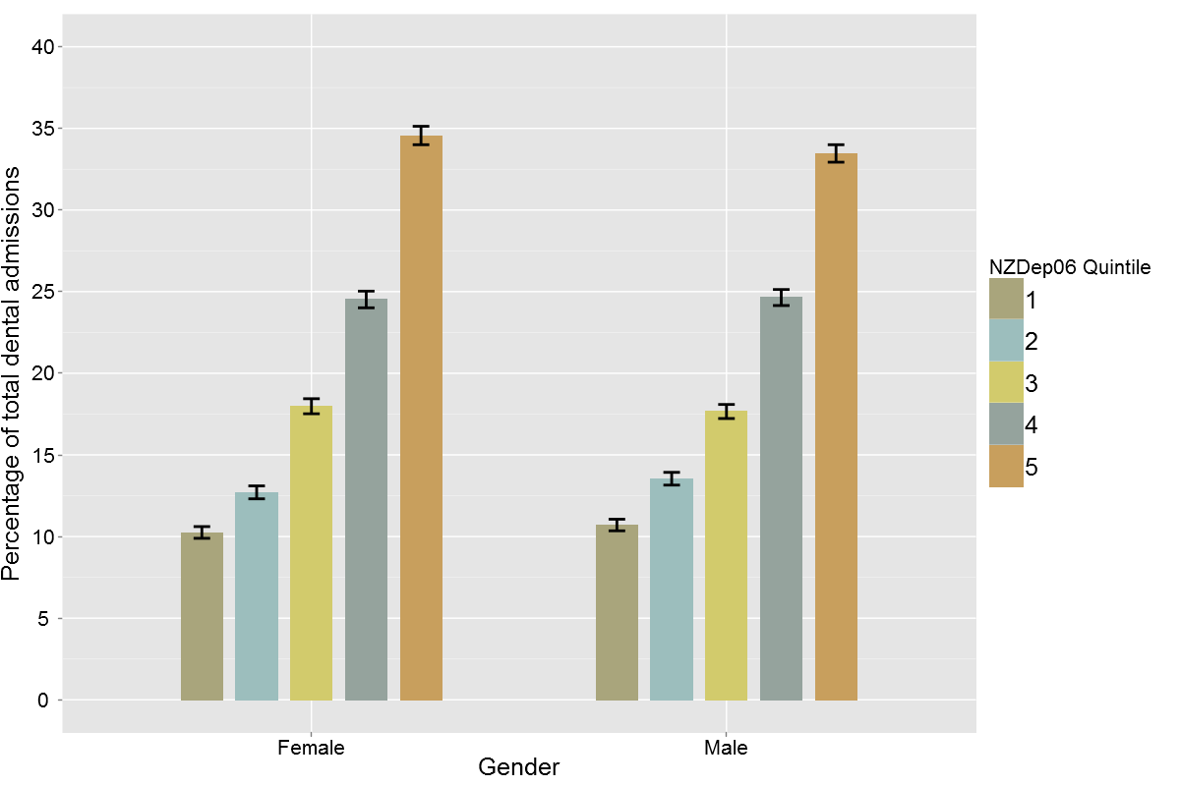
Figure 10 shows the percentage of admissions for each ethnic group by their deprivation index. For Maori, Pacific and Asian population groups the percentage of total dental admissions in the ethnicity group increased significantly with higher deprivation quintile. For Maori over 50% of the admissions to hospital for dental care were for people in NZDep quintile 5 (most deprived 20% of the population) and for Pacific people almost 65% were in NZDep quintile 5.
In the NZ European group, a similar relationship existed but the greatest percentage of admissions were in the NZDep quintile 4 and the admission profile by NZDep group was more evenly spread across the NZDep qunitiles.
Figure 10. Percentage of total hospital admissions for inpatient dental care by deprivation level for each ethnic group (2005 – 2009).
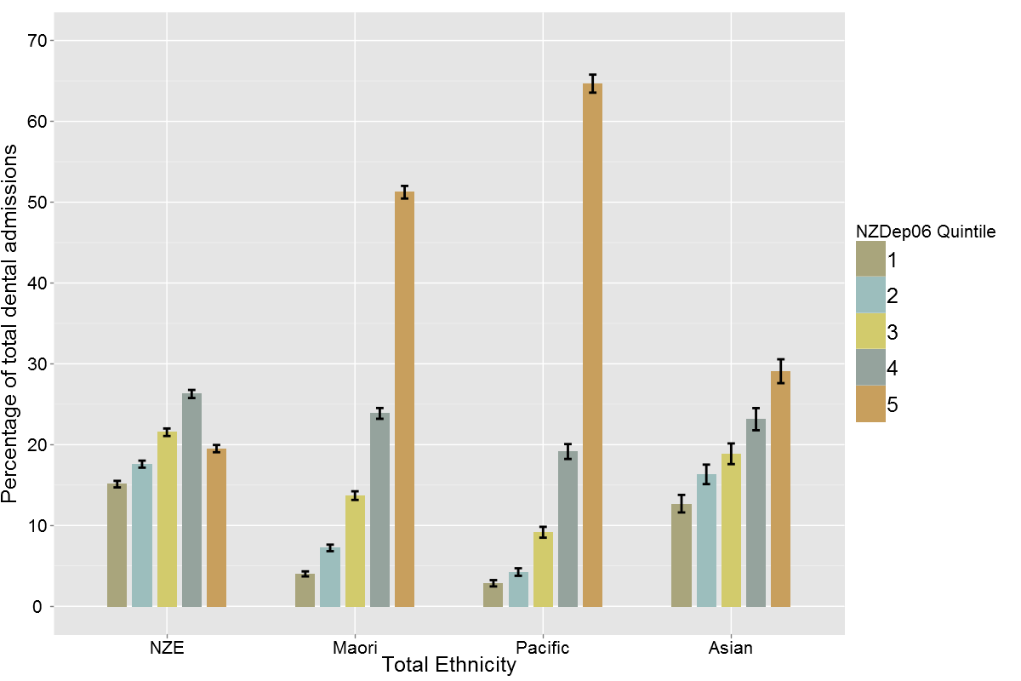
In all age groups, except the 75+ years group, the percentage of admissions increased with NZDep quintile score and were at their highest for the group of the population with greatest socio-economic deprivation (Figure 11). For people aged 55 years and over the relationship is less pronounced and the greatest percentage of admissions for people aged 75+ years was for people in NZDep quintile 4.
Figure 11. Percentage of total hospital admissions for inpatient dental care by deprivation level for each age group (2005 – 2009).
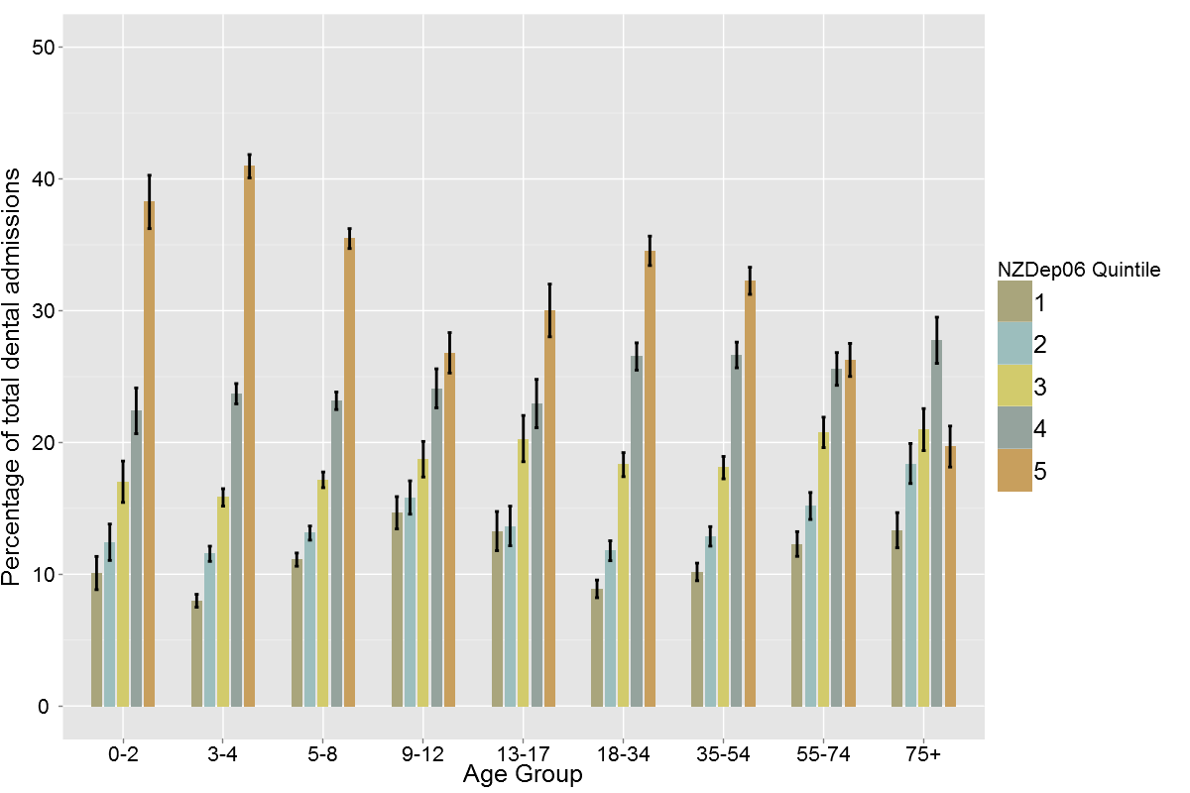

Discussion
In the 20-year period 1990-2009 over 150,000 people have been admitted to hospital for treatment of dental conditions or with dental conditions as a co-morbidity affecting their primary reason for admission. Approximately 80% of these admissions were primary admissions for dental treatment.
This study confirms that over the past 20 years a significant amount of hospital-based dental care has been necessary, mostly for young New Zealanders. In addition to the substantial increases in child dental care provided, there has also been a steadily increasing volume of care provided to adults involving admission to hospital for dental care. The substantial increases in the rate of admission throughout the early study period are likely to reflect changes to general anaesthetic standards. Whyman (2000) has previously reported a significant decrease in the provision of dental care under general anaesthesia in private dental practices in New Zealand through the 1990s. This was consistent with international moves towards more stringent anaesthetic safety practices for general anaesthesia to provide dental care (Department of Health 2000). These changes have increased demand for dental services requiring general anaesthesia through public hospitals.
Other causes for these increases are largely speculative in the absence of further research on the admitted groups. However, this study specifically considered admissions with admission codings that are consistent with “ambulatory sensitive dental conditions”. These are conditions for which hospitalisation is considered to be avoidable with the provision of appropriate preventive care and early disease management, that is usually able to be provided in outpatient and community based settings (Department of Human Services 2007).
It therefore appears reasonable to speculate that the admissions were, partially at least, the result of patterns of access to primary dental care through community-based dental practices, public dental services or outpatient-based hospital services. They are also likely to be the result of increasing dental disease in some population groups. They may reflect lack of primary prevention in both the child and adult population groups, and appear to at least partially reflect increasing difficulties with managing complex dental care needs in an aging adult population with greater retention of natural teeth.
The increases are consistent with international literature on this topic, and so are unlikely to reflect changes that are unique to New Zealand. In 2007 the Victorian Department of Human Services (2007) published a report similar to this research which examined the number of dental ambulatory care sensitive condition admissions in Victoria from 1997 to 2004. That study found that the rate of admissions per 1,000 population also increased over their study period varying from 2.2 in 1997-1998 to 2.9 in 2004-2005. This is similar to the findings of the present study with 1.8 and 2.7 per 1,000 of the population in approximately the same study times respectively.
In this study, the majority of admissions for dental treatment were in children aged 3-8 years. This is not unexpected due to lack of cooperation, high levels of disease in some populations and inconsistent access to fluoridated water but it is concerning given the significant investment in primary dental services for preschool and primary aged children through the community dental service.
The Victorian study also found that children (aged 0-9 years) accounted for the majority of dental admissions to hospital and reported a rate of 7.95 per 1,000 population compared with 1.9 per 1,000 population in people aged over 10 years. In contrast our study found that in children aged under 9 years during the period 2004-05 the rate of admission was 11.76 per 1,000 population and 1.62 per 1,000 population in children aged 9 years and over. These differences are difficult to explain, but may reflect differences in the organisation of primary and secondary dental services for children and adults between Victoria and New Zealand. They are also likely to reflect underlying differences in disease rates, influenced by population health measures such as water fluoridation, service coverage and societal and professional expectations about delivery of dental care for children and high needs adults.
Very few other large-scale investigations of dental admissions in all age groups exist, making comparison with the literature by age group difficult. It is generally assumed that children are more likely to access dental treatment and require a greater number of admissions. A large number of international studies exist which have specifically examined the level of treatment need and dental admissions of children, but few have investigated inpatient dental care in adults. Regardless of the actual numbers reported by these studies, all authors acknowledge that the level of admission is significantly higher in the child populations (Tennant et al., 2000; Alcaino et al., 2000; Wadhawan et al., 2003; Jamieson and Roberts-Thomson 2006a and b; Kruger et al., 2006; Moles and Ashley 2009; Quiñonez et al, 2009b).
Alcaino et al (2000) examined the number of children treated at a large paediatric dental unit in Western Sydney from 1984 to 1996. They found that the number of children treated increased steadily over the 13-year period, with a growth of over seven fold during the study period. The authors also found that the average age of children admitted did not change dramatically over the study period and, analogous to our study, more than two thirds of the patients treated were less than six years of age. Jamieson and Roberts-Thomson analysed national dental hospital admissions for Australian children aged 0-9 years requiring treatment under GA between 1993 and 2004. Similar to the present study, they found that the level of admissions increased three fold between 1993 and 2004 and that those aged 0-4 years had the greatest requirement for treatment.
Moles and Ashley (2009) described the characteristics of children admitted for dental care between 1997 and 2006 in England. They reported over 500,000 admissions for dental treatment and found the majority of children were young with 5-years of age being the most common age of admission. They also report an alarming increase in admissions; 66% between 1997 and 2006. Although not statistically significant, Moles and Ashley found that more females were admitted for dental treatment than males. This is in agreement with a number of studies of dental admissions in children (Tennant et al., 2000; Victorian Department of Human Services 2007) but differs from most literature that reports males, especially indigenous males, to require more admissions than females (Slack-Smith 2009, Jamieson and Roberts-Thomson 2006b). However, in the adult population the percentages of males and females requiring admission were found to be very similar. The majority of information available for gender comparison is for children. However, the Victorian study found that although males has slightly higher admission overall, this was more common in the child population, and female admissions slightly predominated from 15 years of age and older. As the rates of admission are similar in most studies, additional conclusions are therefore difficult to draw.
The present study found Maori and Pacific people to be more likely than NZ European people to have had a hospital admission for dental treatment. This finding is consistent with extensive literature that reports higher levels of dental disease in Maori and Pacific people, especially in young children (National Health Committee 2003; Ministry of Health 2010). However, the increases may also reflect the implementation of multiple ethnicity conventions in the description of ethnicity in official data collections.
International literature also reports that indigenous populations consistently show higher rates of admissions (Victorian Department of Human Services, 2007; Tennant et al., 2000; Cohen et al., 2003; Jamieson and Roberts-Thomson, 2006a, b). A study in Western Australia (Kruger et al., 2006) found that Aboriginal children aged 13-17 years were 31 times more likely to be admitted for dental treatment than non-Aboriginal and significantly more of the Aboriginal admissions were in male children.
In this study, even after age and ethnicity standardisation, the admission rates for Maori and Pacific populations are increasing at a higher rate than for NZ European people. This is most likely due to continued increases in dental disease in these at risk populations, but may also reflect later presentation for care with more advanced disease, concerns about appropriate knowledge of oral health and preventive care and difficulties with access to both publicly funded child dental services and privately funded dental services for adults.
Another explanation may involve social pressure to have care completed under general anaesthesia in some population groups. It may also be a consequence of an incentive to access dental care in a DHB environment where co-payment charges for outpatient visits are significantly lower than in private dental practice and where admission to hospital for dental care is not associated with any direct costs to the patient.
This study has found that significant regional variation existed in the rates of admission to hospital for dental care. These variations do reflect DHB of domicile and are not based on DHB of service. Southland, Whanganui and Nelson/Marlborough DHBs are shown to have the highest rates of admissions over the 20-year period when age and ethnicity standardised to the overall New Zealand population structure. Initial examination of these DHBs based on their child oral health data suggests that the reason for the high levels of admission is more complex than simply their underlying levels of dental disease. It is likely that the regional variation reflects a complex interaction of underlying disease levels, the relationship between the DHBs child dental services and the hospital dental unit, the size and staffing levels of the hospital dental units of differing DHBs, the numbers of people resident in the DHB area with significant disability, adult social deprivation and affordability and access to private dental care for adults.
Regional variation is not uncommon. The Victoria study, among others, found that children from rural regions were more likely to require a dental admission than those from metropolitan regions and that admissions for 0-14 year olds were significantly associated with lack of fluoridation coverage (Jamieson et al., 2006; Slack-Smith et al., 2009).
The findings of this report regarding the effects of deprivation levels on hospital admissions and the need for treatment concurs with what is already known about dental disease; that the more socioeconomically deprived the population the more likely they are to have treatment needs for dental disease. These findings are in agreement with a number of previous studies of the NZ population (Thomson et al., 2004; Thomson and Mackay 2004).

Length of Stay (Figures 12-14)
The majority of dental admissions involve only a day-stay admission. Consequently this study has not analysed the data with reference to a true length of stay. The data have been reported as the percentage of admissions that involved at least one night of admission to hospital. These admissions have been labelled as overnight stay.
The percentage of dental admissions with an overnight stay has decreased from 42.6% in 1990 to 11.7% in 2009 (Figure 12 shows temporal trends by gender). Overnight stays dropped 20 percentage points between 1990 and 1992 and continued to decrease at an annual rate of 0.9 percentage points until 2005. Overnight admissions have remained consistent between 10% and 12% since 2005.
Figure 12. Percentage of primary hospital admissions for inpatient dental care with an overnight stay by gender (1990 – 2009).
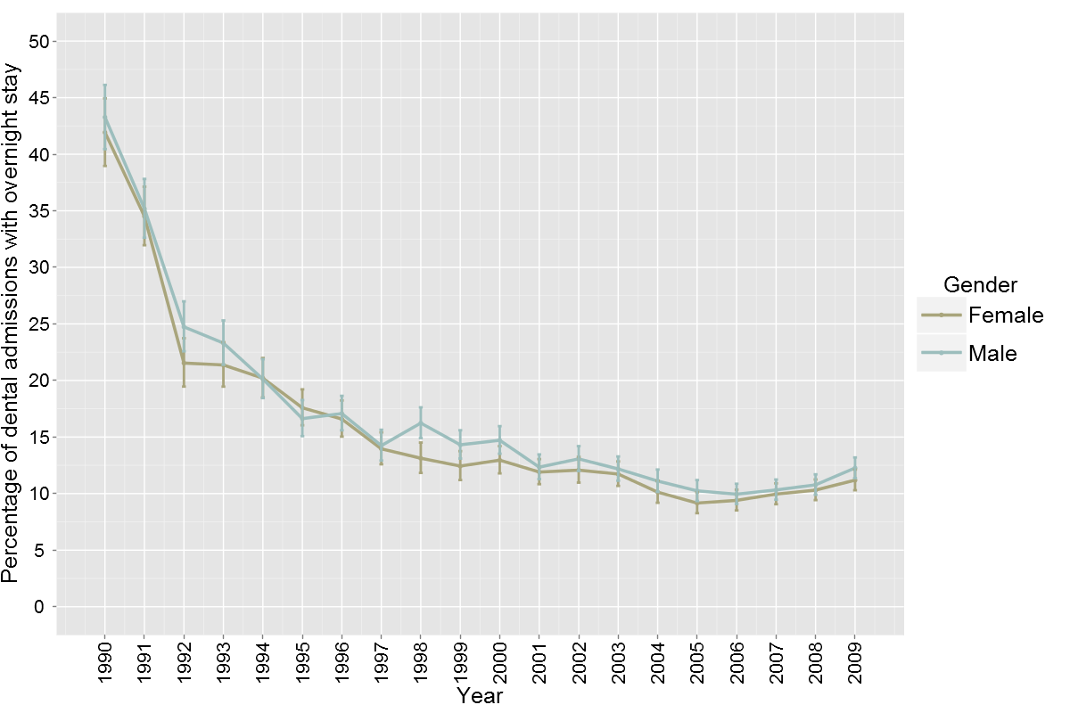

The downward trend in overnight stays was observed for all ethnicities and across all age brackets (Figures 13 and 14). From 1995 onwards, after the sharp decline in overnight admissions had occurred, the NZ European ethnicity group have consistently exhibited a significantly greater percentage of dental admissions with an overnight stay than all other ethnicities (Figure 13).

Figure 13. Percentage of primary hospital admission rates for inpatient dental care with an overnight stay by total ethnicity (1990 – 2009).
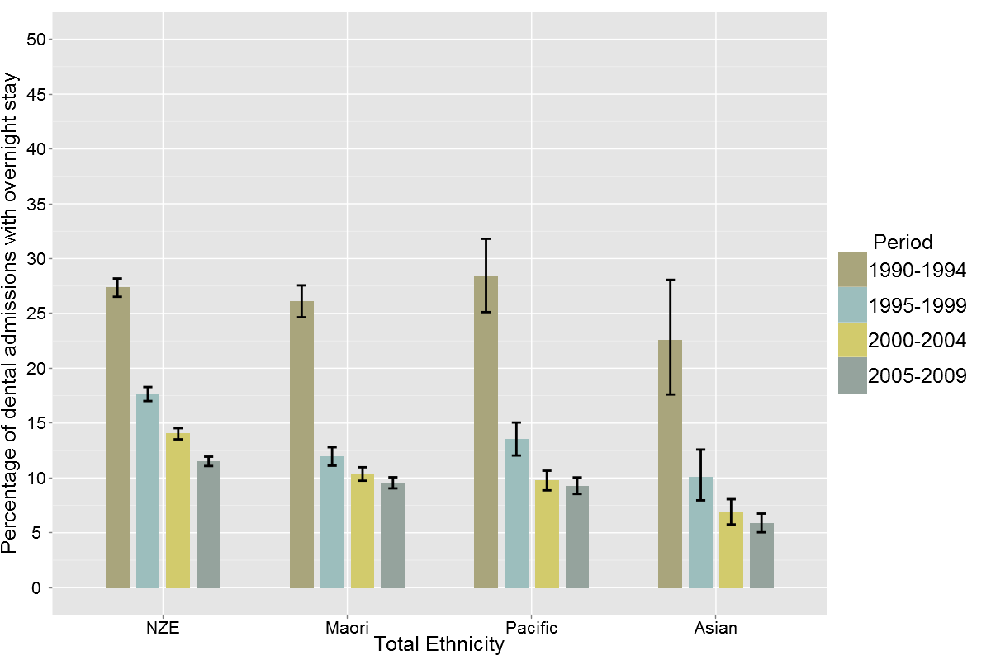
The lowest rates of overnight stay were seen in the 3-4-year-old and 5-8-year-old age groups (Figure 14) which, as reported earlier, had the highest rates of dental admissions. The percentage of admissions with an overnight stay increased with age and were most prevalent among adults aged 65 years and over. An overnight stay was involved for 30% of dental admissions in people aged 55-74 years and 44% of dental admissions for those aged 75 years and over in 2005-09. Between 1990 and 2009 overnight stays have decreased across all age groups.
Figure 14. Percentage of primary hospital admissions for inpatient dental care with an overnight stay by age group (1990 – 2009).
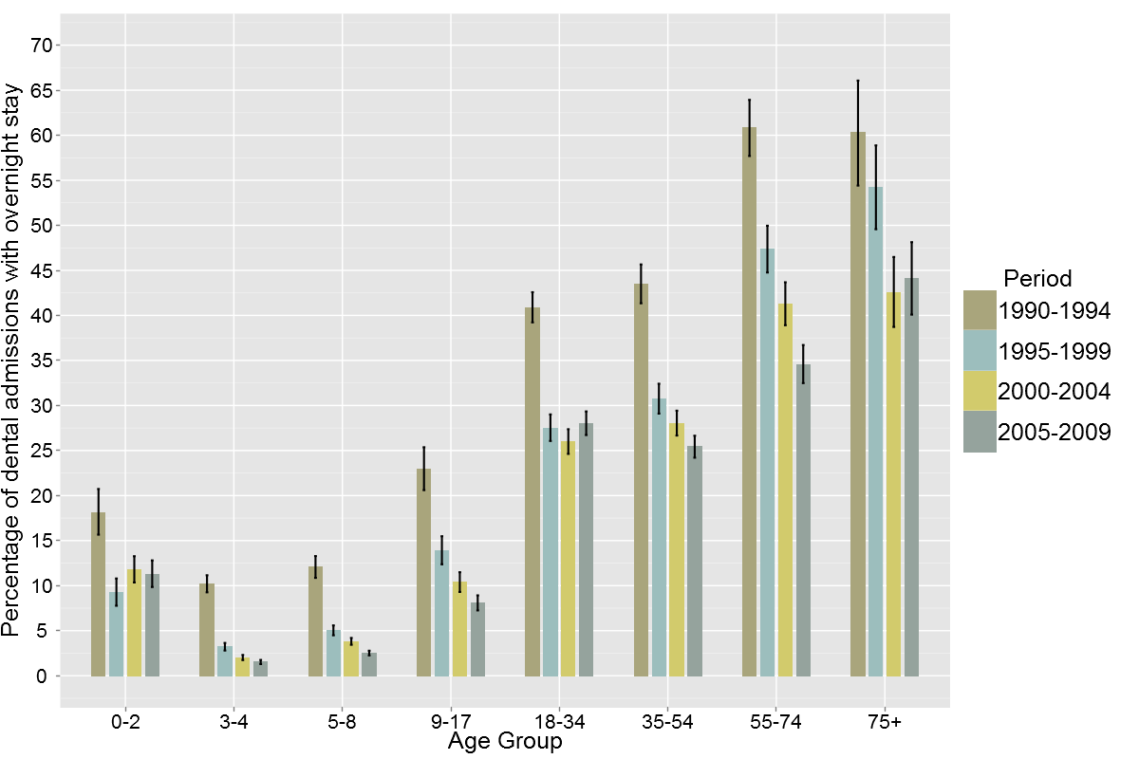

Discussion
The significant decrease in overnight stay associated with dental admissions demonstrated in this study during the period of the early 1990s is consistent with a substantial change to medical and dental practice. Over the past 20 years there has been a strong growth in day of surgery admission and day surgery procedures for dental care in fit and well people. The study confirms that hospitals in New Zealand have widely adopted the use of day surgery for hospital admissions for dental care.
Balogh et al 2004 reported that for people with an intellectual disability aged 20-64 years admitted to hospital for dental care in Ontario, Canada only 3.4% involved an in-hospital stay, with balance being managed with day surgery. Tennant et al 2000 reported that hospitalisation of children under 18 years for dental treatment in Western Australia in 1995 involved a total of 3754 hospital episodes using 4395 bed days, suggesting that 14.6% of the admissions involved an overnight stay.
It is difficult to draw strong comparisons with these studies as the populations under investigation are not directly comparable. However, this review of the New Zealand data for people aged under 18 years in the period 1990-1994 suggests day surgery rates were similar to those in Western Australia at a similar time (Tennant et al 2000).
The age related increase in overnight stays appears to be directly proportional to the change in the diagnoses reported in the section on reasons for admission and procedures undertaken in this study. With increasing age more complex diagnoses such as dental and oral disorders and mouth procedures for non-malignant conditions increased and treatments only involving dental extractions and restorations decreased.

Admission Types (Figures 15-17)
Dental admissions occur as bookings from the waiting list, arranged admissions or as an acute admission. These admission types are defined in the National Health Information Service’s National Minimum Dataset (Hospital Inpatient Events) Data Dictionary 2008 as follows:
Acute admissions – An unplanned admission on the day of presentation at the admitting healthcare facility.
Arranged admissions – A planned admission where the date of admission is less than seven days after the date the decision was made by the specialist that this admission was necessary.
Waiting list – A planned admission where the date of admission is seven or more days after the date the decision was made by the specialist that this admission was necessary.
Across the 20 year period of this study a very small number of admissions were recorded as ‘private’ or ‘psychiatric returned leave’ admission. They made up less than 0.2% of the total dental admissions and have been omitted from the descriptive analysis below.
In the period 2005-2009 75.1% of all dental admission were from the waiting list, 14.3% were arranged and 10.5% were acute (Figure 15).

Figure 15. Admission types as a percentage of hospital admissions for inpatient dental care (1990 – 2009).
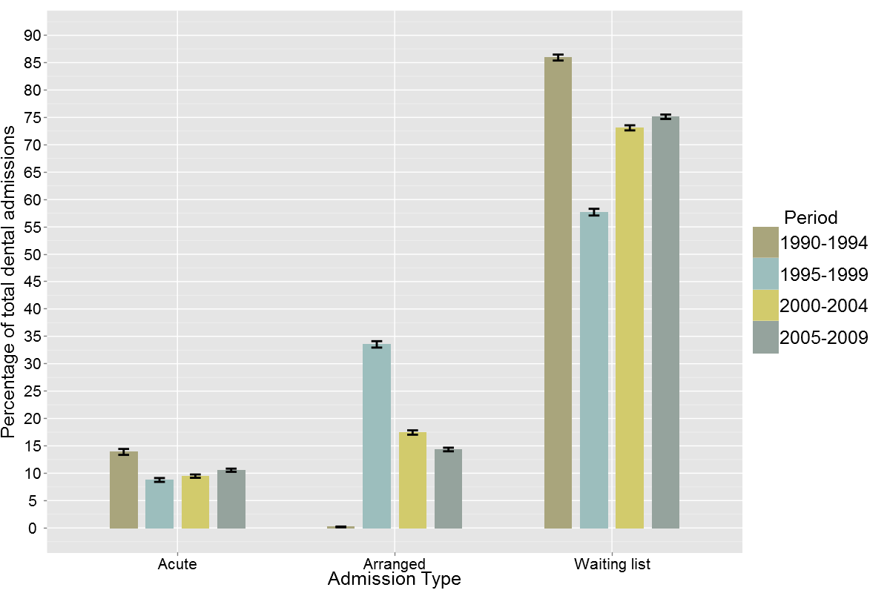

For every year, except 1996, the majority of dental admissions were from the waiting list (Figure 16). The same distribution of admission types was seen among the different ethnicities. Arranged and waiting list admissions are clearly co-dependent of each another.
Figure 16. Admission types of hospital admission for inpatient dental care (1990 – 2009).
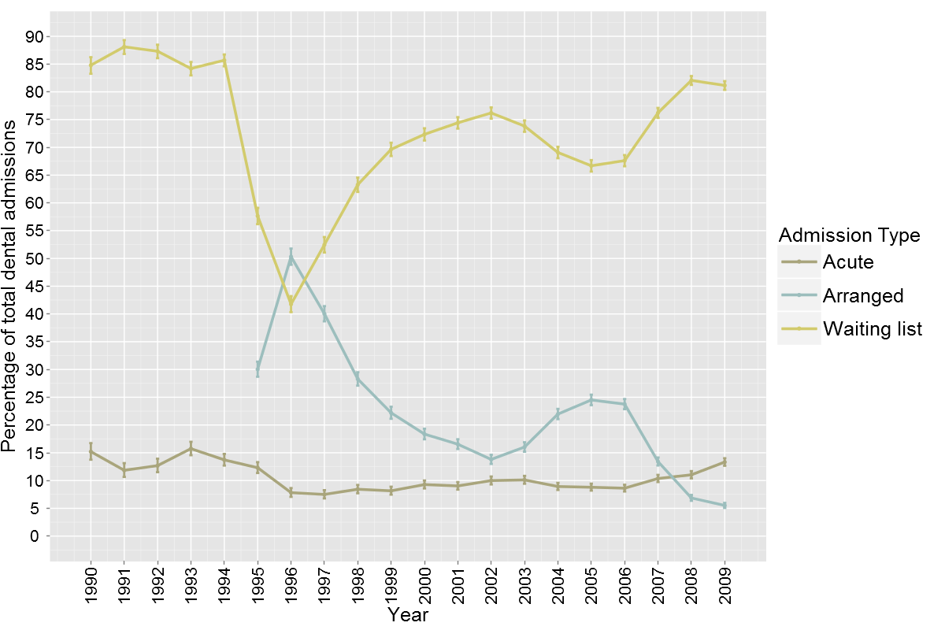
Waiting list admissions were the most common type of admission across all age groups. Arranged admissions occurred for between 7% of people aged 18-34 years and 17% of people aged 5-8 years between 2005 and 2009 (Figure 17). Of particular note were a significantly greater percentage of acute admissions for people aged 18 years and over. In the period 2005-2009 acute admissions comprised between 23% and 32% of dental admissions for people aged over 18 years (Figure 17). For people aged 18-34 years 32% of admissions to hospital for dental care occurred as acute admissions in the period 2005-2009.
Figure 17. Admission types as a percentage of hospital admissions for inpatient dental care by age group (2005 – 2009).
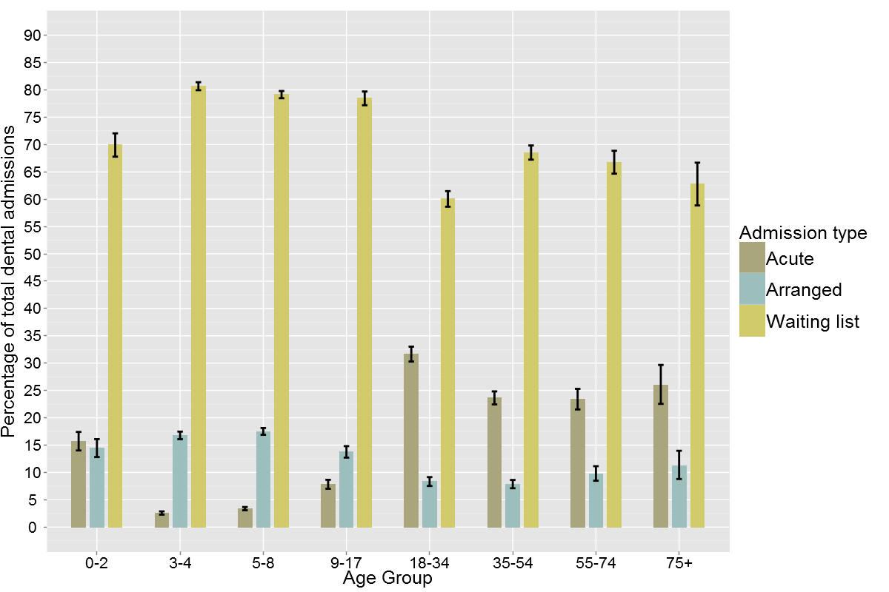

Discussion
Admissions to hospital that have been considered in this report are acute admissions, arranged admissions and waiting list admissions. Figure 16 records a number of changes to the patterns of admission in the mid-1990s that would appear largely the result of the introduction of changes to the definitions in the period 1994 – 96.
A decrease in arranged admissions as a percentage of total admissions between 1995-96 and 2004-05 was directly linked to a growth in the percentage of admissions from the waiting list. It is realistic that these admissions types are co-dependent as they reflect decisions by the consulting dentists or dental specialist as to whether the person needs to be admitted within 7 days, or can wait longer than 7 days.
Of perhaps greatest note in these data are the patterns associated with acute admissions. In children aged 3-12 years, acute admissions were 5% or fewer of all admissions. This result is similar to that in England between 1997 and 2006 reported by Moles and Ashley 2009 where 4.1% of dental admissions to hospital in the NHS were acute admissions and most of the remainder elective admissions.
In contrast, North American literature suggests acute access to hospitals by children for dental care is not uncommon. Ladrillo et al 2006 reported that in Houston, Texas between 1997 and 2001 there was a 121% increase in access to emergency departments for a dental complaint. The majority of these presentations were non-traumatic in nature and associated with dental caries or its sequelae that could have readily been managed in a primary dental care environment. Admissions to hospital from these emergency department presentations also increased as a result. Quinonez et al 2009 reported that over 17% of people presenting to emergency departments for dental care in Ontario, Canada were under 20 years.
Unlike the child data for New Zealand, acute admissions comprised a significant percentage of total dental admissions for people aged 18 years and over. Over 30% of admissions to hospital by people aged 18-34 years were acute admissions and the reasons for admission, also reported in this study, confirm that they were primarily the result of dental caries or its sequelae. It is a concern that acute admissions continue at over 20% of dental admissions to hospital throughout all other adult age groups.
Cohen et al reviewed Medicaid presentations for dental care at Maryland hospitals emergency departments between 1991 and 1995. They reported that 3639 people made 4326 claims during the period, suggesting a level of repeat attendance that may be as high as 18%. Of those people presenting to the emergency departments only 2% went on to a hospital admission also suggesting that the substantial majority of the issues causing the emergency department presentation could have been readily managed in a primary dental care setting. The mean cost of these admissions was US$5793, with a range from US$949 to US$43,524.
More recently, Burnham et al 2011 have reported increases in admission rates for oral and maxillofacial infection amongst adults and children at the Royal London Hospital and conjecture that this may be the result of changes to the NHS primary dental care contract for general dentists.
The acuity of presentation to hospital for dental care is most likely to be linked to the accessibility and the effectiveness of the primary dental care system. For children the availability of a school-based universal, free at point of access dental care service in New Zealand appears to be associated with a low and a stable level of acute presentation at hospital for dental care. However, the low proportion of acute admissions in children aged 3-12 years should be considered alongside the data, also in this report, that show these are the age groups with the highest rates of arranged admissions, the greatest increase in admission numbers and in the rates of admission.
Primary dental care access for adults in New Zealand is principally through user pays, private dental practices. Few safety nets are available to mitigate either accessibility or affordability of dental care. Although the admission rates and admission numbers for dental care amongst the adult age groups are relatively low, it is concerning that acute admissions make up such a significant proportion of these admissions. This result suggests that greater attention to accessible and timely access to primary dental care is necessary to deliver more timely dental care and to mitigate the effects of acute dental disease and the impact on hospitals.

Reasons for Admission and Treatment Provided (Figure 18-21 and Tables 4 and 5)
Of the 152,696 total dental admissions to hospital between 1990-2009, 120,046 had dental conditions coded as the primary reason for admission. A further 32,650 admissions recorded a dental coding as a secondary reason for the admission.
Dental diagnoses were coded as the primary reason for admission for a greater percentage of the total admissions with a dental coding in the dataset 1990-1994 than in the subsequent year groups (Figure 18).
Among children aged 3-8 years admitted to a hospital with dental diagnosis coded in association with the admission, the dental diagnosis has remained the principal reason for admission in over 90% of cases over the time period of this study (Figure 18).
However, with increasing age an increasing proportion of people admitted with a dental diagnosis had the dental diagnosis coded as a secondary reason for admission (co-morbidity). This is particularly notable in the datasets of people admitted after 1995.
The increase in percentage of people for whom a dental diagnosis was a co-morbidity is most apparent in the 55 years and over age groups. In the datasets of people admitted from 2000 onwards dental was coded as the primary reason for admission in only 40% or fewer of cases. In other words, in over 60% of people admitted aged 55 years or over the dental diagnosis was coded as a co-morbidity to their primary reason for admission.
Figure 18. Percentage of hospital admissions for inpatient dental care with dental as the primary diagnosis by age group (1990 – 2009).
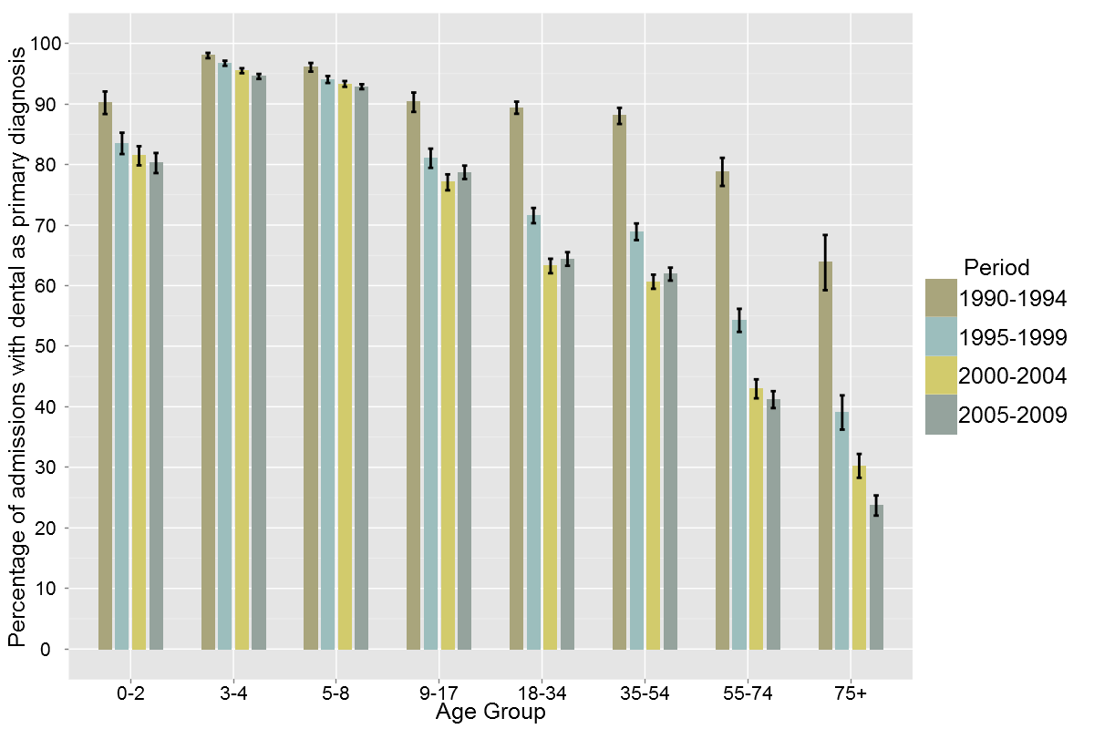
Dental diagnoses were coded as the primary reason for admission for a similar percentage of the group by ethnicity throughout the time periods examined in this study. A lower percentage of New Zealand European people with dental diagnosis as the primary reason for admission is evident. This is consistent with the age pattern of New Zealand European people admitted to hospital for dental care and the greater proportion of older people admitted to hospital with dental diagnoses as a co-morbidity reported above (Figure 19).
Figure 19. Percentage of hospital admissions for inpatient dental care with dental as the primary diagnosis by total ethnicity (1990 – 2009).
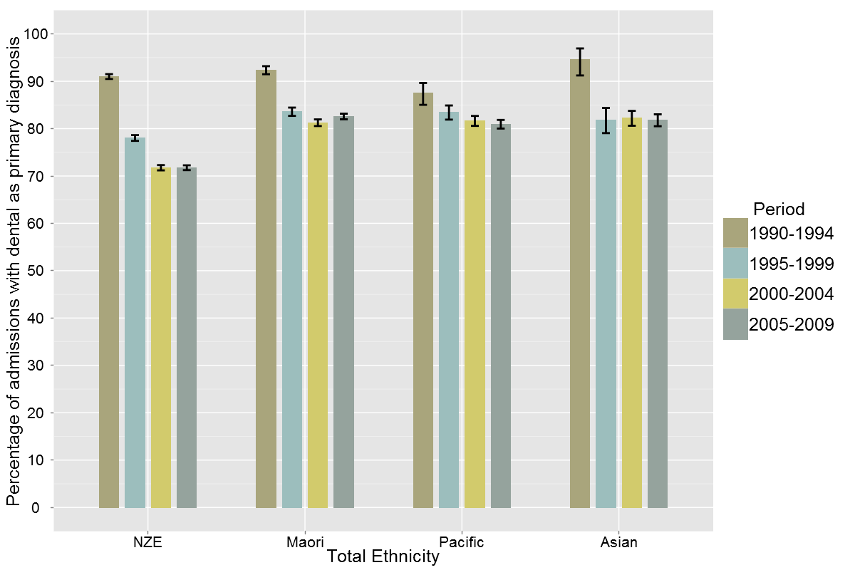
Admissions with a primary dental diagnosis were analysed by ICD 10 CM codes for the time periods 1990-1994 and 2005-2009, the start and end of the time period of this study (Table 4). In all age, gender and ethnicity groups dental caries (K02) accounted for approximately 76% of all of the dental admissions. Diseases of the pulp and periapical tissues (K04) contributed a further 9% of admissions in 1990-1994 and 12% in 2005-2009. A range of other disorders of the teeth, gums, mouth and supporting structures contributed to the other reasons for dental admissions and the range of diagnoses reported had increased in the later time period of this study.
Table 4. Hospital admissions for inpatient dental care by principal diagnosis ICD code (1990-1994 and 2005 – 2009).
ICD  Code |  | Percentage of primary dental admissions (95% CI)
 | Description | 1990-1994 | 2005-2009
K02 | Dental caries | 77.1 (76.5 - 77.8) | 75.6 (75.2 - 76.0)
K03 | Other diseases of hard tissues of teeth | 1.6 (1.4 - 1.8) | 1 (1.0 - 1.1)
K04 | Diseases of pulp and periapical tissues | 9.2 (8.7 - 9.6) | 12.4 (12.1 - 12.7)
K05 | Gingivitis and periodontal diseases | 3.6 (3.3 - 3.9) | 2.8 (2.6 - 2.9)
K06 | Other disorders of gingiva & edentulous alveolar ridge | 0.04 (0 - 0.1) | 0.4 (0.3 - 0.4)
K08 | Other disorders of teeth and supporting structures | 1.5 (1.3 - 1.7) | 1.8 (1.6 - 1.9)
K09 | Cysts of oral region, not elsewhere classified | not recorded | 0.3 (0.2 - 0.3)
K12 | Stomatitis and related lesions | 1.6 (1.4 - 1.8) | 3 (2.8 - 3.2)
K13 | Other diseases of lip and oral mucosa | 5.4 (5 - 5.7) | 2.8 (2.7 - 3.0)

Treatment procedures provided have only been able to be coded by Diagnosis Related Grouping (DRG) codes as this is the level of specificity with regard to treatment undertaken that exists within the NMDS dataset. Table 5 presents all admissions with a primary dental diagnosis by DRG code, illustrating that for the 1990-1994 and 2005-2009 period dental extractions and restorations consistently comprised 84% of the dental treatments provided. A further 11% of people received treatment for dental and oral disorders except extractions and restorations and 3.6% had mouth procedures for non-malignant conditions.
Dental extractions and restorations made up the majority of treatments provided for all age groups, although after the age of 13 years the proportion steadily declines (Figures 20 and 21). Treatment comprising “dental and oral disorders except extractions and restorations” and “mouth procedures for non-malignant conditions” feature in the 0-2 year age group and increasingly in the adolescent and adult groups admitted to hospital for dental care and in a greater proportion of people admitted to hospital for dental care in 2005-09 than in 1990-94.
Table 5. Hospital admissions for inpatient dental care by DRG code (1990 – 1994 and 2005 – 2009).
 | Percentage of total dental admissions (%)
Description | 1990-94 | CI (%) | 2005-09 | CI (%)
Dental extractions and restorations | 83.4 | 82.8 - 83.9 | 83.8 | 83.4 - 84.1
Dental and oral disorders except extractions and restorations | 11.2 | 10.7 - 11.7 | 11.7 | 11.4 - 12.0
Mouth procedures for non-malignant conditions | 4.7 | 4.3 - 5.0 | 3.6 | 3.5 - 3.8
Other | 0.8 | 0.6 - 0.9 | 0.9 | 0.8 - 1.0

Figure 20. Hospital admissions for inpatient dental care by DRG code and age group (1990 – 1994).
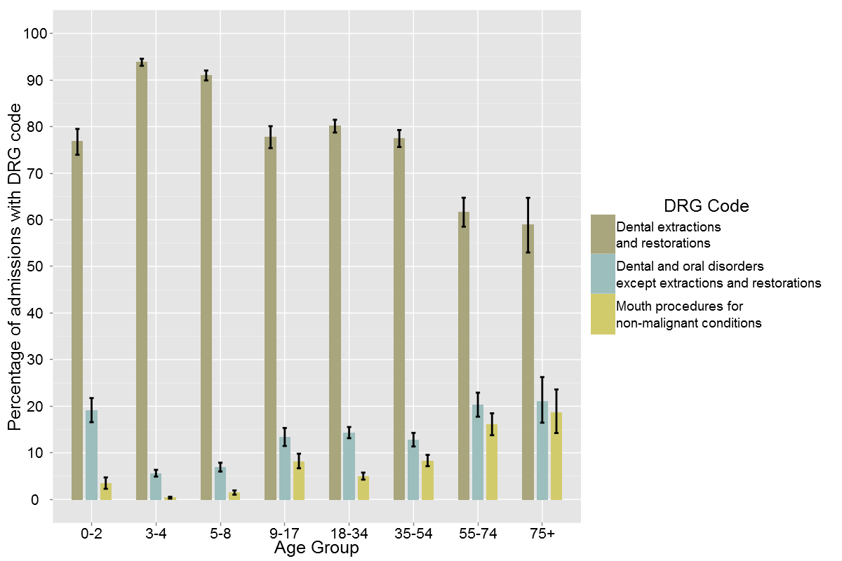

Figure 21. Hospital admissions for inpatient dental care by DRG code and age group (2005 – 2009).
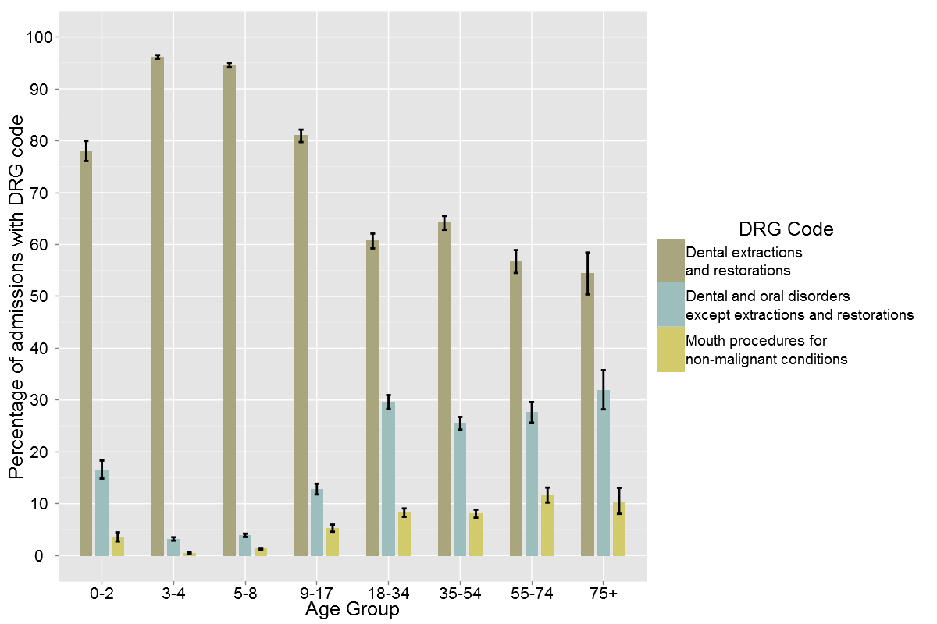

Discussion
Little discussion or comparative data could be found in the literature examining the proportion of admissions to hospital where a dental diagnosis had been coded as a primary reason for admission, as opposed to being coded as a co-morbidity.
In this study it is particularly apparent that in children dental conditions are most frequently coded as the primary reason for admission and therefore the principal driver of the admission to hospital.
However, dental conditions appear related, in a more complex way, to another principal reason for admission in the adult population aged 55 years and over. This would be consistent with dental conditions being identified as co-morbidities associated with, or complicating, a hospital admission. It is also notable that there appears to be an increasing trend for dental co-morbidity in the older adult group, which would be consistent with an aging dentate population where dental conditions are complicating other health conditions and resulting in hospital admissions.
Dental caries as the principal dental reason for admission is consistent with Australian and other international data. The Victorian Department of Human Services (2007) reported that diagnoses for dental caries accounted for 71% of Victorian admissions to hospital for dental reasons in 2004-05 and disease of the pulp and periapical tissues 9.8%. This study used the same subset of dental ICD codes as the Victorian Department of Human Services study and has very similar findings.
Moles and Ashley (2009) reported that dental caries was the leading reason for dental admissions, accounting for 51.5% of the admissions, but reported on a wider set of dental admissions codes including disorders of tooth development and eruption (K00), embedded and impacted teeth (K01) and dentofacial anomalies (K07). These codes were omitted from this study to provide direct comparability of the New Zealand dataset to the 2007 Victorian Department of Human Services study and because the additional diagnoses are more likely to account for oral and maxillofacial surgery admissions to hospital than dental admissions, which are the subject of this study. In the Moles and Ashley study disorders of tooth development and eruption (K00) accounted for 7.9% of the reasons for admission, embedded and impacted teeth (K01) 11.9% and dentofacial anomalies (K07) 10.7%.
It is almost certain that in addition to the admissions captured in this study a further, smaller but significant group of people are being admitted to hospital in New Zealand for maxillofacial and/or dental care for conditions associated with these diagnoses. If the New Zealand levels of admission are similar to the UK data, this group could comprise of up to a further 3000 admissions per year across a variety of surgical disciplines.
Quinonez et al 2009a reported dental caries as the principal reason for admission for dental day surgery in Ontario Canada in all age groups except 15-24 years, when impacted teeth became the leading cause for admission. Once again this study included the full range of ICD K00 to K14 codes and so would have reported both dental and oral and maxillofacial surgical admissions.
Interestingly, an associated study by Quinonez et al 2009b examined emergency department visits for dental care not arising from trauma. Periapical abscess and non-specific toothache were reported as the leading causes for presentation, with dental caries a relatively infrequent coding. However, periapical abscess and non-specific toothache are generally late manifestations of complications from dental caries and it appears the differences are only in relation to the presentation, severity and coding of the conditions. The study supports the finding that dental caries is the leading cause for presentation. In the emergency department study 93% of the patients were triaged and discharged without admission to hospital.
Tennant et al 2000, Kruger et al 2006 and Slack-Smith et al 2009 have also reported dental caries as the leading cause for dental admissions of children under 5 years in Western Australia, and similarly Wadhawan et al 2003 reported a similar finding in New York State. Interestingly Tennant et al 2000 and Kruger et al 2006 have found that although dental caries is a leading cause of admission, impacted and unerupted teeth were also a significant cause of dental admissions to hospital. They expressed concern that this appeared to reflect proportionately high levels of admission for removal on impacted third molar teeth in high school aged children in Western Australia compared to other reasons for dental admission to hospital.
Given that dental caries is the leading cause of dental admissions it is unsurprising that the most commonly provided treatments are dental extractions and restorations. Again little comparative data exists. The Department of Human Services, 2007 reported similar treatment patterns, but using ICD 10 Australian Classification of Health Intervention Codes 2002. They reported that 41% of treatments involved surgical removal of teeth, 35% non surgical removal of teeth and only 13% fillings. This range of treatments would be collectively captured as dental extractions and restorations in the DRG coding available for this study which were reported at a similar level at 83% of the treatments provided. However, it is not possible in this study to further differentiate the nature of the treatments being provided.

Repeat Admissions for Dental Care (Figure 22-25)
Repeat admissions describe individuals with a primary dental admission who were readmitted to hospital for a further episode of dental care within a 4-year period (see methods section in Appendix 1 for detailed description).
Between 1990 and 2004 76,080 individuals were admitted to hospital with a primary dental diagnosis. This number is smaller than reported in other sections of this report as it excludes admissions in the final 5-year period (2005-2009). Of those individuals 4,268 were admitted again for a dental reason within 4 years of the original admission. This represents an overall readmission rate of 5.6%.
As shown in Figure 22 the overall proportion of people with more than one admission for dental care fluctuated between 4.5% and 6.6% through the study period. The proportion of females with a repeat admission was slightly lower over the time period, but no significant or consistent pattern was discernable by gender or over the time period.

Figure 22. Percentage of people who had one or more repeat admissions for inpatient dental care following a first admission (1990 – 2004).
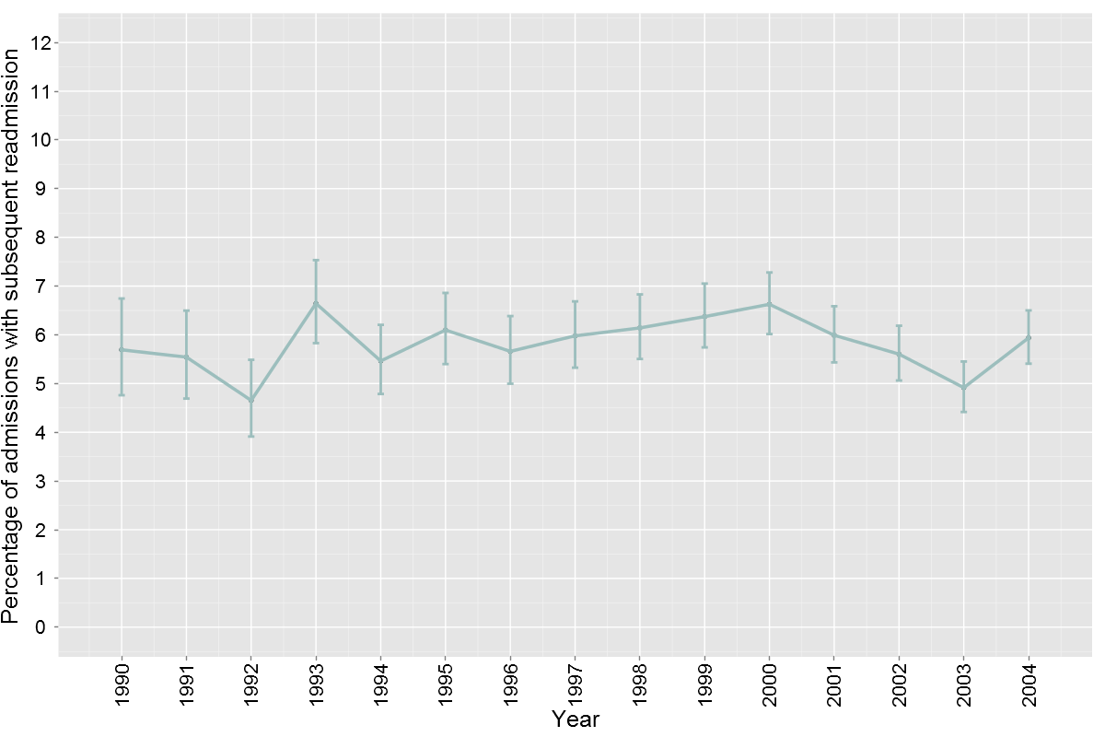
Repeat admission varied significantly by ethnicity across the period 1990-2005. For both Maori and NZ European the rates fluctuated. For Pacific and Asian groups the rates increased significantly through the time period (Figure 23).
Figure 23. Percentage of repeat admissions for inpatient dental care by total ethnicity (1990 – 2004).
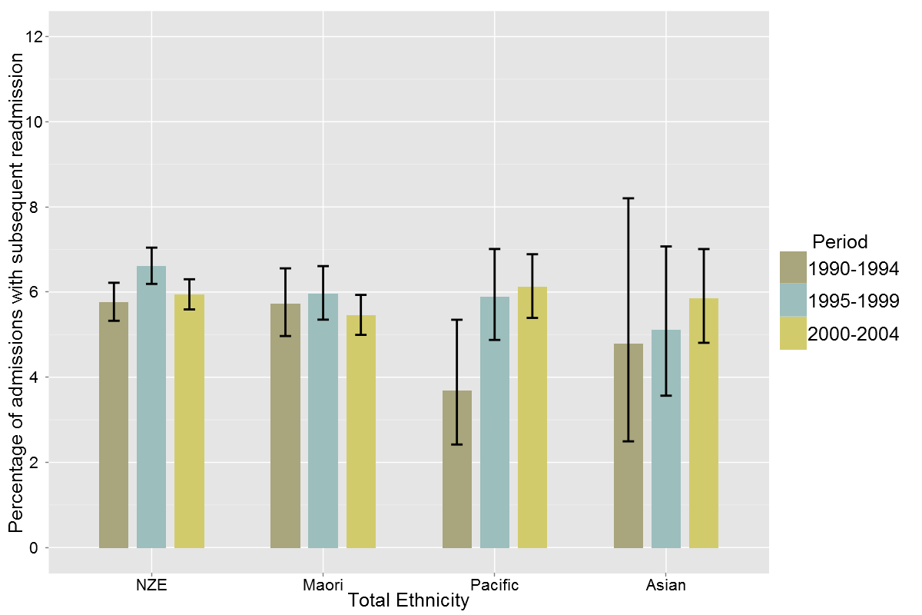
Repeat admissions to hospital varied significantly by age groups (Figure 24). Repeat admissions were greatest, at over 7%, in those patients aged 0-2 and those between 9 and 24 years of age.

Figure 24. Percentage of repeat admissions for inpatient dental care by age group (1990 – 2004).
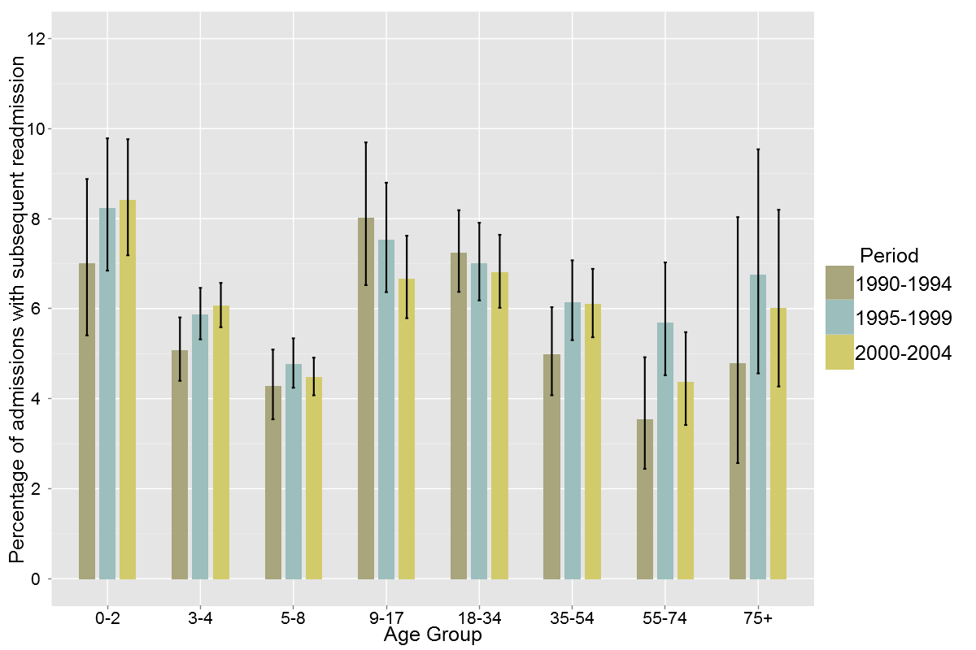
Repeat admission to hospital for dental care has been reported between DHBs for the period 2000-2005 and varied between 2.6% and 9.1% of people admitted (Figure 25).

Figure 25. Percentage of repeat admissions for inpatient dental care by DHB of domicile (2000 – 2004).
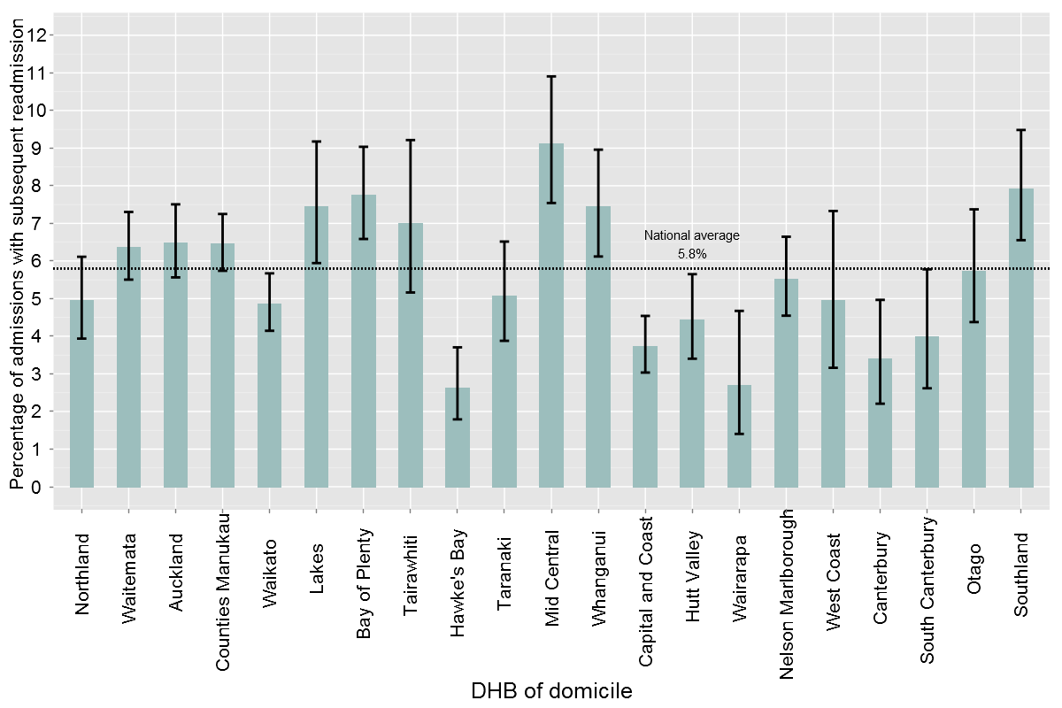

Discussion
This study found an overall readmission rate for dental care of 5.6%, within 4 years of a first admission during the period 1990-2004. The level of readmission appears to have remained remarkably stable and was 5.8% for the period 2000-2004. This level of readmission across the New Zealand admitted population appear similar to, or lower than, other readmissions rates available in, or able to be calculated from, the published literature.
Readmission rates for children admitted to hospital for dental care in the UK and Australia appear somewhat higher than those found in these New Zealand data. UK and Australian studies of children have reported readmission rates of approximately 8-10%. Moles and Ashley (2009) reported on 517,885 episodes of hospital admission for dental care in the English NHS for children aged up to 17 years between 1997 and 2006. These episodes of care related to 470,113 children creating a readmission rate of 10.1%. Similarly Slack-Smith et al 2009 reported 11,523 admissions in the first 5 years of life for 10,493 children born and resident in Western Australia between 1980 and 1995. This represented a readmission rate of 9.8%. O’Sullivan and Curzon reported in 1991 that 8.8% of British children needed a second general anaesthetic within 3-years of their initial treatment.
In contrast, Quinonez et al 2009 examined day surgery hospital admissions for children and adults in Ontario, Canada over 3 fiscal years from 2003/04 to 2005/06 and reported 79,133 episodes of dental care for 75,791 people, giving a readmission rate of 4.5%. While the Canadian study examined both adults and children it is unlikely to be highly comparable as the data set only examined day surgery admissions, while this study examined all admissions, including people who had stays of one or more night in hospital. It is therefore likely that this study represents a wider patient base with more complex dental or medical situations.
The overall readmission levels in this study are greater than those reported in studies of children undergoing dental care under general anaesthesia in two previous New Zealand studies. Thomson 1994 reported a readmission rate of 4.2% for children admitted at Palmerston North Hospital in the period 1989–1994. Drummond et al 2004 reported a readmission rate with general anaesthesia of 5.1% for care undertaken under general anaesthesia on children through the University of Otago School of Dentistry in Dunedin between 1997-1999 by six operators.
While this study found higher readmission rates than previous New Zealand studies, data for both children and adults admitted to hospital for dental care were examined. Most of the previously cited studies have only reported data for child admissions. When these studies are considered against the readmission rates for children aged 3-8 years in this study, they are very similar. It therefore appears that age is an important factor in the readmission rates for dental care.
Variation in the readmission rate will depend on a variety of factors, but it is particularly important to consider the nature of the admitted population, the range of oral conditions and the period of follow up associated with the reported readmission rate. Higher repeat admission rates for very young children admitted for care may relate to recurrence of dental caries within the four-year timeframe, and at an age that is still too young for the child to be managed in a primary care environment. Higher rates for people aged 13-44 years may be related to the strong association of intellectual disabilities for adults admitted to hospital for dental care.
Readmission to hospital with a primary dental diagnosis may occur for a variety of reasons. It is well recognised that in many children further dental caries occurs following an episode of treatment of dental caries under general anaesthesia (Drummond et al 2004). In addition to the occurrence of new primary disease, readmission may be the result of decisions to stage treatment, special needs patients who require periodic treatment under general anaesthesia amongst the treated population group, parental and/or clinician preferences to treatment under general anaesthesia, and absence of adequate primary preventive care programmes (Schroth et al 2007; Quinonez et al 2009)
It is also important to consider the period of follow up of the population group from the time of initial admission when reporting the readmission rates. Rates may be artificially lowered by a short period of follow up from the date of last admission. To minimise the risk of under reporting as a result of short follow up this study examined a period of four years from the date of initial admission and therefore was only able to consider the readmission rate for people admitted up until 2005.
The follow up period is not always clear from reported studies, but Drummond et al 2004 described events over a 2-4 year period following initial treatment. Four years was chosen in this study to provide an ability to compare to the longest follow up period in this New Zealand study and to provide sufficient time for new disease or complications from treatment to have appeared.
Significant regional variation was also found in this study with DHB readmission rates ranging from 2.6% to 9.1%. These variations are likely to reflect a mixture of the predominant age of access of the treated population at each DHB, the level of access to private and public dental care in the community, the service philosophy of the dental service both at a community level in the school dental service and at a hospital level in relation to the management of adult patients with special needs, and the successfulness of treatment provided at the first hospital admission. It is not possible to speculate in a report of this nature on the issues at individual DHBs, but variation of the scale reported in this study warrants further investigation at DHB level.
While some literature on repeat admission rates is available it is also difficult to establish a view on the “right” rate for a DHB without understanding that DHBs service mix for the population. While higher repeat admission rates may reflect a level of avoidable admission, they may also reflect better access to ongoing care for people with special needs. Low readmission rates may be unduly influenced by predominant child access and limited access by special needs adults.

Hospital Discharges by Case Weighting (Figures 26-30 and Tables 6 and 7)
All hospital admission events captured in the National Minimum Dataset by the Ministry of Health are assigned a case weighted discharge (CWD) value. Case weight values are a method to measure the resources required for a patient’s treatment during each admission to hospital. The CWD value is established through a periodic DHB pricing program and published in a joint document with the Ministry of Health (New Zealand Casemix Framework for Publicly Funded Hospitals 2009/10).
Case weighting in relation to dental admissions to hospital has only been considered for primary dental admissions. While case weightings for hospital admissions (costweights) are in the dataset from 1 July 1999 onwards they have been reported in this study from 2001 onwards as the data had stabilised and appeared consistent in the dataset from this time.
The total number of case weighted discharges was relatively stable in the period 2001 to 2004, but shows a sharp increase throughout the period of 2004 to 2007 followed by a subsequent reduction during 2007-09 (Table 6). Case-weights have followed a completely different pattern to the number of admissions for dental care through the period. Initially the two indicators were closely correlated but throughout the period 2004 -2009 case weighting initially increased well ahead of the rate of increase in the number of admissions and then in the period 2007-2009 they have declined in relation to the increase in the number of admissions (Figure 26).

Table 6. Case weighted admissions for inpatient dental care with dental as the primary diagnosis (2001 – 2009).

Year | Total Admissions | Sum of caseweights | Median caseweight
2001 | 6969 | 3159.1 | 0.44
2002 | 6911 | 3143.4 | 0.43
2003 | 7165 | 3256.3 | 0.43
2004 | 7769 | 3595.7 | 0.43
2005 | 8065 | 4204.1 | 0.61
2006 | 8404 | 5058.1 | 0.61
2007 | 8720 | 5145.4 | 0.61
2008 | 9025 | 4972.5 | 0.53
2009 | 9758 | 4773.8 | 0.45

Figure 26. Total admissions and summed case weighting for inpatient dental care with dental as the primary diagnosis (2001 – 2009).
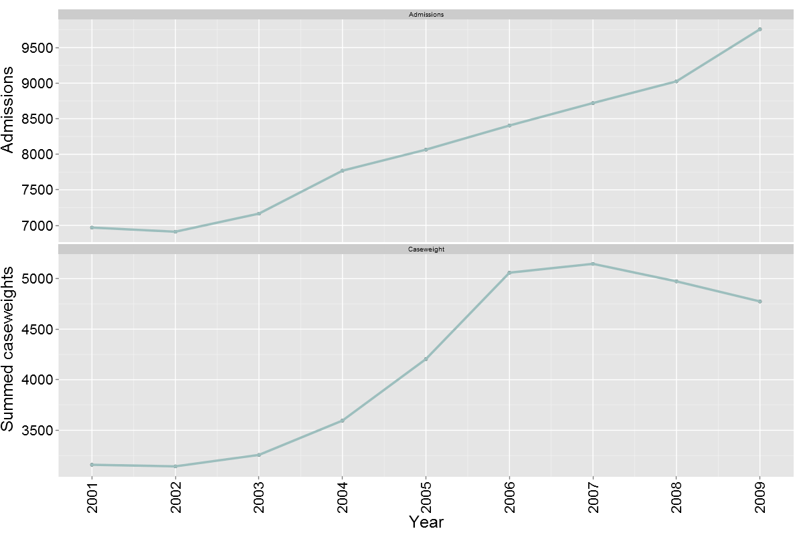

To assess the changes in case complexity, as opposed to increased volumes of admissions, the annual median case weighting of dental admissions has been examined by age group (Figure 27). During the 2001-04 period the median case was 0.43, this subsequently increased to 0.61 in the period 2005 to2007 followed by a decrease to 0.53 in 2008 and 0.45 in 2009. There appears to be little discernable difference in the median case weighting by age group throughout this period.
Figure 27. Median caseweighting of admissions for inpatient dental care with dental as the primary diagnosis by age group (2001 – 2009).
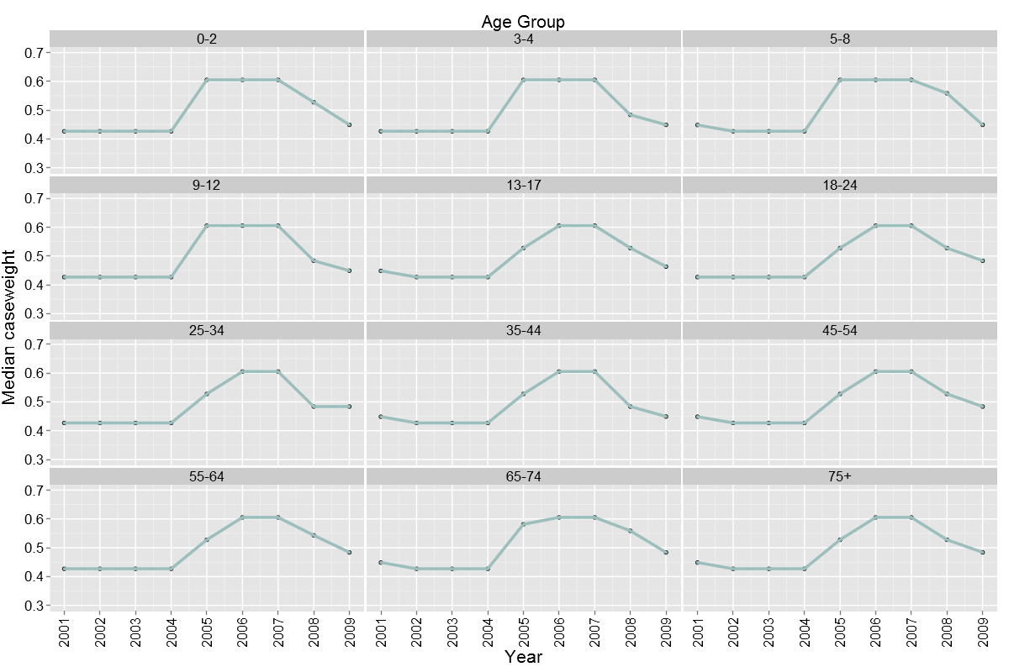
Inter-DHB comparison of the median case weighting for primary dental admissions across DHBs (Table 7) shows a high level of consistency in weightings but that DHB variation in median case weighting has occurred as the median case weights have reduced in years 2008 and 2009.

Table 7. Median case weighting of admissions for inpatient dental care with dental as the primary diagnosis by DHB (2001 – 2009).
 | 2001 | 2002 | 2003 | 2004 | 2005 | 2006 | 2007 | 2008 | 2009
Northland | 0.45 | 0.43 | 0.43 | 0.43 | 0.61 | 0.61 | 0.61 | 0.48 | 0.45
Waitemata | 0.43 | 0.43 | 0.43 | 0.43 | 0.61 | 0.61 | 0.61 | 0.53 | 0.48
Auckland | 0.45 | 0.43 | 0.43 | 0.43 | 0.53 | 0.61 | 0.61 | 0.53 | 0.48
Counties Manukau | 0.43 | 0.43 | 0.43 | 0.43 | 0.59 | 0.61 | 0.61 | 0.48 | 0.45
Waikato | 0.43 | 0.43 | 0.43 | 0.43 | 0.61 | 0.61 | 0.61 | 0.53 | 0.45
Lakes | 0.43 | 0.43 | 0.43 | 0.43 | 0.61 | 0.61 | 0.61 | 0.48 | 0.48
Bay of Plenty | 0.45 | 0.43 | 0.43 | 0.43 | 0.43 | 0.61 | 0.61 | 0.48 | 0.48
Tairawhiti | 0.45 | 0.43 | 0.43 | 0.43 | 0.61 | 0.61 | 0.61 | 0.56 | 0.45
Taranaki | 0.43 | 0.43 | 0.43 | 0.43 | 0.61 | 0.61 | 0.61 | 0.61 | 0.45
Hawke's Bay | 0.45 | 0.43 | 0.43 | 0.43 | 0.43 | 0.61 | 0.61 | 0.53 | 0.48
Mid Central | 0.43 | 0.43 | 0.43 | 0.43 | 0.58 | 0.61 | 0.61 | 0.48 | 0.45
Whanganui | 0.43 | 0.43 | 0.43 | 0.43 | 0.53 | 0.61 | 0.61 | 0.48 | 0.45
Capital and Coast | 0.43 | 0.43 | 0.43 | 0.43 | 0.58 | 0.61 | 0.61 | 0.48 | 0.45
Hutt Valley | 0.45 | 0.43 | 0.43 | 0.43 | 0.43 | 0.61 | 0.61 | 0.56 | 0.45
Wairarapa | 0.43 | 0.43 | 0.43 | 0.43 | 0.61 | 0.61 | 0.61 | 0.48 | 0.45
Nelson Marlborough | 0.43 | 0.43 | 0.43 | 0.43 | 0.61 | 0.61 | 0.61 | 0.61 | 0.48
West Coast | 0.45 | 0.43 | 0.43 | 0.43 | 0.61 | 0.61 | 0.61 | 0.61 | 0.48
Canterbury | 0.45 | 0.43 | 0.43 | 0.43 | 0.61 | 0.61 | 0.61 | 0.61 | 0.45
South Canterbury | 0.45 | 0.43 | 0.43 | 0.43 | 0.43 | 0.61 | 0.61 | 0.61 | 0.48
Otago | 0.45 | 0.43 | 0.43 | 0.43 | 0.53 | 0.61 | 0.61 | 0.48 | 0.45
Southland | 0.45 | 0.43 | 0.43 | 0.43 | 0.58 | 0.61 | 0.61 | 0.48 | 0.45

Given the movements in case weighting across time, which appear to have been related to policy and funding decisions with regard to dental admissions, rather than underlying case complexity, case weighting has been further investigated for calendar year 2009 only.
In 2009 children aged 0-8 years involved 2730.2 case-weights (57.2% of all dental case weights allocated in 2009), children and adolescents aged 9-17 years involved 466.2 case weights (9.8%) and adults aged 18 years and over involved 1577.3 case weights (33%) (Figure 28).

Figure 28. Summed case weighting of admissions for inpatient dental care with dental as the primary diagnosis by age group (2009).
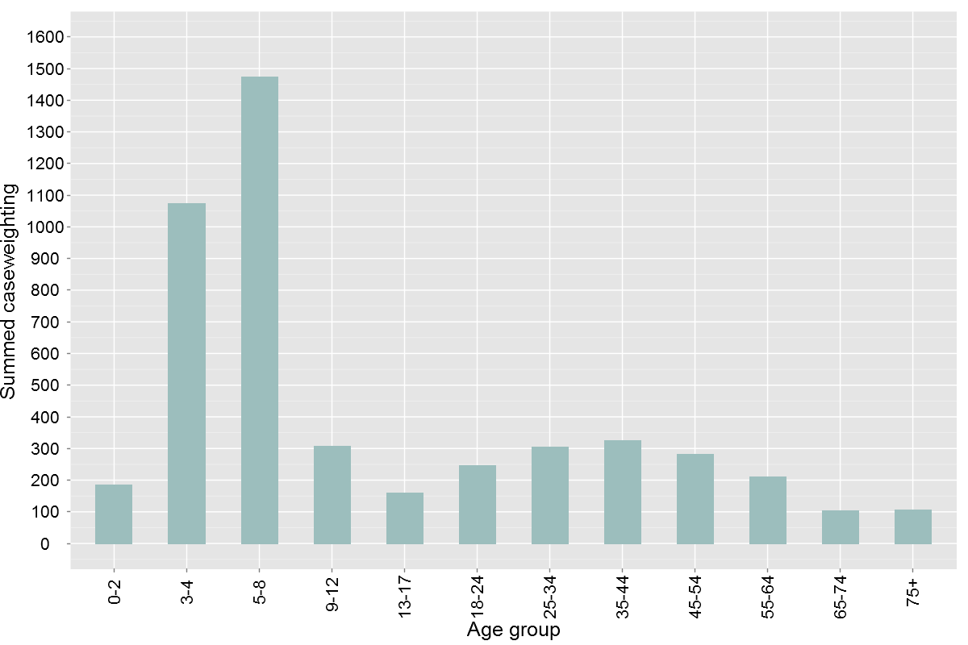
Summed case weights by DHB are reported in Figure 29 and case weights adjusted per 1,000 population in Figure 30. Case weights ranged from a low of 0.63 per 1000 population in Capital and Coast to 2.47 in Whanganui. The national mean case weight for dental admissions per 1000 population in 2009 was 1.13.
Figure 29. Summed annual case weighting of admissions for inpatient dental care with dental as the primary diagnosis by DHB (2009).
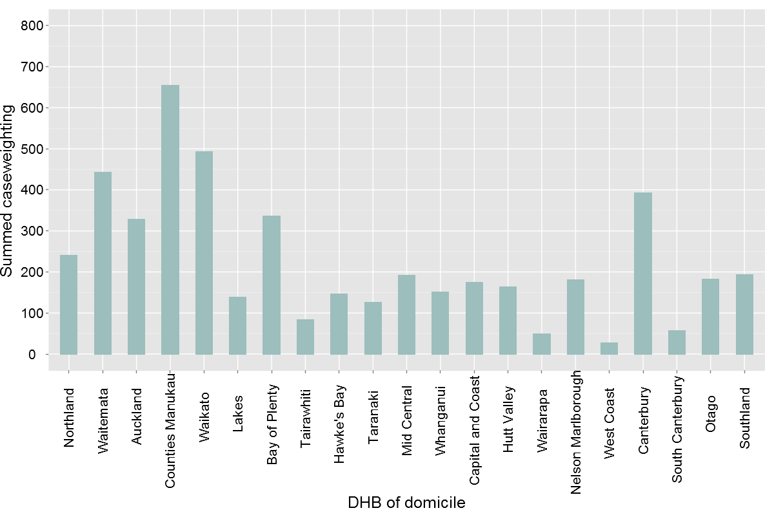
Figure 30. Summed annual case weighting (per 1,000 population) of admissions for inpatient dental care with dental as the primary diagnosis by DHB (2009).
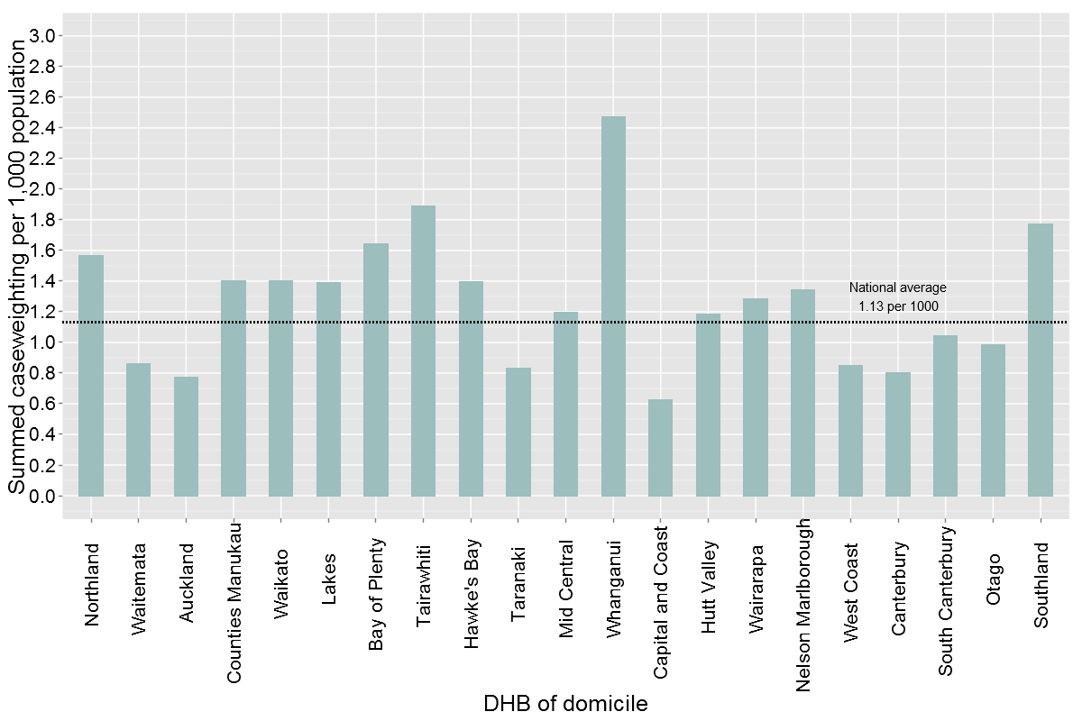

Discussion
Examination of the case weighted discharge patterns of dental hospital admissions, in conjunction with the total numbers of admissions and the rates of admission, assists in assessing the case complexity of the case mix of admissions as assessed by the case weighted funding model. It also enables assessment of approximate funding costs as the pricing for case weights is nationally established.
The homogeneity of the data by age group, and the very distinct time related changes in the median case weighting, appear to be the result of changes to the case weighting applied to the most common dental discharge codes by the pricing methodology. In the period 2004 to 2006 the median case weighting increased from 0.43 to 0.61. However, it appears that subsequent decisions have resulted in the median case weighting decreasing again and in 2009 the median dental case weighting was 0.45. The reasons behind these changes are not clear. However, there is little evidence that the underlying case complexity, as measured by the case-weighting model has changed given the high level of homogeneity between DHB data over time.
In addition to changes to the case weighting applied to each dental admission, total summed case weights are also driven by an underlying increase in the volumes of people admitted to hospital for dental care. However, given the changes to the case weighting model applied to these admissions in the period 2004-2009, total admissions and rates of admission measured by individual appear a more accurate indicator of time related changes for the period of this study.
Case weights per 1000 population vary significantly between DHBs from 0.63 per 1000 population in Capital and Coast to 2.47 in Whanganui. Given the strong correlation between case-weights and total numbers of people admitted in any one year (not withstanding adjustments to the case-weighting formula affecting the pattern discussed earlier) the case weights per 1000 population provide an assessment of the level of service provided in each district heath board, adjusted for population size. Inter-DHB variation in the case weights per 1000 population do appear to be associated at the higher end with DHBs with higher levels of dental caries as assessed from child dental health data.
Nevertheless variation in the case weighted access to inpatient hospital dental services warrants further investigation as part of a consideration of the necessary underlying levels of service and equity of access.

Dental Admissions as a Result of Injury (Figures 31-39)
Dental injuries were identified through ICD 10 codes S02.5 (fracture of tooth) and S03.2 (dislocation of tooth) and maxillofacial injuries were identified through ICD 10 codes S02.4 (fracture of molar and maxillary bones) and S02.6 (fracture of mandible). Admissions for dental and maxillofacial injuries were not included in the wider analysis of dentally related admissions to hospital and have been analysed separately in this section of the report.
In the period 1990-2009 24,403 people were admitted to hospital with maxillofacial injuries, dental injuries or a combination of maxillofacial and dental injuries. In 2009 admissions for these injuries involved 1,840 people.
Admissions to hospital as a result of dental and/or maxillofacial injuries have increased from 650 in 1990 to 1299 in 2000 and 1840 in 2009 (Figure 31). However, they have declined significantly as a proportion of the people admitted to hospital with a dental condition, either as a primary or secondary reason for admission, since 1990 (Figure 32). In 1990 maxillofacial injuries comprised 4.1% and dental injury 16.3% of reasons for dentally-related admissions. In 2009, maxillofacial injuries comprised 5.4% and dental injury 7.0% of the dentally-related hospital admissions.
Figure 32 indicates that the percentage of admissions to hospital as a result of dental and/or maxillofacial injury has been declining since 1990. In 1990, a total of 20.5% of dentally related admissions were due to injury (includes both dental and maxillofacial injury) compared to 12.8% in 2009.
Figure 31. Hospital admissions for inpatient dental care as a result of dental injury (1990 – 2009).
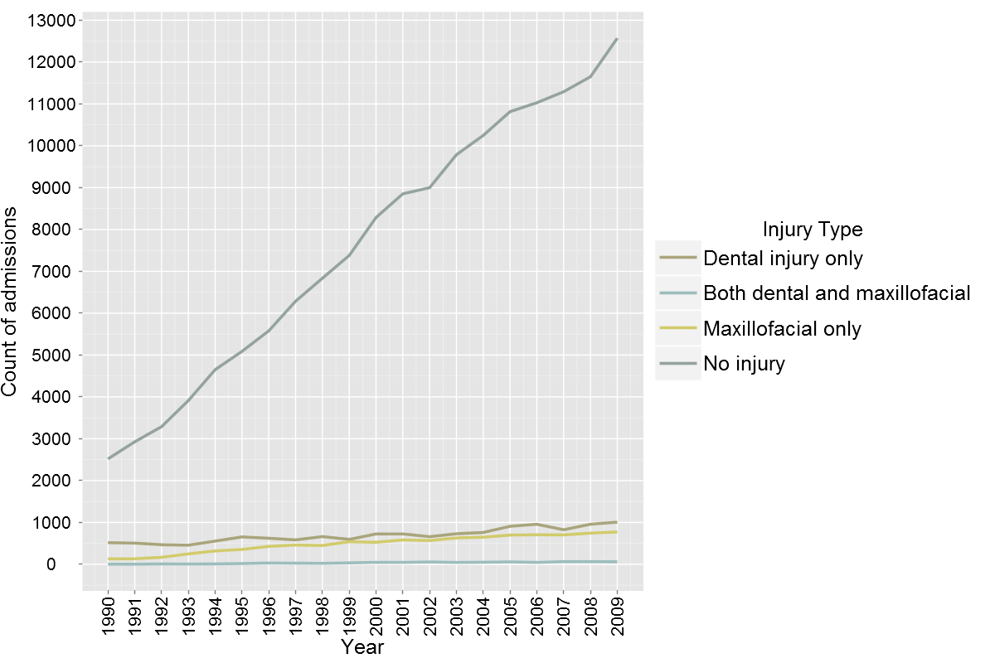

Dental injuries as a primary or secondary reason for admission have almost doubled from 517 admissions in 1990 to 1007 admissions in 2009. In contrast maxillofacial injuries as a reason for, or part of, hospital admission have seen a 6-fold increase from 133 people in 1990 to 833 in 2009.
Figure 32 shows all hospital admissions with a dental and/or maxillofacial injury coding (either as a primary diagnosis or co-morbidity) as a percentage of total dental admissions. Dental injury admissions were a substantially larger proportion of injury admissions than maxillofacial injuries in the early 1990s but have reduced as a percentage from 79.5% of injury admissions in 1990 to 55.8% in 2000 and 54.7% in 2009.
Figure 32. Hospital admissions as a result of dental and/or maxillofacial injury as a percentage of total dental admissions (1990 – 2009).
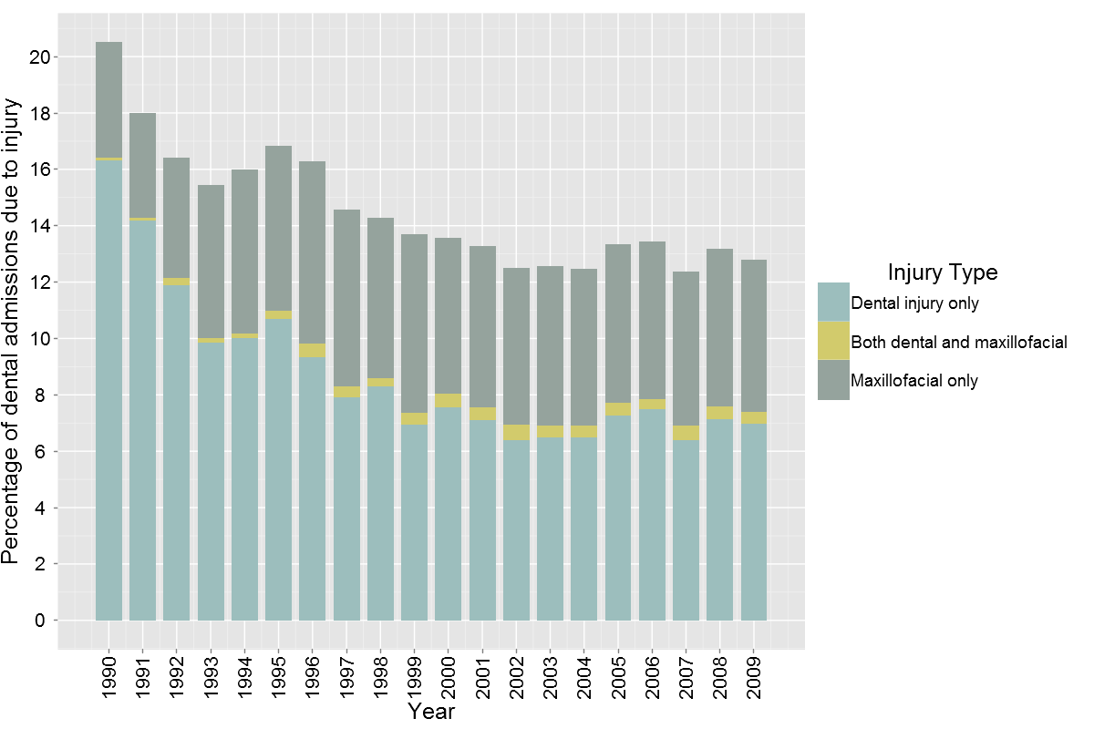

Figure 33 shows the percentage of hospital admissions with a dental and/or maxillofacial injury by ethnicity and indicates that the proportion of admissions as a result of injury is lowest for Pacific people. The proportion of admissions as a result of injury appear to be largely a function of the relative increases in disease related admissions across ethnic groups described elsewhere in this report.
Figure 33. Hospital admissions as a result of dental injury as a percentage of total dental admissions by total ethnicity (2005 – 2009).
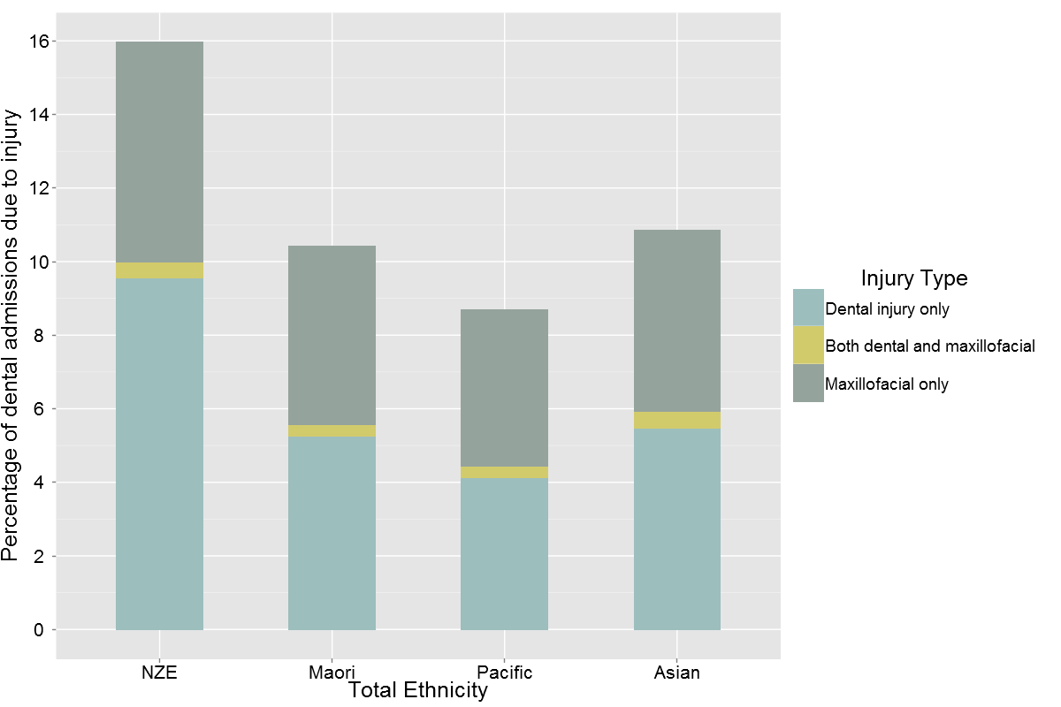
In 2009 people aged 18-24 years had the highest proportion of admissions due to dental injuries (Figure 34). Dental and/or maxillofacial injury comprised a very small proportion of the reasons for admission amongst children aged 12 years and under. In the 0-12 years age groups the vast majority of the injuries were maxillofacial (Figure 35). Among 13- to 17-year-olds there was almost an even split between dental and maxillofacial injuries. For the 18-34 year age group, who had the greatest number of admission due to injury, 59.5% of injuries were dental and 36.2% maxillofacial. The remaining 4.3% of injuries in this age group were those who sustained both dental and maxillofacial injuries.
Figure 34. Hospital admissions as a result of dental injury as a percentage of total dental admissions by age group (2005-2009).
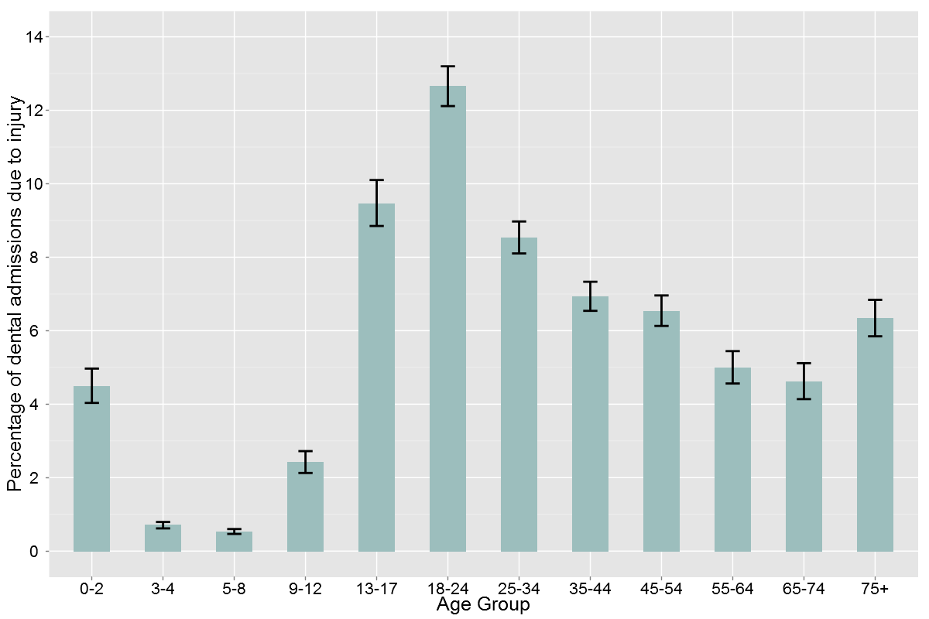

Figure 35. Hospital admissions as a result of dental injury as a percentage of total dental admissions by age group (2005-2009).
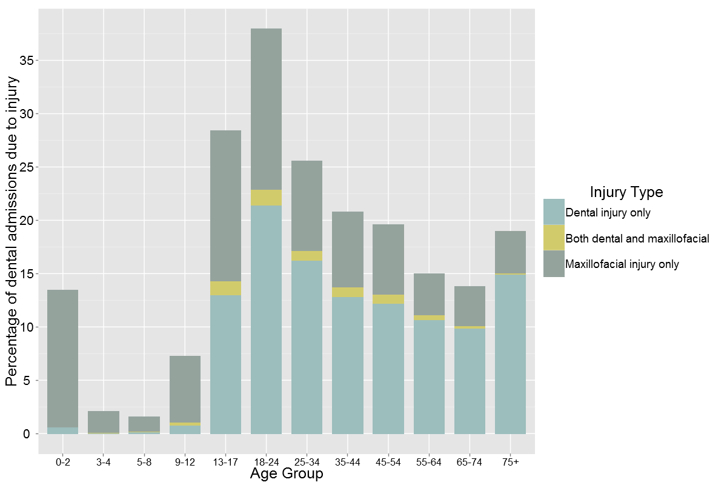

Injury admissions as a percentage of all dental admissions ranged widely between DHBs from approximately 20% in Auckland and Otago to only 8% in Taranaki and Whanganui DHBs (Figure 36).

Figure 36. Hospital admissions as a result of dental injury as a percentage of total dental admissions by DHB (2005 – 2009).
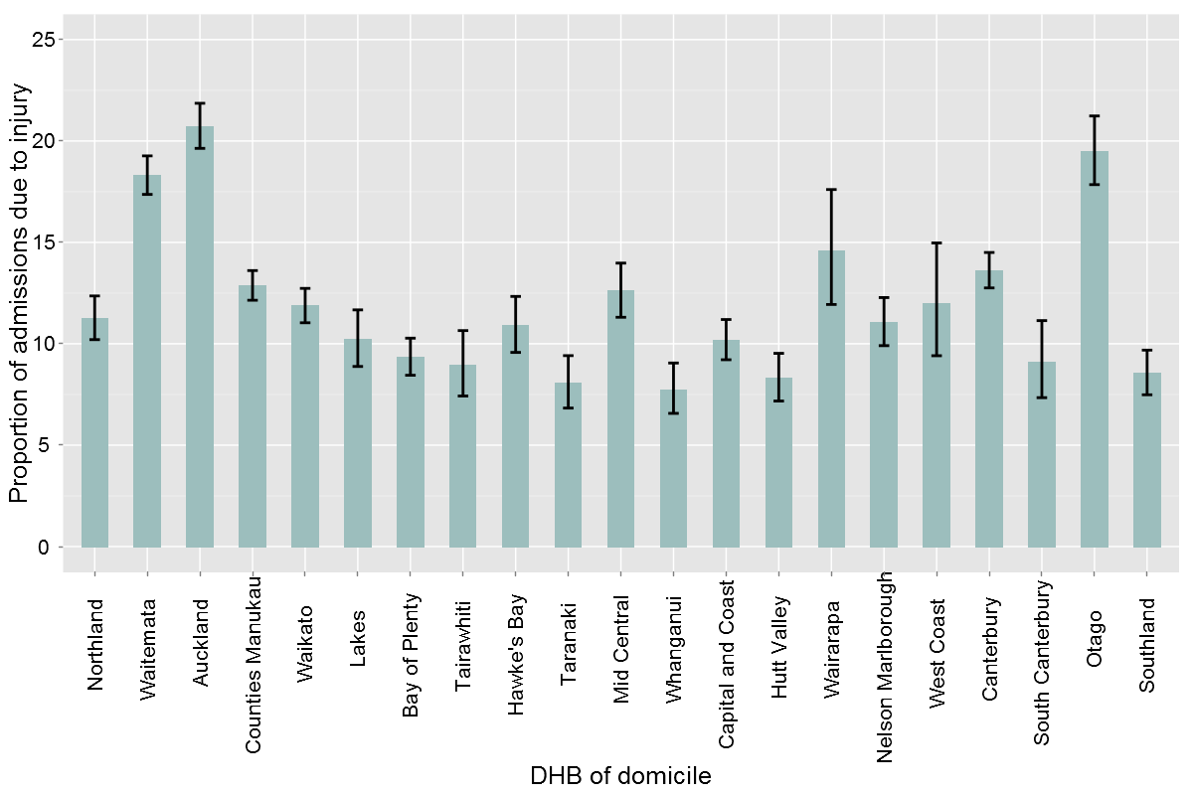
In addition to an increase in absolute numbers of people admitted to hospital as a result of dental and/or maxillofacial injuries, the rate of admission has more than doubled from 19.5 people per 100,000 population in 1990 to 43.8 per 100,000 population in 2009.
The rate of admission for males has remained consistently higher than for females but the difference in rate of admission has declined from a 4.4 fold higher rate in 1990 for males to a 2.8 fold higher rate for males in 2009. The decline in the difference between males and females is the result of the male rate of admission doubling, but the females rate of admission trebling during the period 1990 to 2009 (Figure 37).
Figure 37. Rate of admissions due to dental injury (includes maxillofacial) per 100,000 population (1990 – 2009).
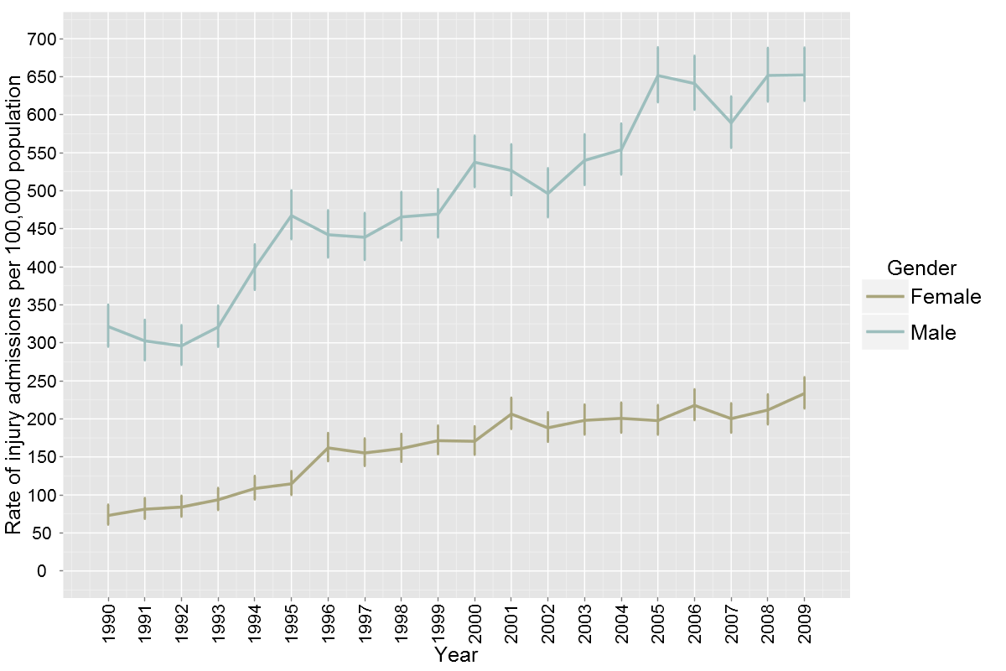
The rate of admission to hospital for dental and/or maxillofacial injuries is highest for Maori at 66.2 per 100,000 population, and lowest for Asian people at 21.4 per 100,000 population in 2009. Figure 38 indicates that admission rates for all ethnic groups have increased across time, and that the relative positions of the ethnic groups have remained the same since 1997, when the admission rate for Pacific people became greater than New Zealand European.
Figure 38. Rate of admissions due to dental injury (includes maxillofacial) per 100,000 population by total ethnicity (1996 – 2009).
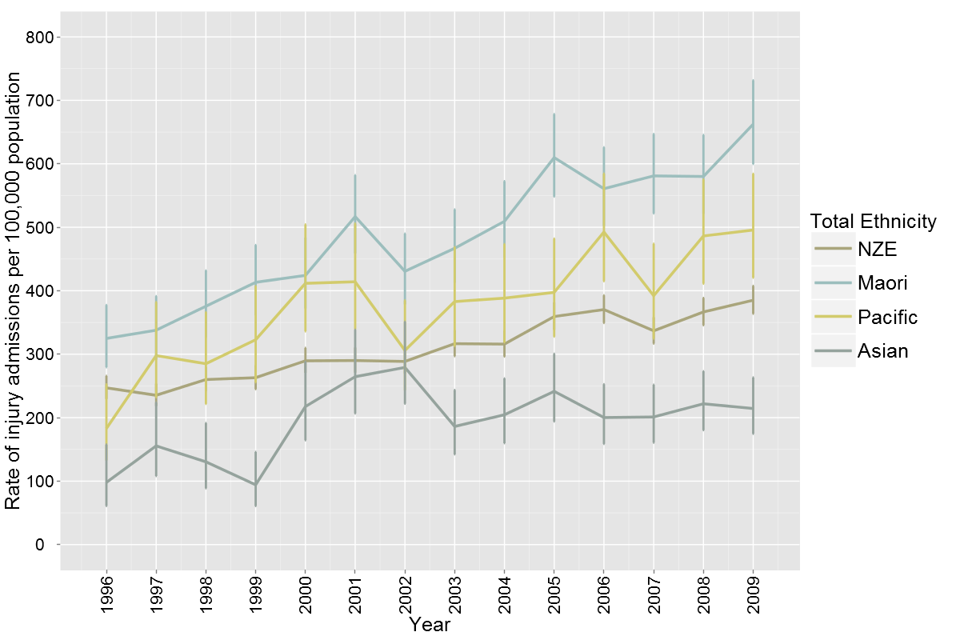
The national rate of admission per 100,000 population for dental and/or maxillofacial injuries in 2005-2009 was 41.3 per 100,000 population but ranged from 52.3 per 100,000 population in Auckland DHB to 26.6 per 100,000 at Hutt Valley DHB (Figure 39).

Figure 39. Rates of admission per 100,000 population as a result of dental and/or maxillofacial injury by DHB (2005-2009).
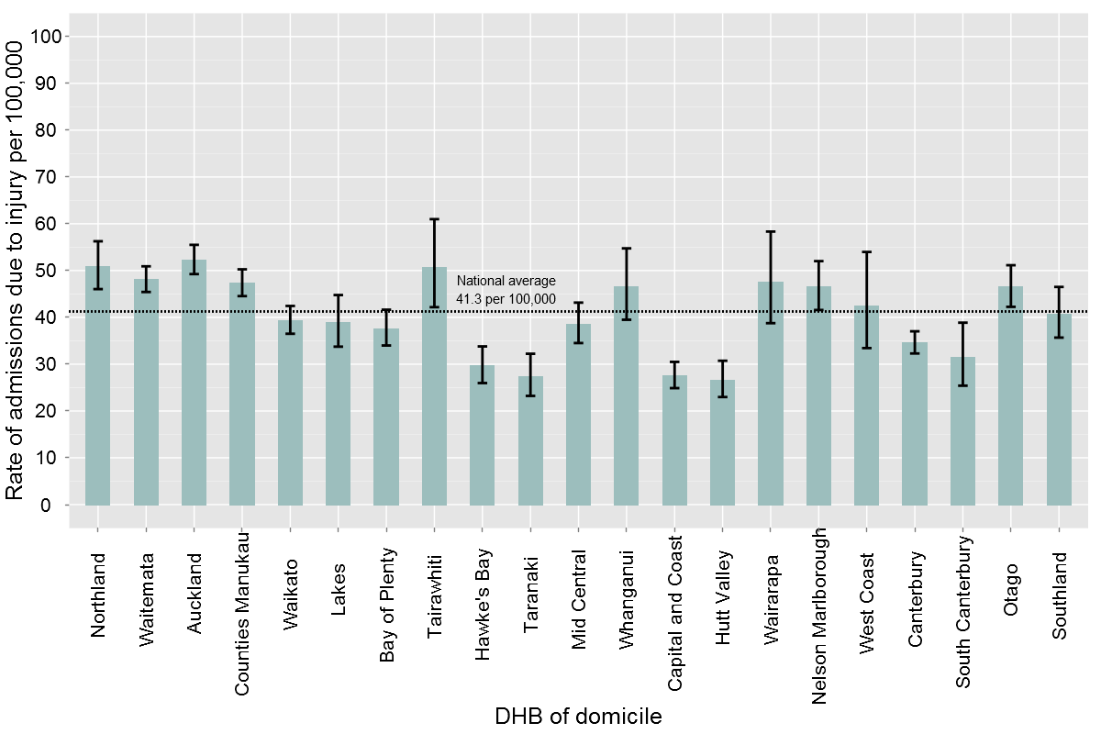

Discussion
Six papers have been published that have examined demographic patterns associated with dental and/or maxillofacial injuries in New Zealand since 2002 (Welch et al 2010; Lee 2009; Love and Ponnambalam 2008; Buchanan et al 2005; Thomson et al 2003; Kieser et al 2002). These papers all describe slightly different profiles of dental injury, in part because they have involved analysis of differing data sets. Welch et al (2010) analysed data obtained from Accident Compensation Corporation claims for dental and maxillofacial injury, Kieser et al (2002) examined data obtained from the same data source as this report (National Minimum Dataset ) for hospital admissions, Thomson et al (2003) undertook an analysis of a combined dataset from the National Minimum Dataset and the Accident Compensation Corporation, while Love and Ponnambalam (2008) and Buchanan et al (2005) utilised data obtained from service information maintained by the School of Dentistry and Waikato Hospital of dental and maxillofacial injuries.
Despite differences in the data sources, and the consequent data captured or extracted, the volumes of dental and maxillofacial injury reported in this study are consistent with earlier reports. In 2009, 833 people were admitted to hospital with maxillofacial or maxillofacial and dental injuries, while a further 1007 people were admitted with dental injuries alone. Kieser et al (2002) reported that 27,732 people were admitted to hospital with maxillofacial fractures in the 20-year period 1979 to 1998 and reported an overall incidence rate of 41.0/100,000 person years. However they also reported that the incidence had decreased from 48.6 per 100,000 person years in the period 1979 to 1988 to 34.1 per 100,000 person years in the period 1989 to 1998. At the lower incidence rate of the latter 10-year period this would suggest approximately 900-1000 maxillofacial fracture admissions per year. This study has found 833 people admitted in 2009, 11 years later and a mean national admission rate of 41.3 per 100,000 population in the period 2005-2009.
Thomson et al (2003) reported that in people aged 65 years and over in the period 1990 to 1999, 629 cases of dental and maxillofacial trauma occurred. This differs slightly from the 548 cases of maxillofacial injury captured in the dataset for this study. It is probable that this difference reflects the slightly differing frames for the data extracted between the two studies. Thomson et al (2003) utilized the ICD 9 diagnosis code of 802 (fracture of facial bones) whereas this study has utilised the more specific ICD 10 codes S02.4 (fracture of malar and maxillary bones) and S02.6 (fracture of mandible). Fractures of other facial bones will not have been captured in the data set of this study.
Dental and maxillofacial injury has previously been reported as a more commonly occurring to males than females. Welch et al 2010 reported a ratio of approximately 3:2, Love and Ponnambalam (2008) that males were more frequently affected in a ratio of 2.01:1 and Buchanan et al reported that 80 percent of patients managed by Waikato Hospital for maxillofacial fractures were male, with the peak incidence in the 15- 24 year age group.
Kieser et al 2002 reported a significant age-related increased incidence of maxillofacial fractures amongst males. For females, the rate peaked between the ages of 15–19 years, with an incidence of 34.7/100 000. In contrast, males showed a peak between the ages of 20–24 years, with an incidence of 200/100 000. Up to the age of 72, males consistently showed a higher incidence of facial fractures than females.
Thomson et al 2003 investigating dental and maxillofacial injuries in older adults reported that in people aged 65 years and over cases occurred more commonly in females than in males. They reported 7883 ACC claims for dental or facial injuries, 4900 for females and 2983 for males and 629 cases of dental and maxillofacial trauma resulting in inpatient treatment in public hospitals, 362 females and 267 males.
This study has also found that dental and maxillofacial injuries resulting in hospital admission occur disproportionately for males.
Of particular note from this study are the proportions of injury admissions that involve only dental trauma, in comparison to those involving maxillofacial trauma. This study did include admissions to hospital where the injury may not have been the primary reason for admission. Consequently dental trauma may have been a co-morbidity when other issues had lead to the admission.
Nevertheless this study and this approach supports an observation by Gassner et al (1999) in an investigation of 6000 patients with facial trauma in Austria. They observed “that in the mosaic of traumatic injuries, the frequencies of tooth trauma and its sequelae are underestimated and that such trauma and sequelae occur without a predictable pattern of intensity and extensiveness”. This finding has implications for the route of admission for people with a dental and maxillofacial trauma and for the clinicians that are tasked with caring for them. The frequency of dental trauma supports an important role for dentally trained clinicians in the care of these patients. It may also raise debate regarding the appropriate dentally-trained clinicians to be available for the acute management of dental injuries, as opposed to maxillofacial injuries.
This study has also found that although the rate of admission to hospital for dental and/or maxillofacial injuries has doubled in the period 1990–1994 to 2005–2009, admissions to hospital for dental trauma now comprise a significantly smaller proportion of total admissions to hospital for dental reasons than in the period 1990 -2000. This change has occurred in large part due to the significant growth in admissions to hospital of children for the management of dental caries shown elsewhere in this report.
However, combined with the information on the make up of dental injuries these data suggest that it is important to consider the skill mix and the staffing mix of hospital dental services throughout the country. Dental injuries require dental clinicians with an appropriate skill mix and services need to be considering the challenges of managing the changing nature of these hospital admissions.

Co-morbidities Associated with Dental Admissions (Table 8)
Co-morbidity coding was investigated only for admissions for which the dental coding was the primary reasons for admission. This was done because the issue of interest in this analysis was the degree to which co-morbidity is associated with an admission to hospital that is principally for dental care.
An initial investigation was made of co-morbidity associated with a primary dental admission using the presence of any additional coded conditions in the NMDS data, described by the chapter headings of the ICD 10 system. These additional coded conditions have been collectively regarded as co-morbidity for the purpose of this study.
Diseases of the digestive system have not been included in this analysis of additional coded conditions, because all dental and oral disorders involve coding in this grouping and differentiation of additional conditions was not feasible.
The prevalence of additional coded conditions is reported for the period 2005-2009 only and is reported separately for people under 18 years and for people 18 years and over. In the period 2005 - 2009, 31,820 people aged under 18 years and 12,152 people aged 18 years and over were admitted to hospital for dental care.
In people aged under 18 years additional coded conditions were not common. The ICD code “factors influencing health status and contact with health services” (Z00-Z99) was the most frequent additional coded condition (3.5%), followed by mental and behavioral disorder (1.8%) and congenital malformations, deformations and chromosomal abnormalities associated with 1.3% of admissions. Thirteen further groups of additional coded conditions were present for people aged under 18 years, but none had a prevalence greater than 1% of admissions.
The percentage of people aged under 18 years with any ICD coded additional condition was 9.2%. The codes Z00-Z99 were used exclusively (i.e. not in combination with any other co-morbidity coding) for 2.4% of people admitted to hospital aged under 18 years.
In people aged 18 years and over additional coded conditions were substantially more prevalent. An ICD coded additional condition was present for 61.3% of people aged 18 years and over. The codes Z00-Z99 were used exclusively (i.e. not in combination with any other co-morbidity coding) for 26.8% of people aged 18 years and over.
Mental and behavioral disorders were coded for 11.4% of people admitted. A further fifteen groups of conditions were additionally coded with the prevalence ranging from 5.45% to 0.03%.
Table 8 describes the prevalence of additional coded conditions by ICD grouping.
Table 8. Co-morbidities coded for primary dental admissions to hospital in people under 18 years and 18 years and over (2005 – 2009).
 |  | Under 18 years |  | 18 years and over
Description | ICD 10  Coding | Number | Prevalence | Number | Prevalence
Certain infectious and parasitic diseases | A00-B99 | 188 | 0.59% | 436 | 3.58%
Neoplasms and Diseases of the blood and blood-forming organs and certain disorders involving the immune mechanism | C00-D48  D50-D89 | 151 | 0.47% | 585 | 4.82%
Endocrine, nutritional and metabolic diseases | E00-E90 | 119 | 0.37% | 648 | 5.33%
Mental and behavioural disorders | F00-F99 | 572 | 1.80% | 1393 | 11.46%
Diseases of the nervous system | G00-G99 | 274 | 0.86% | 662 | 5.45%
Diseases of the eye and adnexa | H00-H59 | 87 | 0.27% | 174 | 1.43%
Diseases of the ear and mastoid process | H60-H95
Diseases of the circulatory system | I00-I99 | 34 | 0.11% | 453 | 3.73%
Diseases of the respiratory system | J00-J99 | 175 | 0.55% | 215 | 1.77%
Diseases of the skin and subcutaneous tissue | L00-L99 | 172 | 0.54% | 460 | 3.79%
Diseases of the musculoskeletal system and connective tissue | M00-M99 | 13 | 0.04% | 87 | 0.72%
Diseases of the genitourinary system | N00-N99 | 11 | 0.03% | 125 | 1.03%
Pregnancy, childbirth and the puerperium | O00-O99 | 0 | 0% | 4 | 0.03%
Certain conditions originating in the perinatal period | P00-P96 | 7 | 0.02% | 4 | 0.03%
Congenital malformations, deformations and chromosomal abnormalities | Q00-Q99 | 408 | 1.28% | 277 | 2.28%
Symptoms, signs and abnormal clinical and laboratory findings, not elsewhere classified | R00-R99 | 251 | 0.79% | 485 | 3.99%
Injury, poisoning and certain other consequences of external causes | S00-T98 | 85 | 0.27% | 324 | 2.67%
Codes for special purpose | U00-U99 | 0 | 0% | 0 | 0%
External causes of morbidity and mortality | V01-Y98 | 0 | 0% | 0 | 0%
Factors influencing health status and contact with health services | Z00-Z99 | 1113 | 3.50% | 4783 | 39.40%

Additional Co-morbidity Analysis
A subset of the co-morbidities was investigated in greater detail for their association with dental admissions, following discussion with the Ministry of Health. These conditions for which additional analysis was undertaken represent either long-term conditions for which there was specific interest about impact on dental admissions to hospital, or they represent co-morbidities that are commonly associated with the delivery of special needs dental care.
Greater investigation was undertaken for the following conditions:
- Intellectual Disability
- Diabetes
- Cancer
- Mental Health
Cancer, mental health and intellectual disability diagnoses were identified from the NMDS coding at the time of primary dental admission. Diabetes was additionally identified as a co-morbidity affecting individuals with a primary dental admission through the Health Tracker database maintained by the Ministry of Health, and linked through the encrypted NHI. A similar approach was to have been taken to investigate the relationship of cardiovascular disease to dental admissions, but data matching with NHI encryption at differing dates could not be obtained from the Ministry of Health for this condition.
A number of other co-morbidities for which interest had been expressed were unable to be investigated in this project as the conditions were either not coded in the NMDS dataset, or the codings available were not specific enough to interpret to the level of the conditions of interest.
Detailed additional co-morbidity analyses were undertaken only for admissions in the period 2005-2009 and for the adult population aged 18 years over, with the exception of intellectual disability for whom the prevalence has also been reported for the under 18 years group.

Intellectual Disability
Intellectual disability diagnoses as a co-morbidity associated with a primary dental admission were investigated using ICD 10 coding F70-F89 codes (see Table 17 Appendix 1).
Overall, intellectual disability was associated with primary dental admissions for 503 patients aged 0-17 years (1.6%) and for 1057 patients aged 18 years and over (8.7%). Intellectual disability as a co-morbidity increased significantly with age to involve approximately 10% of people admitted to hospital for dental care between 13 years and 54 years (Table 9). There was little difference in the prevalence of intellectual disability as a co-morbidity by gender (male 4.1%; female 3.0%).

Table 9. Prevalence of an intellectual disability as a co-morbidity associated with a primary dental admission to hospital by age group (2005 – 2009).
Age Group (years) | Prevalence of Intellectual Disability Co-morbidity (%) | CI (%)
0-2 | 0.05 | 0.00 - 0.31
3-4 | 0.18 | 0.11 - 0.27
5-8 | 1.26 | 1.09 - 1.46
9-12 | 5.27 | 4.46 - 6.17
13-17 | 10.52 | 9.00 - 12.20
18-24 | 9.11 | 7.87 - 10.48
25-34 | 9.53 | 8.44 - 10.72
35-44 | 11.54 | 10.38 - 12.78
45-54 | 9.87 | 8.65 - 11.20
55-64 | 6.52 | 5.21 - 8.04
65-74 | 1.20 | 0.55 - 2.27
75+ | 0.16 | 0.00 - 0.91

People of New Zealand European ethnicity were the most likely to have an intellectual disability associated with their dental admission (5.1%). Intellectual disability affected approximately 1% of Pacific people admitted for dental care and 2% of Maori, Asian and people of Other ethnicities (Table 10).

Table 10. Prevalence of an intellectual disability as a co-morbidity associated with a primary dental admission to hospital by ethnicity (2005 – 2009).
Ethnicity | Prevalence of Intellectual Disability Co-morbidity (%) | CI (%)
NZ European | 5.09 | 4.80 - 5.39
Maori | 2.24 | 2.00 - 2.51
Pacific | 1.22 | 0.95 - 1.53
Asian | 2.38 | 1.87 - 2.99
Other | 1.75 | 0.98 - 2.87

Variability was evident in the prevalence of intellectual disability as a co-morbidity associated with dental admissions between DHBs ranging from 1.0% of dental admissions to 13.9% of dental admissions (Table 11).

Table 11. Prevalence of an intellectual disability as a co-morbidity associated with a primary dental admission to hospital by DHB (2005 – 2009).
DHB | Prevalence of Intellectual Disability Co-morbidity (%) | CI (%)
Northland | 2.05 | 1.52 - 2.70
Waitemata | 3.63 | 3.07 - 4.25
Auckland | 2.95 | 2.38 - 3.62
Counties Manukau | 2.85 | 2.43 - 3.32
Waikato | 4.07 | 3.48 - 4.74
Lakes | 6.00 | 4.80 - 7.40
Bay of Plenty | 3.83 | 3.18 - 4.57
Tairawhiti | 4.72 | 3.44 - 6.31
Taranaki | 0.55 | 0.22 - 1.12
Hawke's Bay | 4.43 | 3.44 - 5.61
Mid Central | 13.91 | 12.27 - 15.68
Whanganui | 4.72 | 3.69 - 5.95
Capital and Coast | 2.94 | 2.24 - 3.79
Hutt Valley | 1.33 | 0.82 - 2.05
Wairarapa | 1.32 | 0.49 - 2.85
Nelson Marlborough | 6.61 | 5.52 - 7.85
West Coast | 1.76 | 0.71 - 3.59
Canterbury | 1.14 | 0.82 - 1.53
South Canterbury | 1.25 | 0.54 - 2.45
Otago | 5.16 | 3.94 - 6.62
Southland | 1.00 | 0.61 - 1.55

Diabetes
Diabetes was a co-morbidity identified from the Health Tracker database as affecting 7.2% (n=879) of the 12,152 people aged 18 years and over admitted to hospital for a primary dental reason in the period 2005-2009. The Health Tracker database did appear to identify a greater number of people with a diabetes co-morbidity than the NMDS coding for endocrine nutritional and metabolic disease (E10-E14) (n=648).
There was no significant difference in the prevalence of diabetes as a co-morbidity by gender. In the period 2005-2009 the prevalence of diabetes as a co-morbidity increased significantly with age from 1.8% of 18-24 year-olds to 17.8% of 65-74-year-olds (Table 12).

Table 12. Prevalence of a diabetes co-morbidity associated with a primary dental admissions to hospital by age group (2005 – 2009).
 | Percentage of dental admissions with diabetes (%) | CI (%)
18-24 | 1.85 | 1.30 - 2.56
35-34 | 2.89 | 2.28 - 3.60
35-44 | 4.71 | 3.96 - 5.57
45-54 | 9.14 | 7.96 - 10.43
55-64 | 15.94 | 13.95 - 18.10
65-74 | 17.78 | 15.11 - 20.71
75+ | 17.27 | 14.35 - 20.51

Diabetes also affected a significantly greater percentage of Maori (9.7%), Pacific (13.0%) and Asian (10.4%) people than NZ European (6.0%) people admitted for dental care.
Diabetes as a co-morbidity varied significantly by DHB of residence, ranging from 12.5% of dental admissions for adults at Bay of Plenty DHB to 3.1% of dental admissions for adults at Hutt Valley DHB.

Cancer
Cancer as a co-morbidity associated with a primary dental admission was investigated in greater detail using ICD 10 coding for a range of head and neck cancers and also for any cancer diagnosis associated with a primary dental admission.
Cancer was identified as a co-morbidity from the inclusion of any ICD 10 code C00-C97 (all malignant neoplasms). Cancer was associated with a primary dental admission for 2.5% (n=300) of the 12,152 admissions. There was no significant difference by gender. A cancer co-morbidity was more likely to be associated with a person of Asian ethnicity (5.8%) than people of NZ European (2.6%), Maori (1.3%) or Pacific ethnicity (2.4%).
Cancer co-morbidities were strongly associated with increasing age (Table 13).
Table 13. Prevalence of a cancer co-morbidity associated with a primary dental admission to hospital by age group (2005 – 2009).
Age Group (years) | Prevalence of Cancer Co-morbidity (%) | CI (%)
18-24 | 0.40 | 0.14 - 0.74
25-34 | 0.60 | 0.35 - 0.98
35-44 | 1.00 | 0.64 - 1.40
45-54 | 2.90 | 2.31 - 3.79
55-64 | 6.60 | 5.29 - 8.13
65-74 | 7.90 | 6.06 - 10.06
75+ | 7.20 | 5.31 - 9.59

Analysis of cancer as a co-morbidity by DHB was of limited value as the annual numbers in almost all DHBs were extremely small.
Head and neck cancers were identified using the following subset of ICD 10 codes (C00 – C49) associated with a primary dental admission (see Table 18 Appendix 1)).
Head and neck cancers were a rare co-morbidity associated with adult primary dental admissions. Only 0.6% of the 12,152 dental admissions recorded a head and neck cancer as a co-morbidity associated with the admission.
Analysis of this issue by gender, ethnicity or DHB is of limited value given the small numbers.

Mental Health
Mental health diagnoses as a co-morbidity associated with a primary dental admission were identified using ICD 10 coding F00-F69 and F90-99 (see Table 18 Appendix 1).
Mental health diagnoses were a co-morbidity affecting 2.9% (n=358) of the 12,152 people aged 18 years and over admitted to hospital for a primary dental reason in the period 2005-2009. There was no significant difference in the recorded prevalence by gender. The prevalence of a mental health co-morbidity was low amongst young adult people aged 18-24 years and relatively consistent in people aged 25-74 years. However, the prevalence of mental health co-morbidities increased significantly in people aged 75 years and over (Table 14).
Table 14: Prevalence of a mental health co-morbidity associated with a primary dental admission to hospital by age group (2005 – 2009).
Age Group (years) | Prevalence of Mental Health Co-morbidity (%) | CI (%)
18-24 | 1.44 | 0.96 - 2.08
25-34 | 2.09 | 1.58 - 2.71
35-44 | 2.79 | 2.21 - 3.46
45-54 | 2.80 | 2.15 - 3.58
55-64 | 2.17 | 1.44 - 3.15
65-74 | 3.88 | 2.61 - 5.52
75+ | 13.16 | 10.57 - 16.11

Mental health co-morbidities were more prevalent amongst people of NZ European ethnicity (3.6%) than Maori (1.3%), Pacific (0.9%) or Asian (1.5%) people admitted for dental care.
Analysis of this issue by DHB is of limited value given the small numbers.

Discussion
Co-morbidity appears to be relatively uncommon in association with admissions to hospital for children and young people, but a relatively common in association with admission to hospital for dental care for adults in New Zealand. Although it is possible to describe the nature of some of the co-morbidities from the ICD coding associated with the hospital admissions, the majority of the co-morbidity is identified using the coding Z00-Z99 which captures “factors influencing health status and contact with health services”. The WHO ICD system (WHO 2007) states that the use of these codes should occur when
“…circumstances other than a disease, injury or external cause classifiable to categories A00-Y89 are recorded as "diagnoses" or "problems". This can arise in two main ways:
- When a person who may or may not be sick encounters the health services for some specific purpose, such as to receive limited care or service for a current condition, to donate an organ or tissue, to receive prophylactic vaccination or to discuss a problem which is in itself not a disease or injury.
- When some circumstance or problem is present which influences the person's health status but is not in itself a current illness or injury. Such factors may be elicited during population surveys, when the person may or may not be currently sick, or be recorded as an additional factor to be borne in mind when the person is receiving care for some illness or injury. “

The Ministry of Health and DHB Service Specification for Hospital-Based Dental Services states
“Hospital dental services provide oral health care services for people with special needs that are most appropriately provided within a hospital setting or in other settings where necessary linkages with hospital services have been established. This may be when special care is required to provide primary care for those with a disability and unable to access care in the community, to provide secondary and tertiary care when special management is required or when dental services are required as part of other medical or surgical treatment.
These services are complementary, rather than being alternative to the oral health care services provided for children and adolescents, emergency dental services for low income adults and dental services for adults that are not publicly funded.”
The extensive use of the Z00-Z99 coding to capture “circumstances other than a disease, injury or external cause” appears to confirm that many people who received dental services in a hospital environment in the period 2005-2009 did so for a complex mixture of social, economic and health reasons that are not easily described by specific disease diagnoses. This was particularly the case for adults receiving care, where almost 40% of the admissions received this coding and the code was used exclusively to capture co-morbidity for 16.8% of people admitted for dental care.
Although use of this code for children was much less it still appeared for 3.5% of the admissions and was the most commonly used code to record co-morbidity for the child admissions.
The prevalence of diabetes in the New Zealand population is uncertain (Diabetes New Zealand 2010) but Ministry of Health modeling for 1996 indicated an expected prevalence that varied between 2.5% in European females and 9.8% for Maori females (Ministry of Health 2002). Diabetes is well established as a co-morbidity with the potential for significant adverse effects on oral health (Lamster et al 2008). This study did find that diabetes was associated as a co-morbidity with dental admissions to hospital. Overall 7.2% of adults had an identified diagnosis of diabetes, and diabetes was present as a co-morbidity for 17.8% of 65-74 year-olds, and 9.7% of Maori and 13% of Pacific adult people admitted to hospital for dental care.
However, diabetes as a co-morbidity did not appear to occur in a pattern between DHBs that might be anticipated by their resident populations. It did not necessarily appear to be associated with DHBs that have higher Pacific or Maori populations. While Bay of Plenty had the highest association of diabetes as a co-morbidity, Lakes DHB had only 4.5% of admissions with diabetes as a co-morbidity. It is possible that this is related to the age structure of the DHB populations as South Canterbury were noted to have 9.7% of admissions associated with diabetes as a co-morbidity. However, the inter DHB variation also appears to raise questions as to the robustness of co-morbidity coding. The differences may also raise issues of equity of access and of service availability as well as disease distribution and need.
The prevalence of mental health co-morbidities associated with dental admissions appeared relatively low compared to the reported prevalence of these conditions in the general population. Oakley Browne et al (2006) reported that 20% of the population will be affected by a mental illness and/or addiction in any one year. They also reported that although people with serious mental illnesses are likely to have visited the health sector for reasons associated with their mental health, their use of the health sector otherwise was low. In this study, the prevalence of mental health as a co-morbidity varied markedly by age. Between 18 and 74 years only 2-3% of the group admitted to hospital for dental care had a mental health co-morbidity, but in the over 75 years group this increased to 13.2%. It is likely that the age-related increase is associated with an increase in dementia and other cognitive disorders that make the delivery of dental care on an outpatient basis increasingly difficult.
People with intellectual disability appear to comprise a disproportionately greater number of the people admitted to hospital for dental care than their overall prevalence in the community. Bray (2003) reported that although it is difficult to establish robust estimates of the prevalence of intellectual disability, New Zealand studies indicate a prevalence of between 0.3% to 1% of the population. They also indicated that the prevalence was higher among children, and males, and slightly higher in older adults. Amongst the population of people admitted to hospital for dental care intellectual disability comprised 1.6% of children and 8.7% of adults.
The hospital dental service specification that indicates hospital dental services are to “provide oral health care services for people with special needs that are most appropriately provided within a hospital setting” and involve the delivery of services when “special care is required to provide primary care for those with a disability and unable to access care in the community”. The apparent disproportionate access to dental care through admission to hospital for people with intellectual disability is perhaps to be expected and overall appears consistent with the service specification. It may well indicate that many hospital dental services are delivering an appropriate service mix. However, the inter-DHB variation raises significant questions with regard to DHB service mix and models of care. A range from 13.9% to 1% of admitted patients with intellectual disability is very difficult to explain and it is hard to explain why a DHB with the highest rate of admission per 1,000 population for dental care also has one of the lowest rates of intellectual disability as a co-morbidity.
Cancer comprises a leading cause of morbidity and death in New Zealand, but does not contribute strongly as a co-morbidity associated with dental admissions to hospital. Even head and neck cancers did not contribute strongly as a co-morbidity. There are numerous likely reasons for this perhaps slightly unexpected finding. People with head and neck cancer may require dental care associated with their initial cancer management, but for a number this can be managed as outpatient care, and so would not contribute to these data. It is also possible that dental care provided in conjunction with primary surgical management of a tumour would be done in conjunction with the initial surgical management. In these circumstances it is more likely the dental care would be captured as a co-morbidity of the admission for cancer care, and these admissions would therefore not have been captured in this analysis.

References
Alcaino E, Kilpatrick NM, Kingsford-Smith ED. Utlization of day stay general anaesthetia for the provision of dental treatment to children in New South Wales, Australia. International Journal of Paediatric Dentistry 2000, 10; 206-212
Armitage, P., Berry, G., & Matthews, J. N. S. 2002. Statistical methods in medical research (4th ed.). Wiley-Blackwell. page 117, equation 4.16.
Balogh RS, Ouellette-Kuntz H, Hunter DJ. Regional variation in dental procedures among people with an intellectual disability, Ontario, 1995-2001. Journal of the Canadian Dental Association. 2004 Nov;70(10):681, 681a-681f.
Bray A. 2003. Demographics and characteristics of people with an intellectual disability. Wellington: National Advisory Committee on Health and Disability (National Health Committee).
Buchanan J, Colquhoun A, Friedlander L, Evans S, Whitley B, Thomson M. Maxillofacial fractures at Waikato Hospital, New Zealand: 1989 to 2000. New Zealand Medical Journal 2005 Jun 24;118(1217):U1529.
Cohen LA, Magder, LS, Manski R, Mullins CD. Hospital admissions associated with nontraumatic dental emergencies in a medicaid population. American Journal of Emergency Medicine, 2003:21 (7) 540-543.
Craig E, Anderson P and Jackson C. The Health Status of Children and Young People
in the Capital and Coast DHB. March 2009; NZ Child and Youth Epidemiology Service: Auckland.
Craig E, Anderson P and Jackson C. The Health Status of Children and Young People
in the Nelson Marlborough DHB. November 2008a; NZ Child and Youth Epidemiology Service: Auckland.
Craig E, Anderson P and Jackson C. The Health Status of Children and Young People
in the Waitemata DHB. November 2008b; NZ Child and Youth Epidemiology Service: Auckland.
Department of Health. 2000. A conscious decision. A review of the use of general anaesthetic and conscious sedation in primary dental care. London: Department of Health.
Department of Human Services, 2007. Demographic analysis of trends in dental ambulatory care sensitive condition (ACSC) admissions in Victoria, 1997–98 to 2004–05. Melbourne: Department of Human Services.
Diabetes New Zealand URL: http://www.diabetes.org.nz/news/press_releases/national_diabetes_prevalence_study_needed. Accessed August 2011
Drummond BK et al. Outcomes two, three and four years after comprehensive care under general anaesthesia. New Zealand Dental Journal 100: 32-37, 2004
Gassner R, Bösch R, Tuli T, Emshoff R. Prevalence of dental trauma in 6000 patients with facial injuries: implications for prevention. Oral Surgery, Oral Medicine, Oral Pathology, Oral Radiology and Endodontics 1999 Jan;87(1):27-33.
Jamieson LM, Roberts-Thomson KF. Indigenous children and receipt of hospital dental care in Australia. International Journal of Paediatric Dentistry. 2006a 16: 327-334.
Jamieson LM, Roberts-Thomson KF. Dental General Anaesthetic trends among Australian children. BMC Oral Health 2006b 6: 16
Kieser J, Stephenson S, Liston PN, Tong DC, Langley JD. Serious facial fractures in New Zealand from 1979 to 1998. International Journal of Oral and Maxillofacial Surgery. 2002 Apr;31(2):206-9.
Kirkwood, B.R., & Sterne, J.A.C. 2003. Essential medical statistics, Wiley Blackwell Publishing. p 238.
Kruger E, Dyson K and Tennant M. Hospitalization of Western Australian children for oral health related conditions: a 5-8 year follow-up. Australian Dental Journal 2006, 51(3), 231-236.
Ladrillo TE, Hobdell MH, Caviness AC. Increasing prevalence of emergency department visits for pediatric dental care, 1997-2001. Journal of the American Dental Association. 2006 Mar;137(3):379-85.
Lamster IB,, Lalla E, Borgnakke WS and Taylor GW. The Relationship Between Oral Health and Diabetes Mellitus. Journal of the American Dental Association 2008;139;19S-24S
Lee KH. Interpersonal violence and facial fractures. Journal of Oral and Maxillofacial Surgery. 2009 Sep;67(9):1878-83.
Love RM, Ponnambalam Y. Dental and maxillofacial skeletal injuries seen at the University of Otago School of Dentistry, New Zealand 2000-2004. Dental Traumatology. 2008 Apr;24(2):170-6.
Moles DR and Ashley P. Hospital admissions for dental care in children: England 1997-2006. British Dental Journal 2009, 206 (7), E14 378-9 Epub 2009 Mar 27
Ministry of Health/District Health Boards New Zealand. Hospital Dental Services Oral Health Services. Tier Two Service Specification. Wellington: Ministry of Health. URL: http://www.nsfl.health.govt.nz/apps/nsfl.nsf/pagesmh/153/$File/Hospital+Dental+T2.doc Accessed August 2011
Ministry of Health. 2002. Diabetes in New Zealand Models and Forecasts 1996–2011. Wellington: Ministry of Health.
MOH NZDep2006 Users Manual. Data and Statistics, Socioeconomic deprivation. http://www.moh.govt.nz/moh.nsf/indexmh/dataandstatistics-subjects-socioeconomicdep. Accessed June 2011
Ministry of Health 2010. Our Oral Health: Key findings of the 2009 New Zealand Oral Health Survey. Wellington: Ministry of Health.
National Health Committee. 2003. Improving Child Oral Health and Reducing Child Oral Health Inequalities. Wellington: National Health Committee.
New Zealand Health Information Service. National Minimum Dataset (Hospital Inpatient Events) Data Mart- Data Dictionary. Version 7.2. July 2008. Wellington, New Zealand Health Information Service. Available at www.nzhis.govt.nz/moh.nsf/indexns/publications
New Zealand Casemix Framework For Publicly Funded Hospitals including WIESNZ09 Methodology and Casemix Purchase Unit Allocation for the 2009/10 Financial Year. Available at www.nzhis.govt.nz/moh.nsf/pagesns/300/$File/wiesnz09-methodology.pdf . Accessed June 2011
O’Sullivan EA and Curzon MEJ. The efficacy of comprehensive dental care for children under general anaesthesia. British Dental Journal 171:56-58, 1991
Oakley Browne, M.A., Wells, J.E., & Scotts, K.M. (Eds). (2006). Te Rau Hinengaro: The New Zealand Mental Health Survey. Wellington: Ministry of Health
Quiñonez C, Gibson D, Jokovic A, Locker D. Day surgery visits for dental problems. Community Dentistry and Oral Epidemiology 2009, 37: 562-567.
Quinonez C, Gibson D, Jokovic, A, Locker D. Emergency department visits for dental care of nontraumatic origin. Community Dentistry and Oral Epidemiology 2009, 37, 366-371
Robson B, Koopu P, Gilmour J, Rameka R, Stuart K, Simmonds S, Purdie G, Davies C, Paine S-J. (2011). Oranga Waha – Oral Health Research Priorities for Māori: low-income adults, kaumātua, and Māori with disabilities, special needs and chronic health conditions. Wellington: Te Rōpū Rangahau Hauora a Eru Pōmare.

Salmond, C., Crampton, P. and Atkinson, J. 2007. NZDep2006 Index of Deprivation. School of Public Health: University of Otago Wellington. Available at www.moh.govt.nz/moh.nsf/Files/NZDepfiles/$file/nzdep2006-users-manual.pdf. Accessed June 2011

Schroth RJ, Smith WF. A review of repeat general anesthesia for pediatric dental surgery in Alberta, Canada. Pediatric Dentistry 2007; 29: 480-487
Slack-Smith L, Colvin L, Kilpatrick N, Bower C, Brearley Messer L. Facotrs associated with dental admissions for children aged under 5 years in Western Australia. Archives of Diseases in Childhood 2009, 94: 517-523
Tennant M, Namjoshi D, Silva D, Codde J. Oral health and hospitalization in Western Australian children. Australian Dental Journal 2000;45:204-207.
Thomson WM. Day-stay treatment for dental caries at a New Zealand hospital dental unit: a 5-year retrospective audit. New Zealand Dental Journal 90: 139-142, 1994
Thomson WM, Stephenson S, Kieser JA, Langley JD. Dental and maxillofacial injuries among older New Zealanders during the 1990s. International Journal of Oral and Maxillofacial Surgery. 2003 Apr;32(2):201-5.
Thomson WM and Mackay TD. Child dental caries patterns described using a combination of area-based socio-economic status measures. Community Dental Health 2004, 21(4): 285-290.
Thomson WM, Poulton R, Milne BJ, Caspi A, Broughton JR and Ayers KMS. Socioeconomic inequalities in oral health in childhood and adulthood in a birth cohort. Community Dentistry and Oral Epidemiology 2004, 32: 345-353.
Urbanek, S., and Horner, J. (2011). Cairo: R graphics device using cairo graphics library for creating high-quality bitmap (PNG, JPEG, TIFF), vector (PDF, SVG, PostScript) and display (X11 and Win32) output. R package v. 1.5-1. Retrieved from http://CRAN.R-project.org/package=Cairo
Welch CL, Thomson WM, Kennedy R. ACC claims for sports-related dental trauma from 1999 to 2008: a retrospective analysis. New Zealand Dental Journal 2010 Dec;106(4):137-42.
Whyman RA. Dental care for children under general anaesthesia by private dental practitioners in New Zealand. New Zealand Dental Journal 2000, 96: 14-17.
WHO 2007. International Statistical Classification of Diseases and Related Health Problems 10th Revision. Version for 2007. Geneva: World Health Organisation.
URL: http://apps.who.int/classifications/apps/icd/icd10online/ Accessed August 2011
Wickham, H. (2009). ggplot2: elegant graphics for data analysis. Springer, New York.

Appendix 1: Detailed Methodology and Data Management
Data Sources
The primary data source for this study was discharge records from the National Minimum Data Set (NMDS,) a collection held by the Sector Services division of the Ministry of Health.
Full details, including a data dictionary for this source, are available at http://www.moh.govt.nz/moh.nsf/indexmh/dataandstatistics-collections-nmds.
The NMDS data provided to the research team contained a “flat” data file structure, with a single line per hospital discharge. Each admission/discharge had information on patient demographics, as well as the recorded diagnoses and procedures that were coded for the admission. Diagnostic information included a “primary reason for admission” field, along with space for multiple other diagnoses to be recorded. In the original NMDS data, diagnoses are stored in a separate table, with (at present) space for up to 99 diagnostic codes.
Admission/discharge data were also linked to an NZDep2006 concordance file (linked to an individual’s most recently updated NZDep value on the NHI master file for that person.) Information on the presence of diabetes as a co-morbidity was derived from Health Tracker data developed by Craig Wright at the Ministry of Health. The Health Tracker database draws from multiple different sources (hospital admissions, outpatient visits, pharmacy dispensations, primary health care reporting data) to determine if and when individuals were first identified as having diabetes. Data for a number of other health conditions potentially able to source4d from the health tracker data were not available to the research team.
Data Processing and Cleaning
All data processing and cleaning was performed in SAS 9.2 (SAS Institute Inc., NC.). Diagnostic ICD codes prior to the 30th of June 1999, where diagnoses and procedures are stored in ICD-9-CM numerical codes, were mapped to the corresponding ICD-10 alphanumeric codes for the purposes of cohort definition (using National Centre for Classification of Health mapping tables). All hospital discharge data records for the entire 20-year period under study were then appended to each other to create a single file.
The final data analysis file was then limited to those admissions/discharges for which a dental diagnosis had been recorded within the first fifteen diagnostic fields (see section below on cohort definition for fuller details).
Cohort Definition: Period
The NMDS data used for this report covers a 20-year period, for discharges from January 1st 1990 to December 31st 2009. Analysis of trends will typically report numbers/percentages/rates of admissions for this entire period. Some detailed analyses, where providing trends would be too complex, are presented as snapshots of dental admissions over a particular period of time (e.g. detail on dental reasons for admission.) Other analyses are limited to a given period of time due to specific limitations to data availability or validity (e.g. cost weighting codes were not used prior to 1999; patterns of admission by NZDep2006 were only analysed for the most recent five-year period as only the most recent NZDep values are available mapped to the NMDS). These decisions are described in more detail at the start of the appropriate results section.
Cohort Definition: Dental Related Admissions
A subset of ICD 10 codes for dental health was selected as identifying ambulatory care sensitive conditions. The subset of ICD 10 dental health codes selected was matched to those used to report dental admissions to hospital in Victoria, Australia in 2007 (Department of Human Services, 2007). These codes were used throughout the analysis to identify the dental health conditions leading to admission to hospital. The ICD 10 AM codes are listed in Table 15.
Table 15: ICD-10-AM codes used to define “dental health admissions” for analysis.
K02 Dental caries
K03 Other diseases of hard tissues of teeth
K04 Diseases of pulp and periapical tissues
K05 Gingivitis and periodontal diseases
K06 Disorders of gingiva and edentulous alveolar ridge
K08 Other disorders of teeth and supporting structures
K12 Stomatitis and related lesions
K13 Other diseases of lip and mucosa
K098 Other cysts of oral region, not elsewhere classified
K099 Cyst of oral region (unspecified)

This study uses three cohorts of dental admissions at different points in the study with selection into any of these study cohorts being based on a set of ICD codes for dental health.
The first cohort is ‘total’ admissions to hospital for dental care, where a dental diagnostic code described above was recorded at any point in the diagnostic fields available, up to the fifteenth listed diagnosis. An example of this might be an older person who is admitted for emphysema as a primary reason, and during this admission a contributing dental condition is identified (as evidenced by a dental health ICD code). As the number of diagnostic fields recorded on the NMDS file has changed over time (see above), we used a consistent rule that dental admissions/discharges for this cohort had to appear within the first fifteen ICD diagnostic codes recorded for that admission/discharge.
In practical terms, the majority of dental admissions appear early in the list of diagnoses: extending the number of diagnoses searched for dental admissions past 10 leads to a less than a 1% total increase in the number of dental admissions identified for inclusion in analysis. In absolute numbers, between 2005 and 2009 the average number of dental admissions identified on the basis of the 15th diagnostic field was 16 (out of an average of 11,554 “any dental diagnosis” admissions per annum).
The second cohort is ‘primary’ admissions to hospital for dental care. These are admissions where the primary reason for the hospital stay (the first diagnostic field recorded) was a dental health reason. This smaller cohort is a subset of the ‘total’ admissions cohort.
The larger cohort is useful for describing the workload and service demands on dental services in an inpatient setting; the smaller cohort is more focused on considering community needs for dental health care in an inpatient setting.
A third cohort was selected specifically for the purpose of considering dental admissions that resulted from injury. This cohort included all admissions where one of the first fifteen diagnostic fields contained a dental injury ICD code (Table 16). A small number of admissions within this cohort contain both dental injury and dental health ICD codes, and this is covered in the analysis of dental injuries. Dental injury codes are in addition to the dental health conditions and were utilised only in the dental injury section of this study.
Table 16: ICD-10-AM codes used to define “dental injury admissions” for analysis.
S02.4 Fracture of malar and maxillary bones [Superior maxilla; Upper jaw (bone); Zygoma]
S02.5 Fracture of tooth; Broken tooth
S02.6 Fracture of mandible [Lower jaw (bone)]
S03.2 Dislocation of tooth

Definitions of Demographic Factors
Age groups were defined in the internal dataset as follows (based on age in whole years at time of admission, and so the stated limits of each age band are inclusive limits): 0-2, 3-4, 5-8, 9-12, 13-17, 18-24, 25-34, 35-44, 45-54, 55-64, 65-74, 75+. These age groups were chosen to give more discriminative ability to describe dental admissions for children (especially around dental developmental milestones) than standard five- or ten-year reporting age bands.
Gender was recorded at the time of admission. A very small number of admissions had “Unknown” gender recorded at the time of admission (8 in total, over the 20 year study period): these admissions were excluded from all reported results for analyses conducted by gender.
Ethnicity information is based on ethnicity recorded at the time of admission, with current recommendations being that ethnicity information be self-reported. From the start of the study period until 30th June 1994, ethnicity was only recorded as Māori/non-Māori. From the 1st July 1994 to 30th June 1996, only one ethnicity could be reported per admission, but ethnicity could be classified using NZ Health Information Service Level 1 ethnicity codes, which provide for five ethnicity groupings – NZ European/European, Māori, Pacific, Asian, and Other (principally Middle Eastern, African, and Latin American peoples). From the 1st of July 1996 onwards, a person could have up to three ethnicity codes recorded for any admission.
For this report, we have used a “total ethnicity” approach to reporting admission rates or characteristics of dental admissions according to ethnicity. Individuals who reported ethnicities from more than one of the Level 1 code groups were counted in the numerator (and denominator, as appropriate) for each ethnicity group for analysis of admissions numbers, percentages, and rates. This addresses issues of undercounting (especially for Pacific peoples) that arise from using a prioritised approach to coding ethnicity. However, the NZ European/European grouping used throughout is an exclusive group (i.e. people who do not report membership of the other ethnicity groupings) to allow for its use as a reference category for comparisons of rates.
An ethnicity category of “Other” was not included in the analysis of data for this study as the way “Other” ethnicities have been defined and/or coded in the data set has altered over the 20-year period and the data exhibit substantial irregularities. The “Other” ethnicity grouping represents less than 1% of the total study population.
DHB of domicile was available within the NMDS. It should be noted that DHB areas only came into existence on January 1st 2001, and so the classification of DHB of domicile prior to this is based on the 2001 DHB boundaries.
Admissions were also linked to NZDep2006 (Salmond et al 2007) values for each person. The available data for NZDep are the most recently recorded value on the NHI master file for that person (that is, only the most recent value is stored for a person, and must be mapped back onto an admission: thus, the NZDep values analysed here are not necessarily NZDep values at the time of admission). Mapping at the Ministry of Health is calculated at Census Area Unit level for the patient’s place of residence at their most recent admission (Census Area Units are the smallest geographical mapping of patient residence available on the NHI records, and are larger than the meshblock level at which NZDep has been created).
NZDep 2006 is derived from census data and applies to a region rather than an individual. The census data used are income, whether people own their own home, employment status, qualifications, access to telephone and car and the size of the house in relation to the number of people living in the dwelling (Salmond et al 2007). For ease of reporting the deprivation levels are split into quintiles; NZDep quintile 5 represents the most deprived and level 1 represents the least deprived.
Denominators for Rates
Denominators for the calculation of population-based rates, and also for age-standardisation, were calculated from New Zealand Census data for 1991, 1996, 2001, and 2006. These data were sourced from Statistics New Zealand according to age group, total response ethnicity, gender, and DHB of domicile (as described above) for each census. Denominators for intercensal years were calculated by linear interpolation (i.e. calculate the change in a specified population between the two censuses, and assume that the population is changing by a fixed rate per annum). Denominators for 1990 were extrapolated by assuming that growth from 1990 to 1991 was the same as calculated between the 1991 and 1996 censuses; similarly, extrapolation for 2007 to 2009 was performed by applying the average annual change in population between the 2001 and 2006 censuses.
Calculations of Rates, Percentages, and Confidence Intervals
Rates, percentages, and confidence intervals for these numbers were calculated in R 2.15 (R Foundation, Vienna). All plots were designed using the ggplot2 package (Wickham, 2009) and output using the Cairo package (Urbanek and Horner, 2011) as implemented in R.
Confidence intervals for percentages were calculated using a formula (Armitage et al 2002) for exact confidence intervals based on the binomial distribution (using the binom.test function in R). Confidence intervals for rates were calculated using a formula based on the delta method (Kirkwood et al 2003) and were calculated using custom scripts.
Age-standardisation, including calculation of confidence intervals, was undertaken in Stata IC 11 (StataCorp, TX.)
It should be acknowledged that the data presented in this study are all dental admissions in the study period, rather than a sample of such admissions. Therefore the absolute numbers given, and rates provided, are not sampling estimates per se. We have chosen to present confidence intervals in several places in this report for several reasons.
Firstly, when considering the rate of admissions for a particular year, we could consider a given year to be a relatively arbitrary unit of measurement, and furthermore we would expect some random fluctuation over time in the observed rate or percentage, in the absence of any changes of the dental health profile of the country or the provision of dental health services.
Producing a confidence interval in this instance is an attempt to give some information about the likely underlying rate or percentage that is associated with that phenomenon. Years (or groups) that have similar rates of admissions – as shown by overlapping confidence intervals – can be considered to have the same underlying rate or percentage driving the observed data, with any differences potentially being due to random processes. In this context, confidence intervals provide useful information from a planning point of view – while the actual rate for 2009 may be known, the confidence interval on this rate will give some additional useful information about what the likely rate might be in the future.
Secondly, given the size of the dental admissions dataset, the calculation of confidence intervals for groups or years gives some useful information on the number of events or admissions that are being considered for analysis. Rare events, or calculations in groups with small denominators, will have wider confidence intervals. In this instance, confidence intervals act to provide some reasonable bounds on considering between group differences.
Calculations of National Means
In this report, national averages refer to the gross national average (e.g. the number of cases for a time-period over the entire country, divided by the total person-years at risk for that time period over the entire country).
This can be conceptualised in contrast to a nationwide average calculated over the individual DHB estimates, which would be the arithmetic average of the independently calculated DHB rates. The former calculation treats each admission in the dataset as having the same importance ("weight") for the calculation of the overall average. The latter calculation in essence treats each DHB as having the same “weight” in calculating an overall average, such that relatively small DHBs will have the same impact on the overall average as relatively large DHBs. The usefulness of each type of average depends on the context.
Definitions of Events for Analysis
Admission Types (category)
Dataset used:
Restricted dataset (primary reason for admission dental) for 1990 to 2009.
Additional notes on outcome classification:
The type of admission is noted on the NMDS dataset according to several categories (up to 30th June 2004, several codes referred to ACC-covered admissions). The analysis grouped these admission types into “Arranged”, “Acute”, “Private”, “Psychiatric patient returned from leave”, and “Admitted from waiting list”. In terms of the data seen for the study period, “Private” and “Psychiatric patient returned from leave” were almost completely absent (6 and 4 discharge records, respectively, out of the 120,052 discharge records considered for this analysis) and are thus excluded from the reported results.

Age-Standardised Discharge Rates
Dataset used:
Restricted dataset (primary reason for admission dental) for 1990 to 2009.
Additional notes on outcome classification:
Direct age-standardized rates and rate ratios by ethnicity; direct age and ethnicity standardised rates and rate ratios by DHB. Rates were standardised in both instances to the 2006 NZ Census total population. Calculation of ethnicity-specific rates was done on the basis of total ethnicity. Age standardisation was performed using the dstdize command in Stata IC11 (Statacorp, TX.)

Caseweighted Discharges
Dataset used:
Dental admissions dataset (primary diagnosis dental only) from 2001 onwards
Additional notes on outcome classification:
Caseweighting (costweights) only available/in use from 1 July 1999 onwards. Analysis of this dataset restricted to 2001 onwards.

Co-morbidities
Dataset used:
Restricted dataset (primary reason for admission dental) for 1990 to 2009.
Additional notes on outcome classification:
Analysis on co-morbidities was undertaken in two main streams. The first stream explored the co-morbidity classifications that appear on dental primary reason admissions. The second stream focused on the dental workload that is related to people with specific co-morbidities – intellectual disability, mental health, diabetes, and oral cancer.
Specific co-morbidities were identified on the basis of ICD diagnostic codes appearing on a discharge record (with the exception of diabetes – see below). Fuller details on the ICD coding structure are available at http://apps.who.int/classifications/apps/icd/icd10online/ and codes used for these analyses are summarized in Tables X-Z below.
Intellectual disability was noted for any co-morbid ICD codes between F70 and F89 (inclusive; see Table 17.) To classify codes for mental health, we noted any discharges with co-morbid ICD codes in chapter V (F codes for Mental and behavioural disorders; see Table 18) with the exception of the codes used for intellectual disability.
For oral cancer, a list of oral cancers that could be identified by a dentist or oral surgeon, or that are likely to directly impinge upon dental care, were chosen (see Table 19.) These codes have previously been used in analysis for Oranga Waha: Oral health research priorities for Māori (Robson et al. 2011)

Table 17: ICD10 codes used to identify intellectual disabilities listed as co-morbidities on dental primary reason admissions.
F70-F79 | Mental retardation  [Includes level of severity]
F80-F89 | Disorders of psychological development  [Mostly autism and Asperger’s syndrome, with some speech/learning disorders]

Table 18: ICD10 codes used to identify mental health conditions listed as co-morbidities on dental primary reason admissions.
F00-F09 | Organic, including symptomatic, mental disorders  [Mostly dementia]
F10-F19 | Mental and behavioural disorders due to psychoactive substance use  [Majority related to alcohol, cannabis, opiods]
F20-F29 | Schizophrenia, schizotypal and delusional disorders  [Principally schizophrenia and schizoaffective disorder]
F30-F39 | Mood [affective] disorders  [Mostly depression, bipolar disorder]
F40-F48 | Neurotic, stress-related and somatoform disorders  [Anxiety disorders, phobias, reaction/adjustment disorders]
F50-F59 | Behavioural syndromes associated with physiological disturbances and physical factors  [Mostly eating disorders, abuse of non-addictive substances]
F60-F69 | Disorders of adult personality and behavior  [Mostly personality disorder]
F90-F98 | Behavioural & emotional disorders with onset usually occurring in childhood & adolescence  [Mostly hyperkinetic and conduct disorders]
F99 | Unspecified mental disorder

Table 19. ICD10 codes used to identify oral cancers listed as co-morbidities on dental primary reason admissions.
C00 | Malignant neoplasm of lip
C01 | Malignant neoplasm of base of tongue
C02 | Malignant neoplasm of other and unspecified parts of tongue
C03 | Malignant neoplasm of gum
C04 | Malignant neoplasm of floor of mouth
C05 | Malignant neoplasm of palate
C06 | Malignant neoplasm of other and unspecified parts of mouth
C07 | Malignant neoplasm of parotid gland
C08 | Malignant neoplasm of other and unspecified major salivary glands
C09 | Malignant neoplasm of tonsil
C10 | Malignant neoplasm of oropharynx
C14 | Malignant neoplasm of other and ill-defined sites in the lip, oral cavity and pharynx
C14.0 | Pharynx, unspecified
C14.2 | Waldeyer's ring
C14.8 | Overlapping lesion of lip, oral cavity and pharynx
C31.0 | Maxillary sinus
C41.0 | Bones of skull and face
C41.1 | Mandible
C43.0 | Malignant melanoma of lip
C44.0 | Skin of lip - Basal cell carcinoma of lip
C46.2 | Kaposi's sarcoma of palate
C47.0 | Peripheral nerves of head, face and neck
C49.0 | Connective and soft tissue of head, face and neck

Dental Admissions According to NZDep2006 Profile
Dataset used:
Full dataset (all dental admissions) from 2005 to 2009
Additional notes on outcome classification:
As noted in the methods, the NMDS records used for this report were linked to an individual’s most recent NZDep record, as held in the master NHI table (i.e. the NZDep score for the most recently held address in the database). As earlier records were therefore likely to have unrepresentative NZDep scores attached to them, data analysis for this aspect of the study was limited to the most recent five years (2005-2009 inclusive,) linked to NZDep2006 records based on Domicile Code.

Dental Injuries
Dataset used:
Extended dental dataset (Dental health and injuries dataset) for 1990 to 2009.
Additional notes on outcome classification:
As noted in the earlier methods, the dataset for this analysis consists of all discharges with diagnostic codes related to dental health (as per ICD code list specified in Table X in methods) and/or with diagnostic codes related to dental injuries (as per ICD code list specified in Table Y in methods).
Each discharge was then coded into four possible combinatory groups: no dental/maxillofacial injury (i.e. dental health only admissions); dental injury with no maxillofacial injury; maxillofacial injury with no dental injury; and both dental and maxillofacial injury.
Preliminary analysis suggested that the percentage of discharges per annum that contained both dental health and dental/maxillofacial injuries (as per our definitions) was quite low. Under the coding scheme detailed above, these individuals are classified (for this analysis only) under the appropriate injury category, rather than under the dental health category.

DHB-Specified Patterns of Publicly Funded Discharges
Dataset used:
Full dataset (all dental admissions) from 2001 to 2009
Additional notes on outcome classification:
Analysis as per Section A, but details by DHB restricted for the period 2001 to 2009 in order to facilitate easier presentation.

DRG Codes Used for Publicly Funded Discharges
Dataset used:
Restricted dataset (primary reason for admission dental) for two periods (1990 to 1994; and 2005-2009).
Additional notes on outcome classification:
Analysis of DRG codes used for dental admissions has been pooled within two periods to allow for straightforward presentation of data. In the report, the list of DRG codes found has been abbreviated to concentrate on dental groupings.
Details of the DRG codes used in the NMDS are available from the Ministry of Health at the following address (please note that this dataset uses the 3.1 encoding)
http://www.nzhis.govt.nz/moh.nsf/menuns/technical+documentation-DRGs

Length of Stay
Dataset used:
Restricted dataset (primary reason for admission dental) for 1990 to 2009.
Additional notes on outcome classification:
Length of stay is measured in number of days between admission date and discharge date: therefore, a day admission (admitted and discharged on the same date) has a length of stay of zero days under this system.
This analysis only calculated the percentage of admissions with at least an overnight stay and the percentage with a day admission.

Publicly Funded Discharges
Dataset used:
Full dataset (all dental admissions) from 1990 to 2009
Additional notes on outcome classification:
None

Readmissions
Dataset used:
Restricted dataset (primary reason for admission dental) for 1990 to 2009.
Additional notes on outcome classification:
For the analysis of readmissions (for a primary dental reason), each discharge record was checked against matching discharge records within a four year period (from admission date to admission date). If another discharge record was found within this period (for a primary dental reason) then the initial admission was noted as having had a readmission.
The analysis of these data considers whether a person discharged in a certain year was likely to be readmitted within four years. The analysis for each year considers whether an admission for that calendar year was associated with a subsequent readmission within four years.
Only the first record for a person for a given year was counted towards the analysis of this data – that is, if someone was admitted in February 2002, and admitted again in September 2002, and then again in August 2003, and again in March 2004, then this person will be counted once in the numerator/denominator for 2002 (with a readmission marked as yes – rather than two admissions both marked as having had a readmission within four years) and once in the numerator denominator for 2003 (with a readmission marked as yes).

Reason for Admission to Hospital by ICD Code
Dataset used:
For analysis of percentage of discharges that had primary dental diagnoses: Full dataset (all dental admissions) from 1990 to 2009;
For analysis of details on primary reason for admission dental: Restricted dataset (primary reason for admission dental) for two periods (1990 to 1994; and 2005-2009.)
Additional notes on outcome classification:
The first analysis looks at the percentage of all discharges (that included a dental diagnosis) that had a dental diagnosis as the primary reason for admission.
The second analysis looks at the specific dental-related ICD code listed as the primary reason for admission (for those people who had a dental diagnosis as the primary reason for admission).

The number of people aged 18 years and over coded with a mental health diagnosis (F00-F69 and F90-F99) plus the number coded with an intellectual disability (F70-F89) in this section is 1415. This is greater than the 1393 people reported with codes F00-F99 in the earlier section, as these codes have not been treated as mutually exclusive in the sub set analysis of mental heath and intellectual disability comorbidities.

