Annual Report of the WHO Compliance Panel
Implementing and Monitoring the International Code of Marketing of Breast-milk Substitutes in New Zealand: The Code in New Zealand (Ministry of Health 2007)
1 July 2021 – 30 June 2022

Introduction
The Ministry of Health (the Ministry) monitors compliance with the Code of Practice for Health Workers (Health Workers’ Code) and the Infant Nutrition Council Code of Practice for the Marketing of Infant Formula in New Zealand (INC Code of Practice) by receiving complaints about possible breaches of either Code of Practice.
This report summarises complaints and significant enquiries made to the Ministry from 1 July 2021 to 30 June 2022. Complaints being processed are not included in this report.

The WHO Code Compliance Panel
The role of the WHO Code Compliance Panel (the Panel) is to:
- make decisions on referred complaints relating to either the Health Workers’ Code or the INC Code of Practice
- provide advice on required action(s) to remedy a breach of either Code of Practice in Aotearoa New Zealand
- provide advice to the Ministry on issues related to implementing the WHO International Code in Aotearoa New Zealand including, but not limited to, complaints that are outside the scope of either Code of Practice.
Advice provided by the Panel may include requesting that the Ministry take further education-focused steps like writing to individuals or organisations that may be operating in Aotearoa New Zealand in a way that is not consistent with the way that the WHO International Code is implemented here.

Panel members and the Independent Adjudicator
- Iris Reuvecamp (Chair)
- Carol Bartle (Academic representative)
- Dana Owens (Community representative)
- Jan Carey (CEO of the Infant Nutrition Council, INC)
- Dr Whitney Davis (Health practitioner representative)
- Jane Glover (Independent Adjudicator).

Summary at a glance
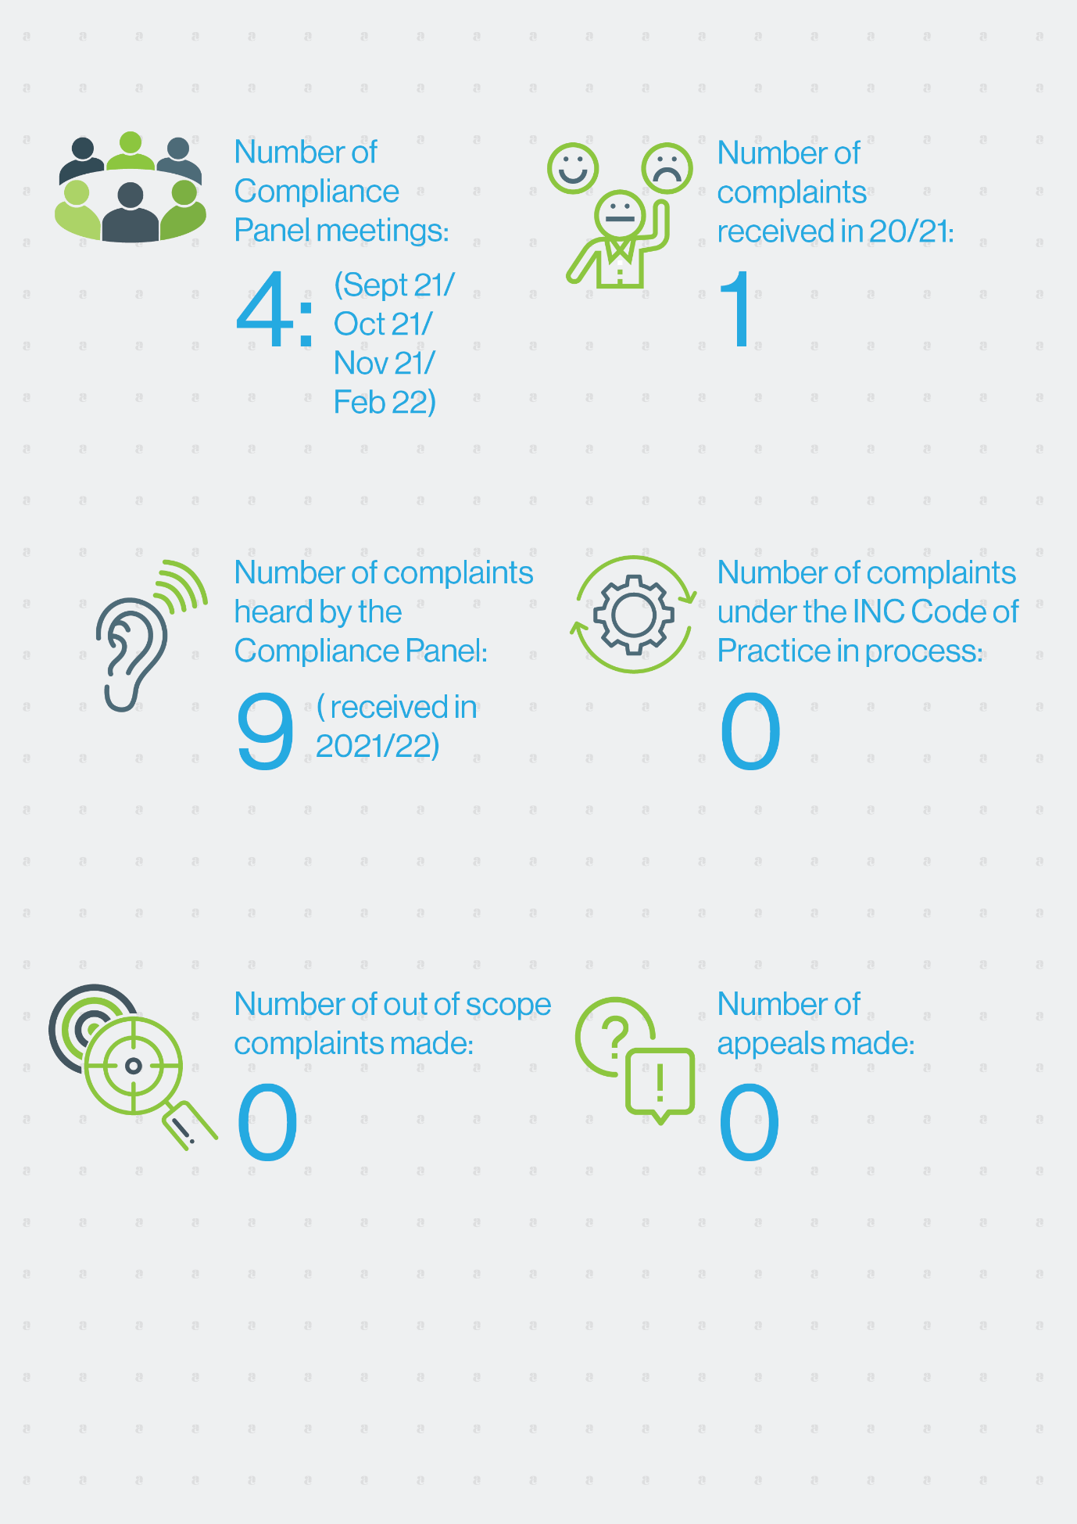

Summary of complaints considered

Key themes from complaints made under the INC Code of Practice
Nine complaints made under the INC Code of Practice were heard in 2021/22. A determination was issued for each complaint.
Four complaints related to breaches of Article 5.1: marketing to the general public were fully or partially upheld by the Compliance Panel. The decisions related to ensuring:
- wording in any promotional material on a print, social media and video platform avoids phrases that directly reference infant formula products, including the generic phrases ‘infant formula’, ‘baby formula’, ‘stage 1’ and/or ‘stage 2’ or identify specific infant formula products
- any pre-populated content (such as chatbot conversation threads) comply with all aspects of the INC Code of Practice, including avoidance of wording like ‘infant formula’, ‘baby formula’, ‘stage 1’ and/or ‘stage 2’ products
- samples of infant formula products cannot be ordered online and FAQs/chatbots do not allow for this practice
- all images used in promotional material clearly match the product and the product’s intended users. There is a concern regarding toddler milk drink advertising that may cross promote infant formula products. This cross promotion is not allowed under the INC Code of Practice.
Five complaints related to breaches of Article 5.1: marketing to the general public were not upheld by the Compliance Panel. Context was critical in three complaints. The Compliance Panel considered that use of phrases like ‘full range’ in a URL address or website text is acceptable if the related content, text and images discuss or visualise only toddler milk products and/or older children. Other phrases like ‘your little one’ or ‘paediatric brand’ do not exclude toddlers and are acceptable when clearly related to only toddler milk products and/or older children.
The wording of social media algorithms was explored in two complaints not upheld by the Compliance Panel. INC companies did not breach Articles 5.1 or 5.5 of INC Code of Practice because they did not directly seek to contact named platform users, even if the platform itself used an algorithm to link marketing posts to those identified as being interested in infant formula, baby bottles and baby foods.
One complaint also related to Article 4: information and education. The inclusion of information about breast is best is not required on marketing for toddler milk products but inclusion of such advice on social media posts does not breach the INC Code of Practice.

Key themes from complaints made under the Health Workers’ Code
The Health Workers’ Code applies to anyone providing infant nutrition information to pregnant māmā/people. It:
- sets out expectations that health workers protect, promote and support breastfeeding
- requires that health workers be familiar with their responsibilities under the Health Workers’ Code, and other Ministry policies and strategies including the Baby Friendly Hospital Initiative, the Baby Friendly Community Initiative, the Well Child Framework and the Ministry’s Food and Nutrition Guidelines for Healthy Infants and Toddlers (aged 0-2 years).
In 2021/22, the Compliance Panel considered one complaint under the Health Workers’ Code. A previous complaint had been made about this health worker. Following the initial complaint, the Compliance Panel responded with an educational letter. On receipt of this further complaint the Compliance Panel issued a formal determination. In issuing the formal determination, it found that the health worker:
- met the definition of health worker under the Health Workers’ Code
- breached Article 1.1 of the Code because her advice was inconsistent with the Health Workers’ Code and other Ministry policies and strategies
- breached Articles 2.1, 2.2, 4.4, 5.1 and 5.3 because she:
  - provided inaccurate advice about the frequency of infant feeding (including advice that was not objective or consistent with clinical best practice)
  - inaccurately implied that some types of infant formula are inappropriate or unsafe for babies and that one type is superior to others and promoted a type of infant formula
  - provided advice that did not take into account individual circumstances
  - incorrectly interpreted evidence
  - offered unsafe advice on infant formula preparation
  - provided insufficient information about the benefits of breastfeeding.
Technical advice on how to address these inconsistencies was provided to the health worker. The Panel also advised the Ministry of Health about the concerns relating her practice.
Anyone providing advice on infant nutrition should consider the Health Workers’ Code and ensure that they are familiar with its expectations and requirements. All advice should be accurate, evidence-based and clinically appropriate.
There are no outstanding complaints being considered under the Health Workers’ Code.

Appeals
No appeals were considered in 2021/22.

Marketing practices of companies that are not members of the INC
The majority of the infant formula industry in Aotearoa New Zealand are members of the INC. Companies that do not belong to the INC are not party to the INC Code of Practice. Complaints about non-INC companies do not proceed through the self-regulatory complaints process. In 2021/22, no complaints about non-INC companies were received.

Other out of scope complaints
No out-of-scope complaints were received in 2021/22.

Infant Formula Industry Update
The INC represents the interests of the infant formula and toddler milk drink industry in Aotearoa New Zealand. It advocates optimal nutrition for all infants. Its members represent almost all those that manufacture or market infant formula in Aotearoa New Zealand.
The INC plays a key role in ensuring compliance and safety in the industry. The INC Code of Practice is a voluntary code of conduct which applies to the marketers of infant formula that are members of INC.
It applies to the marketing of infant formula products suitable for infants up to the age of 12 months. At July 2022, INC members marketing infant formula in Aotearoa New Zealand were:
- Bellamy’s Organic
- Blue River Dairy
- Bodco Dairy
- Fresco Nutrition
- Infant Food Company
- Danone Nutricia Early Life Nutrition
- Fonterra Co-operative Group
- Heinz Watties Ltd
- The Little Oak Company NZ
- The a2 Milk Company
- Nestle New Zealand Ltd
- NIG Nutritionals
- Nuchev
- Spring Sheep Milk Company New Zealand
- Swisse Wellness Pty Ltd (H&H Group)
- Winston Nutritional New Zealand

Appendix A
For the reporting year 2021/2022, the Ministry is the government agency responsible for monitoring compliance with the World Health Organisation’s International Code of Marketing of Breast-milk Substitutes (the WHO International Code) in New Zealand.
The aim of the WHO International Code is to contribute to the provision of safe and adequate nutrition for infants, by protecting, promoting, and supporting breastfeeding and by ensuring the proper use of breast-milk substitutes, when they are necessary. This is achieved through the provision of adequate information and appropriate marketing and distribution of breast-milk substitutes.
The WHO International Code has 11 articles. All 11 articles are implemented and monitored under four codes in New Zealand. The first three Codes listed below are voluntary, whereas the Australia New Zealand Food Standards Code is mandatory:
- The Ministry’s 2007 Code of Practice for Health Workers, which is included in the publication, ‘The Code in New Zealand’
- The INC’s Code of Practice for the Marketing of Infant Formula
- The Advertising Standards Authority’s Code for Advertising of Food (including the INC follow-on formula marketing guidelines), and
- Australia New Zealand Food Standards Code.

