Annual Report of the WHO Compliance Panel
Implementing and Monitoring the International Code of Marketing of Breast-milk Substitutes in New Zealand: The Code in New Zealand (Ministry of Health 2007)
1 July 2020 – 30 June 2021

Introduction
The Ministry of Health (the Ministry) monitors compliance with the Code of Practice for Health Workers (Health Workers’ Code) and the Infant Nutrition Council Code of Practice for the Marketing of Infant Formula in New Zealand (INC Code of Practice) by receiving complaints about possible breaches of either Code of Practice.
This report summarises complaints and significant enquiries made to the Ministry from 1 July 2020 to 30 June 2021. Complaints being processed are not included in this report.

The WHO Code Compliance Panel
The role of the WHO Code Compliance Panel (the Panel) is to:
- make decisions on referred complaints relating to either the Health Workers’ Code or the INC Code of Practice
- provide advice on action to remedy a breach of either Code of Practice in Aotearoa New Zealand
- provide advice to the Ministry on issues related to implementing the WHO International Code in Aotearoa New Zealand including, but not limited to, complaints that are outside the scope of either Code of Practice.
Advice provided by the Panel may include requesting that the Ministry take further education-focused steps like writing to individuals or organisations that may be operating in Aotearoa New Zealand in a way that is not consistent with the way that the WHO International Code is implemented here.

Current Panel members and the Independent Adjudicator
- Iris Reuvecamp (Chair)
- Carol Bartle (Academic representative)
- Dana Owens (Community representative)
- Jan Carey (CEO of the Infant Nutrition Council)
- Dr Whitney Davis (Health practitioner representative)
- Jane Glover (Independent Adjudicator).
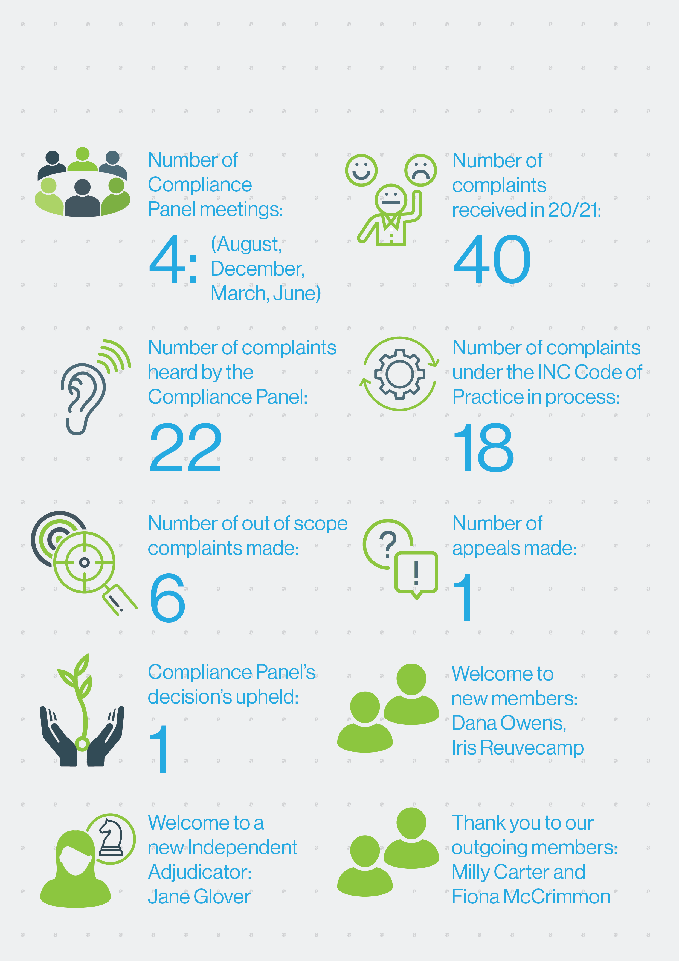

Summary of complaints considered

Key themes from complaints made under the INC Code of Practice
Fourteen complaints made under the INC Code of Practice were heard and upheld by the Compliance Panel, and determinations issued. Most complaints related to breaches of Article 5.1: Marketing to the general public.
Marketers of infant formula and toddler milk products should ensure that:
- any product promotional content used by third party websites or event promotors is checked thoroughly before publication to ensure that it complies with the INC Code of Practice
- wording in any promotional material:
  - avoids phrases that reference infant formula products, including the phrases ‘infant formula’ and ‘baby formula’
  - avoids phrases like ‘formula’ and ‘full range’ where the marketing context means that a person cannot reasonably and clearly differentiate whether the marketing promotes an infant formula product or a toddler milk product
  - clearly describes products as toddler milks (where this is advertised)
- images do not include pack shots for infant formula products (including stage 1 and stage 2 numbering)
- they actively control all content on their social media platforms to ensure compliance with the INC Code of Practice, including statements made by paid influencers and consumers
- they respond to any misinformation about infant nutrition and breastfeeding posted to their social media platforms (i.e., the obligation to protect and promote breastfeeding extends to content not created by the INC member if it is included on platforms controlled or used by it)
- ensure that social media platforms and any related pop-ups, links and FAQs do not enable members of the public to request samples of infant formula (i.e., samples of infant formula cannot be distributed through social media platforms)
- consumer-generated product reviews posted to social media sites comply with the INC Code of Practice.
The Ministry wrote to an event promotor to advise it of how the WHO International Code is implemented in Aotearoa and to advise it of the need to ensure that it supports the INC Code of Practice.
A number of complaints related to Article 5.5. Article 5.5 relates to the activities of marketing professionals seeking contact with pregnant women and parents of infants and toddlers. In most cases, the marketing undertaken was covered under Article 5.1, as marketers were not specifically attempting to contact parents and pregnant women.
The remaining complaints are currently being processed.

Key themes from complaints made under the Health Workers’ Code
The Health Workers’ Code applies to anyone providing infant nutrition information to pregnant women and mothers. That they were covered under the Health Workers’ Code was unclear to both individuals about whom complaints were made. Anyone providing advice on infant nutrition should consider the Health Workers’ Code and ensure that they are familiar with its expectations and requirements.
The Health Workers’ Code:
- sets out expectations that health workers protect, promote and support breastfeeding
- requires that health workers be familiar with their responsibilities under the Health Workers’ Code, and other Ministry policies and strategies including the Baby Friendly Hospital Initiative, the Baby Friendly Community Initiative, the Well Child Framework and the Ministry’s Food and Nutrition Guidelines for Healthy Infants and Toddlers (aged 0-2 years).
Both complaints alleged that advice provided by the two health workers did not protect and promote breastfeeding and was not consistent with core Ministry publications. One complaint related to a Facebook post about situations in which breastfeeding was not ideal; however, the health worker did not ensure that this advice was evidence-based nor did they provide information about the benefits of breast milk and breastfeeding. The other complaint related to a range of infant nutrition advice provided through webinars, emailed content and blogs. This advice contained factually incorrect information that was not consistent with national guidelines and policies.
Anyone providing advice on infant nutrition should ensure that their advice is consistent with the requirements of the Health Workers’ Code and with other guidance relevant to infant feeding in Aotearoa New Zealand. The Compliance Panel took an educative approach to both health workers who were subject to complaints and did not issue formal determinations.

Appeals
One cross appeal was considered. The Compliance Panel’s decisions were upheld.
The Compliance Panel found that the company breached Article 5.1 of the INC Code of Practice for the use of the word ‘formula’. The company appealed noting that the word infant was not used, images of toddlers were used and the promotion related only to toddler milk products (and it was therefore reasonable for consumers to consider that the word ‘formula’ related to toddler milk). The Compliance Panel’s decision was upheld because it did not fail to take a relevant fact into consideration, did not take an irrelevant fact into account, and did not give a relevant fact insufficient weight. When promoting toddler milk products, marketers should avoid using the phrase ‘formula’ in because it can be seen as cross-promoting infant formula.
The Compliance Panel found that the company did not breach Article 5.5 because marketing personnel were not seeking contact with parents. The complainant appealed because marketing is performed by company staff. The Compliance Panel’s decision was upheld because general marketing is covered under Article 5.1. Article 5.5 covers other forms of contact. The advertisement was not another form of contact and therefore was not a breach.

Marketing practices of companies that are not members of the INC
Two complaints relating to advertising of infant formula products for babies aged 0-6 months or the use of the phrase ‘infant formula’ in brand marketing by non-INC member companies were received.
Companies that do not belong to the INC are not party to the INC Code of Practice. Complaints about non-INC companies do not proceed through the self-regulatory complaints process. The Ministry wrote to the infant formula manufacturers to advise them of how the WHO International Code is implemented in Aotearoa New Zealand and to encourage them to join the INC.

Other out of scope complaints
Out-of-scope complaints related to:
- specific product promotions by retailers (which are not covered by either the INC Code of Practice or the Health Workers’ Code)
- other milk powder products (i.e., not infant formula).
Educative letters were provided to retailers advising on the WHO International Code’s implementation in Aotearoa New Zealand. No action was taken on complaints about milk powder products. Complainants were advised of the Ministry’s actions.

Infant Formula Industry Update
The Infant Nutrition Council (INC) represents the interests of the infant formula and toddler milk drink industry in New Zealand which advocates optimal nutrition for all infants. Its members represent over 95% of the volume of infant formula manufactured and marketed in New Zealand.
INC plays a key role in ensuring compliance and safety in the industry. The INC Code of Practice is a voluntary code of conduct which applies to the marketers of infant formula who are members of INC.
It applies to the marketing of infant formula products suitable for infants up to the age of 12 months. INC members marketing infant formula in New Zealand include:
- Blue River Dairy
- Biostime Nutrition
- Bodco Dairy
- Danone Nutricia Early Life Nutrition
- Fonterra Co-operative Group
- Fresco Nutrition
- GMP Dairy
- Zuru New Zealand
- Heinz Watties Ltd
- The Little Oak Company NZ
- The a2 Milk Company
- Nestle New Zealand Ltd
- NIG Nutritionals
- Spring Sheep Milk Company New Zealand

Appendix A
The Ministry is the government agency responsible for monitoring compliance with the World Health Organisation’s International Code of Marketing of Breast-milk Substitutes (the WHO International Code) in New Zealand.
The aim of the WHO International Code is to contribute to the provision of safe and adequate nutrition for infants, by protecting, promoting, and supporting breastfeeding and by ensuring the proper use of breast-milk substitutes, when they are necessary. This is achieved through the provision of adequate information and appropriate marketing and distribution of breast-milk substitutes.
The WHO International Code has 11 articles. All 11 articles are implemented and monitored under four codes in New Zealand. The first three Codes listed below are voluntary, whereas the Australia New Zealand Food Standards Code is mandatory:
- The Ministry’s 2007 Code of Practice for Health Workers, which is included in the publication, ‘The Code in New Zealand’
- The Infant Nutrition Council’s (INC) Code of Practice for the Marketing of Infant Formula
- The Advertising Standards Authority’s Code for Advertising of Food (including the INC follow-on formula marketing guidelines), and
- Australia New Zealand Food Standards Code.

