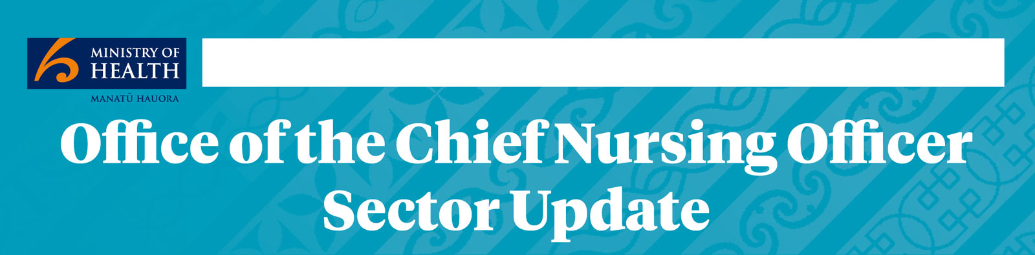
April 2016 ISSN 2423-0561
Apr
Happy New Year from the Office of the Chief Nursing Officer
Here we are through the first quarter of 2016 and, after an unusually long and warm summer here in Wellington, we are now noticing an autumn feeling to the air. This is our first update for 2016, and we hope you will find it interesting to learn more about the work of our office. We welcome feedback or questions about any items in the newsletter – to contact us, please email: andrea.tamahaga@moh.govt.nz
The Office of the Chief Nursing Officer (OCNO) is a business unit in the Ministry of Health (the Ministry). As almost every activity in the Ministry has some relationship to nurses’ work, our team provides advice and leadership across the organisation. For an overview of our work on nursing at the Ministry, visit: www.health.govt.nz/our-work/nursing

We’re changing the way we send this newsletter
The next time we send this newsletter we’ll be making some changes to how we send it to you. The changes will make it easier for you to read the newsletter on your tablet or mobile, and we’ll be sending it to you directly instead of asking your colleagues to pass it on to you.
If you’d like to keep getting this newsletter, there’s just two things you need to do:
- Sign up for the newsletter list on the Health website at www.health.govt.nz/our-work/nursing/newsletter.
- We’ll send you a confirmation with a link in it. Click the link in the email to lock in your subscription.
That’s all you need to do to keep getting the updates.
In this issue:  - Ministry on the Move  - The team that plays together …  - New Zealand Health Strategy  - Enabling nursing scopes of practice  - Nursing workforce  - Quality, safety and productivity | - Health of Older Persons Strategy  - Mental health and addictions  - Rheumatic fever resources on line  - Deteriorating patient programme  - Trans-Tasman cooperation  - Mobility Action Programme

Ministry on the Move
The Ministry has embarked on a change programme called ‘Ministry on the Move’. This refers to both an organisational review to improve how the Ministry supports the health sector in providing services to New Zealanders and also our pending physical move to new premises in Molesworth Street, Wellington, scheduled for October 2016.
Late last year, the Director-General of Health, Chai Chuah, announced a restructure at the Ministry. The initial stages of our change process were implemented on 1 March with the formation of a new executive leadership team (ELT). The ELT structure has 13 members, including the Director-General. There is a new focus on customer insights, Māori leadership and clinical advice. Dr Jane O’Malley’s position has moved across to the new ELT with a role title change, as the new title of this newsletter indicates. Jane is now known as the Chief Nursing Officer (CNO). Along with the Chief Medical Officer (CMO) and the Māori Health Leader, Jane continues to report to the Director-General.
The role and function of the CNO have been clearly defined, with a new emphasis on joint clinical and strategic leadership in the Ministry and across the health sector, working with the CMO and the Māori Health Leader. The CNO and CMO are responsible for leading a clinical board that will advise the Director-General and ELT on clinical matters. The CNO is also jointly responsible, with the CMO and the Māori Health Leader, for leading and promoting initiatives to improve outcomes for Māori and reduce inequalities between populations.
Currently all ELT roles, except the CNO and the Executive Director in the Office of the Director-General, are temporarily filled by people in acting positions. New ELT positions have been advertised, and the recruitment process is progressing. You can view the Ministry organisational chart and see information about each of the business units established on 1 March at:
www.health.govt.nz/about-ministry/ministry-business-units

The team that plays together …
Christmas is now a receding memory for most of us, but for our office, recalling our efforts at the Ministry Christmas party remains an ongoing source of amusement. The theme for this year’s Ministry party was Masterchef. Teams were invited to prepare and serve food to everyone at the party, or you could sign up to simply consume and judge food prepared by other teams. There was a friendly competitive spirit, and in the end, everyone played the role of consumer and judge. There were some amazing dishes served, all with the caveat that they must represent healthy nutrition.
Our team was the Orthorexic Chefs, named for our strong interest in healthy food and varied dietary preferences. Our offering of dressed ham was popular but, in the final count, was outdone by other teams’ delicious salads, tapas and curry. Our team costume, however, drew a lot a comment.
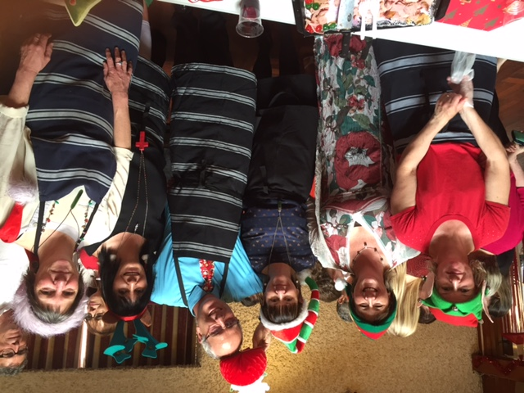
As a Government agency, Ministry spending always comes under scrutiny. This event proved that creativity and a lot of fun is very possible on a very limited, do-it-yourself budget.
Chief Nursing Officer Orthorexic Chefs – Kathy Glasgow, Andrea Tamahaga, Paul Watson, Jane O’Malley, Alison Hussey and Jane Bodkin kitted out for ham carving and serving

New Zealand Health Strategy
Consultation on the draft New Zealand Health Strategy closed on 4 December 2015. The 2016 New Zealand Health Strategy was released by Minister of Health Dr Jonathan Coleman at a symposium focused on the future of the health system on 18 April 2016.
You can access a copy of the Strategy at http://www.health.govt.nz/publication/new-zealand-health-strategy-2016
The New Zealand Health Strategy is organised around the vision of having all New Zealanders live well, stay well and get well. There are five interconnected strategic themes:
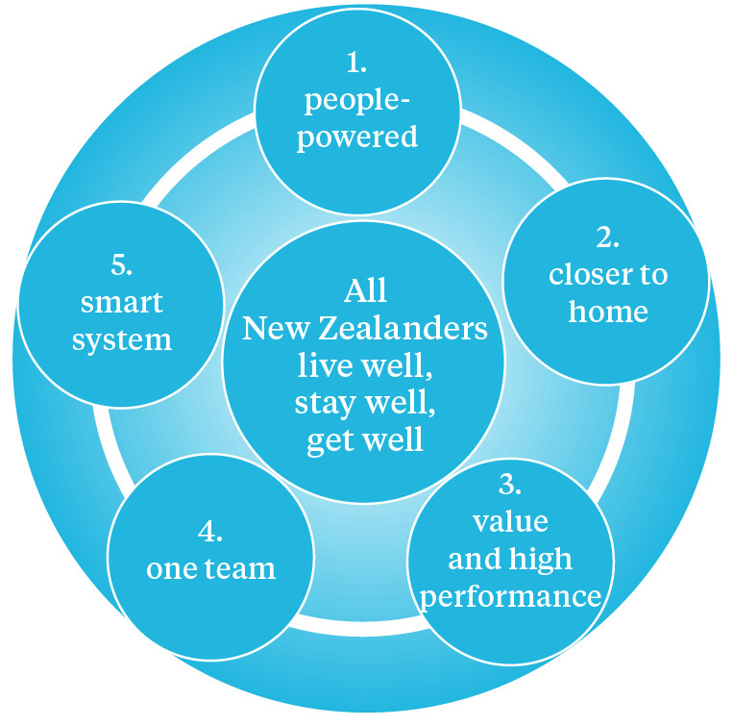
Each strategic theme contains a range of relevant activities, which are linked and interdependent. Finally, each theme has an associated roadmap of actions, some short term and readily achieved and others with a longer-term expectation.
Information about the process to develop the strategy, video clips and a summary of the feedback collected through the consultation process can be found on the Ministry’s website at:
www.health.govt.nz/about-ministry/what-we-do/new-zealand-health-strategy-update

Enabling nursing scopes of practice

The Health Practitioners (Replacement of Statutory References to Medical Practitioners) Bill
Dr Jane O’Malley and Dr Ruth Anderson, former Director of Health Workforce New Zealand (HWNZ), presented to the Health Select Committee meeting when it considered the Health Practitioners (Replacement of Statutory References to Medical Practitioners) Bill (HPSR) in December 2015. Alison Hussey from OCNO, Mary Louise Hannah from HWNZ and Dennis Shum from Health Legal also attended.
The HPSR is now well on its way through the machinery of government. The select committee has reported back on the Bill, and it is back in the parliamentary legislative programme for its second reading this year.
All the information, including the select committee report on the Bill, can be found at: www.parliament.nz/en-nz/pb/legislation/bills/00DBHOH_BILL63296_1/health-practitioners-replacement-of-statutory-references
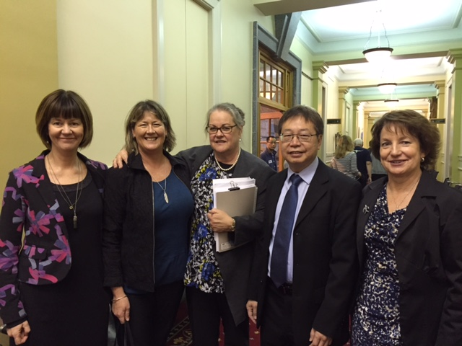
Jane O’Malley, Alison Hussey, Mary Louise Hannah, Dennis Shum and Ruth Anderson at Parliament after the select committee meeting in December

Registered nurse prescribing
Regulations for registered nurse (RN) designated prescribing have been written. We expect the regulations to be enacted by June and brought into force in September. The Nursing Council of New Zealand is working with the Ministry to ensure that nurses currently prescribing under the Medicines (Designated Prescriber – Registered Nurses Prescribing in Diabetes Health) Regulations 2011 retain their prescribing status and access to subsidised medicines once the new RN designated prescriber regulations are brought into force.
The Ministry is also working with PHARMAC to ensure that prescribing rules and subsidies are amended as needed and applied to the medicines on the RN designated prescriber list.
The Cabinet paper presented to the Social Policy Committee, describing registered nurse prescribing in primary care and specialty teams can be found at: www.health.govt.nz/system/files/documents/pages/cabinet-paper-designated-prescribing-authority-registered-nurses-working-primary-health-specialty-teams.pdf
The Regulatory Impact Statement submitted to Cabinet when it considered the proposal for RN prescribing can be found at:
www.health.govt.nz/about-ministry/legislation-and-regulation/regulatory-impact-statements/medicines-designated-prescriber-registered-nurse-regulations

Standing Orders
On 6 April, the Minister of Health presented the proposal to amend the Medicines (Standing Order) Regulations (the Regulations) so that nurse practitioners and optometrists can issue standing orders to the Cabinet Social Policy Committee. Cabinet agreed to drafting instructions being issued to amend the regulations. Later in the year, the Minister will go back to the Cabinet Executive Council to have the regulations enacted under an Order in Council.
You can read the Cabinet Paper considered by the Cabinet Social Policy Committee here http://www.health.govt.nz/our-work/nursing/developments-nursing/amendment-medicines-standing-orders-regulations
The Regulatory Impact Statement describing the options considered before proposing the amendment to the regulations is also available on line at http://www.health.govt.nz/about-ministry/legislation-and-regulation/regulatory-impact-statements/amendment-medicines-standing-orders-regulations-2002
The proposed amendment to the regulations is relatively straightforward and will enable the full intent of the policy behind the Medicines Amendment Act 2014. At that time, nurse practitioners and optometrists were named in the Medicines Act (the Act) as authorised prescribers alongside medical practitioners, dentists, midwives and veterinarians. Although the Act allows all authorised prescribers to issue standing orders, currently, the regulations allow only medical practitioners and dentists to do so. The amendment will make the health workforce more flexible and allow practitioners to practice to the full extent of their knowledge, skills and scopes of practice.
If you are interested in learning more about the process for making legislation, go to:
www.parliament.nz/en-nz/about-parliament/how-parliament-works/fact-sheets/00HOOOCPubResAboutFactSheetsProcess1/parliament-brief-the-legislative-process
And to find out more about making regulations, go to: https://cabinetmanual.cabinetoffice.govt.nz/7.77

Nursing workforce
The Nursing Workforce Governance Group met on 19 February and released the following the key messages:

1. Models of care and equity
For many people, our health system works well. However, poor health outcomes continue to be a reality for some New Zealanders. The governance group believes that the nursing profession is a key resource for delivering customer-focused services by models of care in many settings but that systems can become barriers to nurses contributing to the full extent of their potential. Determining how nursing can help ensure strong and patient-centred models of care that improve outcomes and equity is a priority for the governance group’s work programme.

2. Nursing Workforce Forecasting Model
The Nursing Workforce Forecast Model developed by HWNZ and OCNO indicates that, if current trends continue, the registered nurse workforce will keep growing and will almost keep pace with projected total population growth by 2025. In spite of the overall positive forecast, Māori and Pacific nurses, enrolled nurses and registered nurses in continuing care of the elderly settings are areas that are still vulnerable, with the numbers of nurses in these areas predicted to decline over the next 10 years unless action is taken to improve recruitment and retention. The nursing workforce programme intends to develop strategies for each of these areas with sector stakeholders.

3. Māori nursing workforce
The governance group is beginning to engage with employers, education providers, iwi and other stakeholders to develop a Māori nursing workforce that matches the percentage of the Māori population by 2028. The collective impact of central government leadership and a community-based approach with whānau, hapū, iwi and education and health providers working together will be needed to achieve this goal.

New Nursing Workforce Forecast Model
Health Workforce New Zealand and the OCNO have developed a Nursing Workforce Forecast Model that provides valuable predictions of the likely composition of the nursing workforce through to 2025 in each scope of practice, major ethnic group and practice setting. The model points to the need to prioritise nursing workforce initiatives for Māori, Pacific, enrolled nurses and registered nurses in continuing care (care of the elderly). Key findings of the model are as follows:
- The registered nurses workforce continues to grow in size and is predicted to almost keep pace with population growth (2 percent decline in the number of nurses (head count) per 100,000 population). Most practice settings reflect this picture except: cancer nursing, which is predicted to grow, and continuing care of the elderly, which is predicted to decline significantly (see below).
- The ratio of Māori nurses per 100,000 Māori population will reduce by 17 percent. Currently there are 503 Māori nurses per 100,000 Māori population. This compares with 1083 nurses per 100,000 total population.
- The ratio of Pacific nurses per 100,000 Pacific population will reduce by 4 percent. Currently there are 605 Pacific nurses per 100,000 Pacific population. This compares with 1083 nurses per 100,000 total population.
- Enrolled nurse numbers will decrease by 28 percent by 2025. This will impact particularly on continuing care of the elderly, assessment treatment and rehabilitation and district nursing services.
- The ratio of registered nurses in continuing care (elderly) per 100,000 population will decline by 24 percent. For the population aged 60+, the ratio of registered nurses per 100,000 per head of population will decline by 38 percent. Of all practice settings, continuing care (elderly) faces the largest proportional decline in the number of registered nurses.
- Internationally qualified nurses (IQN) will continue to make up 26 percent of the registered nurse workforce; the largest proportion of any country in the OECD. The IQN exit rate is approximately twice the exit rate of New Zealand trained nurses. IQNs will make up 50 percent of the registered nurses in continuing care (elderly) settings by 2025.

New graduate employment
On 20 January 2016, there were 821 new graduates (57%) known to be employed and 630 still looking for work through the Advanced Choice of Employment system (ACE).
New graduates still looking for work whose first choice practice setting is continuing care elderly as at 20/1/2016
DHB preference 1 | Number preferring continuing care elderly setting
Auckland | 3
Counties Manukau | 1
Hawkes Bay | 1
Hutt Valley | 1
Northland | 2
Taranaki | 2
Waikato | 1
Total | 11

Māori new graduates still looking for work by first choice DHB as at 20/1/2016
DHB preference 1 | Number of Māori graduates looking for work
Auckland | 3
Bay of Plenty | 2
Canterbury | 3
Capital & Coast | 16
Counties Manukau | 8
Hawkes Bay | 7
Hutt Valley | 9
Lakes | 6
MidCentral | 7
Nelson Marlborough | 5
Northland | 6
Tairāwhiti | 3
Taranaki | 1
Waikato | 2
Wairarapa | 2
Waitemata | 3
Whanganui | 1
Total | 84

Pacific new graduates still looking for work by first choice DHB as at 20/1/2016
DHB preference 1 | Number of Pacific graduates looking for work
Auckland | 12
Bay of Plenty | 3
Capital & Coast | 10
Counties Manukau | 15
Hawkes Bay | 1
Hutt Valley | 2
Lakes | 2
MidCentral | 3
Southern Cross Hospitals - Southern | 1
Waikato | 2
Waitemata | 1
Total | 52

Quality, safety and productivity
A major source of harm in hospitals and other health care facilities is pressure injuries. The Health Quality and Safety Commission New Zealand (HQSC), the Accident Compensation Commission (ACC) and the Ministry agreed a joint response to pressure injury prevention in December 2015. Considerable effort is going into this work across the three agencies, and a lot of information and resources are available, as listed below. Paul Watson and Kathy Glasgow are the leads in our office for work on preventing pressure injuries.
- The HQSC has published the qualitative report on preventing pressure injuries (prepared by KPMG), available from its website at: www.hqsc.govt.nz/our-programmes/other-topics/publications-and-resources/publication/2362/
- Stories from people who had experienced pressure injury are a feature of the report. The HQSC has published some of those stories on its website as another way to highlight the implications of pressure areas. You can view the stories at: www.hqsc.govt.nz/our-programmes/other-topics/new-projects/pressure-injury-prevention/patient-stories/
- HQSC provides another page on its website with information and links to other pages: www.hqsc.govt.nz/our-programmes/other-topics/new-projects/pressure-injury-prevention/
- Visit www.hqsc.govt.nz/our-programmes/other-topics/news-and-events/event/2466/ for information about free seminars on preventing pressure injuries by visiting professor Keith Harding.

Health of Older People Strategy
A refreshed Health of Older People Strategy (HOP Strategy) continues to take shape through strategy design workshops around the country. Together with our Health of Older People policy and operations colleagues, OCNO has been getting out and about, from Westport to Whangarei, sourcing ideas and actions for the new HOP Strategy.
Workshops have been held in 12 locations with a wide range of health and social sector representatives, including funders, planners, health professionals and provider organisations, researchers, older people, carers and NGOs representing their interests. Engagement is still underway with Māori and Pacific communities, and suggestions for HOP Strategy content continue to flow through: hopstrategy@moh.govt.nz
Discussions are also being held with various sector groups, including the New Zealand Nurses Organisation Aged Care National Delegates Committee. The HOP Strategy will sit under the overarching New Zealand Health Strategy, and a draft will be released for consultation following the release of the New Zealand Health Strategy.

Mental health and addictions

Preventing Suicide Guidance
Preventing suicide: Guidance for Emergency Departments is now available on the Ministry’s website: www.health.govt.nz/publication/preventing-suicide-guidance-emergency-departments
The guidance was developed by Te Pou, with the assistance of an expert working group, including Jane Bodkin from OCNO. The document builds on (but does not replace) the 2003 Assessment and Management of People at Risk of Suicide guidelines developed by the New Zealand Guidelines Group and the Ministry.
The development of the guidance arose from action 6.2 of the Ministry’s Suicide Prevention Action Plan 2013-2016: to ‘improve the care of people presenting to emergency departments with self-harm’. A draft strategy will be prepared using feedback from workshops, findings from New Zealand and international research and discussions with people currently working in suicide prevention and mental health.

Suicide Prevention Strategy
A series of national workshops have almost been completed. A formal consultation process on the draft Suicide Prevention Strategy is expected by the middle of 2016. Written submissions will also be sought. Feedback will be carefully considered and updates made to the draft Suicide Prevention Strategy. The final Suicide Prevention Strategy is expected to be published by the end of 2016.

Rheumatic fever resources on line
New learning resources to support those delivering the rheumatic fever prevention programme are now available on the Ministry’s website:
www.health.govt.nz/our-work/diseases-and-conditions/rheumatic-fever/rheumatic-fever-resources/rheumatic-fever-learning-resources
The resources include an on-line learning course, guidance for injecting benzathine benzylpenicillin and a range of information sheets and videos to support health care providers working directly with children, families and communities.

Deteriorating patient programme
The HQSC is leading a quality improvement programme on the deteriorating patient. This programme aims to address national variations in identifying and clinically responding to patients who deteriorate during a hospital admission. Kathy Glasgow from OCNO is on the expert advisory committee, alongside several nurses from the nursing sector. You can find out more about this programme at: www.hqsc.govt.nz/our-programmes/other-topics/new-projects/the-deteriorating-patient/

Trans-Tasman cooperation
Dr Jane O’Malley and other Ministry representatives recently met with nursing academics from St Vincent’s Health Australia (based in Melbourne) to discuss improving employment opportunities for indigenous nurses in Australia.
Deanne Riddington and Karen Daws were in Wellington, meeting with nursing leaders as background for the work in Australia to increase the employment of Aboriginal nurses to better match the demographics of the population. Deanne and Karen were particularly interested in the work undertaken in New Zealand to improve the numbers of Māori entering health professions, improving the recruitment of new graduate nurses and the work done in 2014 and 2015 employing new graduate nurses in very low cost access general practices.

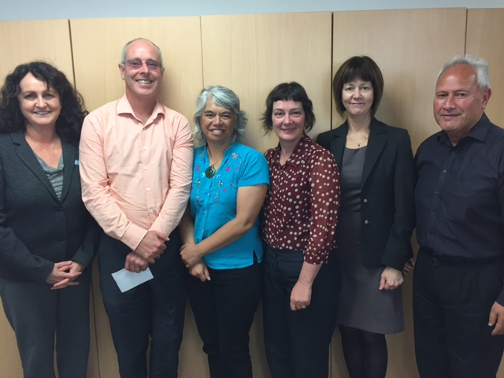
Left to right: Deanne Riddington, Paul Watson (OCNO), Karen Koopu (Ministry of Health Development Manager, Māori Health Service Improvement), Karen Daws, Jane O’Malley, Chas McCarthy (Ministry of Health Senior Contracts and Relationships Manager, Māori Health Service Improvement)

Mobility Action Programme
In Budget 2015, the Government allocated $6 million of new funding over three years to help improve care for people with musculoskeletal health conditions. This includes increasing access to early community based advice and treatment, education to improve self-management and rehabilitation to improve functioning and participation in activities. You can learn more about the Mobility Action Programme (MAP) by visiting:
www.health.govt.nz/our-work/preventative-health-wellness/mobility-action-programme

We are always keen to hear from you. Contact andrea_tamahaga@moh.govt.nz to get in touch with Jane or any of the team. We’d love to know if:
- you would like more information about anything discussed in this newsletter
- there is something particular you would like us to include in our next newsletter
- you have any feedback about the newsletter.

