Guide to annual abortion services reporting
There is a requirement under the Contraception, Sterilisation and Abortion (Information Collection) Regulations 2021 for abortion service providers to submit an annual abortion report on service provision, the workforce and abortion counselling workforce (where the service provides abortion counselling), service access, costs, sex selection abortion enquiries and service refusal information.
Providers must submit this report to Manatū Hauora by 31 March each year for the previous calendar year.
For further information on reporting please see the Manatū Hauora abortion services reporting webpage
Abortion service providers: Annual report guidance
This document provides guidance on the information requirements of each section of the annual provider report.
General information
New service providers: Please complete all relevant fields.
Existing service providers: If you submitted a report last year and the information hasn’t changed you can state ‘no change from previous year’ in the relevant field.
Note: Provider details will be shared and published on the DECIDE website to support people access your service. If you do not want service contact or provision details published on an abortion providers list, please advise us by contacting abortionservices@health.govt.nz

Abortion service provider details
- Add your service name and contact details.
  - Where possible please include the service provider email address. Do not include a personal email address.
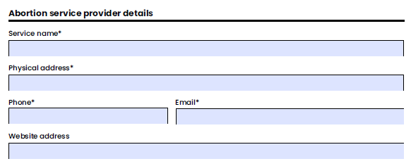

Details of abortion service provision
- Input the service hours for each day of the week.
  - This includes times the clinic is available to the public for enquiries, consultation, or abortion procedures.
- List the types of abortion services provided, gestational limit for the service, cost of procedure and any circumstances where service users are required to pay.
  - Types of services include EMA, surgical abortions, etc
  - Cost of service is the cost charged to service user for the procedure, eg $1,000
  - Circumstances where service users are required to pay. This may include non-resident/ineligible for public funding.

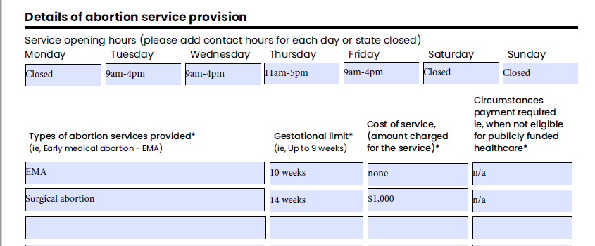

Abortion service workforce details
This data is used to monitor the national abortion workforce numbers.
Important Note: Please advise if you have a practitioner that works across multiple service providers. In these instances, only include the practitioner on the report for the service provider they spend the most time at.
- The total number of health practitioners involved in providing abortion services
  - This refers to health practitioners regulated under the HPCA Act 2003 that are directly involved in providing the abortion or abortion care.
- Health practitioner details
  - Complete one entry per practitioner in the table. Include each health practitioner’s registered profession, ethnicity, gender and any cultural competency or inclusivity training completed during the reporting year (or state ‘none’ if not completed).
  - Do not list social workers or counsellors here – record this workforce in the abortion counselling workforce section.
  - If you run out of space to list practitioners, please include the additional workforce information in table format in your email.

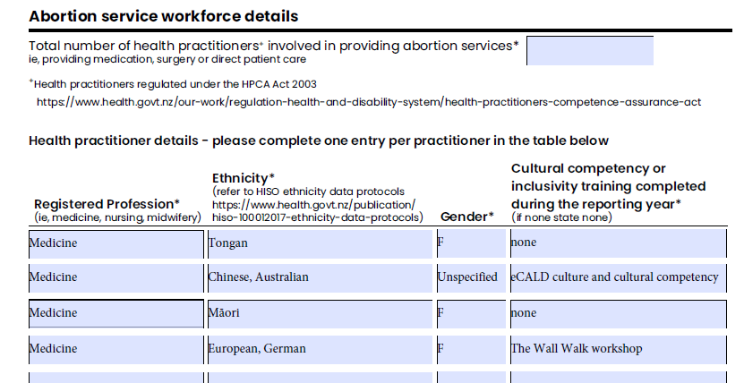

Abortion counselling services
This information is used to understand the counselling services provided, and costs (if any) incurred by the service users.
Complete this section if your service offers abortion-related counselling, eg Abortion decision counselling, pre-abortion counselling, post abortion counselling.
Note - You are not required to complete this section if you contract or direct patients to another counselling service.
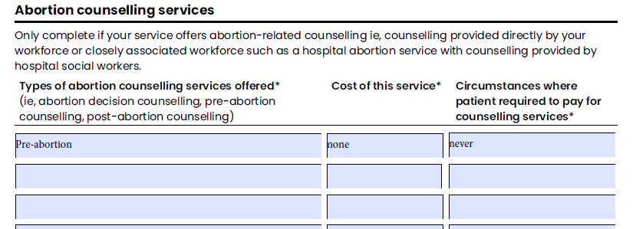

Abortion counselling workforce
This data is used to review the workforce providing abortion counselling services.
- Please refer to the Standard for Abortion Counselling in Aotearoa New Zealand for details of practitioners able to provide abortion counselling.
- Professional membership may include Social Workers Registration Board, New Zealand Association of Counsellors, NZ Christian counselling services etc.
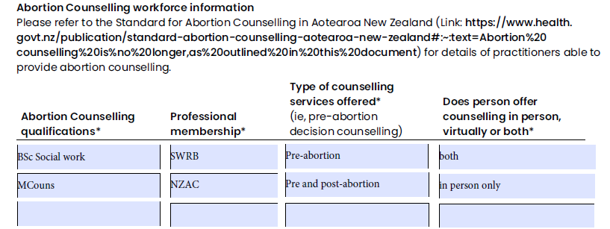
Interpreting services
This section aims to understand the accessibility of the service for non-English speakers.
- List all languages that can be interpreted at your service and who provides the service, eg social worker
- If an external interpreting service is used, list the service name and languages provided by this service, eg Ezispeak phone interpreting over 300 languages.
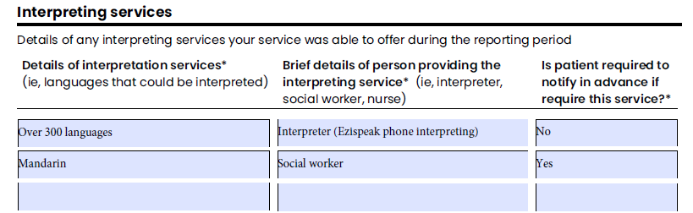

Sex selection abortion monitoring
Record the total number of instances your service is aware of that an abortion was sought for the purpose of sex selection, for this reporting period.
- Include any relevant comments in this section
- Do not include any specific patient details
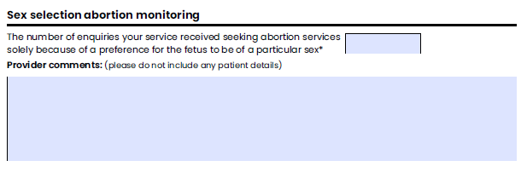

Patients not proceeding to abortion
This section is around service planning. It aims to capture those people accessing abortion services but not choosing to proceed to the abortion procedure.
- Provide the number of people and an estimate of the average consultation time
- Include any relevant comments in this section
- Do not include any specific patient details
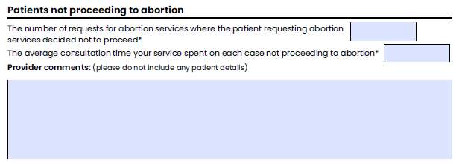

Processes your service has in place
This section captures information to understand how people are supported to find the most suitable service in circumstances where your service is unable to provide it.
- Outline the process your service has in place in instances where your service is unable to provide the service.
  - Eg you are an EMA provider, and a person presents at 12 weeks, do you refer them to a specific service? Do you provide the person with service contact details or information?
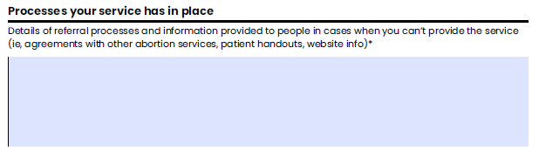

Monitoring abortion service refusals
This section of the form captures service refusals.
- Note the number of requests for abortion procedures that your service has refused, the reasons for refusal and if processes were followed
- Note the referral processes in place ie, processes if the person was referred to another service.
- If there are several refusals for the same reason, indicate the number of cases this applies to eg. 6x person over 10 weeks’ gestation and we only provide EMA.
