Summary of COVID-19 Disease Indicators
For the reporting period 11 to 24 September 2020
Report date: 27/10/2020
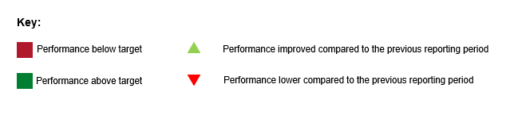

Summary of community cases
Number of cases for this reporting period and cumulative number of cases since 11 August 2020.
Reporting period | Cumulative
12 | 186
The metrics for the system and public health level COVID-19 Disease Indicators (S001, S002, P002, P004) are low due to the delayed identification of two exposure events (one linked to the Jet Park employee and the other linked to the Christchurch returnees cluster) and subsequent delayed identification of close contacts. For example, for the Christchurch returnees cluster, there was a complex web of contacts progressively revealed over time from the inbound flights to New Zealand, the MIF, and the flight to Auckland as the investigation continued – some transmission events were not identified until subsequent cases emerged. As a result, a number of close contacts were not able to be contacted within the target timeframes.

System level indicators
These indicators provide a view of the end-to-end collective actions of the wider health system response (indicators are prefixed with an S#).

S001 - Time from exposure to contact isolation / quarantine
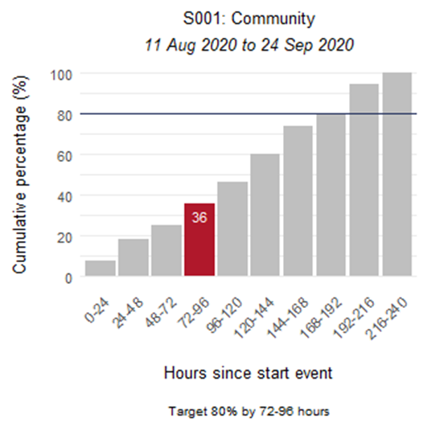
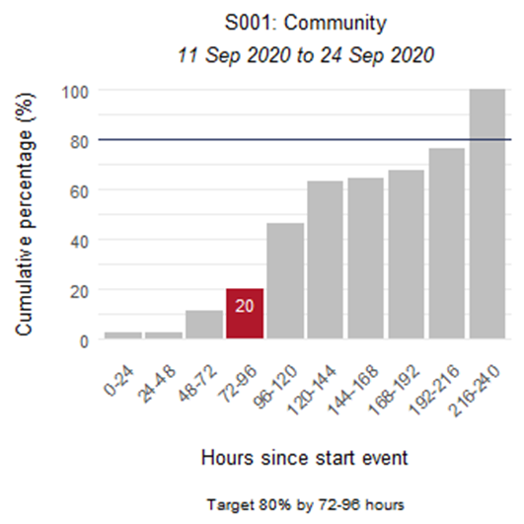

S002 - Time from case first symptom to contact isolation / quarantine
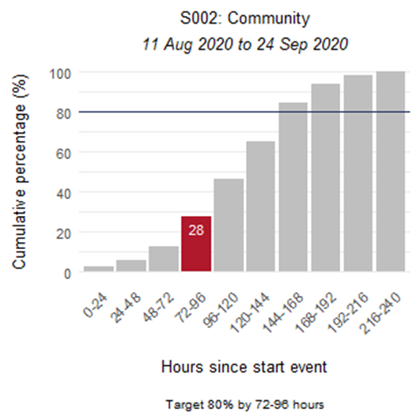
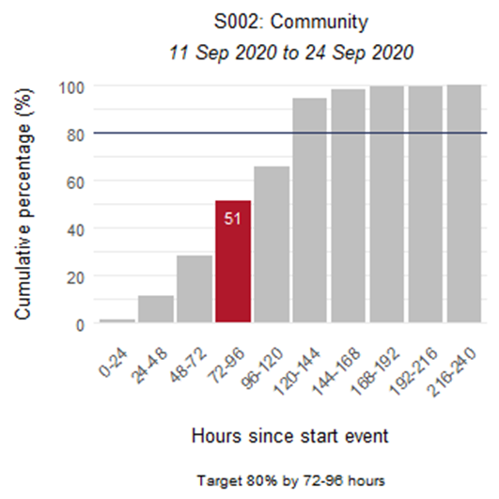

S003 - Time from test sample taken to close contact isolation / quarantine
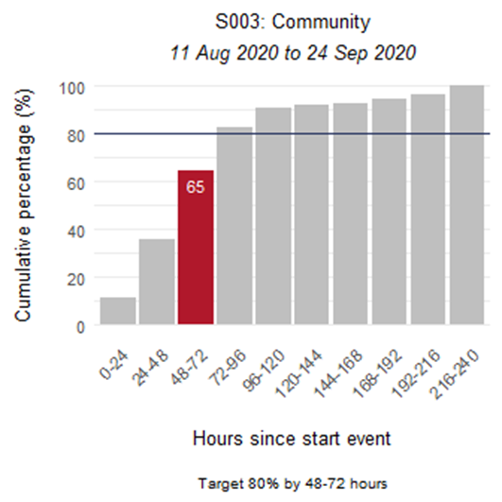
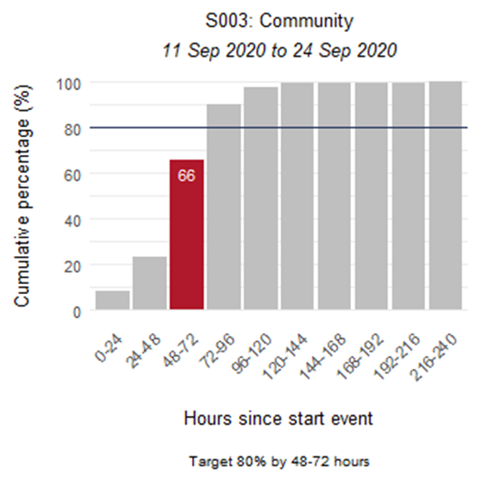

S005 - Proportion of close contacts with confirmed or suspected COVID-19 at the time of tracing
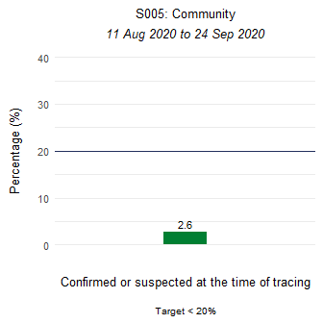
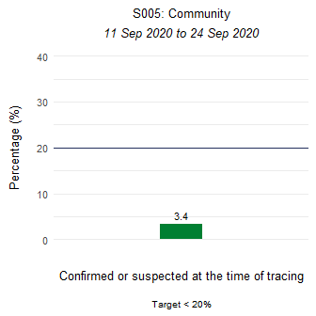

Community-level indicator
This indicator focuses on community behaviours and the impact of communication, education and societal attitudes (indicator is prefixed with a C#). The time period measured is from the symptom onset date as recorded in EpiSurv to the date/time the laboratory received the sample. The time between a sample taken and the receipt date/time of the sample at the laboratory, including transport time, will affect this indicator.

C001 - Time from first symptom to test sample taken for positive cases
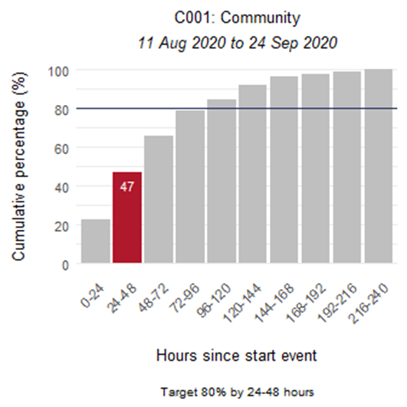
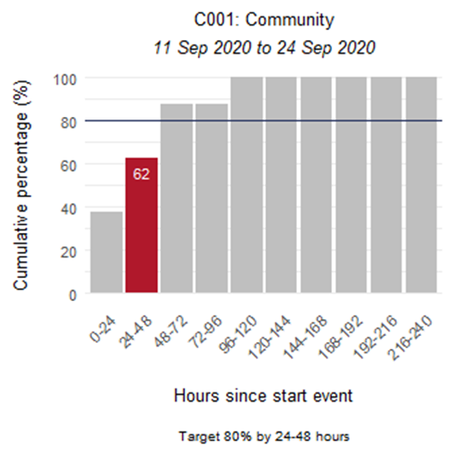

Laboratory sector indicator
This indicator provides insight into the effectiveness of testing facilities and programmes (indicator is prefixed with an L#). The time period measured is from the time the laboratory received the sample to notification of a positive result in EpiSurv. In this reporting period over 80 percent of positive results were notified at hour 39.

L001 - Time from test sample taken to notification of positive result
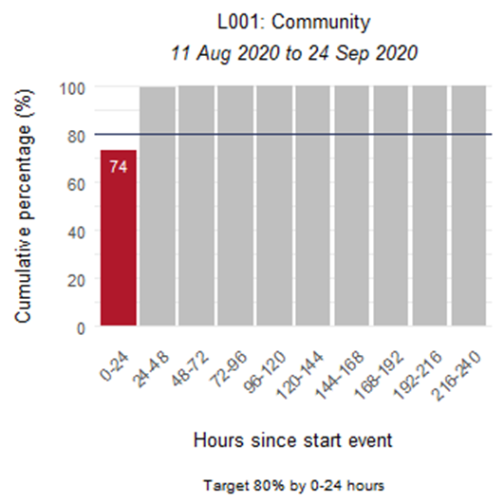
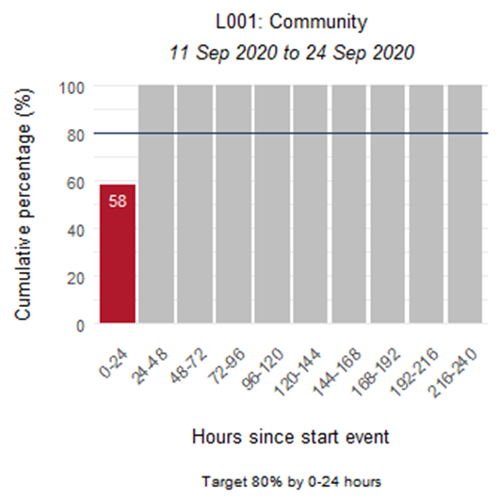

Public health sector indicators
These indicators provide a national overview of contact tracing as well as case and close contact management by public health units (PHUs) and the National Investigation and Tracing Centre (indicators are prefixed with a P#).

P001 - Time from notification to case interview
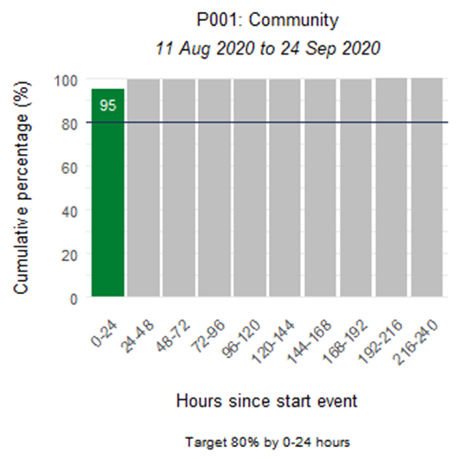
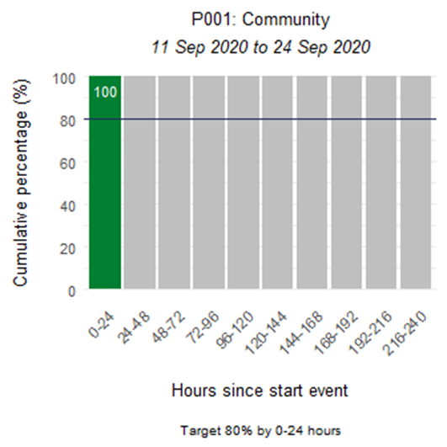

P002 - Time from case notification to isolation / quarantine of contact
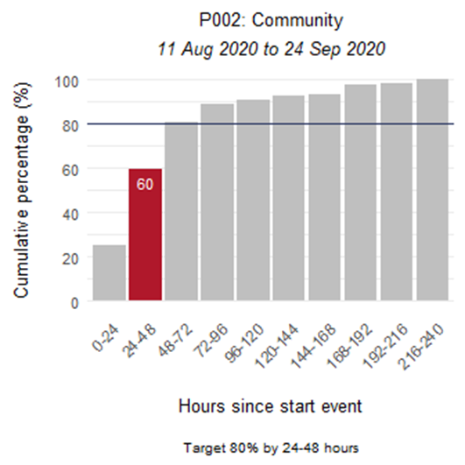
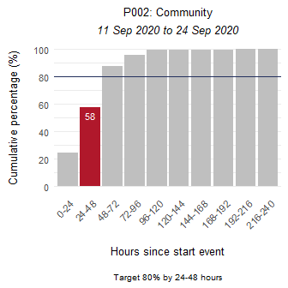

P003 - Time from close contact identification to isolated / quarantined
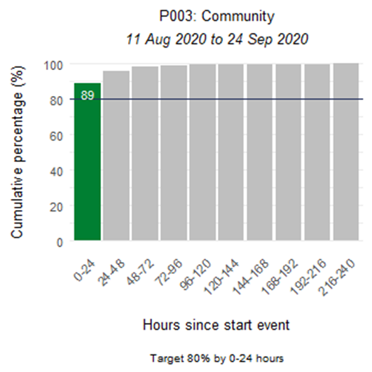
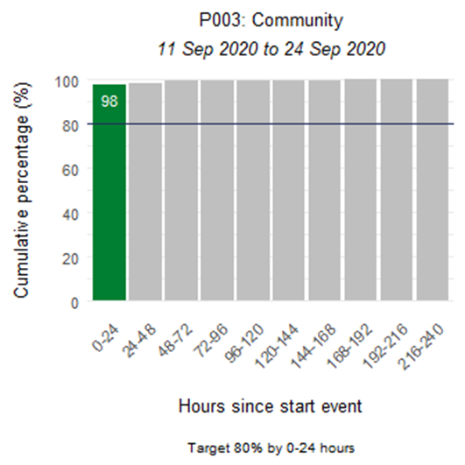

P004 - Proportion of contacts traced in 48 hours
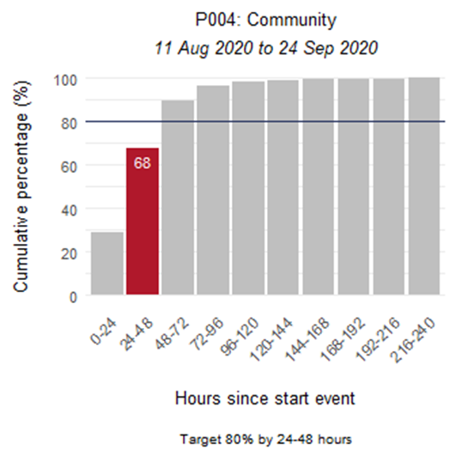
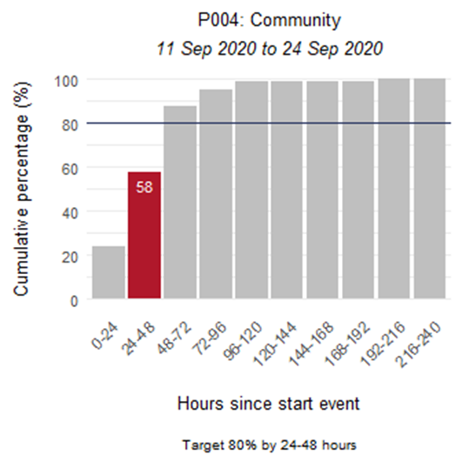

Appendix: Summary of MIQ border and international indicators
This section presents the indicators for Border Managed Isolation and Quarantine (MIQ) and International cases. Indicators S001, S002, and C001 are affected by the inclusion of border cases in MIQ, as returnees’ exposure is arbitrarily set to the day of arrival in New Zealand. They are placed into MIQ upon arrival and are tested if symptomatic or on approximately day 3 and day 12. Therefore, cases in MIQ will make the performance of these indicators appear low.

Summary of MIQ border and international cases
Number of cases for this reporting period and cumulative number of cases since 11 August 2020.
Reporting period | Cumulative
20 | 70

S001 - Time from exposure to contact isolation / quarantine
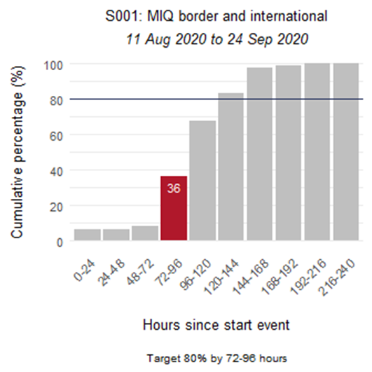
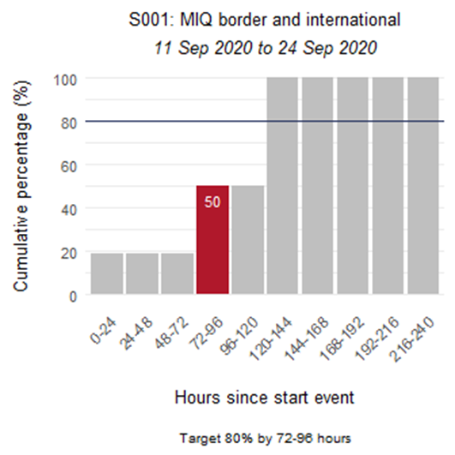

S002 - Time from case first symptom to contact isolation / quarantine
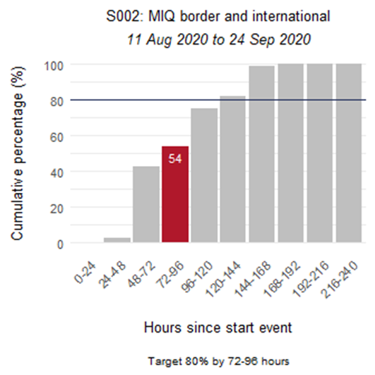
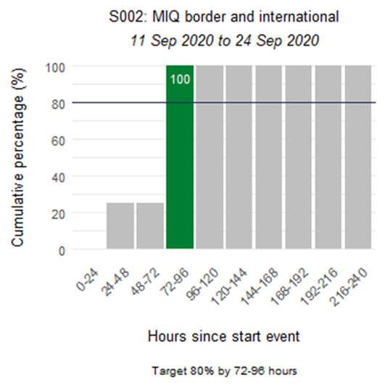

S003 - Time from test sample taken to close contact isolation / quarantine
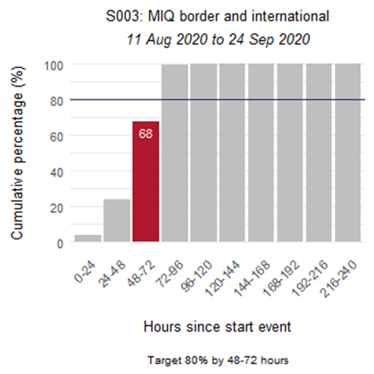
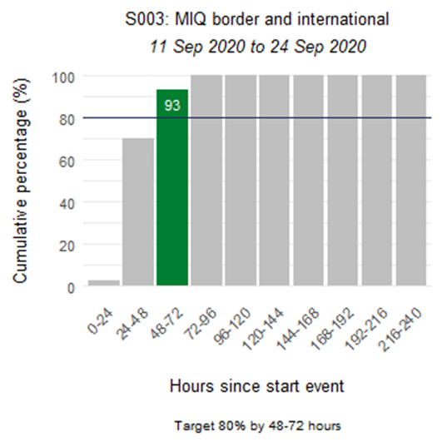

S005 - Proportion of close contacts with confirmed or suspected COVID-19 at the time of tracing
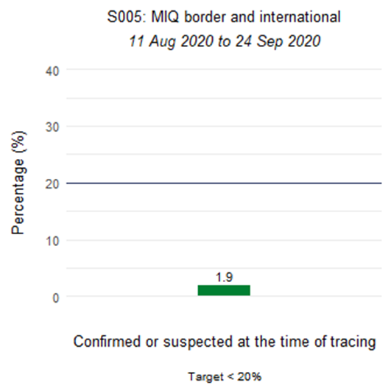
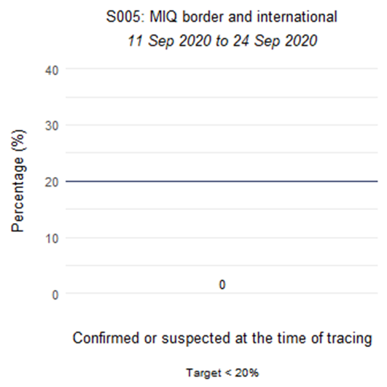

C001 - Time from first symptom to test sample taken for positive cases
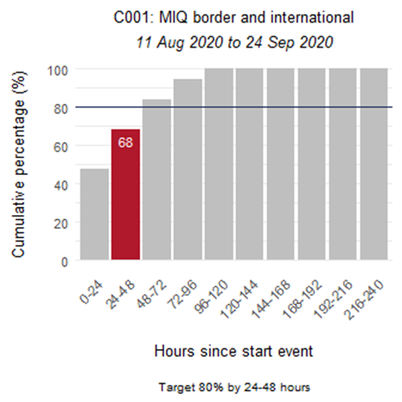
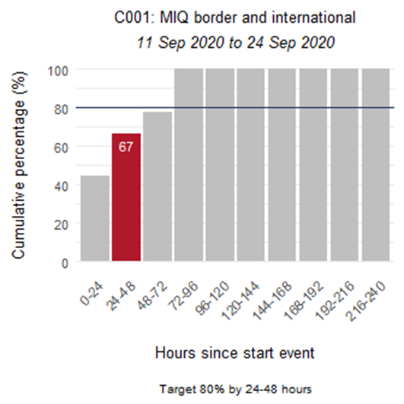

L001 - Time from test sample taken to notification of positive result
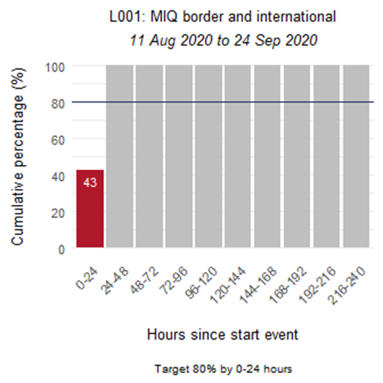
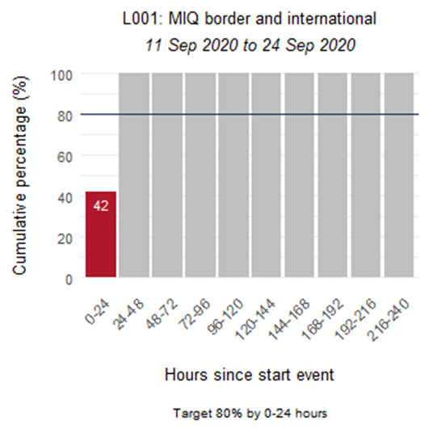

P001 - Time from notification to case interview
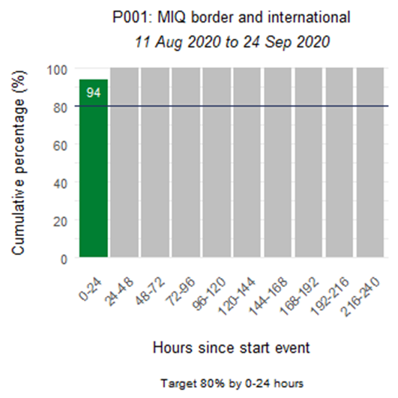
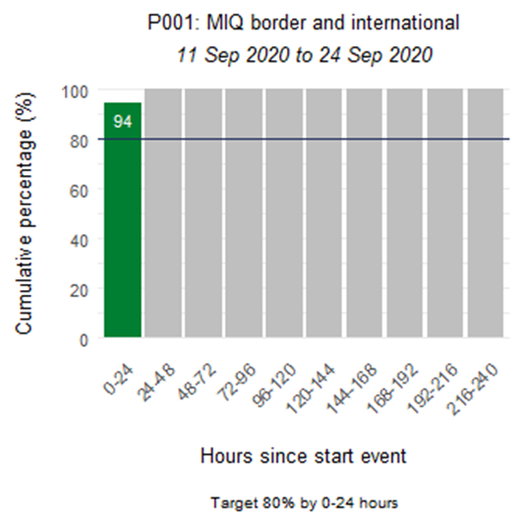

P002 - Time from case notification to isolation / quarantine of contact
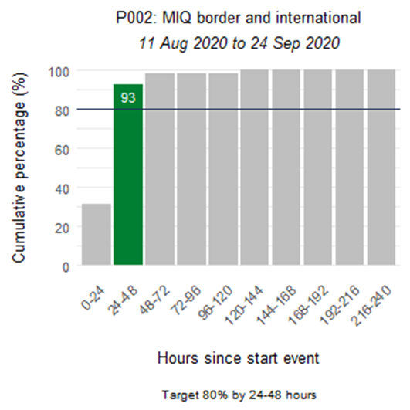
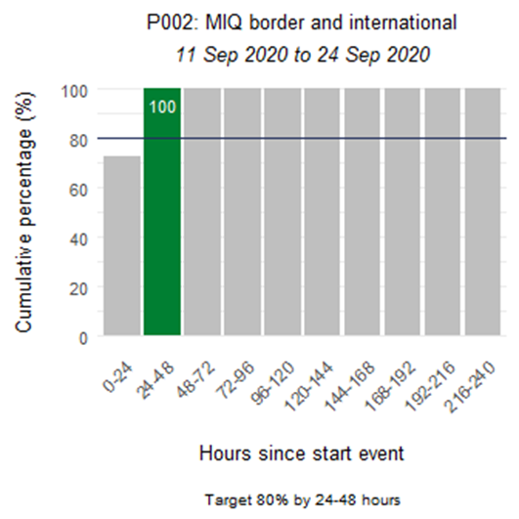

P003 - Time from close contact identification to isolated / quarantined
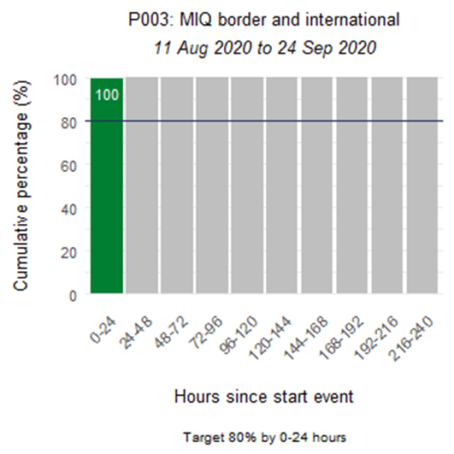
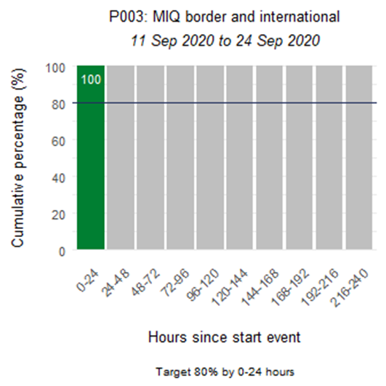

P004 - Proportion of contacts traced in 48 hours
